Aerobic exercise, pain and motor learning

Sport Science 8th semester AAU
Group:
Student: Karsten Thorvald Lawrence Rytman de Lange
Supervisor: Shellie Boudreau
Summer 2013

Aalborg University
School of health science
Frederik Bajers Vej
9220 Aalborg Ø

Title: Aerobic exercise, ischemic pain and motor learning
Theme: Aerobic exercise, ischemic pain and motor learning
Period: 8th semester summer 2013
Supervisor: Shellie Boudreau
No. of figures: 6
No. of pages: 24
No. of Appendices: 18
Date of completion: 02.07.13

Table of contents:

Abstract
Multiple evidence suggests the importance of aerobic activity for cognitive and brain functions. Few studies however, have combined exercise with pain stimulation and motor learning in such a way as is the case for the present study. The objective of this study was to uncover causal relations between exercise and nociceptive stimulation, and to monitor said relations through novel motor learning. Background material spans from investigations of animal behavior in relation to exercise, pain and motor learning, to studies on humans that suggest causal conditions within the same field. There is evidence that suggests that exercise has acute analgesic effects, and in addition can promote motor learning. 21 healthy adults were divided into three groups, among whom two worked at high intensity on a bicycle ergometer and one worked at low intensity. Following the cycle regime they were all subject to cuff pressure pain stimulation for 5 min and then asked to complete 8 sets of novel motor learning finger tapping on a custom keyboard. After a 30 min break they completed a final retention test of the finger tapping task. Results revealed no significant correlations for completion time (p=0.144) or accuracy (p=0.950). The results suggest that there may be correlations between higher pain levels and lower ability to learn motor skills, but are non-conclusive.
Key words: Aerobic exercise, ischemic pain, analgesia, novel motor learning
Introduction
The purpose of this study is to investigate acute neuronal adaptations to exercise and pain stimulation. Motor learning is then used to monitor said adaptations. As we have learned from animal studies, exercise has enhancing effects on learning (Edeline et al, 1993). Studies on humans have shown similar effects (Roig et al, 2012) and also indicate that exercise enhances longevity and vitality in terms of brain health and postponed neural degeneration (Cotman C.W. et al, 2002; Cotman C.W. et al, Neuroscience 2007; Cotman C.W. et al, Alzheimer’s & Dementia 2007; Russo-Neustadt A., 2009; Shepherd R.B. et al, 2001). Exercise also has acute analgesic effects in animals (Martins et al, 2013; Boecker et al, 2008) and humans (Scheef et al, 2012; Sternberg W.F., 2001; Hayden et al, 2005; Hayden et al, 2005,142; Schön-Ohlsson et al, 2005; van Tulder M. et al, 2007; Andersen L.L. et al, 2008; Bement M.K.H. et al, 2011; Nicolakis P. et al, 2002). Pain on the other hand brings about reduced ability to learn new motor skills in animals (Bejat et al, 2008) and humans (Boudreau et al, 2007; Boudreau et al, 2010; Sterling et al, 2001; Sörös P. et al, 2001; Ferguson A.R. 2006; Jull G.A. et al, 2000, Magnusson M.L. et al, 2008).
The study objective was to create an experiment where all three elements were involved: First exercise, then pain (Parhizgar S.E. et al, 2010) followed by motor skill training and learning (Pezet S et al, 2002). The motor learning element of the study represents a way of harvesting knowledge about the neurological adaptations to exercise and pain (Svensson P. et al, 2003). Working with these three elements in the same protocol is unique.
When patients battle chronic pain, it might impair their learning ability. On a clinical level, exercise may be an area for treatment that holds more potential for mitigating pain and promoting motor learning than hitherto believed. The objective of this study is therefore to uncover aspects of exercise and pain and their combine effect on learning. The study’s limited time span and test population dictate prudence in review of findings. Less significant findings might prove interesting through more extensive study.
Hypothesis: Aerobic exercise stimulates analgesic effects that inhibit pain reception and enhance following motor learning.
Methods
Twendy-two healthy adults (age range; 18-40 years, Body Mass Index (BMI) <30) were recruited from various networks in Aalborg, Denmark. Each volunteer was screened for a number of inclusion criteria, and these were repeated immediately prior to testing. Participants who were right-handed non-smokers were included for this study. Participants were defined as right-hand dominant according to the Edinburgh Inventory (Oldfield, 1971). Additionally participants were requested to not ingest alcohol 24 hours prior to study onset, or coffee or caffeine products 2 hours before study onset in order to ensure that they were not influenced by stimulating substances that might alter any of the tested parameters. Additionally subjects were asked to avoid high intensity exercise 12 hours before the onset, in the event that the exercise resulted in delayed onset muscular soreness (DOMS) or might possibly mask the effects of the exercise intervention used in the present study. Elite athletes, individuals training more than 2 hours per day or 10 hours per week, and individuals with musical training, such as piano players, greater than 3 months were excluded.
Experimental design
Subjects were randomly divided into high (Ex1) and low (Con) exercise intensity groups and counterbalanced for gender. Basal heart rate (HR) and blood pressure (BP) were recorded prior to exercise. Exercise consisted of a 30 min aerobic cycling regime at two different intensities. The cycling regime was followed by a five min break and measurement of HR and BP. Subjects were then fitted with a tourniquet blood pressure cuff on the right arm for the purpose of inducing acute ischemic pain for a period of five min. Cuff-pressure pain was recorded with a visual analogue scale (VAS). After a 5 minute rest, participants were asked to complete a 10 min novel motor training regime that required participants to learn a finger tapping sequence using a customized keyboard. Participants then performed a retention test after reading a fictional text for a period of 30 min.
As an additional high intensity group, Ex2 was recruited due to findings that the Ex1 group had low VAS pain scores following cycling. Ex2 worked at the same intensity as Ex1 during the cycle regime and differed in the pain procedure: Ex2 participants were required to squeeze a foam ball until pain levels reached 4 (on a scale from 0 to 10) in order to produce comparable pain levels to the Con group.

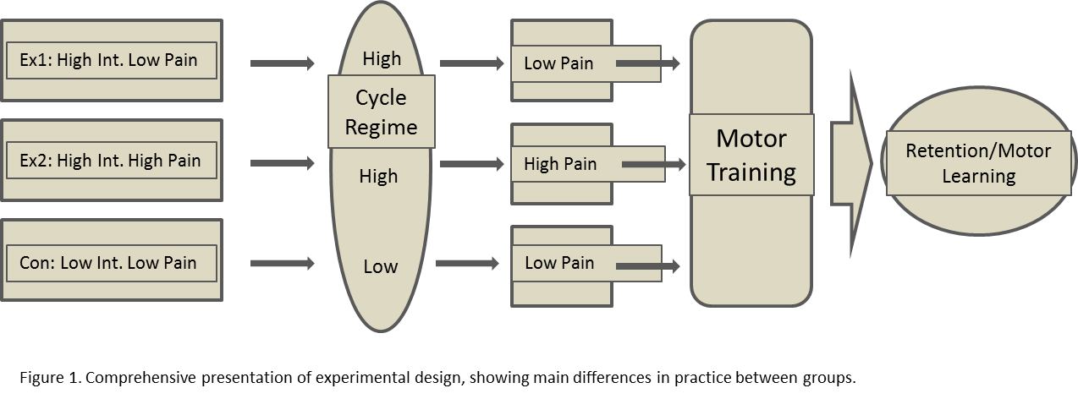
Aerobic cycling regime
Participants were seated on a stationary cycle (Monark 894E bicycle ergometer) and seat height was adjusted for comfort and performance. The cycling regime consisted of 5 min warm-up, 20 min cycling at target heart rate and 5 min cool-down. Groups Ex1 and Ex2 worked at a heart rate estimated at 80% of extrapolated maximum heart rate. The Con group worked at 35-45% of calculated maximum heart rate. Resistance and cadence were adjusted to keep subjects within target heart rate.
Ratings of Perceived Exertion during cycle regime were carried out using a Borg Scale (Borg, 1970); as a check on exertion in addition to heart rate. The Borg scale is a subjective measure for exertion, spanning from 6 (very low or no exertion) to 20 (maximal exertion), and was designed to correlate with heart rate, when the level of exertion is multiplied by 10. Every five minutes during the exercise intervention, participants were asked to verbally state their level of perceived exertion and the results were recorded by the investigator for future analysis. The Borg scale was used for registration of exertion prior to the cycle regime, to assess baseline state.
Heart Rate and Blood Pressure
A heart rate monitor (Polar RS4000 cx) and receiver was fitted prior to cycling and used to record (1 Hz) heart rate, and stored offline for further analysis. Additionally, an online view of the HR was displayed on a computer screen in order to ensure that participants cycled at their target HR. For each participant, during the cycling regime the mean heart rate for every 5 minute block of exercise was worked out and HR expressed as mean for these intervals, order to make statistical and graphical comparisons possible. Blood Pressure (BP) measurement was carried out using an electronic blood pressure monitor (OMRON, 5 Series Blood Pressure Monitor, Model BP 742) at the following points in time; baseline, after cycling regime and after pain (Baseline BP, Postex BP, Postpain BP). Additionally singular HR measurements were made at 7 timepoints; baseline, during warm-up, mid exercise, pre-warm-down, pre-pain, post-pain and pre-motor (prior to motor skill training). Baseline, pre-pain and post-pain measures were made simultaneously with BP measurement and were made using the blood pressure apparatus.
Acute Ischemic Pain
Pain was induced by using an ischemic pain model. A 10 cm visual analogue scale (VAS) anchored with “No pain” (0) and “Most pain imaginable” (10) (VAS APP, Aalborg University) as displayed on an android tablet (Samsung Galaxy s111 10.1 Note). This was used to record the subjective experience of pain. Subjects were informed of how the electronic VAS functioned and they were instructed to update their pain continually and as often as they felt any change in pain level. Peak pain was the maximum level of pain recorded for each subject. Mean pain was the average pain obtained over the 5 minute period. The area under the curve (AUC) of the pain profile was calculated. A higher AUC was indicative of higher pain levels for longer time.
A blood pressure tourniquet (VBN-Medical, Manometer with hand inflator) was used to reduce blood supply to the lower right arm in order to produce ischemic pain, and was placed 3cm above the medial epicondyle of the humerus, as palpitated with a finger while affixing the cuff. Pressures of 130-200mmHg were set to 10% above baseline systolic blood pressure and maintained for 5 min. The two groups Ex1 and Con were asked to squeeze a hand-held foam ball 20 times in order to obtain target pain levels. The Ex1 group failed to meet this level and so the Ex2 group were introduced to the experiment and instructed to squeeze the ball continually until pain levels reached the target level of 4.
Novel Motor-skill Training and Learning
Novel motor-skill training employed a finger-tapping training regime that consisted of predefined successive finger flexions in a set order. This was carried out using a computer keyboard, where the keys labeled ‘2, 3, 4 and 5’ correspond to J, K, L and Æ on a standard Danish keyboard. The training sequencing was 4 5 2 4 3 4 5 2 4 3. The keyboard was modified for this study, so that all other keys were removed, with the exception of the number pad. The display screen showed the finger-tapping number sequence, at all times. The same sequence was used throughout all training and retention test trials. Subjects were seated at a desk and the keyboard and computer screen were located approximately 0.75 m away, directly in front of them. Subjects trained with their right hand and used all fingers excluding the thumb.
During training, participants completed eight blocks of eight trials for a total of 64 training trials. Each block was separated by a rest of 30 sec to avoid fatigue in the hands and/or fingers. Participants were required to not look at their hands during training trials or retention test.
Following completion of the training trials, participants were instructed to read a standardized and unrelated fictional text for 30 minutes. The Reading Activity was incorporated to distract the participants in a standardized fashion from the trained material. Participants rated how interesting they found the text on a scale from 0 to 10. After the reading task was completed participants performed a retention test which consisted of one block of the eight training trials. Participants rated how difficult they found the finger tapping on a scale from 0 to 10.
Calculations were made for finger tapping speed, which is the mean time intervals between each key press for each trial; completion time of entire sequence trial, which is calculated as the time between the first and last press in one trial; and accuracy of key presses, which is the number of correctly pressed keys relative to the total number of predefined key presses, expressed as percentage. The 8 training trials and the retention test (one trial) were separated by the 30 min break.
Statistics
Measurements for Age, BMI, BP were run through a one way analysis of variance (ANOVA). One Way ANOVAs were used to analyse HR data from cycling regime. 2-way repeated measure ANOVAs were used on more complex data such as Pain data and Motor Training and Learning. Time was used as the within subject factor and group as the between-subject factor. The Sigmastat program was used throughout. Student-Newman-Keuls Method was adopted for post hoc multiple comparisons with the level of significance set at 0.05. All results expressed as means and standard errors of the mean (SEM).Results
Participant Characteristics
 |  | Age | Height (cm) | Weight (kg) | BMI
Ex1 | MEAN | 21 | 178 | 67 | 21
 | SD | 12.02082 | 7.778175 | 28.99138 | 7.141778
Ex2 | MEAN | 23 | 167 | 64 | 22.9
 | SD | 0 | 4.949747 | 7.071068 | 1.272792
Con | MEAN | 24 | 184 | 76 | 21.7
 | SD | 2.12132 | 11.31371 | 5.656854 | 1.414214

For age, a one way ANOVA showed no difference (p=0.792) between groups. Similarly there was no difference for height (p=0.183) or BMI, where a Kruskal-Wallis One Way ANOVA on ranks showed no difference (p=0.797). BP comparisons showed no difference between groups at baseline, post-exercise or post-pain (p>0.515). HR comparisons at the same time points as BP showed difference between groups for all three measures (P<0.007).
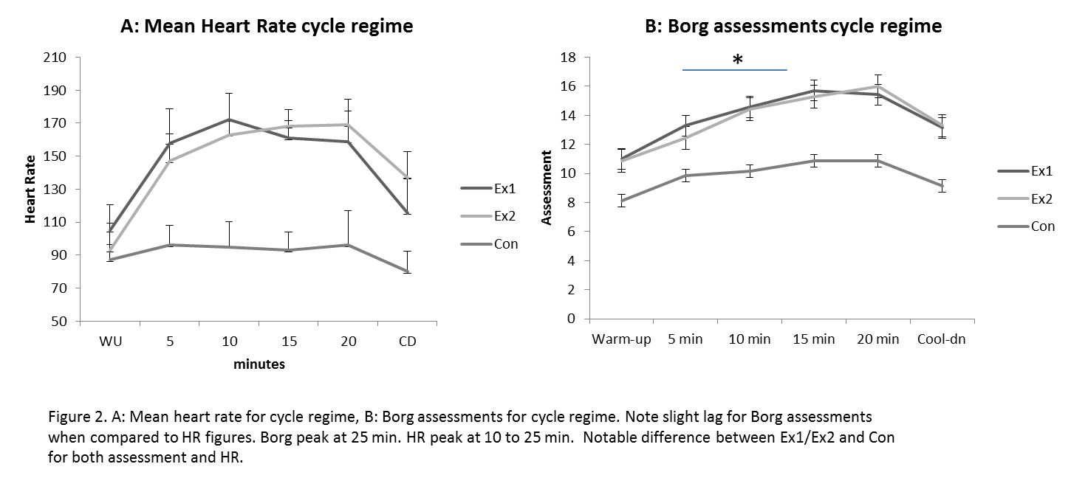
Comparison of HR measurements for the cycle regime showed differences between groups (p=0.001). Mean HR figures for Ex1 and Ex2 were 145 and 146 respectively and 91 for Con, reflecting the desired heart rate. Ratings of perceived exertion (Borg) also showed difference between groups when running One Way ANOVA on mean data (p=0.001). The Borg assessments did not completely mirror HR measures.
Singular pain ratings reported zero pain at baseline. Mean values for all groups revealed slight elevation to 0.619 post-exercise and 2.19 post-pain. One Way ANOVA comparing groups at all three measures showed no difference (p=0.877).
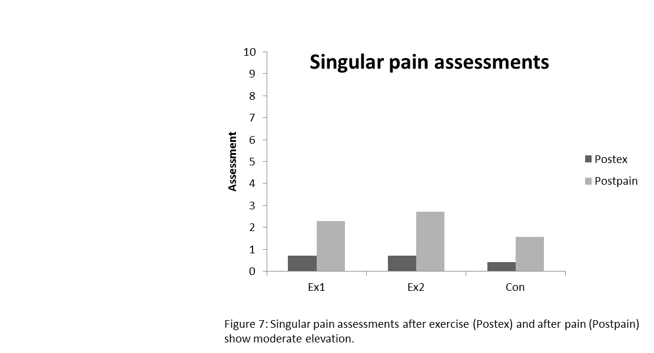
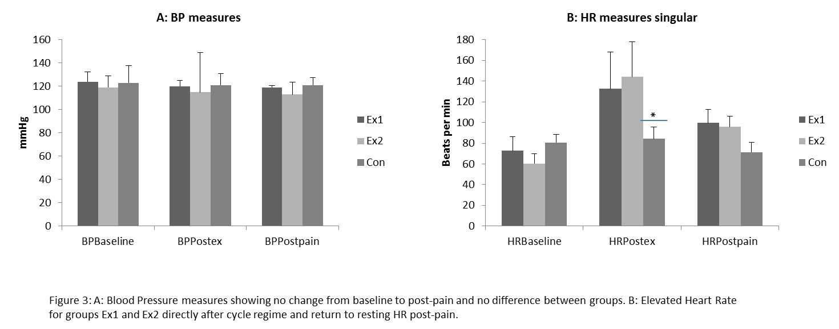
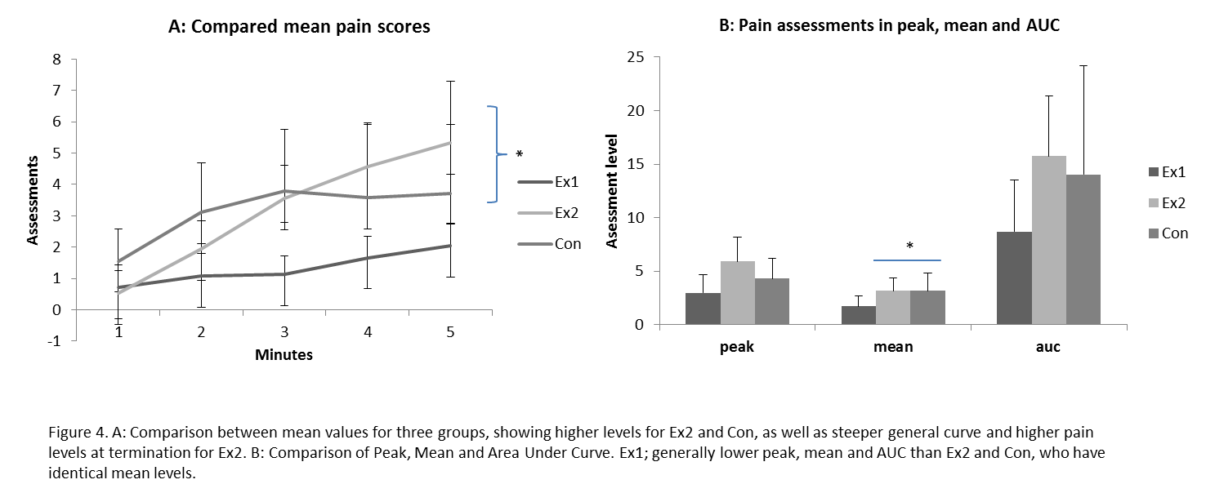
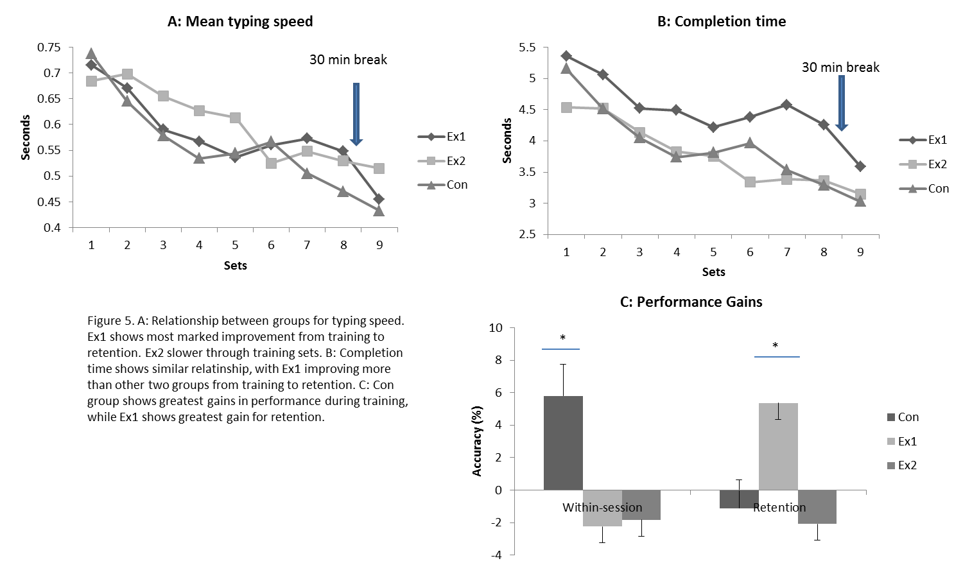

Comparison of mean Ischemic Pain revealed differences between groups (p=0.008), where post hoc analysis showed that difference was not present between Ex2 and Con (p=0.996). Differences were found for peak pain (p=0.003), where the post hoc test revealed that differences were only existent between Ex1 and Ex2. A One Way ANOVA on the Area under the Curve (AUC) showed difference between groups (p=0.021), and post hoc analysis showed that this was the case only for comparison between Ex1 and Ex2.
Novel motor training was compared for accuracy of performance across blocks of key presses and found no difference (p=0.144), except between group and block (p=0.033). Comparison of mean completion time (CT) within training session showed no difference (p=0.950). Comparison of CT within Retention Test showed no difference (p=0.189). Non-significant differences were present between groups at retention, with the Ex1 group obtaining greater accuracy and greater improvements in completion time and performance than the other two groups.
Reading Activity ratings of interest showed differences between groups (p=0.020) with post hoc showing greatest difference between Ex2 and Con groups (p=0.016). Ratings for difficulty of Motor Skill Learning did not reveal any difference (p=0.368), with a mean for all groups of 3.19 (on scale from 0 to 10).

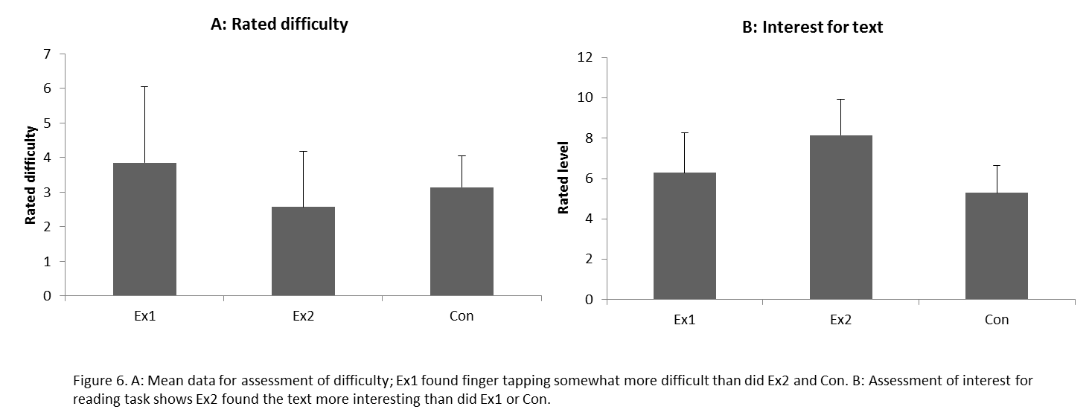
Discussion
This study using the combination of cycle regime, pressure pain stimulation and novel motor learning in human subjects has shown that aerobic exercise has an analgesic effect on pain as evidenced by the differences found in results for pain assessments between groups Ex1 and Con. A novel finding was that results from Ex2 indicate that higher levels of pain possibly mitigate the analgesic effects and enhanced learning effects that might result from aerobic exercise. The novelty of the present study lies primarily in combining the three aspects; exercise, pain and motor learning, and investigating how exercise intensities and pain levels influence motor learning.
Demographics
The decision to use healthy adult subjects was not essential, but uniformity was important for the study due in part to a small number of test subjects and the impact of this fact on the power of the study. To reduce the risk of out-layers, it was necessary to use participants who were comparable for several parameters. Stimulants such as alcohol, tobacco and caffeine have effects on the CNS that influence both nociception and motor learning, so these elements were excluded. Alcohol has known effects on nociception and alertness and so had to be avoided. Tobacco has analgesic effects (Mannelli et al, 2013) and might therefore alter both pain assessments and finger tapping performances. Caffeine has enhancing effects on motor learning ability (Fillmore et al, 1992).
Cycle regime
The purpose of the cycle regime was to stimulate acute adaptations to aerobic exercise that would have an analgesic effect. Although certain studies question the plausibility of exercise-induced analgesia (Padawer et al, 1991; Naugle et al, 2012), exercise generally speaking has been proven in certain studies to have such effects (Umeda et al, 2009). Some studies have investigated said condition among athletes (Sternberg et al, 2001). The present study decided to focus on aerobic activity based on studies that have found significant correlations for f.ex. running and analgesia (Boecker et al, 2008; Hoeger et al, 2011). Based on the Borg scale ratings and Heart Rate measures during the cycle regime, intensities were evaluated to be high enough to bring about analgesic effects. Due to the time that elapsed from ended exercise to motor learning and due to the pressor pain intervention that was placed between cycle regime and motor learning, the neurological connections between aerobic exercise and learning would be problematic to detect. Emphasis has therefore been placed on how exercise influenced pain ratings, which in turn may have influenced motor learning performances.
Pain scores
Singular pain assessments revealed that participants were pain free at baseline and the following two assessments showed slightly elevated levels of pain prior to pressor pain and prior to motor skill training. These findings indicate that the pressor pain was the only cause of the pain scores that were recorded. There were no differences between subjects or groups in pain status before or after pressor pain.
The decision to recruit the Ex2 group came as a necessity to ensure that we had a high intensity exercise group who yielded pain assessments that were comparable to the Con group. The decision came after making the finding that the Ex1 group were making very low pain assessments. The Ex1 and Con groups were stimulated identically to produce pain, and yet this difference in assessments was observed. This fact in and of itself is indicative of the analgesic effects of exercise. It is also indicative of the study design in fact having succeeded in stimulating participants at an exercise intensity that yielded analgesia.

Novel motor learning
The novel motor learning task was chosen carefully to ensure that it was both novel and that learning took place. This is exemplified by the customized keyboard. There was a risk that some subjects might be particularly adept at using a keyboard without there being any way of requiring exclusion. On the other hand the widespread use of keyboards has the advantage of placing subjects on equal terms in relation to whether or not the task could be defined as novel motor learning.
Studies that have investigated motor learning have not only found that the ability to learn in humans is present over time, but that neuronal plasticity can occur over hours and minutes (Pascal et al, 1995; Doyon et al, 2005; Hlustik et al, 2004). That is one reason why a retention test only 30 min after motor training had a probability of yielding interesting findings.
The lacking significance of core findings of typing speed, completion time and performance can be explained. This study had 7 participants in each group, a fact that in and of itself reduces the probability of making findings. The low probability figures for differences between groups creates a risk that researchers might commit a type 1 or type 2 error, as the hypothesis is discarded on non-conclusive grounds. Although findings were non-significant, the post hoc analysis revealed a slight difference between learning abilities in Ex2 compared to both Ex1 and Con. Analgesia in Ex1 appears to have enhanced learning ability albeit non-significantly. One explanation might be that pain levels were low enough in Ex1, that their learning curve was the result of enhancement of motor learning brought about by exercise. Pain levels may not have been high enough to mitigate this advantage of exercise.
Assessments for interest in the text that participants read during the break gave a vague indication of how preoccupied they were with said text. This in turn may indicate that they were not thinking about finger tapping. The element of time alone was also a necessity for being able to define the retention test as a measure of learning. Assessments of difficulty of finger tapping, gave an indication of how challenging the task was. Generally scores here were low (mean= 3.19), indicating that participants found the task easy.
Conclusion
Differences between novel motor learning abilities in this study were present but non-significant. This may mean that further study in the field is necessary; indicated by the apparent analgesic effect on Ex1 and what may be mitigation of analgesic effects in Ex2, exemplified by their respective pain assessments and motor learning figures. This study builds upon and modestly supports other studies that indicate that exercise is healthy. The cumulative effect of regular aerobic activity is not limited to muscular or cardiovascular adaptations, but has acute neurological advantages.
Perspectives
In order to create more conclusive results, the study could have drawn advantage from a greater number of participants. The end result so far yielded results that could be interpreted as indications of tendencies but lacked the statistical power to do so and could therefore also be dismissed as random findings.
Further investigation into the relationship between aerobic exercise and analgesia may be able to uncover a pain threshold at which analgesia of exercise is reduced. This is outside the scope of the present study, but its findings may suggest such a condition.

References
- Alomari M.A., Forced and voluntary exercises equally improve spatial learning and memory and hippocampal BDNF levels, Behavioural Brain Research 247 (2013) 34-39
- Andersen L.L. et al, Effect of Two Contrasting Types of Physical Exercise on Chronic Neck Muscle Pain, Arthritis and Rheumatism, Vol. 59, No. 1, January 15, 2008, pp 84-91
- Bejat G. et al, Effects of noxious stimulation of orofascial tissues on rat licking behavior, Archives of Oral Biology 53 (2008) 361-368
- Bement M.K.H. et al, Pain Perception After Isometric Exercise in Women With Fibrymyalgia, Arch Phys Med Rehabil 2011;92:89-95
- Boecker H. et al, The Runner’s High: Opioidergic Mechanisms in the Human Brain, Cerebral Cortex November 2008;18:2523-2531
- Boudreau S. et al, The effects o training time, sensory loss and pain on human motor learning, Journal of Oral Rhabilitation 2010 37; 704-718
- Boudreau S. et al, The effects of intra-oral pain on motor cortex neuroplasticity associated with short-term novel tongue-protrusion training in humans, Pain 132 (2007) 169-178
- Boudreau S. et al, The role of motor learning and neuroplasticity in designing rehabilitation approaches for musculoskeletal pain disorders, Manual Therapy 15 (2010) 410-414
- Cotman C.W. & Berchtold N.C., Exercise: a behavioural intervention to enhance brain health and plasticity, TRENDS in Neurosciences, Vol.25 No. 2002
- Cotman C.W. et al & Berchtold N.C., Physical activity and the maintainance of cognition: Learning from animal models, Alzheimer’s & Dementia 3 (2007) S30-S37
- Cotman C.W. et al, Exercise builds brain health: key roles of growth factor cascades and inflammation, Trends in Neuroscience (2007) Vol.30 No.9
- Di Cesare Mannelli L. et al, Nicotine is a pain reliever in trauma – and chemotherapy-induced neuropathy models, European Journal of Pharmacology 711(2013)87-94
- Doyon J. et al, Reorganization and plasticity in the adult brain during learning of motor skills, Current Opinion in Neurobiology 2005, 15:161-167
- Edeline J.M. et al, Rapid Development of Learning-Induced Receptive Field Plasticity in the Auditory Cortex, Behavioural Neuroscience 1993, Vol. 107, No. 4, 539-551
- Ferguson A.R., Nociceptive plasticity inhibits adaptive learning in the spinal cord, Neuroscience 141 (2006) 421-431
- Fillmore M. et al, Expected effect of caffeine on motor performance predicts the type of response to placebo, Psychopharmacology (1992) 106: 209-214
- Grau J.W. et al, Impact of behavioural control on the processing of nociceptive stimulation, Frontiers in Physiology 10 August 2012, Vol.3 Art.262
- Gulino R. et al, Synaptic plasticity modulates the spontaneous recovery of locomotion after spinal cord hemisection, Neuroscience Research 57 (2007) 148-156
- Hayden J.A. et al, Systematic Review: Strategies for Using Exercise Therapy To Improve Outcomes on Chronic Low Back Pain, Ann Intern Med. 2005;142:776-785
- Hayden J.A., Meta-Analysis: Exercise Therapy for Nonspecific Low Back Pain, Ann Intern Med. 2005;142:765-775
- Hlustik P. et al, Cortical Plasticity During Three-Week Motor Skill Learning, Journal of Clinical Neurophysiology Vol.21, Nov.3, June 2004
- Hook M.A. et al, Peripheral Inflammation Undermines the Plasticity of the Isolated Spinal Cord, Behavioural Neuroscience 2008, Vol. 122, No.1, 233-249
- Jull G.A. et al, Motor Control Problems in Patients With Spinal Pain: A New Direction for Therapeutic Exercise, Journal of Manipulative and Physiological Therapeutics, Vol. 23, No. 2, Feb. 2000
- Kleim J.A. et al, Motor Enrichment and the Induction of Plasticity before or after Brain Injury, Neurochemical Research, Vol. 28, No. 11, November 2003
- Magnusson M.L. et al, Motor Control Learning in Chronic Low Back Pain, SPINE Volume 33, Number 16, pp E532-E538, 2008
- Martins D.F. et al, High-intensity swimming exercise reduces neuropathic pain in an animal model of complex regional pain syndrome type 1: Evidence for a role of the adenosinergic system, Neuroscience 234 (2013) 69-76
- Naugle K.M. et al, A Meta-Analysis Review of the Hypoalgesic Effects of Exercise, The Journal of Pain, Vol 13, No 12, 2012: pp 1139-1150
- Newell K.M. et al, Time Scales in Motor Learning and Development, Psychological Review 2001, Vol. 108, No. 1, 57-82
- Nicolakis P. et al, Effectiveness of exercise therapy in patients with myofascial pain dysfunction syndrome, Journal of Ofal Rehabilitation 2002 29; 362-368
- Obata K. et al, BDNF in sensory neurons and chronic pain, Neuroscience Research 55 (2006) 1-10
- Padawer W.J. & Levine F.M., Exercise-induced analgesia: fact or artifact?, Pain, 48 (1992) 131-135
- Parhizgar S.E., et al, A Review on Experimental Assessments of Pain Threshold in Healthy Human Subjects, Basic and Clinical Neuroscience, Summer 2010, Volume 1, Number 4
- Pascual-Leone A. et al, Modulation of Muscle Responses Evoked by Transcranial Magnetic Stimulation During the Acquisition of New Fine Motor Skills, Journal of Neurophysiology, Vol. 74, No. 3, September 1995
- Pezet S. et al, BDNF: a neuromodulator in nociceptive pathways? Brain Research Reviews 40 (2002) 240-249
- Roig M. et al (2012) A Single Bout of Exercise Improves Motor Memory. PLos ONE 7(9): e44594. Doi:10.1371/journal.pone.0044594
- Russo-Neustadt A., Exercise: Optimizing Function and Survival at the Cellular Level, 2009 Elsevier Ltd.
- Scheef L. et al, An fMRI study on the acute effects of exercise on pain processing in trained athletes, Pain 153 (2012) 1702-1714
- Schön-Ohlsson C.U.M. et al, Sensory Motor Learning in Patients With Chronic Low Back Pain, SPINE Volume 30, Number 17, pp E509-E516, 2005
- Segal M., Rapid plasticity of dendritic spine: hints to possible functions?, Progress in Neurobiology 63 (2001) 61-70
- Shankarappa S.A. et al, Forced-exercise delays neuropathic pain in experimental diabetes: effects on voltage-activated calcium channels, Journal of Neurochemistry, 2011, 118, 224-236
- Shepherd R.B., Exercise and Training to Optimize Functional Motor Performance in Stroke: Driving Neural Reorganization? Neural Plasticity, Volume 8, NOS 1-2, 2001
- Sörös P. et al, Functional reorganization of the human primary somatosensory cortex after acute pain demonstrated by magnetoencephalography, Neuroscience Letters 298 (2001) 195-198
- Sterling M. et al, The Effect of Musculoskeletal pain on Motor Activity and Control, The Journal of Pain, Vol 2, No 3 (June), 2001: pp 135-145
- Sternberg W.F. et al, Competition alters the perception of noxious stimuli in male and female athletes, Pain 76 (1998) 231-238
- Svensson P. et al, Plasticity in corticomotor control of the human tongue musculature induced by tongue-task training, Exp Brain Res (2003) 152:42-51
- Umeda M. et al, Examination of the dose-response relationship between pain perception and blood pressure elevations induced by isometric exercise in men and women, Biological Psychology 85 (2010) 90-96
- Umeda M. et al, Influence of blood pressure elevations by isometric exercise on pain perception in women, International Journal of Psychophysiology 74 (2009) 45-52
- van Tulder M. et al, Statistical Significance Versus Clinical Importance, Trials on Exercise Therapy for Chronic Low Back Pain as Example, SPINE Volume 32, Number 16, pp 1785-1790, 2007
- Zhuo M., Cortical excitation and chronic pain, Dep. of Physiology, Faculty of Medicine, Centre for the Study of Pain, University of Toronto, doi:10.1016/j.tins.2008.01.003

Work notes
Introduction
This study takes an exploratory look at exercise, pain and learning. It builds on a number of studies that have attempted to uncover physiological and neurological connections between physical activity and motor learning (Roig et.al, 2012; ); between pain and motor learning (Boudreau et al, 2007; Boudreau et al, 2010; Bejat et al, 2008) and between physical activity and pain (Scheef et.al, 2012; Bement et al, 2008; Boecker et al, 2008). Research has shown that pain can be mitigated by exercise (Andersen et al, 2008; Andersen et al, 2008;88). If one were to exercise prior to pain, the experience of pain may be less severe than if one had not exercised. Exercise also has the effect of enhancing motor learning ability (Alomari et al, 2013), which means that an acute effect of exercise is increased ability to learn a novel motor skills. Thus novel motor skill training was integrated in the study, with an expectation that exercise might both mitigate pain and enhance learning in test subjects.
Physical activity
Physical activity has gained recognition as one way of promoting general health and longevity (Moore et al, 2012). The long term effects are not limited to cardiovascular health, protection from carcinogenic risks or postponement of osteoporosis. Other studies focus on the effect of exercise on the brain and whether physical activity promotes mental health or central nervous functioning. Some studies support the notion that long term benefits of physical activity exist in terms of promotion of brain function and postponement of degeneration of central nervous function over time (Cotman et al, Trends in Neuroscience, 2007). This creates an area of interest, because, if there is a long term positive effect through exercise, it might be possible to measure or detect acute effects that have a cumulative effect over time in order to bring about chronic adaptations.
The long term effect gives particular inspiration to the present study on a purely altruistic or ethical note. We are contributing to a pool of knowledge that ultimately can promote well-being and health.
Definitions of physical activity are closely related to set forms of work, such as aerobic and anaerobic activity. As intensity increases from rested state to a steady aerobic working state, such as when one walks or jogs with increasing intensity, the heart rate increases from about 60 beats per minute to 160 or 180 depending on fitness level and age (McArdle et al, 2001 pg. 459). Pulmonary exchange increases as the muscles demand more oxygen to maintain work at the desired level (McArdle et al, 2001 pg. 285). The conscious decision to perform physical work at steadily increasing intensity is paired by endocrine reactions and nervous adaptations on many levels. One example of nervous involvement in physical work is the way in which neurons transmit impulses to the medulla, with information concerning alterations in gas exchange. Receptors in lung tissue sense changes in how the tissue is stretched. Other receptors sense the chemical state of the blood and communicate this to the medulla. Chemoreceptors within the carotid and aortic arteries communicate with the pons and other brain areas, such as the motor cortex in order to adjust ventilation (McArdle et al, 2001, pg. 286).

Pain
Pain is a conscious state of knowing that something hurts. One differentiates between this and nociception, which is the nervous system’s response to pressure, heat, stretching, pricking or other stimuli. Particular nerve receptors respond to different types of stimuli, such as these. One receptor might respond only to heat or cold, while another responds to itching and pricking (Kandel E.R., et al, pg. 472-). If a stimulus is great enough to create an action potential, a message is transmitted which results in the perception of pain. A painful stimulus is described as a noxious insult. Noxious means painful and insult means some form of negative sensation.
The nociceptors are the nerve endings that sense noxious stimuli first, and then transmit a message further up in the central nervous system. These nerves are divided into three types beyond the kinds that sense varying forms of stimuli. There are two kinds of A-delta fibers and then there are C fibers. A-delta fibers are dealt into nociceptors that sense pricking and sharp items and ones that respond to slow burning stimulation or cold. C fibers sense many kinds of stimulation. The difference between them is that A-delta fibers are more heavily myelinated than C fibers and are therefore quicker at transmitting a message (Sigel et al, 2006, pg. 262). This physical fact is mirrored by their respective functions. A-delta fibers could be seen as a first line of defense. They transmit a message quickly so that the organism can avoid the noxious stimulation and f.ex. lift one’s foot quickly so as not to tread heavily on a piece of glass. The C-fibers on the other hand send messages more slowly and are for example involved in transmitting continuous pain such as the throbbing pain that one feels for a long time after having trodden on a piece of glass and gotten cut.
Ischemic pain is one particular form of pain, in which lack of oxygen is the primary source of nociception. One speaks of ischemia when speaking of a stroke, where blood and therefore oxygen is not allowed to pass through to tissue that needs oxygen (Adams R.D., Principles of Neurology, 1981). This is experienced as pain, and when creating experimental ischemic pain, one might close off blood supply to a limb by using a blood pressure cuff that is pumped up beyond systolic levels. It can create a relatively severe level of pain which has the advantage of being controllable, due to the fact that it can be aborted at any moment by opening the blood supply again.
Motor learning
Motor learning can be defined as the alterations that occur in the nervous system when one learns a new skill that requires motor control. Plasticity describes how the motor neurons are altered physically when motor learning takes place and is present in adulthood (Doyon et al, 2005; Hlustik et al, 2004). It is f.ex. possible to measure greater density of nerve fibers in the motor cortex of pianists than in the general population.
Motor Performance could be a particular action carried out at a given speed. Motor learning might describe the same action after learning begins to take place, which means that the motor systems involved in the action begin to memorize it. One theory divides learning into three phases; cognitive, associative and autonomous (Fitts & Posner, 1967). Within this framework, cognitive learning is the first phase, where one is conscious of the task and one attempts to understand a given motion. In the Associative phase, one begins to make small adjustments to the movement. It becomes more fluid and in f.ex. a finger tapping set, one might begin to increase in speed and accuracy without having to consciously tread each key. The final autonomous phase marks where the movement is memorized and can be made without consciously thinking about what to do. One example of this could be the cyclist who corrects his trajectory and balance simultaneously and without actually being aware of what he is doing with his posture or the handlebar.
Consolidation is another term within motor learning and has to do with the development from having acquired a new motor skill to actually having learnt it (Trembe M. et al, 2011). I can teach a student to roll a kayak, but five minutes later he has forgotten how. The action must be ingrained in the nervous system, so the body can recognize the movements and mimic them precisely. This takes time, and happens gradually as movements solidify and become consolidated.
Motor actions require collaboration of many brain regions before an action is carried out by f.ex. a finger. The Thalamus, cerebral cortex and cerebellum transmit information between one another and eventually transmit a message that activates muscles and carries out the action We are constantly learning new motor skills and “storing” them so the next time we try the same movement, it is done with less uncertainty.
Physical activity and pain.
Analgesia and Hyperalgesia are two key concepts that are important for understanding the relationship between exercise and pain. This is because exercise has a so-called analgesic effect on pain. Analgesic means that it mitigates or reduces sensitivity to nociceptive stimuli. Hyperalgesia is the opposite and often occurs due to prior injury, when one experiences increased tenderness around an area that has been hit or damaged. Some studies speak of Hypoalgesia and this is an effect which has some aspects in common with analgesia (Kandall et al, 2000). Some might consider it common knowledge that exercise brings about these analgesic effects, but actual findings that can show what goes on and where is far more satisfying. Although there may be a general trend pointing toward exercise-induced analgesia, there are findings to the contrary (Padawer et al, 1992).
In the present study exercise takes the form of a cycle regime at 80% or 45% of an calculated maximal heart rate. We are speaking aerobic exercise at low or sub-maximal intensity, and the results point towardsOther studies have investigated the effect of resistance or isometric training on pain (Umeda et.al, 2009). Many studies are difficult to compare due to varying methods and exercise intensities. However certain studies have attempted such comparison with a level of success (Naugle et.al., 2012). In this study there were proven albeit varyingly significant results of hypoalgesia found during aerobic exercise and isometric and kinetic resistance training. However, the study also stated that finding a set form of exercise or level of intensity that will produce hypoalgesic affects is not possible within current knowledge.
Activation of the endogenous opioid system during exercise reduces perception of pain during and following exercise. Exercise of sufficient duration and intensity results in the release of beta-endorphines, which have been associated with lowered pain sensitivity. So far, animal data support this theory more completely than do human data (Naugle et.al, 2012). Regulation of pain and regulation of blood pressure involve the same brain stem nuclei, neurotransmitters and neuropeptides (Naugle et.al, 2012). This might be part of the explanation why there exist interesting relations between pain and exercise.
Hayden et.al (2005) investigated exercise interventions focused on alleviation of low back pain, and this study indicated that pain is alleviated by through exercise. As Hayden et. al (2005) concluded in a later study, the effects of physical activity interventions were comparable to no treatment or to other conservative forms of treatment, and so the diversity of opinions is maintained. Scheef et.al (2012) pointed out in a later study that there is a difference between exercising at higher or lower intensities. Higher aerobic intensities appear to have a greater analgesic effect than lower intensities.
Physical activity and learning
Short term effects of learning have been found (Roig et. al, 2012), where two groups were compared for learning ability and one of the groups exercised while the other did not. Exercise brings about a certain state of arousal within the body, both on a cardiovascular level, affecting blood flow and oxygenation of muscles and nervous tissue, but also on a level within the Central Nervous System (CNS), where hormonal factors and factors such as transmitter substances are affected significantly. It may be a good idea to exercise prior to practicing the paino or prior to any other kind of activity that requires fine motor skill.
Pain and learning
Pain is an essential part of learning, because it aids in avoiding harm in the infant. It is often the first warning sign that disease or damage is in process. Much pain is what one might call pointless, as in relation to chronic disease it often serves no purpose as such. Pathological pain is a term used for pain when pain itself is the disease. Research that might aid in reducing or at least understanding what pain is, therefore has the potential to improve quality of life, such as Jull et al, (2000) in their study on therapeutic exercise interventions.
Higher levels of pain reduce subjects’ ability to perform motor tasks (Boudreau et. al, 2007; Ferguson 2006). This has to do with knowledge that we have in part acquired through animal studies (Hook et.al, 2008), where it has been shown that there is a relationship between level of pain and the way in which an animal is or is not able to adjust to new demands on its motor learning capacity. According to Hook et.al (2008), chronic pain arises due to actual plastic adaptations that occur along sensory pathways. A cortical network hypothesis is used to explain the nature of chronic pain development. Pain is targeted in several specific cortical areas: The Anterior Cingulate Cortex (ACC), insular cortex (IC), primary somatosensory cortex (S1), secondary somatosensory cortex (S2) and prefrontal cortex (PFC). Without being able to state conclusively, the same neural pathways are involved in learning, especially when learning new motor skills.
Summary
Exercise, pain and motor learning appear to be intertwined as pain impairs learning or exercise mitigates pain. Motor learning and exercise can often be observed in unison, as a new sporting skill is acquired. Sometimes pain is present also, as the athlete disregards discomfort or injury in order to learn a motor skill that demands physical exertion. All three elements might be present in one motion, such as was the case in Magnusson’s study (2008), where motor control was used as a therapeutic form of exercise to alleviate pain. Exercise, it seems, continues to show potential beyond what we have known so far (Russo-Neustadt, 2009).
Thoughts on study design
Many aspects have been considered in the design phase. Pros and cons have been evaluated for various designs. We eventually agreed upon a model, where we put the three factors (exercise, pain and learning) in order, one following the other. This we thought might produce interesting results at the same time as being a unique design.
However, obvious disadvantages in terms of results and findings are that the design of the study had many factors which might make their presence known as confounders. The necessity of comparing exercise, pain and motor learning in the same study might involve too many factors to create a significant result. Besides that, the limited time span for the study and the fact that it was designed to create the basis for a Masters paper converged to limit its extent, thereby placing limitations on the number of participants and narrowing down the likelihood of making significant findings. The power of the study was an area of concern from an early phase. However, the potential findings caused us to stick to the plan after all.
Biological variation or interindividual variation is a concept that comes into play in this study, where we have a relatively small test population and a certain level of biological variation is to be expected. We have taken certain precautions in order to avoid errors connected to biological variation. Firstly, we have a group that age-wise is similar. There were shown to be insignificant differences between groups. We have test groups that are comparable for health status, when looking at heart rate and blood pressure. These measures were not used as much for screening as for confirmation during the experiment. However, measures such as BMI were registered and found to be insignificantly different between groups. Subjects were not allowed to be elite athletes and thus we avoided out-layers in terms of physical performance. Not least in terms of the physiological changes that occur during hard exercise and in relation to pain, it was important that test subjects would respond in a way that was comparable.

References
- Alomari M.A., Forced and voluntary exercises equally improve spatial learning and memory and hippocampal BDNF levels, Behavioural Brain Research 247 (2013) 34-39
- Andersen L.L. et al, Effect of Two Contrasting Types of Physical Exercise on Chronic Neck Muscle Pain, Arthritis and Rheumatism, Vol. 59, No. 1, January 15, 2008, pp 84-91
- Andersen L.L., et al, Muscle Activation During Selected Strength Exercises in Women With Chronic Neck Muscle Pain, American Physical Therapy Association, 2008;88:703-711
- Bejat G. et al, Effects of noxious stimulation of orofascial tissues on rat licking behavior, Archives of Oral Biology 53 (2008) 361-368
- Bement M.K.H. et al, Pain Perception After Isometric Exercise in Women With Fibrymyalgia, Arch Phys Med Rehabil 2011;92:89-95
- Boecker H. et al, The Runner’s High: Opioidergic Mechanisms in the Human Brain, Cerebral Cortex November 2008;18:2523-2531
- Boudreau S. et al, The effects of intra-oral pain on motor cortex neuroplasticity associated with short-term novel tongue-protrusion training in humans, Pain 132 (2007) 169-178
- Cotman C.W. et al, Exercise: a behavioural intervention to enhance brain health and plasticity, TRENDS in Neuroscience, Vol.25 2002
- Doyon J. et al, Reorganization and plasticity in the adult brain during learning of motor skills, Current Opinion in Neurobiology 2005, 15:161-167
- Ferguson A.R., Nociceptive plasticity inhibits adaptive learning in the spinal cord, Neuroscience 141 (2006) 421-431
- Hayden J.A. et al, Systematic Review: Strategies for Using Exercise Therapy To Improve Outcomes on Chronic Low Back Pain, Ann Intern Med. 2005;142:776-785
- Hayden J.A., Meta-Analysis: Exercise Therapy for Nonspecific Low Back Pain, Ann Intern Med. 2005;142:765-775
- Hlustik P. et al, Cortical Plasticity During Three-week Motor Skill Learning, Journal of Clinical Neurophysiology Vol. 21, Nov. 3, 2004
- Hook M.A. et al, Peripheral Inflamation Undermines the Plasticity of the Isolated Spinal Cord, Behavioural Neuroscience 2008, Vol. 122, No.1, 233-249
- Jull G.A. et al, Motor Control Problems in Patients with spinal pain: A new direction for Therapeutic Exercise, Journal of Manipulative and Physiological Therapeutics, Vol.23, No.2, 2000
- Magnusson M.L. et al, Motor Control Learning in Chronic Low Back Pain, SPINE Volume 33, Number 16, pp E532-E538, 2008
- Moore S.C. et al, 2012, Leisure Time Physical Activity of Moderate to Vigorous Intensity and Mortality: A Large Pooled Cohort Analysis, PLos Med 9(11): e1001335. Doi:10.1371/journal, pmed.1001335.
- Naugle K.M. et al, A Meta-Analysis Review of the Hypoalgesic Effects of Exercise, The Journal of Pain, Vol 13, No 12, 2012: pp 1139-1150
- Newell K.M. et al, Time Scales in Motor Learning and Development, Psychological Review 2001, Vol. 108, No. 1, 57-82
- Padawer W.J. & Levine F.M., Exercise-induced analgesia: fact or artifact?, Pain, 48 (1992) 131-135
- Roig M. et al (2012) A Single Bout of Exercise Improves Motor Memory. PLos ONE 7(9): e44594. Doi:10.1371/journal.pone.0044594
- Russo-Neustadt A., Exercise: Optimizing Function and Survival at the Cellular Level, 2009 Elsevier Ltd.
- Scheef L. et al, An fMRI study on the acute effects of exercise on pain processing in trained athletes, Pain 153 (2012) 1702-1714
- Trembe et al, 2011, Observation learning versus physical practice leads to different consolidation outcomes in a movement timing task, Experimental brain research
Textbooks:
- McArdle, Katch, Katch, 2001, Exercise Physiology 5th edition, Lippinkott, William and Wilkins
- Wilmore, Costill, 1999, Physiology of Sport and Exercise, Human Kinetics
- Carpenter R.H.S., 2003, Neurophysiology, Arnold Publishers
- Siegel A., Sapru H.N.,Essential Neuroscience, 2006, Lippincott, Williams & Wilkins
- Adams R.D., Victor M., 1981, Principles of Neurology, McGraw-Hill
- Kandel E.R., Schwartz J.H., Jessell T.M., 2000, Principles of Neural Science, McGraw-Hill
- Olsen J., Overvad K., Juul S., 2002, Analytisk Epidemiologi 2. udgave, Munksgaard Danmark

