Aalborg University

MIKE-B

Master Thesis

“Reverse knowledge transfer. Actors approach”

Supervisor of the Project – **Max Rolfstam**

Number of pages: **79**

Number of words: **27 185**

Number of symbols: **173 950**

Number of symbols without spacing: **147 186**

**RaitisBroks**

**30.05.2013**

**Summary**

Motivation for writing this project originated two years ago when author of this project in collaboration with other two students wrote project about knowledge management. The basic knowledge and understanding of knowledge management field were obtained. Since then author of this project wrote several projects in fields directly or indirectly connected to knowledge management. This project is an attempt to explore this field in new way –through actors view – and thus gain new knowledge and understanding of the field.

Initial expectations were to create better understanding of reverse knowledge transfer and knowledge transfer as such for both, the author and a reader. As knowledge management is considerably new discipline it has still a lot of unexplored aspects and this thesis tries to explore some of them and thus make knowledge management discipline more understandable for academics as well as general public. As in MIKE program at Aalborg University “K” stands for knowledge this thesis is considered also valuable contribution to future students of this study program.

As in MIKE program “I” stands for innovation in this project author chose to use non conventional approach for project – Actors view. It is absolutely new type of approach for author. Project is theoretical with no practical problem investigation, and following actors view certain results from previous authors projects were used as well as knowledge from previous projects were big foundation for this thesis. Further lot of academic research papers were reviewed and literature analysed in order to get enough valid information to build understanding of reverse knowledge management.

Project has three main parts followed by final conclusion. First part explains motivation and purpose of this thesis as well as connection with previous authors work and interest in knowledge management field. Second part explains in details terms “knowledge”, “knowledge management”, “knowledge transfer” and various important aspects of them. Third part analyses literature and models of knowledge transfer created by various academics and experts in field in order to gain better understanding of knowledge transfer and more specifically reverse knowledge transfer processes.

It was found that reverse knowledge transfer is natural process which to some extent happens at every organization. Various important influencers of reverse knowledge transfer were found as well as proof of benefits which successful reverse knowledge transfer can bring to an organization. However most importantly specific aspects of main three reverse knowledge transfer enablers – tools, conditions, information - were found and suggestions for their development were created. All in all general understanding of reverse knowledge transfer were created and lot of knowledge were placed as well as gained from this project.

The biggest ambition of this thesis has been choice of actors view. Actors view approach has been introduced in MIKE-B methodology course at first semester and it is focusing on knowledge creating. Ambition to create knowledge for self and the reader as well as ambition to innovate led to choice of this approach and results achieved through it is more than initially expected. Thus it can be said that this project not only created better understanding of reverse knowledge transfer but also is successful attempt to use actors view in research.

Contents

1. Introduction 5

1.1. The origins of subject choice 5

1.2. Next step (Introduction) 7

1.3. Problem Formulation 8

2.0. Methodology 10

2.1. Three views 11

2.1.1. Analytical view 13

2.1.2. Systems view 14

2.1.3. Actors view 16

2.4. Other approaches 17

2.5. Methodology in this thesis 20

2.6. Other methodological considerations 24

2.7.1. Data gathering 27

2.7.2. Validity 28

2.7.3. Analysing the data 29

2.8. Delimitation 31

2.9. Outline of thesis 32

3.0. Background 34

3.1. Term of knowledge 35

3.1.1. Knowledge 35

3.1.2. Classifications of Knowledge 36

3.1.3. History of knowledge 37

3.2. Managing the knowledge 39

3.2.1. Knowledge Management 39

3.2.2. Information Technology role 42

3.3. Knowledge transfer (KT) 45

3.3.1. Knowledge creation 45

3.3.2. Knowledge transfer 47

3.3.3. HR role 49

3.4. Knowledge transfer models 51

3.4.1. Wang et al (2004) model 51

3.4.2. Ilovici & Han (2003) model 54

3.4.3. Learn-Forget model 56

3.4.4. Liyanage et al (2009) model 59

3.4.5. Frank & Ribeiro (2012) model 61

3.4.6. Guru-Shishya model 64

3.5. Reverse knowledge transfer 66

4.0. Analysis 70

4.1. Finding channels 71

4.2. Reversing channels 75

4.3. Result 78

5.0. Conclusion 82

References 84

Appendices 88

**List of figures**

Figure 1 “KT types” (Source: Nonaka, 1994) 46

Figure 2 “Member-task-tool network” (Source: Argote, 2012) 47

Figure 3 “KT cycle” (Source: Nonaka, 1994) 48

Figure 4 “KT conceptual model” (Source: Minbaeva et al, 2003) 50

Figure 5 “MNC parent contributes knowledge” (Source: Wang et al, 2004) 52

Figure 6 “Organization KT model” (Source: Ilovici & Han, 2003) 55

Figure 7 “Learning rate effect on execution time” (Source: Tukel et al, 2008) 57

Figure 8 “Impact of forgetting” (Source: Tukel et al, 2008) 57

Figure 9 “Knowledge hierarchy” (Source: Liyanage et al, 2009) 59

Figure 10 “KT – a process model” (Source: Liyanage et al, 2009) 60

Figure 11 “KT between NPD projects” (Source: Frank & Ribeiro, 2012) 62

Figure 12 “The Guru-Shishya model” (Source: Shrowty, 1996) 65

Figure 13 “Subsidiary strategic mandates” (Source: McGuiness et al, 2013) 67

Figure 14 “Paths of information transfer in organization” (Source: Sun & Scott, 2005) 72

Figure 15 “Information structures in KT” (Source: Lin et al, 2005) 78

**List of tables**

Table 1 “Hard and soft systems thinking” (Source: Chekland, 1985) 19

Table 2 “Paradigms, methods and tools” (Source: Mackenzie & Knipe, 2006) 21

Table 3 “Quantitative, qualitative and mixed research methods” (Source: Creswell, 2003) 22

Table 4 “11 research steps” (Source: Mackenzie & Knipe, 2006) 22

Table 5 “Requirements for objectivity” (Source: Arbnor & Bjerke, 2009) 29

Table 6 “Definition of KM” (Source: Kanagasapapathy et al, 2006) 40

# 1. Introduction

## 1.1. The origins of subject choice

In nowadays business as well as in business studies we often come across terms *‘knowledge based economy’, ‘knowledge-creating company’, ‘knowledge management’* and other similar terms. Furthermore, ‘it is widely recognized that the modern economy and society is knowledge based, which have been created through a longer period of time in an evolutionary process, gradually turning it into the current state we live in now (Drucker, 1968)’. For one it just creates natural curiosity to explore the science of knowledge management (KM). OECD defines KM in following way:

*“..How organizations track, measure, share and make use of intangible assets” (OECD, 2004).*

From searches in cases can be found less academic explanations of KM. One of such was found in Xerox report “Winning through knowledge” (Dore, 2002). In report it was written how KM is perceived by financial company.

Put simply, KM is “applied information”. This occurs when value is added to information in such a way that both individuals and/or organizations benefit, however that benefit is measured. All benefits are considered equal as long as they all result in improved company performance (Dore, 2002).

Few small examples from researches and reports do not make one expert in KM therefore more more deeper understanding of the subject more research and learning needs to be done. Accordingly in year 2011 author of this work together with T. Yue and M. Bengtsen conducted literature research named “Clarification of Knowledge Management”. Authors through their research created report which focuses on KM from different perspectives and explains it from real business view rather than just academic view. In short authors concluded, that:

*‘Knowledge management is a process driven by the organizations management where information is transformed into knowledge by a social interference. Knowledge management contributes to the organizations performance and ensures further development in order to obtain or retain a competitive advantage on the market. IT is an essential part of knowledge management in order to support knowledge transfer between employees and to/from the external environment.’* (Bengsten et al., 2011)

Besides all findings which led to above mentioned conclusions there also were discovered issues which requires further research if one would like to understand the subject of KM better. It was believed by authors that within organization human resources (HR) there is a structure responsible for coordinating KM, however plan of project did not include analysis of this aspect.

Author of this project analyzed HRM challenges (Broks, 2011) in order to find how knowledge is recognized and valued from HR point of view in organizations. In project where discovered such a challenges like internationalization and managing diversity. Research showed that acknowledging these challenges and capturing the knowledge diverse and multinational employees might have can greatly improve performance of an organization. Research about HRM challenges did not go deeper in KM aspects however it motivated author to research what kind of role HR have in KT and how in practice knowledge is managed within company. Thus another research was conducted focusing on actual company. During research (Broks,2012) it was discovered that important aspect in company is reverse knowledge transfer (RKT). Research was focusing on traditional KT processes and there were no intention to come upon RKT, nevertheless research led to it. As literature (Alavi and Leidner, 1999) suggested that KT has very important role within marketing and sales department of company, it was decided do investigate that deeper. Other scholars (Schlegelmilch and Chini, 2003) mentioned ‘sticky’ knowledge (knowledge which is costly to acquire, transfer and use) and marketing functions big dependence on it. Also it appeared that there have not been lot of research done towards marketing and KT connection (Broks, 2012). Author decided to analyze if in given company KT plays any role for marketing. Findings indicated that in order to improve marketing functions company should promote processes which are closely associated with RKT. As it was discovered at late stage of project it was not investigated much further.

After finishing previous research author of this work started to search more about RKT. And it was clear that it is another field worth investigating in order to get better understanding of KM as whole. There is enough researches conducted and literature written on this subject for one to learn its whereabouts and role in KM field.

As this chapter shows author of this thesis has prior knowledge of KM field and deep interest to learn more about it. Doing theoretical-methodological researches and/or theoretical-practical researches has proven to be excellent way to learn about KM field therefore it is decided to proceed in the same manner.

## 1.2. Next step (Introduction)

Organizational knowledge is now recognized as a key resource and a variety of perspectives suggest that the ability to marshal and deploy knowledge dispersed across the organization is as an important source of organizational advantage (Tsai and Ghoshal1999). Any organization has to make important decisions every day. To make decision you need certain knowledge. Further knowledge is closely connected with information and skills. Information is intrinsic component of nearly every activity in the organization, so much so that its function has become transparent (Choo, C.W., 1996) Therefore it is very important for a company to grasp how it creates, transforms and uses information. Scholars who have researched these patterns of information in organizations have created topics like KM and KM systems (KMS). More and more companies have created KM programs and KMS in order to become more competitive (Yeh et al, 2006).

One of main reasons why creation of such systems as KMS is so important is the big gap between amount of problems which need to be solved and capacity of human mind to solve them. Simon (1957) (cited in Choo, 1996) suggested that *“the capacity of the human mind for formulating and solving complex problems is very small compared with the size of the problems whose solution is required for objectively rational behavior in the real world – or even for a reasonable approximation of such objective rationality”*. Simon (1957) mentioned three main categories of limitations: limitation by mental skills; limitation by the extent of knowledge and information possessed; and differences between organizational goals and persons values.

KM deals with mentioned limitations and much more, therefore it is very valuable process within organization. And it has been recognized more than 50 years ago. Since then various aspects of KM have been researched and analyzed. Nevertheless several of those aspects are still far from explored. Most of literature talks about KM and its aspects from manager-employee perspective. Meaning that most of literature talks about how management tries to transfer knowledge (KT) from one branch to another, from management to employees, or between inside and outside of organization. Yet there is other direction of KT which is just as important to consider. It is opposite to manager-employee perspective; accordingly it concentrates on how knowledge transfers from employees to management. Such a process is known as reverse KT (RKT). It is not explored as much as traditional KT and neither are fully explored its connections with innovation and company’s performance related activities .Nevertheless there is literature documenting RKT’s beneficial effects on the innovation performance (Iwasa& Odagiri, 2004;Subramaniam&Venkatraman, 2001; Yamin& Otto, 2004, as cited in Rabbiosi, L. &Santangelo, G.D., 2013). Most of literature on RKT topic is written in this century indicating once again that RKT and its effects in organization is yet to be fully discovered.

Topic of RKT has been chosen for this thesis mainly for following three reasons:

1. Indication from literature that RKT is very important aspect for innovation;

2. Previous researches of author suggest that RKT is actual issue in practice and crucial element of KM;

3. RKT in nowadays business environments barely investigated.

## 1.3. Problem Formulation

KT in some literature is described as process of distributing knowledge. That is very short yet useful description. It is process in which knowledge is transferred from one part (person) of organization to another. Transfer can happen from one colleague to another, from one department to another, or even from subsidiary to parent company. All types of transfer can be and have been identified and there is extensive amount of literature focusing on certain types.

With RKT situation is not so distinguished. Available literature and amount of researches conducted is not as extensive as in KT topic. There is not so much literature about RKT and even that little there is mostly focuses on RKT specifically between subsidiary and parent company of multinational corporation (MNC). Such a transfer takes place at managerial level and accordingly that is where literature focuses. Thus literature leaves empty space in topic about knowledge traveling from entry level employee to top management.

Field of RKT cannot be fully understood if only some parts of it are investigated. Therefore it must be understood that there are different levels and categories of RKT. It can be managed by individuals, by organizations or even at national level by policies. Furthermore, there is organizational knowledge and individual knowledge in business. While first in terms of RKT is transferred from subsidiary to parent company latter one is transferred from a lower level employee to a higher level employee. Nevertheless, as mentioned before, in amount of available literature there is bias towards subsidiary-parent RKT. And it is closely related to bias towards technology based companies. RKT mainly has been researched in connection with technology based industries. Accordingly big technology based organizations have often many subsidiaries what creates connection between first bias and the second one.

In fact, most of early work on RKT focused predominantly on innovation, R&D and technology transfer in technology based industries (Hakanson, L. & Nobel, R., 2001). Mostly it is because of difficulty to measure knowledge in service based industries. Whereas in technology based industries innovation is measured in patents and amount of patents is used to express the flow of RKT (Frost, 1998).

Tavani (2010) from researched literature on RKT have identified three main reasons why till now RKT has been viewed mainly from technology based industry perspective:

• Overstressing technical innovation and thus the focus is limited to manufacturing sectors.

• Deficiency in appropriate firm-level micro data and conceptual problems.

• Traditional perception about services as *innovative laggards* and intensive users of technology and knowledge developed by manufacturing firms.

The field of RKT thus is quite biased and there are aspects of it which have not been investigated. The biggest bias is the focus on subsidiary-parent connection. Interestingly in KT field perspective is often different. Besides subsidiary-parent perspective researches in KT often investigate patterns of knowledge transfer within one unit (branch, department, office etc.) of organization. The researchers of RKT have not yet looked from single unit perspective. Accordingly this thesis will not focus on subsidiary-parent perspective as much, but instead will try to capture more general perspective of RKT processes. As mentioned in literature even single employee can be cause of RKT chain which leads to increased performance on business unit (Corredoira, R. A. &Rosenkopf, L., 2010). That is another reason why considerations of single unit of business and its employees should not be left out when analyzing the processes of RKT.

In overall it is most interestingly that RKT in literature is viewed so different from KT, not opposite (which would be understandable when talking about ‘reverse’) but different. Accordingly this thesis aims to create view of RKT in a similar manner how KT is often viewed. By analyzing KT models and existing RKT literature this project will attempt to create general RKT understanding. One reason is that there is close to none RKT models in existing literature. And other reason is that RKT is too biased into technology based industry and some general understanding of RKT needs to be created. Therefore this thesis will create knowledge which will answer the main question of the thesis:

**“How does reverse knowledge transfer works? “**

# 2.0. Methodology

This project is trying to explore and create something. Create understanding of complex processes through simplest possible way. In order to create something new it is often necessary to choose new methods, new ways. It therefore can be very likely that best fitting methods and tools for achieving it would not be traditional ones. Before deciding on specific methodology approach it is necessary to analyze and understand purpose of project (Thomas, G., 2011). Thomas (2011) believes that the understanding that is required is related to the reason for doing the study. In other words, depending on reason of the study results might differ, because chosen method for each reason might be different. Especially in cases when something new is to be created it is important to choose the appropriate pattern of research. Thomas (2011) have created pattern map for case-study creation (see Appendix 2) and similarly when creating new s it is important to choose right pattern depending on purpose.

In this particular project besides purpose of project it is also crucial to find the balance between positivistic, interpretive, and critical perspective. Positivistic perspective is described by Wernick, A. (2006) as perspective where reality is experienced through three elements – thinking, action, and feeling. Describing philosopher’s Auguste Comte ideas Wernick, A. (2006) simply describes positivistic perspective as such were one believes just their own observations and experiences.

Interpretive perspective is slightly different. Interpretive perspective assumes that people create and associate their own subjective an inter-subjective meanings as they interact with the world around them (Orlikowski & Baroudi, 1991, cited by Walsham, 2013). Thus researchers attempt to understand phenomena through accessing the meanings participants assign to them.

Third, critical perspective, is much different from previous two. Although it is closely associated with Karl Marx ideology about economy and world in general, there is also critical research perspective which usually aims to use such approaches which would challenge taken-for-granted norms. And as it has Marxist roots, approach also often aims to expose structures of power and domination (University of Strathclyde, 2013).

Finding balance between above mentioned three perspectives is important because in academic research it is vital to provide prove and evidence to any propositions. If propositions are based on purely subjective feelings and experience, it might be very small issue, not significant for research. On other hand, if propositions are based on global issues it might be too big to investigate for one researcher. Even though it might seem that interpretive perspective is in good balance between other two perspectives, it does not necessarily mean that it will always fit the best. A discussed at the beginning of this section there is purpose for each research. Often purpose is to question something, prove something, or challenge something. Accordingly in those cases interpretive perspective might be too much neutral.

These two criteria – purpose and perspective – are closely related to methodological approach and methods chosen further in this thesis. Purpose of this project is to create new understanding/knowledge. It means that from methodology aspect some level of creativeness should be introduced. Further in terms of perspective methodology again need some adaptation. Research question is more in positivistic perspective than any other two therefore method which would consider personal experience and knowledge should be chosen.

In next section different methodological approaches will be discussed and one will be chosen. As indicated before methodological approach will be chosen taking into account purpose and perspective of project. Also other methodological considerations will be discussed in following sections in order to create more solid methodological foundation of the project.

## 2.1. Three views

Arbnor & Bjerke (2009) have distinguished three methodological views in relation to the study area of entrepreneurship. Accordingly they are called – Analytical view, Systems view and Actors view. They argue that it is very important to choose perspective/view when exploring something. Simply taking example from illustrative materials it can be seen that the same image, be it map, picture or painting, looks very different when viewed from different sides, angles. The same applies for non-illustrative things. When analyzing and/or exploring certain business aspects one can choose different views and depending on chosen view result can be seen very differently.

Starting point for choosing a view is to understand what kind of knowledge is to be obtained. Richey & Klein (2005) writes that research project usually seeks to create knowledge in one or another way. It might be context-specific knowledge, practical knowledge or new guiding knowledge. Richey & Klein (2005) found above mentioned knowledge types by focusing just on development research studies. Furthermore there are several kinds of study which each can focus on different knowledge creation. Carnevalli & Miguel (2008) classify eight kinds of study: Modeling; Theoretical-conceptual; Literature review; Simulation; Survey; Case study; Action-research; Experimental. Considering that each of these studies can seek knowledge in several different ways in total there are many different perspectives how certain field of interest can be viewed.

Arbnor & Bjerke (2009) have taken all of that in consideration when creating three methodological views. They describe connection between methodology and reality, further they consider theory of science and different paradigms. By paradigms authors mean Tornebohm’s (1974) belief that it is something consisting of:

1. A conception of reality (view of the world)
2. A conception of science
3. A scientific ideal
4. Ethical/aesthetical aspects (Tornebohm, 1974, as cited in Arbnor & Bjerke, 2009).

Taking into account contents of paradigms three methodological views can be explained in following way.

The analytical view – reality is filled with facts; conception of science is still under discussion; scientific ideal is that scholars will come up with common understanding of what given subject stands for; ethically and aesthetically analytical view creates lot of knowledge, but rarely play role in actual decision-making.

The systems view – reality consists of fact-filled systems in the objective reality and of subjective opinions of such structures, which are treated as facts as well; conception of science implies that field of interest should be studied as different wholes and patterns instead of isolated subjects; scientific ideal is to make every new systems picture better than the last; ethically systems view considers more and more elements of systems as important aspects of system and aesthetically language, graphs and figures explaining systems are often of greater importance than results of study.

The actors view – reality is dependent on human beings and creator of knowledge also participates as one of reality’s constructors; conception of science in actors view considers taken-for-granted concepts as obstacles to real understanding; scientific ideal is that research itself is in constant interaction with knowledge creation and knowledge is changing and developing during research; ethically he/she must take responsibility of taking part in reality construction of research and aesthetically actors view has an expressed concern in an innovative knowledge interest (not only to describe but also to drive change).

All three views have certain considerations depending on study field. This thesis is focusing on RKT taking place in business rather than in society as such following sections will explain all three views in terms of business researches. All three views must be explained in order to reflect their adequacy for this project. Further, argumentation in favour of one view (the most relevant for this project) will be given.

### 2.1.1. Analytical view

The analytical approach has its origins in classical analytical philosophy and therefore has a deeply rooted tradition in Western thinking. Its assumption about the quality of reality is that reality is factive and has a summative character, that is, the whole is the sum of its parts. This means that once a researcher gets to know the different parts of the whole, the parts can be added together to get the total picture (Arbnor & Bjerke, 2009).

Using analytical view enables one to create knowledge which can be independent of the observer (Arbnor & Bjerke, 2009). Meaning that created knowledge has not been created because of author’s assumptions, beliefs, or experience alone. Any ‘judgments consist of assumptions that can be verified or falsified (hypothesis)’ (Arbnor & Bjerke, 2009).

Other academics describe analytical view differently however the idea is the same. An example, Jones. M.D. (1995) tries to explain analytical view by starting with semantics. ‘The word **analysis** means separating a problem into its constituent elements. Doing so reduces complex issues to their simplest term’ (Jones, M.D., 1995). It once again suggests that studying important parts of problem will give one understanding of whole problem. After all it is easier to study one simple term at a time.

If used correctly than analytical view can be very effective in finding solution for certain problems. Yet there are certain challenges and common mistakes made by researchers and other analytical view users. Mainly there are two ways how mistakes are made. One is made through not considering alternatives and other through not understanding the nature of problem. As analytical view must be independent of observer it must be made through objective observations and analysis. At the same time if nature of problem is not fitting the analytical view than by using it results will be incorrect, even if all analytical processes will be done with careful considerations. Jones, M.D. (1995) has precise explanation of alternatives importance in analytical view and Arbnor & Bjerke (2009) have good example of misunderstanding the nature of problem.

We commonly **begin** our analysis of a problem by formulating our conclusions; we thus start at what should be the **end** of the analytic process. Our analysis usually focuses on **the solution we intuitively favor**; we therefore give inadequate attention to alternative solutions. Not surprisingly, the solution we intuitively favor is, more often than not, the first one that seems satisfactory (Jones, M.D., 1995).

Furthermore ‘we confuse ‘discussing/thinking hard’ about problem with ‘analyzing’ it’ (Jones, M.D., 1995). Author explains further that discussion and hard thinking is often like pedaling an exercise bike, meaning that lot of energy can be spent but with no direction. For proper analysis direction and structure is needed. Author adds that ‘in the structured approach the mind remains open, enabling one to examine each element of the decision or problem separately, systematically, and sufficiently, ensuring that all alternatives are considered’ (Jones, M.D., 1995).

As mentioned above Arbnor & Bjerke (2009) have tried to explain misuse of analytical view through practical example. They suggest that ‘if analytical approach would be used to select best football team, then best offense, best defense players, and best goalkeeper would be chosen as the sum of the best would be the best team’ (Arbnor & Bjerke, 2009), however we know that that is not always true. In cases like football team there is lot of other aspects besides individual elements. Even if individual elements are assessed, alternative players are considered, statistics are used, and each player is observes, it can still turn out that new ‘dream team’ is by far not as good as expected. Football team is very good example to show that result is not always sum of carefully evaluated elements. Besides football team selection there are many other cases where nature of problem requires different approach than analytical one.

### 2.1.2. Systems view

Similarly as in analytical view systems view also focus on elements of problem. The difference is that each element is viewed differently than in analytical view. While in analytical approach elements are independent from each other as well as observer in systems approach components of problem are interdependent to each other. Also it is acknowledged that observer might have some influence on some elements as well.

The assumption behind systems approach is that reality is arranged in such a way that the whole differs from the sum of parts. This means that not only the parts but also their relations are essential, as the latter will lead to plus or minus effects (Arbnor & Bjerke, 2009).

Arbnor & Bjerke (2009) considers systems approach as ‘the dominant in business theory and business practice nowadays’. Taking previously mentioned example about football team it can be adapted to systems view. ‘The football team in this case would be collected taking into account the opponent’s team structure and playing field’ (Arbnor & Bjerke, 2009). It can be seen that this approach would be more realistic and appropriate. The same applies for many business related problems when systems approach allows solving the problem more realistically.

In systems view as well as in analytical view it is never as simple as just using the view and solving the problem. Each problem, whatever view it suites best, has its own characteristics which requires adaptation. Depending on problems specifics systems view very often needs to be adapted to individual needs. Nowadays systems view have developed for long time and has been ‘composed mainly of, general system theory, cybernetics, information theory, chaos theory, and complexity theory’ Montuori (2011).

Systems approaches have been used in most of the social sciences, particularly sociology and management, but their use has extended into the arts and humanities. Creativity researchers have used systems approaches drawing on very different sources and in very different ways. The main focus has been to highlight creativity as a phenomenon that occurs in the context of multiple systems, and therefore involves a network of interactions (Montuori, A., 2011).

Arbnor & Bjerke (2009) also discusses creativity’s role in knowledge creating when working with systems view. While they state that systems view has ‘relatively strict basic prerequisites for creating knowledge’ they refer to reality slightly different than to theory. While in theory one should try to avoid influencing elements of problem in reality ‘systems creators of knowledge are encouraged to be both versatile and imaginative’ (Arbnor & Bjerke, 2009).

Returning to history of systems view it is important to understand that systems view through its development have collected many approaches which can be used in problem solving. As systems view is very complex it is often necessary to find specific approach instead of general one. Monuori (2011) mentions chaos and complexity theories as well developed and very useful theories to consider when using systems view.

In the 1980s chaos and complexity theories introduced important new dimensions to systems approaches. Whereas in general system theory the focus had been on systems in equilibrium, researchers now began to incorporate cybernetic concepts and study systems in states that were far from equilibrium. As a result they began emphasizing the role of self-organization, emergence, and unpredictability (Montuori, A., 2011).

As a result of natural development of systems view it has become a common understanding that complexity is part of system which should and can be analyzed when systems view is used. It is, of course, in case if systems view is the most appropriate view for chosen problem. In most of the cases either analytical view or systems view is good starting point for solving a problem. However there are problems which might be best looked at from another view; Arbnor & Bjerke (2009) call it Actors view.

### 2.1.3. Actors view

This view considers that the other two views use methods which too much influence the outcome of research. By making questionnaires or looking at isolated systems one is limiting the possible outcome of knowledge. Therefore it cannot be called objective knowledge if it has been guided from very beginning. In other words:

The more precisely you determine isolated characteristics of a human being and her activities, quantitatively and statistically, the less you understand of her as a whole. And the better you understand her as a whole, the more uncertain the quantitative/statistic aspects become (Arbnor & Bjerke, 2009).

Other two views try to use methods and tools in order to justify the objectivity of a research. Researcher tries to act as an observer and gain objective picture of situation. Actors view is very different in this matter. In Actors view reality is not considered as something independent of an actor/researcher. Objectivity or reality ‘exists only as a social construction’ (Arbnor & Bjerke, 2009).

Actors view argues that objectivity is created by people and can therefore be questioned and changed. Furthermore, these objectified parts of reality or their meaning influence, in turn, the people who created them. The relations between that which people create and how these creations in turn influence the creators are dialectical (Arbnor & Bjerke, 2009).

Both, analytical and systems view are trying to result in some kind of definitions. It is logical that one takes facts, analyzes them, organizes and puts together in form of definition. However actors view as mentioned earlier view facts and reality differently and therefore use of actors view does not often result in definition.

The actors view claims that the core of knowledge consists of understanding/meaning for the subjects; ambiguity is therefore as desired as it is essential to the creation of knowledge. The actors view talks for that reason about denotations whereas the other two views talk about definitions (Arbnor & Bjerke, 2009).

Most importantly in actors view researcher is encouraged to be part of research whereas in other two it is recommended to act as an observer. Arbnor & Bjerke (2009) explains that ‘conception of knowledge of the actors view is therefore procreative with a clearly expressed ambition to be present and to act – not to stand outside as an observer’.

Using analytical view or systems view researcher can often approach a problem which he/she has never encountered before. Using the right tools, measurements and methods one can arrive to valid definition. With actors view it is different in this matter. Actors view has certain prerequisites. Arbnor & Bjerke (2009) describe those prerequisites as ‘contributions from previously conducted actors research/consulting/investigations’. Authors further elaborate:

When we talk about metatheories we refer to the background theories in the conception of science that are held by creators of knowledge that, in general terms, guide their practical research/consulting/investigation and are therefore related to the paradigm. These are the guiding theories in the actors view, which means that creators of knowledge use them to develop not only an understanding of their object of study – understanding others – but also for understanding themselves. Because creating knowledge in the actors view is to large extent aimed at understanding others by understanding oneself, we realize that creators of knowledge who within themselves are not trying to re-create that inner quality they meet in the actors, are not creators of actors knowledge (Arbnor & Bjerke, 2009).

Actors view is often used when one does not agree with ‘established main roads of research’ (Arbnor & Bjerke, 2009) and instead want to truly create new, deeper understanding of a topic. In other two views research is much more based on existing researches done by others. In actors view the accent is on your own previous research. Therefore actors view is more common in cases when someone wants to create personalized knowledge instead of generalized.

## 2.4. Other approaches

Methodology of project is rarely strictly limited within frames of one methodology. Besides three mentioned general approaches there are other approaches/methodologies which researchers nowadays choose very often in order to achieve the necessary results. Methodologies often in some way overlap each other. The same applies for many methods, tools and frameworks which often are similar to other ones. Therefore it is not argued in this project that only one methodology approach fits. Nevertheless only one is chosen as main approach which to follow. In next section it will be explained why actors approach have been chosen for this project as leading methodology approach.

In this section other two methodologies which in some way fit the purpose of this project and in some way overlap with actors approach will be presented. Purpose of presenting them is to give reader more comprehensive understanding of overall methodological background. As actors approach is not as common as analytical and systems approaches two methodologies which are similar to actors approach will be presented in order to create better understanding of methodological idea of the project.

One of such methodologies is Soft Systems Methodology (SSM). It is advanced systems methodology which allows one to discuss different issues connected with subject without hard evidence. That is good thing to consider when searching for elements whose importance is often subjective.

Soft systems methodology (SSM) takes the idea of constructing a theoretical model and comparing this with what actually happens a step further. It acknowledges the importance of people in organizations and studies a situation from many points of view so that a complex problem situation may be understood. The aim of SSM is to progress from finding out about a problem situation to taking action within it. A system is an entity, a whole. An advantage of SSM is that it does not require the identification of a specific problem; vague unease concerning a situation is sufficient (Land, 1994).

As in this project question about RKT is not meant to be answered in precise definite definition it partly fits with SSM. In order to progress from problem situation to taking action it is assumed that there is something to be improved, repaired or done more effectively. In this project it is more about acquiring new knowledge not repairing or improving something. Of course, it can be talked about improving knowledge, however SSM do not talk about improving ones knowledge, instead it talks about improving whole systems as such.

SSM is designed to cope with the vagaries of human activity and acknowledges that the attitudes and views of participants within a system may present differing perspectives of a problem, and ultimately gain varying satisfaction from a particular solution. Thus SSM has possibilities where there are no definite objectives or where objectives might vary from person to person. It allows the use of dialogue and debate to decide what change is feasible and desirable within a system (Land, 1994).

As it can be seen there are elements of SSM which are much different from traditional systems view and at the same time similar to philosophy of actors view in a way. In can be seen main differences between more traditional hard system/systems view thinking and soft systems thinking. However it can be seen that in sift systems thinking still some systems models can be used because, as mentioned before, SSM often tries to improve and change social systems. At the same time similar to actors view in soft systems thinking it is accepted that inquiry can be never-ending.

|  |  |
| --- | --- |
| **Hard system thinking** | **Soft systems thinking** |
| Oriented to goal-seeking | Oriented to learning |
| Assumes the world contains systems which can be "engineered" | Assumes that the world is problematical but can be explored by using System models |
| Assumes System models to be models of the world (ontologies) | Assumes System models to be intellectual constructs (epistemologies) |
| Talks the language of "problem" and "solutions" | Talks the language of “issues” and “accommodations” |
| *Advantages* | *Advantages* |
| Allows the use of powerful techniques | Is available to both problem owners and professional practitioners; keeps in touch with the human content of problem situations |
| *Disadvantages* | *Disadvantages* |
| May need professional practitioners | Does not produce final answers |
| May lose touch with aspects beyond the logic of the problem situation | Accepts that inquiry is never-ending |

Table 1 “Hard and soft systems thinking” (Source: Chekland, 1985)

SSM has for this project very valuable philosophical aspects like never-ending inquiry acceptance, not required specific problems identification and is oriented to learning, however it is mostly focused on improving systems, and that is the reason why SSM is not the central philosophy of this project.

Second methodology with similar ideas to actors view is grounded theory. Behind term grounded theory is ‘theory that was derived from data, systematically gathered and analyzed through the research process’ (Strauss &Corbin, 1998). In basics this methodology is simple – researcher gathers data and then analyzes it and tries to find some patterns. It is similar to idea of this project – finding patterns of RKT.

In this method, data collection, analysis, and eventual theory stand in close relationship to one another. A researcher does not begin a project with a preconceived theory in mind (unless his or her purpose is to elaborate and extend existing theory). Rather, the researcher begins with an area of study and allows the theory to emerge from the data. Theory derived from data is more likely to resemble the “reality” than is theory derived by putting together a series of concepts based on experience or solely through speculation (how one thinks things ought to work). Grounded theories, because they are drawn from data, are likely to offer insight, enhance understanding, and provide a meaningful guide to action (Strauss & Corbin, 1998).

Idea of allowing theory emerging from data is suitable for this project however the understanding of data in grounded theory is quite opposite to the understanding of data in actors view. While in actors view ones experience and previous researches are considered very valuable data in grounded theory such a data is compared to speculations. This is main reason why grounded theory has not been chosen as main philosophy of project. Nevertheless there are valuable ideas in this theory which is why this philosophy is part of methodological background of this project. Besides theory emerging from data this theory also encourages researcher to ‘build rather than test theory, consider alternative meanings of phenomena, and be systematic and creative simultaneously’ (Strauss & Corbin, 1998). These ideas are very similar to ideas of actors view and it proves that actors view is not the only one recognized methodology which believes that alternative ways of creating knowledge can be just as valuable as more traditional ones.

## 2.5. Methodology in this thesis

As mentioned before the main methodology/philosophy in this project is actors view. However even general methodology is not the first step in choosing the approach of research. It starts a little bit before with paradigm. In earlier section the concept of paradigm was introduced. And it was also explained how actors view fits in concept of paradigm. After paradigm next step is to talk about methods and after that more specifically about tools. Overall approach of project can be shown through explaining all three, paradigm, methods, and tools. Mackenzie & Knipe (2006) point out that there are close connections between paradigms, methods and data collection tools ().

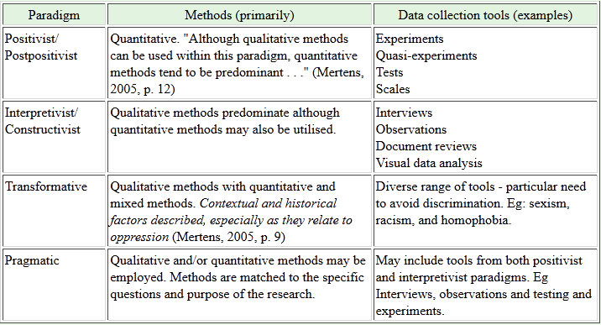

Table 2 “Paradigms, methods and tools” (Source: Mackenzie & Knipe, 2006)

As actors view is much newer type of philosophy/methodology it is rarely listed between other paradigm categories. However it is very close to the interpretivist/constructivist paradigm in its connection to methods and data collection tools. In short interpretivists/constructivists similar to actors view practitioners ‘do not generally begin with a theory rather they generate or inductively develop a theory or pattern on meaning throughout the research process’ (Mackenzie & Knipe, 2006). Accordingly in regards of methods in this project qualitative methods will be used. Other two alternatives are quantitative or mixed methods () however they are more fitting in other paradigms. Due to fact that actors approach is against quantitative or statistical measures it is logical that qualitative methods are the best fit.

|  |  |  |
| --- | --- | --- |
| **Quantitative research Methods** | **Qualitative Research Methods** | **Mixed Research Methods** |
| Predetermined  Instruments based questions  Performance data, attitude data, observation data, and census data  Statistical analysis | Emerging methods  Open-ended questions  Interview data, observation data, document data, and audiovisual data  Text and image analysis | Predetermined and emerging methods  Open and closed-ended questions  Multiple forms of data drawing on all possibilities  Statistical and text analysis |

Table 3 “Quantitative, qualitative and mixed research methods” (Source: Creswell, 2003)

According to Mackenzie & Knipe (2006) there are 11 steps of research (see Appendix 1) from which first nine are methodological nature and just last three are execution related. Therefore besides already discussed steps – paradigm and methods – few more steps need to be discussed in terms of methodology of this project. In this section besides already discussed steps also steps 4-7 () will be shortly discussed. Eighth and partly ninth step will be elaborated in later sections. Rest of the steps will not be discussed as they are not methodology related.

|  |  |  |  |  |  |
| --- | --- | --- | --- | --- | --- |
| Step 1 | Step 2 | Step 3 | Step 4 | Step 5 | Step 6 |
| Determine paradigm | Determine area | Identify approach | Literature review | Determine data types | Choose data collection methods |
| Step 7 | Step 8 | Step 9 | Step 10 | Step 11 |
| Identify where, when, and who data will come from | Obtain ethics approval (validity, reliability) | Data collection | Analyze the data (Findings) | Write up Findings and Conclusions (Discussion) |

Table 4 “11 research steps” (Source: Mackenzie & Knipe, 2006)

Step 4

Once again it must be reminded that main philosophy behind this project is actors view. It means that the very idea of topic for this project has come from authors previous researches and experience and consequently part of literature review have been done in previous researches. Mainly it is because of previous literature reviews as well as results of previous researches of author that project topic of RKT has been chosen. At the early stage of this project additional literature review have been done in order to create better direction for further steps. Literature review have given clear direction and additionally helped to explain better first three steps () of this project.

Step 5

In this project it has been decided to use qualitative data in form of research papers and academic articles. As project tends to create better understanding of RKT and it is not focusing on any specific company, group of society, or subject therefore there is no need to use or create any kind of statistics and also no need to interview or analyze individual participants of some social system. Thus existing academic research papers and academic articles become the best data type for this project.

Step 6

Using previous experience and searching within academic journals new relevant materials. Using Aalborg University library data base and Google scholar articles and research papers have been searched in relevance to subject area of RKT. From found literature the most relevant and useful ones have been selected for further analysis. It has not predetermined how much data will be used however it is chosen to use enough data to synthesize necessary results. Theoretically only two different sources of literature are needed in order to make synthesis, however more are chosen in order to cover as much aspects of RKT as limitations of this project allow. Limitations occur considering that analyzing each article takes time and its result projection takes considerable amount of space (written words). However it is believed that chosen amount of articles is more than sufficient to display understanding of RKT with synthesized technique.

Step 7

Data mainly comes from articles and research papers in field of KT, RKT and KM. Most of data have been collected at early stage of project. As this project tends to create new knowledge result of research and analysis is not hypothesized or assumed beforehand. Therefore even at early stage data is the one which determines further course of project. Meaning that it has been crucial in this project to obtain at least part of research papers and articles at the very beginning as it is closely connected with research methodology and methods. By changing one element in this connection others are influenced, therefore it is important from very beginning trying to get data, methodology and methods which will not contradict with each other.

After elaborating on research types and steps, and identifying the ones related to this project there are still other aspects which one might consider in thesis. In general there are large amount of methodological considerations and aspects which different researchers consider. Taken the specifics of this project few of relevant methodological considerations are presented and discussed in next section. It is complementary to this section and together both sections give reader full insight of specifically in this project used methodology.

## 2.6. Other methodological considerations

Two very basic methodological aspects which are considered in this project are epistemology and hermeneutics. Both are present at most of researches yet less often that some would expect they are mentioned and explained in researches. In cases when knowledge is created they can be very valuable aspect for reader to know.

As Stanford Encyclopedia of Philosophy (SEP) explains ‘epistemology is about issues having to do with the creation and dissemination of knowledge in particular areas of inquiry’ (SEP, 2005). As this project is in a way about knowledge it is important to consider epistemology. In theory part of project it will be explained how knowledge is perceived in this particular work.

Second basic aspect – hermeneutics – is basically text interpretation. Traditionally hermeneutics focus on written text materials and also it is so in this project. However it must be noted that hermeneutics in nowadays are used as interpretation of any type of material – picture, video, or audio. In this project there is no attempt to interpret any pictures, or gather and interpret any video or audio material. It is simply recognized that ideology of hermeneutics – interpretation – is important part in this project.

Another methodological aspect considered in project is Howard Gardner’s ‘5 minds’ (Gardner, 2006). It is methodology presented in AAU MIKE-B program 2nd semester methodology course. To give overall understanding of five minds short description of each is presented:

1. *The Disciplined Mind* has mastered at least one way of thinking; a distinctive mode of cognition that characterizes a specific scholarly discipline, craft or profession.
2. *The Synthesizing Mind* takes information from disparate sources, understands and evaluates that information objectively, and puts it together in ways that make sense to the synthesizer and also to other persons.
3. *The Creating Mind* breaks new ground. It puts forth new ideas, poses unfamiliar questions, conjures up fresh ways of thinking, arrives at unexpected answers.
4. *The Respectful Mind* notes and welcomes differences between human individuals and between human groups, tries to understand these “others.” And seeks to work effectively with them.
5. *The Ethical Mind* ponders the nature of one’s work and the needs and desires of the society in which he lives. This mind conceptualizes how workers can serve purposes beyond self-interest and how citizens can work unselfishly to improve the lot of all (Gardner, 2006).

Only first three minds are used in this project. Disciplined mind helps focus on specific scholarly discipline/topic of KT, Synthesizing Minds helps to synthesize different existing research results in understandable way, and Creating Mind encourages creating new knowledge and understanding of RKT processes. As project is not focusing on individuals or social groups Respectful and Ethical mind is not so relevant for this project. Gardner’s five minds are very useful aspect to simply keep in mind while doing research. It is more of a passive tool which is in the background of researchers mind while working on project. These “minds” are like skills – once researcher learns them he has them. Accordingly author has studied and acquired certain understanding of these “minds”. It is believed that this knowledge helps researcher (or any person) to keep focus on what is important and not get confused when unexpected occurs.

Important is also to consider the form of analysis. Very often analysis strictly follows rules and steps of certain method. It is necessary to have rules and steps in order to keep reasonable structure for research and also process of analysis which not only researcher but also reader can follow and understand. At the same time it is necessary to adapt research methods and analysis for every problem analyzed. Analysis methods and tools should be seen as maps while researchers are the ones who need to navigate to get to the destination.

Analysis is the interplay between researchers and data. It is both science and art. It is science in the sense of maintaining a certain degree of rigor and by grounding analysis in data. Creativity manifests itself in the ability of researcher to aptly name categories. Ask stimulating questions, make comparisons, and extract an innovative, integrated, realistic scheme from masses of unorganized raw data. It is a balance between science and creativity that we strive for in doing research. There are procedures to help provide some standardization and rigor to the process. However, these procedures were designed not to be followed dogmatically but rather to be used creatively and flexibly (Strauss & Corbin, 1998).

That is some researchers prefer to work in groups, because then there is more choices, more alternatives and more opinions of how analysis can be carried out. At the same time some avoid working in groups for the same reason – to difficult to agree and choose direction to proceed with analysis. Hence there is also method of brainstorming. It is a way how either researcher on research group can get new insight to their field on analysis. It is rather unique technique developed from creative problem solving (CPS) (Isaksen, 1998). The idea is to gather people who have knowledge in certain topic where problem exists and let them discuss possible solutions. It has four basic guidelines:

1. Criticism is ruled out. Adverse judgment of ideas must be withheld until later. The purpose of the brainstorming session is the generation of many, varied and unusual options.
2. Freewheeling is welcome. The wilder the idea, the better; it is easier to tame down than to think up. Since criticism is temporarily ruled out, it is acceptable and desired that really wild and unusual ideas are shared.
3. Quantity is wanted. The greater the number of ideas, the greater the likelihood of useful ideas.
4. Combination and improvement are sought. In addition to contributing ideas of their own, participants should suggest how the ideas of others can be turned into better ideas; or how two or more ideas can be joined into still another idea (Osborn, 1953, cited in Isaksen, 1998).

It is useful tool for almost any research if proper group can be found and problem presented in the right way. In topic of RKT it also could be useful to create group from people in big organisation, present them with challenge of RKT and ask to give suggestions of how successful RKT should take place in organisation. However this idea of brainstorming is mentioned just for future considerations because author does not have enough knowledge to conduct brainstorming process.

As well as brainstorming certain empirical evidence also must be left out in this project. In other words actors view choice in this project means that certain aspects of analysis will be carried out based on experience and interpretation of other researches meaning that some of statements and assumptions will be normative. Therefore it is important to consider good balance between empirical and normative statements. As it is new attempt to create new understanding and knowledge it is inevitable to have some normative statements. In future every single aspect of findings in this project can be tested through empirical studies however in this project exclusion of normative assumptions would endanger creation of new knowledge. As in order to create something new certain risks must be taken. Furthermore this project is not seeking for empirical truth of RKT processes it simply seeks to create better understanding and new knowledge of those processes.

### 2.7.1. Data gathering

First of all in this project it has been chosen to use data which qualifies as secondary data. Even though lot of information from previous projects has been created with direct focus on KT and do not need any further corrections, analysis, or interpretation in order to use them in this project it is still considered as secondary data, as it has been obtained prior to beginning of this project. Besides previous author researches lot of other research reports and academic articles are used as a source of information in this project, all of which also qualifies as secondary data. Project does not focus on specific business unit or social system therefore primary data collection is not necessary.

Further there are three basic secondary data – statistics (also financial reports), articles (research papers), and books. In different cases different source might be best suitable. In this project most suitable and mainly used are articles and research papers.

Very few books are used for this project for creating methodology as there are some books which have extensive information on research methodology which can be helpful for researcher when getting started with new project. Further in project books are not used for two reasons. First, it takes long time (usually longer than articles) to publish a book and that makes content of book less up to date than more recent research article. Second, there are much more articles and research papers on KT than there are books therefore more broader understanding can be gained by using variety of articles instead of few existing books.

KT theories are very important data for this project. Thus it is important from where that kind of data can be acquired. First step for that is to understand what information exactly is needed and next step is to look where that information can be found. Aim of this project is to create understanding of RKT. In order to do so one must start by taking step back to KT and even more to knowledge understanding itself. Therefore data about knowledge is needed, further knowledge transfer, and then one can analyze on talk about aspects of RKT. As there is not much data about RKT it must be synthesized. In order to synthesize new understanding of RKT elements for synthesis are needed. Accordingly in this project those elements are understanding of knowledge and understanding of KT. First one is gathered mainly from previous authors works while latter is mainly from academic journals and research papers.

### 2.7.2. Validity

Validity of data can be viewed just in context of particular project. Accordingly in this project validity of data must be viewed in context to actors view and goal of creating new knowledge about RKT. Context of actors view complicates validity aspect in this project. Actors view as a concept does not accept objectivity as reasonable and objectivity is important part of validity. Therefore, when using actors view it is difficult to talk about objectively valid data.

Starting from the actors view conception of reality, and in particular the concept of intentionality, requirements for objectivity stand out as being absurd and illogical. Humans are subjective beings – they create reality out of their own subjective intentions and then locate them through their senses. How, then, can it be possible for creators of knowledge to study subjectivity objectively? They are, after all, objectively a part of their subjectivity. The answer must be that this cannot be done (Arbnor & Bjerke, 2009).

However as discussed in previous section certain risks must be taken and methodologies can be adapted. Table bellow () shows necessary requirements for objectivity within actors view. Arbnor & Bjerke (2009) point out micro level and macro level for objectivity. By micro is meant researchers personal values and macro – interpersonal.

|  |  |  |
| --- | --- | --- |
| OBJECTIVITY | In a scientific process is made by | In results means |
| At macro level | * Pluralism * Awareness * Critical thinking * Favouring actors * Unconditionality | * Scientifically relevant values |
| At micro level | * Logical fit * Subjective interpretation * Translatable concepts | * Certain form of intersubjective testability |

Table 5 “Requirements for objectivity” (Source: Arbnor & Bjerke, 2009)

Above explained objectivity of actors view is just validating the use of this rare methodology. Further must be explained more traditional validity of data used in this project.

It is highest importance to have the valid and reliable data in project. The only way how result can truly be taken seriously is if it is based on solid analysis from reliable data/information. Thereby information is gathered based on principle of correspondence and representativeness of knowledge transfer subject. Theories and literature are gathered from academic papers from qualified academics. The same principle goes for information used from previous researches as data in previous researches were gathered by same principles. In overall objectified actors view and reliable representative data proves that validity of resources in this project is up to academic standards. The same applies for methods of analysis and manner of discussion and conclusion.

### 2.7.3. Analysing the data

Analysis and synthesis, as scientific methods, always go hand in hand; they complement one another. Every synthesis is built upon the results of a preceding analysis, and every analysis requires a subsequent synthesis in order to verify and correct its results. In this context, to regard one method as being inherently better than the other is meaningless (Ritchey, 1991).

Furthermore Dettmer (2006) considers that both are not just complementing each other but are in fact absolutely necessary if one is to solve a problem.

Since the Renaissance, analysis has been the foundation of problem solving. But as we move from the 20th into the 21st century, it's becoming clearer that analysis alone is an incomplete, suboptimal way of understanding and functioning in our world. Worse, without the next step – synthesis – practicing analysis alone is a dangerous way of operating (Dettmer, 2006).

Simply put, synthesis is amounts to putting things together. Sometimes these are pieces known to be part of a system, for example, the rebuilding of an automobile engine from its disassembled parts. In other cases, it may be the combination of things never thought of as “going together” before, to create new concepts, solutions, or realities (Dettmer, 2006).

Creating new reality or understanding is the idea in this project, therefore synthesis is important technique to supplement analysis, not replace. Both are needed as in this project two processes takes place – analyzing existing researches and synthesizing new knowledge.

The task in this thesis is fairly challenging – creating new understanding – thus more than just synthesis is needed to complement research.

Another chosen method is meta-analysis. It is chosen just as additional technique as it is rather extensive. Full meta-analysis anal*y*sis ‘is a long and rigorous process, which follows several steps: statement of objectiveness; definition of articles inclusion and exclusion criteria; tests for homogeneity; pooling; sensitivity analyses; presentation of results; and conclusions’ (Delahaye et al, 1991, cited in Broks, 2013).

Instead of spending lot of time gathering information from primary sources and ending up with one set of results sometimes it is better to gather different existing sets of results and further create new, higher level set of results. In other words ‘rather than doing statistical analyses on the data gathered from multiple participants, the statistical analyses in meta-analyses are conducted on data gathered from multiple studies’ (Durlak, 1995, cited in Broks, 2013).

Full statistical meta-analysis is long process and as it is stated before statistical type of data or any statistical approach in that matter is not used in this project. Fortunately Delahaye (1991) distinguishes between full statistical meta-analysis (quantitative) and more qualitative approach. Delahaye (1991) shortly describe qualitative approach as weighting studies according to their methodological value and quantitative as pooling results from different studies to generate higher data value.

Thus the technique for analysing data in this project will be combination between synthesis and qualitative meta-analysis. It means that by using articles and research papers with high relevance to KT subject similarities will be identified and analysed in order to create set of elements which best describe process of KT. After that another important part of analysis will take place – reversing the processes. Once channels of KT have been identified then it will be analysed if certain channels can be used for KT in reverse direction. Through finding such channels new KT system for reverse knowledge flow can be found. The result will be conceptual basis which will present new understanding of RKT.

## 2.8. Delimitation

There are vast amount of literature in KT field but not all of it is relevant, reliable or usable. As it would take unpredictable long time to analyze all literature available reasonable limitations must be made. Gardner’s (2008) five minds are very helpful in this sense. Using discipline and synthesizing mind it is possible to create reasonable boundaries for literature search. In this work search of literature was mainly limited to sources from publications in academic journals. More extensive use of literature might raise the objectivity of results but it is accumulative process – using more literature rises more challenges and accordingly goes back for more literature search for new answers. Considering actors view which is against objectivity literature limitations are considered reasonable in this project.

Further more research avoids getting into deep analysis of any specific aspect of KT. All aspects are to be analyzed at basic level in order to avoid bias towards certain elements. Deep analysis of certain elements might create false belief that element is more important than others. As purpose of research is simply to identify and reverse channels of KT there is no need to emphasize importance of individual elements.

In future research it might be considered in order to create more realistic/objective view, however this project is delimited from that. This project creates general understanding which might be useful for business and society outside academic circle. While academics and scientists sometimes spend years and years to analyse some subjects and elements business and many individuals not always has that time.

In life and in business it is important to make decision without spending extra time for evaluating criteria. If an organization knows most important traits of knowledge transfer than it do not have to spend extra time for evaluating criteria. It is not even necessarily for one to know details of specific element, it is enough if one recognizes the element as important in general (Broks, 2013).

*‘If one of two objects is recognized and the other is not, then infer that the recognized object has the higher value with respect to the criterion’* (Goldstein and Gigerenzer, 2002).

It means that if subject have to choose which elements of knowledge transfer are more important it will choose the ones it recognizes. That explains why this project wants to create general understanding which companies should recognize. Project delimits from going too deep in details in order to general knowledge basis. Further it would be up to reader to search more details or settle with basic understanding.

It is important to note one more limitation of this project. It does not distinguish between commercial and non-commercialised structures (organisations). While basics of KT should be the same in both Teo & Crawford (2005) believe that there are significant differences of HRM processes between commercialised and non-commercialised organisations. As HRM has close connection to KT (Bengsten et al, 2011) there might be differences between RKT in commercialized and RKT in non-commercialized organisation. In order to investigate that more resources would be needed (time and people) and further more it could lead to necessity of having two separate researches – on for each organisation type.

## 2.9. Outline of thesis

In overall project has four parts – introductory, methodological, theory’s, and analysis. This section is to explain in short how each part is constructed and how they all link together. It is created in order to give the reader a chance to understand overall structure of project before reading it all.

Introductory part reflects on author’s previous experience and its connection with this project and choice of the topic in general. Already in introduction there is lot of emphasis on author’s previous projects and that is even more reflected in methodological section.

Methodological section of project is very important and accordingly is big part of this project. As less traditional methodological approach – actors view – is chosen for thesis it requires solid explanation. Overall understanding of alternative views is presented and argumentation for actors view is presented. Further to give reader better understanding of methodological choice and how it will be carried out number of methodological considerations and method elaborations are given. All presented methodological considerations are important factors influencing the way how this thesis is created. Besides that methodological part also explains data role in this project. Elaborating on both, sources and validity of data, extensive information about it – from where, why, how – is given and also its risks and reliability are explained. Besides that also process of analysis is explained. As in this project actors view is chosen analysis is rather complicated, therefore it is separately explained.

After that theory part is introduced. It is another very important part as it contains all information and data needed for main analysis. In order to give reader enough information to follow complicated analysis decisions carefully background of KT field as such is given. First understanding of term knowledge is presented and after that theory part builds up and step by step through KM, KT history, and KT important elements theory part has prepared reader enough to introduce KT models. Through presenting various KT models found in other researches theory part reaches its last section – introduction of RKT. After in literature found understandings of RKT are presented theory part is completed its purpose and given enough background for analysis part.

Analysis part is very difficult part of project, especially because it continuously keeps reflecting on elements from theory part. Reversing elements of KT requires doing analysis and synthesis almost simultaneously and this process repeats for several times in order to reverse all important channels of KT which have been found and introduced in theory part. Further using qualitative meta-analysis technique in combination with actors view other important aspects are discussed in order to broader cover the explaining of RKT field. After new understanding of RKT channels is created and other important aspects are discussed it all with explanations is created final conclusion is synthesized. Besides that few considerations for future researches are mentioned. In general conclusion section itself is given more as the author’s evaluation of knowledge gained and created through this thesis; which according to actors view was main goal – creating knowledge.

# 3.0. Background

This part of the project will try to give as much as possible details about KT and its components. In order to talk about such a complex process as RKT it is necessary to now the role of main elements. Different approaches can bring different results to project. Similar it is with interpretations and definitions. For reader to better understand certain analytical decisions and interpretations of author it is necessary to set common point of view for basic elements of RKT. It must start with very basics – understanding of knowledge term. Even though it might seem very basic word and it should be well known to everybody it is more complicated when this word is part of complicated process analysis. Different academics might have very different understanding of term knowledge, therefore it will be explained what exactlyauthor means in this project when using term knowledge. Further Background section will build up foundation for analysis by explaining aspects which are closely related to knowledge transfer, managing, and creating.

Background part is to a large extent based on results from author’s previous researches. One of previous research where studying KM field and another KT field. Thus lot of information in connection to RKT topic has been gathered and analyzed before. It is very beneficial to this project that lot of theory needed for analysis has already gone through validation process. In previous author’s researches lot of work has been putted to form understanding of such terms as knowledge, KM, KT, and other aspects close to them. Therefore it is very useful to use those established understandings instead of forming new understandings from other sources which might not share same point of view on mentioned disciplines.

Section will evolve from defining knowledge to KT and introduction of RKT. In between important influencers of KT field will be introduced and discussed. However main cornerstone of this section is not from author’s previous projects. It is newly gathered materials which is main component for analysis - KT models. From different research papers various KT models have been identified and will be presented. These models are each shortly described to capture their structure and underlying. It is crucial part as those models contain important information needed to identify channels of KT.

Before actually identifying and reversing KT channels (it takes place in analysis part) one more term is presented in background part – RKT. Even though this project aims to create understanding of RKT there is already some literature on this topic. Most of literature in RKT topic focused on R&D and technology transfer and by presenting it important prerequisite for creating new understanding is introduced. For one must know the old understanding in order to recognize the new one and see the difference.

## 3.1. Term of knowledge

### 3.1.1. Knowledge

In the business environment full of uncertainty, the most successful companies are those which can sustainably create new knowledge and efficiently put it into practice. Those companies are defined as knowledge-creating companies whose businesses mainly depend on continuous activities of innovation. However, numbers of managers can hardly understand what knowledge-creating company essentially is and fail in managing their own companies (Nonaka,1991). Moreover, nowadays almost every company views knowledge as an important weapon to maintain its competitive advantages (Bengtsen et al, 2011).

Therefore it is important to first see what knowledge actually is. From the classical ancient era to nowadays and from east to west of the world, people never stop searching for the meaning of knowledge. In this thesis understanding of knowledge is viewed in the context of business and management instead of finding out the universal definition of knowledge (Bengtsen et al, 2011).

Knowledge has been defined by Huber (1991) and Nonaka (1994) as a “justified belief” which can improve an individual and/or organization’s capability for effective actions or decisions. Alavi&Leidner (2001) found out that knowledge could be viewed from several perspectives including an (a) object, (b) a state of mind, (c) a process, (d) a condition of having access to information, (e) or a capability. When being viewed as an (a) object, knowledge has been described by Schubert et al. (1998) as what can be gained, discovered or learned though experience or study. When viewed as a state of mind (b) knowledge is what enables ‘individuals to expand their personal knowledge and apply it to the organization’s needs’ (Alavi&Leidner, 2001). A third perspective defines knowledge as a process (c) of ‘simultaneously knowing and acting’ (Carlsson et al., 1996; McQueen, 1998; Zack, 1998a). And this perspective emphasizes the applying of expertise (Zack, 1998a). The fourth view of knowledge is a condition of having access to information (d). Finally, knowledge can be seen as a kind of capability (e) that potentially influences an organization’s future actions (Carlsson et al., 1996). Watson (1999) described the capability perspective in another way that instead of capability for any special actions, knowledge is a kind of capacity to use information (Bengtsen et al, 2011).

According to the above discussion, we can discover that each perspective could only reflect one part of knowledge and it is very difficult to define knowledge clearly, accurately or visually in one word. And the general definition, justified belief, from a philosophical perspective seems not substantial to help us understand the meaning of knowledge under a practical perspective of RKT. Anyhow, everyone believes knowledge does exist, both in individuals and organizations and it is reflected in different ways. Therefore, the key to the gate of the meaning of knowledge is not trying to define it by a simple word or sentence but to see how it is reflected. In other words, the best way to understand knowledge, especially in the fields of business and management, is to categorize it in different types (Bengtsen et al, 2011).

### 3.1.2. Classifications of Knowledge

First there is distinction between explicit knowledge and tacit knowledge. Polanyi (1967) describes explicit knowledge as knowledge that can be codified in the form of document or other types of language. In contrast, tacit knowledge cannot be transmitted as explicit knowledge because it always hides deeply in people’s mind or actions, which means that it is difficult to be formalized and communicated. It can also be found that Nonaka (1994) has developed this type of classification of knowledge and used it in the process of knowledge creation. In general, due to the characters of both tacit and explicit knowledge, Nonaka (1994) argued that tacit knowledge should be shared through the communication between individuals and by contrast, explicit knowledge can be captured via the record of the past for example libraries, archives and databases and can be assessed sequentially (Bengtsen et al, 2011).

In business world both type of knowledge exists and are important. While success of an organization is often associated with tacit knowledge explicit knowledge is just as important for company. Distinction between explicit and implicit knowledge is very basic. There are more detailed ways how to look at knowledge. For example, Walsh and Ungson (1991) posited that there are five retention bins or repositories for knowledge in organizations: (a) individual members, (b) roles and organizational structures, (c) the organization’s standard operating procedures and practices, (d) its culture, and (e) the physical structure of the workplace (Bengtsen et al, 2011).

The knowledge repositories play a dual role in knowledge transfer in organizations. On the one hand, the knowledge repositories are changed when knowledge transfer occurs. Thus, changes in the knowledge repositories reflect the outcomes of knowledge transfer. On the other hand, the state of the knowledge repositories affects the processes and outcomes of knowledge transfer. Just as an individual’s readiness and past knowledge affect his or her ability to acquire new knowledge (Goldstein, 1991, cited in Argote, L. and Ingram, P., 2000), an organization’s current knowledge affects its ability to assimilate new knowledge (Cohen &Levinthal, 1990, cited in Argote, L. and Ingram, P., 2000, cited in Bengtsen et al, 2011).

McGrath and Argote (1993) point out three elements of organizations where knowledge usually is. They are – members, tools, and tasks. Members are the employees of the company. Tools are technologies in company. And tasks are company’s goals, intentions and purposes. Combinations of these three elements create different networks where knowledge transfer takes place (Bengtsen et al, 2011).

In this project it is important to use different classifications of knowledge. It will help to identify more precise the pattern of knowledge creation, transfer and its role in particular situations. Two types of knowledge (tacit and explicit) would be too little to do that. Also too many classifications (philosophical perspective) would create confusion. Thus knowledge in this project is viewed as information, experience and skills which companies have in their five repositories and which they communicate through members, tools, and tasks.

### 3.1.3. History of knowledge

Another much simpler understanding of knowledge is presented through historical development of practical knowledge. As in this project the focus is on knowledge which companies can or would like to utilize it is useful to present how understanding of knowledge has developed through the time and what is has become in eyes of companies and organizations.

Wiig (1997) has analyzed and created the evolution process for understanding of knowledge. He explains the knowledge evolution in the following six stages:

1. Agrarian Economies: A stage where people were focused on growing animals, crops, working the soil, creating food. Knowledge as such was not really recognized yet and specific skills was seen as important and recognized.
2. Natural Resource Economies: People started to create products for markets and resources turned in to saleable goods, and also a few types of experts appeared – masons, blacksmiths, tailors etc. They provided specific services and that is where knowledge started to be recognized.
3. Industrial Revolution: In the 18th and 19th century the manufacturing of products improved. The efficiency of the processes was important and acceptable quality and affordable prices were key factors. Individuals needed to produce as much as possible, therefore technologies were used and processes where routinized. Therefore knowledge was still recognized by only a few specialists.
4. Product Revolution: In the beginning of the 20th century manufacturers started to vary their production. The later manufacturers started to make more sophisticated products, and therefore services to complement such products started to emerge. But still the recognition of knowledge has not changed, and the particular skills and experts, who knew how to use the products, which has the skills to provide support and service, were recognized.
5. Information Revolution: At the second part of the 20th century the recognition of knowledge started to increase. IT became available and took several of the routinized tasks in the manufacturing, logistics, and marketing. Information was exchanged more and faster between enterprises, their suppliers, and customers. The role of individuals changed from physical work in production to ‘desk work’. Although the real nature of mental work were still not well understood and appreciated.
6. Knowledge Revolution: Just at the end of the 20th century knowledge started to be appreciated. Intellectual assets are recognized as crucial to make the companies’ customers satisfied. Companies want to obtain the best possible knowledge in their field and they work closely with customers to understand their businesses and environments. Individuals were more often a source of profitability instead of replaceable commodity (Wiig, 1997).

In all historical stages understanding of knowledge has been correct. Even though in each stage the meaning and role of knowledge has been different it has been recognized in the right way. The challenge is that knowledge is unique quality which never stops developing. And more it develops more complicated it becomes to transfer it. Telling and even teaching how to hold and use hammer is fairly easy whereas explaining and teaching crucial elements of building 100m high building takes long time and practice and even then not everybody can do it. But let us leave knowledge transfer for later in this project. The point of historical section is that people always have known what practical knowledge is, therefore there is no need to further explain what is meant in this project when term knowledge is used.

## 3.2. Managing the knowledge

### 3.2.1. Knowledge Management

Knowledge management refers to a systemic and organizationally specified process for acquiring, organizing and communicating both tacit and explicit knowledge of employees so that other employees may make use of it to be more effective and productive in their work (Aalvi&Leidner, 2001).

And it becomes more and more important nowadays for organizations to practice successfully KM. Already ‘from very early times, wise people have secured sustained succession by transferring in-depth knowledge to the next generation’ (Wiig, 1997) and that is the same what KM is aiming to do. If company wants to be competitive, innovative and successful they need to learn how to effectively share knowledge.

As innovation has become a condition of business survival, this has forced the introduction of explicit forms of knowledge management. In an innovation-driven competitive environment, the cost of missing the boat on a single possible innovation – in other words, ignoring a “good idea” –becomes enormous. So it becomes essential to introduce planned strategies for collecting and documenting ideas and suggestions by employees. In addition to this type of knowledge management, processes for stimulating creativity become essential (OECD, 2004).

Therefore it is time to introduce definitions of KM. As described above KM is the key element to communicate knowledge inside company and between company and outside actors. Useful results in finding KM definition has produced Kanagasabapathy et al (2006) who found several definitions () which are rewarding to look at. They all have two common things; first they all consider that KM is useful for firms and second, almost all of them talk about KM as a process.

|  |  |
| --- | --- |
| **Author** | **Definition of knowledge management** |
| Quintas et al. (1997) | KM is to discover, develop, utilize, deliver, and absorb knowledge inside and outside the organization through an appropriate management process to meet current and future needs |
| Allee (1997)  Davenport (1998)  Alavi and Leidner (2001) | KM is managing the corporation’s knowledge through a systematically and organizationally specified process for acquiring, organizing, sustaining, applying, sharing and renewing both the tacit and explicit knowledge of employees to enhance organizational performance and create value |
| Gupta et al. (2000) | KM is a process that helps organizations find, select, organize, disseminate, and transfer important information and expertise necessary for activities |
| Bhatt (2001) | KM is a process of knowledge creation, validation, presentation, distribution and application |
| Holm (2001) | KM is getting the right information to the right people at the right time, helping people create knowledge and sharing and acting on information |
| Horwitch and Armacost (2002) | KM is the creation, extraction, transformation and storage of the correct knowledge and information in order to design better policy, modify action and deliver results |

Table 6 “Definition of KM” (Source: Kanagasapapathy et al, 2006)

Author of thesis in previous projects (Bengtsen et al, 2011) have researched KM field and created wider definition of KM:

Knowledge management is a process driven by the organizations management where information is transformed into knowledge by a social interference. Knowledge management contributes to the organizations performance and ensures further development in order to obtain or retain a competitive advantage on the market. IT is an essential part of knowledge management in order to support knowledge transfer between employees and to/from the external environment (Bengtsen et al, 2011).

Definition of KM gives very basic understanding of its role in organization. Alavi & Leidner (2001) conducted research to find how exactly companies benefit from KM. Results showed that companies consider KM helpful in many ways which in overall can be grouped in three categories – information, management, and technology.

**1. Information**

* Building vast amounts of data into usable form
* Avoiding overloading users with unnecessary data
* Eliminating wrong/old data
* Ensuring customer confidentiality
* Keeping the information current

**2. Management**

* Change management implications
* Getting individuals to volunteer knowledge
* Getting business units to share knowledge
* Demonstrating business value
* Bringing together the many people from various units
* Determining responsibility for managing the knowledge

**3. Technology**

* Determining infrastructure requirements
* Keeping up with new technologies
* Security of data on Internet (Aalvi & Leidner, 2001)

In delimitation section it is mentioned that there might be difference between how KT happens in commercialized organizations and how in non-commercial ones. As KT and KM are very closely related the same reflects to KM.

There is commercial side of KM which not many talk about. Marc Demarest (1997) talks about commercial knowledge and describes that often in business information and knowledge is seen differently than within scholars. In business it is *‘not about ‘what is right’ but ‘what works’ or even ‘what works better’ where better is defined in competitive and financial contexts’* (Demarest, 1997).

Commercialized organizations not always seek for truth; they not necessarily need that kind of knowledge. Instead they focus on knowledge which will bring them profit. However regardless of which knowledge commercial or non-commercial organization consider more important the common problem is that often managers of organizations do not know how knowledge enters the company, transfers, and exits.

However there is improvement in this area and mainly it is thanks to technology. Ever since companies have understood that intellectual capital is of big value they have tried to develop tools and methods how to capture, measure and even control it.

It is also becoming more important for companies to be able to measure their intellectual capital, as the stock market valuation of a company appears to be increasingly dependent on the value of its intangibles. This is also true when companies are trying to attract venture capital or build a partnership. But if a company is to be able to place an appropriate value on its intellectual capital it needs systems to identify and measure it (OECD, 2004).

Even the brightest minds do not have capacity to consider many aspects of knowledge creation, transfer and application, therefore systems which OECD (2004) talks about are used and information technologies (IT) play significant role here.

### 3.2.2. Information Technology role

Either we like it or not but technology is a big part of our life and business world in particular. Already in 1980ies ‘technology has been a primary driving force for organizational change. […] New organizational forms, especially those which bind groups across national borders, will function only because technology has made it possible to do so’ (Tex Smiley, 1989).

Thirty years later we are witnesses that it is absolutely truth. Industries have developed, companies have expanded, and businesses have grown (Bengtsen et al, 2011). And technology is one of the main reasons for that happening.

Information technology (IT) is one of the infrastructures that an organization can provide to facilitate the knowledge transfer process. Empirical research (Casal&Fontela, (2007), cited in Fei, 2011) reveals that IT systems have the most significant impact on organizational knowledge transfer. A variety of information systems and technologies supports knowledge management processes such as creation, storage, transfer and application of knowledge. For example, data mining techniques such as neural networks find new patterns in data and enhance knowledge creation; knowledge repositories store and retrieve knowledge; electronic bulletin boards, discussion forums, knowledge directories and other knowledge networks enable efficient and accurate transfer of knowledge (Fei, 2011).

It is, however, important to notice that IT can have various roles. In some cases IT can capture knowledge and transfer it all by itself. In other cases, such as when we talk about tacit knowledge, IT can just help one to find the person who has the tacit knowledge, ‘*because most tacit knowledge is too complex and too experiential to be captured electronically* (O’Dell &Grayson, 1998). One must engage in communication with actual person in order to get the necessary tacit knowledge. In fact, that is exactly what happens in organizations. Employees ‘usually turn first to friends and peers to learn where to find relevant knowledge rather than engaging in an extensive search through an organization’s database, regardless of how robust the search functionality or how customized the database is’ (Cross & Baird, 2000). IT once again here can have one of its roles – ability to communicate without meting face to face. However the communication happens between two people, because tacit knowledge cannot be stored. It means that every time somebody has question about tacit knowledge they will address person who has such knowledge, accordingly it can result that certain person repeatedly need to explain to others the same thing. That can take very valuable time of an important person in organization (Broks, 2013).

As there is no clear border where explicit knowledge ends and tacit starts it is often a dilemma for companies to decide which knowledge should be communicated in which way. As Jiangang Fei (2011) describes it - ‘Articulation of knowledge runs the risk of losing finer aspects of the knowledge and therefore should be avoided. However, by stopping diffusing tacit knowledge, an organization will not be able to reap the benefits of leveraging knowledge. The point is then to balance these two by identifying appropriate approach for relevant knowledge’(Fei, 2011).

Fei (2011) based on her research has made five statements about IT role in KT:

1. Accessibility of data storage and retrieval systems through IT facilitates knowledge transfer.

2. Communication-related technology such as email, video conferencing, bulletin boards and discussion forums helps to build personal relationships through easy communication.

3. Availability of communication-related technology such as email, videoconferencing, bulletin boards and discussion forums enables effective knowledge transfer among participants.

4. IT is effective in facilitating transfer of explicit knowledge, for instance written instructions or manuals.

5. IT by itself is ineffective in transferring experiential knowledge, for example, the diagnosis of problem.

In overall role of IT besides important is also complex. Thus, company often needs to evaluate what are their needs in terms of IT and what are their expectations. More and more firms choose to actually outsource their IT. It is very important decision as it brings both, benefits and risks.

Interestingly when company chooses to outsource its IT function they enable another big KT channel between company and IT solution provider. Thus potentially they create new benefits and/or risks. New KT channel can be successful and make company more effective or in case of incompatibility it can set company back in its development. Park et al (2011) think that one of the main factors here is trust. Park et al (2011) study confirmed that trustworthy and cooperative relationships between clients and vendors are necessary so that clients acquire knowledge from their vendors. It means if company consider outsourcing IT then they can do so just if they absolutely trust the firm they want to outsource to (Broks, 2013).

Xinyuan et al (2010) mention several risks of IT outsourcing failure. Outsourcing often brings new temporary or permanent staff members and lot of new communication and training takes place in company. All that gives ground for several failure sources:

* Team risk - staffing buildup, insufficient knowledge among team members, motivation, team communication issues, inexperienced team members.
* Organizational environment risk – organizational politics, lack of top management support for the project, stability of the organization environment.
* Planning and control risk – budgets and schedules, intended deliverables, duration estimates
* Complexity risk - complexity of technology, number of links to existing systems, external entities (Xinyuan et al, 2010).

There are many models of KT, many of which are very closely connected with IT. Each model is created in relation to certain environment, industry and individual needs of organization. However Abdullah et al (2011) believe that in general there are just two type of models – Push model and Pull model.

Push model is also known as knowledge driven model. It drives the knowledge towards identified audiences. The push strategy has a central provider, who decides what information is to be distributed to whom. In contrast, pull model or problem-solving model motivates the knowledge acquirers to search for the knowledge themselves. In this strategy, it is the user who judges what he needs and is motivated to seek and retrieve the knowledge (Abdullah et al, 2011).

IT assets facilitate the rapid collection, collation, storage, and dissemination of data, thereby assisting the knowledge creation and diffusion process. However, the human capabilities rather than IT assets is adopted as the factor affecting knowledge transfer. Human capabilities refer to skills required to manage resources. IT human capability requires four types of skills: technology management, business functional, interpersonal and management, and technical. IT human capability is costly to imitate and it is a valuable resource of a firm. (Parke et al, 2011)

In overall there are two important things to bear in mind when thinking about KT and IT. First, IT has been and is big part of KT. Even back in 1962 Polanyi (1966) argued that explicit form of knowledge can be transmitted in systematic language, codified and made easy accessible to other members of company. As nowadays IT can be also be viewed as transmitter of systematic and codified language it is not surprising that IT has been important part of KT from very beginning of IT as such (Broks, 2013).

And second, even though IT is crucial part of KT it has still just supportive function. It simplifies KT process, makes it faster, more efficient and thus safes company’s time and money, however it ‘*should not be viewed as a standalone component. IT is only a tool to administrate knowledge and cannot contain all the aspects of the complexity of KT* (Alvesson, 2001)’.

## 3.3. Knowledge transfer (KT)

### 3.3.1. Knowledge creation

First, for knowledge to be able in organization to transfer it needs to be created. There is knowledge which is already out there however in organizations new knowledge creation also is regular process and it is process which takes place regardless of participants awareness. Further knowledge creation has certain patterns. In the process of knowledge creation knowledge travels through channels the same way as in knowledge KT processes. Therefore knowledge creation is good place to start search for KT channel routes.

Interestingly that knowledge creation from very beginning requires channel through which it can be created. Even though creation can start within one individual even in such a case there is channel where certain conversion takes place. Nonaka (1994) talks about four groups of channels (or as he calls them “modes”) where knowledge can be created () either it is within an individual or within organization on large scale.

The assumption that knowledge is created through conversion between tacit and explicit knowledge allows us to postulate four different "modes" of knowledge conversion: (1) from tacit knowledge to tacit knowledge, (2) from explicit knowledge to explicit knowledge, (3) from tacit knowledge to explicit knowledge, and (4) from explicit knowledge to tacit knowledge (Nonaka, 1994).



Figure 1 “KT types” (Source: Nonaka, 1994)

Three of the four types of knowledge conversion – socialization, combination, and internalization, have partial analogs with aspects of organizational theory. For example, socialization is connected with theories of organizational culture, while combination is rooted in information processing and internalization has associations with organizational learning. By contrast, the concept of externalization is not well developed. The limited analysis that does exist is from the point of view of information creation (Nonaka, 1994).

Argote (2012) however considers that there are more modes of knowledge conversion. She considers that there are 7 types of modes. In fact, she refers to them as networks, which is very close to term ‘channels’ (preferred in this thesis). These networks originate from previously mentioned (Knowledge section) three elements of knowledge source – members, tools, and tasks. Seven networks are created crossing these elements (Figure 2).

The member–member network is the organization’s social network. The task–task network is the sequence of tasks or routines the organization uses. The tool–tool network is the combination of technologies used by the organization. The member–task network, the division of labor, maps members onto tasks. The member–tool network assigns members to tools. The task–tool network specifies which tools are used to perform which tasks. The member–task–tool network specifies which members perform which tasks with which tools (Argote, 2012).

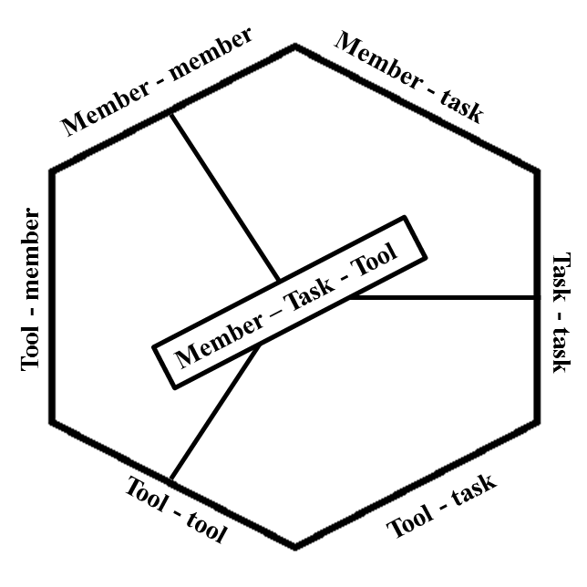

Figure 2 “Member-task-tool network” (Source: Argote, 2012)

### 3.3.2. Knowledge transfer

However process of KT is more complicated than knowing ‘modes’, networks, or channels in that matter. Regardless of channel in which knowledge is created in terms of knowledge creation in organization there is cycle through which knowledge is created ().

Enlarging individual’s knowledge is beginning of the cycle (and the end, as it is cycle). The key to enlarge one’s knowledge is to encourage him/her to express tacit knowledge. When person tries to describe certain processes he/she often learns something new. Nonaka (1994) describes it as an interplay between one’s tacit and explicit knowledge.

In order to raise the total quality of an individual's knowledge, the enhancement of tacit knowledge has to be subjected to a continual interplay with the evolution of relevant aspects of explicit knowledge (Nonaka, 1994).

After person has become aware of his/her tacit knowledge next step of cycle can take place – sharing tacit knowledge. As tacit knowledge is often personal trust plays significant role here. Nonaka (1994) considers that in organization trust often can be created through shared experiences – “the fundamental source of tacit knowledge” (Nonaka, 1994). And communication is considered the best facilitator of shared experience.

Communication is a simultaneous and contextual phenomenon in which people feel a change occurring, share the same sense of change, and are moved to take action. In other words, communication is like a wave that passes through people's bodies and culminates when everyone synchronizes himself with the wave (Nonaka, 1994).

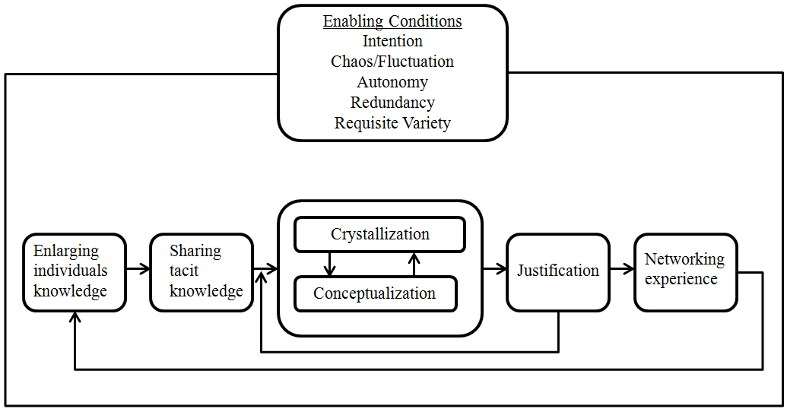

Figure 3 “KT cycle” (Source: Nonaka, 1994)

Further two steps are basically continuous practising of previous one. Conceptualization happens when shared experiences reach the state where participants of that shared experience can start to express it in words and dialogues.

Once mutual trust and a common implicit perspective have been formed through shared experience, the team needs to articulate the perspective through continuous dialogues (Nonaka, 1994).

Through continuous dialogues certain tacit knowledge and experiences takes some form of concept which members of group are able to express and communicate to others whenever needed.

Accordingly when conceptualization has reached mature state then knowledge can be “crystallized into some concrete "form" such as a product or a system” (Nonaka, 1994). After that important role play middle ant top managers of the organization. They are the ones who need to justify the created knowledge. In other terms knowledge is valuable for company if it brings some value, preferably in form of profit. After managers have done their part then knowledge can enter last part of cycle – networking experience. It means that newly created knowledge is brought to organizational level in order to include it in the company’s knowledge base and thus it can become available to any individual of the organization.

Argote & Ingram (2000) in their research about competitive advantages in firms have came up with short yet very useful explanation of what KT is. It in a way summarizes

Knowledge transfer occurs when experience in one unit of an organization affects another unit. Knowledge transfer can occur explicitly when, for example, a unit communicates with another unit about a practice that it has found to improve performance. Knowledge transfer can also occur implicitly without the recipient unit being able to articulate the knowledge it has acquired. For example, if an individual uses a tool that has been modified to improve its performance, the individual can benefit from the productivity enhancement in the tool without necessarily understanding the modifications or being able to articulate why the modifications improved the tool’s performance. Similarly, norms or routines can be transmitted to group members without the members being able to articulate the norm or being aware of the knowledge embedded in it (Argote & Ingram, 2000).

### 3.3.3. HR role

By now it is clear that for modern organization knowledge and people skills are very important assets. Most of those assets are embedded in individuals therefore in order to manage those assets company needs to manage people – it is closely connected. Ability to do so can be very beneficial to company thus many companies are actually doing it successfully for a while. The way how those companies succeed is through previously mentioned KM. However knowledge management is not something one person can simply start to do, it is usually a system – knowledge management system (KMS). And as with most of systems, the need to controlled, supervised, and directed. Usually there is existing structure in company which deals with very similar tasks – human resources (HR).

Human resources management is the main route of looking for employees with knowledge and skill knowledge. While employees are mainly knowledge and skill knowledge management depend on human resources management work. The strategic human resources management is effective in recruitment, training, performance evaluation and incentive to promote participation level in organization et cetera. Generally, knowledge represents power, which leads to fact that employees in knowledge management activities tend not to actively participate in knowledge sharing. In addition, different goals between employee and organization reinforce this point. Practice of human resources management can bring some important enlightenment in such situations. Human resource practice, including fairness of decision-making and openness of communication, helps to promote knowledge sharing (Collins & Clark, 2003; Scarbrough, 2003; Szulanski, 2000; Cabrera & Cabrera, 2005, as cited in Jiang & Zhang, 2011).

It is proved that ‘the strength of the HRM system is positively related to knowledge-sharing behavior at the individual level’ (Minbaeva et al, 2012). There is close correlation between HR and KT. Minbaeva et al (2012) think that if HR teaches employees how to transform knowledge and motivate them then it greatly increases the chance of successful KT. Both things are crucial to improve employees’ absorptive capacity. That is where HR really need to focus, because knowledge transfer cannot take place if people do not have capacity to give and receive it. Minbaeva et al (2012) shows these connections in model () in order to give better understanding of how HR is related to KT.

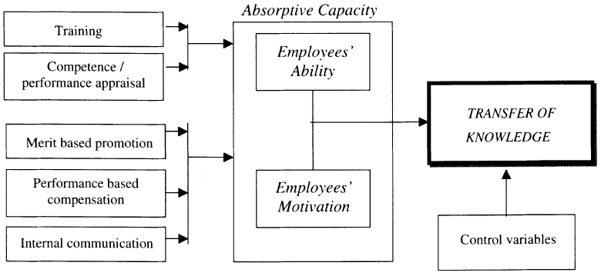

Figure 4 “KT conceptual model” (Source: Minbaeva et al, 2003)

Many elements from HR serve as prerequisites for successful KT. As it can be seen in there is list of elements which are traditionally associated with HR and further it can be seen that they have direct impact of KT. Minbaeva et al (2012) concluded in their extensive research that ‘investments in employees’ ability and motivation through the extensive use of HRM practises contribute to MNC knowledge transfer’ (Minbaeva et al, 2012).

## 3.4. Knowledge transfer models

After knowledge term has been explained and knowledge transfer idea has been presented it is time to go step further and see how knowledge transfer actually happens. In previous section one system/knowledge transfer cycle was presented and that gives basic idea of what kind of knowledge transfer channels there are in the companies. However in order to identify main channels results from one research might not be enough. In each research focus is on slightly different aspects, such as industry, country, parent-subsidiary connection, policy and others. In this section knowledge transfer models from various researches will be presented in order to create comprehensive background for analyzing knowledge transfer channels. In that way also when channels will be reversed it will be conceptual rather than based on specific aspects. Each presented model is based on research which in one way or another is concerned with finding how knowledge transfer works. In this section summarized results from each of them are simply presented. They are not discussed or analyzed in this section in order to give different perspectives of knowledge transfer as they appeared in original researches. Later in analysis part of thesis analysis will be carried out based on information presented here.

### 3.4.1. Wang et al (2004) model

First model focuses on knowledge transfer between parent and subsidiary companies. Research focuses on several MNC and their subsidiaries in China. Wang et al (2004) found in their research that there are four basic aspects included in this transfer and their simple connection is also illustrated in . As it is seen in Figure 5 Capacity To Transfer and Willingness To Transfer are two main factors which determine what kind of knowledge can/will be transferred. Further Capacity to Learn and Intent to Learn are factors which determine which and if the knowledge will be acquired.

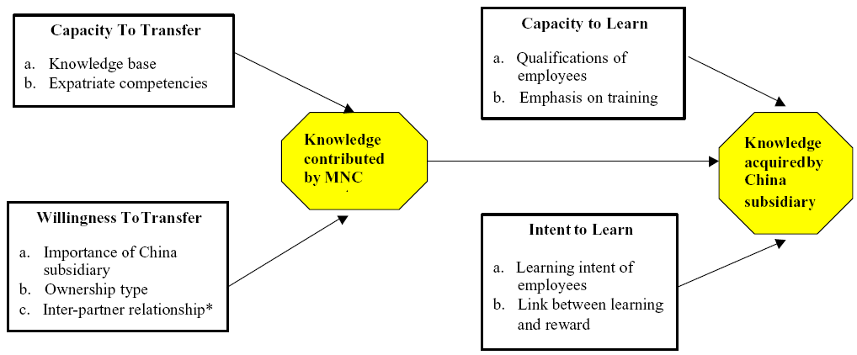

Figure 5 “MNC parent contributes knowledge” (Source: Wang et al, 2004)

There are further elements which contribute to each of four aspects. Each of them is shortly explained bellow for better understanding of the model.

Parents Capacity to transfer

a)

The extent of knowledge contributed was affected by the richness of the former’s knowledge base. Thus the ability of the MNC parent to contribute knowledge to its China subsidiary is a result of the sophistication of its existing knowledge stock (Wang et al, 2004).

b)

The competencies of expatriates have an impact on the results of knowledge transfer. MNC parents that possess a rich knowledge base but fail to appoint competent expatriates often encounter difficulties in imparting expertise to their China subsidiaries. Thus the success of knowledge transfer also depends on the appointment of competent expatriates. Most importantly, good expatriates must possess superior managerial and technical skills. Besides this, however, good expatriates must also have a genuine desire to impart years of hard-learned professional know-how to local employees, commit to localization, and work themselves out of jobs (Wang et al, 2004).

Parents’ willingness to transfer

While capacity to transfer is the requisite condition for knowledge transfer, willingness to transfer determines the extent to which knowledge will be contributed (Wang et al, 2004).

a)

Wang et al, 2004 found that those China subsidiaries which were considered as very important by their parent companies usually received more managerial and technical support from parent company.

Thus different degrees of attention given by the two foreign parents to their China subsidiaries corroborate Glaister and Wang’s (1994) finding that the commitment of a firm to an overseas project depends mostly on the project’s importance to the former (Wang et al, 2004).

b)

Wang et al (2004) found that depending on the ownership type amount of knowledge transfer differs. When MNC owns subsidiary they are willing to transfer more knowledge because they are not afraid of knowledge stealing from partners’ side or other unwilling participant in joint venture situation. Further without involvement from other partners or participants between parent and subsidiary implementing the management systems, culture and values of the parent company is much easier which accordingly lead to better knowledge transfer channel. Besides that wholly owned subsidiaries (WOS) receive more training and thus it becomes even easier to transfer knowledge to them.

c)

Besides WOS there can be also partnerships and in those cases relationship between those partners, especially trust, play significant role. A high level of trust contributes to information sharing and learning because decision makers do not feel that they have to protect themselves from the other’s opportunistic behavior (Child & Faulkner, 1998). Therefore, partners with a good relationship and trust develop a commitment to each other and, presumably, are more willing to transfer skills and capabilities to the subsidiaries (Wang et al, 2004).

Subsidiary capacity to learn

Knowledge transfer is a process that requires commitment from both the transferor and the recipient. Therefore, the second stage of the model shows that, holding constant the extent of knowledge contributed by the parent, the result of knowledge transfer will also be greatly impacted by the subsidiary’s capacity and intent to learn (Wang et al, 2004).

a)

Factors affecting the qualifications of employees include the education background of employees, and the geographical location of foreign invested enterprises, their reputation and the industry involved in. The better the qualifications of employees, the greater the extent of knowledge the China subsidiary acquires from its MNC parent (Wang et al, 2004).

b)

Interestingly that employees’ education before employment does not play significant role in knowledge absorption instead Wang et al (2004) found that special training is needed in order to develop employees’ absorptive capacity. Training is one of key elements for subsidiaries’ capacity to learn. More stress subsidiary puts on training, more knowledge they can acquire from parent company.

Subsidiaries intent to learn

a)

The greater the China subsidiary employees’ intent to learn, the more knowledge the subsidiary acquires from its MNC parent (Wang et al, 2004). In reality it is individuals who learn not the company. Through interviews and research Wang et al (2004) found that there is often challenge for subsidiaries to teach new concepts and ideas to employees who have worked for state owned enterprises (SOE) and other experienced workers, because they have prejudices and less willingness to accept new ideas.

b)

The findings of interviews showed that the reward system of most firms was linked to employees’ job performance rather than learning. However, a few firms had found that a reward system linked to learning results could be quite effective in motivating employees previously working for SOEs to acquire new knowledge continuously. The greater the link between employees’ reward and their learning results, the more knowledge the China subsidiary acquires from its MNC parent (Wang et al, 2004).

### 3.4.2. Ilovici & Han (2003) model

In this model key role of knowledge transfer is assigned to managers. Ilovici & Han (2003) through their literature research have concluded that ‘the project manager as a knowledge manager is at the center of the team and can design and control the knowledge flow to match the requirement of the project’ (Ilovici & Han, 2003). Thus in their model () manager is on the top of structure. In terms of channels basic idea is that there is only one big ‘river’ of knowledge flow and accordingly manager is the one who decides where channel needs to be ‘excavated’.

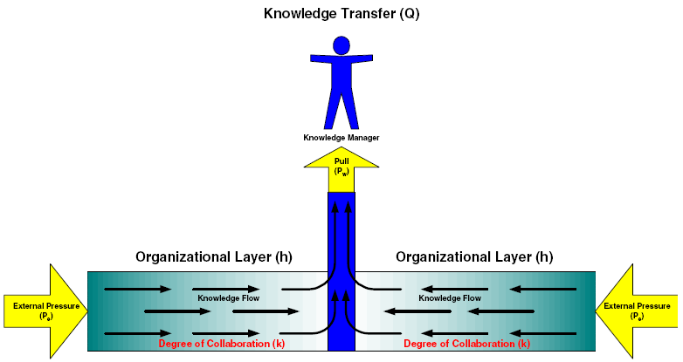

Figure 6 “Organization KT model” (Source: Ilovici & Han, 2003)

Further there are factors which affect knowledge flow rate. In their research Ilovici & Han, (2003) found five main factors (partly included in ) which knowledge manager needs to be aware of:

1. The degree of collaboration that exists within the organization. If the culture of the organization is to collaborate, knowledge transfer can occur. If the culture is to maintain independent silos of knowledge, then knowledge transfer will be minimal. Increasing conductivity (collaboration) increases the knowledge transfer rate.

2. The degree to which an organization’s strategy relies upon knowledge transfer as a measure of success.

3. The manager’s effort to pull information through the organization.

4. The type of knowledge being transferred. Codified knowledge will transfer rapidly, especially if it is available on the organization’s Intranet. Tacit knowledge, existing primarily in the brains of people, would transfer slowly.

5. The organizational layer through which knowledge transfer occurs (Ilovici & Han, 2003).

According to the knowledge flow model, each person is a basic unit of resister/conductor, each group is also a unit of resistor/conductor. An optimum combination of sequential and/or parallel connection will maximize the efficiency of the knowledge flow. There is no unique solution as best one. The combination should also be modified to fit the requirements in the life cycle of the project. The key is to put right people to right positions at the right time (Ilovici & Han, 2003).

There are in general three steps which manager needs to take in order to create new knowledge transfer channel. First, constrains of a project/task need to be established. Basically there are three constrains – amounts of money (budget) available for a task/project, amount of people available a for task/project, and time which is given to complete a task/project.

As Ilovici & Han (2003) explains, second step then is to find out what kind of knowledge is necessary to complete a task/project. It can be simple information, expertise, skills, or combination of them. Ilovici & Han (2003) note that at this stage manager should pull all codified knowledge which is related to specific task/project and put it in a package which will then be knowledge basis for team which will then deal with a task/project.

Accordingly final, third step, is to put together team which will deal with a task/project. Depending on constrains of a task/project the right people can be found. As it is mentioned before it is not always about the smartest and skilful people, it is about ‘right people to right positions at the right time’ (Ilovici & Han, 2003)

### 3.4.3. Learn-Forget model

Tukel et al (2008) focuses on specific characteristic of knowledge – its connection with time. There are two things they consider. First ‘the time required to perform a task decreases as a worker gains experience/knowledge’ (Tukel et al, 2008). And second they take into account the fact that knowledge fades in time; individuals are not only learning new things but they are also forgetting some.

In is illustrated the effect of learning and its effect. On horizontal axis are projected which time the task is done. On vertical axis is time which is needed to do the task proportionally to the time which is needed to do the task for first time. And then three tasks with different learning capacity are presented. ‘0.95’ mean that time needed to perform task is decreasing by 5%. It must be noted that it is rough estimation, because originally in Tukel et al (2008) research rate of decline has been considered also (see Appendix 3).

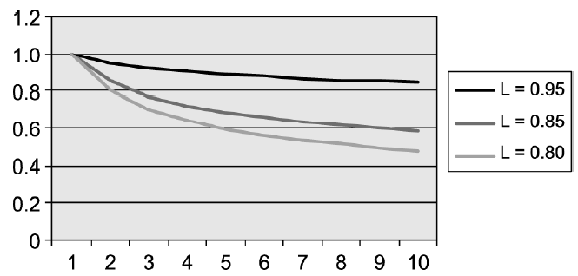

Figure 7 “Learning rate effect on execution time” (Source: Tukel et al, 2008)

While learning takes place during the execution of a task some of this learning can be lost by the time a similar task is started. As a matter of fact, the learning can be lost if the task is interrupted. The amount of learning which will be lost is called forgetting, and depends on the dormant time and the effectiveness of the knowledge transfer tool being used (Tukel et al, 2008).

Accordingly forgetting concept also were investigated, calculated and illustrated () by Tukel et al (2008) to show both sides of knowledge and time correlation. In is illustrated how knowledge forgetting take place. is not based on actual data it is just illustrative example from Tukel et al (2008) project. The meaning of axis is the same as in and clear learning curve is presented for easier understanding.

The presented idea in is that if person does task one time and than for a time amount equivalent to time needed to do task 5 times does not actually perform the task then time needed to perform task for second time will be more (t3) than it would take if person would perform task for second time right after first one (t2). The reality is that as more time passes less effect there is from person’s previous experience.

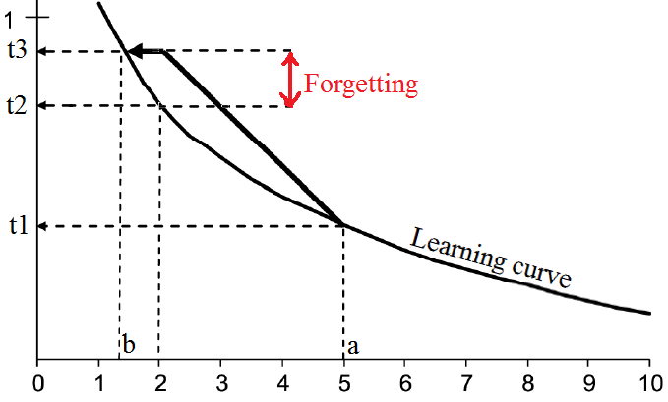

Figure 8 “Impact of forgetting” (Source: Tukel et al, 2008)

It is managers’ obligation to work with learning and forgetting. They need to investigate various tools to promote learning and inhibit forgetting. Since the main resource consumed in the execution of projects is often the skills of personnel, the focus should be on the assignment of personnel to teams and the assignment of individuals to tasks, in a way to promote learning. Furthermore, making close-out documents available to all personnel can be used to inhibit forgetting (Tukel et al, 2008).

Although Tukel et al (2008) does not provide clear model of knowledge transfer they cover very important aspects which any knowledge transfer manager or practitioner should consider. Besides that Tukel et al (2008) suggest methods how learn-forget process can be balanced.

A project manager should enable people to learn as much as they can while doing a task and documenting it. Learning without forgetting obviously improves performance of a worker. However, the critical question is how large this improvement is and whether it is worth spending time recording the knowledge to observe this improvement. This study presents strong evidence of benefits of doing this in the form of preparing close-out (process report) documents or other knowledge transfer tools (Tukel et al, 2008).

The learn-forget process/model clearly demonstrated the magnitude of the differences between slow and faster learning, and the differences between more and less forgetting. It also indicates the importance of integrating knowledge transfer tools, which maximize the impact of learning on successive projects and minimizes forgetting due to dormant times (Tukel et al, 2008).

Another valid suggestion Tukel et al (2008) gives to companies which are research and development (R&D) oriented or project-oriented. Usually such firms perform their processes in stages. Further there are people who evaluate results after each stage and decide if it is in companies best interest to proceed to next stage or stop process and re-allocate resources to more promising processes. These people are usually referred to as “gate keepers”.

Tukel et al (2008) believe that during these stages “gate keepers” should consider the learning and forgetting aspects. Thus one of the criteria in this process should be how much learning can be created and utilized in future work, and although the direct benefits of a particular project deliverable might not be great, the experience and the amount of learning might be so beneficial that the gate keepers might decide to pass it to the next gate’ Tukel et al, 2008).

### 3.4.4. Liyanage et al (2009) model

Liyanage et al (2009) considers that KT is not knowledge transfer in itself. They refer to knowledge transfer as ‘different stages of knowledge transformation’ (Liyanage et al, 2009). They also discuss that various factors which influence KT can be either positive or in other cases also negative. Either way, the basics of knowledge transfer are discussed by same stages and positive or negative aspects simply enhance or delay the transition from one stage to the next one.

First Liyanage et al (2009) discusses two separate processes of knowledge transfer and later they combine them and put into one model. First process is practical knowledge creation and other is transfer itself. In Liyanage et al (2009) show the pyramid of stages through which expertise is achieved.

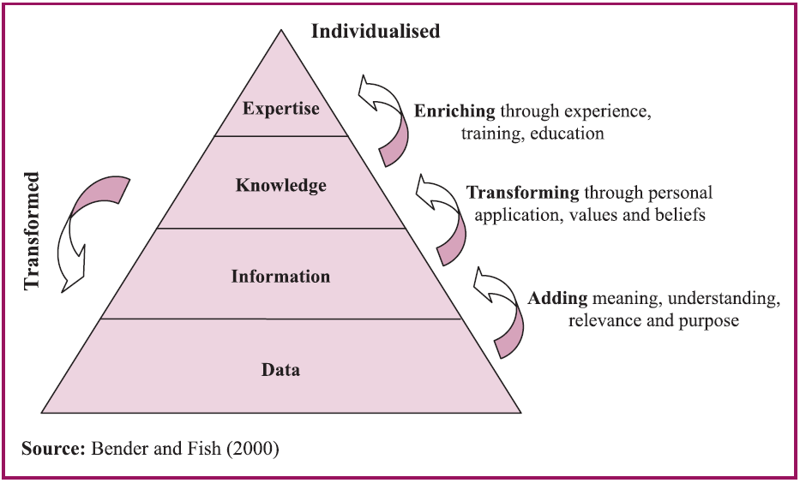

Figure 9 “Knowledge hierarchy” (Source: Liyanage et al, 2009)

Expertise is specialized, deep knowledge and understanding in a certain field, which is far above average. It is gained through experience, training and education and is built up from scratch over a long period of time by an individual and importantly remains with that person (Bender and Fish, 2000, cited in Liyanage et al, 2009).

As often KT process is seen as one way channel Liyanage et al (2009) discuss two way flow in KT channel. And in order to achieve such a flow they introduce new process called externalization. By externalization is meant process through which experience of using new knowledge is communicated back to the source and therefore through feedback loop ‘it can evidently lead to enhanced collaboration and relations’ (Liyanage et al, 2009).

Accordingly in there is introduced external link between source and receiver. In previous process () is adapted to organization’s environment and additional features are added. First, in order to adapt first process in organization – awareness, acquisition, transformation, association, and application stages are included. Each of them serves as a tool to go from one stage to the next one. Awareness is needed to understand that certain knowledge is needed, therefore first stage can take place – finding the necessary data. Further through acquisition data is putted together in relevant blocks thus reaching information stage. One then can analyze information, find practical use for it and thus transform it to knowledge. In order to get the best benefit out of newly created knowledge it needs to be associated with best places for application. When those places are found then expertise level is reached, or in organizations model ‘useful’ knowledge is created. The only thing left then is to actually use this ‘useful’ knowledge and that process in model is referred to as application.

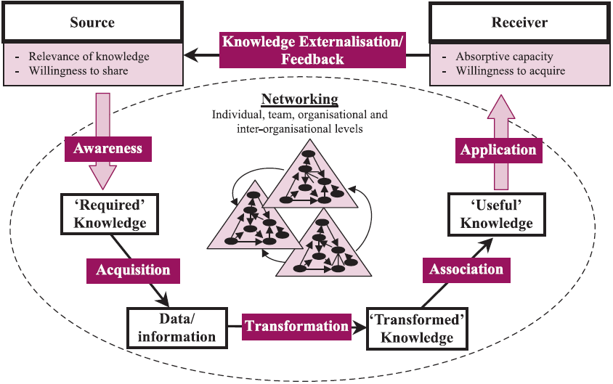

Figure 10 “KT – a process model” (Source: Liyanage et al, 2009)

In organizations KT model another element is introduced – networking. Liyanage et al (2009) have found through their research that ‘for knowledge transfer mechanisms to be effective, close, tight interactions between individuals, teams and organizations is critical in organizations’ (Liyanage et al, 2009).

Networks facilitate this tight collaboration between and across entities, i.e. between individuals, individuals to teams, between teams, across teams, teams to organization, between organizations, etc. Such tight collaborations subsequently allow organizations to generate and coordinate acquired knowledge more efficiently (Liyanage et al, 2009).

Besides networking other two elements are considered by Liyanage et al (2009) as relevant factors of KT. One element is dimensions of context. By that authors mean that ‘individuals and organizations share several dimensions of contexts, e.g. culture, capabilities, skills, management styles, politics, technology, etc.; and each of these dimensions can influence the knowledge transfer process either positively or negatively’ (Liyanage et al, 2009). And another factor is evaluation of KT by assessing its quality and accuracy.

Unless organizations attempt to assess the accuracy and quality of the knowledge acquired, they will not be in a position to identify the success and effectiveness of the knowledge transfer process. This will not only result in failing to recognize the impact it made on the organizations and its practices, but will also result in repeating similar mistakes in future knowledge transfer practices (Liyanage, 2009).

### 3.4.5. Frank & Ribeiro (2012) model

Frank & Ribeiro (2012) have made big and valuable contribution to academic field of KT. They have made extensive literature research in the field. Through their research they have developed model comprehensive model consisting from 5 phases. All phases in one or another way have been described already in some of previous models in this section. However the explanation of each phase in Frank & Ribeiro (2012) work is very precise and more importantly is based on many other experts’ in field opinions. Their model is in form of table () containing lot of information. Besides, table can be used to get ideas where certain phases can be studied more deeply.

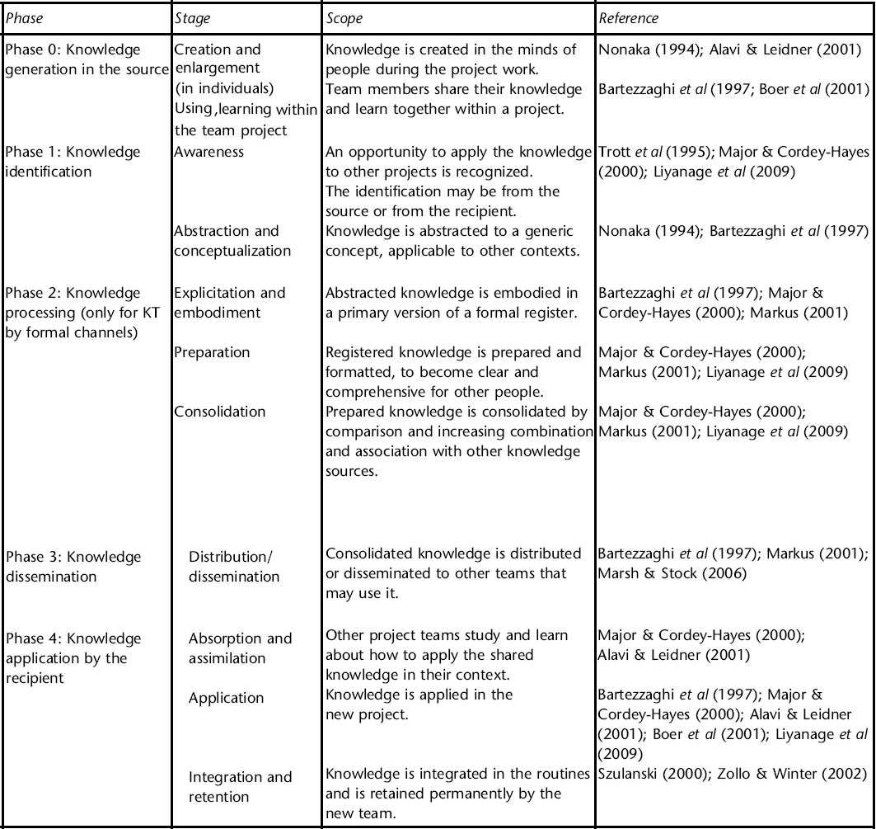

Figure 11 “KT between NPD projects” (Source: Frank & Ribeiro, 2012)

Phase 0: knowledge generation in the source

Before the beginning of the KT process, there is knowledge production or generation in the source. This generation typically happens in the context of individuals and within a project team. This phase can be deployed in stages such as individual’s enlargement of knowledge (or individual’s knowledge creation), and sharing of tacit knowledge among team members during the work routines (Nonaka, 1994; Alavi & Leidner, 2001, cited in Frank & Ribeiro, 2012).

Phase 1: knowledge identification

This phase begins with emerging new ideas from previous new development (NPD) projects. Knowledge seed from previous NPD are recognized in one of two ways – either old NPD team recognizes knowledge which can be valuable in future and identify transfer opportunity or new NPD searching from previous NPD projects recognizes knowledge which can be used in new project. Further knowledge is captured and documented or associated in any other valid way (Zollo & Winter, 2002; Trott et al, 1995; Liyanage et al, 2009, cited in Frank & Ribeiro, 2012).

Phase 2: knowledge processing

At his phase found knowledge is extracted, processed and then transferred in one of two ways – formal or informal. Formal is in case of explicit and articulated knowledge in documents; and informal is when it is context-specific and situated knowledge (usually tacit). After identifying which way of transfer fit the best knowledge should be consolidated in order to take form in which knowledge can be transferred without losing its true meaning. That is usually done either by finding more information and knowledge with which transferrable knowledge can be associated and/or by reinterpreting the knowledge in better form. In other literature sources different terms (interrelation – Abou-Zeid, 2005;knowledge translation and interpretation – Major & Cordey-Hayes, 2000) are used to describe this process however meaning is the same – concept of knowledge must be made clearer (Szulanski, 2000; Alavi & Leidner, 2001; Liyanage et al, 2009, cited in Frank & Ribeiro, 2012)

Phase 3: knowledge dissemination

This phase is trying to make knowledge accessible to team members of existing NPD and possible future NPD project members. This is the stage where ready formed new knowledge actually is transferred to its new receiver. It usually happens in some form of communication. Most popular form of communication is of knowledge is written (either physically – handbooks, books, documents; or virtual – corporate portals, websites, KM systems), however it can also be verbal or even through shared experience when knowledge transfer involves tasks which must be physically demonstrated. Regardless of communication type at this phase proper channels for specific knowledge transfer are found and/or established and thus needed knowledge is made easily accessible to other people (Bartezzaghi et al, 1997;Szulanski, 2000;Lynn et al, 2000, cited in Frank & Ribeiro, 2012).

Phase 4: knowledge application in the recipient

At this phase knowledge is putted in practice in new context. It is crucial at this phase that individuals putting in use new knowledge have enough absorptive capacity to capture true meaning of knowledge and have enough skills to reuse the knowledge in the most fitting way. If individuals have studied knowledge and knows and understands its sources than this phase can be successfully managed and as a result new knowledge should be added to organizational knowledge available for other individuals to use it in future (Szulanski, 2000; Cohen & Levinthal, 1990; Nonaka, 1994, cited in Frank & Ribeiro, 2012).

### 3.4.6. Guru-Shishya model

Shrowty (1996) has absolutely different understanding of knowledge transfer and channels it uses. It is based on very basic idea of master and apprentice. In this model basically there are just two channels – channel of evolution and channel of adoption (). Through evolution channel the expert of certain field learns how to be a master; and through adoption channel apprentice receives all the knowledge from master.

Similarly to previous model this has been adapted for engineering technical knowledge transfer from mother plant to a new site. Guru-Shishya idea has been used in Guldhar Technology Transfer (GTT) project. GTT is a project which aims at many new shop floor management techniques to be introduced at the Guldhar factory of Godfrey Philips (India’s second largest cigarette maker).

The structure for knowledge transfer is quite simple in this model. Through face to face communication experts give workers professional (in Noanaka (1994) explicit) and spiritual ( in Nonala (1994) tacit) knowledge through teaching and interacting. Further there is structure which supervise and support this interaction – Catalytic Agent ’X’ (CAX).

CAX Group –voluntary group cutting across all levels with no hierarchical barriers. It undertook the responsibility to take active part in the PD (Personality Development) programs by being physically present by rotation, sharing the stones of the programs with other CAX members, following up on the outputs, solving problems irrespective of their area of work, etc (Shrowty, 1996).

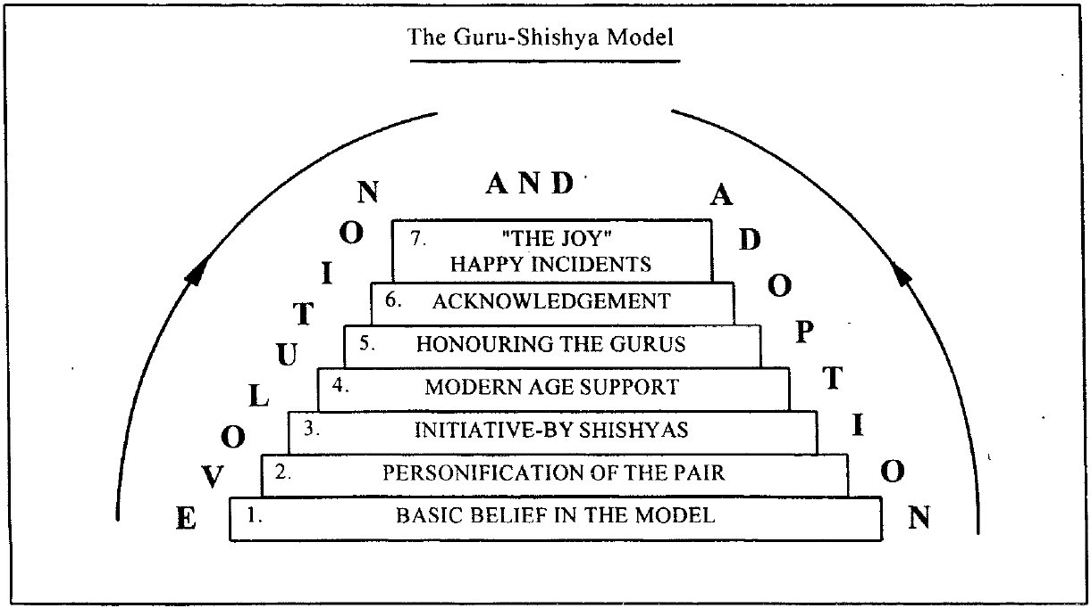

Figure 12 “The Guru-Shishya model” (Source: Shrowty, 1996)

A harmonious blend of the ’spiritual values based knowledge’ and the ’professional skills’ should lead to happiness and fulfillment of our role in life. Today’s accomplished film stars, or for that matter sportsmen derived inspiration from their role models. And it is eminently clear that Mahatma Gandhi, Martin Luther King, Swami Vivekananda and other greats have created other greats without being anywhere near those who learnt from them. It is due to the historical fact that the gurus or rishis were in total command of their disciples, and imparted to them the highest possible in the professional fields of war craft, economics, political diplomacy, etc., and founded them solidly on values. The disciples on their part had unquestionable faith in the stature and capabilities of their gurus. The discipline in the ashrams was followed meticulously for all the twenty-four hours of a day. The parents of the disciples had implicit faith in the gurus, and it was taken for granted that on graduating from these ashrams the products will be the fittest to lead their future life.

Some might argue that this rather philosophical approach will not work so well in most of western world and Shrowty (1996) does not argue against that. He presented the model as example which some might find useful while others not. In fact Shrowty (1996) do even admit that while adapting knowledge transfer methods from other cultures ‘some organizations have succeeded, while others have miserably failes’ (Shrowty, 1996).

The key is to find your own method suited to your needs, sometimes adopoted from elsewhere but tailored to answer our own social, psychological and economic scenario (Shrowty, 1996). And that is exactly what this project agrees with and therefore tries to find general understanding of RKT which further everybody can adapt and tailor to their needs.

## 3.5. Reverse knowledge transfer

At first it seems that RKT should be very similar process to KT. In fact, one might even say that RKT is the same system as KT system except that knowledge flow is in other direction. In reality situation is quite different. While there are many similarities between KT and RKT the latter is more complicated in several ways.

According to Yang et al. (2008, p. 5), reverse transfer is much more difficult than conventional transfer because both are based on different transfer logics. While conventional transfer is more of a ‘teaching’ process, reverse transfer is a ‘persuading’ process. Indeed, in conventional knowledge transfer, the subsidiary is often obliged to replicate knowledge from the parent through the use of control mechanisms. On the other hand, subsidiaries are motivated to transfer knowledge to their parent firm because it could strengthen their strategic position in the whole organization, and they have to persuade the parent firm that its knowledge can fit the parent’s needs (Yang et al, 2008, cited in Narula & Michel, 2009.

Despite the fact that RKT is more difficult to understand and examine it is very important to do so, because either we want it or not but it is very important process of nowadays business and social world. Therefore it is better to understand it and use its benefits instead of loosing because of not knowing.

Frost (2001) states that foreign direct investment (FDI) decisions nowadays are partially ‘driven by the desire to gain knowledge’ (Frost, 2001, cited in McGuiness et al., 2013). Further, McGuiness et al. (2013) state that RKT is ‘an important consideration in the MNE’s search for competitive advantage’ (McGuiness et al, 2013). All that indicates that not only researchers but also companies and individuals start to understand that there not only difference between KT and RKT but also urgent need to learn how to practice RKT and get most benefit out of it.

In a way it is not even effective to talk about KT and RKT separately, because they are very closely linked and cannot exist without each other. McGuiness et al. (2013) have made research on multinational enterprises (MNE) looking on KT aspects and they found that both processes, RK and RKT, usually takes place in organizations and depending on extent to which each process is present organizations can be divided into four different groups (). McGuiness et al. (2013) in their research were looking on MNE and their subsidiaries, and knowledge flow between them. More specifically they were looking on MNE knowledge inflow and outflow.

Figure 13 “Subsidiary strategic mandates” (Source: McGuiness et al, 2013)

Further McGuiness et al. (2013) also through their research found and identified many elements which are important influencers of RKT. Exploring various aspects of MNE and subsidiary connections research found ‘that RKT phenomena can be characterised by 18 variables, which can be grouped under the four main constructs of the potential to create knowledge, relevance of the knowledge created, ability to reverse transfer new knowledge and motivation to reverse transfer new knowledge’ (McGuiness et al., 2013).

Potential to create knowledge:

1. Prior knowledge of the senior management team (SMT)
2. Talent management practices within the subsidiary
3. Headquarters-subsidiary decentralization
4. Innovative capacity of host country
5. Local embeddedness of the subsidiary
6. Proportion of local nationals within the SMT

Relevance of knowledge:

1. Degree of centralization
2. Organizational similarity
3. Cultural similarity

Ability to transfer new knowledge:

1. SMT’s current ability to reverse transfer new knowledge
2. Functionality of performance appraisal and training routines
3. Formal integrative mechanisms
4. Intensity of subsidiary-parent communication
5. Availability of slack resources

Motivation to reverse transfer new knowledge:

1. SMT’s current motivation to reverse transfer new knowledge
2. Functionality of performance-based compensation and merit-based promotion schemes
3. Informal integrative mechanisms
4. Managing Director’s (MD) bonus structure (McGuiness et al, 2013)

McGuiness et al. (2013) research discusses and reflects on each of 18 aspects (see Appendix 4) building detailed picture of RKT phenomena. It must be noted that those 18 aspects are influencers which can work both ways; they can either influence RKT in positive way or negative. This list of many factors once again proves what Yang et al. (2008) already indicated – RKT is very difficult and complicated transfer.

That is why other scholars try to start with broader view and not get into so detailed understanding of RKT. An example, Tavani et al. (2012) have found that some factors are more significant than others. Willingness from both parties (giver and receiver) to engage in RKT and socialization mechanisms between parties are considered by Tavani et al. (2012) as ‘the most significant determinants of the extent of RKT’ (Tavani et al., 2012). It is also very valuable that Tavani et al. (2012) findings were based on Knowledge Intensive Business Services (KIBS). As mostly researches in KT field as such are with focus on manufacturing it is of high value that Tavani et al. (2012) have distinguished between manufacturing sector and KIBS and further found that there are significant differences how different factors influence KT in one or another sector. While influencing factors are still similar in both transfer modes they can bring different effects. An example it was found that subsidiaries external embeddedness has negative influence on RKT in KIBS sector while in manufacturing sector it has opposite effect.

Analysis indicates that willingness and socialization mechanisms are the most significant determinants of the extent of RKT. Further, the impacts of shared values and internal embeddedness are mediated by subsidiary willingness. The results also highlight the significant association between socialization mechanisms and internal embeddedness. Contrary to our expectation, external embeddedness has a negative influence on the extent of RKT(Tavani et al., 2012).

Besides differences in sectors and many different KT influencers which can be grouped in different ways, more broad or detailed, Narula & Michel (2009) points out another aspect of RKT – it can take place on several levels. Narula & Michel (2009) explain that there are three levels at which RKT can take place:

1. From local environment of the host country to the MNE’s subsidiary (what Tavani et al. (2012) refers to as external embeddedness)
2. From the MNE’s subsidiary to the parent company (traditional understanding of RKT)
3. From the parent company to the local environment of the country of origin (Narula & Michel, 2009).

Third level is not often researched and is developed by Narula & Michel (2009) as level where organizational and industry policies can be and, in fact, should be discussed. Narula & Michel (2009) in their paper stress that innovation and development is closely connected with RKT as well as traditional KT, therefore it is time to discuss them at new level.

# 4.0. Analysis

This section is divided in two parts. In first part models presented in previous section will be dissembled. In that way KT main channels can be found. In KT models there are different channels and further also many aspects, influencers, and factors are connected with those channels. It is important to find channels which connect knowledge givers and knowledge receivers and then investigate how knowledge flow can be turned in other direction. While many studies can be found in KT field, and also some in RKT, ‘none of those studies explicitly focus on the benefit of those flows to headquarters’ (Feng & Ying, 2011). Since RKT by various scholars is associated with competitive advantage of organization (Argote & Ingram, 2000; Wang et al., 2004;Feng & Ying, 2011) it is necessary to explore this phenomena.

As RKT firstly were explored in connection with technology based industries there are already examples from real life and real businesses where RKT is used and improving company’s performance. Wang et al. (2004) have found have found proof that MNC benefit from RKT from their subsidiaries in China, Ambos et al. (2006) found that there is many benefits from RKT however parent companies fail to capture those benefits because of lack of knowledge ‘how to’ and lack of initiative.

First of all it can be started by looking on what kind of knowledge companies might transfer in reverse flow. Ambos et al. (2006) found that ‘marketing know-how is the most frequently transferred knowledge, followed by distribution know-how and technological know-how’ (Ambos et al, 2006). Those are valuable findings which finally found that companies nowadays are beyond associating RKT with just technology. It means that benefits from RKT can be achieved in any industry. From one side it creates need to investigate RKT associated with each industry, however in this project that will be left for future investigators. In this thesis general understanding is created and it is simply very valuable that based on Ambos et al (2006) it can be said that basic understanding of RKT can be beneficial to all industries. After industries relevance has been established it can be proceeded with channels themselves.

Ambos et al (2006) findings indicate that channel length and wideness is also important aspects. Ambos et al (2006) found that channels which are connecting knowledge inflow from integrated players[1] bring more benefit to headquarters than from local implementers (length of channel); and also benefit from global innovators is more than from local innovators (width of channel). As differences were not significant it can only be noted that there are longer/shorter and wider/narrower channel. For general understanding there is no need to investigate shapes of channels in more detail thus it can be proceeded to other aspects of channels.

While previous aspect was dealing with question ‘from who?’ next question can be ‘from where?’ Ambos et al (2006) found in their research that in terms of RKT flow ‘headquarters profit more from their subsidiaries in highly developed ‘lead’ countries than from those which are lagging behind’ (Ambos et al, 2006).

Before specific channels get identified there are some more aspects which describe channels as such. One aspect is that channel needs to have some kind of appearance, either it is physical or virtual. It is often in literature referred to as communication channels (Liyanage, 2009; Yali & Taozhen, 2011; Watson & Hewett, 2006) and it can have different physical expressions like face-to-face communication, e-mail, social network of organization, meetings, telephone etc. Those are ways how knowledge can flow between two parties. It is now important to identify those parties between which KT flow takes place.

## 4.1. Finding channels

If we see knowledge as advanced form of information (Liyanage et al, 2009) then knowledge transfer can happen in the same channels as information transfer. Although knowledge transfer is more complicated it must start somewhere. Very likely knowledge transfer starts in information transfer channels and then if needed it develops and adapts, and maybe create new channels of transfer. Sun & Scott (2005) argues that there are 16 information transfer channels (paths, as in Sun & Scott, 2005) through which information is passed ().

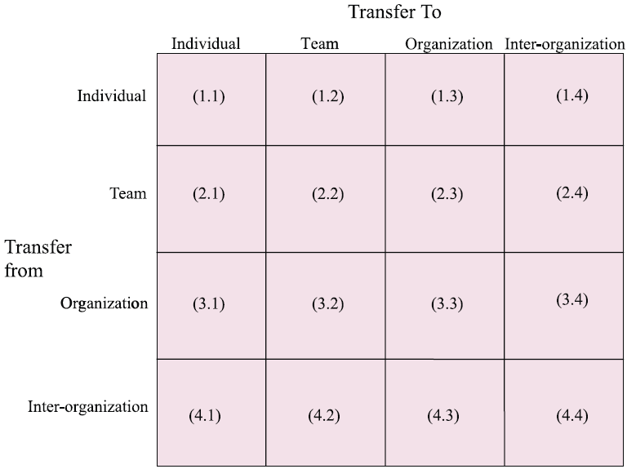

Figure 14 “Paths of information transfer in organization” (Source: Sun & Scott, 2005)

Most of 16 channels have been recognized and discussed in various researches in connection with KT. After all Sun & Scott (2005) 16 channels cover all connections there is. Even though Argote & McGrath (1993) say that besides people (whether it be individual, team or organization) there are also tools and tasks where knowledge can be in Sun & Scott (2005) understanding aspects as tools and tasks are covered under ‘organization’. After all Argote & McGrath (1993) describe tools as technologies of company and tasks as company’s goals and intentions, thus tools and tasks is something organization has.

Sun & Scott (2005) argue that in reality it is very rare that information and knowledge is transferred skipping a level, an example individual to organization or organization to individual, and even if it does it is in unique pattern. Therefore they consider traditional path – individual to team to organization to inter-organization and other way around – as main pattern how information and knowledge is transferred.

At this point each channel can be verified by giving according example of KT from other research findings. Bellow are listed 6 KT channel examples reflecting on 6 traditional information/knowledge paths (cells (1,2),(2,3),(3,4), (4,3),(3,2),(2,1) from ) from Sun & Scott (2005) research.

1. Individual to team (cell (1,2) from )

In Frank & Ribeiro (2012) research Phase 1 (Figure 11) is described process of knowledge identification which includes conceptualization of knowledge. When one create generic concept it becomes applicable to other contexts for all team and even other teams. It is good example showing how knowledge is transferred from individual to team (cell (1,2) from ). Tukel et al (2008) in their research mentioned that when team members have trust between themselves and motivation then they automatically share their knowledge to the team in order to achieve goals. Thus it is clear that one of main KT channels is individual to team.

2. Team to individual (cell (2,1) from )

It might seem that team to individual and individual to team is the same channel with reverse flow of knowledge, but it must be noted that it is not. More in detail the difference between KT and RKT will be discussed later and first KT must be discussed till the end.

Team to individual channel is through which team knowledge is passed to individual. Roberts (2000) call this process ‘show-how’ which is emerging from ‘know-how’. In other words, team members who already know how to perform certain tasks or how work is organized in certain team show it and explain to individual team member. Or other example is when individual which is part of team automatically absorbs knowledge by integrating and interacting with team. Even from psychology can be found examples where individuals learn from team. In Randall et al (2011) research it was found that not only individuals absorb knowledge from team but depending on their skills they can bond with team and create team mental models which further makes team even stronger as unit.

3. Team to organization (cell (2,3) from )

One example is from Ilovici & Han (2003) model where it is showed how manager (organization) pulls the knowledge from organizational layer (teams) and further uses it fro decision making, further distribution or other purposes. It also indicates that knowledge giver not always freely gives away knowledge and therefore it must be pulled. Other academics also have found that based on fact that knowledge is often associated with power ‘employees who master knowledge tend not easily to share knowledge or skills with others’ (Hayes & Walsham, 2000, cited in Jiang & Zhang, 2011).

However there are also other examples which verify existence of ‘team to organization’ channel and where knowledge is more willingly given. One of such example is theoretical model from Liyanage et al (2009) research where it is illustrated how employees through multiple-step process create knowledge which is adapted to organizational needs. Such process cannot be made by one individual thus it can be assumed that it is work of a team. Furthermore Tukel et al (2008) talks a lot about learning and it turns out that team is creating more knowledge and works more efficient when organization enables learning to occur. In Tukel et al (2008) case knowledge is transferred from team to organization not through pulling or forcing but through encouraging and supporting.

4. Organization to team (cell (3,2) from )

Tukel et al (2008) research also proves existence of ‘organization to team’ channel when discussing how learning organization. Many other scholars also have discussed learning organization and benefits for knowledge creation and competitive advantage when learning is cultivated (Levin, 2000; Soosay & Hyland, 2008;Ho, 1999) and that is prove for successful existence of ‘organization to team’ KT channel.

Even in Wang et al (2004) research where mainly transfer between parent company and subsidiary is discussed such aspects as learning and training clearly are determinants of teams and employees. It leads to think that even when organization receives knowledge from another organization then at some point knowledge must be transferred to recipient organizations’ teams thus enabling channel ‘organization to team’. Another example is from Frank & Ribeiro (2012) study where in Phase 3 (Figure 11) is described that knowledge which organization has acquired from their researches and activities after consolidation (Phase 2) can be distributes to other teams, which again reflects on existence of ‘organization to team’ channel.

5. Organization to inter-organization (cell (3,4) from )

When talking about RKT in general scholars usually refer to ‘subsidiary to parent’ knowledge transfer or in Sun & Scott (2005) called ‘organization to inter-organization’ path. It is most common channel to research in connection with RKT. McGuiness et al (2013) in their recent studies not only focused on ‘organization to inter-organization’ knowledge transfer, but they even developed formula and calculated intensity of RKT from subsidiaries of researched company. In other research done by Tavani et al (2012) researchers where exploring how different characteristics influence RKT from subsidiaries to parent company. Interestingly that Tavani et al (2012) similar to others who research RKT field (McGuiness et al, 2013; Yang & Chen, 2011; Narula & Michel, 2009) refers to RKT as it is different from KT in just one aspect – knowledge instead of going from parent to subsidiary goes from subsidiary to parent. Narula & Michel (2009) even refer to ‘subsidiary to parent’ flow as phenomena yet they do not discuss any specific differences which distinguishes RKT from KT. At this moment it is however important to notice that there are several researchers which identify and point out that ‘organization to inter-organization’ channel exists and is of growing interest (Narula & Michel, 2009).

6. Inter-organization to organization (cell (4,3) from )

This channel is the most popular channel discussed in literature of KT. Although different variations of KT are discussed in literature, related to place, people, and ownership (Liyanage et al, 2009), most researches in KT field focus on KT based on ownership. Researchers believe that there is knowledge channel from inter-organization (parent company) to organization (subsidiary) and accordingly research it with great interest, because it is proved that successful knowledge transfer is factor of success, higher performance and competitive advantage (Nonaka, 1994; Argote & Ingram, 2000; Szulanksi, 1996). As there are more researchers focusing on this channel than other channels there are also more findings and different variations of this channel in literature. ChunYu (2011) an example discusses value chain as channel through which knowledge is delivered to partner companies, while Watson & Hewett (2006) focused in their study on consulting company putting accent on differences between industries. Another example is Lin et al (2005) and their suggestion that depending on various aspects knowledge sender and receiver can also loose from KT in certain cases. Lin et al (2005) describe examples in which each side (knowledge sender and receiver) either gain or lose from KT ().

As it can be found in literature inter-organization to organization is common KT channel for scholars to research thus various findings focusing on different aspects and factors can be found.

## 4.2. Reversing channels

Main channels of KT have been found and described and now it is time to trying to reverse them. At this stage it is hard to base this process of reversion on other examples because there are no examples. Literature which describes RKT refers to ‘organization to inter-organization’ as RKT channel and it is assumed that it is reverse version of traditional ‘inter-organization to organization’ KT channel. In this thesis it is argued that both of these channels are different and yet both of them can be reversed just like other four channels.

Taking first channel, individual to team, and trying to reverse first reflex is to think that ‘team to individual’ channel is already reverse version, however if one looks deeper it can be found that there is difference. When individual sends knowledge to team it is through creating concepts, through giving ideas. In ‘team to individual’ channel different knowledge is flowing; knowledge about existing concepts and their applications, experience from previous works, and overall working culture in team. If then in ‘individual to team’ channel one enables flow in opposite direction it would mean that feedback about concept is going back to individual and comments on ideas. And if in ‘team to individual’ channel one enables opposite flow then individual would give suggestions on team work, give advices from experience, would comment on previous research results and give input from his/her expertise.

All those processes actually take place in organizations. It is nothing new that people give feedback, share experience, give advices, and improve existing results; however in some companies it happens more than in others. If companies would understand that these feedbacks, advices and inputs can become systematic part of RKT and increase firm’s performance and competitiveness then they would stimulate it. Once again, it is not a new discovery it is just looking differently on already existing processes.

Further there are ‘team to organization’ and ‘organization to team’ channels. In former reverse flow would include organization giving the team knowledge, training and feedback in area from which current team’s project is. If organization follows the progress of project then they can give valuable feedback and give additional knowledge related to tasks as project progress. Total Learning Organizations (TLO) already has this practice (Ho, 1999) in their companies and it works for best. However there are still many organizations which have not adapted this thinking or do not even know about it. That is one more reason to stress the benefits which company can gain by learning about these processes.

Other, organization to team, flow in opposite direction would include team constantly giving experience reports and information about progress and challenges. If team will do it then organization can make better decisions (Choo, 1996) because correct information is the most important element when organization makes decisions. Choo (1996) describes that there is whole cycle how information is interpreted and analyzed before it can be used for decision making. Thus it is very important to have valid information from teams in order to make decisions which are in everybody’s interest.

Last two channels are ‘inter-organization to organization’ and ‘organization to inter-organization’ and again it must be reminded that those are two different channels. In ‘inter-organization to organization’ opposite knowledge flow is experience and knowledge accumulated by organization from its embeddedness in their environment (Tavani et al, 2012; Millar & Choi, 2009; Xiaoying, J.F. & Connerley, M.L., 2013). In other words, each organization has its own environment, experiences and culture from which other organizations might learn something useful. If organization recognize aspects from their environment and culture which are relevant for inter-organization in order to adapt the knowledge they are sending to organization than they need to send this information. By providing important information relevant to knowledge channel between involved organizations the knowledge channel itself can be modified and made more efficient and it will result in better collaboration between organizations.

Last channel, organization to inter-organization, is the closest one to actual reverse flow of existing channel. Its flow is very similar to the one discussed in previous paragraph yet it is mainly due to incorrect use of terms in literature. In reality knowledge flow from organization to inter-organization includes design and product development information (in case of R&D subsidiaries), and consultative analysis results (in case of Consultancy subsidiaries); which both are direct knowledge flow not reverse as literature of RKT suggests (McGuiness et al, 2013; Tavani et al, 2012). As it is just another channel of KT and it can still have reverse flow of knowledge just like other five channels. As in this channel inter-organization is receiving information and knowledge about either product or service development they can in reverse flow send lot of supportive information and knowledge about expected product/service and their purpose. An example, they can give knowledge about product target market, marketing ideas, service details and specifics – all that information and knowledge would help organization to deliver better knowledge and product from their side. However another reason why RKT in literature is not discussed in such manner is probably because it is not very popular that such knowledge flow takes place. Knowledge sender in such a case might risk being in position where knowledge receiver gains advantage and sender looses it (, box IV). Lin et al (2005) call such a situation Receiver-advantage and in such a case receiver has more useful knowledge and information then knowledge sender.

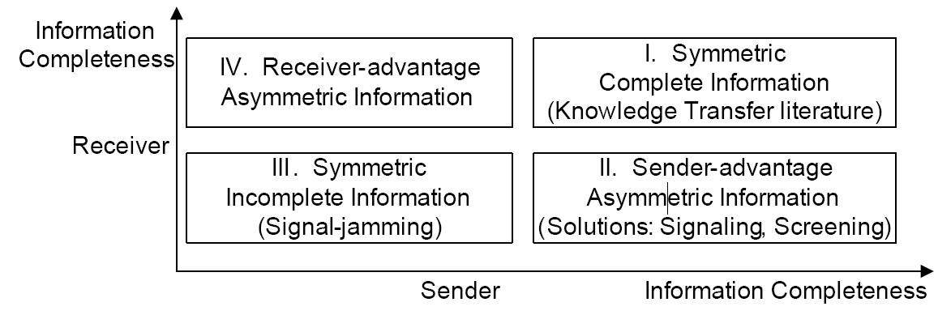

Figure 15 “Information structures in KT” (Source: Lin et al, 2005)

And it is understandable if inter-organization (knowledge sender in case of reverse flow) is reluctant to give their knowledge. Given that nowadays market is very competitive companies do not want to give away their knowledge easily. Nevertheless if inter-organization and organization gain mutual trust, then they both can benefit (, box I) and improve their performance as well as competitive advantage as a team.

After reverse flows of all channels have been found and presented research can continue with forming understanding of RKT. While it is very important to understand each channel it is just as important to understand overall benefits of reversing KT channels as such. There is vast amount of literature proving the benefits of KT, explaining and proving how KT raises competitive advantage and performance of companies. Even Organization for Economic Co-operation and Development (OECD) stresses the importance of knowledge transfer and knowledge management’s importance in business sector (OECD, 2004). It is therefore important to explain what can be done in order to benefit from RKT as well. Next section will address this issue.

## 4.3. Result

In previous sections six channels of KT were found and transferred however that is not the final result intended in this thesis. Idea is to create understanding of RKT and although finding and describing six channels and reverse knowledge flow in them is good result it does not represent all the understanding which this project is planning to give. Although main analysis part has been conducted already in this part still some results will be created. As mentioned in methodology of this project the approach in this thesis is actors view. This section of project is influenced by that at most. As in actors approach researcher creates knowledge largely based on previous experiences and researches in this section certain understanding of RKT is created based on previous experience and researches as well as experience gained in this particular project so far.

Many academic papers and researches in KT field have words ‘knowledge transfer model’ in their titles, however it can be found slightly misleading because usually such papers contain discussion and analysis of various KT influencers. Accordingly such researches result in models with actually just one KT channel and many influencers grouped around that flow; an example Wang et al (2004) model, Ilovici & Han (2003) model, Liyanage et al (2009) and Watson & Hewett (2006). Considering that there is lot of literature in KT field and many different researches have been made reader could expect that somebody would come up with model of knowledge transfer as such, explaining where knowledge starts, how it travels and where it arrives. While considering only explicit knowledge it might be possible to follow its path of transfer with tacit knowledge it is different. The closest way how researchers how got in following tacit knowledge flow is by focusing on performance of company (Park et al, 2011; Argote & Ingram, 2000; Letmathe et al, 2012).

As most valuable knowledge in business is usually tacit knowledge also in RKT difficulties of following such knowledge paths is impossible. If someone wants to explore effects of RKT in specific organization then person needs to measure performance changes during RKT processes. This thesis do not intend to explore RKT in particular company however reflecting on performance aspect on RKT is good aspect to start building final discussion about RKT importance and RKT as such in general.

Performance in connection to KT and RKT has three elements – sender performance, receiver performance, and carrier performance (Chun-Yu, 2011). First and second can be measured fairly easy; performance before transfer and performance after transfer needs to be measured and the difference will be the result. However with knowledge carrier it is more difficult. Knowledge carrier usually is either paper, IT system, model, or person; and it is difficult to measure performance of carrier because it can always be associated with either sender or receiver. Thus it is important for sender and receiver to have good understanding between themselves and have open communication through which type and methods of carrier can be changed. In general ‘the face-to-face contact between people is the most effective way to transfer tacit knowledge’ (Yali & Taozhen, 2011). However it is not always possible to have face-to-face contact, especially when MNC have subsidiaries all over the world. Nevertheless it is important to note that organization can increase performance connected with RKT processes if proper attention is given.

Another aspect in general closely connected with RKT yet not so often discussed is knowledge hiding. Connelly et al (2011) in their article state that ‘in many instances employees are unwilling to share their knowledge even when organizational practices are designed to facilitate transfer’ (Connelly et al, 2011). Knowledge hiding has been present in companies since the beginning however it has now reached new point of importance. As business world recognizes the importance of knowledge, knowledge sharing and knowledge transfer knowledge hiding has become very important aspect to consider and investigate. Connelly et al (2011) research proved that trust is one of main reasons why individuals in companies hide knowledge; and further they suggested that unfair interpersonal treatment also might be one of significant knowledge hiding enablers. Knowledge hiding thus could be minimized if company improves knowledge sharing climate in company. Connelly et al (2011) states that ‘employees in organizations with stronger knowledge sharing climates were less likely to engage in evasive[2] knowledge hiding’ (Connelly et al, 2011). Jiang & Zhang (2011) also have discussed knowledge hiding in their research and they consider that knowledge hiding is often result of ‘sticky knowledge’[3]. Such knowledge gives employee advantage over others and thus employee who masters this knowledge not willingly shares it as it would mean losing advantage.

Last aspect which will be presented and shortly discussed is probably the most important aspect from all. In order to gain advantage from RKT it must be practiced, the more the better. Of course other aspects must be taken into account in order to do it successfully however it will rarely be perfect from beginning thus it must be perfected through practice. Tavani (2010) argues that as knowledge transfer quality rises as relationship between knowledge exchangers becomes closer and knowledge transfer becomes more regular. Also Watson & Hewett (2006) agrees that often use of knowledge transfer improves the overall performance of project connected with involved knowledge and in longer term performance of organization as such.

Thus the creation of knowledge flow channels in general can be associated with path creation in grass field between two cities. If there is close relationships between two cities across the grass field they will start to trade resources (physical as well as knowledge). More they develop their collaboration, more they trade; more they trade, more often people cross the field of grass and eventually path is clear and hard. If collaboration continues then at some point road is built between cities and trading can be faster and in bigger amounts. In result both cities will develop and become stronger and richer compared to other cities. The same aspects of performance, trust, and hiding apply to this example; all those aspects will influence the intensity and amount of resources exchanged. This example reflects situations in real life just as all reverse flows of KT and their aspects have been identified through researches focusing on real businesses in nowadays.[4]

# 5.0. Conclusion

Research and analysis conducted for this thesis have found lots of information relevant to RKT topic. At the same time all gained information and knowledge indicate that question ‘How does reverse knowledge transfer works?’ is not the right question if one wants to find out more about RKT. Because answer on that question is ‘it works by itself’. Literature indicates that knowledge transfer is natural process which has always been there. Therefore proper questions which have to be asked if one is to understand RKT processes better are ‘why in some companies RKT is more active than others?’; ‘why some companies do not want to practice RKT?’; ‘why is RKT important?’; ‘how is it different from KT?’. Those are the questions which can lead to better understanding and knowledge about RKT. Accordingly all those questions have been investigated in this project and most of them answered. The overall question which is actually answered in this thesis is ‘how to enable reverse knowledge transfer?’ While some might argue that it has just been stated that ‘it works by itself’ there is more to that. Yes, it works by itself, however it needs to be enabled and encouraged. It is like with fire; one cannot understand how exactly fire moves, but it is clear that it needs air and something to burn in order to be active. Same applies to RKT, it is impossible to follow exact pattern of knowledge flow, because it is embedded in individual’s mind, in organizational culture and other aspects which are hard to capture. Thus very early in this project pursue of knowledge flow pattern stopped and project took course of exploring influencers of RKT. As a result of that it can be concluded that there is no ready model for RKT creation but there is a lot that company can do to make sure that RKT takes place in efficient way and thus creates benefits for company in form of increased performance and competitive advantage.

Interestingly that when right conditions are present then KT and RKT flows create themselves in most efficient way. Knowledge is meant to be putted in use. The key is to create conditions which encourage knowledge to flow; and that can be done by giving the right tools, conditions, and information for knowledge transfer. In various sources of literature certain tools, conditions and information is continuously mentioned as main enablers of RKT. Accordingly if organization wants to enable and sustain successful RKT it needs to contribute to those enablers:

1. Tools – networking systems, IT, technology

* Create networking system for employees, where they can find and interact with other members
* Implement IT systems which allow employees to process information efficiently
* Provide employees with relevant technology to analyze and improve their information (service) and products (production).

1. Conditions – merit based promotion, friendly environment/trust, collaboration

* Notice and reward hard work
* Create friendly environment and conditions in which employees do not have reason to hide knowledge
* Be supportive and responsive to employee concerns and ideas

1. Information – training, externalization, distribution

* Provide employees with training which will make them more knowledgeable and skillful in relation to their daily tasks and current projects
* Encourage and support expression of tacit knowledge in explicit forms such as project reports, notes, task manuals, and even experience reports
* Make important knowledge and information available to all interested employees

While it might seem simple to just follow this list it can be costly and time consuming to obtain necessary tools, create proper conditions and provide employees with necessary information. As Watson & Hewett (2006) mentions ‘the development and maintenance of a knowledge transfer system is quite costly’ (Watson & Hewett, 2006). However more and more firms are ‘actually undertaking the development of knowledge repositories to facilitate knowledge transfer’ (Watson & Hewett, 2006) and it is a prove companies believe that benefits from KT and RKT will outweigh the costs of maintaining them.

In overall this thesis provides lot of basic information about RKT, its routes, benefits, and enablers. As intended general understanding of RKT has been created and lot of information have been provided. This thesis is first step of RKT cognation. In future results from this thesis can be used in more practical researches where one could try to implement RKT enablers in existing organization and hopefully create successful methods have any company could implement RKT enablers and thus increase their performance and competitiveness.

# References

1. Abdullah, S., Selamat, M.H., Cob, Z.C. and Sazaly, U.S. (2011), “Measurement Framework for Knowledge Transfer in E-Learning”, Information Technology Journal, Vol. 10.
2. Alavi, M. &Leidner, D. (2001), “Review: Knowledge management and Knowledge Management systems: Conceptual Foundations and Research Issues”, MIS Quarterly, Vol. 25.
3. Alvesson, M. (2001), “Understanding organizational culture”, London Sage.
4. Ambos, T.C., Ambos, B. & Schlegelmilch, B.B. (2006), “ Learning from foreign subsidiaries: An empirical investigation of headquarters’ benefits from reverse knowledge transfers”, International Business Review, Vol. 15.
5. Arbnor, I. & Bjerke, B. (2009), “Methodology For Creating Business Knowledge”, 3rd edition, SAGE Publications.
6. Argote, L. & Ingram, P. (2000), “Knowledge Transfer: A Basis for Competitive Advantage in Firms”, Organizational Behavior and Human Decision Processes, Vol. 82.
7. Argote, L. & Ingram, P. (2000), “Knowledge Transfer: A Basis for Competitive Advantage in Firms”, Organizational Behavior and Human Decision Processes, Vol. 82.
8. Argote, L. (2012), “Organizational Learning: Creating, Retainging and Transfering Knowledge”, Springer, 2nd Edition.
9. Argote, L., & McGrath, J. E. (1993). “Group processes in organizations: Continuity and change”, International Review of Industrial and Organizational Psychology, Vol. 8.
10. Bengtsen, M., Yue, T. and Broks, R. (2011), “Clarificaton of Knowledge Management”, 7th semester project at Aalborg University.
11. Broks, R. (2013), “Which traits of knowledge transfer play the main role in companies’ growth and development”, 9th semester project at Aalborg University.
12. Carlsson, S. A., El Sawy, O. A., Eriksson, I., and Raven, A. (1996) “*Gaining Competitive Advantage Through Shared Knowledge Creation: In Search of a New Design Theory for Strategic Information Systems*” in Proceedings of the Fourth European Conference on Information Systems.
13. Carnevalli, J.A. & Miguel, P.C. (2008), “Review, analysis and classification of the literature on QFD – Types of research, difficulties and benefits”, Int. J. Production Economics, Vol. 114.
14. Checkland, P. (1985), “A Development of Systems Thinking for the 1990s”, The Journal of the Operational Research Society, Vol. 36, No. 9.
15. Choo, C.W. (1996), “The Knowing Organization: How Organizations Use Information to Construct Meaning, Create Knowledge and Make Decisions”, International Journal of Information Management, Vol. 16.
16. Chun-Yu, Z. (2011), “Research on Enterprise Knowledge Transfer Model and Performance Evaluation Based on Knowledge Value Chain”, IEEE 2011 Conference Publication.
17. Connelly, C.E., Zweig, D., Webster, J. & Trougakos, J.P. (2011), “Knowledge hiding in organizations”, Journal of Organizational Behavior, Vol. 33.
18. Corredoira, R. A. &Rosenkopf, L. (2010), “Should old acquaintance be forgot? The reverse transfer of knowledge through mobility ties”, Strategic Management Journal, Vol. 31.
19. Creswell, J.W. (2003), “Research design: Qualitative, quantitative, and mixed method approaches”, 2nd edition, SAGE Publications.
20. Cross, R. and Baird, L. (2000), “Technology is not enough: Improving performance by building organizational memory”, MIT Sloan Management Review, Vol. 41.
21. Delahaye, F., Landrivon, G., Ecochard, R. and Colin, C. (1991), “Review, Meta-analysis”, Health Policy, Vol. 19.
22. Dettmer, H.W. (2006), “Destruction and Creation: Analysis and Synthesis”, Goal Systems International, Part 3.
23. Fei, J. (2011), “An empirical study of the role of information technology in effective knowledge transfer in the shipping industry”, Maritime Policy & Management: The flagship journal of international shipping and port research, Vol. 38.
24. Feng, L. & Ying, X. (2011), “Analysis on Reverse Knowledge Transfer in Transnational Merge & Acquirment”, 2011 IEEE Conference Publication.
25. Frank, A.G. & Ribeiro, J.L.D. (2012), “An integrative model for knowledge transfer between new product development teams”, Knowledge Management Research & Practice, December.
26. Frost, A. S., The Geographic Sources of Innovation in the Multinational Enterprise: US Subsidiaries and Host Country Spillovers, 1980-1990, Doctoral dissertation, Massachusetts Institute of Technology 1998.
27. Gardner. H. (2006), “Five Minds for the Future”, Harvard Business School Press
28. Goldstein, D.G. & Gigerenzer, G. (2002), “Models of Ecological Rationality: The Recognition Heuristic”, Psychological Review, Vol. 109.
29. Hahn, J., Subramani, M.R. (2000), “A Framework of Knowledge Management Systems: Issues and Challenges for Theory and Practice”, 21st International Conference on Information Systems, Brisbane, Australia.
30. Hakanson, L., & Nobel, R. (2001). Organizational characteristics and reverse knowledge transfer. Management International Review, Vol. 41.
31. Ho, S.K.M. (1999), “Toatal Learning Organization”, The Learning Organization, Vol. 6.
32. Huber, G., (1991) “Organizational Learning: The Contributing Processes and the Literatures” Organization Science, Vol. 2.
33. Ilovici, I. & Han, J. (2003), “Optimization of Organizational Knowledge transfer Model”, 16th IEEE Symposium on Computer-Based Medical Systems, 2003.
34. Isaksen, S.G. (1998), “A review of Brainstorming Research: Six Critical Issues for Inquiry”, Creative Problem Solving Group - Buffalo®
35. Jiang, D. and Zhang, T. (2011), “Research on Strategic Human Resource Management based on Knowledge Management”, International Conference on Emergency Management and Management Sciences.
36. Jones, M.D. (1995), “The Thinker’s Toolkit: 14 Powerful Techniques for Problem Solving”, Times Business. As cited in <http://www.thwink.org/sustain/articles/000_AnalyticalApproach/index.htm>
37. Kanagasabapathy, K.A., Balasubramanian, S., Radhakrishnan, R. (2006), “*Empirical Investigation of Critical Success factor and knowledge management structure for successful implementation of knowledge management system – a case study in Process industry*” (internet) [http://hosteddocs.ittoolbox.com/KKRR41106.pdf Accessed 15/05/2013](http://hosteddocs.ittoolbox.com/KKRR41106.pdf%20Accessed%2015/05/2013).
38. Land, L. (1994), “Problem solving using Soft Systems Methodology”, British Journal of Nursing, January 1994.
39. Letmathe, P., Schweitzer, M. & Zielinski, M. (2012), “How to learn new tasks: Shop flooe performance effects of knowledge transfer and performance feedback”, Journal of Operations Management, Vol. 30.
40. Levin, D.Z. (2000), “Organizatioinal Learning and the Transfer of Knowledge: And Investigation of Quality Improvement”, Organization Science, Vol. 11.
41. Lin, L., Xianjun, G. & Andrew, B. W. (2005), “A Sender-Receiver Framework for Knowledge Transfer”, MIS Quarterly, Vol. 29.
42. Liyanage, C., Elhag, T., Ballal, T. & Li, Q. (2009), “Knowledge communication and translation – a knowledge transfer model”, Journal of Knowledge Management, Vol. 13.
43. Mackenzie, N. & Knipe, S. (2006). Research dilemmas: Paradigms, methods and methodology. *Issues In Educational Research*, 16(2), 193-205. (Internet) Available from <http://www.iier.org.au/iier16/mackenzie.html>, accessed 12.04.2013
44. *Management Journal,* Vol. 41.
45. McGuiness, M., Demirbag, M. & Bandara, S. (2013), “Towards a multi-perspective model of reverse knowledge transfer in multinational enterprises: A case study of Coats plc”, European Management Journal, Vol. 31.
46. McQueen, R.(1998), “*Four Views of Knowledge and Knowledge Management*” in Proceedings of the Fourth Americas Conference on Information Systems.
47. Milalr, C.C.J.M. & Choi, C.J. (2009), “Reverse knowledge and technology transfer: imbalances caused by cognitive barriers in asymmetric relationships”, International Journal of Technology Management, Vol. 48.
48. Minbaeva, D.B., Makela, K. and Rabbiosi, L. (2012), “Linking HRM and Knowledge Transfer via Individual-Level Mechanisms”, Human Resource Management, Vol. 51.
49. Minbaeva, D., Pedersen, T., Bjorkman, I., Fey, C.F. and Park, H.J. (2003), “MNC knowledge transfer, subsidiary absorptive capacity, and HRM”, Journal of International Business Studies, Vol 34.
50. Montuori, A. (2011), “Systems Approach”, California Institute of Integral Studies, Elsevier Inc.
51. Narula, R. & Michel, J. (2009), “Reverse knowledge transfer and its implications for European policy”, MERIT Working Paper Series, Vol. 35.
52. Nonaka, I. (1991), “*Knowledge-Creating Company*” Harvard Business Review, November 1991.
53. Nonaka, I. (1994), “A Dynamic Theory of Organizational Knowledge Creation”, Organization Science, Vol. 5.
54. O’Dell, C. and Grayson, C.J. (1998), “If only we knew what we know: Identification and transfer of internal best practices”, California Management Review, Vol. 40.
55. OECD (2004), “The Significance of Knowledge Management in the Business Sector”, Policy Brief Publication, July 2004.
56. Park, J.Y,.Im, K.S., Kim, J.S. (2011), “The role of IT human capability in the knowledge transfer prosess in IT outsourcing context”, Information & Management, Vol. 48.
57. Polanyi, M. (1966), “The Tacit Dimension”, The University of Chicago Press Ltd., London.
58. Polanyi, M. (1967), “The Tacit Dimension”, Routledge and Keoan Paul, London.
59. Randall, K.R., DeChurch, L.A. & Resick, C.J. (2011), “Building Team Adaptive Capacity: The Roles of Sensegiving and Team Composition”, Journal of Applied Psychology, Vol. 96.
60. Richey, R.C. & Klein, J.D. (2005), “Developmental Research Methods: Creating Knowledge from Instructional Design and Development Practice”, Journal of Computing in Higher Education, Vol. 16.
61. Ritchey, T. (1991), “Analysis and synthesis”, Systems Research, Vol. 8.
62. Roberts, J. (2000), “From Know-how to Show-how? Questioning the Role of Information and Communication Technologies in Knowledge Transfer”, Technology Management & Strategic Management, Vol. 12.
63. Schubert, P., Lincke, D., &Schmid, B. (1998) “A Global Knowledge Medium as a Virtual Community: The Net Academy Concept”, AMCIS 1998 Proceedings. Paper 207.
64. Shrowty, A.W. (1996), “Knowledge Transfer and the Guru-Shishya Model”, Journal of Human Values, Vol. 2.
65. Smiley, T. (1989), “A Challenge to the Human Resource and Organizational Function in International Firms”, European Management Journal, Vol. 7.
66. Soosay, C. & Hyland, P. (2008), “ Managing knowledge transfer as a strategic approach to competitive advantage”, International Journal of Technology Management, Vol. 42.
67. Strauss, A. & Corbin, J. (1998), “Basics of qualitative research: Techniques and procedures for developing grounded theory”, 2nd ed., SAGE Publications.
68. Sun, P.YT. & Scott, L. (2005), “An investigation of barriers to knowledge transfer”, Journal of Knowledge Management, Vol. 9.
69. Szulanksi, G. (1996), “Exploring Internal Stickiness: Impediments to the Transfer of Best Practice Within The Firm”, Strategic Management Journal, Vol. 17.
70. Tavani, Z. N. (2010), “Mediating effects in Reverse Knowledge Transfer Processes: The Case of Knowledge –Intensive Services in the U.K.”, PhD Thesis at University of Manchester, 2010.
71. Tavani, Z.N., Giround, A. & Sinkovics, R.R. (2012), “Mediating Effects in Revese Knowledge Transfer Processes”, Management International Review, Vol. 52.
72. Teo, S.T.T. and Crawford, J. (2005), “Indicators of Strategic HRM Effectiveness: A Case Study of an Australian Public Sector Agency During Commercialization”, Public Personnel Management, Vol. 34.
73. Thomas, G. (2011), “A Typology for the Case Study in Social Science Following a Review of Definition, Discourse, and Structure”, Qualitative Inquiry 2011, Vol. 17.
74. Tsai, W. and Ghoshal, S. "Social Capital and Value Creation: The Role of Intrafirm Networks," *Academy of*
75. Tukel, O.I., Rom, W.O. & Kremic, T. (2008), “Knowledge transfer among projects using a learn-forget model”, The Learning Organization, Vol. 15.
76. Walsh, J. P., &Ungson, G. R. (1991).Organizational memory.Academy of Management Review, Vol. 16**.**
77. Walsham, G. (2013), “What is Interpretive Research”, lecture presentation material at Oslo University, Course on Interpretive, Lecture 1.
78. Wang, P., Tong, T.W. & Koh, C.P. (2004), “An integrated model of knowledge transfer from MNC parent to China subsidiary”, Journal of World Business, Vol. 39.
79. Watson, R. T. (1999), “Data Management: Databases and Organizations”, 2nd edition, John Wiley, New York.
80. Watson, S. & Hewett, K. (2006), “A Multi-Theoretical Model of Knowledge Transfer in Organizations: Determinants of Knowledge Contribution and Knowledge Reuse”, Journal of Management Studies, Vol. 43.
81. Wernick, A. (2006), “Comte and the Encyclopedia”, Theory Culture Society 2006, Vol. 23.
82. Wiig, M. K. (1997), “Knowledge management: where did it come from and where will it go?” Elsevier Science Ltd., VOL.13.
83. Xiaoying, J.F. & Connerley, M.L. (2013), “Local Embeddedness and Expatriates’ Effectiveness for Knowledge Transfer within MNCs”, Chapter 22, Publisher: IGI Global, April 30, 2013.
84. Xinyuan, L., Yanmei, W., Weijun, W. and Jinlong, Z. (2010), “An evaluation of Knowledge Transfer risk factors in IT Outsourcing Service Based on Rough set”, 2010 International Conference on Computer Application and System Modeling.
85. Yali, C. & Taozhen, H. (2011), “Conceptual Model of Tacit Knowledge Transfer within Organizations”, 2011 IEEE Conference Publication.
86. Yeh, Y., Lai, S., & Ho, C. (2006), “*Knowledge Management Enablers: A Case Study*” Industrial Management & Data Systems, Vol. 106.
87. Zach, M., (1998a), “An Architecture for Managing Explicated Knowledge” Sloan Management Review.

And

1. Stanford Encyclopedia of Philosophy, 2005 (Internet), <http://plato.stanford.edu/entries/epistemology/> Accessed 12.04.2013

<http://www.strath.ac.uk/aer/materials/1educationalresearchandenquiry/unit4/whatiscriticalresearch/>

accessed on 19/3/2013

# Appendices

Appendix 1

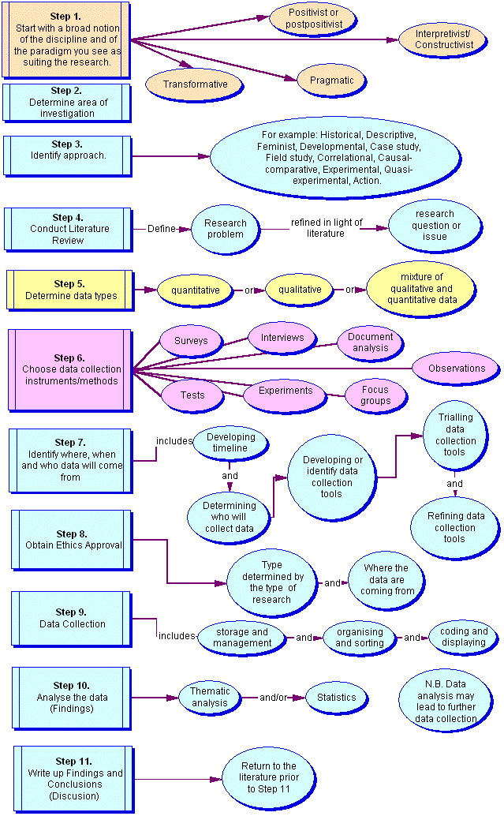

Appendix 2

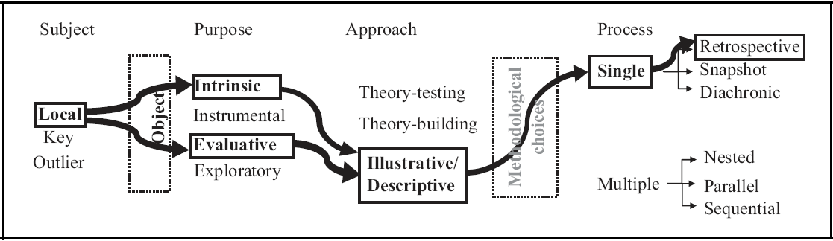

Appendix 3

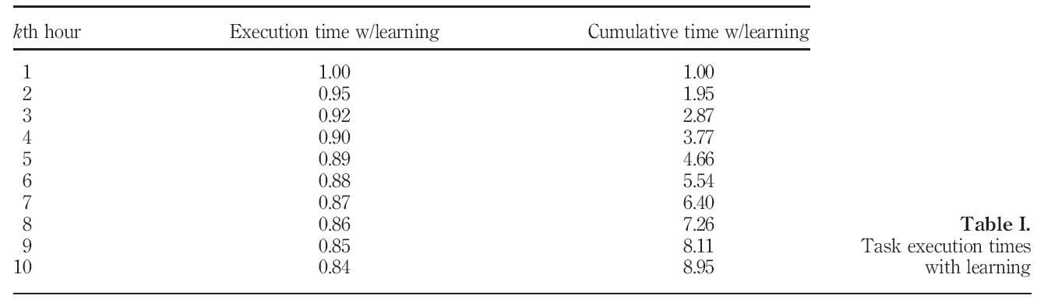

Appendix 4

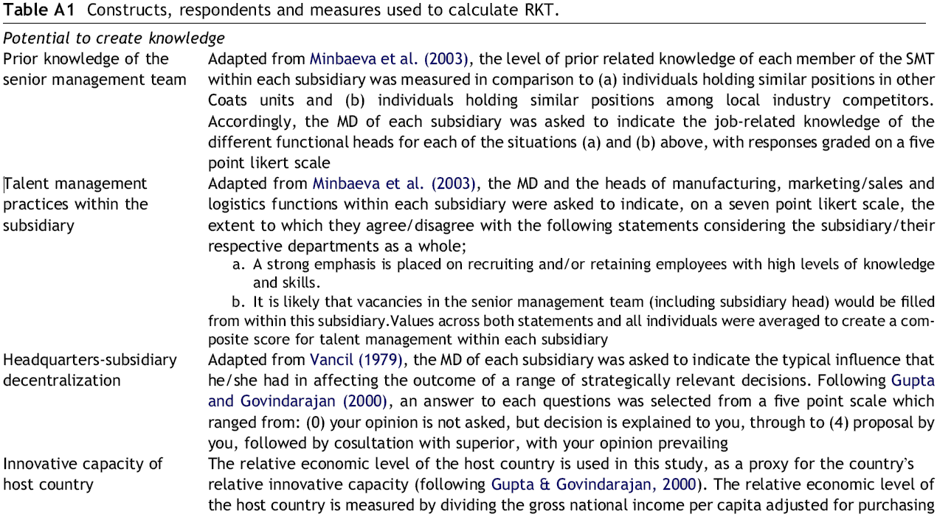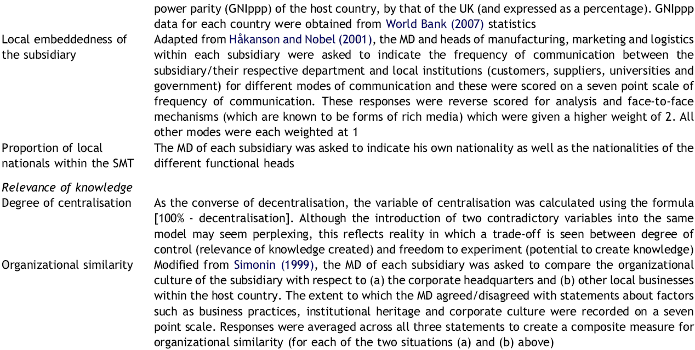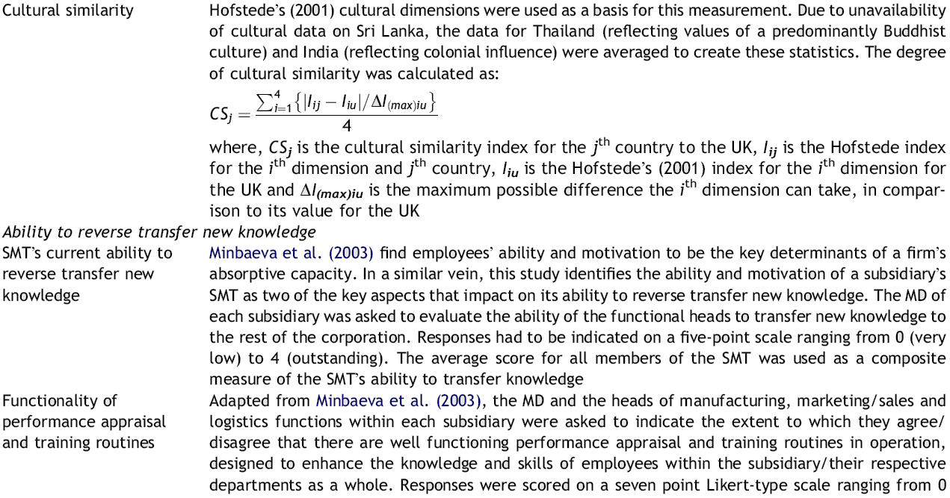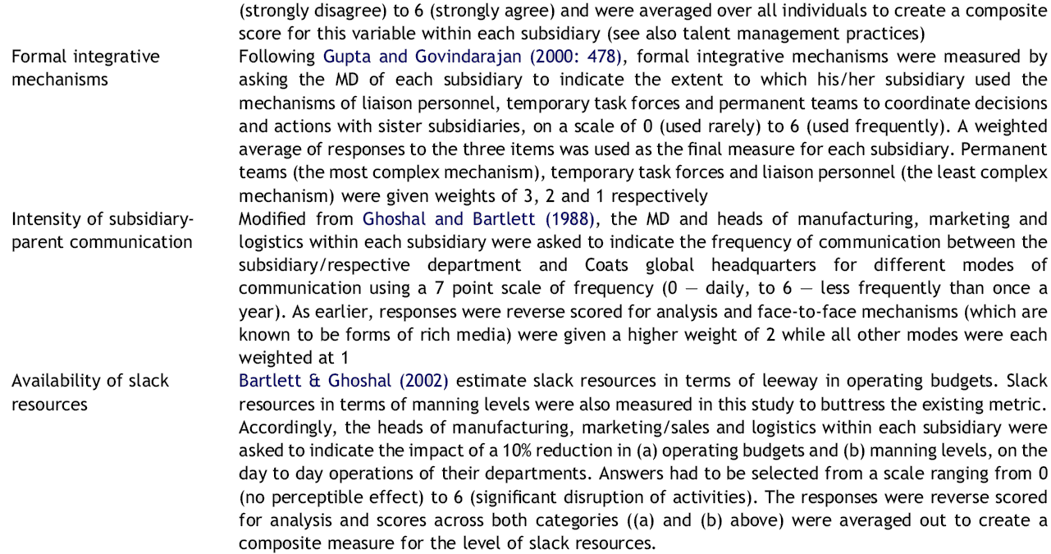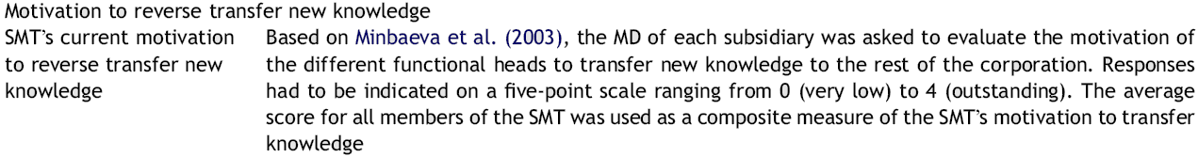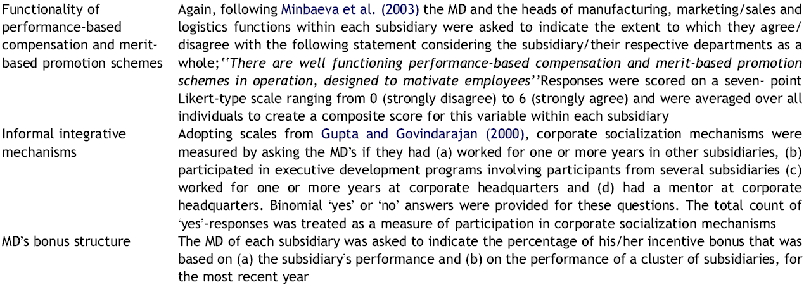

1. Integrated players – units which are deeply integrated in the MNC network and exhibit high inflows and high outflows.
2. Knowledge hiding which involves instances where the hider provides incorrect information or a misleading promise of a complete answer in the future, even though there is no intention to actually provide this (Connelly et al, 2011).
3. Sticky information/knowledge – information that is difficult to transfer, stickiness being reflected in the incremental cost of transferring the information (Szulanski, 1996).
4. Most of researches used to identify KT channels and their aspects have been published after year 2000.