Bewitching Writing

An Analysis of Intertextual Resonance in the Witch-sequence of Terry Pratchett’s Discworld

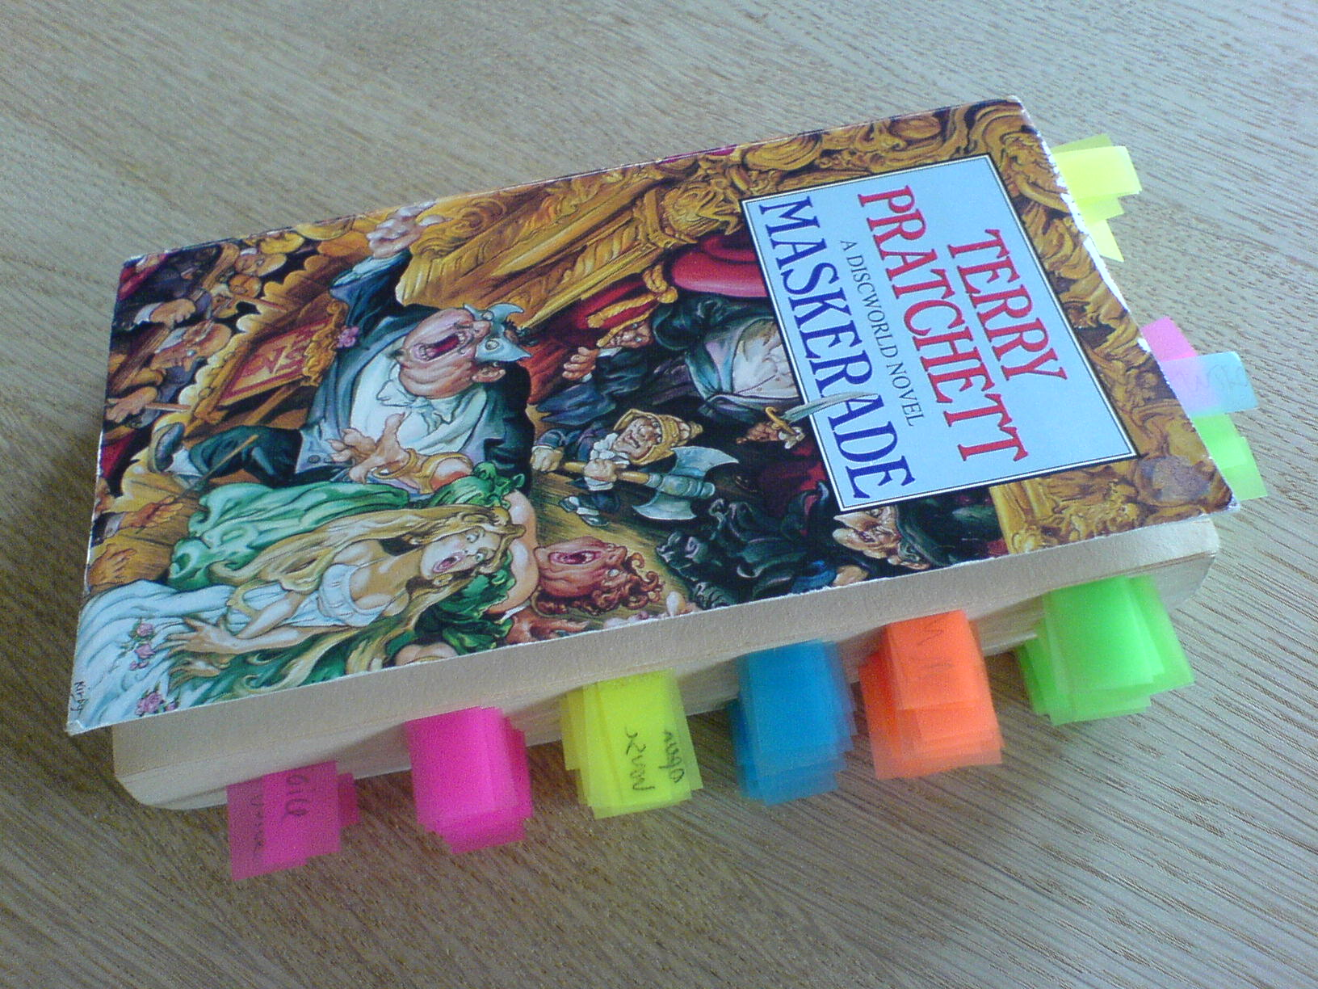

Aalborg University
Dorthe Andersen
November 2006

