Appendix 3
Thickness of clay layers located above QS3 in Aalborg Municipality
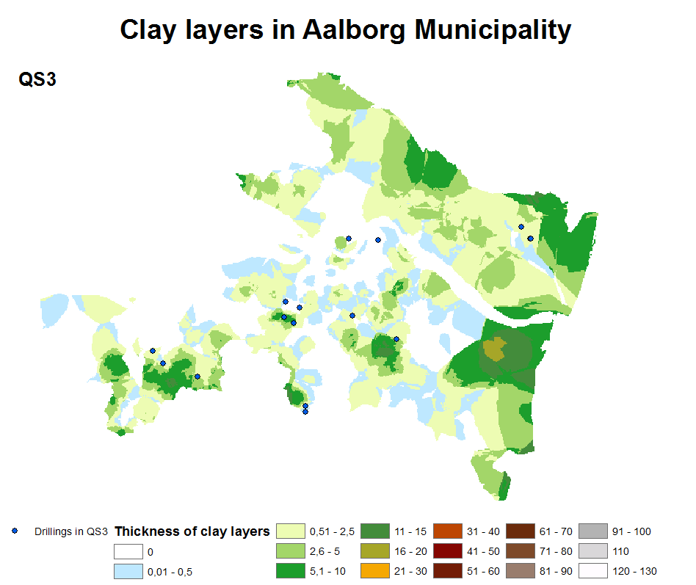
Figure 1 illustrates how thick the clay layers located above QS3 are in Aalborg Municipality. The thickness of the clay layers is in m (NIRAS 2012, b).

Appendix 4
Thickness of clay layers located above pre-quaternary lime in Aalborg Municipality
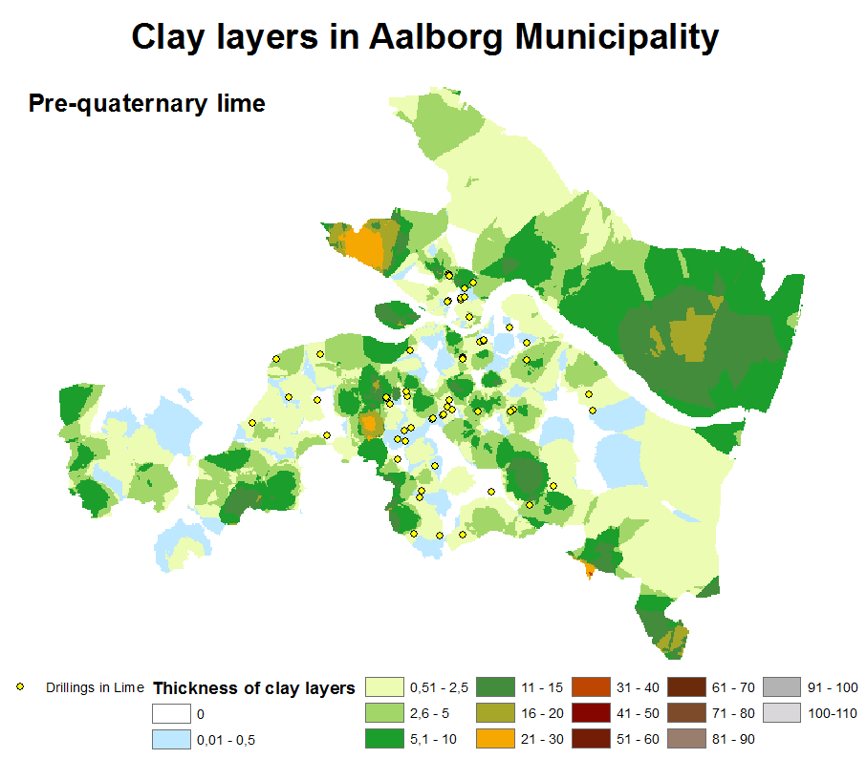
Figure 2 illustrates how thick the clay layers located above QS3 are in Aalborg Municipality. The thickness of the clay layers is in m (NIRAS 2012, b).

Appendix 5
Thickness of clay layers located above QS2 and QS3 in Herning Municipality

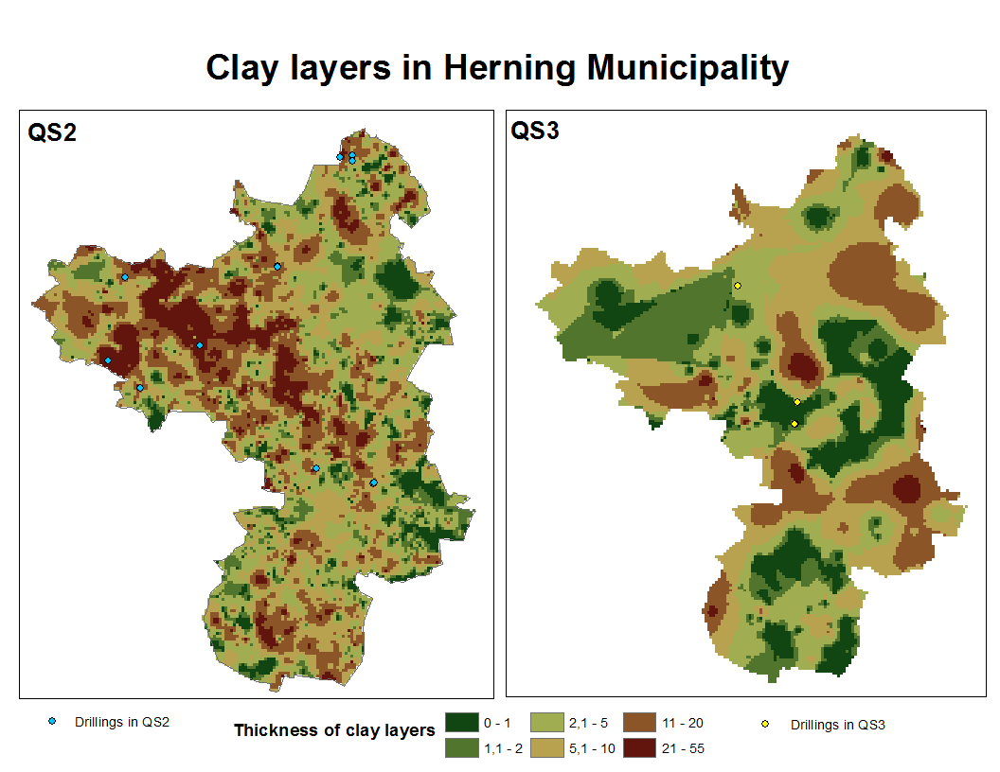
Figure 3 illustrates how thick the clay layers located above QS2 and QS3 are in Herning Municipality. The thickness of the clay layers is in m (NIRAS 2012, b).

