Communications Strategy for the Concept ’Sjovt, Sundt Sommerhus’

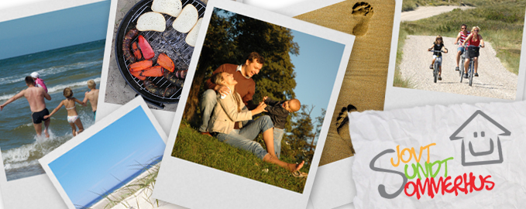

Marie Laursen & Stine Møller Kjær
10th Semester Tourism
Aalborg University
2011

