Modeling of sediment transport and self-cleansing in sea outfalls

I. Ibro * and T. Larsen *
*Department of Civil Engineering, Aalborg University, Sohngaardsholmsvej 57, DK- Aalborg, Denmark
(E-mail: tl@civil.aau.dk and iibro09@student.aau.dk)

Abstract
The paper describes an on-going project on modeling of sediment transport in outfalls with special focus on the self-cleansing problem occurring due to the daily flow variations seen in outfalls. The two central elements of the project is the development of the numerical model and a matching physical model in the laboratory. The numerical model covers both sediment transport over bed accumulations as well as transport over clean bottom. The physical modeling emphasizes on measurement of the non-steady removal and transport of well-defined and limited accumulations along the pipe. The paper contains results from both the physical and the numerical modeling. Preliminary conclusions will be given.
Introduction and background
A sea outfall can be understood as the last part of an urban sewer system and the design of the outfall follows in most ways the same principles. The objective of the design of the pipe itself has two principal points: The outfall shall have the necessary hydraulic capacity and also have the necessary capacity for the removal of sediments that for various reasons has entered the pipeline. Self-cleansing in respect to sediments for sea outfalls is essential for the design especially because of the inaccessibleness of the pipeline and the diffuser. Accordingly the self-cleansing aspect has always been treated rather conservatively.
From a theoretical viewpoint sediment transport in sea outfalls do not differ from transport in normal sewers and pumping mains. Furthermore the research has shown that the general principles for modeling sediment transport in rivers and channels with the necessary adaptation can cover sewers as well. In the 90-ties sewer sediment transport was included in the commercial computer packages for example in MOUSE (DHI software, Denmark) and Hydro Works / Info Works CS (Wallingford Software, United Kingdom). It seems well-argumented that these models can cover sea outfalls also.
On the other hand the design practice regarding self-cleansing is not based fully on rational causal considerations. Because of the daily variations in the flow it is difficult to satisfy a minimum standard for velocity or shear stress all 24 hours of the day. Most often the criterion is formulated as a minimum which has to be fulfilled at least 1 – 2 hours of the day. This implies that an accumulation of sediments can built up during the night which then is flushed out during the day. In order to sustain self-cleansing in a long-term perspective it is necessary that all sediments are removed every day in the high-flow hours.
The figures 1 and 2 shows the differences in flow velocity and wall shear stress between ordinary part-full running sewers and full-running sea outfalls in respect variations in the flow. It is seen that that the variations in sea outfalls are considerably larger than in sewers. This indicates that experiences from sewer systems only with some caution can be transferred to sea outfalls.
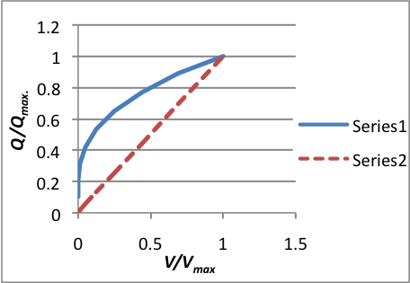 | 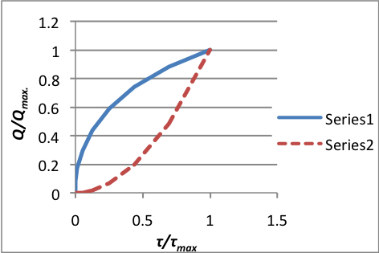
Figure 1, Relative flow velocity (V/Vmax) in circular pipeline as function of relative flow (Q/Qmax.). The blue trendline corresponds to part full pipe where Qmax occurs when pipe is running half full. The red trendline is full running pipe | Figure 2, Relative wall shear stress (τ/τmax) in circular pipeline as function of relative flow (Q/Qmax.). The blue trendline corresponds to part full pipe where Qmax occurs when pipe is running half full. The red trendline is full running pipe
Some of the most important reasons for the presence of sediments in sea outfalls:
- Initial sediments left from construction (or repair) works
- Sediments carried by the sewage
- Intrusion of sediments from the sea caused by waves, currents and density differences
- Intrusion of sediments from the sea because of transients caused by pump operations, surge towers etc.
- Intrusion of sediments because of damage of diffuser from anchors and fishing gears etc.
- Flocculation due to salinity gradients.

Objective of study
The objective of the project is to model the sediment transport including deposition as well as erosion in a 24-hour flow cycle in order to clarify when and why self-cleansing can be insufficient. Hence, to find a way to formulate the self-cleansing criteria with a formula that can be used in the model and will give relatively similar results as experimental work.

Sediment transport in full running pipes
Sediment transport can be classified by the following flow regimes (in a succession corresponding to increasing flow velocity):
- Flow with a stationary bed
- Flow with a continuous moving bed
- Flow with separated dunes moving along the clean bottom
- Flow with sediments in suspension often denoted wash load)
This succession phenomenon corresponds to uniform sediments with the same grain size. For the transport of mixed sediments more regimes can exist simultaneously.
Experiences from sewers systems show that depositions of sediment significantly increase the flow resistance primarily because of the influence of the bed forms.

Influence of deposits in sea outfalls
In the main pipe (upstream the diffuser) the risk of blockage from depositions is small because the increased flow velocity and sediment transport capacity caused by the reduction of the cross-section area. In the diffuser section depositions can disturb the flow balance in the system. If for example a multiport diffuser has depositions in the outer half part (seaward side) the increased friction in this part will reduce the flow here because more water will pass out through the landward ports. In this way a deposition may enhance the tendency for further deposition. For this reason self-cleansing is critical especially in the diffuser section.
Experimental work and analysis of data
The experimental work was carried out in both rectangular 300 mm wide channel and a 240 mm diameter flowing full Plexiglas pipe, both with flat fixed smooth beds. Both channels were provided with sloping and recirculation facilities.
The flow was supplied to the pipes by an adjustable pump that could give a maximum discharge up to 20 l/s. To ensure that the required flow depth, y₀, (for full running conditions) was achieved, a rectangular thin plate weir was used. A flat false bed made up of aluminum plates, was placed in the bottom of the rectangular flume covering a length from the upstream till reaching the weir (6.8m), to create smooth pipe conditions. No bed roughness was applied in the circular pipe. The bed thickness varies from the pipes and it is maintained constant during different experiments.

The non-cohesive sediment (d ranging from 0.075 mm to 0.25 mm and d₅₀ = 0.2 mm) placed into the invert bottom, was located about 1.5 m from the upstream end to give a sufficient entry length to obtain a fully developed uniform flow. Three different time-running were chosen for carrying out the experiments in circular as well as in rectangular pipes (respectively 5 min, 10 min and 20 min), where the amount of sediment was kept constant during all experiments (Q_{s} = 1000 g).

Existing formulas
The sediment transport is often represented by non-dimensional parameters. Several relationships for bed load transport under steady flows have been proposed where the rate is mostly related to dimensionless bottom shear stress or Shields parameter.
Meyer – Peter and Muller (1948) ɸ = 8*(θ- θcr)32
Einstein – Brown (1950) ɸ = f(1/Ψ)
Engelund – Hansen (1967) ɸ = 0.1/f* θ^{5/2}
where θ_{cr} is the critical Shields parameter and 1/Ψ = τ*
These models give relatively similar results for non-cohesive particles with homogeneous diameter in uniform flow.
Nevertheless, in this paper, non-steady state conditions are assumed. Ackers - White sediment transport formula for circular pipes is used, and calibrated to have better agreement with laboratory data. The sediment transport relationship of Ackers and White is expressed;
G_{gr} = C*((F_{gr}/A) – 1)^{m}
F_{gr} = u*^{n}/g*D₅₀*(s-1)*[V/$\sqrt{32}*log⁡(\frac{10y_{0}}{D_{35}})$]^{1-n}
and
D_{gr} = D₅₀*[g*(s-1)/𝜗²]^{1/3}
where F_{gr} is the mobility parameter D_{gr} is the dimensionless grain diameter, u* is the shear velocity given as g*R*S=V* f/8 , f is the friction factor, V is the limiting deposit velocity, g is the acceleration due to gravity, R is the hydraulic radius, S is slope, D₅₀ is the median diameter, y₀ is the flow depth, s is the relative density of solid phase to fluid phase and 𝜗 is the kinematic viscosity of water (temperature dependent).
The coefficients C, A, m, and n are determined as functions of D_{gr}. (Ackers, 1991)

It is important to be mention that, there are not many data regarding fully running pipelines, nevertheless, the basic physics of sediment transport of non-cohesive sediment is the same both in pipe-lines or alluvial channels. Therefore, this paper gives brief information regarding sediment hydraulics in pipe-lines by calibrating the basic formulas through a build-up model.

Modeling of non-cohesive sediment in pipes
The transport of sediment particles is mostly based on a numerical approach given by the continuity equation for bed sediment. This numerical model is based on a finite difference scheme. Bearing in mind that just few laboratory experiments have been carried out regarding sediment transport in pipes running full, it is not easy to establish a general relationship for the sediment transport in such regime. Hence, a modeling approach is made to describe this phenomenon:

For simplification of the calculations the internal bottom of the pipe is assumed to have a trapezoidal shape (see Figure 3). Initial conditions for modeling set up are based on experimental data gathered previously.
D
B₀
h

B

Figure 3, Cross section of pipe with the deposited sediment

Another assumption in setting up the model was to apply a specified initial sediment capacity which in the future will be the main parameter to be calibrated. By applying Engelund – Hansen correction factor (V₀/V)⁵, it is possible to have a relationship between the sediment transport and sediment capacity.
g_{s}= g_{s0}*(V₀/V)⁵
If the flow rate is constant then the formula can be transformed;
g_{s}= g_{s0}*(A₀-A_{s}/A₀)⁵

where g₀ is the initial sediment capacity, g_{s} is the sediment capacity calculated, A₀ is the clean pipe cross section equals (B₀ *h + h²), A_{s} is the sediment cross section, B, B₀ are respectively the sediment width and the lower side of the trapezoidal shape, and h is the sediment height.

The sediment transport rate is given as shown;

q_{s}= g_{s}*B* (A₀-A_{s}/A₀)⁵
Below a simple scheme to introduce the finite difference equations used in a Pasqual numerical model is presented;
i_{max}
1
2
i - 1
i
i + 1

Q
q_{s1}
q_{s2}
q_{si-1}
q_{si}
q_{si+1}
q_{simax}
q_{simax}

h₁
h₂
h_{i-1}
h_{i}
h_{i+1}

Figure 4, One dimensional scheme of the numerical model approach

h[i,j+1] = h[i,j]+(qs[i,j]-qs[i+1,j])*dt/(dx*B[i,j])

where i, j are respectively the space and time loop in the programming language.

Results from experiments and numerical modeling for sediment transport
The sediment was spread uniformly into the rectangular and circular invert bottom by filling respectively 50 cm and 100 cm length of test pipe, using the same amount. For preserving undisturbed sand conditions while the uniform flow conditions were established, the water inflow and velocity were set at minimum. Once the water depth was bigger than pipe radius/pipe height, the flow discharge at the required flow conditions (depth and velocity) was then set. At this moment the time was recorded. Sediment transport rates were taken after the time readings were made at 20 cm and 40 cm intervals over the length of pipe test (6.8 m and 5.6 m respectively). The amount of sediment leaving the pipe was then calculated and showed graphically.
A comparison with the existing data sets is also shown in a way so it could be possible to investigate sediment transport formula (especially bed load transport)

Table 1 Experimental Work in Circular Clean Channels

Authors | Pipe conditions | Velocity V(m/s) | Material | Pipe diameter (mm) | d_{50 (mm)}
Novak-Nalluri (1975) | Half Full | 0.45-0.75 | Uniformly graded | 305 | 0.53-8.4
May (1982) | Full/Half Full | 0.5-1.2 |  | 77-300 | 0.64-7.9
Mat Suki (1987) | Full | 0.5-1.11 |  | 164-253 | 1.3-8.0
Larsen-Ibro (2011) | Full | 0.39-0.5 | Sand | 244 | 0.18-0.25

Circular Pipe Data

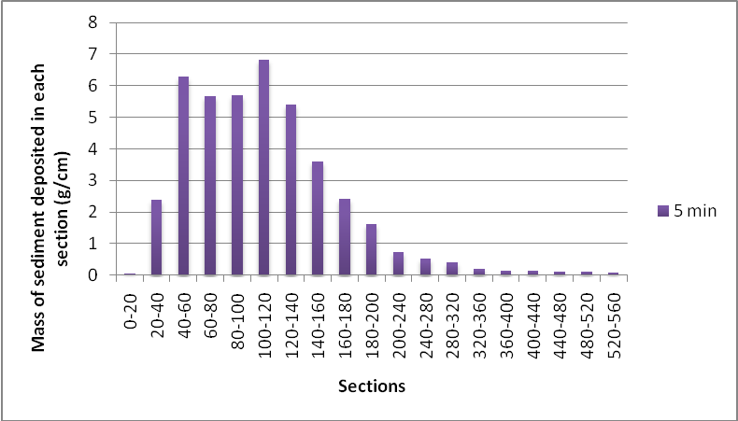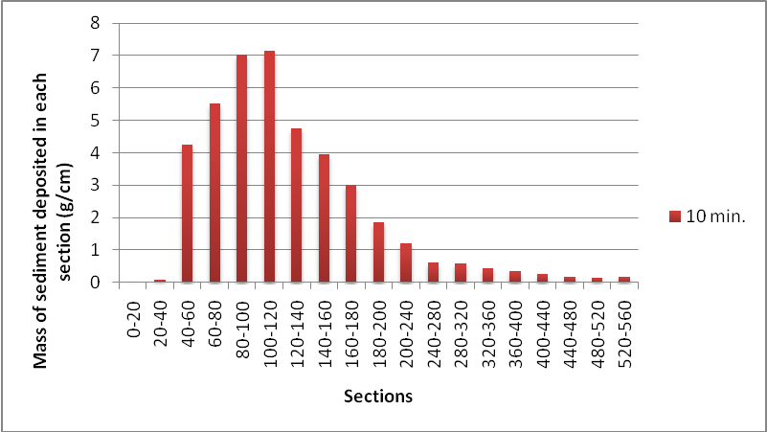
Figure 5, Mass of sediment deposited in the first scenario  (t = 5 min) | Figure 6, Mass of sediment deposited in the second scenario  (t = 10 min)
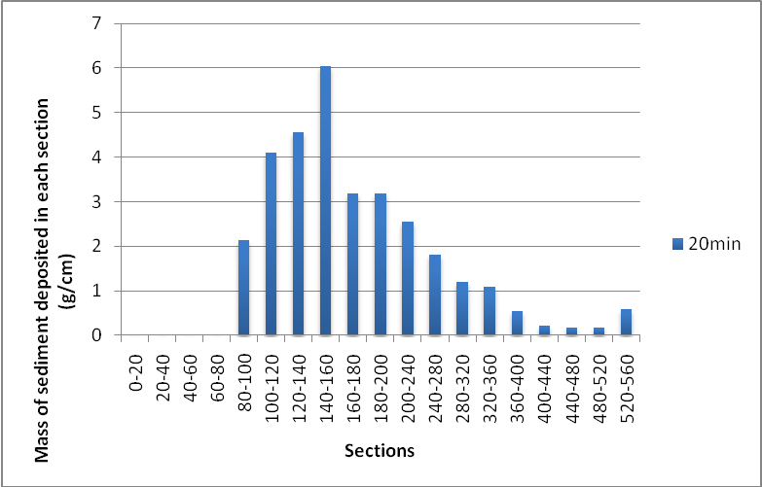
Figure 7, Mass of sediment deposited in the third scenario
(t = 20 min)

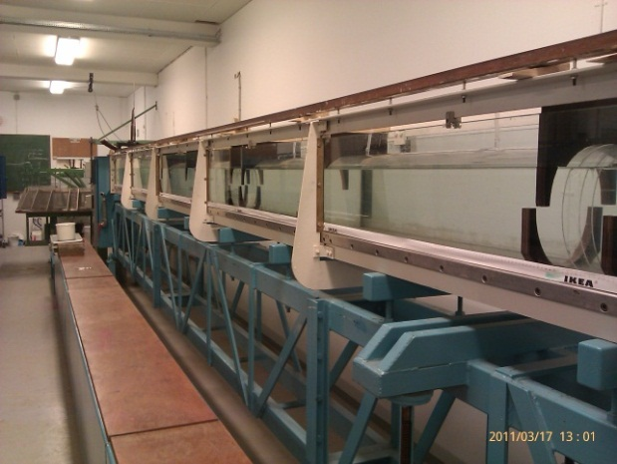
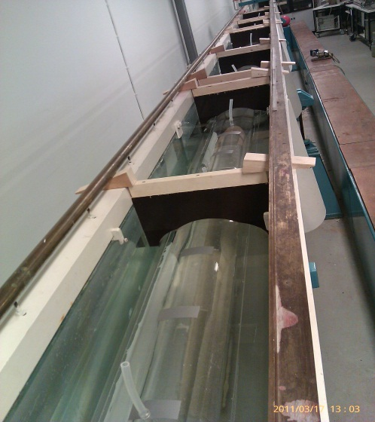
Figure 8, Experimental set up for the pipe running full

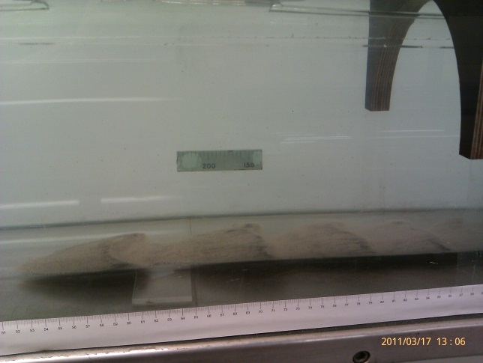
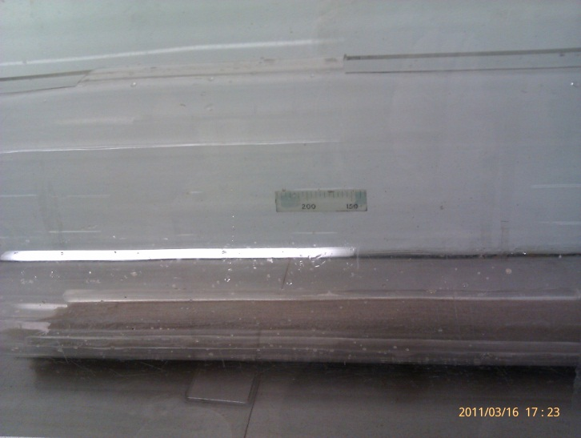
D = 240 mm

Figure 9, Initial conditions and creation of the sediment dunes inside the pipe ( D = 240 mm).
Water flow velocity V = 0.4 m/s

Rectangular Flume Data

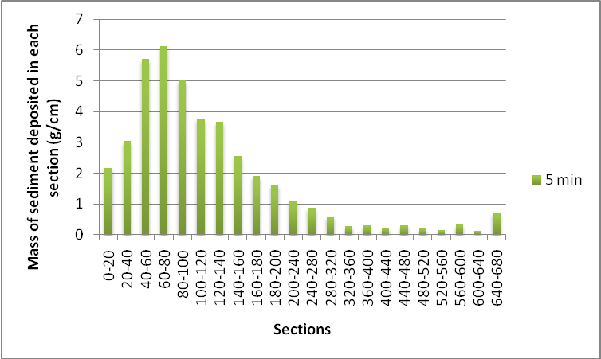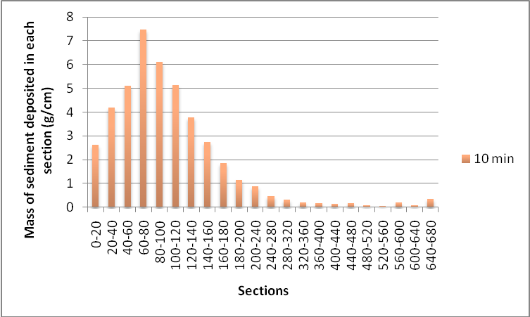
Figure 10, Mass of sediment deposited in the first scenario  (t = 5 min) | Figure 11, Mass of sediment deposited in the second scenario  (t = 10 min)

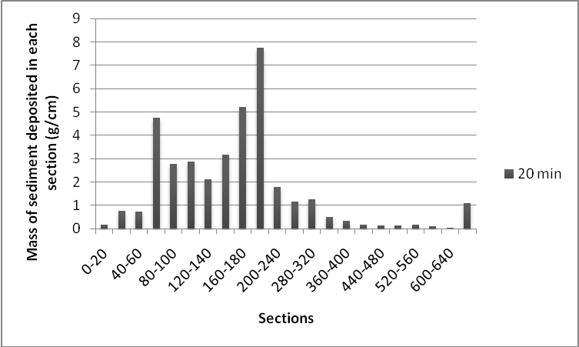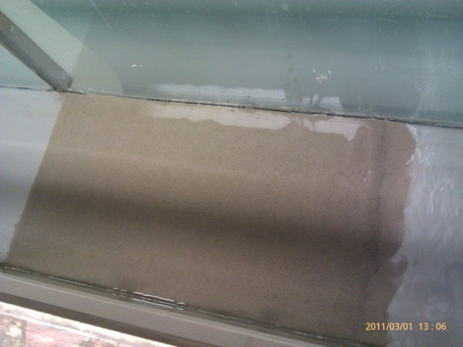
L_{s} = 50 cm
Figure 12, Mass of sediment deposited in the third scenario  (t = 20 min) | Figure 13, Initial conditions set up in the flume  (width B = 300 mm)
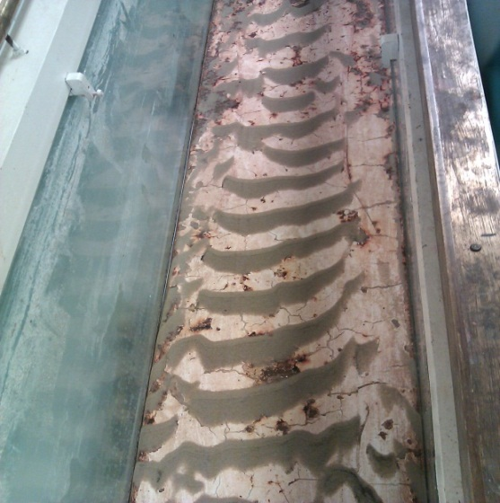
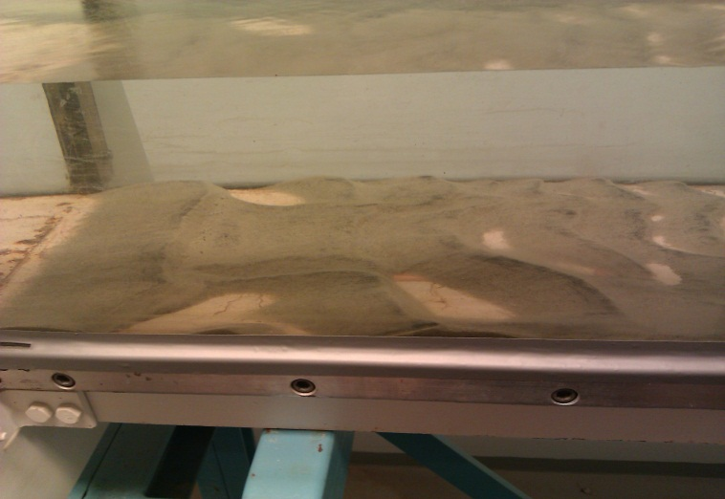

y₀ = 0.17 cm
B = 300 mm

Figure 14, Creation and spreading of the sediment dunes inside the flume (width B = 300 mm, velocity V = 0. 5 m/s)
Modeling results
The numerical model was calibrated against the experimental results presented previously. The model constant parameter initial sediment capacity is g_{s0} = 0.000011 m²/s/m and it is a result of calibration.
As the figures below indicates the calculated results of the sediment mass transported in each section of the pipe lie within an acceptable range.
The curves from the calculation indicate good agreement with experimental measurements; however the measurements lie in a range between 0-8 g/cm while the calculated values lie between 0-10 g/cm. This might result as course of simplifications made in the numerical model.
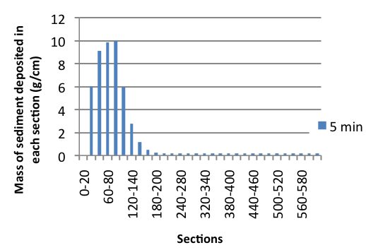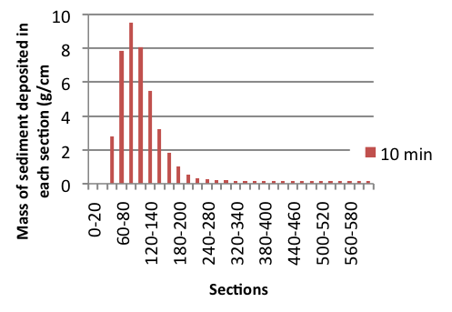
Figure 15, Modelled mass of sediment deposited in the  first scenario (t = 5 min) | Figure 16, Modelled mass of sediment deposited in the  second scenario (t = 10 min)

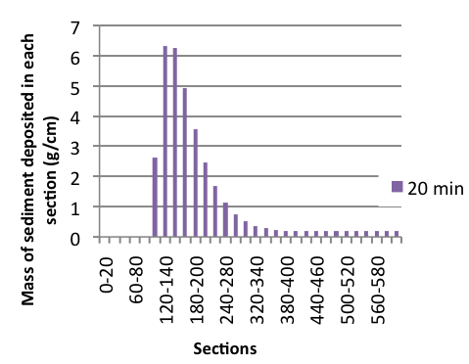
Figure 17, Modelled mass of sediment deposited in the third scenario
(t = 20 min)

Considering the lack of time no verification with Shields number was made in this model.

Conclusions

- Preliminary analyses on the present data at the limit of deposition show that the self-cleansing velocity (V) is affected by the volumetric sediment concentration (C_{v}), flow depth (y_{o}), particle size (d₅₀), surface roughness (k₀) and pipe size (D).

- It is important to mention that, like in sewer pipes, in sea outfalls the required self-cleansing velocity decreases as particle size increase and increases with the increase of the volumetric sediment concentration.

- The presence of a rougher surface could either increase or decrease the required self-cleansing velocity depending on whether the effects of the increase in flow resistance or the additional turbulence due to secondary currents is more dominant. The sediment transport also causes the increase in friction factor.

- It is necessary to have a specific minimum velocity/shear stress at least 1 hour per day to avoid blockage of the outfall pipe

- The literature shows that, the minimum velocity estimated necessary to flush the sediment is V = 0.45 – 1 m/s for pipes with D = 240 mm which is in good agreement with experimental results gathered in this study.

References
[1] 54, A.-M. a.-N. (Reprinted 1977). Sedimentation Engineering. New York.
[2] Ackers, P. M. (1991). Invited lecture: Sediment transport of drainage and outfall design. Environmental Hydraulics, Lee Cheung (eds).
[3] B.G.Krishnappan. (February 1981). Unsteady, Nonuniform, Mobileboundary Flow Model-Mobed. Hydraulics division, National Water Research Institute, Burlington, Ontario.
[4] Bertrand-Krajewski, J.-L. (2006). Modelling of Sewer Solids Production and Transport, Cours de DEA "Hydrologie Urbaine". Lyon.
[5] C. Nalluri*, A. A., & El-Zaemey**, A. K. (1994). Sediment Transport Over Deposited Beds in Sewers. Department of Civil Engineering, University of NewCastle upon Tyne.
[6] Ghani, A. A. ( (November 1993)). Sediment Transport in Sewers PhD Thesis . NewCastle: University of Newcastle Upon Tyne.
[7] Vaoni, V. A. (editor) (1975). Sedimentation Engineering. American Society of Civil Engineering. New York.

