|  |
| --- |
| **logo aau.bmp** |

**Department of Electronic Systems**

**Antennas Propagation and Radio Networking**

**Mobile Communication**

Fredrik Bajers Vej 7A1 · Aalborg University · DK - 9220 Aalborg · Denmark

**Title**: *“***Small antennas on dielectric materials for 4G applications”**

|  |
| --- |
| Abstract:  Nowadays, antenna size reduction represents a crucial point in the design of a mobile device. Until now, several works has been done with a focus on different techniques that face this challenge. Specifically, the effect of a high-permittivity ceramic dielectric substrate on the antenna size was analyzed. In order to investigate this aspect and to design the antenna in the UMTS band, simulations was done using the FDTD method. In this thesis it has been shown, that at a fixed resonant frequency, the antenna size and its bandwidth depend on the value of permittivity dielectric substrate. Using the higher dielectric substrate, it is possible to reduce the radiator size but, it is accompanied by a reduction in bandwidth. Then, the antenna is smaller and narrowband for high permittivity values. The antenna behavior is described in terms of bandwidth, quality factor, efficiency and mismatch loss. |

Project period:

*10th Semester*

Student :

*Lorenzo Maccarrone*

Supervisors:

*Samantha Caporal Del Barrio*

*Mauro Pelosi*

*Gert F. Pedersen*

Number of pages:

Delivered: June, $1^{st}$ 2011

The content of this report is freely available, but publication (with reference source) may only be pursued due to

agreement with the respective authors

***Preface***

This report has been written as a project for the ${10}^{th}$ semester final master thesis within the ambit of Erasmus study project between University of Catania and Aalborg University, specifically between Department of Telecommunication at Catania University and Department of Electronic Systems at Aalborg University , during the period February2011 – June 2011

A correct interpretation of the following report is possible referring to a list of literature references, that are marked in square brackets , a list of equations, that are marked in brackets, and also all chapters are numerated, as shown in table of contents.

***Report Structure***

This report is about “ Small antennas on the dielectric materials for 4G applications”.

This is divided in the following parts:

- Five numbered chapters, with a description of the project arguments.

-The appendices which are arranged alphabetically.

***Table of contents***

Abstract……………………………………………………………………………………………1

Preface……………………………………………………………………………………………..3

Report structure…………………………………………………………………………………..3

Table of Contents…………………………………………………………………………………4

List of Symbols……………………………………………………………………………………6

**Chapter 1:Introduction**

1.1 - Evolution of Mobile System Standards…………………………………………..…9

1.2 - LTE systems…………………………………………………………………….…..11

1.3 - MIMO systems……………………………………………………………….……..12

1.4 - Problem Definition………………………………………………………………….14

1.5-Simulation environment……………………………………………………………14

**Chapter 2 : Technical Background**

2.1 -Main Antennas Parameters …………………………………………………………15

2.2 - Field regions………………………………………………………………………….15

2.3 –Radiation Patterns…………………………………………………….……………16

2.4 - Radiation Power density…………………………………………….………………..17

2.5 - Radiation intensity…………………………………………………….……………18

2.6 – Directivity…………………………………………………………….…………….18

2.7 - Antenna impedance and reflection coefficient…………………….……………….19

2.8 - Accepted power and mismatch loss…………………………………………………21

2.9 - Antenna radiation efficiency………………………………………………………..22

2.10 – Gain…………………………………………………………………………………..22

2.11 – Bandwidth…………………………………………………………………………..23

2.12 - Quality factor………………………………………………………….……………24

**Chapter 3 : Small antennas for handset**

3.1 -Planar inverted folded antenna (PIFA)……………………………..…………….25

3.1.1- PIFA with meandering. Design and simulation results………………..29

3.1.2- PIFA dual band. Design and simulation results………………………..31

3.2 – FICA. . Design and simulation results ………………………………..…………32

**Chapter 4 : Small antennas with ceramic material**

4.1 -State of the art ceramics…………………………………………………………..34

4.2 - High dielectric substrate…………………………………………………….…….35

4.3 - Small antenna with dielectric substrate…………………………………………..36

4.4 - Reduction size……………………………………………………………………..37

4.5 - Simulation and results…………………………………………………..………..38

4.6 - Quality factor……………………………………………………………………..42

**Chapter 5 : Conclusions**

**5**.1Conclusions…………………………………………………………………………46

***Reference***………………………………………………………………..……………………47

***Appendix A : Matlab scripts***……………………………………………………………..49

***List of symbols***

*ε* electric permittivity

$ε_{r}$ electric relative permittivity

$ε_{0}$ permeability in free space

*σ* electric conductivity

*μ*  magnetic permeability

$μ_{0}$ permeability in free space

*ρ* density

*Г* voltage reflection coefficient

*ω* angular frequency

*λ* wavelength

*k*  free space wave number

*c* speed of light in free space

β bandwidth

*Δx* x-directed space increment

*Δy* y-directed space increment

*Δz* z-directed space increment

*Δt*  unit time step

$\vec{E}$ electric field

$\vec{H}$ magnetic field

$\vec{D}$ electric flux density

$\vec{B}$ magnetic flux density

$\vec{J}$ electric current density

$\vec{M}$ magnetic current density

*D* directivity

$\vec{A}$, $\vec{F}$ potential vectors

$e_{0}$ antenna efficiency

$e_{d}$ dielectric efficiency

$e_{r}$ reflection efficiency

$e_{cd}$ radiation efficiency

*f* frequency

$f_{r}$ resonant frequency

*G* gain

$G_{abs}$ absolute gain

$P_{A}$ accepted power

$P_{available }$ total available power from the source

$P_{loss}$ power consumed in the load or the imperfect conductor

$P_{rad}$ total radiated power

*Q* quality factor

$Q_{lb}$ low band quality factor

$R_{A}$ antenna resistance

$R_{r}$ radiation resistance

$R_{g}$ generator resistance

$R_{l}$ loss resistance

$S_{11}$ return loss

U radiation intensity

$v_{p}$ numerical phase velocity

$L_{1}$ length of the antenna patch

$L_{2}$ width of the antenna patch

H height between the ground plane and antenna radiating element

W width of the short cut element of antenna

$X_{A}$ antenna reactance

$X_{g}$ generator reactance

$Z_{A}$ antenna inpedance

$Z_{in}$ input impedance

$Z_{0}$ characteristic impedance

***Chapter 1: Introduction***

The 4 Generation Mobile Communication systems are projected to provide a wide variety of new services, like high quality voice, high definition video, high data rate wireless channels. It include also several types of broadband wireless access communication systems. It support mobile service and fixed wireless networks.

The goal of 4G systems might be synthesized with the word - Integration.

The following part of this chapter is an overview of evolution of mobile systems, highlighting the aspects and characteristics of the LTE systems, and the benefits of MIMO technology.

**1.1-Evolution of Mobile System Standards**

To reach the current 4G mobile systems has been a long process. The history and evolution of mobile service from 1Genaration to 4 Generation are mentioned briefly in this section. The earliest service were implemented in 1970s, based on basic cellular structure of mobile communication and analog technology. In the beginning, the phones adopted analog radio channels (frequencies around 450 MHz), used for voice calls only, and their signals transmitted by the method of frequency modulation (FM). This kind of phones had some disadvantages, such as a poor security due to the lack of encryption. Furthermore, numerous incompatible analog systems were placed in service around the world during the 1980s.

The most prominent 1G systems was Advanced Mobile Phone System (AMPS), that was the

first 1G system to start operating in the USA (in July 1978), Nordic Mobile Telephone (NMT),

and Total Access Communication System (TACS).

With the 2-Generation systems, instead, networks radio signals were digital encrypted technology.

Moreover, 2G used digital multiple access technology, such as TDMA and FDMA, were significantly more efficient over their predecessors.

These 2G systems was provided circuit-switched data communication services at a low speed and SMS text messages services.

The continuous evolution of design and implement digital systems led to a variety of different standards such as GSM, Cordless Telephone, DECT, and PACS.

During the 1990s, 3G mobile system was defined and was relatively to be adopted, with the aim to eliminate previous incompatibilities and become a really global system.

I this way, the 3G systems had higher quality voice channels, as well as broadband data capabilities, up to 2 Mbps. Unfortunately, their differences could not reconciled, with the consequent adoption of two mobile standards for 3G. The 2.5G was an interim step between 2G and 3G. It was basically an enhancement of the two major 2G technologies to provide increased capacity on the 2G radio frequency channels and to introduce higher throughput for data service, up to 384 kbps. A very important aspect of 2.5G was that the data channels were optimized for packet data, with consequently introducing access to the Internet from mobile devices, whether telephone, Personal Digital Assistant (PDA), or Laptop. This generation ,still used in some country, offers extended features, it has additional capacity on the 2G systems, such as GPRS, EDGE, HSCSD. Furthermore, it offers wireless multimedia IP-based services and applications.

The protocol used in 3G systems support high speeds and are targeted for other applications apart from voice, such as motion video, mp3, video conferencing and fast Internet access.

UMTS system is one of the 3G mobile telecommunications systems. There are many radio spectrum frequencies designated for the operation of the UMTS. In this project, we consider only the frequencies for band I, II, V, XIV, which are showed in the following table.

|  |  |  |  |  |  |
| --- | --- | --- | --- | --- | --- |
| Operating Band | Frequency Band | Commond name | Uplink | Downlink | Region |
| I | 2100 | IMT | 1920-1980 | 2110-2170 | Europe, Asia, Korea, Japan, New Zealand , Brazil |
| II | 1900 | PCS | 1850-1910 | 1930-1990 | North America |
| V | 850 | CLR | 824-849 | 869-894 | North America, Australia, New Zealand, Brazil |
| XIV | 700 | SMH | 788-798 | 758-768 | America (future) |

Table1. UMTS Bands

**1.2 - LTE Systems**

LTE (Long Term Evolution) or 3G Long Term Evolution is the evolution of mobile cellular

communications technology towards broadband IP network. The aim of the 3GPP project is to further develop the Universal Mobile Telecommunications System (UMTS) standard and moreover provide an enhanced and simplified technology on mobile broadband. The main keys of the 4G infrastructures are accessing information anywhere, anytime, with a seamless connection to a wide range of information and services, and receiving a large volume of information, data, video, pictures.

With 4G, a range of new services and models are available to provide a comprehensive and secure all IP solution to laptop, smart phones and other handset devices. The requirements for this standards are peek speed at 100 Mbit/s for high mobility and 1Gbit/s for low mobility *[1]* .

The 4G infrastructures consist of a set of various networks using IP (Internet protocol) as a common protocol so that users are in control because they are able to choose every application and environment. Based on the developing trends of mobile wireless communication, 4G has broader bandwidth, higher data rate, and smoother and quicker handoff, all that to ensure service across a multitude of wireless systems and networks.

The performance of radio communications depends on an antenna system, termed smart or intelligent antenna. Recently, multiple antenna technologies are emerging to achieve the goal of 4G systems. In this sense, the spatial multiplexing technology and the MIMO technology gained importance for its bandwidth conservation and power efficiency. In fact, spatial multiplexing involves deploying multiple antennas at the transmitter side and at the receiver side. Independent streams can then be transmitted simultaneously from all the antennas. The usage of the MIMO technology multiplies the base data rate by the number of transmit antennas or the number of receive antennas. Apart from this, the reliability in transmitting high speed data in the fading channel, with the TX – RX diversity, can be improved by using more antennas at the transmitter or at the receiver. Both transmit-receive diversity and transmit spatial multiplexing are categorized into the space-time coding techniques, which does not necessarily require the channel knowledge at the transmitter. The other category is closed-loop multiple antenna technologies, which require channel knowledge at the transmitter.

**1.3 - MIMO Systems**

MIMO is an acronym that means Multiple-Input Multiple-Output [2]. In fact, several transmitters and receivers can be used at each end of the radio link in order to achieve a high capacity. The signal multiplexing is used for MIMO between multiple transmitting antennas (space multiplex) and frequency or time. This technology uses the OFDM for the channel access. The signal transmitted by *m* antennas is received by *n* antennas. Processing of the received signals may deliver several performance improvements in terms of range, quality of received signal and spectrum efficiency. In principle, MIMO is more efficient when many multiple path signals are received, as shown the 802.11n standard, the theoretical speed upper than 600 Mbit/s. However, the performance in cellular deployments is still subject to research and simulations. Moreover, it is generally admitted that the gain in spectrum efficiency is directly related to the minimum number of antennas in the link.

Figure 1 shown various MIMO configurations [3] , for example:



Figure1. Radio access channel, variations of MIMO

* MIMO: Several antennas are placed at the transmitter and receiver.
* MISO: Several antennas are placed in the transmitter but only one in the receiver.
* SIMO: Only one antenna is placed in the transmitter and several are located in the receiver.
* SISO: Only one antenna is placed in both the transmitter and the receiver.

The main requirement for MIMO systems is that the antennas must be able to receive different

signals, even though if they are closely spaced. The different signal paths should be uncorrelated

to ensure a good diversity gain and the mutual coupling has to be as less as possible to avoid

the energy transfer between antennas and therefore, the increase of the correlation.

Due to this requirements, implement MIMO systems in mobile phone is nowadays still a challenge,

because it is difficult to add multiple antennas on something so small and pretend to have

a good isolation. Another feature is that the performance of the antenna will be degraded by the

effects of inter-antenna coupling, envelope cross-correlation and coupling to biological tissues in

the user’s hands.

Some advantage of MIMO technology [3] are :

*- Array gain,* that increase in received SNR (Signal Noise Rate), like a results from a coherent combining effect of the wireless signals at a receiver. The coherent combining could be realized through spatial processing at the receive antenna and/or spatial pre-processing at the transmit antenna.

*- Spatial diversity gain,* that mitigates fading and it is realized by providing the receiver with multiple transmitted signals in space, frequency or time. With an increasing number of independent multiple copies of the same signal, the probability that at least one of the copies is not experiencing a deep fade increases, then improving the quality and reliability of reception.

*- Spatial multiplexing gain,* that offers a linear increasing in data rate, transmitting multiple and independent data streamswithin the bandwidth of operation. Moreover, the spatial multiplexing gain increases the capacity of a wireless network.

*- Interference reduction,* that in general results from multiple users sharing time and frequency resources. This kind of interference may be mitigated by exploiting the spatial dimension to increase the separation between users. Furthermore, the spatial dimension can be leveraged for the purposes of interference avoidance minimizing interference to other users. Interference reduction and avoidance improve range and coverage of a wireless network.

In general, it may not be possible to reach simultaneously all the benefits described because

to conflicting demands on the spatial degrees of freedom. Nevertheless, the usage of some combination of this across a wireless network could be to improve capacity, reliability , and coverage.

**1.3 – Problem definition**

The antenna size reduction of a mobile device is nowadays a crucial point of a designer. Until now, studies are largely focused on different techniques able to doing this. However, it has been shown the effects of a high-permittivity ceramic dielectric substrate on the size of an antenna.

This thesis focuses on the design of an antenna in UMTS band, using the FDTD method. The size of that is reduced depending on the value of permittivity and keeping the same resonant frequency. It is shown the bandwidth is also reduced and therefore, the antenna is narrowband. The antenna behavior is described in terms of bandwidth, quality factor, efficiency, losses and mismatch loss.

**1.4 - Simulation Enviorement**

It was used the AAU3 software to make all the simulations of this thesis. The code was written in Matlab high-level. This software allows to design antenna and to generate, using the FDTD method, the main output parameters in electro- magnetic, for example the radiation patterns, smith chart, impedance, radiation, efficiency. There are two types of running the simulations: either by Matlab kernel or by Fortran FDTD kernel, which is fastercompared in the compilation duration.

The finite difference time domain (FDTD) computational algorithm is used to give a solution of the Maxwell’s equations, it is based on the Yee’s algorithm. Contrary to Moment Method, this method gives a straightforward solution of the six-coupled field components of the Maxwell’s curl equations. The electric and the magnetic field components are computed [17] “by discretizing the Maxwell’s curl equations both in time and space, and then solving the discretized equations in a time marching sequence by alternatively calculating the electric and magnetic fields in the computational domain”.

***Chapter 2: Technical Background***

**2.1 - Main antennas parameters**

To describe how antennas irradiate energy and build them to optimize its performance, it is necessary to introduce the following parameters and the most important electrical properties.

The performance of an antenna can be evaluated through the input impedance, the gain, the mismatch and absorption [4] .

**2.2 - Field regions**

It is usually to subdivide the space surrounding an antenna into three regions [4] :

- the *reactive near field*, that is the region immediately surrounding the antenna;

- the *Fresnel region*, or *radiating near field* zone, that is between the other two regions

- the *Fraunhofer region* ,or *far field* zone, that it is calculated according the Rayleigh condition.

Figure shown the three different zone, note that they depend on the distance R from the antenna surface, the largest dimension D of an antenna and the wavelength λ.

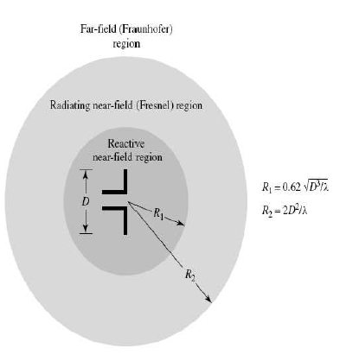

Figure 2.1 : field zone of an antenna

**2.3 –****Radiation Patterns**

An antenna *pattern* is defined in as *[4] :* “a mathematical function or a graphical representation of radiation properties of the antenna as a function of space coordinates. In most case, the radiation pattern is described in the far-field region and is represented as a function of the directional coordinates. Radiation properties include power flux density, field intensity, radiation intensity, field strength directivity, polarization or phase ”.

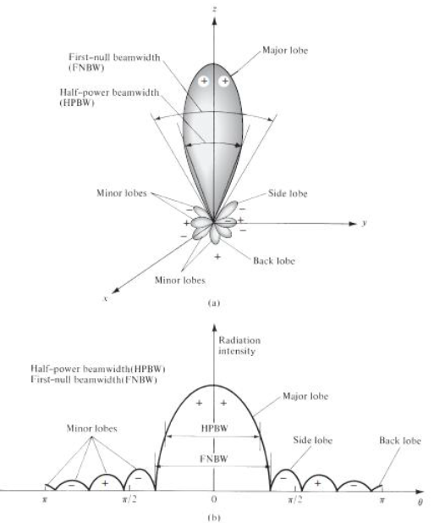

Figure 2.2: (a) radiation lobes of an antenna pattern. (b) linear plot of power pattern.

In general, it is a good instrument to evaluate the behavior of an antenna, specifically the radiation lobes and power pattern.

**2.4 - Radiation Power density**

An electromagnetic field is used to transport information through a communication medium, wireless or guiding structure, from one point to the other. Energy and power are associated with electromagnetic wave. In this sense, the Poynting vector, that is a power density, is defined as *[4]*:

$\vec{W}$ = $\vec{E}$ $\vec{H}$

*

with :

$\vec{W}$ is the instantaneous Poynting vector (W/ $m^{2}$)

$\vec{E}$ is the instantaneous electric field intensity (V/m)

$\vec{H},$ instantaneous magnetic field intensity (A/m)

However, the instantaneous total power P (W) crossing a closed surface may be obtained by integrating the normal component, over the entire surface, of the Poynting vector. That in equation form is :

$\vec{P}$ = $\oint{\vec{W} }$·d $\vec{s}$

However, the time average Poynting vector may be calculated using the equation *[4]* :

$W_{av}$ = $\frac{1}{2}$ Re($\vec{E}·{\vec{H}}^{*}$)

Where:

$W_{av}$ = average power density (W/ $m^{2}$)

The average power radiated is defined as:

$P_{av}$ = $P_{rad}$ = $\oint{ {\vec{W}}_{rad} }$·d $\vec{s}$ = = $\frac{1}{2} \oint{ Re(\vec{E}·{\vec{H}}^{*}) }$·d $\vec{s}$

Therefore, the power pattern of an antenna is defined as a function of direction, of average power density radiated.

**2.5 - Radiation intensity**

The Radiation intensity in a given direction is defined as: “ power radiated from an antenna per unit solid angle” *[4]* and is calculated *[4]* as:

U = $r^{2}W_{rad}$

Where:

U is the radiation intensity (W/unit solid angle)

$W_{rad}$ is the radiation density (W/ $m^{2}$)

**2.6 – Directivity**

The directivity is defined *[4]* as: “*the ratio of the radiation intensity in a given direction from the antenna to the radiation intensity averaged over all directions*. *The average radiation intensity is equal to the total power radiated by the antenna divided $4π$* ”, and it is calculated *[4]* as:

D = $\frac{U}{U_{0}}$ = $\frac{4πU}{P_{rad}}$

Where :

U is the radiation intensity

$U_{0}$ is the radiation intensity of isotropic source

both evaluated in (W/ unit solid angle)

$P_{rad}$ is the total radiated power (W)

Therefore, the radiation intensity for maximum directivity is:

$D_{max}$ = $D_{0}$ = $\frac{U_{max}}{U_{0}}$ = $\frac{4πU_{max}}{P_{rad}}$

Where :

D is the directivity

$D_{0}$ is the maximum directivity

$U_{max}$ is the maximum radiation intensity

$U_{0}$ is the radiation intensity of isotropic source

**2.7 - Antenna impedance and reflection coefficient**

Each antennas are characterized by an impedance, that is presented at its terminals,

here are designated as a – b.

In general, the complex input impedance of antenna, frequency dependent is calculated

as: $Z_{A}$ (ω) = $R_{A}$ (ω) + j $X_{A}$ (ω)

Where:

$Z_{A}$, $R_{A}$, $X_{A}$ are respectively impedance, resistance and reactance at terminals a-b (Ω)

At lower frequency, the impedance presented the same properties as a capacitor *[4]* , therefore the antenna resistance may be divided in two components:

$R_{A}$ (ω) = $R_{r}$ (ω) + $R_{l}$ (ω)

Where:

$R_{r}$ is the radiation resistance of antenna

$R_{l}$ is the loss resistance of antenna

If it is assuming that the antenna is linked to a generator with internal impedance

$Z_{G}$ (ω) = $R_{g}$ (ω) + j $X_{g}$ (ω)

Where:

$Z_{g}$ is generator internal impedance (Ω)

$R_{g}$ is resistance of generator impedance (Ω)

$X_{g}$ is reactance of generator impedance (Ω)

Consequently, the maximum power delivered to the antenna are presented when :

+ =

The following figure shown an antenna coupled to the generator, in terms of equivalent circuit, when the transmission mode is used :

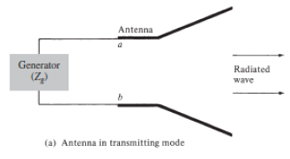

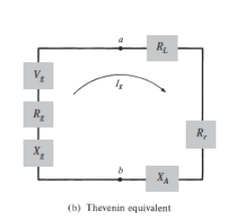

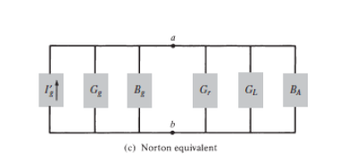

Figure 2.3 (a)Antenna model , (b) (c) equivalent circuit

Note: for this part, it is assuming that quarter wave antenna exhibits a nominal 50 ohm characteristic impedance.

Instead, the reflection coefficient of the antenna is [bal]:

Г = $\frac{Z_{in }- Z_{0}}{Z_{in} + Z_{0}}$

Where :

$Z_{in }$ is the input impedance of the antenna;

$Z_{0}$ is the characteristic impedance of the source and the feedline,

according that the feedline is matched to the source ;

**2.8 - Accepted power and mismatch loss**

Considering that the accepted power (AP) is defined as the power delivered to the antenna terminal from source, its depends by reflection coefficient:

AP = (1 - ${׀‌ Г ‌ ׀‌‌}^{2}$ ‌‌‌‌‌) $P_{in}$

‌

Where :

*AP* is the accepted power

$P_{in}$ is the input power

Instead, the corresponding mismatch loss to the accepted power is defined as:

$\frac{AP}{P_{in} }$ = 1 – ${׀‌ Г ‌ ׀‌‌}^{2}$

‌‌‌‌‌

And the mismatch in dB is:

*ML*(dB) = -10 log($1 – ‌‌‌‌‌{׀‌ Г ‌ ׀‌‌}^{2}$)

**2.9 - Antenna radiation efficiency**

There are in literature several methods to calculate the radiation efficiency, for example the pattern integration method, Q- factor method and Wheller method, such as is illustrated in [D], some of these making the calculation easier.

The radiation efficiency $e_{rad}$ is the amount of power that propagates far field from the power delivered to the terminals of antenna. Can be written as [4] :

$e_{rad}$ = $\frac{P_{rad }}{AP}$ = AP - $P_{diss}$

$P_{diss}$ is the dissipated power in the antenna;

Generally, all the possible losses can be taken into account through total efficiency $e_{t}$, that may be written as [5] or [4]:

$e_{t}$ = $e_{r}e_{c}e_{d}$ = $\frac{P_{rad }}{P_{in }}$

Where the quantity are dimension-less:

$e_{r}$ is the reflection (mismatch)efficiency,

$e_{c}$ is the conduction efficiency

$e_{d}$ is the dielectric efficiency

In this way it is possible to consider the losses due to reflection, conduction and dielectric losses;

**2.10 - Gain**

The gain describes an important way to evaluate the performance of an antenna. It is function of the efficiency and the directional capability. A gain definition is given in [4] as : ” *the ratio of the intensity, in a given direction, to the radiation intensity that would be obtained if the power accepted by the antenna were radiated isotropically. The radiation intensity corresponding to the isotropically radiated power is equal to the power accepted by the antenna divided 4𝜋* ”. That corresponds as:

Gain = *4 𝜋 $\frac{U}{P_{in }}$*

Where :

U is the radiation intensity

Furthermore, when the antenna is perfectly matched, that means $Z_{in }$ = $Z_{C }$,

The gain may be related to the total efficiency and the directivity in the following way:

*Gain* = $e_{t }$· D

Where D is the directivity.

**2.11 - Bandwidth**

The bandwidth , noted as BW, is defined as [4] : **“***the range of frequencies within which the performance of the antenna, with respect to some characteristic, conforms to a specified standard”.*

In general, for a mobile handset antenna, the objective is a bandwidth that covering the operative frequency bands. Using this parameter it is possible to evaluate if an antenna is broadband or narrowband, This dimensions often depends the antenna size and mismatch effect . In this work, it is considered for a handset antenna that the limit is $S_{11 }$ = -6 dB at the border of the frequency band , that corresponds to a power reflection of 25 %, as explained in [6] .

**2.12 - Quality factor**

The quality factor is described in function of small antennas property and of bandwidth. There are some method to define the quality factor, some of these are considered following. It represents a parameter giving a well indication on the bandwidth. Indeed, it is evaluate for a tuned antenna at the resonating frequency $f_{0}$. According to *[4]* , is defined :” *the tuned antenna is one whose feed point reactance is tuned to zero at a frequency $f_{0}$ using a single, lossless, series tuning element having a reactance $X_{s}(ω_{0})$ = ${- X}_{A}(ω_{0})$“.*

A way to define the quality factor is:

Q($ω_{0}$) = $\frac{ω_{0}W(ω_{0})}{P_{in }(ω_{0})}$

Where:

$ω_{0} is the tuned frequency$;

$W(ω_{0})$ is the internal energy;

$P_{in }(ω_{0})$ is the power accepted;

It is possible to approximate the exact value of the quality factor as:

$Q_{ }(ω_{0}$) ≈ $Q_{z }(ω_{0}$) = $\frac{ω_{0}}{2R_{A }(ω_{0})}\sqrt{R_{A}^{'} {\left(ω_{0}\right)}^{2}+ (X_{A}^{'}\left(ω_{0}\right)+\frac{⃒X_{A }(ω_{0})⃒}{ω_{0}} )² }$

It is possible to define a relation for bandwidth and quality factor that is suitable for all frequency range. As is written in *[4]* : “*The definition of bandwidth suitable for this purpose is fractional matched VSWR bandwidth, ${FBRW}_{V }\left(ω_{0}\right),$ where the VSWR of the tuned antenna is determined using a characteristic impedance, equal to the antenna’s feed point resistance”.*

The fractional matched VSWR bandwidth is defined as *[7]* :

${FBW}_{V }\left(ω_{0}\right)= \frac{ω_{H}-ω_{L} }{ω_{0}}$ = $\frac{Δf }{f_{0}}$ $∝\frac{1 }{Q}$

Moreover, It is possible to relate the Fractional matched VSWR bandwidth and Q as *[7]*:

$Q\left(ω_{0}\right)$ ≈ $Q_{z }(ω_{0}$) = $\frac{2\sqrt{β} }{{FBW}_{V }\left(ω_{0}\right)}$, $\sqrt{β}$ = $\frac{s-1}{2\sqrt{s}}$ ≤1

Or more simply, the Q factor may be written in according to *[8]* :

$Q(ω$) = $\frac{ω}{2R_{A }\left(ω\right)}\frac{{dX}_{A }\left(ω\right)}{dω}$

***Chapter 3 : Small antennas for handset***

In general, the antennas are designed and measured in well-defined environments,  
on both ground planes of infinite or large. However, in a small electrical device such as handset communication terminals, the antenna will undergo a distortion of its radiation characteristics. Therefore, it is therefore important to emphasize that the integration of an antenna in a terminal is very complex, therefore the design of a portable antenna is not an easy task and certainly will affect the actual behavior with regard to both the input and radiation characteristics [1, 2].

However, this type of antenna is subject to very strict specifications [3]. Small, compact, light weight, low profile, strength and flexibility are the main considerations taken into account in conventional small antenna design [4]. To this we must add, as new mobile devices are required to operate to different standards, their antennas are expected to grab as much spectrum as possible, so they can cover multi-band and broadband [5].

Although the development in microelectronics led to a more significant reduction in the size of the terminal, the size of the antenna cannot be so simply reduced, due to physical factors. Indeed, this could bring restrictions on the polarization, the radiation efficiency and bandwidth, and also increases the sensitivity to manufacturing tolerances. In the past, some compromises have been taken in relation to performance the antenna, and the deterioration in some of its performance characteristics has been accepted, whether the objectives of integration and cost were achieved. However, in recent years the trend is changing, and network operators wishing to obtain terminals even more efficient.

The highly efficient proposed 4G technologies will certainly make use of MIMO technologies to further reduce interference and provide for extra capacity require in future applications. However, this require multiple antennas at ends of downlink and uplink. The current trend on the reduction of volume of mobile devices leads to a consequent reduction in the size of the antenna, but at the same time be able to operate on a larger number of frequency bands, corresponding to its number of diverse wireless systems a portable device. Miniaturization, integration, multi-band operation, and the final performances were instrumental in choosing the design of initial models.

Considering that an antenna that covers continuously without tuning a wide spread of frequency bands is a single-band but also wideband antenna. But, today’s wireless terminology, an antenna that operates double bands frequencies, like GSM 900 and GSM1800 frequencies is considered a multi-band antennas.

Tree different antenna models are shown in this chapter. The first two are a PIFA model and the last one is a FICA model, which exhibit respectively single and multiband behavior.

**3.1 - Planar Inverted Folded Antenna**

This section provide a description of the characteristics of the planar inverted –F antenna , that is a more popular antenna for portable wireless devices because of its low profile, small size, and built-in structure [9].

The other major advantages are easy fabrication, low manufacturing cost, and simple structure *[10]*. Also, PIFA’s inherent bandwidth is higher than the bandwidth of the conventional patch antenna, because since a thick air substrate is used.

The basic PIFA, with a grounded patch antenna at λ/4 and patch length instead of λ/2, formed by a top element of a radiating patch , a ground plane which is fed from a transmission line between a DC shorting plate .Moreover, are considered some variations of dual-band or multi-band PIFAs suitable for application in mobile units reported recently [11],[12],[13],[14]*.*

In the Figure 3.1 it shows the geometry of a conventional single band PIFA element. Modifying these ones, leaves the possibility to design well adapted antennas following different handset bandwidth [10].

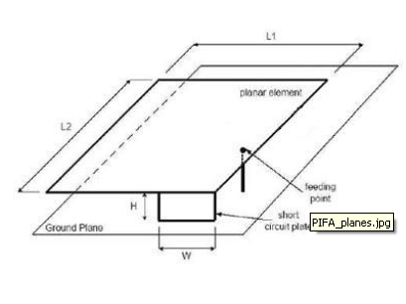

Figure 3.1 : PIFA model

A major advantage concerning the PIFA is that the dimension of the patch can be reduced, introducing the short circuit element between the feed and the ground plane. In addition, using a shorting element of a smaller dimension than that of the patch, the effective inductance of the antenna increases and the resonant frequency becomes lower. In fact, to have a PIFA resonating at a low band frequency, the current distribution effective length has to be as long as possible. To take advantage of the longest length of the patch, the ratio between the length ($L_{1}$) and the width ($L_{2}$) of the patch, has to be as high as possible, with a shorting element small behind the dimension of the edge [15].

In other terms,

$\frac{L₁}{L₂}≥1, W≪L₁$

The fundamental step that has to be done when designing a new PIFA is the calculation of the patch dimension to make the antenna resonate at the right frequency. At first, the formula relying on the plate dimensions with the wavelength was the following:

L₁+L₂ = $\frac{λ}{4}$ $\overset{⇔}{} fr$ = $\frac{c}{4(L₁+L₂)}$

Nevertheless, it does not consider the presence of the shorting plate, which gives :

L₁+H = $\frac{λ}{4}$ $\overset{⇔}{} fr₁$ = $\frac{c}{4(L₁+H)}$, for $\frac{W }{L₁}$ =1

or

L₁+L₂+H = $\frac{λ}{4}$ $\overset{⇔}{} fr₂$ = $\frac{c}{4(L₁+L₂+H)}$, for W=0

and

*L₁+L₂+H - W*= $\frac{λ}{4}$ $\overset{⇔}{ } f_{r2}$ = $\frac{c}{4(L_{1}+L_{2}+H-W)}$, for 0< $\frac{W }{L₁}$ <1

Where:

$f_{r}$:Resonance frequency [*Hz*]

c:Vacuum light speed 3· ${10}^{8}$,

*L₁*: Length of the PIFA antenna[*m*]

*L₂*: Width of the PIFA antenna [*m*]

*H*: height between the ground plane and the patch

*W* : the width of the shorting element

Consequently, it is understandable that the resonant frequency is increasing with the width of the plate because of the negative sign at the denominator before *W.* As it is explained in [15], the resonant frequency , when 0 < $\frac{W }{ L₁}$ < 1, can be approximated thanks to the following equations :

fr= r·f1+(1-r)·f2, for > 1

And

fr=rk ·f1+(1-rk), for $\frac{L1}{L2}$ >1

with r = $\frac{W }{ L₁}$ and K= $\frac{L1}{L2}$.

The mismatch loss is rising with the growth of the L₁/L₂ ratio whereas; the bandwidth is going down linearly.

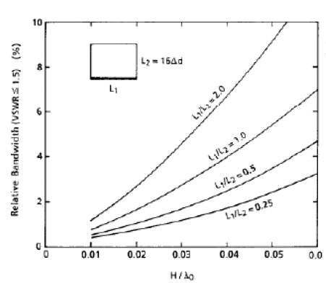

Figure 3.2 (a) Bandwidth of the PIFA when short circuit plate width is equal L1[15]

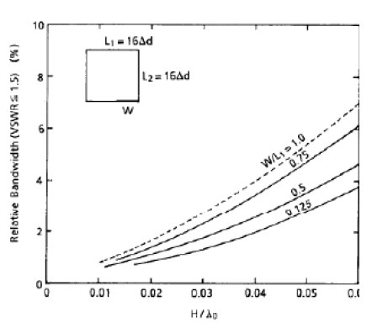

Figure 3.3 (b) Bandwidth of the PIFA when short circuit plate width is narrower than L1*[15]*

**3.1.1 - PIFA with meandering**

The first model investigated was a single band PIFA antenna. The design is showed in Figure 3.4. The geometry of the proposed structure along with definition of its dimensions. The antenna design proposed is showing the matching property at 796 MHz . The dimensions of the plate is fixed at 40x20 mm .The width of the ground plane is kept fixed at 40 x 100 mm to cover the whole part of the patch. The meandering are long 210 mm and width is 1 mm. The distance between patch and ground plan is 5 mm. The distance between source and short is 4 mm.

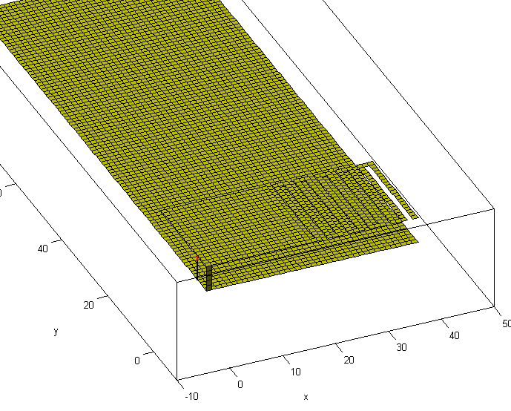

Figure 3.4 PIFA design1

During the simulation, it shown that changing the distance between source and short, can give mismatch of coupling and gain loss. Such as, the bandwidth is increasing when the patch and the ground plane are getting closer each other. Moving the short away from the feeding source shows that both the bandwidth and frequency resonance are modified. Indeed, the most far is the short away from the source, and the higher is the resonant frequency.

As shown in Figure 3.5, the maximum return loss is -31.28 dB at 796 MHz. The upper and lower band frequencies are 778 MHz and 813 MHz, respectively, giving the absolute bandwidth of 35 MHz. Therefore, the bandwidth obtained for the proposed PIFA is 4.4%.

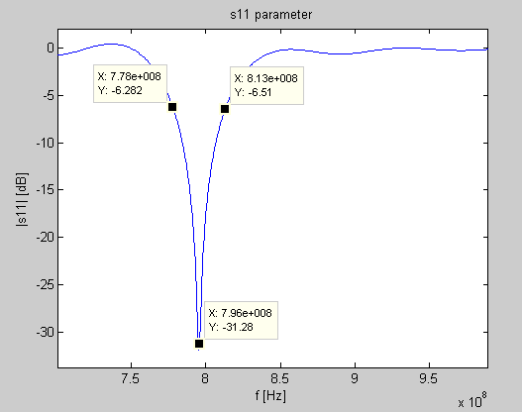

Figure 3.5 PIFA design1. S11 parameter

Figure 3.6 shows the smith chart, and describes the matching obtained in the simulation, where the colored part is interest frequency range.

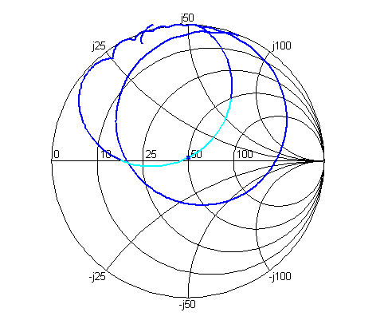

Figure 3.6: Smith chart

**3.1.2– PIFA Dual band**

This PIFA model exhibits two resonant mode, obtained on the same patch volume. The geometry of the proposed structure is shown in Fig. 3.7 ( note: the ground plane is not showed ) along with definition of its dimensions. The original conception of this kind if antenna is showed in [19].The antenna design proposed is showing the matching property both at 772 MHz and 1942 MHz . The dimensions of the plate is fixed at 40x24 mm .The width of the ground plane is kept fixed at 40 x 100 mm to cover the whole part of the patch. The distance between patch and ground plan is h=5 mm.

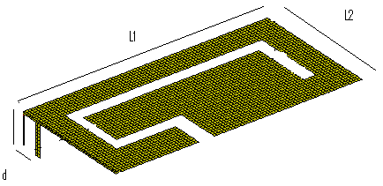

Figure 3. PIFA design2

This design of antenna exhibits two resonating in UMTS band. The first is in band XIV, its presents the S11 equal to -21.93 dB at 774 MHz and the bandwidth is narrowband, only 15 MHz. The second frequency range is in band I, that presents the S11 equal to -14,94 at 1942 MHz, and bandwidth is 70 MHz .A great matching is achieved with the between source and short equal to d = 3 mm.

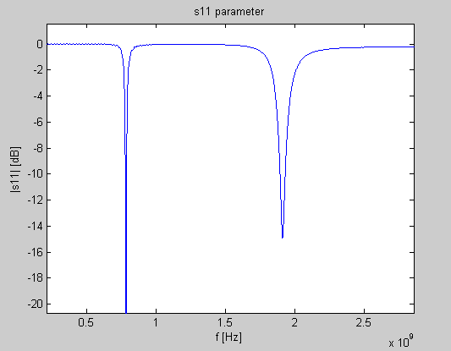

Figure 3.8 S11 parameters

**3.2 - FICA**

According to [18], the Folded Inverted Conformal Antenna is a kind of antennas that exhibits three resonating modes, which operate by sharing the same antenna volume. The geometry of the proposed structure is shown in Fig. 3.9 along with definition of its dimensions. The dimensions of the plate is fixed at 40x24 mm .The width of the ground plane is kept fixed at 40 x 100 mm to cover the whole part of the patch. The distance between patch and ground plan in this case is different, it is equal to h = 5 mm.

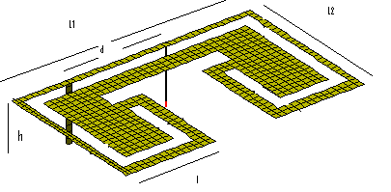

Figure 3.9 FICA antenna

How shown in the following figure 3.10, this design exhibits the I - II - V UMTS bands

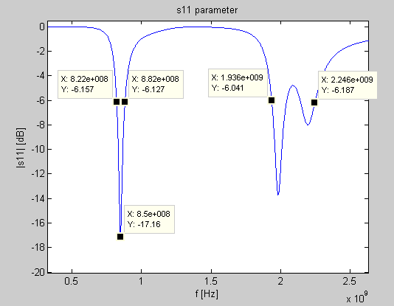

Figure3.10 FICA. S11 parameters

It is shown in the Smith chart, that the antenna has greater matching property at 850 MHz

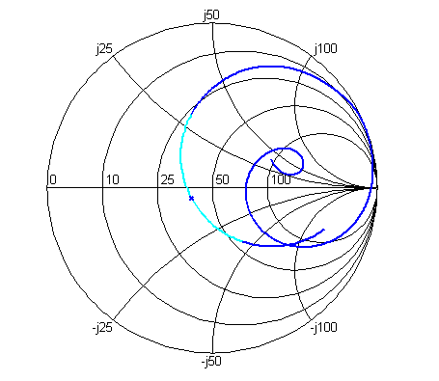

Figure 3.11 FICA Smith chart

Moreover, it is possible to allow a spreading of the reactive electromagnetic energy in all the antenna volume with this configuration [19]. In this way, the antenna exhibits a lower Q factor and produces a wider radiating bandwidth.

***Chapter 4***

***Small antennas with ceramic material***

**4.1 - State of the art ceramics**

The demand for smaller, cheaper antennas are increased because of higher integration with the packaging structures of mobile device systems. Many methods have been proposed and explored in achieving miniaturization of antennas.[22-28]. For example, a shorting wall has been used to decrease the size by a factor two[22]. Orting posts near the feed have taken this a step further[23,24]. Another approach for antenna size reduction is to employ substrate[25].

The use of ceramic materials, that presents high dielectric constant and low loss, it is a new approach to reducing the antenna size. This types of antenna are called *Ceramic chip antenna,* made by a ceramic substrate block and metal patterns printed on it. Some studies done on antenna types have shown that it is possible to use high constant ceramic substrate allowing a good antenna reduction size.

For instance, using a substrate with constant of 20, resulting an area of only 25%, compared to using an FR4 substrate. Otherwise, an antenna on ceramic with two different permittivity dielectric value, the fist one is the Barium - Titanate with a dielectric constant of 37 and the second ones is neodymium-titanate substrates with a dielectric constant of 85. In the first case, the operating frequency was 1,5 GHz, used a BaTiO3 substrate with $ε_{r}$ =37, the area of the antenna was 333 mm.

The second case was with a Neodymium -Titanate substrate with $ε_{r}$ =85,the area of the antenna area was 105,16 mm, with a possible reduction size of more than 85% over a conventional antenna on FR4 substrate. It is considered a thickness equal to 2.54 and, in the best case, the bandwidth was only 2.5 MHz . According to [34], to get a reasonable small antenna on a 2 mm thick substrate, with high dielectric constant 38, the antenna reduction dimension is significantly smaller then 1/10 of the wavelength, and the bandwidth is only 4,72 MHz .

**4.1 - High dielectric ceramics substrate**

A number of works in the literature have reported or calculated results on the effects of high permittivity [33].There are several types of ceramic materials, each of these having different thermal stables properties, that depends on the frequency use[32]. What emerges from state of the art , most of the materials using a higher permittivity, i.e greater than 80, are mixed with low other dielectric material on texture[35], combining both the its benefits. In addition, synthetic dielectric can be produced by mixing materials of two or more different dielectric constants. This types of substrate lead to texture substrate. These types of substrates lead to textured substrates, which provide for additional design control, useful in impedance matching. Combining all of these characteristics with a broadband (bowtie) antenna design, it is possible to improve upon past benchmarks of efficiency and bandwidth while maintaining significant miniaturization. As is well known, increasing the dielectric constant of the antenna substrate (while reducing the dimensions of the device) results in narrower bandwidths [20].

With the use a dielectric substrate with large permittivity and overall size reduction at fixed operating frequency, the impedance bandwidth of antenna is usually decreased. Figure shows the effect of substrate thickness on impedance bandwidth and efficiency for two values of dielectric constants [24]. While the bandwidth increases monotonically with thickness, a decrease in the value $ε_{r}$ value increases the bandwidth.

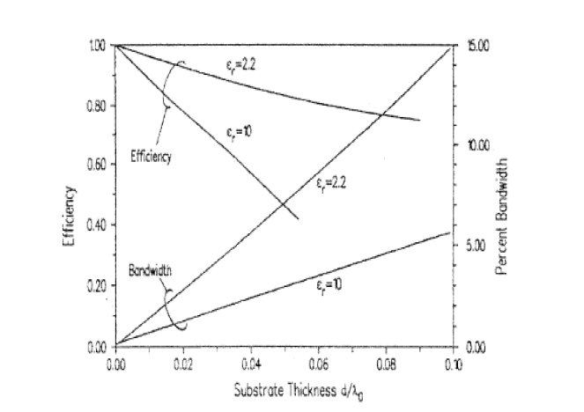

Figure4.1 Effect of substrate thickness on impedance

bandwidth and efficiency for two dielectric constants

**4.3 - Small antenna with dielectric substrate**

Because the Fyrkat didn't work for several days in the last month, now it is possible to present in this project only results on the FICA antenna model, choice due because of its lower quality factor and broadband characteristics.

As a result of the sensitivity analysis, all of simulations in this section are settled as follows:

|  |  |  |  |  |  |  |
| --- | --- | --- | --- | --- | --- | --- |
| Fc[MHz] | Fs[MHz] | Time[s] | PML thickness [cells] | Number of time steps | Cella size | Energy computed [step] |
| 1500 | 2300 | 1x ${10}^{-9}$ | 8 | 100000 | 0,0005 | 100 |

Figure 4.2 the FDTD parameters used in the simulations

In this section, all the antenna model are designed to resonate around at a theoretical frequency of 850 MHz .

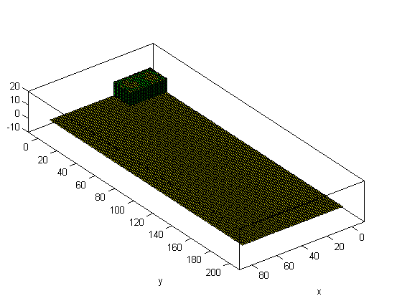

Figure4.3 FICA model reduced. $ε_{r}$ = 20

According to the commercial furniture of the ceramic substrate and the appropriate value of their tangent loss value, the conductivity values have been calculate for different frequency values. It was used the following formulas:

σ= $ε_{0}ε_{r}$ ωtgd

|  |  |  |  |  |  |
| --- | --- | --- | --- | --- | --- |
| frequency | Tang loss | εr=1 | εr=4 | εr=16 | εr=20 |
| 845 Mhz | 0,001 | 4.65*10^-5 | 1.86*10^-4 | 7.44*10^-4 | 9.3*10^-4 |
|  | 0,005 | 2.32*10^-4 | 9.4*10^-4 | 3.76*10^-3 | 4,7*10^-3 |
|  | 0,01 | 4.65*10^-4 | 1.86*10^-3 | 7.44*10^-3 | 9.3*10^-3 |
|  | 0.02 | 9.3*10^-4 | 3.76*10^-3 | 1.5*10^-2 | 1.18*10^-2 |
| 795 Mhz | 0,01 | 4.41*10^-4 | 1.76*10^-3 | 7.05*10^-3 | 8.82*10^-3 |
| 1950 Mhz | 0,01 | 1.08*10^-3 | 4.34*10^-3 | 1.735*10^-2 | 2.17*10^-2 |

Figure 4.4 Conductivity values

**4.4 - Reduction size**

The antenna design with a high dielectric value allows a reduction antenna size

|  |  |  |  |  |  |  |  |
| --- | --- | --- | --- | --- | --- | --- | --- |
| Antenna_Type | Frequency | Substrate  [$ε_{r}$] | Area  [mm²] | Miniaturization by a factor size | Bandwidth  [MHz] | Q | efficiency |
| FICA | 845 | air | 960 | - | 118 | 7.1 | 1.00 |
|  | 847 | 4 | 377 | 2,54 | 17,12 | 49.47 | 0.98 |
|  | 852 | 16 | 155 | 6,19 | 9.17 | 92 | 0.74 |
|  | 845 | 20 | 135 | 7,1 | 7.6 | 110 | 0.60 |

Figure 4.5 Reduction size

**4.5 - Simulation and results**

It is shown a result loss comparison between different permittivity value.

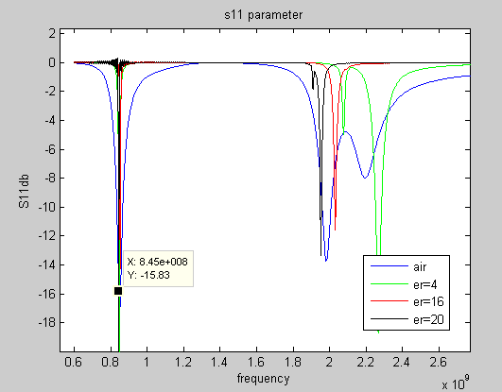

Figure 4.6 Return loss comparison between different value of $ε_{r}$, band I -V

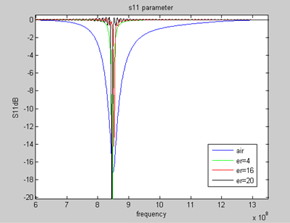

Figure Return loss comparison between different value of $ε_{r}$, band V

Increasing the permittivity value, the antenna became narrowband.

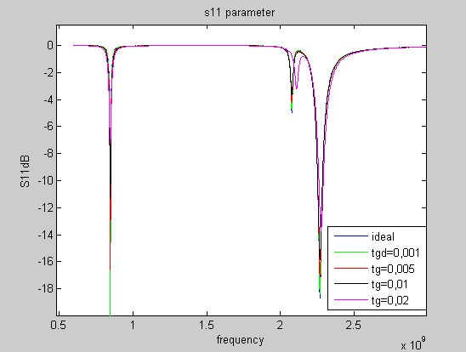

Figure4.7 Return loss comparison between different value of tangent loss. $ε_{r}$ =4

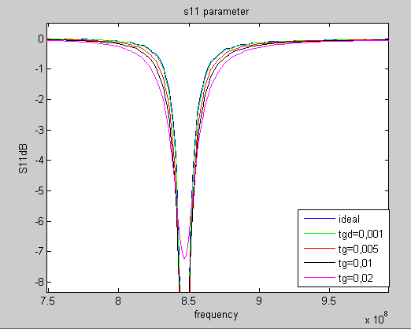

Figure 4.8 Return loss comparison between different value of

tangent loss. Band V $ε_{r}$ =4

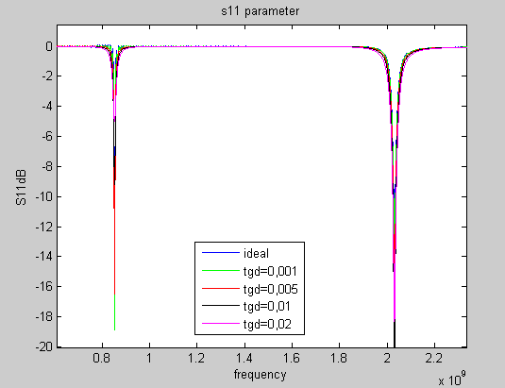

Figure 4.9 S11dB BI, BV. $ε_{r}$ =16

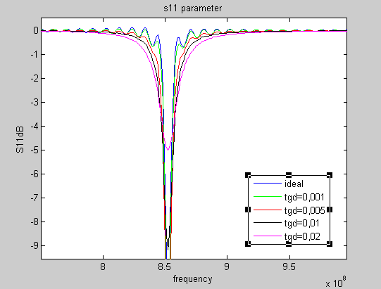

**F**igure 4.10 Return loss comparison between different value of

tangent loss. Band V. $ε_{r}$ =16

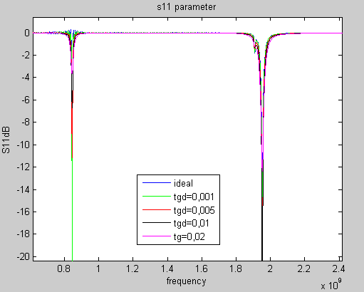

Figure 4.11 Return loss comparison between different value of

tangent loss. Bands I-V $ε_{r}$ =20

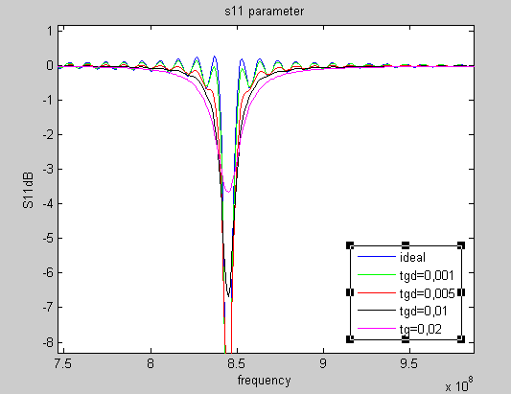

Figure 4.12 Return loss comparison between different value of

tangent loss BV. $ε_{r}$ =20

**4.6 - Quality factor**

It is possible to evaluate the quality factor of an multiband antenna according to [37]

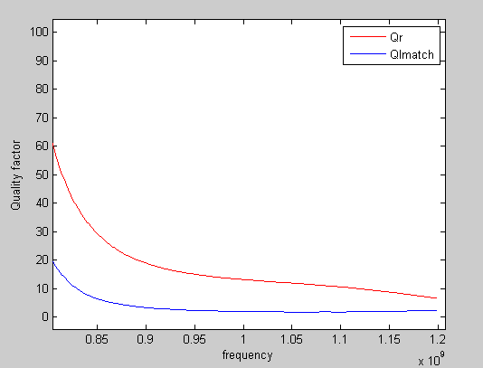

Figure 4.13 FICA model. Comparison of exact Quality factor

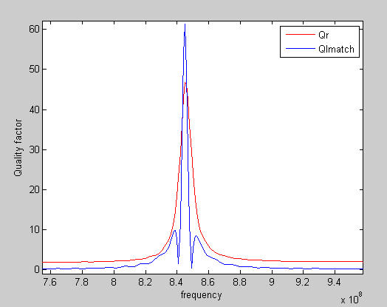

Figure 4.14 FICA $ε_{r}$ =4. Comparison of exact Quality factor

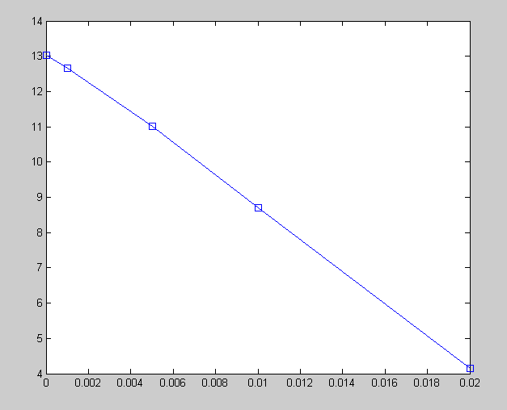

Figure 4.15 FICA $ε_{r}$ =4. Comparison of the quality factor

for different values of tangent loss

This figure showed that increasing the tangent loss value, the quality is reduced.

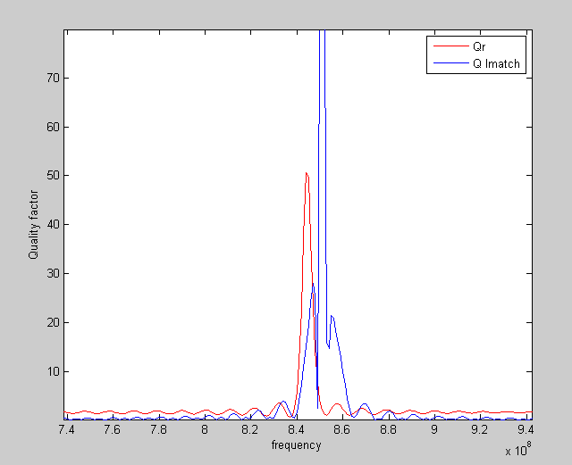

Figure 4.16 FICA $ε_{r}$ =16. Comparison of exact Quality factor

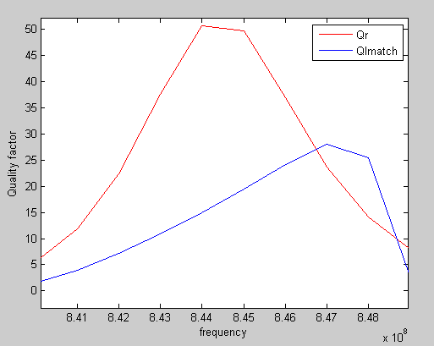

Figure 4.17 FICA $ε_{r}$ =20. Comparison of exact Quality factor

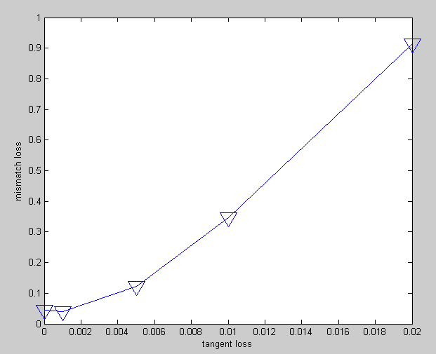

Figure 4.18 FICA $ε_{r}$ =4 . Mismatch loss for different values of tangent loss

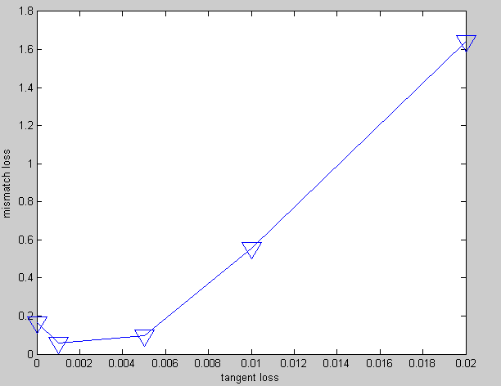

Figure 4.19 FICA $ε_{r}$ =16 . Mismatch loss for different values of tangent loss

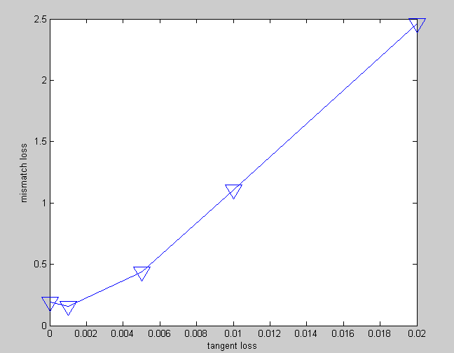

Figure 4.20 FICA $ε_{r}$ = 20. Mismatch loss for different values of tangent loss

This means that the mismatch loss is increased when the tangent loss value is increased

***Chapter 5 Conclusion***

The goal of this project has been achieved partially. In effect, a resize of a antenna FICA has been done, using high permittivity value of 20 has been achieved a reduction factor of 20 with only 7.6 MHZ of bandwidth . Instead, a minimal bandwidth of 20 MHz has been almost possible using dielectric constant of 4 and a miniaturization by a factor size of 2,4. It has shown that the bandwidth is inversely proportional to the quality factor.

Therefore, the optimal choice of an antenna that has a low quality factor is critical for this type of investigation.

Moreover, as said to increase the bandwidth could change the thickness of the substrate.

More simulations have been done about the FICA antenna design, for example has been increased the thickness of the substrate, but that choice has made ​​it difficult to strictly design of all antennas at different values ​​of permittivity.

Also, it will be possible evaluate the performances of ceramic antennas when

when other components are placed in close proximity.

Furthermore, it will be important investigate the human hand influence on the small antenna performance

*Reference*

*[1] ITU global standard for international mobile telecommunications ´IMT-Advanced´*

*[2]* *http://www.ieee.li/pdf/viewgraphs/wireless_mimo.pdf*

*[3]* ***A. Constantinides A. Goldsmith A. PaulRaj H. Vincent Poor E. Biglieri, R. Calderbank****.*

*MIMO Wireless Communications. Cambridge University Press, 2007*

*[4]* ***C. Balanis*** *: “Antenna Theory - Analysis and Design, Third Edition”*

[5]. **Kazuhiro Hirasawa, Misao Haneishi**. *“Analysis, Design, and Measurement of Small and Low-Profile Antennas”.* 1992.

[6]. **F. Gustrau, D. Manteuffel**. *“EM Modeling of Antennas and RF Components for Wireless Communication Systems”.* 2006.

[7]. *Impedance, Bandwidth, and Q of Antennas****.* Best, Arthur D. Yaghjian and Steven** R. 2005.

[8]. *Antennas, from Theory to Practice.* **Yi Huang, Kevin Boyle**. 2008.

[9]F**. Wang, Z. Du, Q. Wang and K. Gong**, “Enhanced-bandwidth PIFA with T-shaped ground plane”, *Electronic Letters*, vol. 40, no. 23, pp. 1504 – 1505, Nov. 2004.

[10 ]**B. Kim, J. Hoon and H. Choi**, “Small wideband PIFA for mobile phones at 1800 MHz,” *Vehicular Technology Conference*, vol.-1, pp. 27-29, May 2004.

[11] **Z. D. Liu, P. S. Hall, and D. Wake**, “Dual-frequency planar F antenna,” IEEE Trans. Antennas Propagation., vol. 45, pp. 1451-1458, Oct. 1997.

[12] **C. R. Rowell and R. D. Murch**, “A compact PIFA suitable for dual-frequency 900/1800-MHz operation,” IEEE Trans. Antennas Fropagat., vol. 46, pp. 596-598, April 1998.

[13] **S. Tarvas and A. Isohatala**, “An internal dual-band mobile phone antenna,” in 2000 IEEE Antennas Propagat. Soc. mt. Symp. Dig., pp. 266-269.

[14] **C. T. P. Song, P. S. Hall, H. Ghafouri-Shiraz, and D. Wake**, “Triple band planar inverted F antennas for handheld devices,” Electron. Lett., vol. 36, pp. 112-1 14, Jan. 20, 2000.

[15] **Kazuhiro Hirasawa, Misao Haneishi**.*“Analysis, Design, and Measurement of Small and Low-Profile Antennas”.* 1992.

[15] **Mittra, R., and S. Dey**, “Challenges in PCS Antenna Design,” *IEEE Antennas and*

*Propagation Society International Symposium Digest*, 1999, pp. 544–547.

[16] **D. M. Pozar and D. H. Schaubert, Microstrip Antennas**:,the Analysis and Design of Microstrip Antennas and Arrays, New York: IEEE Press, 1995.

[17] **A. Taflove**, “*Computational electrodynamics: the finite-difference time-domain method*”

Artech House 1995 first edition

[18] **C. Di Nallo, A. Faraone**, “Multiband internal antennas for mobile phones”. Electronics letters vol41.

[19**] Vainikainen,P.**,:” Resonator-based]analysis of the combination of mobile handset antenna and chassis”, IEEE Trans. Antenna Propag. 2002,50(10),pp.1433-1444.

[20] “ *Multiband Antenna for GSM and 3G Mobile System”*. **ABDURAHMAN M M OWAG**. 2006

[21**] B. Lee and F.J. Harackiewiez**, “Miniature Microstrip Antenna with a Partially filled High Permittivity Substrate”, IEEE Transactions on Antenna and Propagation, AP-50, August 2002 pp 1160-1162

[22]. **S. Pinhas and S. Shtrikman**, "Comparison Between Computed and Measured Bandwidth of Quarter- Wave Microstrip Radiators," *IEEE Transactions on Antennas and Propagation,* AP-36, November 1988, pp. 1615-1616.

[23**]. R. B. Waterhouse**, "Small Microstrip Patch Antenna," *Electronics Letters****,*** 31, April 1995, pp. 604-605**.**

[24]. **Y. J. Wang, C. K. Lee, W. J. Koh, and Y. B. Gan**, "Design of Small and Broad-Band Internal Antennas for IMT-2000 Mobile Handsets," *IEEE Transactions on Microwave Theory Techniques,* MTT-49**,** August 200 1, pp. 1398-1403**.**

[25]. **T. K. Lo, C.-O. Ho, Y. Hwang, E. K. W. Lam, and B. Lee**, "Miniature Aperture-Coupled Microstrip Antenna of Very High Permnittivity," *Electronics Letters,* 33,January 1997, pp. 9-10.

[26**]. K.-L. Wong and K.-P. Yang**, "Small Dual-Frequency Microstrip Antenna with a Cross Slot," *Electronics Letters****,*** 33, November 1997**,** pp. 1916**-**1917.

[27]. **K.-L. Wong and K.-P. Yang**, "Modified Planar Inverted F Antenna," *Electronics Letters,* 34, January 1998,pp. 7-8.

[28]. **B. Lee and F. J. Harackiewicz**, "Miniature Microstrip Antenna with a Partially Filled High-Permittivity Substrate," *IEEE**Transactions on Antennas and Propagation,* AP-50**,** August 2002, pp. 1160-1162.

[29]. **D. R. Jackson and N. G. Alexopoulos**, "Simple Approximate Formulas for Input Resistance, Bandwidth, and Efficiency of a Resonant Rectangular Patch *IEEE Transactions on Antennas and* *Propagation,* AP-39**,** March 199 1, pp. 407-410.

[30]. **E. Chang, S. A. Long, and W. F. Richards**, "An Experimental Investigation of Electrically Thick Rectangular Microstrip Antennas," *IEEE**Transactions on Antennas and Propagation, AP-34,*June 1986, pp. **767-772.**

[31].**Ahmad Hoorfar and Alessandro Perrotta**”An Experimental Study of Microstrip Antennas on Very High Permittivity Ceramic Substrates and Very Small Ground Planes

[32]. **G. Kiziltas, D. Psychoudakis, J. L. Volakis, and N. Kikuchi**, "Topology Design Optimization of Dielectric Substrates for Bandwidth Improvement of a Patch Antenna," *IEEE**Transactions on Antennas and Propagation,* AP-51, October 2003, pp. 2732-2743.

[33] **D. H. Schaubert and K. S. Yngvesson**, “Experimental study of a microstrip array on high permittivity substrate,” *IEEE Trans. Antennas Propagat.*, vol. AP-34, pp. 92–97, Jan. 1986.

[34] **Hans Add, Rainer Wansch and Christoph Schmidt** “Antennas for a Body Area Network**”**

[35] **KuW’, D. Pryehoudaltir’, C-C. Ched, L. Vola, H. Halloran**, ’ Patch Antenna Miniaturization Using Thick Truncated Textured Ceramic Substrate

[36] **D. M. Pozar and D. H. Schaubert, Microstrip Antennas**: the Analysis and Design of Micrtostrip Antennas and Arrays, New York: IEEE Press, 1995.

[37] **Arthur D. Yaghjian*, Fellow, IEEE,* and Steven R. Best*, Senior Member, IEEE ,***Impedance, Bandwidth, and Q of Antennas

***Appendix A***

**Matlab scripts**

***- QUALITY FACTOR***

clear all;

close all;

load prova1_20_002;

load prova2_16_002;

Rs=50;

f0=845;

Df=1e6;

figure;

%in relazione alla formula (81) di pag 1308 del paper:" Impedance, Bandwidth, and Q of Antennas".

Qf=abs(((imZ(2:end)'-imZ(1:end-1)').*f_axis(2:end)')/(4.*Df.*Rs)); % imZ, f_axis portati sotto forma di vettore riga

plot(f_axis(600:1000),Qf(600:1000));

%plot(f_axis,Qf);

q=Qf(f0);

BW=f0/q;

save Q_er20tg002 Qf;

***- QUALITY FACTOR L-MATCH***

clear all;

close all;

load prova10_20;

load prova1_20;

f0=845;

Rs=50;

ZL=Z_disp(f0);

X12=lmatch(Rs,ZL,'r');

X12(1,2);

X12(2,2);

Z1=X12(1,1);

if abs(X12(1,2))>abs(X12(2,2))

Z2=j*X12(2,2);

else

Z2=j*X12(1,2);

end

X2=(X12(1,2));

X1=(X12(2,2));

if X12(1,2)>0 & X12(2,2)<0

C=1/j*2*pi*f_axis*X2;

L=X1/j*2*pi*f_axis;

%Zin=real(Z_disp)+(j*2*pi*f_axis*L)+(1./(j*2*pi*f_axis*C));

else

L=X2/j*2*pi*f_axis;

C=1/j*2*pi*f_axis*X2;

%Zin=real(Z_disp)+(j*2*pi*f_axis*L)+(1./(j*2*pi*f_axis*C));

end

%Q=50*square(C/L);

%Zin= real(Z_disp)+(j*2*pi*C)+1./(j*2*pi*L);

Zin=((Z1*(Z2+real(Z_disp)))./(Z1+Z2+real(Z_disp)));

gamma=abs((Zin-real(Z_disp))./(Zin+real(Z_disp)));

%fprintf('\nBW equal %g MHz,QF equal %g at fr %d MHz\n',BW,Q,f0);

plot(f_axis(650:1200),Zin(650:1200),'r')

qu20=abs(Zin(f0))

load Q_er20 ;

hold on

plot(f_axis(650:1200),Qf(650:1200),'b')

BW20=f0./qu20

save BW_20 BW20;

save qu_20 qu20

***- TWO METHODS QUALITY FACTOR***

clear all;

close all;

load prova10_20;

load prova1_20;

f0=845;

Rs=50;

ZL=Z_disp(f0);

X12=lmatch(Rs,ZL,'r');

X12(1,2);

X12(2,2);

Z1=X12(1,1);

if abs(X12(1,2))>abs(X12(2,2))

Z2=j*X12(2,2);

else

Z2=j*X12(1,2);

end

X2=(X12(1,2));

X1=(X12(2,2));

if X12(1,2)>0 & X12(2,2)<0

C=1/j*2*pi*f_axis*X2;

L=X1/j*2*pi*f_axis;

%Zin=real(Z_disp)+(j*2*pi*f_axis*L)+(1./(j*2*pi*f_axis*C));

else

L=X2/j*2*pi*f_axis;

C=1/j*2*pi*f_axis*X2;

%Zin=real(Z_disp)+(j*2*pi*f_axis*L)+(1./(j*2*pi*f_axis*C));

end

%Q=50*square(C/L);

%Zin= real(Z_disp)+(j*2*pi*C)+1./(j*2*pi*L);

Zin=((Z1*(Z2+real(Z_disp)))./(Z1+Z2+real(Z_disp)));

gamma=abs((Zin-real(Z_disp))./(Zin+real(Z_disp)));

%fprintf('\nBW equal %g MHz,QF equal %g at fr %d MHz\n',BW,Q,f0);

plot(f_axis(650:1200),Zin(650:1200),'r')

qu20=abs(Zin(f0))

load Q_er20 ;

hold on

plot(f_axis(650:1200),Qf(650:1200),'b')

BW20=f0./qu20

save BW_20 BW20;

save qu_20 qu20

***-FIND F0 AND BANDWIDTH***

clear all;

close all;

load prova3;

load prova1;

A=s11db;

A=logical(A<-7);

B=diff(A);

C=find(B>0);%start;

D=find(B<0);%end

f1=C(1);

f2=D(1);

f3=C(2);

f4=D(2);

f5=C(3);

f6=D(3);

n=size(s11db);

i=0; % index of array ekements

v=s11db;

% find min

min=v(1);

posmin=1;

for i=2:n

if(v(i)<min)

min=v(i);

posmin=i;

f01=posmin;

end

end

Q1=f01./(f2-f1)

fprintf('\nS11db equal %g, at frequency %d MHz\n',min,posmin);

***-RESIZE HAND***

clear all;

close all;

%A=rand(5,4,2);

load hand6;

A=VolArray;

%[I,J]=size(A);

%[I,J,K]=size(A);

[I,J,K]=size(A);

%AA=double(zeros(I*2,J*2));

AA=double(zeros(I+2,J*2,K*2));

for i=1:I;

for j=1:J;

for k=1:K;

%AA(2*i-1, 2*j-1) =A(i,j);

AA(2*i-1, 2*j-1, 2*k-1)=A(i,j,k);

end

end

end

for i=1:I;

% AA(2*i,:)=AA(2*i-1,:);

AA(2*i,:,:)=AA(2*i-1,:,:);

end

for j=1:J;

%AA(:,2*j)=AA(:,2*j-1);

AA(:,2*j,:)=AA(:,2*j-1,:);

end

for k=1:K;

AA(:,:,2*k)=AA(:,:,2*k-1);

end

VolArray=AA;

clear A;

clear AA;

clear I;

clear J;

clear K;

clear i;

clear j;

clear k;

save hand6

***- DOUBLE HAND***

clear all;

close all;

%A=rand(5,4,2);

load hand1;

A=VolArray;

%[I,J]=size(A);

%[I,J,K]=size(A);

[I,J,K]=size(A);

%AA=double(zeros(I*2,J*2));

AA=double(zeros(I+2,J*2,K*2));

for i=1:I;

for j=1:J;

for k=1:K;

%AA(2*i-1, 2*j-1) =A(i,j);

AA(2*i-1, 2*j-1, 2*k-1)=A(i,j,k);

end

end

end

for i=1:I;

% AA(2*i,:)=AA(2*i-1,:);

AA(2*i,:,:)=AA(2*i-1,:,:);

end

for j=1:J;

%AA(:,2*j)=AA(:,2*j-1);

AA(:,2*j,:)=AA(:,2*j-1,:);

end

for k=1:K;

AA(:,:,2*k)=AA(:,:,2*k-1);

end

VolArray=AA;

clear A;

clear AA;

clear I;

clear J;

clear K;

clear i;

clear j;

clear k;

save hand1