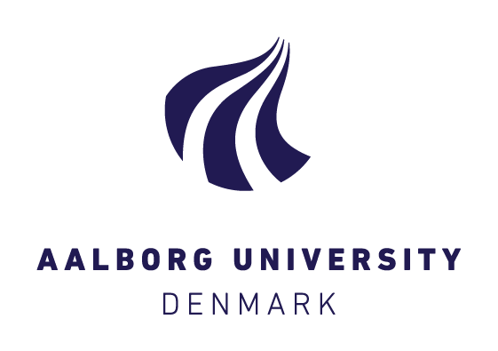
S T A N D A R D TITLE P A G E F O R PROJECTS

To be completed by the student(s)
Subjects: (tick box) | Project : |  | Thesis: x | Written Assignment:
Study programme: |  | Msc. International Business Economics
Semester: |  | 4th
Exam Title: |  | IBE Master Thesis
Group Number:
Names +  Student Nos of group member(s): |  | Name(s) |  | Student Number(s)
 |  | Dusan Petrovic |  | 20151262
Submission date: |  | 6/9/2019
Project Title /Thesis Title |  | How has Nefab Internationalized its operations in Slovakia: An Exploratory Case Study
According to module description,  maximum number of characters/words/pages  of the paper |  | 100 pages/ 240000
Number of characters/words/pages  (Standard page = 2400 characters including Tables and Figures, excluding References, Appendices, Front Page, Table of Contents) |  | 39pages/93.600 keystrokes
Supervisor (project/thesis): |  | Prof. Svetla Marinova
We hereby declare that the work submitted is our own work. We understand that plagiarism is defined as presenting someone else's work as one's own without crediting the original source. We are aware that plagiarism is a serious offense, and that anyone committing it is liable to academic sanctions.
Rules regarding Disciplinary Measures towards Students at Aalborg University:
http://www.plagiarism.aau.dk/Rules+and+Regulations/
Date and signature(s):
_________________________________
Signature and date

_________________________________
Signature and date
_________________________________
Signature and date

_________________________________
Signature and date

_________________________________
Signature and date

_________________________________
Signature and date

_________________________________
Signature and date

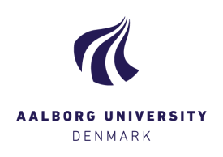
.
.
.
.
.
.
.
.
.
.

Master Thesis
“How has Nefab internationalized its operations in Slovakia: A n Exploratory Case Study”

Author: Dusan Petrovic
Date submitted: 06/09/2019
Word count: 12444 words

Contents

Chapter 1 Problem Identification 6
1.1 Research Background 6
1.2 Problem Formulation 7
1.3 Research Significance 8
Chapter 2 Literature Review 8
2.1 The concept of Internationalization 9
2.1.1 Rational Action Modelling 10
2.1.2 Theoretical perspective of Internationalization firms 11
2.2 Eclectic or OLI paradigm 14
2.2.1 The Eclectic paradigm and FSA-CSA framework 15
2.2.2 Resource seeking FDI 17
2.2.3 Market seeking FDI 17
2.2.4 Efficiency seeking FDI (global sourcing) 17
2.2.5 Strategic asset/capabilities seeking FDI 18
2.3 Liability of foreignness (LOF) 18
Chapter 3 Methodology 20
3.1 The Paradigmatic Approach 20
3.1.1 Ontology 21
3.1.2 Epistemology 23
3.1.3 Human Nature 24
3.1.4 Methodology – Ideographic Approach 25
3.2 The Philosophical position of the Research 25
3.2 Methodological and Research View Positioning 26
3.3 The Research Design Strategy 27
3.4 Research Method Approach 27
3.4.1 Inductive Reasoning 28
3.4.2 Case Study Types 29
3.5 Modes of Data Collection and Case Company Introduction 30
3.5.1 Case Introduction of Nefab corporation 30
3.5.2 Primary Data 32
3.5.3 Secondary Data 32
Chapter 4 Key Findings and Discussion 34
4.1 Nefab’s presence in the area of Slovakia and Central/Eastern Europe 34
4.2 Data Analysis 35
4.3 Key Findings 36
4.3.1 Nefab’s Internationalization strategy of its operations in Slovakia 36
4.3.2 Discussion 40
Chapter 5 Conclusion, Limitations and Future Research 41
5.1 Conclusion 41
5.2 Limitations and Future Research 41
References 42
Appendix A 48
Appendix B 52
Appendix C 54

Chapter 1 Problem Identification

Research Background

The primary goal of this research paper is to better understand and try to explain in a clear and concise manner the motives of internationalization of a global company within the specific region, namely Slovakia which is located in central Europe. The essential part of this study is also to understand the time frame meaning why and what mode of entry of the internationalization has happened in the particular time instead just focusing on the geographical location of the host country and its economic conditions. Ultimately, it brings us to another integral part of this research work which is to link the major or key factors what have had an impact on the whole time/space decision allocation of internationalization process. From the theoretical perspective there are four models such as Institutional-economic, Strategic-competition, Learning and Inter-organizational model as defined by Strandskov (1995) along the two dimensions: drivers and nature of decision as illustrated in the table 2.
By theoretically analyzing the internationalization business theories known as eclectic paradigm OLI (ownership, location, internationalization) along with the industrial inputs of the company researched have been achieved to identify the gaps and to explore in more depth the researched topic. Furthermore, with the respect of OLI business theory four different forms of FDI (foreign direct investment) have been defined as follows: Resource seeking, Market seeking, Efficiency seeking and Strategic asset/capabilities seeking FDI. All these theoretical concepts have been elaborated in more depth in the Chapter number two where the literature review has been conducted. As the building blocks of the international business strategy are defined Firm-specific advantages and Country-specific advantages which again have been examined in connection of the Nefab corporation context more closely in Chapter two and later discussed in Chapter number four. In the context of the research paper on theoretical constructs of internationalization business theories and its aspects, the global industrial packaging company Nefab headquartered in Sweden has been investigated. Nefab has a manufacturing site along with its business/sales unit in Levice, Slovakia established in 2005. Since me as an author who conducted this study, I have been able to draw upon my three years long experience within the company based in Slovakia from a various job-positions perspective. I have been also a member of the International Business Development department in Shanghai within the Asia/Pacific region as a part of my Business Internship placement during my Bachelors studies at Deakin University in Melbourne, Australia. My experience and knowledge of the company has been further developed with another position placement at Nefab in Czech Republic as a sales representative for automotive industry segment. Moreover, Nefab is an established company in a global industrial packaging market operating for seventy years. Since it has its representation in over thirty countries worldwide as a sales and business units, manufacturing sites and more than 2800 employees it has been natural to choose this Scandinavian based company as a research subject to explore the topic of internationalization within the Slovak republic from where I come from. Consequently, I have been able to build upon my tacit knowledge of the host country due to my background.

Problem Formulation

Within the scope of the problem formulation of the case company Nefab which is a global industrial packaging corporation represented in over more than thirty countries, it has been studied on how theoretical and industrial inputs of internationalization strategy impact the decision making of the company. The research paper further investigates on how these factors have been identified, evaluated and implemented into the decision making in creation of Internationalization Strategy of the company. Furthermore, what have been the challenges and practical implications, opportunities in regards of dealing with the information on the specific host country – Slovakia. Subsequently, have Slovakia been targeted for some specific reasons – country specific assets/resources or it has been company strategy from the start of the decision making process defines as Firm’s specific advantages. More importantly, how has Nefab researched the Slovakian conditions on having a green-field manufacturing plant established in industrial location at Levice. In contrary, would the decision be different if the company have had a different set of knowledge on different areas of Central Europe or overall geographical locations along with economic environment? In other words, have there been more options in consideration of building a manufacturing plant? Hence, the main research question states as follows:
- How has Nefab Internationalized its operations in Slovakia?
The subquestions are as follows:
- What is the Internationalization Strategy view of Nefab corporation?

- How is the internationalization strategy of Nefab corporation influenced by different factors?
- How is the decision making on internationalization of company operations affected by researching of different aspects of the area specific conditions?

The research paper further addresses the various aspects of Internationalization Strategy view of Nefab corporation analyzing the motives and modes of entry along with the industrial practices.

Research Significance

The significance of this research paper lies in deeper understanding on why a global industrial packaging company has decided to manufacture in Slovakia – economy still in transition from centrally planned into the fully developed economy. Have these decisions been made based on a rather short-term analysis or with the respect of more future and long-term view of the host country? The theoretical implications as oppose to industrial aspects of internationalization within the area of core business interests of Scandinavian company contribute to further understanding of motives, forms and decision making before the execution of the plan. Moreover, by exploring the gap in this very case choosing one country over another - Slovakia over Hungary or Czech Republic for instance, which have had very similar if not identical socio-economic conditions help to uncover a detailed information a company might be operating with. Ultimately, the contribution to future research lies in more depth evaluating various factors affecting the research of the targeted areas with the respect of company internationalization interests/goals.

• Research Objective
The core objective of the research paper is to analyze both theoretical and industrial practices in terms of internationalization within the host country alongside of the various factors influencing the decision.

Chapter 2 Literature Review
This Chapter elaborates on the theoretical knowledge in the context of the researched topic. The literature review is structured firstly to define the Internationalization Theory and provide a comprehensive overview of four perspectives as interpreted by Hollesen (2007) and Strandskov (1995) defined by nature of decision and internal & external drivers. Following with the theoretical review of Eclectic or OLI paradigm elaborated by John Dunning in 1973 in order to gain a better understanding on different internationalization drivers, modes of entry, influencing factors and motives along with the Liability of Foreignness concept definition. The purpose of the theoretical literature view on Internationalization of a firm has been to map and later in this research paper in Chapter 4, to elaborate on the links, interconnections between the specific factors within the scope of the researched company along with the analysis in the alignment of the key findings.

2.1 The concept of Internationalization
In general, Internalization explains the boundaries of a firm. This principle targets to explain where these boundaries lie and how they shift as a response to changing environment. The internationalization concept itself does not explain other aspects of the firm’s behaviour. It is a branch of international business theory that offers a logical, integrated approach to knowledge on the economic theory of the firm. Internalization of the firm is mostly understood as a process. According to Strandskov (1995) the internationalization of the firm consists of process of adaptation, change and development within the firm’s fundamental functions, structures and systems as a consequence of interaction with the multinational and transnational environment. Buckley and Casson (2009) argue that it can be combined with other theories like for example trade theory to explain the location of the firm’s business activities or with innovation theories to explain the industry in which firm would operate. It does not apply only to geographical boundaries. It also applies to boundaries such as company’s product range which is studied separately as a product diversification. Due to market imperfections, there may be several reasons why a firm wants to make or organise an activity itself. Buckley and Casson (influenced by Coase), suggested that a firm overcomes market imperfections by creating its own market – internalization. The theory of internalization was long regarded as a theory of why FDI occurs. By internalising across national boundaries, a firm becomes multinational. Two distinct forms characterized by operational internationalization and knowledge internationalization have been identified. The operational form is defined as flow of intermediate products through stages of production and distribution and knowledge form of internationalization has been described as internationalization of flow of knowledge coming from research and development. When external markets for supplies, production, or distribution fail to provide efficiency, companies target to invest FDI (foreign direct investment) to create their own supply, production, or distribution streams.
- Advantages
  - Avoid search and negotiating costs
  - Avoid costs of moral hazard (hidden detrimental action by external partners)
  - Avoid cost of violated contracts and litigation
  - Capture economies of interdependent activities
  - Avoid government intervention
  - Control supplies
  - Control market outlets
  - Better apply cross-subsidization, predatory pricing and transfer pricing
John Dunning attempts to integrate a variety of strands of thinking and creates Eclectic Theory. He draws partly on macroeconomic theory and trade, as well as microeconomic theory and firm behavior also known as industrial economics. The potential for market imperfections is likely to be much greater for transactions between rather than within countries:
- Greater geographical distance
- Greater risk and uncertainty
- Less information and knowledge about products, markets, technical specifications, tastes and competitors
- Greater scope for intervention
- Greater cultural or ‘psychic’ distance - different languages, values, laws and ways of doing business.
Lots of specific aspects including timing of the expansion, industry in which the company has produced its products or services and countries in which the MNEs have invested, have been grasped based on the above understanding of general significance of internationalization.

2.1.1 Rational Action Modelling
The theory of Internationalization analyses the choices that the owners, trustees or managers of the company made. It suggests that these choices are rational based on the ability to identify the set of options and based on the set objectives these options can be ranked and selected. It is important to note that rationality does not imply complete information and when confronted with search costs only sufficient information is collected to make the risks acceptable, meaning that mistakes can always be made. As for market entry strategy for example, only a limited number of options are usually held to be considered. Buckley and Casson (1976) adopted the view that in the context of the internationalization of firms is to maximize profit as the main objective. Profit maximization view reflects interests of the stakeholders in the firm and that the salaried employees interests are subordinated to them. Rational action modelling distinguishes between exogenous and endogenous variables. The factors that influence decision-making are exogenous while the results from the decision are endogenous. Introduced by the models of Buckley and Casson (1976) the endogenous variables are such as growth, profitability and degree of multinationality of the firm. The exogenous variables have been classified as firm-specific (costs of R&D), industry-specific (costs of licensing) or location-specific (production costs in different regions). Ration action modelling can be applied to a different number of issues such as: dynamic market entry, International Joint Ventures, extending the theory of the firm etc. It is necessary to ensure that methodological approach is consistent with internationalization theory when combined with other theories. Otherwise the end result will be a confusing incompatible set of ideas.

2.1.2 Theoretical perspective of Internationalization firms

The purpose of this section is to provide an outline of a background, implications and basic assumptions on the internationalization of the firm. Furthermore, an overview of a differences as well as potential overlap, connections among the different theories have been discussed along with its limitations. The four perspectives are as follows: Institutional-economic perspective, Learning perspective, Strategic competition perspective and Inter-organizational perspective. See the Table 1 below for the illustration of all the characteristics.

Table 1: Four theoretical perspectives on the firm’s internationalization
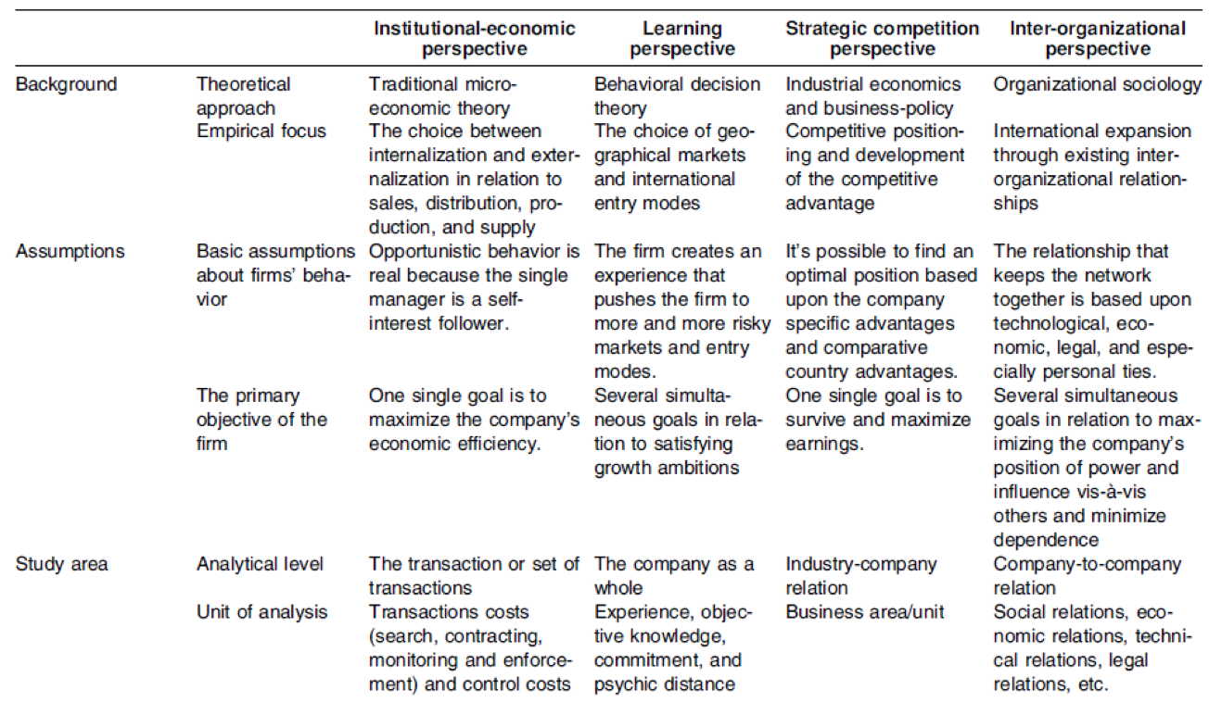 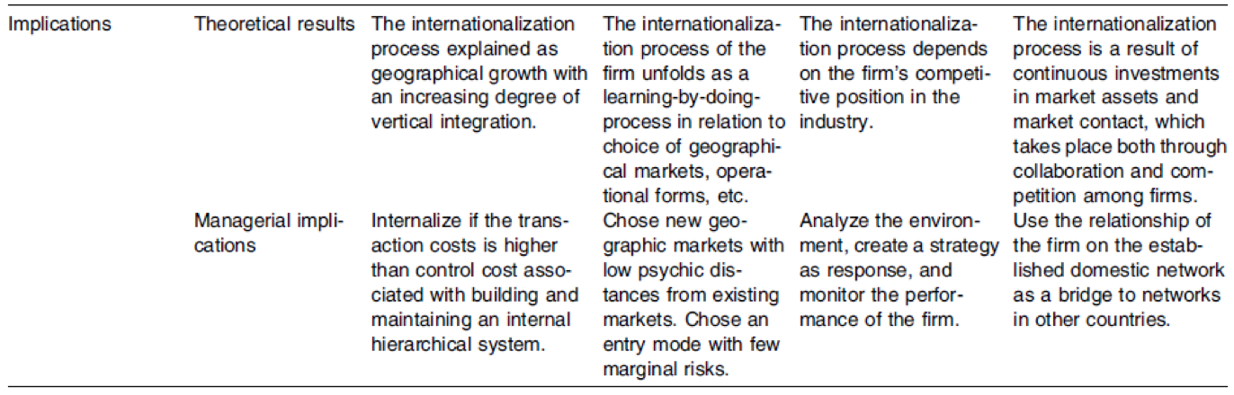 Source: Theoretical Perspectives on the Internationalization of Firms, Journal of Teaching in International Business · November 2008, Morten Rask, Jesper Strandskov & Dorthe Døjbak Håkonsson

In the table 2 below the Institutional-economic perspective is positioned in the upper-left corner connected to internal drivers with planned decisions. This position suggests that due to necessary but insufficient conditions developed internally within the company determines whether the activities might be internationalized. Furthermore, it is assumed that the firm’s decision on internationalization of some of the business activities are based on planned, thorough analysis of transaction costs. The most fundamental contributions in regards of this perspective are by Williamson (1975), for the Transaction Cost theory and Hymer (1976) for the Internationalization Theory. This literature contains the discussions in relation to opportunism, uncertainty and bounded rationalism as well as further elaboration on assumptions of centralization vs. decentralization, size of control and coordination costs of foreign subsidiaries. The Learning perspective is positioned in the lower-left corner signaling the internal drivers with emerging nature of decisions. It is due to fact, that companies typically gradually gain experience from launching of different foreign business activities and learn from them. It is implied that the internationalization is gradually emerging. The major forces behind as commitment and experimental learning function as oppose to firms acting on the rational plan. The major contributions from Johanson and Vahlne (1973) the Uppsala-school internationalization model and the stages model by Bilkey and Tesar (1977), Cavusgil (1980), Czinkota (1982), Luostarinen (1970), Reid (1981). A Strategic-competition perspective positioned in the upper-right corner indicating external drivers with planned nature of decision making. The nature of decisions on internationalizing are planned based upon thorough assessments of competition analyses against the firm’s resources and competences on which part of supply chain activities should be transferred to foreign markets. The external industry related conditions are the key factor in determining these choices. An inter-organizational perspective as one of the least researched models links the internationalization of the company with the external drivers along with emerging nature of decision. The major distinctive aspect of this perspective is that it provides the view of company’s interaction with other players from a different position through influence and power as a consequence of social exchange. Therefore, the choices on transferring the business activities to foreign countries are based on political negotiations about services and trade offs. These decisions cannot be foreseen or planned in advance as they depend on the current power position and influence of the negotiations.
Table 2: Four theoretical perspectives on the firm’s internationalization: drivers and nature of decision
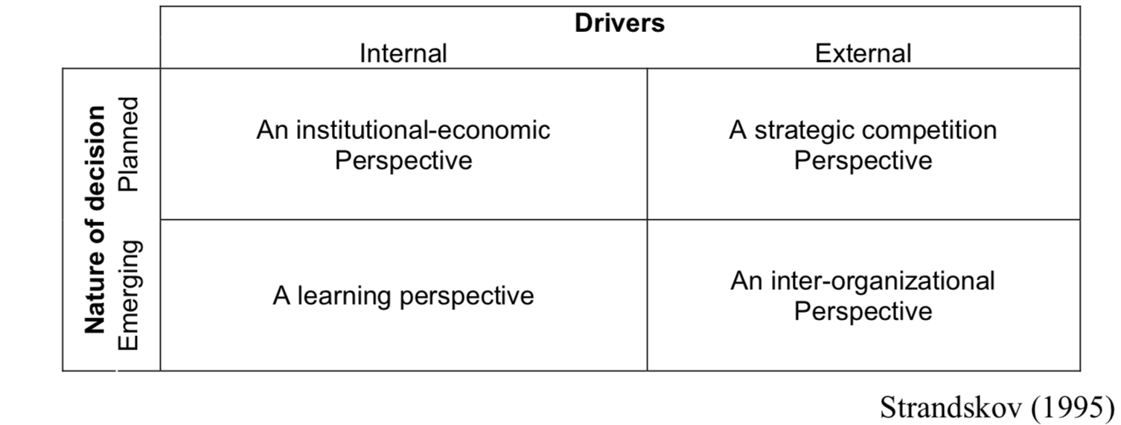
Source: Theoretical Perspectives on the Internationalization of Firms, Journal of Teaching in International Business · November 2008, Morten Rask, Jesper Strandskov & Dorthe Døjbak Håkonsson

Based on the above review of the four theoretical perspectives on the Internationalization of the firm, it is assumed that models related to one perspective cannot be used interchangeably with perspectives related to other. However, it is argued that the overview provides a better understanding of the various perspectives of internationalization of the certain company. It might be beneficial to analyze the internationalization process of the firm from a different perspective and explore the strengths and limitations in respect of the theoretical concepts. Ultimately, to design the right way to follow the specific purpose of the analysis by integrating insights and key findings to obtain the desirable understanding is the challenge here.

2.2 Eclectic or OLI paradigm
For the last fifty years the theory of internationalization has been largely developed mainly thanks to leading researcher John Dunning in his theory known as the eclectic paradigm published in a series of publications (Dunning, 1980, 1981, 1988, 1992). He has built on the internationalization theory developed by Peter Buckley and Mark Casson (Buckley and Casson, 1976). Based on the theory, there are three following factors to determine internationalization of a firm: ownership (O) advantages, location (L) advantages and internationalization (I) advantages. Hence, also called the OLI paradigm. Ownership advantages comprise of company’s intangible assets (also called firm’s specific advantages) such as organizational structure and management skills, brands and knowledge. According to Dunning it also includes natural factor endowments such as industry market structure, legal, cultural and institutional environment, manpower and capital which could be defined as country’s specific factors but can be turned into ownership advantages. This capital can be replicated in different countries without losing its value, and easily transferred within the firm without high transaction costs. The localization advantages classified such as the market size, natural resources, aspects of infrastructure, the governance structures, the education system and other aspects of political/government activity (Rugman, 2010). In some cases, the distinction between O and L is hard to determine. When a company acquires the rights over for example mineral resources or mines then the L advantages turned into O advantages. The internationalization advantages strongly connected to ownership advantages through institutional form of multinational enterprises being owned-internalized by the firm. Essentially, intangible knowledge assets of the firm as an example of replacing the market. Contrary to the internationalization theory which is more firm-level based at its core, the Eclectic paradigm is more industry-level oriented. The analysis of the O & L & I advantages explain the outward flow of FDI thus it has firm-level implications but it has been tested only at industry level (Dunning 1992). The OLI paradigm describes the outward FDI patterns at the industry level. The internationalization theory differs from the eclectic paradigm also from the entry modes perspective. The internationalization theory examines the choice of mode of entry via firms specific control mechanism advantages where a company evaluate all the risks associated with the assets knowledge protection typically to begin with exports and FDI, gradually to engage in more risk prone relationships like joint-ventures, licensing and alliances. In brief, the modes of entry are examined and have to be offset against risk degradation and the liability of foreignness when entering risky markets abroad (Rugman and Verbeke 2003). In essence, the eclectic paradigm is more descriptive and provides explanation of motives of outward FDI through the combination of O, L and I at its industry level. The internationalization theory is more focused on the intangible knowledge advantages of multinational enterprises. Rugman (1981) argues that there are two major determinants of FDI. These are called country-specific advantages (CSAs) and firm-specific advantages (FSAs). In conclusion, the eclectic or OLI paradigm suggests that the greater the O and I advantages possessed by firms and the more the L advantages of creating and exploiting these advantages from a location outside its home country, the more FDI will be undertaken. Where firms possess substantial O and I advantages but the L advantages favour the home country, then domestic investment will be preferred to FDI and foreign markets will be supplied by exports.

2.2.1 The Eclectic paradigm and FSA-CSA framework
As mentioned in the previous section above, Rugman (1981) has identified two key determinants of outward FDI as a result of upgrading the internationalization theory bringing together firm’s specific and country specific advantages in a matrix. Arguably, the Dunning’s OLI parameters cannot be seamlessly allocated to FSA or CSA categories. However, the O advantages come together with CSAs axis without a conflict in the matrix. Therefore, the conceptual challenge lies in placement of O and I advantages along the axis but as discussed by Rugman and Verbeke (1992) they combined fell into the firm’s specific advantages axis of the matrix. To further explain the rationale behind of reconciliation Dunning’s OLI with Rugman’s FSA and CSA matrix is that both models seems to cover the same actors of internationalization of MNEs with slightly different approach. Firstly, the definition of location advantages by Dunning are for example natural resources, human force, market size and culture with environmental factors are essentially Country Specific Advantages determinants as constructed by Rugman. In conclusion, there is no significant difference between Dunning and Rugman incorporation Location Advantages within the Country Specific Advantages axis in the model. Secondly, the combination of Ownership and Internationalization can be successfully incorporated into the Firm’s Specific Advantages axis of Rugman’s model because they are essentially firm’s specific. “In other words, the outward FDI of interest to Dunning is undertaken by MNEs, who are the agents to simultaneously internalize and exert proprietary control (ownership) over the use of scarce, firm-specific, knowledge- based advantages” (Rugman, 2010, p.6). Hence, the MNE effectively act as an institutional mechanism to link Ownership advantages with Internationalization advantages on to the Firm’s Specific Advantages Axis of the model. Further evidence that OLI can be transformed into the FSA/CSA matrix provides four motives for FDI developed by Dunning and Lundan (1992). The four motives are as follows: resource-seeking, market-seeking, efficiency seeking and asset-seeking motives. As demonstrated in the table3 below they have been incorporated into the FSA/CSA matrix.
Table 3: The Eclectic Paradigm motives for FDI in the FSA – CSA matrix
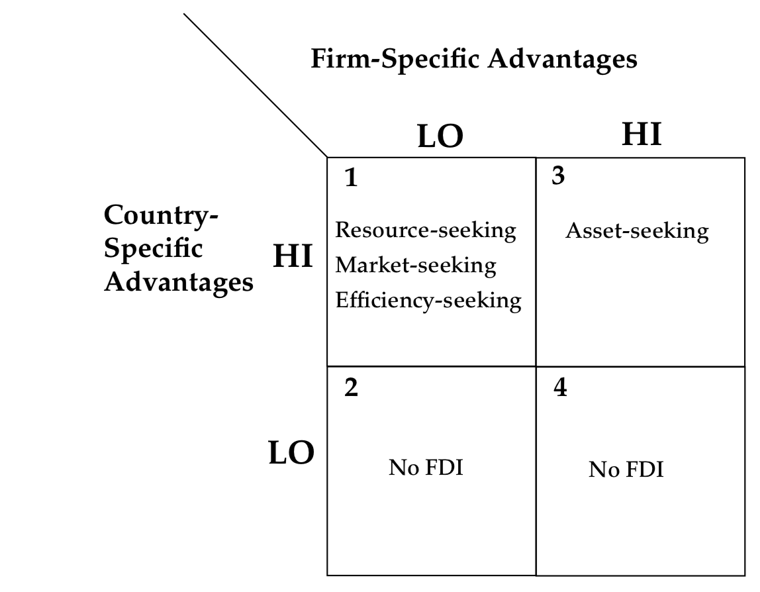
Source: Rugman (2010), Reconciling Internalization Theory and the Eclectic Paradigm, Multinational Business Review
To explain the outward FDI in the cell 1 is where a firm is interested to access CSA and FSA do not matter that much meaning that a company is interested country specific resources such as natural resources, cheap labour or beneficial govt. policies. It also seeks to expand to the foreign country due to exploiting the size of a consumer base as well as infrastructure and supplier networks, hence country specific market-seeking along with the efficiency-seeking motives such as saving on labor force etc. In brief, the strong CSAs overwhelmingly explain the resource/market seeking motives in cell 1. The situation in the cell 2 describe lack of FSAs as well as CSAs which suggests no FDI in the foreign country. In cell 3, is a strong FSAs as well as CSAs in terms of asset-seeking motives of a firm. Typically, MNEs especially from emerging economies based on the recent developments seek knowledge related assets in host countries. It has been largely discussed if such a transfer of knowledge after acquirement happens or is transferred as control of this process lies beyond the home country company. Rugman and Doh (2008) explain that acquisitions of creative companies are unlikely to generate knowledge. There is no FDI in cell 4 because Dunning’s four motives of outward FDI was developed towards host country meaning there must be strong incentives in Country Specific Advantages in order to invest in host country. In conclusion the Dunning’s OLI paradigm explains the outward FDI on the basis of opportunities CSAs in host country. Moreover, the four motives for FDI - resource, asset, efficiency and market seeking motives are analyzed from the host country perspective and therefore are considered as the reason to invest the host economy. In contrary, the Rugman (1981) model of FSA/CSA matrix is based upon home FSAs and CSAs to explain the outward FDI motives. Scholars have identified four main types of foreign based multinational enterprises activity:

2.2.2 Resource seeking FDI
- To seek and secure natural resources e.g. minerals, raw materials, agricultural products or unskilled labor or supply oriented FDI

2.2.3 Market seeking FDI
- To identify and satisfy foreign market or groups of foreign markets for the firms’ finished products or in other words demand oriented FDI

2.2.4 Efficiency seeking FDI (global sourcing)
To restructure its existing investments so as to achieve an efficient allocation of international economic activity of the company. International specialization whereby firms seek to benefit from differences in product and factor prices and to diversify risk. Global sourcing – resource saving and improved efficiency by rationalizing the structure of their global activities. Undertaken primarily by network based MNCs with global sourcing operations. Typically, it is sequential to the first and second kind of FDI motives.

2.2.5 Strategic asset/capabilities seeking FDI
Designed to primarily protect or augment strategic operations of the MNEs through the acquisition of existing firms and/or assets to protect O specific advantages in order to sustain or advance its global competitive position and/or reduce those of the competitors.
  - Acquisition of key established local firms
  - Acquisition of local capabilities including R&D, knowledge and human capital
  - Acquisition of market knowledge

Table 4: Comparison of FDI motives
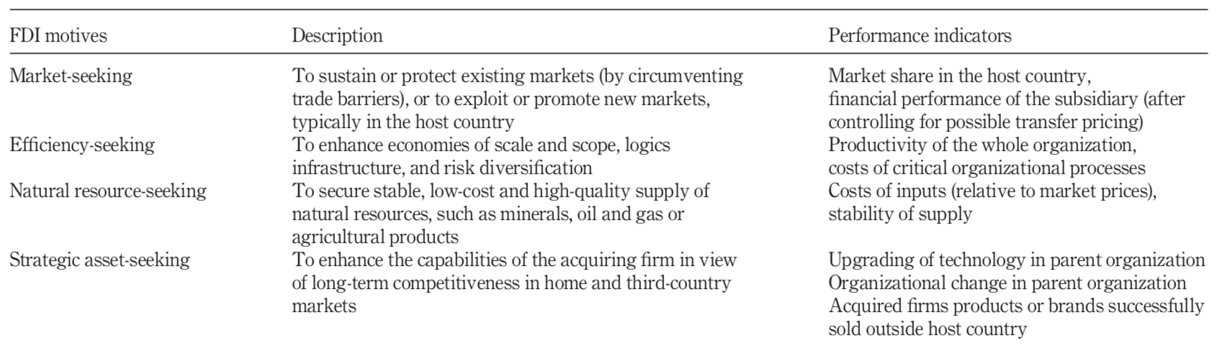
Source: Myer (2015), What is “strategic asset seeking FDI”?, Multinational Business Review

2.3 Liability of foreignness (LOF)
This concept was first to introduce by Stephen Hymer in 1960 and published in his seminal thesis study in 1976. At the core of this concept is the idea that firms face social and economic costs when they operate in foreign markets. The local firms in general have an advantage over foreign based company new entrants on the country in terms of language, law, economy and politics (Hymer, 1960). These disadvantages might be as follow:
    - Information disadvantage
    - Foreign exchange risks
    - Discrimination by host government
    - Restrictions on firm internationalisation
There are many different barriers affecting an entrant firms what can be divided in either more or less permanent nature. A study by Zaheer and Mosakowski (1997) suggested that the with increasing time being active in the foreign market the costs allocated in liability of foreignness are likely to decrease due to increased knowledge of the foreign market. The theory of internationalization suggests that with the increasing knowledge of the foreign market the risk and perceived uncertainty decreases which in turn creates more investment commitment. However, based on the study done by Welch and Wiedersheim-Paul (1980) it has been discovered that some of the entrants experience more uncertainty given the gained knowledge along the internationalization process and not the opposite. Furthermore, it is assumed based on the internationalization theory, companies with a little psychic distance to a foreign market such as neighboring countries where cultural values and perhaps language are shared along with the historical trade practices, as a result these firms experience somewhat high levels of uncertainty and therefore additional costs related to the business activities. According to Evans et al. (1992) evidence is provided in many Canadian companies operating in the United States of America. In addition, there is also growing evidence on failing investment in close countries such as Mitchell et al. (1994) have discussed in their research. Table 5: LOF composition of 3 factors (octagonal boxes) developed by Hymer (1960)
Source: Pedersen (2002), Coping with liability of foreignness: Different learning engagements of entrant firms”, Journal of International Management
The Liability of Foreignness can be categorized in three groups:
- Unfamiliarity hazards
- Relational hazards
- Discrimination hazards
Firstly, the unfamiliarity hazards group is defined through incorrect market assessment such as insufficient and inadequate knowledge of the host country business practices, norms and culture (Caves, 1971, Petersen and Pedersen, 2002, Eden and Miller, 2004). Secondly, the relational hazards of LOF occur as higher costs related to organizational internal and external transactions such as management of employees abroad (Eden and Miller, 2004). Furthermore, the supplier-buyer interactions between firms incur relational hazards because of lack of trust and embeddedness in local networks (Ring and Van den Ven, 1992). Finally, the discriminatory hazards occur when the company is treated in an unfavorable way within the host country market institutions and consumers (Henisz and Williamson, 1999, Balabanis et al., 2001).

Chapter 3 Methodology

This Chapter is to present the audience with the methodological and philosophical dimensions of the research paper. The term “methodology” as defined by (Arbnor & Bjerke, 2009, p.243) is a process which embeds the mechanism of creating theory in a systematic manner to interpret the reasons behind knowledge creation. It is to create understanding on how the researcher has carried out the research and further to elaborate the perception of reality of the author of the paper. It means that this chapter on methodology provides more detailed view of the specific paradigms applied in the research and understandably thus undermine the existing relationship to the particular methodological view of a research. Furthermore, the brief presentation of both ontological and epistemological point of view should provide the understanding on the intended direction of the research with the aim to help to better grasp different areas relevant to the research paper. Following the understanding of the methodological approach, data collection and information on the case study of Nefab company links to the discussion and analysis of the research.

3.1 The Paradigmatic Approach
In this section, the scientific research paradigm of the paradigmatic approach in connection with the research question on: “How has Nefab internationalized its operations in Slovakia?” is described as to help to understand Nefab corporation internationalization strategy influenced by different aspects. Consequently, the role of the Nefab top level management to identify and implement these factors in order with the internationalization strategy of the corporation. The inductive research approach has been applied. The paradigm definition by Bryman & Bell (2011): “is a mix or a combination of set of different beliefs aiming to elaborate the influence of different disciplinary areas with relevance to scientific context; of what must be undertaken as a study subsequently also aiming to explain the research mechanism by providing guidance to the reader in understanding the archived results”. According to Anderson and Narus (1990) research process can be done in either Subjectivist or an Objectivist approach. The Subjectivist defines the Interpretative paradigmatic approach. The Objectivist approach lean towards the Positivist paradigmatic approach.
See Table 6 below for scientific paradigm of a Subjectivist approach of this research study:
Table 6: Perspective on Subjectivist Approach
Dimensions | The Subjectivist Approach
Ontology | Nominalism
“What exists?” or what is existence | Nothing has an independent existence
Epistemology | Anti-Positivism
 | Meaning symbols, rules, norms & values are important in understanding Human Beings
Human Nature | Voluntarism
Methodology | Ideographic
Source: Lecture slides from Research Methodology I; Meta-theoretical perspective and research design Methodology (Kuada 2017)

3.1.1 Ontology
Ontology can be defined as a philosophical field revolving around the study of the nature of reality and the different entities and categories within the reality. John Kuada (2012) described that the Ontology elaborates within the particular nature of things which is being sought by researchers. In other words, Ontology is part of the major branch of philosophy called metaphysics and deals with the questions about what things exist and can be said to exist. Furthermore, how can be these entities categorized based on their differences and similarities.

• Objectivism vs Subjectivism
According to Kuada (2012) on how individuals tend to view reality it is argued that all of them are engaged in the process of creating a certain individual reality. Following the previous definition, two dimensions in which the reality is existing occur and it is either based on Subjectivism (Nominalism) or Realism (Objectivism). The Subjectivism represents a systematic process in which individuals tend to create a particular reality. It is achieved based on the interaction amongst each other through a set of certain values, norms and beliefs (Kuada, 2012). In other words, the subjectivist stand-point of reality may and most likely differ from one individual to another. In contrary, Objectivism is oriented towards having a real/objective perspective of the world with no interference of human interaction and thus the researcher interprets the reality as it is existing (Burrell & Morgan, 1979). Based on the above mentioned, Ontology exhibits the two different dimensions which are objectivism and subjectivism. In an objectivist view, an organization is perceived as part of particular reality implying that this is a tangible real object. It is composed of a certain framework with a particular set of different rules, regulations and policies to be followed by individuals who are part of the organizational setup (Bryman & Bell, 2007, p.22). Subjectivism, on the other hand, where the reality exists as part of an individual perception, the focus is shifted on a certain set of values, systems and principles which would be exposed to a subjected change as the reality is constructed and de-constructed (Bryman & Bell, 2007, p.23).
Table 7: Objectivism vs. Subjectivism
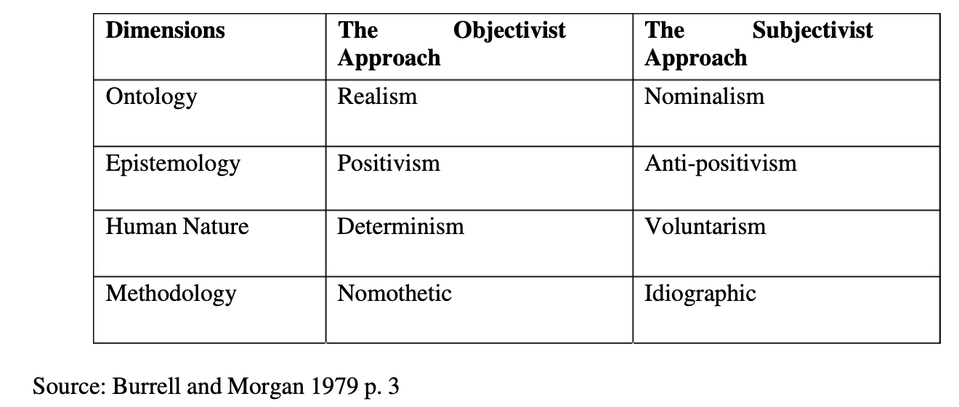

• Nominalism
In this paper, the Nominalism – Subjectivist approach is applied to interpret the research findings relevant to the problem statement. With the help of the subjectivist view the research provides a perspective with the focus on certain areas. The certain areas are later defined via actors relevant to the data collected from the case study of Nefab corporation in the context of internationalization strategy and influencing factors. The research is to analyze the importance of The Internationalization strategy along with its influencing factors and link the significance to the factors and influences in the context of Nefab corporation. Consequently, the Subjectivist approach has been applied.

3.1.2 Epistemology
According to Kuada (2012) Epistemology defines the exact nature of knowledge while explaining the different ways and means of knowing which depends on a pattern of knowing and how that acquired knowledge is being perceived by a researcher. Essentially, it is theory of knowledge in regard to its methods, scope, validity and the distinction between justified belief and opinion. Epistemology can be categorized as Positivism, Interpretivism, Realism and Rationalism. Further defined by two main philosophical dimensions which are Positivism and Anti-Positivism. This research paper is based on Subjectivist approach of the relevant Ontological dimension defined by Interpretivist approach.

• Interpretivism
Based on Kuada (2012), Interpretivism subscribes to understanding a given social world from the perspective of people who are being studied and their intentions in relation to their behavior. Therefore, inductive method applies. Furthermore, Kuada (2012) argues that Interpretivism approach emphasis the need to understand people’s definition of situations in which they are involved and the meaning from their experiences. “Interpretive paradigm requires investigators to perceive their actors as engaged in continuous interpretation, meaning creation and sense-making of events and their contexts. Investigators therefore focus their work on understanding rather than explaining. These investigators subscribe to the view that human beings do not passively respond to what is going on around them” (Kuada, 2012, p.77). Based on the previous, it has been essential for all intentions and purposes of this research paper to elaborate on the subjective experiences associated with different views and motives relevant to the situations or definition of reality in the context of this research topic.

• Anti – Positivism
As defined by Kuada (2012) Anti-Positivism takes various forms but mostly assumes that that the social world is relativistic – socially constructed and it is understood only from the perspective of individuals directly engaged in the world of social activities under investigation. It has been made known that scholars adopting this viewpoint do not believe in generating objective knowledge of any kind within the field of social sciences. Following the meaning of this approach, it helps to gain a specific understanding of the data gathered and compiled like for example in the process of interviews done with the company researched. Arguably, this approach helps to develop an understanding and gain perspective on the Internationalization strategy of the Nefab company and how is the strategy implemented influenced by various factors within the host country. Thus, it is critical that the knowledge and understanding of the theoretical frameworks, strategies and practices in the area of Internationalization Theory is well understood and presented and could be linked to the research for analysis of the Internationalization of Nefab corporation operations. Hence, it is essential that the research is carried out with the utmost attention and diligence to achieve justified end result. It is therefore in direct connection to the Subjectivist approach of this research paper.

3.1.3 Human Nature
“The term Human Nature describes how the researcher sees the relationship between human beings and their environment” (Kuada, 2012, p.59). Furthermore, it sees to establish whether the researcher perceive the individuals outside their social world or if the social environment and people determine each other. It is relevant to the notion on how knowledge is acquired and what is perceived as the “truth” by the researcher. As presented in Table 7 Human Nature is categorized based on Subjectivist approach as Voluntarism and based on Objectivist approach as Determinism. Voluntarism is defined by researcher’s assumption that human beings are capable of creating their own reality and are completely independent of their external environment with the unpredictable behavior (Burell & Morgan ,1979). The Determinism is a researcher’s assumption that individuals behavior is determined by external causes and thus people cannot behave any other way as they do.

3.1.4 Methodology – Ideographic Approach
As defined by Kuada (2012) Methodology is a plan or strategy that describes the reasons underlying the choice and use of specific methods and research process. It can be also interpreted as how the researcher search for the knowledge he desires. In context of the above definition, as a part of this section it is elaborated on how different methods have been chosen and what are the key underlying reasons for choosing them. As far as this research paper chosen approach goes it is crucial to have a well-rounded understanding of the external social world in order to be able to understand and analyze the individual perception of the reality. To achieve such a level of understanding, it is necessary gain the relevant knowledge of the problem being researched be letting the one’s subject unfold its nature and characteristics. Based on the above, the ideographic approach has been chosen. According to Burell & Morgan (1979) this methodology is based upon elaborating the subjectivist approach analysis which is made possible by acquiring the specific insight into the real situations. In other words, it is about to get involved close to the subject investigating and explore its detailed background and details. In contrary, the Nomothetic approach is based around systematic protocol and technique. It is concerned with the construction with scientific tests and the use of quantitative techniques (Burell & Morgan, 1979). In this regard, qualitative research methods following an inductive approach which is based on subjectivist perspective has been applied with the limited use of a structured approach.

3.2 The Philosophical position of the Research
This research paper philosophical position has been described in detail within this chapter in the sections on Ontology and Epistemology. To further clarify the previous statement, this paper is based on Subjectivist approach. To achieve a cohesion with the paradigm applied, it is to analyse of investigation within the scope of the research question. The research question sees to answer on How has Nefab internationalized its operations in Slovakia? Consequently, how Nefab has developed its internationalization strategy and what are the different factors having an impact on the strategy. This paper aims to understand the connection between the Internationalization Strategy of Nefab and its various aspects by understanding the major theoretical constructs of the relevant area. Hence, subjectivist approach has been applied with the focus on rather understanding than explaining. It is also important to remember that there might be certain implications or factors subject to change over period of time in relation to a continuous interpretation of the world as an interpretivism paradigm. Primary data have been gathered via phone interview with Mr. Lars-Åke Rydh the long eighteen years serving CEO of the company and a member of the Board since 1994. Secondary data have been collected via public websites, academic journals, reports, books and other relevant academic sources. All of the presented data in this paper have been made publicly available with the consent of the all affected parties and not in any measure being the subject of business secret and are not in violation of any laws local or international.

3.2 Methodological and Research View Positioning
The three-dimensional methodological view distinguished by Arbnor & Bjerke (2009) in their publication called Methodology for Creating a Business Knowledge, consist of Analytical View, Systems View and the Actors View. It has been developed in order to better grasp the and help the audience to understand the connection to its research paradigm in the context of the research paper. The authors argue that it is important to take a stand in order to look or examine the reality and it might appear to be different from different views. The three methodological views are defined as follows: The Analytical view is concerned with the objective reality, facts and is based on a dominant position of logic and mathematics. Scholars usually come up with the common understanding and create a lot of knowledge. The Systems view: “from the methodological point of view can be summarized in terms of philosophical influences, similarities and differences when explaining and understanding using the system view, basic systems language, the relation of the system view to its paradigm and typical theoretical results from the system view” (Arbnor & Bjerke, 2009, p. 102). The roots of the System view are based on three overlapping philosophies as Systems Theory, Holism and Structuralism. The Actors View is based on major concepts such as dialogue and dialectics, meaning and intentionality. Defined by Arbnor & Bjerke (2009) based on the uncertainty principle, the more precisely you determine isolated characteristics of a human being and her activities, quantitatively and statistically, the less you understand of her as a whole, the more uncertain the quantitative/statistic aspects become. While the previous two views analyze the reality with the tools and methods while researcher gains the objective picture by observing the reality. The Actors view in a contrary support the argument that reality is not detached from the one’s reality and therefore cannot be studied as something independent from the researcher/actor which means that reality is a social construct (Arbnor & Bjerke, 2009). Moreover, as an end result of the Actors view there are less likely to be definitions or theories rather than more understanding and meaning of the subject researched realities. With the above perspective in mind this research paper adopts an Actors View which is based on Subjectivist approach in order to achieve the understanding of how Nefab follows the Internationalization Strategy and its different factors. The goal of the research is to discover, understand this reality by understanding how the individuals involved in the strategy decision making perceive their reality or social construct while creating and executing decisions made towards internationalization of the company operations in Slovakia along with the various aspects involved.

3.3 The Research Design Strategy
In order to create a successful research paper quite a few research methods could be used. It is essential that by choosing of research design a relevant research method suitable for the purpose of the paper must be used. Following on choosing the right research design along with the research method helps to collect correct data in a right way. This paper is mainly concerned to collect qualitative data, which means that the research design method has been chosen accordingly. Research design can be defined as a framework of techniques and methods to combine various components in a certain manner of the research so the research problem is well handled (Bryman & Bell, 2011). In other words, a research design provides a so called blue-print in order to help the reader to understand the research approach and design along with the methodological positioning (Bryman & Bell, 2011). Accordingly, this research follows a Case Study approach with a qualitative data collection for the research analysis and findings with the subsequent Inductive Research approach. Thus, the relevant qualitative data has been gathered, collected and compiled from the Nefab corporation in Sweden. The data collection is relevant to Internationalization Strategy formed by Nefab corporation along with the various factors having an influence on such a process with the region-specific qualities.

3.4 Research Method Approach
As mentioned earlier in this chapter this research paper gathers qualitative data and thus will follow an inductive research approach.
Based on the inductive approach of gathering the data an Exploratory Study Case approach has been applied.

3.4.1 Inductive Reasoning
The inductive reasoning has been qualified under the scope of qualitative research methods (Saunders, Lewis & Thornhill 2009). This research paper follows inductive reasoning. Furthermore, elaborating all conclusions in the context to certain information hence to form an idea or theory from all observations/data gathered. In other words, the broad generalizations are made based on the data collected. The conclusions are drawn from the observations. As the most relevant research to the inductive approach the exploratory research has been used in this paper. In the context of the research question with the focus on the areas of Internationalization and various factors involved in the process the exploratory research helps to explore the importance and understanding within the area of interest. Following the research question on How has Nefab internationalized its operations in Slovakia, to develop an understanding and investigate how the global corporation has created, developed and implemented the internationalization strategy along with the different influencing factors with the regards of the specific geographical region of Central European country like Slovakia. Consequently, relevant internationalization business theories along with the literature review and various influencing factors in the context of the region. The phone interview as a form of collecting primary data has been conducted with the at that time CEO and Board member of Nefab corporation. The data collected have been analyzed and interpreted in the context of the theoretical knowledge and theory to create an understanding of the process of internationalization within the scope of the research question. Thus, key findings have been linked to the theoretical frameworks elaborated in the literature review of this study. The acquisition of a specific company views also helped to review and map the gap in the current information available and thus to reconsider and evaluate the theoretical information in the context of the research question. As Saunders, Lewis & Thornhill (2009) pointed out this kind of realignment of existing information is quite common in the context of exploratory case study approach as such a study has the benefit of being flexible in allowing a certain shift in direction of the relevant research constructs. Following the mapping of the inductive approach to research method of this paper, the key theoretical aspects of the literature has been reviewed in the context of the primary and secondary data collection. The flow of the research method of this research paper could be therefore interpreted as firstly, the development of the theory from the information available, the qualitative data collection in alignment of the Exploratory Case Study research method following by the Analysis and Findings with the Discussion.
As this research paper has been focused to explore the Internationalization Strategy of the company and various factors influencing the process, it also strives to gain a knowledge on a position of the company when to internationalize or what could be the key aspects, incentives of having to internationalize different operations of the company in the context of specific economic, geo-political and sociological environment.

3.4.2 Case Study Types
The case study approach can be characterized as single/multiple or holistic with the single analytic unit of study presented and embedded case studies which presents multiple units of study. As argued by Alaranta (2006) a single case study would aim to either accept or reject stated hypothesis following a deductive reasoning based approach. In contrary, the embedded case study approach employs the inductive reasoning method relevant to the inductive theory building. This paper has adopted a single case study approach based on inductive reasoning in order to understand Internationalization Strategy and its factors in the context of the Nefab corporation. There are several categories of case study. Yin (1984) describes three major categories such as exploratory, descriptive and explanatory case studies. Firstly, exploratory case studies set to explore any phenomenon in the data which serves as a point of interest to the researcher. Secondly, descriptive case studies set to describe the data as they occur. Finally, explanatory case studies examine the data closely in deep in order to explain the phenomena in the data. (Zainal, 2007). For the purposes of this research paper an Exploratory case study approach has been adopted in order to study the Internationalization Strategy and its factors of Nefab corporation within the republic of Slovakia. Accordingly, the inductive reasoning approach has been applied in order to draw conclusions into the Internationalization business theories and its factors. The aim of the paper is to further understand the motives and how is the Internationalization Strategy formed within the global corporation along with the influencing factors. The inductive approach enables to investigate thoroughly the research question within the theoretical context and help to understand the different practices, theories, strategies and concepts.
• Exploratory Case Study Approach
As mentioned above this paper follows an exploratory study case approach. The aim of this research is to explore how the internationalization process of the global industrial packaging company Nefab based in Sweden has taken place in Slovakia and what are the factors influencing such a process given the specific geographical area. Understandably, this research work is then set to investigate and understand the process of internationalization of the company with the influencing factors of the local country. It has been crucial to comprehend the theory of Internationalization business strategies in order to successfully uncover the very nature of the research question incorporating the perspective or the view of the world of the company. To assess the theoretical understanding, the study of any complex linear relationships which might exist between variables or perform a statistical analysis is not desirable because this study paper does not depend on any cause – effect relationships. This case study research has been predominantly contextual for the theoretical research. The combination of the primary data collection via phone interview with the top-level executive and secondary data collection to gain the business perspective following the mapping of theoretical knowledge in cohesion with the literature review.

3.5 Modes of Data Collection and Case Company Introduction
The research study is based on a combination of both primary and secondary modes of data collection. Nevertheless, the secondary data have played the major part of the sense-making of the information. The primary data have been collected via phone interview with the top executive at the source of creation, development and execution of the business strategies and shaping the future of the company in the world.

3.5.1 Case Introduction of Nefab corporation

Nefab is a global packaging company founded in 1923 in Sweden as a carpentry workshop. Later in 1949 is considered as a start of a company NEFAB providing complete packaging solutions also called CPS concepts. Its global headquarters is located in Jönköping in Sweden. From 1949 the focus of the company was on the product and only domestically. Later, with the expansion of the company internationally the focus has shifted to market/service oriented strategies (Nefab’s History, n.d.). Nefab has grown to become a global industrial packaging company with production plants, sales and representative offices all over the world. Nefab is located in over thirty countries worldwide. Nefab employs 2,800 employees all over Europe, North and South America and Asia. Invoiced sales in 2018 amounted to be approximately SEK 4.5 billion (Facts about Nefab, 2018). Nefab delivers complete packaging solutions to international customers within the segments of Telecom, Energy, Vehicle, Healthcare equipment and Aerospace. The business concept is to optimize the total costs and reduce the environmental impact with innovative packaging and logistics solutions. The vision of the company as stated on their official website is the preferred global partner for sustainable packaging solutions & logistics optimization. Nefab operations in Slovakia could be characterized as rather medium to small size manufacturing site with up to hundred employees manufacturing mainly plywood and wood made packaging and pallets.
• Nefab Internationalization Strategy and Contextual Relevance
As mentioned previously in the brief introduction of the company, Nefab has since its establishment in Sweden 70 years ago, internationalized massively and it is represented in more than thirty countries all over the world. The internationalization has been driven by various means to aim to achieve different goals. Mainly, the common factor to internationalize would be to remain sustainably competitive as well as to maintain the desired profitability on the global scale. The ever changing global business playing field has offered different opportunities and options to exploit or turn these opportunities in to a company resources to build the sustainable and secure future of the global company if not the business leader in the relevant industry. Nefab has done that mainly through either outsourcing of some operations, acquiring companies, building the manufacturing plants on green fields or combination of the modes. The mode of entry differs depending on desirable outcome to be achieved and has been quite extensively studied in the business literature for the last fifty years. Nefab Internationalization Strategy appears to be in alignment of the current economic and social as well as environment opportunities manifesting themselves in specific areas of the world. In order to have such specific region and socio-economic detailed information a specific knowledge has to be gained and evaluated in respect of the company goals and continuous improvement within the industry and business overall.

3.5.2 Primary Data
Various methods exist on how to collect the primary data. The primary data might be collected via phone through structured or semi-structured interview. In order to collect the data, a set of questions have been developed to gain the understanding on how has Nefab internationalized its operations in Slovakia. The phone interview has been conducted with the top-level executive Mr. Lars-Åke Rydh who has been involved in International Business and Trade policy making within the company as well as CEO and board chairman since 1994. The goal has been to keep the questions in alignment of conducting the semi-structured interview with rather open-ended types of questions. In general, the questions have been constructed to grasp the overall strategy of Nefab internationalization policies, the creation, development, implementation and challenges within the process of the specific geographical area.
• Limitations of Primary Data
The interview has been conducted in the year of 2019 while the internationalization of Nefab operations to Slovakia has happened in 2005. The decision on how and when to internationalize some of the operations to Slovakia must have been made even more in advance. These facts might have been a limiting factor for the accuracy of the data and could have been interpreted differently with the over 14 years time gap. Nevertheless, the questions have been structured in a way that should aim on the Internationalization Strategy along with the overall business goals of the company relevant to the time period when the internationalization to Slovakia occurred. Some constraint or limits of the data might also come from the very nature of such a topic as internationalization of the company due to its complexity. To ensure the reliability and correct valid data analysis a thematic data coding has been applied to also minimize bias in the data set.

3.5.3 Secondary Data
The social science research data can be divided into the three basic categories namely primary, secondary and tertiary data (Blaikie, 2010). Secondary data consist of data sets which have been acquired from secondary sources mainly publicly available in forms of electronic data, websites, books, newspaper articles, academic journals articles ensuring that the researched topic has a complex perspective embedded (Blaikie, 2010). A secondary data can be further characterized as qualitative and quantitative data collection approach. In order to get more theoretical perspective following the theoretical approach to investigate the research question the use of secondary data is considered to be comprehensive enough and resourceful. Secondary data gives the opportunity to make the decision to use the data in the research paper in advance due to the fact that data collected via secondary sources might be decided upon whether they are suitable to be used in the research paper or not in connection to the research outcome (Stewart & Kamins, 1993). The tertiary data defined as the collection of primary and secondary sources as for example Wikipedia website. For the academic research purposes of this paper, data however must be collected via relevant academic sources as websites, journals, books etc. Accordingly, the data relevant to the Internationalization Strategies and its factors have been gathered and analyzed. The topic of internationalization of global companies is widely covered in the publicly available sources. In order to gain a complex perspective on the researched topic a longitudinal approach has been applied where time period of the literature reviewed is decades long. Ultimately, as defined by Saunders et al. (2009), this approach offers more flexibility and presents broader view of knowledge change as well as more updates incorporated in the data over a particular period of time. As wide as is the topic of Internationalization covered, following the above mention approach assisted to analyze a lot of literature written by different authors with distinct view from various geographical regions. The scope of the literature has been diversified enough to offer a desirable overview. Ultimately, following the diversified research approach ensures the research validity criteria (Saunders, Lewis & Thornhill, 2009).
• Secondary Data Modes of Collection and Limitations
There are three different categories for secondary data sources. The secondary data sources are classified as survey-based data, documentary data and multiple sources data. Concerning the research paper, it follows the documentary data characteristics given that it incorporates gathered data from the company relevant sources and academic literature sources following the theoretical approach. Amongst other relevant sources, in order to gain academic perspective on the researched topic, the academic articles elaborating internationalization business theories and its factors from international business journals have been reviewed. The major source of the literature comes from the academic search engines available for Aalborg university students. As far as the collection of secondary data goes, the company relevant data via the company website where the publicly available general information on the company history, structure of business and more strategic information as vision and mission statement has been gained to comprehend the official company view on the researched topic of internationalization. To keep the research data valid in terms of secondary data collection, the time frame horizons had been kept in alignment with the research constructs. Since the research paper is concerned to understand the theoretical importance between internationalization and its factors of a global company, the flow of information is mainly descriptive. Consequently, the structured approach to literature review has been with a certain frameworks and strategic interconnections to map the major constructs of the research question.

Chapter 4 Key Findings and Discussion

The focus of this chapter is to elaborate on the data analysis construct along with the research findings in the area of Internationalization of a manufacturing company within the area of Slovak republic in the context of Nefab corporation. The key findings have been analyzed through the theoretical constructs from an industrial perspective as a result potential gaps in the current available knowledge have been identified.

4.1 Nefab’s presence in the area of Slovakia and Central/Eastern Europe

The role of the Nefab manufacturing plant in the area of Slovakia and the region has been for the last fifteen years rather insignificant in terms of size of the plant and economic output. Since its start in 2005 the main focus has been to serve the clients in western and central part of Europe as North has been served by the similar plant based in Estonia and South by the production plant in Spain. The main product being the production of industrial packaging and pallets made out of plywood and wood. The company in Slovakia is based near town of Levice which is rather a small town with about thirty thousand inhabitants located in the south region of Slovak republic (https://www.nefab.com/sk/slovensko/). The research findings in terms of Internationalization and motives correlate to the very Nefab manufacturing plant in Levice, Slovakia.

4.2 Data Analysis

This research study has been based on collection of a combination of primary and secondary data applying Inductive and Exploratory Study Case approach. The case company being Nefab – Swedish global packaging company, active for seventy years in the industry serving clients all over the world. The primary data have been collected via a phone interview with the at that time CEO Mr. Lars-Åke Rydh serving for 18 years at the position, and also being a member of a board since 1994 and a chairman of the board. The secondary data have been collected via publicly available sources such as company press releases, website and academic journals. The data triangulation process of the content of combination of primary and secondary data has been performed through the thematic and axial coding. According to Eisenhardt (1989) both methods helps the integration of qualitative data sets from primary and secondary resources along with analyzing the core themes to present in more direct theory process following the inductive approach. Following the process by analyzing the theoretical constructs of the Internationalization process and its factors to which the data have been gathered as a response from Mr. Lars-Åke Rydh (CEO). By reviewing the key elements of the research design along with the analysis of qualitative data sets from both primary and secondary sources in respect of the relevant theoretical constructs the reliability and validity of the data has been accomplished. See below figure 1 and figure 2 for the illustration of data analysis process and data coding respectively:

Figure 1: data analysis process
primary & secondary data

thematic coding

concept formulation

theoretical concepts compared
(similarities – differences)

development of the final theme
Source: own creation

Figure 2: data coding process
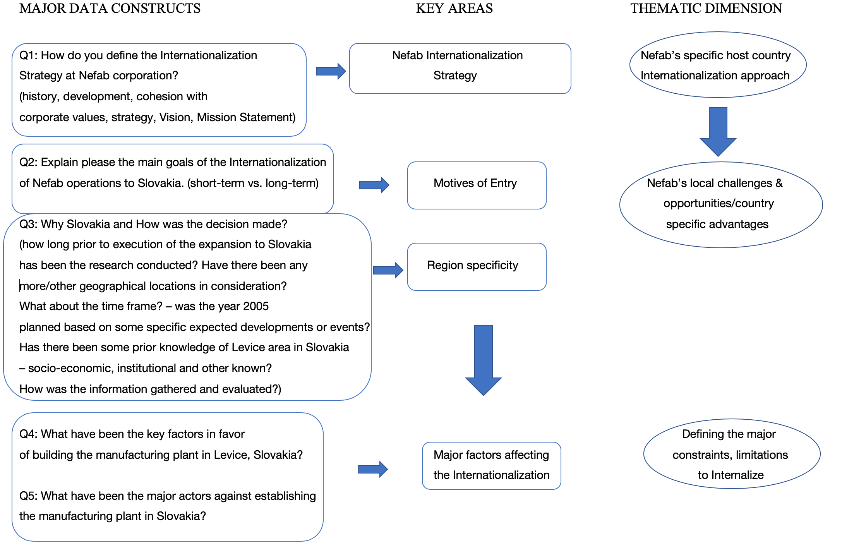
Source: own creation

4.3 Key Findings

The focus of this research paper has been on the internationalization process of a global company Nefab as a study case for this purpose with the underlying specifics of establishing a production plant in Slovak republic. The findings are to highlight how the global packaging company from Sweden - Nefab defines the internationalization strategy, motives and what are the key factors influencing this process in regards of a specific area of Slovakia. The phone interview with the at that time CEO Mr. Lars-Åke Rydh serving long 18 years as well as chairman and member of the board since 1994 until now has been focused on these major areas and are explained in the following part of this chapter.

4.3.1 Nefab’s Internationalization strategy of its operations in Slovakia

The analysis part of this research is firstly mapped into the main research question and further developed accordingly within the context of the literature review.
The main research question as follows: How has Nefab internationalized its operations in Slovakia? Based on this main question all open-ended questions from the interview can be categorized in three main thematic dimensions:
Nefab’s Internationalization Strategy
Nefab’s CSA within the foreign country
Nefab’s major factors in Internationalization process of its operations in Slovakia
The next section has revealed industrial perspective research findings in relation to the published literature in the context of the area of Internationalization. Subsequently, each of the relevant theme of the interview questions is discussed. As mentioned previously all of the questions have been asked during the interview with the at that time CEO Mr. Lars-Åke Rydh member of the board. He has been involved directly in decision making of the particular time of interest on strategic topics of the corporation of Nefab.

- Nefab’s Internationalization Strategy
According to the findings Nefab has been since 1960 up until 1980 product oriented company (https://www.nefab.com/en/about/history/). During this time period the company in close collaboration with one of the major client Ericsson developed a product which has had saved a lot of costs to the them. Following the great success of such a cooperation, Nefab after the twenty years of product focused period started to follow its biggest customers to serve them also in foreign markets as a local partner. Since the 1980s Nefab has transformed its view on the foreign markets and started to explore new possibilities and options expanding firstly within Europe following by America and Asia later. Since 2000s Nefab has shifted the strategic focus to form a market and service oriented strategy in which the vision of being a global packaging company for the complete packaging solutions has been established. At this roughly ten years period Nefab has entered various markets and made acquisitions all over the world. Since the 2010 until current Nefab strive to create a close business relationships and develop existing customer networks. As mentioned in the interview by the CEO Lars-Åke Rydh: “we are following main customers”. In a brief, as according to the history and current situation it is clear that Nefab has paid a great attention into developing a seamless relationships with its most interesting clients. Further in history it was more question of a product, later it was more about providing the local service to global accounts and recently it is about being the market-oriented, global service company. From the theoretical perspective in can be concluded that the company’s strategy has shifted from Firms Specific advantages into the Country Specific advantages meaning that, firstly Nefab had the knowledge, brand and management skills to simply follow and produce for its biggest clients abroad but later the shift has been towards following the country specific advantages in this case Slovakia. To follow the three determinants of Eclectic paradigm then it can be concluded that Ownership advantages comprising of company’s intangible assets such organizational structure, intellectual property as well as managerial skills worked as an advantage to the company. As mentioned earlier, this capital can be replicated in different countries without losing its value, and easily transferred within the firm without high transaction costs. To mention the second determinant as defined in Dunning’s Eclectic paradigm,
the localization advantages classified such as the market size, natural resources, aspects of infrastructure have been applied or exploited significantly later in the phase of early 2000s when the company transferred into more market/service oriented strategy. While ownership advantages still in play, localization advantages have emerged and have been recognized to have an important role within the strategy of the corporation which has ultimately led to an internationalization of operations as based on early days of the expansion following the internalization of knowledge later on.

- Nefab’s Country Specific Advantages within Slovakia
Based on the data the main motive for entering the Slovakian from the short-term vs. long-term perspective has been cutting the costs in production and meet the growth/demand recorded and projected in the broader Central/Eastern European area where at that time, many especially western companies producers have been relocated its operations. In the own words of Lars-Åke Rydh:” the market being part of Europe expanding rather quickly. We saw a lot of European companies moving their production to former East Bloc countries. We saw a growing market there. That was one reason why we have chosen that part of Europe. The other reason was the high cost structure we had in our production in Germany hard to reach our profitability, obviously. So, we saw the cost cutting costs by focusing on from Germany to Slovakia.” From the theoretical perspective of outward FDI there are four main forms such as market seeking motives, resource seeking, efficiency seeking motives and strategic capabilities motives. According to the findings, the motives of FDI in Slovakia have been to meet market demand in a long term and efficiency seeking motives in a short term. Clearly, when Nefab has seen its clients moving their operations to the area they ultimately wanted to meet the growing demand/market in the area which is market seeking motive. As long as the efficiency seeking motive of Nefab investment in Slovakia it was clearly to cut the costs on some of the costly operations they had in this case in Germany. Slovakia being with the high unemployment rate of 11,8% (Appendix C) and with the low average wage of ten thousand Euros a year comparing to Germany three times lower has been a great option to apply more efficient operations (https://www.statista.com/statistics/419502/average-annual-wages-slovak-republic-slovakia-y-on-y-in-euros/).

- Nefab’s major factors affecting the internationalization of its operations in Slovakia
The major factor has been the location, in this case Nefab has evaluated four more countries in the area of Central/Eastern Europe and Slovakia from this perspective has been the ideal choice from the logistics perspective situated nearly in the center of the area it has supposed to cover. As mentioned by Mr. Lars-Åke Rydh:” we looked at Poland, Slovakia, Czech Republic, Hungary and Romania. That's five potential countries. It was those five we compared with. And at that time, we found that Slovakia was the best from the logistic point of view.” In terms of the neighboring countries while evaluating the information on socio-economic, institutional, cultural and human capital aspects the results have been more-less the same “To be honest. I think we're choose Hungary or the Czech Republic with more and less the same result close enough to be getting close” based on that time CEO Mr. Lars-Åke Rydh statement. It is suggested that the key here has been the flow of information and network that Nefab has had in connection of institutional/trade bodies like Swedish Chamber of Commerce. According to Mr. Lars-Åke Rydh the Swedish Chamber of Commerce has facilitated the contact with the area of Levice representatives in Slovakia where at that time a brand new greenfield project of industrial park has been developed and thus created ideal conditions on to building a new production plant. It has been also assumed that the liability of foreignness for Nefab has been reduced to low levels because of the established information and networks via Swedish Chamber of Commerce along with the other Swedish companies united in this network and already operating in the area. The concept of Liability of Foreignness alone describes the limitations and disadvantages which translates to higher costs for the foreign company comparing to the domestic firms. In case of Slovakia, the all three categories such as Unfamiliarity, Relational and Discriminatory hazards have been reduced to such a level that it has been economically profitable to enter the market and make a commitment in a form of establishing the manufacturing plant along with the support and administration services like Business and Marketing for example. In this case Swedish Chamber of Commerce along with the work of local authorities in Slovakia, led to a successful foreign direct investment without incurring higher costs along the process due to pre-adaption and learning to overcome barriers prior to the actual execution of the investment.

4.3.2 Discussion

This research study has investigated the research question on: How has Nefab internationalized its operations in Slovakia? According to the key findings, the issue of internationalization of Nefab in Slovakia is complex and has to be understood in the much broader context of the history, corporate values and development of the strategy along the long seventy years of existence of the company. It has been discovered that the issue on specific advantages of the country like Slovakia in terms of socio-economic, institutional, cultural and human capital has not been decisive. Based on the data collected the most important factor was the central location and thus from the logistics perspective in terms of suppliers and customers distance, the perfect fit for the Nefab’s planned interests. Understandably, the country specific advantages like low average wage, high unemployment rate and relatively close cultural means have contributed to the decision but not so much in distinguishing among other countries in consideration like Poland or Czech Republic as mentioned by Mr. Lars-Åke Rydh. It is opened for perhaps other discussion as how much significant has been the role of Swedish Chamber of Commerce along with local authorities into the execution of the plan to invest in Levice, Slovakia especially in reducing the costs of liability of foreignness. Interestingly enough, one point during the interview has occurred and that was the issue of moving the production operations out from Germany to Slovakia. It is important to mention that, the reaction of german clients have been negative and according to Mr. Rydh:” we underestimated the psychological impact on the market and we lost some very important customers when we took this step not because of other things that the psychological thing - they saw us we didn't have an operation in Germany and gave a local competitive advantage. We lost a few customers there.” This factor of internationalization has not been considered prior to the decision or at least Nefab did not know how would the German customers react. It is also beyond of the control of firm’s intern mechanisms or out of scope of three determinants based on OLI paradigm and country and firm’s specificity. However, as Mr. Rydh stated in the interview later, he would still make the decision and move the production out of Germany to Slovakia. Assuming, that even if the production operations remained in Germany and clients would not leave the company, it has not been economically desirable as stated by Mr. Rydh. In other words, the interest of the stakeholders which translates into the goals of the company in terms of profit and growth would not have been met anyway.

Chapter 5 Conclusion, Limitations and Future Research

5.1 Conclusion

In the concluding argument of the research it can be stated that the topic of internationalization of a firm as much widely as it has been covered in the literature is still exhibiting some actual gaps. It seems that in order to understand and gain a company perspective on motives, modes of entry of internationalization process, it is not enough to simply look at the factors and determinants defined in the literature. It is crucial to try understand the company history and core values in a sequential or chronological way in order to comprehend the nature and behavior of firm’s internationalization attitudes. As mentioned above some of the aspects of the process are beyond the control or planning of a firm which to certain extent cannot be overseen. Furthermore, the aspect of coincidental chain of events in this case of Swedish Chamber of Commerce networks with local institutions and business networks might have been instrumental in closing the deal in the industrial park of Levice, Slovakia. Seemingly unnoticed might occur aspects of current clients served and the effects in connection of internationalization projected on them.

5.2 Limitations and Future Research
As this research has been based around Slovakia or Central/Eastern European area and then solely focused on Nefab corporation, it is assumed that the findings would have had a different application considering other companies expanding to other regions.
As mentioned in the concluding argument, the aspect of the psychological effects as a reaction on internationalization of a supplier company might be one of the topics for the future research. Should a firm take into consideration its clients possible psychological reactions? As in this case of Germany when the production move to Slovakia has led to losing of some of the big clients in that market. Also, the topic of seemingly coincidental chain of events contribution to the final decision of FDI might be the subject of the future research in order to better understand or explain the very nature of the investment placement if possible.

References

Andersen, O., (1997), Internationalization and Market Entry Mode: A Review of Theories and Conceptual Frameworks, Management International Review, Special Issue 1997/2, Vol. 37, pp. 27-42
Anderson, J.C., & Narus, J.A., (1990). A model of distributor firm and manufacturer firm working relationships. Journal of Marketing, 54: 42-58.
Arbnor, I. and Bjerke, B., (2009). Methodology for creating business knowledge. 3rd. edition. London: Sage Publications.
Alaranta, M., (2006). Combining theory-testing and theory-building analysis of case studies data. ECIS 2006 Proceedings. Paper: 175.
Balabanis, G., Diamantopoulos, A., Mueller, R. D., Melewar, T.C., (2001). The impact of nationalism, patriotism and internationalism on consumer ethnocentric tendencies
Journal of International Business Studies, 32, pp. 157-175
Bilkey, W. J., & Tesar, G. (1977). The Export Behavior of Smaller-Sized Wisconsin Manufacturing Firms. Journal of International Business Studies, 8 (1), 93-98.
Blaikie, N. (2010). Designing social research, Polity Press 2nd edition.
Bryman, A. & Bell, E., (2007). Business Research Methods. Oxford: Oxford University Press.
Bryman, A. & Bell, E., (2011). Business Research Methods. 3rd ed. Oxford: Oxford University Press.
Buckley, P.J., and M.C. Casson. 1976. The future of multinational enterprises. London: Macmillan.
Buckley, P. J., & Casson, M., (2009), The Internationalisation Theory of the Multinational Enterprise: A Review of the Progress of a Research Agenda after 30 years, Journal of International Business Studies, 40, 1563-1580
Business News, (2004), “Nefab group is up to Standard”, Packaging Magazine, vol. 7, no. 15, pp. 13, retrieved 20 May 2019
Burrell, G. and Morgan, G., (1979). Sociological paradigms and organizational analysis, Elements of the sociology of corporate life, Ashgate Publishing Limited
Caves, R.E., (1971). International corporations: the industrial economics of foreign investment, Economica, 38, pp. 1-27
Cavusgil, S. T. (1980). On Internationalization process of firms. European Research, 8 (November), 273-281.
Czinkota, M. R. (1982). Export development strategies: U.S. promotion policy. New York, N.Y.: Praeger.
Competence development, retrieved 20 June 2019, <http://www.nefab.com/Competence_Development.aspx>
Dunning, J. H. (1988). The Eclectic Paradigm of International Production: A Restatement and Some Possible Extensions. Journal of International Business Studies, 19 (1), 1-31.
Dunning, J.H. 1992. Multinational enterprises and the global economy. Woking- ham, UK and Reading, MA: Addison-Wesley Publishing Company.
Dunning, J. H., (2000), The Eclectic paradigm as an envelope for economic and business theories of MNE activity, International Business Review, Vol. 9, Iss. 2, pp. 163-190
Dunning, J. H., (2001) The Eclectic (OLI) Paradigm of International Production: Past, Present and Future, International Journal of the Economics of Business, 8:2, 173-190, DOI: 10.1080/13571510110051441
Dunning, J.H., & Lundan, S., (2009). Multinational enterprises and the global economy. 2nd ed. Cheltenham, UK: Edward Elgar.
Eden, L., Miller, S., (2001). Opening the black box: multinationals and the costs of doing business abroad, Academy of Management Proceedings, pp. C1-C6

Eden, L., Miller, S., (2004). Distance matters: liability of foreignness, institutional distance and ownership strategy, Advances in International Management, 16, pp. 187-221
Evans, W., Lane, H., O’Grady, S., (1992). Border Crossings: Doing Business in the United States. Prentice-Hall Canada, Scarborough, Ontario.
Eisenhardt, K. (1989). Agency theory: An Assessment and Review. Academy of Management Review, 14(1)
Eisenhardt, K. (1989). Building Theories from Case Study Research. Academy of Management Review, Vol. 14(4), pp. 532-550
Eisenhardt, K. M., Graebner, M. E. (2007). Theory building from cases: Opportunities and challenges. Academy of Management Journal, 50(1), 25–32. doi:10.5465/amj.2007.24160888
Ekqvist, S (2008), “Nefab Acquires Packaging Company in France”, retrieved 20 June 2019, <http://www.nefab.com/Nefab_Acquires_Packaging_Company_in_France.aspx>
Facts about Nefab, Nefab, retrieved 20 June 2019, <http://www.nefab.com/admin/UploadFile.aspx?path=/UserUploadFiles/Press-release-2011-06-07.pdf >
Healy, M. and Perry, C. (2000) ‘Comprehensive Criteria to Judge Validity and Reliability of Qualitative Research within the Realism Paradigm’, Qualitative Market Research: An International Journal, 3, 118–126.
Henisz, W.J., O.E. Williamson, O.E., (1999), Comparative economic organization - within and between countries, Business & Politics, 1, pp. 261-277
Hollensen, S. (2007). Global Marketing – A decision-oriented approach (4 ed.). Essex, England: Financial Times Press.
Hymer, S.H., (1960). The International Operations of National Firms: A Study of Direct Foreign Investment. MIT Press, Cambridge, MA (published in 1976)
Hymer, S. H. (1976). The international operations of national firms: a study of direct foreign investment. Cambridge, Mass: MIT Press.
Johanson, J., Vahlne, J.-E., (1977). The internationalization process of the firm: a model of knowledge development and increasing foreign market commitments. J. Int. Bus. Stud. 8, 23–32.

Johanson, J., Wiedersheim-Paul, F., (1975). The internationalization process of the firm: four Swedish cases. J. Manage. Stud. 12, 305–322.
Kuada, J.E., (2012). Research methodology: a project guide for university students. Samfundslitteratur.
Luostarinen, R. (1970). Foreign operations of the firm. Thesis, Lic. Sc., Helsinki School of Economics, Helsinki.
Mitchell, W., Shaver, J.M., Yeung, B., (1994). Foreign entrant survival and foreign market share: Canadian companies’ experience in United States medical sector markets. Strateg. Manage. J. 15, 555–567

Mezias, M. J., (2002), How to identify liabilities of foreignness and assess their effects on multinational corporations, Journal of International Management, Vol. 8, pp. 265 - 282

Myer, K., (2015), What is “strategic asset seeking FDI”?, The Multinational Business Review, Vol. 23, No. 1, pp. 57-66

Nefab’s History, retrieved 20 June 2019, < http://www.nefab.com/History.aspx>
Nefab 2010, Nefab Acquires US Chick Packaging, Nefab, retrieved 20 June 2019, <http://www.nefab.com/admin/UploadFile.aspx?path=/UserUploadFiles/Rooster-PM-ENG-100913-FINAL.pdf >

Ok, L, Tansel, E 2007, Motives for offshoring: A qualitative case study of three Swedish companies, Jönköping International Business School, retrieved 22 May 2019, <http://hj.diva-portal.org/smash/record.jsf?pid=diva2:4722>
Packaging portfolio review, (2002), “Nefab solves Chinese puzzle”, Packaging Magazine, vol. 5, no. 22, pp. 28, retrieved 22 May 2019

Petersen, B., Pedersen, T., (2002), Coping with liability of foreignness: different learning engagements of entrant firms, Journal of International Management, 8, pp. 339-350

Rask, M., Strandskov, J., Håkonsson, D. D., (2008), Theoretical Perspectives on the Internationalization of Firms, Journal of Teaching in International Business, Vol. 19, Iss. 4
Reid, S. D. (1981). The Decision-Maker and Export Entry and Expansion. Journal of International Business Studies, 12 (2), 101-113.
Ring, P.S., van de Ven, A.H., (1992), Structuring cooperative relationships between organizations, Strategic Management Journal, 13, pp. 483-498
Rugman, A.M., & Verbeke, A. (1992). Multinational enterprise and national economic policy. In Multinational enterprises in the world economy: Essays in honour of John Dunning, ed. P.J. Buckley and M. Casson, 194-211. Aldershot, UK: Edward Elgar.
Rugman, A. M., (2010), Reconciling Internationalization Theory and the Eclectic Paradigm, The Multinational Business Review, Vol. 18, number 1
Rugman, A.M., & Verbeke, A., (2003). Extending the theory of the multinational enterprise: internalization and strategic management perspectives. Journal of International Business Studies 34(2): 125-137.
Rydh, L (2007), Nefab acquires plywood factory in Spain, Cisionwire, retrieved 20 June 2019, <http://www.cisionwire.com/nefab/r/nefab-acquires-plywood-factory-in-spain,c303578>
Strandskov, J. (1995). Internationalisering af virksomheder (Internationalization of Companies). København: Handelshøjskolens Forlag
Shuang, C, Hossain, M (2005), Influencing Factors on the Selection Process of Enterprise System(s), Jönköping International Business School, retrieved 20 June 2019, <http://hj.diva-portal.org/smash/get/diva2:3846/FULLTEXT01>
Saunders, M.N.K., Lewis, P. & Thornhill A. (2009) Research Methods for Business Students. 6th ed. Financial Times/ Prentice Hall.
Stewart, D.W. & Kamins, M.A. (1993) Secondary research: information sources and methods, Sage Publications
Welch, L.S., Wiedersheim-Paul, F., (1980). Initial exports—a marketing failure? Journal of Management Stud. 17, 333–344.
Williamson, O.E. (1975). Markets and hierarchies: Analysis and antitrust implications; A study of the economics of internal organizations. New York: Free Press.nal 26: 809-825.
Zaheer, S., Mosakowski, E., (1997). The dynamics of the liability of foreignness: a global study of survival in financial services. Strategic Management Journal 18, 439–464.
Zainal, Z. (2007) Case study as a research method, Jurnal Kemanusiaan, 9, pp. 1-6.
Yin, R.K (1984) Case Study Research: Design and Methods. Sage Publications, Beverly Hills, California

Appendix A

The phone interview transcript
DP: Dusan Petrovic (author/interviewer). LR: Lars-Åke Rydh (CEO/interviewee)

DP: OK so I'm writing my master’s thesis on the problem formulation which states as how has Nefab internationalized its operations in Slovakia. It's an exploratory case study which I am aiming to gain a perspective on why specifically in Slovakia have you invested and make a commitment and build on the greenfield manufacturing plant. So, I have formulated five questions five basic questions which I'd like you to elaborate a bit on. So, my first question is how would you define the internationalization strategy at Nefab corporation in terms of in the respective history development and with the cohesion with the corporate values and vision and mission statement.

LR: This question is one of the easiest to answer because Nefab is product-oriented company, where the product development was in collaboration with Ericsson the telecommunication company.

DP: Yes, I do

LR: Nefab developed what we called an ExPak box ExPak packaging. And it was a success and save some money for Ericcson and we followed Ericsson’s internationalization. So, where Ericsson went, we also establish our operations and after Ericsson we have focused on other. We have continued to do business with Ericsson. But we also choose a number of other big international companies and it has been and is our strategy to follow those big important customers wherever they go. So that's the way we are.

DP: OK. Thank you. The second question.

LR: We are following main customers.

DP: I understand. Thank you. The second question would be aimed specifically to a Region of Slovakia. And can you please explain what was the main goals of internationalization of…

LR: It was two goals. First of all, the market being part of Europe expanding rather quickly. We saw a lot of European companies moving their production to former East Bloc countries. We saw a growing market there. That was one reason why we have chosen that part of Europe. The other reason was the high cost structure we had in our production in Germany hard to reach our profitability, obviously. So, we saw the cost cutting costs by focusing on from Germany to Slovakia.

DP: All right. And did you have any specific goals to meet in in the short term versus the long-term goals within establishing this…

LR: I mean in a short term it was to decrease direct cost in production. Long-term it was to meet the growth goal.

DP: Understand. Thank you. And the third question I would have is how was the decision made. You mentioned that you saw a lot of growth companies go into produce in that eastern part of Europe. And what was the information behind when you say you saw the growth in that part of Europe. Did you make any special research on that area or did you have any other prior information that other companies are moving or going to move in that in that area? So, can you please elaborate. How was the decision made?

LR: I because… we had a very high contact with our customers, and we saw our customers moving production from former West Europe to new countries in the former Eastern, Easter Europe. So, it was more-less open our eyes and see our customers. Then when it comes to the conversation of Slovakia – advantage instead of other places. That was made a study and frankly we had the student in a position like you are. He made us your job for us. He compared a number of countries, we looked at Poland, Slovakia, Czech Republic, Hungary and Romania. That's five potential countries. It was those five we compared with. And at that time, we found that Slovakia was the best from the logistic point of view. Because we at that time, we had we already set up production unit in Estonia. So, we were able to cover Scandinavia it was not problem to cover also Poland and part of your Germany. So, from the logistic point of view was Slovakia perfect fit. There was more of a coincidence that we came in contact with the Levice community, I think it was through called a Swedish chamber of commerce. They recommended us to look at Levice and they then just started to develop new industrial park. I think we were the first… the second company there.

DP: Yes, and Thank you for your answer. Following up I would have perhaps a sub question if you can name or list what have been. You mentioned that the logistics they were the key factor in favor of building the manufacturing plant. And as far as I know you already operated via the sales as business unit in Bratislava. I think it's been established.

LR: Yes, we did.

DP: OK. And can you name…

LR: Levice factory was to start with we to talk and then brace for operational for production.

DP: Yeah.

LR: and the order. So those have got the responsibility to work with marketing maintain Czech Republic. And also, some other countries.

DP: OK. Thank you. And last question would be Can you perhaps name the major actors against establishing the plant in Slovakia. What was the biggest problem or comparing to Czech Republic or Hungary which was the lowest score or the less perfect conditions for Nefab building the plant.

LR: To be honest. I think we're choose Hungary or the Czech Republic with more and less the same result close enough to be getting close. That was not a big question if should establish in one or another. The big question was if we can close our operation in Germany.

DP: Yes

LR: Because we didn't really know if the german customers would move in a different way where we did not have our operation near them and it's obvious that we underestimate the psychological impact on the market and we lost some very important customers when we took this step not because of other things that the psychological thing - they saw us we didn't have an operation in Germany and gave a local competitive advantage. We lost a few customers there.

DP: OK. Understood.

LR: Knowing what we know today we had still open up the operation in Slovakia, but I have kept the German decision one way or another because it was it was not good thing keep the German. We lost some credibility on the German market because we…

DP: Okay. Thank you very much. And I'm not going to waste any more of your time. I'm. I'm very grateful I appreciate your time and I wish you all the best for the future. And I maybe follow up with some sub- questions. If you don't mind.

LR: That’s not a problem.

DP: Okay. Thank you very much. Have a good day.

LR: Thank you. Good luck.

DP: Thank you.

Appendix B

The e-mail conversation on LinkedIn leading to a phone interview:

Lars-Åke Rydh · 1st
Styrelsearbete
- AUG 14Dusan Petrovic sent the following messages at 2:31 PM
View Dusan’s profile
Dusan Petrovic 2:31 PM

Dear Lars-Åke Rydh, My name is Dusan Petrovic and I am currently in the process of writing my Master Thesis at Aalborg Univerisity in Denmark on:" How has Nefab internationalized its operations in Slovakia." Therefore, I'd like to ask you a few questions. Would you be able to help? Kind Regard
- AUG 15

Dusan Petrovic 2:10 PM

Dear Lars-Åke Rydh, Thanks for accepting me as the connection here on Linkedin. I am currently in my last semester of my MSc. of International Business Economics studies at Aalborg university in Denmark, writing Master Thesis on the Internationalization Strategy of Nefab corporation. The main focus of my work is directed towards the decision to establish a manufacturing plant in Levice, Slovakia in 2005. I worked myself for the Slovakian plant in Levice on different positions starting from production planner to customer service and sales support. I have also been part of the Business & Development dept. for Asia/Pacific in Shanghai office as an intern during my Bachelors studies in Melbourne, Australia in 2010. I have identified you as a professional who might be the most helpful in respect of my research since you have been the CEO of the company approx. at the time of my interest and long time member of the board. Please, correct me if I am wrong. I have prepared following questions: Q1: How do you define the Internationalization Strategy at Nefab corporation? (history, development, cohesion with corporate values, strategy, Vision, Mission Statement) Q2: Explain please the main goals of the Internationalization of Nefab operations to Slovakia. (short-term vs. long-term) Q3: Why Slovakia and How was the decision made? (how long prior to execution of the expansion to Slovakia has been the research conducted? Have there been any more/other geographical locations in consideration? What about the time frame? – was the year 2005 planned based on some specific expected developments or events? Has there been some prior knowledge of Levice area in Slovakia – socio-economic, institutional and other known? How was the information gathered and evaluated?) Q4: What have been the key factors in favor of building the manufacturing plant in Levice, Slovakia? Q5: What have been the major actors against establishing the manufacturing plant in Slovakia? I understand that some of the questions or subquestions might aim for the answers which could be the subject of the business secret and I fully accept that. However, I would very much appreciate if you would be able to help me on to gain your perspective and better understanding of the company view of the researched topic. It will be highly appreciated if you could provide me with the answers in two weeks time if possible. Will you need any details in regards of the thesis questions, myself or any other information feel free to contact me anytime. Kind Regards Dusan Petrovic
- Lars-Åke Rydh sent the following message at 2:27 PM

Lars-Åke Rydh 2:27 PM

I Will answer shortly
- AUG 26Dusan Petrovic sent the following message at 12:19 PM

Dusan Petrovic 12:19 PM

Dear Lars-Åke, I hope you are doing well. This is just a friendly reminder of my previous message. Have a good rest of your day! Dusan
- Lars-Åke Rydh sent the following message at 8:47 PM

Lars-Åke Rydh 8:47 PM

Hello Dusan, I believe the best is to arrange a phon meeting when you can ask me the questions. I’m available: Aug 28 08.00 - 10.00 Aug 29 08.00 - 14.00 Aug 30 08.00 - 15.00 BR Lasse
- AUG 27Dusan Petrovic sent the following message at 9:46 AM

Dusan Petrovic 9:46 AM

Hi again, Brilliant, I would like to have a phone conversation on August 29 at 13:00. Would it be ok with you if I record the phone call? I shall attach the transcript of the call to my thesis. What number I can call please? Have a good day! Dusan
- Lars-Åke Rydh sent the following message at 3:33 PM

Lars-Åke Rydh 3:33 PM

Its ok Call +46705924570

Appendix C

