Master Thesis in CCG International Relations
Harper’s New Northern Narrative:
An Analysis of Canadian Foreign Policy During the Harper Era

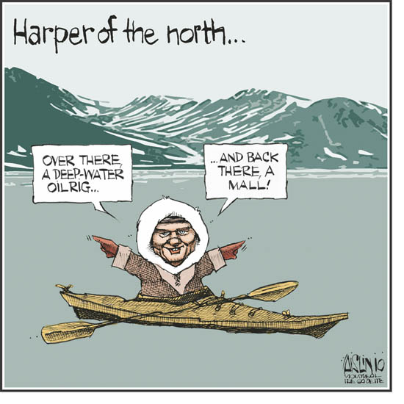
Osmund Lindberg
Aalborg University
Department of Culture and Global Studies
Supervisor: Robert C. Thomsen
01-02-2016

