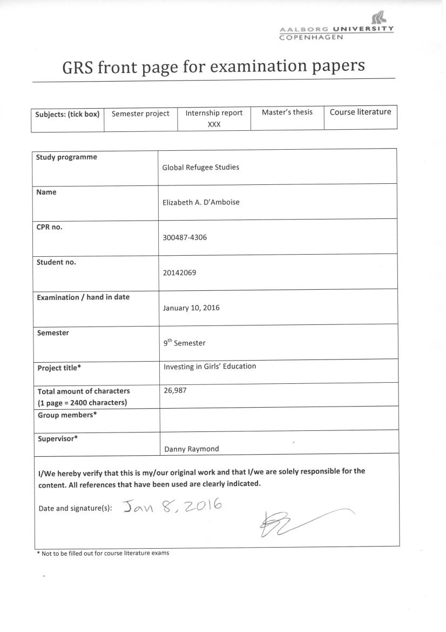

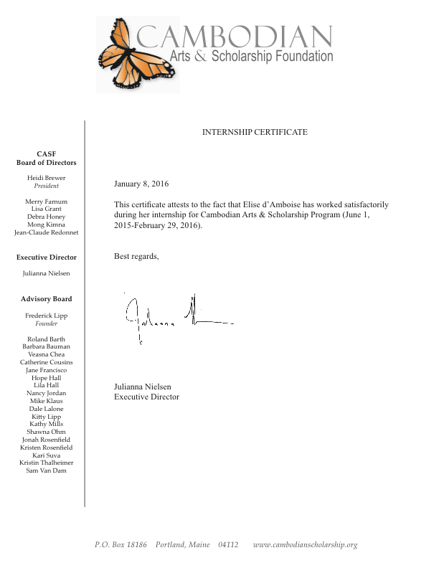

Aalborg University, Copenhagen

Global Refugee Studies

Cambodian Art’s and Scholarship Foundation
Investing in Girls’ Education
Phnom Penh, Cambodia
January 10, 2016

Elizabeth d’Amboise

Table of Contents

Introduction 5

Organization Description 5

Internship Activity Report: Roles and Responsibilities 6

Insights Gained Through Working with CASF 8

Research Question 9

Analysis 10

Barriers Girls Face in Getting an Education 10

Girls vs. Boys 11

Investing in Girls’ Education 13

Conclusion 15

Bibliography 116

Introduction
This internship report is based on my 9th semester Master’s program in Global Refugee Studies at Aalborg University. I participated in a nine-month internship with an organization called Cambodian Arts and Scholarship Foundation starting on June 1st, 2015 and ending on February 29, 2016. My position was the in-country Program Coordinator located in Phnom Penh, Cambodia.

Organization Description
The Cambodian Arts and Scholarship Foundation (CASF) is a non-profit organization that is committed to improving the lives of children in Cambodia through education. CASF focuses on working with poor, at-risk girls who, for a number of reasons, are denied equal access to education. CASF provides and empowers students through financial, emotional, and medial support for as long as the student wants to continue learning. CASF is based in Phnom Penh, Cambodia and in Portland, Maine, United States.
CASF is overseen by an all-volunteer Board of Directors based in Portland, Maine and a Program Coordinator, based in Phnom Penh, Cambodia. CASF operates in the countryside of Cambodia in Kandal, Svay Rieng, and Kompong Cham provinces, as well as in the capital of Phnom Penh. CASF supports girls in grades 6-12 in the provinces by providing economic, social, medical, and emotional support for students to stay in school and continue their studies. Once provincial students reach grade 12 and pass the National Exam, allowing them to continue onto university, they move to Phnom Penh to study a subject of their choice at a university of their choice. The students who move to Phnom Penh for university all live together in an all women’s CASF dorm with a native English teacher, whom they are required to take daily English courses with. While living and attending university in the capital, CASF continues to provide all expenses paid for each student to continue their education: which includes housing, medical, school fees, living costs in the form of a monthly stipend, school documents, transportation and so on.
There are currently 35 students in the CASF provincial program; Kandal province (12 students), Svay Rieng province (22 students), and Kompong Cham province (1 student), and 20 students in the university program in Phnom Penh, with one student working towards a Master’s degree.
Internship Activity Report: Roles and Responsibilities
As the in-country program coordinator for Cambodian Arts & Scholarship Foundation, I was responsible of developing and overseeing the educational program in Cambodia for all CASF scholarship students. I worked closely with the Educational Coordinators in each province to ensure educational, social, medical, and economic support for all CASF students to successfully complete their studies. As the Program Coordinator, I also monitored all student progress, filed reports to the Executive Director, managed all expenditures in Cambodia, and carried out new initiatives and protocols as approved by the CASF Board.
Some of my general duties included overseeing all finances related to CASF in Cambodia, including submitting monthly reports and budgets to the Executive Director, Board President and Accountant, who are all located in the United States. I also reported weekly to the Executive Director in the United States via Skype. I was responsible for supervising the Dorm Assistant (a fourth year university student with high English proficiency and leadership skills) and English teacher (a native English speaker (female) from the United States who lives in the CASF dorm) in Phnom Penh. I also provided support and logistics to all CASF representatives or board members who visited Cambodia on quarterly oversight visits. Such support for oversight visits would include booking transportation for village visits to the three villages CASF operates in in the countryside, or making reservations and plans for any CASF activities, meetings, and appointments that take place while the board is visiting Cambodia. I was also responsible of providing immediate medical reports on medical needs, results, and treatments to the CASF health board members via e-mail. I attend all medical visits with students as needed. And lastly I maintained an excel database of all students: tracking attendance, grades, medical issues, contact info, and any other relevant notes.

For university students duties I collaborated with the CASF Dorm Committee to implement CASF policies, as well as attended Dorm Committee meetings (via Skye) whenever necessary. If needed, I sought advice from the Dorm Assistant and/or English teacher on issues pertaining to CASF policies, programs, and support and communicated these with the Dorm Committee and Executive Director as needed. As the Program Coordinator, I also monitored all policies and dealt with any disciplinary issues that arose. If I could not settle an issue myself, I forwarded the issue onto the Dorm Committee and Executive Director in the United States for collaboration and intervention if necessary. I over sought all grade reporting of each student: mid-term, final results and transcripts, as well as all tuition fee payments and due dates of payments. If a student was struggling academically, I reported this to the Executive Director, while taking action of assisting the student by finding a tutor or mentor to get her grades up or provide extra support. I visited the student dormitory every Sunday, but also at various times throughout the week to check-in on the students and ensure the progress of their studies, health, and social wellbeing. Informally, I coached students on an individual (or group) level basis on various life and career skills. Lastly, I arranged for new students (ones who passed the grade 12 National Exam) to move to Phnom Penh. I worked closely with the Higher Education Committee to research and provide the best guidance for our new students in regards to their choice of study and school. I helped each new student move and settle into the CASF dormitory from her perspective province/village. I helped each student register at university, register for computer courses, obtain new dorm materials (bike, desk, chair), arranged for individual medical check-ups upon their arrival to Phnom Penh, and over sought the start of CASF English classes provided by the CASF dorm English teacher.
My duties pertaining to CASF’s provincial students included overseeing the work of the Educational Coordinators in each province. There are three CASF Educational Coordinators, one in each village we operate in. I arranged for monthly stipend payments to the Educational Coordinators and all students in provinces. I took quarterly oversight visits (every 3 months) to visit the provinces and hand out monthly stipends in person. The Educational Coordinators were responsible for handing out monthly stipends when I was not present to do so. If needed, and by recommendation of the Educational Coordinator, I interviewed potential new students for the CASF program, and upon doing so, I provided notes/recommendations on each potential students to the CASF board for final review. I also coordinated career counseling workshops conducted by CASF university students to provide guidance to all provincial students, especially grade 11-12 students. Lastly, and with the help of the Educational Coordinators, I maintained and kept records of all students in the provincial program by tracking their progress, attendance, grades and contact details.
This job required me to pay special attention to detail, as I was responsible of the oversight of over 50 students in the program. It was very hands on position and required constant communication and collaboration with the students in the program and the Board in the United State.

Insights Gained Through Working with CASF
My time working with CASF has been a great opportunity. Not only was it a fulfilling role, but also I’ve been able to gain first-hand experience of the intricacies of working for an NGO. I was able to gain a better understanding of how a small but meaningful organization functions and operates from an inside perspective. The best part about working with CASF was the meaningful relationships made with CASF students. The students are incredible motivated, positive girls, who made my job beyond fulfilling and worthwhile; on a daily basis, they specifically shed perspective on the importance of giving every child an education. They are incredibly hard working, grateful and caring individuals. Despite coming from extremely disadvantaged and marginalized backgrounds, these girls radiate with hope and prosperity when given the chance to grow, learn and go to school.
One of the most challenging aspects of the job was the cultural barrier. I’ve lived in Cambodia and worked with this organization before starting graduate school, so because I already knew and worked with the majority of the students, there was already a strong level of foundational trust formed between us. Unless otherwise familiar with Cambodia culture and norms, it can be a challenge to work with Cambodian students, especially girls. In Cambodian schools and society, there is very little in the way critical thinking and voicing individual opinions, especially for girls who culturally are more submissive to the male population. Students in schools are taught to generate very specific ‘right’ answers to questions with little room for interpretation. An example of how this proved challenging to me was when I was trying to give our university students a survey. The survey was created by the CASF ‘dorm committee’ and myself; and the purpose was to get a better understanding of how CASF can help the students meet their needs for when they graduate, enter the job market, and move out of the dorm. The questions were simple open-ended questions like: ‘list important skills needed to prepare you for getting a professional job when you graduate, what skills or support do you now receive from CASF, and what skills or support would you like to receive that you do not receive now from CASF.’ The survey proved to be a challenge and the girls had difficulty answering the questions on their own. The girls are used to being told what the right answer is in preparation for an exam. They did not know how to answer these questions because they are so often concerned with telling the questioner what they want to hear. So instead of telling me what they think, they will tell me what they think I want to hear, and if they don’t know what I want to hear, they will simply go silent and not answer all together. Overall the survey was successful because I have gained a level of trust and understanding with them over the past few years that has allowed me to break down the cultural barrier. However, it takes some probing and a clear understanding of the cultural norms and barriers. When I first started working with these girls back in 2013, this specific challenge was significant, but over time and with gained trust, the barrier has broken down.

One common question I found myself trying to answer from locals in various parts of Cambodia after explaining my work and CASF, was “why only girls?” People would often ask me why we didn’t accept equally poor, disadvantaged boys into our program. This inquiry has led me to reflect further on the importance and value of educating girls in developing countries (keeping in mind that boys too should have access to education).
In many developing countries, getting an education for girls is not a right, but a privilege. If girls wish to get an education they must overcome many obstacles in order to go to school. Poverty, while not the only barrier to getting an education, is a root cause to why millions of girls around the world are denied equal access to education. Another leading reason is gender-based discrimination and cultural social norms, which largely favor men and boys over women and girls
Research Question:
What is the value of educating girls in developing countries and why is it such a great investment with high return rates for developing countries?
Education is recognized as a fundamental human right, according to UNESCO, a branch development agency of the United Nations. It is also is a key factor in promoting development and eradicating poverty worldwide, and yet education still remains a leading challenge and the world is far from achieving global quality education for all, especially girls.

Barriers Girls Face in Getting an Education
For various reasons, girls in developing countries face far greater hurdles than boys when it comes to going to school and getting an education. According to Plan, an international development agency that works towards improving the lives of children worldwide, there are six main barriers preventing girls from obtaining an education: economic costs, distance from school, violence at school, gender norms, poverty, and early child marriages and pregnancies (Plan International, 2016).
In many developing countries, girls face far more inequities and discrimination than boys; for example, it is not uncommon that boys are favored over girls when a poor family can only afford to send one child to school. And while education should be free for all, there are a number of hidden costs that prevent poor families from sending all their children, especially their daughters to school: such as school uniforms, books, pencils, or transportation fees. (Plan International, 2016)
Another obstacle girls face is the distance to and from school. Many poor families live in rural and remote regions, far from schools, hospitals roads and infrastructure. Depending on the route, distance, and available transportation, many parents choose to keep their daughters home as a means of preventing them from the all too common prevalence of violence against girls/women; such as rape, harassment, and aggression on her route to school. Once girls do reach school however, her troubles are not over, she is also a subject of violence at the expense of her teachers, peers and other school affiliates while in school and on school grounds. (Plan International, 2016) What is more, is that many schools in developing countries, but especially in rural areas, often lack infrastructure or facilities such as toilets, outhouses or clean water where girls feel comfortable to go while on their menstrual cycle, which leads girls to miss school during the time of month when she is on her period. (Sperling, Winthrop, and Kwauk, 2015)
Another great challenge girls face is cultural gender norms, which commonly lock her into her place in the household. In many developing nations, girls are responsible for daily household chores; such as cooking, cleaning, fetching water, wood, child care and more, granting her little opportunity or time to go to school because her value and place in the household is regarded as greater and essential by family members, and cultural societal norms.
Early child marriages and pregnancies are all too common causes preventing girls from attending school in developing nations. In many developing countries girls are married off at a young age, well before she has had a chance to fully develop. According to UNESCO, one is eight girls is married off by the age of 15 in Sub-Saharan Africa, and South and West Asia, and one in seven has given birth by the age of 17 (UNESCO, 2013). If a girl is married off or becomes pregnant before she has had the chance to fully develop, she is far more likely to drop out of school to care for health, care for her child’s health, due to the stigma, to tend to her husbands needs or for other cultural norms. If all girls received a primary education, there would be 14 percent fewer child marriages, and two-thirds fewer child marriages if all girls received a secondary education, according to UNESCO (UESCO, 2013).
Health is another common factor contributing to many children staying out of school. Children of poor families often lack adequate nutrition and clean water to keep them healthy and nourished, which is essential for growth and a positive learning experience. If a child is barely surviving by not getting adequate food and clean water, they will be underdeveloped and learning will be a great challenge for them. Due to poverty, many children face stunting and malnutrition, another barrier keeping children out of school. (Plan International, 2016).

Girls vs. Boys
There are currently 31 million girls of primary school age out of school and of these, 17 million are expected to never receive an education. There are 4 million fewer boys out of school than girls. For female adolescents, there are 34 million out of school. (UNESCO, 2013) The effects of these statistics are staggering and have severs consequences. About a quarter of young women aged 15-24 in developing nations have never completed primary school (116 million), which makes up 58% of young children not completing primary school (UNESCO, 2013). By not completing primary school, these girls/women lack the necessary skills needed to enter the job market.
What is more is that 4 million women go ‘missing’ annually (missing meaning the number of women in low/middle income countries who die relative to their counterparts in developed countries) (The World Bank, 2014). The exclusion of girls and women in school and the labor force translates into a ‘less educated workforce, inefficient allocation of labor, lost productivity, and consequently diminished progress in economic development’ (The World Bank, 2014).
On a global scale, girls are being educated at lower rates than boys. They are also completing less education than boys and so the implications for educating girls are greater because the gap is larger and the problem is greater for girls. Parents of poor families around the world cannot afford to send all their children to school. When parents are faced with the choice of sending either a daughter or son to school, it is oftentimes the boys who are chosen to receive an education over the girls (Sperling, Winthrop and Kwauk: pg. 7). This has lead to more girls out of the classroom than boys.
It should be noted that while promoting a greater investment in girls’ education in developing nations should not lead one to believe that the crisis of education in poor nations is just a girls’ issue (Sperling, Winthrop, and Kwauk: pg. 4). This is to say that boys’ education is just as important as girls’, however the percentage of boys completing a high-quality secondary degree program in many developing nations is usually higher than girls. It is still low however, but in comparison to girls it is higher.
This fact holds true in Cambodia, where I was working to support and promote girls’ empowerment through education. In Cambodia for example, according to UNESCO’s Education For All Global Monitoring Report, 28% of females complete lower secondary school compared to 32% of males (WIDE, 2010). While 11% of females complete upper secondary school compared to 14% of males (WIDE, 2010).
The NGO I was working for, Cambodian Arts and Scholarship Foundation, firmly believes in educating girls for the reason that they deserve the same rights and opportunities as boys and that educating girls is the key to development and the eradication of poverty. Girls should not be denied access to the basic right of an education because of her gender. No child, boy or girl, should be denied access to an education for that matter.

Investing in Girls’ Education
What makes investing in girls’ education in developing nations worthwhile is not only the economic gains and growth it holds, but the number of other positive impacts it has on these nations. For instance, investing in girls’ education lowers maternal and infant mortality rates, reduces fertility rates, reduces child marriage rates, as well as incidents of HIV/AIDS and malaria rates. Investing in girls and women also has a positive impact on agricultural productivity, resilience to natural disasters and increases women’s empowerment (Winthrop, Sperling, and Kwauk: pg. 4). For these reasons and more, investing in girls’ education has a strong ripple effect on not every level of society.
Educating girls carries multifaceted benefits, not only for the girls themselves but for their families, communities’, and societies on a whole. There are wide ranging benefits that affect every level of society when developing countries decide to invest in girls.

Investing in girls’ education increases overall economic growth
The most obvious reason for promoting girls’ education is that it contributes to overall economic development, growth, wages and upward mobility of any nation, developed or undeveloped. However, more than the large developmental return (economic), investing in girls’ education in developing nations has vast, wide ranging returns such as reducing poverty and increasing development across sectors. Women represent a previously untapped source of human capital in developing nations and when such nations invest in gender equality in education, they can expect to reap high social and economic benefits (Tembon and Fort, 2008).
In “What Works in Girls’ Education,” many statistics and studies are cited depicting the link between girls’ education and overall economic growth. One such study conducted in 146 nations from 1950 to 2010, found that ‘schooling has a significant positive effect on output, with the rate of return being a 5 to 12 percent increase in economic growth for each additional year of schooling in the average population’ (Winthrop and Sperling, and Kwauk: pg. 20).
In a Global Monitoring Repot by UNESCO, an analysis shows that an increase in the average educational attainment of a particular country’s population by just one year increases the annual per capita GDP growth from 2% to 2.5% (UNESCO 2013: pg. 154). The report highlights that developing countries must invest in equitable education for all, poor and rich populations in order to achieve growth that will eradicate poverty. To this point, education alone and more time spent in schools is not enough however; the quality of education must be a priority as well (UNESCO 2013: pg. 154).

Investing in girls’ education saves millions of lives.
According to UNESCO, investing in girls’ education saves the lives of millions of children and mothers worldwide. Increasing girls’ education increases the chances of child and mother’s survival rates. Both infant and maternal mortality are grave realities in many developing nations worldwide. Women who are educated are less likely to die during childbirth. If all women received a primary education, then maternal deaths would be reduced by two-thirds globally, that’s 98,000 lives. If all women received a primary education, then there would be 15 percent fewer child death, and if women received a secondary education, half of child deaths would be prevented, saving 3 million lives. What is more is that when girls receive an education, their children are healthier and are less likely to be stunted from malnourishment. (UNESCO, 2013)
Children’s health and wellbeing can be directly related to women’s education. One study carried out by the International Food Policy Research Institute, found that women’s education and women’s status (in comparison to men) plays a key role in a child’s early development both cognitive and socially. The report, Explaining Child Malnutrition in Developing Countries: A Cross-Country Analysis, by Lisa Smith and Lawrence Haddad, found that: ‘improvements in female secondary school enrollment rates are estimated to be responsible for 43 percent of the total 15.5 percent reduction in child underweight rate of developing countries during the period of 1970-95’ (Smith and Lawrence, 2000). According to this study, women play an important role in influencing a child’s nutritional status because they play a crucial role in maintaining household food security and they are often the primary care givers of children; responsibilities often falling on women to feed, bathe, watch, and care for children. Due to these key roles of women in a child’s early life stages, a woman’s knowledge, ability, decision-making power and own physical well- being are all crucial elements to overall children’s health and well-being (Smith and Lawrence, 2000). If all women completed primary school, the under-5 mortality rate would drop by 15% in low and lower middle-income countries (UNESCO, 2014).
By simply giving a girl an education, we can reduce the rates of child and maternal mortality rates across the globe. For each additional year a girl goes to school, her chances of her surviving childbirth and her child’s chances of surviving past the age of five increases dramatically (Winthrop, Sperling, and Kwauk, 2015).
Education is one of the best ways of improving people’s overall health according to UNESCO. In addition to lowering infant and maternal mortality rates, and improving malnutrition rates, educating girls and mothers also decreases other preventable diseases and disabilities such as HIV/AIDS, malaria, diarrhea, and phenomena. Educated people have more access to information and are therefore more informed about specific diseases, granting them the ability to take more preventative measures in prevention (UNESCO 2014). Girls and mothers are no different; mothers who are educated are more likely to take preventative measures in ensuring the wellbeing of her children because she is equipped with the ability of recognize signs of illnesses earlier, seeking advise and acting on it.

Conclusion
The list of benefits that results from educating girls goes on and on; from boosting economies, reducing infant mortality rates, reducing maternal mortality rates, reducing population growth, promote smaller more sustainable families, reducing child under 5 mortality rates, increasing child nutrition, increasing overall health of a society, increasing sustainability practices, increasing agricultural outputs, reducing a number of diseases, increasing women’s empowerment and so on and so forth. However the real benefit of investing in girls’ education is the generational cycle it creates; when a girl is educated she not only benefits individually, but her children, her family, community, and society directly benefit as well. When a girl is educated, she grows up to become an educated mother, a mother who invests in the health, wellbeing and education of her children. She understands the value of an education and the importance of empowering women; she passes this value onto her daughter, who passes it onto her daughter, creating a positive cycle of change for the future. A common African proverb illustrates the impact of investing in girls’ education best: “Educate a boy, and you educate an individual. Educate a girl, and you educate a community (nation).” Invest in women and girls and everyone around them prospers, but deny them an education and world suffers.
Bibliography

- Fort, Lucia and Mercy, Tembon (2008). Girls’ Education in the Twenty-First Century: Gender Equality, Empowerment, and Economic Growth. Washington D.C.: World Bank

- Plan International Canada (2016). Girls’ Education: 6 Things Keeping Girls Out of School and What Plan is Doing About it [Online] Available at: http://plancanada.ca/6-things-keeping-girls-out-of-school [Accessed 2 Jan. 2016]

- Smith, Lisa and Haddad, Lawrence (2000). Explaining Child Malnutrition in developing Countries: A Cross-Country Analysis. [Online] International Food Policy Research Institute. Available at: file:///Users/Elise/Downloads/43512.pdf [Accessed 23 Dec. 2015]

- Sperling, Gene B, Rebecca Winthrop, and Christina Kwauk (2015). What Works in Girls’ Education: Evidence for the World’s Best Investment. Washington D.C.: Brookings Institute

- The World Bank (2014). Girls’ Education. [Online] Available at: http://www.worldbank.org/en/topic/education/brief/girls-education [Accessed 2 Dec. 2015]

- UNESCO (2014). Education for All Global Monitoring Report: Teaching and Learning: Achieving Quality for all. Paris

- UNESCO, Education for All Global Monitoring Report: World Inequality Database on Education, Cambodia. [Online] Available at: http://www.education-inequalities.org/countries/cambodia#?dimension=sex&group=|Female|Male&year=latest [Accessed 6 Dec. 2015]

- UNESCO (2013). Education for All Global Monitoring Report: Girls’ Education: The Facts. [Online] Available at: http://en.unesco.org/gem-report/sites/gem-report/files/girls-factsheet-en.pdf [Accessed Dec 20, 2015]

