**1. Introduction**

The appeal of places has always been mediated through cultural expressions. In the past, media such as literature, music and poetry have been a major element to explain the beauty of nature and influence the travellers to visit particular places (Seaton, 1998). In today’s society, a variety of platforms can be used to increase awareness of a destination. Popular media plays a major role in influencing the appeal of travel destinations as well as activities through constructing or reinforcing particular images of those destinations that act as ‘markers’ (MacCannell, 1976). Film induced tourism is the collective term used for the study of the tourist who come to visit a destination or an attraction after watching it on cinema screens, DVDs, television series or videos etc (Hudson & Ritchie, 2006).

According to Walaiporn (2008), watching movie is an intangible visual experience and that is the reason why movie locations appeal to the audiences. On the other hand, various tour operators around the globe organize tours to various film locations; movie sets that also act as a part of intangible movie experience for the audiences. As a result, film tourists feel a sense of association with their favourite movie and create an interest to visit that destination. Hence, despite being a moderately niche element of tourism activity, there is a high increase in the film tourism initiatives by destination marketing organizations (DMOs) and the economic development organizations, eager to capture additional promotion, visitor awareness as well as visitor numbers (Connell, 2012).

Bollywood is one of the largest film industries in the world, producing over 1,000 movies every year. It is a $72 billion industry selling six billion tickets annually (Desai, 2005; Lovgren, 2004). As a result, nowadays, countries of the developed world like Switzerland, Ireland, The Netherland, Australia, and New Zealand go out of their way to attract Bollywood production houses to shoot in their regions (Hassam & Paranjape, 2010). One of the main reasons behind is that placing a destination in a film is the ultimate in tourism product placement. A significant example can be given by the recent flow of Indian tourists towards Spain after the release of the blockbuster movie named Zindagi Na Milegi Dobara that has set against Spanish backgrounds (Harjani, 2011). Correspondingly, Mr. Yash Chopra, who is known as a major producer/director of Bollywood movies, idealized Switzerland as a romantic destination in his films and consequently played an important role in increasing the outbound travel from India to Switzerland by 30% (Dubey, 2008). Over last two decades, Bollywood cinema has been gradually more evident (Hassam & Paranjape, 2010). Hence, place-placement, just like product placement, has been seen as the ultimate touristic campaign as it gives access to wider markets, offers differentiation from competitors and can increase interest towards more unconventional touristic destinations (Ritchie & Hudson, 2006). But on the other hand, no research in film tourism study has found that how the impacts of film tourism can sustain in a destination after the film got featured.

**2. Problem formulation**

In this thesis, I am going to explore the relationship between Bollywood films and the image of Switzerland as a romantic destination that has been created through various films shot in the 90s by Yash Raj productions. At the same time, I would like to explore how the key actors of film tourism in Switzerland are exploiting this romantic image of Switzerland to attract tourists from Indian market despite of the fact that nowadays not many films are being featured in Switzerland. It would help me to understand various strategies that these key actors of film tourism are using and how they are collaborating with each other to sustain this brand image of Switzerland created by Bollywood.

**3. Research objective**

To explore how various key actors of Swiss tourism industry capitalize on the tourism potential of Bollywood films.

**3. Research questions**

What kind of strategic activities are performed by Swiss intermediaries specializing in Indian market?

What are the strategies used by various DMOs in Switzerland to attract Indian market?

What kind of strategies do Swiss suppliers adapt to meet the needs of Indian visitors to Switzerland?

How do all these actors (national/regional/local) collaborate with each other to attract Indian market?

**4. Research Methodology**

Methodology is a model which consists of theoretical principles, as well as a framework that provides guidelines about how research has been carried out in the context of a specific paradigm (Sarantakos, 1998). Henning (2004) describes methodology as an approach that complements one another and has the ability to deliver data and findings that will reflect the research question and suits the research purpose. On the other hand, methods are the tools used by researchers for data collection and analysis that will be put into place to collect data on the world and thereby create a theory about that world (Jennings, 2001).

**4.1. Philosophy of Science**

This thesis is based on social constructivist ontology and is therefore based on the contention that knowledge is not something that we can find or discover; rather it is something that we construct or build (Schwandt, 2000). As this research is based on both supply and demand side, on the supply side, qualitative semi-structured interviews from experts of Swiss tourism industry capitalizing on Indian market and a review of academic literature on various strategies of the key actors of film tourism will act as the main data sources. The social constructivist approach will help to understand the strategies adapted by various key actors of film tourism in Switzerland as well as to analyse how they use the potential of film tourism to capitalize on Indian market. The reason behind is that the phenomena in society is constructed and changed by various social processes and constructivists believe that not one prevailing truth exists, but different versions of truths can be found depending upon individual’s social construct (Bryman, 2008). Hence, this approach will be helpful to understand the perspectives of various key actors and their strategic preferences that will help us to find how they adapt their strategic focus according to the demand and preferences of their potential customers.

According to Bryman (2008), constructivism is an ontological position that asserts that realities are not objective; they are influenced by a person’s background. It implies that social phenomena and categories are not only produced through social interaction but that they are in a constant state of revision. Researchers always present a specific version of social reality, rather than one that can be regarded as definitive. Also because the research itself is a product of his/her own social constructions of research area *(ibid*). This thesis utilizes qualitative semi-structured interviews as the main tool to find the meaning in the social constructions of the organizations’ representatives. These interviews will help me to understand the meanings and human interactions. This practice can be understood with the perspective of Gergen who is a social constructivist and argues,” it is human interchange that gives language its capacity to mean and it must stand as a critical locus of concern” (Gergen, 1994).

In relation to this research, it means that even though I have interviewed people as the representatives of various organizations, it is the social construction of their word views that I am going to analyse. Here, I would like to mention that I accept the statements of interviewees as the statements of the organizations, even though these might be affected by the social construction as well as pre-knowledge of the individuals. As the same time, it raises the question about validity as the answers I have got from the interviewees might be affected by the relation that particular interviewee has to the organization that he or she represents. This can be explained well by Potter’s argument,”(…) the world (…) is constituted in one way or another as people talk it, write it and argue it” (Potter, 1996). In the same way, these interviews will not only help me to understand how various key actors of film tourism focus on target customer segment in Indian market by collaborating with various national, regional and local organizations but also to analyse how they change their strategic focus according to the demand of customers to capitalize on Indian market.

Following the claim of Bryman, I must also believe that during my research, I was also a part of social construction that might also impact the conclusions that I generate for this thesis. For example, I went to Switzerland as a researcher, but at the same time I took the Bollywood tour with my husband under the assistance of Erwin Fassler, which was actually like a field trip for 2 days. During my trip, on one hand, I was taking the interviews for data collection and on the other hand, we were visiting romantic Bollywood locations as a couple as well as posing for photographs (scenes from DDLJ, Mohabbatein and Chandani) for Erwin at various locations where some memorable scenes were shot. He was using us as models to upload those photographs for his Facebook page to market his Bollywood tours to the Indians and NRI customers. Hence, my social constructivist approach both as researcher and a tourist relates to various issues related to my data collected through interviews, observations, photos and being a part of Bollywood locations and photographs (posing for famous film shots) and also the capabilities that I should keep in mind while analyzing and drawing conclusions based on this data collected.

**4.3. Research design and execution**

Exploratory research has been carried out in order to gain more knowledge about the role of the key actors of film tourism in Switzerland focusing on Indian market. The reason behind is that I had very little knowledge about them and exploratory research helped me to gain in depth knowledge about all aspects of my research objectives because of its flexibility to permit considerations of all aspects of the research problem (Pizam, 1994). Exploratory research is carried out to gain new insights, discover new ideas or increase knowledge of a phenomenon (Burn & Grove, 2003). Therefore, an exploratory research is the best way to diagnose a problem, screening of alternatives as well as helps to discover new ideas to solve the research problem.

Following this research, a number of theoretical frameworks have been used to support the research in this thesis. Various theories based on marketing communication, destination branding and collaboration among key actors of film tourism as well as differentiation, focus and segmentation strategies presented in section 6 have been useful to enlighten the research and gave a meaning to the research objectives. The research questions are based on the theory that has been used for the research. Hence, the research has been primarily based on the research objectives rather than hypothesis because of the reason that research objective is ‘a clear statement of what information is required during the research.’ (Aaker *et al*, 2004). The research objective is:

To explore how various key actors of Swiss tourism industry capitalize on the tourism potential of Bollywood films.

After formulating the research objective, a list of information was required to support the research. The aim of the research is to find out different strategies adapted by the key actors of film tourism in Switzerland capitalizing on Indian market. To proceed further in this research, a clear understanding about the role of various key actors of film tourism and the strategies they apply for distant market were required that is undertaken through literature review.

On the other hand, exploratory research is undertaken to explore previously under researched and unclassified area. For example, in this case it is to explore various strategic activities undertaken by the key actors of film tourism in Switzerland capitalizing on Indian market and the way they collaborate with each other to exploit film tourism potential has not been undertaken by any of the researcher from this perspective. Hence, this research will provide the readers to understand a different perspective of the key actors in film tourism capitalizing in long haul markets as well as provide a whole new area for further research. Especially for those who are interested in Bollywood films and want to analyse its potential to market a destination and make it popular.

**4.2. Methods of reasoning**

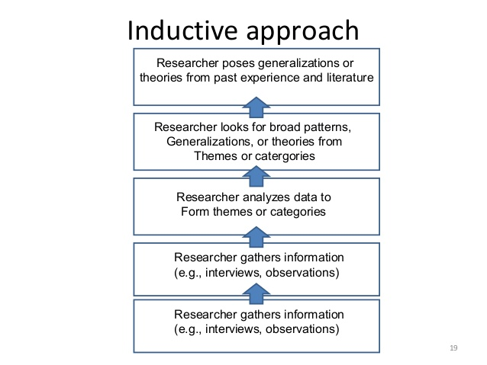Inductive research begins in the real world setting and by following this research theory, firstly, information about the tourism phenomenon is collected and then the information is analysed. On

Fig 1: The Inductive Approach, *Source:* Creswell, 2008

the basis of collected information, theoretical framework is either generated or modified. So, this research is based on inductive approach. As shown in Fig 1, the process of induction involves drawing generalisable inferences out of observations (Bryman, 2008). But on the other hand, during this research, I had knowledge about some of the theories related to Bollywood tourism which I gained while writing 8th semester project. But at the same time, I was missing the ethnographical part in that project. Hence, this time, the observations and data is collected through ethnography by going to Switzerland and meeting various tourism professionals to take interviews. At the same time, taking the Bollywood tour as a film tourist and visiting various film locations gave me an opportunity to be a part of social constructions itself and think out of the box to understand the emotions of Bollywood lovers who come to take the tour which can be different for everyone.

Therefore, continuing my previous knowledge about the role of various key actors of film tourism and books, articles, brochures, web pages and annual reports of Bollywood tours, DMOs and suppliers (mentioned in section 4.4) are explored to get a better understanding of the role of key actors of film tourism operating in Switzerland focusing on Indian market. On the other hand, my role as a researcher and my own experience as a Bollywood tourist helped me to develop knowledge about various strategic activities undertaken by these key actors to brand and market Switzerland in Indian market and how they collaborate with each other to reach the targeted customer segments. After getting a clear understanding of these research objectives, I made a selection of relevant theoretical framework to guide my research further.

**4.4. Data collection methods**

Data collection is a way to collect and evaluate information gathered on different subjects relevant to the research topic. Therefore, it is important that the chosen procedure of data collection should be effective and appropriate with the research in order to gain in depth information about the subject matter (Brotherton, 2008). In the current research, two different types of data have formed the basis. Qualitative empirical data in the form of semi-structured interviews and secondary data in the form of literature review about the key actors of film tourism and their strategies for distant markets as well the websites, brochures and annual reports etc provided by the Swiss tourism professionals capitalizing on Indian market during the interviews. I have chosen this approach to reach a level of triangulation-“ Looking at the same phenomenon, or research question, from more than one source of data” (Decrop, 1999) as triangulation “(…) opens the way for richer and potentially more valid interpretations” (*Ibid*). Thereby heightening the validity of the results produced during the research. In this research, triangulation helped me to include participation observation that I gained as a Bollywood tourist by taking field trip to Bollywood locations with Erwin Fassler, discussions throughout the trip with him and my husband about Bollywood and various locations in Switzerland, and at the same time taking interviews with various tourism professionals and collecting data. Hence, this triangulation method gave me the possibility to include all the data collected in order to get in depth information to analyse my research questions.

**Secondary data**

As mentioned earlier also, the secondary data in this thesis is the literature review on the key actors of film tourism. The purpose of this review is not only to discover about the existing research, from a quantitative as well qualitative stance about film tourism, but also from a more explorative angle, to find out what kind of strategies are used by various key actors of film tourism and their collaboration with each other to capitalize on distant markets, in order to use this as fuel for further discussions. On the other hand, secondary data like brochures, homepages of DMOs and Bollywood tours, annual reports and Swiss statistics provided by various interviewees (mentioned in the next section) helped me to understand their organization and to analyse my research questions more effectively.

**Empirical data**

One of the most important choices for empirical data collection for this thesis is the qualitative approach. The reason behind is that no previous research related to the key actors of film tourism capitalizing on long haul markets has been undertaken. It means that it would have been very hard to conduct a quantitative research, if not impossible, as there would be very less or no data to base it on. Furthermore, during my previous projects, I realized that collecting qualitative data is more interesting way because it gives the researcher a possibility to talk to various tourism professionals and attain more knowledge about certain concepts and gives the chance to observe things yourself as a researcher which is not possible in a quantitative research method. Hence, qualitative approach helps to acquire in depth information on certain issues by focusing on the questions like “why” and “how” (Brotherton, 2008).

**Interview type and situation**

In the previous section, it has been discussed that the empirical data collected for this thesis consists of 9 qualitative semi structured interviews. The reason behind choosing this interview type was; there were certain topics following my research questions that I actively required answers for, but at the same time, I wanted to have a conversation with the tourism experts in order to get in depth inputs on the subjects that I might have not mentioned while structuring the interview guides (Thagaard 2004; Russel, 2006).

Three different types of interview guides were made for this thesis. One for national, regional and local DMOs, second for the intermediaries specializing in Bollywood tours and third for the suppliers (Hotels/restaurants) operating in Swiss market. All of them were made on the basis of a series of research questions and literature review, especially focusing on the key actors of film tourism capitalizing on Indian market (Kvale, 2006).

The interviews were between half an hour and one hour long; ideally and mainly conducted face to face in the offices of each representative so that the interviewee is in the most comfortable situation. It helped to minimize the anxiousness that might be correlated to the environment of the interviewee. All the interviewees were so supportive that they also provided me various secondary data of their organizations like brochures, annual reports as well company statistics etc.

In order to conduct the interview, firstly emails were sent to all the interviewees requesting about the time and availability. The importance of their role in the research was also made clear to them. However, there were some respondents who were interested in the research purpose, but unavailable for the interview because of the high number of visitors during the peak season.

During the interviews, I also found out that some of the respondents were interested to give more in depth information on various topics asked for example representatives from DMOs had a lot of information about various emerging markets apart from Indian that they are targeting and the repositioning of the brand image of Switzerland for the target group of young customers especially for Indian market. But at the same time, a few interviewees were not able to answer a couple of questions from the interview guide, may be because they were quite new in the organization and did not have detailed information about their strategies etc. In that case, I had to mould my questions a little to acquire the information that was required for my research especially, because I have travelled all the way from Denmark to Switzerland for data collection purpose. At the same time, as a researcher, I had to sometimes make changes in my questions to bring the person back on the topic again if the discussion had gone on other track that I think is useful for my research. This is because I did not want to prolong the interview time as well as the energy of the interviewee.

**Choice of respondents**

The respondents were primarily chosen because of their importance for the thesis-which will be outlined below. An element of snowballing was also used because I had to ask some of the interviewees for their recommendations on some other related people who would also like to interview about the incoming Indian tourists to Switzerland. Hence, the picture of Swiss tourism sector in this thesis might show as the one only interested in Indian market which is not really the case. The reason is that apart from Indian market, Swiss tourism sectors also focuses their strategies on various growing markets like China, Beijing, Russia, and Australia etc. An overview of the interviewees can be seen below:

|  |  |  |  |
| --- | --- | --- | --- |
| **Company** | **Company type** | **Representative** | **Data/ Interview** |
| Swiss Tourism, Zurich | National Destination Management Organization (DMO) | Urs Eberhard, Vice President Marketing | * website * promotional material * social media * statistics * face to face interview |
| Gstaad Saanenland Tourismus, Gstaad | Regional Destination Management Organization (DMO) | Kerstin Sonnekalb, PR Manager | * website * promotional material * social media * statistics * face to face * interview |
| Titlis Tourismus, Engelberg | Local Destination Management Organization (DMO) | Tobias Matter, Sales Director | * website * promotional material * social media * statistics * face to face   interview |
| Hotel Central  Engelberg | Three Star Hotel, Independent Owner | Maja , Hotel Manager | Face to face |
| Hotel Victoria Jungfrau,  Interlaken | Five Star Hotel | Niklas Breitenbach, Sales Manager | Face to face |
| Erwin Tours | Incoming travel agent | Erwin Fassler, Owner | * promotional material * social media * face to face interview |
| Guides Gstaad Saanenland | Tour guides | Anita Roth, Bollywood Tour Guide | * promotional material * face to face |
| Restaurant GourmIndia, Lucerne | Four Star Restaurant | Marcos Bhategar, Front Desk Manager | Face to face |
| AM Films | Production Company | Ankita Makwana, Founder AM Films, Bollywood actress | Face to Face |
| Oyster Tours, India | Wholesale Tour Operator | Abhay Jaipuria, Owner | * website * social media * Skype interview |

As it is shown in the table, I chose the national, regional and local DMOs operating in Switzerland to understand all the strategic activities that they perform and the way they collaborate to perform those strategies to capitalize on Indian market. In the next section, a short introduction about all these key actors will be given.

The Switzerland Tourism (ST) has been promoting Switzerland as a holiday, travel and conference destination both locally and internationally for almost 100 years. It is a public corporation in which the board comprises of 13 representatives from tourism, business and industry associations (ST Annual report, 2014). The Head quarter is in Zurich and there are offices in 27 countries, employing 245 staff members. As a national DMO, ST is considered as the dominant organization in the Swiss market. The interview with the Vice President Marketing, Urs Eberhard, helped me to gain insights about the organization, their roles as a national DMO as well as the way they collaborate with other DMOs and stakeholders around nationally and internationally.

Gstaad Tourismus (GT) is a regional DMO which is unique in many ways. The visitors can find various leisure cultural and sporting activities all year round (Appendix: 9.3). The region is located in the Alpine landscape and is known for a combination of style and glamour which makes it an internationally renowned destination. Some of the events have a top international format, such as the Menuhin Festival, the credit Agricole Suisse Open tennis tournament, the Beach Volleyball World Tour of the Hublot Polo Gold Cup etc (Appendix: 9.3). From GT, I got the chance to talk to Kerstin Sonnekalb, PR Manager, who talked about the image of Gstaad and various marketing and PR activities that they perform individually and in collaboration with ST and other stakeholders.

Titlis Engelberg Tourismus (TET) is a local DMO which is famous because of mount Titlis which is located at 1000 metres above sea level and is famous as winter as well as summer holiday destination offering various summer and winter activities for all age groups (Appendix: 9.3). The organization undertakes various marketing and PR activities and also collaborates with ST to promote Switzerland as a destination in various markets. TET is also partner with Hotel Terrace that specialize in Indian Cuisines and that is one of the reasons that the destination is very much popular among the Indian visitors. The interview with Tobias Matter, Sales Director of TET, gave me insights about the reason why Engelberg is one of the favourite locations around Switzerland and how their strategic focus has changed over the years to meet the needs and preferences of Indian visitors.

During the research, I also found out that despite of the fact that Switzerland has been shown in various Bollywood films in 90s, the potential of Bollywood has recently been realized by the tourism sector. Therefore, at present, only two Bollywood tours exist to show various Bollywood locations around Switzerland. One of them is Erwin Tours (ET) run by Erwin Fassler, who acts as an incoming travel agent. Another is Guides Gstaad-Saanenland (GGS) that organizes the Bollywood Tour around Gstaad in collaboration with GT and Oyster Tours, India (OT). There are 6 guides in the group. The design of this tour has been formed by Abhay Jaipuria, the owner of OT, India. The interview with Erwin Fassler, Anita Roth and Abhay Jaipuria provided information about the motive of starting these Bollywood tours and various marketing activities they are doing to attract Bollywood fans not only from India but NRIs from all over the world that watch Bollywood movies and are interested in visiting various movie locations around Switzerland.

The interviews with Niklas Breitenbach, Sales Manager, Hotel Victoria Jungfrau (HVJ), Maja, Front Desk Manager, Hotel Central (HC) and Marcos Bhategar, Front Desk Manager, Restaurant GourmIndia helped me to understand how hospitality industry ranging from a 3 star restaurant to 4 and 5 star hotels differentiate their products and services in order to cater the needs and demands of their Indian customer segment.

Last but not the least, I also got the chance to talk to Ankita Makwana, Founder of AM Films and an upcoming actress in Bollywood. The interview provided the information about her passion about Bollywood and how she made her way to Bollywood films all by her own despite of being born and brought up in Switzerland.

**4.5. Validity & Generalisability**

In this method section, I have made discussions about the practical, academic and formal limitations surrounding the design of this thesis. So, it is also important to discuss about the terms that form the headline of this section.

*Validity* determines that we are measuring or researching what was indented to be measured or how truthful the results are (Joppe, 2000).In the current research, qualitative method has been used, so the individual elements have possibly glided into the data analysis resulting in low validity. According to Wainer and Braun (1998), the validity in quantitative research is “construct validity.” In the same way, during the quantitative semi structured interviews, a series of questions were asked from the interview guide. However, the affect was minimized by applying the theoretical framework related to the strategic activities that the key actors of film tourism perform and how they collaborate with each other to capitalize on long haul markets. On the other hand, the interview was conducted in very easy and simple language was quite clear to the interviewees and they were able to give their opinions and suggestions related to the research questions. At the same time, the interviewees were all professionals in their specific designations and hence, the collected information should be considered as credible and truthful as well as useful for the research.

Generalisability refers to the level to which something can be considered as valid and representative (Kvale, 2006). As I have already discussed that this thesis cannot be regarded as generalisable to the whole tourism sector present in Switzerland. Instead, keeping my research objective in mind, I have aimed to look for the most preferable regions for Indian visitors as well as the key actors of film tourism who capitalize especially for Indian market around Switzerland. This has helped me to collect more interesting patterns within the actions and the opinions of the representatives of Swiss tourism sector and from these the generated results will give the indications about the sector as a whole as well as act as an inspiration for further, more generalisable research.

**4.6. Research limitation**

Despite of the overall success of the research methodology, a number of limitations were identified which will be discussed in this section. Switzerland was selected as the case study area because it has been used in several films during 1990s by Yash Raj productions and has been very famous among Indians especially for honeymoon couples and families. As I am also from India, so I also wanted to go to Switzerland and find out how the image created by Bollywood is sustained and being used by various tourism professionals.

Secondly, Switzerland is a destination divided in 26 cantons and it was not possible to visit all these cantons and meet the tourism professionals. Therefore, I selected Zurich, Engelberg, Interlaken, Gstaad and Lucerne because these areas are most popular among the Indian visitors and as my research is primarily based on the key actors of film tourism capitalizing in Indian market, selection of the appropriate geographical locations was really important to collect sufficient data to support the analysis in order to answer the research questions and drawing relevant conclusions.

As my research objectives are focusing on exploring the strategic activities of the key actors of film tourism in Switzerland focusing on long haul markets like India, the strategies related to the suppliers in literature review may not directly related to film tourism. The reason behind is that although there are various research based on film induced tourism and how it helped in marketing a destination but there is very less or no research literature available that is focusing directly on the key actors of film tourism capitalizing on long haul markets. Hence, various strategies related to key actors of tourism capitalizing on distant markets have been used to base the theoretical framework which is considered applicable as my research questions also focus on the strategies in connection to distant markets.

Although Bollywood shares a long term relationship with Switzerland, but the potential of it has been realized by Swiss tourism sector quite later. Due to this reason, I was only able to find two Bollywood tours going around Switzerland organized by Erwin Tours and Guides Gstaad. Furthermore, Erwin tours is run by Erwin Fassler who works like a travel agent and guide as well. In the same way although Guides Gstaad is collaborating with GT and OT (India), but the guides are the ones to take the visitors at various Bollywood locations and are quite new in the market. So, I have categorized both of them as tour guides which helped me to analyse their strategies in a proper way to answer my research questions and draw conclusions.

**5. Literature Review**

In order to be fully equipped to analyze the empirical findings, a strong theoretical foundation plays an important role to ensure a higher level of understanding about Bollywood induced tourism, key actors as well as various intermediaries, DMOs and suppliers and their roles in the tourism industry at local, regional and international level. For this purpose, various marketing and branding strategies performed by these actors will be discussed as well as the importance of their collaboration to capitalize on long haul markets. Therefore, this section intends at introducing various theories which have been examined during the thesis writing process. However, not all the mentioned theories will be applied while analyzing the empirical findings. The sections about film tourism and effects of films on tourism were essential to understand the phenomena of film tourism and its potential to promote a destination worldwide to its audiences. On the other hand, to grasp an understanding about film commission and various intermediaries’ role was important to understand their relation with the tourism industry and how they can exploit the image created by films.

**5.1. What is film induced tourism?**

Film tourism is also referred in the international bibliography with the terms ‘film induced tourism’ or ‘media induced tourism’, or ‘movie induced tourism’ or ‘cinematographic tourism’ or even ‘media pilgrim’ (Horrigan, 2009). According to Hudson and Ritchie (2006) film tourism comes under the umbrella of cultural tourism and it is encouraged by the expansion of the entertainment and international travel industries. As searching for monuments and heritage sights is one part of cultural tourism, in the same way, film tourists also search for these signs and visual icons, known as ‘markers’ that remind them of the scenes that they have seen in their favourite movies. Iwashita (2003) claimed that films, television and literature are the factors that interpret the particular characteristics and attractions of a destination. Therefore, they can act as reasons behind influencing the travelling preferences of the individuals.

According to Scotland’s national tourism organization, film tourism is the business of attracting visitors through the depiction of the place’s storylines in the film, video and television (Scottish Tourist Board, 1997). However, Tooke and Baker (1996) argue that film tourism is not only the effect of both cinema film and of television film but also the number of visitors coming to the place where the filming has taken place. Film location refers to a place where a film or film scenes were shot in a real physical setting rather than a studio (Beaver, 1994).

Nowadays, tourists are well informed about various destinations and frequently very selective in their destination choice. If storyline and location are closely related, watching a movie set in a particular country can lead to the construction of a certain image of the country’s people, nature and culture in the viewers mind (Walaiporn 2008). For example, in Bollywood blockbuster, Zindagi Na Milegi Dobara, Tomatina Festival and Bull Fights are shown as a part of Spanish culture and many viewers would like to visit the place especially to see these cultural festivals as well as the beautiful locations of Spain depicted in the movie.

Every individual has their own image of a place and they create this image through many sources over the time. Advertising, news, word of mouth and actual visitation are commonly known as information sources. However, travel stimuli, confidence in the travel intermediary, previous travel experience, perceived risks, and destination knowledge are also known as important variables which influence tourists’ decision-making process (Sellgren 2011). According to a study about movie locations done in the UK and their impact on destination image formation and travel behaviour, it was found that tourists’ travel decisions were made primarily on the basis of word-of-mouth from their friends and relatives (Wang 2007).

According to Roesch (2009) the success of a movie in terms of the money it has generated does not necessarily mean that it also has the potential to attract film tourists as well. However, listed media exposure, alternative status and enormous fan base are the most important factors when it comes to movies attracting visitors to a destination.

**5.2. The effect of films on destinations**

One of the earliest papers to explore the potentially profitable effects of film tourism for a destination was that by Cohen (1986), who acknowledged the power of film in motivating tourist demand and recommended destination marketers to categorize films that might be used in place promotion strategies. By the early 2000s, the concept of film tourism gained momentum in tourism research alongwith a growing awareness based on the case studies of destinations where film tourism already produced some kind of impacts (Beeton, 2001; Connell 2005a; Mordue, 2001).

Generating interest in a destination is the key to increasing visitation. According to Bachmann *et al.* (2010) film tourism can be defined as the visitation of a site or a location, that is or has been used for or have some association with filming. Hence, films can act as a means of marketing a destination to millions of viewers. It is well documented that many destination marketing organizations (DMOs) have used the success of film-induced attractions to promote their region to the visitors. Hence, many destinations are now working to become ‘film friendly’. According to Roger Grant (personal interview, 2001), Executive Director Geelong Otway Tourism, they have taken a proactive attitude towards encouraging film shooting in the region by developing good relations with the major film studios, international and local PR companies and advertising agencies. Other activities like providing relevant filming information regarding sites and legal requirements are also included (Beeton 2005).

According to a survey done in year 2004 in the UK, 8 of 10 residents remarked, that they got the idea for their vacation destination through movies, and 1 among 5 is planning a trip to visit their favourite movie location (Hudson and Ritchie, 2006). On the basis of this survey, it can be said that there are numerous elements that motivate people to become tourists and to select particular destinations and activities (Beeton, 2005). The social scientist, John Urry (1990) postulates that one of the basic consumer motivations is the desire to experience imaginary pleasures in reality that have been developed in the consumer’s mind over time. Tourism has a nature of involving daydreaming and the anticipation of different experiences that a person constructs while watching his/her favourite movie. Therefore, it is the image in a tourist’s mind that is the most powerful motivator to visit a destination. Film tourism is reasonably grounded on tourists and their strong desire to enter to their vision and experience the cultural landscapes shown in their favourite films.

A film can be a very powerful marketing tool and a great contribution to a destination’s awareness but at the same time, image creation and enhancement through showcasing the features and attributes of the destination on screen, the natural and cultural environment can experience within the destination from the film industry as well as from the resulting increase of tourism activity (Forsyth, 2002). On the other hand, various case studies have also highlighted the impacts such as variation of the environment by film crew during film shooting as well as the negative reactions by the local community due to the disturbance in their daily routines (Bolan, Crossan and O’Connor, 2007).

Referring back to different types of film tourism that have been discussed in academic research so far, impacts can have a difference in both scale and level. The reason behind is that the more successful a film is, more likely it can attract tourism activities at the destination (Riley, Baker & Van Doren, 1998). Another thing which is to be noted is that, although the tourism impacts can be for short-term but are of immense volume. On one hand the major economic benefits and factors of film-induced tourism is that viewing past locations can be an all-year around and all-weather attractions. But on the other hand, there are some drawbacks related to film-induced tourism as well. An example can be taken from the movie, *The Beach*, filmed in Thailand by *20 century Fox films.* The Beach that was used for the shooting of the film; was bulldozed and widened and much of the native vegetation was removed from there. Furthermore, Fox claims that they removed three tons of rubbish from the isolated beach and posted a $US150, 000 bonds, in order to return the beach in its former state (Gritten, 1999).

Hence, it is clear that both negative and positive impacts are related to film-induced tourism. Within the context of various cultural activities promoted by local authorities, the audiovisual sector plays a major role as it is considered of strategic importance in increasing the local productivity, attracting human and financial capital, creating new employment opportunities as well as helping in development of territorial marketing campaigns with positive consequences on tourism (Cucco, 2011). In most of the cases, the action plans drawn up also envisage the creation of a film commission. Therefore, the role of film commission and film fund will be discussed in the next section.

**5.3. Key actors of film tourism**

The role and interest of the key actors of film tourism vary in terms of tourism planning. Therefore, the level of participation and involvement in the planning process differs accordingly. The focus lies on the key stakeholders that are: DMO, film commission, film fund, intermediaries and hospitality industry/suppliers (Heitmann, 2010). The contribution of each key actor in marketing a tourism destination and various strategic activities they focus on to capitalize on distant markets will be discussed in the next section.

**5.3.1. Film Commission**

Film commissions are non-profit organizations set up by local institutions to attract various productions like films, TV series, documentaries, music videos, advertisements etc. to a specific region by offering them a number of free services. These organizations are aimed to generate economic impacts (direct, indirect and induced) for their region with a number of goals i.e. growth of local firms, creating employment opportunities for community, development of local professional competencies needed by the audiovisual industry, promoting the image of the region and consequent growth of the tourism sector (Cucco, 2011).

Film commissions play an active part in continuously improving the network of various regional and public agencies as well as use their media industry knowledge to improve the production and shooting conditions within their particular regions. They are responsible to coordinate between the film production industry and the related intermediaries. On the other hand, nowadays, film commissions represent a well-established form of public involvement, normally on a local scale as well as throughout the world having different dimensions, resources and activities (Cucco, 2011).

Apart from film commissions, various intermediaries of tourism sector also play an important role in the development of a destination. Tourism and hospitality industries are connected to customers through tourism marketing channels consisting of various tourism intermediaries and facilitators (Ritchie & Crouch, 2003). This whole system of diverse contacts, interconnection and accessibility between operators and consumers enable destinations and their concerned enterprises to reach the preferred market with their products and services. A brief discussion about the various intermediaries and suppliers of tourism industry is given in section 5.3.4 and 5.3.5.

**5.3.2. Film Fund**

Film commissions are usually not entrusted with the management of any regional fund set up to support audiovisual production. Therefore, the local authorities appoint a special committee known as film fund in which the director of film commission is often a member. Financing is an important aspect to make any movie. In the last two decades; many regions have set up a film fund to support the film productions (Helderman, 2014). A film fund is an amount of money set aside for one or more stages of film production that can be obtained from the administration that sets it up. On the other hand, the regional support is usually granted in form of co-financing, repayable loans and direct grants.

Generally there are two main reasons behind the decision to set up a film fund. Firstly, the desire to support local cultural production and the creative ability present in the region which supports to make the region more interesting to the producers, even though the financing is usually a small amount (Cucco, 2011). Secondly, due to the fact that film producers are hesitant to share economic information about their production with other production houses, the amount of fund varies from region to region depending upon the size, wealth and recognized strategic significance for the film sector, in terms of economic and cultural policy (Cucco, 2011).

**5.3.3. DMOs & their strategic activities**

DMOs have a high interest and power in influencing the development of a film tourism destination because it represents a new opportunity even if it is an existing, emerging or a totally new destination. But on the other hand, close cooperation between DMOs and film industry plays an important role to assure the sustainable tourism development of a destination (Heitmann, 2010). National destinations have established national tourist offices whereas states, provinces and territories have also created similar organizations. Some cooperation between various levels of DMO is evident, but at this point of time the extent of cooperation seems generally to be rather limited. Marketing is a broader function than promotion; still some of these organizations believe that any activity that is not related to promoting the destination is a waste of effort and funds (Ritchie & Crouch, 2003). But the role of DMOs is quite different in comparison to other marketing intermediaries and facilitators. However, there are some DMOs that have begun to implement a developed perspective of their role beyond promotion and even marketing.

Today, a tendency of increase in the number of DMOs is observed internationally, which implies that the requirement of their existence has been renowned, as well as there is a positive involvement of their work in the promotion of various destinations. DMOs possess and organize the “commercial brand name” of the destination. On the other hand, they also have the possibility of offering a wide range of services and support to the consumers while maintaining close relationship with the suppliers of the tourist products (Vagionis & Loumioti, 2011).

Development of various new destinations, specific branding strategies and the fracturing process of mass tourism have shifted many DMOs from their marketing emphasis way to promote generic tourism activities of escape, enjoyment, sightseeing and shopping, to tourism of special interests. Film tourism has also emerged as a part of the game. But the challenge for DMOs is to proficiently create and utilize film induced tourism, including product development and management (Vagionis, 2011). After a research around 490 DMOs worldwide, it has been found that almost all the organizations have to work with marginally sufficient economic and human resources and they cannot keep pace with the requirement of innovative strategy of publicity. On the other hand, it is also found that the investment of money in promoting film tourism is risky because there is almost no guarantee for a positive outcome (Hudson & Ritchie, 2006). The basic profits include: the strengthening of brand image of the destination, increase in number of tourists and the positive economic effects etc. The strategic activities of DMOs related to exploit the potential of film induced tourism is discussed in the next section.

**(i) Communication with distant markets**

Literature shows that the promotional activities stem whether from public tourist institutions or private enterprises or rather in collaboration between both the parties. As shown in Fig. 2, their main focus is to stir-up tourists’ interest with a lengthy cinematographic product life cycle that includes pre-release acts, premiere, DVD release and after release to inform tourists about the film locations (Vagionis, 2011). Here, it depends upon the ability of the DMOs to negotiate with the film producing companies that they have the intention to attract the shooting of films in their own regions. Furthermore, DMOs should also discuss about what the region will attain from the producers as an advantage. Therefore, several DMOs hire experts of public relationship in order to promote their region in various film studios and set communications between distant markets through them.



Fig 2: Various Marketing Activities (before, during and after) film release, *Source*: Elmgaard, 2012

An important fact to be kept in mind is that even if the destination planners are involved in the early stages of film making process, they would not have any influence over the target group or audiences. Here, the DMOs have less powerful position. Therefore, they have to adapt their strategy accordingly in order to align it to the vision of the film (Hall, 2008). Here, the public relation officer plays an important role to maintain the image of the destination. For example, Canada and Bahamas, have engaged Weber Shandwick, known as the most famous personalities in public relationship in the world, to achieve their region’s maximum appearance in the films to attract more number of film tourists. Hence, it is significant for the DMOs to set up an efficient public relations department so as to strongly promote the destination as the best location for the film shooting (Hall, 2008).

Promotion of a film location by celebrities does not only create the connection between the location and film audiences but it can also produce considerable attention towards the destination. For example, after the terrorist act of 11th September, the local tourism organizations of New York used sports personalities, film stars for the reinforcement of tourism in the city. At the same time, an organization of Washington used the leading stars from TV series “*The West Thing”* filmed around the capital and has strong relation with life around the White House and the Capital. The aim was only to reinforce the tourist visits again in the city (Vagionis, 2011).

**(ii) Collaboration with the film industry**

Negotiation with the film companies is also regarded to be an important part of DMOs’ strategy. The reason behind is that it can be problematic if the genre or storyline of the film is negative. Due to the fact that tourism is perceived to be the happy industry in general, and any image of a destination should be portrayed in the positive light to attract tourists. Hence, as evidenced in many cases, DMOs have been keen to include the film industry in their decision-making process (CanagaRetna, 2007). But on the other hand, it also depends upon what the destination can offer so as to have the possibility to control which sites of the destination will appear in the movie. The implementation of the strategy to attract film producers is more effective in the early stage of the planning the production of the film. To achieve this goal, many organizations provide training to their staff who is interested to be a part of film induced tourism intermediaries. For example Visit Scotland provides training for tourism professionals that desire to attract film crews in order to develop on the long-term impacts of “location tourism” (VisitScotland, 2007).

**(iii) Movie Maps**

Movie maps are becoming increasingly popular and have been proved to be one of the cost-effective forms of product development in tourism marketing. These maps can utilize the branding of the films as well as point tourists to specific film related sites rather than to a general locality as many locations may not be on the regular tourist trail. About eight Bollywood hits are filmed in the UK annually and this is increasing nowadays. Hence, UK is following a trend set by Switzerland, where not many films are shot these days but the tourism remains. In year 2002, more than 200,000 Indian tourists spend 212 million Euros in the UK. Hence, VisitBritain has released a Bollywood movie map that consists of 22 locations that have been featured since 1990 and 17 classics from the 1960s, 1970s and 1980s. Around 55,000 copies of this movie map were distributed through the offices in India and the Middle East (O’Connor, 2010). In the same way, New Zealand also published movie maps identifying the country as the home of film *Lord of the Rings*, promoting various road trips to the film locations and combining a picturesque journey of the key locations of the film on its homepages.

The growth of the movie maps is an essential factor of film induced tourism, which can have a very positive impact on the growth of tourism in a destination. However the promotional capability of all the films is not equal. Some movies have little impact, while others may be both influential and memorable-that can be the plot, characters, the storyline or the combination of all three that helps to create the film experience of lasting importance (Beeton, 2005).

Moreover, DMOs are not the only player engaged in destination management, there are several other government departments e.g. those dealing with transportation, the environment, education, training, economic development etc. have significance and responsibility in this area (Ritchie & Crouch, 2003).

**Tourism Intermediaries**

In literature, mainly two different types of intermediaries, i.e. tour operators and outgoing travel agencies have been discussed. However, leisure tourism distribution channels also consist of some more members that can be, incoming/handling travel agencies based at destinations that carry out the handling of incoming groups. Furthermore, national and regional tourist organizations and DMOs are used by both the tourists as well as the travel trade for additional information, support documentation, classification and inspection of tourism products, co-operation in promotion as well as special arrangements (Wanhill, 1998).

Hence, the competitiveness of a destination depends upon their competence with which it utilizes its marketing intermediaries and facilitators (Ritchie & Crouch, 2003). According to Wanhill (1998), the primary role of intermediaries is to bring buyers and sellers together, either to create markets where they formerly did not exist or to make existing markets work more efficiently and thereby expand market size.

**5.3.4. Tour operators & their strategic activities**

In the organization and structure of the tourism industry, tour operators are a central link between the tourists and their holiday destinations. Hence, they have the power to influence both demand (tourists) and the supply (service providers) sides depending upon their interests.



Fig 3: The tour operator as an intermediary, *Source*: Education Bureau, 2013

A tour operator can act both as a broker who buys bulk to sell to clients or as a producer who buys individual products in bulk and combines them in newly “manufactured “ product “the holiday package”, is that of a “middleman”. Hence, they are the intermediaries between the suppliers of various products and services that combine to form an ultimate tourism product, and reach the final consumer-the tourist (Calveras, 2006).

Tour operators are also known as wholesalers, although they sell both to the travel agents as well as directly to the tourists. There are mainly two categories of tour operators, inbound and outbound. Inbound tour operators are normally located in the key urban centres, usually the capital city or the gateway towns to the main tourist attractions. They can be private-owned ranging from multinational companies that also own lodges and vehicles, to low-budget small firms with a couple of employees (Honey & Krantz, 2007). On the other hand, outbound tour operators send tourists abroad and may sell their own exclusive package tours. Some operators market directly through magazine or newspaper advertisements or catalogs, brochures, videotapes, CD-ROMs and internet. Due to a lot of competition in the tourism market, many tour operators try to persuade travel agents to carry their packages by offering higher commissions, incentive programmes, various advertisement, attractive articles, interesting contests and offering discounts on various trips (Higgins, 1996).

Tour operators can be viewed as producers because they combine various parts of the tourism product to create a new and more complex product. Hence, their success depends upon their ability to buy separate products and services at a comparatively low price and combine all these in a profitable manner to benefit both the clients and themselves. On one hand, they also try to differentiate their products and services to enhance competitiveness and for that they also provide additional services like travel insurance, visa assistance, travel newspapers, maps or guides, travel consultants to their packages (Holloway, 1998).

As shown in Fig 3, a vast majority of small and medium-sized tourism enterprises (SMTEs) also exist in tourism sector but due to their structural and functional weaknesses, hotels depend almost entirely on the tour operators for their communication with consumers as well as visibility in major markets (Buhalis, 1994). Furthermore, through vertical integration, tour operators also control both transportation companies (charter airlines) and retailers (travel agency chains). The strategies adapted by various tour operators or travel agents of film tourism to capitalize on distant markets are discussed in the next section.

**(i) Attracting tourists to the film locations**

The initiatives to attract tourists are location centred, rather than film-centred. It is about being more clearly related to individual locations, areas or regions associated with a particular film. As such, they are targeted mainly at those who have previously been transformed from film audience to tourist or potential tourist. In other words, at those individuals whose interest in travelling to film locations has already been established (Olsberg, 2007). Furthermore, these proposals also have strong awareness raising power and can give contribution by creating an interest in travelling to the locations. But in order to achieve the goal, tourism agencies have to collaborate with other stakeholders on these initiatives. It can be either producers/distributors of the film, individual locations, private tourism companies, other tourism agencies or the press.

**(ii) Movie tours**

Movie tours are also very popular and successful promotional tools used for marketing the destination (Hudson & Ritchie, 2006b). These may vary from walking tours for small areas, or transportation-based for larger areas. Many local tour operators, regional tourist organizations as well as movie studios offer film tours to various destinations. Furthermore, there are many movie studios that have become so strongly linked to a particular destination that often they are used to market the destination (Beeton, 2005). For example, in *New Zealand*, there are various tour operators that offer tours for the locations from *Lord of the Rings*. On the other hand, *Los Angles* often uses its built movie heritage sites such as the recognizable entry portals of *Paramount* and *Universal* studios as destination images. On the other hand, for those participants accompanying the movie fans, the tour guide should also have proper knowledge about various sites shown in the movie. A CD player should be fitted to the vehicle of transport so that the film music can be played in situations where film location tourists can feel an emotional involvement with the visited locations (Roesch, 2009).

Another factor when it comes to the movie tour is Price. When talking about the scenes filmed on a location, generally tour guides use the character’s name rather than the actor’s name in order to make the audience more connected to the film location experience (Roesch, 2009).

*Many visitors taking the tours see it as a less traditional way to see the town,*

*and it also appeals to independent travellers who are not interested in*

*‘normal’ tour with boring tour guides narrating the same facts and figure*

*throughout the whole day (Beeton, 2005).*

On the contrary, Sellgren (2011), who found out during a study about the travel behaviour and motivations of film tourists, that movie tours were regarded as inauthentic and uninteresting because of their large group size and strict schedule. Hence, film tours should not only provide good amount of information related to the film, but also add tourist-relevant experience and a focus on quality and authenticity (Roesch, 2009).

**(iii) Media coverage**

Destination marketing plays a significant role in tourism strategy, intended at either reinforcing the existing image in the potential visitor’s minds or constructing a new image by replacing the negative image (Holcomb, 1993). For this purpose, visual media is considered to be the most influential image creators rather than marketing because it has the capability to adapt, create and strengthen the destination image and with no doubt, film has become a popular source of information. As more number of potential visitors is in contact to increasing amount of visual media presentations, it is assumed that popular images shown through films play a positive role in influencing destination images as well as tourists’ prospects for a specific location (Morgan & Pritchard, 1998). Hence, tourist organizations should be aware about importance of having positive images of a destination in a film. However, by its nature, tourism is about participant’s ‘gaze’ in photographs and video and it is closely related with the image forming media such as imaginary films (Beeton, 2005).

**(iv) Relationship Marketing**

Relationship is a form of marketing which focus mainly on customer retention and satisfaction as well recognizes the long-term customer relationship and even extends communication (Middleton et al. 2009). In order to be more competitive in the marketplace, a tour operator or travel agent should know the needs and preferences of their customers (Kotler, 2004). However, not all the customers want to build a relationship with the company. Some of them are aware of the wide choice of products and services and do not want to limit themselves to only one specific company. Hence, while planning a relationship marketing strategy, one must keep in mind which customers to target (Bowie & Buttle, 2004). Building closer relationships with potential customer can be mutually rewarding both for the company as well as the customers.

**5.3.5. Suppliers & their strategies**

As tour operator or travel agent act as intermediaries, the tourism supply chain also involves various components such as accommodation, transport, excursions, restaurants, food productions etc. When all these products and services combine, they form a part of the holiday product that is expected by tourists when they purchase holidays (Tapper, 2004). To an ordinary person, a good holiday is a mixture of three main elements-satisfactory accommodation, safe transportation and suitable entertainment. A hotel is a place that offers its facilities and services for sale. The services can vary from just one to combination of products that can be taken as a part of the total market concept of a hotel (Karppinen, 2011). In this section, various strategies that suppliers adapt to attract targeted customers from distant markets will be discussed.

**(i) Maintaining good relation with intermediaries**

As discussed in the previous section, intermediaries and accommodation establishments have the potential to develop two-way relationship with each other (Merwe, 2003). Nowadays, many hotels use intermediaries in their distribution channels. This means that the instead of communication directly to the hotels, customers talk rather to travel agents or tour operators. Hence, the customer does not pay for the services provided by the travel agent but he gets commission from the hotel. On the other hand, a tour operator gets paid by his customers and does not receive any commission (Karppinen, 2011). Hence, by creating a good relationship with these intermediaries, the suppliers i.e. hospitality industry can have win-win situation and get the chance to receive lot of visitors through these intermediaries during peak seasons or during various events held in the region.

**(ii) Various communication modes**

Development of information technology plays a significant role in the whole distribution channel. The internet is getting larger part in direct marketing and new online intermediaries have emerged by offering various products and services similar to that of travel agents and tour operators (Karppinen, 2011). These kind of marketing activities that provide extra incentives to the intermediaries or distributors are known as sales promotion (Belch, 2001). For example, if a customer goes online to book hotel or flight like from booking.com or hotels.com and makes a reservation, then the hotel pays commission to the website and the customer doesn’t pay any commission (Middleton et al. 2009).

Another way that is very popular among big chain of hotels is advertising which is used by an organization to inform about their product and services to existing customers and persuade them to buy them (Youell, 1998). Through advertisement a large group of customer can get the message at the same time. Another way which is applicable for big companies is public relation which is considered as most credible form of market communication these days. Publicity is not directly paid, since the company invites media to say something positive about it through newspapers or magazines etc. It helps to create a positive image of the organization to its customers which also include shareholders, employees and suppliers (Motlatla, 2000).

**(iii) Products and services**

In the tourism industry, tourists expect efficient services right from the airport to the accommodation facilities, food and beverages facilities (Karppinen, 2011). To meet these requirements of the customers, the hotel staff must have “the right service attitude” because if the employees do not have the right attitude towards their job, they can prove as a weakening link in management’s efforts of delivering high quality of service to their potential customers. In order to maintain employee satisfaction and keep them motivated, many big hotels have reward system to appreciate the good work of their employees (Bowie & Buttle, 2004). At the same time, the needs, demands and expectations of each customers varies according to the situation. Hence, it is very important for the hotel staff to have a good relationship with the customers and it has to be clear what customer-contact employee can do in responding to customer requests and complaint in order to maintain their good position in the market (Merwe, 2003).

**5.4. Role of Transportation**

Nowadays, accessibility and tourism activities have broken barriers and opened formerly off-the-beaten track areas to the tourists with the help of effective marketing activities of some far-off destinations with the availability of transport (Sorupia, 2005). According to Page and Lumsdon (2004) transportation system of a destination plays an important role in tourism experience. Furthermore, it is also helpful to know how people travel and why they choose various forms of holidays, destination and transport system. Also due to the improvement of transportation modes alongwith low fares has increased the convenience of areas that were considered off-the-beaten-path some years ago. According to Ozbay, K. *et al*. (2003) efficient and reliable transportation is a key factor in a region’s economic welfare and a region with good access of transport network ensures operations of manufacturing, retail, labour and housing markets as well.

**5.5. Benefits to the local businesses**

As discussed in the previous section, film tourism provides with lots of profits to all the stakeholders involved. Furthermore, hotels, attractions, restaurants and museums that are evident in the movies, get promoted as well. It can be seen as product placement featured in the movies, or even a part of branded entertainment. For example, if the tourists are going to *Tunisia*, they would like to see ‘*Tataouine*’, an actual city depicted in *Star Wars* series. They like to stay in the house of *Luke Skywalker* which has also become popular, despite of the fact that it is a hotel. Guests like to experience drinks and dining in all the areas shown in the movie (Reeves, 2006).

Another example can be taken from *Der Bergdoktor*, the drama series, the main location, the Mountain Doctor’s medical practice located on *Mieminger Plateau* in *Tyrol*, experienced a considerable increase in day visitors because visitors would like to experience the location where the main character lived. Some years saw upto 200 coaches pulling up at the house (Gspan, 1999). The Oscar-nominated movie Lost in translation, the main characters, the protagonists played by Bill Murray and Scarlett Johansson stayed at the Park Hyatt Hotel in Tokyo. The film tourists do not only visit the rooms where these characters lived but also the lobby, bar, gym, corridors, swimming pool and all the fantastic views that are visible throughout the movie. The hotel has seen an increase number of visitors since the movie has been released due to the fact that the hotel served as a character itself in the movie (CNN article, 2004).

From the above given examples, we can say that apart from DMOs, the other stakeholders of film tourism like hotels and restaurants get benefitted by the postproduction tourism effects of film tourism. However, there are some examples where the local community was neglected. After the British Television series, *Heartbeat* featured in the town of *Goathland*, from the financial point of view, only a small number of individuals profited from the increased visitation numbers. These were mainly individuals such as landowners or tour operators, who had some connection with the filming process. The local community that was involved in the filming process didn’t get any financial benefits (Roesch, 2009).

**5.6. Intersectoral Collaboration**

Comparable to the suppliers, various related and supported industries also affect destination competitiveness. Here we are talking about similar and complementary products and services that help to emphasize and support a destination’s tourism industry by their existence. Theatre, music, literature, film, live entertainment, art galleries and various festivals etc. are the key components in the competitiveness of many successful destinations. On one hand, these cultural events and activities are usually supported and attended by the locals in majority; on other hand they can play a significant role to attract large number of foreign audiences e.g. Broadway in New York and the West End of London. Furthermore, many tourists of New Zealand go to Australia to take part in major theatre productions in Melbourne and Sydney (Ritchie & Crouch, 2003).

Furthermore, a strong retail industry offering a wide range of competitively priced, high quality goods can also complement the destination’s tourism industry. Nowadays, shopping is considered as a major tourism activity, accounting for a significant share of tourist expenses. Because shopping is what people are most likely to do during their holidays. Tourists can be relied on shopping. There are various shopping complexes that incorporate hotels and night clubs as well so there is no need to go outdoors (Roberts, 2004). People are likely to spend more money than in the past, and they are devoting more time to spend it. For example, Japanese in particular, are known for their propensity to return home with many purchases for themselves as well as their family and friends. Hence, a strong retail industry that offers a wide range of shopping goods can attract various genres of tourists to the destination.

**5.7. Destination Branding**

The American Marketing Association characterizes branding as ,‘a name, term, sign, symbol, design or a combination of these projected to identify the goods or services of one seller or group of sellers and to differentiate them from those of competition’ (Kotler & Armstrong, 1999). In recent times, branding strategy is being used by the destination marketers who consider that the concept is as relevant to destinations as it is to airlines, attractions, hotels and restaurants (Seaton & Bennett, 1996). In recent years, the marketing of destinations has developed to be exceptionally competitive and as the chances are increased, public sector marketing strategies are becoming ever more complicated (Morgan & Pritchard, 1998). Particularly, many upcoming and new destinations are now chasing a more focused communication strategy to which branding plays an important role to facilitate overcoming the media chaos among the world of tourism marketing (Seaton & Bennett, 1996).

Tourism destinations are probably one of the toughest product to sell due to the involvement of various stakeholders and at the same time a brand image on which a destination marketer has very little or no control. These days, the variety and complexity of tourist destinations has been recognized, that helps to make a brand progress very difficult for national, regional and local tourism organizations. Anholt (2004) recognizes that the destination brands that have emerged to attain immediate stardom are of course the world’s top ten destination brands; Britain, France, Germany, Italy, Japan, Scandinavia, South Korea, Spain, Switzerland and the USA. Due to effective marketing, Germany and the USA are recognized as the leading global destination brands. But on the other hand, brand status is mostly due to the result of long-term cultural, economic, political and social factors.

Through a successful brand strategy, a destination can become stronger. If the key factors required to create a thriving brand for a destination are measured, a strengthened destination brand strategy can be kept into place. For example, Louisiana brand management team invested significantly on their brand management, as they recognized that a well-planned tourism destination branding campaign could be useful for their destination (O’Connor, 2010).

Other branding strategy is to include guidebooks. In order to support or reduce the effect of other kinds of imaging efforts, guidebooks can play an important part to influence the image of a destination. Generally, they are created by different tourism stakeholders. Hence, it is very important to have collaboration between all the stakeholders as well as the guidebook authors and publishers (Beeton, 2005). On the other hand, these days, marketers are working more than ever with film stakeholders in order to market their destinations as potential film location because they have now realized that films can be a mode to improve awareness of a destination and decision-making processes (Seaton, 1998). Despite of this, the process by which films persuade destination images and related decision-making has not been extensively investigated.

Films can also act as a mode of attention to lesser known geographical destinations. For example France has used film *Chocolat* (2000) to draw tourists’ attention to Burgundy and *Charlotte Gray* (2001) to the Aveyron and Lot Valley. But at the same time, when the film has been chosen, marketing campaigns should also be organized on the film cycle (O’Connor, 2010). The best practice framework that New Zealand has used in partnership with the makers of Lord of the Rings. Hence, it is essential that destinations use examples from successful film induced branding to begin their own strategies that are shown in Fig: 4. 

Fig: 4 Best Practice: Film induced tourism and destination branding

The exposure given to Lord of the Rings has been focused certainly on the UK and the USA. The aim of Tourism New Zealand was to make sure that all the potential components were used for the coverage of New Zealand in newspapers and magazines etc (Tooke & Baker, 1996). The government also launched funding packages to support tourism promotion and now tourism is an important economic generator in New Zealand by contributing 10% approximately of national GDP. It is a well known fact that films are reoccurring events and with DVD/video launches, television airing and other marketing activities, various opportunities can be gained that will strengthen the association between the film and its location.

**Film related branding strategies**

Traditional film tourism strategies are concerned with building the destination image and attracting tourists to the locations, yet these strategies have been executed by DMOs at only basic levels (Croy & Walker, 2003). But the only strategy that has grown in importance in the advertising industry and is significant to film tourism strategy is branded entertainment. This strategy is a convergence of advertising and entertainment that blurs the line between the two mediums (Hudson, 2006). Destination image has always been important to tourism brands, and films offer them not only a big screen to showcase beautiful landscapes, but also has the capability, with branded entertainment strategies, to extend more sophisticated strategies that are meant to protect and increase the integrity of their brand. Film and other electronic content seem to have a benefit for creating impact as the use of motion, sound and visuals that influence emotion are the key elements within these mediums and have also considered to be the basis of dynamic creative executions (Belch, 2009).

As discussed in section 5.5, several countries and specific locations have seen an increase in both domestic and international visitors not only as a result of being featured in film or television dramas but also due to branding and marketing activities operated by various tourism sectors. For example, in the UK, the Yorkshire Country has seen an increase of visitor numbers as a result of popular TV-dramas shot there, such as *Heartbeat* (Tooke & Baker, 1996; O’Connor *et al*, 2008). Part of the North Yorkshire Moors has even been branded ‘Heartbeat Country’ (Edensor, 2001).

On the other hand, it is generally much easier to measure visitors to more isolated and less populated areas. Some hotels which were used as the setting for a movie, included this in their advertising, such as The Crown Hotel in England, where the film *Four Weddings* and *a Funeral* was shot and The Park Hyatt Hotel in Tokyo, shown as one of the backdrops of the movie *Lost in Translation* (Walaiporn, 2008). In the last decade, South Korea has received a large increase of visitors from other Asian countries because of the successful Korean television dramas (Iwashita, 2008). Furthermore, in *Salzburg*, the von Trapp Villa, which plays a major role in *Sound of Music*, has been turned into a hotel. Tourists can now stay in the former rooms of the real von Trapp family. The villa also hosts a *Sound of Music* themed weekly dinner show and has become a popular place for weddings, which may be due to the family and marriage theme of *Sound of Music* (Roesch, 2009).

Sometimes a movie can become inseparably associated with a destination, which is especially true for exotic and upcoming destination such as Thailand’s link with the movie *The Beach* (O’Connor, 2010). According to Warnick et al. (2005) the impact of the movie *The Beach* on students’ desire to visit Thailand because it showed many features thought to attract a young audience: a young main character, backpacking, the search for adventure and alternative lifestyles. Tourist statics in Thailand noted an increase of youth travellers at the shooting location on *Phi Phi Island* after the movie released, but it was not clear if this rise had been caused specifically by the movie or by other factors.

Hence, it can be said that any strategic film tourism or branded entertainment strategy should be concerned with the final outcome ensuring that the outcome reflects the core characteristics of the brand. Film tourism strategies should not only attract production companies to destinations but also ensure landscape placement. Because film and television affect societal beliefs and movies are the part of popular culture and offer opportunities for brand exposure that are unremarkable (Kim & Richardson, 2003). Various opportunities exist for strategic and subtle visibility to the audiences for destinations through different types of production, and this visibility provides a platform to present the sensitive side of the destination’s brand in more sophisticated ways.

**5.8. Other related strategies**

Apart from above mentioned strategies that the key actors of film tourism adapt, in this section, I am going to discuss a few other strategies that can also be used by these tourism stakeholders to capitalize on distant market as well as keeping ahead of the competitors.

**Market segmentation:** In case of marketing communication, brand awareness and brand preference play an important role. According to Smith (1956) when segmenting a market, groups of individuals are developed which are considered similar to some personal characteristics. The benefit of using this strategy is that the tourism stakeholders are able to specialize the needs of a specific group of customers and become the best in catering for that customer segment (Dolnicar, 2008).

**Differentiation:** This strategy is based on the unique attributes that are Product, Price and promotion in an industry that are widely valued by the customers.

*Product*: These are goods and services that a company offers to the target market. Furthermore, it refers to all the activities related to the product development as well as its differentiation from other products existing in the market (Hutchison, 2009).

*Price*: There is a wide range of pricing techniques applicable in tourism businesses. It refers to the amount for what the product is to be sold (Borden, 1964). In differentiation strategy, price is determined as an important component as it is one of the key determinants of a product value (Hutchison, 2009).

*Promotion*: It includes all types of communication methods that a company may use to provide information regarding their products and services to the customers (Borden, 1964). It helps the customers to make the decision to purchase a product and includes: advertising, public relations, personal selling and sales promotion (McDonald, 2013).

**5.9. Collaboration between the key actors of film tourism**

As discussed in the previous sections, various key actors of film tourism are; DMOs, Film commission, film fund and various tourism intermediaries like travel agents, tour operators and suppliers i.e. hotels and restaurants at both regional and national level. Key actors in collaboration theory are defined to “include all individuals, groups or organizations that are directly influenced by the actions that others take to resolve the problem” (Gray, 1989). It should be kept in mind that if the relevant persons/or organizations related to the problem are not identified at the beginning, the failure of the collaboration process can be predictable. Furthermore, it is also necessary to examine if all the key actors participating in the process represent the affected actors effectively (Gregory & Keeney, 1994). If the collaborating key actors do not represent all the affected actors, some of the needs and interests may not be expressed because key actors enter the collaboration process not only with different resources but also with a varying degree of power and has a unique appreciation of the problem.

While having a closer look at the marketing and promotion of destinations through film tourism, one should be conscious about various key actors that are influencing the process of film tourism. Here it is important to mention that the key actors in film tourism not only have different levels of interest but also their “potential to influence the decision-making process of an organization; here: destination management organization” (Heitmann, 2010) differs from each other.

As it is already mentioned, the film industry is an important and the most popular actor in film tourism as they are starting the process by their decision to use a destination as a location for a movie. Due to their power and impact regarding decisions and the representation of the destination, their influence is very high among other key actors. But at the same time, the film industry has low interest in film tourism development (Heitmann, 2010). On the other hand, DMOs have more influence on the planning process, both at regional and international level, as they work closer with the other key actors involved in film tourism. However, due to their little influence related to the filming process, their power can be measured as lower than film industry. Apart from that, another critical success factor is that the storyline of the movie matches with the location, which is helpful to develop certain response with the audience that associates these experiences with the location (Tooke & Baker, 1996). This is another factor that cannot be influenced by the DMOs although it is the desired outcome.

In a survey conducted with 140 DMOs around the world, it has been found that 96% of the respondents admitted that they should be more active on attracting the tourism-inducing film productions houses to their regions. Hence, a powerful way to induce film tourists is for the tourism industry to collaborate with the film industry (Hudson & Ritchie, 2006). Destinations tend to have a short term focus only concentrating on the related economic impacts when facilitating film production (Croy & Walker, 2003). Therefore, the relationship between film and tourism is problematic and in, most cases the popularity of a film is unclear until after the release, when it can be too late to identify tourism impacts. So, to achieve profitable destination marketing and product development through a film, all the involved tourism actors and film production companies must establish good working relationship from the beginning of the film production. Even though it is difficult to predict possible tourism-inducing effects, if the strategies are ready, film commissions and actors of tourism may possibly react relatively quickly to arise the opportunities for film tourism (Roesch, 2009).

Tourism can be defined as a system in which interdependence is crucial (Bjork & Virtanen, 2005) and the collaboration and cooperation between various key actors involved in a tourism destination generate the tourism product for the visitors (Pechlaner, Abfalter & Raich, 2002). This collaboration can be based on informal local alliances, formal partnership agreements, local, regional or national tourism organizations or other government structures (Scott, Baggio & Cooper, 2008). Therefore, the basic idea of tourism destination management is that the cooperative planning and organizational activities can be effective on the joint interactions, that when improved can benefit all the key actors.

**5.10. Bollywood and tourism**

Once, the Indian film industry was limited to South Asia in its capacity and resources, but it has now become increasingly global and is attracting greater international audiences and foreign investors. The Mumbai-based Hindi film industry was worth upto 2 billion dollars annually by the year 2007 (Martinez, 2008). Although the industry went through global economic crisis, in 2009 Indian films still made business of estimated 3.6 billion compared to 2.6 billion for Hollywood releases (Monteiro, 2014).

On the other hand, in the everyday use of the term, Bollywood refers not only to Mumbai film industry but also South Asian film industry as well. The word “*Bollywood*” was announced in the year 2001, and its inclusion in *Shorter Oxford Dictionary* was noticed by *The Times of India* newspaper (Hassam & Paranjape, 2010). Similarly, Hollywood not only refers to the US film industry, but also signifies the relations and integration of various European and even Australian elements, including directors, technicians, actors and so on.

Bollywood movies are making huge records across the international stage as well, not only with their perfectly coordinated dance numbers, but also in their representation of Indian travel behaviours. As a growing country, India has seen incredible growth in its 300 million middle class and their buying behaviour in past two decades and this growth has affected the Indian economy, including outbound international tourism as well (Rempel, 2007). With the growing influence of Bollywood films, these forces have produced a prospect for growth for overseas destinations.

Another key attraction and essential part of Bollywood movies are the complex songs. Songs and dance numbers play an important role in every Bollywood movie and contribute to its profits. These songs are often the main deciding factor in determining whether the film is going to be a hit or flop. In the 1950s, 1960s and 1970s, romantic sequences, especially songs in Indian films were shot mostly in Kashmir in India, which is considered as ‘heaven on earth’. But in late 1980s, after the terrorist attacks in Kashmir, the Bollywood directors began to search for locations overseas (Macionis, 2004). In mid 1960s, interest in foreign location began, when actor/producer/director Raj Kapoor shot his first color film *Sangam*, in European locations Italy, France and Switzerland. This started a trend of films being shot in foreign destination in Indian cinema. In particular Yash Chopra is known as one of the greatest film makers in the history of Indian cinema, contributed to Swiss lakes, misty valleys and snow covered mountains in his films during his career span of 53 years, which boosted tourism in Switzerland (Dubey, 2008). He also played an important role in promoting Britain as a glamorous destination in his films. With the flourishing number of audiences of Bollywood films, destination marketers are keen to benefit from film induced tourism in various destinations shown in Bollywood movies.

**6. Analysis of Empirical findings**

Building upon the knowledge gained from the elements of literature review, in this section, I will focus on the data collected, and analyze the empirical findings to discover the strategies and used by the key actors of film tourism in Switzerland and the way they collaborate to capitalizing on Indian market. As discussed earlier, during my data collection, I focused on regions like Zurich, Engelberg, Interlaken, Lucerne and Gstaad because of the reason that these are the regions that are very much famous among Indian visitors as well as shown in various Bollywood films. As ST is the national tourism organization, DMOs around Switzerland work together with them in organizing various marketing and media related events etc. So, ST plays an important role in understanding the strategies of other DMOs as well. As mentioned before, only two Bollywood tours by ET and GGS are running in Switzerland, so their strategies related to Indian tourists will be analysed in this section. Also the interview with Abhay Jaipuria will help to analyse the design of the Bollywood tour organized by GGS. Data collected through interviews from various restaurants and hotels around Switzerland will help to analyse the strategies adapted by the suppliers focusing on Indian market will help to understand how they focus their strategies according to the needs and preferences of Indian visitors. The interview with Ankita Makwana will provide information about the interest of Swiss film commission in attracting Bollywood production houses to Switzerland. Last but not the least, the collaboration among all these key actors in Swiss tourism sector will also be discussed.

**6.1. Strategic activities by DMOs**

Morrison (2013) describes destination marketing as a continuous, sequential process through which destination management plans, researches, implements, controls and evaluates activities designed to meet customers’ needs and preferences as well as DMOs own organizational objectives. In the same way, in this section, I am going to discuss about the various strategic activities adapted by ST, TET and GT on the basis of the data collected through various interviews, brochures, observations etc.

**6.1.1. Market communication through PR**

As discussed in the literature review section 5.3.3 (i), DMOs appoint PR officer or representatives in distant markets to create a good communication and attain the knowledge of that target market. In the same way as mentioned by Urs Eberhard (Vice President Marketing, ST),

” *our office in India is communicating with all the partners that are interested*

*in Indian market, out of India, with partners here in Switzerland but*

*also the local ones in India. So our office is basically the hub between*

*Switzerland, (…) between India.”*

From this statement, it is clear that ST has appointed local representatives in Delhi and Mumbai and they are basically responsible to maintain communication between both the markets. As the PR representatives are responsible for developing and maintaining positive relationship with the DMOs both locally and internationally (Morrison, 2013). Similarly, the representatives in India provide information about the changing needs and preferences of the various customer segments to the PR representative located in ST office, Zurich. It is also important for ST to appoint local representatives in India, because they can very well understand about the changes in behavioral patterns of the Indian customers. They are also responsible to keep the media informed about the events and stories that are taking place in Switzerland, organizing media and fan trips, communicating with local tour operators and travel agents as well as maintaining good relationship with them.

Furthermore, due to good relationship with media and tour operators present in India, ST keeps themselves updated about the changing preferences of their customers and try to innovate their products and services according to the market demand. According to Urs Eberhard (Vice President Marketing, ST),

*” by being present in India for the last 13 years we have established*

*a network with the tour operators (…) with media and obviously*

*we did a lot beyond Bollywood.“*

Hence, it can be said that Bollywood could be one of the main reasons why Indians started coming to Switzerland because of its image as a romantic destination and DMOs in Switzerland 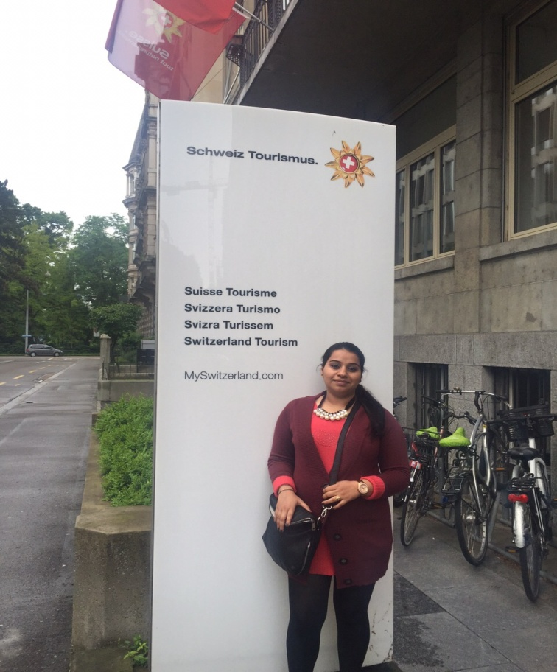have realized the importance of capitalizing on Indian market. But at the same time, as mentioned earlier, they continued to maintain this relationship with Indian market through various PR representatives based in India who are responsible to maintain a good communication between Switzerland and Indian market through which ST has got the advantage to cater the needs of their potential Indian customers.

According to Urs Eberhard (Vice President Marketing, ST), *“As a National tourist organization, the product that you are selling is like with a picture (…) it’s a frame, its Switzerland (…)”.* As shown in Fig 3, ST presents Switzerland as a complete package with attractions for example, Titlis, Jungfrau, Glacier 3000, trains and suppliers (hotels and restaurants) etc. The reason is, by offering a complete package; they can make much more impact on the targeted market segment in India. Most of the packaging in tourism is done by tour operators, travel agencies, hotels and resorts, but sometimes DMOs get involved as well (Morrison, 2013).

According to Urs Eberhard (Vice President Marketing, ST),

*“we obviously try to match the interest in a market with the respective*

*product of Switzerland. Depending upon the market (…) the product*

*can vary in terms of outdoor activity, hotel category, content*

*and much more.”*

Therefore, as mentioned in section 5.8, ST offers different products for different markets keeping in mind the needs and demand of the customers. For example, for Indian market, they focus mainly on romance shown through various Bollywood locations, panoramic trains, mountain excursions and Swiss culture etc. In this way, they differentiate their products and services to cater the needs especially for Indian market. In order to fulfill the needs, they collaborate alongwith various regional and local DMOs and perform various marketing activities to create various new experiences, hence, try to give more reasons to the new visitors to visit Switzerland. This kind of strong network consisting of various PR representatives in India and Switzerland help ST to update their products and services according to the demand of the customer segment in Indian market. Furthermore, various media and marketing activities through the intermediaries i.e. tour operators and travel agents present in India as well as in Switzerland help ST to communicate the message among the potential customers. So, it becomes difficult for the competitors to enter in these markets and this has proven as an advantage for ST as they exist in Indian market for a long time and have good understanding of the changing needs and demands of the customers.

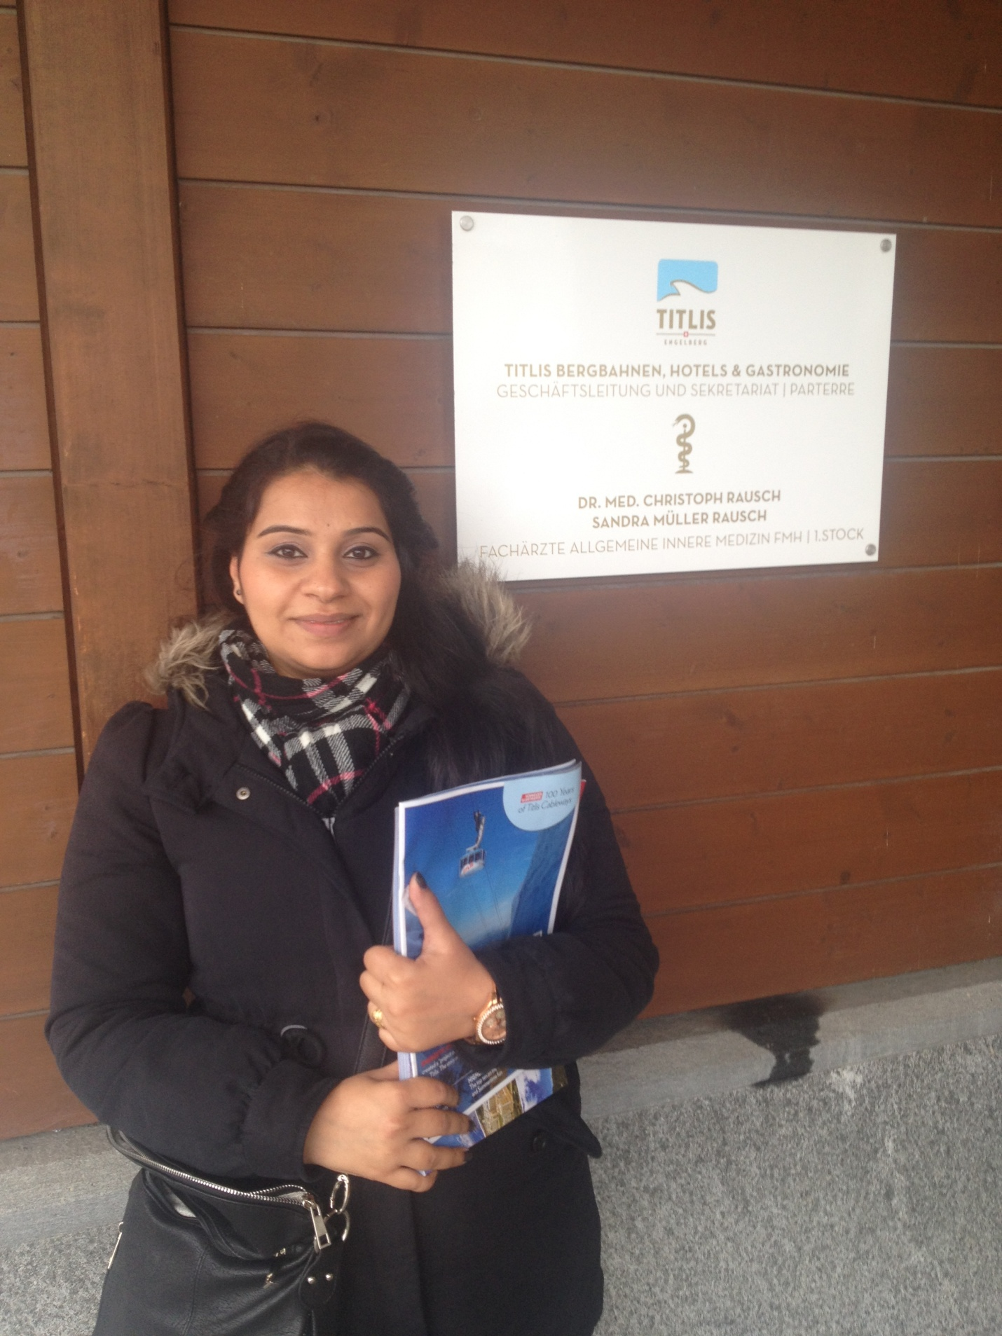Apart from collaborating with ST, regional and local DMOs have their own strategies to promote themselves in various markets. For example as Tobias Matter (Sales Director, TET) said,*” we are in this market for more than 15 years, one of the first companies in India.”* Being the first company to present Switzerland in Indian market could be a risk for TET. For example, in the beginning it could be difficult to understand Indian preferences related to locations, food, travelling etc. But like ST, TET also used the strategy to communicate with Indian market through their PR representative named Rio Choksi, who is based in Mumbai, India. He is responsible to make good relationship with all the intermediaries present in the Indian market as well as communicates about the customers’ preferences to TET. So, generally he travels a lot between India and Switzerland and keeps TET updated about the change in the demands of customer segment in India. Therefore, I would say that although there are not many films shot on Titlis, still it is the most popular destination among the Indian visitors. The reason behind is that, according to Tobias Matter (Sales Director, TET) they have a long term relationship with Indian market and they always try to innovate their products and services as well as launch new experiences as per the demand of the Indian visitors. At the same time, suppliers like Hotel Terrace provide the accommodation as well as good Indian food to the customers and they have adapted themselves over the years to meet the requirements of Indian consumers. Hence, that is the main reason why Engelberg and Titlis are very important for Indian guests because consumers are searching for more than a single element; they buy into the array of relevant experiences which surround the brand (Dahlen, Lange & Smith, 2010).

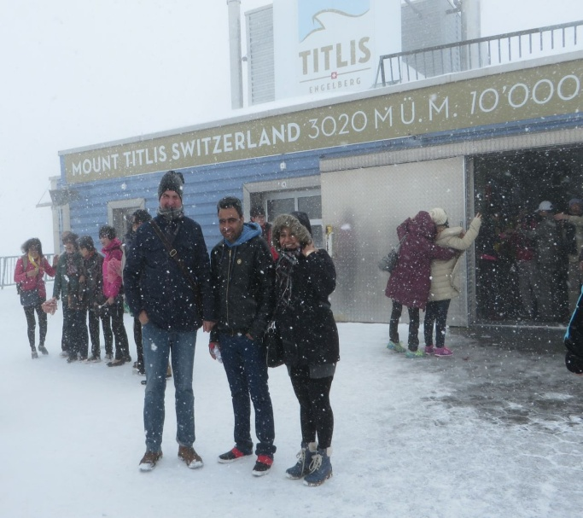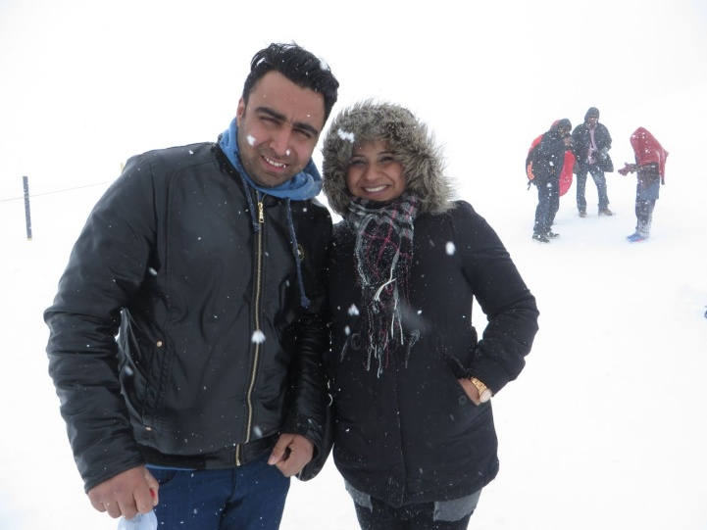On the other hand, as mentioned by Tobias Matter (Sales Director, TET) they promote Mount Titlis as *“an international mountain with snow and ice all year around”* where there are a lot of activities from a young child to grandfather. Hence, one may argue that despite of the fact that Mount Titlis has not been shown in many Bollywood films, still due to various communication strategies like PR and marketing by TET, they have been able to learn a lot about the needs of customers and tried to discover various fun and sports activities on the top of Mount Titlis. As mentioned by Tobias Matter (Sales Director, TET),

”*Honestly they are not very sportive”* by this he means that although Mount Titlis is very popular among Indians, but they do not like activities like skiing and hiking etc. like Europeans because they prefer to do more soft adventure. Hence, especially on the demand of Indian customers, TET has created the Rotair, where people can sit inside and look at the snow covered peaks. The Glacier Park gives the chance to the whole family to go and touch the snow because touching the snow is very important for many Indians when they come to Switzerland. During my visit to Titlis, as it can be seen in the above pictures, despite of heavy snowfall, Indians were running around on snow, clicking photos and enjoying the weather. Therefore, I would say that TET has really tried to innovate their products and created various new activities s well over the years keeping in mind the demand of the consumers.

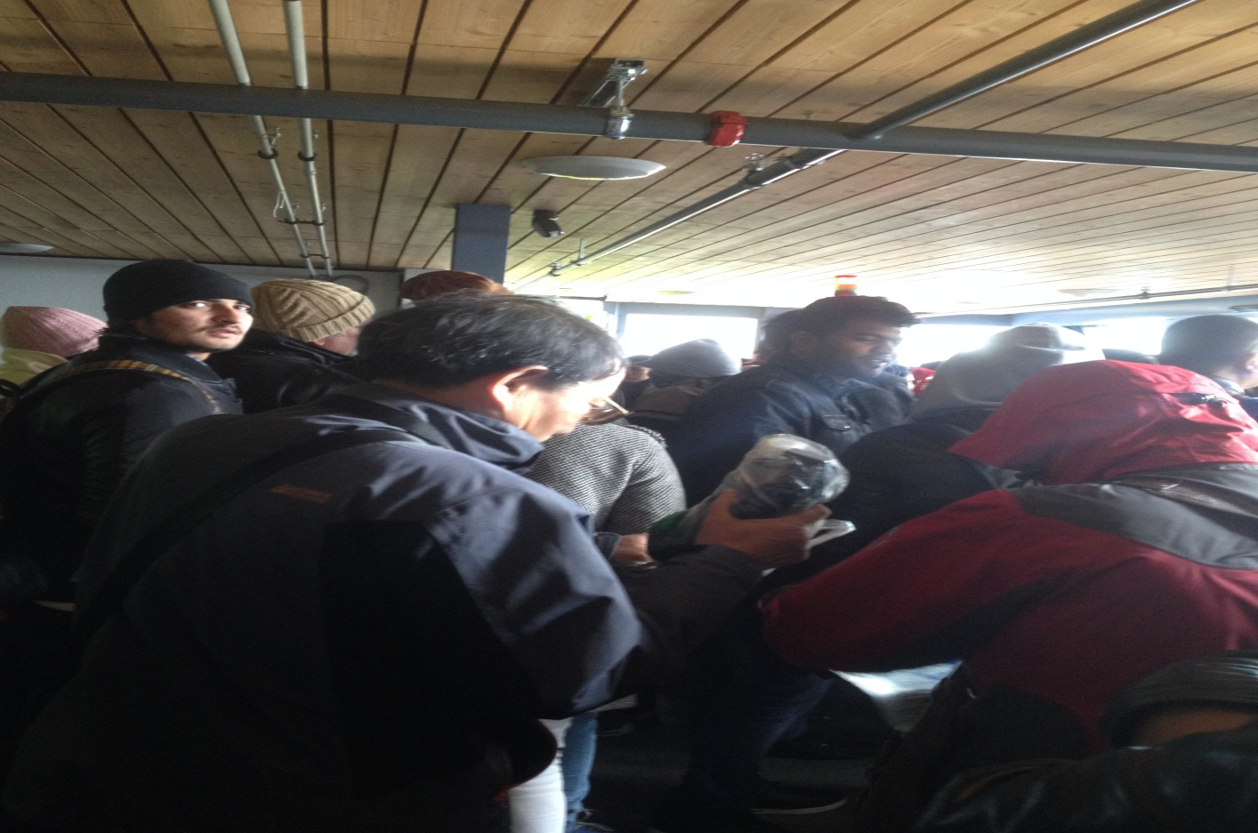According to Tobias Matter (Sales Director, TET), *“fun for everybody (…) close to all other cities (…) can see many things in one day is their USP”.* In order to differentiate from related products in the same market, a brand should be standing alone and convince the customers enough to the attribute before they make purchase (Dahlen, Lange & Smith, 2010). But as seen in the picture, I would like to say that due to the accommodation, Indian food as well as easy travelling from Engelberg, one can see a huge amount of Indian visitors at Mount Titlis and all around Engelberg. Hence, I would consider it as one of the main reasons behind low food quality available on the top of Mount Titlis, which is supplied by Hotel Terrace and at the same time one has to wait in long queues outside the toilets that make the place even more crowded.

On the contrary, the scenario is opposite in Gstaad region. According to Kerstin Sonnekalb (PR Manager, GT), *“it is a destination for luxury travellers.”* One of the reasons behind is that most of the Bollywood movies by Yashraj Films have been shot in various locations around Gstaad and Saanen region. As mentioned by Kerstin (PR Manager, GT), *“(…) it is common to see famous film stars both from Bollywood and Hollywood walking around”* because they get a lot of privacy and nobody around the area disturbs those celebrities. Therefore, as discussed in section 5.7, Bollywood movies have also helped to brand Gstaad as destination with romantic locations and that is why it is preferred by various Bollywood lovers especially as honeymoon and skiing destination. Another reason behind Gstaad’s reputation as a luxury holiday destination is the International School “Institut Le Rosey”, which is well known as “School of Kings” for its royal distinguished alumni. Since 1917, every winter its campus is relocated from Rolles on Lake Geneva to Gstaad, where it holds summer campus too (Appendix: 9.3). With an annual tuition of $113,000, it is considered as the most expensive private schools in the world. Some of the school’s former students include King Faud II of Egypt, Julian Casablancas, Prince Albert II of Belgium and Jose Ferrer.[1]

But at the same time GT collaborates with ST as well as their representatives in India to attract only high end customer segment to Gstaad region. The interface between company, customer and media are all points of contact within which the brand ‘talks’ to existing and potential customers and help constitute brand meaning (Dahlen, Lange & Smith, 2010). Hence, it can be said that because of the Institute Le Rosey, GT has got the immediate advantage to exploit their brand and present the region as a luxurious destination. That is why they focus their strategy mainly on high end customers because of the Royal families related to the international school.

**6.1.2. Communication via Media**

As mentioned in section 5.6, DMOs also assist various programming that enhance tourists experiences such as events, festivals and individualized arranged activities for tourists. These events range from mega events such as the Olympics, World Expo and the World Cup to smaller-scale business events (Morrison, 2013). In the same way, GT also hosts some of the events with top international format such as the Menuhin Festival, the credit Agricole Suisse Open tennis tournament, the Beach Volleyball World tour of Hublot Polo Gold Cup etc (Appendix: 9.3). Hence, one may argue that these world class sports events hosted by GT is also an important strategic activity to attract especially the international jet set to the destination and present it as a dream region because when these events are covered by various media channels, they provide a lot of attention to the region.

On the other hand, as mentioned by Tobias Matter (Sales Director, TET)*,” last year we had a big promotion in National Geographic in Mumbai (…) to promote brand new Rotair”* So, the DMOs around Switzerland promote their own regions through various media channels to capitalize on Indian market. For example, as mentioned by Kerstin Sonnekalb (PR Manager, GT) being a National DMO, ST offers both big and small packages to various DMOs around Switzerland. So, if they see that a particular market is growing, then they buy big package which includes all the media events organized by ST. On the other hand, if the market is not growing that fast, they buy small package that includes some important events instead. Therefore, it is clear that apart from collaborating with ST through various media events, inviting fam trips etc to Switzerland, DMOs like GT and TET also do some independent marketing through media and PR representatives in Indian market to attract preferable customer segments to their regions.

**6.1.3. Improving brand positioning**

Sometimes a destination may need to adjust or revitalize its brand position in the market because the outside factors and market trends may pull the product category in a relatively different direction (Dahlen, Lange & Smith, 2010). In the same way, ST and TET are planning to introduce some new activities for young people to change the image of Switzerland only as a romantic destination to a place which is more happening and has more activities for the young travellers. According to Tobias Matter (Sales Director, TET),

*” young people like to do something different (…) in the eyes of young*

*people it is boring (…) image of Switzerland in India is that it is a*

*nice but boring country.”*

It shows that the destination managers around Switzerland are strategically thinking to attract more young travellers who would rather like to go to Australia, New York, Amsterdam and Spain etc because these destinations have been shown in various Bollywood movies as more interesting places with lots of adventure and fun activities for young people. One of the recent examples is related to the blockbuster movie, Zindagi Na Milegi Dobara, where the successful interplay of movie and tourism involved Bollywood in India and Spain. Turespana (Spain Tourism) provided support for the shooting of the film in several locations around Spain. At the same time, they spent an estimated USD 660,000 on marketing through TV commercials by showing the clips of various adventurous scenes from the film (Munshi, 2012). The film was released in July, 2011, but as the result of the marketing and promotions of the film, by August, 2011 visa applications at Spain’s embassy doubled the number. The country saw an increase of 65% of Indian visitors to Spain in comparison to 2010 (Morrison, 2013). The joint promotion of the movie also helped the destination managers of Spain to reposition the image of Spain as a beach destination to the country having diverse culture, adventure sports, dance and a happening destination for young generation.

According to Tobias Matter (Sales Director, TET), the feedback that they get from various tour operators and travel agents around India is that Switzerland is a preferred destination for honeymoon couples as well as families but with this image, it is unable to attract youngsters. It is rather considered as boring because young people look for adventure sports, parties, clubs, discos and other fun activities etc. while choosing a destination for holidays. Similar opinion was given by Urs Eberhard (Vice President Marketing, ST) when he said,

*“if you look at the modern Indian movies, this is much more (…)*

*the James Bond, the urban, the speed races, lot of electronics*

*(….)and stuff like that. The taste is changing (…) young*

*Indians (….) are looking perhaps less for romance*

*but more for action and activities.”*

As mentioned in section 5.7, I would say that DMOs around Switzerland have to really work hard to reposition their brand image and make new strategies to fulfill the needs and preferences of the next generation of travellers. Otherwise it would be difficult for them to compete with other destinations that are doing a lot for youngsters by marketing their regions through Bollywood films and giving a tough competition to Switzerland. An important fact is that India is a relatively huge and growing market and through Bollywood, it is relatively easier to promote the destination through films that has been seen by a vast number of audiences every day. Therefore, it could be difficult for a destination like Switzerland to sustain and compete if they are not able to change their strategic positioning as well as brand image according to preferences of the young generation of Indians. As consumer behavior changes, they would like to update their evaluative criteria while making purchase in the category (Dahlen, Lange & Smith, 2010).

This also relates to the other strategic goal of the DMOs around Switzerland that is to raise the number of Frequent Independent Travellers (FIT). As mentioned by Tobias Matter (Sales Director, TET),”*our main goal is that FITs stay in a village like Engelberg (…) spends money in restaurants”.* The reason behind attracting more FITs is that they spend more money on local businesses and stay for a longer period of time in a region. As mentioned in section 5.5, DMOs want that their suppliers like hotels and restaurants would also get benefit from these FITs because most of the tourists in Switzerland come in big groups like 30-40 people, stay for short period, get discounts as well as spend less money in food and other stuffs.

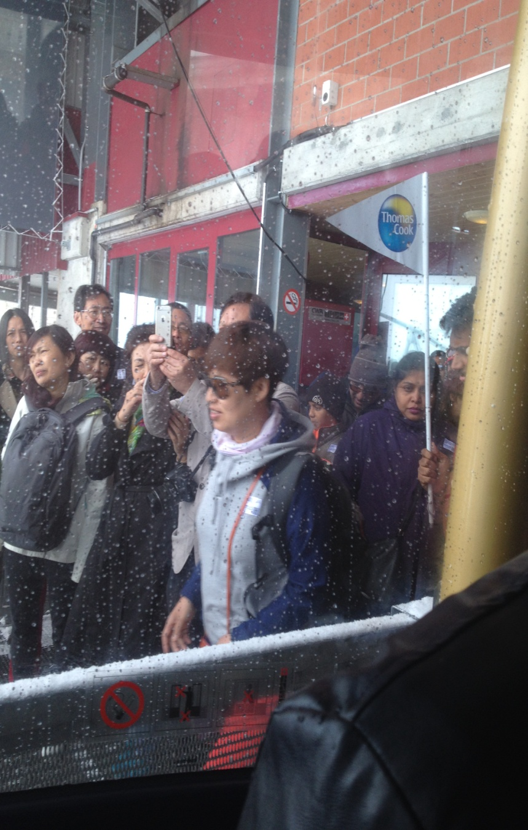On the other hand, it can be argued that if there is a big group brought by the tour operator, then a middle class Indian can also afford to come to Switzerland because it is an expensive destination. But in case of FITs, the percentage would be relatively less because there is higher number of middle class families in India than high class. The DMOs cannot directly and completely control the visitor mix but they can indirectly influence this through marketing and promotion (Morrison, 2013). Hence, with the help of various marketing activities through intermediaries, DMOs around Switzerland can focus of FITs segment. However, we can say that there is a contradiction between the DMOs and the needs of rest of the tourism sector because the hospitality sector/suppliers have good relationship with big tour operators like Sita Online Tourism Corporation (SOTC), Make My Trip (MMT), Thomas Cook and Yatra etc and they also provide huge discounts to these groups which is profitable for them even during off season. Hence, as mentioned by Urs Eberhard (Vice President Marketing, ST),

*” on one hand, it is keeping the desire of dream destination,*

*we have to keep that going (…) because it is the main reasons*

*why people want to visit Switzerland(…) but also more for the*

*young generations.”*

So, the DMOs around Switzerland should adapt a dual strategy so that on one hand, they can continue to sell the image of Switzerland as a romantic destination which is more appealing to the honeymoon couples and families coming in big groups and on other hand, they can create new experiences for young generation and FITs as well. It is important to understand which marketing communications strategy is relevant to promote a realistic impression of which audiences must be targeted, and what objectives and strategy are required to being about effective communications (Dahlen, Lange & Smith, 2010).

As mentioned in section 5.3.3 (iii), movie map of various Bollywood locations launched by ST, is not being used both by ET and GGS during the Bollywood tour in Switzerland. Both the Bollywood tours have their own preferred film locations that they show to the visitors. More information about these tours and the strategies behind its design will be discussed in section 6.2.

**6.1.4. Sub conclusion**

Apart from above mentioned strategies, DMOs around Switzerland are also working on some other strategies discussed in section 5.8. According to Urs Eberhard (Vice President, Marketing, ST) and Tobias Matter (Sales Director, TET) they are focusing to attract more FITs and young generation of Indian tourists to Switzerland. This shows that apart from family and honeymoon couples, they are now focusing on a new segment of customers that according to them is more profitable than the segments that have been coming to Switzerland for many years. Market segmentation is the process of splitting the potential customers within a market and focusing on catering the needs of that particular customer segment (McDonald, 1998). But on the other hand, if we talk about GT, according to Kerstin Sonnekalb (PR Manager, GT) the customer segment that they want to focus is the high end customers as well as FITs not only from Indian market but also through their various International events, mentioned in previous section, their strategy focuses on attracting high end International jet set visitors as well. Hence, we can say that like GT, ST and TET are also realized about changing their strategic focus to attract more FITs and high class customer segment from Indian market due to the fact that the number of middle class visitors from Indian market is relatively higher than FITs and high class customers which is not so much profitable for their stakeholders like hospitality sector and various attractions etc.

**6.2. Strategies of Tour guides**

Destination image plays an important role for various DMOs and intermediaries i.e. tour operators and travel agents to attract potential customers and films offer them not only a big screen to showcase beautiful landscapes, but also the ability to utilize this image through various strategies that can be used to sustain and develop the brand image of the destination (Horrigan, 2009). In this section, I am going to discuss about the strategies used by ET who is an incoming travel agent as well as tour guide and GGS, who collaborate with GT and OT, India. Both the companies use Bollywood locations around Switzerland but at the same time, the product and design of both the tours differ from each other. So, on the basis of the empirical findings and participant’s observations while taking the field trip with Erwin, their strategies to capitalize on Indian market will be discussed in this section.

**6.2.1. Exploiting Switzerland’s image through Bollywood Tours**

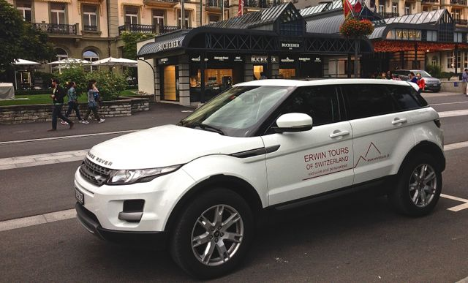For many travellers, knowing that a location has been used as an important site of a film, the experience of being there at the same location enables the visitors to stimulate the feel and atmosphere of the film in connection with the location (Roesch, 2009). In the same way, as discussed in section 5.7, the romantic blockbusters like DDLJ, Mohabbatein and Chandani made by Yashraj Films contributed a lot to create the romantic image of Switzerland with beautiful landscapes, snow covered mountains and grasslands etc. This image was first exploited by Kuoni Tours who started an enchanted journey in collaboration with Yashraj films by taking tourists to Bollywood locations around Switzerland but they stopped this tour last year. Erwin Fassler (Owner, ET) started this tour 3 years back. He mentioned,

*” I decided to make my hobby to a profession and I started a small business*

*(….) my goal is to show Switzerland to people in a way that usually you*

*cannot get in big groups.”*

So, I would like to mention that looking at Kuoni Tours, Erwin might realized the potential of using the romantic image of Bollywood and started with these tours because there was a market as Indian people who come to Switzerland might be interested to visit Bollywood locations themselves. At the same time Erwin said*,” I do like Bollywood (….) so for me it is very interesting to really go in search the shooting locations.”* During my research, and while going to field trip to various Bollywood locations with Erwin for 2 days, I came to know that he is not following any locations mentioned in movie map created by ST. He thinks that many locations shown in that map are not real, so he likes to discover these places himself and for that he picks up the famous scenes and songs from DDLJ and Mohabbatein and has been successful in finding the authentic locations. He claims that,

*” I am really getting to a point that any favourite movie or any favourite*

*scene in the movie shot in Switzerland (…) you can ask me and I*

*will bring you there.”*

Hence, the tour is designed in a way that the tourists get the chance to visit their favourite movie locations that add more to their experience except for only visiting Switzerland. Furthermore, he has his own personal car, with which it is easier to reach the locations which are otherwise not reachable with trains or buses. On the other hand, one may argue that at present, Erwin cannot take more than 4 people because he has a small car. However, he is planning to buy a big car in future. But for now, it is not possible for him to take a family or a group with 7-8 people at the same time. The fact is that small group sizes enhance the location experience as there are fewer disturbances from within the group. They also help in development of a stronger bond and avoid the waiting time while taking photographs and buying souvenirs etc (Roesch, 2009).

Another reason behind visiting authentic film locations is important for the visitors is that the photos from the visited locations serve as a souvenir and are used by visitors as proof to show friends, relatives and other fans that you have been there at the same locations shown in your favourite movie (Roesch, 2009). For example, I took the Bollywood tour with Erwin alongwith my husband and we clicked pictures at various Bollywood locations that really fascinated our friends and family and they also showed interest to visit those locations when they plan to go to Switzerland. But at the same time, those pictures were used by Erwin Fassler for his facebook page, because he used us as Indian models to click various photographs in the same poses like the actors did in the film scenes. Hence, as mentioned in section 5.3.4 (ii), tourists can very well differentiate between the locations in the movie and the locations they visit during the tour. Therefore, authenticity of the place while taking the locations is also an issue in film induced tourism (Beeton, 2005; Roesch, 2009).

As discussed earlier, GGS is a group of 6 guides that are collaborating with OT, India and GT. The Bollywood tour offered by GGS started a year ago by Abhay Jaipuria (Owner OT, India). According to him*,” I was really wondering that can we do something with Bollywood locations around Gstaad.”* So, it was Abhay Jaipuria who wanted to show various Bollywood locations around Gstaad and he approached GT. Furthermore he said*,” I took 6 guides from them and trained them.”* Hence, the design of the tour is created by Abhay Jaipuria and then he gave all the training to the guides so that they can take the tour and show Bollywood locations to the tourists as shown in the picture below.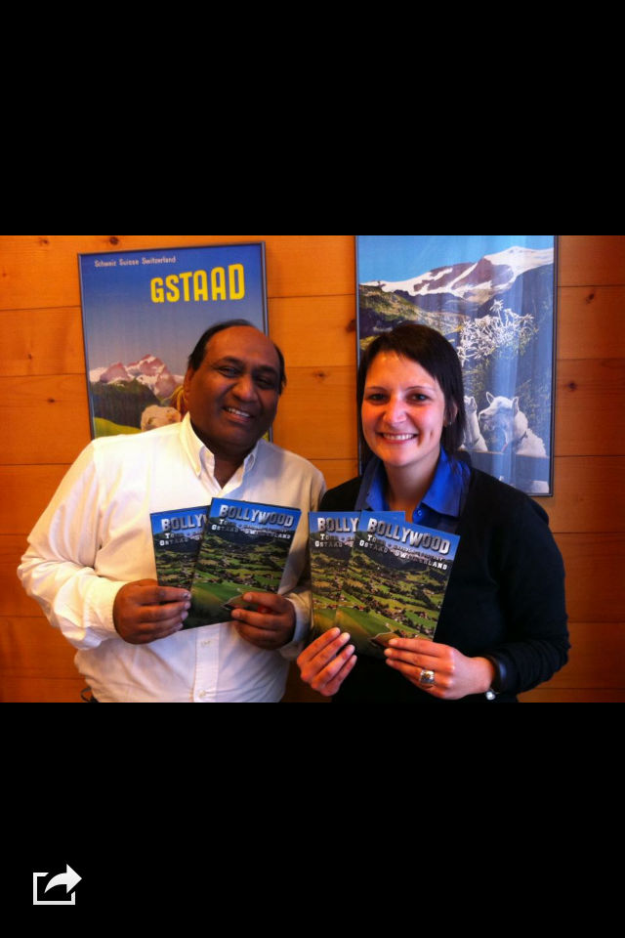

At the same time, as mentioned by Anita Roth (Tour guide, GGS)*, “It is based on train rides (…) so we can step on and off”*. It shows that the tour has been designed in a way that matches with the route of Golden Pass train to visit specific locations as all the passengers have Swiss Rail Pass, so that they don’t have to pay any extra money for travelling in trains or buses all around Switzerland. Usually there are 15 people in a group but if exceeds to 30, then they take two guides together. According to Anita Roth (Tour guide, GGS)*,” it gets too complicated to keep them together and to make sure that each one gets off (….) right time at the train.”* Hence, as mentioned in section 5.3.4 (ii), it is usually uninteresting in a big group because the guides are telling the same facts and figures to all the visitors and there is no scope of connecting emotionally to the place through story telling of that particular scene from the film. The reason is that when seeing a movie location, some visitors are particularly interested in getting an explanation about how their favourite scene was shot (Horrigan, 2009).

But on the other hand, being a Bollywood fan, I observed that it was difficult for Anita to pronounce the name of the movies that were related to the locations. As mentioned by Abhay Jaipuria (Owner OT, India)*,” I really wanted that if I could find some Indian living there to make a professional guide.”* Hence, I would say that only knowing about name of the film that has been shot in a particular location does not connect the visitors to the location. In order to be up to visitor’s expectations, the tour guide should be knowledgeable, passionate and if possible, should have link to film production (Roesch, 2009). As Abhay Jaipuria (Owner OT, India) said*,” they have the script for the guides (…) what the guides will speak (….)”* From this statement*,* it is quite clear is that in order to connect the Bollywood fans with the help of scripted information is not the right way and also seems quite boring. Therefore, as mentioned in section 5.3.4 (ii), it is really important that OT should appoint a guide who is emotionally connected to Bollywood. Guides can re-enact scenes by quoting the famous dialogues from the film and by character’s facial expressions and tone of voice to actually make the visitors to have the feeling of being on their favourite movie location (Roesch, 2009).

On the contrary, as Erwin Fassler (Owner, ET) said*,” India was very much closed in 80s.”* It shows that he has a long term relationship with Bollywood movies and Indian culture as he has been travelling to India since 80s. Therefore, he is able to narrate story related to every location using the characters name from the movie to create an emotional bonding of the visitors to the location because the film tourist experience is concluded by watching the movie again after returning home, to remember the experience of having been there (Horrigan, 2009). This statement suits very well with my own personal experience because after coming back to Denmark, me and my husband saw all the songs and scenes from DDLJ, Mohabbatein and Chandani to co relate it with the pictures clicked at the locations and telling stories to our friends that we really visited the places where all these blockbusters were shot.

**6.2.2. Marketing through various Media channels**

The image of a destination is primarily influenced by tour operators’ promotional activities in tourist generating country (Kozak, 1999). As mentioned earlier also, Erwin Fassler (Owner, ET) is an incoming travel agent as well as guide and GGS is a group of tour guides who are collaborating with GT and OT, India. So, in this case we are going to discuss about the marketing activities of ET and OT operating in India to attract Indian visitors to Switzerland because as mentioned by Anita Roth (Tour guide, GGS) they do not perform any marketing activities to promote their Bollywood tour. So, OT is responsible to market the tour to Indian customers. In case of Erwin Fassler (Owner, ET) he mentioned,

*” for India facebook is very important (….) I do have LinkedIn (....)*

*which is very important for International contacts (…) I also*

*have google plus account (…) I am on Twitter and then I*

*just recently started to post photos on National geographic.”*

Therefore, it shows that he is doing a lot of marketing through social media not only for Indian market but Indians living in foreign countries as well because of the fact that he has more NRI customers than the ones coming from India. One of the main reasons is that it is believed that the future competitiveness of a destination will mainly depend upon the way they have been promoted in targeted destination via various marketing and promotions (Buhalis & Cooper, 1999). Hence, I would argue that in a destination like Switzerland where big tour operators are using lot of PR and media activities to target their customer segment, it is very important for a new company like ET to keep himself updated about the needs and preferences of his customers and use various promotional activities to market his Bollywood tour because most of film tourists use internet and other social media before they plan to visit specific film location. Therefore, a detailed and well designed website featuring number of locations visited, photographs matching with the equivalent film shots attract significant attention of the visitors (Roesch, 2009).

However, right now, he does not have big budget to go beyond social media platforms to promote his Bollywood tour, according to Erwin Fassler (Owner, ET)*,” this is my third year and I am able to manage it but no investments.”* Therefore, if he wants to buy a new car, he does not have the budget for it. So, one may argue that he has to rethink of his strategic position or may be collaborate with other tour operators in India as well as in Switzerland so that he can carry big groups for the tour because in big groups per person cost is divided and middle class people can also afford it. But in this case Erwin Fassler (Owner, ET) said,

*” if a couple comes to Switzerland (…) they have to pay 1000 francs*

*per day (…) for just driving and a tour guide…they are not*

*willing to pay that much.”*

Hence, it is clear that Erwin Fassler (Owner, ET) has to make connections with various tourism professionals not only around Switzerland but also operating in Indian market as well. However, he is working on it but as mentioned in section 6.1.3, the number of big groups coming to Switzerland is much higher than FITs. So, it is difficult for Erwin to find a group of 4 people to take his tour and it is too expensive at the same time. During the two days field trip with him, he also went to meet all the interviewees with me and gave his brochure to them. From this, I observed that being an independent travel agent and having his own business rules can be one of the reasons why none of the tour operators or DMOs is interested in collaborating with him. The other reason can be that the DMOs around Switzerland are changing their strategic positioning more on the young segment of travellers from India, so they are no more interested in Bollywood tourism as the romantic image of Switzerland is not appealing for the younger generation.

As mentioned by Anita Roth (Tour guide, GGS)*,” I think marketing was the combination of Swiss Tourism, Gstaad Tourism and Oyster tours,”* So, these guides get customers through OT and ST to take Bollywood tour and they are just taking the customers to the tour but not responsible for the marketing activities. Therefore, OT does various promotional activities for these Bollywood tours. As mentioned by Abhay Jaipuria (Owner, OT), they do advertising in newspapers, facebook page and maintain a database of customers primarily for the travel agents. Furthermore they also sponsored two shows on NDTV, India to show various Swiss locations. From which one was shot in Lucerne and other was Gstaad.

On the other hand, being a wholesale tour operator, they also have B2C connections with their potential high end customers. Hence, one may argue that because of being a wholesale tour operator, OT is not only focusing on marketing Bollywood tour because it is offered as a part of their package tour to Switzerland for their customers. According to Abhay Jaipuria (Owner, OT), India*,” people think that Interlaken and Lucerne is the end of Switzerland.”* That can be one of the reasons why not many people are taking the Bollywood tour and another thing is that the tour is quite new and OT is the only company which is promoting Gstaad region in Switzerland not only because of Bollywood location but also due to its beauty and luxury. Furthermore, as Abhay Jaipuria (Owner, OT, India) said*,” I told them not to open an Indian restaurant in Gstaad (….) it is not a problem until you are fussy about eating Indian food (…)”* Hence, one may argue that it can be a main reason why Indians are attracted more to Engelberg, Interlaken and Lucerne areas because the hotels they are staying in provide Indian food and some people may not want to compromise with the food even though they are on holidays. Hence, it is important for OT to focus their strategy mainly on Bollywood tours and try to use more media channels to promote this tour.

**6.2.3. Building good relationship with customers**

The intermediaries have the responsibility to meet customers’ requirements and following changing in their needs and wants. This is possible by making good relationship with customers. During my research, and the field trip with Erwin Fassler (Owner, ET), I found out from his conversation that he focuses very much in creating good relationship with customers. As mentioned by Erwin Fassler (Owner, ET),

*” (…) the most important for me besides social media is personal*

*contacts with people (…) a connection which is almost like friendship*

*because you know each other and trust each other (…).”*

So, according to Erwin, he spends a lot of time in making personal contacts with people so that they can share word of mouth experience with their friends and family. But on the other hand, I would say that not all the visitors would have the same opinions about the tour or as Erwin shared that most of his customers promise that they would write a trip advisor review for him, but not everyone does that. Another example is mine as a tourist, because I thought it was expensive to take the Bollywood tour with Erwin, so maybe I would not recommend it to my friends because as a researcher my requirements were different from those who have just gone for holidays in Switzerland. Hence, this strategy cannot bring same results from all the customers; it is only applicable in case of repeated customers where the intermediaries have the possibility to talk to them again and improve their services according to customer’s requirements.

On the other hand, OT also focuses on relationship strategy from a completely different perspective than ET. According to Abhay Jaipuria (Owner OT, India),

*” (…) 150 top families (…) mid of January (….) just send them*

*a kit with brochure when other companies are done with*

*advertising during Christmas or New Year.”*

So, as mentioned in section 5.3.4 (iv), tour operators take out the database with all the long term and potential customers. In the same way, OT also follows the same relationship marketing strategy by sending special hampers to their potential customers alongwith their brochure to advertise various products and services. Another example told by Abhay Jaipuria (Owner, OT, India) is when they booked the whole theatre for 50 top families to show the last scene of Dhoom 3 (the one with jumping from top of the bridge) and at the end he announced that the location is in Switzerland and the customers can also gain the same kind of experience shown in the film through bunji jumping from the dam as shown in the movie. It can be considered as an innovative idea to promote a destination through film and as a result 14 out of those 50 families booked holiday through OT. Hence, these kind of various strategic activities has helped OT to gain potential customers over the year and as said by Abhay Jaipuria (Owner OT, India)*,” 65% of my business is Switzerland”* so he tries to use various marketing activities to promote Switzerland to his potential customers not only for Bollywood tours but also for other activities and new locations. In order to integrate its communication to the target group, an organization needs to embrace diversity and variety and in order to balance the effort to secure clarity and consistency in its overall expression to the customers (Dahlen, Lange & Smith, 2010).

**6.2.4. Sub Conclusion**

As discussed in section 5.8, both the Bollywood tour guides are also possessing price differentiation strategy. For example, Erwin Fassler (Owner, ET), charges 110 Swiss Francs per hour (including travelling in his car) whereas Guides Gstaad have group of 15-20 people and charges are 120 Swiss Francs approx. per person for the whole tour (alongwith Swiss Rail Pass). But keeping in mind the price, as mentioned above, I would like to say that because a higher number of middle class families coming from India and the price charges of ET is much higher than GGS. The other reason is that mostly all the tourists prefer to buy a Swiss Rail Pass during their stay because it provides them with cheaper travelling all around Switzerland. Thus, price is one of the evaluative criteria used by the customers while buying a product or service (McDonald, 2013). On the other hand, according to Erwin Fassler (Owner ET), despite of his higher price, the Bollywood tour he is offering has more authentic locations and he is flexible to the schedule made by the customers and personalizes the group because of having only 4 customers at a time Hence, both the Bollywood tour guides should implement a sound pricing strategy to attract potential customers towards their product that will support their overall marketing strategy and profitability (McDonald, 2013).

**6.3. Strategies of Suppliers/ Hotels**

When one travels to another city or country, one usually has different needs and demands from the destination (Karppinen, 2011). To meet all these requirements, hospitality industry plays an important role. In this section, I am going to discuss about 2 hotels, HC in Engelberg and HVJ in Interlaken and GourmIndia restaurant in Lucerne. As all these three suppliers are located in three different regions, it would be interesting to analyse their strategies and see how they apply these strategies through various activities for Indian market.

**6.3.1. Maintaining two-way relationship**

As discussed in section 5.3.5 (i), it is very important to create a good relationship with various intermediaries like travel agents and tour operators as usually they are responsible to offer various packages to the customers and work on the customers’ behalf concerning all the travel arrangements (Karppinen, 2011). As mentioned by Maja (Front Desk Manager, HC)*,” we work with MMT, SOTC and Yatra (….) they are again making all their booking through agents.”* So, hotels collaborate with wholesale tour operators who then sell their packages to the travel agents. Then it is the responsibility of the travel agents to book hotels, buses and tours etc. Hence, it is very important for these hotels to have a good relationship with the travel agents in order to get recommendation for their hotel. But in case of HC, one may argue that despite of working more closely with travel agents, they are more focusing on Tour Manager (TM). As mentioned by Maja (Front Desk Manager, HC),” *(…) really important to work with the tour managers.”* Therefore, the strategy in case of this hotel seems a bit different from usual as according to them the TM is the person who has total control on a big group and gives the feedback to the big tour companies about the hotel and their services. Hence, they try to make as good relationship with TM. On the contrary, as mentioned in section 5.3.5 (i), commission can also play an important role behind the change of the usual strategy followed by hotels. Because of the reason that HC is not a 5 star hotel, so they are not ready to pay commission to travel agents to bring customers, rather they work and collaborate with big companies and tour operators and try to impress the TM and save their commission.

On the other hand, as mentioned by Niklas Breitenbach (Sales Manager, HVJ),

*” we have two sales representatives (….) who go 2-3 times per year to*

*India to visit the local TO, travel agents (…) that have influence*

*on travel lives of Indian guests who book through them.”*

From this statement, it seems that HVJ relates to their intermediaries located in India through the sales representatives who meet them and try to understand the needs and changing demand of Indian market. For example, during my research, I found out that Erwin Fassler (Owner, ET) recommends HVJ hotel to his customers, by using Yash Chopra Suite as an attraction because if the fact that those who are coming to take Bollywood tour surely know about Yash Chopra and might get influenced to stay in the hotel. Furthermore, Abhay Jaipuria (Owner, OT) also mentioned that he send many of his potential customers to HVJ. Hence, as mentioned in section 5.3.5 (i) one may argue that these tour operators and travel agents may get commission from this hotel because it is a 5 star hotel and paying some percentage of commission to these intermediaries would not be a big deal for hotels like HVJ.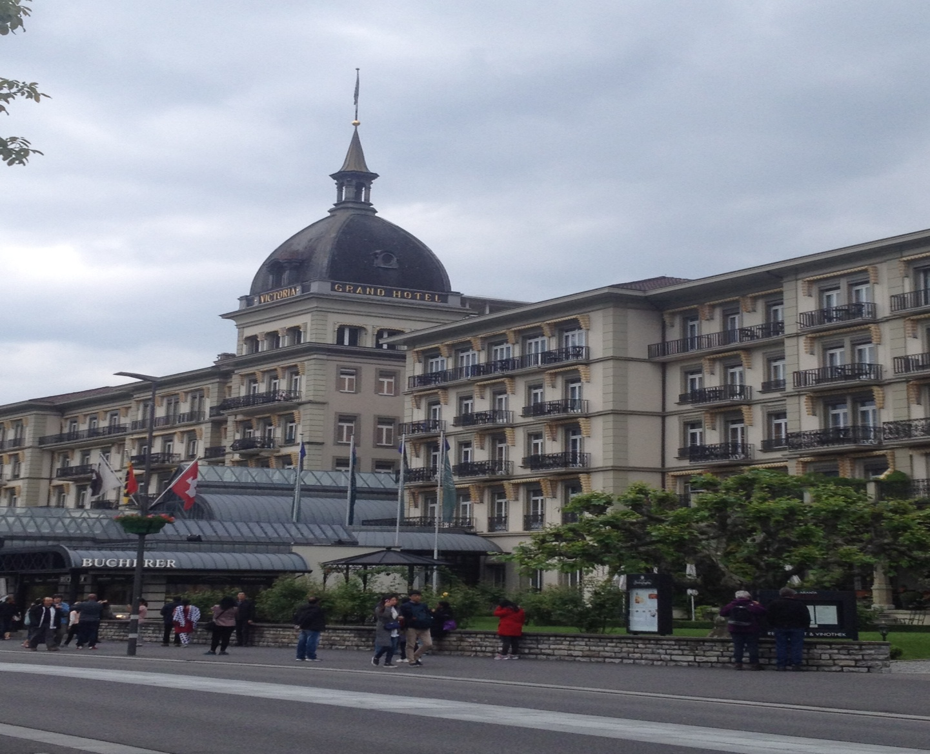

Another thing that is important to mention is with the local community. As mentioned by Maja (Front Desk Manager, HC), *“there are basically two big suppliers (…) who supply Asian food in Switzerland (…) all the others things we get from local people.”* Similarly, Niklas Breitenbach (Sales manager, HVJ) said*,” you support the local community and local economy as well…so of course we try to find good mixture between finding good local things*.” Hence, from both the statements, it is clear that despite of getting special Indian spices from Indian suppliers based in Zurich, HC and HVJ also buy some products like meat, fish, chicken, vegetables, dry fruits etc from the local market. It is seen as one way of developing the individuality and uniqueness of a region and at the same time maximizes the benefits of visitor spend to the region’s economy and local communities (Hall and Sharples, 2003). Hence, it is very important for the hospitality industry to enhance the local economy of the destination by buying local products and it also helps to maintain a good relationship with local community as well.

**6.3.2. Communication to Indian market**

As discussed in section 5.3.5 (ii) these days various communication methods are used by tourism organisations to promote their products and services. As mentioned by Niklas Breitenbach (Sales manager, HVJ)*,”the PR representative is responsible (…) for the whole collection of hotels.”* VJ owns a small chain of 4 hotels located in Lucerne, Interlaken, Bern and Zurich, and for the marketing of these hotels, a PR representative from Switzerland is appointed and is responsible for communicating to all the markets like China, India, and Russia etc from the office located in Zurich. Furthermore, the PR representative is also responsible to collaborate with the DMOs to invite media and fam trips for the marketing of Switzerland in Indian market. This communication acts as a means of assessing the targeted customers in a market in order to anticipate consumer’s needs and then manages to satisfy those needs to achieve sales (Dahlen, Lange & Smith, 2010).

On the other hand, as HC is a smaller hotel in comparison to HVJ, so they completely depend of the feedback of the TMs. As mentioned by Maja (Front Desk Manager, HC),*” (…) with the Indian market (….) most important are the TMs and the families that have been over here.”* Therefore, the most important modes of marketing for this hotel is the way the TMs give their feedback to the big tour operators. According to Maja, (Front Desk Manager, HC) if the feedback is positive, they would get good amount of groups in the next season but if in case there is a negative feedback about their hotel, and then they would not have many groups next year. Another very important mode of communication that has been mentioned by both the hotels is word of mouth communication from their customers. The impact of word of mouth is usually better than planned communication because the source does not belong to any company but is related to the customers (Dahlen, Lange & Smith, 2010). Hence, according to these suppliers, in India, word of mouth communication plays an important role and we can say that this kind of strategy based on emotional communication really works out for Indian market.

**6.3.3. Quality of service-an important factor**

As discussed in section 5.3.5 (iii) it is very important for the hospitality industry to understand the importance of customer satisfaction to attain a long-term relationship with potential customers. As mentioned by Maja (Front Desk Manager, HC), *” (….) we are really trying to give good quality and service (….) it doesn’t matter which nation you are from.”* HC is not only getting Indian customers but also EU customers who enjoy Indian food as well. According to mentioned Maja (Front Desk Manager, HC)*,” in the beginning when we started this Indian restaurant (….) from April- October we have Indian chefs (….) other than that we have Swiss cuisines (….) then we made it all year round.”* So, in order to cater the needs and demand of the Indian customers, HC started the Indian restaurant first for a couple of months around the year with special chefs’ team coming from India. But later on they observed that apart from Indians, there was a demand for Indian cuisines from other guests who come from Europe or other parts of the world. Hence, they decided to continue the Indian restaurant all year around with only Indian dishes. At the same time, they also started the Take Away service especially for the local people of the region because people like Indian food and this business goes all year round. Hence, it is clear that HC has used their experience with Indian food and tried to change their strategy over the years according to the demand of their customer segment.

But at the same time, as told by Maja (Front Desk Manager, HC), they also expect their employees to understand the behaviour and preferences of Indian guests, especially because the whole staff belongs to Switzerland. But on the other hand, they have Indian owner and with his help as well as the old staff members, it is easier for the new staff to understand the expectations of Indian guests because it is very important for the employees to understand a totally different culture and give up to the mark service. In order for a hotel to succeed in delivering service quality it has to have motivated employees who know what they are selling (Karppinen, 2011). In the same way, one may argue that despite of being Swiss people, the guests would expect that the staff should have proper knowledge about the Indian cuisines, which is their specialty especially when it is a small hotel with only 20 people in service staff to manage big groups of 35-40 people at one time.

As mentioned by Maja (Front Desk Manager) HC,

*” (….) for the Indian travellers (…) food is the most important thing*

*(….) if they don’t get their local food (….) they would say that*

*the travelling is not so good.”*

So, beside service it is also important for the hotel to provide good Indian food as well. According to Maja (Front Desk Manager, HC), the owner Mr. Antalia has 30 years of experience in catering and hotel industry. Therefore, it is necessary for him to provide the best quality chefs from India who can cook authentic Indian cuisines for the guests. As mentioned earlier, the only way of communication with Indian market is the feedback from TMs and guests who come to HC. Therefore, to maintain good quality service and food is the only way they can expect to have positive feedback from the visitors and always ready to innovate their products according to customers preferences.

On the other hand, five star hotels are characterized by the best in luxury, service, location, fine dining and exceptional convenience and comfort for their visitors (Karppinen, 2011). In the same way, HVJ is a five star hotel chain and the one in Interlaken has completed 150 years and consider as a well known hotel in Indian market. According to Niklas Breitenbach (Sales Manager, HVJ),

*” (… .) we have breakfast buffet (….) we have Indian dishes (….)*

*big proportion of Indian travellers eat Halal (….) so of course we*

*take that in account as well (….)”*

Hence, it can be said that Indian market is very important for this hotel as they provide Indian cuisines for their customers which is very important thing. As HVJ is a five star hotel, despite of food, they also keep in mind that they are able to provide high quality service to their customers. As Niklas Breitenbach (Sales Manager, HVJ) said*,” (….) we try to differentiate ourselves in terms of service (…) we want to make them feel at home (….)”* So, we can say that with a staff of 205 employees, the expectations of the customers is high and to meet these expectations and differentiate themselves from the competitors, a hotel like HVJ should have high quality of trained staff that is able to cop up with all kind of customers coming from various cultural backgrounds especially Indians because of different needs and preferences than European tourists.

Due to the increased competition in the market, tourists are becoming more sensitive towards services provided by the hospitality industry (Kozak, 1999). In order to remain on the top in this competitive market, the hotel also provides special Spa services for their guests which are very famous. Not only that but they also provide with private waiting rooms for the women especially from India or Emirates. Praying mats for people from Emirates are also available in the hotel. As Niklas Breitenbach (Sales Manager, HVJ) said*,” (…..) the only way we can differentiate is the service”* Hence, one may argue that by providing not only food, but also keeping in mind various cultural needs and demands as well as understanding the trends in the market through various PR and media activities, a hotel like HVJ is ready for the competition and that might be the reason why it is existing in the market for a long period of time with customers coming from all parts of the world.

**6.3.4. Sub conclusion**

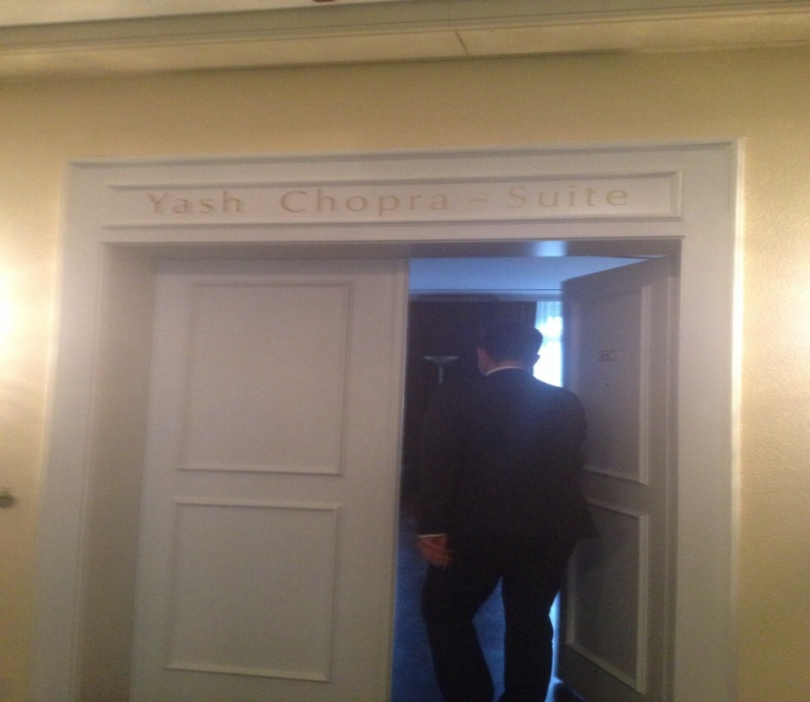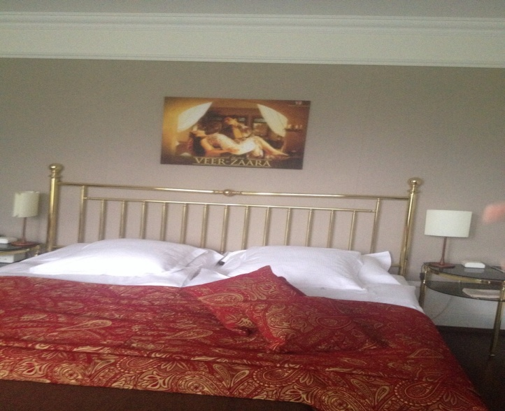Here, on the basis of section 5.8, I would like to discuss about the price differentiation strategy among HC and VJ. As mentioned earlier, both the hotels claim to provide good service according to the needs of their Indian customers. But according to Niklas, Sales Manager, VJ, one of the main reasons behind their popularity among Indian market as well the NRIs is the Yash Chopra Suite which can be booked by the customers by paying 2000 Swiss Francs per night. In the suite, there are various posters from the movie “Veer Zara” starring SRK and Preity Zinta, as shown in the picture. A firm must be unique at something if it expects a premium price (Porter, 2008). Hence, one may argue that HVJ has the unique product for which customers are ready to pay a higher price and it also differentiates them from their competitors in the market. Because Hotel Saanerhof, in Saanen, also has Shahrukh Khan’s (SRK) room but they do not want to use this product to market their hotel. As mentioned by Erwin Fassler, Owner ET, the owner refused to promote the hotel on the name of SRK. At the same time, one may argue that this strategy is used by HVJ to focus only on high end customers coming from India because it is not possible for a middle class Indian family to afford the price list of this 5 star hotel anyway. Hence, if we compare HC and HVJ, it is clear that being a 5 star hotel and having product like Yash Chopra Suite, HVJ can differentiate themselves using price strategy by providing luxurious experience to their customers as well as stays in the competition in this growing market on the basis of their high end profitable customer segment.

**6.4. Discussion about the key actors of Switzerland**

Effective destination management is not only the responsibility of the DMOs, but it also requires efforts from various stakeholders within the destination as well as partners in other places (Morrison, 2013). In case of Switzerland, ST is the National tourism organization and collaborates with various regional and local DMOs to present Switzerland as a tourism destination in other markets through various marketing campaigns, media and fam trips etc. According to Urs Eberhard (Vice President Marketing, ST),

*“we are really trying to coordinate with each other (…) some*

*work with us and some of them work with us but they also have*

*their local representatives in India.”*

So, the DMOs around Switzerland work together with ST as well as do various marketing activities to promote their region in other markets as well. As mentioned in section 5.3.1, in order to promote film tourism in a destination, film commission plays an important role. For example, tourism development and marketing as well as film development and marketing have been integrated by DMOs and film commission at many places (Morrison, 2013). But as mentioned by Urs Eberhard (Vice President Marketing, ST), *“there is a Film Commission and its more or less (….) towards supporting domestic film productions.”* Similarly it has been mentioned by Ankita Makwana, Owner AM Films that the local film commission is more supportive for domestic films and does not really seem interested for Bollywood film shooting in Switzerland. Here, I would say that because Switzerland has a long term relationship with Bollywood, it is relatively easier for Swiss Film commission to attract Bollywood production houses to shoot in Switzerland if unlike other European destinations which are showing great interest in Bollywood as mentioned about Spain in section 6.1.3.

On the other hand, according to Urs Eberhard (Vice President Marketing, ST),

*” we are not able to pay those amounts that other destinations (….)*

*are offering. We are not able to support them financially (….) it can*

*be one of the reasons.”*

As mentioned in section 5.8, it is clear that in order to shoot a film in a destination, film production houses demand lot of finances because now they have realized that shooting a film would help in place promotion and growing economy of the destination. But according to Urs Eberhard (Vice President, ST) they do not have that much finances. But if they collaborate with film commission and film fund, they would probably have good budget to invite Bollywood production houses to Switzerland. Hence, if the DMOs around Switzerland want to reposition the romantic image of Switzerland to a destination that is more appealing to the young generation, they should collaborate with the film commission to change the brand image of Switzerland through various pre and post marketing campaigns related to the film as shown in Fig 3. This strategy can be effective for Switzerland to reposition the image of Switzerland and attract not only the romantic couples and family but also FITs and young generation to the destination. But on the hand, it is only possible if the Swiss film commission will also realize the potential of film tourism and shows interest in collaborating with DMOs and other key actors of film tourism to reposition the image of Switzerland and stay in this competitive market.

DMOs also collaborate with various stakeholders like tour operators, hospitality industry to provide various training programmes to make the service industry understand the preferences of the specific market (Morrison, 2013). In the same way, in case of Indian market, (Appendix: 9.3).ST also tries their level best to make the hospitality industry around Switzerland to understand the cultural aspects, need and expectations of Indian visitors so that the service staff can understand their requirements and provide the best possible service. As mentioned by Niklas Breitenbach (Sales Manager, HVJ), ,”*we strategically focused on expanded markets and growing markets (….) together with the tourism board of Interlaken as well (…)”*Similarly, as it is discussed in section 5.6, intersectoral collaboration plays an important role in destination promotion through various media and marketing campaigns hosted by DMOs and give the benefit to all the stakeholders to promote their products and services to the target markets. Furthermore, one may argue that the training provided by various DMOs helps the hospitality industry in Switzerland to understand the cultural background of the visitors coming from different parts of the world so that they can understand their needs and provide best quality service to their potential customers.

As discussed in section, 6.3.1, on one hand, the hospitality industry collaborates with various intermediaries i.e. tour operators and travel agents and on other hand, promotes their own products and services through various communication channels according to their budget and convenience. For example, a 5 star hotel spends more money on PR and marketing in comparison to a 3 star hotel that does not have big budget for all these promotional activities. So, they only rely on maintaining good relationship with their potential stakeholders instead they focus more on big tour operators who bring big groups to the hotel for example HC that has been discussed earlier.

On the other hand, during my research, I found out that Erwin Fassler (Owner ET), does not use any middleman to communicate to his customers. As mentioned earlier, he uses social media and personal relationship strategy to market his Bollywood tours to Indian market. As mentioned by him,

*“it would be good to work together with Indian companies like*

*travel agencies (…) I was in India last year and most of the Travel*

*agents I met who work with middle class Indians are just too expensive.”*

So, high price can be one of the reasons that the travel agents in India are not showing interest in Erwin’s Bollywood tour. But during my research I observed that he has connections with some big hotels like HVJ and Hotel Saanerhof in Gstaad. Here, I would say that he might get commission to bring customers to these big 5 star hotels and that is the reason why he does not have connection with small hotels. But in order to get more customers and to stay in the market for long time, Erwin Fassler has to adapt strategy to collaborate with the key actors of tourism both from India and Switzerland to enhance his business.

As mentioned in section 5.4, various transportation modes also play an important role to attract tourists to a destination. If the transportation system is poor, it would be difficult for the visitors to reach the desired places. In the same way, all the DMOs around Switzerland think that the Swiss Rail system plays an important role in their tourism system. According to Urs Eberhard (Vice President, Marketing, ST) *,” it is easy and convenient for people with Swiss Rail Pass*.” So, with the help of Swiss Rail Pass, it is very easy to travel all around Switzerland by spending not so much money which is considered as a USP by the DMOs. It is important that access to the different locations and sights should be possible through various modes of transportation which can be a bonus for a destination (Roesch, 2009). At the same time, local people around Switzerland can talk in English and that is also very important for a tourist who does not know the local language. Hence, I would say that there is a good collaboration between the trains and other transportation modes all around Switzerland which is very cheap and convenient for the tourists. It is also considered as one of the important factors by the destination managers because it helps a lot to control the visitor flow by not creating any hastle like traffic jam for the locals and also not disturbing their daily travelling routine. DMOs must be concerned about the quality of experience that visitors are having as it impacts a lot on the satisfaction level, word-of-mouth recommendation as well as repeat visit intentions of the tourists (Morrison, 2013).

Hence, it can be said that all the key actors of tourism in Switzerland capitalizing for Indian market are using various marketing and collaborative strategies because they are increasingly recognizing the positive synergies of working together (Morrison, 2013). But one of the main actors of film tourism i.e. film commission and film funds are missing in this collaboration. But as mentioned in section 6.1.3, the destination managers do not want to continue the same brand image of Switzerland as a romantic destination, but they want to reposition the image to an adventurous destination by giving various new experiences to attract young Indian customer segment. DMOs cannot effectively perform all the roles of repositioning the brand image without the assistance of other stakeholders like tour operators, travel agents, hospitality sector and attractions etc (Morrison, 2013). So, as mentioned in fig 3, DMOs around Switzerland have to collaborate for example, communicating about the repositioning the image of the destination to all the stakeholders of film tourism, effective planning about the pre and post marketing and promotional activities, in order to reposition the destination not only for family and honeymoon couples but also the one which is preferable by young generation from Indian market in order to stay competitive in the market.

**7. Conclusion and Reflections**

The image of a destination is constructed in our minds through narrations of other persons, books and to large extent from watching films that have been shot in that country (Vagionis, 2011). In the same way, the essence of romanticism is combined with Switzerland because Bollywood and especially Yash Raj films have used Switzerland as a setting for a lot of romantic films in 1990s which is the main reason why Indians are attracted towards Switzerland. This research of this thesis examines the strategic activities adapted by the key actors of film tourism in Switzerland capitalizing on long haul markets like India. In addition, it also investigates how these key actors collaborate with each other to market Switzerland in Indian market. On the basis of the results of analysis and discussions of this thesis, the following observations and general conclusions can be made in relation to the research questions.

From all the strategic activities that is discussed in section…and these strategic activities are helping the key actors of film tourism in Switzerland to capitalize on Indian market. But on the other hand, it is also clear that all the DMOs around Switzerland want to reposition the romantic image created by Bollywood to a destination which is more appealing for the young generation. To achieve this goal, it would be much easier to reposition the image of Switzerland through films. Film tourism is a very powerful tool for marketing a destination and also requires careful strategy and planning by the DMOs and other stakeholders (Vagionis, 2011). But in case of Switzerland film commission and film fund seems uninterested when it comes to Bollywood. Hence, the DMOs and other stakeholders should take initiatives to exploit their relationship with Bollywood and try to convince the film commission of Switzerland to support their strategic goal due to the fact that if both tourism and film stakeholders are involved in the initial planning of the film, a more effective brand image could be put forward and a stronger brand will help to make Switzerland a competitive destination among the other alpine destinations because marketing through films leads the audiences to categorize themselves among the actors of the film and creates a desire to experience the plot of the movie by visiting that destination (Vagionis, 2011).

On the other hand, Erwin Tours and Guides Gstaad are not bothered about the repositioning the image of Switzerland because they are exploiting the romantic image of Switzerland through Bollywood tours. But as these tours are quite new, it would be beneficial for Erwin Tours and Guides Gstaad to focus their strategy to collaborate with various DMOs around Switzerland as well to market their Bollywood tours among Indian visitors by displaying the brochures or flyers at the local accommodation providers, tourism information centres and tourist attractions (Roesch, 2009). From the above mentioned strategies of both the Bollywood tours, it is clear that Erwin Fassler, Owner ET, has collaboration with a couple of hotels around Switzerland and Guides Gstaad is collaborating with Gstaad Tourismus. But in order to promote their tours they should also offer special tour packages of the famous locations, accommodation and by organizing stalls at tourism trade fairs with DMOs (Roesch, 2009) which is only possible by collaborating with DMOs as well as hotels and restaurants capitalizing for Indian market which would create a win-win situation for tour guides as well as the hospitality industry.

Another very important thing that none of the key actors mentioned is sustainability of the destination. I found out during my research that all the DMOs talk about the strategies to increase the number of Indian visitors to Switzerland but at the same time, they should also not ignore the problems like carrying capacity of the destination, congestion, overcrowding etc. For example, I found Mount Titlis very crowded that can also be felt by tourists coming from other parts of the world. Hence, it is very important for the suppliers, which is Hotel Terrace, to provide good food quality on the top of Mount Titlis which was not up to the mark. Furthermore, the destination managers should increase the number of toilets according to the number of visitors so that people do not have to stand in long queues for these basic things and the place should have the carrying capacity according to the number of visitors expected every year. It is important for the local and national tourism organizations and the tourism policy makers to develop various strategies to support the locations aiming to have increase in tourism flows with sufficient infrastructure and services for the visitors (Vagionis, 2011).

The principal findings of my research through this thesis, contributed to the existing pool of knowledge related to film induced tourism. In order to satisfy the research objective, insights from a variety of areas such as tourism, destination marketing and branding, competitive strategies and supplier network strategies were utilized and incorporated into the literature review. This gathering of data from a variety of disciplines was necessary because as already outlined, these topics are yet unresearched in tourism studies and not much literature can been found related to the strategic activities of the key actors of film and their collaboration to capitalizing on long haul markets. Thus this research goes some way to filling the knowledge gap of this unresearched area. The research objective is investigated in context of Switzerland, which was chosen because of its long term relation with Bollywood and Indian market. Overall, the outputs represent a significant amount of insights into the strategic activities of the key actors of film tourism and the way they collaborate with one another into the film induced tourism phenomenon. This will not only contribute extensively to the existing knowledge but also stimulate further research areas. On the supply side further research on the needs and motivations of young generation of Indian tourists is required as well as the strategies that DMOs in Switzerland are going to use to reposition the brand image of Switzerland need to be researched as well. In terms of the theoretical contributions of this thesis, research that vitally uses, assesses and develops the presented literature review is required to establish it as an inspiration within motivation research.

1. <http://www.businessinsider.com/le-rosey-switzerland-expensive-boarding-school-2012-2?op=1&IR=T>, 12th June, 2015, 12:40