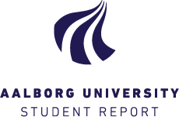

## Aalborg University

## Culture, Communication and Globalisation, MA

## Thesis, 10th semester

# Non-economic dimensions in the Lithuanian economic migration: inquiring potential for return, and implications

## Author: Jurgita Dagilyte

## Supervisor: Peter Hervik

## Submitted in June, 2015