Abstract
The practice of corporate social responsibility (CSR) can be considered an organizational asset in the development and preservation of an organization’s image and reputation – also signifying its potential relevance in a crisis situation, where the image and reputation may be threatened. If an organization finds itself in the midst of a crisis, an efficient communicative crisis response, accommodating the nature of the crisis and the interests of its stakeholder, is essential. If the crisis is inflicted by social responsibility issues, the discursive advantages of CSR may constitute an efficient crisis response – if represented in the right way.
The study deals with the communicative challenges of an organization during an organizational crisis, and is directed at an organization’s implementation of CSR discourse to constitute an efficient crisis response. To shed light on this area of interest, the study revolves around the organizational crisis of the Mozilla Foundation in 2014, where CSR discourse was extensively applied in its crisis communication. The crisis absolved with a full apology by Mozilla for mishandling the situation, meaning that its crisis response failed. This opened up the study question of, whether the occurrence of CSR-related discursive misalignments in its crisis communication could have caused this outcome, and to what extent. To further elucidate this question, the study examines how these conflicting discourses may arise in Mozilla’s crisis communication.
Following the hermeneutic and interpretive scientific approach, the study relies on the principles of the hermeneutic circle and social constructionism – complementing the set analytical frameworks of the study. William Benoit’s image restoration theory, Timothy Coombs’s situational crisis communication theory and Finn Frandsen and Winni Johansen’s rhetorical arena model constitute the analytical framework of crisis communication – used in the analysis of Mozilla’s overall crisis communication. Norman Fairclough’s critical discourse analysis theory, supplemented by Laclau and Mouffe’s Discourse Theory, constitute the analytical framework used in the analysis of discursive properties within the CSR-infused crisis communication.
Through the analysis of Mozilla’s crisis communication and the discursive properties thereof, the study reveals that discursive misalignments are apparent in Mozilla’s representation of its social responsibility – creating an ambiguous message in its crisis response. The cause of these misalignments is primarily found within the active role of several communicating actors with authority (CEO, Executive Chairwoman and the organization), whose identities are conflicting, resulting in the presence of different ideological and social purposes. The study finds that the observed misalignments are too indistinctive to be measured in terms of crisis communication theory in its current form. Accordingly, the study is inconclusive in determining the extent to which the revealed discursive misalignments caused the outcome of the crisis. However, it does point to an insufficiency in crisis communication theory – so as to accommodate more complex discursive structures in organizational crisis communication. Moreover, the findings of the study provide valuable insights in the usage of CSR discourse in crisis communication, even though these may be limited due to the scope of the study. Nevertheless, it contributes to a research area that is seemingly unexplored and opens up potentials for further research, which may be considered the academic purpose of the study.

Table of Contents

Abstract 1
1. Introduction 6
1.1 Case Representation 7
1.2 Literature 7
1.2 Problem Statement 8
2. Methodology 9
2.1 Scientific Approach 9
2.2 The Hermeneutic Spiral 10
2.3 Social Constructionism 11
2.4 Study Design 11
2.4.1 Theoretical Approach 12
2.5 Empirical Data Collection 13
2.5.1 Primary Data 13
2.5.2 Secondary Data 14
2.6 Analytical Approach 14
2.7 Delimitations 14
3. Literature Review 15
3.1 Crisis Communication 15
3. 2 Corporate Social Responsibility 16
3. 3 Crisis Communication and Corporate Social Responsibility Interconnected 18
4. Theoretical Framework of Crisis Communication 20
4.1 Defining a Crisis 20
4.2 Crisis Communication 22
4.3 William L. Benoit’s Image Restoration Theory 23
4.3.1 Critical Reflections 26
4.4 The Situational Crisis Communication Theory by Timothy Coombs 28
4.4.1 Critical Reflections 32
4.5 A Unification of the Rhetorical and Situational 33
4.6 The Rhetorical Arena 35
4.6.1 Macro Component: The Multi-vocal Arena 36
4.6.2 Micro Component: Inside The Rhetorical Arena 37
4.7 Reflective Deduction 40
5. Analytical Discourse Framework from a Critical Perspective 42
5.1 Understanding Critical Discourse: Theory and Method 42
5.2 Ernesto Laclau and Chantal Mouffe’s Discourse Theory 43
5.2.1 Reflections 45
5.3 The Theory and Method of Critical Discourse Analysis 46
5.3.1 The Three-dimensional Framework of Critical Discourse Analysis 48
5.3.1.1 Text Analysis 51
5.4 Corporate Social Responsibility: Concept and Discourse 52
5.4.1 Corporate Social Responsibility 52
5.4.2 CSR Discourse 53
5.5 Setting up an Analytical Framework for Discourse Analysis 55
6. Empirical Data 58
6.1 Case 58
7. Analyzing the Crisis Communication of the Mozilla Foundation 60
7.1 Actors within The Rhetorical Arena 60
7.2 Context 60
7.2.1 Societal and Cultural Context 60
7.2.2 Organizational and Institutional Context 61
7.2.3 Situational Context 62
7.3 Medium and Genre 63
7.4 Text 64
7.5 Crisis Response Strategies 64
7.5.1 Statement 1 64
7.5.2 Statement 2 66
7.5.3 Statement 3 67
7.5.4 Statement 4 69
7.5.5 Statement 5 70
7.5.6 Statement 6 71
6.5.7 Statement 7 72
7.6 Reflective Summary 73
8. Critical Discourse Analysis of Mozilla’s Crisis Communication 74
9. Conclusion 85
Bibliography 90
Appendix 98
Appendix 1: Definitions of CDA Terms 98
Appendix 2: Brendan Eich responding to 2012 controversy 100
Appendix 3: Mozilla Firefox advertisement 101
Appendix 4: Stakeholder comments on advertisement 101
Appendix 5: Statement 1 102
Appendix 6: Official Mozilla and Firefox Tweets on March 26 103
Appendix 7: Statement 2 104
Appendix 8: Statement 3 105
Appendix 9: Employee Tweets on March 27 106
Appendix 10: Statement 4 107
Appendix 11: Statement 5 108
Appendix 12: Statement from CREDO, Concerning Petition Campaign 109
Appendix 13: Okcupid Boycott Notification 110
Appendix 14: Brendan Eich’s Comments in an Interview with the Guardian 111
Appendix 15: Statement 6 112
Appendix 16: Statement 7 113

1. Introduction
This introduction to the study will provide a preliminary presentation of the topic of interest, followed by a brief representation of the case selected for a qualitative analysis in the study – as a basis for identifying the specific problem on which the problem statement is based.
A strong and positive organizational image and reputation is essential to the functionality of an organization, as it signifies the extent to which stakeholders perceive and conceive an organization in a favorable manner – especially in terms of trustworthiness (Cornelissen 2011, 10). In times where an organization faces the challenges of a crisis, its image and reputation can potentially be tarnished. It is therefore in the interest of an organization to efficiently address its stakeholders to repair the damage done, meaning that the way in which the organization communicates is crucial. The practice of communicating in a crisis has been researched and conceptualized as crisis communication – primarily concerning the development of rhetorical strategies to set up an efficient crisis response (discourse) (Benoit and Drew 1997, W. T. Coombs 2007).
In connection with an organization’s image and reputation, corporate social responsibility (CSR) has received great attention in recent years within public relations, as it represents an organization’s commitment to its stakeholders’ interests on a non-corporate level – concerned with socially benefitting activities (Coombs and Holladay 2012, 8). Accordingly, it has been considered a practice with a positive effect on an organization’s image and reputation and therefore labeled as an important organizational asset. Moreover, CSR is also considered a potential asset in a crisis, as it presents positive information about the organization, which can be disseminated with a potentially supplementing effect on the efficiency of the crisis communication in place (Grabowski and Kruse 2013, 113).
However, in the wake of a crisis, inflicted by issues of an organization’s perceived social responsibility, the positive nature of an organization’s CSR may be challenged. Thus, CSR can become the center of negative attention in an organizational crisis, meaning that CSR-related information will, expectedly, become a part of the organization’s crisis communication, discursively represented to accommodate the specific CSR-related circumstances – so as to have a desired positive effect. According to crisis communication theory, this is achieved through the application of specific crisis response strategies, constituting discourses to convey a desired message. Conversely, a wrong approach may bring further harm to the organization’s reputation (Benoit and Drew 1997, W. T. Coombs 2007).
Consequently, CSR presents an organizational asset regarding a positive image and reputation. However, in an organizational crisis, when CSR can become the target of negative criticism, challenges may arise as well, as its representation through discourses within an organization’s crisis communication may become the determining factor to the communicative success of the crisis response.

1.1 Case Representation
In March 2014, the Mozilla Foundation got plunged into a reputational crisis, when the board appointed the Chief Technology Officer Brendan Eich as the new CEO. This provoked boycotts and protests from the LGBT community, because Eich, back in 2008, had made a donation for an anti-same-sex marriage legislation, called Proposition 8. Moreover, several employees of Mozilla expressed their contempt through the social media channel Twitter (Shankland 2014). Subsequently, Mozilla, with the supplementing voices of Chairwoman Mitchell Baker and Brendan Eich, responded to the criticism from all of the involved stakeholders.
Seemingly, the main communication strategy of Mozilla was to communicate its values of inclusiveness and diversity – with the purpose of reinsuring stakeholders about the foundation’s social commitment to the LGBT community. Consequently, the discourse in use was, primarily, based on the social responsibility of Mozilla (CSR) (Eich 2014). This means that the organization utilized its CSR identity to express concern and redemption through promises of social commitment, which may seem as a valid tactic (Mozilla Foundation 2005). However, in less than ten days after the crisis broke out, Brendan Eich stepped down as CEO and Mozilla issued a full apology (M. Baker 2014). Conclusively, Mozilla’s crisis communication, with extensive use of CSR discourse, failed.

1.2 Literature
A review of relevant literature, connected to the topic of interest, indicates that there may be an academic vacuum in studies of crisis communication, concerning the significance and implication of CSR discourse within an organization’s crisis communication. This theoretical observation will be elucidated later in a literature review (Chapter 3). Considering a reputational relationship between CSR and crisis communication, together with the circumstances of the Mozilla case, it may therefore be of great interest to examine this relationship on a discursive level, possibly enabled through theories of crisis communication and discourse (2.4.1).

1.2 Problem Statement
The outcome of the Mozilla crisis opens up questions about the influential nature of CSR discourse, when it becomes a significant part of an organization’s crisis communication. From the theoretical perspective of an interrelationship between CSR and crisis communication, with no research directed at the discursive level (3.3), it could therefore be of interest to critically examine the CSR discourse used in the case of Mozilla – so as to seek an explanation of the outcome of its crisis communication practiced. The main interests are to analyze the crisis situation in view of the crisis communication strategies used by Mozilla, and to discuss them in contrast with the CSR discourse within the communication. Therefore, the purpose is to study relevant discursive elements arising between CSR discourse and crisis communication, where point of entry will be to examine the potential occurrence of discursive misalignments between those two parameters.
Accordingly, the study seeks to examine:
To what extent discursive misalignments between Mozilla’s use of CSR discourse and its overall crisis communication can explain the outcome of the crisis?
- How do CSR-related discursive misalignments arise in Mozilla’s crisis communication?
- How may discursive misalignments between CSR and crisis communication in the Mozilla case contribute to crisis communication theory?

2. Methodology
The methodology chapter will outline the scientific approaches used in order to accommodate the research area of this study. Building on Theory of Science, significant methodical aspects with a hermeneutic focus point will be introduced, explained and placed in relevance to the scope of the study. Moreover, the study design and the specifications of the empirical data collection will be addressed as well.

2.1 Scientific Approach
The exploitation and elucidation of methodological procedures can be said to have the overall goal of providing tools to generate optimal knowledge surrounding a specific research area – so as to validate a hypothesis set in that area. Accordingly, to gain knowledge is the ultimate purpose behind setting up scientific procedures, which may be facilitated on the basis of two primary philosophical stances: the positivist and interpretive approach (Bryman 2008, 13). These two approaches each signifies a paradigm (Ibid: 13), which are separated in terms of various meta-theoretical assumptions, mainly concerning ontology (nature of reality) and epistemology (nature of knowledge). At an ontological level, the positivist approach entails a perception of reality in terms of an objective world, separated from subjective experiences. Conversely, interpretivism entails the perception of a world dependent upon how it is subjectively experienced and perceived through human interpretations (Weber 2004, 5). When it comes to epistemology, the establishment of human knowledge, from a positivist perspective, is seen as a reflection of a reality, constituted by an objective and independent world. Within interpretivism, the establishment of knowledge is seen as a social construction: it is reflected through individual culture, goals, history and experiences – in the sense that knowledge is constituted through sense-making activities within the parameter of an individual’s ‘views of the world’ (Ibid: 6). Moreover, the positivist approach may also be referred to a quantitative research approach (focus on tangible data), where the interpretive approach is more in line with a qualitative research approach (Bryman 1988, 3, Lin 1998, 162).
In light of the ontological and epistemological views of the two scientific approaches, the qualitative interpretive research approach is in line with the purpose and position of this study. With a methodological focus on phenomenology and the hermeneutics (Blaikie 2004, 509), interpretivism generally entails the interpretive examiner to aim for an understanding of relations between social properties and individual actions (Lin 1998, 163). This aim corresponds with the intention embedded within this study, in the sense of understanding crisis communication in relation to CSR, with focus on the construction of discourses – seeing the constructed discourses as patterns of actions with social relations. More specifically, through inductive reasoning, this study seeks to understand and interpret the Mozilla Foundation’s discursive actions, and the consequences thereof (conflicting discourses), within the frameworks of crisis communication strategies and CSR discourse. Consequently, the intention of the study is to understand and explore the field of crisis communication in view of the implementation of CSR discourse as the primary crisis response facilitator.

2.2 The Hermeneutic Spiral
The notion, constituting the hermeneutic spiral as a significant knowledge-generating method within interpretivism, is built around the principle of a spiral circle. Surrounding this principle is the idea that the comprehension of various elements within a context or entity constitutes a comprehension of that context/entity – an understanding of the bigger picture. An example could be an element (passage, sentence) within a text, where an understanding of this element could derive an understanding of the text as a whole. However, the text itself could also just be seen as an element, constituting an understanding of the author behind the text or its societal setting (Pahuus 2003, 147). The principle of the spiral circle comes into play in the sense that one must go back and forth between one’s understanding of elements and understanding of the whole – in accordance with the ‘revealment’ of additional and possibly redefining elements (Ibid: 145). The process of understanding, through the principle of the spiral circle (Pahuus 2003, 153-154), is further defined by Hans-Georg Gadamer’s notion of fusions of horizons. It is asserted within this notion that by each time an individual encounter a textual content (elements), his/her predetermined horizon of understanding of the text gradually aligns with the meaning of the text (Gadamer 2004, 302). As symbolized with the ‘spiral’ representation, the purpose of the method described is to seek some sort of ‘truth’ about the broader perspective, based on various defining elements – even though such a truth may not exist due to differing interpretations (Gadamer 2004, xx, Pahuus 2003, 147).
The statements available from Mozilla during its organizational crisis and the discourses within can be considered the elements that need to be understood – so as to gain a holistic understanding of crisis communication when perceived in a context of CSR discourse. By applying the method of the hermeneutic spiral, a plethora of understandings (knowledge) throughout the analysis will emerge, constituting a holistic ‘truth’ – though not an unconditioned truth, as new perspectives and elements with different meanings may continuously emerge.

2.3 Social Constructionism
The concept of social constructionism, from a hermeneutic perspective, builds on the philosophical stance of interpretivism (both ontological and epistemological aspects), where patterns of actions or phenomena are related to social properties or societal processes (shaped and influenced by human interests) and therefore a social construction (Collin 2003, 248-250). The role of language is considered essential in the construction of ‘reality’, as the semiotic process of language constitutes the structure and substance of reality, as well as cognitive knowledge. Arguably, the premises of a social construction is facilitated through language or the discourses semantically structured thereof. This has entailed a link between the hermeneutics and social sciences, examining the social parameters revealed through language, referred to as discourse analysis (Ibid: 252). With impetus towards the examination of social relations – especially referring to ideological motives and identity construction (Ibid: 275) – the analysis of discourses and the connotation of language have significant momentum in this study, aiming at revealing discursive misalignments. To further apply the perspective of social constructionism, critical discourse analysis is the primary method in use, where language, discourse, perspective and method will be extensively elaborated and explored in Chapter 5.

2.4 Study Design
The study builds on the case of the Mozilla Foundation’s CEO crisis in 2014, meaning that the study utilizes a case study design, aiming at investigating the phenomenon of crisis communication in relation to a specific context (CSR discourse as crisis communication). The main purpose of the case study design is to enable an in-depth examination of a phenomenon by using the data of a given case. In this study, the case in question is an organization in a crisis situation (Keddie 2006, 20). Moreover, by applying this design as a research method, it is possible “to retain the holistic and meaningful characteristics of real-life events – such as […] organizational and managerial processes” (Yin 2009, 2) in an investigation.
A case study can be descriptive, exploratory or explanatory in character, where this study makes use of the latter, directing focus on the cause of the phenomenon to unfold as it did (Keddie 2006, 20). Generally, the how and why questions are eminent within a case study design, also highlighting the unit of analysis (what is it specifically that needs to be analyzed in the case?) (Yin 2009, 22). Within the Mozilla case, the utilized crisis communication strategies that are conveyed through CSR discourse are considered the unit of analysis. Relations or ‘boundaries’ between crisis communication strategies and CSR discourse are not clearly evident, due to the lack of research in the specific area, which is in line with a case study being an empirical inquiry that aims at investigating and determining these undefined relations (Ibid: 13). On the other hand, the use of only one case in a study can be considered delimiting in achieving a representativeness and generalizability in other similar situations (Keddie 2006, 21). Consequently, it is important to recognize that the results of this study are deduced on the basis of one case, which may restrict its holistic purpose. But, the choice of focusing on one case enables a more in-depth analysis, including a ‘range’ of analytical methods to more comprehensibly examine the research area in question – so as to provide more valuable and reliable results for further research (Yin 2009, 37).

2.4.1 Theoretical Approach
The theory selected, in accordance with the scope of the study, has both the purpose of accounting for the phenomenon and context, as well as providing a foundation for the analytical approach. As a result, the main theory section, following a literature review (Chapter 3), operates around two research fields that are of interest to the study, divided into two chapters (4 and 5).
The first chapter accounts for the field of crisis communication through the original work of William Benoit (1997), Timothy Coombs (2007) and Finn Frandsen and Winni Johansen (2007). Coombs and Benoit’s theories have been selected largely on the basis of being tried-and-true; their prominence in the field speaks well for their ability to analyze a crisis communication situation. Frandsen and Johansen’s theory has been selected due to their focus on external and internal parameters, influencing the process of crisis communication, which can supplement an analysis of a crisis situation. These represent three different perspectives on crisis communication, which are being portrayed and evaluated – with the purpose of constructing a theoretical framework and analytical model (Chapter 4).
The second chapter accounts for language and discourse, critical discourse analysis and CSR discourse – primarily building on the original work of David Machin and Andrea Mayr (2012), Ernesto Laclau and Chantal Mouffe (1985), Marianne Jørgensen and Louise Phillips (2002) and Norman Fairclough (2010). However, due to limited access to the work of Laclau and Mouffe, Jørgensen and Phillips serve as the primary source for their Discourse Theory. The review and evaluation of the various theories has the purpose of providing an understanding of language and discourse in relation to CSR and critical discourse analysis, culminating in an analytical approach with focus on the linguistic content of the empirical data (Chapter 5).

2.5 Empirical Data Collection
There are generally two ways in which research data may be collected: the quantitative method (data that can be measured) and the qualitative method, which can be related to the approach of interpretivism (Bryman 1988, 3). In accordance with the focus on discursive misalignments within the crisis communication of Mozilla, this study has a clear focus on qualitative data, where the method in practice has an emphasis on the analysis of words instead of quantification thereof. Moreover, following the case study method, the primary method of data collection employed is document analysis, which is a choice deriving from the observation that the subject under investigation (Mozilla) solely produces textural data. (Kohlbacher 2006, 81).
Data from various sources have been collected throughout the research process, mainly concentrated on official statements from the Mozilla Foundation (through its website) and statements from Mozilla’s executive Chairwoman and CEO on their personal but official Mozilla blogs (primary data). Additionally, stakeholder statements/comments on the social media channel Twitter and blogposts, as well as statements represented through traditional media channels, have been collected (secondary data).

2.5.1 Primary Data
The study is mainly focused on the primary data collected, which constitute the textual material in the analysis. The primary data center around the Mozilla statements published throughout the assumed period of the organizational crisis. Generally, the applicability of each ‘document’ is evaluated on the basis of four criteria: time period, relevance, content and source. As portrayed, the time period of each piece of data needs to comply with the assumed period of crisis (March 24 – April 3), corresponding with the scope of the study. Relevance refers to the factor that the data segments need to be useful in a fulfilment of the purpose of the study. As an organization does not stop all its affairs during a crisis, content is important as well, because the statements need to reflect the crisis situation through communication and discourse. Finally, the source is important when operating from a perspective of social constructionism, as a statement from its original source can be considered more reliable – free from the potential restructuring of a third party. The data/statements will be readdressed in Chapter 6.

2.5.2 Secondary Data
The main purpose of the secondary data, including stakeholder comments (mostly gathered through third party sources), is to supplement the primary data and substantiate an understanding of the overall case. The secondary data supplements the primary by providing an objective indication of the efficiency of the crisis communication in practice – through stakeholder reactions. This knowledge may be significant in a discussion and an evaluation of the situational context, in the sense that additional considerations can be brought into perspective, augmenting the validity of the findings.

2.6 Analytical Approach
The first order of analysis is to establish an understanding of the crisis situation and the crisis communication strategies in use by Mozilla. To achieve this, the constructed analytical framework (4.7) is applied, where the initiating phase of the analysis is to evaluate the various circumstances surrounding the case. Subsequently, each statement made throughout the reputational crisis is examined – so as to divulge the crisis communication strategies in use.
Next, focus is directed more comprehensively towards the linguistic properties of the individual statements, on the basis of a critical discourse analysis. The main approach is an analysis of the lexical surface features and interpretations thereof, which can be further evaluated, in terms of the established crisis communication strategies in use (hermeneutic spiral). Consequently, there is a focus on the textual and discursive content of the produced statements. This approach may also be referred to as qualitative content analysis (a part of the case study research design), which differs from the classical quantitative content analysis by including the context as well as other considerations based on the research area (Kohlbacher 2006, 86). Moreover, qualitative content analysis is theory-guided, where it in this study relies on critical discourse analysis (Kohlbacher 2006, 54).

2.7 Delimitations
A few factors may inhibit the reliability and generalizability of the findings. First of all, the study includes all official statements in connection with Mozilla, which are being analyzed from two different perspectives (crisis communication and CDA) – in order to reach a more comprehensive understanding. However, this may result in the study not being able to go into specific details with each statement, possibly leaving details unaccounted for. Moreover, stakeholder statements and other data have not directly been brought into the analysis, which is explained by the latter. Secondly, even though the communication of crisis-related information within the case of Mozilla was exclusively through the internet medium, the online (web 2.0) context (social media channels and dissemination of information) is only briefly addressed in the literature review (3.1). Consequently, it is an acknowledged area, but it has not been included in the analysis, as it does not have direct significance to the area of research.

3. Literature Review
This chapter precedes the main theory section of the study and will include a brief review of relevant literature, affiliated with the topic of interest – so as to provide an understanding of the literary background of the research area, emphasizing its context as well as underlying interest.

3.1 Crisis Communication
The crisis communication area is an important aspect within the public relations field and the research of communications. Throughout recent decades, crisis communication has been conceptualized around the practice of conveying a message from organization to stakeholders during an organizational crisis (Sellnow and Seeger 2013, Frandsen and Johansen 2007, 187). William Benoit represents the theory of this practice with a descriptive approach and a case-study design, constituting a comprehensive typology of rhetorical crisis repair strategies (W. L. Benoit 1997, Benoit and Drew 1997). From a more prescriptive approach, in relation to attribution theory, Timothy Coombs challenges the practice of a descriptive one-way transmission of a rhetorical message (W. T. Coombs 2007). His theoretical framework operates around stakeholder perceptions – more specifically how stakeholders perceive the crisis at hand. Accordingly, how the crisis is perceived determines the utilization of rhetorical response strategies (W. T. Coombs 2007).
Finn Frandsen and Winni Johansen (2007) represent a supplementing perspective on crisis communication, which derives from the early studies of both Benoit and Coombs (Frandsen and Johansen 2007, 251). Their theoretical framework, referred to as The Rhetorical Arena, seeks its foundation and inspiration from both the text-oriented tradition (Benoit et.al.) and the context-oriented tradition (Coombs et.al.) (Frandsen and Johansen 2013). Frandsen and Johansen introduce a multi-vocal approach, portraying the complexity and dynamics of a crisis situation, where the potentiality of several cross-interacting senders and receivers are taken into account (Ibid: 252). With supplementing inspiration from other theories, such as aspects from text and discourse theories, both a macro and micro component constitutes their rhetorical arena model (Frandsen and Johansen 2012). The first represents the communicative circumstances and processes inside of the figurative arena, determined by the number and nature of actors/voices communicating in relation to the specific crisis (Frandsen and Johansen 2007, 275-277). The latter represents the individual processes and discourses, mediated through the four parameters of context, medium, genre and text – thereby outlining the influential factors to an organization’s crisis response message (Frandsen and Johansen 2007, 280-284).
With the continuing evolvement of the internet as a prominent facilitator of crisis information, crisis communication becomes even more essential, where Alfonso Gonzalez-Herrero and Suzanne Smith point to the influential factors that the Web 2.0 context has on crisis situations. Their study of crisis communications emphasizes the increasing magnitude of information dissemination online (González-Herrero and Smith 2010, 97-105). Considering the high degree of information flow online, stakeholders are in a perceptive position, where an organization’s activities reach an unavoidable state of transparency. This means that unethical behaviors, are, potentially, brought into public display, with the possible result of an organizational crisis (Sørensen and Peitersen 2007, 5). The internet is a medium, where communication platforms have presented themselves, enabling a plethora of communicating actors – relating to Frandsen and Johansen theory, as the internet medium can influence the message communicated (Sellnow and Seeger 2013, 11-12). The most essential communication platform would be the social media, giving individual stakeholders a prominent voice – thereby shifting the locus of power from the organization to the stakeholders (Berthon, et al. 2012, 262).

3. 2 Corporate Social Responsibility
Coombs and Sherry J. Holladay have studied the strategic and communicative relevance of the concept of CSR, where best practice of CSR implementation, creation of CSR initiatives and ways of communicating the initiatives are discussed. The creation of CSR initiatives is characterized as a complex process, which cannot be prescribed, because of an undeniable uniqueness of each organization. An important aspect examined by Coombs and Holladay is the strategic dimensions of CSR, where one area discussed is its reputational relevance. On the basis of additional research (Fombrun 2005), it is argued that CSR is rapidly developing into becoming a driver of reputation. Reputations are portrayed as being evaluations of stakeholders and can, consequently, range from favorable to unfavorable (Coombs and Holladay 2012, 36).
The reputation benefitting element of CSR and the concept itself is also related to the practice of propaganda, which is recognized within the study of the field, as it supplements the phase of communicating and selling (through discourse) a corporation’s social responsibility (Fleming and Jones 2013, 2). However, without actual achievements and sincerity to support the words, the reputational gain of the practice can parish and even provoke criticism from stakeholders (Keys, Malnight and Graaf 2009). The practice of efficient CSR can be considered a reconciliation process between organizational goals and social good, where the premises are constantly changing (Schwartz and Carroll 2003, 509). Case studies show that, as societal values and stakeholder expectations shift, corporations react and adapt their CSR, in practice and communication, in order to avoid potential criticism of their corporate practices (Fleming and Jones 2013, 17).
The essentiality of communicating CSR is further examined by Ralph Tench, William Sun and Brian Jones, combining CSR research and communication studies. The purpose is to grow knowledge and understanding of the ways in which businesses communicate CSR (Tench, Sun and Jones 2014, 3-4). This is achieved through the findings of important research studies, including studies of CSR communication and discourse (Chia 2014, Walter 2014, Dhanesh 2014) and employee skepticism (Theofilou and Watson 2014). The findings highlight the importance of CSR communication, enabling that an organization’s message of CSR can effectively be conveyed from sender to recipient. Furthermore, when the CSR is communicated, intentionally or unintentionally, the CSR information exchange process begins, having two different effects based on stakeholder perceptions and understandings. It can have a positive effect, where the message is seen as sincere, reliable and clear, and a negative effect, where the message is perceived as false, unreliable and generally misunderstood. Consequently, emphasis is directed at the challenge of managing mutual expectations between organization and stakeholders. The key to efficient CSR communication relies on a two-way communication principle, as stakeholders perceive CSR differently (Tench, Sun and Jones 2014, 20).
All in all, CSR communication can be seen as the practice of transmitting CSR-related information (Täuschel 2004, 3). Even though CSR discourse is addressed by Tench et.al, their presented research studies do not seem to provide a clear characterization – other than describing it as a type of discourse regarding CSR, where some focus has been directed at dialectical relations in CSR discourse – though not completely explored (Dhanesh 2014). Accordingly, CSR discourse seems to be a fairly unexplored subject, but in relation to dialectical relations, discourse itself has been greatly explored. In this field of study, the construction and meaning of discourses are examined, where Ernesto Laclau and Chantal Mouffe’s Discourse Theory (1985) can be considered prominent. In short, the theory proclaims that meaning in texts is created through relations between words and clauses (signs/moments) (Laclau and Mouffe 1985, 105). Moreover, discourses have been further examined through the work of Norman Fairclough (2010), theorizing critical discourse analysis – so as to examine the meaning of a discourse through dialectical relations, revealing its social and ideological purpose (Fairclough 2010, 3). Consequently, a general understanding of ‘discourse’ is that it signifies the semiotic choices of language use, constituting a specific meaning and message, based on an underlying social and ideological purpose (Machin and Mayr 2012, 20).

3. 3 Crisis Communication and Corporate Social Responsibility Interconnected
Research literature, concerning CSR and crisis management/communication, present overlapping areas, such as reputation management and stakeholder perceptions and expectations, which connect the two areas within the public relations field. Additionally, where crisis communication is primarily a management process during extraordinary circumstances, mitigating health and safety effects by conveying information while managing reputation, the CSR area is also a social function of public relations, which compliments the same interest areas (Palenchar 2013, 778). This constitutes a relational similarity between CSR and crisis communication, where studies even point to interconnectedness between the two areas: From a CSR perspective, focusing on its characteristics and potentials, Steve Tombs and Denis Smith point to an apparent inter-relationship between CSR and crisis avoidance (Tombs and Smith 1995, 135, 142). The study directs its focus towards crisis management research concerning various phases of crises, and sees crisis management as a significant process of crisis prevention or avoidance. This involves the pre-crisis phase at the time when a potential crisis inflicting incident occurs (Ibid: 141). Tombs and Smith argue that the evaluated main consequence and attribute of implemented CSR, in a potential crisis situation, is the openness and flourish of crisis-avoiding information, which emerge from all stakeholders of an organization (Tombs and Smith 1995, 143-144).
More recent studies also acknowledge the importance of CSR in relation to crisis management, as a way to restore trust between organization and stakeholders and repair the corporate reputation (Grabowski and Kruse 2013, 115). In relation to the pre-crisis element of crisis management, researchers sees CSR as an insurance policy against potentially harmful events, which is achieved and enhanced by social activities – maintaining a good reputation (Saeed and Arshad 2012, 226). This principle is also labeled as reputational capital, considered advantageous to organizations in a crisis situation, as it may be a mitigating factor (W. T. Coombs 2007, 165). On the other hand, a favorable pre-crisis reputation may raise the expectations of stakeholders, increasing the potential reputational loss during a crisis, if these expectations are greatly challenged (Helm and Tolsdorf 2013). Following the notion of mutual dependency between CSR and crisis communication, Grabowski and Kruse argue that CSR is a significant strategic business initiative, where the communication of socially responsibly activities is an essential factor in times of a crisis – so as to direct attention towards positive aspects of the organization. An organization’s CSR policy’s main purpose is to safeguard the interest of all stakeholders, where its ability to do so is enhanced by the crisis communication in play (Grabowski and Kruse 2013, 113)
Consequently, CSR is a recognized practice in relation to crisis management and communication, where it can have an interconnected influential role in a crisis situation on a reputational level. On the other hand, as the communication and discourse of CSR is considered a significant factor in efficient CSR practice, through various studies, no definite discursive relationship between CSR and crisis communication seems to have been made (Tench, Sun and Jones 2014). In a crisis situation; how an organization communicates and what an organization communicates are crucial matters, which depend on the nature of the crisis (W. T. Coombs 2007, Wester 2009, 124). Expectedly, a CSR-related communicative content and discursive structure will arise in crisis situations caused by social issues, which makes CSR discourse in crisis communication an interesting and important area to study.

4. Theoretical Framework of Crisis Communication
In accordance with the case and research area, this chapter provides an understanding of relevant and supplementing factors within the crisis communication field, as well as an outline of valuable theories, providing the primary basis of a theoretical framework. Benoit’s image restoration theory and Coombs’s situational crisis communication theory will constitute the foundation of a framework, where Frandsen and Johansen’s Rhetorical Arena concept will represent the frame, in order to facilitate a somewhat comprehensive analytical tool, directed at the specific case.

4.1 Defining a Crisis
A definition of what actually characterizes a crisis is a significant focus point when examining the circumstances of a crisis situation – in terms of determining the type of crisis, when and how the crisis broke out and to evaluate factors leading up to the crisis (Sellnow and Seeger 2013, 4).
When examining the term crisis, a fundamental understanding behind the term dominates the field – with specific relevance to the corporate world. There is a consensus about crises being either natural or man-made (human errors), unpredictable, and negative (Frandsen and Johansen 2007, 74). Nevertheless, theories and definitions of what constitutes a crisis vary within the literature, because it depends on where focus is directed. Generally, the concept of crisis can be divided into two categories, being disaster and organizational crisis. The first refers to sudden and extremely unexpected events, such as a tornado (W. T. Coombs 2015, 3). The latter encapsulates “the perception of an unpredictable event that threatens important expectancies of stakeholders […] and can seriously impact an organization’s performance and generate a negative outcome” (W. T. Coombs 2015, 3). The theories of both Benoit and Coombs, as well as Frandsen and Johansen’s study, have their main focus directed at the organizational crisis aspect (Ibid: 3). Expectably, this definition of a crisis will follow the same principle, aimed at the case of Mozilla.
A crisis has the potential to emerge in the coil of an incident, which poses an unpredictable threat to areas such as public health and safety – affecting organization, business and stakeholders negatively (Frandsen and Johansen 2007, 78). However, it is the magnitude of the influential effect of the incident that creates the crisis. The magnitude is not determined on the basis of the nature of the incident itself, but by personal, community and cultural perceptions; a process driven by strong expectations, which have been violated to some extent (Sellnow and Seeger 2013, 4). As a result, an incident with a potentially negative and harmful outcome to a specific organization will not necessarily invoke a crisis situation, because it depends on whether it is perceived as a crisis or not, and the magnitude thereof (Ibid: 5). Embedded within the magnitude parameter is also the understanding that a few stakeholders, who perceive a situation as being a crisis, raising critical assertions about an organization, do not necessarily create a crisis (Coombs and Holladay 2012, 408). The definite perception of a crisis evolves from community and social consensus in terms of violated expectations (Sellnow and Seeger 2013, 5-8). The complexity in what causes a crisis is therefore salient, but, as asserted by Coombs; what ultimately causes a crisis is how the incident posing a threat is handled by the organization – and more importantly, the subsequent perceptions of the situation by stakeholders (W. T. Coombs 2015, 4).
Situations involving incidents posing a reputational threat to an organization can also be referred to as para-crises, because they may simulate a crisis – invoked by a harmful event or unsatisfied stakeholders. The para-crisis term is defined as a publicly visible crisis threat, which may evolve into a crisis, if not addressed properly (Coombs and Holladay 2012, 409). With the potential to evolve into a crisis, para-crises should be recognized and addressed. An example of a para-crisis evolving into a regular crisis can be found within the case of Mozilla. Preceding the 2014 crisis situation of Mozilla, when CTO Brendan Eich was elected CEO, public anger towards Eich’s anti-gay-marriage donation had already emerged back in 2012, when the incident became known. However, the controversy abated after Eich dismissed the essentiality of the incident – right up until the moment he was appointed CEO of Mozilla two years later, when the issue attracted renewed attention (Faircloth 2012), meaning that the issue itself never had subsided. A para-crisis, which the Mozilla controversy in 2012 may resemble, relates to a challenge crisis (Coombs and Holladay 2012, 409), meaning that it signifies low attribution of responsibility (W. T. Coombs 2007, 168), which might explain, why the controversy abated in 2012.
The aspect of responsibility is considered important when it comes to organizational crises, as it underlines the essentiality of perception in a crisis, which determines the magnitude: an organizational crisis arises when the organization is perceived to be responsible for an offensiveness caused by a specific incident (W. L. Benoit 1997, 178). Similar to Coombs, Benoit sees perception as more important than reality, meaning that it does not matter whether or not the organization is responsible; the only reality that matters is if the stakeholders believe it to be responsible. Subsequently, if the organization is perceived to be responsible, a response to address the issues present is of outmost significance (Ibid: 178).
In the description presented thus far, incidents posing an organizational threat have not been represented as crises on their own, but as catalysts potentially leading to an organizational crisis – determined on how they are handled and perceived. From a somewhat different theoretical standpoint, Frandsen and Johansen acknowledges the event as an actual crisis as well, but also presents the idea of a double crisis, which is created on the basis of how the original crisis is handled – in the form of a communication crisis. Consequently, the preceding theoretical definitions are not negated by Frandsen and Johansen, but rather expanded in order to address the complexities of crises and the consequences of the communication involved (Frandsen and Johansen 2007, 79). Despite obvious differences in the categorization of a crisis, the double crisis parameter relates, in some measure, to the para-crisis term by Coombs and Holladay, as they emphasizes the importance of correct communicative handling of an threatening event as well – in order to avoid a crisis (Coombs and Holladay 2012, 409). All in all, the various theoretical perspectives seem to reach the consensus that incidents can shatter the organizational and social sense of normalcy, stability and predictability, which can threaten organizations as well as stakeholders. Accordingly, “Making sense of them and reestablishing some new normal requires communication” (Sellnow and Seeger 2013, 14), which accommodates the diversity and complexity of the circumstances (parameters of what, how, where and when) surrounding the specific incident (Ibid: 14).

4.2 Crisis Communication
An understanding of crisis communication has been well-examined through recent decades – in particular since the mid 1990’s, where a plethora of crisis communication studies have emerged (Frandsen and Johansen 2007, 200). Through an overview of the various studies, there are two significant developments of crisis communication research. The first academic development focuses on crisis communication from a text-oriented perspective, where there is an attention towards the rhetoric of the communication. Hence, how and what the organization writes and says during a crisis are of main interest (Ibid: 200). Within this development of crisis communication, also referred to as the text-oriented tradition, we find theorists like Keith Michael Hearit (1995) studying the ethics of apologia, and Benoit (1997) as the most prominent with his image restoration theory. From a descriptive perspective, Benoit represents the text-oriented tradition towards crisis communication, consistent of response strategies at the present crisis level, which build the foundation of how an organization can restore its image and reputation. (Frandsen and Johansen 2007, 201). The image restoration theory by Benoit, operating at the present crisis level, signifies a narrow perception of crisis communication, where communicative attention is directed at the specific crisis inflicting incident. Moreover, the narrow perception defines the communication process during a crisis as sender-oriented and as the transmission of information – with a pragmatic and tactical approach (Ibid: 15-16), which to some extent represents Robert L. Heath’s (1992) transmission paradigm: the stimulus of the sender’s communication will invoke a corresponding response in a recipient (message reception) (Frandsen and Johansen 2007, 271).
The second academic development within crisis communication is referred to as the context-oriented or strategic tradition. Unlike the text-oriented tradition, this tradition has a stronger focus on the situational aspects of the crisis, where the crisis communication process is based on an understanding of the crisis type, the extent of the crisis, decision making and stakeholder attributions (Ibid: 201). As a result, this tradition has an interest in exploring where and when it is statically most beneficial to communicate what and how – in order to achieve the reputational restoring goals set by the organization. The most prominent representative of this tradition is Coombs and his situational crisis communication theory (Ibid: 202). From a more prescriptive perspective, Coombs operates at the pre-crisis, present and post-crisis level, signifying a broad perception of crisis communication (Ibid: 16). Instead of just focusing on the communication of the sender, there is a focus on the communication of the recipients as well, which enables a deeper understanding of parameters applicable in a crisis situation (Ibid: 17). Moreover, the broad perception defines a strategic approach to the communication and sees it more as a process, where actors create meanings through interactions. It can therefore be positioned within the interactions paradigm by Heath (Ibid: 272).
Consequently, Benoit and Coombs represent two different developments and traditions within crisis communication. Even though Coombs’s theory has a more versatile perspective on crisis communication as a process – by including the aspects of crisis management – it cannot be seen as superior to Benoit’s theory. Each approach and perception of crisis communication presents various understandings, which may be seen as supplementing instead of distinctive and/or contradicting.

4.3 William L. Benoit’s Image Restoration Theory
Benoit’s studies on image restoration rely on the rhetorical and sociological traditions, where the rhetorical aspects primarily seek inspiration from Ware and Linkugel’s (1973) apologia theory and guilt redemption by Burke (1970), and the sociological aspect seeks inspiration from the theory of accounts by Scott and Lyman (1968) (Frandsen and Johansen 2007, 204, W. L. Benoit 2005, 407). The academic studies of these theorists are utilized in the theorization of image restoration and the construction of a comprehensive typology, which is considered prominent within the area of apologetic rhetoric and strategies (Sellnow and Seeger 2013, 168). Even though the theory is labeled as image restoration, the terminology of the theory has been altered in later studies. Benoit acknowledges that the ‘restoration’ of an image to a pre-crisis state might not be possible or even desirable to an organization, where the ‘repair’ of one´s image is a more fitting definition (W. L. Benoit 2000, 40). Consequently, though the theory is still labeled as image restoration, the strategies within are referred to as repair strategies by Benoit (Ibid: 40).
As a person’s or organization’s image or reputation is extremely important, Benoit sees image repair messages as crucial when that image is threatened. To successfully communicate in those circumstances, he points to two essential parameters, which need to be determined. First of all, the accusation(s) or suspicion(s) threatening the image need to be clarified. Secondly, the most significant audience, who need to be addressed in the situation, will have to be determined (W. L. Benoit 2005, 407). If an organization is blamed for an offensive incident, understanding the issue(s) at hand and the most important audiences/stakeholders determine which image repair tactics are the most applicable (Ibid: 408). When seeking to repair one’s image, it is all about acknowledging the facts of the case, meaning that if an organization is guilty, full responsibility needs to be communicated. This also highlights the potential harm of lying in a sensitive image threatening situation (Ibid: 408).
The image repair tactics, embedded within Benoit’s image restoration theory, are categorized under five general strategies, being denial, evading responsibility, reducing offensiveness, corrective action and mortification. These strategies and underlining tactics have the purpose of providing actors with communicative guidance in applying the right discourse to efficiently defend themselves (W. L. Benoit 1997). The general strategies and affiliated tactics are briefly addressed on the basis of Table 1.
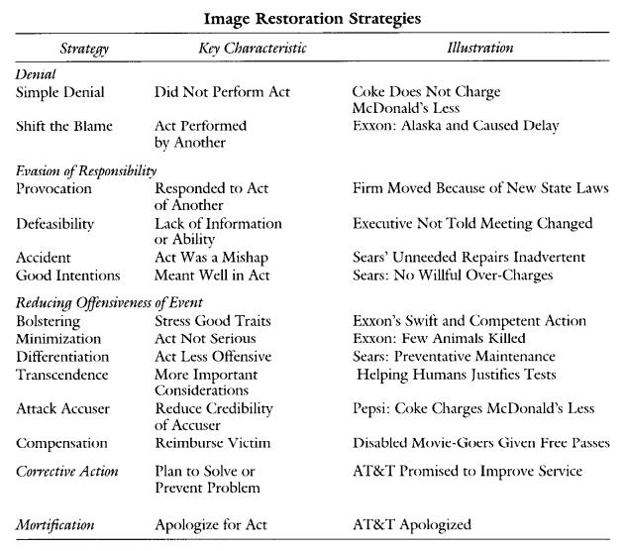
Table 1: Image Restoration Typology by Benoit (1997, 179)

The first image repair strategy presented by Benoit is denial, where we find two different tactics with similar communicative value. The first tactic is simple denial, where an organization denies the actuality of an incident or the merit of any accusations deriving thereof (W. L. Benoit 1997, 179). The second is shifting the blame, where an external actor is blamed for the wrong-doings, so as to remove negative feelings from the organization itself (Benoit and Hanczor 1994, 419, W. L. Benoit 2005, 408). This may also be referred to as scapegoating (Schwarz 2013).
The second categorized strategy is evasion of responsibility, a strategy where main focus is directed at negating the degree of responsibility attributed in the wake of an offensive act/incident. The tactical approaches presented by Benoit range from provocation, defeasibility, accident and good intentions (Benoit and Hanczor 1994, 420). Provocation involves the mentioning of another wrongful act, which this current act was a response to, meaning that the undesirable act committed is reasonable in retrospect of what prompted it (W. L. Benoit 1997, 180). The tactic of defeasibility is to simply state that it was impossible to perform the right act, because of the lack of information or control of events (Ibid: 180). The accident tactic and good intentions tactic either involve the proclamation that the wrongful act was unintentional or that it was done with the best intentions – potentially reducing the degree in which the organization is held accountable (Ibid: 180).
Reducing offensiveness is a strategy type centered on the concept of justification, which has the purpose of minimizing the ill-feelings associated with the given incident (Benoit and Drew 1997, 156). In order to counterweigh the negative feelings towards the organization, positive acts in the past or positive characteristics can be stressed to bolster stakeholders’ positive view on the organization. Otherwise, the simpler tactic of minimization can lessen the offensiveness as well, by implying that the negative consequences of the incident were not that significant (W. L. Benoit 1997, 180). The purpose of the differentiation tactic is to situate the performed act in contrast to other similar, but considerable more offensive acts – thereby changing the harmful perspective, stakeholders may have (Ibid: 181). To further change the perspective of the stakeholders, an organization can make use of the transcendence tactic, where the specific act is placed in a more favorable context. The purpose is to redirect the perspective towards higher values, which may justify the action (Ibid: 181). An organization can also decide to attack the accuser in order to damage ‘his’ credibility and reduce damage towards itself. Benoit’s final tactic in reducing offensiveness is compensation (cash, goods and services), which in short means that an organization can choose to reimburse stakeholders, as a way of easing the tension of the situation (Ibid: 181).
The corrective action strategy does not have any underlining tactics and is considered an essential strategy in repairing one’s image. When an organization makes use of this strategy, it communicates that it has the desire to restore normalcy of the state of affairs present before the offensive act or prevent a reoccurrence of the act (Ibid: 181).
The last strategy, referred to as mortification, is the act of apologizing, begging for forgiveness and taking full responsibility. In the performance of this strategy, it is of crucial importance that the promises and apologies are perceived as sincere – otherwise it could further harm the organization’s image (Ibid: 181).

4.3.1 Critical Reflections
Benoit’s typology of image repair is a widely applied theoretical framework within the field of crisis communication, which has proved proficient in a wide range of case studies of politicians, organizations or movie celebrities – many of which were conducted by Benoit himself (Sellnow and Seeger 2013, 171). However, the theory has been met with criticism from various scholars, who either found it too static or unclear in its presentation or too focused on the sender (Frandsen and Johansen 2007, 214-216). This criticism is mostly presented by Burns and Bruner (2000), whose notions were later addressed by Benoit (W. L. Benoit 2000). Even though, Benoit acknowledges that his theory is focused on the sender, the recipients are still considered essential, as it is outlined throughout the theory (Ibid: 41). Moreover, in 1997, Benoit and Shirley Drew conducted a case study to measure the effectiveness and appropriateness of various image repair strategies in the eyes of the stakeholders. They could conclude that mortification and corrective action were perceived as more appropriate and effective than other strategies. On the other hand, bolstering, provocation, minimization and denial were characterized as the least favorable on those terms (Benoit and Drew 1997). Although these observations may not be considered conclusive, it was an attempt to apply Benoit’s typology in a more interpersonal communication context, which also highlights that there is an interest in further developing the theory (W. L. Benoit 2000, 42). Most of Burns and Bruner’s criticism is acknowledged by Benoit, who sees the limitations of his theory, but still points out that, “Every study must have bounds or it cannot be completed”(Ibid:43). Crisis communication is a complex area, deriving a plethora of different theoretical approaches, used to conduct studies and seek an understanding. Accordingly, to include all the different approaches and perspectives in a study would probably be too extensive and complicated – without any clear conclusion.
Evaluating the theory of image repair concludes that the strategies presented are descriptive with focus on the rhetoric in a crisis. Benoit describes his theory as image repair discourse, where the rhetoric becomes a form of persuasive discourse, meaning that he does not directly acknowledge his image repair strategies as a crisis communication theory (W. L. Benoit 1997, 183). However, he does position his discourse theory in relevance to crisis communication (Ibid: 182), but considering that the theory involves guidelines for how to efficiently communicate in a crisis, it may be defined as a crisis communication theory as well. Even though, the significance of the circumstances of a crisis and perceptions of stakeholders are proclaimed, an in-depth evaluation of the context-based factors, supplementing the significance of the former, seems to be limited. This means that the application of the various image repair strategies becomes undeviating or static to some extent, as the complexity of a crisis is not fully acknowledged – focusing on a ‘standardized’ crisis communication context instead. As a result, the image restoration theory, relying on the rhetorical tradition, sets up a comprehensive typology of strategies applicable in a crisis, which shape the discourse of an organization, but has little focus on the contextual, complex and dynamic parameters of the crisis. Accordingly, its purpose is more directed at describing and evaluating the discourse or strategies in use during a crisis, than providing prescriptive relevance to an organization; a purpose which can be considered valuable within crisis communication research.

4.4 The Situational Crisis Communication Theory by Timothy Coombs
In contradistinction to Benoit’s academic position within the rhetorical tradition, Coombs positions his research within crisis management and crisis communication (Frandsen and Johansen 2007, 227). The main purpose of the situational crisis communication theory (SCCT) is to maintain or recreate a favorable organizational reputation and image, which is why Coombs’s theory is widely utilized within public relations research (Sellnow and Seeger 2013, 91). Coombs argues that the utilization of SCCT can protect the organizational reputation during a crisis, as it provides a prescriptive system for efficiently matching the response strategies with the specific situation (Coombs and Holladay 2002, 183). SCCT has been inspired by previous studies on crisis response strategies, where outlined strategies (Benoit et.al.) have been organized from the perspective of attribution theory. Generally embedded within attribution theory is the idea that stakeholders of an organization will make attributions about a crisis, based on the available information. A crisis situation varies greatly on the basis of this, as it determines the degree of perceived responsibility towards the organization or other actors (W. T. Coombs 2009, 110). Moreover, the SCCT is built on the basis of the expectation that it can either “alter attributions about the crisis, or change perceptions of the organization in crisis” (Ibid: 110), where both of them, separately or combined, can protect the organizational reputation. With the focus at the situational aspects of a crisis, Coombs’s theory differs from Benoit’s theory, primarily, due to an endeavor to contextualize the rhetorical response strategies. The perspective of the attribution theory, together with the public relations aspect and an organizational aspect, enable sociological/psychological context factors – influencing the applicability and effectiveness of response strategies in a specific crisis (Frandsen and Johansen 2007, 229).
On the basis of whether crisis response strategies are used in altering attributions about a crisis or perceptions of the organization, these are organized within four presented postures or clusters. The constructed clusters of SCCT, involving strategies with similar traits, are denial strategies, diminish strategies, rebuild strategies and bolstering strategies (W. T. Coombs 2009, 110). In short, the purpose of the first cluster of strategies is to remove any connection between the company and the crisis. The second cluster of strategies is designed to reduce attributions (limit degree of responsibility), where the purpose of the third cluster is to improve or repair an organization’s reputation, by accepting full responsibility. The final strategy cluster seeks to supplement the three other clusters, by building on a positive relationship between stakeholders and organization (Ibid: 110). The specific strategies within each cluster are presented in Table 2. As mentioned earlier, the strategies in the SCCT draws on the image restoration strategies of Benoit, where Coombs’s representation functions as the foundation of SCCT, but it is not the focus of the theory, as how to use the response strategies is more essential (W. T. Coombs 2007, 163).
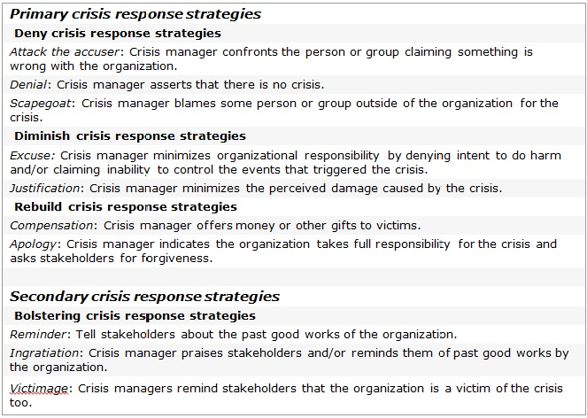
Table 2: Crisis Response Strategies by Coombs (2007, 170)

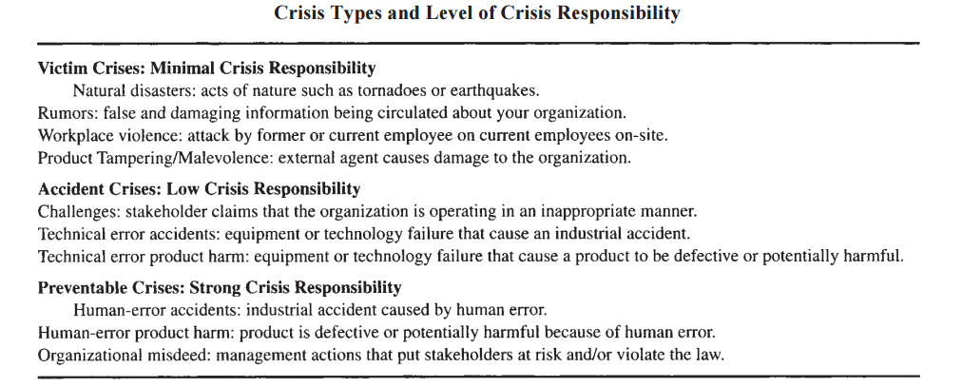
A key aspect of Coombs’s theory is to understand the situation, where it is important for an organization to assess the level of reputational threat, invoked by a crisis (W. T. Coombs 2007, 166). The reputational threat is shaped by the situation, where, Coombs points to three essential and influential factors. The first factor is the type or frame of the crisis, which is shaped on the basis of the attribution theoretical perspective. Consequently, embedded within this factor is the initial crisis responsibility attribution, which signifies the degree in which stakeholders believe the organization to be responsible for the offensive incident. On that account, three types have been determined in order to categorize crises, being victim crises, accident crises and preventable crises and can be seen in Table 3 (W. T. Coombs 2009, 111). Coombs sets up a direct linkage between attributed responsibility and the level of reputational threat. In a victim crisis, an organization is perceived to be a victim of some unfortunate event, meaning that minimal responsibility will be attributed (mild reputational threat). The circumstances of an accident crisis will generate a low degree of ascribed responsibility, as the circumstances of the event are perceived to have been out of control (moderate threat) – in contrary to the latter, where the organization could have prevented the event from happening. Consequently, a preventable crisis generates a high degree of attributed responsibility (severe threat) (Ibid: 111).
Table 3: (W. T. Coombs 2009, 111)
The second significant factor of reputational threat assessment relies on the crisis history of the organization. Generally, it is believed that if an organization has been through other crises, especially concerning similar issues, the reputational threat of the current crisis will be intensified. Moreover, it signifies that the organization has an ongoing issue, which it has failed to address properly (W. T. Coombs 2007, 167). This applies with attribution theory, where a history of crises can invoke unreliability in the eyes of stakeholders, who, as a consequence, may treat a victim crisis as an accident crisis and an accident crisis as a preventable crisis. As a result, a history of crises can affect the degree of stakeholder attributions and the intensity of reputational threat (W. T. Coombs 2009, 111-112). This applies to the last influential factor as well, being the prior relational reputation of an organization. In short, this factor is determined on the perception of whether an organization has treated its stakeholders well or poorly in the past. In the case of the latter, it shows that an organization has shown little concern for its stakeholders, meaning that the trustworthiness of the organization is limited in a crisis (W. T. Coombs 2007, 167). In connection with this factor, studies have been conducted on the assumption that a positive prior relational reputation might build up as reputational capital and serve as a buffer in a crisis – a so called halo effect. However, studies could not prove this effect a reality, but it was possible to conclude the negative influential effect of a bad reputation (W. T. Coombs 2009, 112). The factors of crisis history and prior relational reputation can to some extent be seen as overlapping, as they both represent organizational parameters of the past, and they can influence the intensity of the reputational threat in a crisis. Additionally, as the attribution theory is ascribed as a context factor, constituting the variables of the theory, the reputational threat factors are also constituted from the perspective of public relations and the neo-institutional organization theory. The public relations aspect signifies the relation between an organization and its stakeholders and a temporal measurement thereof. The neo-institutional organization theory, on the other hand, signifies the sender’s organizational legitimacy and reputation, attached to the relational aspect regarding stakeholders (Frandsen and Johansen 2007, 229-233).
Following the assessment of the crisis type, crisis history and prior relational reputation, Coombs has set up recommendations for effectively making use of the various response strategies. These recommendations, which can be seen in Table 4, are based on the theoretical framework of SCCT and validated through tests on stakeholders (W. T. Coombs 2009, 112).

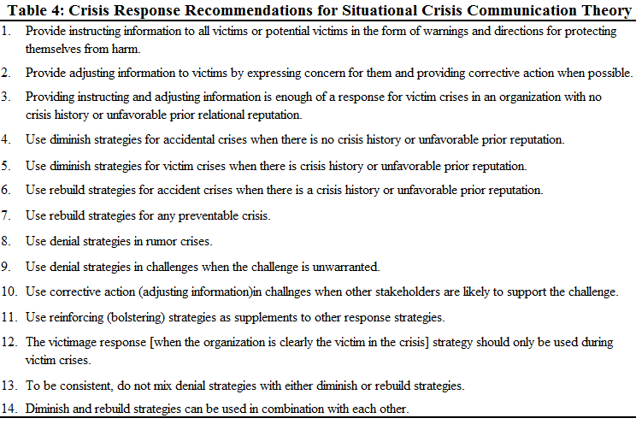
As portrayed by SCCT, the key to protect one’s organizational reputation during a crisis is to select the most appropriate and applicable response strategies. Determined by factors of reputational threat, it is argued that as the reputational threat in a crisis situation increases, an organization will have to make use of more accommodative strategies: increasingly take more responsibility in accordance with stakeholder interests (W. T. Coombs 2009, 112).
(Developed by Author (W. T. Coombs 2015, 152))

4.4.1 Critical Reflections
Unlike the rhetorical and text-oriented approach to crisis response strategies, Coombs’s theory of situational crisis communication has a higher focus on the context, where he relies on theories and test studies rather than case studies. This is an approach valued by Coombs, as mere speculations turn into knowledge (Ibid: 113). However, Frandsen and Johansen argue that the tests, conducted by Coombs and others to falsify or prove an hypothesis, are too simple in their construction, as they rely on static information in an constructed context and stakeholders’ causal attributions thereof. Consequently, SCCT does not fully account for the dynamics of a crisis, where the situation (information) and stakeholder attributions change during a crisis. Moreover, SCCT does not differentiate between stakeholders – other than categorizing them as primary or secondary. As a result, the expectations of attributions become static as well, because it would be a plausible assessment that employees, customers or the media may perceive information differently (Frandsen and Johansen 2007, 245-246).
Despite the critical view on the method supporting SCCT, the theory still present high value within the studies of reputation, and it does provide a prescriptive approach to crisis response strategies – on the basis of contextual factors. On the other hand, it can be argued that it is too limited to studies of reputation and lacks rhetorical eloquence within each SCCT category, as it is considered secondary (Sellnow and Seeger 2013, 96, W. T. Coombs 2009, 110). Considering the image restoration theory’s reliance on the rhetorical tradition, it would be fair to assume that Benoit’s theory has more rhetorical value as a supplement to Coombs’s theory.

4.5 A Unification of the Rhetorical and Situational
To construct a theoretical framework of crisis communication for practical and discursive analytic usage, an amalgamation of the rhetorical image restoration theory and the context-oriented SCCT can be a beneficial approach. In supplement to the different theoretical backgrounds of the theories, another major difference is Benoit’s sender-oriented focus versus Coombs’s receiver-oriented focus, which would indicate that the two theories are opposites. However, they still operate within the same parameters – concentrated at the process, where an organization or individual (sender) communicates a message with strategic value to the stakeholders (receiver). Additionally, the crisis response strategies presented for each theory are similar in their symbolic construction, as Coombs used Benoit’s typology as inspiration. This fundamental alignment with two different perspectives facilitates the construction of a crisis communication tool, building on the strengths and parameters of the theories (see Model 1).
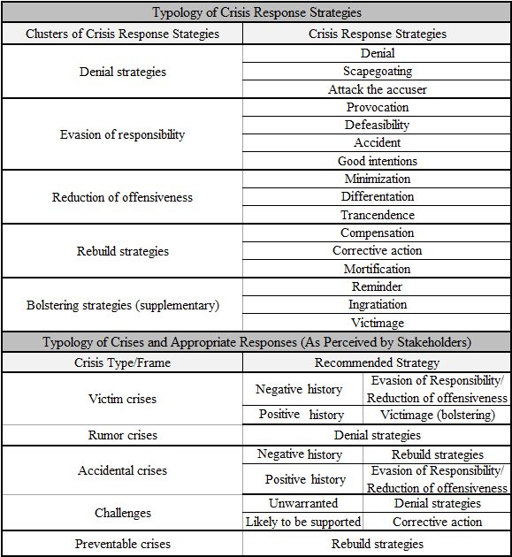
Model 1: Amalgamated Framework of the Image Restoration Theory and SCCT.

(Developed by Author)
The constructed typology of crisis response strategies is based on Coombs’s notion of clusters, which to a greater extent conceptualizes the differences between strategies, but the cluster of diminish strategies has been divided into two. Benoit’s terminology has been used to distinguish these two, as evasion of responsibility and reduction of offensiveness are essentially embedded within Coombs’s perception of diminish strategies – more specifically concerning excuse and justification (W. T. Coombs 2007, 170). This has been done to more sufficiently characterize the nature of the utilized response strategies in the examination of a specific case. In the cluster of denial strategies, it has been assessed that the attack the accuser tactic is more fitted to this categorization, as this type of communication generally seeks to deny the validity of the accusations by confronting the accuser (W. T. Coombs 2009, 111). The specific crisis response strategies in the evasion of responsibility cluster are based on Benoit’s typology. While they correspond with Coombs’s idea of an excuse, the four types defined by Benoit provide a more differentiated analysis of an organization’s applied crisis response strategies. The same evaluation applies to the reduction of offensiveness cluster, which corresponds with the justification aspect presented by Coombs. Alterations of this cluster involves moving the compensation tactic down to the cluster of rebuild strategies, as it is represented by Coombs, because the understanding of compensation more naturally correlates with corrective action (Ibid:111). Bolstering has become a cluster on its own and acknowledged as a supplementary strategy, because it is usually expressed in connection with another strategy (Ibid: 112). Moreover, in Coombs’s outline of strategies, there are three different types of bolstering, which from an analytical perspective could prove useful. The typology of crisis types and appropriate responses is based on Coombs’s theoretical recommendations of how to use the crisis response strategies – based on reputational threat (W. T. Coombs 2015, 152), but with necessary alterations of the terminology, in accordance with the model. Moreover, the positive and negative history depictions encapsulate, whether or not an organization has a history of crises and/or a poor prior relational reputation.
The evaluation of the two crisis communication theories, constituting the specifications of the constructed model, accommodates the theoretical frameworks and understandings of crisis responses presented by Benoit and Coombs. Moreover, the model is structured in order to accommodate an analytical process of determining crisis type, utilized strategies in connection with the CSR discourse in play, and supposed efficiency thereof. On the other hand, considering the critical reflections on each theory, the model can have insufficiencies in correspondence with the study (determination of efficiency on a discursive level), which may be improved through the theoretical properties of Frandsen and Johansen’s Rhetorical Arena theory.

4.6 The Rhetorical Arena
The Rhetorical Arena by Finn Frandsen and Winni Johansen, constituting a dynamic crisis communication model, is both sender and receiver-oriented and directed from a multi-vocal perspective – encapsulating the contextual dynamics of a crisis. Frandsen and Johansen do not construct a typology of crisis response strategies like Benoit and Coombs, because the specifications of the influential context and rhetorical factors are of greater importance. According to Frandsen and Johansen, The Rhetorical Arena aims at exploring and defining the dynamic and complex processes of crisis communication – representing the third step of crisis communication research, where Benoit and Coombs represent the first two (Frandsen and Johansen 2007, 251-252).
The construction of The Rhetorical Arena model relies on the theories of both Benoit and Coombs, but primarily concerning their constructed crisis response strategies and Coombs’s approach to context factors. In terms of the multi-vocal approach applied by Frandsen and Johansen, the theoretical perspectives of Priscilla Murphy’s (1989) representation of the game theory and the chaos theory, represented by Mathew Seeger, Timothy Sellnow and Robert Ulmer (2003), are included as well – encapsulating understandings of crisis dynamics and the influential nature and motivational interests of different communicating actors (Ibid: 267).
Frandsen and Johansen’s rhetorical model is a two-layered model and consistent of two components, which represent the external and internal parameters of the crisis communication process. The first component is referred to as the context model, introducing the multi-vocal approach towards the communication. The second component is of a rhetorical or socio-discursive nature and is referred to as the text model, operating within the parameters of context, medium, genre and text (Ibid: 252). However, in more present accounts of The Rhetorical Arena model, Frandsen and Johansen label the two components as the macro and micro components (Frandsen and Johansen 2012). The four represented parameters within the second component signify an overlap in the terminology of The Rhetorical Arena model (context versus context). Generally, the first matter of context depicts an overview of the communicative evolvement of the case (involvement of actors), where the other depicts the context influential to a specific communicating actor. To avoid potential challenges in the comprehension of the study, the usage of macro and micro in the description of the two model components will therefore be applied.

4.6.1 Macro Component: The Multi-vocal Arena
The macro component of The Rhetorical Arena represents the figurative arena of communications, which arises in the wake of a crisis inflicting event and includes all the influenced actors – whether they are stakeholders or the organization itself. The arena is considered closed in the sense that all actors communicate and act within the parameter of the crisis situation: publicly displayed communications are directed at the specific crisis, but more actors may enter during the crisis. The key aspect of the arena is that it is not enough to understand the communication of one sender, because everyone in a crisis has a voice with potential relevance, which needs to be understood (Frandsen and Johansen 2007, 275). Consequently, crisis communication is not limited to include the communication applied by an accused organization in a crisis, defending its image and reputation: the actions and expressed accusations, rumors and anger of stakeholders towards an organization are considered crisis communication as well. The magnitude of actors within the arena varies in terms of the complexity of the situation, but all of them have both the role of a sender and a receiver (Ibid: 276). The complexity aspect of the arena revolves around the fact that the actors, with varying influential standing, can either communicate with, against, past and/or about each other, which has been illustrated in Model 2 (Ibid: 277).
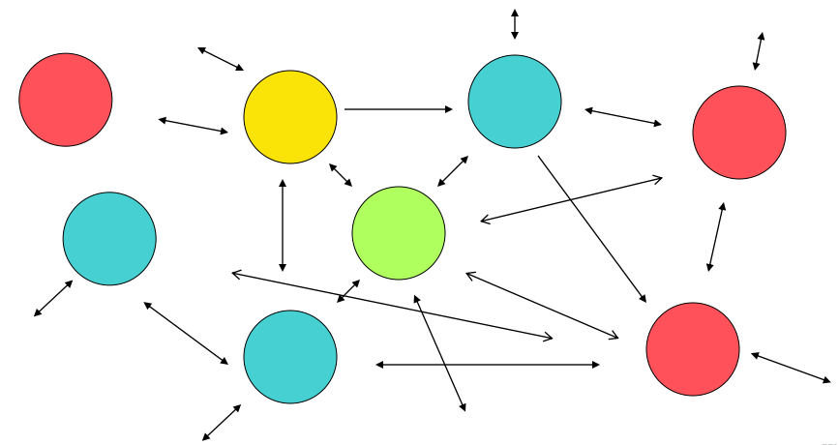
Model 2: The Rhetorical Arena: Macro Component (Frandsen and Johansen 2012)

The different influential standing of the many actors within the arena is determined on the basis of their degree of power, communicative access, strategic advantage and social and economic capital, which differentiates the stakeholders from each other. Based on the influential capital of each actor/stakeholder, an organization can direct its crisis communication at the most prominent, arguably increasing the efficiency of the communication applied and its image and reputational defense (Ibid: 277-279).

4.6.2 Micro Component: Inside The Rhetorical Arena
The micro component of The Rhetorical Arena represents the rhetorical or socio-discursive aspects of the communication within the arena. This model component is seen as a supplement to the already existing crisis response strategies of Benoit and Coombs, where the context, medium, genre and text parameters and choices influences the application of the specific strategies. The various strategies are directed by rhetorical conditions, which to some extent frame the crisis communication in place. The micro component is inspired by text and discourse theories, constituting a socio-discursive model with three entities, being senders, receivers and the crisis communication itself – together with the four parameters represented (illustrated in Model 3) (Frandsen and Johansen 2007, 280-281). The senders and receivers refer to the actors of the macro component, where they, in the communication process, attempt to create meaning towards themselves and others – defined by interests, behavior and attributions (Coombs). The crisis communication entity signifies the crisis response strategies available and all of the connected forms of expression, meaning the use of words, as well as pictures, actions, and so on. Consequently, Frandsen and Johansen apply a more complex and dynamic configuration of crisis communication – in order to accommodate the multi-vocal arena (Ibid: 281-282).
Model 3: The Rhetorical Arena: Micro Component (Frandsen and Johansen 2007, 284)
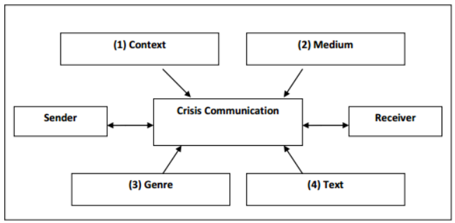
The first parameter of the model is labeled as context, which is the main frame of the crisis communication, and it encapsulates the external and internal sociological and psychological contexts. The sociological context aspect can be characterized by three different sub-contexts, being the societal and cultural context (national or international communication), organizational and institutional context (type of organization) and the situational context, relating to Coombs’s representation of the reputational threat of a crisis, based on crisis type, as well as other conditions of the situation (time, place, target) (Ibid: 285). The ways in which the communication is facilitated is a significant parameter and labeled as the medium. Frandsen and Johansen differentiate between three main groups of mediums, being the printed media (newspapers), the electronic media (television) and the new media (internet, social media). The choice of medium depends on the method of which organizations wish to communicate and who they want to communicate with – for example through the internet to quickly reach stakeholders online (Ibid: 291-294).
The genre parameter is an aspect, which defines the generic nature of texts (Ibid: 295). If a group of texts share the same communicative purpose and are similar in their rhetorical structure and content, then it will be considered a genre. When referring to genre in a crisis communication context, it is determined as communication channels, meaning that it does not have to be an actual text; it can also be internal meetings and press conferences. In the case of organizations, the press release genre will be the primary genre applied, facilitating a larger amount of information, which can be framed in the right manner – based on their strategic approach. (Ibid: 296). Press releases are defined as a genre with the purpose of being ‘absorbed’ by another genre (news articles), meaning that the content is a pre-formulation of what reaches the larger part of the audience (Ibid: 298).
The last parameter is text, which encapsulates how rhetorical tactics are actualized and expressed. This parameter signifies the specific discourse and/or actions applied, meaning that it is the most essential parameter of this study. There are many ways in which each crisis response tactic can be conveyed. Frandsen and Johansen take tactics of denial as an example. There is a difference in how a denial strategy is expressed: denial can be directly expressed (‘we did not poison the water’), but also indirectly (‘it is a fact that the water is clean’) (Frandsen and Johansen 2007, 300). The text parameter is highly influenced by the other parameters, because the language and the frame thereof changes in accordance with the situational factors (crisis type, cultural setting and so forth) (Ibid: 300-301). Neglecting the various crisis situation determiners can be harmful to the crisis communication in play. One major issue can be the tactical coherence of the crisis communication, where different tactics are used in supplement to each other. If an organization denies its implication in the incident and at the same time expresses the desire to compensate the victims, then there is a tactical misalignment (Ibid: 301), which is pointed out by Coombs as well (W. T. Coombs 2015, 152). Accordingly, this can derive conflicting discourses, which can counter the communicational effect an organization wishes to achieve.

4.7 Reflective Deduction
Frandsen and Johansen’s Rhetorical Arena model does not directly apply prescriptive guidelines for how an organization should communicate in a crisis, as done by Coombs (Ibid: 159) and to some extent Benoit (W. L. Benoit 1997, 182-184). However, they provide an extensive range of parameters with direct influence to the crisis communication process, which can prove valuable in a practical sense, but more in terms of an evaluation and analysis of the communication in an organizational crisis.
The macro component of the two-layered model can be utilized in a preliminary evaluation of the organizational crisis of Mozilla, where the various actors and their overall communicative role can be determined. A determination of external actors, their interests in play and what they communicate can be valuable – so as to determine whether or not the organization, through their discourse, sufficiently addresses the perceived issue of the crisis – also concerning the analysis of conflicting discourses.
As mentioned in the beginning of this chapter, The Rhetorical Arena will function as the frame of this study’s theoretical framework of crisis communication. Accordingly, the socio-discursive or micro model component will represent this frame, where the established unification of Benoit and Coombs’s crisis response strategies will be the center of the model, which can be seen in Model 4.
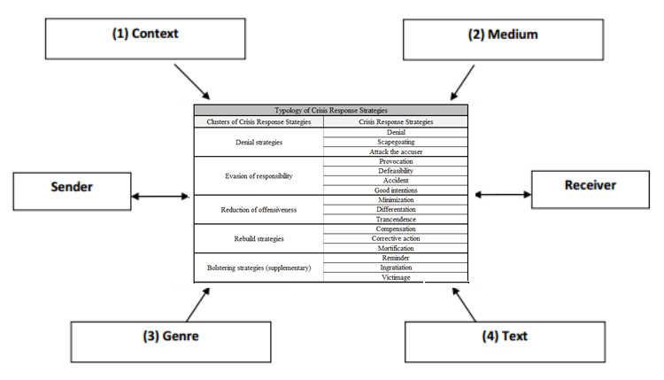
The developed model has been labeled crisis communication matrix, as it represents the fusion of various notions within crisis communication, which have been accounted for in this chapter. The position of the established typology of crisis response strategies does not completely replace the crisis communication entity of the socio-discursive model (non-verbal actions not included). Nevertheless, from a purely analytical perspective, with the focus on discursive properties, it signifies the essence of the crisis communication in use – in terms of utilized strategies. Subsequently, the external parameters have the analytical purpose of evaluating the circumstances of the crisis and the applied crisis response strategies in the Mozilla case – so as to determine the theoretical communicative efficiency. The situational aspect of Coombs’s theory (crisis type) is placed within the context parameter, where the established recommendations will be applied as well. The genre and especially the text parameters are considered significant in the analysis of the case, as they have a direct focus on the more discursive aspects within the communication. Furthermore, text is a parameter under the influence of the additional parameters. As a result, the text and genre parameters will serve as a link between the crisis communication analysis of the case and the critical discourse analysis. The link can be made due to the latter’s focus on describing, interpreting and explaining language and discourses – in terms of socio-discursive practices, where also the context factor of the micro-component can be seen as relevant (Fairclough 2010, 132). The specifications surrounding analysis and theories of discourse will be elaborated in Chapter 5.
Model 4: Crisis Communication Matrix (Developed by Author)

5. Analytical Discourse Framework from a Critical Perspective
To analyze the discourse within the case – so as to determine discursive misalignments (conflicting discourses) between CSR and crisis communication, undermining the efficiency of the crisis communication – critical discourse analysis (CDA) will be the primary analytical method applied. Accordingly, a theoretical understanding of the influential nature of language and discourse must be reached, as well as a methodological understanding thereof.

5.1 Understanding Critical Discourse: Theory and Method
The notion of critical discourse analysis has its origin in what is referred to as the tradition of critical linguistics. This tradition is followed by linguistics like Roger Fowler, Robert Hodge, Gunter Kress and Tony Trew (1979), who studied the ways in which language and grammar can be used as ideological instruments in the process of creating meaning. Alterations in meanings of a text, in accordance with different discursive choices, signify the purpose of analyzing such texts – so as to reveal their underlying ideology (Machin and Mayr 2012, 18). In the line of critical linguistics is the understanding that our perception of our culture is inseparable from language: societal knowledge is intertwined with the perceived dissemination and regulation of the practice of language, in the sense that language is seen as a social practice (Ibid: 3-4). Society is constituted by specific practices, ideas, values and identities, which are all bodies of society being promoted and naturalized through language by people, who have particular views of the world. These particular views of the world are what regulate society as well as language usage; how people use language in a text is therefore intertwined with the societal context (Ibid: 4). Consequently, analysts will focus on what is unsaid in a text, but also what is assumed as an actuality – in order to reveal the underlying ideology (views of the world).
One of the most prominent practitioners of CDA is Norman Fairclough (1992), who has criticized the critical linguistics tradition’s inability to address an interrelationship between language, power and ideology – an interrelationship in focus in the theoretical framework of CDA. Nevertheless, CDA shares the understanding that language both shapes and is shaped by society. Moreover, scholars like Fairclough (2010) Ruth Wodak (2001) and Teun Van Dijk (2001) studying CDA sees language as a means of social construction (Machin and Mayr 2012, 4).
In the Mozilla case, CSR discourse is prominent within the organization’s crisis communication, where the CDA focus on power relations can be recognized as a significant factor within CSR discourse (Aasprong 2012). Hence, the concept itself is a product of society, which is conveyed through language/discourse and can be seen as a social construction, as well as a public relations practice (Michotte 2008, 2). In the representation of Ernesto Laclau and Chantal Mouffe’s Discourse Theory (1985):“A discourse is understood as the fixation of meaning within a particular domain” (Jørgensen and Phillips 2002, 26). Accordingly, CSR can be understood as a particular field, as it is referred to from a CDA perspective (Fairclough 2010) and therefore considered more applicable to the study. The understanding of CSR as a social field derives a discursive meaning thereof – in accordance with the sender’s perception. On the other hand, crisis communication may be seen as a field as well, in which the CSR field is positioned, arguably creating a more complex communicative scenery. To efficiently understand and evaluate the discursive meanings of the case, this chapter will focus on CDA – namely represented by Fairclough, as he provides a more comprehensive method (Ibid: 7). As a theoretical foundation of the social constructionist approach, Laclau and Mouffe’s Discourse Theory – represented by Marianne Jørgensen and Louise Phillips (2002) – will be applied as well (Ibid: 24).

5.2 Ernesto Laclau and Chantal Mouffe’s Discourse Theory
To create an understanding of discourse, including the two essential aspects of social and meaning, Laclau and Mouffe fuse the two theoretical traditions of Marxism and structuralism. With the former representing the social and the latter encapsulating discourse meaning, the two fused traditions establish the poststructuralist theory. Embedded within this theoretical perspective is the idea that “the whole social field is understood as a web of processes in which meaning is created” (Jørgensen and Phillips 2002, 25). In the understanding of Laclau and Mouffe, the social and the physical reality are completely interdependent, where reality is superimposed by the social, because everything is determined through discourse. Accordingly, social practices are understood as fully discursive, where the poststructuralist theory operates within the same concepts to define and analyze the social as well as the discursive meanings (Jørgensen and Phillips 2002, 35). Moreover, it is asserted that what we refer to as ‘society’ is not an objectively perceived phenomenon, but a meaning of society, created in a way that it appears objective and natural (Ibid: 33-34). As a result, society (ideas, values, identities) is not fixed, but ever-changing as the result of contingent, discursive processes (Ibid: 34). On this account, Laclau and Mouffe also represent the concept of hegemony, deriving from the work of Antonio Gramsci (1971). As meaning is structured through discourses within a particular field, social consensus can arise in terms of those discourses, where they can become dominant in social interpretation. Hegemonic discourses will structure social practices, where they will appear natural and be perceived as ‘common sense’ (objective) – also similar to the ‘views of the world’ aspect of the critical linguistics tradition (Jørgensen and Phillips 2002, 48). The principle of hegemonic discourses is described by Mouffe (2008) as:
“The practices of articulation through which a given order is created and the meaning of social institutions is fixed, are what we call ‘hegemonic practices’…What is at a given moment accepted as the ‘natural order’, jointly with the common sense that accompanies it, is the result of sedimented hegemonic practices” (Mouffe 2008, 4).
Articulation is how Laclau and Mouffe portray how the structured totality of discourses generally is created, as the articulatory practice establishes a relation among elements, modifying and depicting their value (identity) on those terms (Laclau and Mouffe 1985, 105). Within this context, an element has not yet been fixed and articulated within a discourse, and therefore has no collective meaning. After the practice of articulation, the element has been articulated and has a relational meaning, where it is referred to as a sign/moment (Ibid: 110). These are some of the most essential concepts in Laclau and Mouffe’s theory’s outline of the creation of meaning and definition of discourse. Jørgensen and Phillips illustrate discursive relations with the metaphor of a fishing-net: linguistic signs are the ‘knots’, having particular positions in the net and deriving meaning from their difference from one another, becoming a moment. It is the fixation of articulated elements (signs) that creates meaning, where each sign has its own meaning/identity, changing as it is positioned in a particular relation to other signs. Nevertheless, they are contingent (fixed and challenged by negotiations, conventions and conflicts in society), which means that each sign and signs in relation to signs have the potentials to create a specific and desired discursive meaning, but not necessarily (Jørgensen and Phillips 2002, 25). Accordingly, creating meaning within a text can be a conscious process in the hands of the sender, who has the desire to fix a specific meaning, which accommodates the sender’s ‘views of the world’ and fits a purpose. According to Jørgensen and Phillips, the contingency aspect makes this process impossible to perform with certainty, which is where discourse analysis has its entry point: the examination of which meaning was in fact created by the fixed signs (Ibid: 26).
In close correlation with the linguistic understanding of discourses presented thus far are the concepts: nodal points, closure and the field of discursivity. When a sign has a greater significance within a discursive context than others, it will be referred to as a nodal point, signifying a center of fixation or a reference point, where the meanings of other signs are partially ordered, based on their relationship with the nodal point. A nodal point is also referred to as a floating signifier, because it bears no direct meaning on its own, but it directs/signifies an order between other signs (Jørgensen and Phillips 2002, 26). In accordance with the study, the CSR concept itself may be seen as a nodal point or floating signifier in a discursive context, where an element like ‘justice’ has a specific meaning due to its relationship with the CSR reference point. Fixated as a moment in relation to CSR, justice may signify ‘human rights’, where it may signify ‘punishment’ in relation to a reference point like ‘law’. Consequently, the establishment of discourses, in the process of sign fixation to create meaning, excludes other possible meanings that a sign could have, as to create a unified system of meaning. This is referred to as closure, signifying a temporary stop in the fluctuations of alternate meanings of signs. All the possibilities of meaning embedded within a sign and excluded by the discourse are called the field of discursivity, encapsulating all meaning absent from the discourse in question. The unified system of meaning within the discourse (closure) cannot be seen as constant due to this field of discursivity, where its range of alternative constructions of meanings or identities derives a potential to undermine and disrupt this unified system – a potential limited by the referential nodal points (Jørgensen and Phillips 2002, 27-28).
The disruption of meaning occurs in the presence of mutually excluding identities, where they make contrasting demands within the same field. This is referred to as social antagonism, signifying a conflict and power struggle among discourses and identities (Ibid: 47-48). According to Jørgensen and Phillips, seeking inspiration from Fairclough, Laclau and Mouffe’s conceptualization of the field of discursivity may be too including, as all discourses, constituting variants of meanings/identities are of equal status, where some should be seen as more likely to invoke a discursive conflict. They point to the concept order of discourse instead, which is applied within critical discourse analysis theory as well, and it represents the discourses more likely to reach a state of social antagonism (Jørgensen and Phillips 2002, 55-57). From Fairclough’s perspective, the order of discourse concept denotes a network of social practices, in the sense of different social fields, which are consistent of discourses potentially in a hegemonic struggle with each other across fields due to social and cultural change (Fairclough 2010, 555).

5.2.1 Reflections
The combination of Laclau and Mouffe’s concepts represented within Discourse Theory establishes an understanding of inter-reliance between discursive meaning and the concept of hegemony. It has been declared that discourses are created through the articulation of elements, constituting signs, where relational fixation thereof modifies meanings/identities and creates moments, which are unified into one discursive meaning – through the exclusion of conflicting identities. The view of discourse theorist Michel Foucault (1969) on the formation of discourses can be seen as substantiation to Discourse Theory, as it is recognized that discourses are composed of signs in the same meaning-bearing sense. However, he also highlights the complexity of discourses, relating to relations between institutions, behavioral patterns, social processes and systems of norms – with relevance to questions of power (Foucault 2002, 51-54). This notion of Foucault can be seen as a main principle within Fairclough’s theoretical perspective on CDA, which will be elaborated later.
From the perspective of Discourse Theory, the process of the exclusion of conflicting identities or meanings, represented through the ‘order of discourse’, can be seen as directly linked with the concept of hegemony (power/dominance), as unified meaning is created through both articulation and discursive struggles for hegemony. Moreover, on the account of hegemonic practices: “hegemony and discourse are mutually conditioned in the sense that hegemonic practice shapes and reshapes discourse” (Torfing 1999, 43). The contingent nature of discourses (meaning can never be ultimately fixed), together with its interconnectedness with social structures, opens up constant social struggles to define (discursive) identities and society as a whole (Jørgensen and Phillips 2002, 24). Consequently, the concept of hegemony presents “General validity for analyzing processes of disarticulation and rearticulation that aim to establish and maintain political as well as moral-intellectual leadership” (Torfing 1999, 101). This understanding of hegemony may prove useful in the analysis of conflicting discourses within the Mozilla case, as it focuses on the articulation in use to establish and maintain control, which to some extent relates to the articulated CSR discourse aiming at controlling the reputational crisis situation. Supplementary, the power struggles between identities, constituted by discourses, can present lines of conflict. In order to locate these lines of conflict within a text, one can determine different understandings of reality, and where they are in antagonistic opposition to one another. Lastly, one can determine the social consequences of each prevailing reality (Jørgensen and Phillips 2002, 51).

5.3 The Theory and Method of Critical Discourse Analysis
The main purpose of critical discourse analysis (CDA) can be asserted as an explanatory critique (Fairclough 2010, 7), which seeks to produce interpretations and explanations of social life. Accordingly, CDA has a focus on the effects of the discursive aspects of power relations – including questions of ideology in the sense of being ‘meaning’ in the service of power (Fairclough 2010, 8). Moreover, the most essential role of discourse from a social perspective is that it signifies “the speaking and writing in the exercise, reproduction and negotiation of power relations, and in ideological processes and ideological struggle” (Fairclough 2010, 129); hegemonic practice takes the form of discursive practice (Ibid: 129).
According to Fairclough, three basic properties constitute CDA, being that it is relational, dialectical and transdisciplinary. The relational aspect is highlighted from a perspective of discourse, where an understanding is that it is impossible to independently define discourse as merely an entity or object; a deeper understanding of discourse’s complexities can only be reached in the process of analyzing sets of relations. Generally, CDA operates within the complex nature of social relations – encompassing relations between communicative processes, languages, discourses and genres, as well as other elements seen as interconnected in social activity and praxis (persons, institutions) (Fairclough 2010, 3). Consequently, interconnectedness between social structures and discourse, where language is a social practice, is an essential parameter of the social constructionist approach to CDA (Machin and Mayr 2012, 4). Furthermore, discourse is recognized as complex and as a facilitator that brings in complex relations, which constitute social life – in terms of both meaning and creating meaning (Fairclough 2010, 3).
From Fairclough’s perspective, the relational aspect presents factors of relations within the CDA approach, which are considered dialectical in character. Relations between objects that are not excluding, but still different in the social process are termed dialectical relations. This means that dialectical relations can be perceived as different moments within the same order of discourse. In the relation between discourse and power, these two elements are considered different moments of the social process, but power is still partly or can be internalized in discourse and vice versa – in the sense that power can be achieved and maintained through discourse (Fairclough 2010, 4). In accordance with this, Fairclough asserts:
“Social activity or praxis consists in complex articulation of these [power and discourse] and other objects as its elements or moments; its analysis is analysis of dialectical relations between them and, and no one object or element (such as discourse) can be analyzed other than in terms of its dialectical relations with others” (Fairclough 2010, 4).
Fairclough sees discourse as in a dialectical relationship with other social dimensions, meaning that he differentiates between the discursive and non-discursive, where Laclau and Mouffe perceive everything as discursive. This means that Fairclough does not just understand discourse as an entity that shapes and reshapes social structures, but also as a social practice that reflects them (Jørgensen and Phillips 2002, 61).
The analysis of the discourse itself is not in focus within CDA, but rather the analysis of dialectical relations between discourse and external elements or moments, and internal relations within the discourse as well (Fairclough 2010, 4). Where external dialectical relations are made and the boundaries between disciplines (linguistics, sociology and politics) are mitigated, the analysis form of CDA may be referred to as transdisciplinary. This term signifies that the analysis form of CDA entails a somewhat abstract dialogue between the theoretical and methodological parameters of each discipline (Fairclough 2010, 4). In other words, the transdisciplinary approach enables a theory-driven process, constituting a methodology in terms of objects of research, which have the function of establishing ‘points of entry’ for a discourse analyst. Fairclough argues that such a research object could be ‘strategies for overcoming a crisis’. Hence, the theory or discipline of crisis communication and strategies involved can be seen as having a discursive character. A ‘point of entry’ can therefore be to focus on “discursive features of strategies [explanations, justifications and legitimations] and how they may contribute to their success or failure” (Fairclough 2010, 5-6). The discursive nature of the articulated explanations, justifications and legitimations in the Mozilla case are primarily in terms of CSR (the order of discourse), which directs a specific ‘point of entry’ for a critical discourse analysis.

5.3.1 The Three-dimensional Framework of Critical Discourse Analysis
In the previous paragraph, it has been made clear from a CDA perspective that discourse can be considered both constitutive and constituted in terms of social structures, and it operates within specific fields like medical discourse, political discourse or CSR discourse. Moreover, discourse signifies a specific way of speaking, deriving a meaning from a particular perspective, which can be said to be interrelated with social relations (Jørgensen and Phillips 2002, 66-7). Of the process of dialectical relations, Fairclough represents three major ways of which discourses relate to other social elements (social practices or social events): “As a facet of actions; in the construal (representation) of aspects of the world; and in the constitution of identities” (Fairclough 2010, 232). In the analytical process, corresponding to these relational ways, three discourse-analytical categories are highlighted, being genre (could be a news article, constituted by specific semiotic ways or relations between signs of acting and interacting), discourse (semiotic ways in which social actors’ ‘views of the world’ are expressed) and style (the ‘way of being’ or identity, which is expressed through semiotic ways as well) (Ibid: 232).
As represented by Jørgensen and Phillips, two dimensions of discourse are valuable to use as focal points in an analysis. These are determined by Fairclough (1995b), being the discursive event (an incident where the discourse is produced) and the orders of discourse (“totality of discursive practices of an institution, and relations between them” (Fairclough 2010, 96)), where also genre has its significance, because it signifies a direction of the discursive practice (production and consumption of text and talk), in combination with discourses within the order of discourse (Jørgensen and Phillips 2002, 67). The order of discourse depicts a system of a type of discourse in a specific social field (CSR, political, sociological), where the discursive event can be seen as a reproduction of this system – denoting a dialectical relationship between those two (Jørgensen and Phillips 2002, 71).
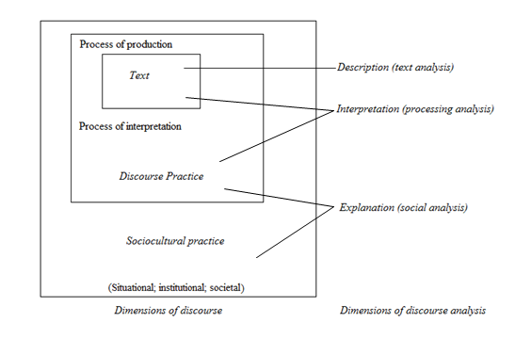
Discourse analysis from a critical perspective enables the process of both interpreting and criticizing produced texts – more specifically connections between properties of these texts, the social processes supporting the production and relations in the sense of ideologies and power relations. To illustrate this in a more structured form, Fairclough has constructed a three-dimensional framework (see Figure 1), which encapsulates both a three-dimensional conception of discourse as well as a three-dimensional method of discourse analysis (Fairclough 2010, 132).
Figure 1: Three-dimensional Framework (Fairclough 2010, 133)

Embedded within Figure 1 are the three discourse dimensions: text, discourse practice and sociocultural practice (a later conceptualization of social practice). In accordance with these discourse dimensions, general methods of analysis are applied as well, illustrating levels of analysis in terms of the description of the text, the interpretation of the relationship between the discursive processes and the text, and an explanation of the relations between discourse practice and social processes. The three dimensions are not seen as independent occurrences of a process, but seen as simultaneous, consistent of a spoken or written language text, signifying text production and interpretation – in the sense of discourse practice, and interrelated with sociocultural practice. The dimension of discourse practice (how a text is produced and interpreted) can be seen as a mediator of the link between a text and sociocultural practice: How a text is produced and interpreted is determined by which order(s) of discourse applies, facilitating particular discursive practices and conventions (system of genres and discourses), which are articulated together on the basis of the nature of the sociocultural practice (social field) (Fairclough 2010, 132). According to Fairclough, this process is an essential parameter in a discourse analysis, which is conceptualized as interdiscursivity (modelled upon intertextuality – building on the idea that elements of an already exciting text have been reproduced into another text (Baker and Ellege 2011, 62)). The normal heterogeneity of texts is emphasized by this concept – in the sense that combinations of diverse genres and discourses constitute them, which “highlights a historical view of texts as transforming the past – existing conventions, or prior text – into the present” (Fairclough 2010, 95). Suggested by the concept of interdiscursivity, possibilities of creativity in discourse – in the sense of a plethora of combinations of genres and discourses – are seemingly endless, but the actuality of hegemonic relations and struggle, encompassing the questions of power of ideology, limit and constrain these combination possibilities (Ibid: 95). Within Fairclough’s framework (Figure 1), three contextual parameters are portrayed, referring to different levels of social organization when analyzing the discursive event as social practice. The three levels are categorized as situational, institutional and societal, where aspects of power and ideology may arise at each level, stressing their importance within the sociocultural practice dimension (Fairclough 2010, 95).
The surface features of a text are shaped by the pertinent and socially defined discourse practice of text production. Subsequently, how these surface features of the given text are to be interpreted is determined by the similar nature of the discourse practice of text interpretation (Fairclough 2010, 132).

5.3.1.1 Text Analysis
In the wake of a discursive event, a spoken or written text is presented, which undeniable is the center of attention in a discourse analysis – in order to interpret and explain meaning and relations or backgrounded information of a text. It is the foregrounded information or surface features of a text (signs/moments) that commences an analytical process and determines the discourse practice and so forth. Important considerations of texts include their generic forms (e.g. a narrative structure), as well as:
“Their dialogic organization (turn-taking), cohesive relations between sentences and relations between clauses in complex sentences, the grammar of the clause (transitivity, mood, modality) and vocabulary” (Fairclough 2010, 94).
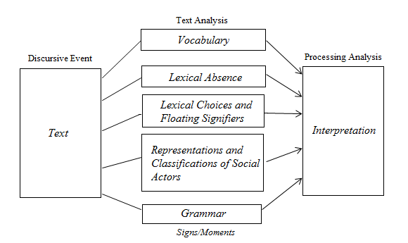
The textual considerations portrayed by Fairclough generally outline the linguistic aspects within a text. However, from a CDA perspective, David Machin and Andrea Mayr (2012) represent a wide range of linguistic or lexical surface features, from which a text analysis (description) can be approached. These features or linguistic terms can be seen as elaborations of Fairclough’s linguistic aspects, which may be categorized to accommodate an analytical model for a text analysis (Model 5).
Model 5: Analytical Model for Text Analysis (Inspired by (Machin and Mayr 2012))
The depicted model encapsulates the lexical features (through constructed categories) embedded within a text analysis from a CDA perspective – as represented by Machin and Mayr (p. 32-165). Furthermore, it is possible to draw some parallels with Laclau and Mouffe’s Discourse Theory, complementing the constructed model, in terms of clarifying the ‘nature’ of its components/categories and applying an additional text component, which may be of relevance in the analysis. First of all, the categories of Model 5 may be understood as signs (textual elements with individual meaning) and/or moments (fixated signs in relation to other signs, creating meaning). Secondly, the textual component floating signifiers can be seen as a supplement to the category of lexical choices, as it represents signs (e.g. words) with no clear meaning, directing the meaning of other signs (Jørgensen and Phillips 2002, 26).
The specifications of lexical features within each category are not of any significance at this point, but they are represented in Appendix 1 for clarification, where relevant features will be addressed in the analysis as well. All in all, Model 5 illustrates an analytical approach to any given text produced (discursive event), where signs/moments (lexical surface features) will be embedded and can be revealed through a descriptive analysis, which leads to an interpretation (process of analysis).

5.4 Corporate Social Responsibility: Concept and Discourse
CSR is currently a well-used concept within the corporate world, where an understanding of this concept can be necessary in order to comprehend the discourse ‘framing’ it. Nevertheless, as the concept to some extent has been addressed in the literature review (3.2), it will only be briefly addressed, followed by its discursive aspects.

5.4.1 Corporate Social Responsibility
The concept of CSR has undergone a massive development process, originating from research studies concerning social responsibility from a corporate standpoint, where the most prominent have been presented by Howard Bowen (1953), Keith Davis (1960), Harold Johnson (1971) and Milton Friedman (1970). These theorists can be said to have been the main inspiration for CSR, as we know it today – even though it is not a completely determined concept. In a more general overview, it can be argued that the current status of the CSR concept is developed through a perceptual struggle between the perception of CSR as a means of profit maximization (social obligations are sufficiently met through keeping shareholders financially satisfied) and the perception of CSR as a facilitator for organizations to become ‘citizens’ of a society (an organization has the social duties of that of a citizen). Subsequently, an understanding of balancing the economic, social and environmental aspects has been reached (triple bottom line), creating a more streamlined perception of CSR – more accommodating towards the needs and preferences of various stakeholders (Sethi 1975, Fairbrass, O’Riordan and Mirza 2005, Johnson 1971, Friedman 1970, 211).
The practice of CSR has also been perceived as voluntary – in the sense that it is a practice not governed by law, where organizations are ‘free’ to live up to the expectations of being socially responsible (European Commission 2011). All in all, the essence of CSR can be seen as, “voluntary actions that a corporation implements as it pursues its mission and fulfills its perceived obligations” (Coombs and Holladay 2012, 8) – obligations directed at all stakeholders of an organization, as well as the environment and the society as a whole (Ibid: 8).

5.4.2 CSR Discourse
It is not possible to provide a clear account of CSR discourse as a particular and determined term, as literature and research does not facilitate such a term. However, the conceptualization of discourse and various research studies connecting CSR and discourse can provide valid insights. From the perspective of constructionism, CSR can be seen as a social construction – as previously asserted and supported through research of the matter (Michotte 2008, 2). This is a social construction being shaped, reshaped and reflected through discourse, as discourse is a social practice (Jørgensen and Phillips 2002, 61), where CSR generally has been positioned in a business context, meaning that businesses are the ones producing the discourse on CSR – by communicating it on the basis of their understanding of the concept. On the other hand, other actors with different perceptions of what the construction is can produce it as well. Consequently, the discourse embedded within the concept can be seen as contingent, corresponding with the theoretical understanding of discourse portrayed (5.2.1). In a research study by Jon Burchell and Joanne Cook, this has been elaborated from the perspective of Fairclough’s views on the constant mixing of social fields, genres and discourses, where they deduce:
“[…] both the discourses of sustainable development and CSR are reflective of Fairclough's arguments. Both reflect a process of transition within which social, ethical and environmental concerns have become central aspects in debates regarding the role of business in society, no longer easily dismissed as ‘externalities’ with no direct bearing on business performance” (Burchell and Cook 2006, 124).
Based on this quote, it can be reasoned that Burchell and Cook represent the discourse of CSR as a sort of ‘hybrid’ between various social fields, which have constituted the role of businesses in society. The social, ethical and environmental concerns can all represent a different social field, which are combined within discourses of sustainable development and CSR (considered to be connected due to shared normative goals (Dobers and Springett 2010, 63)). Moreover, businesses or organizations in general are still the main reference point for CSR discourse, which may be considered a field as well, incorporating a type of business or organizational discourse. To substantiate this, it can be related to a research study of the discourse of multinational corporations’ annual CSR reports by Miia-Emilia Itänen. In the findings of this study, three categories of discourses were evident, being ‘business discourse’ (discourse relating CSR to business goals concerning profitability, growth and competiveness), ‘caring discourse’ (positioning the corporation as an engaged actor within society, ensuring social development) and ‘sharing discourse’ (the corporation positions itself as an engaged actor seeking to participate in the collaborative resolution of global and shared issues) (Itänen 2011, 110). Considering the perspective of non-governmental organizations, it may be likely that the type of business discourse described would have been presented to a lesser extent. However, the three discourse types presented with direct linkage to CSR, signifies the discursive complexity and interdiscursivity of CSR discourse.
Three basic principles can be attached to the purpose of communicating CSR and the discourse thereof, being: the desire to satisfy the expectations of stakeholders and society through a legitimization on an institutional level; expressing a legitimate application of corporate responsibility, depicting public responsibility on an organizational level; and on an individual level, managerial discretion is to do ‘what is perceived as right’ (Blindheim and Langhelle 2010). The legitimization process within these principles may be an essential parameter, which points to aspects of power within CSR discourse (Aasprong 2012, 76). From an overall perspective, the communication of the CSR discourse on an institutional level, organizational level and individual level can be seen as in the generic form of a narrative, which is a shared description of how CSR generally is communicated (Dobers and Springett 2010, 66). A narrative can be considered the form in which constructed discourses are conveyed, as to generate the social reality of what and who an organization is. Through the discursively determined narrative form, the production of one’s ‘views of the world’ (sensemaking) and individual and collective identity constitutions are facilitated and revealed – in terms of language and discourse being the primary medium (Humphreys and Brown 2007, 405-6).

5.5 Setting up an Analytical Framework for Discourse Analysis
Following the theories of discourse, misalignments between discourses (conflicting discourses) may be found within questions of ideology, power and identity, constituted by discursive properties (signs/moments). In order to set up an efficient approach to the critical discourse analysis of the Mozilla case, the overall contextual circumstances of the case must be considered as well.
The case involves different active participants, being Mitchel Baker (executive Chairwoman of Mozilla), the Mozilla Foundation, stakeholders (interest groups, community and individuals) and Brendan Eich (CEO and ‘reason’ for crisis outbreak). As the crisis depicts a focus on Eich, his communicative handling and discursive properties thereof may be of greater importance. It has been portrayed that CSR discourse has the form of a narrative, which facilitates both ideology (views of the world) and identity constitution, where Eich’s and Baker’s statements can be expected to include discourses from both their own perspective and Mozilla’s perspective, concentrated around CSR aspects. Consequently, it can be argued that two ‘processes’ of identity constitutions are at play (their own and Mozilla’s identity), possibly opening up a specific ‘point of entry’ to analyze and reveal conflicting discourses thereof. Moreover, the expected different constitutions of identities can point to the question of ideology. The question of ideology becomes essential in the view of the official voice of Mozilla (the Mozilla Press Center) versus the voice of Eich and Baker, possibly conveying a specific ‘CSR’ message or ideology (and identity) – in terms of displayed crisis communication strategies, which may have the function of another discursive frame (than that of CSR). As a result, conflicting discourses may be revealed between and within the expressed ideology and identity in Mitchel Baker’s, Brendan Eich’s and Mozilla’s statements (in terms of ‘applied’ crisis communication strategies) – all expressed through discourses with CSR aspects. These relations portrayed are to some extent illustrated in Model 6 – including possible relations of which conflicting discourses may arise.

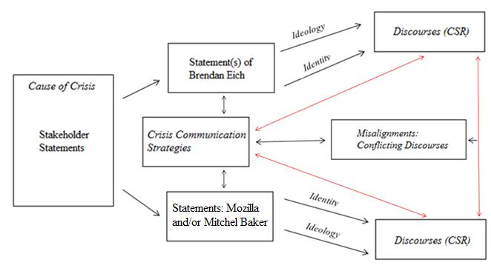
Model 6: Outline of Relations between Primary Elements of Communication (Developed by Author).
In short, the constructed figure illustrates where misalignments between discourses (conflicting discourses) may arise, depicted by the red-colored arrows – as a result of communicative and discursive relations between the elements portrayed.
Statements of Mozilla and Mitchel Baker are positioned in the same box, as the last official Mozilla statement is written by Baker (Appendix 15), leaving a question about the author of the preceding Mozilla statements. Two ‘categories’ of conflicting discourses may be expected in the view of the specific case. First of all, the active presence of three communicating voices facilitates potential discursive misalignments in their (constructed discourses) relationship to each other – as well as potential misalignment between discourses within each statement. This is an expectation arising from the consideration that three authors are set to communicate, expectably, the somewhat same information with the same discursive frames (crisis response strategies and CSR), but with different stakes (Mozilla is in a crisis because of Eich). The second category concerns the discursive relationship between the constructed discourses (CSR) and the crisis communication strategies in use, which can be said to direct the main discursive frame. Moreover (illustrated with the two-ended arrow in the middle of the model), it can be assumed that the conflicting discourses arising within the first category may overlap with the second – in the sense that the conflicting discourses between the ‘two’ statements may be in conflict with the crisis communication’s discursive aspect as well. The element of ‘stakeholder statements’ represents the occurrence of the crisis, providing the basis for producing the responsive statements. The ‘ideology’ and ‘identity’ arrows signify the terms or ‘explanation’ in which the discourses (and the potential conflicting discourses) are created, which may be determined through the critical discourse analysis.
To accommodate the expectations/presumptions presented through Model 6, the analytical approach will be based upon Fairclough’s three-dimensional framework. The text description/analysis will be conducted on the basis of the represented analytical model (see 5.3.1.1 – Model 5), focusing on the most prominent lexical surface features (signs/moments). The model will be the foundation of an interpretation of the texts and embedded discourses of CSR, where a determination of conflicting discourses may be made.

6. Empirical Data
Through a representation of the development of the Mozilla crisis situation, this chapter will, chronologically, present the empirical data in use within the analytical part of the study. To more comprehensively address the specifications of the case, the empirical data will be narratively presented in correlation with text material (statements) from external actors with plausible relevance in an analytical discussion.

6.1 Case
In April 2012, when the incident of Brendan Eich’s anti same-sex marriage donation in 2008 (Proposition 8) became known to the public (McKinley 2008), discontent quickly disseminated across the media landscape – especially on Twitter with over 5.000 comments criticizing Eich (Netburn 2012). The community surrounding Mozilla was enraged by this discovery, but the organization itself did not act on it. On the other hand, Eich himself made a statement to address the anger towards his person and organization (Appendix 2). The controversy was not resolved in the wake of this statement, but the situation abated eventually (Faircloth 2012).
On March 24, an official statement from Mozilla announced that the new CEO of Mozilla was Brendan Eich (Mozilla 2014). The day after the announcement, media stories started to emerge with mentions of the personal past of Eich (Mozilla 2014). At this point, the app developer Rarebit announced that they would remove their apps from the Mozilla Firefox marketplace, because they had no desire of supporting a foundation, endorsing a person with hateful views (Machkovech 2014). Moreover, blog posts and social media comments from angered stakeholders emerged – for example in connection with an image on the Mozilla Firefox Facebook page (Appendix 3), where stakeholders expressed an intention to boycott Mozilla products until Eich was ‘shown the door’ (Appendix 4).
On March 26, Mozilla Firefox responded to the comments on Facebook by referring stakeholders to two explanatory statements concerning the matter, being blog posts by Brendan Eich (Appendix 7) and Chairwoman Mitchell Baker (Appendix 8) on their private Mozilla blog channels. These blog posts were also officially referred to in a smaller Mozilla statement on March 25 (Appendix 5) through the official Mozilla Press Center (Mozilla Foundation 2014). Moreover, the Firefox and Mozilla Twitter accounts also referred followers to the two blog posts (Appendix 6) – stating that “inclusiveness is essential to who Mozilla is. Read more […]” (Oberlander 2014, 7-8).
On March 27, after the release of the Mozilla statements with the primary voice of Baker and Eich, employees at the Mozilla Foundation expressed their anger on Twitter towards the appointment of Eich as CEO (Appendix 9). Several employees shared the same message across the social media platform, being, ”I’m an employee of @mozilla and I’am asking @brendaneich to step down as CEO” (Machkovech 2014). Additionally, stakeholders from the LGBT community reached out to Eich, encouraging him to genuinely apologize (Thomas 2014). The news media got hold of another controversial incident on March 28, as a result of Eich’s promotion to CEO: several media channels shared the story about the resignation of three board members of the Mozilla Foundation, who were dissatisfied with current change of leadership (Barr 2014). However, in a non-published statement, Mozilla addressed the resignations as non-related to the appointment of Eich (Shankland 2014). The following day (March 29), statements from both the Mozilla Foundation (Appendix 10) and Baker (Appendix 11) were put on display, reaffirming Mozilla’s eminent support for LGBT rights and marriage equality. The Baker statement was directly linked with the more official Mozilla statement, as it was a comment to the content of that statement (M. Baker 2014, Mozilla Foundation 2014).
The day after, the social change organization CREDO officially began its campaign against Mozilla – with the specific purpose of forcing Eich to resign (Appendix 12). At the same time, the dating site Okcupid issued a boycott – in the sense of encouraging people to use another browser than Firefox to access its website. This occurred on March 31 through an online notification (Appendix 13), which also outlined Okcupid’s contempt towards Eich and his anti-gay standing (Brandom 2014). On the 2nd of April, Eich commented on the controversy in an interview with the Guardian – stressing his and Mozilla’s previous stance (Ball 2014) (Appendix 14). On the 3rd of April, the Mozilla Foundation, with the voice of Baker, published an official statement declaring Brendan Eich’s resignation as CEO (Appendix 15) – also including an apology for how things had been handled (M. Baker 2014). Eich also briefly addressed his resignation in a blog post on his official Mozilla blog (Appendix 16).
The text material/statements that will be directly applied in an analysis, following the established criteria (2.5.1), include: Appendix 5, 7, 8, 10, 11, 15, and 16, and they will be, according to chronological appearance, represented as Statement 1-7 in the analysis, so as to ensure referential simplicity throughout the analysis.

7. Analyzing the Crisis Communication of the Mozilla Foundation
The first part of this analysis chapter will address the circumstances surrounding the reputational crisis of Mozilla through the four parameters: context, medium, genre and text (4.6.2) – aiming at determining and evaluating the crisis situation and communication in full. However, to provide an overview of the case’s communicative ‘frame’, the communicating actors within the case will be briefly accounted for (4.6.1).

7.1 Actors within The Rhetorical Arena
The different actors, who are implicated and who communicate within The Rhetorical Arena, can be seen as important – when it comes to evaluating the situational context applicable to Mozilla’s crisis communication. The first actors to enter the arena are stakeholders (including LGBT individuals and employees), who are angered by Mozilla’s appointment of Brendan Eich as the new CEO, which is communicated to both the public (Twitter) and Mozilla/Eich (Appendix 9). This forces the Mozilla Foundation to enter the arena, including Eich and Mitchel Baker, whose main interests probably are to address its stakeholders in the right manner, in order to mitigate the crisis situation and regain trust and approval. Mozilla’s communication is directed at the public/stakeholders and presumably the media. Consequently, at the same time, the media has entered the arena, whose primary interest is in depicting the most news-worthy material, based on both the communication deriving from stakeholders and Mozilla. After the first statements by Mozilla, Eich and Baker, additional stakeholders get involved, including organizations as well (Okcupid). They stand together in anger towards Mozilla and Eich, communicating about and to Mozilla (Appendix 12, 13). Presumably, their main interest is to challenge Mozilla to be socially responsible in its choice of direction and leadership – through the engagement in LGBT rights and equality.

7.2 Context
On the account of the context of the situation (with Mozilla in focus), three sub-context factors are considered essential, being: the societal and cultural context, the organizational and institutional context and the situational context.

7.2.1 Societal and Cultural Context
When evaluating the societal and cultural context surrounding the case of the study, it is important to consider that Mozilla as an organization produces products for online usage. Consequently, Mozilla operates within the boundaries of the internet, which are generally non-existent – meaning that the Mozilla crisis has an international reach and therefore no specific cultural context applies. However, it may be argued that a broad usage of the internet – in the essence of it being open and opportunity filled (as Mozilla intends its affiliation to be engaged at (Mozilla Foundation 2015)) – is more in line with the properties of Western Culture (Pew Research Center 2013). Western Culture is not applied to specific ethnicities, but a description of a certain set of societal ideals, including science, technology, happiness, individualism, capitalism and rights – all deriving from a perception of ‘reason’ (reality) (Western Culture Knowledge Center 2009). It can be fair to assess that the case in question may be linked to the ideals entailed by Western Culture, especially when it comes to the question of ‘rights’.

7.2.2 Organizational and Institutional Context
Evaluating essential matters like organizational structure and culture is a difficult task when it comes to the Mozilla case, as internal knowledge would be needed. On the other hand, it can be considered valuable to externally evaluate the organization – so as to briefly set up an understanding of the organization (agenda, values, identity). Generally, the Mozilla Foundation is dedicated to improving and maintaining openness, innovation and opportunity on the internet, where the capabilities, opportunities and enrichment of the individual are matters of focus. Led by a CEO and a board of directors, the Mozilla Foundation aims at ensuring the vitality of the internet (public good) through motivated individuals and communities and free software (Mozilla Foundation 2015).
In connection with the initial statements from Mozilla (Eich and Baker respectively), focus was directed at the Mozilla foundation’s “Community Participation Guidelines” (Appendix 7-8), which were established in 2013 and still currently apply. These guidelines depict what may be considered the expressed organizational culture of Mozilla, aimed at portraying the values that belong to its community, which consists of employees as well as other participators (stakeholders). The two main principles of the guidelines are ‘inclusion’ and ‘diversity’, which drive the expressed identity of the organization and community. The essence of these principles is stated as follows,
“It doesn’t matter how you identify yourself or how others perceive you: we welcome you. […] including, but not limited to people of varied age, culture, ethnicity, gender, gender-identity, language, race, sexual orientation, geographical location and religious views” (Mozilla Foundation 2013)
Additionally, it is stated that all participators who identify themselves with activities working against inclusiveness and diversity are inclined to leave it as a personal matter and not carry it into Mozilla activities. The principles of inclusion and diversity are seemingly essential to Mozilla’s identity, meaning that everyone is welcome, if the condition of the latter is met (Mozilla Foundation 2013). To some extent, the guidelines presented depict the organization’s social responsibility towards community members (CSR), as a part of Mozilla’s identity (ideals and values).

7.2.3 Situational Context
It is clear in view of the development of the case that the crisis began approximately after the announcement of a new CEO on April 24. However, the 2012 public awareness of Brendan Eich’s support of anti-gay marriage can be seen as the beginning of the issue leading to a crisis. As previously mentioned, the 2012 incident can be understood as a para-crisis, which slowly abated after Eich’s statement (Appendix 2). It can be argued that the incident/challenge was not addressed properly by Mozilla, considering that the same issue gained significant momentum years later – following the para-crisis management principle (refute, reform or refuse), represented by Coombs and Holladay (2012, 412). All in all, the issue publicly unfolded in 2012, where the crisis itself began after Eich’s appointment, which again abated after his resignation.
The most significant situational aspect in understanding the crisis communication in place can be considered the assumed public perception of the crisis. Following the crisis communication theory represented, the crisis type can be established and the degree of responsibility attributed to the organization determined. Considering the circumstances (Rhetorical Arena – 7.1) and the CEO appointment leading up to those circumstances and the crisis, it can be reasonable to assume that Mozilla had no intention of promoting anti-gay marriage with its selection of Brendan Eich. This is an assumption based on Mozilla’s expressed identity portrayed earlier, which can place the crisis as an accident – in the sense that it is a matter of stakeholders claiming that the organizations is acting in an inappropriate manner. However, in consideration of the 2012 incident, opening up an issue to the public concerning Eich’s person, Mozilla is positioned in a situation, where it is perceived as ‘ignoring’ a publically known issue. Moreover, according to theory, the presence of a bad crisis history can invoke more harmful stakeholder attributions, altering the public perception of the crisis. In view of the case specifics, further substantiated by the aggregated stakeholders’ (actors within The Rhetorical Arena) comments and reactions (Appendix 4, 9, 12 and 13), it can therefore be argued that the crisis in question should be seen as a preventable crisis. As a result, the crisis presents a potentially significant reputational threat with strong crisis responsibility attributed to Mozilla. Following the theoretical recommendations set for a preventable crisis, the utilization of rebuild strategies is considered the most efficient choice for the communicative approach.

7.3 Medium and Genre
The medium, by which the crisis communication in the Mozilla case is being facilitated, is characterized as the new media – more specifically the internet. As formulated in the Methodology chapter, all information communicated is conveyed through written texts, meaning that Mozilla never made use of vocal crisis communication. Additionally, all communication was handled through blogs: the communication of Mozilla as an organization and with the voices of both Eich and Baker were all disseminated through three different blog systems attached to the organization. It is possible to directly link Eich and Baker’s blogs to Mozilla due to clear blog references of their role at Mozilla, and due to the fact that Eich’s blog became silent after his resignation – indicating that his blog was dependent on him working at Mozilla (Appendix 7, 8).
A blog or ‘blogging’ can be seen as a specific genre of structured ways of communication. Generally, a few premises will have to apply: first of all, the main purpose of blogging is that it is social, networked and conversational, which is enabled through the readers’ ability to comment. Secondly, it is personal and a process instead of a product and therefore different from broadcast journalism (Bradshaw 2008). Based on those premises, it is apparent that the written statements in this case do not comply completely with the blogging genre. The primary indicator of this is the fact that commenting has been disabled, which removes the social, networked and conversational aspects to some extent (people can still make comments to the statements elsewhere). Hence, even though the medium is blogging, the structure of the texts lacks complete correlation with the equivalent textural genre. Taking Baker’s first statement as an example (Appendix 8), it is clear from a general perspective that it is written in a more formal manner, it is considerably informative, directed at the public and written from both the perspective of Mozilla and Baker herself with self-promotional elements, “Acting for or on behalf of Mozilla, it is unacceptable to limit opportunity for *anyone* […] This is not only a commitment, it is our identity” (Appendix 7, line 8-10). The observations made align with an understanding of a press release genre, which has the purpose of communicating to journalist and the public with the ‘voice’ of an organization (Catenaccio 2008, 28).

7.4 Text
The text parameter is considered important in the study, as it has a focus on the micro level of the statements, evaluating how the crisis communication is rhetorically expressed. This is an analytical element addressed in the evaluation of applied crisis response strategies (7.5) and more in depth at the stage of critical discourse analysis. Therefore, it will not be addressed in detail at this point. However, a general observation can be made, which is considered important when analyzing discursive properties. It has been made clear from early evaluations that CSR ‘infused’ discourses are at play in the communication (2.6). This is evident from a narrative structure surrounding value-laden words like inclusion, diversity, equality and commitment throughout each statement – directed at strong matters like sexual orientation and health. Moreover, after an evaluation of Mozilla as an organization, including its Community Participation Guidelines, it has become apparent that similar textual content on Mozilla’s website is present within the statements as well (Mozilla Foundation 2013). Accordingly, the observation that similar CSR discourse elements are produced in different texts would indicate the occurrence of interdiscursivity.

7.5 Crisis Response Strategies
On the basis of the theoretical amalgamated crisis response strategies (Model 1), each selected statement will undergo a systematic analysis of relevant elements to determine crisis response strategies in use.

7.5.1 Statement 1
The first statement (Appendix 5) is rather short with, supposedly, a primary focus on directing the public at Eich and Baker’s individual statements (blog posts), as direct links to those are portrayed (lines 9 and 10).

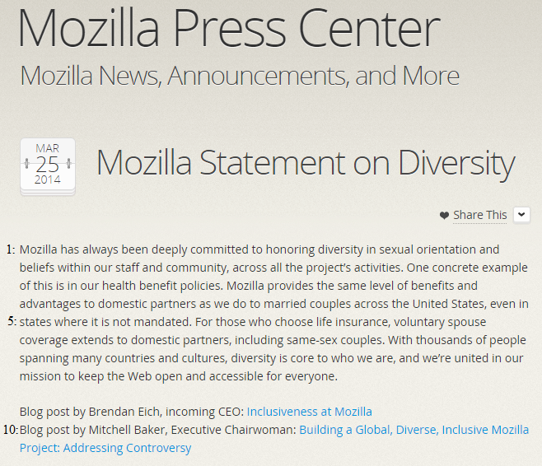

The content of the statement itself only consists of sentences portraying the organization as open-minded and ethical, which is shown in the following quotation:
(Appendix 5)
“Mozilla has always been deeply committed to honoring diversity in sexual orientation and beliefs within our staff and community […]. One Concrete example of this is in our health benefit policies” (line 1-3)
Hence, Mozilla proclaims that it is an upright organization committed to non-discriminatory activities and behaviors. Additionally, by referring to health benefit policies, Mozilla stresses its righteousness. All in all, the evident strategy applied is bolstering, in terms of reminding stakeholders of the organization’s past good work. It has been asserted that bolstering is a supplementing strategy, but it is difficult to concretely determine which strategy it supplements. On the other hand, considering that the content is solely focused on highlighting positive aspects of the organization, the transcendence strategy might be a possibility. This strategy is concerned with positioning a harmful act in a favorable context, which seems to be the case here – with the positive aspects as the constructed context, even though the act itself is not mentioned. These observations place Statement 1’s rhetorical nature within the reduction of offensiveness cluster.

7.5.2 Statement 2
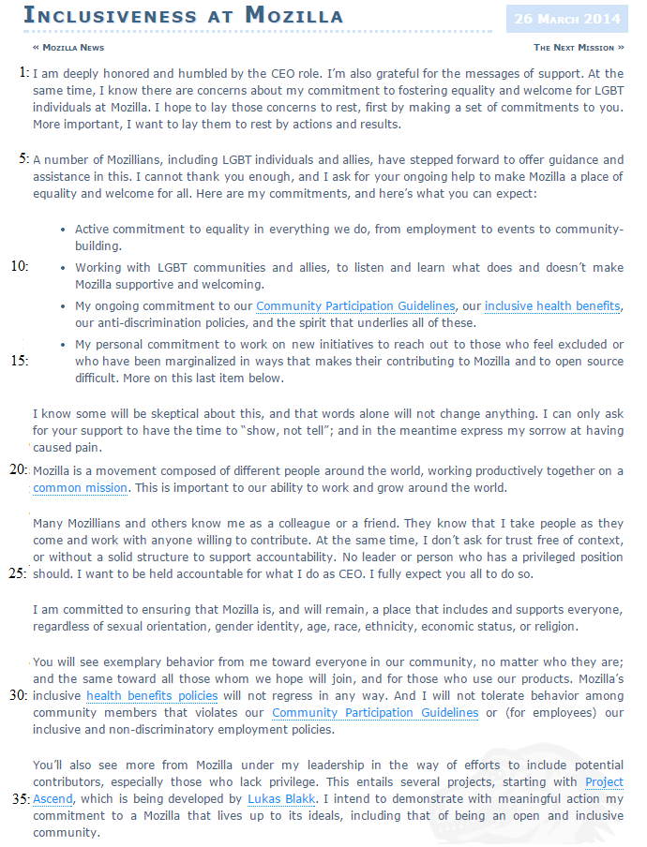
The second statement is CEO Brendan Eich’s official response to the controversy on behalf of Mozilla but also very much on behalf of himself (Appendix 7).
(Appendix 7)

The main strategy structuring the content of the whole statement is corrective action, which is expressed on several occasions, a few of them being, “I want to lay them [concerns] to rest by actions and results” (line 4) and “I am committed to ensuring that Mozilla is, and will remain, a place that includes and supports everyone” (line 26). Within the same rhetorical category (rebuilding strategies), one example of mortification is expressed in the sentence, “[…] and in the meantime express my sorrow at having caused pain” (line 18). This is expressed in correlation with the corrective action strategy, indicating that his perception of attributed responsibility is more in line with a preventable crisis, which is further addressed in the discourse analysis (8).
To supplement the primary strategy (corrective action), a high number of different bolstering strategies can be found. First of all, the reminder bolstering approach is expressed through the references to both the health benefit policies (lines 12, 30) and the Community Participation Guidelines (lines 12, 31). It is also expressed in a personal manner in the sentence, “They [colleagues and friends] know that I take people as they come and work with anyone willing to contribute” (line 22-23). Furthermore, the bolstering approach ingratiation comes to attention primarily in the beginning of the statement, where he directly thanks LGBT individuals and stakeholders in general for their support in making Mozilla a better place (line 5-6). This will be readdressed in the discourse analysis section.

7.5.3 Statement 3
The opening lines of Baker’s first official statement (Appendix 8) can be interpreted as a crisis response strategy of transcendence. This is shown through the positive attitude towards Eich’s new role as CEO, which in particular is expressed with the sentence, “In the next few days we’ll see more from Brendan and the leadership team on the opportunities in front of us” (line 3-4). There are no indications of an issue present; there is solely an emphasis on ‘opportunities’ ahead. Moreover, this may also have similarities with the minimization strategy, as Mozilla’s ‘harmful’ act in choosing Eich as CEO might be minimized by his potentials. Minimization may also be present in other parts of the statement, especially in connection with the proclamation of Mozilla’s commitment to equality and inclusiveness, where it is stated that “Brendan shares this commitment as the new Chief Executive Officer” (line 12). The latter indicates that Brendan Eich is professionally committed to the great values of Mozilla, meaning that the choice to appoint him was the right one. In lines 26 and 32, this same sentence reappears, emphasizing its significance.

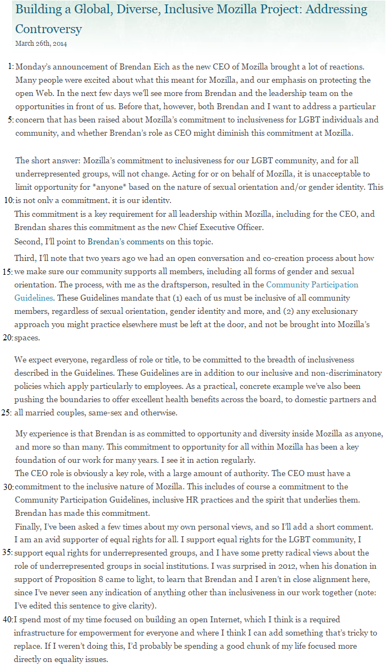

Throughout the rest of the statement, the main rhetorical tactic can be seen as corrective action – in the sense that Baker reinsures the readers that Mozilla is committed to inclusiveness and so on, as well as Mozilla participants: “We expect everyone, regardless of role or title, to be committed to the breadth of inclusiveness” (line 21). Considering that Eich is still in the position of CEO can indicate that he is perceived as being in line with Mozilla’s expectations of commitment. This can be interpreted as the result of a strategy of minimization as well, as it could be assumed that Mozilla and Baker wish to minimize the seriousness of accusations against Eich. In relevance to CSR related segments, the bolstering strategy is yet again applied – with substantial references to and elaborations of the Community Participation Guidelines and health policies.
(Appendix 8)

7.5.4 Statement 4
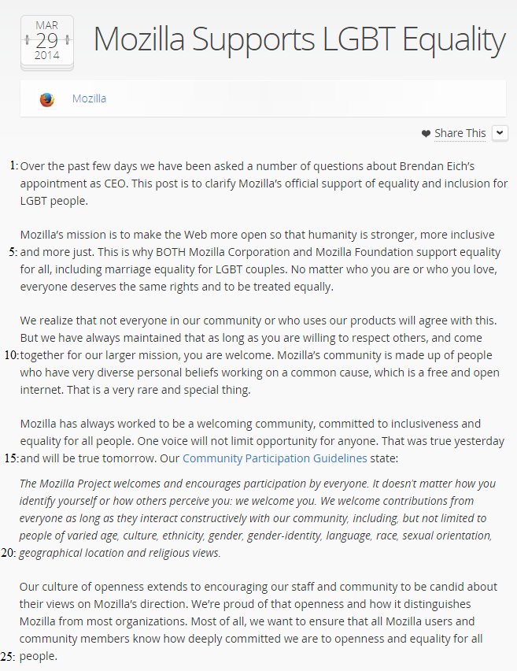
Mozilla’s second statement (Appendix 10) is almost purely concerned with clarifying the organization’s social responsibility towards equality and inclusiveness within its community.

(Appendix 10)
With the same textual elements and references (guidelines, policies) as within preceding statements, bolstering is therefore a prominent strategy applied. The only indicator of the controversy itself is the first sentence, “Over the past few days we have been asked a number of questions about Brendan Eich’s appointment as CEO” (line 1-2). The latter shows the reader that this statement is addressing the controversy. However, considering that the following content only promotes the values of Mozilla, which are expressed as an actuality (“Mozilla has always […] line 13), it can be argued that the organization makes use of the transcendence strategy: overarching values are expressed on a macro level to undermine the contradicting ‘values’ on a micro level. The sentence, “One voice will not limit opportunity for anyone” (line 14) substantiates this observation. Moreover, Mozilla’s proclamation of the insignificance of one contradicting voice may signify a distancing from the views of Eich, and thereby also minimizing the harmfulness of the situation (Eich as CEO).

7.5.5 Statement 5
In connection with the Mozilla statement, Baker publishes a short supplementing statement on her blog (Appendix 11).
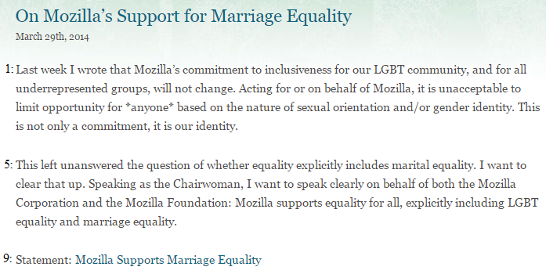
(Appendix 11)
Other than directly referring to the Mozilla statement (line 9), the content of the statement is directed at stressing the good traits of the organization, by explicitly expressing Mozilla’s identity as an organization with a commitment to equality for all (line 4). Accordingly, the bolstering strategy has significant momentum in the statement, plausibly supplementing a minimization tactic, which is shown through the usage of specific proclamations, directed at the controversy at hand: “Mozilla supports equality for all, explicitly including LGBT equality and marriage equality” (line 7-8).

7.5.6 Statement 6
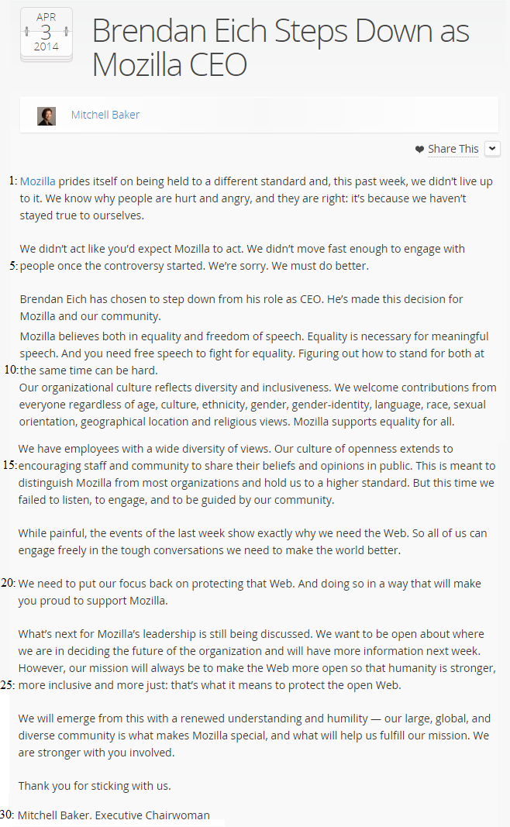
In this statement (Appendix 15), communicated by Baker, Mozilla states that Eich steps down as CEO, which marks a new direction in the organization’s crisis communication.

(Appendix 15)
The primary strategies structuring the statement are mortification and corrective action, which are supplemented with bolstering strategies. Two instances of mortification are present within the statement, where the first is a simple and clear, “We are sorry” (line 5) assertion, where the other substantiates the latter with, “We failed to listen, to engage, and to be guided by our community” (line 17). Throughout the statement, corrective actions are being expressed (line 5, 20), where the most prominent is within the last section, being “We will emerge from this with a renewed understanding and humility” (line 26).
With the usage of the reminder approach of bolstering, the middle sections of the statement (line 8-13) are directed at promoting the ‘true’ values of Mozilla – in the same manner as within the preceding statements. In the last section of the statement, ingratiation bolstering is applied with the expression of gratitude towards its community, concluded with the line, “Thank you for sticking with us” (line 29).

6.5.7 Statement 7
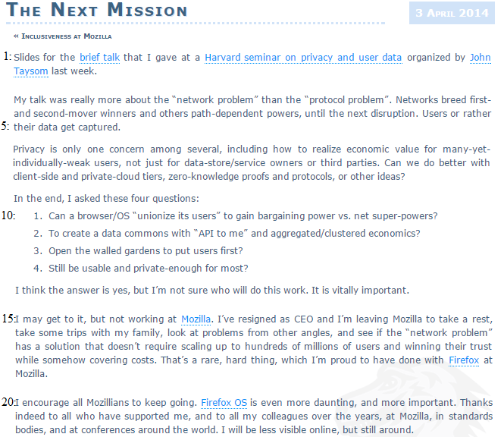
Following the Mozilla statement, Eich published a statement as well (Appendix 16), but with little focus on his resignation.
(Appendix 16)
The first half of the statement is non-related, involving a new work related focus (privacy and user data). In the subsequent half of the statement, however, Eich asserts that he has resigned as the CEO of Mozilla (line 15). He does not address the controversy whatsoever, but rather points to his good work at Mozilla – with Firefox as an example (line 18). This indicates a use of the bolstering strategy, which is further exploited in the final section, where he expresses his gratitude towards his supporters and colleagues (line 20-21). It may be argued that Eich intends to show the public that he should be remembered for his professional and successful work and not the controversy – by directing attention towards a broader and positive context (transcendence).

7.6 Reflective Summary
Through the examination and determination of Mozilla’s utilization of crisis response strategies, it is possible to conclude that both differences and similarities can be found between the seven statements. The differences can be measured in terms of the specific clusters represented: The statements by Mozilla and Mitchel Baker, before the 3rd of April, are presumably embedded with elements, which are structured on the basis of transcendence and minimization strategies, belonging to the reduction of offensiveness cluster. In contrast, Eich’s first statement seems to consist of elements building on the strategies of corrective action and mortification, both belonging within the cluster of rebuilding strategies. This rhetorical approach can be considered similar to the approach structuring the last statement of Mozilla and Baker, even though the content is different.
On the basis of some considerations, it was reasoned that the crisis can be seen as a preventable crisis (7.2.3). Evaluating the occurrences of applied crisis response strategies in the case, through the theoretical framework set (4.5), it is possible to assert that inconsistencies are present. It is theorized that rebuilding strategies should be applied in a preventable crisis, as the attribution of responsibility is high. Accordingly, the reduction of offensiveness strategies supposedly applied by Mozilla and Baker may be considered an insufficient crisis handling approach. The use of these strategies may signify a perception of the crisis as being less harmful (low attribution of responsibility). However, it is not possible to assess the exact significance of this observed inconsistency between context and approach, as reduction of offensiveness and rebuild strategies can be used in combination with each other (4.4).
Based on the account of the supplementing bolstering strategy, it is apparent that the application of this type of strategy is consistent throughout every statement, affiliated with the same CSR-related content. However, the representation of the similar content can be interpreted as being different – in the sense of fixed representations (repetition of rehearsed sentences (Appendix 10, line 16-20)) versus unfixed representations (Appendix 7, line 26). To some extent, this has been a consideration in the analysis of applied crisis response strategies, but it is more in line with a discourse analysis, examining the text parameter more thoroughly – from a critical perspective.

8. Critical Discourse Analysis of Mozilla’s Crisis Communication
From the preliminary analysis of Mozilla’s crisis communication and the analysis of crisis response strategies in play, it seems that CSR-related discourses are quite notable in Mozilla’s crisis communication – with a variety of communicative purposes (transcendence, minimization or corrective action), but primarily bolstering. In accordance with the study, this chapter will focus on the CSR discourses within the seven statements – so as to determine the significance of this type of discourse to Mozilla’s crisis communication (Model 5). However, other discursive elements may also be examined for relational purposes.
CSR discourses are prominent within Statement 1 (Appendix 5), where no indications of the controversy are expressed, but it is still placed within the crisis situation, due to the clear references to Eich and Baker’s statements at the bottom. Consequently, there is a lexical absence (See Machin and Mayr 2012, 38) within Mozilla’s first statement. This lexical absence may indicate that Mozilla does not intend to affiliate itself directly with the issue debated, but distances itself instead by portraying values and beliefs, contradicting the stakeholder accusations (Appendix 9). The account thereof can be considered very descriptive in its style due to the usage of adjectives (sexual, domestic, married, same-sex and so on) to supplement signifiers like ‘partners’, ‘couples’ and ‘orientation’, emphasizing a message of social responsibility. These linguistic choices emphasize the use of the bolstering strategy, as they are value-laden words, supplementing the set arguments with referential significance (reminder). Furthermore, the LGBT individuals are being included in a collectivization of a specific kind of people (people within a relationship), giving the expression that LGBT individuals are not seen as a different category of people. This can be understood as the main message in the short statement, where ‘Mozilla’ is mentioned four times, supplemented by the pronouns: ‘our’ and ‘we’ (Appendix 5, line 1-8). The use of ‘Mozilla’ expresses that this is the stance of the entire organization, giving it more momentum (authority). On the other hand, the pronouns include the organization, the entire community and perhaps the reader as well – possibly with the persuasive purpose of making stakeholders embrace Mozilla’s ideas and values as a ‘shared’ understanding (e.g. in society).
Within the statement, in connection with the pronouns and ‘Mozilla’, high modality is evident. This can be seen in the first sentence, “Mozilla has always been deeply committed to honoring diversity in sexual orientation and beliefs within our staff and community” (line 1-2), where the high modality verb ‘has’ and adverbial ‘always’ indicate a high degree of certainty behind the proclamation. The factor of certainty is consistent all the way through the statement, and with the sentence, “Diversity is core to who we are, and we’re united […]” (line 7), it is indicated that Mozilla intends to depict a socially responsible organizational identity and ideology. The interpretation of the discursive elements in the latter points to Mozilla’s desire to create a different understanding of the situation; Mozilla wants to transcend the negative aspects and create a positive context. This is primarily done through the utilization of ‘diversity’.
Examining the connotation (See Machin and Mayr, 32) of the word ‘diversity’ signifies ‘difference’, which can be seen as a floating signifier with no specific meaning, but as it is related to ‘sexual orientation’ and ‘beliefs’, it gets a specific meaning. Consequently, commitment to diversity in the discursive context of the statement promotes Mozilla’s commitment to different beliefs. In practice, this would include beliefs different from those of Mozilla, indicating an acceptance towards the ‘opposing’ beliefs of Eich. An interpretation thereof may derive a few assumptions about Mozilla’s intentions behind the statement: it can be understood as an attempt to persuade stakeholders into embracing diversity as a valuable asset within the Mozilla community. By framing diversity in sexual orientation in equivalence to diversity in beliefs, the issue within the controversy may be mitigated (minimization) and seen in a more favorable context (transcendence), as restrictions on ‘diversity’ would lead to a degree of discrimination (structural oppositions – Ibid: 39). These assumptions can be substantiated by the statement’s concluding words; “Diversity is core to who we are, and we’re united in our mission to keep the web open and accessible for everyone” (line 7-8). Furthermore, this presents the same ideology and identity specified within Mozilla’s Community Participation Guidelines (7.2.2), which may explain the lexical properties within the discourses revealed and analyzed – in the practice of interdiscursivity.
Seen from a somewhat different perspective, the degree of certainty and authority expressed through the discourse, and the observation that the portrayed text completely contradicts stakeholder accusations without directly acknowledging an issue, may point to a denial strategy. It is likely that it is unintentional, as transcendence and minimization seem prominent, but an indirect denial of the actuality of a crisis seems likely: a contradicting reality is presented as absolute. Theoretically, this points to a major discursive misalignment between Mozilla’s CSR discourse and crisis communication, as a utilization of denial strategies in combination with other strategies derives a communicative inconsistency.
Many of the lexical observations examined in relation to Statement 1 (e.g. high modality) apply to equivalent CSR discourses found within the statements, meaning that the similar interpretations can be made. This particularly applies to Statements 3 and 4 (Appendix 8 and 10), where also the value-laden word ‘inclusiveness’ is portrayed in connection with the question of diversity. It is a word with an open connotation, depending on which words and clauses it is set in relation to. More importantly, the word can derive a structural opposition within a discourse, as it is the opposite of the word ‘exclusiveness’, emphasizing the properties embedded within the word ‘inclusiveness’. Additionally, there are direct and literal references to the Community Participation Guidelines, which is the case in Statement 2 (Appendix 7) as well.
However, Mitchel Baker’s representations of Mozilla’s socially responsible values in Statement 3 are different from Statement 1 on some accounts. The main difference is the linking between Mozilla’s values and commitments, and Eich and the controversy itself. An example of this is: “Mozilla’s commitment to inclusiveness for our LGBT community, and for all underrepresented groups, will not change.” (Appendix 8, line 7)” […] Brendan shares this commitment as the new Chief Executive Officer” (line 12). A few interpretive observations can be made from the quoted sentences. The first observation is the use of ‘will’, as to express certainty in Baker’s saying, but it also gives a sense of authority, as it depicts a timeless certainty ensured by Mozilla. This expressed certainty and indication of past and future consistency in Mozilla’s commitment both shows a bolstering tactic and a minimization tactic, as it is ‘proclaimed’ that the incident has no damaging effect. The use of the pronoun ‘our’ to address the LGBT community signifies a desire to express unity between Mozilla and LGBT individuals, which is further emphasized by the lexical choice of utilizing ‘community’ instead of ‘individuals’, so as to express an equal position of authority within the Mozilla community. Furthermore, separated with the ‘and’ conjunction, ‘unrepresented groups’ are set in contrast to the LGBT community, which can be seen as an elevation of their independency and authority as well, due to perceived connotations of ‘underrepresented’ (weak, vulnerable). This may also be understood as an elevation of Mozilla’s authority and capabilities, as the organization has the power to support underrepresented groups. Considering its textual context, it stresses the application of the bolstering strategy as well.
Based on observations of expressed authority, the linguistic choice of spelling out the abbreviation ‘CEO’ emphasizes Brendan Eich’s important position within Mozilla, with certainty about his fulfillment of the strong commitment set by Mozilla. It can be argued that it is a discourse intended to align ‘Eich as CEO’ with ‘strong socially responsible commitments’. Earlier, it was argued that the content of the latter (line 12) would point to the minimization strategy, as it limits the perceived damage done. On the other hand, considering that the verb ‘shares’ is in present tense, it does not signify an unconditioned actuality, but rather a strong promise, signifying the corrective action strategy instead. It is also essential to point out the use of ‘commitment’, as it presumably connotes the ‘promise of loyal support’, which in relation to value-laden words (inclusiveness), can create a persuasive discourse. The possible intended persuasiveness of the use of ‘commitment’ becomes more salient considering the extensive usage of the word throughout the statement, where it appears more than ten times. This would indicate an overlexicalization (See Machin and Mayr, 37) of the word, which signifies an over-persuasion to facilitate an ideological contention. Even though a ‘promise of loyal support’ would indicate corrective action, its relational position probably substantiates minimization instead (line 7).
Discursive structures similar to the one analyzed in the previous section (Mozilla commitment to inclusiveness, which is shared by CEO Brendan Eich) reappears on two accounts within the statement (lines 20 and 29). Baker’s discussion and elaboration of the Community Participation Guidelines can substantiate a seemingly consistent ideological contention embedded in the statement. Baker represents the guidelines by stating that, “Each of us must be inclusive of all community members […]” (line 17) “[…] any exclusionary approach you might practice must be left at the door [of Mozilla]” (line 19). By applying the modal ‘must’, the first sentence expresses the inclusiveness factor as a necessity for all community members to uphold – signifying the Mozilla community’s power and authority (pronoun: us) towards individual participators. The same use of modal applies to the second sentence, where the same degree of power towards individual participators is expressed, asserting that any activities opposing the inclusive values of Mozilla are not approved of inside the community. With the direct reference to the guidelines, the practice of interdiscursivity is utilized, which stresses the utilization of the reminder bolstering strategy.
It can be interpreted that an ideology is expressed, setting up arguments for including members of contradicting beliefs, as Mozilla’s community identity is all about inclusiveness and the approval of diversity. Consequently, the main communicative purpose of Statement 3 may be to persuade stakeholders to align with Mozilla’s commitment to inclusiveness with a committed Eich as a frontrunner (CEO), who fits right in with Mozilla’s identity (ideals). This is conveyed by Baker, who also expresses her set of ideals as the same as Mozilla’s by proclaiming her direct involvement in the development of the guidelines (draftsperson, line 16). In accordance with the presumed ideology expressed, it corresponds with Mozilla’s representation in Statement 1, building on the transcendence strategy. Nevertheless, Eich’s commitment is included as well, where its discursive representation may be in line with the corrective action strategy, but from an overall perspective, it does seem to align with the latter. Even though the somewhat same CSR discourse is represented in Baker’s statement, denial does not seem to be expressed, because of the direct acknowledgment of an existing controversy, “Addressing Controversy” (title).
In the last part of the statement (line 33-43), Baker directly comments on her personal views on the matter, where she constructs her stance, discursively, through the use of the word ‘support’ instead of ‘commitment’. This lexical choice is consistent throughout the last paragraph, usually set in relation to ‘equal rights’ instead of inclusiveness – an example being, “I support equal rights for the LGBT community” (line 34). The sentence shows high modality (‘I support’) and therefore certainty in terms of Baker’s support of equal rights. Connotations deriving from ‘support’ differ significantly from ‘commitment’, as the former points to the act of caring rather than promising. When it comes to the words ‘equal’ and ‘rights’, it may be argued that these are more directly affiliated with the issue of the crisis, pointing to Eich’s opposition of LGBT couples’ equal marital rights. Hence, Baker expresses her personal beliefs, contradicting the presumed beliefs of Eich, which is followed by the sentence,
“I was surprised in 2012, when his donation in support of Proposition 8 came to light, to learn that Brendan and I aren´t in close alignment here, since I´ve never seen any indication of anything other than inclusiveness in our work together” (line 36-38).
In the first part of the sentence, Baker indirectly declares her perspective on equal rights as different from Eich’s. The use of ‘surprised’ to express this can both be understood as positive and negative, but considering the textual context it is related to (Baker’s beliefs), it brings forth a somewhat negative connotation. The last part of the sentence, which has been edited for clarity by Baker (line 39), includes the word ‘inclusiveness’ – thereby making a linguistic reference to the previous sections of the statement. Other than functioning as a reference to previous content, it is also semantically placed in correlation and alignment with beliefs stated by Baker (support of equal rights). This means that a connotation of ‘inclusiveness’, in the textual context in which it occurs, can be perceived as similar to ‘equal rights’, in the sense signified by Baker. As a result, it can be argued that Eich’s personal beliefs are expressed as being inconsistent with Baker’s ideal of inclusiveness, even though Eich’s commitment to Mozilla’s ideal of inclusiveness was portrayed earlier by Baker herself (line 12). This would indicate a discursive misalignment, possibly resulting in a conflicting message.
Only focusing on the discourse represented, especially in lines 36-38, Baker uses a clear negation (discursive distancing), stressing that her and Eich are not aligned in their beliefs. Moreover, it is also a presupposition (See Machin and Mayr, 153), as an understanding of the specific beliefs attached to Proposition 8 is presupposed – thereby also declaring its relevance in the crisis. Generally, Baker strongly positions herself in alignment with more radical views on equal rights (line 35) than Mozilla and especially Eich (to some extent bolstering of herself) – substantiated in the sentence, “If I weren´t doing this, I´d probably be spending a good chunk of my life focused more directly on equality issues” (line 42). The latter can indicate that she sees Mozilla’s commitment as less directed on equality issues than her own, meaning that she might indirectly distance herself from Mozilla’s decision to appoint Eich as CEO. Arguably, considering the discursive elements and textual relations presented, Baker might to some extent deny her direct involvement in the situation.
Nevertheless, the linguistic composition of the content in the last paragraph of the statement signifies a different discursive expression (style) than within the preceding content – pointing to a discursive misalignment. This may point to conflicting identities and ideologies within Statement 3, though written by the same person. It can therefore be reasoned from the text that Mitchel Baker represents Mozilla as well as herself, where the ideologies and identities of each do not align completely. To place this into perspective, the concept of hegemonic practice may be included, because the two conflicting ideologies and identities, seemingly presented through the discourse, can be understood as a hegemonic struggle. It has been interpreted that opposing understandings of ‘reality’ (5.2.1) – more specifically opposing understandings of equal rights and inclusiveness – are indicated through the discourse. On the one hand, Mitchel Baker presents a socially constructed discourse, determined by Mozilla’s established identity and social stance (7.2.2), signifying complete acceptance towards Eich’s beliefs. On the other hand, she presents a socially constructed discourse, determined by her own personal views and identity, signifying a doubtful attitude towards Eich’s beliefs. With Baker as Executive Chairwoman of Mozilla, the likely ideological struggle displayed (conflicting discourses) may result in an ambiguous message.
The content and linguistic composition of Brendan Eich’s statement (Statement 2 – Appendix 7) shows obvious similarities with Statement 1 and 3 – especially in terms of CSR discourse, where Mozilla’s ideals (institutional context) are followed. Except for the emphasis on the Community Participation Guidelines and affiliations, the most prominent indicator, linguistically, is the ongoing use of ‘commitment’: it is repeated seven times throughout the statement to comment on CSR related concerns: “I am committed to ensuring that Mozilla is, and will remain, a place that includes and supports […]” (Appendix 7, line 27), meaning overlexicalization. This can indicate an intention to persuade with the use of bolstering and the corrective action strategy, as he primarily represents Mozilla’s social responsibility as an ongoing process (‘is’ and ‘will remain’) and not an unconditional actuality. Moreover, the arguments of commitment are accompanied by an extensive use of personal pronouns, both subject (‘I’) and possessive (‘my’), generally expressing his own commitment to Mozilla’s ideals of inclusiveness and so on (line 27) – instead of portraying Mozilla’s commitment to the same. Consequently, it can be argued that Eich’s main discursive approach is to persuade stakeholders of his commitment, but also by emphasizing Mozilla’s ‘actual’ values and ideals, which Eich is a part of as well, by the use of ‘our’: “My ongoing commitment to our Community Participation Guidelines […]” (line 11). The type of discourse portrayed in the latter is expressed with high modality (‘I can’, ‘I am’) and a specific set of modals, “You will see exemplary work from me […]” (line 29).
The use of ‘you will’ on more than one occasion (line 31, 34), together with high modality elements, express both certainties in the discourse and a high degree of authority – also supported by Eich’s self-representation as CEO, “I want to be held accountable for what I do as CEO” (line 28).
In the first paragraph of Statement 2, it can be argued that Eich highlights the sentence, “I know there are concerns about my commitment to fostering equality and welcome for all LGBT individuals at Mozilla.” (line 2-3) by setting it up as a stakeholder concern, followed by promising a fulfilment of his commitment to fostering equality (line 4). As a result, with the positive connotations of ‘fostering equality’ (nurture), it is indirectly expressed how he is supporting equality for LGBT individuals at Mozilla, possibly with the intention to mitigate the seriousness of the concern. It can therefore be argued that Eich makes use of bolstering to stress his ‘actual’ commitment, with the potential purpose of supplementing a minimization strategy – followed by a corrective action strategy to discursively set up a promise of fulfillment of the commitment asserted.
One observation may be of significance in the portrayed sentence as well, being the linguistic choice of representing LGBT’s as merely ‘individuals’ instead of ‘our LGBT community’, as it was the case in Baker’s statement (Appendix 8, line 7). The illustrated difference in representation does not necessarily provoke any negative connotation, but with its textual relations, it may express a current limit on the degree in which LGBT individuals are perceived as integral and equal members of the Mozilla community. This assumption can be substantiated in the following paragraph, where Eich states that, “A number of Mozillians, including LGBT individuals and allies, have stepped forward to offer guidance […]” (Appendix 7, line 5). Even though the LGBT individuals are collectivized as Mozillians, they might still to some extent be seen as ‘outsiders’ due to the linguistic attachment ‘and allies’, occurring again later (line 10). Eich’s intentions behind the word ‘allies’ can only be speculated, but the word itself can have varies connotations (supporters, associates, partners), which generally points to ‘common ground’ between two or more individuals/collectives. An interpretation of the discursive properties thereof may therefore be that all Mozillians do not stand as ‘allies’ with LGBT individuals. This assumption is difficult to verify, but it does align with Eich’s presumed attitude towards LGBT individuals, where he does not stand as an ally. Nevertheless, it can be seen as a discourse in conflict with the discourses presented by Mitchell Baker and Mozilla, as it to some extent portrays Mozilla as a place where equality and welcome is not yet an absolute actuality, also expressed in the sentence, “[…] your ongoing help to make Mozilla a place of equality and welcome for all” (line 6).
Within the statement, Eich does express that something has made stakeholders doubt him, “I know someone will be skeptical about this [his commitments]” (line 17), where he also declares his sorrow for having caused pain (line 18), indicating a use of the mortification strategy. However, he does not at any point address the issue itself (lexical absence), signifying that he does not wish to comment on his support of Proposition 8. Furthermore, his expression of sorrow merely relates to having caused pain, meaning that he does not express mortification for his action. This may also prove an example of Eich’s beliefs being revealed through the discourse, which can have a contradicting factor concerning the CSR expressed – considering that Eich is a part of the leadership of Mozilla. Whether it derives a discursive conflict or not will probably depend on, whether stakeholders expect the same standards from him as of Mozilla. Reviewed stakeholder reactions may prove it so (Appendix 4, 12). Eich also sets up a discourse to promote (bolstering) and defend himself by asserting, “Many Mozillians and others know me as a colleague or a friend. They know that I take people as they come […]” (Appendix 7, line 22). First of all, this may be understood as an attempt to redirect attention from the issue and affiliated concerns about his person (as to align him more closely with Mozilla’s ideals through a transcendence strategy). The use of ‘many’ and ‘others’ to represent his argument, signifies the use of hedging (See Machin and Mayr, 186). In this case, the two portrayed words can gloss over a lack of concrete evidence, substantiating a desire to persuade.
All in all, the discursive setup of Eich’s statement represents the same CSR discourse as in Statements 1, 3 and the Community Participation Guidelines (interdiscursivity) – though significantly more directed at Eich’s own commitment to those Mozilla ideals. On the other hand, the few lexical interpretations made may reveal discursive misalignments as well.
Revolving the CSR discourse, the most essential observation is the misaligned representation of Mozilla’s ideals – in terms of portraying them as ‘not yet completely achieved’ instead of completely fulfilled and consistent. The cause of the conflicting discourses may be explained by the public fact that Eich’s action in 2008 is the reason for Mozilla’s crisis, as his past action and his position as leader of the organization raised concerns of whether Mozilla will move in the direction of discrimination of LGBT individuals (situational context). Therefore, Eich is in the need of constituting an identity as CEO of Mozilla, which is in perfect alignment with that of Mozilla – thereby setting up arguments to persuade stakeholders of such (corrective action strategy). Accordingly, the context ‘dictates’ corrective behavior from Eich, meaning that when he speaks as the CEO, and therefore on the behalf of Mozilla, his supposed personal persuasive purpose is ‘superior’ – in contrast to the purpose supposedly set by Mozilla (transcendence/minimization). Eich does, however, more often make use of the word ‘equality’ instead of ‘inclusiveness’, but its textual relations indicate the somewhat same connotation, meaning that it may be seen as a description of the same.
The usage of ‘equality’ in connection with the inclusive ideals of Mozilla becomes essential in the CSR discourse in Mozilla’s follow-up statement (Statement 4 – Appendix 10). The content and communicative purpose of the statement is captured by the proclamation, “This post is to clarify Mozilla’s official support of equality and inclusion for LGBT people” (line 2). The Mozilla statement is supported by Statement 5 (Appendix 11), where Mitchel Baker stresses her authority as Executive Chairwoman and declares her and Mozilla’s support of equality for all (Appendix 11, line 6). Together with the ‘LGBT people’ representation instead of ‘our LGBT community’, this statement can be seen as linguistically more aligned with Eich’s statement.
Statement 4 also supplements the organization’s assertion of commitment with a more direct expression of ‘support’ of LGBT equality and inclusion, which can be considered more aligned with Baker’s personal views in Statement 3. Consequently, Mozilla’s follow-up statement can be understood as an attempt to construct a more unified message to present the stance of the organization. Nevertheless, the statement is still constructed on the basis of the Community Participation Guidelines (bolstering), where a direct citation is represented as well (Appendix 10, lines 16-20) – with the quoting verb ‘state’, signifying certainty. Moreover, it is portrayed as an undeniable actuality in the past, present and future: “That was true yesterday and will be true tomorrow” (line 14-15). As a result, the same CSR message as previously is still discursively expressed – thereby also expressing acceptance towards Eich’s beliefs. Again, this points to the primary crisis response strategy as being transcendence – so as to persuade stakeholders in the direction of a more positive understanding of the situation.
There is but one sentence that strikes out, being, “One voice will not limit opportunity for anyone” (line 14). In its grammatical composition, it is a presupposition about the actuality of one voice, supposedly opposing inclusiveness and equality for all (line 13), and a negation, removing the harmfulness of that one voice. It was previously mentioned (7.5.4) that this may be a way to mitigate the significance of Eich’s beliefs, but if related to Eich, as the textual context may indicate (lines 13-14), it can be in direct conflict with Eich and Baker’s assertions concerning Eich’s eminent commitment to Mozilla’s ideals (Statements 2, 3). In addition, it may also reveal a limitation in Mozilla’s acceptance of Eich’s beliefs, to some extent positioning him as a voice opposing equality for all. The lexical absence of Eich’s commitment to the Mozilla ideals may also indicate that they [sets of values] do not completely align and therefore left out.
In the statement announcing Eich’s resignation as Mozilla CEO (Statement 6 – Appendix 15), the voice of the Mozilla Foundation and Baker has been completely unified (written by Baker), adding a degree of authority to the statement (Mitchell Baker, Executive Chairwoman, line 30). With sentences like, “[…] we haven´t stayed true to ourselves” (line 2) and “We must do better” (line 5), it can be deduced that Mozilla expresses the actuality of its previously stated stance (Community Participation Guidelines), but it acknowledges that it has failed to live up to them (building on both on the mortification and corrective action strategy). It is declared that, “Mozilla believes both in equality and freedom of speech” (line 8), where the use of ‘believes’ signifies certainty and commitment. Subsequently, it is asserted that Mozilla wanted to stand for both at the same time (line 9), pointing to an overall understanding of the communicative purpose embedded within the preceding statements. Generally, this may prove the interpretive assumption that Mozilla made use of the transcendence strategy – attempting to discursively persuade stakeholders of its understanding of Mozilla’s social responsibility.
Considering that the crisis situation seems to abate after the publication of both Statement 6 and 7 (Appendix 16), it is unnecessary to go into details with their discursive properties, as it has no clear significance to the study question. However, their crisis communicative content marks the development and outcome of the case, which is relevant to the study as a whole – in the sense of substantiating potential significance and consequences of the conflicting discourses pointed out.

9. Conclusion
Through the examination of the Mozilla Foundation’s crisis situation, CSR discourse had a prominent position within the organization’s crisis communication. The contents of the statements (excluding Statement 7) were concerned with portraying the socially responsible attributes of Mozilla – thereby making use of CSR discourse to facilitate the organization’s discursive practice, building on the institutional context of the organization (Community Participation Guidelines and health benefit policies). Consequently, interdiscursivity was evident in Mozilla’s produced crisis communication – supposedly with the intention of portraying a specific CSR message, which could absolve the organization from mistrust. However, throughout the discourse analysis, cases of discursive misalignments seemed to be prominent, concerning CSR discourse.
From the analysis, it was deduced that Mozilla (Statement 1) and Mitchell Baker (Statement 3) discursively portrayed the organization’s CSR (Community Participation Guidelines) as unconditioned, achieved and consistent with great ethical values. Moreover, the importance of diversity and inclusiveness was stressed as the key of Mozilla’s identity, where Baker also directly pointed to Eich’s commitment to the strong Mozilla values. As a result, bolstering, minimization and especially transcendence strategies were the backbone of the organization’s and Baker’s crisis communication at that point – supposedly placing the incident and Eich’s leadership position in a positive context. However, in the final paragraph of Baker’s statement, she announced her personal views on the matter, alternating the discursive setting (vocabulary), negating alignment with Eich regarding values, and indirectly expressing that she was more directly concerned with equality issues than Mozilla. Consequently, as the Executive Chairwoman of Mozilla, Baker discursively distanced herself from the preceding CSR content in her own statement by expressing her personal values as not completely aligned with Mozilla’s, and the opposite of Eich’s. It may therefore be concluded that her structured discourses were in conflict, due to her identity and ideology as Mozilla’s Chairwoman and as an individual, to some extent creating two opposing crisis communication messages.
A similar issue of identity was found within Eich’s statement (Statement 2). The communicative message of Eich’s statement was primarily structured on the basis of the corrective action strategy, which in some sentences almost gave the impression that Mozilla’s ‘CSR’ was unachieved. This would create a discursive misalignment concerning Mozilla’s presentation of its CSR, where it was defined as achieved. It was therefore argued that there may be a conflict between Eich’s own identity and his CEO identity, as stakeholders may have expected him to show corrective behavior (situational context), but discursively, the two identities were expressed as almost interconnected, meaning that his corrective behavior was reflected through discourses on behalf of Mozilla – possibly creating this misalignment.
On the basis of these two instances of conflicting discourses, it can therefore be concluded that different prominent communicating identities (voices of authority), in the discursive ‘reproduction’ of CSR, may have resulted in an ambiguous message in the overall crisis communication. However, the social construction of identity through discourse has only to some extent been addressed in connection with critical discourse analysis (5). Further examinations may therefore be of interest – so as to explore identity construction in the research area of CSR discourse in crisis communication.
Another prominent discursive misalignment also presented itself in Statement 4. Even though it seemed that Mozilla had attempted to linguistically unify its crisis communication message, a discursive misalignment transpired, due to the textual presupposition of one voice opposing the values of Mozilla. This presupposition may have directly contradicted the earlier assertions about Eich’s commitment to Mozilla’s values – substantiated by the fact that he was the only known voice in the case.
To what extent the presented discursive misalignments may have influenced the outcome of Mozilla’s crisis is difficult to conclude in terms of the organization’s crisis communicative approach (strategies). Throughout the analysis of Mozilla’s crisis communication, the instances of discursive misalignments could be affiliated with the application of the crisis response strategies: minimization, transcendence and corrective action, all belonging to either the reduction of offensiveness cluster or rebuild strategies cluster – supplemented by an extensive use of bolstering. According to crisis communication theory, these types of strategies could be used in combination with each other in an organization’s crisis communication (4.4), meaning that any measurement of the harmfulness of located conflicting discourses cannot be conclusive.
However, considering that discursive misalignments seemed evident in Mozilla’s crisis communication, but seemingly too strategically ‘aligned’ to be measured in terms of crisis communication theory, may indicate that the theory is insufficient when it comes to the discursive level of an organization’s crisis communication. Frandsen and Johansen do address the parameter of textual expression, but only to the extent, where it is deemed an important consideration, meaning that it is only ‘superficially’ accounted for with no direct practical application. On the other hand, they do point to the complexity of structuring discourses, where for example denial can be expressed in many ways (4.6.2). The question of expressed denial also relates to the Mozilla case, where the potential presence of denial in Statement 1 was discussed. It was discussed on the basis of the static and definite representation of achieved and consistent CSR, almost expressing a denial of anything opposing that proclamation – thereby presenting a CSR discourse in conflict with the overall crisis communication, as a denial strategy does not align with any other strategy.
It can therefore be concluded that the definitions of crisis response strategies may be too broad to accommodate more complex discursive constructions, meaning that this study cannot sufficiently determine the extent to which the discursive misalignments between Mozilla’s CSR and crisis communication can explain the outcome of the crisis. Accordingly, this study rather points to the necessity of exploring crisis communication at a discursive level, where the crisis response strategies set by Benoit and Coombs may merely be seen as overall guidelines to direct an organization’s development of a ‘text’ – discursively produced to fit the surrounding circumstances of the crisis.
Moreover, the findings of the study do present a deeper understanding of CSR discourse, when it is applied in an organization’s crisis communication. One important observation may be that a CSR message can become ambiguous, if there is more than one communicator. As this study may have indicated, a discursive understanding of how to facilitate a desired and cohesive message is important, so as to avoid conflicting discourses – especially when it comes to promoting a CSR message, because an ambiguous CSR message will most likely be less persuasive. It may therefore be fair to assume that the way in which Mozilla communicated its CSR in the crisis was ineffective – especially considering that Mozilla wanted to express its support of both equality and freedom of speech (Appendix 15, line 9).
To emphasize the potential relevance of the study, which can open up an interest for further research in the area of CSR discourse in crisis communication, a crisis response model will be presented. The constructed model (Model 6, page 88) should be seen as a reflective amalgamation of theoretical understandings and analytical findings in the study – providing another perspective on crisis communication, when an organization finds itself in a crisis, inflicted by CSR issues.

Model 6: An Organization’s Discursive Process (Text Production) in a CSR Related Crisis Situation (Developed by Author)
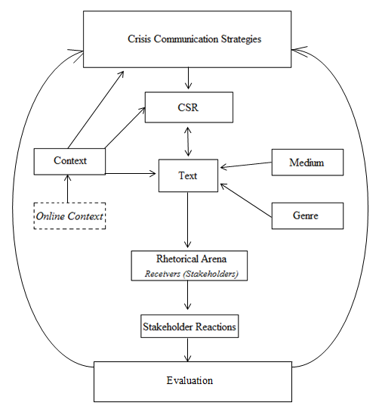

The constructed model is an attempt to define an organization’s discursive process in the production of a text, representing its crisis response information communicated in a CSR related setting. The crisis communication strategies component (Benoit and Coombs) signifies the overall discursive frames/approaches, guiding the production of the text. The selection of a specific frame is determined by the context – more specifically the situational context (type of crisis). In connection with the CSR component, the organization needs to define a clear and consistent CSR standpoint, building on organizational ethics and values, which are determined by the institutional context, and corresponding with the crisis type and issue. The established CSR considerations direct the content of the text, which is also influenced by the context (primarily the societal context), medium and genre (4.6.2).
After the production of the text, based on the circumstances known to the organization, it is externally communicated (Rhetorical Arena), expectedly resulting in reactions from various stakeholders, providing the organization with new information, which may reevaluate the different parameters (components) and assist in the production of a new text.
The model is a simple construction of a complex process, and therefore more to be seen as a hypothesis, where the study at hand falls short in providing sufficient answers. However, further examinations, following the theoretical lines of discourse theories, critical discourse analysis, CSR and crisis communication, can possibly provide additional valuable understandings of how an organization effectively can utilize its CSR to discursively structure a persuasive and efficient form of crisis communication.

Bibliography
Baker, Mitchell. "Building a Global, Diverse, Inclusive Mozilla Project: Addressing Controversy." Lizard Wrangler (Mozilla), March 26, 2014.
—. "On Mozilla's Support for Marriage Equality." Lizard Wrangler Mozilla Blog, March 29, 2014.
—. "Brendan Eich Steps Down as Mozilla CEO." The Mozilla Blog, April 3, 2014.
Baker, Paul, and Sibonile Ellege. Key Terms in Discourse Analysis. London: Continuum International Publishing Group, 2011.
Ball, James. "Mozilla CEO insists he won't resign over 'private' support for gay marriage ban." The Guardian, April 2, 2014.
Barr, Alistair. "Three Mozilla Board Members Resign over Choice of New CEO." The Wall Street Journal, March 28, 2014.
Becker, John M. "Half of Mozilla's Board Resigns; Pressure Mounts on CEO." The Bilerico Project, March 31, 2014.
Benoit, W. L. "Image repair discourse and crisis communication." Public Relations Review, 1997: 177-186.
Benoit, William L. "Another visit to the theory of image restoration strategies." Communication Quarterly Vol. 48.1, 2000: 40-43.
Benoit, William L. "Another Visit to the Theory of Image Restorations Strategies." Communication Quarterly Vol. 48 No. 1, 2000: 40-44.
Benoit, William L. "Image Repair Discourse and Crisis Communication." Public Relations Review Vol. 23, 1997: 177-186.
Benoit, William L. "Image Restoration Theory." In Encyclopedia of Public Relations Vol. 1, by Robert L. Heath, 407-410. Houston: SAGE Publications Inc., 2005.
Benoit, William L., and Shirley Drew. "Appropriateness and Effectiveness of Image Repair Strategies." Communication Reports, Volume 10, No. 2, Summer, 1997: 153-163.
Benoit, William, and Robert S. Hanczor. "The Tonya Harding controversy: An analysis of image restoration strategies." Communication Quarterly Vol. 42,4, 1994: 416-433.
Berthon, Pierre R., Leyland F. Pitt, Kirk Plangger, and Daniel Shapiro. "Marketing meets Web 2.0, social media, and creative consumers: Implications for international marketing strategy." Business Horizons, 2012: 261-271.
Blaikie, Norman. "Interpretivism." In The SAGE Encyclopedia of Social Science Research Methods, by Michael S. Lewis-Beck, Alan Bryman and Tim Futing Liao, 509-511. New York: SAGE Publications, Inc., 2004.
Blindheim, Bjørn-Tore, and Oluf Langhelle. "A reinterpretation of the principles of CSR: a pragmatic approach." Corporate Social Responsibility and Environmental Management, 2010: 107-117.
Bowen, Howard R. Social Responsibility of the Businessman. New York: Harper & Row, 1953.
Bradshaw, Paul. "An attempt to define blogging as a genre." Online Jounalism Blog, November 13, 2008.
Brandom, Russell. "OKCupid asks users to boycott Firefox because of CEO's gay rights stance." The Verge, March 31, 2014.
Bryman, Alan. Quantity and Quality in Social Research. New York: Routledge, 1988.
Bryman, Alan. "The End of the Paradigm Wars?" In The SAGE Handbook of Social Research Methods, by Pertti Alasuutari, Leonard Bickman and Julia Brannen, 12-26. London: SAGE Publications Ltd, 2008.
Burchell, Jon, and Joanne Cook. "Confronting the “corporate citizen”: Shaping the discourse of corporate social responsibility." International Journal of Sociology and Social Policy, 2006: 121-137.
Burke, K. Rhetoric of Religion. Berkeley: University of California Press, 1970.
Burns, J. P, and M. S. Bruner. "Revisiting the theory of Image Restoration Strategies." Communication Quarterly, 2000.
Catenaccio, Paola. "Press Releases as a Hybrid Genre: Addressing the Informative/Promotional Conundrum." Pragmatics Vol 18 No. 1, 2008: 9-31.
Chia, Joy. "Communicating, Connecting and Developing Social Capital for Organisations and their Communities: Benefits for Socially Responsive Organisations." In Communicating Corporate Social Responsibility: Perspectives and Practice, by Ralph Tench, William Sun and Brian Jones, 41-58. Leeds: Emerald Group Publishing Limited, 2014.
Collin, Finn. "Socialkonstruktivisme i Humaniora." In Humanistisk Videnskabsteori, by Finn Collin and Simo Køppe, 248-275. Viborg: DR Multimedie, 2003.
Coombs, Timothy, and Sherry Holladay. "Helping Crisis Managers Protect Reputational Assets." Management Communication Quarterly Vol 16, 2002: 165-186.
Coombs, W. Timothy. "Conceptualizing Crisis Communication." In Handbook of Risk and Crisis Communication, by Robert L.Heath and H.Dan O’Hair, 99-118. New York: Routledge, 2009.
—. Ongoing Crisis Communication: Planning, Managing and Responding - Fourth Edition. Thoudsand Oaks: SAGE Publications Inc., 2015.
Coombs, W. Timothy. "Protecting Organization Reputations During a Crisis: The Development and Application of Situational Crisis Communication Theory." Corporate Reputation Review Volume 10 Number 3, 2007: 163-176.
Coombs, W. Timothy, and J. Sherry Holladay. "The paracrisis: The challenges created by publicly managing crisis prevention." Public Relations Review, April 6, 2012: 408-215.
Coombs, W. Timothy, and Sherry J. Holladay. "Conceptualizing Corporate Social Responsibility." In Managing Corporate Social Responsibility: A Communication Approach, First Edition., by W. Timothy Coombs and Sherry J. Holladay, 1-27. Oxford: Blackwel lPublishing Ltd., 2012.
—. Managing Corporate Social Responsibility: A Communication Approach. Oxford: Blackwell Publications, 2012.
Cornelissen, Joep. "Corporate Identity, Image and Reputation." In Corporate Communication: A Guide to Theory and Practice, by Joep Cornelissen, 59-79. London: SAGE Publications Ltd., 2011.
Cornelissen, Joep. "Crisis Communication." In Corporate Communication: A Guide to Theory and Practice, by Joep Cornelissen, 199-213. London: SAGE Publications, 2011.
Davis, Keith. "Can business afford to ignore social responsibility?" California Management Review, 2, 1960: 71-73.
Dhanesh, Ganga S. "A Dialectical Approach to Analyzing Polyphonic Discourses of Corporate Social Responsibility." In Communicating Corporate Social Responsibility: Perspectives and Practice, by William Sun, Brian Jones Ralph Tench, 157-177. Leeds: Emerald Group Publishing Limited, 2014.
Dijk, Teun Van. "Multidisiplinary CDA: A Pleas for Diversity." In Methods of Critical Discourse Analysis, by R. Wodak and M. Meyer, 95-120. London: Sage, 2001.
Dobers, Peter, and Delyse Springett. "Corporate Social Responsibility: Discourse, Narratives and Communication." Corporate Social Responsibility and Environmental Management - Volume 17, issue 2, 2010: 63-69.
Eich, Brendan. "Brendan Eich." brendaneich.com. April 5, 2012. https://brendaneich.com/2012/04/community-and-diversity/ (accessed April 19, 2015).
—. "The Next Mission." Brendaneich (Mozilla), April 3, 2014.
—. "Inclusiveness at Mozilla." Mozilla Blog - Brendan Eich, March 26, 2014.
European Commission. A renewed EU strategy 2011-14 for Corporate Social Responsibility. Communication from the Commission to the European Parliament, the Council, the European Economic and Social Committee and the Committee of the Regions, Brussels: European Commission, 2011.
Fairbrass, Jenny, Linda O’Riordan, and Hafiz Mirza. Corporate Social Responsibility: Differing definitions and Practices? Prepared for Business Strategy and the Environment Conference 2005, UK, Bradford: School of Management - University of Bradford, 2005.
Faircloth, Kelly. "Tech Celeb Makes Prop-8 Donation; Internet Goes Berserk." Observer, April 9, 2012.
Fairclough, Norman. Critical Discourse Analysis. Longman, 2010.
—. Critical Discourse Analysis: The Critical Study of Language. Edinburgh: Pearson Education Limited, 2010.
—. Discourse and Social Change. Cambridge: Polity Press, 1992.
—. Media Discourse. London: Edward Arnold, 1995b.
Fleming, Peter, and Marc T. Jones. The End of Corporate Social Responsibility: Crisis & Critique. London: SAGE Publications, 2013.
Fombrun, C.J. "Building corporate reputation through CSR initiatives: Evolving standards." In Corporate Reputation Review , 8 ( 1 ), by Corporate Reputation Review, 7-11. Palgrave Macmillan Ltd., 2005.
Foucault, Michel. Archaeology of Knowledge. Hove: Psychology Press, 2002.
Fowler, Roger, Robert Hodge, Gunter Kress, and Tony Trew. Language and Control. London: Routledge, 1979.
Frandsen, Finn, and Winni Johansen. "Inside the Rhetorical Arena: Developing a multi-vocal approach to crisis communication." Aarhus University. Örebro, November 30, 2012.
—. Krisekommunikation: når virksomhedens image og omdømme er truet. Samfundslitteratur, 2007.
Frandsen, Finn, and Winni Johansen. "Rhetorical Arena (Crisis Theory)." In Encyclopedia of Public Relations, by Robert L. Heath, 798-801. Thousand Oaks: SAGE Publications, 2013.
Friedman, Milton. "The Social Responsibility of Business Is to Increase Its Profit ." Business Ethics Now (originally New York Times Magazine), 1970: 211-214.
Gadamer, Hans-Georg. Truth and Method. London: Continuum, 2004.
González-Herrero, Alfonzo, and S. Smith. "Crisis Communication management 2.0: Organizational principles to manage crisis in an online world." Organizational Development Journal, 2010: 97-105.
Grabowski, Gene, and Samantha Kruse. "The Keys to Combining Crisis Communication and CSR." In PR News' Corporate Social Responsibiity Guidebook Volume 6, by PR News, 113-117. PR News Press, 2013.
Gramsci, Antonio. Selections from Prison Notebooks. London: Lawrence and Wishart, 1971.
Hearit, K. M. "From "We Didn´t Do it" to "It´s not Our Fault"." In Public Relations Inquiry as Rhetorical Criticism, by W. N. Elwood. Westport: Praeger, 1995.
Helm, Sabrina, and Julia Tolsdorf. "How Does Corporate Reputation Affect Customer Loyalty in a Corporate Crisis?" Journal of Contingencies and Crisis Management Vol. 21, Issue 3, 2013: 144-152.
Humphreys, Michael, and Andrew D. Brown. "An Analysis of Corporate Social Responsibility at Credit: Line: A Narrative Approach." Journal of Business Ethics Vol. 80, May 27, 2007: 403-418.
Itänen, Miia-Emilia. CSR Discourse in Corporate Reports - Exploring the Socially Constructed Nature of Corporate Social Responsibility. Master's thesis, Espoo: Aalto University, 2011.
Johnson, Harold. Business in Comtempoary Society: Framework and issues. Belmont: CA: Wadsworth, 1971.
Jørgensen, Marianne, and Louise J. Phillips. Discourse Analysis as Theory and Method. London: SAGE Publications, 2002.
Keddie, Vince. "Case Study Method." In The SAGE dictionary of social research methods, by Victor Jupp, 20-22. New York: SAGE Publications Inc., 2006.
Keys, Tracey, Thomas W. Malnight, and Kees van der Graaf. "Making the most of corporate social responsibility." Mckinsey&Company, December 2009: Insights & Publications.
Kohlbacher, Florian. The Use of Qualitative Content Analysis in Case Study Research. Journal, Forum Qualitative Sozialforschung / Forum: Qualitative Social Research, 7(1), Art. 21, 2006.
Laclau, Ernesto, and Chantal Mouffe. Hegemony and socialist strategy : towards a radical democratic politics. London: Verso, 1985.
Lin, Ann Chih. "Bridging Positivist and Interpretivist Approaches to Qualitative Methods." Policy Studies Journal, Vol. 26, No. 1, 1998: 162-180.
Machin, David, and Andrea Mayr. How To Do Critical Discourse Analysis: A Multivocal Introduction. London: SAGE Publications Ltd., 2012.
Machkovech, Sam. "Gay Firefox developers boycott Mozilla to protest CEO hire." Condé Nast, March 25, 2014.
—. "Mozilla employees tell Brendan Eich he needs to “step down”." Condé Nast, March 27, 2014.
McKinley, Jesse. "Top Court in California Will Review Proposition 8." The New York Times, November 19, 2008.
Michotte, Emmanuelle. Controlling discourse on CSR: An analysis of the Belgian case. Paper, London: International Conference on Organizational Discourse: Translations, Transformations and Transgressions. , 2008.
Mouffe, Chantal. Critique as Counter-Hegemonic Intervention. Vienna: European Institute for Progressive Cultural Policies. April 2008. http://eipcp.net/transversal/0808/mouffe/en (accessed April 2, 2015).
Mozilla Foundation. "Mozilla Statement on Diversity." Mozilla Press Center, March 25, 2014.
—. Mozilla.org. April 30, 2015. https://www.mozilla.org/en-US/about/manifesto/details/ (accessed April 30, 2015).
—. "Community Participation Guidelines." Mozilla.org, January 7, 2013.
—. "Mozilla Foundation Forms New Organization to Further the Creation of Free, Open Source Internet Software, Including the Award-Winning Mozilla Firefox Browser." Mozilla.org, August 3, 2005.
—. "Mozilla Supports LGBT Equality." The Mozilla Blog, March 29, 2014.
Mozilla. "Mozilla Press Center." Webpage for Mozilla Press Center. March 24, 2014. https://blog.mozilla.org/press/2014/03/mozilla-leadership-changes/ (accessed April 19, 2015).
—. "FAQ on CEO Resignation." The Mozilla Blog, April 5, 2014.
Murphy, Priscilla. "Game Theory: A New Paradigm for the Public Relations Process." In Public Relations Theory, by C. Botan and V. Hazleton, 173-192. Hillsdale: Lawrence Erlbaum, 1989.
Netburn, Deborah. "Brendan Eich's Prop. 8 contribution gets Twittersphere buzzing." Los Angeles Times, April 4, 2012.
Oberlander, Kristin M. Case Study: Firefox. May 7, 2014.
Pahuus, Mogens. "Hermeneutik." In Humanistisk Videnskabsteori, by Finn Collin and Simo Køppe, 140-169. Viborg: DR Multimedie, 2003.
Palenchar, Michael L. "Public Relations." In Encyclopedia of Crisis Management Vol. 1, by K. Bradley Penuel, Matt Statler and Ryan Hagen, 776-778. London: SAGE Publications Inc., 2013.
Pew Research Center . "Among Muslims, Internet Use Goes Hand-in-Hand With More Open Views Toward Western Culture." Pew Forum, May 31, 2013.
Saeed, Muhammad Mohtsham, and Faria Arshad. "Corporate social responsibility as a source of competitive advantage: The mediating role of social capital and reputational capital ." Database Marketing & Customer Strategy Management Vol. 19, 4, June 14, 2012: 219-232.
Schwartz, Mark S., and Archie B. Carroll. "Corporate Social Responsibility: A Three-Domain Approach." Business Ethics Quarterly, Vol. 13, No. 4, 2003: 503-530.
Schwarz, Andreas. "Scapegoating." In Encyclopedia of Crisis Management, by K. Bradley Penuel, Matt Statler and Ryan Hagen. Thousand Oaks: SAGE Publications, Inc., 2013.
Scott, M. H., and S. M. Lyman. "Accounts." American Sociological Review, 33, 1968: 46-62.
Seeger, Mathew, Timothy Sellnow, and Robert Ulmer. Communication and Organizational Crisis. Westport: Praeger, 2003.
Sellnow, Timothy L., and Matthew W. Seeger. Theorizing Crisis Communication. Chichester: Wiley-Blackwell, 2013.
Sethi, S. P. "Dimensions of Corporate Social Performance: An Analytic Framework." Carlifornia Management Review, 17, 1975: 58-64.
Shankland, Stephen. "Objecting to new CEO, resignations sweep Mozilla board: Report." CNet, March 28, 2014.
Sørensen, Mikkel H., and Nicolai Peitersen. "CSR 2.0." Social Ansvarlighed (Forlaget Andersen), 2007: Chapter 3.3 (1-8).
Tench, Ralph, William Sun, and Brian Jones. Communicating Corporate Social Responsibility: Perspectives and Practice. Leeds: Emerald Group Publishing Limited, 2014.
Theofilou, Anastasios, and Tom Watson. "Sceptical Employees as CSR Ambassadors in Times of Financial Uncertainty." In Communicating Corporate Social Responsibility: Perspectives and Practice, by Ralph Tench, William Sun and Brian Jones, 355-382. Leeds: Emerald Group Publishing Limited, 2014.
Thomas, Owen. "Brendan Eich: Just Apologize For Supporting Proposition 8." Readwrite, March 28, 2014.
Tombs, Steve, and Denis Smith. "Corporate Social Responsibility and Crisis Management: the democratic organization and crisis prevention." Journal of Contingencies & Crisis Management, September 1, 1995: 135-148.
Torfing, Jacob. New theories of discourse: Laclau, Mouffe and Zizek. Oxford: Blackwell Publishing Ltd, 1999.
Täuschel, Alexander. The Basic Concepts of Discourse Analysis. Seminar Paper, Frankfurt: University of Frankfurt (Main), 2004.
Walter, Bernd Lorenz. "CorporateSocial Responsibility Communication: Towards a Phase Model of Strategic Planning." In Communicating Corporate Social Responsibility: Perspectives and Practice, by William Sun Ralph Tench and Brian Jones, 59-79. Leeds: Emerald Group Publishing Limited, 2014.
Ware, B. L., and W. A. Linkugel. "They Spoke in Defense of Themselves: On the generic critisism of apoligia." Quarterly Journal of Speech, 59, 1973: 273-83.
WBCSD. Corporate Social Responsibility: Meeting changing expectations. CSR Report, Conches-Geneva: World Business Council for Sustainable Development, 2002.
Weber, Steven. "The Rhetoric of Positivism Versus Interpretivism: A Personal View." MIS Quarterly Vol. 28 No. 1/, March 1, 2004.
Wester, Misse. "Cause and Consequences of Crises: How Perception Can Influence Communication." Journal of Contingencies and Crisis Management Vol. 17, Issue 2, June 2009: 118-125.
Western Culture Knowledge Center. "Western Culture Global." 2009. http://www.westerncultureglobal.org/what-is-western-culture.html (accessed April 30, 2015).
"The Discourse-historical Approach." In Methods of Critical Discourse Analysis, by Ruth Wodak and M. Meyer, 87-122. London : Sage, 2001.
Yin, Robert K. Case Study Research: Design and Methods - Fourth Edition. London: SAGE Publications Ltd., 2009.
Aasprong, Marius Lervåg. Uncovering Corporate Social Responsibility: Deparadoxation of power in the CSR-discourse. Master's Thesis, Trondheim: Norwegian University of Science and Technology, 2012.

Appendix

Appendix 1: Definitions of CDA Terms (Machin and Mayr 2012, 32-190)
Word connotations: The general meaning or connotation(s) one can derive from specific words in use – on the basis of how they influence certain sets of associations within a clause. Moreover, a valid approach can be to determine whether or not there is a predominance of particular types of words (neutral or highly value-laden words) (Ibid: 32).
Overlexicalization: The usage of a specific type of words and its synonyms to describe something or someone, indicating over-persuasion and reveals a plausible ideological contention (there is a sense of need to persuade) (Ibid: 37).
Suppression or lexical absence: The obvious absence of elements within the text that would be expected to have been included (an example could be a response to a critique, where some points are not being addressed at all) (Ibid: 38).
Structural oppositions: Usage of words or concepts that have a clear opposite (militant versus citizen) and therefore indirectly emphasizing the properties thereof (Ibid: 39).
Lexical choices: To express a desired degree of authority (scientific sounding words, specialist comments, expert knowledge to express a high degree of authority contra everyday words to express equal status) (Ibid: 42).
Quoting verbs: How the sender of the text choses to quote someone else (neutral (said) versus value-laden (shouted): a matter of how the sender wishes to portray the person and the quote in question (Ibid: 57).
Representational strategies in language: How the sender decides to represent a person (portraying his identity; the Muslim man contra the young man) (Ibid: 77).
Classification of social actors:
Personalized versus impersonalized: The opinion and voice of one specific person or an entire institution that may give extra weight to a particular statement.
Individualization versus collectivization: Bringing forth the individual or bringing forth a group of a specific kind of people.
Specification and generalization: Specific person or a type of person.
Nomination and functionalization: A person is defined by function (job title, activity).
Objectivation: A social actor is represented through a feature (‘a beauty’ instead of a woman).
Anonymization: Social actors are not recognized (‘a source said’).
Pronouns: The usage of pronouns instead of nouns (we, us, them), which can express the sender’s ideas as the same as the recipients (or a persuasion of the same).
Suppression: No agents (social actors) are revealed in a clause, where particular concepts, theories or ideologies are portrayed as the agents (globalization, democracy) (Machin and Mayr 2012, 79-85).
Nominalization: Actors are not mentioned within a clause, but merely the ‘victims’ and the actions themselves, which indicates no clear responsibility (the changed global economy) (Ibid: 137).
Presupposition: Something (concepts, ideas, as for example ‘British culture’) is assumed to be understood without further explanation (Ibid: 153).
Transitivity: A term that refers to the depiction of actors/patients in terms of who does what to whom, and how (important actors within a clause are revealed). Significant aspects to consider are the participants, processes (material, mental, behavioral, verbal, relational and existential´verbs and verbal groups) and circumstances (adverbial groups or prepositional phrases) (Ibid: 104-112).
Modality: Any unit of language that expresses the sender’s personal opinion or commitment to what they say, like hedging (I believe/think) and word units like ‘may’, which depicts the degree of certainty (Ibid: 186).
Modals: The use of modals in a sentence generates expressed degrees of power and authority of the author (‘you will’ versus ‘you should’) (Ibid: 190).

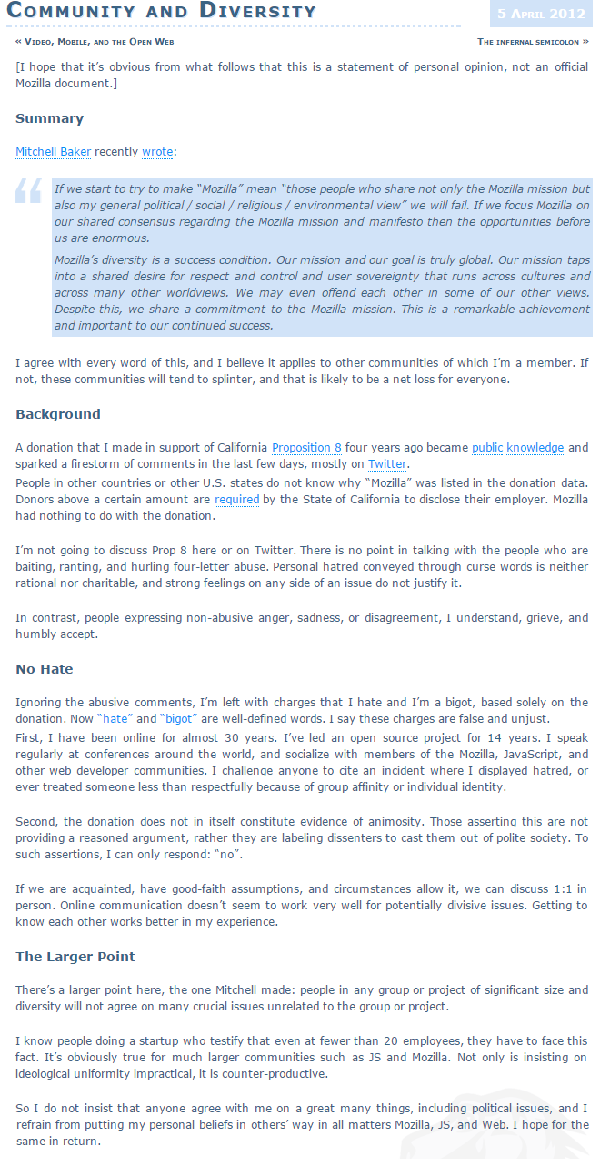
Appendix 2: Brendan Eich responding to 2012 controversy (Eich 2012)
Appendix 3: Mozilla Firefox advertisement (Oberlander 2014)
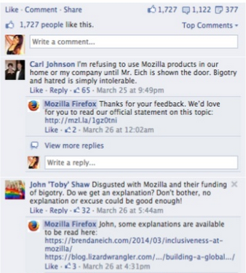
Appendix 4: Stakeholder comments on advertisement (Oberlander 2014)

Appendix 5: Statement 1 – Mozilla Statement on Diversity (Mozilla Foundation 2014)

Appendix 6: Official Mozilla and Firefox Tweets on March 26 (Oberlander 2014, 7-8)
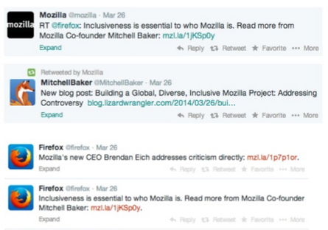

Appendix 7: Statement 2 – Statement of Brendan Eich (Eich 2014)
Appendix 8: Statement 3 – Statement of Mitchell Baker (M. Baker 2014)

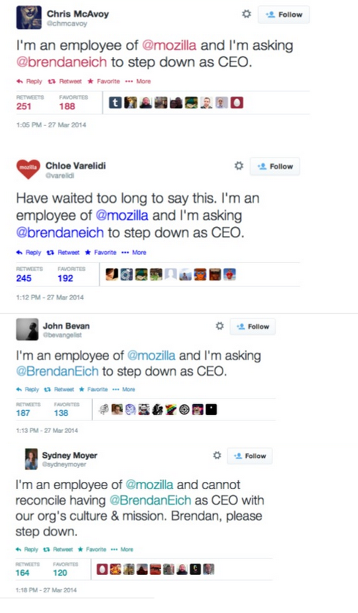
Appendix 9: Employee Tweets on March 27 (Oberlander 2014)

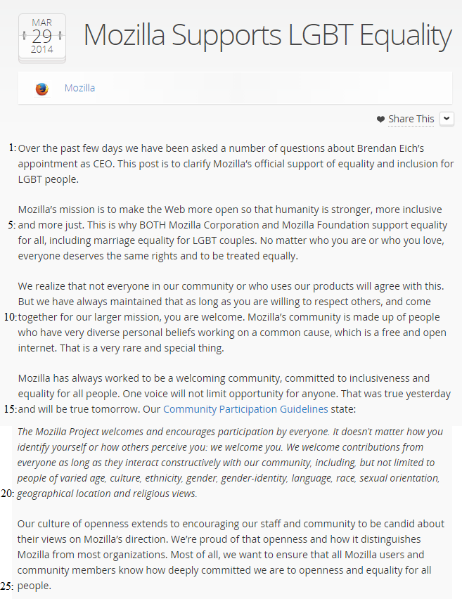
Appendix 10: Statement 4 – Official Statement from Mozilla (Mozilla Foundation 2014)
Appendix 11: Statement 5 – Second Statement from Mitchell Baker (M. Baker 2014)
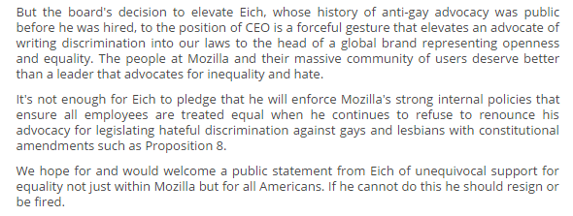
Appendix 12: Statement from CREDO, Concerning Petition Campaign (Becker 2014)
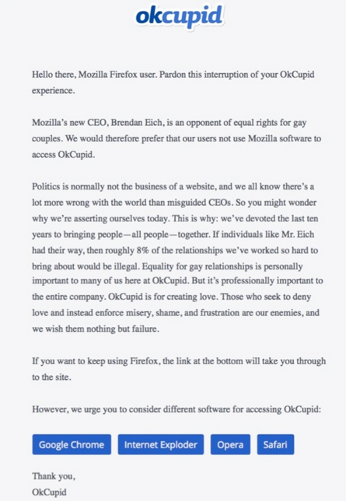
Appendix 13: Okcupid Boycott Notification (Brandom 2014)

Appendix 14: Brendan Eich’s Comments in an Interview with the Guardian (Ball 2014)
“So I don't want to talk about my personal beliefs because I kept them out of Mozilla all these 15 years we've been going,” he told the Guardian. “I don't believe they're relevant.”
“I agree with people who say it wasn't private, but it was personal,” he said of the donation. “But the principle that I have operated by, that is formalised in our code of conduct at Mozilla, is it's really about keeping anything that's not central to our mission out of our office.”
“If I stop doing that now I think I would be doing wrong that code of conduct and doing a disservice to Mozilla. And I really do think it's an important principle of inclusiveness for Mozilla to succeed.”
“With the board of directors departures, two of them were already planning to depart … those are before any of the current news about me came out,” he said. “I would also say that OkCupid is a good example. I think there's a chance that we could actually turn that around. I think they acted a little rashly”.
“I don't think they were aware of the statement [Mozilla foundation chair] Mitchell Baker made at the weekend [that] Mozilla as an organisation believes in LGBT equality, and I've heard from a lot of people that OkCupid had actually not been aware of that. So I think we can actually turn that around.”
“There's a difference here between the company, the foundation, as an employer and an entity, versus the project and community at large, which is not under any constraints to agree on LGBT equality or any other thing that is not central to the mission or the Mozilla manifesto.”
“So far we've been able to bring people together of diverse beliefs including on things like marriage equality,” he said. “We couldn't have done this, we couldn't have done Firefox One. I would've been excluded, someone else would've been excluded because of me – I wouldn't have done that personally, they'd have just left. So imagine a world without Firefox: not good.”
“If you think about how networks evolve you get superpowers, Yahoo then Google, Facebook on social, and that can be a good thing,” he said. “But because they have network power, users have to go in there and put their data inside walled gardens. Mozilla as a browser has the potential to unionise our users, and if we do that we get collective bargaining rights over our data. That's one of the corners I think I can help us turn.
“I think I'm the best person for the job and I'm doing the job.”

Appendix 15: Statement 6 – Last Official Statement from Mozilla and Mitchell Baker (M. Baker 2014)

Appendix 16: Statement 7 – Eich’s Statement of Resignation (Eich 2014)

