School of Culture and Global Studies
Study Board for Cross-cultural Studies
The impact of negative electronic word-of-mouth on the Danish hotel industry

Supervisor: Carina Bregnholm Ren
Written by: Irena Dimitrova Peneva

1st June 2015

Table of Contents
1. INTRODUCTION 5
2. LITERATURE REVIEW 8
2.1 Word-of-mouth (WOM) 8
2.2 Electronic word-of-mouth (eWOM) 9
2.3 Impact of negative eWOM 14
2.4 Effect of eWOM on hotels 16
2.5 Corporate response strategies towards negative eWOM 19
3. METHODOLOGY 29
3.1 Research design 29
3.1.1 Goal of the research 29
3.1.2 Exploratory research 30
3.1.3 Research methods 31
3.2 Mixed methods 32
3.3 Qualitative research 33
3.3.1 Interview 34
3.4 Quantitative methods 36
3.4.1 Survey 36
3.5 Philosophical paradigm 38
3.5.1 Pragmatism 38
3.6 Limitations 41
4. ANALYSIS 43
4.1 Findings of the survey 43
4.2 Analysis 54
5. CONCLUSION 70
BIBLIOGRAPHY 71
LIST OF FIGURES 78
APPENDICES 79

Abstract

Electronic word-of-mouth (eWOM) is a contemporary phenomenon and it is a subject of many discussions. It is an influential factor for customers’ purchase decisions, consequently, it has an impact on the companies involved. The current project will investigate on one hand, how negative eWOM can affect the Danish hotel industry and on the other hand, by what means Danish hotels defend their image and reputation against guests’ critiques expressed on the Internet.

Personal unstructured interview and self-completion e-questionnaire were conducted with a number of Danish hotel managers in order to collect data. It was revealed that negative eWOM can have a harmful impact on hotels’ image and reputation if the problem is very serious and no corporate effort was made to fix it. The data collection has shown that hotels tend to adopt response strategies in order to deal with negative online reviews. The most used strategy is the accommodative one due to its favorable influence on hotel guests’ behavior and purchase decision-making.

Key words: electronic WOM, negative online reviews, Danish hotels, customers, hotels’ image and reputation, response strategies

INTRODUCTION

In the last decades, the Internet has given the opportunity for consumers to express their feelings and past shopping experiences with others. Sharing information online regarding a product, service, or a company is considered by the reserchers as electronic word-of-mouth (eWOM). Nowadays, eWOM is used by the consumers to make judgments about products and companies. Currently, to the eWOM information are exposed millions of people everywhere on the Internet – on blogs, online stores, companies webpages, chat rooms, online stores, review websites, etc. (Luo et al., 2015).

More and more consumers turn to eWOM before making a purchase decision especially before booking a hotel room (Koslow, 2000). Electronic word-of-mouth is considered to be more credible than the marketer-related messages, because it is consumer-generated and there is no intention of manipulating the reader (Bickart and Schindler, 2002, p. 428).
The motivation for eWOM occurs when consumers are very satisfied or dissatisfied by a product, service, or a company. Thus they create positive or negative online reviews that have the power to benefit companies or damage their image and reputation (Jeonga & Jang, 2011).
Usually, negative eWOM is an outcome of a company’s service failure. Researchers are concerned that negative reviews on Internet can have a harmful impact on companies. Many of them stress that negative eWOM can be more easily generated and more influencial than positive eWOM (Hornik et al., 2015).
The hotel sector is highly affected by eWOM due to the fact that its offerings are less tangible and thus greatly dependent on the perceived image and reputation. The literature on eWOM suggests that when choosing accommodation, potential hotel guests rely on online reviews to a great extent (Ekiz et al., 2012).

Businesses are not perfect and mistakes happen resulting in negative eWOM spreaded on the Internet. This process cannot be stopped, however there are ways of handling and neutralizing already existing negative reviews. In order to avoid bad reputation and even substancial losses, companies need to be aware of the problem that encouraged the negative eWOM and take corrective actions towards fixing that problem (Hoffman & Bateson, 2006).

As e WOM grows constantly and influences consumer decision making and purchasing, more companies have started to pay attention to eWOM and its persuasive power. They have started to manage it in one way or another (O'Connor, 2010).

The literature suggests a number of strategies for dealing with negative online feedback. Lee and Song (2010) present three corporate response strategies – accommodative, defensive, and “no action”. Similarly, Thomas et al. (2012) introduces five strategies from which two (respond and delay) are of interest to the current research paper.
With the use of a response strategy, companies are able to react to consumers’ critiques in a timely manner and twist the effect from these critiques to a positive outcome (Thomas et al., 2012).

Building on the facts mentioned above, the author of this paper formulated the problem statement of the project: “The impact of negative electronic word-of-mouth on the Danish hotel industry”. In order to answer the given problem statement two sub-questions were conceived. Firstly, the project will investigate “To what extent the negative eWOM affects the image and reputation of the Danish hotels?” Secondly, the author of the paper will research “How do Danish hotels deal with the negative eWOM?”.
This research examines the opinions of Danish hotel managers in regards to the power of eWOM and it aims to find out if hotel managers consider eWOM as a significant communication tool. The paper strives to elaborate on the extent to which negative eWOM can affect or even harm the image and reputation of the hotels. Additionally, this project explores how hotels handle critiques and how do they try to avoid and cope with complains posted online. The study case reveals a phenomenon researched on a country level but striving to present the global situation.
In order to answer both sub-questions the author of the project will conduct a personal interview with the manager of a hotel in Copenhagen and investigate his opinion, perceptions, attitude, and recommendations toward the negative eWOM effect on hotels. Also, he will be asked to express his experiences as a person who deals with negative reviews on a daily basis. In addition, a survey will be send to a large number of Danish hotel managers from all around the country in order to discover if they share the same opinion.
The author of the paper believes that the topic regarding eWOM concerns equally all hotels regardless of the country of location. Therefore, the researcher chose to collect data from Denmark due to the fact that she resides there. Taking that into consideration, it is easier for the author to obtain hotels’ contacts and more importantly- to conduct personal interviews.
The aim of the project is to explore the significance and impact of the eWOM from the perspective of the companies, not the customers. In order to gain a theoretical knowledge about the given topic the author of the paper investigates literature regarding traditional word-of-mouth, negative eWOM, its effect on hotels, and the corporate response strategies used by companies to deal with negative reviews.

LITERATURE REVIEW

The literature review chapter gives an overview of previous studies conducted on the same or similar topics. This part of the project provides descriptions and explanaitions of the main subjects and represents a base and inspiration for building this study.

2.1 Word-of-mouth (WOM)

This part of the literature review presents how different researchers define the marketing term “word-of-mouth” (WOM). The following definitions are important for this project because they provide the notion of what it will be researched later on.

Historically, word-of-mouth (WOM) has been considered as one of the most influential information resources. The influence of word-of-mouth on consumer decision making is extensively studied in academic literature (Steffes and Burgee, 2009). Referring to past researches, WOM has bigger effect on consumers than other conventional advertising media and marketing tools (Cheung et al., 2008; Engel et al., 1969; Katz and Lazarfeld, 1955).

Researchers describe WOM as the communication between people who are independent of the company providing a service or product that is a subject of their discussion (Silverman, 2001, p. 25). This informal communication is among people who are considered to have no commercial interest in persuading others in using a service or product and therefore have no particular intention to distort the truth in favor of the service or product (Cheung et al., 2008).

According to Jalilvanda et al. (2011), consumers tend to imitate each other following a social learning paradigm, however more importantly is that they talk to each other. That is defined from the literature as WOM communication. This process allows consumers to share knowledge and viewpoints to other people and in regards to specific products, services, and brands (Hawkins et al., 2004).

Westbrook (1987) describes WOM as “all informal communications directed at other consumers about the ownership, usage, or characteristics of particular goods and services or their sellers”. Pollach (2006) refers to WOM as “person-to-person communication about a brand, a product or a service between two or more consumers”. Additionally, WOM can be any positive or negative oral and personal communication, about a brand, service, product, and also an organization, in which the receiver of the message is aware that the sender has non-commercial intentions (Casielles et al., 2013). The expression word-of-mouth is a form of communication that occurs mainly among friends, families, groups, independent specialists, and/or customers (current or potential) of a service or product (Sandes & Urdan, 2013).

Furthermore, WOM as a process of delivering information from one person to another plays a significant role in customer buying decisions (Richins & Root-Shaffer, 1988). Therefore, WOM marketing is considered to be very influential but hard to influence (Jansen, 2009).
In the context of WOM communication, verbal points of view about services, products or brands can be conveyed, developed, and transmitted from one person to another through so-called “social networks” (Ennew et al., 2000; Thevenot and Watier, 2001). The message is perceived as non-commercial, although it refers to products or brands and it influences pre-usage attitudes consumer choice and purchase decisions and post-usage perceptions about the product or brand (Jose et al., 2013).

2.2 Electronic word-of-mouth (eWOM)

This part of the literature review defines the term “electronic word-of-mouth” (eWOM), which is the main subject of the present study. The researches on eWOM communication are generally very fragmented and large. The following paragraphs will provide a systematic review of the existing eWOM literature in regards to the research topic.

Electronic word-of-mouth is an important type of WOM, which represents the opinions expressed by customers in online review sites and social networking websites (Gonzalez et al., 2013).
Whereas WOM refers to the idea of person-to-person discussion between consumers about a service or product (Sen and Lerman, 2007), the spread of the internet throughout the world developed a less personal and more ubiquitous type of WOM - electronic word-of-mouth (e.g. Brown et al., 2007; Davis and Khazanchi, 2008; Godes and Mayzlin, 2004). With time, the notion of eWOM communication has received great attention in both academic and business communities. There have been conducted many studies in order to explore the effectiveness of eWOM communication (Cheung et al., 2012).

In the pre-internet era, consumers used traditional WOM to share each others’ product-related experiences. Nowadays, the Internet makes it possible and easy for consumers to share their opinions and experiences regarding a product or service via eWOM activity (Cheung et al., 2012).

Same as the traditional WOM, electronic WOM is an “informal, person-to-person communication between a perceived non-commercial communicator and a receiver regarding a brand, a product, an organization, or a service” (Yolanda & Chan, 2011). Electronic word- of- mouth is also defined as “any positive or negative statement made by potential, actual, or former customers about a product or company, which is made available to a multitude of people and institutions via the Internet” (Yolanda & Chan, 2011).
Additionally, Westbrook (1987) defines eWOM as all communications exchanged between consumers through Internet-based technology that relate to the characteristics or usage of services and products or their sellers. Moreover, eWOM includes communication between consumers and between consumers and producers - both essential elements eWOM and both strongly differentiated from communications occurring through mass media (Stephen et al., 2008).

Electronic WOM has long been an important topic for marketers (Balasubramanian & Mahajan, 2001; Bickart & Schindler, 2001; Hennig-Thurau et al., 2004). Moreover, in recent years there is an explosion of literature focused on the eWOM communication effectiveness. There is no doubt that eWOM is a powerful marketing tool (Cheung et al., 2012). Electronic WOM is powerful because it allows companies to reach, listen to, and communicate with the customers so that they can better understand and try to meet their needs (Yolanda & Chan, 2011).

Furthermore, Cheung et al.(2008) point out that the new type of WOM has become a major venue for consumer to express their opinions (Mayzlin, 2006) and it is considered to be much more effective than the traditional one due to its high reach and strong accessibility (Chatterjee, 2001). Pai et al. (2013) add that eWOM has bigger influence than the traditional information presented by marketers because it is considered to be more convenient and with higher credibility (Bickart & Schindler, 2001).

According to Bickart and Schindler (2001), consumers are involved in the communication and transmission of online service- and product information through a variety of formats such as comments, tweets, blog posts, and reviews. Electronic WOM, regardless of the format, normally involves positive or negative, direct or indirect recommendations regarding a service, product or a company. These recommendations from consumers are eWOM messages that are believed to guide others in their purchase decisions (Bickart & Schindler, 2001; Ha, 2002; Nielsen, 2012). Additionally, people become aware that information provided from marketers is information that aims to present their products or services in a favorable light, therefore consumers tend to develop negative perceptions in regards to the credibility of marketer-created messages (Koslow, 2000). Thus, more and more consumers turn to eWOM in order to guide their purchase decisions (Trusov, Bucklin, & Pauwels, 2009).
Researchers have discovered that consumers are generally more interested in products and services discussed by other people on web forums and blogs than they are interested in those marketed in traditional ways (Pai et al., 2013). Many studies have been conducted in order to prove that “when consumers generate information based on their personal experiences, this information tends to exert more impact on others’ attitudes and holds more credibility than if it were generated by advertising companies and corporate marketing departments”. The credibility of eWOM is confirmed by the fact that “other consumers are perceived to have no vested interest in the product and no intentions to manipulate the reader” (Bickart and Schindler, 2002, p. 428). Consumers find the information exchanged on internet social networks more relevant and trustworthy as the information reflects product consumption in real-world settings by other consumers and is free from marketeers’ interests (Abrantes et al., 2013).

Electronic word-of-mouth has gained even more credibility with the population’s raising use of the Internet as a medium of communication on a daily basis (Sandes & Urdan, 2013). The wide spread and the range of information on the Internet provides consumers with easier and faster access to what others comment about services, products, and companies and their comments have turned into a reference for more and more people (Duana, Bin, and Whinston 2008).

Electronic word-of-mouth can definitely contribute in raising the credibility of a service or product (Bickart & Schindler, 2001). Therefore, Pai et al. (2013) believe that it is highly important for companies to efficiently gather and analyze consumers’ opinion as it certainly has its impact on consumers’ decision process. A recent survey found that “most consumers perceive online opinions to be more trustworthy than brand web sites” (Nielson, 2007). The results reveal how great influence eWOM can have on the consumer decision making (Jalilvanda et al., 2011). Cheung et al. (2012) postulated that information from a source that is considered to be more reliable and trustworthy will increase the persuasiveness of the given information.
Due to the uncertainty of buying, prices, and other risks related to the purchase decisions, consumers seek eWOM. Biz Rate conducted a survey with more than 5,500 web consumers. The findings showed that 44 per cent of the participants said that before making a purchase decision they had consulted review websites and 60 per cent considered consumer-generated reviews as more reliable and trustworthy than expert reviews (Yolanda & Chan, 2011).

There are different theories among researchers in regards to the average rating in online reviews and the number of the reviews. Some consider the average ratings to be significant, while others find that the quantity of reviews has a stronger impact on consumers (Yolanda & Chan, 2011).

Park et al. (2007) found out that quality and quantity of the online consumer reviews are very significant charachteristics in terms of consumer information-processing. They postulated that there is a strong relationship between the quality of reviews and customer purchase decisions. According to them, “if online reviews are logical and persuasive, with sufficient reasons based on specific facts about the product, they are likely to have an impact on consumers’ purchase intention”. There is also a relationship between the quanity of online reviews and consumer purchase choice. The reason behing this statement comes from the fact that online reviews imply the popularity of a product or a company, thus the larger the number of reviews, the higher intention to purchase (Yolanda & Chan, 2011).
A considerably large number of studies reveal that the volume of reviews is significantly related to product sales and not so much the rating of reviews. Berger et al. (2010) stress that “any publicity is a good publicity”. They found out that even negative reviews (e.g., negative eWOM) could increase the purchase likelihood. According to Duan et al.(2008), the online consumer reviews signify the existence of a service or product and thus generates an awareness effect. Therefore, eWOM volume creates a positive relationship with purchase decisions.

Another aspect regarding eWOM is the fact that Internet has created many opportunities and also challenges for eWOM communication (Goldsmith, 2006). A big opportunity is the fact that eWOM allows consumers not only to receive information related to services and products from the few people they know but also from “a vast, geographically dispersed group of people, who have experience with relevant products or services” (Jalilvanda et al., 2011). However, the anonymity of communicators could be a challenge due to the fact that it might potentially lead to out-of-context and misleading messages (Stephen et al., 2008).

Undoubtedly, eWOM is one of the sources of marketplace information with biggest influence on customers (Dellarocas, 2003). During the last several years the appearance of new media networks has offered a great range of opportunities for eWOM communication. According to Lee et al. (2013), more and more people use Web 2.0 tools to express their thoughts and opinions and to exchange information about products and services. Electronic word-of-mouth is spread through online platforms such as brand websites, retailer websites, product review websites, personal blogs, social networking sites, etc. (Lee et al., 2013).

Boyd (2008) found out that social networking site Facebook has more than 900 million users, another site - Twitter counts more than 340 million tweets every day (Kietzmann & Canhoto, 2013). Gonzalez et al. (2013) studied the website TripAdvisor. According to their findings “TripAdvisor represents the largest travel community in the world, with more than 35 million visitors per month (comScore Media Metrix 2010) and contains more than 45 million reviews and opinions on more than 1.3 million hotels, restaurants, and attractions (TripAdvisor 2011).” Furthermore, Gonzalez et al. (2013) believe that TripAdvisor is the website that consists of the greatest number of customer reviews of dining, transportation, and hospitality services. Currently, TripAdvisor has the reputation of the most successful website in regards to travel giving information and advices to travelers for travel planning and hotel booking. It also provides reviews of various facilities and businesses (Zhang & Vasquez, 2014).

According to Cheung et al. (2012), in terms of making purchase decisions Internet users tend to have more trust in reviews posted online by unknown consumers than they trust traditional media”. In addition, the researchers note that ‘user-generated content in the form of online customer reviews was found to significantly influence consumer purchasing decisions”. Dichter (1966) states in his work that positive eWOM communication might increase customers willingness to purchase (especially a new) product or service, due to the fact that positive eWOM reduces the risk embedded in the purchase. Other studies confirm that positive eWOM can assist in creating and maintaining a favorable image of a brand and its company (Jeonga & Jang, 2011).

2.3 Impact of negative eWOM

Unlike positive eWOM, the negative one can have the opposite effect on companies. The following paragraphs are focused on negative eWOM, which stands in the core of the problem statement and will be used to give answers to the research questions. An overview of the existing literature within the frame of the current project is presented.

Ideally, companies work to keep consumers satisfied and aim not to fail them. However, issues regarding products and/or services inevitably happen because businesses are not perfect (Hart, Heskett, & Sasser, 1990). According to Bolkan et al. (2012), when problems occur, consumers have a choice to pursue different responses. One option includes exit (not using the company again); second option is the direct voice (complaints discussed with the company at the time of the problem); another response is the indirect voice (complaints presented to the company via phone calls or email, etc.); customers can also use negative eWOM to express their dissatisfaction (sharing unfavorable experience by posting a negative review online) (Bolkan et al., 2012).

Studies on WOM suggest that there are two dimensions of eWOM communication- positive and negative. While positive eWOM is considered to derive from satisfactory experiences, negative eWOM is assumed to be an outcome of many needs and motives that were not satisfied (Hornik et al., 2015). Lee and Song (2010) stated that consumers’ assessments of a company are “more sensitive to negative information of corporate responsibility than to positive information”.
It seems that both researchers and marketers tend to believe that negative electronic word- of- mouth is more powerful and influential than positive eWOM (East et al., 2008). Similarly, Assael (2004) points out that negative eWOM has much stronger impact on people than the positive one. Moreover, many researches on the topic have got to the conclusion that negative information is more shocking and for that reason it “might draw more attention, might spread faster, is more influential and trusted, and might have much greater impact compared to positive information” (Hornik et al., 2015).

The Internet helps unsatisfied customers to give a voice to their opinions and experiences. The fact that Internet offers better and faster communication, builds exceptionally large audience, and voice out the issue is not dependent on time or costs (Hennig-Thurau et al., 2004). Even more, by using review websites and blogs unhappy customers “can get the problem off their chests” in a private and often times anonymous way (Au et al., 2010, p. 286). Due to the advantages of the Internet and the need of expressing negative attitudes travel review websites such as TripAdvisor have gained exceeding popularity (Ekiz et al., 2012).

Electronic word-of-mouth, especially negative communication, can cause serious troubles for companies due to the fact that not only it can have significant impact on consumer perceptions of them and/or their services/products, but it is also accessible for a large number of people, for a long period of time (Funches et al., 2010).

Lee and Song (2010) stress that many companies realize that online complaints might damage their reputation. However, they prefer not to respond to these negative comments in a timely manner (Homburg & First, 2007). The reason for that phenomenon is companies’ fear that a possible response from them could escalate the problem (Lee & Song, 2010). This matter will be discussed later on in the chapter.

Most researchers argue that the motivation for eWOM occurs when a customer has an extremely good or extremely bad experience. Therefore, it can be confirmed that there is a relationship between customer satisfaction and quantity of online reviews. “The most satisfied and most unsatisfied customers will be the ones who will generate more commentary, while customers who are neither extremely satisfied nor unsatisfied will share less WOM comments, particularly electronic reviews” (Bansal and Voyer 2000; Gremler 1994; Litvin, Goldsmith, and Pan 2008; Murray 1991). A great attention in the literature has been given to negative eWOM considering its unfavorable impact on businesses, especially as it has been discovered by many researches that consumers “do not complain to the person providing the service or product, but instead switch suppliers and share negative eWOM” (Gonzalez et al., 2013).

Vermeulen and Seegers (2009), by conducting a research on hotels found out that negative eWOM generates negative attitudes and came to the conclusion that single cases do not cause much treat, however repetition can be seriously detrimental. Pantelidis (2010) discovered that positive electronic reviews outweighed the negative ones for restaurants in London. His study further asserts that failure to propose good value to the customers is the main reason for negative eWOM, nevertheless negative reviews can be a chance for improvement if they are managed accurately.

The findings from many studies on different industries reveal a concern for eWOM regarding the fact that people tend to focus more on critiques and negative reviews than to positive comments. There is also a hypothesis stating that “as the number of reviews of a hotel increases, the ratings in these reviews are more positive”. The online ratings are more negative when less people evaluate the hotel (Gonzalez et al., 2013). By receiving more comments from customers, hotels will neutralize the harmful effects of negative reviews. Gonzalez et al.(2013) do not aim to understate the importance of negative eWOM, which is a useful source of information about what needs to be improved. Instead, they emphasize that “an increase in the number of online reviews will better reflect the customers as a whole, reducing the bias produced by an overrepresentation of malcontents or those who had an atypically bad experience”. Therefore, according to Gonzalez et al. (2013), companies should motivate their customers to post reviews online and create “exogenous eWOM”.

2.4 Effect of eWOM on hotels

Many studies made on eWOM are based on the customer purchasing decision, as Cheung et al. (2012) stated: “It is looked through the eyes of consumers”. However, in this project the author is aiming to show the other side – the companies and how eWOM (and more specifically negative eWOM) can affect their image and reputation. Therefore, in this part of the literature review the above-mentioned will be the main objective.
Recent studies in the tourism area has showed how both positive and negative eWOM can have an influence on businesses across different nations. Among these is the research of Morgan et al. (2003) based in New Zealand. They noted that negative WOM can have an overwhelming impact upon the image of the destination and thus the whole tourism sector. This occurred because of unsatisfied tourists who posted unflattering comments on the Internet in relation to their unpleasant experiences. Similarly, the study of Crick (2003), conducted in the Caribbean, asserts that “when locals display hostile feelings towards tourists, the result is negative WOM and a likely downturn in the industry”. Another example is presented by O’Neill et al. (2002) who conducted a research in Australia regarding wine tourism. They discovered that tourists’ recommendations posted online after their visit boost the wine sales. Further, Shanka et al.’s (2002) study states that the majority of tourists from Western Australia make their travel decisions based on eWOM. However, even though positive eWOM is favorable in terms of purchase decision, it also increases the expectations of the customer, who will become more demanding (Stephen et al.,2008). As a consequence, companies should work harder because it becomes more difficult for them to satisfy these expectations. Therefore, hotel managers should “monitor guests’ comments on the web not only to understand their critical aspects pointed out by negative reviews but also to comprehend the service expected by the customer”. In other words, an effective way of improving the service and gaining a competitive position on the market would be consulting the consumers reviews (Mauri & Minazzi, 2013).

From a company perspective, eWOM’s impacts can be considered as opportunities, because if hotels manage these impacts accurately, their business could gain competitive advantages. If not, hotels would be negatively affected by customers’ online critiques (Dickinger, 2011; Hills and Cairncross, 2010; Ye et al., 2009).
Managing the eWOM impacts properly can allow betterment in the quality of the services, the recognition of needs, and the adoption of new strategies (Loureiro and Kastenholz, 2011; Jun et al., 2010). Generally, positive online reviews can increase the reputation of a hotel on the market meaning better sales results and positioning. On the other hand, negative reviews can reduce the interest of consumers in services offered by the hotel, which surely will affect its profits (Cantallops, 2014).

According to Lee and Song (2010), not many studies have been conducted to investigate the impact of negative eWOM on hotels (Hennig-Thurau & Walsh, 2003). In contrast, Gonzalez et al. (2013) claim that the effect of eWOM (and traditional WOM) on companies is presented in the many studies, which conclude that positive eWOM increases consumers’ willingness to purchase, and negative eWOM has the opposite effect. Gonzalez et al. (2013) stated that these effects are especially noticeable in accommodation businesses. Jeonga and Jang (2011) support this statement by pointing out that particularly in the hospitality industry the impact of eWOM is very strong. The impacts of eWOM are especially significant in the tourism sector due to the fact that the products it offers are intangible and very difficult to evaluate prior to their consumption.

Many studies proved that evaluations posted on the web and social networking sites are valuable for consumers and influential for purchase decision making (Ba and Pavlou 2002), thus businesses have to pay serious attention to those opinions. Gonzalez et al. (2013) stress the fact that this mostly holds true in the hotel industry, where many potential guests tend to check online reviews posted by previous guests before making their booking decisions. In general, hotels and also other tourism businesses should be willing to have positive reviews posted and to avoid negative ones (Gonzalez et al., 2013).

Negative reviews and so called online complaints normally take place on public platforms (e.g. TripAdvisor, Facebook profiles of companies, complaint forums, or protest websites) which experience a continuously increasing number of consumers seeking information and consequently present a far reaching influence on peoples’ perceptions of corporate image (Shoham, 2004; Tripp andGrigoire, 2011). With the growing number of consumers who realize the power and potential of complaining online, the need for hotels to adopt existing complaint management strategies to an online context where “consumer communication behaviour and service expectations differ significantly from offline environments” constantly increases (Breitsohl et al., 2014).

Furthermore, Homer and Yoon (1992) found that in the hotel industry the importance of positive eWOM is commonly recognized, while the impact of the negative eWOM has always been disregarded. They suggest that, in general, negative information gets more attention than positive information, it has stronger influence on the purchase decisions, and it has higher impact on tourists’ hotel evaluations. Negative eWOM may cause great damage to hotels and their reputation. The reason, according to Arndt (1967), is that “the negative word-of-mouth information magnifies consumers’ prevailing uncertainty and fear initiated by their poor cognitive knowledge structure of a hotel”.

Despite the excellence of the service a hotel delivers, at some point, every hotel happens to fail in meeting the expectations of all hotel guests, especially of those who tend to be more demanding and less loyal to brands (Kim et al., 2009). Due to the high ‘‘people factor’’, services failures in the hospitality sector are inevitable (Susskind, 2002). Those failures can lead to customer dissatisfaction from the service provider, which can make customer inclined to complain. Additionally, dissatisfied hotel guests may exit silently, voice their complaints to the service provider, but also they can spread a negative WOM and harm the hotel by changing the mind of customers who were willing to use the same service (Kim et al., 2009).
On the contrary, some studies assure that the influence of negative eWOM is not so different from the influence of the positive one (Ricci and Wietsma, 2006). Moreover, Vermeulen and Seegers (2009) assert that both negative and positive feedbacks increase consumer awareness of the existence of a hotel, no matter if the reviews are negative - they might lower consumer’s opinions. Mauri and Minazzi (2013) add that “the hotel awareness generated compensates the effect of negative comments, especially if the quantity is low”.

2.5 Corporate response strategies towards negative eWOM

This last part of the literature review will inform the readers of this project how companies, and particularly hotels, cope with negative eWOM. Many studies will be presented below with different arguments regarding what is a good strategy and when it should be applied.

Even the best service companies, no matter how hard they try, are not able to completely eliminate every problem or mistake (Karatepe and Ekiz, 2004). These problems and mistakes are performances that express an inefficiency of a company to meet customers’ expectations (Hoffman and Bateson, 2006). Once a service failure occurs, according to Zemke and Anderson (2007), firstly companies need to be aware of the issue by obtaining customer feedback and secondly they have to take corrective action towards fixing the problem(s) (also known as service recovery). Ekiz et al. (2012) point out that a failure of doing so could lead to substantial losses or even bankruptcy.
Funches et al. (2010) believe that “an affirmative negative-comments” management can reduce the negative effect of eWOM on a product or company image and also on the purchase intentions of potential consumers.

Many research papers emphasize that the prompt and proactive response to negative online reviews can be crucial for the companies, so that they can avoid unwanted reactions from other consumers. For that reason, the use of correct response strategy to online complaints is needed in order to save or even improve the reputation of a company (Davidow, 2003). However, not much attention has been focused on investigating the influence of company response strategies to negative online reviews (Lee & Song, 2010).

Most studies based on service failures point out that a major predictor of consumer attitudes following organizational mistakes is consumer satisfaction resulting from the way companies cope with complaints (e.g., Andreassen, 1999; Susskind, 2005; Tax, Brown, & Chandrashekaran, 1998). In fact, as many researchers argues satisfaction with the way companies deal with negative reviews seems to be “the gold standard upon which post-complaint decisions are made” (Bolkan et al., 2012).
Chen and Xie (2008) and Pantelidis (2010) postulate that customer reviews and feedbacks posted online demand both - monitoring and appropriate responses by the companies. One beneficial outcome from the reviews - positive or negative, is the opportunity for companies to learn about the experiences and reactions of their customers (Gonzalez et al., 2013).
As a common reaction, consumers who are dissatisfied with services or products might negatively evaluate the company. In that case, proactive actions from the company involved, such as simple apology, some kind of compensation, or problem-solving actions can help the company to restore its positive image (Griffin, Babin, & Darden, 1992). The response strategies could be defensive (organizational interest is on first place) or accommodative (complainers’concerns are most important) (Coombs, 1999; Marcus & Goodman, 1991). Lee and Song (2010) suggest that the “defensive- accommodative continuum” should be adopted from companies in order to cope with corporate crises such as serious service or product issues, scandals, accidents, etc.

Chen and Xie (2008) conducted a research in order to find out how a company should interact with consumer comments and how online WOM can be controlled. They realized that the company’s response have to correspond to the type of service and the kind of information. Corporate response strategies can be “defensive” or “accommodative” (Marcus and Goodman, 1991), however some researchers consider “no action” as another option for responding (Lee & Song, 2010).

The defensive strategies consist of many kinds of action such as “denying responsibility for the negative event, taking an attack on the accuser, and shifting blame to others”. Some studies affirm that defensive strategies can be useful when the source of the problem is difficult to be identified. Lee and Song (2010) argue that the defensive approach could very likely lead to escalating the problem and thus damaging the company’s image. Lee (2005) explains that companies attempt to avoid taking responsibility for the negative events will provoke negative opinions about the company.

Unlike defensive strategies, accommodative approach includes any form of “apology, compensation, and/or corrective action”. Consequently, using this strategy the companies are willing to publicly accept and take responsibility for the problem and most importantly to take actions, if possible, towards preventing that problem and avoid any similar issues of happening in future (Lee & Song, 2010).

The strategies called ‘‘No action” refer to “offer no substantive comment or take no overt action” (Smith, 2002). Companies applying ‘‘no action” strategies are merely trying to “separate themself from the negative events by remaining silent in the online sites” (Lee, 2004). According to some researchers, this approach might be useful in cases when there is no evident blame, when a company does not feel responsible, or when giving an improper response could cause serious offense (Mclaughlin, Cody, & O’hair, 1983). Other researchers, however, argue that there is a high possibility that such silence can be acceptable only by consumers who have strong positive feelings for the company. Therefore, ‘‘no action” strategies can risk letting negative comments about a company to stay unchallenged, which most likely might harm the company’s image and reputation (Lee & Song, 2010).

The study conducted by Lee and Song (2010) investigating the three types of corporate response strategy (defensive, accommodative, and no action) states that in some situations taking no action against a negative comment can lead to a more favourable results than adopting a defensive strategy. In contrary, other researchers believe that it is vital for the the company to respond to the online comments and that “no action strategy” will surely damage the company’s image and reputation (Mauri, & Minazzi, 2013).

Many findings showed that corporate response strategies have a strong impact on consumers’ evaluation of a company. These results support the idea that appropriate response strategies can give a rise to consumers’ positive attitude toward negative events. According to researchers, the defensive response strategies have a bigger impact on the consumers’ perception than ‘‘no action” strategies. This discovery implies that consumers might feel unhappy with a company that is trying to lay the blame on the complainer (Lee and Song, 2010).

Another interesting finding is that ‘‘no action” strategies hold the lowest value of responsibility for the negative events, which means that a company can reduce blame by just not taking any actions against these events (Mclaughlin, Cody, & O’hair, 1983). A potential explanation of this finding is that a company’s response such as an apology might be understood as admitting responsibility for the negative events, thus it can provoke blame for the problems. The results reveal that the impact of accommodative strategies on the consumers’ evaluation of the company is much stronger than any other response strategy. The study of Lee and Song (2010) indicates that accommodative strategies may also provide “favorable outcomes toward the negative events, including consumers’ satisfaction and their continued loyalty to the company”.

There is an increasing number of articles presenting studies of negative social media campaigns and corporate responses. Thomas et al. (2012) suggest five general strategies based on gathered and analyzed examples of companies dealing with negative reviews. The five strategies are respond, delay, censorship, legal action, and partner. Each strategy will be explained in the next paragraphs, however only two of them (respond and delay) will be analyzed later on in this project.

The respond strategy involves “listening to, acknowledging, and potentially addressing the negative feedback generated via social media”. There are different levels of company’ response - from replying to individual comments to taking serious actions due to a pressure from large number of consumers. The biggest advantage of the respond strategy is the opportunity of influencing conversations on social media by actively taking part of them. With this strategy companies are able to quickly react to consumers’ critiques and twist their effect to a positive outcome. According to Thomas et al. (2012), many companies use social media to “turn dissatisfied customers into brand advocates”. Their study revealed that a large number of consumers who posted negative reviews on a social networking and ratings sites obtained a response from the companies. Due to that fact, some of these customers became loyal to the brand and purchased more products.
The respond strategy has the potential to convert once dissatisfied customers to loyal customers with strong relationship with the company.

According to Barone (2009), “actively participating in the conversation provides the company with the opportunity to soothe the hype, influence the conversation, and quell commercial rumors”. Due to the real time communication with people on social media, another convenience of the respond strategy is the possibility of correcting imprecise information. Lisa Barone (2009) believes that companies that face negative comments over misrepresented facts can use the respond strategy in order to politely and quickly correct the information.

Using the respond strategy has also its important disadvantages. A major disadvantage with this strategy is “the potential disagreement that can occur with a consumer, especially if the negative attack is based on incorrect information or a wrong perception” (Thomas et al., 2012). In this case, the company has to advocate for its brand carefully without angering a large group of consumers who see the comment and are now misled by the incorrect information. Even if the company presents the truth behind the events, consumers might not favor the style of the company’s response and that can lead to even stronger negative impact (i.e., a snowball effect).

The second strategy used by companies is the so called “delay strategy”. It is based on the notion that “if a company delays the response, the negative social media campaign will die down on its own, allowing the company to not respond or ignore the customer complaint altogether” (Thomas et al., 2012). The delay strategy allows the company to take time to review the negative comments and develop a proper response for the problem if needed. This strategy, according to Vogt (2009) can actually be viable, as the “collective memory” of consumers tends to be rather short. He also adds that the information that outrages the public has a tendency to rise and fall very quickly as soon as new information emerges in the social media. Therefore, in some cases, companies can delay their responses and even decide not to give a response at all (Thomas et al., 2012).

Although delay or ignore seems to be a less feasible option in the contemporary socially-mediated world, there are reasons that can motivate companies to choose this strategy. For instance, ignoring negative posts prevents companies from engaging in a “tug-of-war” with consumers who offended its image and reputation. Similarly, a poor response could be even more harmful for the company than no response (Thomas et al., 2012).

A disadvantage of the delay strategy is when an opinion that the company is being disinterested and unwilling to listen to the consumers arise. According to Thomas et al. (2012), “when businesses are unresponsive or slow to respond, they are perceived as uncaring, aloof, or guilty of the complaints for which they are being accused”.

Another strategy is the “censorship”. This strategy involves “removing or suppressing unwanted information via the social media forum”. It is a tricky strategy to implement due to a misbalance between customers’ and companies’ perceptions. Consumers associate the censorship with a lack of transparency and authenticity. Companies associate it with protection of its image and reputation from a negative word-of-mouth.

The next strategy researched by Thomas et al. (2012) is the “legal action”. The legal action involves “one party initiating judicial proceedings against another”. In the case of social media, legal actions can be launched by the company or by the consumers. Social media is rather new phenomenon, thus there are not many legal precedents occurred so far.

Another corporate response strategy is the “partner strategy”, which presents association or relationship. With this strategy companies aim to “partner with consumers in the marketplace, treating them like pseudo-employees, creating a constructive and committed relationship”. By utilizing the partner strategy, the company creates a business bond with an outside “spokesperson” (i.e., a consumer who advocated for the company). The spokesperson assists in promoting, maintaining, and defending the image and reputation of the company (Thomas et al., 2012).

Marketers, who have long tried to manage the interactions with customers online, have recently started to consider and use strategies to control the influence of online interpersonal communications. Tourism and hospitality marketers take the issue under consideration and acknowledge its importance for the following reasons: first, tourism and hospitality product and service offerings, due to their intangibility, cannot be assessed before their consumption, thus increase the significance of interpersonal influence (Lewis & Chambers, 2000); second, most of the tourism and services and products are considered to be high-risk purchases, hence the “emotional risk of reference group evaluation” is a major factor for the customers decision-making (Lewis & Chambers, 2000); third, the tourism and hospitality industry is highly competitive, which suggests that the use of online interpersonal influence could ensure vital competitive advantages for early adopters; finally, taking under consideration the scarcity of tourism and hospitality industry-specific studies based on the issue, it might seems that “the industry lags behind others in the development and discussion of strategies for managing interpersonal influence in an electronic environment” (Stephen et al., 2008).

According to O'Connor (2010) and Vssquez (2014), as eWOM continues to grow and to influence consumer decision-making and purchasing more and more companies are trying to pay more attention to eWOM and to realize how important it is to employ online reputation management.

In their research Mauri and Minazzi (2013) aim to answer the question “How can a hotel try to minimize the impact of negative comments on booking intentions and on expectations”? Some studies assert that the worldwide use of eWOM and the online hotel feedbacks can be seen as an ‘opportunity’ rather than a ‘threat’ for the hotel managers (Litvin et al., 2008). Companies that see the value of eWOM as a new marketing instrument are taking the benefits from online consumer feedbacks by posting favorable service or product information and participating in online forums (Dellarocas, 2003). Godes and Mayzlin (2009) use the phrase “exogenous WOM” to express companies actions that persuade their consumers to spread the word about their services or products on Internet. There are some companies that even intentionally manipulate online reviews aiming to influence the purchase decisions of consumers (Mauri, & Minazzi, 2013).

Funches et al. (2010) postulat that all online forums, newsgroups, and bulletin boards give the opportunity to consumers to share their knowledge, opinions, and experiences with other people on specific subject. These and other social networking websites allow the electronic communication and have the power to bring a significant impact on the business world (Owyang and Toll 2007). Therefore, companies are very worried because of the negative effect of social media (Funches et al., 2010). Owyang and Toll (2007) stress that “as the effects can be instantaneous and far-reaching, it is no longer appropriate for companies to simply ignore such activities, they must now proactive1y monitor and respond to these exchanges”.

According to Mauri and Minazzi (2013) the company should reply to consumer reviews according to the product/service offered and the information embedded in the message. They argued that too defensive and standardized strategies must be avoided. Additionally, the two researchers stated that the media, where the reviews are posted, is from a great importance. For instance, responding on websites such as TripAdvisor could be perceived as interference in the communication between customers and therefore it might have a negative impact on their perceptions of the company. Moreover, a reply from a company could be seen by consumer as a commercial communication. Therefore, Mauri and Minazzi (2013) suggest that it would be better for companies if they try to reach consumers through social media (i.e. Facebook, Twitter, etc.) where consumers actively participate in the company’s network and a corporate interaction would be preferred.

Businesses interference in negative eWOM communication is a quite recent response strategy triggered by the increasing power of social networking platforms (e.g. TripAdvisor, Facebook, Twitter, etc.) (Ahluwalia, 2002; Marquis and Filiatrault, 2002; Ryu and Han, 2009; Yang and Mai, 2010). Miller et al. (2009) note that company response communication has to “take place selectively in relation to the number of participants in a given online forum and the degree of personal exchanges and quantity of relations within”. Metzger et al. (2003) believe in the credibility benefits of corporate interference with consumer comments, whereas Dellarocas and Narayan (2006) stress that participation of companies’ makes consumers skeptical and leads to loss of credibility. Nevertheless, the need of handling with negative eWOM is doubtless. Breitsohl et al. (2014) noted that negative eWOM can be much more credible than the marketing efforts of the companies “even if little or nothing is known about the author”.

Additionally, as mentioned in many studies (Casarez, 2002; Clark, 2001; Homburg & First, 2007) the prompt and proactive response to online negative comments can be crucial for the companies so that they will not face the negative attitude from other consumers. Therefore, appropriate strategies for managing the negative reviews are very needful for keeping company’s good reputation (Lee & Song, 2010).
The management of negative reviews, according to Sandes and Urdan (2013), includes “the monitoring and treatment, by the company, of any negative comments posted about it or its products”. This management comprises identifying of WOM posted by consumers online and then giving a response that clarifies the problem and satisfies the customer (Sandes & Urdan, 2013).

Lee (2005) concluds by saying that “the company’s response to accept responsibility for the negative events facilitates developing consumers’ trust on the company, which in turn leads to affect their evaluation of the company as well as their purchase intention” (Lee & Song, 2010).

In regards to the hotel industry, managers should make efforts to reduce negative eWOM and to encourage the positive reviews by implementing personalized activities in their consumer-related strategy. In order to increase the satisfaction level, first, hotels can try to improve the quality of the service and thus to reduce the volume of negative reviews. Second, if a problem already occurred, the hotel should improve the service recovery when the guest is still at the hotel, thus stimulating direct critiques. Third, a beneficial effort for the hotels will be “conducting customer satisfaction surveys and personal interviews and developing guest comment areas on the corporate websites when the customer has already gone home” (Mauri & Minazzi, 2013).

From a theoretical perspective, we observed that there is a vast number of studies dedicated on eWOM. The literature review aimed to provide the readers with a grasp of what eWOM stands for, how is communicated, and how is perceived by the consumers and by the companies.

This chapter delivered the knowledge that eWOM is a powerful communication tool and it plays a significant role in terms of customer purchase decisions. With its appearance through the Internet, eWOM provided opportunities for consumers who are willing to share their experiences with others about companies and their products/services, for consumers who are willing to make a purchase and are in need of credible opinions, and for companies that can deal with eWOM and even use it for gaining more business achievements.

The literature review revealed that eWOM has a significant impact on companies. Under the form of online customer reviews, eWOM can influence a company’s image and reputation positively or negatively depending on the message content and the volume of reviews. Most importantly, the chapter presented the fact that negative eWOM could be handled with the proper use of different corporate strategies.

The above-mentioned information will be discussed in details further in the analysis chapter. There, it will be integrated with the findings of this project and disputed in order to answer the research questions. The next chapter – methodology, assists in obtaining these findings.

METHODOLOGY

The aim of the methodology chapter is to provide an understanding of the methodological considerations of the research. The purpose of this chapter is to present and discuss how the author proceeded in order to accomplish the objectives of the research. Theoretical definitions and explanations are given in each section followed by the author’s choice of methodology and justification for it.

3.1 Research design
Research design is a logical progression of stages or tasks, from problem formulation trought theory and methodology that are necessary in planning and carrying out a study to the generation of conclusions (Bickman & Rog 2009; Marshall & Rossman 1999; Creswell 1997). Therefore, in the next paragraphs of the report the goal of the research, the chosen research approach, research methods, and theoretical paradigm will be discussed.

3.1.1 Goal of the research
The research is conducted in order to analyze the effect of eWOM on Danish hotels. In nature, electronic word-of-mouth is any “positive or negative statement made by potential, actual, or former customers about a product or company, which is made available to a multitude of people and institutions via the Internet” (Yolanda & Chan, 2011).
Clearly, from all the studies researched for the purposes of this paper, eWOM has a very powerful influence on consumers’ opinion and the choices they make. Based on that fact, this research is aiming to look into the phenomenon eWOM from a different perspective – the one of the companies. Moreover, the research is focused mostly on the negative online reviews and intends to discover how they can affect the image and reputation of tourism companies. Additionally, corporate response strategies will be researched and analized in order to find out how companies cope with the negative opinions about them posted on the Internet. For a subject of the case study, the author chose to investigate hotels in Denmark. Considering the statements from many studies on eWOM, the author of this paper believes that the hotel sector more than any other sector in the tourism industry is affected by the negative eWOM. Denmark, as a local source of information, is chosen to reviel the situation in one country which represents to high extent the reality of the rest of the world.

3.1.2 Exploratory research
In consideration of the objective of this paper, the author proceeds with implementing an exploratory research as a significantly relevant methodological approach. The exploratory research, in its nature, is undertaken when not much is known about a specific situation, or there is limited information on how similar issues or research problems have been solved in the past (Sekaran, 2003). Exploratory studies are highly useful when some facts are known, but more knowledge is required for developing a relevant theoretical framework. In such cases, extensive work has to be done to understand what is occurring and to gain familiarity with the situation at hand before an accurate design for comprehensive investigation is set up (Sekaran, 2003, p. 120).

According to Sekaran (2003), exploratory studies are initiated to better comprehend the essence of the problem since very few studies might have been conducted in that area. Furthermore, exploratory research, as the name implies, is often carried out to explore the research issue and is mostly done when the alternative options are not clearly defined. Further, the exploratory studies allow researchers to investigate concepts and issues in detail in order to familiarize themselves with the problem (Singh, 2007, p. 63). Likewise, exploratory approach allows the author of this paper to explore in depth the subject matter and to discover problems never discussed or analyzed before. Thus, extensive interviews with number of people have to be considered in order to get a handle on the situation and fully understand the phenomena (Sekaran, 2003, p.121). In the particular case, in-depth interviews can be very helpful to ‘find out what is happening and to seek new insights’ (Saunders, et al, 2009). More thorough research could then proceed (Sekaran, 2003, p.121).

Furthermore, the exploratory design can be a two–phase design that can be recognized because the researcher begins by qualitatively exploring a topic before building to a second - quantitative phase (Morgan, 1998). The same two- phase design is integrated into this research paper.

Creswell and Clark (2007) explain the exploratory design by stating that it starts with collection and analysis of qualitative data in order to investigate a phenomenon in depth. In the next phase, which represents the point of interface in mixing, researchers build on the findings of the first qualitative step by stating propositions for testing and identifying variables based on an emergent theory or framework. Creswell and Clark (2007) further point out that these developments connect the initial qualitative phase to the following quantitative phase of the research to explore the essential variables using the knowledge gained from a new sample of participants. Finally, the researcher determines how and to what extent the quantitative results generalize or expand on the initial qualitative findings (Creswell & Piano Clark, 2007, p.87).

Creswell and Clark (2007, p.87) stress that a primary intent of the exploratory design might be the aim to generalize qualitative findings based on small sample from the first phase to a larger number of individuals reached during the second phase. The purpose of the two-phase exploratory design is that the result of the first qualitative method can assist develop the second on the premise that an examination is needed. Due to the fact that this design starts qualitatively it is well suited for exploring a phenomenon in depth (Creswell, Plano lark, et al, 2003). Similarly, this research paper, conducted by the means of two-phase design, aims to obtain profound information from the first qualitative phase, which to use as a starting point for the second quantitative phase, consequently leading to collecting data sufficiently enough to answer the research questions.

In sum, exploratory studies are essential for obtaining a good grasp of the phenomena of interest and achieving better knowledge through subsequent theory building and assumptions testing (Sekaran, 2003, p.120).

3.1.3 Research methods
According to Bryman (2008), a research method is simply a technique for collecting data. It can involve a specific tool, such as questionnaire, a structured or unstructured interview, or participant observation. In this part of the paper, actions that were taken in order to conduct the study will be explained and discussed. Furthermore, techniques used for collecting and analyzing data will be presented and justified accordingly.
During the process of conducting a research study, the researcher can choose between a qualitative and a quantitative research method or he can combine both of them. The combination of qualitative and quantitative methods is called mixed methods research. For the purposes of this paper, the two methods complementing each other will be used.

3.2 Mixed methods

In order to expand the range of data collection possibilities, the author of this paper used mixed methods that tend to provide more options of retrieving needful information, thus enhancing the chances of achieving better results. In their nature, mixed methods are officially described as the class of research where the researcher combines or mixes qualitative and quantitative research methods, approaches, techniques, or concepts into a single study (Johnson, & Onwuegbuzie, 2004).
The mixed methods, in which qualitative and quantitative methods are combined, are instantly recognized as valuable due to the fact that they can capitalize on the respective strengths of each approach (Breitsohl et al., 2014). Merging qualitative and quantitative elements in a single study can achieve various aims such as corroborating findings, generating more sufficient data, and employing results from one method to enhance insights obtained from the complementary method (Breitsohl et al., 2014).
As recognized by mixed methods research, both qualitative and quantitative methods are significant and useful. The aim of mixed methods research is not to replace either of these approaches but rather to minimize the weaknesses and draw from the strengths of both when employing them into a study (Creswell & Plano Clark, 2007, p. 6). Usually, several data collection tools are used to gather information in regards to a tourism phenomenon. The basic assumption is that the use of qualitative and quantitative methods, in combination, assures a better understanding of research issues than either method alone (Creswell & Plano Clark, 2007, p. 6).

Creswell and Clark (2007) stress that in some research projects “the questions that need to be asked, the variables that need to be measured, and the theories that may guide the study” might not be clear enough. These unknown factors may result from the newness of the researched case study. In these situations, the best decision would be to explore qualitatively in order to learn what theories, questions, variables, etc. need to be investigated and then follow up with a quantitative study to generalize the information and test what was learned from the exploration (Creswell & Piano Clark, 2007, p.9).
Many research questions and combinations of questions are best and most fully answered through mixed research solutions (Johnson, & Onwuegbuzie, 2004). According to Bouma (2004, p. 20), the challenge of the process is to relate the theory and research in such a way that questions are answered. The final result of the research process is neither theory nor data but knowledge.
The current research uses qualitative approach by conducting indepth interview with Danish hotel manager in order to collect empirical data and to achieve an overall overview regarding the effect negative eWOM has on its image. With the assistance of this method the researcher might get a point of view that was not known or not taken into account before. Therefore, in this way when creating the online survey the author can have a more accurate idea of what has to be considered and the questions that have to be answered. Hence, mixing methods is a tool used to complement each research method in order to attain a more accurate final product.

3.3 Qualitative research

Qualitative research is a multifaceted approach that explores society, culture, and behavior through an analysis of people’s words and actions. This approach does not seek to transform verbal symbols into numerical ones and the data remains to be under the form of words, pictures, etc. (Hogan et. al., 2009).
According to Walliman (2011), qualitative data is typically expressed in words rather than numbers, therefore it cannot be accurately counted or measured. It is engaged with qualitative phenomenon, i.e., phenomena relating to quality or kind (Kothari, 2004, p. 3). Furthermore, essentially human activities and characteristics such as beliefs, customs, and ideas, that are investigated in the study of human beings and their cultures and societies cannot be measured in any exact way. For that reason, any data of this kind is descriptive by nature. This fact does not make it any less valuable and useful than quantitative data. Even more, its richness and delicacy lead to significant insights into human society (Walliman, 2011, p. 73).

Generally, the qualitative methods can be defined by their focus on the subjective experiences and dimensions of social character. These methods aim to investigate further into each case study rather than to carry out a more concentrated and abstract set of qualitative data (Meier, 2010). Pope and Mays (1995) point out that qualitative research methods are able to reach areas of inquiry which are not accessible to other methods. Qualitative methods present the aim of studying a range of phenomenon such as thoughts, feelings, human interactions, ways of communication, etc. Moreover, the qualitative methods strive to achieve understanding of human behaviour’s complexities by using participants’ own frame of reference in a naturalistic setting. (Shmerling, et al., 1993).
According to Meier (2010), when the results attained through qualitative methods are not statistically representative their outcomes are rather more than just descriptions of single cases as it is and their interpretation. Taking into account the fact that each single case is considered as being a part of the human society, which reflects wider processes, the results obtained with qualitative research procedures cannot be generalized. That creates the possibility of combining qualitative methods with quantitative ones.
In sum, qualitative research has usually been conducted by means of “personal experiences, case studies, focus groups, interviews, direct observation, introspections, or researcher’s own participation”. For the purpose of this study, personal interview will be conducted.

3.3.1 Interview
One method of collecting data is to interview respondents in order to obtain information about the issues in subject. Interviews could be unstructured, semi-structured or structured, and conducted either face to face or by telephone or online (Sekaran, 2003, p. 225).

The qualitative approach involves the researcher in encounters with people where he tries to achieve greater understanding and knowledge primarily through ‘interviewing’ people. This interviewing is done either on a one-to-one basis or with larger numbers (pairs, trios or larger groups)(Owen, & Chandler, 2002). Whilst the ‘interviewing’ process normally occurs in accordance with some plan it tends to be driven by an understanding of the interviewee’s needs and the overall objectives of the conducted project (Owen, & Chandler, 2002).
According to Saunders et al. (2009, p. 323), the researcher is likely to need to conduct a qualitative interview when there is a need for the researcher to understand the motives for the decisions that his/her research participants have taken or to find out what are the reasons for their opinions and attitudes.

Kothari (2004) notes that the interview as a method of collecting data typically involves presentation of oral-verbal stimuli and reply in relation to oral-verbal responses. This qualitative method can be used through interviews conducted personally with the respondents, as it is in the case of this project. Kothari (2004) also states that personal interviewing requires the interviewer to ask questions mostly in a face-to-face contact to the other person or people. This kind of interview is mainly in the form of direct personal investigation where the interviewer collects the needful information in person from the sources concerned (Kothari, 2004, p. 97).

Cooper and Schindler (2008) assert that where it is undertaken an exploratory study, or a study that includes an exploratory element, it is likely that there will be included unstructured (qualitative) research interviews in the research design (Saunders, et al, 2009, p. 324). As this paper has been written by the means of exploratory research, the qualitative side of the conducted mixed methods includes an unstructured interview with a the manager of a Danish hotel located in Copenhagen.

The unstructured interviews represent a flexibility of approach to questioning. They do not follow an interview guide with pre-determined questions and specific standard techniques for recording the information (Kothari, 2004). Additionally, in a non-structured interview the interviewer has greater freedom to ask supplementary questions if needed and he is allowed to skip certain questions if the situation requires so. He might also alter the order of questions. Also, the interviewer is free to include some aspects and exclude others while recording the responses (Kothari, 2004, p. 98). In addition, this type of interviews is informal. Researchers use unstructured interviews to investigate in depth a particular area in which they are interested (Saunders, et al, 2009, p. 321)

After the interviews are conducted and recorded, they are most frequently transcribed, coded, and analyzed. The interviews are transcribed in order to that the researcher is able to adequately interpret the information obtained from the interviews (Salkind, 2010).
The purpose of doing a thorough interview is in order to provide the researcher with as much information as possible about the subject. From one hand, the researcher is able to gain an overall knowledge of the phenomenon of interest and to discover how a hotel manager perceives and responds to negative online reviews. On the other hand, the qualitative interview is meant to provide this research with a base from which the author can create and conduct a quantitative survey and thus find out whether the rest of the hotel managers share the same opinion or not.

3.4 Quantitative methods

According to Green (2007), quantitative methods play a crucial role in applying the scientific method to the study of human development. The observations of behaviour must be transformed into data and this data must be explained and used in order to generalize a problem.
Additionally, Walliman (2011) postulates that clearly some forms of data are presented as numbers, e.g. scientific measures, population counts, economic data, etc., however other forms that seem initially remote from quantitative measures can also be transformed to numbers. For instance, people’s opinions about the performance of political parties seem difficult to quantify, nevertheless if certain options of answers are given in the form of questionnaire the numbers of the various responses can be counted. The collected data can then be treated as quantitative (Walliman, 2011, p. 73).

3.4.1 Survey
Survey research is a type of field research that includes the use of a questionnaire to gather information from a sample of respondents (Levine & Hogg, 2010). According to Botterill and Platenkamp (2012), a proper definition of surveys can be collecting data in a standardized way from a sample of respondents allowing the data to be measured and analyzed. The ability to collect a large amount of information from great number of people simultaneously is the main strength of surveys. Botterill and Platenkamp (2012) argue that social surveys depend on few presumable behaviors of respondents, which may all be corrupted. First, respondents are supposed to read or hear the questions and interpret them as intended. Then, it is expected from the respondents to reflect on their personal experiences before giving a response. Finally, the respondents are expected to be honest in their answers.
Sekaran (2003, p. 236) explains that a survey is a prestructured written set of questions to which respondents record their answers, normally in the frame of rather closely defined alternatives. When the researcher knows exactly what information is needed for his research and how to measure the variables of interest, surveys tend to be a very effective data collection mechanism.
A survey can be conducted personally, electronically distributed, or sent by mail to the respondents.
The survey method of data collection is very popular, especially in case of big enquiries. It is being used by private individuals, scholar researchers, private or public organisations, etc.
According to Kothari (2004), in this method a questionnaire is sent to the persons concerned with a request to answer the questions and return it to the sender. A questionnaire includes a number of questions typed in or printed in a specific order on a form or set of forms. The questionnaire is mailed to respondents who are expected to read and understand the questions and type in or write down the answers in the spaces meant for the purpose in the questionnaire itself. Kothari (2004) adds that the respondents are obliged to answer the questions on their own.

In this paper, the method used to gather quantitative information from Danish hotel managers was a questionnaire due to its flexibility in collecting the answers and various ways of distribution, such as e-mail, online or face-to-face. The questionnaire was distributed via email. The survey program www.surveyplanet.com was utilised in other to construct it. The questionnaire is consisted of 15 questions which provide several different answers (multiple choices).
In the email with the enclosed questionnaire, the author of the project introduced her work with a short description. In the description, the anonymity of the participants was promised, due to the specificity of the topic. Then the author invited the respondents to answer the questions.
The 15 questions were structured taking into account the qualitative interview conducted beforehand. Various types of questions were used in the questionnaire such as contingency questions, semantic differential questions, dichotomous questions, and multiple choice.
In order to analyse the data, statistical program SPSS 20 (Statistical Package for the Social Sciences) was used. SPSS 20 belongs to one of the most utilized programs for the statistical data analysis.
In the end, the database was reviewed. The 15 items of the questionnaire were intended to be analyzed. Further, the data was inserted into the section Variable View. After the questionnaires were filled out the answers were added to the section Data View. Next step was to execute the statistical analysis of the data (Analyze - Descriptive Statistics – Frequencies). The results are expressed in percentages.

3.5 Philosophical paradigm

A paradigm, according to Guba (1990, p. 17), is a basic set of beliefs that guides actions - whether an action taken in connection with a disciplined inquiry or the everyday variety actions.

3.5.1 Pragmatism
Pragmatism is generally accepted as the philosophical partner for the mixed methods approach. It presents a set of assumptions about knowledge and enquiry that supports the mixed methods and which differentiates the approach from simply qualitative approaches that are based on a philosophy of constructivism or interpretivism or purely quantitative approaches that follow the philosophy of (post)positivism (Johnson & Onwuegbuzie, 2004; Maxcy, 2003; Rallis & Rossman, 2003).
Pragmatism as a paradigm for social research has gained substantial support as a stance for mixed methods researchers (Feilzer, 2010; Johnson & Onwuegbuzie, 2004; Maxcy, 2003; Morgan, 2007). Moreover, pragmatism is gradually accepted as the primary philosophical orientation associated with mixed methods, the same way (post) positivism is associated with quantitative methods and constructivism is connected to qualitative research (Denzin, N. & Lincoln, 2011; Johnson, et al., 2007).

Pragmatism gives the foundation for using mixed methods approaches as a “third alternative” - another opportunity in front of the social researchers if it happens that neither qualitative nor quantitative research alone can provide adequate findings for a particular part of research they have in mind (Tashakkori & Creswell, 2007). Additionally, there are times when pragmatism all in all is accepted as a “new orthodoxy” built on the notion that not only is it allowable to mix methods from different research paradigms, but it is also desirable to do so. The reson for that comes from the assumption that a good social research will certainly require the use of both - qualitative and quantitative methods, in order to provide an adequate answer (e.g. Greene et al., 2001, 2005; Rocco et al., 2003).
Creswell and Clark (2011) argue that pragmatism is the “worldview”, the philosophical framework that is typically associated with the mixed methods. Similarly, Tashakkori and Teddlie (2010) assert that pragmatism is a partner for mixed methods. They also believe that it can efficiently operate a “middle philosophy” that underlines steady interaction with multiple philosophical standpoints. According to them, paradigm can allow researchers to construct new research approaches, designs, and set of working assumptions that can assist in answering many research questions.
Johnson et al. (2007) agree that pragmatism is an attractive and well-developed philosophy for integrating different approaches and perspectives. According to them, it offers an epistemological justification and logic for combining methods and approaches.
Downward and Mearman (2004) express their beliefs that, if a future tourism research is going to use mixing methods, it is crucial that the approach will be made under a paradigm that amplifies the credibility of the selected methods. Pansiri (2005) expanded the debate even wider by introducing pragmatism as the only paradigm that could easily ensure better research outcomes where mixed methods are to be applied. According to Johnson and Onwuegbuzie (2004), research approaches should be merged in such manner that they would provide the best opportunities for answering important research questions.

Pragmatism, as it became clear, is strongly associated with mixed methods research and it also is a practical approach to an existing problem (Cameron, 2011). One of the main ideas embedded in pragmatism is that engagement in philosophical activity has to be done not to build systems but to address problems (Biesta, 2009). Morgan (2014) notes that the key point is the understanding of pragmatism as a philosophy that goes beyond problem solving.
Similarly, Greene and Hall (2010) assume that pragmatism appears in a problem solving, action-oriented inquiry process built on engagement to democratic progress and values. It aims to solve practical problems in the “real world” rather than focus on assumptions about the nature of knowledge (Feilzer, 2010, p8).
The constant problem connected to the pragmatism is merely the question of “what works” (Morgan, 2014). Moreover, the pragmatism is a dynamic standpoint suggesting that people search for “workable solutions” to what is believed to be problematic in the human society (Tashakkori, & Teddlie, 2010, p. 89).
The pragmatic approach presents the idea that the consequences and results are more important than the process itself and therefore that “the end justifies the means”. It supports “a needs-based or contingency approach to research method and concept selection” (Johnson and Onwuegbuzie, 2004) so that researchers are free to decide what works best for answering the research questions. The philosophy of pragmatism is associated with the belief that the practicalities of research in their nature can not be driven by theory or data exclusively and that it is recommended a process of abduction which enables the researcher to move back and forth between deduction and induction throughout the process of inquiry (Doyle, et al., 2009).

The pragmatic rule reveals that the current meaning or provisional truth value of an expression is to be defined by the practical consequences of use of this expression in the world (Murphy, 1990). This sensible outcome-oriented rule can be applied through thinking, experiences, or practical experiments. The pragmatic method in such cases is to try to interpret each notion by tracing its respective practical consequences (Johnson & Onwuegbuzie, 2004).

Furthermore, pragmatism aims to present knowledge as a “copy” of reality (Dewey, 1931;
Rorty, 1980). Knowledge is constructed so that the existence can be better managed and it takes part in the world. Dewey (1931) explains that “the function of intelligence is therefore not that of copying the objects of the environment but rather of taking account of the way in which more effective and more profitable relations with these objects may be established in the future” (Goldkuhl, 2012). The knowledge character within pragmatism is thus not limited to understanding (main form of interpretivism) and explanations (key form of positivism). In pragmatism other forms of knowledge are essential such as normative (exhibiting values), prospective (suggesting possibilities), and prescriptive (giving guidelines) (Goldkuhl, 2012).

Additionally, Cameron (2011) believes that any considerations and discussions about pragmatism will be quite productive in the mixed methods research movement because it offers a very useful and immediate middle position methodologically and philosophically. Moreover, it presents a practical and outcome-orientated method of inquiry based on actions and elimination of doubt. It also offers an approach for choosing methodological mixes that can assist researchers to find the best possible answers to their research questions (Cameron, 2011).
In general, pragmatism is concerned with the interaction between knowledge and action. This characteristic makes it appropriate as a foundation for research approaches interfering into the world and not simply observing the world (Goldkuhl, 2012).
Pragmatism plays significant role in this paper for the following reasons. First of all, pragmatism’s primary philosophical orientation is associated with mixed methods research which here is extensively used for the data collection process. During that process the researcher followed the pragmatic belief that merging qualitative and quantitative methods in a single research will lead to better research results. Further, the main goal of the researcher was to solve the problems occurring within the area of eWOM from the position of Danish hotels. Additionally, using prospective (suggesting possibilities) form of knowledge, the researcher constructed an action-oriented inquiry for data collection as in this case simple observation would not be adequate to provide the expected outcomes. Through the process of inquiry, the researcher has been moving back and forth between the inductive and deductive methods which are allowed by the rules of pragmatism. The researcher had the freedom to experiment and to be flexible in the choices that makes and the approaches that uses in terms of information collection.

3.6 Limitations

The present project is based on an exploratory study and presents some limitations that could be improved in a future research. First, the project is limited by the number of personal interviews and launched online questionnaires. Due to the lack of time and unwillingness of hotel managers to participate, the author of the project was able to obtain only one personal interview and a sample of 26 e-questionnaires. The insufficient data may negatively affect the results in this study. A larger number of participants was needed in order to achieve a better overall image of the impact on eWOM on Danish hotels.

Another limitation consists of the fact that some of the questions in the survey mismatch the ones asked in the interview. The reason for that was the time limit. The researcher had to send the online survey before the interview occurred. In contrast with the methodology, where the quantitative data has to be based on the qualitative, in this paper many of the survey questions do not correspond to the information from the interview. That issue might lead to conducting insufficient data analysis.
Further, SPSS 20 is not able to analyse multiple responses for one question. Therefore the author had to divide all essay-like answers into categories. Even though the results are useful and adequate, they only provide key words from the answers and not the whole perspective behind them. If SPSS had allowed analysing the entire responses, the researcher would have had more information to include in the research process.
Another limitation, in connection to the SPSS program, is its unavailability to include in the graphs the answers that were not chosen by any of the survey participants. The program does not register these answers so it appears as if they do not exist. This issue might lead to confusion for the readers of the project. The complete information with all possible answers from the e-questionnaire is mentioned only in Appendix 2.

ANALYSIS
The analysis chapter will thoroughly present the findings from the survey followed by analysis of the data. This chapter is constructed in order to discuss findings and give answers.

4.1 Findings of the survey

In order to compliment the findings of the interview an online questionnaire was created (see appendix 1).
Item 1. Are you familiar with the term electronic Word-Of-Mouth?
More than 61% of the respondents are familiar with the term electronic word of mouth. However there is a high percentage of 38% that do not know what eWOM is.
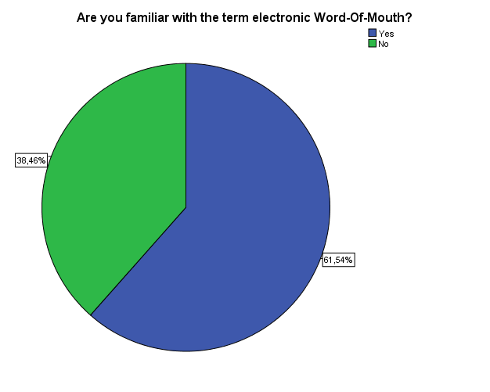
Figure 1 - The representation of item 1

Item 2. Do you consider E-WOM to be a powerful communication tool?
The answers from the second question show that almost 81% of the participants of the survey consider E-WOM to be a powerful communication tool, whereas 19% have a different opinion.
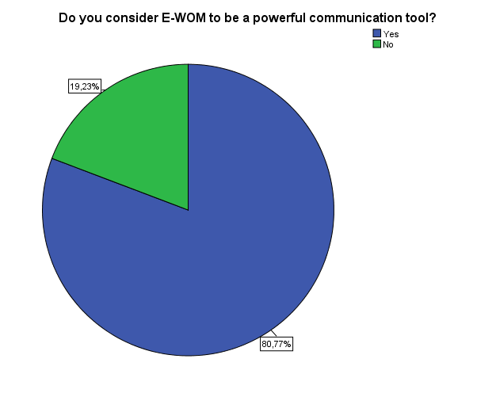
Figure 2 - The representation of item 2

Item 3. Do you think E-WOM affects consumer’s purchase decisions?
To the question “Do you think E-WOM affects consumer’s purchase decisions?”, most of the respondents (42%) answered with “affects”, followed by “strongly affects” with more than 38%. Approximately 15% of the people have a neutral opinion, and only less than 4% believe that E-WOM does not affect consumers purchase decisions much.
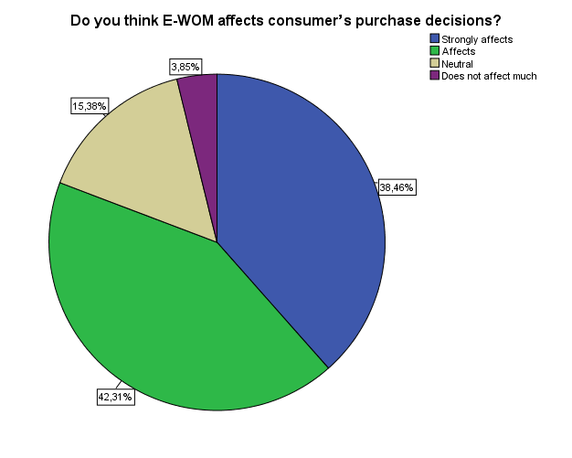
Figure 3 - The representation of item 3

Item 4. Do you think that negative E-WOM is able to make people dislike a hotel for a long-term?
Over 46% from 26 respondents answered “Yes” to the forth question. Almost 35% answered with“Maybe” and 19% of the participants do not think that E-WOM can influence people to such an extent that they will dislike a hotel for a long term.
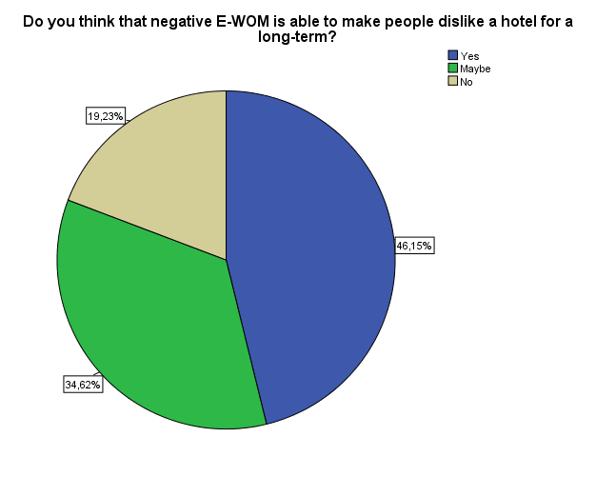
Figure 4 - The representation of item 4

Item 5: On a scale from 1 to 5 (5 being the highest), please rate to what extent negative online reviews can impact a hotel's image?
The fifth question offered a scale, where participants can rate from 1 to 5 the impact of negative online reviews on hotel’s image. No one from the participants rated with “1”, which stands for lowest impact. Less than 4% rated with “2”, 23% of the participants assessed the impact with “3”. Almost 31% of the people consider that there is a high impact by marking “4” and the largest percent of the answers – 42%, chose the highest rate of “5”.

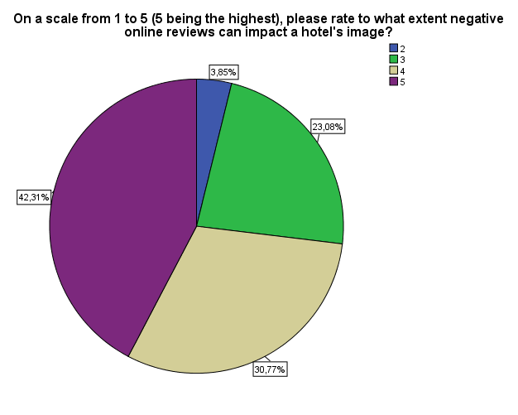
Figure 5 - The representation of item 5
Item 6: What is the general attitude of people towards your hotel - according to people's feedbacks in different social networks?
For this question from the survey, from five options all of the participants chose only two. None of them answered with “Very negative”, “Negative” or “Neutral”. Slightly under 58% answered “Positive” and more than 42% answered “Very positive”. This means that a great majority of the people that answered the questionnaire have very good feedbacks posted online about their hotels.
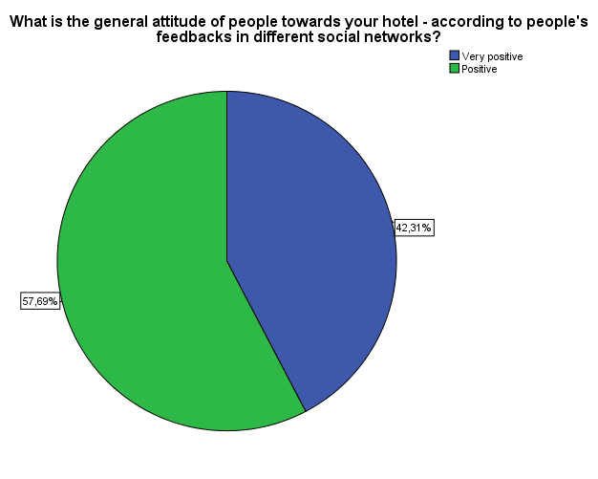
Figure 6 - The representation of item 6
Item 7. On which social network people write comments about your hotel the most?
The next question from the survey revealed the fact that almost 77% of the respondents point out that people mostly write comments about their hotel on TripAdvisor. The same percent of 7, 69% share the options: Facebook, Tweeter, and Other. No one from the 26 participants of the survey chose YouTube or LinkedIn as an answer.
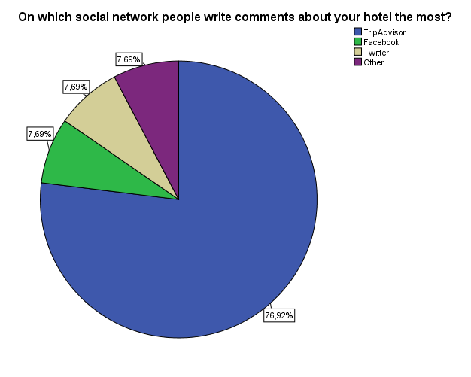
Figure 7 - The representation of item 7

Item 8. Have you encounter negative online reviews regarding your hotel?
The answers from the question “Have you encounter negative online reviews regarding your hotel? ” show that more than 80% of the participants to the survey have encounter negative reviews about their hotel on Internet. Slightly more than 19% do not recall seeing any negative comments. However, none of the respondents answered with “No” to the question.
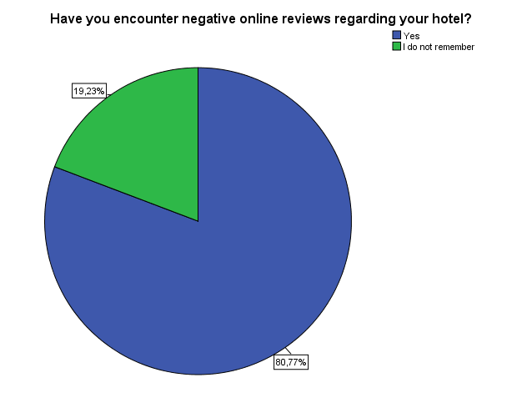
Figure 8 - The representation of item 8

Item 9. What is (would be) your reaction when you encounter a negative online review concerning your hotel ?
To the question about what their reaction is or would be when they encounter a negative comment about their hotel, a high majority of the respondents- over 65%, stated that they will become highly concerned about the eventual consequences of that negative comment. 23% of the persons that answered the question find such comments somewhat frustrating, however they take no particular action. Less than 12% of the 26 participants of the survey ignore the negative reviews on Internet.
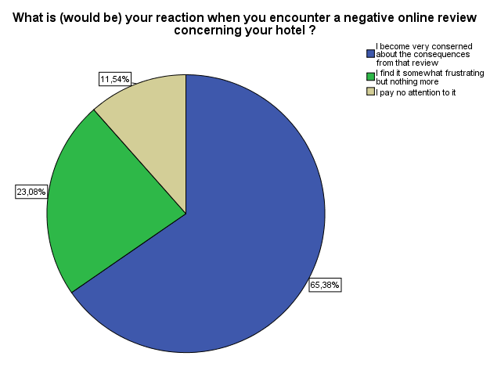
Figure 9 - The representation of item 9

Item 10. What action do (would) you take towards a negative comment online?
The respondents who filled in the survey were asked what they (would) do when encounter a negative comment posted on the Internet. Half of them (50%) choose the first option “I try to contact the person and solve the problem”, followed by near 31% of the participants who would “write an apology”. More than 15% will ignore the comment and only less than 4% will deny being responsible for the problem they were accused of causing. No “Other” actions were selected by the respondents of the survey.
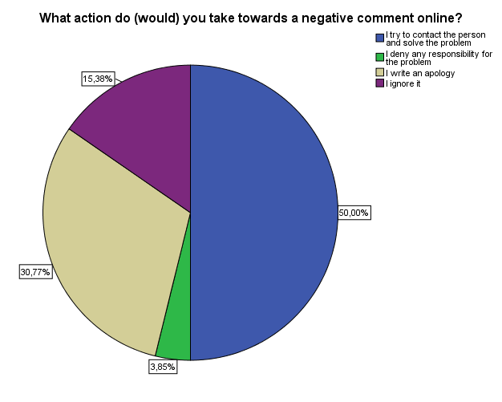
Figure 10 - The representation of item 10

Item 11. What are the negative comments mostly about?
Top of Form
The question regarding “What are the negative comments mostly about?” offered multiple answers. Slightly over 26% of the people consider that “Unhelpful staff” is the main reason for negative feedbacks. “Bad service”, “Lack of cleanliness”, and “Not working amenities” share the same percentage of more than 15%. “Safety issues” and “Inconvenient location” seem to be less problematic with 11%, as well as “Overcharging” – with only 4%.
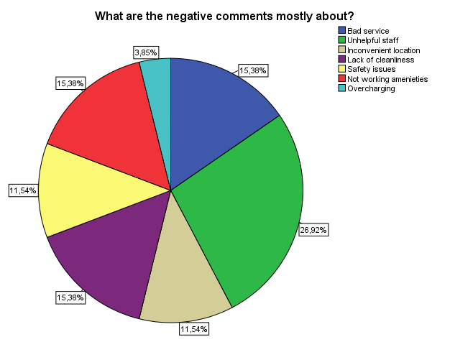
Figure 11 - The representation of item 11

Item 12. Does your hotel aim to deal with negative reviews about it on the Internet?
Almost 70% answered “Yes” to the question “Does your hotel aim to deal with negative reviews about it on the Internet?”. 23% chose the answer “No”. Only 7% responded with “I don’t know”.
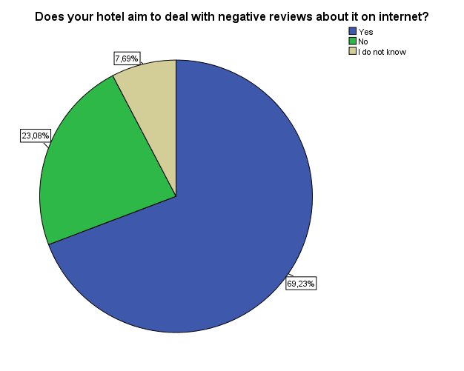
Figure 12 - The representation of item 12
Item 13. Does your hotel have a strategy/ plan to deal with negative online reviews? If not, skip questions 14 and 15.
The responses for question number 13 show the fact that the majority of the respondents have a strategy/ plan in order to cope with negative reviews posted on Internet. Over 73% answered positively, whereas 27% do not have any strategy focused on dealing the negative reviews posted online.
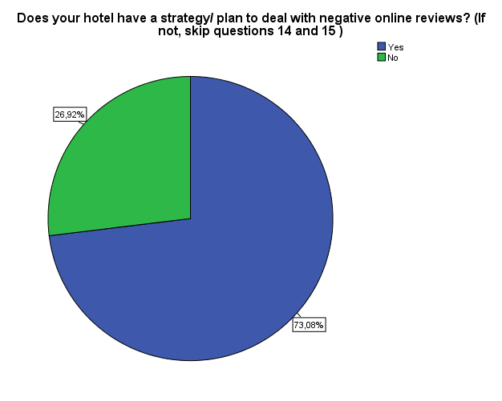
Figure 13 - The representation of item 13

Item 14. Could you, please, shortly describe your strategy/ plan below?

For this question the participants had the freedom to write their own opinion. The answered were coded and divided into three categories. More than 38% gave an answer within the first category “Writing a response back”, which was the highest percent. The second notion - “Handle the problem before it appears on social media”, was given by 23% of the respondents of the questionnaire. A very small percentage of people answered with “Take no action”. Unfortunately, a large percent (over 34%) of the participants did not answer to question 14.

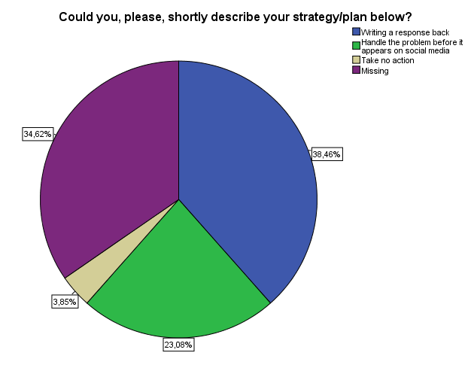
Figure 14 - The representation of item 14

Item 15. What was the outcome from the strategy?

Likewise the previous question, the answers for question 15 were given by the participants with no options to choose from. The answers were again coded and presented in several categories based on the responses given. As an outcome of the strategy mentioned in question 14, more than 19% of the people stated “Appreciation” and “Reduced level of negative feedback”. According to almost 16% of the participants the strategy resulted in “Satisfied clients”. Nearly 8% noted that there were “More bookings generated”. Only 4% of the people, who answered the question, wrote that there was “No specific outcome”. Similarly to question 14, a large number of people (35%) gave no answer to this question.
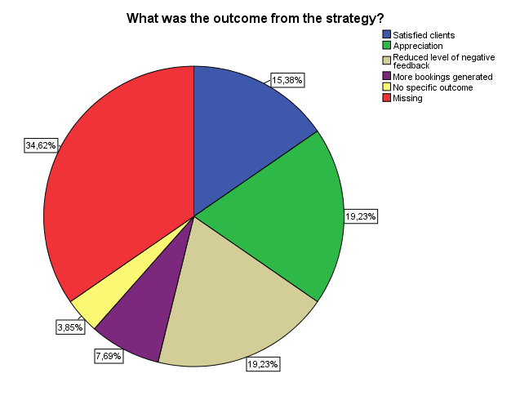
Figure 15 - The representation of item 15

4.2 Analysis

In the recent years, electronic WOM has gained a great popularity among academics and practitioners. It is an interesting phenomenon to be researched due to its two-sided effect. From one side, it can show a great potential for businesses and be particularly beneficial in enhancing corporate images. From another side, it shows a risk for companies. If it is not managed properly, eWOM could be harmful for corporate reputation and result in loosing potential customers and sales.

As this is an exploratory research, the author of this project is allowed to explore the subject of interest and discover issues that might have never been analyzed and discussed before (Sekaran, 2003). Therefore, the researcher chose to collect data from companies instead of consumers as the latter ones are usually the object of eWOM studies. According to the author of the paper, another research based on consumers’ opinion can hardly bring any new insights and innovative perspectives to the subject.
Furthermore, the few studies investigating companies’ standpoints present draw different conclusions on how companies perceive eWOM and its marketing power. Some researchers believe that most companies do not realize the significance of eWOM. Others think that companies acknowledge the influence of eWOM on customers, however prefer to ignore it. Therefore, this research project aims to contribute to these arguments by empirically exploring companies’ perspectives.

This paper intents to look closer upon the impact of eWOM on hotels and how they manage its impact by adopting response strategies. The main focus has being put on negative online reviews and what role they play in the hospitality industry in Denmark. The goal is not to make generalization for the whole industry, but to give an example of how one country handles negative online feedback. In order to accomplish that, the opinions of different Danish hotel managers were sought. In this chapter, their perspectives will merge with previous studies so that the sub-questions will be answered.

To begin with, the author of the paper aims to answer the first sub-question “To what extent the negative eWOM affect the image and reputation of the hotels?”. In the data collection, questions like “What is your opinion about eWOM’ effect on companies?” and “Do you think that negative E-WOM is able to make people dislike a hotel for a long-term?” were built in order to obtain general information about how Danish hotels perceive the impact of eWOM on their businesses.
The participants of the survey initially were asked if they are familiar with the term “eWOM”. The percent of people who answered that they are not familiar with it was surprisingly high (38%). The reason for that might origin from the fact that in the description in the beginning of the survey no sufficient information regarding what eWOM means was provided. The use of abbreviation (eWOM) instead of the whole name was also confusing for the respondents. Nevertheless, the result from this question did not affect the following ones as in most places “negative reviews” was mentioned instead of eWOM. The same issue did not occur during the personal interview, as in the email to the participant the definition of eWOM -“any positive or negative statement made by potential, actual, or former customers about a product or company, which is made available to a multitude of people and institutions via the Internet.” given by Yolanda and Chan (2011) was presented.
The researcher tried to find out what is the participants’ point of view regarding the power of eWOM and its impact on companies. The findings from the interview were confirmed by the ones from the survey. According to Cheung et al. (2012) and the participants of this research, there is no doubt that eWOM is a powerful communication tool and it has an impact on businesses, especially if a great number of people share the same opinion. However, why is eWOM communication so powerful?
According to Nielson (2007) most consumers consider online reviews to be more trustworthy than the commercialized websites. The same opinion is confirmed by many other researchers who believe that the expressed personal experiences are much more credible than any other messages generated by the companies (Bickart & Schindler, 2001). Additionally, Yolanda and Chan (2011) mentioned a survey conducted with more than 5,500 web consumers. The findings from their study revealed that more than 44 per cent of the participants have consulted online reviews before making a purchase decision, and 60 per cent of them find consumer-generated reviews to be more trustworthy and reliable than expert reviews. The literature is corroborated by the findings from the personal interview. The participant stressed that the inadvertence of the feedback to promote or harm the image of a hotel makes the message more believable. The research shows that there is no second opinion on this matter, which leads to the explanation of why eWOM communication has such big influence on consumers and companies.
So far in the paper, it was spoken about “companies” now the focus is put on hotels as they are the object of the paper.
It is known that eWOM is transmitted via Internet. However, according to the author of the paper, it is important to narrow down this knowledge and find out where eWOM takes place the most regarding hospitality industry. The researcher considers that knowing specific website(s) involving massive consumers’ discussions about hotels could be beneficial for the further recommendations to hotel managers.
Electronic word-of-mouth is spread through different social networking sites, personal blogs, brand websites, product review websites, etc. (Lee et al., 2013). Nevertheless, the findings of the research and the literature on eWOM are unanimous in their opinion that TripAdvisor plays “a dominant role in the online travel market” (Law,2006).
During the interview, the participant mentioned the travel website TripAdvisor few times. He stated that there are posted the most important critiques and it is the most genuine website for online reviews. Considering the fact that there are many well know social networking websites, such as Facebook and Twitter, the author of the paper sought the opinion of other hotel managers. The survey revealed, according to 77 per cent of the respondents, that TripAdvisor indeed is the most used website for eWOM communication regarding hospitality services. In correspondence with the results from the interview and the survey, different studies emphasize that “TripAdvisor currently enjoys a reputation as one of the most successful websites dedicated to travel, providing travelers with information on trip and hotel bookings” (Zhang & Vasquez, 2014). Discovering the “hub” of online reviews is an important finding because it gives valuable information to hotel managers about where they should focus their attention. Moreover, by knowing the main source of information, hotels obtain the opportunity to manage the critiques easier than if the number of the sources was larger.
Speaking of the importance of TripAdvisor, the interview participant mentioned that the majority of hotels have positive rating on the website. The author of the paper wanted to go into depth by asking the survey participants what is the general opinion of people about their hotels. The results were confirmative – positive and very positive. The existing literature, however, does not provide specific debates on that matter. No examples and statistics were provided regarding the average ratings of hotels in other countries, which would have been helpful for the analysis. The literature only discusses the effect of positive and negative reviews, where positive reviews increase the willingness of consumers to purchase and negative ones have the opposite effect (Gonzalez et al., 2013).

Even though the abovementioned findings show that hotels might have mostly positive online feedbacks, there is always critique and as the interview participant believes - there is no way to stop it from happening. Despite the attempts of hotels to deliver excellent service at some point every hotel happens to fail in meeting the expectations of every guests, especially of the more demanding ones (Kim et al., 2009). Because of the high ‘‘people factor’’, failures in service delivery sometimes are inevitable (Susskind, 2002). These failures cause negative eWOM.
The goal of this research is to explore the negative eWOM. Therefore, the researcher asked if the participants have ever encountered any negative review regarding their hotels. The majority of people from the survey (80 per cent) stated they have, which is in correspondence with the answer of the interview respondent, who even gave an example. He explained that “there was a comment about a shower not functioning properly, or the breakfast items not being fresh, or our reception staff being rude”. According to him, the hotel staff always takes action towards solving the problem. He adds that the positive side resides in the fact that they will “correct the issues and get better”, whereas the negative side can occur in deteriorating the reputation of the hotel. According to Homer and Yoon (1992), negative eWOM can cause serious damage to hotels and their reputation.
To go deeper into the characteristics of the negative comments, the researcher sought to find out what are the negative comments mostly about, where are the weak spots that can provoke the bad attitudes of hotels’ guests. In order to accomplish that, the author of the paper took under consideration the examples of negative online comments mentioned by the interview participant. He highlighted a situation when “a bathroom that was not cleaned well enough”, which can be put into a category “Lack of cleanness”. Comparing these findings with the answers from the survey - there will not be a single categorical answer. Hotel managers obviously have different concerns about their own hotels, which differ from the others. Nevertheless, the most common complaints occur due to “Bad service”, “Lack of cleanliness”, and “Not working amenities”. The reason for researching this matter is due to the need of knowledge regarding which problematic categories provoke guests’ negative attitudes the most. According to the author of the project, one way of avoiding negative eWOM is to realize where the issue derives from and to take appropriate actions. The findings from the interview show that an issue such as “Lack of cleanliness” can actually harm the image and reputation of a hotel if it is extremely serious one.
There are different opinions regarding how badly negative eWOM can influence the consumers and thus the companies. Some studies assured that the influence of negative eWOM is not so different from the influence of the positive one (Ricci and Wietsma, 2006). Vermeulen and Seegers (2009) added that both positive and negative feedbacks increase consumer awareness of the existence of a hotel. In the contrary, Lee and Song (2010) stated that consumers’ assessments of a company are “more sensitive to negative information of corporate responsibility than to positive information”. In sum, there are more opinions supporting the statement that negative eWOM is more powerful and influential than positive eWOM. The findings of the interview supported the idea that negative reviews can be harmful for the business; however the problem needs to be very serious or left unfixed. According to the majority of the survey participants, the negative eWOM can be highly disruptive. From the information provided, it could be concluded that there is no unanimous opinion. However it seems that, generally, not all negative comments can undermine a hotel’s image. The destructive eWOM depends on factors such as a particular situation, seriousness of the issue, and corporate reaction. In this regards, the interview respondent mentioned pictures that were posted online showing his hotel in “an unfavourable light”. He emphasized on the fact that being posted online these pictures will be exposed for a long period of time to a large audience. He added that “this definitely can be a huge run-down of our success because we have a lot of viewers and serious reputation so I definitely believe that they can hurt us”. This finding is corroborated by Funches et al,(2010), who stressed that negative eWOM can cause serious troubles for companies due to the fact that not only it can have significant impact on consumer perceptions of them, but it is also accessible for a long period of time, for a large number of people.

Taking under consideration the example of the participant regarding “Lack of cleanliness” mentioned earlier, such issues can have also a positive side. Besides affecting the reputation of a hotel due to negative attitudes of guests, negative eWOM can motivate companies to “correct the issues and get better”. This argument brings up a new perspective for negative eWOM. Moreover, the interview participant welcomes the negative feedback, because it provides valuable information of what needs to be improved in the hotel. Some studies agree that the use of eWOM and the online hotel feedbacks can be seen as an ‘opportunity’ rather than a ‘threat’ for the hotel managers (Litvin et al., 2008). One beneficial outcome from the reviews - positive or negative, is the opportunity for companies to learn about the experiences and reactions of their customers (Gonzalez et al., 2013). Hotels that see the value of eWOM can take the benefits from online consumer feedbacks (Dellarocas, 2003). These findings present a possibility of reducing the harmful effect from negative eWOM. However, the opportunity can arise only if hotels take advantage of eWOM and use the information in practice. This matter will be discussed later in the chapter.
Returning back to the negative side of eWOM, the author of this paper wanted to retrieve what does the negative eWOM affect more – the one time purchase decision or the whole image of the company. The single purchase decision in this case is regarding the willingness of the guest who posted the comments and the ones who saw that comment to book a room for the next time they need it. However, it does not mean that their general opinion of that hotel will be negative and that they will never use its services again.
In relation to the eWOM’s effect on purchase decisions, the findings from the interview show that there is a high possibility that an unsatisfied guest will not return to the hotel for the next time he or she needs an accommodation. The survey results supported that opinion. The majority of respondents think that negative eWOM affects in a high degree the consumers’ purchase decision. Homer and Yoon’s (1992) study affirms these findings by noting that negative information has strong influence on the purchase decisions and it has major impact on tourists’ hotel evaluation. The author of the paper believes that if negative eWOM occurs often, its impact on a single purchase decision may become more damaging than it seems. This unfavorable impact on purchase choices can surely affect the number of bookings, thus corporate actions are needed. It is highly important for companies to efficiently gather and analyze consumers’ opinion as it certainly affects consumers’decision process (Pai et al., 2013).
Later on, based on the statement of Arndt (1967) that negative reviews might cause “great damage” for hotels and their reputation, the author of this project aims to evaluate the impact of negative eWOM on the image and reputation of a hotel. In other words, the intention is to find out if negative eWOM can make people dislike a hotel for a long term. The interview respondent considered the possibility that eWOM can damage the overall image of a hotel, however he does not think that this damage can be extreme, especially when it can be minimized by a single corporate response. He also considers that negative online reviews cannot have a detrimental power, unless most of them are negative. The findings of the survey show that negative online reviews influence hotels’ image and reputation. Nevertheless, most of the respondents said that “maybe” eWOM can have a harmful effect. In the literature was also used the verb “might”, which leads to the notion of uncertainty. Therefore, a conclusion can be drawn that not all negative comments equally can damage a long maintained reputation. It depends most likely on the situation and the way this situation has been handled by the hotel’s staff.
The previous findings revealed that negative eWOM has a serious impact on the purchase decision, which has its unfavourable effect on the companies involved. Also a tendency was proven that negative eWOM may harm the image and reputation of hotels depending on the seriousness of the problem. In this context, Vermeulen and Seegers (2009), by conducting a research on hotels, found out that negative eWOM generates negative attitudes and came to the conclusion that single cases do not cause much treat, however repetition can be seriously detrimental. His study further revealed that failure to propose good value to the customers is the main reason for negative eWOM, nevertheless negative reviews can be a chance for improvement if they are managed accurately. According to the author of this project, the used literature and the findings from this project overlap each other and agree that negative eWOM can be “tricky” – it can be dangerous for hotel business and actions towards it are needed but also it can be an opportunity for improvement.

Further, an important notion that came up few times during the interview was about the argument that the number of reviews is more important than their characteristics - positive or negative. The interview participant stands behind the idea that the more comments are posted, the more the positive opinions will be. Thus, the effect of the few negative will be eliminated. There are different theories among researchers in regards to the average rating in online reviews and the number of the reviews. Some researchers consider the average ratings to be significant, while others find that the quantity of reviews has a stronger impact on consumers (Yolanda & Chan, 2011). According to the interview participant, previous studies have disproved that negative comments have the higher influence on people. Moreover, the positive comments are more important than the negative ones and the “more positive reviews you have the better”. The same effect would occur if the negative reviews prevail in number over the positive ones. He gave an example stating that “when speaking about negative eWOM - if a number of consumers shared the same experience such as poor service, poor food quality, and bad attitude of the staff, this could influence consumers to decide not to use that product”.
Yolanda and Chan (2011) argue that regardless of the positivity or negativity of online reviews they imply the popularity of a product or a company, thus the larger the number of reviews - the higher intention to purchase.
A contradiction occurs between the findings from this research and the literature. They both prove that the number of reviews influences significantly the customer purchase decisions. However, the findings stress that the average rating plays an important role. The respondent believes that the volume of reviews is dependable on the rating, whereas the literature disputed that only the number matters. Berger et al. (2010) added that even negative reviews could increase the purchase likelihood.
In the current case study, the results from the interview and the survey show that the general rating of the Danish hotels is positive and highly positive. Therefore, the larger number of reviews the better outcome for hotels.
In sum, what was retrieved from the analysis so far is that the negative online reviews can affect the image and reputation of the hotels. The one time purchase decision tends to be more vulnerable to negative eWOM than the image and reputation of the hotel. However, depending on the situation and the significance of the service failure, hotels’ images and reputations can be harmed significantly. Unfortunately, this paper does not provide specific examples of such serious service failures to prove how harmful negative eWOM can actually be. The conclusions are based on the provided statements from different studies and the data collection, which lack in providing thorough information on this matter. Even though the interview participant explained a situation regarding lack of cleanliness that went viral, this single case does not provide us with any information about the consequences if any.

Furthermore, the author of the project retrieved different opinions regarding the volume of online reviews and its impact on hotels’ image and reputation. Again, the researcher was not able to bear out any of the opinions with examples from the hospitality industry as there has not been done much researching on this area. Nevertheless, from what has been analyzed so far it could be concluded that the large volume of reviews represent the popularity of a hotel. Additionally, the findings show that Danish hotels were positively evaluated by consumers on the Internet, thus the negative eWOM seems to be no real treat for the industry in the country.

The presented analysis was able to give an answer to the first sub-question “To what extent the negative eWOM affect the image and reputation of the hotels?”. The results conclude that the image and the reputation of a hotel can be harmed to a great extent by negative electronic word-of-mouth but only in case of serious problems caused by service failure. This conclusion leads to the next part of the analysis, which is dedicated to answer the second sub- question.

Further in this chapter, the author of the project will analyze the negative eWOM caused by serious service failure. Karatepe and Ekiz (2004) consider that even the best service companies, no matter how hard they try, are not able to completely eliminate every problem or mistake. The focus here is to present the position and attitude of hotels once an issue occurs. Zemke and Anderson (2007) suggest that hotels firstly need to be aware of the issue by obtaining customer feedback and secondly they have to take corrective action towards fixing the problem. Therefore, appropriate strategies for managing the negative reviews are very needful for keeping company’s good reputation (Lee & Song, 2010). The studies on eWOM concur that the consequences from serious service failure can be reversed. In order to achieve that, hotels must adopt corporate response strategy. Their corrective actions will result in keeping hotels’ prestige and “good name” clean.

The findings for this part of the analysis are focused on giving an answer to the question - “How do hotels deal with the negative eWOM?”. The purpose of asking questions, such as “Does your hotel have a strategy/ plan to deal with negative online reviews?” and “Do you believe that ignoring negative feedback is a wrong decision?”, is to provide information of how Danish hotels cope with negative online reviews.
According to O'Connor (2010) and Vasquez (2014), as eWOM continues to grow and to influence consumer decision making and purchasing more and more companies are trying to pay more attention to eWOM and to realize how important it is to employ online reputation management. The respondent from the interview affirmed that there has to be a response when a negative feedback occurs. According to him, from a great importance is the effort that hotels make in order to fix the problem and apologize correspondingly to their guests. In corroboration with that, Griffin and Darden (1992) emphasize that proactive actions from the company involved, such as simple apology, some kind of compensation, or problem-solving actions can help the company to restore its positive image. Further, the findings from the qualitative research revealed that even for a small hotel like “Christian IV” negative comments can cause unfavorable customers’ reactions and the only way of neutralizing these reactions is if hotels get involved in the eWOM communication. According to the participant, the opportunity to answer the comments is of great benefit. Additionally, he said that a strategy part number one is “simply to reply to these reviews”. As a result of such actions, many studies show that corporate response strategies have a strong impact on consumers’ evaluation of a hotel. These findings support the idea that appropriate response strategies can give a rise to consumers’ positive attitude toward negative events.

The interview findings and the literature complement each other in proving that hotels need to be active and use a strategy in order to deal with negative eWOM in one way or another.
The literature on eWOM suggested different strategies – accommodative, defensive, and no action (Lee and Song, 2010), which are explained in the literature review chapter. Similarly, other researchers (Thomas et al., 2012) talk about the same strategies – respond and delay with the difference that “respond” includes the accommodative and the defensive strategies and “delay” stands for “no action”. The author made the personal choice of not analyzing the other three strategies (censorship, legal action, and partner) mentioned by Thomas et al., due to the belief that they do not apply for the current study case. The researcher aimed to focus her exploratory research on respond (accommodative) and delay (no action) strategies instead.

The literature explains that there are different levels of response strategy - from replying to individual comments to taking serious actions due to a pressure from large number of consumers. The interview respondent pointed out that he replies personally to most of the comments by apologizing and takes further actions if the problem requires them meaning that he uses the accommodative strategy.
Generally, accommodative approach includes any form of “apology, compensation, and/or corrective action”. Consequently, using this strategy, the companies are willing to publicly accept and take responsibility for the problem and most importantly to take actions towards preventing that problem and avoid any similar issues of happening in future (Lee & Song, 2010). Correspondingly, the results from the interview and the survey report unambiguously that replying to online comments is how hotels can efficiently deal with negative eWOM. Additionally, the results from the survey show that most of the participants will become highly concerned about the eventual consequences of a negative review and they will either try to contact the person and solve the problem or simply write an apology under his/her critique. Even though, some participants choose “ignoring the problem” the results all together show that the best way to deal with negative comments is by giving a response to it. In sum, the findings are definitive regarding the need of response - whether it is simply an apology or an explanation of the problem, there has to be a corporate participation in the eWOM communications.
According to Barone (2009), active participation in eWOM conversation can provide a hotels with the opportunity to “soothe the hype” and turn the conversation toward a favorable for them direction. The survey participants consider that such participation can lead to “appreciation” from the guests and it will reduce the level of further negative comments. Due to the real time communication with people on social media, another convenience of the respond strategy is the possibility of correcting imprecise information. Lisa Barone (2009) agreed that companies, which face negative comments over misrepresented facts can use the respond strategy in order to politely and quickly correct the information. As the research discovered, a possible reason for imprecise information could be the anonymity of the online conversation participants. This statement is confirmed by Stephen et al. (2008) who noted that the anonymity of communicators could be a challenge due to the fact that it might potentially lead to out-of-context and misleading messages. Moreover, according to the interview respondent, because many people are anonymous on social networking webpages it is hard to give an explanation for a particular situation or to try to reach a person with no real name or contact details available. Therefore, the anonymity is an obstacle for hotels as they are not able to defend their position and their only option of fixing the problem is by apologizing.

Metzger et al. (2003) believe in the credibility benefits of corporate interference with consumer comments, which is supported by the data findings of this research. However, Dellarocas and Narayan (2006) stress that participation of companies’ makes consumers skeptical and it can lead to loss of credibility. Additionally, Mauri and Minazzi (2013) argued that too defensive and standardized strategies must be avoided and that a corporate reply could be seen by consumer as a commercial attempt. In order to prove or disprove these statements, a data from customers must be collected. According to the researcher, the position of the hotel managers on this matter would not be valid. As the consumers’ opinions are not the objective of the currents project the aforementioned arguments can be perceived only as recommendations for further research.

Further, some studies bring up the so called defensive strategies as a type of corporate response strategies. When a hotel adopts a defensive strategy it denies any responsibilities for negative events and shifts the blame to others. Neither of the survey respondents chose “defense” as an action towards negative online reviews, nor did the interview participant mention “denying responsibility” as an option. The explanation for that phenomenon is well identified in Lee and Song’s (2010) research. They argue that the defensive approach could very likely lead to escalating the problem and thus damaging the company’s image. Additionally, Lee (2005) explains that companies’ attempt to avoid taking responsibility for the negative events will provoke negative opinions about the company. It can be concluded that instead of dealing with negative eWOM defensive strategies will actuate more negative customer feedback and it can worsen its already vulnerable reputation.

The third corporate response strategy is “no action” or “delay”. Companies applying ‘‘no action” strategies are merely trying to “separate themself from the negative events by remaining silent in the online sites” (Lee, 2004). The reason for this corporate attitude is explained by Lee and Song (2010). They stressed that many companies realize that online complaints might damage their company reputations but prefer not to respond to these comments. According to the researchers, an excuse for companies’ passiveness could be the fear that a possible response from them might escalate the problem.
Realizing the damaging effect of not replying to eWOM, the interview respondent spoke against “no action” strategy. He stressed that ignoring negative comments online is “the worst thing” that can be done. Once again, the hotel manager highlighted the importance of replying and stressed that “people can get very frustrated not so much because of the problem they had while staying at the hotel but because there is no response to show them that they matter”. The results from the survey supplement his opinion. More than 65 per cent of the respondents become highly concern when they encounter negative reviews regarding their hotels (resulting in immediate action), whereas only small percentage of the people are willing to take no action towards negative eWOM. In a correlation with the findings, Lee and Song (2010) points out that ‘‘no action” strategy can risk letting negative comments about a company to stay unchallenged, which most likely might harm the company’s image and reputation. The general opinion confirms the unfavorable outcome for companies who choose to take no actions towards negative eWOM. Nevertheless, some studies oppose this opinion. For instance, some researchers considered this approach to be useful in cases when there is no evident blame, when a company does not feel responsible, or when giving an improper response could cause serious offense (Mclaughlin, Cody, & O’hair, 1983). The author of the paper finds this argument to be insufficient due to the fact that an apology, even when a hotel does not feel responsible, can only benefit the image of that hotel. An improper response might arise from defensive approach but it seems untypical for accommodative one.
Furthermore, basing on the data collection the author is convinced that an improper response will cause less damage, than showing no interest of what people say. This is corroborate with Thomas et al.’ (2012) research that stated “when businesses are unresponsive or slow to respond, they are perceived as uncaring, aloof, or guilty of the complaints for which they are being accused”.
There is a lot of contradiction regarding which corporate response strategy leads to the best results in dealing with negative eWOM. It is hard for the author to analyze all different opinions presented by the literature review and to draw conclusions. Therefore, she focuses on the data findings and the strategy identified by the interview and survey respondents as the most appropriate one.
The results from the data collection support the accommodative response strategy as an efficient way of dealing with negative reviews posted on the Internet. The interview participant confirms that his hotel has adopted such strategy. The same result was retrieved by the conducted survey where 73 per cent of the participants affirm that they also use a strategy involving apology and polite manner against negative eWOM.
In regards to the hotel industry, managers should make efforts to reduce negative eWOM and try to encourage the positive reviews by implementing personalized activities in their consumer-related strategy. In order to increase the satisfaction level, first hotels can try to improve the quality of the service and thus to reduce the volume of negative reviews (Mauri & Minazzi, 2013). According to the interview respondent, the best solution for hotels in order to achieve that, is simply to offer an excellent service, to assure that the staff is courteous and polite, to have “good product in the restaurant”, to offer pleasant rooms, etc. Any effort for improvement will lead to reduced number of negative reviews and consequently increased positive average rating on the Internet.

Another means of reducing the negative attitudes of hotel guests is, when a problem already occurred, the hotel should improve the service recovery when the guest is still at the hotel, thus stimulating direct critiques (Mauri & Minazzi, 2013). In this matter, the finding from the interview emphasize that it is for the best if a hotel deals with dissatisfied guests and solves the problem while they are still in the hotel. Once the issue is eliminated on time it will most likely not go viral as soon as the guests check out of the hotel. High percent of the survey respondents support this statement. However, according to the researcher, this attempt to prevent future critiques does not seem to be enough. First of all, not every guest tends to raise a complaint to the company. Secondly, even if the hotel’s staff has tried to help it may not always be able to satisfy the needs of the guests, especially if they are highly demanding.
Being a useful strategy - dealing with the problem before it becomes a negative eWOM, does not give an answer to the question of how to handle an already existing comment. Nevertheless, it provides valuable information on how to avoid negative eWOM in future and it serves as a recommendation for hotel managers.
Furthermore, a beneficial effort for the hotels will be “conducting customer satisfaction surveys and personal interviews when the customer has already gone home” (Mauri & Minazzi, 2013). In accordance with the literature, the results from the interview presented another corporate strategy – sending out questionnaires. The interviewed hotel manager believes that by sending questionnaires privately by email to the guests they will feel no need to express their dissatisfaction elsewhere. According to the respondent, the adoption of this strategy creates a double benefit. On one hand, it prevents the unhappy guest from complaining online. On the other hand, private evaluation is obtained, which can be useful for managers to spot the weaknesses of the hotel.
In sum, the idea of sending questionnaires to former hotel guests is just a way to eventually prevent negative comments of appearing on the social media. The author is concerned that this strategy does not assist hotels in dealing with the reviews that have been already seen by a great number of people. Similarly with the previous paragraphs, this approach is a result from the current research. That fact makes it valuable for the topic as the approach expands the knowledge and presents more perspectives for future studies.

Studies conclude that “the company’s response to accept responsibility for the negative events facilitates developing consumers’ trust on the company, which in turn leads to affect their evaluation of the company as well as their purchase intention” (Lee & Song, 2010).
In correlation with this statement, as a possible outcome from a corporate response the survey respondents mention “appreciation” from the guests and forthcoming “reduced level of negative feedback”. This result gives the encouragement that responding to negative eWOM not only protects the image and reputation of a hotels from being damaged, but also could assist them in gaining more satisfied and loyal guests. The respond strategy has the potential to convert once dissatisfied customers to loyal customers with strong relationship with the company (Thomas et al., 2012). These findings highlight the significance of corporate response strategies. Their role in the business development should not be underestimated as they have the power to control consumers’ behavior. Needless to say, influencing people’s decision-making is a significant advantage in the corporate world.

In conclusion, a recommendation from the interview respondent to other hotels summed up the information presented so far – hotels should try to solve the problems within the hotel, send a private questionnaire to all former guests, and show that they “care” about people’s opinions by replying to their online reviews. Whenever a negative eWOM occurs a reply from the hotel is needed, otherwise the outcome of a single complaint might provoke negativity in many potential guests. This brief summery gives an answer to the second sub-question, which is “How do hotels deal with the negative eWOM?”.
Generally, the analysis chapter is written in a way that aims to present the connection between eWOM and the hotel industry and to convince the reader of its importance. The author of the project decided to make a research on eWOM as it is contemporary topic and it affects businesses to a great extent. She chose an innovative way of achieving that by focusing on companies’ perspective. It is innovative due to the fact that most of the studies conducted on this subject are concentrated on what the consumers “have to say”, not on the corporate point of view. Also the researcher was hoping to retrieve knowledge that has not been discussed before by applying an exploratory approach.
This project retrieved the fact that negative eWOM can have a serious impact on hotels when the issue - responsible for the complaint, is serious and shocking. The number of the reviews matters to a great extent, however it cannot be concluded in this research if their characteristic (positive or negative) play any role in a large volume of online posts. This issue could be a base for future research.
Further in this paper, it was retrieved that negative eWOM help hotels to realize that there are improvements that need to be done in order to increase the likelihood of the hotel. It was proved that negative eWOM can have a positive side for the hotel management and that positive side is an element of surprise for the researcher. Thus, the question follows - Do hotels need to deal with negative reviews if they can be so beneficial?
According to the findings from the analysis and the author’s opinion the positive side of negative eWOM does not eliminate the negative outcome. If a hotel ignores the importance of eWOM, it may lose control over its potential and current customers. It could be said that no commercial attempt has the same power that corporate involvement in eWOM communication has. That fact is realized by many researchers and also by the participants of this research. Thus, it was retrieved that a response strategy is required in order to keep consumers reviews under control. And the best way to do so is by means of accommodative strategy involving an apology.
In sum, negative eWOM can be handled. However there are ways for hotels to decrease its appearance by taking actions before a need of online complaining even occurs. This paper recommends that hotels should pay attention to negative reviews; use them as evaluation of their weaknesses; try to cope with these weaknesses; and place guests’ needs first.

CONCLUSION

Electronic WOM is considered one of the most powerful forms of communication in the market today. EWOM is used by the consumers to make judgments about products and companies and it is consider to be a more trustworthy source of information that any marketer-related message. Its ability to influence consumers and consequently to affect the companies intrigued the author of this paper and motivated her to conduct the research. Additionally, the fact that hotel offerings are less tangible and greatly dependent of the perceived image was the main reason for choosing hospitality industry as an objective of the research.
The aim of this research was to elaborate on the extent to which negative eWOM can affect or even harm the image and reputation of the hotels. This project strived to explore how hotels handle critiques and how they try to avoid and handle with complains posted on the Internet. The study case revealed a phenomenon researched on a country level, however it might be able to present the global situation.
In order to answer the both sub-questions, thus the problem statement, the author of the paper conducted a personal interview with a Danish hotel manager and investigated his perceptions toward the negative eWOM and his experiences with it. In addition, an online questionnaire was released to a number of Danish hotel managers from all around the country in order to discover if they share the same opinion.
The empirical research has shown that eWOM plays an important role in the company – consumer communication. In the current paper, it was revealed that negative eWOM can have a damaging impact on hotels’ image and reputation if the problem is significant and no corporate effort was made to fix it. Additionally, the same negative eWOM was found out to have a positive side for hotels under the form of evaluation. Nevertheless, a response strategy is needed so that hotels can twist negative reviews into positive ones.

Finally, this thesis ends by advising hotels and companies in general to pay attention to eWOM because it has the power to increase companies’ likelihood but also it can have a detrimental impact on those who do not take actions towards it.

BIBLIOGRAPHY

Abrantes, J. et al. (2013). Drivers of in-group and outof-group electronic word-of-mouth (eWOM). European Journal of Marketing, Vol. 47 Iss 7 pp. 1067 – 1088.

Arndt J. (1967). Role of product-related conversations in the diffusion of a new product. Mark Res, 4(8), 291-295.

Basuroy, S. et al. (2003). How critical are critical reviews? The box office effects of film citics, star power, and budgets. Journal of Marketing, 67(4), 103 - 117.
Behavior: Exploratory and Experimental Studies. Journal of International Consumer Marketing, 25:3, 181-197.
Berger, J. et al. (2010). Positive effects of negative publicity: when negative reviews increase sales, Marketing Science, 29 (5), 815–827.

Bickart, B. & Schindler, R. (2001). Internet forums as influential sources of consumer information. Journal of Interactive Marketing, 15(3), 31 - 40.
Bolkan, S. et al. (2012). Antecedents of Consumer Repatronage Intentions and Negative Word-of-Mouth Behaviors Following an Organizational Failure: A Test of Investment Model Predictions. Journal of Applied Communication Research, 40:1, 107-125.

Botterill, D. & Platenkamp, V. (2012). Key Concepts in Tourism Research. London: SAGE Publications.
Bouma, G. D. 2004. The Research Process. Fifth Edition. Melbourne: Oxford University Press.
Breitsohl, J. et al. (2014). Online Complaint Communication Strategy: An Integrated Management Framework for e-businesses’, in Handbook of E-business Strategic Management, Martinez-Lopez, F.J (Ed.), Springer Publishing House.

Bryman, A. (2008). Social research methods. Oxford: Oxford university press, Third edition.
Cameron, R. (2011). Mixed Methods Research: The Five Ps Framework. The Electronic Journal of Business Research Methods Volume 9, Issue 2. pp 96-108.
Cantallops, A. (2014). New consumer behavior: A review of research on eWOM and hotels. International Journal of Hospitality Management, 36, 41– 51.
Casielles, R. et al. (2013). The Word of Mouth Dynamic: How Positive (and Negative) WOM Drives Purchase Probability An Analysis of Interpersonal and Non-Interpersonal Factors. Journal of advertising research.

Charlett, D. et al. (1995). How Damaging is Negative Word of Mouth? Marketing Bulletin, 6, 42-50, Research Note 1, Page 1 of 9.

Cheung, C. et al. (2008). The impact of electronic word-of-mouth: The adoption of online opinions in online customer communities. Internet Research, Vol. 18 Iss 3 pp. 229-247.

Cheung, C. et al. (2012). The impact of electronic word-of-mouth communication: A literature analysis and integrative model. Decision Support Systems 54, 461–470.

Chiou, J. & Cheng, C. (2003). Should a company have message boards on its web sites? Journal of Interactive Marketing, 17(3), 50 – 61.
Cohen, D. & Crabtree, B. (2006). Qualitative Research Guidelines Project. Hospitality Marketing & Management, 19:7, 754-772.
Creswell, J. et al. (2003). Advanced mixed methods research designs. In A. Tashakkori & C. Teddlie (Eds.), Handbook of Mixed methods in social & behavioral research (pp. 209-240). Thousand Oaks, Ca: Sage.

Creswell, W. & Piano Clark, V. (2007). Designing and Conducting Mixed Methods Research. Sage Publications, California, 2007. Paperback, 273 pages.

Denzin, N. & Lincoln, Y. (2011). The SAGE Handbook of Qualitative research. Fourth edition. SAGE Publications, Ltd.
Doyle, L. & Brady, A. & Byrne, G. (2009). An overview of mixed methods research. Journal of Research in Nursing. Vol. 14 (2), 175–185.
Duan, W. et al. (2008). Do online reviews matter?—an empirical investigation of panel data, Decision Support Systems, 45 (4), 1007–1016.

Ekiz, E. et al. (2012). Air the anger: investigating online complaints on luxury hotels. Journal of Hospitality and Tourism Technology Vol. 3 No. 2, 96-106.

Funches, V. et al. (2010). Assessing the Damage: An Exploratory Examination of Electronic Word of Mouth. Journal of Global Academy of Marketing Science, 20:2, 188-198.

Godes, D. & Mayzlin, D. (2004). Using Online Conversations to Study Word of Mouth Communication. Marketing Science, Vol. 23, No. Fall (4), pp. 545–60.

Goldkuhl, G. (2012). Pragmatism vs interpretivism in qualitative information systems research. European Journal of Information Systems, (21), 2, 135-146.

Goldsmith, E. (2006). Electronic word-of-mouth, in Khosrow-Pour, M. (Ed.), Encyclopedia of E-Commerce, E-Government and Mobile Commerce, Idea Group Publishing, Hershey, PA, pp. 408-12.

Gonzalez, S. et al. (2013). Online Customer Reviews of Hotels: As Participation Increases, Better Evaluation Is Obtained. Cornell Hospitality Quarterly, 54 (3), 274-283.

Hawkins, I. et al. (2004). Consumer behavior: Building marketing strategy (9th ed). McGraw-Hill, Boston.

Homer, P. & Yoon, S. (1992). Message framing and the interrelationships among ad-based feelings, affect, and cognition. Advert , 21(1),19- 33.

Hornik, J. et al. (2015). Information dissemination via electronic word-of-mouth: Good news travel fast, bad news travel faster! Computers in human behavior, 45, 273-280.

Jalilvanda, M. et al. (2011). Electronic word-of-mouth: challenges and opportunities. Procedia Computer Science 3, 42–46.

Jansen, B. (2009). Twitter Power:Tweets as ElectronicWord of Mouth. Journal of the American society for information science and technology, 60(11), 2169–2188.

Jeonga, E. & Jang, S. (2011). Restaurant experiences triggering positive electronic word-of-mouth (eWOM) motivations. International Journal of Hospitality Management 30, 356–366.

Johnson, B. & Onwuegbuzie, A. & Turner, L. (2007). Toward a definition of mixed methods research. Journal of Mixed Methods Research, Vol. 1, (2), pp 112-133.
Johnson, R. & Onwuegbuzie, A. (2004) Mixed Methods Research: A Research Paradigm Whose Time Has Come. Educational Researcher, Vol. 33, No. 7, pp. 14–26.

Jose, M. et al. (2013). Viral marketing through e-mail: the link companyconsumer. Management Decision, Vol. 51 Iss 10 pp. 1970 – 1982.

Kietzmann, J. & Canhoto, A. (2013). Bittersweet! Understanding and Managing Electronic Word of Mouth. Journal of Public Affairs, Vol 13 (2), 146–159.

Kim, T. et al. (2009).The effects of perceived justice on recovery satisfaction, trust, word-of-mouth, and revisit intention in upscale hotels. Tourism Management, 30, 51–62.

Koslow, S. (2000). Can the truth hurt? How honest and persuasive advertising can unintentionally lead to increased consumer skepticism. The Journal of Consumer Affairs, 34, 245-267.
Kothari, C. (2004).Research methodology. Methods and techniques. New Age International Ltd.
Lee, C. H. & Cranage, D. A. (2012). Toward understanding consumer processing of negative online word-of-mouth communication: The roles of opinion concensus and organizational response strategies. Journal of Hospitality & Tourism Research. Advance online publication.

Lee, S. et al. (2013). A mixed methods approach to electronic word-of-mouth in the open-market context. International Journal of Information Management, 33, 687– 696.

Lee, Y. & Song, S. (2010). An empirical investigation of electronic word-of-mouth: Informational motive and corporate response strategy. Computers in Human Behavior, 26, 1073–1080.

Levine, J. & Hogg, M. (2010). Encyclopedia of Group Processes & Intergroup Relations. Los Angeles: SAGE Publications.
Luo, C. et al. ( 2015). Examining the moderating role of sense of membership in online review evaluations. Information & Management, 52, 305–316.

Mangold, G. & Faulds, J. (2009). Social media: The new hybrid element of the promotion mix. Business Horizons, 52, 357 – 365.
Mauri, A. & Minazzi, R. (2013).Web reviews influence on expectations and purchasing intentions of hotel potential customers. International Journal of Hospitality Management, 34, 99– 107.

Mays, N. & Pope C, eds. (1996). Qualitative Research in Health Care. London: British Medical Journal Publishing Group.

Morgan, D. (2014). Pragmatism as a Paradigm for social Research.Qualitative Inquiry, Vol. 20(8), 1045 -1053.
Newman, I. & Benz, C. R. (1998). Qualitative-quantitative Research Methodology: Exploring the Interactive Continuum. Southern Illinois University.
Nielson (2007). Trust in Advertising: A Global Nielsen Consumer Report, October.
O'Connor, P. (2010). Managing a Hotel's Image on TripAdvisor. Journal of Hospitality Marketing & Management, Vol. 19, Issue 7, p. 754-772.

Owen, M. & Chandler, J. (2002).Developing Brands with Qualitative Market Research. SAGE Publications Ltd.

Pai, M. et al. (2013). Electronic word of mouth analysis for service experience. Expert Systems with Applications, 40, 1993–2006.

Pansiri, J. (2006). Doing Tourism Research Using the Pragmatism Paradigm: An Empirical Example. Tourism and Hospitality Planning & Development, 3:3, 223-240.

Park, C. & Lee, T. (2009). Information direction, website reputation and eWOM effect: A moderating role of product type. Journal of Business Research, 62, 61–67.

Pope, C. & Mays, N. (1995).Reaching the parts other methods cannot reach: an introduction to qualitative methods in health and health services research. British Medical Journal; 311: 42–5.

Sandes, F. & Urdan, A. (2013) Electronic Word-of-Mouth Impacts on Consumer.

Saunders, M. et al.(2009). Research Methods for Business Students. Pearson Education Limited

Sekaran, U. (2003). Research methods for business. John Wiley & Sons, Inc., 4.
Shmerling, A. & Schattner, P. & Piterman, L. (1993). Qualitative research in medical practice. The Medical Journal of Australia. 158: 619–22.

Singh, K. (2007) Quantitative social research methods. Sage Publications India Pvt Ltd.

Stephen, W. et al. (2008). Electronic word-of-mouth in hospitality and tourism management. Tourism Management 29, 458–468.

Tashakkori, A. & Creswell, W. (2007). Exploring the nature of research questions in mixed methods research. Journal of Mixed Methods Research, 1(3), 207-11.

Tashakkori, A. & Teddlie, C. (2010).The SAGE Handbook of Mixed Methods in Social & Behavioral Research. Second edition. Sage Publications, ltd., pp 119-143.
Thomas, J. et al. (2012). Social Media and Negative Word of Mouth: Strategies for Handing Unexpecting Comments, Atlantic Marketing Journal, Vol. 1, Iss. 2, Article 7.

Trusov, M. et al. (2009). Effects of word-of-mouth versus traditional marketing: Findings from an internet social networking site. Journal of Marketing, 73(5), 90 - 102.
Verhagen, T. et al. (2013). Negative online word-of-mouth: Behavioral indicator or emotional release? Computers in Human Behavior, 29, 1430–1440.

Walliman, N. (2011). Research Methods. The Basics. Routledge.

Yolanda, Y. & Chan, N. (2011). Conceptualising electronic word of mouth activity. Marketing Intelligence & Planning, Vol. 29 Iss 5 pp. 488 – 516.

Zhang, Y. & Vasquez, C. (2014). Hotels' responses to online reviews:Managing consumer dissatisfaction. Discourse, Context and Media, 54–64.

LIST OF FIGURES

Figure 1 - The representation of item 1 43
Figure 2 - The representation of item 2 44
Figure 3 - The representation of item 3 45
Figure 4 - The representation of item 4 46
Figure 5 - The representation of item 5 47
Figure 6 - The representation of item 6 47
Figure 7 - The representation of item 7 48
Figure 8 - The representation of item 8 49
Figure 9 - The representation of item 9 50
Figure 10 - The representation of item 10 51
Figure 11 - The representation of item 11 52
Figure 12 - The representation of item 12 52
Figure 13 - The representation of item 13 53
Figure 14 - The representation of item 14 54
Figure 15 - The representation of item 15 55

APPENDICES

Appendix 1
Transcript of a personal interview

Interviewer: Knowing what is negative eWOM, what is your opinion about its effect on companies?

Participant: Positive as well as negative word of mouth can definitely impact a business. For example, when speaking about negative word of mouth - if a number of consumers shared the same experience such as poor service, poor food quality and bad attitude of staff, this could influence consumers to decide not to use that product. Although negative word of mouth can damage a company – the real effect would be determined by how the company handles it.

Interviewer: Do you think that consumers consider reviews given by strangers to be trustworthy?

Participant: Definitelly! People know that guests who post on Internet about hotel services do not try to promote or undermine the hotel intentionaly. They just want to express their satisfaction or dissatisfaction out loud. So the information obtained by eWOM can definatelly be considered as trustworthy - much more than the online commercials provided by the hotel.

Interviewer: What is the general opinion of people for your hotel on internet- according to people’s feedbacks in different social networks?
Participant: We recieve very postive feedback, most notable for the friendliness of the staff.
Interviewer: Could you tell us what is your strategy towards negative reviews posted online?
Participant: I think online reviews are important for a lot of reasons. So we even welcome some of the bad comments that we get. Obviously it would be nice if we get the comments personally and not have them out there in the cyber space forever. But luckily we have a chance to response to these reviews – the negative and the positive ones so I think this is the first call to actually give some kind of response to the reviews. So that is a strategy part number one – simply to reply to these reviews that we get. But the negative reviews always bring some kind of cause reaction for even a small hotel like us. So there was a comment about a shower not functioning properly, or the breakfast items not being fresh, or our reception staff being rude or something like that. We will always bring some action towards trying to solve it. So that is the positive side – that we will correct the issues and get better, the negative part obviously is that we will get a worse reputation online.
Interviewer: Obviously you do your best to deal with issues inside the company, however do you reply to negative comments by explaining that you took care of the problems that caused them?
Participant: That is strategy that we used in the past. I think we are most focusing our energy into the TripAdvisor reviews, we find that they are one of the most important critiques, because they are the most genuine. We also have asked our guest to rate us on TripAdvisor so we can get really accurate picture of how they evaluate us, but I am sure that if you see all the comments on TripAdvisor about our hotel, I think I have applied to most of them personally. The hard part is that we cannot really do anything for the guests, because they already checked out of the hotel. And also sometimes they are anonymous; there is no name or email address, so we do not really know who we are replying to. They just have a username. All we can do is either apologize if there was a problem or we can tell them “Thank you for bringing this to our attention, this is something we are already working on or we already fixed”. This is how we act against online critique.
Interviewer: Do you think that even though you responded to the negative comment there still was a negative effect on your hotel? When people were more focused on what the guest said than what you wrote back. For example was there a very serious complaint that you could not handle by just apologizing?
Respondent: I think few years ago we had very bad pictures published on TripAdvisor. At the time that was an issue for us. There was a problem with the bathroom not being cleaned properly. And these pictures are still online, if I am not mistaken, and luckily for us they are so old that you have to browse through quite a few pages, but this definitely can be a huge run-down of our success because we have a lot of viewers and serious reputation so I definitely believe that they can hurt us. I mean, I do not think that some of the comments can hurt us extremely, because I think that a reply to the negative comments can minimize their effect. The ones who read the negative comments will also read our reply and they will make their own decision about how viable complaint the person made.
So to answer your question briefly, yes, I think there are some comments that can really hurt us but also I think that it’s possible for most of the comments that we receive to give some kind of feedback as to how we try to solve the problem or if the problem was really that big of an issue.
Interviewer: Is there anything that you can recommend to other hotels so that they can avoid negative comments or how to deal with the already existing ones?
Respondent: I think that people can always find a way to express their feelings. There is no way that this can be stopped. The first thing hotels can do is to try to get to the guests, who had a bad experience, to find them while they are still at the hotel so you can help them there and therefore demotivate them to post negative reviews afterwards.
I think the next best thing is to actually send out questionnaires from the hotel to the guests personally instead of letting them post on TripAdvisor or booking.com, where everyone can see their posts. You need to be the first one to ask them about the level of their satisfaction. I think that they will reply to that and will feel no need to share their dissatisfaction elsewhere. I think that after their stay at the hotel, guest will prefer to reply to the survey sent by the hotel. I think that is something really useful. If hotels try to send questionnaires after the guest have checked out so they will get some feedback – good and bad feedback, they will find out how they present themselves in front of their clients and also find their own weak spots. Then hopefully they will try to avoid the negative reviews of getting published on a popular websites such as TripAdvisor. So that is the best advice I can give – so try to solve the problem within the hotel first and if you don’t experience a problem there may be the guest won’t say anything until they get a chance to voice their opinion with these surveys, therefore it would be for the best if you are the first one to send them questionnaire and have the negative reviews for your own knowledge only.
But obviously the best solution is just to have a good product, to train your stuff to be courteous and polite, to have good product in the restaurant, to offer nice rooms, etc. but this can be hard for a lot of reasons, because maybe the guest will think that they have spent too much money on your hotel and will voice their concerns about what was not perfect. It is always hard to have perfect product and it can never be perfect for everyone.
Interviews: Do you think that negative comments can affect the one time purchase decision or the general reputation of a hotel?
Participant: I don’t think that the reputation of a hotel can be harmed very much, unless most reviews posted online are negative. If you look at the majority of hotels they will all have positive score. On TripAdvisor, for instance, on the scale of 10, most will be scored somewhere between 7 and 10. So you can argue that if you get a lot of reviews the majority of them will be positive. So the more reviews hotels get the bigger number will be the positive ones and therefore the few negative comments cannot be a treat. But, yes, there is a chance if someone had a bad experience with a hotel once, he or she will not return there next time.
Interviewer: Don’t you think that regardless of the number of positive reviews people will be more influenced by the few negative and will focus on them?
Participant: Previous studies have disproved that negative comments have the higher influence on people. They say that actually the positive comments are more important than the negative ones and the more positive reviews you have the better. I have seen a study for this in connection with, I don’t recall it now, I think is reviewpro.com which is one of these companies that is focused on the issue. And there are certain companies that are investing in a lot of technologies to make it easy for companies to deal with this kind of complaints and to beat these complains by being the first to send the satisfaction surveys. So I think that if there are a lot of negative reviews they can have an impact on the one time purchase decision, especially if you don’t reply to them. The guests who had unpleasant experience most likely won’t come back if you do not try to fix the problem.
Interviewer: So you believe that ignoring negative feedback is a wrong decision?
Participant: Yes, this is the worst thing you can do! I think that trying to reply to these comments, at least the negative ones, has to be a priority for the hotel in order to avoid drop in the bookings. I think that more and more guests can encounter reviews on a lot of different sites, not only TripAdvisor, they even may end up booking directly through the hotel but they have searched in so many other websites and read all the reviews. So the best thing is to try to reply as much as possible at least to the most visited webpages. The point is to show the people that “you care”. Ignoring people’s feedback and there comes the opposite effect. People can get very frustrated, not so much because of the problem they had while staying at the hotel, but because there is no response to show them that they matter.

Appendix 2

I am a master student at Aalborg University and I am conducting a research regarding the effect on negative electronic word-of-mouth on Danish hotels. I would kindly ask you to fill in the anonymous questionnaire below.

- Are you familiar with the term electronic Word-Of-Mouth?
- Yes
- No

- Do you consider E-WOM to be a powerful communication tool?
- Yes
- No

- Do you think E-WOM affects consumer’s purchase decisions?
- Strongly affects
- Affects
- Neutral
- Does not affect much
- Does not affect at all

- Do you think that negative E-WOM is able to make people dislike a hotel for a long-term?
- Yes
- No
- Maybe

- On a scale from 1 to 5 (5 being the highest), please rate to what extent negative online reviews can impact a hotel's image?

1. 2. 3. 4. 5.

- What is the general attitude of people towards your hotel - according to people's feedbacks in different social networks?
- Very positive
- Positive
- Neutral
- Negative
- Very negative

- On which social network people write comments about your hotel the most?
- TripAdvisor
- Facebook
- Twitter
- Youtube
- LinkedIn
- Other

- Have you encounter negative online reviews regarding your hotel?
- Yes
- No
- I do not remember

- What is (would be) your reaction when you encounter a negative online review concerning your hotel ?
- I become very conserned about the consequences of that review
- I find it somewhat frustrating, but nothing more
- I pay no attention to it

- What action do (would) you take towards a negative comment online?
- I try to contact the person and solve the problem
- I deny any responsibility for the problem
- I write an apology
- I ignore it
- Other
- What are the negative comments mostly about?
Top of Form
- Bad service
- Unhelpful staff
- Inconvenient location
- Lack of cleanliness
- Safety issues
- Not working amenities
- Overcharging
- Other
Bottom of Form

- Does your hotel aim to deal with negative reviews about it on internet?
- Yes
- No
- I do not know

- Does your hotel have a strategy/ plan to deal with negative online reviews? If not, skip questions 14 and 15.
- Yes
- No

- Could you, please, shortly describe your strategy/plan below?
_________________________________________________________________________________________________________________________________________________________________________________________________________________________________

- What was the outcome from the strategy?
_________________________________________________________________________________________________________________________________________________________________________________________________________________________________

Appendix 3
Analyze- Descriptive Statistics- Frequences

Item 1

Are you familiar with the term electronic Word-Of-Mouth?

 |  | Frequency | Percent | Valid Percent | Cumulative Percent
Valid | Yes | 16 | 61,5 | 61,5 | 61,5
 | No | 10 | 38,5 | 38,5 | 100,0
 | Total | 26 | 100,0 | 100,0

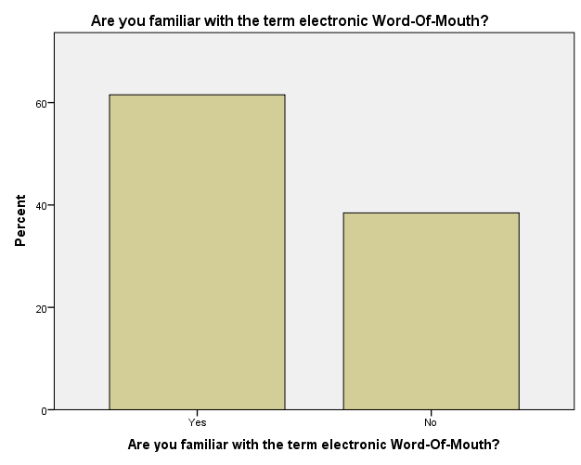
Item 2

Do you consider E-WOM to be a powerful communication tool?

 |  | Frequency | Percent | Valid Percent | Cumulative Percent
Valid | Yes | 21 | 80,8 | 80,8 | 80,8
 | No | 5 | 19,2 | 19,2 | 100,0
 | Total | 26 | 100,0 | 100,0

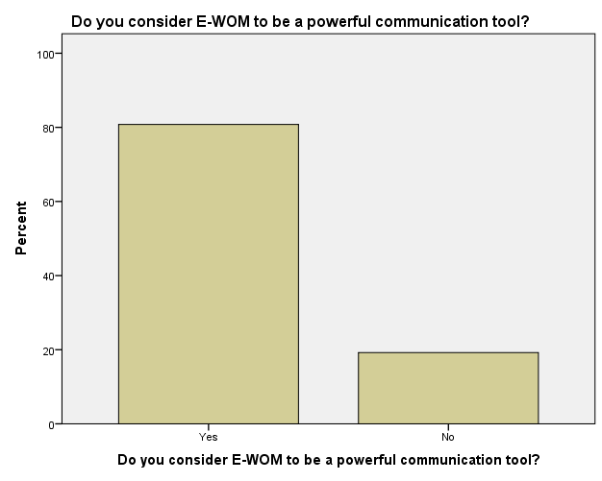

Item 3

Do you think E-WOM affects consumer’s purchase decisions?

 |  | Frequency | Percent | Valid Percent | Cumulative Percent
Valid | Strongly affects | 10 | 38,5 | 38,5 | 38,5
 | Affects | 11 | 42,3 | 42,3 | 80,8
 | Neutral | 4 | 15,4 | 15,4 | 96,2
 | Does not affect much | 1 | 3,8 | 3,8 | 100,0
 | Total | 26 | 100,0 | 100,0

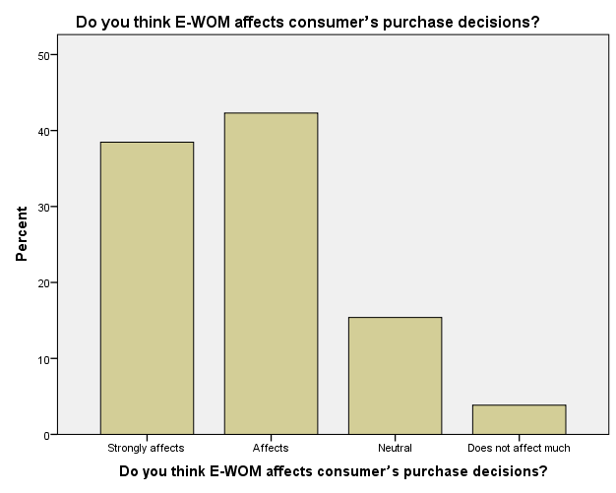

Item 4

Do you think that negative E-WOM is able to make people dislike a hotel for a long-term?

 |  | Frequency | Percent | Valid Percent | Cumulative Percent
Valid | Yes | 12 | 46,2 | 46,2 | 46,2
 | Maybe | 9 | 34,6 | 34,6 | 80,8
 | No | 5 | 19,2 | 19,2 | 100,0
 | Total | 26 | 100,0 | 100,0

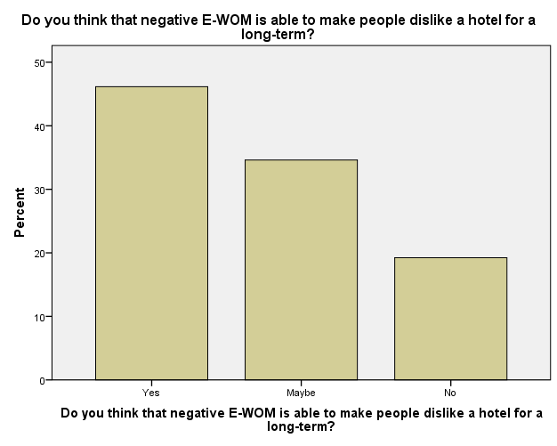

Item 5

On a scale from 1 to 5 (5 being the highest), please rate to what extent negative online reviews can impact a hotel's image?
 |  | Frequency | Percent | Valid Percent | Cumulative Percent
Valid | 2 | 1 | 3,8 | 3,8 | 3,8
 | 3 | 6 | 23,1 | 23,1 | 26,9
 | 4 | 8 | 30,8 | 30,8 | 57,7
 | 5 | 11 | 42,3 | 42,3 | 100,0
 | Total | 26 | 100,0 | 100,0

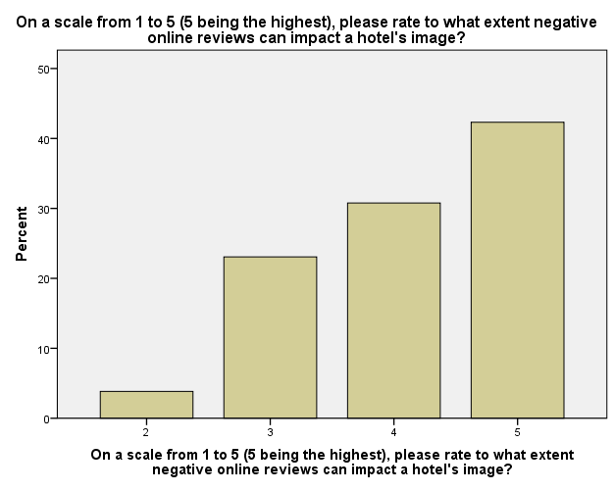

Item 6

What is the general attitude of people towards your hotel - according to people's feedbacks in different social networks?

 |  | Frequency | Percent | Valid Percent | Cumulative Percent
Valid | Very positive | 11 | 42,3 | 42,3 | 42,3
 | Positive | 15 | 57,7 | 57,7 | 100,0
 | Total | 26 | 100,0 | 100,0

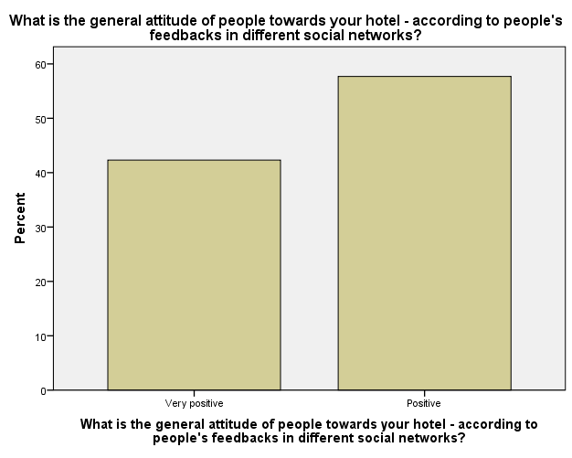

Item 7

On which social network people write comments about your hotel the most?

 |  | Frequency | Percent | Valid Percent | Cumulative Percent
Valid | TripAdvisor | 20 | 76,9 | 76,9 | 76,9
 | Facebook | 2 | 7,7 | 7,7 | 84,6
 | Twitter | 2 | 7,7 | 7,7 | 92,3
 | Other | 2 | 7,7 | 7,7 | 100,0
 | Total | 26 | 100,0 | 100,0

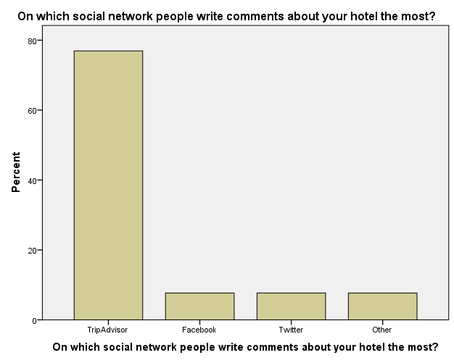

Item 8

Have you encounter negative online reviews regarding your hotel?

 |  | Frequency | Percent | Valid Percent | Cumulative Percent
Valid | Yes | 21 | 80,8 | 80,8 | 80,8
 | I do not remember | 5 | 19,2 | 19,2 | 100,0
 | Total | 26 | 100,0 | 100,0

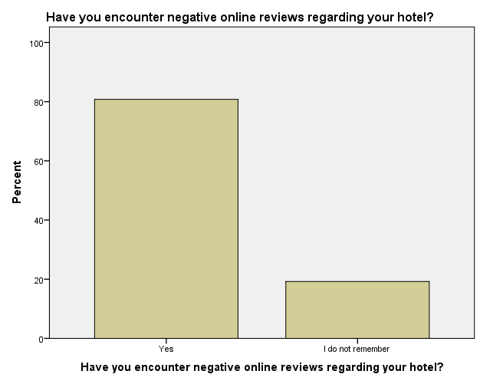

Item 9

What is (would be) your reaction when you encounter a negative online review concerning your hotel ?

 |  | Frequency | Percent | Valid Percent | Cumulative Percent
Valid | I become very conserned about the consequences from that review | 17 | 65,4 | 65,4 | 65,4
 | I find it somewhat frustrating but nothing more | 6 | 23,1 | 23,1 | 88,5
 | I pay no attention to it | 3 | 11,5 | 11,5 | 100,0
 | Total | 26 | 100,0 | 100,0

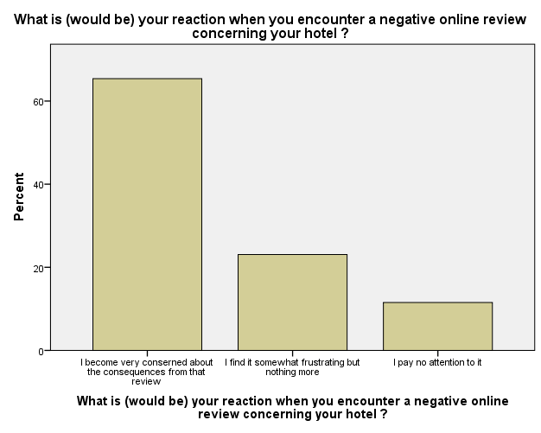

Item 10

What action do (would) you take towards a negative comment online?

 |  | Frequency | Percent | Valid Percent | Cumulative Percent
Valid | I try to contact the person and solve the problem | 13 | 50,0 | 50,0 | 50,0
 | I deny any responsibility for the problem | 1 | 3,8 | 3,8 | 53,8
 | I write an apology | 8 | 30,8 | 30,8 | 84,6
 | I ignore it | 4 | 15,4 | 15,4 | 100,0
 | Total | 26 | 100,0 | 100,0

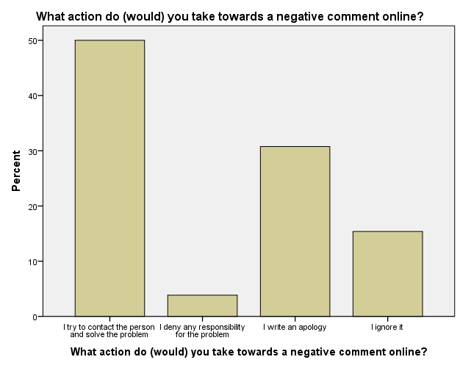
Item 11

What are the negative comments mostly about?

 |  | Frequency | Percent | Valid Percent | Cumulative Percent
Valid | Bad service | 4 | 15,4 | 15,4 | 15,4
 | Unhelpful staff | 7 | 26,9 | 26,9 | 42,3
 | Inconvenient location | 3 | 11,5 | 11,5 | 53,8
 | Lack of cleanliness | 4 | 15,4 | 15,4 | 69,2
 | Safety issues | 3 | 11,5 | 11,5 | 80,8
 | Not working amenieties | 4 | 15,4 | 15,4 | 96,2
 | Overcharging | 1 | 3,8 | 3,8 | 100,0
 | Total | 26 | 100,0 | 100,0

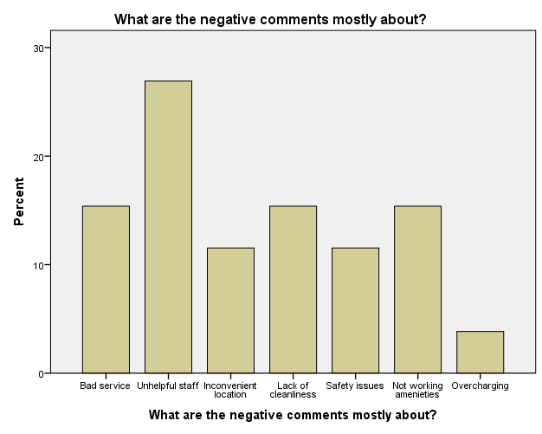

Item 12

Does your hotel aim to deal with negative reviews about it on internet?

 |  | Frequency | Percent | Valid Percent | Cumulative Percent
Valid | Yes | 18 | 69,2 | 69,2 | 69,2
 | No | 6 | 23,1 | 23,1 | 92,3
 | I do not know | 2 | 7,7 | 7,7 | 100,0
 | Total | 26 | 100,0 | 100,0

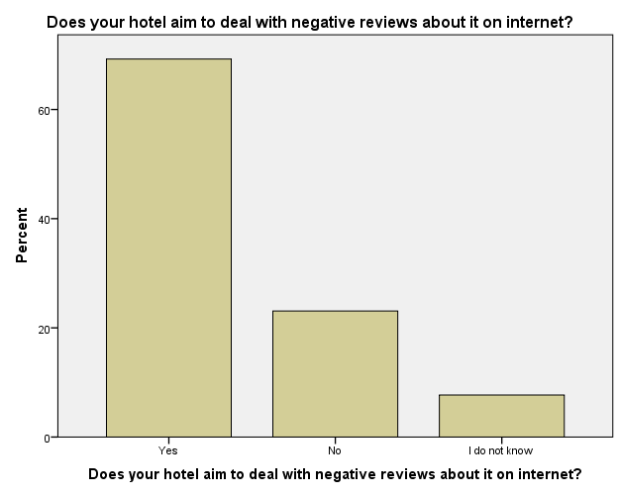

Item 13

Does your hotel have a strategy/ plan to deal with negative online reviews? (If not, skip questions 14 and 15 )

 |  | Frequency | Percent | Valid Percent | Cumulative Percent
Valid | Yes | 19 | 73,1 | 73,1 | 73,1
 | No | 7 | 26,9 | 26,9 | 100,0
 | Total | 26 | 100,0 | 100,0

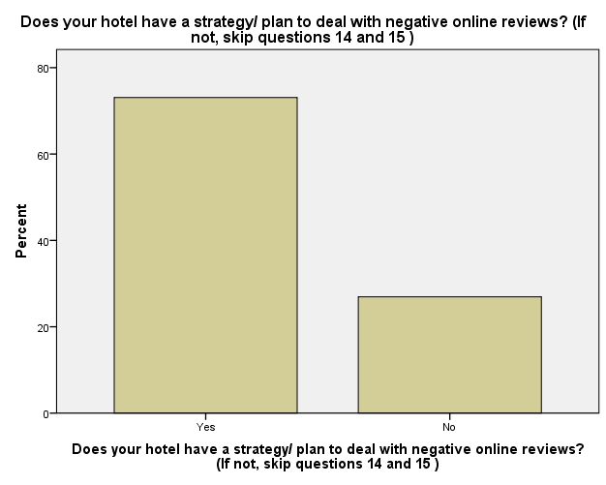

Item 14

Could you, please, shortly describe your strategy/plan below?

 |  | Frequency | Percent | Valid Percent | Cumulative Percent
Valid |  | 9 | 34,6 | 34,6 | 34,6
 | Writing a response back | 10 | 38,5 | 38,5 | 73,1
 | Handle the problem before it appears on social media | 6 | 23,1 | 23,1 | 96,2
 | Take no action | 1 | 3,8 | 3,8 | 100,0
 | Total | 26 | 100,0 | 100,0

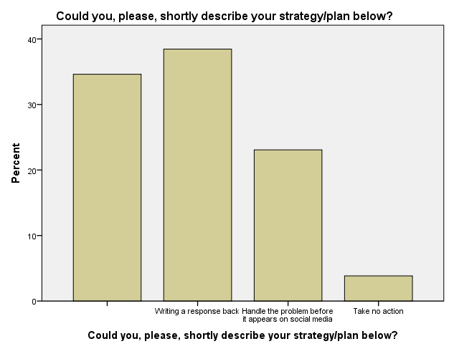
Item 15

What was the outcome from the strategy?

 |  | Frequency | Percent | Valid Percent | Cumulative Percent
Valid |  | 9 | 34,6 | 34,6 | 34,6
 | Satisfied clients | 4 | 15,4 | 15,4 | 50,0
 | Appreciation | 5 | 19,2 | 19,2 | 69,2
 | Reduced level of negative feedback | 5 | 19,2 | 19,2 | 88,5
 | More bookings generated | 2 | 7,7 | 7,7 | 96,2
 | No specific outcome | 1 | 3,8 | 3,8 | 100,0
 | Total | 26 | 100,0 | 100,0

