ANOTHER WORLD IS POSSIBLE

Ecological and Social Justice for indigenous peoples of Southern Mexico

a critique of mainstream development

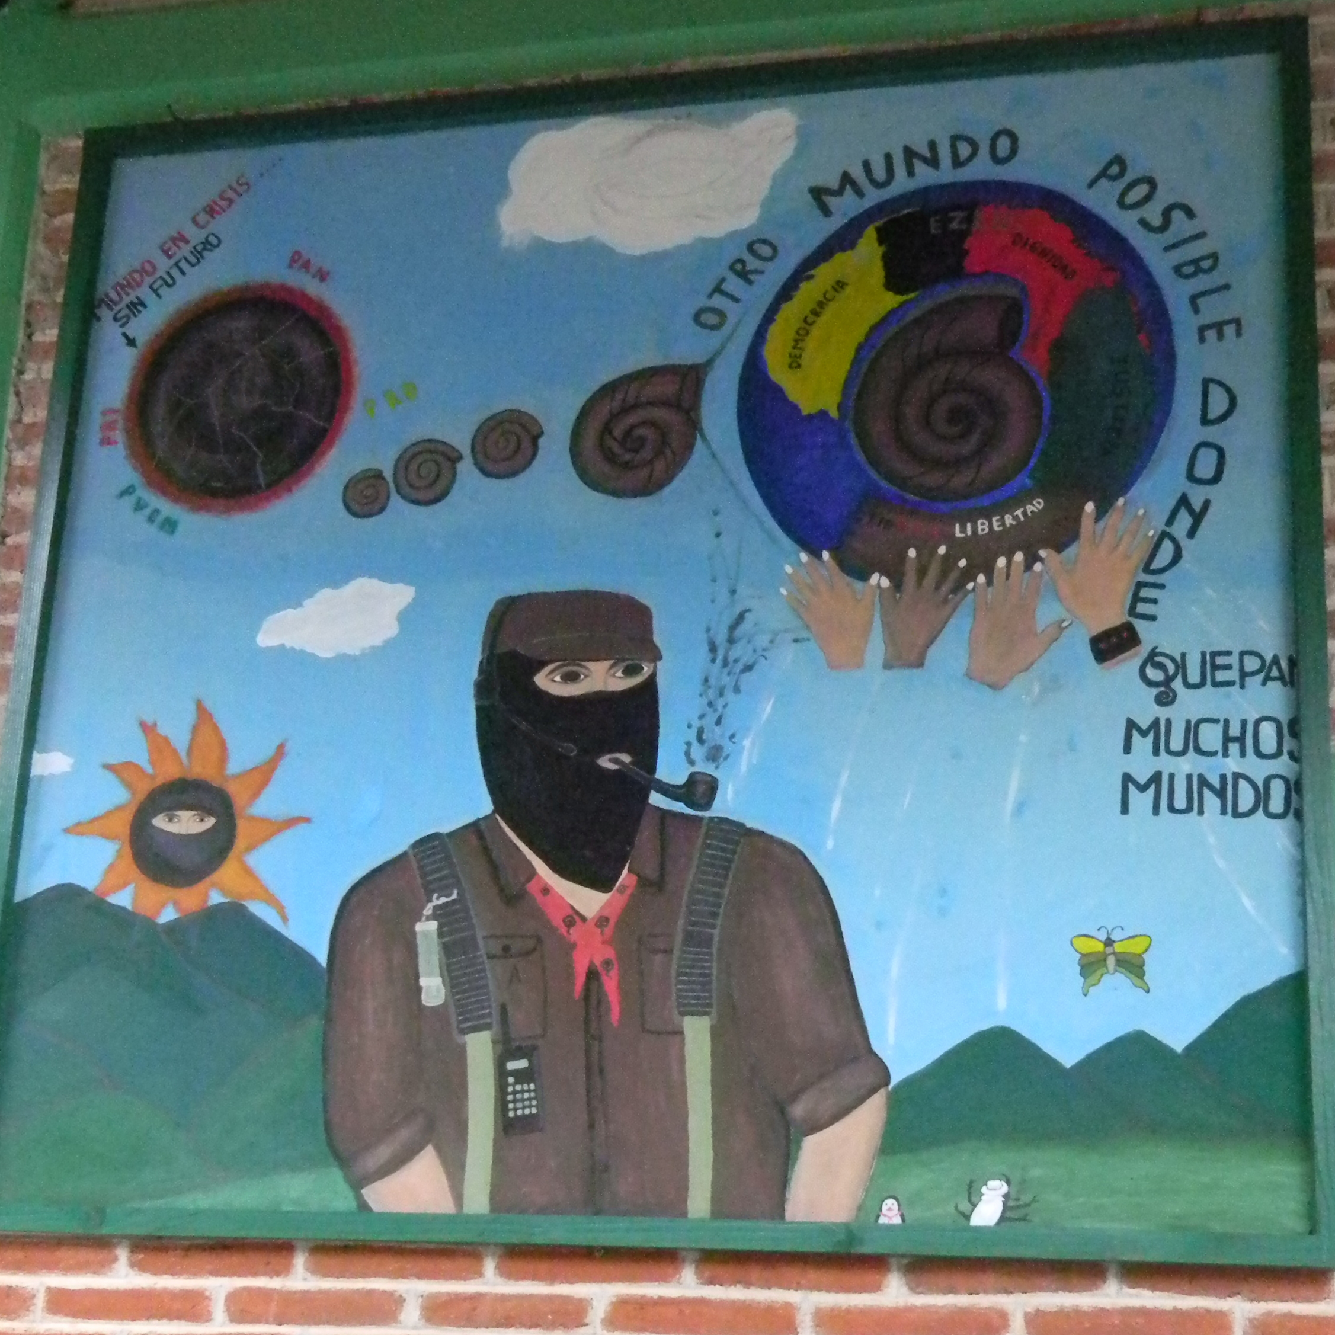
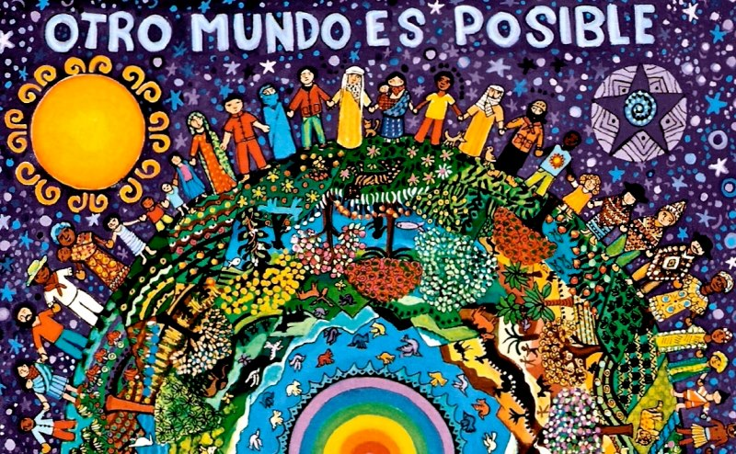


Sarah Crumlin Spanggaard

Aalborg Universitet 2014

