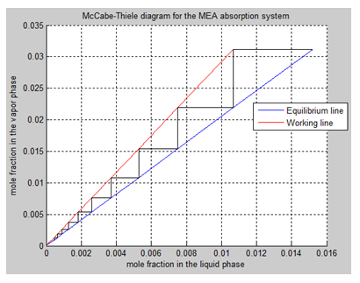

Amines as gas sweetening agents

Henriette Hansen

Master thesis

Spring 2014