Table Of Contents

Introduction 1

Problem Formulation 4

Anthony Nolan Trust 5

Technology 13

Methodology 23

Data & Data Analysis 29

Discussion 41

Conclusion 52

Reference List 52

Appendix 53

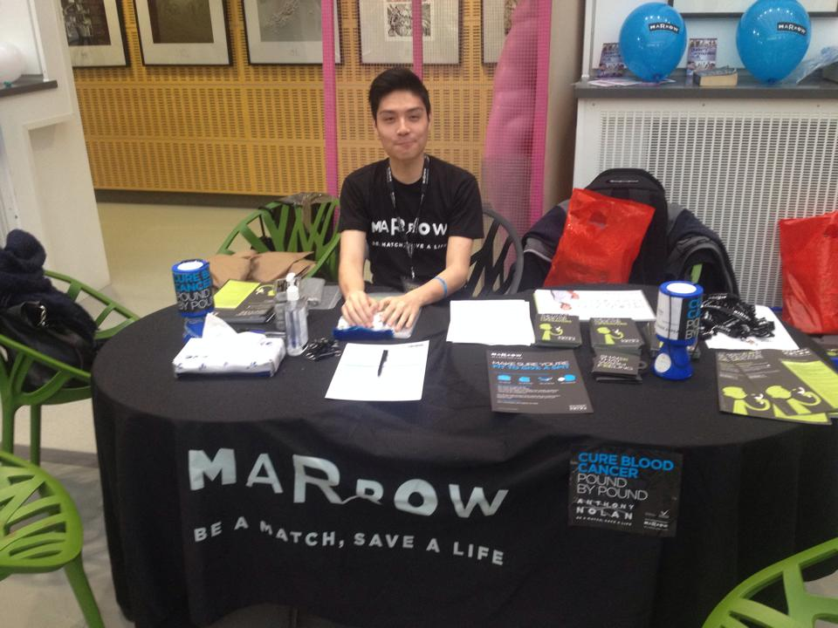

# 

# Introduction

“Help save the life of a Cancer patient.” The president of MMS (Middlesex Marrow Society) Nathaniel Legal said to me as I walked past the MMS tent on a Welcome to University event. MMS is ran by volunteer students and represents the Anthony Nolan Trust (AN) at Middlesex University (MDX). AN is a charity focusing on blood transplantation to cancer patients. The conversation with Nathaniel interested me, as I have always been interested in medical technology. I am a biomedical scientist so I was quite interested in what he had to say about the Anthony Nolan Trust (AN) and how they save lives, by registering potential donors who are willing to donate their stem cells to cancer patients and people suffering from serious blood diseases. I was over the age limit to donate however after a talk with Nathaniel and explaining to him about my background as a soon to be techno-anthropologist he mentioned that all the members of MMS were science students and thus had trouble communicating with non-science students. This sounded like a problem a techno-anthropologist can solve and thus I emailed him with my thesis proposal and he was just as excited as I was on how I can look into ways they can better communicate their technology to the MDX students. I was also offered the position of promotions coordinator, that way I would be able to help them better explain their technology and at the same time gain some valuable insider information on how the society works.

MMS are educated under strict guidelines made by AN on how to operate. They are in constant contact with AN in order to assure that things are run in accordance with the AN organization's values. Some of the things they were given include, educational leaflets, power point slides, promotional items (such as pens etc.), the spit kits (are tubes containing chemicals which the potential donors spit into and then sent to the AN laboratory to be screened and put into the AN register until a matching patient needs a donor. The potential donor will then be contacted and the donation process will be set in motion. Further explanation of this process, the spit Kit , MMS and AN will be given later in this thesis.

In order to gain knowledge about the Problem area and to try and solve it, a number of Qualitative Data will be used. I have chosen to concentrate my time on only qualitative data and not on gathering quantitive data because due to my background as a biomedical scientist I have used quantitive data and I would therefore like to take this opportunity to improve on gathering qualitative data. In this thesis I will be conducting a number of different qualitative data methods, such as a field study, interviews, and workshops. In doing so I hope to gain the knowledge, skills and competencies needed by a Techno-Anthropologist.

Knowledge

The collection of the following data will help me identify the interdisciplinary scientific problems in the intersection between AN technology and the MDX culture. A field study is to be made of the Middlesex Marrow Society (MMS) in order to gain insight on how the group works and how they inform MDX students about the donation technology and how the students react to the information that is being given to them. In doing so I hope to gain knowledge of anthropological study design and analysis.

Skills

In conducting this anthropological study of interviews, workshops and field studies to which I will analyze and discuss in future chapters, I hope to demonstrate my skills in the study of the relationship between the AN technology and its underpinning social, and cultural implications on male Asian students. That is the reason behind my interviewing of Asian students in order to gain insight as to how AN's technology is viewed in their culture and society. In order to critically evaluate these connections with the organizational and institutional connections of AN a detailed tour of the AN laboratory has been made along with gathering information obtained from their latest published scientific papers. A field study of how the organization works has also been made along with a study of various materials given to potential volunteers such as website and leaflets. The anthropological study will also cover the ethical assumptions and implications that may contribute to how Asian students view the technology in questions. That is why the students will be asked directly about this issue and an article that researched religion effect on donation will also be included in order for better analysis.

Technological research by reading papers, books and websites about the technology together with the analysis discussed above will be combined with future workshops data in order to try and design new responsible and innovative solutions to improve the communication of AN to the students. All the solutions found will be considered carefully and translated and implemented to give concrete actions.

This thesis will be written in a manner that will make it a communicative tool to use for different parties involved as well as any other interested party, such as experts, political, administrative, economic stakeholders as well as the general public. In this case the general public will be students interested in finding out what results and suggestions have been found. The experts, and economic stakeholders here will be people from AN. I do not think political and administrative parties will read this thesis, however the intention of this thesis is to be understood by all in order to help bridge gaps between different cultures and parties.

Competencies

This techno-anthropological study has ethical dilemmas such as religion, and how this effects the decision of becoming a donor. There will also be other ethical dilemmas that rise from this study, because we are dealing with a European technology being explained to an Asian/European culture, so cultural ethical differences will be handled and discussed in this Thesis. Not to mention that the technology is very scientific and being 'sold' to non-scientific students, which means that it could be a target at people that view science and this technology to have ethical flaws. The handling of ethical dilemmas will therefore be an important topic that will be handled in this thesis.

* In order to gather the quantitative data needed for this thesis the president of MMS was contacted and I had a meeting with him explaining how I as a techno-anthropologist can with MMS collaboration find solutions to improve their communication with students with no scientific knowledge. In doing so I have independently initiated and lead an interdisciplinary collaboration with professional responsibility. This thesis will hopefully show that I have independently taken responsibility, and demonstrated professional and interdisciplinary development and specialisation. Hopefully this methodology chapter shows a good management of work. The data, analysis and discussion chapters will show that I am capable of managing situations that are complex, unpredictable and require new analysis and solutions give example.

# 

# Problem Formulation

*Can a technology organization like Anthony Nolan improve their communication to Middlesex University non- science male students with Asian* descent in order to increase the percentage of potential donors in their registry?*

*by Asian I mean Muslim British -Indians

**sub questions**

1.Why are Asian males less likely to become a potential donor than other students at MDX?

2. How can Middlesex Marrow Society and eventually Anthony Nolan Trust attract more Asian males to become potential donors?

3. How can technology experts better explain their technology to the general public?

# Anthony Nolan Trust

In order to improve the communication between AN and the students it is important to first of all understand the AN organisation, its history, structure, aim, strategy how it functions etc. MMS is a society representing AN, they are a part of the AN organisation. In this thesis the problem formulation and the conducted research has MMS as the focus. Therefore this chapter will focus on MMS structure and function.

**BACKGROUND**

The Anthony Nolan Trust (AN) is a blood bank registry, whose main goal is to find donors of stem cells or bone marrow to patients with blood cancer and blood disorders. It was founded in 1974 by Shirley Nolan who was inspired in 1973 by a blood transplant that saved the life of a little boy. Shirley Nolan had a little boy of her own who suffered from a blood disorder, but sadly no match was found for her son, Anthony Nolan who died in 1979. In the 1980's, the organization had up to 100,000 potential donors in the UK and became a member of the Bone Marrow Donors Worldwide making it able to search registers in about 50 different countries. In the 1990's the growth of the organization continued and a research institute and laboratory was established. In 1998 a record of 300 transplants in one year was made with the help of the AN registry. By 2000 AN has successfully helped 2,500 people receive transplantations. The PBSC technology of collecting blood, which is a quick and less painful method of blood collection started being used in that year as well. This method will be discussed in the technology chapter. The Founder of AN passed away in 2002. Meanwhile the trust continued to grow registering 380,000 potential donors by 2006. And by 2008 the trust set up the first UK blood cord bank , enabling the technology of blood cord donation to be used to its fullest potential (1) (look at technology chapter for further reading on this matter).

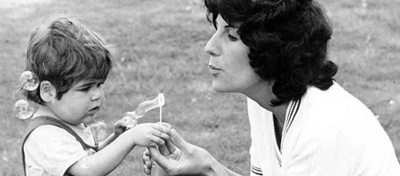

**Shirley Nolan and son Anthony Nolan www.anthonynolan.org**

**AN Vision:**

"To save the lives of everyone who needs a bone marrow or stem cell transplant"(1).

**AN Aims (1):**

* "To find a donor for every person who needs one"
* "To improve the quality of life of people who have had a transplant"
* "To put people in need of a transplant and our incredible donors at the heart of what we do"
* "To provide the right people, environment and funding to maximize our impact"

**AN strategy:**

According to its strategy booklet AN has several important changes they would like to make, one being improving patient outcomes, meaning the success in finding a compatible donor which will improve the patient's outcome. Continuing to listen to the donor centres needs as they are ever changing is another thing AN would like to make. A more holistic approach towards the staff, volunteers, donors and patients is wanted as they are all interconnected and if there is better communication between these groups AN is expected to run more smoothly. In order to maximize its impact AN must prioritize the staff, their environment and funding. AN has many objectives and strategies on how to best meet their needs, including bettering the registry so more UK citizen lives can be saved (1).

The Structure of Anthony Nolan

AN is an independent charity with the vision of saving the lives of everyone who needs stem cells or bone marrow transplant. The organization is made up of an experienced Board of Trustees and a Senior Management Team. The Board of Trustees has the overall responsibility for the direction, management and control of Anthony Nolan. Trustees are appointed by invitation only based on their skills and experience. Their aim is to have a Board with a diverse range of people who can work together to help the charity prevail. Trustees retire from the Board every three years, however there is an option for re-election. The Trustees meet four times a year and the Senior Management Team attends all the Trustee meetings. The Senior Management Team is responsible for the daily running of AN and meet bi-weekly to oversee the management of the charity and lead the strategic direction of AN (1).

The Funding of Anthony Nolan

It costs £100 to add each person to the bone marrow register to become a potential donor. So in order to save lives AN relies on generating money using different strategies. The main source of income is provided from charging for donors for patients both in the UK and overseas. AN are experts in tissue-typing and are one of the leading authorities on stem cell transplantation, so another source of income comes from AN conducting molecular analysis for medical professionals. The Charity also relies on financial donations from individuals and organizations. These supporters enable AN to increase the bone marrow register, fund research into improving survival rates and the quality of life for patients post-transplant, and raise awareness of the need of potential donors (1).

**How the organization functions**

An is an organization that matches stem cell or bone marrow donors to people in need of this life saving transplantation technology. AN has research laboratories who research ways of improving the success rate of transplants and the lives of cancer patients. They also educate young people about the difference they can make if they choose to join the AN registry. AN does this by having adult volunteers go around schools and give presentations to youths between the ages of 16 and 18. At the end of the presentation, the young people are then offered the chance to register if they wish to do so. Potential donors in general may also order a spit Kit (see below) online on the AN website and they will have a spit Kit sent home to them. They can do the test at home and send back the kit to the AN laboratories. When or if a match is found they will be contacted and go through the same procedure as any other donor (see below). AN has workers working around the clock at maternity wards ready to collect donated umbilical cords. Umbilical cords are full of stem cells and the process of donation does not interfere with the birthing process or effect the mother and child in any way. The procedure of attracting donors that this thesis will focus on is, the formation of societies in universities across the UK to represent AN and attract potential student donors.

Volunteers

The Anthony Nolan organization relies heavily on volunteer work in order to meet its goals. There are many different types of volunteer work which those who are interested can sign up to via their website.

**Middlesex Marrow Society**

The Marrow Society groups, which can be found in many Universities across the UK, are the type of volunteer work which has been observed foe this thesis. They are usually made up of students of either a medical or scientific background. They are taught by AN and a committee is formed by applying for the different jobs. The different jobs will be mentioned below with a short description of the different volunteers, so that the reader can get a better sense of who the society consists of.

President

Nathaniel Legal

Nathaniel has been working for Middlesex Marrow for 2 years. Last year he was the society’s Promotions Coordinator. Nathaniel has contributed to Middlesex Marrow winning the MDXSU award for Best Campaigning Society during 2012-13. Nathaniel is a 2nd year bachelor student of Biosciences. His dream is to become a Research Scientist in the field of Neuroscience.

Nathaniel’s role in the society has been to act as liaison between National Marrow and Middlesex Marrow on related matters. He also acts as main point of contact for MXDSU and queries from students. He has been the figurehead and spokesperson of the society. Nathaniel ensures a smooth running of the society, by taking ultimate responsibility for events, meetings and communication. He Consults the Societies’ training presentation and makes sure relevant information is distributed to the committee and members. His role as president means that he gets to attend any meetings that involve the society, e.g. the Societies AGM.

Clinics coordinator

Astrid Hasund Thorseth & Nasteho Yussuf

Astrid worked for MMS for over a year. She is a Biomedical Science bachelor student on her 2nd year. Astrid loves to travel and experience new cultures, her dream job is therefore to work for Doctors Without Borders as a biomedical scientist.

Nasteho started working for MMS this year, she too is a 2nd year student of Biomedical Science. Nasteho would like to work in the field of biomedical science after she graduates.

Astrid’s and Nasteho’s roles in the society is to be in charge of the clinics. They book areas for the society to hold its clinics and organise the roles the volunteers will be taking in each clinic in order to have the best outcome for the clinic. They are also responsible for reporting to Anthony Nolan the results of each clinic and sending back used and unused materials, Kits etc.

Treasurer

Isaac Ching

Isaac started working for MMS this year, he is a biomedical science student on his 2nd year. Isaac would like to work in research as a biomedical scientist. Somewhere along the line he would also like to become a chemistry teacher as that is his true passion.

His role as treasurer is to manage the society’s budget and paying in and taking out funds on behalf of the society from their MDXSU bank account. His role is to Liaise with MDXSU on matters of finance. Isaac ensures that external agencies used by the society send correct invoices if they need to be paid. He is responsible for filling out grant and/or loan applications and returning them to a MDXSU reception in good time before the Funding Committee Meeting (Small Grants Fund) at which the application is to be discussed. Overall Isaac ensures that any handling of cash is done in a trust worthy manner with full records kept.

Promotions Coordinator

Balkis Fares

Balkis started working at Marrow society this year. She is an exchange Techno-Anthropology Masters student taking her electives in Marketing Communications. She has a bachelor in biomedical science and has worked as a biomedical scientist. Her dream job is to work in an NGO where she can combine her biomedical science background with communications.

Balkis is responsible for the up keeping of all social media sites and the promotion of events and fundraising, i.e. Facebook, Twitter, making posters and distributing them, writing articles etc. The Promotions Coordinator role is also to liaise with Union over the advertisement of MMS events, using all resources.

Inclusions & Societies Officer (Ex Promotions, Clinics, Events, Fundraising Coordinator)

Zeshan Ahmed

Zeshan has been a member of MMS for almost two years now. He has organised MMS' largest clinic and voluntary opportunity GPU 2013. Zeshan is a 2nd year student of Bsc (hons) Biomedical Science. His dream job is to one day work in Cancer Research, Medicine.

Zeshan’s role as Inclusion and societies officer is to make sure each student is catered for and that there are no barriers for anyone to enter and be part of the society.

He Works with other committee members to ensure that their area has taken inclusion into consideration. Zeshan takes a proactive approach to ensure the society reflects the diversity of the membership of the student union and that the society is inclusive and accessible to all.

Training coordinator

Sarah Henry and Warda Ismail

Sarah has been a member of MMS for a year. She is a Biomedical Science 2nd year student. Her dream job is to apply for medical school and become a doctor one day.

Warda started working for MMS this year, she too is a 2nd year student of Biomedical Science. Warda would like to work as a biomedical scientist after she graduates.

They are responsible for liaising with Anthony Nolan to ensure that all volunteers are trained to the standard required. If volunteers require further training or a refresher session the training ,Sarah and Warda as the training coordinators are responsible for organising further training or presenting a training refresher session. They work with MDXSU to provide suitable space for the training events.

Socials coordinator

Navisa Naqibullah

Navisa has been working for MMS for two years. She is a 2nd year biomedical science student. Her dream job is to become a Haematologist after she graduates.

As a socials coordinator Navisa’s role is to arrange MMS social events and liaise with both MDXSU and Anthony Nolan.

*Recruiting*

A description of how the society works to recruit members will be found in the Data and Data Analysis chapter under Field Work.

*Education*

When the potential donors are approached they are educated by the MMS volunteers on how they can save a life and the procedure. This is done orally but they are also given a leaflet, which is a guide on how one can become a lifesaver. It starts off with a short description of some facts about the amount of people effected by cancer and an explanation of stem cells and how they can be used. There is also a FAQ where their general concerns can be addressed. The two donating methods are explained along with the full procedure the volunteer will go through once a match is found. These methods and procedures are explained in everyday language with lots of diagrams (7).

*Donating Methods*

Donating stem cells;

When donating stem cells the donor receives 3 visits from a nurse on three consecutive days, in order to be injected with a synthetic growth factor ( G-CSF ) in order to stimulate the production of stem cells in the blood stream. These visits can either be made at the home of the donor or at his workplace. AN is trying to insure that only minor disruption is caused to the donors life. On the fourth day the donor is asked to go to the hospital for the last injection and the net day they will be asked back to the hospital to donate their stem cells. The donor is injected with a tube that transports the blood from the body towards a machine that filters the body's stem cells and then transports the blood back to the body via a tube connected to the opposite arm. This procedure takes 4 to 5 hours and the donor is free to go home straight after the procedure ends. In some cases there might rise a need to collect more stem cells so the donor will be asked to go back the following day. The donor should be able to resume normal activity 24 to 48 hours after the donation. In using this technique the donor might experience flu-like symptoms like pain in their muscles and bones or/and headaches. These symptoms should however disappear within 24 hours of the last G-SCF injection (7).

Donating Bone Marrow;

The above mentioned method is usually used in 90 % of cases however in 10% of the cases the donor will be asked to donate bone marrow instead. The donor will stay at a specialized hospital for two days. On the day of the operation the donor will be sedated. The operation takes only about half an hour, where bone marrow is extracted from the pelvic bone using a needle and syringe. The donor is welcome to leave the hospital 24 hours after the operation and should be able to conduct normal activity 7 to 10 days after the operation. A full blood count is given a month after the operation in order to insure that the donor is producing a normal amount of stem cells. Side effects from this procedure may include slight lower back pains for a short period of time (7).

# Technology

To improve the communication between MMS volunteers and the students one must understand the technology the is being used, in order to come with suggestions on how to explain the process and attract potential student donors. In order to understand the technology one must also gain an understanding of the diseases that the technology is used to cure. Thus this chapter will include a description of the technology of donation and the diseases it helps cure. A terminology list is included at the end of this chapter.

**BACKGROUD**

AN is an organization that registers potential stem cell donors and uses various tests to match these donors with people suffering from blood cancer or other sever blood disorders. In order to gain a better understanding of the technology used by AN, a short introduction to stem cells and the diseases and cancer they are used will therefore be given.

**Stem Cells( and Bone Marrow)**

AN recruits potential donors who donate their stem cells, these are cells found in the blood. They are young unspecialized cells which can transform into any type of 200 specialized cells which the body may need. Stem cells can make other stem cells or become a specialized cell. Bone marrow is rich in stem cells which can become red blood cells (2).

**Blood Cancer**

Blood Cancer is the broad term given to cancer of the blood, bone marrow and the lymphatic system. It is a life threatening disease. It damages the person's immune system, thus making normal illnesses life threatening. In the UK 25,000 people are diagnosed with blood cancer per year. And there are many others that are living with other lethal blood related conditions such as sickle cell anaemia and Thalassemia to mention a few (1).

*Three main types of blood cancer*

Leukaemia

Leukaemia is the 10th most common cancer in the UK, it affects the production of the white blood cells which are an essential part of the immune system. A person with leukaemia produces abnormal blood cells which ‘clog up’ the bone marrow stopping production of other cells that are vital for the immune system (1).

Acute leukaemia attacks the body suddenly and is a very aggressive part of cancer that rapidly spreads across the body and thus needs to be dealt with immediately (1).

There are four types of leukaemia . Acute Lymphoblastic Leukaemia is common among individuals over the age of 65 although many under that age have also been diagnosed. In the UK 2,000 people a year are diagnosed with Leukaemia. Chronic Myeloid Leukaemia is also found though mostly in people in their 60’s and rarely in children. Acute Lymphoblastic Leukaemia is the most common type of cancer found in children and young adults between the ages of 15 and 25. It affects 400 adults a year in the UK. Chronic lymphocytic leukaemia is the most common form of cancer with 3,000 people being diagnosed each year (1).

Lymphoma

Lymphoma can develop in many different organs including the lymph nodes, bone marrow, blood, spleen affects the lymphatic system in your immune system which is responsible for protecting the body against infection and disease. In the case of lymphoma the body produces lymphocytes (a type of white blood cells and the immune system. ) in abundance thus causing the immune system to be compromised (1).

There are two main types of Lymphoma are non-Hodgin Lymphoma (NHL) and Hodgin Lymphoma. Hodgin Lymphoma is less common than NHL making around 20 % of all lymphomas and 1% of cancers in the UK, where around 2,000 people are diagnosed a year. Those most commonly diagnosed with Hogin Lymphoma are either in their 20's or in their 70's. Most commonly diagnosed lymphomas are NHL, making it the sixth most common form of cancer in the UK. With around 12,000 people and 90 children diagnosed per year in the UK alone. Over half of the NHL patients are over 65 years of age (1).

Myeloma

Myeloma is the blood cancer of the plasma cells, which are formed abnormally in the bone marrow hence decreasing the production antibodies which are produced by plasma cells. This is caused by abnormal plasma cells clustering in the bone marrow and hindering the process of normal cell formation (1).

**Blood disorders**

Blood disorders vary where some are treatable while others are life threatening. The blood disorders effect many parts of the body including erythrocytes (red blood cells, which carry oxygen), leucocytes (white blood cells who fight infection), platelets (they help blood clot), and plasma (which helps transport molecules in the blood as it is the fluid part of the blood).

Sickle Cell Anaemia

People with sickle cell Anaemia are unable to carry as much oxygen due to the fact that their red blood cells are sickle shaped. The haemoglobin which carries oxygen sticks together to form long rods inside the erythrocytes when oxygen levels are low. Thus making the cell rigid and sickle-shaped, this shape causes them to get stuck in small vessels, cutting off the normal supply of blood. This causes symptoms such as swelling and painful irritation and great tiredness due to the body’s lack of oxygen. The disease is genetic and often found in people of African, Mediterranean, Middle Eastern, and South Asian descent (4). Stem cell transplants can cure Sickle Cell Anaemia. Currently there is no cure for Sickle Cell Anaemia although transplantation of stem cells is curative, this procedure is not commonly performed because of the after effects and death rate. (2). People with sickle cell anaemia get normal blood cell transfusion instead of their sickle cells, this is done in some cases by replacing some of the patient’s blood with normal blood cells. In other cases patients are just given a transfusion without having their blood removed. After the transfusion the patient usually feels more refreshed given that they now can transport more oxygen in their body. The transfusion also decreases the chances of a pain crisis occurring. Blood transfusions do have their risks though, patients can get virus infections, even though careful screening is made of the volunteers there is still a potential for serious risks. There is also the chance of the patient developing a reaction to the donor cells or the donor cells attacking the patient’s cells. After getting a transfusion the patient’s body may have an excessive amount of iron which will cause damage in the heart, liver and other organs. In order to solve this problem patients who get regular transfusions take Iron reducing medicine. Bone marrow transplantation is also an option for patients with severe sickle cell anaemia. Red blood cells are produced in the bone marrow, so in the case of a sickle cell patient having a normal bone marrow transfusion this would mean they would be producing normal erythrocytes. In a bone marrow transplantation the patient 's own bone marrow is first eliminated, this is done by radiation and/or medicine. The healthy bone marrow is then transported to the patient via a tube into the veins, which is also how a blood transfusion is made. However like blood transfusions, bone marrow transfusions also have high risks. Sometimes the transplantation does not work or the patient’s body rejects the donor bone marrow. The patient must therefore spend the remainder of their life taking immune suppressing drugs and this puts them at risk because it weakens their immune system and makes them vulnerable to viruses and bacterial infections. In 2007 researches discovered that it is possible for some people with sickle cell anaemia to produce normal haemoglobin after having bone marrow or stem cell transfusion (1,2,3).

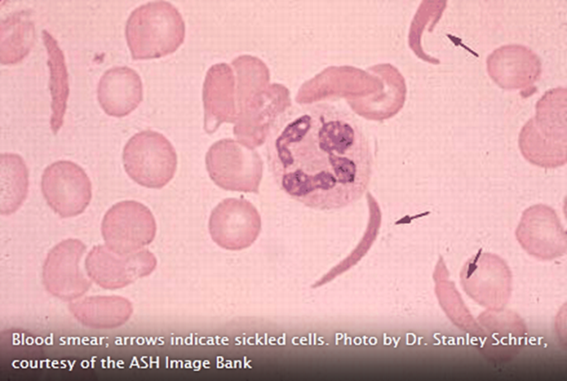 http://www.hematology.org

Thalassemia

Thalassemia and sickle cell anaemia, which is described above are both autosomal recessive inherited disorders which affects the structure or the synthesis of haemoglobin. Haemoglobin is the protein that carries oxygen in the erythrocytes. The abnormal Haemoglobin thus causes the erythrocytes to be destroyed hence causing severe anaemia. The body copes by increasing the production of erythrocytes, and this is made by increasing the marrow capacity in the bones as well as increasing the spleen and the liver. The spleen ad bones also increase in size in order to deal with the breakdown of the erythrocytes. Side effects of anaemia can be fatigue, headaches and concentration problems and may cause more serious side effects such as shortness of breath. Patients of Thalassemia usually require monthly blood transfusions. Thalassemia can be treated in children after a bone marrow transplant. The most common form of Thalassemia in the UK is the beta type and effects people of Indian or Mediterranean descent (1,4).

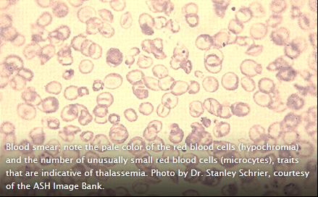 http://www.hematology.org

Aplastic Anaemia

This is a rare and life threatening condition, the disease causes the decrease of blood cells being formed in the bone marrow, especially in the case of producing erythrocytes. Thus this causes anaemia which as mentioned above can cause side effects of which some are quite serious. It is difficult for doctors to diagnose the reason behind developing Aplastic Anaemia. This disease can be caused as a side effect to medication, some forms can be genetic, it can be caused by autoimmune condition or by viral infections. Treatment for Aplastic Anaemia can be blood transfusion and stem cell transplants (1).

**THE TECHNOLOGY**

**Treatments**

Treatments for people with various types of blood cancer and blood disorders can be made by the use of radiotherapy, chemotherapy, and stem cell transplants. The treatment is chosen in accordance to the type of blood disorder or cancer the patient has, how aggressive it is and how advanced it is. Another factor that plays a part in the diagnosis is the general health of the patient. In the following chapter will describe the following treatments, with focus on stem cell transplantation as this is the method AN trust is helping raise donors for. These treatments are also used when transplantation occurs and that is why a small description of each will be made in this chapter (1).

Chemotherapy

In chemotherapy the patient takes drugs that are targeted towards destroying fast multiplying cells, which are usually cancerous cells. This is because cancer cells grow and multiply faster than normal cells. However these drugs do sometimes attack normal cells that multiply fast and that why side effects such as hair loss, nausea, and tiredness occurs. This form of treatment is sometimes taken in combination with other treatments such as radiotherapy (1).

Chemotherapy is also used in stem cell, bone marrow, or cord blood transplantation. It is used in order to suppress the immune system so the donor tissue is not rejected (1).

Radiotherapy

Radiotherapy is used to treat some times of leukaemia and lymphoma. It is a treatment that uses high energy x-rays to eliminate cancer cells. A machine called the linear accelerator is used that targets specific areas of the body, those were the cancer lies with radiation. However this machine is not 100% accurate and thus normal cells are hit as well causing mild side effects such as tiredness. The side effects usually end a few weeks after the ending of the treatment, since the normal cells reproduce (1).

Radiotherapy is sometimes used, with a low dosage of radiation before transplantation therapy, to lower the immune system of the patient in order for the donor’s tissue to be accepted by the body and not rejected as foreign cells (1).

Transplantation Therapy

It is the process of replacing your abnormal cells with a donor's normal cells. The donor cells are collected from the donors umbilical cord, bone marrow or blood. Transplantation occurs as a final form of therapy when all else fails. This is due to the significant side effects that come with this form of therapy and the long recovery period of around a year. Graft-versus-host disease (GvHD) this is a side effect were the patient's body rejects the donor's cells and attacks them. Medication is used in order to stop the patient's immune system attacking the donor cells is used however this can still cause serious problems for some patients. Another side effect is infection, due to the foreign cells in the body and due to the immune system being suppressed by chemotherapy, radiotherapy and transfusion (1).

The Autologous transplantation is a technology that was developed on order for the patients not to experience the side effects mentioned above. This type of transplantation is made by collecting the patient's blood cells before they undergo cancer treatment and then injecting the cells once the therapy is finished in order help the body recover. This method has the benefit that the patient's body would not reject the blood cells since they are his own. So no immune suppressant drugs or side effects that are related to this issue will happen. This form of transplant is made on patient’s health, if they do not suffer from other diseases such as diabetes for instance. It would also depend on whether they still have healthy stem cells where the cancer has not spread and where the cancer form is not that aggressive(1).

Most people find using sibling transplantation the fastest way to find a match. The donor and patient need to have a human leukocyte antigen (HLA) in order to be a match. HLA is what makes the body identify its cells as opposed to foreign cells. That is generally good because the body in this way recognizes foreign cells that attack the body and can respond to them. However this means that it is difficult to find someone with a similar HLA and that is why it is important to have a huge registry to choose from in order to find a match. Genetically speaking there is a 1/4 chance that a sibling has an HLA match to the patient. That is why when transplantation is needed doctors always start by using this option (1).

If the patient does not have siblings or if they are not a match, the next step is to look at family members to see if there is an HLA match. This process is called "related adult match". If there is no related adult match, then stem cells from family members with partially HLA are used and this is referred to as the Haplo-Identical match transplantation (1).

If for some reason the patient is unable to receive a transplantation from family, an Allergenic Transplantation is made, this is simply refers to transplantations made were the donor is not a family member. In these type of cases AN's registry is used. AN has around half a million potential registered donors so the process of finding a match can take many months. The ethnicity of the patient plays a part in how easy or difficult it can be for AN to find a match as not all ethnicities are equally represented in the AN donor registry. This is due to some ethnicities being not as agreeable as others to join the AN registry. If in some cases there is no donor match in the registry an international search is made by AN as it has many departments across the world (1, 2).

Patients can also receive stem cell donations by cord blood transplantation which is collected, free zed and stored in the cord blood bank straight after delivery. Cord blood has a rich amount of stem cells. AN asks soon- to- be mums whether they would like to donate their cord blood, if they are then they are asked to sign a consent form after birth by AN workers. This is a very promising technology as the blood is directly available and does not need to be an exact match, this is because the stem cells in the cord blood are not fully mature yet and can therefore match patients (1).

**The Laboratory tour (19.02.14)**

AN relies on heavily on liquid handling systems to help process the high amount of samples and they rely on their high quality machinery for DNA extraction, virology screening, PCR setup and the SSOP processes.

Histocompatablity and Immunogentetics are the methods used in order to test the potential donors saliva and the 'donor blood'. The HLA of the donors are tested in the laboratories of the potential donors and recipients. They not only test for their register but also for other haematopoietic stem cell transplantation centres worlds wide. HLA typing is the name of the process of identifying the different HLA types. HLA is a group of highly polymorphic genes, this is when more than one morph occurs in one phenotype. This group of polymorphic genes which is found in the HLA is located on the sixth chromosome. HLA typing is the identifying process of the product of these polymorphic genes. This is made by the DNA identification of each gene thus identifying the alleles in that location and therefore determining the HLA of the recipients or potential donors (1,5).

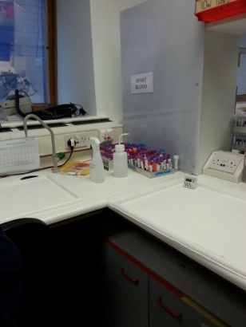  *blood samples that have arrived from the hospital before they are put into the tubes that are placed into the machine.*

The DNA in the blood is first duplicated in order for further testing to take place. This is made by a Polymerase chain reaction (PCR). After the PCR is complete there are 3 different methods of HLA typing. The Sequence specific oligonucleotides (SSOP), this method is used as the primary method of HLA typing as it can be used on a large number of samples where up to 100 reactions can be tested in a single tube. In this method AN uses Luminex xMAP® technology, oligonucleotide probes individually attach to 100 sets of uniquely fluorescent microspheres. Sequence specific primers (SSP), this is the quickest form of HLA typing. It is used in the case of organ transplantation and in the final stages of testing whether a patient and donor share similar HLA by testing specific DNA sequences after PCR to see if they are similar in a HLA gene (1,5).

Sequence based typing (SBT), this method is used during the final stage of testing to clear any uncertain results. This is made by directly analysing the nucleotide sequence (the PCR product) in the specific area that is being investigated for HLA similarities. This method is gives high resolution results and takes the longest time to analyse (1,5).

There are around 60 laboratory staff members at AN these include, scientists, technicians and administrative workers. There are 6 main departments, one of which is the Cellular group which is responsible for sample reception, DNA extraction, serological HLA typing, ABO blood grouping and virology screening. Another is the Intermediate Typing group which performs all the SSOP typing and HLA typing for all new potential donors. The High Resolution group is responsible for the high resolution typing required for the exact matching of donor to patient at the final stages of the matching process. While the Clinical Services group provides scientific support for transplant centres that use our HLA typing service. The Solid Organ group provides scientific support for the Royal Free Hospital’s renal, liver and islet cell transplants. And finally the Registry Reporting group is in charge of coordinating the processing of samples for disease association testing and AN cord blood, it collaborates with the Registry Development group (1,5).

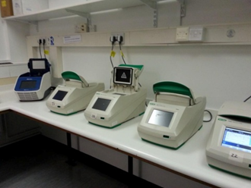  *PCR machines used to amplify DNA, there are 8 of them.*

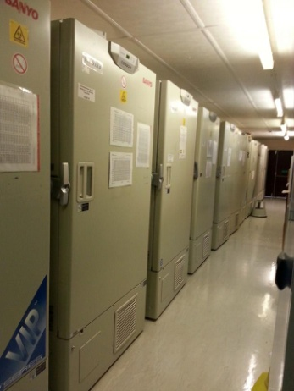 refrigerators where all the potential donor material is stored.

**Terminology**  (6)

**Polymorohous (polymorphic genes)**- occurring in many different forms.

**Phenotype**- the characteristics that are due to both environmental and genetic make-up and can be physically seen.

**Deoxyribonuclearic acid (DNA)**- A nucleic acid which is found in the cell nuclei. It the basic structure of the genes and is responsible for the control and passing of hereditary characteristics.

**Alleles** – A pair of genes that cover the same relative positions and produces different effects.

**Oligonucleotide**- a single strand of DNA or RNA strand that is used to determine genetic tests.

**Nucleotide**- a compound found in the nucleaus. It is made of sugar, acid and a nitigen containing base.

**Haemoglobin**- the protein in the red blood cells that carries oxygen.

**Autosomal-** a non-sex chromosome.

**Chromosome-** the structure of DNA and RNA.

# Methodology

Now that the reader is familiar with both the organization and technology, a look at the methods in order to answer the problem formulation and sub-questions will be made in this chapter. A verification of these will be given in the Discussion chapter.

Methods used

This study will be conducted with the guidance of articles and knowledge gained through previous semesters. New articles and Books that are relevant to this study will also be used. The articles will be found through well known search engines like PubMed. The books will be carefully chosen from MDX Library. When looking for new literature, a careful study of the source, date and publication will be made. This is to insure that the information gathered is non-bias and not out dated. In looking at how to improve the liaise between AN and the students, I will be using the methods that I have learned by the technique of Participatory Design, in particular that of Future Workshops and interviews. These methods will be used together with value sensitive design in order to improve the design process AN has made to recruit potential donors. Thinking within Participatory Design will bring opportunities for understanding the students more and thus hopefully creating better communication. The dogma of Participatory Design is the direct involvement of the people (8). In this case it is very applicable to use the students to gain a better understanding of how to design an improved method of communication. That is why I am conducting interviews with students and workshops, in order to get them involved in the process of improving the design of the recruiting process. Studies show that designers may benefit from conducting a classic ethnographic field work before planning the framing of their design-game (9). That is why I have chosen to conduct a 50 hour ethnographic field work of how Middlesex marrow recruits potential donors before moving on to making future workshops and interviews. All the while I will be keeping value sensitive design in mind. As the value sensitive design takes into account the human values of the people when conducting a design process (10). In this case I believe this to be especially relevant because I will be looking into improving the design for people of a specific ethnicity and therefore culture and values that might be different to my own. So I need to make sure that the design proposal for better communication that I come up with is sensitive to the culture and beliefs of the people I am targeting otherwise the proposal will not improve them becoming potential donors.

Participatory Design;

Participatory design could be seen as an extension of User Driven Innovation, because the users are involved from the very beginning of the design process (11). The “users” in this case since I am looking into communication design are both MMS members and the students at MDX. While the real experts are the science students representing AN in the Middlesex Marrow society as well as the AN workers. Involving the users from the beginning in this case is applicable because the communication design needs to be both highly technical because we are describing a scientific technology and simple because we are describing it to non-scientific students. A look into Market-orientation will be made in order to identify what it is that is missing in the communication process of MMS members in order to attract more Asian potential donors. I will try to transgress company logic by getting inspiration for new ideas outside the traditional logic of AN and this will be done by gaining ideas from students through future workshops and interviews. In this case I will focus on the inclusion of the marginalized users, which in this case might be Male Asian students because they seem to be the least type to volunteer and thus one might assume that a factor in this could be that they were not included in the thought process of designing a communication strategy to attract potential donors.

Another reason as to why User Driven Innovation will be used is because the AN company experts, may not be of Indian decent and therefore lack the knowledge to know what can attract this minority to donate their stem cells. In other words AN experts and MMS members lack the knowledge of the Asian students (11) and that is why it is relevant to include them in my study. It is also best to include the potential donors because the experts may develop a dominant logic due to their field of expertise, and t become narrow minded when it comes to innovation of new ways to communicate (11). I have in this research study concentrated the field research, workshop, and interviews on both the potential donors and on the MMS members as communication is a two way dialog and one needs to understand the needs, values…etc. of both sides in order to improve the dialog between them.

Value Sensitive Design

Value Sensitive Design (VSD) as an approach that takes ethical issues into account (12). I will be applying VSD in order to take into account any ethical concerns that may arise when dealing with volunteers or potential volunteers. The VSD values may be considered typical western values, but I find them applicable here. I will be concentrating on the following values (12);

*human welfare* - I will try to propose a new communication strategy that still keeps in mind human welfare, were potential donors health is still a priority and they are made aware if donating stem cells will affect them in any way. For example if a condition that can worsen if they donate stem cells, a guideline book given to MMS by AN with a list of conditions is used when recruiting.

*ownership and property*- The issue of ownership and property will also be taken into consideration. As donating stem cells can raise issues of ownership etc.

*privacy-* the privacy of the donors is an ethical subject that may rise during this research.

*freedom from bias*- the new communication design must still be clear and factual and not bias and only emphasis the positive points in order to gain more donors.

*universal usability*- the new communication proposal would not only be attractive to male Asian students but to all nationalities and sexes.

*Trust-* MMS members need to be honest about the procedure the volunteers will have to go through in order for them to trust their bodies to the AN trust and undergo donation etc.

*Autonomy*- the students will not be coursed or controlled in any way to register.

*Informed consent*- it is important for the potential donors to be well informed and to get their consent.

*Calmness*- the communication should occur in a calm manner.

*Identity*- Identity issues may arise due to culture differences so during this investigation one must be sensitive to such issues.

I will be applying these values in relation to proposing a communication strategy as well as in my interviews and in future workshops. The first phase is the conceptual phase in which I have recognized the values that are relevant for this particular study. The Empirical Investigation phase focuses on the human interaction with the technology. Here I will focus on qualitative measurements to evaluate the presentation of technology to the students by making field research, interviews and future workshops. (12). Finally in the third phase an Investigation of the Technical issues will be made by interviewing and making a workshop with MMS committee members. In this phase the technical design of the product development procedure is analyzed, here by the way by which MMS members approach students. The technical view is then assessed in order to examine how it supports the particular values mentioned above and how the values in the conceptual phase can be best supported by new communication design possibilities (12).

Future Workshops as a Game Design Tool

The Future workshops will be run solely by myself as Kensing (1991) (13). mentions that future workshops should be run by one or two facilitators with no more than 20 participants. I will have the committee members as a participants for the first workshop, which means 8 participants, as mentioned they are chosen as participants because they are the technical experts and they are the ones trying to communicate AN technology to the students so they will hopefully be able to shed light on the present communication strategy and how to improve it. The second workshop will be with 7 Asian male non-science students, they are the ones this communication design will be targeted at so it is important to involve them. They will hopefully be able to introduce some issues that can be improved given that they are experts in their culture. The future workshop is divided into 3 phases: the Critique, the Fantasy and the Implementation phase (13). The critique phase is where the participants come up with problems relating to the registration of potential donors by MMS in Middlesex University. The Fantasy phase is when participants will be asked to come up with radical solutions to the problems, the goal here is to get the participants to think creatively. The implementation phase is realistic solutions are thought up by the participants, because their minds have been thinking creatively in the prior stage that will hopefully help them conger new realistic ideas to improving the registration process (see Appendix).

Field work

A form of ethnographic technique will be conducted. One definition of ethnography is that it is an observation of the customs, habits and differences between people in everyday situations. Ethnography is a mix of observations and interviews to record behavioral dynamics (14). In order to gain knowledge about the communication process between AN and in particular MMS and MDX students a field study will be conducted. An unstructured observation will be made, this means that all relevant phenomena for this research will be monitored without a detail specification in advance. So unlike the structured observation I will not specify in detail what I will look for as I need to in the beginning look at the whole picture. After I have gathered enough knowledge and am confident in the area I would like to focus on, more structured observations will be made. Thus I have after many days of observation and talking to my supervisor, decided to focus my observation on the communication of MMS volunteers with students of Indian descent. At this stage I believe a structured observation method is best because it will allow me not to miss any important interactions, that I could miss have I been trying to observe all communications. This is because MMS has many volunteers that try and recruit potential donors simultaneously during clinics.

When conducting field work one must convert jot notes into field notes as soon as possible while the observation is still fresh in the observers mind. This is because the field notes that are written should be very detailed, including a description of the physical context and the people involved. Their behavior and nonverbal communication should be noted and words that are as close as possible to the words used by the people observed should be used. The field notes should include thoughts, impressions and explanations of the observer. Thus field notes of high quality are accurate, descriptive and detailed, that is why I will report my findings using the same mentioned method (15).

The field notes may also include new ideas that the observer has on how to carry out the research study. One may write about the methods chosen and on what basis they were chosen, how they were carried out and the possible outcome. Methodological notes a part of the field notes or they can be separate. However writing them during the field work process will be of great help to the researcher when later writing up the methods section of the project, therefore I will try to write method notes alongside writing the field notes(15).

Interviews

There are different types of interview types such as structured, semi-structured, informal and retrospective interviews. Each type of interview method is used to gain a different type of information. However the different interview methods overlap and blend with each other. For the type of research I would like to conduct I have chosen to use a semi structured interview method (see Appendix).

The qualitative semi structured interview method will allow the MMS members and students to convey their opinions from their perspective (16) without feeling restricted giving room for potential discussions which may help creativity and the development of new ideas to improve the communication. The semi structured method will also allow the directing of the participants into relevant areas so that useable knowledge and inspiration is gained in the area I am interested in (17). However the participant’s attitude is not always not always apparent therefore one must not only be attentive to the participant’s answers but also to their voice tone and body language (18,16).

The interviews will be made face to face in order for the body language to be taken into account as well as the voice and actual answer. The MMS committee will be interviewed during free time at clinics and after MMS committee meetings. They will be informed beforehand about the interview so they can choose the time that is best suitable for them. In doing so, they will be able to take their time in answering the questions. The Asian male students will be approached randomly on MDX grounds and in MDX residential Halls. They will always be asked in the beginning whether they are able to spare some time to answer a few questions. Their interviews will consist of the three main questions I would like to find out in order to come up with a proposal to improve communication. They are only asked three questions because random students may not have the time or the will to participate in a long interview. However as mentioned before the interview is semi structured, so participants can answer as much as they would like. The questions leave a lot of room for a lengthy answer. Random students are chosen in order to exclude bias and because when students are approached for registration of becoming a potential donor it is made by clinics being set on different locations on MDX grounds and approaching random students. So in mimicking this I am actually approaching the actual target audience.

# Data & Data Analysis

I have chosen to combine the data and data analysis chapters in order to make it easier for the reader to comprehend. I also believe it is important in this case because I have a lot of different data gathered by many different methods.

**Field Notes**

As I have a many field notes due to over 70 hours of field work. I have divided the relevant topics/areas I have observed into categories and will be giving a short and precise description of each area with an analysis of what this might show.

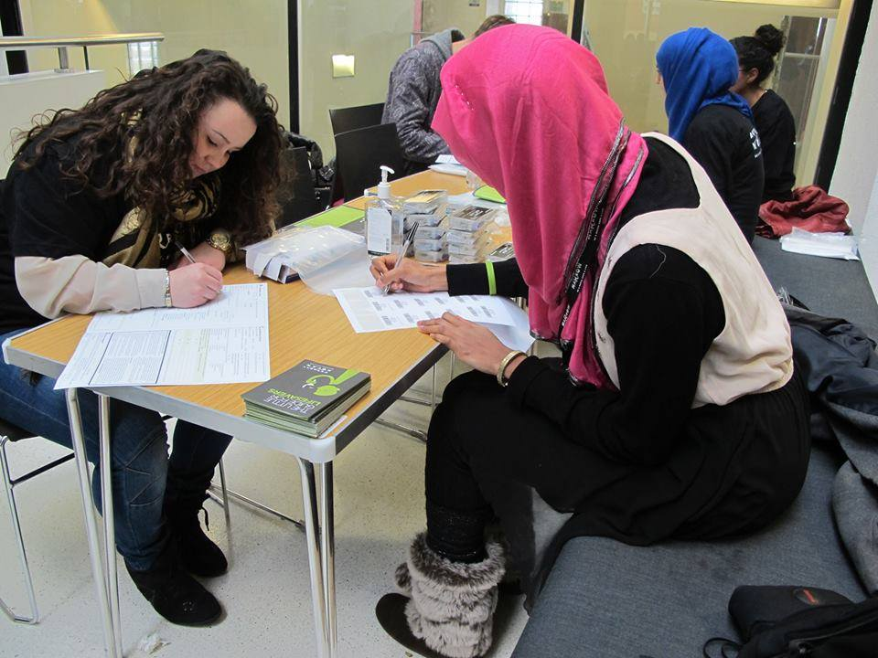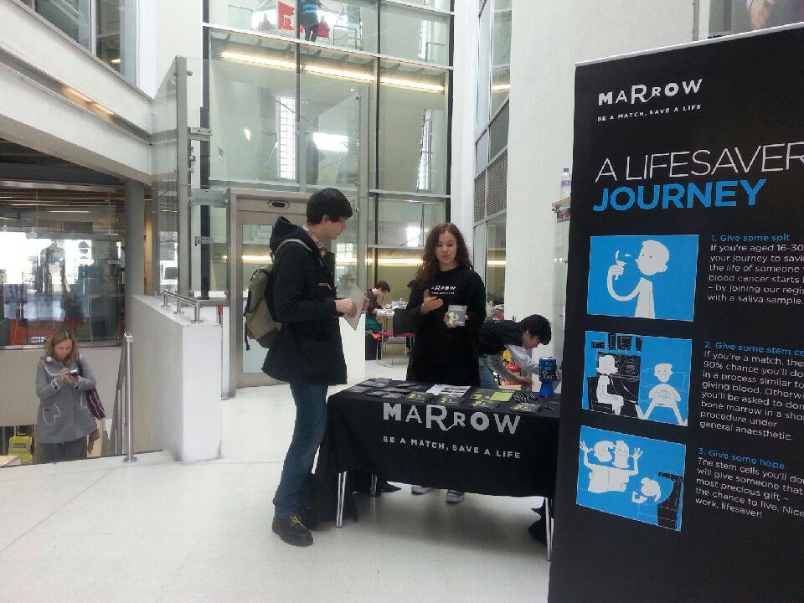

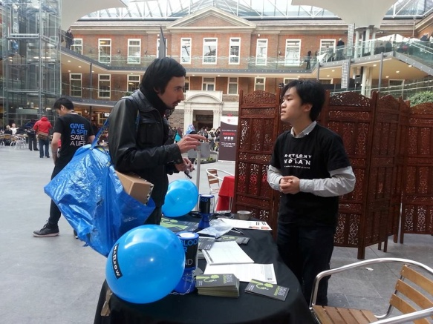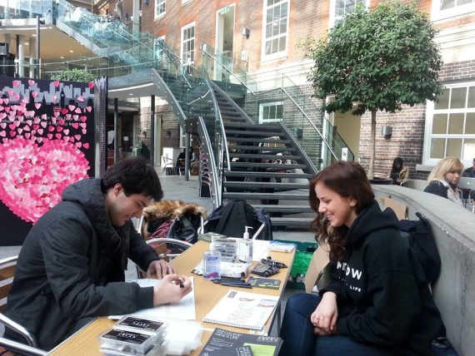

**The environment of the clinics**

* The clinics are made up of two areas, one for educating the students about the technology and recruiting them and the other to perform the spit test (see Appendix).
* The spit test is conducted in a calm and hygienic manner.
* The equipment used is delivered by AN and sent back to them by the end of the clinic, with a count of how many kits were used and how many are left.
* Everyone is always up beat and no one of the volunteers is afraid to ask his colleagues for help.

My observations seem to show that the environment that the clinic is conducted in is clean and calm and the volunteers are happy to help one another causing minimal problems to occur.

**The spit Test** (see Appendix)

* The potential donor is educated about the technology and the process one has to go through as a donor.
* The potential donor is given a sign up form and asked to read it and answer questions about his/her health, give their doctor and contact details. The first page of the form is a list of requirement one must for fill in order to be accepted as a donor, this is a list includes diseases, age weight...etc.
* The potential donor is instructed to sign at the end of the form.
* The form is looked through by a volunteer to make sure everything is filled in correctly and is signed by them too.
* The form, test tube, and bag which the tube will be placed in are all labelled with the potential donors name and birthday.
* The potential donor spits into the tube which contains and the tube is closed and sent along with the form to AN.

From my observation and with the knowledge that I have having worked as a biomedical scientist, I can see that the manner in which the potential donors are addressed and the tests are taken are done in a good manner.

**The process of making a clinic**

* A venue is booked by the clinic coordinator and a doodle is made for volunteers to sign up, then the clinic coordinator can keep track of who is coming when and assign different jobs.
* Posters and handouts and tweets and fb (Facebook) notifications are made 1 week prior t the clinic and up to the day of the clinic by the promotions coordinator.
* Education for volunteers is arranged and a doodle is made for that as well. They are normally held for around an hour before the clinic starts.
* Communication about any issues that may arise is made through fb messaging, they have a private chat for only committee members.

The process of making a clinic seems to run smoothly. The committee members take their roles seriously and thus not many problems occur. The fb chatting system seems to work pretty well, as all the committee members have smartphones and are always checking their phone. I have attended an education lesson for new volunteers in the beginning without telling them about who I am and what I am planning on doing my thesis on. This was done in order to see what the lessons really were like when they think they are not being watched and written about. In my opinion I found the lesson ran quite well, with easy to understand slides and explanations so that anyone without a scientific background could understand.

**Fundraising events**

* At the first week on University a Henna event was made before I was introduced to MMS
* MMS got a place at the EXCEL London building, which is a massive building that holds exhibitions, we received professional help from AN because the amount of people there was massive. Most of the volunteers and MMS committee members felt over whelmed and some felt that they would rather not participate in something so massive again. However the event was a huge success many were recruited and many were informed about the AN work. A local celebrity signed up and made a short video to help attract more people. An interview was made with an Imam in order to assure those that thought it was against their religion.
* Bubble football was a very successful event for both raising awareness and raising money. Everyone at the committee worked hard on getting people to support it. A lot of MDXA athletes were made aware of AN due to this event.

The fundraising events, although they require extra work from the committee members, they seem to help reach people that are not usually reached by clinics, so they are a success in raising awareness about AN technology.

**The Asian Males**

* More females than males approach the MMS clinics
* The males that approach the clinic seem to be of European ethnicity
* When approached by MMS volunteers other male ethnicities are just as likely to register as males of European ethnicity
* When the Asian males are approached by the MMS volunteers they are communicated to using the same procedure they use on all MDX students**.**

The Asian students at MDX seem to be a little reluctant to approaching the volunteers. However when approached they seem to be just as willing as anyone else to volunteer. They are approached using the same technique as the one used with all other students. so maybe the problem is not the actual communication but the lack of knowledge about the AN technology, because it seems that once it is explained to them they are will to sign up to become potential donors.

**Communication between MMS volunteers and students**

* This procedure starts with asking whether the person has heard of AN. The answer is usually no. A short introduction in everyday language is given and the person is then asked wither they would like to join the register today. The volunteers only have a few minutes to attract the students so they use a very brief introduction to the technology. Some start their communication by asking wither they have heard of AN while others try to attract the students by starting off with asking them or telling them “you can save someone’s life”. The students are than told that they can save a person with cancer by donating their stem cells which are found in blood “you get hooked up to a machine that is just like a dialysis machine “ in most cases and only rarely would the donor have to undergo an operation and donate bone marrow. They are than asked wither they are willing to save a life and sign up today.

* After hearing about the technology usually what I have observed is that around half say they would like to sign up and one forth say they would like to do further reading online then sign up online or come to our next clinic.
* Not everyone that is approached is willing to listen. This is usually because they say have some where to be i.e. classes . Some say they will come back later, some do come back and others don't.
* During the clinics that are held in the Quad ( a big hall way in the university) a lot of people that we approached say that they have already been approached. However when I was doing my interviews in days where there weren't clinics all the students I stopped there said they have never heard of AN or MMS.

From my observations it seems as if the communication strategy MMS takes works well. They explain the technology in a simple and calm manner so that no one feels pressured into signing up that is not really will to donate.

**Student Interviews**

**AN and MMS awareness**

No one that I have interviewed seems to have heard of AN, nor have they seen the MMS clinics, which have been ran on a monthly basis with volunteers walking around MDX and talking to students in order to raise awareness and gain potential volunteers. Nor have they seen the posters that have been hung around MDX and handed around one week before each clinic.

**Reasons students gave as to why Asian Males students might not want to donate**

Below are the most significant issues that were brought to my attention during interviews as to why male Asian students at MDX think the reasons behind Asian males being the least to donate. These quotes represent reasons that have been mention several times by different students.

*“It could be due to circumstances that they are not donating.”(non-science Asian male student)*

The circumstances that the students I interviewed seem to fall into for categories. They raise concerns about the health of Indians, they also mention a lot about lack of awareness and education about donation thus creating loads of myths that scare potential donors of donating. Family is another factor in influencing the decision to donate or not. The society and culture that they grew up with seems to also play a big factor in the decision process.

Health

From the Quotes mentioned above one can get the sense that the young male Asian students at MDX seem to view themselves and their peers of similar ethnicity as having poor health in comparison to other ethnicities and that is why they believe that they are not volunteering as much as other ethnicities to donate stem cells or bone marrow.

*“Indians are very sensitive people and might think they will be hurt by donation.” (non-science Asian male student)*

*“Their health could stop them from donating.” (non-science Asian male student)*

*“It could be because of health issues, because Asians don't usually have good health. Maybe they are weak and therefore the majority doesn't donate.” (non-science Asian male student)*

*Misconceptions /Education/ Myths*

There seems to be a lot of misconceptions and myths about the technology of donating stem cells. This was the factor that was most mentioned by the students I interviewed. There are misconceptions about them not having enough blood to donate. They do seem to state that these are myths and caused by there not being enough awareness of the technology due to what they believe could be low education.

*“a cause can be low education, there is not enough awareness.” (non-science Asian male student)*

*“They could believe that donating blood will give them anaemia.” (non-science Asian male student)*

*“Myths could be a reason why they don't donate.” (non-science Asian male student)*

*“They might be misguided not knowing the true facts behind donation.” (non-science Asian male student)*

*Family*

The students I have interviewed talked about students not volunteering due to their parents objecting to it. Reasons they believe as to why the parents may disapprove is their lack of education about the technology. The students also mentioned that Asians usually are very helpful towards donating to family members and have they had cancer in the family they would be more willing to donate.

*“Family members especially the parents might not approve of donating, this could be because of a lack of education.” (non-science Asian male student)*

*“They are helpful people so if they have a family member that has suffered from cancer, this would make them feel more empathy and want to donate.” (non-science Asian male student)*

*Society and Culture*

According to the students the Indian culture and society plays a role in their decion to donate. They mention that in Indian society it is not in their tradition to donate so because it is not something that is common in their culture they might be reluctant to donate. According to the students some might have religious concerns that drive them not to donate.

*“the social society that they grew up in, donation is not common.” (non-science Asian male student)*

*“It is not an Indian tradition to donate.” (non-science Asian male student)*

*“It's their mind-set, in India this doesn't happen, it is not in their culture, so they are not used to it.” (non-science Asian male student)*

"Religion might be the cause why some decide not to donate"*(non-science Asian male student)*

**Reasons students gave on how to improve the recruitment technique:**

The quotes below represents what the majority of the students believe are ways to improve the attraction of Asian students to donating their stem cells. They can be grouped to 4 categories, which are an improvement in Advertising , education, location convenience and due to their opinion on having poor health that is also mentioned a lot even though it is not a form of improvement.

*Advertising*

The students seem to think that more advertisement will help in the increase of Asian males donation, because they believe that by advertising one would educate the public with facts about how donation can help cancer and blood disease patients and therefore more people will be willing to donate to AN.

*"More advertising, more posters, society members going around in clinics and spreading the word is limited, they will not reach that many Indians." (non-science Asian male student)*

*"raise awareness by online advertising and education".(non-science Asian male student)*

*Education*

The students said that there should be more education about the technology than now, with informative posters hanging around MDX and not just relaying on the days were MMS holds clinics and their volunteers go around to informing students.

*"More education would help raise awareness, like for example making more posters and hanging them around university." (non-science Asian male student)*

*"Raise more awareness by adverts and education because word of mouth doesn't work, so just having society members informing students during clinics is not enough." (non-science Asian male student)*

*convenience*

MDX students mentioned that if it was convenient for them to give blood then they will be more will to donate. This means that clinics would have to be held more regularly and in many different areas of MDX. With good advertisement so that the students know exactly when and where.

*"mobility is important so they are not always in the same place so that it is more convenient for us." (non-science Asian male student)*

*"They can have hotspots one can go to, this will give a better chance." (non-science Asian male student)*

*Health*

Some students that think it is due to poor health that Asians don't donate. So in their opinion there is nothing really that can be done to increase the amount of Indian males donating.

*"They can't attract awareness if it is due to their health that they are not donating." (non-science Asian male student)*

**"Future Workshops"**

MDX students

The top solutions that were agreed open by the group are listed below.

present issue:

The present issue that was presented to the students was that a research made by AN showed that Male Asians were the lest type to donate.

creative solution:

* TV commercials and TV programs that broadcast to TVs in MDX with informative programs about AN and MMS.
* Give rewards for donating
* Mobile app where one can see times there are clinics

realistic solution:

* more adverts on MDX newspaper, MDX radio, MDX broadcasting channel online, MDX website.
* More stories of real families in need of help should be distributed.
* More success stories due to the help of AN should be distributed.

MMS committee members

The top solutions that were agreed upon by the group are listed below.

present issue:

The present issue that was presented to the committee members was that a research made by AN showed that Male Asians were the lest type to donate.

creative solution:

* a lot of money spent on promotion
* Go to mosques and inform people there with the help of Imams
* go to the communities and educate
* higher social funds as this will help more volunteers to want to join the society and thus there will be more people to recruit

realistic solution:

* promotion of education
* More stories of real families in need of help should be distributed
* increase in promotion of societies through various media

Both workshops seem to show that an increase in promotion is considered to be a good idea as well as the use of real life stories of patients. This will help reach the male students because they will feel more empathy towards the cause. More education seems to also be a factor that people from both workshops believe will help. These issues that are being mentioned in the future workshops seem to be in also regarded by the students I interviewed as relevant factors to improve upon.

# Discussion

The results obtained from the thesis research will be discussed in this chapter and possible solutions to the problem formulation will also be discussed. Thus perspectivation will also be included in the discussion. The methods used to collect this data will be examined.

**Method verification**

field work

In my field work I have tried to keep a non bias observation. As mentioned in the Data & Data Analysis chapter in the beginning I made observations without telling the MMS volunteers and committee members at the education lesson and later at the 4 hour clinic that I am making field work for my thesis. This was done in order to assure that the MMS volunteers and committee members teach and act during clinics like they always do, because if they know that they are being watched they might act differently(14). The only person that knew was the president of the society and unfortunately he had told some of the committee members but overall most did not know. I was of course not able to hide the fact that I am conducting field work for further observations from the MMS committee members, however most of the volunteers at the clinics did not know that I was making a field study, which hopefully means that they have been acting freely.

When I approached MMS about my thesis idea, I explained that I had a bachelor in biomedical science and was doing my masters in techno-Anthropology with electives from marketing program, the president seemed to be very interested in the fact that I has a scientific background like them, so was able to understand the technology , yet also had a learned from my masters how to communicate this technology to the general public. This is why I was offered the promotions coordinator position, it was good because this meant that I had an opportunity to witness how the committee functions and not only the clinics but the work that goes into making the society work. This means that if there is any problems in the making that might affect the actions taken during the clinics, I would be able to identify them. This could however also cause a certain bias from my behalf since I have been working for them and might sometimes not see things in the eyes of someone with a completely fresh perspective (14). However I have always taken direct and detailed notes of what I have observed in order to minimize any bias if it may occur.

**Student Interviews**

I have conducted interviews (see Appendix and Methodology chapter) with questions that are open ended and in no way bias or leading. Since all have not heard of AN. I also gave a short description of their technology. I have kept quiet after each question and allowed the students to answer freely without any influencing their answer. If they seemed confused or looking for me to lead them , I just rephrased the information about AN technology and the question but did not guide them in any way on how to answer. However just my presence could have somehow effected their answer, this was apparent to me because after most interviews the students would say that they actually do themselves donate blood or that that they have donated blood in the past. The fact that around 90% of whom I interviewed are blood donors seems unlikely, and it thus might seem like they have been trying to show themselves in a favorable light. Or one could question wither they were answering the questions truthfully or wither they were saying what they assumed the interviewer would like to hear(14). In order to improve this process in the future I could make a piece of paper with the questions and the students could answer them anonymously fold the piece of paper and hand it in to me. This method might better allow them to express their opinions more freely.

**"Future Workshops"**

Future Workshop is the term given to a specific type of workshop (see Methodology chapter). I found it quite difficult to make sure that a reasonable amount of people actually arrived to the future workshop. A lot more people seemed more interested in joining but they did not actually come on the day. I have however considered beforehand that this could happen, in class the lecturer Lars Runne has warned us that more people usually sign up then show up. So I have taken that into consideration when doing the students Future workshop and made sure that a lot more people than need signed up. For the MMS committee Future Workshop I did not have this luxury , but although not everyone at the committee showed up( around 60%), they made a good contribution and could most definitely helped in finding a solution to improving the amount of Asian students volunteering.

The future workshops were both conducted in accordance with Magnusson(2009), Cummings(2006) ,and Kensing (1991) (11,12,13) ran smoothly and there weren't any moments were the participants were at loss for words. The results that were obtained for realistic solutions into improving the recruiting process were realistic enough to be implemented in my personal opinion ( see data and data analysis chapter). The stage where they had to come with creative ideas was not all that successful , the ideas that they came up with were not outrageously creative and according to Kensing (1991) (13) this is the stage when participants are supposed to have no limits to their imaginative ideas, an example of this could be suggesting that AN advertises using sky writing or building a room at university that could work as a donation Hotspot and has volunteers working their 24/7 so it is made very convenient for students to donate their blood. According to Kensing (1991) (13) by thinking of outrageous creative ideas it will open the minds of the participants so that in the realistic stage they are able to open their minds and come up with innovative realistic solutions. So the fact that the participants did not come up with outrageous creative ideas could mean that the realistic ideas they produced in the later stage would have been more innovative have they dared to be more creative in the prior stage. In the future if the participants seem to be struggling with creative ideas, the facilitators could come up with an example or two to inspire the participants to become more creative.

**Altruism**

Titmuss (19) conducted research to find out why people donate blood and his results showed that altruism is the greatest reason to donate, with 26 % of the participants listing it as a good reason. He defined altruism as a desire to help, both in the general and particular sense.

One can consider the act of donating stem cells to save cancer patients as an act of altruism, according to Smith (1995) the consequences of acting altruistically are (19):

• "a vicarious pleasure in the welfare or happiness of others"

•" a sense of relief when another’s needs appear to be met"

•" good equated with caring for others"

• "the exclusion of self may result in disequilibrium in relationships

if only others are legitimized as the recipients of

care" (Gilligan 1982)

•" care of self may be considered selfish." (Smith 1995, p. 789)

kranser and ullmann (1973) argue that people are motivated to donate not out of altruism but out of egoism and donating is thus about satisfying ones ego but also happens to benefit someone else. They believe therefore that one chooses to donate because the act of donation does not only benefit oneself but is also makes them feel virtuous (19 ). Thus one can use this information to suggest that student donors choose to donate to feel virtuous. This can mean that of the present 2 methods of attracting students ( see Data & Data Analysis Chapter) where one starts with Have you heard of AN and the other with you could be a life saver and save a cancer patient, the later applies more to the student's sense of being virtuous and thus could be the better method in attracting students.

On the other hand Cialdini et.al (1997describes the act of donation not as a form of being altruistic or for feeling benevolence and not because of empathetic concern but as a result of feeling "oneness" with someone else. This feeling of oneness occurs from identifying with and associating with the patient they are donating for) (19). A good point is raised here, one could assume that if the adverts and personal appeals ( which are messages from cancer patients and their families urging people to donate) where of people of Indian decent this would make the students of Indian decent identify more with the patients and want to donate. This point is also clearly shown in my interviews with the students, many of them mention that males of Indian ethnicity would not mind donating to family members , so if the advertisements and appeals were of people of the same ethnicity this would give them a since of familiarity and might increase the amount of donors. Maybe this will help make a new Indian tradition were donating is a part of the culture and lead to even more donations. If this occurs then more awareness of the AN technology will be raised due to it being part of the culture and more people using the technology and informing family and friends about it, so in the long run raising awareness and education about the technology due to the factors mentioned above will increase donation volunteers. However liberal communitarians argue that acts of altruism are conducted due to the volunteers feeling a sense of "connection" with the patient and that altruism is not an act one does because they are part of a community (19). So according to their believes this means that if donation becomes part of the British-Indian community it does not necessarily improve donation acts. It is still however a step in the right direction because even if donation becoming a norm in the British -Indian society doesn't increase donation it might still increase awareness and education about the matter, which could increase donation.

Titmuss's Research (19) found Gratitude for good health to be the second reason why people donate blood, with 14 % choosing it as a valid reason. This could explain why many of the students I interviewed gave poor health as a reason as to why male Asians donate the lest. However my personal opinion is that they could also mean that if one is in poor heath they are physically incapable of donating. Awareness was listed in Tismuss' research (19) with 11% choosing it as a reason, this corresponds well with my findings both in the interviews and in the Future workshops, raising awareness was mentioned as a dominant reason to improve donation.

**Is It Ethical to Reward donors?**

In the future Workshop with the students, the idea of giving rewards to donors was heavily debated. Some believe that in order to increase the registration of male Asian students, one could give awards to entice them to become donors. From my field work I have observed that the MMS volunteers and committee members have chosen to give small tokens, like pens, key chains, bottle openers, tea, and badges to those who have registered to become potential donors. However it is in no way advertised or mentioned in the talk given to students to educate them about AN and encourage them to register. Plus the gifts given are of small cheap objects not anything good enough to sway the mind of anyone to register or not. They are more as a thank you gift than a enticing gift to register. However at the Future Workshop gifts that are more enticing were discussed like for example money. This raises ethical issues and that is why it was only mentioned as a creative solution and not a realistic solution. One ethical issue that may arise from giving money in my opinion is that donation could end up becoming a business transaction, where people who are in need of some money choose to donate. So this raises a new question about body parts being for sale. This could cause those who would like to donate out of altruism not to want to donate, because the whole idea of being selfless and wanting to donate out of the goodness of your heart will no longer be true. A counter-argument in favor of a move to paid is made by Keown (20), in his article he states that donors motivated by altruism and community solidarity could still donate under a paid system and not accept payment. He goes further to mention "This argument may be factually correct but overlooks the change in the character of the system which could well result from the introduction of remuneration." which could lead a significant proportion of voluntary donors not willing to take part in a system where blood is bought (20). On the other hand one can argue that if the donors were paid it might save AN money in the long run from having to always run adverts and personal appeals to attract the sympathy of people and entice them to register. the cost of employing marketing workers and workers to train society members and the cost of advertising to join societies representing AN will also decreases if not abolished all together.

"even were it more expensive to use unpaid donors (given the cost of recruiting and keeping volunteers),is the promotion of altruism and social solidarity not worth the expense?" (20)

"no money values can be attached to the presence or absence of a spirit of altruism in a society. Altruism in giving to a stranger does not begin and end with blood. It may touch every aspect of life and affect the whole fabric of values".(20)

**Gender, age and the community's influence on donation**

The Hollingsworth et. al study also researched wither the age and gender of the people living in a community would influence the decision to donate blood. They found out that the proportion of donors in an area is significantly increased by higher proportions of women aged 20–29 and 40–49, and of men aged 60–69. While the presence of a higher proportion of males aged 20–29 significantly reduces proportion of donors (21). This can go to prove the point that young Asian males are the lest willing to donate as the AN claims, however since this study was not targeted at Asians it could show that it is not specifically an Asian issue but that young males in general are not as willing to donate. During my field work I have noted that a lot more females than males approach the clinics and are willing to donate.

 Another study conducted by Armstrong (1996)(22) researched if age is an indicator of willingness to donate. A study into a driving license database of 1,969,382 persons which accounts for 86.7% of the population 17 years of age or older. The database is made up of 54% males and 46% females. The data were divided into three groups, males, females, and males & females. They were then subgrouped by age, were in total 54% answered yes to willing to donate and 46% answered no or had not answered. The study found that in the males &females group, the percentage of positive answers by age (17 -49 years old) remained relatively constant, between 56% and 62% but decreased with age to 39%. The data for males only and females between 17 to 49 years of age showed a similar decrease, with slightly more females than males willing to donate by around 5%. This difference decreased with age in this case too. Armstrong believes that it is a good sign that the young generation is open to donating and believes this will have a positive effect for the future as these generations get older and teach their children the same values. The fact that Armstong(22) found people of the ages 50 and up are not as willing to donate does not affect the mission of AN because they are only interested in donors between the ages of 16-30, because they are at their healthiest and will be able to stay the longest as part of the registry as potential donors, AN believes that this is the best use of their limited resources (1, 22). This study also mentions that females are more willing to donate then males, which is similar to my findings in my field work. The difference found by the article is however slight and due to the nature of my work being quantitative rather than qualitative I cannot accurately give a number on exactly how many women were interested than men. This has issue has also not been the main focus of this project therefore qualitative research into this issue would have been unnecessary given the time limitations I have on this project it was better fit to concentrate my resources elsewhere. It also seems to be debatable wither in fact women are more enthusiastic about donating as a study conducted by Bani et . al (2010) (23) found men where more likely to be donors than women. Men made up nearly 70% of the donors while women only made up around 30 %. This study was conducted in Italy and further studies into other countries were made to compare, the percentage of women who donate was similar in Greece, however the Beni et.al found that this has nothing to do with geographical means, as other Mediterranean countries such as Spain and Portugal had higher percentages 46% and 43% respectively. In countries such as the Denmark, Netherlands, and France studies show that men and women donate equally. Mean While in the United Kingdom and France women donate slightly more than men, they make up around 53% (23). These finding show that it seems quite random why in some countries one sex is more likely to donate than the other. It agrees with my finding and the findings of Armstrong (22) that in the UK women do donate more than men. However there seems to be no territorial reason for this as mentioned earlier with the Mediterranean example so one can argue that culture might not a factor either, since countries that are geographically close tend to have similar culture. One can also assume that the reason for donation is not a biological one since no specific sex seems to be more willing to donate than the other.

During my research the British -Indian community was referred to a lot on having influence on wither people volunteered or not . They would mention " it is not that common in the Indian community to donate so people don't" also they mention that young British born male students don't donate because elders in the community don't accept it, because of misinformation. Hollingsworth et. al (2004)(24)used 29 762 individuals from 1999 - 2000 to investigate socio-demographic characteristics and found that a higher proportion of people born overseas significantly reduces the proportion of blood donors in an area. This could be in this case the British-Indian elders. They suggest that in order to increase donation, blood collection agencies should target specific groups and target individuals who are born overseas to participate in the process(24).There findings correspond well with my findings in that both committee members, and the students believe that if more people with Indian ethnicity were used in the adverts and personal appeals this would lead to an increase in donation (23).

**Religion and knowledge**

In my research I came across factors such as lack of awareness, education and Knowledge about the technology as being reasonable reasons why Asian males might choose not to donate, they were also believed to be the factors that if resources were put into, then an improvement in the amount of Asian donors will occur. The committee members made comments regarding this issue stating that the problem is that they lack the knowledge behind technology and therefore may believe myths or choose not to donate. The students opinions seem to agree with the committee members they mentioned reasons for fewer Asian males donating as

*“a cause can be low education, there is not enough awareness.”*

S. Ramsey (2003)(25) also mentions in his article that misperceptions, lack of information, and inaccurate beliefs contribute to this discomfort which thus lead to people choosing not to donate. In my interviews and previously in this discussion I have mentioned and argued for that having advertisements of someone male Asians can identify with will encourage them to donate, S.Ramsey (2003)(25) also claims that personal knowledge of someone who has received a donation seems to alter views toward the process.

From my field research and literature research it seems that raising awareness and education about the AN technology would be beneficial in increasing the amount of male Asian MDX students wanting to donate. This could mean that AN will have to spend more resources in MMS, by giving them more leaflets, booklets, advertisement posters and personal appeals of Indian ethnicity. MMS could if possible create more educating lessons and presentations. At the moment the presentations made by MMS are mostly to science students, because it is thought that they are the ones interested in science and might want to join as a volunteer in the society. However it could be an advantage to also make presentations for non science students. They might also be interested in becoming volunteers, not because of the technology and from a scientific point of view, but they might want to join because of more humane reasons like feeling empathy or knowing someone with cancer and wanting no one else to experience what they went through. Having more volunteers will hopefully lead to more people being talked into becoming potential donors, not to mention Asian students. The presentations to non science students will also help raise awareness and knowledge of the technology which might also lead to them wanting to donate.

Another major topic that was apparent during my field research is Religion. Many stated that religion could be a factor in the decision process of wither or not to donate. Some students and committee members stated that some might believe its against their religion to donate. S.Ramsey et. al(25) made a study that looked into if religiousness effects donation. By looking  the results obtained by S.Ramsey et.al (25)one can conclude that individuals who rated themselves higher in religiousness were more likely to be less accepting of organ donation. The article mentions as I have already mentioned previously that the solution to increasing donation is  knowledge of the transplantation procedure and knowing someone who gave or received an organ was associated with a more positive attitude towards donation. These findings have a number of implications. The article further states that movies and media coverage of the transplantation process can have a significant impact on the general public. This is because most people do not have personal experience with organ donation so accurate coverage of this process can increase knowledge and demolish misinformation. Also exposure to people who have directly benefited from transplantation could improve attitudes toward the process. So in this case personal appeals will be a good idea to inform students plus leaflets . The articles mentions further that listening to and talking with someone who has experienced a transplant or donated an organ can demystify the process and assuage fears. "Transplantation organizations can capitalize on this information by utilizing various forums to transmit accurate information and call on organ donors and recipients to speak to the general public."(25). Although this is a good idea I do not believe it is realistic by financial means for AN to hire people that have already donated to give presentations. However maybe they can ask the donors after they have donated wither they would like to volunteer some of their time to give presentations at universities to attract donation and demolish any myths surrounding donation.

The findings in the article by S.Ramsey et.al (25) suggest that how religious an individual views themselves is associated with their attitudes toward organ donation, the association is present regardless of the individual’s religious orientation or frequency of attending services. It was found that people were more willing to donate if they anticipated the support of the religious community and a religious leader. This suggests that religious leaders are in a powerful position to convey support of donation while abolishing inaccurate religious assumptions."(25). Thus to encourage more Asian donors, AN should involve the religious leaders in order to abolish any misconceptions about religion's views on donation. This could be done in a form of leaflets where a statement from a religious leader is given and distributed to MDX students by the MMS. An video short interview with a religious leader could also be included in AN and MMS websites and social media.

The study by S.Ramsey et.al (25) does have its limitations though because they have mainly used Caucasian university students and I am looking into Asian university students."(25). However the issues I have discussed seem to be applicable in this case too, because the use of religious leaders to abolish any misconceptions regarding religion has been brought up and discussed during the future workshop with the committee members.

**Middlesex Marrow Committee as an organization**

From my extensive field work with MMS, I can acknowledge that as a committee they function very well and take their jobs very seriously. The education lessons for the new volunteers are very informative and they are friendly and open to answering and questions that may arise. The power point that is used is one that AN made for volunteer recruitment and seems to cover all the information needed for volunteers to know. The clinics are very well organized and no one is in doubt of their role during the clinic. There is however a problem with volunteers arriving late, a decrease in the amount of volunteers due to lateness could mean that less students are approached and thus less sign up to become potential donors.

The communication between MMS volunteers and the Asian male students seems to function well as it is, I am basing this on my field work observations. As mentioned earlier I have noted that Asian Male students were approached by MMS volunteers and communicated to in the same manner as everyone else and it was noted that when approached Asian males were just as likely as anyone else to sign up for the register. Thus my data shows that the actual communication made at the clinics between MMS volunteers and male Asian students is fine. The problem is in that Asian male students don't approach the clinics on their own to solve this as discussed earlier awareness of the technology needs to be raised. Some students also mentioned that convenience of donation is a factor that plays a part this could be solved by making more clinics. However one will need to look into recruiting more volunteers to work the extra clinics or have the current volunteers work extra hours. So further research needs to be made in order to determine if this is a possible solution.

**Health**

Another major reason that was given by students as to why they may not donate is that British-Indians have poor health, in this case the students were unable to give a solution on how to improve this because if they have poor health then they simply can't register. I have considered this carefully and though I do not know wither British-Indians in general have poorer health than other ethnicities as this will require a lot of research, I think a wise solution to this issue could be for MMS volunteers to approach students of Asian ethnicity and after educating them about the donation process if they still seem uncertain then to show them the list of health requirements needed to register, thus if it is only a presumption on their part that they are not fit enough they can check it against actual facts and this might change their minds. From my field research I observed that this list is first showed to students after they have agreed to donate, so showing them before if they seem reluctant might help increase donation.

## Conclusion

This thesis has shown that a technology organization like Anthony Nolan can improve their communication to MDX non-science male students with Asian descent. According to this study, the recruitment dialog held between MMS volunteers and the Asian male students is fine. The problem is how to attract them into approaching the clinic. According to the research done in this thesis, the students don't approach due to a lack of awareness, knowledge and misconceptions. The quantitative research made in this thesis suggests that in order to improve the rate of male Asian student potential donors, one must distribute more leaflets, hold more lessons & clinics, increase posters and personal appeals of people similar ethnicity.

# Reference List

1. www.anthoynolan.org
2. Genetic and developmental diseases and disorders : Sickle Cell Anemia, Judy Monroe Peterson, Rosen Publishing 2009. P.46
3. Need to Know sickle Cell Disorder, Oliver Gillie, p.4-5 2005 Heinemann library
4. Report of a working Party of the Standing Medical Advisory Committee on Sickle Cell, Thalassaemia and other Haemoglobinopathies. Department of health, 1993 p.12-13
5. Laboratory Tour 19.02.14
6. Balilliere’s Nurse’s dictionary, twenty-third edition,published by Bailliere Tindall and Royal Collage of nursing, 2000
7. Anthony Nolan Leaflet
8. Brandt, E. (2006). Designing exploratory design games: A framework for participation in Participatory Design?
9. Randall D., Harper R., Rouncefield, M. (2007) ‘Chapter 3: Some Perspectives’ in Fieldwork for Design, Springer, London
10. Friedman, B. and Kahn, P.H. (1997) Human Agency and Responsible Computing: Implications for Computer System Design. Human Values and the Design of Computer Technology, B. Friedman Eds., CSLI Publications Stanford, CA, 221-235.
11. Magnusson, P. R. (2009) Exploring the Contributions of Involving Ordinary Users in Ideation of Technology-Based Services
12. Cummings, M.L. (2006) Integrating ethics in design through the value-sensitive design approach. Science and Engineering Ethics, Volume 12, Issue 4, p: 701-715
13. Kensing, F., Madsen K. (1991) Generating Visions. Future Workshops and Metaphorical Design in Design at Work
14. Naresh K.Malhotra and David F.Birks , Marketing Research An Applied Approach 2 ed.
15. DeWalt, K. M., DeWalt, B. R. 2011 Participant Observation. p: 165-168. Walnut Creek, CA: AltaMira Press.
16. Kvale, Steinar(1996) Interviews: An Introduction to Qualitative Research Interviewing. SAGE Publications Inc. California, USA
17. Robson, Colin(2002) Reat World Research 2nd edt. Blackwell
18. Fetterman, David M.(2010) Etnography: Step-by-Step. 3rd edt. SAGE Publications, Inc. California, USA.
19. F.L.Rapport and C.J Maggs (2002) Titmuss and the gift relationship: alturism revisited 40(5):495-503
20. John Keown (1997),The gift of blood in Europe: an ethical defence of EC directive 89/381, Journal of Medical Ethics 1997; 23: 96-100).
21. Bruce Hollingsworth et. al , What population factors influence the decision to donate blood? Transfusion Medicine Volume 14, Issue 1, pages 9–12, February 2004.
22. Armstrong GT. Age: an indicator of willingness to donate? Journal of Transplant Coordination. 1996 Dec;6(4):171-3
23. Marco Bani and Barbara Giussani, Gender differences in giving blood: a review of the literature, Blood Transfus 2010;8:278-287
24. Bruce Hollingsworth et. al , What population factors influence the decision to donate blood?  Transfusion Medicine Volume 14, Issue 1, pages 9–12, February 2004 .
25. S. Rumsey, D.P. Hurford, and A.K. Cole Influence of Knowledge and Religiousness on Attitudes TowardOrgan Donation, Transplantation Proceedings, 35, 2845–2850 (2003).

## Appendix

Interview Questions

* 1. Have you heard of the organisation AN? (if no a short description is given)
  2. A description of the male British-Asian donors situation is given and followed by ; Why do you think male British-Asians are the least registered potential donors?
  3. How do you think this can be improved?

Future Workshop Questions

* + 1. The problem formulation of this thesis is introduced to the participants together with an introduction to AN and the technology they use.
    2. The participants are asked to think of highly creative solutions to solve the problem ( for example if money was not an issue)
    3. The participants are asked to rethink their creative answers to give possible solutions to improve communication and attract more male Asian donors.