Promotion of China´s Peaceful Development

– An analysis ON how the People´s Republic of China communicates its soft power resources in Germany

Aalborg University & University of International Relations in Beijing
Supervisors: Peer Moeller Christensen & Guoshuai Zhang
Master Thesis
Msc in China and International Relations
Kitti Szekeres
The aim of this thesis is to investigate how the Chinese soft power resources are communicated in Germany.

Importance of this thesis: The rise of China has significant implications on the global affairs, therefore, China´s soft power, which can be defined as its ability to persuade others in order to achieve certain outcomes (Nye, 2004) play a crucial role in shaping the international relations.

Table of Contents
Table of Figures 4
Abstract 5
Introduction 8
Problem statement 9
Core concepts 9
Power 10
Types of power 10
Foreign Policy Techniques 11
Peaceful Development 11
Research Design, Scientific Paradigm & Methodology 11
Data collection & Analytical logic 12
Thesis Structure and Choice of Theories 13
Delimitations 14
Importance and Motivation 16
Theoretical Background 18
Complex Interdependence 18
Soft Power Discourse 20
Nye´s definition of soft power 20
Chinese Discourse on Soft Power 21
Peaceful Development Theory 24
An integrative model of soft power 26
Harold Lasswell´s Model of Communication 29
Case study 30
Sino-German relations 30
Analysis of China´s Soft Power in Germany 35
Discussion & Future Research Prospects 48
Conclusion 52
Bibliography 55

Table of Figures
Figure 1 – Visualization of the Thesis Structure 14
Figure 2 – An integrative model of soft power. Source: (Li & Worm, 2010). 26
Figure 3 – Harold Lasswell´s Communication Model. Source: (Lasswell, 1948). 29
Figure 4 – EU Member States´ attitudes towards China. Source: (Fox & Godement, 2009) 33
Figure 5 – Number of registered NGOs in China. Source: (Economist, Enter the Chinese NGO, 2014) 36
Figure 6 – Communication model of Chinese soft power in Germany after Lasswell (1948) & Li & Worm (2010). 39
Figure 7 – German Favourable Opinion of China. Source: (Database, Opinion of China, 2013). 40
Figure 8 – German Unfavourable Opinion of China. Source: (Database, Opinion of China, 2013). 40
Figure 9- Views of China. Source: (Research, 2011). 41
Figure 10 – How China´s Growing Power Affects Your Country. Source: (Research, 2011). 42
Figure 11 – Component parts of soft power. Source: (McGlory, 2010). 45
Figure 12 – Soft Power Index Results in 2010. Source: (McGlory, 2010) 46
Figure 13 – Soft Power Index Results in 2011. Source: (McGlory, 2011) 46
Figure 14 – Soft Power Index Results in 2012. Source: (McGlory, 2013). 46

Abstract
The aim of this thesis is to investigate how China communicates its soft power capabilities in Germany in order to build a positive image of its peaceful development. The significance of this paper lies in the fact that the Germans have a strongly negative view on China (Pew Global Attitudes Research, 2013), despite that the bilateral relations have recently been upgraded to a ´comprehensive partnership´ and these two countries are greatly interdependent by being the world´s biggest traders (The Economist, 2014).

The concept of power has always been one of the key aspects within the field of international relations. According to Willson (2008), it can be translated into influential potential, defined as the ability to control or influence the behavior of others (Nye, 2004).
The power can be categorized on the basis of its distinctive forms, such as hard power, soft power, or the most recent debate discusses the emergence of smart power. Hard power can be defined as the country´s military power, and it is based on force and inducement of payments, metaphorically on ´sticks and carrots´. Whereas the soft power is a rather newer concept, since it was coined in 1990 by Joseph Nye. Soft power can be defined as “the ability of a state to influence the actions of another through persuasion or attraction, rather than coercion” and this skill is based on “culture, values and foreign policies” (Nye, 2004; Nye, 2011).

For a rising power, like China, making use of the opportunities of a successfully implemented soft power strategy should be a crucial part of its foreign policy; however, Mingjiang (2008) argues that this notion is inadequately understood within the Chinese discourse on soft power. Furthermore, the Chinese discourse is fragmented, but still based on Nye´s (2004) conceptualization; the comparison of these perceptions might enrich our understanding of power and how China intends to influence it´s national image and attractiveness abroad. Soft power is currently a widely debated concept in China; which shows that China still needs to develop a comprehensive soft power strategy in order to enhance its influence in the international arena (Mingjiang, 2008).

The Sino-German relations have recently been upgraded to a “comprehensive partnership” (Kundnani & Parello-Plesner, 2012); even though, further interconnectedness and cooperation is expected in these bilateral relations, only 28% of the German citizens had favorable view of China in 2013 (Pew Research Global Attitudes Project, 2013). Consequently, the Chinese soft power in Germany is weak, which is in line with the debate of the Chinese academia (Glaser & Murphy, 2009).

The case study was mainly based on the framework of Li & Worm (2010), who concluded that the most important elements of the Chinese soft power are comprised of its culture and economic temptation and to a limited extent, its development model and international imagine, further, that these can be communicated through formal, economic or public diplomacy to political elites, interests groups or general public.

The results of the case study analysis show that the soft power resources are communicated sufficiently and frequently through interstate dialogue mechanisms and the decisions are mostly in favour of China, which shows that the soft power strategy works at this level. However, the other two levels are rather problematic, since despite the increasing number of Confucius Institutes, cultural exchanges and arrangements, the German citizens still have a negative view on China. This could be due to China´s negative framing in the media; therefore, it has been concluded that there is an urgent need for the Chinese government to have a more conscious cooperation and communication with the German media in order to shape the discourse in a more positive way.

Another important finding is that China has yet to develop a comprehensive soft power strategy, which would ideally be based on an effective communication strategy of its soft power resources; and which is suitable for the needs and characteristics of the target audience. Furthermore, the Chinese discourse on soft power adds a domestic perspective, signifying that “the harmonious world concept has great significance on China´s domestic building of a harmonious society, and constructing a harmonious society is part of strengthening China´s soft power” (Fu, 2010). Consequently, the formulation and implementation of a comprehensive soft power strategy would not only be crucial for China´s image abroad, but it would also foster national stability and unity (Edney, 2012). Even though China still needs a long time in order to be positively perceived globally; however, it is moving towards a more sophisticated management of its own soft power with regards to its peaceful development.

Introduction
One of the most important concepts of the field of international relations is power. This core concept of political science can be translated into influential potential (Willson, 2008). As the most comprehensive and cited definition suggests, power is the ability to control or influence the behavior and decisions of others (Nye, 2004). Furthermore, this is also one of the most debated ideas within this field, since its changing nature is becoming more and more difficult to quantify.

The forms of power can be labeled as ´hard´ power and ´soft´ power. Hard power can be seen as a traditional foreign policy tool, like a military threat, whereas soft power has been emerging and evolving to be more influential in the 21st century. The term soft power was coined by Nye in 1990 and it can be defined as “the ability of a state to influence the actions of another through persuasion or attraction, rather than coercion”; and this influence is based on “culture, values and foreign policies” (Nye J. J., 2004). Later on this definition has been extended to “the ability to affect others through the co-optive means of framing the agenda, persuading, and eliciting positive attraction in order to obtain preferred outcomes” (Nye J. J., 2011). Nye previously stated that power can have three faces, namely threat by force (usually labeled as stick), inducement of payments (metaphorically named as carrots) or shaping the preferences of others (Nye J. J., 1990). Whereas hard power is centered on the first two faces, soft power is rooted in the third face, while being based on the attractiveness of a certain country´s culture, institutions, politics, etc., which results in shaping the preferences of other nations by attraction.

For a rising power like China, using the opportunities created by a sufficient soft power strategy is certainly one of the most important aspects of its foreign policy, which appears to be insufficiently understood both in the People´s Republic of China and throughout the world (Mingjiang, 2008). There are a number of other reasons as well, which support the importance of the investigation of the Chinese soft power. First of all, due to the rather different – but still nascent - discourse from the Western one, it might enrich our understanding of power and other factors that influence a nation´s image and attractiveness (Blanchard & Lu, 2012). Furthermore, the debate on soft power is currently a hot topic in China. Nevertheless, China still has not managed to develop a coherent and comprehensive soft power strategy, which would be the key to reduce the risk of confrontation in the international arena (Mingjiang, 2008). Additionally, it has been suggested that the soft power has a context specific nature (Moss, 2013); therefore, a case study is a suitable method for analyzing the Chinese soft power in a real situation.

Today, China and the European Union are the two biggest traders in the world. EU is China´s biggest trading partner, whereas China is EU´s second largest trading partner after the United States (Commission, 2014). As Kundnani & Parello-Plesner (2012) argues, the future of this strategic partnership will be largely determined by the Sino-German bilateral relations. Despite the “economic symbiosis” (Kundnani & Parello-Plesner, 2012) between China and Germany, the number of Germans, who have a favorable view on China, declined from 46% in 2005 to 28% in 2013 (Project, 2013). Additionally, only 28% of the Germans saw China as a partner rather than an enemy (Project, Global Indicators Database, 2013). This is one of the underlying arguments of the Chinese academia for claiming that the Chinese soft power is rather weak (Glaser & Murphy, 2009). Consequently, the following problem statement evidently arises:

Problem statement
How does China communicate its soft power resources in order to build a positive image of its Peaceful Development in Germany?

In order to answer the Problem Statement, the following Research Questions need to be taken into account:

- Which aspects are included in China´s power resources?
- What is ´China´s Peaceful Development´?
- How does China utilize these factors in its soft power in Germany?
- How can China improve its future soft power strategy in Germany?

Core concepts
Due to the problem statement and the research approach, there are certain core concepts which need to be defined. These will serve as the foundation of the project and later on the knowledge of these concepts will be taken for granted.

Power
According to Nye (2004), power can be defined as a capacity or ability to get certain outcomes by influencing the behaviour of others. Additionally, this power is context-specific, indicating that the power might fade away if the circumstances change. Nye (2004) admits that the average public and even politicians might find this definition too complicated and difficult to apply, therefore, they turn to another definition, which states that the power is based on acquiring and possessing those resources and capabilities which are necessary to affect the outcomes (Nye J. J., 2004).

Types of power
As mentioned in the Introduction, there are different types of power, such as soft and hard power and smart power. Hard power can be defined as the use of military forces or economic coercion or technological threat in order to reach specific behavioural outcomes (Nye J. J., 2004). Hard power is interplay of using inducements or rewards (“carrots”) or punishment (“sticks”). “The hard power is evident in the practices of threat, coercion, sanction, payment and inducement” (Nye J. J., 2004). Today, hard power is still a crucial mean of states guarding their independence and non-state groups, like terrorist organizations, in order to reach their intended results (Nye J. J., 2004).

With regards to soft power, there are varying definitions among Western and Asian academia, which the Theoretical background will conceptualize. Nonetheless, since Nye was first to coin the term and it is the widely accepted definition, the soft power in the framework of this thesis will be understood as “the ability to get what you want through attraction rather than coercion or payments” (Nye J. J., 2004). The resources of soft power are characterized as culture, political values and foreign policies (Nye J. J., 2004).
Smart power can be defined as “an approach that underscores the necessity of a strong military, but also invests heavily in alliances, partnerships, and institutions of all levels to expand […] influence and establish legitimacy of […] action” (Armitage & Nye, 2007).
However, since the scope of this thesis is limited to soft power strategy, the concepts of smart power and hard power will not be taken into account in the analysis.

Foreign Policy Techniques
Foreign policy techniques are policy options used by decision makers in order to reach a given set of objectives (Baldwin, 1985).

Peaceful Development
China´s peaceful development can be defined as “not only a path of striving for rise, but also a path of adhering to peace and never seeking hegemony” (Thornton, 2005).

Research Design, Scientific Paradigm & Methodology

The overall research design of this paper is the qualitative case study design within the paradigm of social constructivism.
The social constructivist paradigm can be defined as: “a basic set of beliefs that guides action” (Guba, 1990). Therefore, the paradigm is in line with “reconstructing the ´world´ at the only point at which it exists: in the minds of constructors” (Guba, 1990). Within this paradigm, there are multiple realities (Guba, 1990), which have a crucial implication for the case study, namely, ´the truth´ does not exist, but rather there are more and less suitable alternative solutions. This can also be illustrated by this quotation: “Realities are multiple, and they exist in people´s minds” (Guba, 1990).
Consequently, broader answers and recommendations can be formulated as an answer to the research question, which is important in the field of international politics. This also entails that the conclusion and findings of this research cannot be regarded as ´definitive truth´, but rather ´real´ reality, or as Bryman (2008) argues: “the researcher always presents a specific version of social reality, rather than one that can be regarded as definitive”. Nonetheless, it has to be noted that this does not make the results of this case study less relevant or valid.

Scientific paradigms are comprised of ontological, epistemological and methodological levels (Bryman, 2008). Ontology examines the nature of the world. Epistemology results from the ontological position and refers to the researchers´ assumptions on how to reach the truth and how to understand the nature of the world (What is your paradigm?, 2014). The epistemology leads to the methodology, which in the case of social constructivism is discourse analysis (Herrera & Braumoeller, 2004).

Discourse is “the content and construction of meaning and the organization of knowledge in particular realm” (Crawford, 2004), whereas discourse analysis is used for analyzing and interpreting social phenomena which is qualitative and constructionist in nature (Hardy, Harley, & Philips, 2004). In depth, it aims to explore the socially produced ideas by uncovering how the reality is generated (Hardy, Harley, & Philips, 2004). Due to the fact that the purpose of this study is to investigate the social phenomenon behind the negative views on China, the discourse analysis provides a suitable framework.

To conclude the section on the scientific paradigm, the readers have to bear in mind that “the knowledge is a human construction, never certifiable as the ultimate truth but problematic and ever changing” (Guba, 1990). Therefore, social reality results from our thoughts, conversations, explanation and understanding, indicating that the reality is socially constructed (Wenneberg, 2002). Furthermore, discourse analysis is about power and politics, not language (Laffey & Weldes, 2004), consequently, it will be a suitable methodology for the case study.

Data collection & Analytical logic

The paper is centered on contemporary phenomena; therefore, the data used will be journals and academic articles and recent news. Additionally, the German perception on China will be illustrated through statistics derived from the Pew Global Perception and BBC Global Poll surveys.
With regards to the analysis of the secondary data, this thesis will employ an inductive method. Inductive reasoning moves from a specific hypothesis to a more general one, whereas deductive logic is the opposite of this, meaning that general hypotheses will be tested for a more specific one. The main weakness of inductive logic is that the conclusion might still be false even though the premises are true, due to the lack of data (Bryman, 2008). Nevertheless, this study is centered on Germany, it will generate important findings regarding the image of China in the rest of the European countries, but it will be emphasized that these results will need further validation.

Thesis Structure and Choice of Theories

The thesis will be comprised of 5 chapters. The Introduction familiarizes the readers with the premises and fundaments of this thesis, since it clarifies the problem statement, research questions, core concepts, research paradigm, methodology, delimitation and the importance of the thesis. This is followed by the Theoretical background, which summarizes the theoretical foundation for the case study. The Sino-German relations will be viewed from a Complex Interdependence point of view (Nye J. J., 1976), followed by an introduction to the concept of Soft Power by Nye (2004) and soft power in the Chinese context by Mingjiang (2008). The analytical model, which was chosen to discuss the soft power resources of China, is the Integrative Model of Soft Power by Li & Worm (2010). The Peaceful Development of China is one of the pillars of its soft power resources; therefore, the Theoretical Background will end by introducing the history of the concept and defining it in the current framework by Glaser & Medeiros (2007).
Chapter 3 will be devoted to the Case Study. First of all, the Sino-German relations will be described, afterward an analysis on China´s soft power in Germany will be conducted; complemented with an investigation of China´s media representation.
Chapter 4 will give place to a Discussion on the Future of the Chinese Soft Power. The thesis will end with a Conclusion, where the most important results will be summarized.

Figure 1 – Visualization of the Thesis Structure

Delimitations
Due to the limited number of pages, this thesis will not make a cross-country comparison, therefore, the general validity of the results generated here need to be further tested.
As the discourse analysis signifies, “the analyst must make choices about the kind of discourse they will focus on and the boundaries of the discourse – both temporal and genre – that they will examine” (Crawford, 2004). Consequently, the discourse here will be the development of China´s image in Germany. Since the global attitudes surveys started in 2004, and the concept of peaceful development was first mentioned in 2003, the time frame of the analysis will be between 2004 and nowadays. Furthermore, since the question refers to a development, the comparison will largely be based on the data from the start of the global attitude surveys in 2004 until 2013, the year with the most recent data is available.

Furthermore, even though Keohane & Nye (2011) stated that the theory of complex interdependence was meant to be “a thought experiment about what politics might look like if the basic assumptions of realism were reversed”, due to the concept´s further development over time described in the Theoretical Background section, complex interdependence will be regarded as a theory in the framework of this thesis; and the discussion on whether it should be seen as a concept, theory or paradigm will be excluded.
During the discussion of China´s image, claims, misperceptions and accusations in various issues, such as violation of human rights, corruption, etc., will be regarded as opinions and due to the limited space the validity of these views will not be elaborated on.

The Peaceful Development of China is a heavily debated concept and the researchers have not yet agreed on whether China will become a global power or whether it will reach this through peaceful means. However, in the CPC´s official communication this notion is highlighted and is recognized as one of the main pillars of the Chinese foreign policy, therefore, this thesis will also take China´s peaceful development for granted.

Since the EU has not developed a comprehensive strategy towards China yet (Fox & Godement, 2009), the following thesis will not aim to discuss how the EU-China relations influence the Sino-German bilateral relations.

According to Economist (2014), there are approximately 1.5 million unregistered NGOs in China, however, due to their questionable legality and the lack of sufficient data on their cooperation with foreign NGOs, this thesis will only account for the registered NGOs in China.

According to Wanta, Golan, & Lee (2004), the more coverage a nation receives, the more publics in the receiving country are likely to think that that particular nation is strategically important. Furthermore, the more negative this coverage is the more negatively the country will be perceived, whereas positive reporting does not effectively affect country´s opinion on another country. These results will need to be bear in mind when China´s media coverage in Germany will be examined.

Importance and Motivation
An increasing number of scholars argue that in a globalized world, where force is more costly and technology more prominent, the non-coercive soft power increases its importance (see e.g. (Bially Mattern, 2005) or (Ding, 2008)).
As described in the Introduction, China has the world´s second largest economy and the European Union and China are the two biggest traders in the world. Furthermore, Hertz (1981) argues that: “It is perhaps no exaggeration to say that today half of ‘power politics’ consists of image-making”. Furthermore, a good national image is subject to a successful soft power policy.
Given the strategic partnership between Germany and China, it is rather problematic that the German public has a negative view on China, which is getting worse over time. Consequently, this thesis will generate crucial results on the development of a comprehensive Chinese soft power strategy and thereby enhancing the national image.

In the words of Ramo (2007), due to the crucial role of China in preserving the peaceful international order, the mis-perception or mis-branding of China might lead to dangerous consequences. Moreover, a positive national image decreases the costs of economic transformations; therefore, building a positive national image is significant (Ramo, 2007).

In line with Blanchard & Lu (2012), the conceptualization of the Chinese soft power cannot be separated from the target audience and the context. Therefore, the chosen research design is based on a case study. The example of Germany has been chosen, since even though the image is more negative than in other member countries of the European Union, China invests a great amount of money into communicating its soft power resources, bilateral relations, the booming number of Confucius Institutes and academic exchanges. Blanchard & Lu (2012) claim that China´s domestic situation greatly affects the soft power resources, which in case of China are seriously damaged due to the internet censorship, questionable civil and human rights and the level of corruption. It has also been noted that the negative impact is dependent on the audience (Blanchard & Lu, 2012). Consequently, the case of Germany provides a challenging example from both analytical and practical perspectives. Additionally, even though there are statistics on the national image, academia has not yet discussed the reasons behind this phenomenon.
To conclude, this thesis intends to contribute to both the literature and discussion on soft power and it will also compare and contrast the soft power resources to the actions taken and thereby formulate possible policy recommendations.

Theoretical Background
The purpose of the following section is to illustrate and discuss the theoretical background necessary for conducting a profound case study. First of all, the theory of complex interdependence will be depicted, followed by a description of soft power and its resources. Afterward, the section will be continued with a portrayal on the evolution of the theory regarding China´s peaceful development. At the end, Harold Lasswell´s communication theory (1948) will be introduced.

Complex Interdependence
When examining China´s negative image in Germany, it is evident to start with an introduction to the bilateral relations and strategic partnership between the two countries. The reasons behind the choice of this theory are twofold: firstly, it implies that the relations can be analyzed from both horizontal and vertical axes; and secondly, it clearly illustrates the changing notion of international relations in today´s globalized world, which is characterized by increased interconnectedness and collaboration.

First Robert O. Keohane and Joseph S. Nye coined the term of complex interdependence, when they published their book called Power and Interdependence: World Politics in Transition in 1977. Complex interdependence can be defined as “a world in which security and force matter less and countries are connected by multiple social and political relationships” (Keohane & Nye, 2011).

Discussion on the concept of mutual dependence or interdependence can first be found among the works of Rousseau and Montesquieu (Baldwin, 1980). As Baldwin (1980) further argues, the modern study of interdependence was closely linked to the study of integration and the first modern contributors to this discussion were Karl Deutsch, Normal Angell and Ramsay Muir. Afterward, the concept of ´economic interdependence´ by Cooper was coined. This was later on developed to become a functionalist theory of interdependence by David Mitrany, claiming that the technical and economic collaboration after the World War II would lead to greater cooperation and thereby peace. These concepts were extended by Keohane & Nye (2011) by “broaden[ing] the neofunctional strand of liberalism that has been developed by Ernst Haas and others in the 1950s and 1960s” (Keohane & Nye, 2011).

The development of the concept of complex interdependence started with the declaration of “asymmetries in dependence […] are most likely to provide sources of influence” (Keohane & Nye, 2011).
Complex interdependence is deeply rooted in liberal ideas and aims to “define an ideal type of world politics” (Keohane & Nye, 2011). According to this theory, societies are connected by interstate, transgovernmental and transnational channels. These multiple channels bear increasing relevance to foreign policy decision making, thereby becoming sensitive to external factors. Additionally, it was also claimed – in contrast with the realist approach – that certain nonstate actors, such as multinational corporations and multilateral organizations would gain more influential power (Keohane & Nye, 2011).

With regard to these interstate relations, complex interdependence implies that the agenda of these connections does not have significant hierarchy, entailing that traditional ´low´ or ´high´ politics do not dominate the agenda. This entails that a clear distinction between domestic and foreign policy becomes more and more difficult, blurred and impossible. It is important to note that the military is still considered as core part of the national power, however, according to the complex interdependence theory; it does not have hierarchical significance within the interstate relations (Brenner, 2001).

While the theory of complex interdependence was declared as a “groundbreaking work on the politics of international interdependence” (Stanley & Michalak, 1979), it has been widely criticized. Keohane & Nye (2011) drew upon these criticism and developed the term “realism-complex interdependence continuum”, which links the liberalist and realist approaches of international relations together, thereby taking a middle ground, since “the earth is today poised between a world of nationalism and world of transnationalism” (Rosecranz & Stein, 1973). Nye does not ignore the realist views on tangible sources of power, but he argues that “the stage of world politics is becoming more crowded with additional actors, the distinction between domestic and international is not so neat, and the politics of transnational relations and complex interdependence need an understanding of liberal and constructivist approaches as well as classical realism” (Nye J. , 2008).
Almost 20 years after the first publication of the complex interdependence theory, it still remains relevant and despite the criticisms it can be used in order to capture the essence of interstate relations in today´s world.

Soft Power Discourse
The soft power discourse in the Western world and in China will be described in the next section of this thesis by illustrating the conceptualization of the term through the American school and the Chinese discourse.

Nye´s definition of soft power
The concept of soft power was first coined by Nye, who argued that “soft power rests on the ability to shape the preferences of others […] with intangible assets such as an attractive personality, culture, political values and institutions, and policies that are seen as legitimate or having moral authority (Nye J. J., 2004). According to Nye (2004), the means to reach the desired outcomes can be twofold: either force or attraction. Soft power is the capability to achieve the desired outcome via persuasion rather than inducement or coercion, indicating that soft power is about “shaping preference of others” (Nye J. J., 2004).

Soft power is often compared with hard power. Nye (2004) argues that soft power resources are related to the co-optive ends of behavior, whereas hard power is rather correlated with command behavior. Furthermore, hard and soft power can be co-aligned, but they often interfere with each other (Nye J. J., 2004).

As Nye (2004) puts it, the core of a soft power strategy is ideological influence implemented through institutions or foreign policy instruments. The sources of soft power are culture, political values and foreign policy; however, one of the shortcomings of this conceptualization is that the reach and attractiveness of the culture are limited to specific contexts (Nye J. J., 2004).

McCormick (2007) maintains that the most powerful actors in the current international era are the ones who attract others and create opportunities, not those who threaten others. Consequently, the meaning of power has been altered and it can be argued that the soft power has become more influential and crucial than ever.

Chinese Discourse on Soft Power
The Chinese soft power debate started in 2000; and the research and discussions have mostly been centered on “soft power with Chinese characteristics” (Zheng E. D., 2009). Since the Chinese academia has not reached a consensus on what constitutes the Chinese soft power, what the weaknesses and strengths are, the following paragraphs will explain the most recent stage of the Chinese soft power discourse by describing the most dominant discussions and research findings. Currently, the Chinese discourse has further developed the conceptualization by Nye (2004) and mainly debates the elements of the Chinese soft power, which can be put into three categories, namely a) culture, b) development model, and c) political values (Mingjiang, 2008). However, it has been mentioned in the Delimitation section, that the discussion on the development model will be excluded. The reasons for this include a) Germany being a developed country, and b) the thesis is limited to the Sino-German bilateral relations and thereby excludes the multilateral and international levels of analysis. Consequently, the following paragraphs will explain the points of views of those scholars, who advocate that the core of Chinese soft power should either rely on culture or political values.

Culture as a core element of Chinese soft power
The main argument of this conceptualization is that: “if a country has an admirable culture and ideological system, other countries will tend to follow it” (Huning, 1993). Consequently, the core soft power resources according to the Chinese cultural school are ideology and culture. Furthermore, this definition also argues that the political power is the core of the soft power strategy. The most important scholars of this school are Yu Xintian (俞新天) and Zheng Yongnian (郑永年). They claim that soft power is based on ideas, thoughts, principles, institutions and policies, which all function in the framework of a nation´s culture. Furthermore, Xintian (2007) states that “the more fashionable the ideology, the more people will accept it and the greater possibility to build country´s soft power”. Looking at the Chinese soft power resources, Xintian (2007) also argues that ideology, institutions, and policies are the backbones of the strategy. Additionally, if the ideology is welcomed, the Chinese culture and development model will be valued as well.
With regards to the ideology, the most appealing aspects – and therefore the most crucial to be communicated and emphasized – are harmonious society and priority of human beings (Xintian, 2007).

The current Chinese soft power strategy is greatly influenced by this conceptualization. In 2002, during the 16th CPC Congress, the China´s Cultural System Reform was launched. The reform focused on the importance of culture building: “the power of culture is becoming an important component in integrating national power and international competitiveness” (Yunshan, 2002). Furthermore, the report also points out that: “In today´s world, culture intertwines with economics and politics demonstrating a more prominent position and role in the competition for comprehensive national power” (Zemin J. , 2002). In 2006, Five Year Plan for Cultural Development was published, which included the strategy of ´going global´, meaning that the cultural-related enterprises and media should increase their global impact. In order to realize this plan, the booming network of Confucius Institutes was established and cultural and educational exchanges were encouraged as well in line with a 45 billion Renminbi investment into CCTV 9, a 24-hour international television channel. Also in 2006, President Hu Jintao declared that: “The increase in our nation´s international status and influence will have to be demonstrated in hard power such as the economy, science and technology, and defense, as well as in soft power such as culture” (Lisi, 2006). Furthermore, a year later the Chinese People's Political Consultative Conference National Committee held a special session on ´cultural construction as the main approach for national soft power building´, during which the officials were encouraged to “deeply understand the importance of national soft power with cultural construction as the main task, to meet domestic demands and enhance China´s competitiveness in the international arena” (Yue, 2007).
All of these examples clearly illustrate the importance that Chinese leaders attach to the soft power building; furthermore, they also demonstrate the influence of the conceptualization of culture as the core of the Chinese soft power.

Political values as core elements of the Chinese soft power
The main advocates of this conceptualization are Yan Xuetong (阎学通) and Xu Jin（徐进）. According them, the soft power is comprised of three elements: a) domestic mobilization capability, b) international mobilization capability, c) international attractiveness. The latter is pursued through national development, whereas the second element refers to the influence applied by the state through strategic relations. However, this concept rules out hard power or coercive measures; further, the first element is concerned with the domestic political support achieved by excluding the possibility of gaining support through inducement. These arguments acknowledge the role of foreign policy measures and participation in multilateral and international organizations (Xuetong & Jin, 2008), thereby putting an emphasis on China´s full integration and active participation in the international system (Samvelidze, 2010).

According to this school, the soft power derives from three dimensions: a) institutional power, b) identifying power and c) assimilating power. The first concept means the state´s capability of building new international institutions, whereas the second refers to state´s capability of influencing other states via the acknowledgement of its leadership role, whilst the latter centers on the attractiveness of the state´s social system and ideology (Tieying, 2007).

Comparison between Nye´s (2004) theory and the Chinese Discourse on Soft Power
From the paragraphs above, it can be concluded that the Chinese approach to soft power is a development of Nye´s (2004) concepts. Whereas Nye is mostly concerned with improving the nation´s image abroad, the Chinese view is rather centered on the alignment of domestic and foreign policies, creating a unity between the international policies and domestic development. This is also evident in Feng´s (2008) work, who maintains that soft power is more about whether the international community agrees to the nation´s domestic policies, furthermore, to what extent the nation is capable of defending its choices in the international arena. This is also the reason why some scholars argue that the main reason behind the development of a soft power strategy based on cultural resources is domestic cultural revitalization (Mingjiang, 2008).

Another element is that Chinese scholars consider their development model as part of the soft power strategy, whereas Nye´s (2004) conceptualization lacks this notion. Furthermore, the cultural dimension in the Chinese discourse includes the ideology, which is also not been found in Nye´s (2004) framework.

Even Nye himself argued that the views on China and the Chinese soft power are greatly influenced by domestic politics and how the values and policies are domestically implemented (Nye J. J., 2004). This leads to an interesting discussion on the limits of Chinese soft power, namely that due to the imbalanced economic development, legitimacy concerns, human right abuses, corruption and violation of fundamental rights, China´s soft power capabilities are greatly limited throughout the world (Samvelidze, 2010).

Nonetheless, the Chinese soft power strategy is still in an emergent phase, indicating that it is a rather weak link when it comes to the comprehensive national power. It is rather regarded as a defense mechanism among the Chinese academia, being used for putting the foreign misconceptions on China on an accurate path and developing a more positive image of China in the world.

Peaceful Development Theory
The peaceful development theory is an integral part of China´s soft power resources and it is used to eliminate the notion of perceiving China as a threat. The following paragraphs will contain a brief historical overview and a summary of the current definition of the concept.

The history of the conceptualization of peaceful development dates back to 2002, when Zheng Bijian (郑必坚) submitted a report to the Central Committee of the Communist Party of China on the American perceptions of China and its rise in the international arena. In this report, the term: “the development path of China´s peaceful rise” was coined, whilst it was also called for more research on “the relationship between the construction of socialism with Chinese characteristics that began in the late 1970s and its process of integration with the region and the world” (Zhang, 2006).

The concept was officially introduced at the Boao Forum (博鳌论坛) in 2003, where Zheng Bijian delivered a speech on: “The new road of China´s peaceful rise and the future of Asia”, during which it has been highlighted that the development is “not only a path of striving for rise, but also a path of adhering to peace and never seeking hegemony” (Thornton, 2005). The peaceful rise is comprised of three elements: 1) economic and political reforms in favour of the socialist market economy, 2) cultural support, and 3) balance between the interests of the different actors (Zheng B. , 2003). As Zheng puts it, peaceful development started at the Third Plenum of the 11th Central Committee in December 1978 and it is still an ongoing process aiming to reach a ´well-off´ society. The main ideal behind peaceful development is that socialism and capitalism can coexist in peace, further, that China wants to have “an equal status as a big country in the international community so as to contribute more to world peace” (Ruan, 2004).

The first Chinese leader embracing the term was Wen Jiabao in 2003, whilst a couple of days later President Hu Jintao delivered a speech saying that China must “insist on taking the road of peaceful rise, insist on getting along with the other countries on the basis of the five principles of peaceful co-existence, actively develop exchanges and cooperation with other countries on the basis of equality and mutual benefit, and contribute to the lofty causes of mankind´s peace and development” (Ping, 2004). Nevertheless, due to the connotations of the word ´rise´, it has later been changed to ´development´. Jianfei (2006) argues that: “Scholars probably need not waste their energies trying to figure out which is more politically correct, peaceful rise or peaceful development. Besides, there is no essential difference between the two. Both are just two ways of expressing the same process”. Consequently, this thesis will employ the term peaceful development in order to avoid the underlying associations of China´s rise being a threat to the international order.

Nonetheless, this theory is criticized as well. It has been claimed that a peaceful development has never taken place in the world´s history; therefore, China might not be able to do that, either. Furthermore, it might weaken China´s capability to deal with the separation of Taiwan or the Diaoyu Islands dispute with Japan. Thirdly, it might undermine the support for the military and last but not least, it might be too early to discuss the rise of China (Glaser & Medeiros, 2007). Furthermore, the realist Mearshimer argues that: “If China continues its impressive economic growth over the next few decades, the US and China are likely to engage in an intense security competition with considerable potential for war” (Mearshimer, 2005).

To conclude, despite the criticism, the peaceful development of China refers to the notion that China is not striving for hegemony, but it will rather contribute to the peaceful development of mankind.

An integrative model of soft power
The following section of this thesis will present an analytical tool to the soft power which will further be used to conduct a profound case study analysis on China´s soft power in Germany.
The model of Li & Worm (2010) incorporates six sources of soft power, while they note that there could be certain country-specific soft power resources. This integrated model is based on Nye´s conceptualization of soft power theory (Nye J. J., 2004) and draws upon the complex interdependence paradigm by identifying three channels, through which a country can communicate its soft power resources in another country, namely a) formal diplomacy, b) economic and public diplomacy, and c) public diplomacy. These multiple channels are also in line with Kurlantzick (2006), who maintained that ´high´ soft power is targeted at political elites, whilst ´low´ soft power is targeted at broader public.
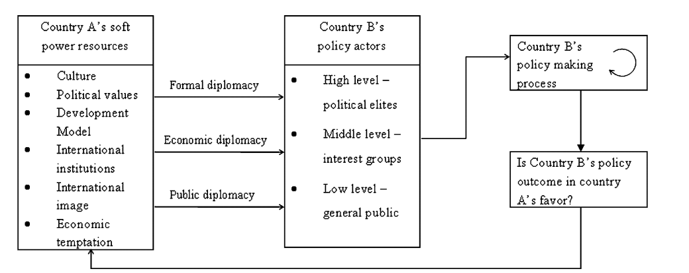
Figure 2 – An integrative model of soft power. Source: (Li & Worm, 2010).
As the Figure above shows, the soft power resources lie in six areas: 1) culture, 2) political values, 3) development model, 4) international institutions, 5) international image, and 6) economic temptation. These can be communicated to political elites, interest groups and the general public via the three channels discussed above. This influences the other countries´ policy making process, which could be in country A´s favor. This is a cyclical process, meaning that country A can communicate its soft power resources in a way it reaches certain outcomes.

Li & Worm (2010) not only developed this integrative model, but they also analyzed China´s soft power resources. With regards to the cultural resources, China has giant competitive cultural capabilities due to its unique culture, 5000 years history, Chinese language, philosophy, medicine, food, etc. Furthermore, the Chinese culture has been promoted by the Confucius Institutes, which provide language teaching, promotion of Chinese culture and cultural exchanges.
Despite these great resources, China is far behind US or UK in cultural influence. According to Li & Worm (2010), there are two reasons for this: a) lack of a complete cultural strategy, and b) small Chinese cultural industry.
Concerning the political values, there are two elements of a country´s political values: a) domestic, and b) international. Domestic refers to the government rule, whereas the international means the policies addressing foreign countries and international affairs. China has been widely criticized for its domestic policies and political values, due to the lack of democracy, rule of law, violation of human rights, etc. Internationally, China conducts its foreign policy along with the Five Principles of Peaceful Co-existence, including a non-interference principle with other nations´ domestic issues. As Hongyin & Yeh-Chung (2008) point out, in many countries, this projects a peaceful image; however, certain countries accuse China of not taking enough responsibilities in solving international problems.

When it comes to the development model, there is a division among scholars on to what extent China is able to promote and export its development model, the ´Beijing Consensus´ (北京共识). Some scholars argue that “China´s experience provides a successful development model of socialist market economy for the international community, therefore making China as an alternative model for those who can make a choice” (Mingqian, 2008), whilst others claim that China is not able to export the model, since the process is still ongoing and it is a seriously imbalanced model (Samvelidze, 2010). Due to this debate, the Chinese leaders rather promote the ´scientific development view´ （科学发展观）, than the ´Beijing Consensus´. The scientific development view includes the construction of a harmonious and sustainable society. To conclude, the Beijing Consensus could be appealing for developing countries which are in need of assistance ´without strings attached´, whereas the scientific development could interest the biggest critiques of the imbalanced Chinese development model (Li & Worm, 2010).

The fourth element of soft power is the country´s capability of international agenda setting and the creation of new international institutes. Since the opening up policy in 1979, China increased its international presence by participating in the most important international institutions; furthermore, China is also dedicated to pursuing regional multilaterism (Li & Worm, 2010).

The fifth element of the soft power is the international image, which is influenced by the behaviors of the government, multinational corporations, products, people, etc. The international image of China is both shaped by the aspects discussed above, the quality of made-in-China products and press coverage.

The last aspect is economic temptation. China has the second largest economy in the world; however, it is currently losing its competitiveness to the lower-wage countries. It has been recommended that China should send more delegations abroad in order to promote investment opportunities (Li & Worm, 2010).

To conclude, Li & Worm (2010) argue that China possesses great soft power resources in terms of all aspects of soft power resources. Nonetheless, every aspect creates criticism in certain countries, which fosters a negative image; therefore, China is in need of developing a more nuanced, country-specific and target-oriented soft power plan.

Harold Lasswell´s Model of Communication
The focus of this thesis is not only China´s soft power capabilities and resources, but also how they are communicated through the above specified three channels. “One of the earlier and most influential communication model” (Shoemaker, Tankard, & Lasorsa, 2004) is the Harold Lasswell Formula, which is “a convenient way to describe an act of communication is to answer the following questions: Who, Says What, In Which, Channel, To Whom, With What Effect?” (Lasswell, 1948).
The reasons behind the fact that it is still one of the most influential communication models are threefold: a) it is easy and simple to use, b) it is suitable for all types of communication and c) it includes the concept of effects. However, the major drawbacks are that it is a linear model which lacks the notions of noise and feedback mechanism (Communication, 2013). Nevertheless, this is an appropriate model for this case, because soft power communication includes various types of communication and the model is centered on the receiver side and the effects of strategic communication.
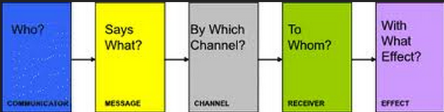
Figure 3 – Harold Lasswell´s Communication Model. Source: (Lasswell, 1948).
The theory received also other criticisms. Greenberg & Salwen (2008) stated that: "Although Lasswell's model draws attention to several key elements in the mass communication process, it does no more than describe general areas of study. It does not link elements together with any specificity, and there is no notion of an active process” (Greenberg & Salwen, 2008). Nevertheless, this is a useful theory for this thesis, since it does not intend to look into the specifics of the communication process, but it rather aims to clarify the indicators, where the soft power could be more prominently used.

Case study

Sino-German relations

The Sino-German relations date back to 1861, when Prussia and the Qing Empire signed the first Sino-German Treaty after China´s defeat in the Second Opium War. Two years later, the commercial relations between Prussia and China started by the Treaty of Tianjin (天津条约). This treaty was inherited by the later formed German Empire and it governed the commercial bilateral relations until the First World War, when the Republic of China unilaterally repudiated the Treaty. The Sino-German cooperation was resumed during the Second World War, whereas it was fueled after the reunification of Germany, which is the fundament of the emergence and formation of the Sino-German bilateral strategic partnership. China established the diplomatic relations with East Germany in 1950 and with West Germany in 1972.

The analysis of this strategic partnership from a complex interdependence point of view involves the examination of three stages, namely 1) multiple channels of connection, 2) multiple issues without hierarchy, and 3) minor role of military force (Keohane & Nye, 2011).

According to Keohane & Nye (2011), the multiple channels which connect the societies can be divided into interstate, transgovernment and transnational ties, including the official and formal intergovernmental relations, information relations between the interests groups and transnational organizations. Evidently, this aspect is concerned with the vertical features of the interdependent relations.
The relations were upgraded from “strategic partnership in global responsibility” to “comprehensive strategic partnership” in 2014. Since 2011, there are intergovernmental consultations, whereas currently there are more than 60 dialogue mechanisms involving senior government levels. Furthermore, the intergovernmental negotiations already resulted in more than 40 concrete agreements. All in all, it can be concluded that the bilateral relations are developing positively, however, there are fundamental differences on human rights and rule of law issues. Therefore, there is a Sino-German dialogue involving an annual symposium on the rule of law since 1999. Furthermore, there is cooperation in trade management, climate change, energy sector, technology and research, and cultural exchange (Amt, 2014).

The civil societies of both sides are actively engaged in the bilateral relations. There is a Sino-German Civil Society Dialogue Forum, which focuses on the development of the grassroots. There are other initiatives involving the collaboration of the civil societies, such as the Sino-German Low Carbon City Dialogue or the Sino-German Workshop on Biodiversity Conservation. Besides these official cooperation mechanisms, there are also other initiatives on rule of law and human rights issues. Consequently, it can be argued that the civil societies of both countries are greatly interdependent. Nevertheless, it has to be mentioned that these projects are focused on the sustainable development of China, whereas, it is rather difficult to find programs aimed at introducing changes in Germany (Amt, 2014).

Another form of vertical interdependence is the migration. Today, Germany has one of the longest-established Chinese immigrant populations in Europe. The migration wave started in the 1980s, and currently there are ca. 200.000 Chinese migrants living mostly in the bigger cities, such as Berlin, Hamburg, Bonn, Frankfurt and Munich. Approximately 40% of the Chinese migrants in Germany come from Zhejiang province, whereas another 40% originates from Guangdong and Hong Kong. Furthermore, there are also ca. 50000 Chinese exchange students studying in Germany. It can be argued that Germany is a more attractive destination for the Chinese immigrants than the other European Union Member states due to its economic conditions (Latham & Wu, 2013).

To conclude the section on the vertical aspect of complex interdependence, it can be claimed that due to the intergovernmental mechanisms, a huge number of transnational cooperation initiatives involving both senior government and the civil society and the growing number of Chinese migrants and exchange students living in Germany highlight the new phase of an even more interdependent Sino-German relationship.

Moving onto the horizontal axis of the Sino-German relations, the following paragraphs will be devoted to multiple issues, meaning that there is a new tendency that the agenda is not dominated by security issues, but by other topics, such as energy, economy or environmental protection (Keohane & Nye, 2011). When taking a look at the agenda of the Sino-German bilateral cooperation, the discussions are mostly about economic issues and the human rights and environmental questions are becoming more important. Therefore, it cannot be concluded that the agenda setting is without priorities, but it is definitely not dominated by ´high politics´.

According to Wen Jiabao, "The Sino-German relationship has opened a new page. The sound development of bilateral ties has brought benefits to the people of both countries, as well as to people around the globe. The Chinese government, along with the German government, will strive hard for peace, cooperation and a harmonious word for the 21st century." Furthermore, "We have found a lot in common over the China-Germany government consultation. It is also the first round of this mechanism. 16 ministers from China signed agreements with the German government, worth more than 15 billion US dollars”, Wen concluded (Xinhuanet, 2011). These quotations illustrate the new era of a comprehensive strategic partnership and that both sides are committed to work on an even more interdependent relationship.

In the 1970s, Germany and China had almost no trade relations. Since then, Germany has evolved to be the biggest contributor to bilateral trade with China in the European Union, accounting for almost 50% of EU exports to China and around 25% of the total imports, resulting in the biggest trade deficit. With regard to foreign direct investment, the picture is the opposite, since German companies are investing far more in China than the Chinese companies in Germany. However, due to the ´going global´ policy, the Chinese investments have been growing (Union, 2011). "The 12th Five-Year Plan (2011-2015) and the first exclusive Sino-German government talks are a strong foundation for future growth of Sino-German trade," said Alexandra Voss, a delegate of the Association of German Chambers of Industry and Commerce in Beijing (Fangfang, Lan, & Chang, 2011).

The economic relations are not only characterized by the growing volume of trade and foreign direct investment, but the number of trade disputes is increasing as well. These trade disputes are mainly results of trade barriers. Regardless of China´s accession into the World Trade Organization (WTO) in 2001, there are still a great amount of (non)trade barriers of both parties. These have a negative impact on the bilateral relations and interdependence. Moreover, some scholars also claim that due to China´s huge internal market and plans to change the export-driven economic model to a consumption-driven one, Germany needs China more than the other way around (Union, 2011). Some scholars argued that the growing number of economic disputes and trade frictions suggest that the Sino-German partnership is not a real strategic realignment (Li M. , 2009). The trade disputes are centered on protective economic measures, product safety, and appreciation of Renminbi, China´s market economy status, intellectual property rights and trade imbalances (Union, 2011).

With regard to the political relations, there are other issues potentially harmful for the interconnectedness of the Sino-German strategic partnership. These include the pressure of the solution of the human rights problems, lifting of the arms embargo imposed on China after the Tiananmen Incident, and Merkel´s meeting with the Dalai Lama, even though Germany officially supports the one-China policy, due to which several high-level meetings and discussions were cancelled (Li M. , 2009).

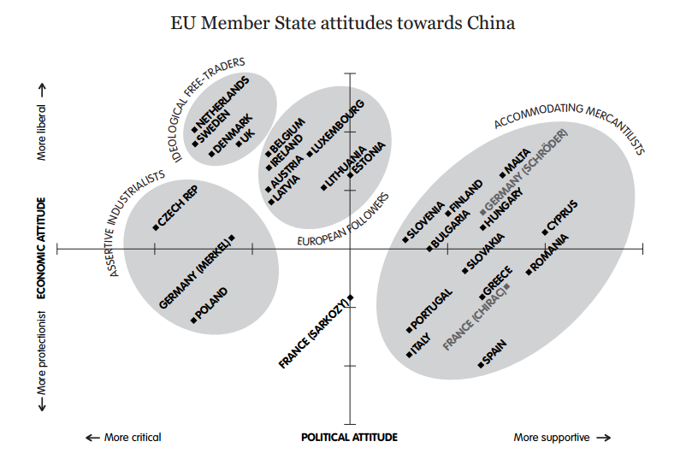
Figure 4 – EU Member States´ attitudes towards China. Source: (Fox & Godement, 2009)
As the Figure above depicts, Germany´s attitude to China under the Merkel administration can be labeled as ´Assertive Industrialist´ perspective, meaning that Germany is willing to put pressure on China in anti-dumping or human rights issues (Fox & Godement, 2009). Consequently, the relations can be described as ´realism-complex interdependence continuum´, since both the horizontal and the vertical axis of the complex interdependence analysis point out that the two countries are getting more interconnected, however, as the Figure above and the problematic aspects of the bilateral connection show, there are still certain topics which are guided by rather a realist thought than a liberalist.

The third aspect of complex interdependence is the decreased possibility of the use of military force (Keohane & Nye, 2011). The military cooperation is rather limited due to the lack of common strategic goals and little mutual military trust. Additionally, Germany´s disinterest in a military alliance with China and the still not lifted arms embargo all point to direction that Germany and China have very little prospects for military cooperation. Nevertheless, the cooperation regarding the major international issues is becoming closer, including the increased cooperation in personnel exchanges and military policies (梁军, 2010). Consequently, the third level of interconnected relations is also true in the case of the Sino-German bilateral relations.

To conclude, the Sino-German bilateral relations have become more complex since the first establishment of the diplomatic connections according to the framework of Keohane & Nye (2011). With regards to the horizontal relations, there are a growing number of summits and symposiums involving senior level government officials, whilst the vertical relations are not dominated by ´high politics´, but they are rather determined by economic and environment and political cooperation.
Nevertheless, the bilateral relations can be rather characterized as a ´realism-complex interdependence continuum´, since the negotiations of certain topics, such as the arms embargo or trade frictions, show realist ties, not only liberalist philosophy.

Analysis of China´s Soft Power in Germany
As pointed out above, the following analysis will be based on the framework proposed by Li & Worm (2010). The levels of formal diplomacy, economic diplomacy and public diplomacy will be further explored. This analytical model has been chosen, since it is in line with elements of soft power conceptualized by Nye (2004), namely, foreign policy, culture and political values. The following analysis will not take into account the Chinese perception on soft power, since the universally accepted definition is coined by Nye (2004). Furthermore, it has to be acknowledged that the Chinese communication of its own soft power resources has a rather top-down approach, therefore, the analysis will examine this matter; and later on in the Discussion section is will be debated on how to make the strategy more suitable for the German audiences and thereby transforming it to a more professional and successful level.

In the words of Edney (2012), the general aim of Chinese soft power is to explain China to the world via focusing the narrative on China´s policies, culture, history and social development. CPC´s foreign propaganda is overseen by the Foreign Propaganda Leading Small Group, which operates under the CPC´s Central Propaganda Department, whereas the public face of these institutions is the State Council Information Office (SCIO). The SCIO has nine offices and is responsible for issuing official press releases and white papers, developing foreign relations and researching on China´s soft power and perceptions around the world (Brady, 2008).

According to Jiechi (2007), China´s overall foreign policy goals when dealing with the European Union countries are improving China´s image and strengthening the relations with ´the great powers´. Furthermore, Sino-German relations are dominated by economic matters, whereas the common security cooperation remains rather limited.

China started to enhance its soft power capabilities and projections in order to address incidents and negative news. These new strategies aim to achieve the following four purposes. First of all, China wants to communicate its harmonious society including recognition and basic understanding of China´s political system and values. In other words, Zemin (1999) stated that “it is absolutely necessary to know the basic Chinese values in order to have a good understanding of what has happened and what will happen in China”. Secondly, China also wants to communicate its peaceful development in order to project an image of a responsible partner who is not to be feared. Thirdly, it aims to be seen as a trustworthy member of the international community striving for world peace. Fourthly, its culture should not only be regarded as an ancient one, but also as lively and exciting (Jiechi, 2007).
To sum up, the main goals behind China´s current soft power strategy are to make the European leaders understand that the Chinese model is not superior to other models, but it fits the best to the Chinese circumstances (d´Hooghe, 2010).

The application of Li & Worm´s (2010) integrative model of soft power implies the investigation of the Sino-German bilateral relations from high, middle and low levels of communication.
With regard to addressing the political elites, - as already discussed under the bilateral relations – there are currently more than 60 bilateral mechanisms, many of them between line ministers, state secretaries and heads of government authorities (Amt, 2014). The agenda for intergovernmental consultations includes environmental and economic issues, social development, education, science, research and civil society exchange. Consequently, the soft power within formal diplomacy relies on the capacities of economic temptation, culture, political values and with China´s growing international presence, the bilateral relations are also increasingly shaped by China´s international image.

The second level of soft power reaches the interest groups. Interest groups can be defined as a non-profit and frequently voluntary whose members are working for a common cause by influencing public policy (Businessdictionary.com, 2014). As shown on the Figure below, over the past 25 year the number of registered NGOs in China reached over 500000 (Economist, 2014).
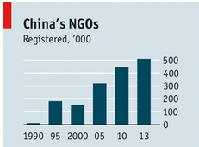
Figure 5 – Number of registered NGOs in China. Source: (Economist, Enter the Chinese NGO, 2014)
In order to foster and manage the cooperation between these NGOs, the China Association for NGO Cooperation (CANGO) was created in 1992. The mission of the non-profit organization is to promote China´s civil society development and to provide a platform for information sharing. In order to perform these tasks, CANGO maintains relations with more than 170 foreign NGOs, among which 4 are Germans: EED, Federal Ministry for Economic and Cooperation and Development, Heinrich Boell Foundation and Misereor. These relations are centered on environmental protection, social, economic and political development (Cooperation, 2014).
Furthermore, there are a number of other Sino-German NGOs working together especially on environmental protection and human rights issues, however, currently, there are no official statistics on this matter, therefore their reach and importance cannot be examined (Economist, 2014).

The third way of exercising soft power is through public diplomacy. As Paradise (2009) underlines China funds the Confucius Institutes in order to boost its soft power capabilities. Currently, there are 18 Confucius Institutes in Germany. The aim of the Confucius Institutes is twofold, firstly, they teach Chinese language and culture; and secondly, they are also part of a broader soft power strategy involving raising a cultural profile and foster business activity. Confucius Institutes are created through partnerships between two academic institutions, one in China and one abroad. It is heavily debated to what extent the Confucius Institutes are part of China´s soft power policy. As one teacher argued: “I don´t like soft power. I think power is aggressive. We just do something all people like” (Paradise, 2009). Nevertheless, President Hu Jintao called for enhancing soft power though culture in 2007; further, Jia Qinglin, chairman of the National Committee of the Chinese People´s Political Consultative Conference claimed that: “Cultural development, a main theme in building a country´s soft power, plays a significant role in enhancing comprehensive national power” (Paradise, 2009). Additionally, Confucius Institutes have emerged to be the Chinese soft power´s “brightest brand” (Xinhua, 2007). Therefore, this thesis will also consider the Confucius Institutes as part of China´s soft power strategy.

It can be claimed that Sino-German cultural cooperation has reached a high level. From 2007 to 2010, a three-year long event series called “Deutschland und China – Gemeinsam in Bewegung” [Germany and China – Together in Motion], which was followed by the “Chinesisches Kulturjahr” [Chinese Culture Year] in 2012, whereas currently “Deutsch-Chinesisches Sprachenjahr” [German-China Language Year] is going on. These arrangements involve more than 500 events per year including an introduction to Chinese language and calligraphy, theatre plays and exhibitions, and most of them are organized and managed by the Confucius Institutes. Furthermore, this increased interest in the Chinese culture and the educational connections are enhanced as well by funding Europe´s biggest China Research Institute in Berlin. Not only these institutes, but also the universities foster the interconnectedness of the two countries. Currently, there are over 30 Sinology studies and other study lines within Humanities, which have started to offer the major in Chinese Area Studies (Hong, 2013).

Consequently, the public diplomacy is based on China´s culture and values; however, the political and development levels are seriously limited in the case of Germany. Consequently, the soft power communication at this level does not make use of other resource capabilities such as international image or participation at international institutions.

To sum up, the three channels of soft power communication are based on different soft power resources. Whereas the formal diplomacy uses all capabilities, but mainly the economic temptation and growing international presence, the interests groups have focused on the development issues and the public diplomacy is centered on cultural attractiveness.

Chinese image in Germany
As the analysis above suggests, all three channels make use of certain soft power capabilities, however, China´s overall image in Germany is still negative. The following paragraphs will discuss the reasons and which strategies might help to turn the situation into China´s favour.

Figure 6 – Communication model of Chinese soft power in Germany after Lasswell (1948) & Li & Worm (2010).
When taking Lasswell´s Formula into account, the Sender is China or the Chinese government, who aims to communicate a positive image of its Peaceful Development through formal/economic/public diplomacy to high/middle/low level policy actors, but this communication process only reached negative effects.
The outcome of the soft power communication is rather twofold. As the progress of the bilateral relations show, the “strategic partnership in global responsibility” was upgraded to “comprehensive partnership”, whereas most of the bilateral talks and mechanisms lead to concrete agreements. Consequently, despite the fundamental differences in human rights, trade disputes or rule of law issues, the German policy outcomes are rather in China´s favour.

When taking a look at the general German view of China, the picture is rather different. The number of favourable views on China dropped from 46% to 28% during 2005-2013 (Database, Opinion of China, 2013).
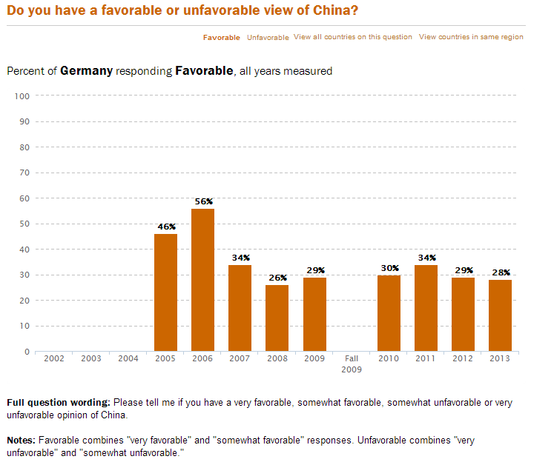
Figure 7 – German Favourable Opinion of China. Source: (Database, Opinion of China, 2013).
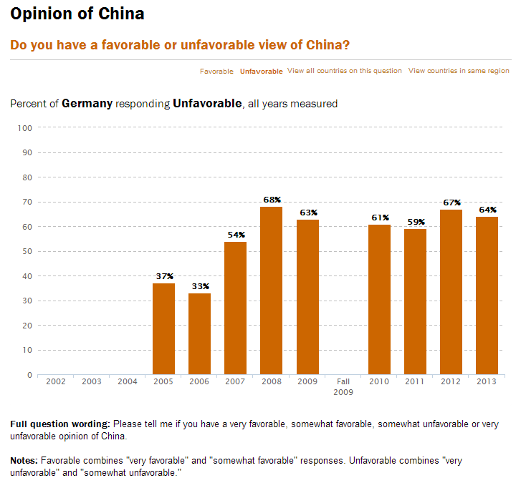
Figure 8 – German Unfavourable Opinion of China. Source: (Database, Opinion of China, 2013).
During the same period, the unfavourable opinion rose from 37% to 64% (Database, Opinion of China, 2013). When the German public opinion on China is compared with other countries´ perceptions, it is visible that the Germans are almost as unfavourable of China as the Japanese.
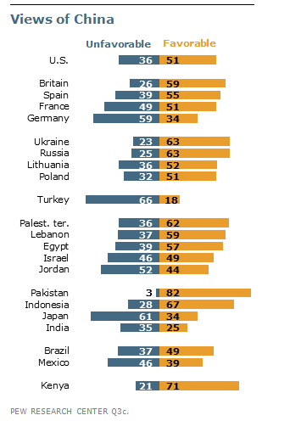
Figure 9- Views of China. Source: (Research, 2011).

Additionally, Germans have a negative view of China´s growing military power and they are divided whether China´s growing economic power is a positive or negative issue.
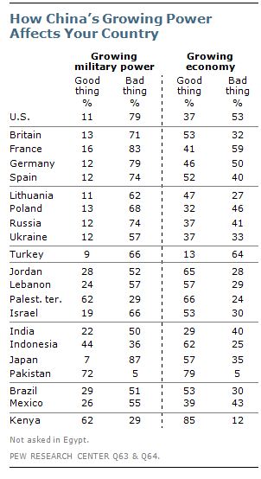
Figure 10 – How China´s Growing Power Affects Your Country. Source: (Research, 2011).
The tendencies depicted above correspond to the data collected by the BBC World Service Poll, or Globescan/Pipa and the European Commission´s Eurobarometer measuring China´s image worldwide.
The data above suggests that when it comes to public diplomacy and to the general public, the communication of China´s Peaceful Rise rather fails, despite the great amount of money invested in Chinese cultural events, academic exchange or research institutes. The statistics point to the direction that the general German public views China´s development as a threat.

China´s Portrayal in the German Media
The discourse on Chinese soft power is not only shaped by China, but also by the media itself, since they construct a certain reality by presenting certain topics from specific angles, thereby shaping the public discourse and the society´s images and perceptions of China. This leads to the key to the negative perception: an uncritical, one-sided presentation greatly reduces the potential for mutual understanding and efficient problem solving (Richter & Gebauer, 2011).
Furthermore, the Chinese perspective on soft power highlights the importance of global communications capacity (Edney, 2012); therefore, the media representation is a crucial aspect for this analysis.

China´s portrayal in the German media ranges between two extremes: from the country´s exotic aspects and unique history, to the questionable social order and unsustainable development.
The recent representation in the most read media, such as Der Spiegel and Die Zeit, covers the following topics: environment, economy, death penalty, civil rights and the internet in China (Spiegel, 2014). The number of reports and the volume of coverage suggest that there is a wide public interest in Germany for China and for the development in China. Nevertheless, reading the articles, one can identify that China´s problems get more space, which might be distorting reality resulting in disconcert of the Chinese image. Many reports are framed by well-known stereotypes and clichés, such as “cheap producer”, or “enormous appetite for natural resources” (Richter & Gebauer, 2011). Consequently, there is a great threat that these oversimplified stereotypes and one-sided reporting greatly affects the German public´s negative view on China (Richter & Gebauer, 2011).

According to Li & Worm (2010), the second channel of soft power communicates to the interests groups. If media is classified as an interests group, one can scrutinize whether the soft power capabilities are sufficiently conveyed to them. As Richter & Gebauer (2011) underline, journalist complain the difficult access to original sources, therefore, many topics might remain uncovered due to the lack of personalization. Furthermore, journalists also complain about the one-sided information regarding sensitive topics, such as civil rights or minorities in China, which leads to less accurate reporting. In order to overcome this difficulty, Richter & Gebauer (2011) argues that both the journalists and the Chinese authorities need to change their attitude towards each other. Whilst the media should strengthen the event-independent analysis, Chinese authorities should be more willing to cooperate with the correspondents. This would serve multiple goals: instead of unsophisticated representation of China, a more holistic approach could be realized and the Chinese side would be given a bigger opportunity to frame the news coverage and create a more positive image of their peaceful development via questioning the stereotypes (Richter & Gebauer, 2011).

As the Singaporean Senior Minister Lee Kuan Yew (李光耀) stated: “soft power is achieved when other nations admire and want to emulate aspects of that nation´s civilization” (Foo, 1996), and currently the Chinese soft power seems to be far away from this goal among the average German citizens.

China Nation Brand Index
Despite the tangible nature of soft power, researchers attempted to quantify it in order to measure the soft power of states. The British Institute for Government developed its own scale in 2010 in order to conduct a cross-national comparison. This study does not include all countries in the world, only the strategically important ones for the British diplomacy. The framework for this assessment is based on Nye´s (2004) work, that soft power is comprised of culture, political values and foreign policy. Drawing upon Nye´s (2004) framework, the Institute for Government proposed five categories for measuring a country´s soft power skills: a) business/innovation, b) culture, c) government, d) diplomacy, e) education (McGlory, 2010).
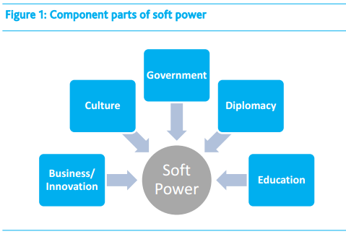
Figure 11 – Component parts of soft power. Source: (McGlory, 2010).

The Culture refers to the cultural attractiveness and to what extent others are able to identify themselves with the cultural values of – in this case – China. The Government sub-index measures the quality of political institutions and government effectiveness. The Diplomatic sub-index measures the global perception, whereas the Education refers to the country´s attractiveness for foreign students and educational exchanges, whilst the Business sub-index aims to scale the openness, innovation and the regulations of a nation´s economy. It has to be noted that the British Institute for Government acknowledged the shortcomings of this scale, such as “soft power is a dance requiring partners” (Nye J. J., 2011), but at the moment this is the most reliable conceptualization of the soft power index; therefore, this thesis will make use of the results of this scale.
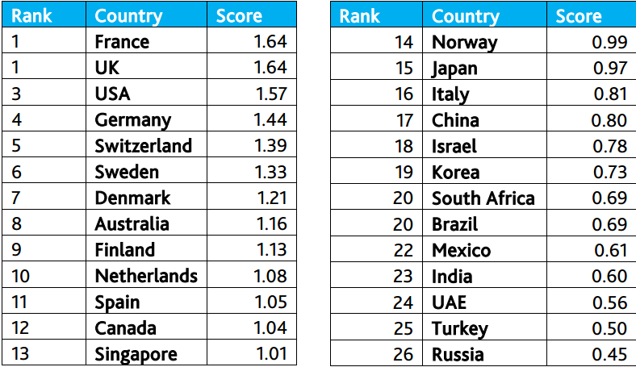
Figure 12 – Soft Power Index Results in 2010. Source: (McGlory, 2010)
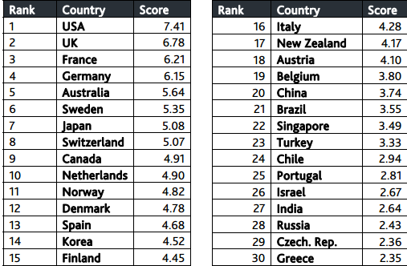
Figure 13 – Soft Power Index Results in 2011. Source: (McGlory, 2011)
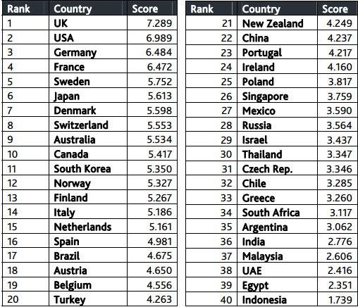
Figure 14 – Soft Power Index Results in 2012. Source: (McGlory, 2013).
In 2010, China reached the 17th place on this scale, 20th place in 2011, and the latest results put China on the 22nd place (respectively in (McGlory, 2010); (McGlory, 2011); (McGlory, 2013). These results might be surprising, since soft power is generally considered to be a weak strategic point for China. However, due to the growing number of Confucius Institutes and foreign-language Xinhua news agency and growing public diplomacy budgets used for Chinese cultural years and educational exchanges, China reached a higher ranking than at first assumed. Nevertheless, it is also visible on the scale that China is moving downwards, instead of upwards. When taking a look at the sub-indexes, over the years China gained more points in the fields of education and culture, though, -according to the Institute for Government- China´s scores in Government sub-index declined, due to the questionable individual freedom and government transparency (McGlory, 2013). Consequently, despite the shortcomings of China´s soft power, the Soft Power Index shows that China is on the right track when it comes to developing and conducting a comprehensive soft power strategy.

Findings of the case study
First of all, the Sino-German bilateral relations were examined from the complex interdependence point of view and it has been concluded that the relations are becoming more interconnected since the official beginning of the diplomatic contacts. Afterward, the communication of the Chinese soft power is analyzed through three different channels; whilst the receivers are the political elites, interests groups and general public. The Chinese soft power resources are best communicated at the highest level due to the bilateral cooperation mechanisms involving senior government officials and political elites, further, most of these annual meetings resulted in concrete agreements. There is cooperation between the interests groups; however, since they are generally working on China´s development, the reach of the soft power is rather limited. Lastly, the general public is reached through cultural events and educational exchanges. The most visible manifest for this collaboration is the 18 Confucius Institutes in Germany. However, the opinion polls show that most of the Germans have a negative view on China, which could be due to China´s negative media representation; therefore, it has been discussed that a more transparent communication between the foreign journalists and the Chinese authorities could foster the positive image of China´s peaceful development. At the end, the Soft Power Index developed by the British Institute for Government was taken into account. On this index there is a slight fall year after year with regard to China´s ranking, which shows that China lacks a comprehensive soft power strategy even though it has sufficient resources for carrying out one.

Discussion & Future Research Prospects
The topic of this thesis presents various aspects for discussion.
First of all, soft power is understood in a profoundly different way in the Chinese discourse than in the Western one, since it involves not only the foreign policy aspect, but it is also used for domestic nation building purposes. This thesis decided to employ Nye´s (2004) conceptualization of soft power, since it is the internationally acknowledged one; and as described above, all the analytical tools and models used were based on Nye´s (2004) framework. This is an essential approach, because the focus of this thesis was to analyze the Chinese soft power in Germany, in a country, where soft power itself is defined according to Nye (2004). As both the general communication theories and Lasswell´s formula (Communicationtheory.com, 2013) suggest, the process of communication needs to be centered on the receiver´s side, otherwise the decoding of the message will be insufficient, since the receiver will understand a different message than is intended by the sender. The comparison of this idea with the underlying weakness of the Chinese soft power framework, which is different from the Western one by emphasizing the domestic issues, entails that the Chinese soft power is bound to fail as long as it does not include and embrace the characteristics of the German publics.

Nevertheless, the inclusion of a domestic approach might not be theoretically unjustifiable. Keohane and Nye (2011) argue within the theory of complex interdependence, that in this new paradigm the line between domestic and foreign politics becomes more and more blurred. Taking this into account, a need emerges on a more comprehensive and up-to-date conceptualization of a nation´s soft power and its resources.

China faces a serious dilemma when working on its soft power strategy generally in the Western world, but especially in Germany; because - in line with Nye (2004) – China´s political values are hardly transferable or admirable in the Western societies. Consequently, those Chinese scholars who advocate that the Chinese traditional culture should be promoted together with the ideology, would face crucial difficulties – or even impossibility – when trying to formulate an efficient soft power strategy.

Furthermore, Nye (2004) also argued that soft power should not only originate from above, but it also includes a bottom-up approach in terms of the promotion of culture. Since this approach is difficult to quantify and currently there is no data available on whether the Chinese migrants in Germany worsen or improve China´s perception in Germany, this has been excluded from the thesis. But there is a strong tendency that the 20-30 year old generation views China profoundly more positively than people in the other age groups; and since they are the ones with the most probable connection to the Chinese migrants through participation in education and jobs, it can be argued that the Chinese minority makes a positive impact in terms of soft power communication. Additionally, Nye (2004) claimed that “spending billions of dollars to increase its soft power … China has had a limited return on its investment” (Moss, 2013). According to him (2004), a top-down soft power strategy is likely to be interpreted as propaganda. This argument corresponds to the claim on centering the communication process according to the audiences´ needs, otherwise the message might get lost in translation (Communicationtheory.com, 2014).

Even though most of the literature written on China´s soft power in Germany or in Western Europe emphasize the limits of a successful strategy, such the imbalance in soft power resources, legitimacy concerns and lack of coherent agenda (Gill & Huang, 2007) entailing a strategically weak Chinese soft power with low return on investment (Nye, 2004), the greater picture of the world affairs shows that the same strategies seem to be working in South America and in Africa. The Chinese language teaching is increasing its volume and 50 out of 54 countries in Africa benefitted from development aid, investment in infrastructure and re-building of the cities. Kenneth King reports in his recently published book China’s Aid and Soft Power in Africa that the Africans find the Chinese values of hard work and learning increasingly appealing, which indicates that the Chinese soft power works in Africa. Furthermore, similar results are reported from South America, where the business approach and the economic development model dominate the discourse. This highlights how much the soft power discourse and strength is dependent on the context. This makes the recommendation for China to build a comprehensive soft power strategy rather doubtful and debatable, since the current efforts are working in certain parts of the world. Consequently, it might be a better strategy to communicate the soft power resources differently in the various regions of the world, so it fits the audience and the context better. This approach is also in line with the discussion above, which argued that the main cause of the low return on Chinese soft power investment is not taking into account the needs of the audience. Additionally, the case of Africa does not only stand for a context-based nature of the Chinese soft power, but it also challenges the Western belief that soft power cannot work as a top-down approach.

Another aspect to discuss is whether hard power is a precondition for soft power capabilities. The Soft Power Index in the last three years suggests that the countries with the best soft power capabilities, such as the Scandinavian countries or Singapore, do not necessary need to have sufficient hard power capabilities. This brings interesting questions to light, for instance, how the current enhance of China´s military power will affect its soft power capabilities. This could have a special impact on the Sino-German bilateral relations and the power discourse between the two countries. This narrative might not only be shaped by the growing interdependence between the two countries, but also by a more comprehensive understanding of power. According to Nye (1990), “smart power is neither hard nor soft. It is both”. There needs to be more research conducted on the outcomes of China´s growing soft power and to what extent it might harm the bilateral relations.

One of the most important findings of the analysis is that Germany´s policy making is still favourable to China, despite the German public´s negative view. Consequently, another point for further research and discussion could be based on the question regarding the public´s influence on Germany´s foreign policy decision making process on China. This result would be beneficial for the Chinese side, since it would clearly indicate to what extent it is actually essential for them to enhance its soft power communications and whether Nye is right when he argued that the Chinese soft power has little return on investment (Moss, 2013).

To sum up, this section includes valuable points for future research. First of all, the ´one-size-fits´ all approach of a comprehensive Chinese soft power strategy formulation is criticized, followed by a call for a more up-to-date conceptualization of the term of soft power. Thirdly, there needs to be more research conducted in order to quantify a bottom-up soft power strategy and fourthly, the interplay between the soft power, hard power and smart power should be conceptualized as well. Since the importance of soft power is growing, the implications of the findings of the above mentioned research topics are expected to become essential and needed for the decision making processes in the near future.

Conclusion
The aim of this thesis was to examine how China communicates its soft power resources in Germany in order to build a positive image of its Peaceful Development. The core concept of power was defined as A´s ability to influence B, which could have two types when it comes to power between countries in the context of international relations: a) soft power and b) hard power. Hard power means the use of punishment and reward, whereas soft power is “the ability of a state to influence the actions of another through persuasion or attraction, rather than coercion” (Nye J. J., 2004). The forms of soft power are “culture, values and foreign policies” (Nye J. J., 2004). In reviewing the literature, it was found out that the soft power has a context- specific nature; therefore a case study is relevant method to examine the Chinese soft power in action.

The prior studies also have noted the importance of shaping the discourse of soft power in order to reach the desired outcomes of behavior, therefore, this thesis was based on the social constructivist paradigm and analyzed how the soft power discourse of China is realized in Germany.

The literature review has shown the differences between the Western and Chinese understanding of soft power and decided to use the Western one due its more concrete theoretical models. According to Li & Worm (2010), the most significant Chinese soft power capabilities include its culture, values and development model. These can be communicated through three channels to the political elites, interests groups and the general public. One might ask: “What is public diplomacy? It is quite simple. There are two objectives in attracting other countries to attend the exhibition. One is to let people know us. The other is to let people like us” (Hang, 2004). Furthermore, the history of the concept of Peaceful Development was also discussed. After conceptualizing these ideals, the analysis was set forth to determine how the Chinese soft power capabilities are communicated to these three different stakeholder groups.

The case study started with a description of the Sino-German relations from a complex interdependence point of view. It has been found out that despite some trade frictions or events, such as when Angela Merkel met the Dalai Lama, the relations are increasingly interconnected and dominated by economic issues. Consequently, the Sino-German bilateral ties fit to the realism-complex interdependence continuum (Nye J. J., 1976), where certain events trigger a realist response, however, the two countries are generally becoming more interdependent.

The results of the investigation show that the at the formal diplomacy level, the soft power resources are communicated frequently through interstate dialogue mechanisms. Most of these dialogues lead to concrete policy implications in favour for both China and Germany, which indicates that the Chinese soft power works efficiently at the highest level.
The most crucial soft power resource is the culture, which is communicated through the Confucius Institutes, academic exchanges and cultural events. However, the Global Attitudes Surveys show that the German population has a profoundly negative view on China. The analysis went on finding its sources, and it has been concluded that the media shapes the discourse on China by reporting about the problems and the negative issues, whereas, China´s achievements are less reported on. Therefore, it has been argued that the Chinese political elite could work together with the German media in order to shape the discourse in a more positive way.

One of the most important findings of this thesis is that China has yet to develop a comprehensive soft power strategy based on an ideal mix of soft power capabilities and resources (Gill & Huang, 2007). Furthermore, the Chinese discourse on soft power not only integrates a domestic perspective, but it is also in line with all the CPC´s domestic propaganda goals, indicating that “the harmonious world concept has great significance for China´s domestic building of a harmonious society, and constructing a harmonious society is part of strengthening China´s soft power” (Fu, 2010). Consequently, the development of a comprehensive Chinese soft power strategy would not only result in a better foreign perception, but also a national stability and unity (Edney, 2012). The Chinese conceptualization of soft power is rather defensive towards the West and does not include an offensive perspective which would threaten the existing pillars of the global world order.

The present study list several questions and points of discussion, which could become future research topics. First of all, the paradox of China not being liked in Germany and that it is still managing to receive favourable policy outcomes would be one of those ideas. Furthermore, “[s]oft power is achieved only when other nations admire and want to emulate aspects of that nation´s civilization” (Foo, 1996). Other studies have indicated that the current communication of soft power works well in Africa and Latin America, which challenges Nye´s (2004) argument that the Chinese soft power has generally low return on investment. Consequently, China still needs a long way to go in order to be positively perceived globally, however, it is moving towards a sophisticated management of the soft power discourse with regards to its Peaceful Development.

Bibliography
Amt, A. (2014, 04 04). China. Retrieved 04 11, 2014, from Auswaertiges Amt: http://www.auswaertiges-amt.de/EN/Aussenpolitik/Laender/Laenderinfos/01-Nodes/China_node.html
Armitage, R. L., & Nye, J. J. (2007). CSIS Commission on Smart Power. Center for Strategic and International Studies .
Baldwin, D. A. (1985). Economic Statecraft. Princeton University Press.
Baldwin, D. A. (1980). Interdependence and Power: A Conceptual Analysis. International Organization , 471-596.
Bially Mattern, J. (2005). Why ´Soft Power´ Isn´t So Soft: Representational Force and the Sociolinguistic Construction of Attraction in World Politics. Millennium , 33(3), 583-612.
Blanchard, J.-M. F., & Lu, F. (2012). Thinking Hard About Soft Power: A Review and Critique of the Literature on China and Soft Power. Asian Perspective , 565-589.
Brady, A. (2008). Marketing Dictatorship: propaganda and Thought Work in Contemporry China. Lanham, MD: Rowman and Littlefield.
Brenner, L. J. (2001). The U.S.-PRC Relationship: From Realism to Complex Interdependence. Department of Politics and Public Administration, University of Hong Kong .
Bryman, A. (2008). Social Research Methods. New York: Oxford University Press.
Businessdictionary.com. (2014). Businessdictionary.com. Retrieved 05 17, 2014, from Interest group: http://www.businessdictionary.com/definition/interest-group.html
Commission, E. (2014). European Commission. Retrieved March 30, 2014, from Countries and Regions: http://ec.europa.eu/trade/policy/countries-and-regions/countries/china/
Communication, T. (2013). Communication Theory. Retrieved 05 17, 2014, from Lasswell´s Model: http://communicationtheory.org/lasswells-model/
Cooperation, C. A. (2014). China Association for NGO Cooperation. Retrieved 04 13, 2014, from http://www.cango.org/english01/?en=new&id=5
Crawford, N. C. (2004). Understanding Discourse: A Method of Ethical Argument Analysis. Qualitative Methods , 22-25.
d´Hooghe, I. (2010). The Limits of China´s Soft Power in Europe - Beijing´s Public Diplomacy Puzzle. Netherlands Institute of International Relations ´Clingendael´ , 1-35.
Database, G. I. (2013, 07). Opinion of China. Retrieved 04 13, 2014, from Pew Research Global Attitudes Project: http://www.pewglobal.org/database/indicator/24/country/81/
Database, G. I. (2013, 07). Opinion of China. Retrieved 04 14, 2014, from Pew Research Global Attitudes Project: http://www.pewglobal.org/database/indicator/24/country/81/response/Unfavorable/
Ding, S. (2008). To Build a ´Harmonious World´: China´s Soft Power Wielding in the Global South. Journal of Chinese Political Science , 13(2), 193-218.
Economist, T. (2014, 04 12). Chinese Civil Society - Beneath the glacier. Retrieved 04 13, 2014, from The Economist: http://www.economist.com/news/china/21600747-spite-political-clampdown-flourishing-civil-society-taking-hold-beneath-glacier
Economist, T. (2014, 04 11). Enter the Chinese NGO. Retrieved 04 13, 2014, from The Economist: http://www.economist.com/news/leaders/21600683-communist-party-giving-more-freedom-revolutionary-idea-enter-chinese-ngo
Edney, K. (2012). Soft Power and the Chinese Propaganda System. Journal of Contemporary China , 21(78), 899-914.
Fangfang, L., Lan, L., & Chang, B. (2011, 09 09). China Daily European Weekly. Retrieved 04 11, 2014, from China Top Market for Germany: http://europe.chinadaily.com.cn/epaper/2011-09/09/content_13660136.htm
Feng, Z. (2008). China Should Give Priority To Soft Power Rise. Global Times .
Foo, L. P. (1996). Only Tang Dynasty Came Close to Having Influence. The Strait Times .
Fox, J., & Godement. (2009). A Power Audit of EU-China relations. Policy Report by the European Council on Foreign Relations , 1-18.
Fu, K. (2010). Harmonious world concept and China´s soft power diplomacy. People´s Daily .
Gill, B., & Huang, Y. (2007). Sources and limits of Chinese ´soft power´. Survival: Global Politics and Strategy , 48(2), 17-36.
Glaser, B. S., & Medeiros, E. S. (2007). The Changing Ecology of Foreign Policy-Making in China: The Ascension and Demise of the Theory of "Peaceful Rise". The China Quarterly , 291-310.
Glaser, B. S., & Murphy, M. E. (2009). The Ongoing Debate. In C. McGiffert, Soft Power With Chinese Characteristics and Its Implications for the United States (pp. 10-26). Center for Strategic and International Studies.
Greenberg, B. S., & Salwen, M. B. (2008). Mass communication theory and research: Concepts and models. In M. B. Salwen, & D. W. Stacks, An integrated approach to communication theory and research (pp. 61-74). Mahwah: Erlbaum.
Guba, E. G. (1990). The Paradigm Dialog. London: Sage Publications Ltd.
Hackley, C. (2010). Advertising and promotion. An integrated marketing communications approach. London: Sage Publications.
Hang, X. (2004). Interview of Zhou Hanmin on Shanghai World Expo 2010. THe Bund .
Hardy, C., Harley, B., & Philips, N. (2004). Discourse Analysis and Content Analysis: Two Solitudes. Qualitative Methods , 19-23.
Herrera, Y. M., & Braumoeller, B. F. (2004). Symposium: Discourse and Content Analysis. Qualitative Methods , 15-39.
Hertz, J. H. (1981). Political Realism Revisited. International Studies Quarterly , 25(2),.
Hong, M. (2013, 12 25). Die deutsch-chinesischen Beziehungen im Jahr 2013 - Bilanz und Ausblick. Retrieved 04 13, 2014, from Beijing Rundschau: http://german.beijingreview.com.cn/International/txt/2013-12/25/content_587940_2.htm
Hongyin, W., & Yeh-Chung, L. (2008). The conception of soft power and its policy implications: a comparative study of China and Taiwan. Journal of contemporary China .
Huning, W. (1993). Culture as National Soft Power. Journal of Fudan University .
Jianfei, L. (2006). A rectification of peaceful rise. Liaowang xinwen zhoukan , 62.
Jiechi, Y. (2007). China´s Diploamacy since the Beginning of Reform and Opening Up. Foreign Affairs Journal .
Katsikeas, C. S., Samiee, S., & Theodosiou, M. (2006). Strategy Fit and Performance Consequences of International Marketing Standardization. Strategic Management Journal , 27(9), 867-890.
Keohane, R. O., & Nye, J. S. (2011). Power and Interdependence. Pearson Publishing.
Kundnani, H., & Parello-Plesner, J. (2012). China and Germany: Why the emerging special relationship matters for Europe. European Councial on Foreign Relations .
Kurlantzick, J. (2006). China´s charm: Implication of Chinese soft power. The Annals of the American Academy of Political and Social Science , 1.
Laffey, M., & Weldes, J. (2004). Methodological Reflectations on Discourse Analysis. Qualitative Methods , 28-30.
Lasswell, H. (1948). The Structure and Function of Communication in Society. The Communication of Ideas. New York: Institute for Religious and Social Studies.
Latham, K., & Wu, B. (2013). Europe China Research and Advice Network. Retrieved 04 11, 2014, from Chinese Immigration into the EU: New Trends, Dynamics and Implications: http://www.euecran.eu/Long%20Papers/ECRAN%20Chinese%20Immigration%20into%20the%20EU_%20Kevin%20Latham%20and%20Bin%20Wu.pdf
Li, M. (2009). China-Eu relations: A Strategic Partnership at Crossroads. China: An International Journal , 7(2), 227-254.
Li, X., & Worm, V. (2010). Building China´s Soft Power for a Peaceful Rise. Journal of Chinese Political Science/Association of Chinese Political Studies , 69-89.
Lisi, M. (2006). Preliminary Thoughts on Accelerating China´s Soft Power Building. Literature of Chinese Communist Party , 35-38.
McCormick, J. (2007). The European Superpower. New York: Palgrave Macmillan.
McGlory, J. (2011). The New Persuaders II: A 2011 Global Ranking of Soft Power. Institute for Government , 1-14.
McGlory, J. (2013). The New Persuaders III: A 2012 Global Ranking of Soft Power. Institute for Government , 1-14.
McGlory, J. (2010). The New Persuaders: An international ranking of soft power. Institute for Government , 1-14.
Mearshimer, J. (2005). The Rise of China will Not Be Peaceful At All. The Australian .
Mingjiang, L. (2008). China Debates Soft Power. Chinese Journal of International Politics , 287-308.
Mingqian, Z. (2008). Sustainable Influence and Big Power Mentality. Xiandai Guoji Guangxi .
Moss, T. (2013, 06 04). Soft Power? China Has Plenty. Retrieved 04 15, 2014, from The Diplomat: http://thediplomat.com/2013/06/soft-power-china-has-plenty/?allpages=yes
Nye, J. J. (1990). Bound to Lead: The Changing Nature of American Power. New York: Basic Books.
Nye, J. J. (1976). Independence and Interdependence. Foreign Policy , 130-161.
Nye, J. J. (2004). Soft Power: The Means to Success in World Politics. New York: Public Affairs.
Nye, J. J. (2004). The Changing Nature of Soft Power. In J. J. Nye, Soft Power: The Means to Success in World Politics. New York: Public Affairs.
Nye, J. J. (2011). The Future of Power. New York: Public Affairs.
Nye, J. (2008, 05 15). Teaching America to be more British. (T. Talk, Interviewer)
Paradise, J. F. (2009). China and International Harmony: The Role of Confucius Institutes in Bolstering Beijing´s Soft Power. Asian Survey , 49(4), 647-669.
Ping, G. (2004). China´s peaceful rise, which emphasizes achieving modernization through self-reliance, will benefit mankind. Remnin ribao .
Project, P. R. (2013). Global Indicators Database. Retrieved March 30, 2014, from China Partner/Enemy: http://www.pewglobal.org/database/indicator/64/country/81/
Project, P. R. (2013). Global Indicators Database. Retrieved March 30, 2014, from Opinion of China: http://www.pewglobal.org/database/indicator/24/country/81/
Ramo, J. C. (2007). Brand China. London: Foreign Policy Centre.
Research, P. (2011, 07). Views of China. Retrieved 04 14, 2014, from Pew Research Global Attitudes Project: http://www.pewglobal.org/2011/07/13/chapter-4-views-of-china/
Richter, C., & Gebauer, S. (2011). The Portrayal of China in the German Media. Heinrich Boell Foundation , 1-11.
Rosecranz, R., & Stein, A. (1973). Myth or Reality. World Politics , 26(1), 1-27.
Ruan, Z. (2004). What are the implications of China´s peaceful rise in the world? Boao Forum .
Samvelidze, N. (2010). The Rise of China´s Soft Power: The Efficiency of China´s Involvement in the Developing World. Master Thesis submitted to the Central European University .
Shoemaker, P., Tankard, J. J., & Lasorsa, D. (2004). How to Build Social Science Theories. Thousand Oaks: Sage Publications.
Spiegel, D. (2014). Der Spiegel. Retrieved 04 14, 2014, from Ihre Suche: China: http://www.spiegel.de/suche/index.html?suchbegriff=china
Stanley, J., & Michalak, J. (1979). Theoretical Perspectives for Understanding International Interdependence - Review article of Power and Interdependence: World Politics in Transition. World Politics , 32(1), 136-150.
Thornton, J. L. (2005). China´s Peaceful Rise: Speeches of Zheng Bijian 1997-2003. Washington, DC: Brookings Institution Press.
Tieying, G. (2007). On the Dimensions of Soft Power. World Economics and Politics , 16-22.
Union, D.-G. f. (2011). EU - China Trade Relations. Directorate B, Policy Department , 2-75.
Wanta, W., Golan, G., & Lee, C. (2004). Agenda Setting and International News: Media Influence on Public Perceptions of Foreign Nations. J& MC Quarterly , 84(2), 364-377.
Wenneberg, S. B. (2002). Socialkonstruktivisme - positioner, problemer og perspektiver. Frederiksberg: Samfundslitteratur.
What is your paradigm? (2014). Retrieved January 26, 2014, from Getting started as a researcher: http://www.erm.ecs.soton.ac.uk/theme2/what_is_your_paradigm.html
Wikipedia. (2014). Power (social and political). Retrieved 04 09, 2014, from Wikipedia: http://en.wikipedia.org/wiki/Power_(social_and_political)
Willson, E. I. (2008). Hard Power, Soft Power, Smart Power. Annals of the American Academy of Political and Social Sciences , 110-124.
Xinhua. (2007). Confucius Institutes becomes China´s "soft power´s" brightest brand. Xinhua .
Xinhuanet. (2011, 06 29). Xinhuanet. Retrieved 04 11, 2014, from China, Germany enhance bilateral relations: http://news.xinhuanet.com/english/video/2011-06/29/c_13956465.htm
Xintian, Y. (2007). Some Reflections on Soft Power. Foreign Affairs Review , 97(35).
Xuetong, Y., & Jin, X. (2008). A Soft Power Comparison between China and the United States. Xiandai Guoji Guanxi .
Yue, P. (2007). CPPCC National Committee Convenes a Special Consultation Meeting. Remnin Ribao .
Yunshan, L. (2002). Hold High the Banner of Advanced Culture. Remnin Ribao .
Zemin, J. (2002). Political Report to the 16th CCP Congress.
Zemin, J. (1999). President Jiang Spells out Chinese Values. People´s Daily Online .
Zhang, L. (2006). Personal and official contacts between Zoellick and Zheng Bijian have subtly and profundly improved Sino-US relations. Shiji jingji baodao .
Zheng, B. (2003). A new path for China´s peaceful rise and the future of Asia.
Zheng, E. D. (2009). China´s Use of Soft Power in the Developing World. Center for Strategic and International Studies - Smart Power Initiative .
梁军. (2010, 11 03). Chinese, German defense ministers agree to improve military cooperation. Retrieved 04 12, 2014, from english.people.com.cn: http://english.people.com.cn/90001/90776/90883/7186003.html

