*“Men acquire a particular quality by constantly acting a particular way... you become just by performing just actions, temperate by performing temperate actions, brave by performing brave actions.”* Aristotle (384 BC - 322 BC)

[1. Pre-analysis 5](#_Toc232390668)

[1.1. Preliminary problem statement 5](#_Toc232390669)

[1.2. Previous work and motivation 5](#_Toc232390670)

[1.3. Interactionism 5](#_Toc232390671)

[1.4. Cognition 7](#_Toc232390672)

[1.4.1. VR or VE? 8](#_Toc232390673)

[1.4.2. Presence 8](#_Toc232390674)

[1.4.3. The body schema 11](#_Toc232390675)

[1.4.4. The basic methods of measuring presence via questionnaires 11](#_Toc232390676)

[1.5. State Of The Art 14](#_Toc232390677)

[1.5.1. Telepresence 14](#_Toc232390678)

[1.5.2. Interaction 17](#_Toc232390679)

[1.6. Part conclusion 19](#_Toc232390680)

[2. Final problem statement 21](#_Toc232390681)

[2.1. Delimitation 21](#_Toc232390682)

[2.2. Hypothesis 22](#_Toc232390683)

[3. Research 23](#_Toc232390684)

[3.1. Psychology of HCI 23](#_Toc232390685)

[4. Design and Implementation 30](#_Toc232390686)

[4.1. Theories Implementation 30](#_Toc232390687)

[4.2. Design 34](#_Toc232390688)

[4.2.1. Conceptual Design 34](#_Toc232390689)

[4.2.2. Interaction Functionality 36](#_Toc232390690)

[4.2.3. Contextual narrative design 42](#_Toc232390691)

[5. Test methodology 47](#_Toc232390692)

[6. Results 56](#_Toc232390693)

[6.1. Expected Results 56](#_Toc232390694)

[6.2. Data Presentation 58](#_Toc232390695)

[6.3. Discussion of results 74](#_Toc232390696)

[7. Conclusion 78](#_Toc232390697)

[Bibliography 81](#_Toc232390698)

[Appendix 83](#_Toc232390699)

# Pre-analysis

This chapter contains the preliminary problem statement, a summary of previous work along with the motivation. Besides this, information not considered research but of relevance to the thesis is also presented.

## Preliminary problem statement

How do we use knowledge on cognitive processes to understand and construct interaction in a VE?

## Previous work and motivation

During our study we have approached topics in the area of cross modality with focus on cognitive aspects. The intention with this thesis is to design a framework which considers these topics as the connection between technology and cross modal feedback. This connection is a part of the cognitive process which via proper knowledge of the psychological mechanisms will enables the possibility of evolving the ordinary usage of media.

In such case, it is assumed that the possibility to trigger correct psychological mechanisms while using a media will extend the experience beyond the media itself to a higher level where the experience is provided by the person and not the media. These considerations are based on previous studies on the cognitive interpretation of audio-haptic feedback within a narrative setting(1), acoustic ecology combined with ergodic narrative (2) and visual /auditory cognitive processes’ affect on attention and memory (3). Having been introduced to the topic of telepresence by Herbelin (4) it dawned upon us the major possibilities not being investigated in terms of human to human interaction and the technology providing the opportunity.

This thesis ­is founded on theories of Human Computer Interaction (HCI) and Cognition with focus on the postcognitive theories of activity theory, distributed cognition and phenomenology. Our approach is to determine how an appropriate psychological theory can be applied in order to analyze human interaction with a system that provides the user the possibility of experiencing a virtual environment.

This study will look into what kind of parameters the system requires in order to provide the elements used to trigger psychological mechanisms affecting the overall experience of the user. We intend to make a system able to provide a fully virtual interactive experience to the user.

Having discussed and described our intentions regarding interaction and theories as a complete system, the focus of the next section is interaction in order to form an understanding of the relation between different theories and the gathered experience of a Virtual Environment (VE).

## Interactionism

To understand the intertwined theoretical relations of interaction, the approach in this section is to define what in the field of psychology is referred to as “interactionism” or “symbolic interactionism”. This will be presented as a historical explanation in order to set the proper relational perspective.

The branch of interactionism started its development at the end of the 1800 as an alternative, at the time, to more common psychoanalysis and behaviorism studies. The first breakthrough, during the 1930s, helped to construct the fundament for the modern sociology, oriented psychology as ethno methodology, social constructivism and post structuralism. Both psychoanalysis and behaviorism became established as a clash between the self-conscious and oriented experimental psychology, underlining the need for psychoanalysts to not only study human self-conscious, but also to understand and theorize mental mechanisms of the subconscious. At the same time behaviorism studies tried to reformulate the study of psychology as a science of observable activities, where factors as consciousness, emotions and thoughts were excluded because these are not observable.

According to Watson (1913) the human behavior had to be studied as the behavior of animals. In his critique of introspection or systematic self observation of experimental psychology he deems it being imprecise, speculative and not able to provide concrete proves. Similar to the behaviorist studies, psychoanalytic researcher present critic against introspection. The argument concerns self observation to be regarded as unreliable, simply because humans are not able to acknowledge their own subconscious motives. According to Freud the discovery of the subconscious mechanism is characterized by defense mechanisms that prevent access to the subconscious. Therefore the subconscious has to be “interpreted and analyzed” by a psychoanalyst and cannot be “described” by the person / “patient” himself (Freud 1917/1994).

The different and contrasting approaches to the study of the human mind and behavior leads to new methodologies referred to as “interactionism”.

The notion of interactionism is a combination of the words *inter* (among, with) and *action* (achievement, exploit). Interaction means an interrelationship between two systems / unities and can be used both for interplay between physical objects as well as humans. The notion of interaction in interactionism changes according to the field of study. Rene’ Descartes relates in his theories interaction as an interrelationship of physical and mental phenomena, as opposed to James, Cooley and Mead who defines interaction more as communication and human reciprocal action.

As opposed to psychoanalysis and behaviorism, the studies of interactionism believe that the subconscious is, and will be, the psychological focal point by focusing on personal experience and self awareness[[1]](#footnote-2). Another contrast emerges between interactionism and experimental psychology, because according to the interactionism, the notion of self awareness cannot be studied in laboratories via methodologies as introspection. According to interactionism it is only possible to study the basic psycho-physiological processes in a laboratory. From the psychologist point of view these studies are misleading because the awareness of different social forms, as external factors to a situation, is not included in the laboratory experiments. This gap is due to a lack of a clear distinction between simple stimuli and the complex human communication form (Mead 1934), in addition the notions studied are often organized in a hypothetic scientific vocabulary, which are to a large extent different from the notions used by psychology to describe the processes used daily.

Interactionism, generally, is far from laboratory studies and it distances itself by moving into the social reality of everyday human interaction. Therefore these everyday events should be analyzed as a part of a greater whole. It is possible to state that interactionism is more in line with phenomenology[[2]](#footnote-3) studies, even if interactionism did not agree on the foundation of phenomenology’s philosophical methods, because these philosophical methods often results in metaphysic[[3]](#footnote-4) notions of self awareness which overcome what one can acknowledge though sensory perception and daily experience.

Therefore these everyday experiences should be analyzed and interpreted from these actions themselves (James 18907 1950; Schutz 1932/ 1972). This means that studies of interaction has to be analyzed on the local level, being when events happened and not when reconstructed in a laboratory. These variables are in line with the study in the area of phenomenology that focuses on the studies on the subconscious level in its pre-theoretic form. The subconscious’s availability as “form” before the formation of scientific terms allows the process of interpreting action and reaction at the subconscious level and afterwards assigns meaning to these events and not vice versa.

Even if the approaches in interactionistic studies have many common relations to phenomenology the clear distinction has to be found in the definition of the Ego. Phenomenology, also, defines the “pure Ego” or the “transcendental Ego” as that part of the human consciousness which is untouched by everyday events and notions. In opposition to Phenomenology, Interactionism defines the Ego as the “empiric Ego” (James 1890 / 1950; Cooley 1902).

Interactionsim does not refer to the term “empiric Ego” as to data being collected under controlled circumstances, but to the “Self” that is available to all in our social world. This means as we understand our “self” daily and interact with the environment around us according to specific events, regardless of philosophical or scientific studies about the “Self” or “Ego”.

It is with this approach that interactionism differ from all other studies in the field, arguing that if it is not possible to study the “Self” in laboratory or via philosophical method, the only the option left is to study interaction between humans in their social reality.

Psychologist can simply observe humans executing their essential daily actions (Mead 1934; Schutz 1932/ 1972). Because humans are in constant interaction with each other it is no longer possible to study them when isolated. Interactionism is the first socio-psychology that focuses on groups, norms, rules, language, communication, culture, subculture, economy and social relationships which have meaning for our daily relation with the world. It is also possible to state that classic psychology focused on human individual subjectivity, interactionism focuses on inter-subjectivity, to understand how human experiences are constant influenced by other humans’ reaction upon what we say and do (5).

To present an important point, with this knowledge it can be possible to register and research the user’s interaction with an interface, constructed to allow the collection of information regarding the user’s empiric ego. This would be done by observing and asking about his mental sensation of the situation while using an interface.

## Cognition

This section concerns several aspects of cognition all in close relation to presence. These cover topics of Virtual Reality and Virtual Environment, Presence in relation to experience and in relation to the body and space. To end the section a discussion of different methods of measuring presence is presented last.

### VR or VE?

The possibility of having different names for a common understood concept is well known. The media industry is a good example of this, as the tremendous capability, the industry contains, to introduce new concepts and terminology to the common user is unchallenged. This also has the drawback of diminishing the borders of what is the correct term and what is the commonly acknowledged terminology.

When speaking about presence, virtual reality and virtual environments the chance to become confused is very much real as the concepts are interrelated and mutually dependent. To distinguish the term Virtual Reality (VR) from the term Virtual Environment (VE) is essential to define the space used within the research of presence.

According to Hilis (6) VR is a hybrid description, converging the individual experience, mediated via technology, with the social relation (and meaning) as a means of communication. This duality of technological- and social components is suggested, by Hilis, to be considered, by developers when working with VR as a term. In other words the user is able through the media available to communicate. The range of communication possibilities allowed, e.g. body language, is set by the limitations of the system. The overall user experience is then something the designer of the system can consider, e.g. what impact does the level of freedom to communicate create and how does this influence the experience of presence.

Hilis considers a VE to be a representational space provided by a computer generated 3-D environment. This means that the understanding of the virtual environment, in the human factor, is the understanding of what is presented as concepts, ideas and objects. The technical aspect of VE is to present a space where the technology creates the representational holding.

### Presence

In the effort to determine and measure presence in virtual environments several approaches have been developed resulting in debates for and against different measuring methods. The main approaches have been developed by Witmer and Singer (7) and Slater, Usoh and Steed (8) in the late 90’ and early millennium.

Witmer and Singer presented a presence questionnaire, referred to as WS, where the objective was to take into account the subjective elements contributing to presence, gaining acknowledgement in the academic community. Witmer and Singer based their questionnaire on four factors, “Control Factors”, “Sensory Factors”, “Distraction Factors” and “Realism Factors”.

Slater, Usoh and Steed presented their method where the formulation of the questions were in themes rather than a set formulation, this method also gained acknowledgement. The themes were “sense of being in the VE”, “the extent to which the VE becomes the dominant reality” and “the extent to which the VE is remembered as a Place”

This was a different approach to create a questionnaire, as the debate about which questionnaire was the best to measure presence went on, and both sides did their best to argue for and against. Essentially both parties work with the same topics of course with the distinction that Slater et. al works with a flexible method allowing for a better usage with a wide range of experiments.

As the debate continued the duality of presence became more evident and in 2006 Coelho et. al (9) addressed the topic of presence with two approaches, a technological and a psychological.

The technological aspect of presence is considered as the function of a given medium, referred to as **Media Presence**, or **Media Form**. The result of the medium is a perceptual illusion of non-mediation produced by the disappearance of the medium from conscious attention. Elaborating this “disappearance of the medium”, employed by the technological and psychological aspect, the term **Transparent Media** is used to describe the state where the user considers the medium as a means to perform a desired action within the VR. This, of course, implies that the individual understands the medium and its intention of usage in order to be able to ignore the physical shape and use the technology for what is meant to do. The same idea is presented from Gibson supported by a similar view by Heiddeger. Their understanding of presence, elaborated further by Zahorik and Jenison(10), views it as *“actions successful afforded by the environment”*.

The psychological view of presence is referred to as **Inner Presence.** The main point is that Virtual Reality depends, amongst other elements, on sensorial input and interaction which does not need technological actuation. In this sense there is input and only system response, which could not be considered as an interaction feedback. From immersion presence emerges, and from the sensation of “being there” the possibility of “acting there” arises. In order for the individual to move from Immersion to Presence, interaction as a feedback, not just system response, must happen. Sensorial input and interaction, within Inner Presence, are the foundation of immersion and the feeling of “being there”. Regarding interaction, with objects, and presence both understand it as the understanding of an object, and with the understanding of the intention, the equipment becomes “transparent” to the user, and the representation of the instrument disappears.(9)

Turning from the definition and general understanding of presence, the focus of the next section is about the variables of presence from the user’s perspective.

**User characteristics**

Several items can be considered when dealing with the individual user and presence, these items can be as simple as how susceptible is the person to simulator sickness or how experienced one is with VR. No matter how one can argue for and against elements of presence, it ultimately engulfs an individual and regardless of the subjective factors and their effect on presence, one factor is evident according to Coelho. *“The willingness to suspend disbelief to participate in a VR environment and experience the feeling of presence.”* (9 p. 32). This means that even though all the variables which can affect presence, a highly important factor to be aware of are the willingness to participate and become immersed, which is the pre-requisite to presence. So the individual’s interest, so to say, is of the utmost importance when working with presence and virtual reality.

Expanding this willingness, or interest, to cover the content of which ones attention is drawn to, presents another important variable. This variable is the user’s meaning attributed to the object of attention in the given event with in the VR. This is understood in the context of how significant, or crucial, the meaning is in the situation where the user finds himself. Presence is, in the aspect of willingness, dependent on the individual’s ability to concentrate and ignore distractions from outside the VR. This ability to concentrate, or focus, is a mental ability, suggesting that the user’s interest is a major contributor to presence, according to Coelho.

**Media characteristics**

One can, on the basis of the research done by Coelho et. al (9), present the characteristics of media as two main parts, Form and Content .

The term “**Media Form**” referrers to the following variables, which one can consider when working with the characteristics of media. “Number of sensorial channels”, “Pictorial realism”, “System response time”, “control” and ”field of vision”. Each variable will be explained in this section.

The term “Number of sensorial channels” referrers to the technological capability of reproducing sufficient and credible stimuli to satisfy the user’s requirements. Research shows that simultaneously presenting multiple modal stimuli, as the result of an interaction, enhances the “feeling of presence”.

Pictorial realism considers the visual depth and several researchers have found relations between presence and the sense of depth.

System response time referrers to the feedback latency, understood as the time between the user’s action and until the appropriate response are provided by the system.

With “control” Coelho et al. referrers to the individual’s ability of understanding the possibility of acting with the virtual environment. The individual understanding relates to the cognitive relation of a representational understanding of an object related to the intentional use and understanding of this.

Restricting the field of vision within the VE, removing or limiting real world influence, the facilitation of immersion via VR is possible. Research shows that HMDs[[4]](#footnote-5) has the possibility to improve presence in VR, compared to when a screen is used(9 p. 35).

Thesecond part of Media characteristics is **Media Content.**  Factors, as discussed earlier, contributing to presence and their relationship of how presence is formed proves complex. Studies (9 p. 35) show that the content presented in the VE is important in the effort to create presence.

Some studies have measured the difference in presence by comparing HMD, a monitor and wall projected video where the content was the variable in focus. Presenting emotional content, as a variable, could enhance presence in VE mediated by less advanced equipment. The emotional content presented has to be understood by the person receiving it, e.g. making the mental and cultural connection in order to understand the meaning of the content. Through this connection of meaningfulness the user can become present. This connection suggests that future studies could focus on the interaction within the VE, in order to expand the understanding of presence. Along with emotional content another important aspect of the media content is to incorporate proprioceptive information to the user to expand the notion of letting the user create a mental model of the VE which improves the possibility of acting within the VR.

As mentioned earlier in order to have interaction with feedback, besides system response, the presence of other subjects in the VE environment in needed. Being able to interact with others in a VE, the comprehension of the influence on presence, specifically social presence, is shortly divided into five types.

**Behavioural engagement** is the final result of different factors contributing to the experience of social presence. **Mutual awareness** presents the awareness between the user and a mediated other individual. If an object in the virtual environment displays a minimal intelligence in response to the user and other events in the environment, the variable of a **Sense of access to intelligence** is reached. The term intelligence is meant to cover aspects such as physics within the VE.

When interacting with another person, individuals report to be present due to the understanding and immediacy of the interpersonal relationship which helps to lessen the distance, from a mental point of view. This is referred to as **Salience of interpersonal relationship**. Within social presence and interaction the **Mutual understanding** of themedium allows the individual to “project”, comprehend and present an understanding of the self with the mediated environment.

**Part conclusion on presence**

Having covered topics and terms as “Transparrent media”, User characteristics and the “willingness to suspend disbelief” the relation to Media characteristics is clear. The form of the technological means of presentation, narrative content presented and “behavioral engagement” provides the basis for the suspension of disbelief to become effective. Another conclusion which also can be drawn is that presence is a state of mind, a result of influencing factors rather than a “switch” that can be turned on or off.

### The body schema

Spence and Holmes (11) discuss the understanding of the body from a neurological point of view, as two distinguishable aspects of the **body schema**. The first aspect is a postural schema based upon kinaesthetic and proprioceptive knowledge. The second aspect schema based upon cutaneous information supported by tactile stimuli. As an introduction to the space surrounding the body two definitions must be considered, peripersonal and extrapersonal.

Peripersonal space is defined as the space surrounding the body, or a body part, within the reach of e.g. an arms legth. Expanding this explanation, the extrapersonal space is the area beyond peripersonal space, beyond the grasp of the individual.

According to Holmes and Spencer, so far the research has not determined if the ability to use tools affects the body schema and peripersonal space or if it results in a remapping of extrapersonal space into peripersonal space (11). Meaning that when the usage of tools if employed it is unknown if the peripersonal space is extended or not. In another study in 2007 (12) Holmes et. al suggest that the use of a tool shifts the attention and strengthen the discrimination of stimuli responses to the side of the body where the tools was used. If two tools was used, one in each hand or if the tools changed hands, reduced this effect showing incompatibility with their previous research regarding the use of tools and the claimed extension of peripersonal space.

### The basic methods of measuring presence via questionnaires

Two generally accepted methods of measuring presence via a questionnaire are presented in this section, the Witmer and Singer (WS) method and the Slater, Usoh and Steed (SUS) method.

Witmer and Singer created their questionnaire, (WS), in the attempt to measure presence by including the subjective perception as the input to the questionnaire.(7). Their questionnaire is build upon four main factors of control, sensory, distraction and realism.

**Control Factors**, referrers to the method of control, the anticipation of events and the modifiability of the environment with respect to the interaction possibilities with the environment. **Sensory Factors** includes the usage of multiple modalities as a means to provide accurate information about the environment. **Distraction Factors** incorporates the possibility of the user to ignore external stimuli via displays such as HMD or screen, using audio equipment as headphones to cancel external, to the VE, audio events. **Realism Factors** are the relation between experience conveyed by the VE and the consistency to what is expected.

Having examined the concept of Witmer and Singerwhotakes into account the subjective elements contributing to presence our focus turns toward Slater, Usoh and Steed’s (SUS) method and approach to presence(8) in order to cover another aspect on the subjective elements one must consider. The method is based upon a combination of questions where the formulation of the question was in the theme of either one of the following three themes:

* “sence of being in the VE”,
* “the extent to which the VE becomes the dominant reality”
* “the extent to which the VE is remembered as a Place”

As mentioned in the beginning of section the debate for and against which type of presence questionnaire to utilize has been an ongoing discussion. Slater, Usoh, and Steed participated in the debate with a conclusion upon having compared the WS questionnaire to the SUS questionnaire. The main point in the conclusion was formulated as “*cross environment comparisons … do not seem to be valid using this approach*”. This formulation refers to the fact that their experiment showed no significant difference between the two approaches of measuring presence when comparing a VE to a real environment. (8) This is an important conclusion which supports the findings described in section regarding the individual interest being a major part in presence and not the ability to duplicate a real environment in a VR through the use of VR technology. Even though strong arguments pro and against the use of questionnaires as a tool to measure presence the effort to connect the definition of presence with additional factors in the area of individual task performance seems accepted (7)(13).

Moving from the discussion of which questionnaire method is the best, the ITC-SOPI method(14), by Lessiter et. al, presents a response to the need of understanding how to measure presence with the possibility to take into account, by observation, the way the user interacts with the VE. The ITC method is build upon the work by Slater, Usoh & Steed as well as Witmer and Singer. It is constructed of content areas of the following list of topics. Besides this the ITC method uses a five point Likert scale for the response option. Another study by Slater encourage novel approaches in presence experimentation where the data gathering is not done by Likert scales due to the tendency of the method to have the results at the extremities.(15)(16)

In the development of the ITC method Lessiter et. al found that presence is likely to be related not only to a physical understanding but also a personal interest as well as the believability of the presented VE with respect to content and the affordance of the VR. This finding supports the generally acknowledged position regarding the limitation of presence questionnaires.

Insko (17) researched the measurement of presence on the basis of WS, SUS and the ITC methods. As a part of the reflection on presence and questionnaires he forms the following list of elements important to presence.

* “sense of space”
* “involvement”
* “attention”
* “distraction”
* “control and manipulation”
* ” realness”
* ” naturalness”
* ” time”
* ”behavioral realism”
* “para-social presence”
* “co-presence”
* “personal relevance”
* “arousal”
* “negative effects”

Insko argues that the validity of questionnaires is proven, but with the drawback of being presented after the experience has ended. Insko, with the user’s behavior in mind, addresses the issue of measuring behavior as a factor, though with the possibility of being exposed to bias from the researcher. This position is formed on the basis that behavior has to be reviewed as a part of the data collection after the experiment.

Continuing with the effort to measure presence Turner et al. (18) utilized a method containing a modified SUS questionnaire and the possibility for the user to speak out loud. This method has by the authors a concluded drawback of reduced presence due to the usage of the “speak out loud” method. This conclusion is opposed by other studies, e.g. in therapy, where the therapist will question the patient, while within a VR, as an outside stimuli to the VE. The method seems to work when the subject becomes accustomed. Although this method is subject to critique from the scientist point of view, it has gained some acknowledgement but is not widely recognized.

In the knowledge presented so far, the data collection has not reflected how people behave within a VR system as an observation. In the search for the method which will best suit the needs of this thesis, the approach of observing the user has become an interesting topic. Previously mentioned problems with post-immersion/presence questionnaires would never provide a proper response to presence, as it is an individual understanding. The user’s behavior with the VR could be subject to research bias as a part of reviewing and grading behavior after the experiment.

Neale et. al developed the TBCA[[5]](#footnote-6) method(19). It is a qualitative method designed to provide information about the user opinion or behavior, consisting with the main idea of Insko. The method consists of five main procedures, **data collection**, **data collation**, **theme definition and classification**, **higher order theme selection** and **presentation of classification matrix**. The main point of classifying the data collected is the practical usage of the third, fourth and fifth procedure. This classification can for example be divided into “Behavior” “raw data theme” and “higher order theme”. Each of these then has a number of sub categories where the data collected can be assigned. This allows the researcher to present his data in a number of ways because each piece of data is classified within the raw and higher order data themes.



Figure 1 Example of data classification from Neale et. al (19)

The TBCA method is swift to identify usability issues and implement changes and is best suited as an evaluative and iterative tool of VE systems, though it has been criticized for the rapid method of data analysis compared to grounded theory analysis which can take weeks or months with data analysis.

## State Of The Art

In this section a review of what has been done commercially, rather than research wise, is the focus. This section is divided into telepresence and interaction possibilities, reflecting the possible, and realistic, expectations in the near future.

The scope one should consider is a complex user situation with a variety of technology in a combination ranging from sensor technology to lighting, audio and visual equipment presents a wide range of combinations providing the opportunity of creating new systems.

### Telepresence

The professional development of telepresence[[6]](#footnote-7) has reached high levels within the area of presentation and communication. Much effort is put into areas such as high definition displays, directional audio presentation, multiple microphones, professional lighting, the possibility to read body language via the high definition displays, and collaboration possibilities and creating the feeling of sitting at the same desk. Besides these features a prerequisite is a conference room to be properly equipped.

In an effort by the communication industry to incorporate the feeling of presence into the telepresence products the focus is on the experience of the participants. The specific technology they utilize is not the primary selling point but the application of it. In the section below three companies, **Cisco**, **Polycom** and **Tandberg**, and selected products are presented to show the similarities they employ to facilitate telepresence.

**Cicso** has as a part of communication systems developed as series of telepresence systems suited for the business to business market. The product “TelePresence System 3000” is a system suited for a limited number of participants on “each side” of the conference table. The system requires a room in order for the telepresence setup to be fully effective, as opposed to a significantly simpler setup such as the desktop and a web camera mounted on top of the screen.

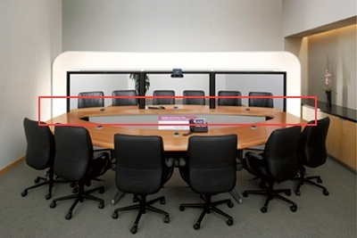

Figure 2 Cisco TelePresence System 3000, presenting the method of using common elements on each "side" of the conference table.

If one looks closer at the picture, , it is noticeable that the middle of the conference table runs directly to the screen, while at the other location the same principle is utilized. In order to create the experience of actually sitting across the table from another person the setup actually helps by the simple variables such as matching furniture, room décor and screen matching the size of a full grown person.

**Polycom** presents it’s “Immersive Telepresence” Polycom RPX HD series with the same basic setup as Cisco but with the, general, difference in the choice of screen. Polycom uses a panoramic view and presents the possibility of the specially equipped room to be used for normal conferences via the gap between the conference desk and screen, see the red marking in . In order to keep the presence element Polycom has chosen to use the same technique as discussed in the Cisco section in order to create extra presence by building a short table at the panoramic screen, noticeable above the red marking in .

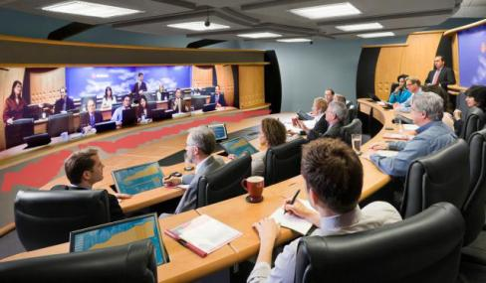

Figure 3 Polycom “Telepresence RPX 400” features the same principal setup as mentioned earlier. This specific product utilizes a panoramic view to create the additional feeling of presence.

**Tandberg** presents their telepresence system much like the other companies mentioned, but with the distinct difference of the method they employ to facilitate the feeling of being present. This is created by using the background and “extending” it to the top of the displays, as opposed by the other companies presented, which mainly use the table as a means of creating the feeling of being present in the same room.

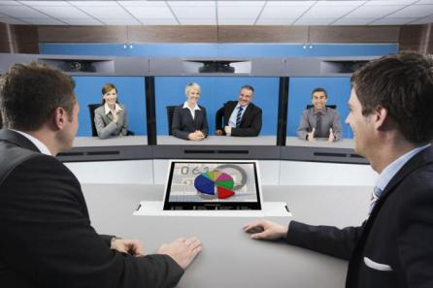

Figure 4 Tandberg T3 Employs the same background on each side of the table but "extend" the background above the screens in order to add to the feeling of presence.

Based upon the products presented here it is obvious that the focus is on displays with the actual size of a man with high video resolution and audio in order to generate the premise for collaboration. When it comes to the actual collaboration the general solution is facilitated via the user’s laptops as a source of information. The presentation of the information, from laptops, is via screens mounted at different locations, it is in this perspective that a clear opportunity of interaction development presents itself.

From the point of working with telepresence and the field of innovative interfaces, implementing further collaboration via sensor technology and HMD is an obvious path to explore in development of a tool to expand the freedom of collaboration and the feeling of presence.

### Interaction

A VR/3D Controller [[7]](#footnote-8) for **PlayStation3** has been prototyped by Sony, to implement the idea of being able to pick up and manipulate objects visible on a screen. The handheld device mainly consists of a vibrator, configured to provide tactile feedback, the ability to capture the degree of the bending of the fingers.

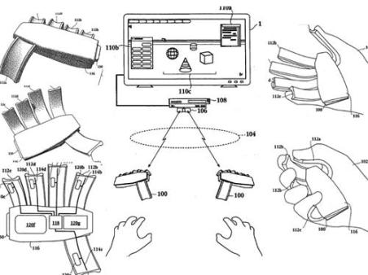

Figure 5 This 3D game controller is designed to be held in your hands, is able to capture all your palm and finger movements and transmit them as commands to your PS3 or Vaio PC. You can pick up and manipulate various objects on screen just by squeezing and relax. Image from

**Immersion**, A company devoted to haptic and tactile feedback products for every aspect of the market, consumer as well as industrial. Their virtual reality product named the “CyberGlove II System” has several additions available for enhancement of the virtual reality experience. The CyberGlove is a wireless motion capture data glove providing real-time digital joint-angle data. Mainly it can be expanded with products such as “The CyberGrasp” or “The CyberTouch” respectively providing resistive force feedback and tactile stimuli to each ofthe fingers.



Figure 6 The CyberGlove® II System, allowing a user to use his or hers hands inside e.g. a virtual environment.



Figure 7 The CyberGrasp™ Exoskeleton allows the user to grab a object in a 3D virtual world and feel the size and shape of the object, this is an addition to the CyberGlove system.

**Virtual Reality Peripheral Network** [[8]](#footnote-9) **(VRPN)** is a set of classes and libraries indented for use by developers. It has been developed by The NIH National Research Resource in Molecular Graphics and Microscopy at the University of North Carolina at Chapel Hill, supported by the NIH National Center for Research Resources and the NIH National Institute of Biomedical Imaging and Bioengineering. The VRPN is indented to be a network interface between servers while providing a connection between application programs and physical devices, such as trackers, sensors and other equipment, attached to a PC.

**Head Mounted Displays** currently today offers the implementation of headtracking, microphone and audio as an addition to the screen(s). Depending on the model of HMD it might have the capability to receive input from an audio/video device with output capabilities, other than a computer where the preferred output source is the USB port.

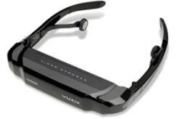

Figure 8 Vuzix iWear VR920 [[9]](#footnote-10), HMD product

A modern example [[10]](#footnote-11) is available from the Inition webpage, as well as from the manufacturer , which also provides an overview of current models[[11]](#footnote-12). A noticeable change is the user friendliness and variety of applications the iWear product is usable with a number of computer games and operation systems.

These examples of ideas and products show the level of commitment with respect to virtual reality and possibilities of interaction as well as customizability making it possible to create innovative systems via a combination of these or similar products. The ability to expand a telepresence system with a HMD and a handheld controller is certainly doable in order to bring the telepresence systems to the next level with respect to interaction possibilities.

## Part conclusion

During the analysis of presence and the theories associated, the overall understanding of why and how different approaches to the same topic are necessary becomes evident from the perspective of Medialogy[[12]](#footnote-13) as a cross disciplinary education combing aspects from humanism and engineering.

Having presented the theories of presence in section on page 8 the main common factor of presence is the possibility to act with the virtual reality. This “possibility” is the key with respect to the cognitive understanding and perception regarding the intention and interaction of an object, See section on page 8 for an explanation of the understanding of the intention of- and interaction with and object. The body schema, section , is also a key component with respect to the mental comprehension and awareness regarding the medium and can be considered a prerequisite to the state where the media becomes transparent.

As discussed as a part of presence, content with emotional relation to the use has been revealed to increase presence on systems with conventional technology as screens or monitors. This aspect has been discussed by Coelho (9) in order to understand presence from a point where technology is not implicit as a part of content and medium.

To gain an overview of the main theories was constructed. It is split into two parts, the top part, consisting of the two boxes with the numbers 1 & 2 along with the sentence “Possibility of Acting in VR” with the number 3 above it. The second part is the progression time line, it represents the phases one must go through in order to achieve presence.

represents the two main approaches to presence and their common denominator, acting. The four main stages are shown in the bottom part. Beginning from the left, represent a combination of theories in praxis and the experience economy employed to create the meaning, interest and reason for why the user is entering the VR. The main user characteristic, interest, is associated with the Pre-Narrative created by the experience economy found at the bottom left corner.

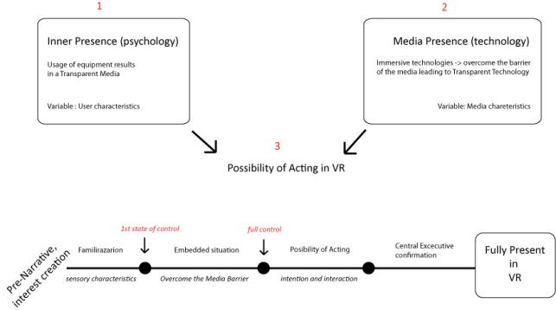

Figure 9 Framework of Presence theories presented from the psychology and technology aspects. Illustration is produced by the authors

The key point from both perspectives on presence, the possibility of acting, is denoted with the number three, marked in red. If one had to, from the user’s point of view, depict the process of becoming fully present in a virtual environment, **Inner Presence** and **Media Presence** must have reached the same goal of transparency. This is denoted as the phase after “full control” is reached.

As stated in the motivation section, relation between psychological theories and a practical application, it is the intention to achieve a system designed to enable users to dismiss the physical state of the interface technology and focus on its intention and the perceptual stimuli. This “dismissal of the physical state” is the foundation of the cognitive experience as a consideration of the presented stimuli, and as a prerequisite to being present in a VE.

Having presented a theoretical framework of the advantages and disadvantages of the method in collecting subjective measures after a VR session, it has become a special interest to us. The argument of Insko, regarding measurement of user behavior, could be solved by evaluating the behavior as a part of the narrative element where certain specific user actions provides a measurable variable if they are considered essential to the progress of the narrative. Along with the disadvantage of questionnaires, incorporating the questions as a part of a narrative presents an interesting approach to collect measurable data while the experience is ongoing.

# Final problem statement

Having presented the considerations about presence and debate divided into psychology and technology the influence on the user is as huge as the size of the debate. Telepresence videoconference is a prime example of how the dominant reality is a state of mind, where the dualism between reality and virtual reality is a psychological result of what is perceived, and evaluated, as real hereby blurring the boundary between the immaterial and the material in the sense of VE and Reality.

The setup of the telepresence systems, including the light, sound and décor, is a good example of how the boundary is minimized greatly; an interest arises when the ability to interact becomes a possibility for the next generation of telepresence systems. When mentioning possibility, ability and interaction, the possibility is in the choices available to be made and the willingness to explore the capacity of the system. To distinguish the term ability, the meaning is with the understanding of the individual’s dexterity with respect to movement as action upon a chosen possibility.

The possibility to interact, and the dexterity of the individual ability, has become a main point of interest and with these points in mind along with the preliminary problem statement of “How do we use knowledge on cognitive processes to understand and construct interaction in VE?” the final problem statement is formulated as:

“**How does the possibility to manipulate objects and collaborate in a Photo Realistic VE influence the presence?”**

The main elements of the final problem statement are formed by the expressions and topics which are outlined by the following working definitions:

**Manipulation of objects:** that the user need be able to see, observe, grab and move all objects in the VE. By this the intention is to design a VE where the interaction possibilities are predefined by tasks. More specific if the user wants to move an object, even if this is not part of the task, the system will allow this freedom.

**Collaboration:** inside the VE there will be another actor present, who has the role of collaborator, helper and interviewer / observer.

**Photo realistic VE:** the user feedback is entirely based on real time audio video stimuli. This is based on the principle known from teleconference systems.

## Delimitation

As other researchers have done to contribute to the presence debate, it is not our wish to provide an interpretation of a comparison between the WS or SUS questionnaires as well as their relation to the TBCA method.

Due to the nature of the experiment haptic stimuli as a feedback is not an element of interest and will not be considered in this experiment and technical setup.

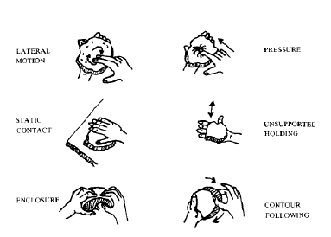

Figure 10 Exploratory Procedures used to recognize objects

The test results are presented in a discursive form based upon observations of user behaviour due to the amount of human factors that can become difficult to analyze at an empirical level. The final data will not be analyzed at a statistical level but where user patterns are visible it will be possible to analyze these results more thoroughly in order to compare and understand the given behaviours.(20)

The amounts of users needed to test the setup and answer the final problem formulation are limited to a visible trend line provided by the data results.

## Hypothesis

* If the users are able to adjust to the VE they will be able to control and understand the affordance of the system.
* If the users are able to abstract from the technological limitation of the system they will be able to clarify their experience while the test session is in progress.
* Can one document that the sense of presence is a function of the interconnection of the users’ proprioceptive knowledge and the visual representation of this in the VE.
* By collecting the users’ opinions while being interviewed in a VE it will be possible to gather better subjective and specific answers about their definitions of “sense of presence” during the test experience.
* The users’ sense of presence can be understood as they will not be present in the VE but the VE is part of their reality in terms of whether the technology is not noticed but used or it is noticed and used for its purpose.
* When performing a task is it possible that the user takes little, or no, notice of the virtual representation of his arm because the arm representation become, in that state of mind, a tool to be used for a task and not a body part?

# Research

This chapter concerns human computer interaction and related theoretical fields of Interaction design informed by activity theory, postcognivist theory, distributed cognition, actor network theory and phenomenology theory. These theories are individually compared with each other to provide the reader with an understanding, not only of the theory but the relation to other aspects of HCI.

## Psychology of HCI

We observed that the development of multiple theories, which associates different studies backgrounds, provides opportunities and different angles of approach in the study of human-computer interaction (HCI). In order to convey a more proper definition and association of these theories, the intention is to weight the psychological or humanistic approaches of HCI design. The main focus is devoted towards interaction design informed by activity theory. Afterwards the chapter extends the description to postcognitivist, distributed cognition and actor-network theories and eventual connection in between these. The last topic in this research considers the human phenomenology in relation to HCI approaches. The topic is more a critique, questioning the development in the field, where the usage of computers in every day action assumes a dueling position. Each theory contributes with a unique set of perspectives and concepts.

A novel approach in the developing of HCI is that the user experience will be different as the systems which he interacts with become more aware of the context of the interaction. Considering the context as information about who is involved in the interaction and what they are trying to accomplish. This can be done by capturing and acting on information about the situation in which an interaction takes place. In this scenario systems will be able to make broad use of personal information to guide the interaction in the particular user-task context (21).

Just as in human-human interaction, knowledge of who someone is interacting with is a key part of the context of HCI. By understanding the context, according to Karat (21), it is possible to shape the interaction and contribute to the determination of appropriate responses.

But understanding all of what goes into the context of an interaction between two people (or between a person and a machine), is a daunting task. It is simply not possible to know how to capture all the information in a context that is relevant to an interaction. In fact the belief of making systems more intelligent will largely mean making them better able to respond intelligently to specific people and situations based on information contained in a wide variety of context elements (e.g., who, where, and when in an interaction), and the thought is aimed towards building on the “who”, in the simple informal context become central to success (21).

Obviously there are many possible approaches to collect information about context, and then using it in interaction. For example, information about a user can be either explicitly gathered or implicitly obtained.

Broadly speaking, it is possible to use any information about the user to alter the content presented. This can be done by remembering what the user did the last time he used an application or identifying where he was, providing information specific to that location. The management of these present possibilities for personalizing interaction, through use of the context information of previous use and physical location, is to a great extend in use nowadays but still framed in a rigid and predefined design. The difficulty is not in seeing that context can be useful in interactive system design, but in deciding what elements of context might be important, and how to respond to them appropriately (21).

While there has been a fair amount of research aimed at enabling systems to adapt interaction based on some understanding of the user, prior work has only examined narrow contexts. Currently, most interactions with computers take place between a system that understands little of the particular user and individuals who have limited understanding of the system or application.

Over the last few decades, the general population has developed more complicated conceptual models of human interaction, while the technology has made relatively small progresses in relation to the understanding of humans in the act of interaction with a machine. Meaning that, there is no general model of the costs and benefits users consider when deciding if they might want to relate information to a system, and no general model to guide developers in making decision concerning how to personalize interaction with a particular system (21).

The assumption is that, the value of personalization varies over individuals, use context, and personalization approach or techniques aiming to understand the nature of this variation. The proposal would be to collect information on the value of personalization for a range of contexts and to develop a model to capture our understanding of the relationships between the entities involved.

To solve the challenge new studies in the field of HCI bases its development on the aspects and mechanism of human psychology. Each theory incorporates technology in its own way while sharing common ground (22):

* **Activity theory**[[13]](#footnote-14), has as key principle is tool mediation.
* **Distributed cognition**[[14]](#footnote-15) theories views cognition as distributed across people and their tools
* **Postcognitivist theories**[[15]](#footnote-16) are highly critical of the mind – body dualism, in the meaning of without the mind there can be no body.
* **Actor-network theories**[[16]](#footnote-17) specify the agency of technology— the way things (such as machines) are agents in their own right, interacting with humans in actor-networks.
* **Phenomenology** theories suggest that we understand thinking as derived from being, that is, ‘‘being-in-the-world,’’ including the tools in the world.

In general the theories that approach the psychological aspects of interaction design consider as vital point the role of technology in human life.

It can be complicated to differentiate these theories from each other in the field of HCI development; because some theories are a combination of others. These have more or less similar elements (tools, action, and perception) forming the theoretical concepts. The differences in the theories are more visible if the focus is on the theory elements, rather than the theory itself, and the relation to the human factor, the definition of this, and the to the concepts of **intentionality** and **activity**.

According to Kaptelinin and Nardi (22) the interpretation of **intentionality** lies in the cultural aspect of communication which implies the capability of imagining, planning and tool use, forming the basis for understanding intentionality. The interpretation of **activity** refers upon the notion of needs and motives. The result of acting upon needs, to an object becomes a motive requiring a subject’s activity. This creates the fundamental notion of activity theory, having needs and objects as motives for activity.

These interpretations combined with theories earlier mentioned the development of HCI to a specific media can provide the additional means of interaction and define how it is possible to design a personalized user experience.

**Interaction design informed by activity theory**

The notion of activity theory research focuses on the understanding of the prospects for using theories as a tool for the analysis and design of concrete technologies for HCI. With the introduction of activity theory to interaction design it became possible to reframe key concepts to include topics of transparency, affordance, and direct manipulation (22).

A key theoretical contribution of activity theory to HCI was an extension of the field’s scope of analysis and subject matter. In activity theory, the use of technology is embedded in meaningful context not limited to information processing but has to operate at several levels that have to be integrated in the final objective. Along with other postcognitivist approaches, activity theory is instrumental in reformulating the general objective of HCI. Where other approaches are predominantly concerned with conducting laboratory studies aimed at revealing the underlying mechanisms of human information processing which, according to Kaptelinin and Nardi, are basically the same regardless of who is interacting with technology.

Activity theory employs these mechanisms in user interface design; as a mechanism that have to be understood as interfaces and interactions which has to deal with specific meanings and contexts of technology use in everyday life. Activity theory considers technology as a **mediator** between human beings and the world, rather than a pole of interaction.

This brings to light new important issues that can be identified by three aspects of user interface that should be taken into account in design (22):

* **Physical aspects** (operating with a device as a physical object).
* **Handling aspects** (the logical structure of interaction with the interface)
* **Subject– object-directed aspects** (how objects ‘‘in the computer’’ are related to objects in the world).

The emphasis on the role of technology within the entirety of meaningful, purposeful human interaction with the world revealed limitations of purely cognitive analyses. According to Kaptelinin and Nardi (22) computer users are not “*just information processing devices but individuals striving to achieve their goals. Their interests, emotions, hopes, passions, fears, and frustrations are important and powerful factors in choosing, learning, and using a technology.”* Activity theory provides a coordinated description of the use of technology at several hierarchical levels at the same time, and thus opens up a possibility to combine, or at least coordinate, analyses of different aspects of the use of technology, such as physical interaction, conceptual interaction, and social ‘‘contextual’’ interaction. These aspects, considered to be different levels of analysis, are traditionally studied by different disciplines (respectively, psychophysiology, cognitive psychology, and sociology or sociocultural psychology).

To guide design effectively, requirements and considerations originating from different levels of analysis should be integrated into a coherent set of system requirements. Activity theory offers a conceptual framework allowing vertical integration of different levels of analysis. The underlying principles of activity theory are used to reconsider some of the most central concepts of traditional HCI, including concepts of transparency, affordance, and direct manipulation (22).

* **Transparency**: has traditionally been considered a key aspect of user interface quality. Typically, its meaning is indicated by describing what it is not, as a lack of distractions caused by the user interface itself. Transparent interaction is an interaction in which the user can focus on his work, while the system remains ‘‘invisible.’’ Therefore, user interfaces can be called ‘‘transparent’’ in a metaphorical sense, which is related to attention rather than perception. The notion of transparency implies that users are not aware of the system, not that they do not actually see it. According to activity theory, individuals are aware of their actions, while routine operations are carried out automatically without interfering with conscious processes. Therefore, transparency can be accomplished through skill automatization, meaning the transformation of actions into operations. Transparency is not a fixed property of a system; almost any user interface, provided that sufficient time and effort is invested by the user, can become transparent. In other words, transparency cannot be ‘‘built’’ into a system. However, the outcome— whether or not an interface is transparent— depends critically on concrete users in concrete contexts of use.
* **Affordance:** is a concept which has created much debate in HCI. The concept commonly understood according to Kaptelinin and Nardi, is that affordances are the possibilities for action provided by the environment, and that these *‘‘exist relative to the action capabilities of a particular actor’’.* Discrepancies between individual interpretations of ‘‘affordances’’ emerge when different theorists assign different meanings to terms such as ‘‘actor,’’ ‘‘action,’’ and ‘‘action capabilities.’’ There have been several attempts to address the issue of affordances from an activity theory perspective. These analyses articulated a few ideas that may help avoid a narrow understanding of ‘‘action’’ and ‘‘action capabilities’’ when developing a conceptually consistent view on affordances. The meaning of ‘‘action’’ in activity theory includes much more than motor responses dissociated from perception. Perception is an integral part of human interaction with the world. Where the possibilities for action in these contexts are apparently determined by culture. Therefore, conceptual similarities between activity theory and affordance help to contextualize the concept in interaction design. Another way activity theory based analysis has contributed to a conceptual exploration of affordances was through exploring the differences between mediation and learning and its view of human activity as hierarchically organized. Affordances are typically interpreted in terms of low-level manipulation with physical artifacts e.g. keyboards. Therefore, the concept is limited to the level of operations or ‘‘operational affordances.’’ Operational affordances indicate which operations can be carried out with the objects at hand. However the concept can be extended to levels of actions and activities, as well. From an activity theory standpoint, the notion of affordances needs to be extended to human activity as a whole, not just the level of operations.
* **Direct manipulation**: is another fundamental concept of traditional HCI that was revised within the framework of activity theory. The concept of direct manipulation and most common examples are the WIMP (windows, icons, menus, and pointing) interfaces and can be considered one of the most astonishing technological successes in history. This success capitalized on human abilities to act with objects in the physical world, perfected through millions of years of evolution. In the late development of HCI direct manipulation incorporates tangible interfaces where artifacts or tokens and their combination or association provide different inputs and outcomes.   
  The suggestion is that integration of the principles of direct manipulation in new user interfaces designs , namely has to cover the following considerations:

(a) Continuous representation of the objects of interest

(b) Physical actions instead of complex syntax

(c) Rapid incremental reversible operations with immediate feedback

(d) Spiral learning.

To summarize; interaction design informed by activity theory describes that individuals engage and interact with their environment, and the production of tools is the results. For many years, these principles, and the underlying vision of direct manipulation as the ideal user interface, were rarely challenged in HCI research. In both physical and virtual environments people employ ‘‘instruments,’’ such as hammers and screwdrivers, or scroll bars and toolbars, when performing operations on things. Driving a screw into a piece of wood is typically accomplished not by pressing and turning the screw with bare hands, but by applying an effort to a screwdriver, which, in turn, produces the desired effect. Similarly, scrolling a document is accomplished by controlling a scroll bar, which, in turn, makes the document scroll.

**Postcognitivist theory**

Postcognitivist theory address the primacy of tool use and human experience and via this facilitates the understanding of why technology is central. These theories supply the possibility of an alternative to other areas, such as psychology, where technology is almost invisible as the result of a determination of describing human experience and capabilities universally.But as a main aspect postcognitivist theories focuses on the **body-mind dualism** view on technology and the network with humans. The relationship of these elements is the, simple, dynamic relations between cognition and the external world consisting of other people and objects. The simplicity of this approach seems insufficient, at least in consideration of HCI development and creating criticism in the research areas. But if the consideration should include an expanded view on the body- mind dualism relationship with technology and networks the complexity of the notion will escalate radically. In fact, the external influence effect is determined by the subject and not by the influence, meaning that the subjective view and understanding is utterly dominating (22).

**Distributed cognition**

Distributed cognitiondefines cognition as a system, distinguished as two parts, dividing the distribution between human and tool. The difference between activity theory and distributed cognition rests with the view of what a system consists of. In activity theory, the system is humans mediating with tools, created for a purposeful and intentional activity. In distributed cognition tool use is connected to cognitive purposes via their representation as functional properties. So the aspect of a system is the intention of tools and the cognitive understanding of the tool properties as a means to mediate information and solve problems. Tool mediation was one of the most important discoveries, uncovering that, over time, persons stop using meditation tools in problem solving but maintain the same level of performance when returning, showing a developmental change on the individual level. From the point of distributed cognition, and actor network theory, the system regards individuals as components, depriving them of the unique status. There is a difference between the goal of the system and the goal, or intention and needs, of an individual. This view sets a clear gap between the theories while underlining the important point, in favour of activity theory and phenomenology, that “*humans must be dealt with as motivated individuals*” (22).

**Actor-network theory**

Actor-network theory views human and tool as two parts of a network claiming that segregating the two cannot be done, as it is the view of distributed cognition. This network theory is founded on the concept of any node can perform with another type of node; this is referred to as symmetry in this context. The activity within the network is signified by the focus on agency and cognition as a way to explain the fundamental unity of the mind and the world. A network which contains both people and objects is described as heterogeneous. Distributed cognition defines a network in an entirely different manor than the phenomenology theory. A network, or system, is defined as heterogeneous because the symmetrical node is treated similar, regardless of being human or nonhuman (22).

**Phenomenology theory**

Phenomenology theory relates the mind and the world as a unity bound by the requirements of tool usage. This relates to the topic of tool use in a phenomenological approach showing diversity as a meaningful activity engages a human subject in performing a task. This meaningful engagement of tool-concepts is categorized as “ready-to-hand” or “present-at-hand”. “Ready-to-hand” is defined as when the subject has no conscious awareness of the tool but uses it to accomplish a task; also kwon as transparent media or transperancy. If a problem occurs or a focus shift, then one has to give attention to the tool, becoming consciously aware of it. Retaining a commitment to the individual is the point of activity theory and phenomenology, maintaining a contextual understanding. The relation between communication and collaboration, in a social context, is the fundamental basis when having to understand the human relationship to technology. Individuals are part of a larger system, though still with their own needs, reasons. This goes beyond any activity because individuals reflect, and understand, their actions based on the collective system activity. This does not mean that humans can be condensed to a small part of a large system, as it is the human who makes the nature and meaning of the larger system, society, demonstrating the importance of the individual needs, though the motivation is influenced by culture (22).

According to Turkle (23) the culture that we are living in, invites us all to interact with computers in ways that permit us to become close with their second nature. And as this happens, the relationship between people and machines that we have seen in the computer subcultures becomes the precursor of new tensions and the search for new resolutions that will mark our culture as a whole.

The desire for fusion has its echo today, although in a new and troubling form. Instead of a quest for an idealized person, now there is the computer as a second self. The images of the computer offering a new expressive medium and of the computer offering a “schizoid compromise” between loneliness and fear of intimacy are representative of the encounter between the machine and our emotional lives (23)

According to Turkle along with this encounter comes another: between computers and our philosophical lives, in particular our thinking about human nature. Because they stand on the line between mind and not-mind, between life and not-life, computers excite reflection about the nature of mind and the nature of life. *“It calls into question our ways of thinking about ourselves: most dramatically, if mind is machine, who is the actor? Where is responsibility, spirit, soul? There is a new disorder”*(23).

Turkle mentions that even those who accept the idea *“that as humans they are computers”* find ways to think of themselves as something more as well. Now the computer culture, like the psychoanalytic culture before it, threatens the very idea of “self.” The computer’s threat to the “I” is in many ways similar, but far more persistent. The computer takes up where psychoanalysis left off. It takes the idea of a de-centered self and makes it more concrete by modeling the mind as a multiprocessing machine. According to Turkle a resistance to the idea, of the unconscious and the irrational, leads to an alternative view of people as essentially logical beings. Where a resistance to a computational model of people as programmed information systems leads to a view that what is essential in the human is what is overwhelming, unable to be captured by language or formalism.

The use of information-processing models used to explain larger and larger slices of our behavior seem to force and isolate our “core” in something that is possible to think of as beyond information. This notion is mentioned in Weizenbaum’s assertion: *“the human is unable to be coded, or no matter how perfect, a computer simulation of thought is not thought, because the computer will simply be following rules that “it” does not understand”*(23)*.* No matter what a computer can do, human thought is something else according to Turkle.

Thoughts are the products of our specific biology, the product of a human brain, meaning neurons and the chemistry of the synapses. The computer makes a new contribution along with a new necessity; it provides a new discourse for describing the divided self. On one side is placed what is possible to simulate; on the other, that which cannot be simulated.

People who say they are perfectly comfortable with the idea of mind as machine agree to the idea that simulated thinking is thinking, but often cannot bring them to suggest further that simulated feeling is feeling. The concept of synthetic feeling as “indescribable” is mentioned from people who have and accept the technology, not by those who are fleeing from it (23).

The computer gives support to those who see human psychology in mechanistic terms, and also, in a paradox that is increasingly important for our culture, it is a point of reference for those who place greatest value not on rationality but on affect. According to Turkle *“we surrender to the computer the power of reason, but at the same time, in defense, our sense of identity becomes increasingly focused on the soul and the spirit in the human machine. Computers, with their interactivity, their psychology, with whatever fragments of intelligence they have, now bid for this place”*.

The hard to-live-with, self-contradictory notion of the emotional machine captures the fact that what we live now is a new and deeply felt tension. One thing is certain: the riddle of mind, long a topic for philosophers, has taken on new urgency. Under pressure from the computer, the question of mind in relation to machine is becoming a central cultural preoccupation (23).

# Design and Implementation

This chapter focuses on prototype design, describing how one could apply the researched theories to an interface. The intention is to relate the techniques of creating telepresence to the psychological understanding of mirror neurons. This incorporation is implemented to expand the possibility of interaction to include elements, within a telepresence setup. At the psychological level it is the intention to use presence elements along with the technique of mirror neurons to facilitate the human test participants to easily accept the technological part of the interface. The key elements and functionality applied to the design of the interface will be described and illustrated to clarify the elements and technologies used in the test session.

## Theories Implementation

Our interface prototype is intended to overwrite the stimuli from the physical location with photorealistic visual stimuli and environment sounds from the remote location enabling an experience of presence. As described in the part conclusion on presence, see section , presence or telepresence is a state of mind rather than a mechanism to be turned on or off. As illustrated in the SOTA chapter it’s possible to create a design on how to structure a teleconference room allowing users to reach telepresence. The issue with these systems is that the users still will be bound to their physical place according to the fact that physical interaction with objects in a remote location and haptic feedback is not available. The innovative thought in this project is to attempt to “break through” the user’s physical displacement in a location by creating the illusion, for the participant, of being able to interact with physical objects and with a person in a remote location, visually presented as a photo realistic environment. The illusion is created by applying the knowledge gained from the presented research, as well as experience previously gained. The key theory elements implemented in the interface and test scenario are based upon Interactionism and Activity theories.

**Interactionism and Activity theories**

In this context the implementation of the prototype interface employs the mechanisms of HCI. The main implementation of the activity theories focuses on how the participants interact, not only with the interface but also with the person present at the remote location, referred to as an interviewer. The test’s embedded narrative will allow the observation of the participant’s ability to fulfil predefined interaction schematics designed to allow both the guidance and follow the participants during the test(s).

The intention is to record and analyze the movements of the user and the relation to the movement in VE at a level of dexterity that the system is able to map. The movements of the test participant are defined as the interaction with objects but also with the interviewer. This last point can only be based on observation with emphasis on the role of technology as a mediator within the entirety of meaningful and purposeful human interaction revealing the limitations of purely cognitive analyses.

**Breaking the context**

As described in the test methodology, chapter , the test participant will at first be approached by us outside the test lab and then enter the room where the interface is situated. When the test participants enter they will encounter a theatric scenario that is far from the “normal” laboratory test and not expected see page 46 for a conceptual illustration. The scenario is constructed in order to pull the participant out of his/hers everyday context. By previous experience it is noted that utilizing this method, the participants’ willingness and engagement during the test session is enhanced, to satisfy the need to provide meaning to the situation. A concept schematic of this method is illustrated in .

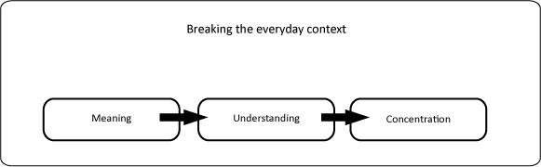

Figure 11 Breaking the everyday context, the phases an individual goes through

The method encourages the curiosity in the test by constructing narrative elements which aims to be related to the entire motivation and intentionality of acting for the user. The next step, in close relation to breaking the context is when the participant is connected with the interface. It is the intention, at this stage, to provide the user with visual feedback representing a normal environment, collapsing the participant’s expectations. This is due to two different aspects of the test, one more ephemeral to reinforce the out of the context concept, meaning that the user will again be disoriented and in the need of providing meaning to the situation. The other aspect is due to technological limitations described in the design section.

**Peripersonal and extrapersonal space**

We are aware of the ongoing debate on this subject and chose to relate to the position of tool use extends peripersonal space. These considerations are partially founded by the researches on the topic, where the debate on the effect that tool use has on peripersonal space and the possible extension, or the remapping of the extrapersonal space to be a part the body schema(11). The validity of these considerations has yet to be answered (12), see section for a more detailed presentation of the debate and definitions of peripersonal – and extrapersonal space.

In compliance with our stand on the topic of peripersonal – and extrapersonal space, we assume that it is possible to displace peripersonal space in the VE via our interface. The participants, when interacting with the interface, will operate in a VE resulting in the extension of their peripersonal space. They will be able to manipulate and interact with physical objects in a VE, becoming this, their extrapersonal space in the Real Environment (RE) but their peripersonal space in VE.

Explained at a conceptual level where our understanding and the theory is implemented, an illustration of the conceptual system with users and their respective peripersonal and extrapersonal spaces are shown in along with the assumed displacement of space.

**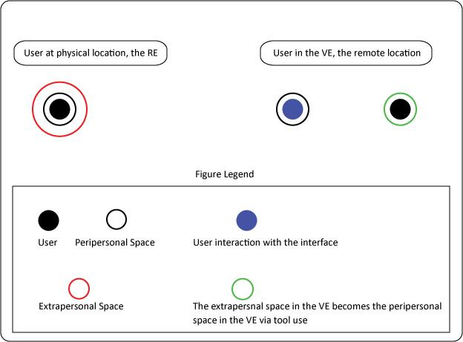**

Figure 12 Conceptual illustration of the interaction space in RE and VE

**Mirror neurons theories.**

To recreate the hand and arm movements of the participant when they interact with the remote location it is our intention to place a person at the remote location to mimic the movement of the participant. How this is done and how the mime will be able to mimic the movement of test participant is illustrated and described in the design section . This is in order to trick the participant’s mind to have the illusion of seeing their actual movement through the screen providing the visual feedback.

According to the “mirror neuron” theory when a person sees another person grasp an object he or she will activate the exact same neurons as the grasper. The interface is implemented by mimicking the test participant’s movement. This will for the user reinforce the mirror neuron mechanism allowing a higher activation threshold of the neuro-activities for the grasping and over all peripersonal sensation. This is on a theoretical base and cannot be proved more that on an observation level none having an opportune measuring device (fMRI scanner) able to measure the participant’s brain activity. The test participants will not be aware of the mime, at the remote location, during the test session.

**Stimuli**

Based on previous research the perception of one’s environment is based on the stimuli processed about the given space. By this process, and previous experience from the space, one forms a complete representation about the world and space in which one is present, relying on the Umwelt[[17]](#footnote-18) as ones “self experience of the world”(24). This representation is the result of the process of stimuli, weighted and based upon what is known, or unknown, depending on the situation. The modalities, cognitively weighted to the situation can normally be arranged in a hierarchy with visual stimuli as the dominant, auditory, haptic stimuli and so forth as secondary to vision. This is understood in terms of the fact that humans rely on the weighing of all modality stimuli to form a complete representation of the Umwelt, where the vision is the one which is relied upon heavily.

The subjective knowledge of the environment itself Fagioli, Couyoumdjian and Ferlazzo (25) investigated the representation of space, being dynamic and created accordingly to the cognitive load and demands of the modalities. Explaining this understanding Fagioli et. al states that the representation of space is based upon past modal stimuli as well as current stimuli and the representation must be considered accordingly. The representation and knowledge of a known environment is then processed more fluently compared to an unknown one. In some cases this difference in fluency results in perceiving a space as smaller or bigger. The multimodal representation of space is continuously updated via the stimulus perceived, according to the results of Fagioli et. al. This means that the perception as “big” or “small” can change by experience as the cognitive load is reduced when one becomes familiar[[18]](#footnote-19) with the stimuli of the environment.(26)(27)

## Design

### Conceptual Design

The theories presented so far, can be summarized as an intention of the conceptual design to develop an interface allowing the user to break the physical barrier of a system, limited to visual interaction via a telepresence system, as seen in teleconference systems.

The focus of the concept is to enhance the freedom of the user movements allowing the possibility to completely interact with the physical elements of a photorealistic VE. This means that the user will be able to interact with objects and persons of the VE as in real life. In order to make this possible the solution lies with the connection between the real world and the VE.

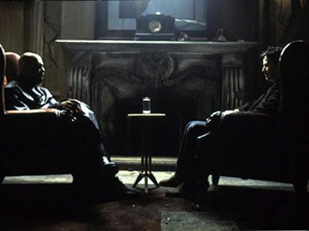

**Figure 13 A fitting example of the situation of interaction with another person, while physically being in front of a screen but mentally present in a virtual dimension. This shot from the movie "The Matix" conceptualizes the idea of meeting in the VE while having the possibility to suspend disbelief and interact, changing the dominant reality from the physical world to the virtual.**

The conceptual idea of the connection between these two worlds is to have a person in the VE which copies the hand movements of the user situated in the real world. To simplify the concept of the user situated in the real world and the one of the person situated in the VE (the mime) we refer to the situations respectively as physical and remote locations.

The issue in this concept is to control the movement’s degree of freedom provided by the user to the mime. Expanding the degree of freedom in a teleconference system, the concept is to implement the possibility of having a 360 degree field of view, immersing the users with the ability to move and act within the teleconference, not limiting the participants to watch a screen.

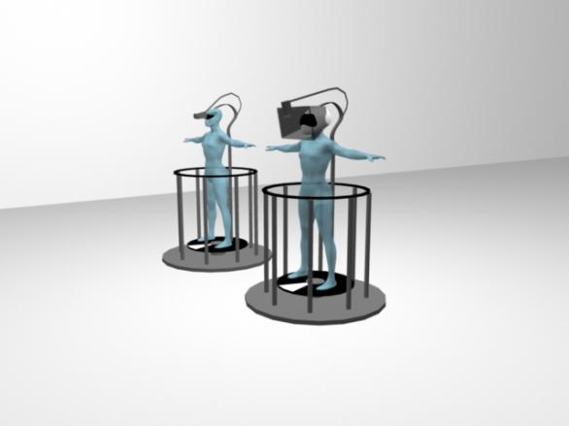

**Figure14**: **Conceptual design illustrating the interface where the user is situated to the right and the mime to the left. In the illustration it is possible to see that the platforms of the user the mime are surrounded by a railing that is both needed for security so the user don’t falloff and so the user can grab it with his hands it order to spin around his self.**

### Interaction Functionality

We will introduce how the setup functions technically, present conceptual visualization of the functionality to provide an understanding to the reader who hasn’t been able to see the setup in reality.

**Audio Visual Input**

The key purpose of the elements, of the interface, is to overwrite the visual and auditory stimuli from the user’s physical location with the stimuli from the remote location and in addition to allow free body movement. This is done by dividing the interface in two platforms, connected with each other. One platform represents the physical location interface, being the one the user interacts with, and the second platform represents the remote location.

**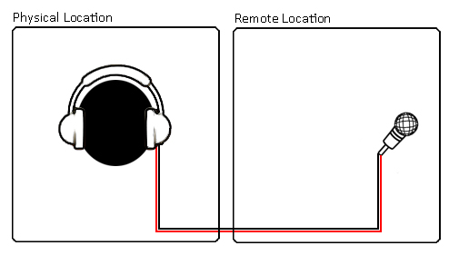**

Figure 15: Audio signal transmitted from the remote to the physical location.

At the remote location the interface has a video camera mounted which provides real time visual input to a screen placed at the user’s platform. The auditory stimuli will be collected by microphones and in real time and also be send to a pair of headphones at the user’s platform. Fig. XX displays how the visual and auditory stimuli is send to the physical location from the remote location by the technique known both from teleconferencing but also from direct television transmissions.

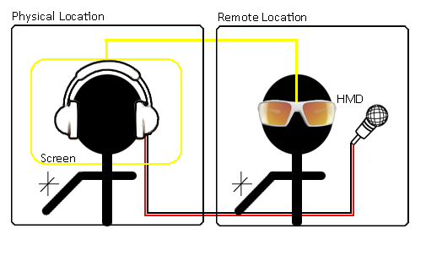

Figure 16: Audio video signal transmitted from the remote to the physical location.

The next step is to allow the user to interact with the remote location. The person miming the user will receive the input of the user movement via a set of HMD where the input is provided by the downward facing video camera mounted in front of the interface screen of the user’s platform. With this scenario the camera will be able to record the movements of the user arms, providing the video signal in real time to the HMD. The HMD will allow the mime to match the user’s hand and arm position. FigXX illustrates the set up with the person in the remote location and camera set up, so far allowing only interaction with the space in front of the user.

**Transmission of body movements**

In order to achieve full embodiment in VE the user must be allowed to move his body in the physical location. But this capability has to be replicated at the remote location presenting a problem of having the mime match the user’s degree of freedom. Furthermore the entire set up has to follow both the user and the mime, a difficult task due to amount of movements and technical limitations.

The solution to this problem is to limit the user’s degree of freedom to the rotation of the Y-axis and transmit this rotation to the mime. The platform’s rotation, of 360 degrees, will be mapped to the mime’s platform allowing, the mime, to focus on matching the user’s hand and arm movements while simultaneously allowing the user to interact with his peripersonal space from 0 - 360 degrees from his position.

The alignment of the rotation between the two platforms is mechanically implemented by connecting the two with a wire, as conceptually illustrated in , an image showing the implementation can be viewed in .

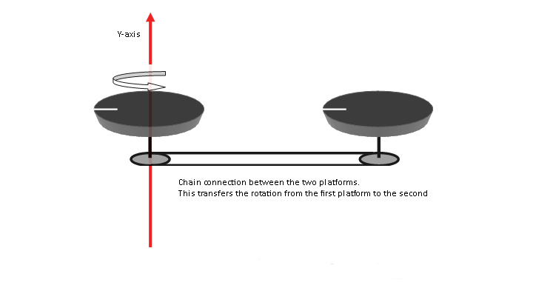

Figure 17 Conceptual illustration of the connection between the two platforms enabling duplication of the rotation from one to the seccond

**Head and body constraints**

The platforms solve to a great extend the method of limiting or controlling the user’s degree of freedom while still preserving the possibility to move and transmit the action to the remote location in real time. But the implementation of the platforms does not fully resolve the issue of eventual body torsions as well as head movement. To solve these issues the thought is to constrain the user’s body to a structure mounted on the platforms and have the users wear a helmet. The structure which supports the helmet, screen and video camera is conceptually illustrated in .

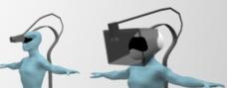

**Figure 18 Close up of the mounting structure supporting the Helmet screen and video camera, conceptual illustration**

The inclination of the helmet is close as possible to the natural inclination of the head when a person interacts with something in front of him. The helmet is customized with headphones transmitting the audio signal of the microphone at the remote location. In front of the helmet a screen is mounted that transmits the video signal from the camera at the remote location. The area from the screen to the helmet will be sealed, to reduce visual disturbing elements form the physical location that can perturb the feeling of presence of the participant in the VE.

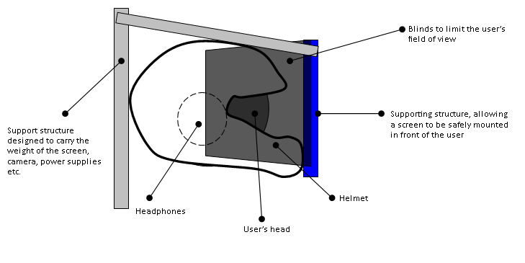

Figure 19 Conceptual setup of the user with helmet on, sitting on the chair while looking at the screen mounted on the support structure.

An illustration of the helmet in shown in the implementation of the helmet will filter as well as isolate the user from the physical location allowing a more fluent processing of the perceptual stimuli provided by the remote location.

Considering all the elements in the conceptual setup, depicted in , it is possible to transmit the information from the physical location to the remote one. The result of this is that the user’s perceptual experiences will be crossed between the physical and remote location. But taking into account how the user interacts with the system, it is clear that the interface do not allow a “natural use”, according to hand interaction. In fact, the user’s mental interpretation of the sensory representation is different from the proprioceptive knowledge. This presents the issues of evaluating, not only audio visual stimuli from the remote location with the body at the physical location, but also the hands positions. In fact in order to provide a spin with the platform the user needs to perform an action on the railings. Consequentially   
the user’s hands are used in both locations with totally different interaction tasks, creating interaction difficulties and reinforcing the perceptual differences from the two locations causing interference with the user’s sense of presence.

This means that the laws of physics from of the real environment will overwrite the ephemeral or non existing physics of the VE. Keeping in mind that the system can become complicated to operate, the resulting interaction difficulties would become more distractive than utile.

Iterating on the problems, the conceptual system design in is modified to a system based upon two chairs, each customized to support the necessary equipment and duplication of rotation. The implementation of the office chairs will allow the user to be seated and have a natural interaction in the spin situation by permitting the spin around the Y-axis by legs movement. This avoids the perceptual cross between the physical and remote location while allowing the user’s hands to remain free for interaction in the VE.

This implementation resolves the majority of our problems, integrating a common usage of an “office chair” the user’s experience does not become subject to flow interruptions, allowing easier familiarization with the interface, facilitating the understanding of its mechanism and usage. Allowing the user room to focus on what is possible to do with the interface and simplify the knowledge needed to comprehend the capabilities of the system and intended use. These parameters are fundamental in order to achieve an eventual sense of presence.

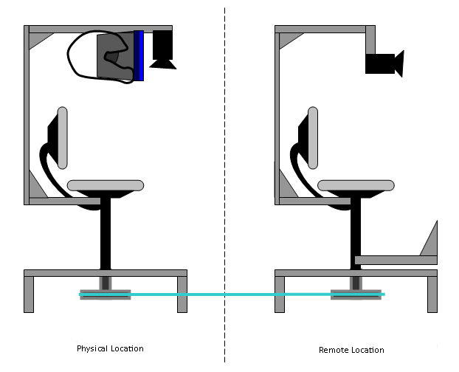

Figure 20 Conceptual illustration of the customized chairs at their respective location.

As illustrated in thetwo chairs are customized with the helmet, screens and video cameras. The mechanism that allows the chair rotate is extended through a wood panel, see .

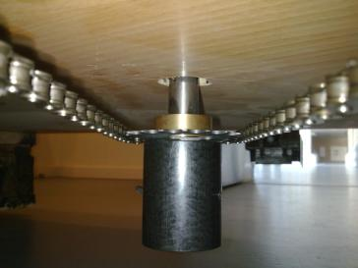

**Figure 21 Picture of the implementation of the chain connection between the two platforms, allowing duplication of rotation.**

The wood panel is elevated from the floor to where the users place their feet at the physical location. This permits the user to use his legs to perform spins as it is usual for an office chair. Under the wood panels the transition, between the two chairs, is located. With this set up the user will be able have full freedom of movements of his hands and arms as well as 360 degrees of rotation allowing a free exploration and interaction in his peripersonal space.

### Contextual narrative design

As mentioned in the implementation, section , it is important to bring the user out of his everyday context during the test session. The approach is a combination of providing proper expectation to what will occur during the test but also to encourage the user’s willingness to participate. To implement this concept it is divided into two phases, outside and inside the lab.

* **Outside the lab:** in this phase the objective is to gain knowledge about the user’s experience and opinion of VEs and telepresence systems. This knowledge is obtained by asking a series of questions about the topic. The questions are as follows:

**What do you know about teleconference?**

**Have you tried use a teleconference system?**

**What do think about this technology?**

**Do use web-cameras to communicate with other people?**

The intention is to conduct this interview while walking with the test participants to the lab. Our behavior towards the test participants will be inquisitive and interested in the manner of a normal conversation.

Upon entering the lab the conversation will change to the narrative fasion by introducing this to the participant. This part of the test is described as follows:

* **Inside the lab:** Enter the lab the test participants will be introduced to the narrative. The point of the narrative is to motivate the individual and reinforce the experience with a narrative explaining why we need them and what their task is. Via the narrative we will inform him of important system rules via the narrative. The narrative is, shortly, described as that the former test participant is trapped in the system because **he moved too fast**. Theresult of moving toofast **broke the communication box, used to exit the VE.** The test participant **needs to help the former user by locating him in the VE and find the pieces of the control box out of his reach.** The first thing that the participant has to do is to establish contact with the former user and **he will instruct how to collect the pieces and how to** **assemble the control box.** At this point we will ask the participant to be seated at the interface.  
  There will be no explanation of what the device can do or its purpose until the participant has entered the VE.

When the test participant is seated at the interface we will turn it on. At this point the test participant will see and hear what happens at the remote location. This stage is where the data collection starts. The task that the test participant has to complete is divided in different phases, presented in . Within the VE there are one control point, three objects, one tool and an interviewer. The user has to interact both with the interviewer and objects in the VE, these interaction possibilities are designed with different levels of difficulties with respect to the type of interaction which as to be done in order to retrieve the objects.

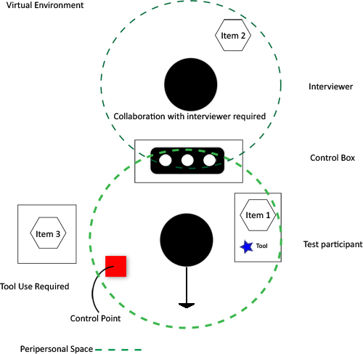

**Figure 22 Task phases in the VE and interaction elements positions. The two black dots represent the test participant and the interviewer. The grey squares represent tables where objects relevant to the test are placed. The black box with white dots represents the location of the control box. Item 1 is to be picked up by the user himself, item 2 has to be retrieved by collaborating with the interviewer and item 3 can only be retrieved via the use of a tool, marked with a blue star in this depiction.**

The six different phases which the user goes through in the duration of the test are described below; please consult to obtain an overview of the setup and the location of the items used in the different phases.

**Phase 0:** “Ability to use the legs as a part of the interface” phase. The test participant is facing in a direction where he is not able to see the interviewer. This is depicted by the black arrow in . The objective of this phase is familiarization and movement. As a part of this, the interviewer will introduce himself to the user, asking him to locate the control point, represented as a red dot (The control point is marked as the red square in ).

**Phase 1:** “Awareness of movement possibilities” phase**.** In order to accomplish the location of the control point, the user has to point at the red dot. If the user does not do this he will be asked to do it by the interviewer to introduce the possibility of using the arm.

**Phase 2: “**Interaction w. Interviewer & Embedded situation” phase**.** The interviewer instructs the user about the control box and the search for the missing pieces, see for an illustration. The sequence of returning the objects is green, yellow and red, corresponding to the action of grabbing, collaborating and employing tool use.

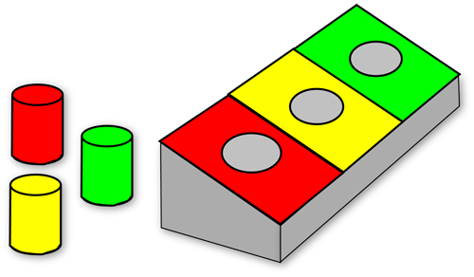

**Figure 23 The control box with the objects required to be located by the user.**

**Phase 3:** “The Possibility of acting” phase. In this phase the user has to locate the green object, grab it and insert it into the control box.

**Phase 4:** “Collaboration with interviewer” phase. The requirement to the user is to locate the yellow object, behind the interviewer, and instruct him to grab it and pass it to the user. After this the object has to be inserted into the control box by the user.

**Phase5:** “Tool use” phase. Having positioned the red object just beyond the reach of the user, the task is to locate a tool in order to extend his peripersonal space.

**Phase 6:** Virtual Environment Interview. As discussed, in section , the methods of conducting data collection with presence questionnaires has been the subject of debate. The objective of this phase is the collection of data with the user “present” in the virtual environment a method, to our knowledge, not yet attempted with the interviewer as a part of the environment as an active narrative element.

The point with this approach is that the user does not have to exit the VE and break the experience, before being subject to an interview or a questionnaire. The point of interviewing the test participant while being in the VE is our method to avoid the problems of measuring presence previously mentioned , see section for a summary for the presence measurement debate and the reason of choosing the method presented here. This is a solution well suited for a as it presents an opportunity, to our knowledge not yet attempted.

This concludes the presentation of the phases as well as the interaction functionality, next a presentation of the scenography to explain the setup of the test as a whole, in terms of décor.

**Theatric scenography**

The wish is to recreate an environment different from what is expected when entering a lab to test a system. The idea of how the lab should look like is inspired by the cinematographic setting shown in .

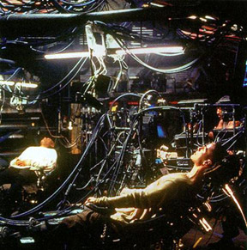

**Figure 24 The setting combines the darkness and colored lights, with the interface for entering the virtual dimension in a scene. This shot is from the movie "The Matrix", and represents the concept of using a system to mentally enter a virtual dimension and solve a task while the body “remains” at the physical location.**

Due to time costs and location possibility it is not possible to recreate a scene as in . To simplify the solution, an environment with the contrast of dark and colored lights is created. To enhance the environment ambient sound resembling miscellaneous industrial and technological items is created. The intention by the ambient soundscape is to make the setup seem more elaborate that it actually is.

The lab contains both the physical as well as the remote location, also referred to as the VE. The interface and the remote location will be occluded from each other to keep the participants unaware that the remote interface is in the same room as the physical one. displays the lab setup.

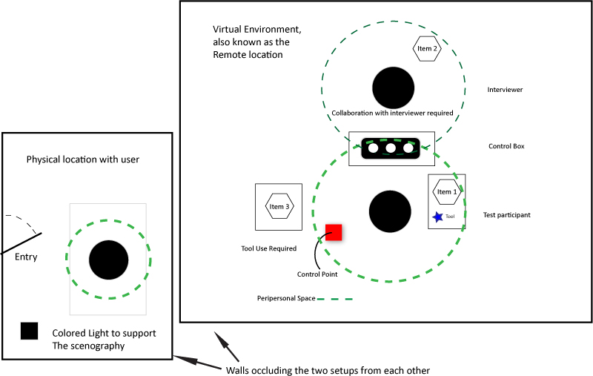

**Figure 25 The lab set up where at the left is situated the physical location divided by a separating wall from the remote location. At the right side is situated the remote location interface and the interviewer. The left side contains the setup which the user will be introduced to at first, before “entering” the VE via the interface, thus mentally becoming present at the remote location. The Black dots denotes the user, the dotted line denotes the peripersonal space. The distance between the two platforms is approximately 10 meters.**

The scene of the remote location resembles an office where there will be appropriate lighting, in contrast to the physical location’s dark and colored illumination. Here the user will meet the interviewer for the first time and the six phases begins.

**Part Conclusion**

We are aware that the field of view in the VE is limited by the video camera, the angle of it and the screen resolution limiting the visual perception of the VE to that of the technological devices. Yet we are confident that the novelty, elaborateness of the setup and narrative incensement will convey the experience discussed in this chapter.

# Test methodology

In this chapter the focus is on the conduction of our test setup and how this is related to the research theories presented in chapter .

The description, meaning and significance of key elements used to define the test stages will be explained in relation to the presence frame work presented in on page 20. A comparable overview of the presence frame work and the main test stages is presented in .

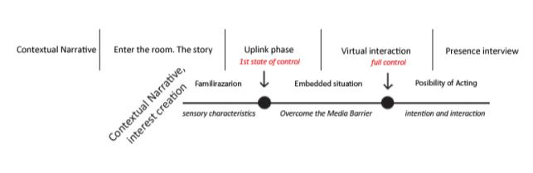

Figure 26: Test stages reflected on the presence frame workflow.

The main test stages are designed based on the presence frame work and the research on how it is possible to achieve presence in a VE. As described in the test participants will at first be introduced to a contextual narrative to invoke their interest and convey the needed motivation necessary at the subjective level to form a basis for presence.

The contextual narrative is defined at fist, outside the room where we will conduct our test and will continue when the participant enters the room. Having entered the participant will then be directed to the equipment that is used in this telepresence test, this denoted as the Uplink phase. As part of the virtual narrative the state of familiarization will allow the participant to become confident with the system ad reach the first state of control over the system.

In order to proceed to a full control of the system, the participant has to become accustomed to the system technology understanding the intention of the media allowing this to become transparent. These processes are both part of the Uplink and Virtual Interaction stages. Presence is the continuous, mental, confirmation of the media transparency, intention, interaction and possibility of acting, in accordance with the subject expectations and willingness to believe. As a part of the entire narrative, encasing the test session, the Presence Interview stage is designed to maintain presence in a VE while allowing the collection of quantitative data via the observation, and interview, of the participant during his/hers presence in the VE. Below is a detailed explanation of the different components.

**Outside the lab interview**

Outside the lab, an interview is conducted with the objective to gain knowledge about the user’s experience and opinion of VEs and telepresence systems. The interview has four questions, they are as follows:

* “What do you know about teleconference?”
* “Have you tried using a teleconference system?”
* “What do think about this technology?”
* “Do use web-cameras to communicate with other people?”.

The questions will, of course, build the participant’s expectation of what is to happen, but their function is to help in breaking the everyday context upon entering the lab. Furthermore their function is to allow us to have an understanding of what the individual is used to and has experienced in terms of similar technologies as we have utilized in the test.

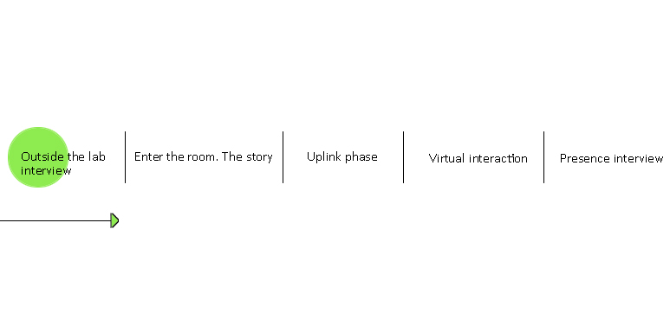

Figure 27 The different phases of the test, the green dot positions the phase being described in the report, but also is a representation of the subjective understanding of the system.

**Entering the room, entering the story**

Our role at this stage is to convey important rules and features from a storytelling point of view rather than an explicit user manual. The emphasis is on characteristics of our setup to provide a different insight to the known VE, punctuating how it can be possible achieve optimal interaction during the test session, please see section for a description of the characteristics. illustrates the first stage of the test and a green dot represents the participant self understanding of the situation and presence level in the actual surrounding, not the remote VE. At the time being the possibility to influence the subjectivity of the participants is reduced.

The participant who enters the room encounters a totally different environment that he /she is used to, the theatrical scenario of the room provides this experience, consult section for a detailed description. At this time the participant will be informed of the main goal of the test conveyed as a short narrative containing the task and the system’s limitation in terms of how fast one can move. illustrates the influence on the participant provided by the story and by the scenography of the room. The influence is represented by the white color in the green dot. 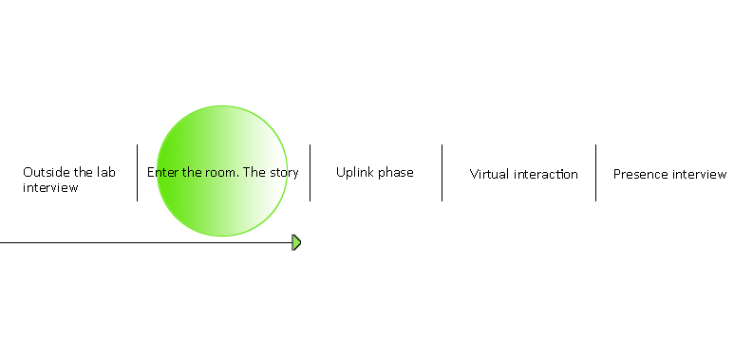

Figure 28 The subject’s consciousness and understanding starts to become influenced by the test

The participant’s understanding of the context depends on the need to create meaning of the situation, due to the difference from the expectations. It is in this situation that the participant is susceptible to external influence in the search for meaning. The narrative allows the construction of the contextual meaning shaping the user’s understanding. The act of shaping the understanding results in a motivated, open minded and interested subject who is willing to put an effort into the understanding of the overall test scenario.

**Uplink phase**

Upon having told the narrative the uplink phase is reached, here the participant is seated at the interface. This phase allows the participant can become accustomed to the control of the equipment and the system’s feedback upon his input. This is also where the user has to learn the limitations and practice interaction with elements in the VE before entering the “embedded situation” and having transformed the physical media into a transparent one as denoted in .

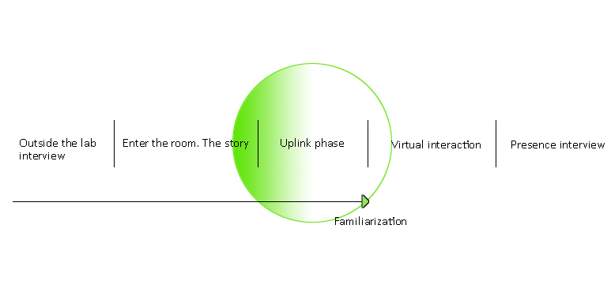

Figure 29 The uplink phase. This is where the participant is introduced to the system and has to learn the limitations and practice interaction with objects

**Virtual interaction**

The supposed result is that the user reaches a sense of presence, based upon the combination of interaction and the perceptual input provided from the VR experience.

Before this is possible the user has to overcome the media barrier, making virtual interaction possible due to the combination of suspension of disbelief and a continuous action confirmation. The participant’s continuous interaction with the system aids in sustaining the credibility of the VE via appropriate and constant video/audio feedback. This is also known, from psychology, as the brain’s central executive confirmation. The central executive is divided into two types of tasks a “Control task” and an “Automated task”.

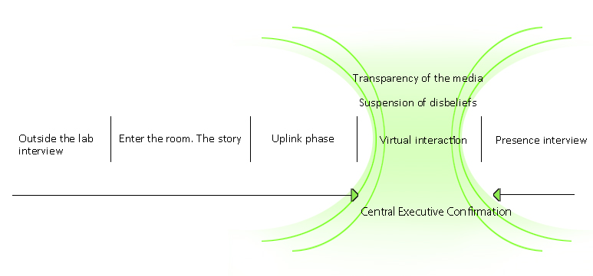

Figure 30 Presence is reached due to the familiarization of the VE via central executive confirmation, combined with the suspension of disbelief supported by the interaction and transparency of the media.

The parallel with the concept is, initially, the participant’s action feedback as a learning experience of how the system responds to input. Meaning that a user who becomes acquainted with the system, will move from a controlled task to an automated task. In this situation the participant’s actions will also become exploratory and widen the area of interaction and possibility of acting within the VE.

**Presence interview**

In the VE presented to the participants a person will be present. This person has the narrative role of being the one in need of help as well as being an interviewer. Having a real person being part of the scenario will facilitate the test in diverse levels. As mentioned the person can guide the participant in his interaction with the VE and initiate dialogs as in real life, where the input responses are related not only to the overall narrative but also as interaction with peers, resulting in a fully collaborative environment.

**Data collection**

What we want is to establish is people’s definition of presence measured by a qualitative interview regarding their experience during the test as a part of the interaction between the interviewer and the user, this is followed by a quantitative questionnaire after the test.

The data collected by the interviewer during and after the test are based upon a set of presence questions in order to create a predefined stage for the interviewer to pose questions as a part of the narrative. This method is designed to understand the participant’s sense of being present while being in a VE. Besides the questions video cameras record the movements of the user and the mime for comparison as well as to record the amount of time used, by the user, to reach the different phases described in .

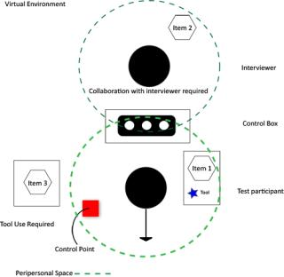

Figure 31

From the collection of the interviews information it will then be possible to compare the user movements, with the movements of the mime analyzing the videos recorded during the test session. The comparison of the movements will then be related to the resulting timing needed to reach the prerequisite to obtain control check marks, given by the observers, which refer to the observable levels of interaction reached during the test session.

**Interview Structure**

Implementing the TBCA method of analyzing the data from the phases described in section . The intention is to structure the notation of observations about the user, from each phase by the main interaction points the test participant is expected to complete. To support the structure of notation, the TBCA method is implemented due to the advantages, discussed in section . The structure of on page 53 consists of three categories. “Higher order themes”, “Raw data theme” and “Observation”. The Phases described in section matches the Higher order themes, and the presence questions matches the Raw data theme and the observations from each subject is noted in the Observation column.

Table 1 TBCA data analysis. The Phases described in the contextual narrative section matches the Higher order themes, and the presence questions matches the Raw data theme and the observations from each subject is noted in the Observation column.

|  |  |  |
| --- | --- | --- |
| **Observation** | **Raw data theme** | **Higher order theme** |
|  | **Spoke to the interviewer** | **Phase 0**  **Ability to use the legs as a part of the interface**  **(Control factor)** |
|  |  |
|  |  |
|  | **Asked for help** |
|  |  |
|  | **the subject used the his legs to rotate the chair** |
|  |  |
|  |  |
|  | **Control of rotation movement through the environment** | **Phase 1**  **Awareness of movement possibilities**  **(Control factor)** |
|  |  |
|  | **User awareness about possibility of using the arm** |
|  |  |
|  | **Adjust to the virtual environment** |  |
|  | **Experience of delay between action and system action** |  |
|  | **Describe your sensation of about this situation?**  **-- question --** | **Phase 2**  **Interaction w. Interviewer**  **Embedded situation** |
|  |  |
|  | **How does it feel to interact in this way?**  **--question—** |
|  |  |
|  | **Understanding of the task** |  |
|  | **Search for item 1** | **Phase 3**  **Possibility of acting** |
|  |  |
|  | **Understanding of the possibility to grab item 1** |
|  | **Return item 1 to the control box** |
|  | **Insertion of item 1 in the control box** |
|  | **Location of item 2 located behind the interviewer** | **Phase 4**  **Collaboration with interviewer** |
|  |  |
|  | **Method utilized for reaching item 2** |
|  | **Insertion of item 2 in the control box** |
|  | **Search for item 3** | **Phase 5**  **Tool use** |
|  |  |
|  | **Tool search** |
|  | **Tool use to reach item 3** |  |
|  | **Insertion of item 3 in the control box** |  |
|  | **Is the user employing the interface to convey an explanation** | **Phase 6**  **Qualitative Interview** |
|  | **Example making by using objects in the VR** |  |

This table would be employed for test to have sufficient space for notes, as well as a summarized overview providing a view from the observations on the tendency of the users’ behavior.

**Questionnaire structure**

The qualitative interview is founded upon a mix of different methods to cover, as best possible, the main presence factors by. The sources were “Witmer and Singer” as well as “Slater, Perez-Marcos, Ehrsson and Sanchez-Vives”(28). The questions selected represent the presence factors of control, sensory characteristics, Distracters and Realism. The questions used in phase 6 are as follows:

* How much were you able to control events?
* How natural was the mechanism which controlled movement through the environment?
* How aware were you of your display and control devices?
* How compelling was your sense of moving around inside the virtual environment?
* How well could you move or manipulate objects in the virtual environment?
* How proficient in moving and interacting with the virtual environment did you feel at the end of the experience?
* How much did the visual display quality interfere or distract you from performing assigned tasks or required activities?

After the qualitative interview, and the test, a questionnaire is presented to the user based mainly upon the topic of “virtual body representation” in a study by Slater, Perez-Marcos, Ehrsson and Sanchez-Vives(28). The questions revolve the user’s feeling of the virtual arm as well as their experience. The questions are covering the same topic as the narrative related questions; this is done to ensure the validity of the answers and the expose any misinterpretations by the researchers. The questions were formulated as the following points; see the Appendix for an example.

* Was it difficult to adjust to the virtual environment?
* Upon entering the lab, was the scenography something you would expect to see?
* Was the scenography of the lab, something you would expect to be used the virtual world
* During the test I felt as if the virtual arm resembled my own arm to an extent that I did not pay attention to the difference when performing a task.
* Could you focus on the task at hand and “forget” the screen providing visual feedback
* Were you able to correctly anticipate what would happen as a “system response” to the actions you performed?
* How involved were you in the virtual environment experience?
* How did you perceive the sound “in the virtual world” in terms of being insufficient?
* During the experiment there were moments in which I “felt” as if my real arm was becoming the virtual one.
* How much delay did you experience between your actions and expected outcomes?
* Which item was the most difficult to retrieve?
* Was the experience as a whole (the scenography of the lab, the narrative and the VR) confusing?

# Results

This chapter is divided into three parts, one with expected results, the second part with the presented results and the last with a discussion of the results.

## Expected Results

This section concerns the presentation of the expected results from the test, based upon several pilot tests of the different parts of the interface and the system as a whole. The first part will cover the narrative related questions, used in phase 0 to 5 (TBCA table), the second part revolves the phase 6 interview. The last part will cover the questionnaire.

**Narrative related questions**

The presence experience is expected to produce the following results from the observation and narrative related interview, not to be confused with the final interview in phase 6.

Regarding control, the users in general, are expected to observe to easily control events, with the actual movement of rotating the chair with the legs. The possibility to manipulate objects took a few tries, but quickly became an easy task.

With respect to the ability of “overcoming the media barrier” the setup and user interface are developed based on theories of mirror neurons and plasticity. It is expected to be very useful in helping the users to understand the relative simple nature of the tasks at hand.

The result leads towards an “overcoming of the media barrier” where the interface is not distractive to the users. The ability to overcome the media barrier is reported as a process, which with time, is expected to be easy by the participants.

In relation the visual quality is expected to be sufficient causing limited interference or distraction. These distractions can be part of the frame structure of the chair that at times is not as stable as wanted due to inappropriate building materials.

The audio quality can be reported as insufficient or not close to reality due to the audio signal that is heard by the users through headphone, resulting in a more “closed” sound and quality degradation.

To some users the test can became interesting but difficult to understand in a broad connection. The expectation in these cases is that the users will be able to complete the tasks and to some extent to achieve a sense of presence. They will focus more the unusual aspect of the test and interface becoming more distracted where their expectation will not be satisfied.

**Questionnaire**

In this presentation of expectations of the data collected from the questionnaire has the expectations written below the question.

1. **Was it difficult to adjust to the virtual environment?**

From the questionnaire it is expected that the user’s adjustment to the VR was not difficult, though requiring a bit of time.

1. **Upon entering the lab, was the scenography something you would expect to see?**

It is not expected to be something the test participant would anticipate; this is mainly due to the fact that incorporating an environment and narrative as an important part of the test scenario is not something usually done.

1. **Comparing the virtual world with where you were sitting, was the setup of the virtual world something you would expect to see when “entering” the virtual world?**

We realize that this question could be considered ambiguous and might be misunderstood, but essentially when the user has had the initial experience of entering the lab, being introduced to a narrative and a task in a futuristic setup with ambient sounds in a dimly lit room. Does this effect the test participant’s expectation when entering the VE and is presented with a regular environment. It is the expectation that the setup of the VE will not be expected.

1. **During the test I felt as if the virtual arm resembled my own arm to an extent that I did not pay attention to the difference when performing a task.**

The expected result is “yes” as this question has a strong reference to the topic of mirror neurons and related research.

1. **Could you focus on the task at hand and “forget” the screen providing visual feedback**

When dealing with a photorealistic feedback, along with the fact that a main sense in this test is vision, it is expected that the ability to ignore the screen and accept the feedback can happen. This effect will happen as the user “breaks the media barrier” while being occupied with a task and consequently focuses on that.

1. **Were you able to correctly anticipate what would happen as a “system response” to the actions you performed?**

As the only problem is that the user can perform a movement not anticipated, it is expected that generally the test participants are able to anticipate a response as the physical rules have not changed.

1. **How involved were you in the virtual environment experience?**

Due to the narrative, decor and the setup it is expected that the experience will involve the users.

1. **How did you perceive the sound “in the virtual world” in terms of being insufficient?**

It is expected that the sound will not be considered as insufficient because the sound is not the primary sense being employed and have little practical relevance when interacting with the VE. It should be noted that the interviewer has a microphone transmitting to the test participant’s headphones.

1. **During the experiment there were moments in which I “felt” as if my real arm was becoming the virtual one.**

Again, as asked in question 4, the answer is expected to be yes. This is due to the fact that if one is able to accept the arm, and the representation is somewhat similar to the user’s arm there will certainly be an opportunity for the mirror neuron effect to come into play.

1. **How much delay did you experience between your actions and expected outcomes?**

The narrative contains an important part, moving slowly. This is due to the mime having to mimic and to allow for the chair to rotate with the delay one can only naturally expect in such a construction. Therefore delay is expected to be reported, but also it should be accepted, to a degree, due to the narrative element.

1. **Which item was the most difficult to retrieve?**

This question is expected to have item 1 as the least difficult due to the fact that the user does not have to utilize a tool or collaborate with another person in order to retrieve it. Item 2 requires collaboration with the interviewer and is expected to be considered mainly as “easy” due to the fact that the task of grasping the item is almost the same as in item 1. Item 3 however is expected to be the difficult one as the tool required to retrieve it is placed at item 1’s location. Furthermore the action of using the tool requires depth perception, something only supported via the cognitive understanding of the user, understood in the sense that the task is meant to be difficult but not impossible.

1. **Was the experience as a whole confusing?**

It is the meaning of the setup to surprise the test subject upon entering the lab, though the experience is not meant to be confusing but so different that the user has to spend all his effort on the experience and not let the mind “drift”, thinking about something else.

This concludes the expectation of the test, and the first part of the result chapter. Below the second part will be introduced and present the results gathered in an overview.

## Data Presentation

Having discussed the expected results, this section concerns the presentation of the data collected. As the test was qualitative the process of presenting the observations is the main focus. The presentation will consist of a TBCA table, a review of the questionnaire and comments noted along with this and the interview conducted inside the VE.

In order to have a graphical representation of the answer given by the test participant the is created based on the following score method:

***Outside the lab interview***

* If the test participants are knowledgeable about teleconferences the score value is given as 1.
* If the test participants have tried teleconferences systems the score value is given as 1.
* If the test participants mention possibilities about this technology the score value is given as 1, if they mention negative aspects the score value is give as -0.25.
* If the test participants uses web-cameras to communicate often the sore value is given as 1, if they used occasionally the score is given as 0. 50.

***Phase6***

* If the test participants fells that they have (much) control over the events in the VE the score value is given as 1.
* If the test participants fell that the control of the movements is natural the score value is given as 1.
* If the test participants are aware (during the test) of the display and control device the score value is given as 1. A 0.50 score is given if the user experience mechanical delay in the rotation or adjusts their comments during the test from negative to positive attitude.
* If the test participants have a compelling sense of moving in the VE the score value is given as 1.
* If the test participants express that they are well able to manipulate objects in VE the score value is given as 1.
* If the test participants think that they are proficient when interacting with the VE the score value is given as 1.
* If the test participants express that the visual quality interferes or disturbs their action the score value is given as 1. A 0.50 score is given if the user experience delay or adjusts their comments during the test from negative to positive attitude.

**Outside the lab interview**

The graph in displays the overall answers given by the test participants showing that 50% of them have knowledge about teleconference system which covers basic functionalities technological knowledge or its main purpose. The score 5 is upon S2, S3, S6, S7, and S8 answers.

Figure 32 Graphical representation of the answer given by the test participants outside the lab.

58% of the test participants have tried teleconferencing system either for educational or business purpose. Here S2, S3, S5, S7, and S8 have more experience with this technology and the score is given as 1 to each other, where S9 had tried teleconference only once during a lecture and the score is given as 0.75.

The 80% of the test participants have the opinion about teleconferencing that this technology is subject to delay or technical problems but overall serves it purpose. Within this percentage half of the test participants focus more on the possibility of the technology; one of the interviewed see the possibility for this technology for medical use (long term). The score for these answers are as: S1, S2, S5 and S6 are given the score 1 because their general comments are positive. S8 scores 0.75 because mention delay aspects, but that teleconferencing serves its purpose. The remaining answers from S3, S9 and S10 the score -0.25 each, due to the test participants focus on delay and technical problems. Overall the score to this question along the test participants is 6 which results in 40% that have a general god opinion about the technology.

According to the usage of web-cameras for communication 90% of the test participants uses this technology, S1, S3, S7, S8 and S10 score 1 each because uses this form of communication often. S4, S5, S6 and S9 score 0.50 because they use web-cameras just occasionally. The overall score is 7 resulting in 70% of the test participants have more or less experience with this form of communication.

For a graphical representation of the answer given to each single question asked to the test participants before entering the lab we refer to Appendix ().

**TBCA**

*The data presented in this section are summarized from the whole TBCA table. To read the actual comments and observation of the test participant during the test session we suggest seeing Appendix ().*

The overall results of the observation made during the test session are divided in 7 major phases or higher other themes, each with different control stages or raw data theme. In general all the test participants were able to rotate the chair use their hands to interact in the VE and all have solved the test tasks. All the participants were able to hear and speech with the interviewer while interact in the VE and had clear visual input on their location from the VE. The audio visual stimuli were perceived in real time, with some delay on the visual aspect and rotation of the chairs, for all the test participants.

The summarization of the observations can be listed as follow:

***Phase 0* *Control Factor.***

Higher order theme**: ability to use the legs (to rotate the chair) as part of the interface.**

* Raw data theme**: spoke with the interviewer**.

All the participants spoke with the interviewer when they heard his voice and have no problem hearing what told. S1, S6 react immediately by saluting the interviewer where S8 giggles and S9 move the head to look around. S2 had a better understanding of the overall narrative asking the interviewer how he could help him. The interviewer afterwards mentions to the test participants their first task (locate the red control point in the VE). S4 locate first the interviewer and start to small talk with him where S5 while speaking to the interviewer, about the location of the control point, poke the screen even before rotating the chair. S10 locate, in the starting position of the chair, a red object on the flour that was not the control point, he had not yet performed a rotation with the chair.

* Raw data theme: **asked for help.**

After the interviewer told the participants about the red control point, S1, S4 , S6, S7 and S8 asks how to move, and helped to become aware of the possibility to rotate the chair. S2 and S9 initially wonder about what the control point is and respectively S9 cannot find it. S3 and S10 have no problems to figure how to navigate (rotate) but S10 question how much he canturn.

* Raw data theme: **the subject used his legs to rotate the chair.**

In the effort to understand the possibility of rotation S1 make a walking movement with his feet. S3 giggles when he find out that he can rotate and S4 moved first in one direction and the in the other.S5 and S8 start move to the right and locate the interviewer at first. The rest of the participants moved to the left.

***Phase 1* *Control Factor.***

Higher order theme**: Awareness of movement possibilities.**

* Raw data theme: **Control of rotation movement through the environment.**

Over all the test participants once understand the possibility of rotation have no problems in this stage and try to rotate in both directions while speaking with the interviewer showing interest in their exploration. S5 express that the chair is “kind of wobbly”.

* Raw data theme: **User awareness about possibility of using the arm.**

The observation focuses on how the test participants react when they find the red control point and have to point at it.

S1 uses both hands in free movements where S2 is aware of the hands before he reaches the control point. S3, S4, S5, and S8 pokes at the screen first where S6 and S10 hesitates being in doubt of they have to poke the screen or extend the arm; they both choose to extend the arm. S9 extend the arm right away where S7 have to be guided by the interviewer.

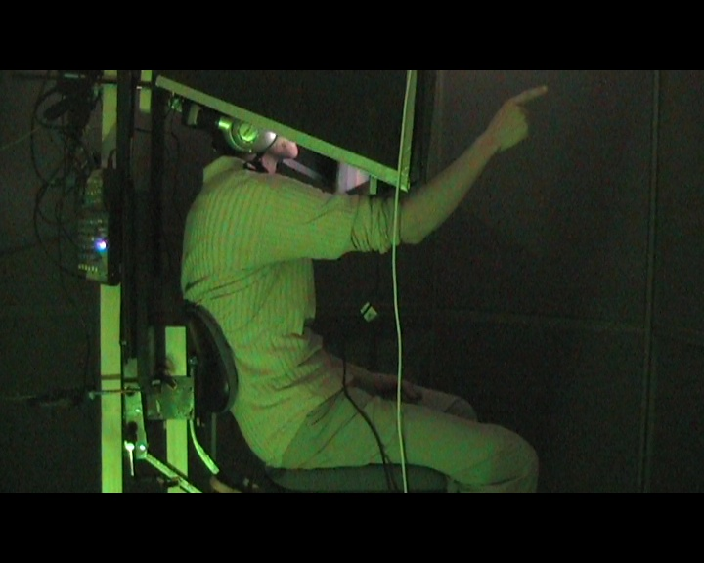

**Figure 33: Test participant pointing at the control point.**

* Raw data theme: **Adjust to the VE.**

At this point the test participants have become aware of the main functionalities of the system. The observations at this stage aims on how the users have adjusted to the VE.  
Overall the participants have an understanding of the system possibilities and had explored almost all the VE and adjust their actions to the system and have a positive reaction. S2 can recognize the VE after have explored it and S8 become aware of the full rotation capability of the chair and explore the VE at the same time. S5 is adjusted by moving slowly and guess that the interviewer is located in a room next door where S7 move fast to test the system. S4 is afraid to fall of the chair and this makes him more distract, where S6 locate a series of object but at this stage have not yet found the control point.

* Raw data theme: **Experience of delay between action and system action.**

The test participants mention generally both mechanical delay due to the chair rotation and delay upon their hand arm movements in the VE but generally are acquainted with this. S1 move slower to avoid delays and S6 do not really experience delay. S10 explains that the delay is noticeable but refer that it is due to the system and because the location “is far away”.

***Phase 2* *Embedded situations.***

In this phase the interviewer changes his behavior towards the test participant from general conversation or observer, during Phase 0 and 1, to ask direct questions to the users’ while they navigates in the VE

Higher order theme**: Interaction with Interviewer.**

* Raw data theme: **Describe your sensation of about this situation?**Overall the participants are more that positive and are in general in a wondering stage about the situation showing big interest and laughing. S2 ask if the interviewer can see his face, S4 describes that it is awesome “to be” with the interviewer and that the situation is much better that a normal webcam conversation. S3 feels that it is almost him that is doing the action in the VE and S8 express that it is nice to have a “chat” with the interviewer. S7 express the situation as being “weird” (this being as a positive comment).
* Raw data theme: **How does it feel to interact in this way?**The test participants had a largely positive reaction to this question. S2 is not quite aware of what he can reach where S8 refers the interaction close to a video game but thinks that the tool use is quite interesting. S10 have the impression to look at his arms where S4 comment the interaction feeling as strange but brilliant. S5 understand that he can interact with whatever he sees from his chair and express this as being weird but ok.
* Raw data theme: **Understanding of the task.**The interviewer introduces the main task of the test to the test participants (insert the items in the control box).  
  All the participants have been able to solve the task during the test session. Some had minor starting difficulties or misinterpretations. As S2 asks if he colours of the control box are meaning full or as S4 that asks if he had to look on “his chair” this is also the case for S6. S6 afterwards indicate to the interviewer items of the VE that has nothing to do with the task itself (a box of Tuborg beer). S7 thinks that he has understood but grabs artefacts elements of the control box. S8 ask the interviewer why he (S8) has to assemble the control box before the interviewer terminate his explanation and is troubled by the meaning of the control point.

The Phases 3, 4 and 5 are aimed to observe the test participants while they find the items in the VE that have to be inserted in the control box. These phases are predefined in the TBCA table as:

1. **Phase** **3** handling of the item 1 that can be reached by the users themselves.
2. **Phase 4** handling of the item 2 that is passed to them by the interviewer (after the users have located the item).
3. **Phase 5** handling of the item 3 that involves the use of a tool in order to reach the item itself.

The order in which these phases are approached by the test participants are completely random but here reported in the refer other.

***Phase 3 Task performances.***

Higher order theme: **Possibility of acting.**

* Raw data theme: **Search for item 1.**

The users that locate this item first found it easily or they remember where it was located in the VE. S2 comment his discovery by saying that the item he sees should be the green one and S5 find this item after had tried to reach unsuccessfully item 3.

* Raw data theme: **Understanding of the possibility to grab item 1**

In general the users grab the item with no problems having the understanding of the possibility to reach for the objects in the VE. S7 is the only that do not have the full understanding of the possibility at this moment where S6, S8 and S10 explains that they have the item right “here” or in front of them. S5 had a funny experience by performing the action.

* Raw data theme: **Return item 1 to the control box.**

All the test participants return that item to the control box with no difficulties some with the arm in a straight position others with arm slightly bend. Some uses the left hand some others the right. S5 is smiling while returning the item to the control box while his hand posture is very precise.

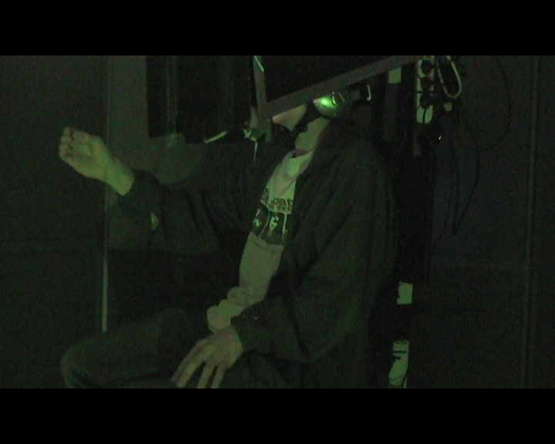

**Figure 34: Test participant returns item to the control box.**

* Raw data theme: **Insertion of item 1 in the control box**

The insertion of the item in the control box become a more precise operation, here it is visible from how the participants need to adjust the item after inserting it in its control box location as S1. S9 make the movements very precise and is very careful where S9 uses his finger to adjust the item. S8 gives the thumbs up o the interviewer after have completed this task.

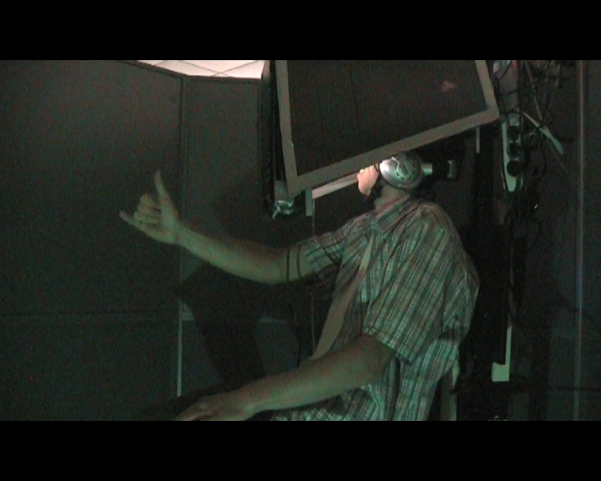

**Figure 35: Test participant show his appreciation to interviewer.**

***Phase 4 Task performances.***

Higher order theme: **Collaboration with interviewer.**

* Raw data theme: **Location of item 2 located behind the interviewer**

As for item 1 some of the test participants locate this item first. In order to reach this item the test participants need to collaborate with the interviewer. First they have to locate it and then the interviewer will pass the item to the users so they can insert it in the control box. The localization for S2 and S8 has been more difficult than for the rest of the test participants. S5 locate the item first try to reach it but do not ask for the help of the interviewer and search for another item; after having returned other items to the control box S5 understand the collaboration task with ease. Generally all the users guide the interviewer to the location of the item either by pointing at the item or by telling the interviewer the precise location of the item coordinating the interviewer’s movements towards the object in the VE.

* Raw data theme: **Method utilized for reaching item 2.**Within this action S2 question if the interviewer is not able to insert the item in the control box by itself, here the interviewer respond that it was not possible. S2 extend his arm and grab the object from the interviewer hand. S3 change his hand position form pointing with the finger to an open hand where S5 exclaims that he will try to use his other hand to grab the item. In general all the operation had no problems.
* Raw data theme: **Insertion of item 2 in the control box.**The operation of inserting the item in the control box was succeeded by all the participants. S1 readjust the item afterwards but S8 leave it not correct placed telling while laughing that the interviewer can adjust it by himself at the time being. S4 and S6 during the task had a hand position that was almost closed or imprecise according to the item shape, but in the readjusting phase S4 placed the item more correctly with his fingers where S6 in the approaching phase to the control box change his hand closure so it resembles the actual shape of the item.

***Phase 5 Task performances.***

Higher order theme: **Tool use.**

* Raw data theme: **Search for item 3.**As form item 1 and 2 some of the test participants locate this item at first. The difference in this situation is that the item is out of both the users and interviewer reaches. Common for all the participants is that they all try to reach the item. S2 question if he can reach the object, realizing that this is not possible comment that the item cannot be the one he searches for.S6 and S10 tell that they know the location of the item because they have seen it while navigating in the VE.
* Raw data theme: **Tool search.**The test participants, realized that they cannot reach the item, search for the tool that they have to employ so they are able to move the item 3 closer to them so they can grab it. S1, S6 and S8 move straight to the location of the tool where S2 question if he can use the tool he sees that is the actual one to use in this task. S4, S5 are the only user that employs two hands to hold the tool.
* Raw data theme: **Tool use to reach item 3.**Beside one participant all the users finds it difficult to handle the tool in the VE but they are still able to reach the item and use the tool to make them able to grasp the item and they enjoy the action. S9 and S10 without having the tool in their hands, try at first to grab the shelf where the item is located on. Especially S10 succeeding in pulling out the shelf from its placement and tried to place it on the table where the control box was situated. At this point the interviewer interrupts the participant’s actions telling him that it will become quite difficult to place the shelf on the table and guided the user to replace the shelf in its original position. S9 also try to grab the shelf but afterwards ask the interviewer to pass him a paper stapler. In this occasion the interviewer pass the participant the stapler. The participant moves towards the item and tries again to reach the object. The interviewer ask at this point the user what his intention are; the user respond that he want to try to grab the top of the item by closing the stapler around an artefact of the item. The user carries out his intention but realize that his actions are not possible because the item is too far away. The interviewer at this point tells S9 that maybe he could try to find something that could be more helpful. S2 shift hands in proximity of the item where S3 is the only one that holds the tool in a horizontal position and tries to reach the item with a swing motion. S5 holds the tool with two hands in a precise position as show in .

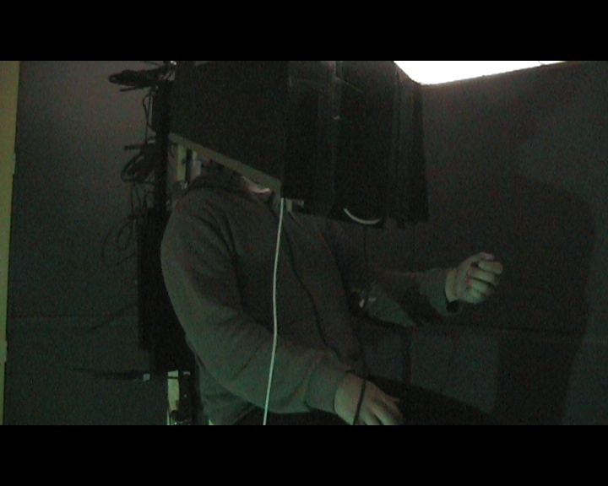

**Figure 36 Test participants employing two hands to hold the tool.**

S8 is very conscious of the VE, in fact he is retracting the arm when the tool hit the inventory of his surroundings in the “virtual location”. S7 accomplish that task with gaudies’ from the interviewer. S6 moves very slowly and have no problems.

* Raw data theme: **Insertion of item 3 in the control box.**In this case the test participants have to insert the item in the control box with one hand while they have to figure out what to do with the tool. For the most the users just drop the tool on their way to the control box. S2 holds the tool while inserting the item in the control box where S3 drop the tool and switch the item to the other hand. It is observable that S4become more involved in this action than he was previously. S6 insert the object too short according to the control box position so the item is close to fall to the ground but recovers it and with any problems inserts it in the box. The rest of the participants have no problem performing the task.

***Phase 6 observations during the VE interview.***

Higher order theme: **Qualitative interview.**

At this stage the test task is terminated and most of the participants have to answer a range of question. The results of this question are indicated in the Phase 6 section. The observations reported here are based on how the participants employ the interface to make examples or using objects. The interviewer asks all the participants to look at their hands in the VE as a last test.

* Raw data theme: **Is the user employing the interface to convey an explanation.**S1 try to assume hands position common to his daily work (dentist) and tell the interviewer that this will not work. To state here that the mime had real difficulties to match this positions.S2 clap his hand applauding. S7 explains that the system could be quite efficient and useful in different situations.S4, S5 and S6 are troubled about what they are seeing and question if they look at their hands or not. S10 try to tap the interviewer table while the rest of the participants gesticulate while speaking to the interviewer. S4 shake hands with the interviewer at first with a very imprecise movement but on hand release the hand position become very precise. In general the test participants are acquainted whit the situation and have fun. At times the conversation stops because they gesticulate and start focusing at the hands and the result end with laughs and giggles. S3 is the only user that spins the chair explaining about its mechanical limitations.

|  |  |
| --- | --- |
|  |  |
| \\alcazar\group\studgroups\09ml103\Raw video\Frames\observation_1st_person_complex_finger_movment.bmp | \\alcazar\group\studgroups\09ml103\Raw video\Frames\observation_3rd_person_shaking_hands_with_interviewer.bmp |
|  |  |
| \\alcazar\group\studgroups\09ml103\Raw video\Frames\observation_0201_complex_finger_movement.bmp | \\alcazar\group\studgroups\09ml103\Raw video\Frames\observation_0202_looking_at_hands.bmp |
|  |  |

**Figure 37: Different test participants’ gastrulates while interviewed making examples with their hands.**

* Raw data theme: **Example making by using objects in the VR.**S2 grab the tool hand try to hook it to the table (“to pull the table towards him”), in this case the mine misunderstand the participant action and try to reach a plastic cup. S3 while talk about the control of the system grabs the red item and throws it back in the control box. Luckily in this situation the item centre perfectly the control box hole, this result in a big laugh form the participant. The rest of the participants employ different objects passed to them by the interviewer.

Overall all the test participants’ expresses that the test is very interesting and had fun performing the tasks during the entire test session. All have been question if they knew how the system worked and all at the end figure out the role of the mime approximately around the end of the tasks. Some had more difficulties to make this association than others and some, even if they knew about the presence of the mime, had hard time to distinguish their hand from ones of the mime. All test participants have been shown how the system worked ones the test session was concluded. We encourage for a more detailed overview of the TBCA table to see Appendix ().

**Phase 6 interview**

The first question regarding the participants’ control of events, making statements as subject1:”*Yes, I focused on solving the task and made it*” or as subject 7 stated:” *weird*” and then giggled a bit in surprise and amusement of interacting with the VE in such manner.

For most of the subjects stated that they were in control, subject 2 and 9 evaluated them self to be “*very much*” in control of events. Due to these responses the score applied to their statements were of the value 1.

Question two is regarding the mechanical control of movement and how natural if felt. Subjects were aware of the delay because it took a bit of rotation before the remote location chair responded, but the subjects quickly accepted it. Subject 1, 4 and 8 described it as a mechanical delay, yet it did not bother them. Subjects 3, 5, 6 and 9 described their ability to move as “*natural*” opposed to subject 1, 2, 4, 7, 8 who had minor difficulties or made special comments about the delay during the interview. Subject 10 described the delay as “*dream like*”.

In the third question about display awareness it is noticeable that 40% of the participants expressed that they was aware, but their comments during the test shows an positive attitude change by expressing acceptance towards the display and control devices. The participants were S2, S3, S5 and S10 and the total grade of their comments are scored as the value 2,25. Subject 10 scored 1, as he remarked that the delay made him aware of the screen, subject 2 and 3 scored 0,5 as they had remarks but made positive comments during the interview. Subject 5, who scored 0,25, was to some extend aware of the screen as he thought that the visual representation of the hands were a pre recorded and compared with his movements for a live analysis, causing the delay, before displaying the hands.

The general acceptance from the participants is a combination of adjusting to the system’s limitations of movement and the nature of the task being solved. In this case the scores are considered negative, hereby marked with a red bar.

The fourth question,regarding how compelling was your sense of moving around inside the virtual environment?

The participants had very positive remarks though subjects 2, 3 and 4 had remarks leading to a lower score than the very positive value of 1.

Their remarks wereSubject 2: “*interesting, slow – I can adapt to the slowness*“, subject 3: “*chair rotation delay, but compelling. Representation of the arm/hand on the screen is cool.*” Subject 4 stated: “*was afraid to fall of the chair, but I had fun.*”

Besides these comments, who were not negative per say other comments were in example subject 5: “*it is cool*”, subject 6: “*I can use whatever and hit other things*” and subject 7 stated: “*I was interested and looked for details*.” In overall the total score is 9 for this question reflecting the positive comments.



Figure 38 Results of the VE interview adapted to the score system with percentage of amount of total answers

With respect to object manipulation in the VE, the subjects responded to the fifth question generally positive, finding it compelling to move and being proficient in manipulation.

Noticeable comments weresubject 4: “*Well, did movement with fingers to test “the range” of the system*.” Subject 1, a bit negative stated that: “*The movement was not accurate enough but I was able to grab the objects Tried to “reset” the mime when wanting the mime to “catch up” to m*e.” This was to some extend supported by subject 2 reporting: “*minor issues such as the inclination of the tool*”.

Subject 7, reported that the object manipulation was compelling; though he was skeptical and reluctant about the test as an experience.

Other subjects, such as 9 and 10 realized that they could interact with everything in the VE, leading to explorations of grabbing items, of no relevance to the task, and making exploratory procedures upon objects with the hand and fingers.

In question 6 - How proficient in moving and interacting with the virtual environment did you feel at the end of the experience?

The participants were proficient in interacting and moving, though some required more training and mentioned the delay as an obstacle with respect to their proficiency. Subject 6 and 7 mentioned this in the interview. Subject 1 felt that he could have used more time to train in contradiction to subject 5 who felt delayed at first but was convinced that the movements matched after a while. These comments were scored as 0,5.

Subject 2, 3 and 4 stated that they were proficient, where subject 4 was the only one to do a series of slow, yet complex, finger movements and laughed. Their comments were scored as 1 per subject.

The remarks of subjects 8, 9 and 10 got the score of 1, as their statements were: “nice.” Subject 8 did not mind to use the system, even though he at a very early stage figured out that the virtual hand was not his own. The overall score of question 6 was 8

Question 7, furthermore the quality of the visual display was generally accepted though three participants (S4, S5 and S7) reported the quality to be interfering. Of the three, S4 and S5 made comments about the display, revising their position positively being graded with the value of 0,5 whereas S7 was so distracted by the display that his negative comments scored the value 1. In this case the scores are considered negative, hereby marked with a red bar.

**The Questionnaire**

The compiled results from the questionnaire are displayed in The graph represents the amount of positive and negative answers per question posed in the questionnaire. Positive answers does not refer to “yes” but to the answer which is correct which in some questions is “no”. Negative answers refer to the incorrect response to a question.

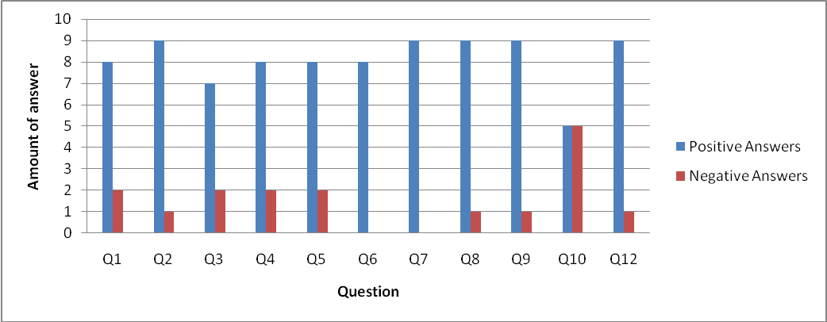

Figure 39 Results from the questionnaire

As shown the results from the questionnaire contains generally positive responses. In the first question formulated as “Was it difficult to adjust to the virtual environment” shows eight positive answers and two negative. The second question “Upon entering the lab, was the scenography something you would expect to see” has a slightly better score of nine positive and one negative answer.

The third question “Comparing the virtual world with where you were sitting, was the setup of the virtual world something you would expect to see when “entering” the virtual world?” showed less positive answers than the previous, having seven positive and two negative.

The fourth questions “During the test I felt as if the virtual arm resembled my own arm to an extent that I did not pay attention to the difference when performing a task.” Had eight positive and 2 negative answers, the same result as questions five “Could you focus on the task at hand and “forget” the screen providing visual feedback”.

Questions six and seven had no negative answers but were respectively missing two and one answers from the subjects in terms of marking either yes or no. Question six was posed as “Were you able to correctly anticipate what would happen as a “system response” to the actions you performed?” and question seven “How involved were you in the virtual environment experience?”

The eighth question, posed as “How did you perceive the sound “in the virtual world” in terms of being insufficient?” had nine positive and one negative answers, the same result as question nine “During the experiment there were moments in which I “felt” as if my real arm was becoming the virtual one.”

Question ten “How much delay did you experience between your actions and expected outcomes?” received five positive and negative answers.

Question eleven is not presented in this graph as it contains multiple questions. Question eleven was “Which item was the most difficult to retrieve?”

The twelfth question “Was the experience as a whole confusing?” had one negative and nine positive answers.

Having reviewed the initial result of the questionnaire, it became evident that at several questions some of the test subject had answered “no”, but the comment written was in fact a positive answer. To compensate, an interpreted graphical version of the answers is presented in

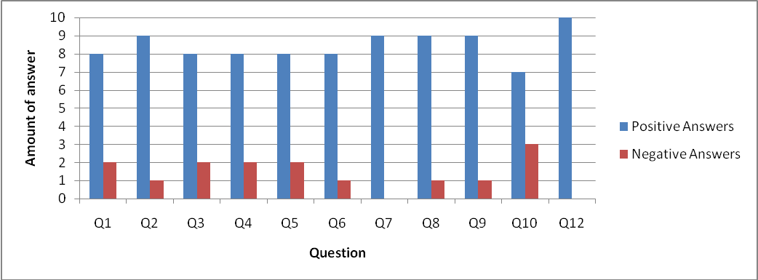

Figure 40 Interpreted results of the questionnaire according to comments of the test participants

To point out where an interpretation has influenced the reported score from four questions has been adjusted accordingly. Question 3 has been corrected to eight positive answers; question 6 had an increase of one negative answer. Question 10 had an increase in positive answers from five to ten and a decrease in negative answers from five to three. Question 12 has increased positive answers to ten from nine and the negative answer is reduced from one to zero.

As the reader might have noticed question 11 is missing. This question is regarding the test subject’s evaluation of the items and the difficulty of retrieving each item. illustrates the reported score. To see a review of the tools please see on page 43.

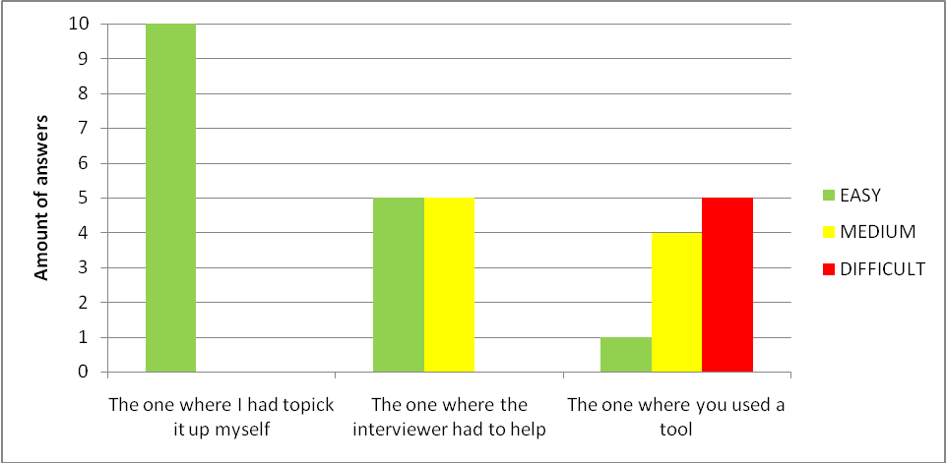

Figure 41 Question 11 reported answers on the difficulty of retrieving each of the items

Question 11 is divided accordingly to the items the user had to use in order to solve the task. Instead of numbering the items, we have in the questionnaire referred to them in terms of how the items had to be retrieved. From left to right each question corresponds to item 1, item 2 and item 3.

Each item has the possibility to be graded with the level of difficulty of “easy, medium or difficult” As shown in the item where the user had to pick it up himself had ten answers in the easy category. The second item, where the interviewer had to assist in retrieving the item, the categories of easy and medium have both received five votes. The last item, requiring tool use, got five answers on difficult, four on medium and one on easy.

## Discussion of results

**TBCA**

Analyzing the test participants’ actions it is possible to observe that all the users during the test session act with the system as intended. In fact the mechanism of the system is understood by the test participants as an interface where interactions deal with specific meanings and contexts. The interactions of the test participants in the VE informed them of what was possible or not and how problems in the VE had to be solved. The system design, which is based on the functionalities of an office chair, has been operated as a physical object due to its properties conveying a known and natural use. The handling aspect of the interface and design of the test session permit the test participants both to interact with the interface and in the VE in an easy and logical structure. The aspect of how the objects or items in the VE are related to the real world has to be interpreted as a fusion of the two environments, this because in the real world the objects are not present. The subject-object relation is in fact based on the test participants’ imagination that makes them assume hand posture that resembles the item shape.

The transparency of the interface becomes evident in the interaction with the objects in the VE. In fact all the users were able to focus on their work, with small or any interference provided by the system. The users comment that they were not aware of the system in the real location. The system here is intended as a combination of the chair and arm movement, where the majority (if not all) focuses on the activity and orient themselves in VE and not in the real world. This reinforced by their actual movements recoded where no one seems conscious of their arm movement in the real world but still aware of their actions, while operating in the VE carrying out the tasks automatically without any interference.

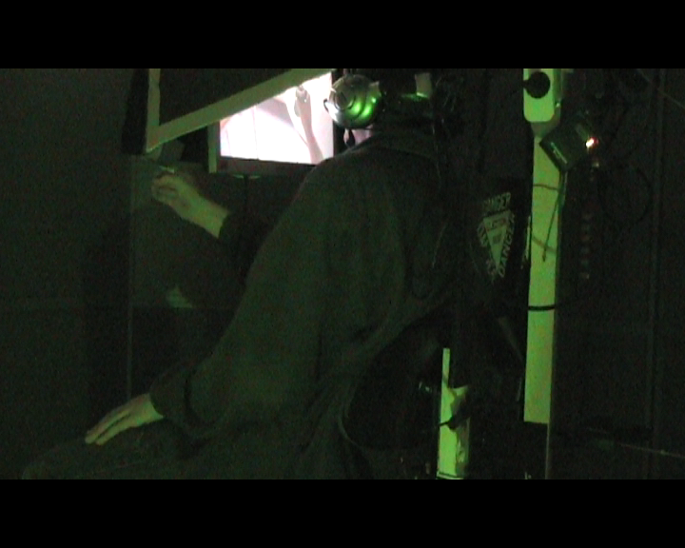

**Figure 42: Test participant performing the action of holding an item from the VE. In the figure it is possible to see the display of the system where the participant focuses on the virtual hand holding an item while holding his arm forward. To notice is the hand of the participant in the real world that is closed as he is holding the item.**

Because the VE environment is photorealistic designed and is an actual physical location the affordance of the system is only limited by the peripersonal space of the mime/ user. The test participants are able to interact with what is in their reach and to extend their action with the use of tools or by collaborating with the interviewer. When users once became aware of the possibility of the system rapidly extend their perception of the VE and possibility of acting in this.

The assumption is that the kinesthetic memory of the users is involved in their actions and the fusion between the VE and real environment affect their proprioceptive knowledge during the test session. This is also observed by the ability to directly manipulate all the objects in the VE, these designed so the test participants easily could find them. The users in fact when adjusted to the VE and become able to navigate, in general find the items easily. All the handling of the items in the VE required physical action in the real world and all the test participants were able to solve the overall assignment. The tool use needed more effort that the other task but provided to the test an increased level of attention that was mentioned as entertaining experience.

The interviewer role and the test participants’ possibility of action in the VE provide an immediate feedback to the users’ incrementing the reversibility of the operations. This as to be intended as the flexibility of the test session and the role of the interviewer where the test participants could choose to switch their own strategy to complete a task at need or be helped if needed. Furthermore the ability of the test participants’ to have this freedom provides them quicker considerations about their operations in the VE.

All the participants experienced a learning curve but this was calculated and integrated in the test design. Generally all the users become quickly acquainted with the usage of the system once become aware of its capability. The learning process shows no difficulties.

**Phase 6 interview**

As an overall conclusion of the interview the subjects is that they were in control and able to cognitively adjust to the VE, showing interest by exploring the VE and testing the affordance of the system. The visual quality was not to a degree causing problems with every single test subject, though a few commented on this. Furthermore the subjects had fun and felt proficient in moving and interaction with the VE. With basis in this conclusion it is possible to confirm the first and second hypothesis, respectively ”If the users are able to adjust to the VE they will be able to control and understand the affordance of the system” and “If the users are able to abstract from the technological limitation of the system they will be able to clarify their experience while the test session is in progress.” For a detailed discussion please view the discussion below.

As an overall statement it is possible to state that the hypothesis, presented in section ,” If the users are able to adjust to the VE they will be able to control and understand the affordance of the system” is proven by the first question in the “phase 6 interview” as they evaluated themselves to be “in control” or “very much in control” fitting the general result of the observations, with a score of 10. Furthermore to support this hypothesis, the answers from the second question show the adjustment to the system in terms of the descriptions of the ability to rotate the chair as “natural”, though with comments about the delay caused by the practical setup of the system. From the third question it is possible to conclude that the delay did in fact bring the participants to notice the display, but only four users (S2, S3, S5, S10) reported that the delay brought their attention to the display. Subject 10 felt that the delay was to such a degree that he could not forget it due to the interference. Subjects 2, 3, and 5 did during the interview make comments of a positive nature during the interview, proving that even though they noticed the display, it was possible to abstract from the visual delay. Their remarks was scored with a negative value of 2,25 of 10. The quality of the display was generally accepted as not interfering to the degree of being unavoidable to notice. Subjects 4, 5 and 7 reported the quality to be interfering, whereby subject 4 and 5 revised their position positively via had comments during the interview. Subject 7 felt distracted by the quality and was not able to overcome this factor. Question seven was negatively graded with a negative score of 2 of 10 leading to the conclusion of the display quality was sufficient to solve the task and the participants were able to concentrate on the task at hand.

Concluding on the involvement, ability and dexterity of the test subjects it is possible to state that the suspension of disbelief was present as several users reported having fun and made comments out loud as “nice” or giggled while exploring the VE. This lead to the overall score of 9 out of 10 for the fourth question supported by the fact that several subjects made complex finger movements, grabbed items of no relevance to the task, dropped objects. Subjects 1 and 2 had reported minor issues with the performance of the mime as well as inclination issues when using the tool to retrieve a task item. This was primarily caused by the fact that the view provided to the mime was top down, providing a view of one dimension limiting i.e. the ability to adjust a tool properly.

Despite the issue with the tool, by the end of the test, the majority of the subjects felt proficient in moving and interacting with the VE, scoring 8 out of 10. Despite this, the delay remained minor issue, this is visible in question six, where subjects 6 and 7 felt that more training would have been nice with a reference to the delay as a main problem. This however did not stop several participants from making complex movement in order to test the system’s affordance. In general the score of question six with 8 of 10 emphasized the participants proficiency, ability to convey their experience, via a narrative related conversation, supporting the second hypothesis If the users are able to abstract from the technological limitation of the system they will be able to clarify their experience while the test session is in progress. Furthermore the plasticy of the brain, a concept from psychology, was displayed via the participants’ ability to adjust to the novel situation of having to match their proprioceptive knowledge to a visual input and relate the two cognitively.

**Questionnaire**

As proposed in section , it can be concluded that the participants did generally not have problems adjusting to the VE, though two participants answered “no” to this question. Furthermore the setup of the physical location, as well as the remote location in the VE, was not expected by the participants in general.

The experience of delay can be concluded as the reason why the users report the resemblance of the virtual arm and the real did disturb. This was not much, but enough to provide a slightly less positive answer than question nine, regarding whether there were moments where the virtual arm could resemble the real. Both questions had for the most part positive responses enabling the conclusion that the representation of the virtual arm was at times able to provide a resemblance close enough to the proprioceptive knowledge and the intention of the participants.

In support of the positive answers regarding the virtual arm, the participants were able to break the media barrier and perform the task required. This was evident as the participants reported positive answers, but also due to the fact that they could react instinctively when interacting, showing that they have cognitively adjusted, learned and accepted the basic “rules” of the system.

Besides the acceptance of the stimuli, it is also possible to conclude that the method of creating a setup with scenography, ambient sound did not confuse the subjects as it was a part of the narrative presented to them. This did also involve the participants in another manner than one usually would try, with the effect that the subjects reported being very involved in the VE experience, making spare of the moment comments such as “nice” and “cool”.

Regarding the retrieval of the three different items, it is possible to conclude on the expected results that the expectation of the tool receiving the score “easy” would be item 1, which it was. The difficulty of item 2, requiring collaboration with the interviewer, was expected to be “easy” but was in fact reported as being both “easy” and of “medium” difficulty. Regarding item 3, retrieved by use of a tool, was expected to be considered difficult. The users did for the majority report it as “difficult”, with four persons scoring the difficulty as “medium” and one as “easy”. This leads us to the conclusion that order of difficulty in which we had expected the tool to be arranged was correct.

In conclusion, it is possible to relate the acceptance of stimuli, the breaking of the media barriers and task performance to the sixth hypothesis. The hypothesis is stated as: “When performing a task is it possible that the user takes little, or no, notice of the virtual representation of his arm because the arm representation become, in that state of mind, a tool to be used for a task and not a body part?” Taking into consideration the answers regarding the resemblance of the virtual arm compared with the real, it is possible to state that when the user accepts the virtual arm it is possible to perform tasks even though the user knows that the visual representation is not the real arm.

# Conclusion

**“How does the possibility to manipulate objects and collaborate in a Photo Realistic VE influence the presence?”**

In the effort to bring a comprehensive yet summarized answer to our problem statement, the main issue of what is presence was debated by Gibson and elaborated by Zahorik and Jenison REF(10), with their understanding of presence formulated as *“actions successful afforded by the environment”*. This formulation refers, implicitly, to several aspects of activity theory, distributed cognition and actor network theories. Yet the simplistic formulation to such a vast topic is intriguing in its concise manner.

Presence is the result of influencing factors, a state of mind as one might describe it, rather than a switch that can be turned on or off.

These factors have been the topic of interest in this thesis, allowing us to work with topics as transparency and affordance in relation to the characteristics of the user and media. Pursuing novel methods of testing presence the observation and interview of test subjects was conducted by implementing a narrative incitement containing a task solving in order to sustain the user’s interest. The interest is believed to be of the utmost importance due to the fact that one cannot become present if one is not interested and is willing to suspend disbelief. Another important aspect of presence is the possibility of acting presenting a unique common ground between the psychological and technological sides of the presence research.

Analyzing the test participants’ actions it is possible to observe that all the users during the test session acted with the system as intended. In fact, the mechanism of the system is understood by the test participants as an interface where interactions deal with specific meanings and contexts. The interactions of the test participants in the VE informed them of what was possible or not and how problems in the VE had to be solved. The system design, which is based on the functionalities of an office chair, has been operated as a physical object due to its properties, conveying a known and natural use. The handling aspect of the interface and design of the test session permits the participants both to interact with the interface and the VE in an easy and logical structure.

The aspect of how the objects or items in the VE are related to the real world has to be interpreted as a fusion of the two environments, this because in the real world the objects are not present. The subject-object relation is in fact based on the test participants’ imagination that makes them assume hand posture that resembles the item shape.

The transparency of the interface becomes evident in the interaction with the objects in the VE. In fact all the users were able to focus on their work, with small or any interference provided by the system. The users comment that they were not aware of the system in the real location. This is reinforced by their actual action, that were video recoded, where no one seems conscious of their arm movement in the real world but still aware of their actions, while operating in the VE carrying out the tasks automatically without any interference.

As an overall conclusion of the interview with the test participants is that they were in control and able to cognitively adjust to the VE, showing interest by exploring the VE and testing the affordance of the system. The visual quality was not to a degree that caused distractions, though a few commented on this. Furthermore the participants had fun and felt proficient in moving and interaction with the VE.

**With this basis the hypothesis:**

* If the users are able to adjust to the VE they will be able to control and understand the affordance of the system.
* If the users are able to abstract from the technological limitation of the system they will be able to clarify their experience while the test session is in progress.
* Can one document that the sense of presence is a function of the interconnection of the users’ proprioceptive knowledge and the visual representation of this in the VE.
* By collecting the users’ opinions while being interviewed in a VE it will be possible to gather better subjective and specific answers about their definitions of “sense of presence” during the test experience.
* The users’ sense of presence can be understood as they will not be present in the VE but the VE is part of their reality in terms of whether the technology is not noticed but used or it is noticed and used for its purpose.
* When performing a task is it possible that the user takes little, or no, notice of the virtual representation of his arm because the arm representation become, in that state of mind, a tool to be used for a task and not a body part?

**Are confirmed.**

**In order to answer our problem statement we want to quote our test participants:**

* *It is nice! It is very very nice it feels almost like me doing the stuff!*
* *It is good; it is awesome to be here with you it is more lifelike that a normal webcam*
* *It is ok, the delay is in the system, you are far away and in VR it’s ok*
* *Can you see my face?*
* *I’m not conscious of what I can reach*
* *If I move slowly it is not difficult. But ones you got the feeling of the slowness it kind of natural in a slow way. I’m in control! its real life! It is happening right now! It is very interactive.*
* *It feels ok! It is kind of weird but looks ok! I can interact with whatever I see…so it feels I can interact with everything…from my chair off course!*
* *It is just behind you! Can you hand it to me?*
* *Ah there it is right behind you! But I cannot quite reach it!*
* *Oh! Ok it is my own hand!*
* *It feels more and more that I’m in the same room with you. It becomes more and more natural.*
* *They look like my hands.*

# Bibliography

1. **Hjørland, P P, et al.** *An audio haptic study in a narrative environment.* Department of Medialogy, Aalborg University Copenhagen. 2007 fall .

2. **Hjørland, P P, Jensen, E K D and Letizia, N.** *Hyper Narrative Sounds.* Department of Medialogy, Aalborg University Copenhagen. 2008 spring.

3. **Hjørland, P P and Jensen, E K D.** *Enhancing attention using auditory cues in rear space.* Department of Medialogy, Aalborg University Copenhagen. 2008 fall.

4. **Herbelin, B and Ciger, J.** Teaching and Learning Immersion and Presence. *PRESENCE.* Proc. the 11th Annual International Workshop on Presence, 2008, pp. 305-313.

5. **Karpatschof, B og Katzenelson, B.** *Klassisk og moderne psykologisk teori.* 1. udgave. s.l. : Hans Reitzels forlag, 2007.

6. **Hilis, K.** *Digital Sensations: Space, Identity, and Embodiment in Virtual Reality.* s.l. : University of Minisota Press, 1999.

7. **Witmer, B G and Singer, M J.** Measuring Presence in Virtual Environments: A Presence Questionnaire. *Presence.* 7, 1998, 3, pp. 225-240.

8. **Slater, M, et al.** Using Presence Questionnaires In Reality. *Presence.* 9, October 2000, 5, s. 497-503. contains questions to be used for determining Presence.

9. **Coelho, C, et al.** Media Presence and Inner Presence: The Sense of Presence in Virtual Reality Technologies. [ed.] G Riva, et al. *From Communication to Presence: Cognition, Emotions and Culture towards the Ultimate Communicative Experience. Festschrift in honor of Luigi Anolli.* Amsterdam : IOS Press, 2006, pp. 25-45.

10. **Zahorik, P. og Jenison, R. L.** Presence as being-in-the-world. *Presence: Teleoperators and Virtual Environments.* 7, 1998, s. 78-89.

11. **Holmes, N. P. og Spence, C.** The body schema and multisensory representation(s) of peripersonal space. *Cogn Process.* 2004, 5, s. 94-105.

12. **Holmes, N. P., et al.** Tool-use: Capturing multisensory spatial attention or extending multisensory peripersonal space? *Cortex.* april 2007, 3, s. 469–489.

13. **Slater, M.** Measuring Presence a response to the Witmer and Singer presence questionnaire. *Presence.* 8, 1999, 5, s. 560-565.

14. **Lessiter, J, et al.** *Development of a New Cross-Media Presence Questionnaire: The ITC-Sense of Presence Inventory.* Department of Psychology, Goldsmiths College, University of London. s.l. : Goldsmiths College and the Independent Television Commission, 2000.

15. **Friedman, D, et al.** Sharing and Analyzing Data from Presence Experiments. *Presence.* 2006, Vol. 15, 5, pp. 599–610.

16. **Slater, M and Garau, M.** The Use of Questionnaire Data in Presence Studies: Do Not Seriously Likert. *Presence.* 2007, Vol. 16, 4, pp. 447–456.

17. **Insko, B E.** Measuring Presence: Subjective, Behavioral and Physiological Methods. [ed.] F. Davide, W.A IJsselsteijn G. Riva. *Being There: Concepts, effects and measurement of user presence in synthetic environments.* 2003.

18. **Turner, P., et al.** Evaluating Soundscapes as a means of creating a sense of place. *Proceedings of the 2003 International Conference on Auditory Display.* 2003, pp. 148-151.

19. **Neale, H and Nichols, S.** Theme-based content analysis: a flexible method for virtual environment evaluation. *Int. J. Human-Computer Studies.* 55, 2001, pp. 167-189.

20. **Lederman, S J and Klatzky., R L.** Hand Movements: A Window into haptic object recognition. *Cognitive Psychology.* 1987, Vol. 19, pp. 342-368.

21. **Karat, C M.** *Designing Personalized User Experiences in eCommerce.* s.l. : Kluwer Academic Publishers, 2004. pp. 8-26.

22. **Kaptelinin, V and Nardi, B A.** *Acting with Technology : Activity Theory and Interaction Design.* s.l. : MIT Press, 2006. pp. 187 - 207.

23. **Turkle, S.** *Second Self : Computers and the Human Spirit.* s.l. : MIT Press, 2005. pp. 281-295.

24. **von Uexküll, J.** An introduction to Umwelt. *Semiotica.* 134, -1/4, pp. 107-110.

25. **Fagioli, S, Couyoumdjian, A and Ferlazzo, F.** Audio-visual dynamic remapping in an endogenous spatial attention task. *Behavioural Brain Research.* 173, 2006, pp. 30-38.

26. **Chalmers, D.** Facing Up to the Problem of Consciousness. *Journal of Consciousness Studies.* 1995, Vol. 2, 3.

27. **Mayer, R and Moreno, R.** Nine Ways to Reduce Cognitive Load in Multimedia Learning. *Educational Psychologist.* 2003, Vol. 38, 1, pp. 43-52.

28. **Slater, M., et al.** Towards a digital body: the virtual arm illusion. *Frontiers in hujman neuroscience.* August 2008, Vol. 2, 6.

# Appendix

## Questions when walking to the lab with a test subject

* What do you know about teleconference?
* Have you tried using a teleconference system?
* What do think about this technology?
* Do use web-cameras to communicate with other people?

## Phase 6 questions

* How much were you able to control events?
* How natural was the mechanism which controlled movement through the environment?
* How aware were you of your display and control devices?
* How compelling was your sense of moving around inside the virtual environment?
* How well could you move or manipulate objects in the virtual environment?
* How proficient in moving and interacting with the virtual environment did you feel at the end of the experience?
* How much did the visual display quality interfere or distract you from performing assigned tasks or required activities?

## Phase 6 Answers for questions

**Q1) - How much were you able to control events?**

S1: Yes! I focused on solving the task and made it.

S2: Very much, Better at the end. Right hand better than left, in the end the hands were equal. Smooth passing of the yellow item. The tool as used slowly.

S3: Have control of events

S4: Was in control

S5: Natural control

S6: Able to control

S7: Weird, laughing

S8: Able to control

S9: Very much, grab stapler to reach the red item.

S10: Was in control

**Q2) - How natural was the mechanism which controlled movement through the environment?**

S1: There is delay but it is easy.

S2: Good, requires a bit of effort.

S3: Feels easy and natural

S4: Natural, but with mechanical delay.

S5: Generally natural

S6: Is kind of natural

S7: Had difficulties in the beginning

S8: Heavy torsion, tries to match position and reference points in physical location with virtual environment by the colored light.

S9: Was natural

S10: Dream like delay

**Q3) - How aware were you of your display and control devices?**

S1: In the beginning the screen was very close but later I did not care.

S2: Not too much aware of the display, had problems with depth perception. Had to lean forward sometimes and got close to the screen.

S3: Mechanical delay when rotating.

S4: Was not aware

S5: To some extend (thinks that the hands projected on the screen is pre recorded animation)

S6: Not at all

S7:

S8: Did not mind

S9: not aware of the display

S10: the delay of the arm interrupted the flow in some moments.

**Q4) - How compelling was your sense of moving around inside the virtual environment?**

S1: Cool

S2: Interesting, slow – I can adapt to the slowness.

S3: Chair rotation delay, but compelling. Representation of the arm/hand on the screen is cool.

S4: Was afraid to fall of the chair, but I had fun. Had the sense of being in the same room due to audio. Believed, that the remote location was on the other side of the occluding scenography and not several meters away.

S5: Is cool

S6: I can use whatever and hit other things.

S7: Was interested and looked for details.

S8: Compelling

S9: Compelling

S10: Compelling (could not tell where the room location, only that it was on the 2nd floor due to the window.)

**Q5) - How well could you move or manipulate objects in the virtual environment?**

S1: The movement was not accurate enough but I was able to grab the objects, tried to “reset” the mime when wanting to “catch up” with it.

S2: Minor issues such as the inclination of the tool

S3: Is proficient

S4: Well, did movement with fingers to test “the range” of the system.

S5: Can manipulate everything

S6: Cool

S7: Compelling, but is reluctant and skeptical.

S8: Fine

S9: Figured out that he can interact with all objects in the VE

S10: Try different things, exploratory procedures

**Q6) - How proficient in moving and interacting with the virtual environment did you feel at the end of the experience?**

S1: Become easier, needed more time to train.

S2: Very aware of the limitation, but proficient.

S3: Proficient

S4: The finger response from the mime made him laugh.

S5: Appears delayed at first, but later it matched

S6: Camera delay

S7: Experienced and mentioned delay

S8: Did not mind to operate in the system, even if he figured out that the virtual hand was not his own.

S9: Cool / nice

S10: Nice action reaction

**Q7) - How much did the visual display quality interfere or distract you from performing assigned tasks or required activities?**

S1: Not at all

S2: Generally not distracting. Have to remember to stay back, sufficient quality of movement.

S3: No interference of the display, does not mention the chair.

S4: Mentioning during the interview the pixel aspect ratio and the issue with camera inclination.

S5: In the beginning it was near, pixilated.

S6: Forgot the screen

S7:

S8: Is focus centered, but used head and eyes to search the VE.

S9: No (took a while to figure out the system setup )

S10: Would have loved a panoramic screen.

## Theme Based Content Analysis (TBCA) Answers

|  |  |  |
| --- | --- | --- |
| **Observation** | **Raw data theme** | **Higher order theme** |
| **S1** Spoke with the interviewer right away.  **S2** “*How can I help you?”*  **S4** Locate the interviewer at first: “*Hi. How are you doing”* small talks with the interviewer afterwards, giggles a lot.  **S5** While speaking with the interviewer about the location of the control point poke at the screen, even before rotating with the chair and looks around on the screen. Sees the interviewer after have found the control point. *“Ah…Hello!”*  **S6** Says Hallo to the interviewer by hearing his voice. | **Spoke to the interviewer** | **Phase 0**  **Ability to use the legs as a part of the interface**  **(Control factor)** |
| **S8** Giggles  **S9** Move the head to look around |  |
| **S10** Locate a red item on the flour |  |
| **S1** Elaboration on how to move.  **S2** Wondering about what the control point is.  **S4** *“What am I supposed to do?”*  **S6** Had to be helped by the interviewer in order to start rotating.  **S7** “What do I have to do?”  **S8** “*How do I do that!* “(move around )  **S9** ”*I cannot find the control point”*  **S10***“Can I turn all the way around?”* | **Asked for help** |
|  |  |
| **S1** At first make a walking movement with his feet.  **S3** Giggles when spin the chair.  **S4** After told by the interviewer rotate first left than right.  **S5** When mentioned by the interviewer that he is sitting on an “office chair” start to rotate right away: *“OK I see…”*  **S8** Moved first towards the interviewer | **The subject used the his legs to rotate the chair** |
|  |  |
|  |  |
| **S1** ones figure it out spins the chair with ease.  **S2** “*Is perfectly ok*” ask if he moves too fast. Ask how much the chair can turn and limits of the rotations.  **S3** Find the control point with not difficulties, very confident with the chair rotation.  **S5** “*It feels ok kind of wobbly ”*    **S6** Rotate towards the item 1 and thinks that this is the control point. Afterwards rotates in the opposite direction and locate the interviewer: *“Ah is that you?”*  **S8** “*I’m look in the other direction”* | **Control of rotation movement through the environment** | **Phase 1**  **Awareness of movement possibilities**  **(Control factor)** |
|  |  |
| **S1** Uses both hands in free movements.  **S2** Move the hands right away without have been told. Experimenting with the hands while finding the control point. “*To adjust the hand where I really want it I have to do a little bit of calibration*”.  **S3** Poked at the screen first. Point at the control point and laugh.  **S4** Poke the screen at twice: *“Do I have to touch it?”* the interviewer tell him to point at it: *”Yes I’m pointing at it ”*( but still on the screen)  S5 Pokes at the screen, several times, than stretch his arm with flat hand.  **S6** When the control point is located:*” I think that I have found the control point now!”* and laughs. Hesitate, by being in dough about pointing at the screen or in front of himself, very fast he chose to extend the arm.  **S7** Do not point at first. Helped by the interviewer.    **S8** Point with the finger on the screen at first; sais “*great*” when he is aware of the arm and the try to point and to touch the control point.  **S9** extend the arm right away (did not poke screen) Giggles.  **S10** was close to point at the screen but starched his arm instead with pointed finger | **User awareness about possibility of using the arm** |
|  |  |
| **S1***”It’s OK”*  **S2** Recognize the VE after had explored it.  **S4** Is afraid to fall off from the chair. Tells that this is kind of distractive.  **S5** Adjusted by moving slowly. He is guessing that the interviewer is located in a room next door:  *You could be anywhere!”*  **S6** Locates a series of objects but hasn’t spotted the control point. Looks around on the screen while searching for the control point.  **S7** Move fast to test the system.  **S8** Become aware of the full rotation capability of the chair and explore the VE at the same time | **Adjust to the virtual environment** |  |
| **S1***”A bit delay, but ok if I move slow”.*  **S2** Hand movements.  **S6** *“Not really”*  **S10** “*It is ok, it is in the system, you are far away and in VR it’s ok* ” | **Experience of delay between action and system action** |  |
| **S1** *“Kind like Skype calls”*  **S2** *“It is fine maybe I move to fast”.* When retrieving the third object asks the interviewer: *“Can you see my face?”*  **S3** *“It is nice! It is very very nice it feels almost like me doing the stuff!”*  **S4** Laughs: *“It is good; it is awesome to be here with you it is more life like that a normal webcam conversation.”*  **S5** *“It feels cool, a bit slow but cool!”*  **S6** *“It fells quite natural!”*  **S7** “*Weird!”*  **S8** Sais “*Hi*” and giggles. “*Nice to have a chat*”.  **S9** “*Ones learned is not a problem at all” Giggles* | **Describe your sensation of about this situation?**  **-- question --** | **Phase 2**  **Interaction w. Interviewer**  **Embedded situation** |
|  |  |
| **S2** *“I’m not conscious of what I can reach”*  **S3** *“If I move slowly it is not difficult. But ones you got the feeling of the slowness it kind of natural in a slow way. I’m in control its real life It is happening right now! It is very interactive.”*  **S4** *“It fells strange!”* Tries to grab and object while explaining but interrupt his action. Do not understand right away that he can interact with every thing in the VE. Afterwards the interviewer passes him a pen: *“Ah… that’s brilliant!”*  **S5** *“It feels ok! It is kind of weird but looks ok! I can interact with whatever I see…so it feels I can interact with everything…from my chair off course!”*  **S6** *“It is easy!”*  **S7** *“Could have possibility in the real world*”.  **S8 *“****It is ok, very much as a video game interesting to use the tool.”* Refer to the rubber hand illusion.  Relays only on the VE for orientation. Describe the difference of proprioception in the two worlds but disregard the physical location intentionally.  **S9** *“It was very cool to grab object”,* but for the most with the interviewer. Occurred late to the ability to interact with all the objects in the VE.  **S10** “surreal, Looks like my arm but it is lagging a bit” Giggles. | **How does it feel to interact in this way?**  **--question—** |
|  |  |
| **S2** *“Are the colours meaning full to the control box?*”  **S4** *“Should I look on my chair?”* the interviewer tells him to look around in the VE.  **S5** After had inserted the item 1 in the control box: *“Now I have to find the yellow and the red one.”*  **S6** Has difficulties, looks for the items in the physical location and indicate the interviewer that behind him there is a box of Tuborg beer. But after locate the yellow item (ITEM 2)  **S7** Yes. Tries to grab something from the control box.  **S8.** Ask why he has to assemble the Control Box before he has a full explanation from the interviewer. Cannot understand the connection with the control point. | **Understanding of the task** |  |
| **S1** Fond it fast.  **S2** *“This should be the green one”*  **S3** Locate this item first.  **S5** Find this item after had tried with the item 3.  **S10** Locate this item first | **Search for item 1** | **Phase 3**  **Possibility of acting** |
|  |  |
| **S4** Grab it with ease  **S5** Reaches for the item and laughs.  **S7** Not right away.  S6 locate the item after having tried to reach item3. “Ok I’m gone to grab this!”  **S8 *“****I have the green item in front of me and I’ll try to grab it”*  **S10** *“I’ve have a green one here”* | **Understanding of the possibility to grab item 1** |
| **S2** Holds the arm straight forward.  **S3** Same as S2 but with left arm.  S5 Holds the item with his left hand and straight arm while smiling. | **Return item 1 to the control box** |
| **S1** Adjust the item after have inserted it into the control box.  **S4** Inserts the item in a distracted way (letting the mime doing the job).  **S5** Make the movement very precise, and adjust the item in the control box very carefully.  **S8** Gives the thumbs up to the interviewer.  **S9** Adjust the item in the box with the fingers. | **Insertion of item 1 in the control box** |
| **S1** Finds this item first.  **S2** *“I can not find the yellow one!”*  **S3** *“Now I just need the yellow can behind you”* and point at it directing the interviewer towards it.  **S4** *“It is just behind you! Can you hand it to me?”*  **S5** Locate this item first. *“Maybe this one?”* And tries to reach it but can’t.  **S6** When located says: “Take it!” to the interviewer.  **S7** Locates this first. Ask the interviewer to turn and reach for the item.  **S8** Have difficulties find it at first; but when located sais very quickly:” *Please give it to me”* while pointing at the item, giggles  **S9** Locate first this item while talking with the interviewer.  **S10** direct the interviewer to the object “look a little bit down behind you” | **Location of item 2 located behind the interviewer** | **Phase 4**  **Collaboration with interviewer** |
|  |  |
| **S1** Spoke and direct the interviewer.  **S2** *“Maybe you can pass it to me? Or you can insert it yourself?”* stretches the arm and giggles*” That was good!”*  **S3** While pointing at the item opens the hand to grab the item.  **S5** Searches the VE “I cannot see it!” When located behind the interviewer: *“Ah there it is right behind you! But I cannot quite reach it! ”* The interviewer asks if he has to pass the item to him. *“ Yes Please! I try the other hand though!* (right one)*”*  **S6** Extend the arm when the interviewer passes him the item. In the beginning the hand position is not precise. | **Method utilized for reaching item 2** |
| **S1** Done with ease, readjust the item afterwards.  **S4** Insets the item with ease, not paying so much attention to his movements but correct the placement of the item in the box with his fingers.  **S5** Has no problems and laugh when he made it.  **S6** The hand position goes from almost closed to a position that resembles that he has the item in his hand.  **S8** The item was tilted and sais to the interviewer: *“you can adjusted*” and giggles | **Insertion of item 2 in the control box** |
| **S2** First item located asks:”*Can I reach that? So that is* ***not*** *the one that goes in the red!”*  **S3** Locate this item as second, by passing by and returning to it saying *“ups there it was”.* Try very hard to reach the object whit out tool.  **S4** locate this item first. Try to reach out for it. The interviewer redirects him towards item 1.  **S6** Remembers the location of the item in the VE: *“I guess I had seen something red here around*”. Went for it just after item 2. Try to reach it but understand that it is too far away.  **S7** Find this item as the last.  **S8** Is the first to be found. Tries to grab it several times.  **S10**  *“I know where it is”* | **Search for item 3** | **Phase 5**  **Tool use** |
|  |  |
| **S1** Went strait for it knew the location  **S2** *“Can I grab this?”*  **S4** The interviewer tells that he needs a toll to grab item 2, afterwards the user moves very fast in to the tool location. Find the tool uses both hands to adjust the grab and to switch from left to right.  **S5** Find the tool: *“I’m guessing that I can use this one!”*  **S6** Locates the tool very easy.  **S8** Quickly realize where the tool is after inserting the first item in the control box.  **S9** Ask to use a paper stapler.  **S10 “**that’s a nice one!**”** | **Tool search** |
| **S1** Experiencing, difficulties in its use.  **S2** Shift from right hand to left when he has the item in his proximity.  **S3** Holds the tool horizontally. Approach the item from outside/in with a swing motion. Giggles.  **S4** Moves a little bit to fast but solve the task. Giggles. Reach the item with the left hand and throw the tool away.  **S5** While rotating towards the item he holds the tool with the left hand above the right one separated approximately 30 cm from each other with an inclination of 45 degrees. In proximity of the item he lets the tool go with the right hand. The movements to reach the item are inconsistent but solve the task. Ones the item is in his proximity he let the tool go with his left hand and grabs the item with the left hand.  **S6** Moves very slowly and have no problems.  **S7** Uses it with coordination help from the interviewer.  **S8 R**etract arm to avoid hitting environment, rotate hand and is very careful**.**  **S9** Try to grab the shelf unsuccessfully**.** Try to use the stapler to grab the item, but just leave it after trying. Still holds the tool even if it is out of the view of the screen after having the item in his other hand.  **S10** Try to grab the shelf rotate his hand, grab the shelf use the other hand and sais “*can I put the shelf on the table?”(*The interviewer interrupts this action). Puts the shelf back. | **Tool use to reach item 3** |  |
| **S1** Adjustments, have little problems.  **S2** Holds the item in the right hand and tool in the left hand.  **S3** After just dropping the tool switches the item from left to the right hand.  **S4** Is more precise and involved in the action that the first item inserted in the control box.  Holds the hand in front of him self after inserting the item in the box.  **S6** Inserts the items too short in respect to the hole. The item almost falls on the ground but recovers it and inserts it again with no problems.  **S7** Not correctly. And he leaves it has it is.  **S8** Use left hand | **Insertion of item 3 in the control box** |  |
| **S1** Gesticulate. Tries to set hand position common for its daily work (dentist). “*No, this will not work!*”(The mime had really difficulties to match hand and finger position).  **S2** Gesticulate.  **S3** Rotate the chair, explaining the mechanical limitation drag. Shake hand with the interviewer.  **S4** Look at his hands *“It is strange”*. Giggles. Sake hands with the interviewer, at first with a very imprecise hand movement but on release of the hands he is very precise.  **S5** *“I thing that I could be quite cool, it could be quite efficient, useful in many different situations”* when the interviewer ask him to look at his hands trough the screen and to move them very slowly  **S5** says: *“Oh! Ok it is my own hand!”* Even if S5 have a t-shirt that cover his arms completely and the mine haven’t. After a short moment he realizes that there is a mime in the VE.  But there more he interacts with the interviewer S5 says:”*It feels more and more that I’m in the same room with you. It becomes more and more natural”.*  **S6** Gesticulates and have the felling the hands resemble it own: “ They look like my hands”.  **S8**Gesticulate and from a closed hand extend one finger at the time ending with an open hand.  **S9** Gesticulate make the “VULCAN” salute.  **S10** Gesticulates, rotates his hand slowly, tries to touch the interviewer and tap the table, | **Is the user employing the interface to convey an explanation** | **Phase 6**  **Qualitative Interview** |
| **S2** Hand clapping, turns the chair and try to interact with the tool trying to grab the table (the mime understand this as reaching a plastic cup)  **S3** Talking about the control grabs the red item and throws it back into the control box, “making a hole in one” laughing afterwards. Grabs for a pen”*nice very nice”.* The interviewer reaches him a box and S3 try to see if there is something inside.  **S5** Uses to pens to try more aspects of the system: *“It feels quite nice”.* The interviewer passes him a box and he try to open it: *“OK how do I open this thing”*. When he discovers that it is empty he throws it away.  **S7** Only with objects passed by the interviewer. | **Example making by using objects in the VR** |  |

## Questionnaire for subjects, after phase 6

1. **Was it difficult to adjust to the virtual environment?**

|  |  |  |
| --- | --- | --- |
| Yes |  | No |
|  |  |  |

Please Comment:

1. **Upon entering the lab, was the setup something you would expect to see?**

|  |  |  |
| --- | --- | --- |
| Yes |  | No |
|  |  |  |

Please Comment:

1. **Comparing the virtual world with where you were sitting, was the setup of the virtual world something you would expect to see when “entering” the virtual world?**

|  |  |  |
| --- | --- | --- |
| Yes |  | No |
|  |  |  |

Please Comment:

1. **During the test I felt as if the virtual arm resembled my own arm to an extent that I did not pay attention to the difference when performing a task.**

|  |  |  |
| --- | --- | --- |
| Yes |  | No |
|  |  |  |

Please Comment:

1. **Could you focus on the task at hand and “forget” the screen providing visual feedback**

|  |  |  |
| --- | --- | --- |
| Yes |  | No |
|  |  |  |

Please Comment:

1. **Were you able to correctly anticipate the system’s response from the actions you performed?**

|  |  |  |
| --- | --- | --- |
| Not at all |  | Yes |
|  |  |  |

Please Comment:

1. **How involved were you in the virtual environment experience?**

|  |  |  |
| --- | --- | --- |
| Very |  | Little |
|  |  |  |

Please Comment:

1. **How did you perceive the sound “in the virtual world” in terms of being insufficient?**

|  |  |  |
| --- | --- | --- |
| insufficient |  | Sufficient |
|  |  |  |

Please Comment:

1. **During the experiment there were moments in which I “felt” as if my real arm was becoming the virtual one.**

|  |  |  |
| --- | --- | --- |
| Yes it did |  | No it did not |
|  |  |  |

Please Comment:

1. **How much delay did you experience between your actions and expected outcomes?**

|  |  |  |
| --- | --- | --- |
| Little Delay |  | Much Delay |
|  |  |  |

Please Comment:

1. **Please rate each item on how difficult it was to perform the task of retrieving the item**

|  |  |  |
| --- | --- | --- |
| The one where you used a tool | The one where the interviewer had to help | The one where I had to pick it up my self |
|  |  |  |
| Easy Medium Difficult | Easy Medium Difficult | Easy Medium Difficult |

Please Comment:

1. **Was the experience as a whole confusing?**

|  |  |  |
| --- | --- | --- |
| Yes |  | No |
|  |  |  |

Please Comment:

General Comments:

1. Self awareness: the result of the evolution via collaboration and reciprocal action with other humans [↑](#footnote-ref-2)
2. Phenomenology: the study of the development of human consciousness and self-awareness as a preface to or a part of philosophy [↑](#footnote-ref-3)
3. a division of philosophy that is concerned with the fundamental nature of reality and being and that includes ontology, cosmology, and often epistemolog [↑](#footnote-ref-4)
4. Head Mounted Display [↑](#footnote-ref-5)
5. Theme Based Content Analysis [↑](#footnote-ref-6)
6. “*The use of remote control and the feedback of sensory information to produce the impression of being at another location; a sensation of being elsewhere created in this way*” source: Oxford English Dictionary [link](http://dictionary.oed.com/cgi/entry/00298671?single=1&query_type=word&queryword=telepresence&first=1&max_to_show=10) [↑](#footnote-ref-7)
7. http://www.unwiredview.com/2007/04/13/vr-controller-for-your-ps3/ [↑](#footnote-ref-8)
8. http://www.cs.unc.edu/Research/vrpn/index.html [↑](#footnote-ref-9)
9. http://www.vuzix.com/iwear/index.html [↑](#footnote-ref-10)
10. http://www.inition.co.uk/inition/product.php?URL\_=product\_hmd\_vuzix&SubCatID\_=16 [↑](#footnote-ref-11)
11. http://www.inition.co.uk/inition/compare.php?SubCatID=16&SortID=186&Asc=0 [↑](#footnote-ref-12)
12. www.medialogy.dk [↑](#footnote-ref-13)
13. **Activity theory:** theorizes that when individuals engage and interact with their environment, production of tools results. These tools are "exteriorized" forms of mental processes, and as these mental processes are manifested in tools, they become more readily accessible and communicable to other people, thereafter becoming useful for social interaction. [↑](#footnote-ref-14)
14. **Distributed cognition** theories with insights from sociology, cognitive science, and the psychology of activity theory it emphasizes the social aspects of cognition. It is a framework (not a method) that involves the co-ordination between individuals and artifacts. It has two key components: the representations that information is held in and transformed across and the process by which representations are coordinated with each other. [↑](#footnote-ref-15)
15. **Post-cognitivist theories:** comprises varieties of psychology that have emerged since the 1990s, challenging the basic assumptions of cognitive and information processing models of cognition. Important predecessors of these movements include critical psychology and humanistic psychology [↑](#footnote-ref-16)
16. **Actor-network theory**, often abbreviated as **ANT**, is a distinctive approach to social theory and research which originated in the field of science studies. Although it is best known for its controversial insistence on the agency of nonhumans, ANT is also associated with forceful critiques of conventional and critical sociology. [↑](#footnote-ref-17)
17. The term “Umwelt” refers to subjective universe. One description of the term is “*An organism actively creates its Umwelt through repeated interaction with the world. It simultaneously observes the world and changes it*”. [↑](#footnote-ref-18)
18. Familiarity: In general, a stimulus will seem familiar whenever the following list of requirements is met;

    1. The stimulus is encountered before.

    2. Because of 1 it is faster and more efficient to process that stimulus.

    3. Process fluency is detected and it leads to register somehow the stimulus distinctive or special.

    4. The stimulus reaches a distinctive quality because it is a stimulus that has been met before.

    5. Finally it is possible to conclude about when and where the stimulus was encountered.

    It is a conclusion that is drawn based on a feeling that is triggered by the stimulus. [↑](#footnote-ref-19)