Preface

This Thesis is the final work of my Master study at the Department of Humanities in Aalborg University.
In this Thesis, I decided to combine Marketing and Recruitment aspects. This paper is about how companies communicate and promote themselves as an employer by using the Internet medium, with a special focus on the utilisation of corporate websites. This choice was influenced by my personal vita. Actually, in 2006, I did an interesting internship in Greece which was related to web-marketing. I experienced there the advantages of using the Internet to communicate, promote and sell a product or a service. This internship permitted me to apply my theoretical knowledge in Marketing and Communication, which I acquired during my previous studies in France and in the United Kingdom. In addition, during the 9th semester in Aalborg University, 2008, I effectuated my internship in Robert Walters, a recruitment consultancy. There, I discovered the Recruitment Industry and the importance for companies to promote themselves in order to attract appropriate employees.
Also, I am particular interested in this field because I am seeking for a career in Human Resource. Moreover, I decided to do this investigation because I will look soon for a career opportunity. To do so, I will utilise the Internet medium and more precisely career websites. This Thesis could help me to be more critical and objective in regards to career websites.
Table of Contents
1 Introduction 5
2 Methodology 10
2.1 The content analysis method 13
2.1.1 Definition of content analyisis 13
2.1.2 Advantages and disadvantages of content analysis 14
2.1.3 Procedure 15
2.2 The focus group interview method 19
2.2.1 Definition of a focus group interview 19
2.2.2 The interviewees 22
2.2.3 The focus group session 24
2.2.4 Limitations of focus group interviews 25
2.2.5 The focus group interview process 26
3 Theoretical Framework 29
3.1 Internet: a new medium to recruit 29
3.1.1 The use of Internet to search a job and to recruit 29
3.1.2 Definition of e-recruitment 29
3.1.3 Advantages of e-recruitment 30
3.1.4 Disadvantages of e-recruitment 32
3.1.5 Definition of the term corporate website 32
3.1.6 Definition of the term career website 33
3.2 Career websites and companies attraction 34
3.2.1 Career websites content 34
3.2.2 Career website form 36
3.2.3 Career websites function 37
3.3 Employer Branding 40
3.4 Objective, subjective, critical factors 41
3.4.1 The Objective Factor Theory 41
3.4.2 The Subjective Factor Theory 41
3.4.3 The Critical Contact Theory 41
3.5 Signalling theory 43
4 Analysis part 46
4.1 Background information 46
4.1.1 Google presentation 46
4.1.2 IBM presentation 46
4.1.3 L’Oreal presentation 46
4.2 The use of the Internet to find a job 47
4.3 Analysis of the three career websites 47
4.3.1 Websites content analysis 48
4.3.2 Websites form analysis 59
4.3.3 Website function analysis 63
4.3.4 Discussion 63
4.4 Practical guidance to companies 66
5 Limitations and directions for future research 69
6 Conclusion 70
7 Bibliography 72
8 Appendix 77
8.1 Appendix A: Advertisement for the Focus Group Interview 77
8.2 Appendix B: Invitation mail 78
8.3 Appendix C: Focus Group Interview Guide 79
8.4 Appendix D: Transcription of the Focus Group 81
8.5 Appendix E: Questionnaires 99
8.5.1 Touffik answers 99
8.5.2 Nathalie answers 103
8.5.3 Markus answers 107
8.5.4 Julia answers 111
8.6 Appendix F: Google career website 115
8.7 Appendix G: IBM career website 116
8.8 Appendix H: L’Oreal career website 117
8.9 Appendix I: Websites content analysis: Coding form draft by Cober et al. (2004) 118
8.10 Appendix J: Google analysis 120
8.11 Appendix K: IBM analysis 122
8.12 Appendix L: L’Oreal analysis 124

Introduction
Nowadays, in this increased global competition, the growth or even the survival of a company is not easy. In fact, it is not sufficient for a company to be effective in selling a particular product or service or to rely on its reputation. At the present time, companies need to respond to a rapidly changing global environment. To do so, they need to retain and attract high qualified people who can respond effectively to this changing environment. Due to the lack of qualified employees, companies often have difficulties in attracting competent applicants. These difficulties are expected to continue in the 21th century, because of the low unemployment rate among academics and the lack of qualified applicants for many positions. Moreover, the importance of ensuring the recruitment of the right individual to join a company is becoming increasingly apparent, as the emphasis on people as a prime source of competitive advantage has grown. These are the reasons why sourcing quality talent is important. Further, fears of a declining talent supply due to demographic shifts and dynamics of skills shortages are predominant concerns of companies worldwide. The global survey (Executive Issues 2005, Accenture), identifies that the number one concern of executives is to attract and retain skilled staff. Similarly, the study of the Aging Workforce, reports that availability of talent and talent management are the top two issues for Human Resource executives. These statistics justify that identifying, attracting and retaining skilled talent is of paramount importance for companies nowadays.
Tyson (2006) argued in her book that recruitment is one of the most important Human Resource tasks, further, recruitment is essential for economic activity to take place, it provides energy and creativity. As said by Tyson (2006), all success and failure of a company stem from the quality of the people in it. According to Leonard (1999), companies have started to allocate significantly more resources to attract and retain qualified people. For instance, a lot of companies are increasing their budgets for recruitment, nowadays; they are spending around 31% of the Human Resource budget on recruitment and retention.
In order to attract candidates, employers can rely on numerous approaches in order to transmit relevant job offers and corporate information to potential applicants. For instance, companies utilise methods such as job advertisements, employee referrals, employment agencies, etc. According to the annual survey report “Recruitment, retention and turnover”, conducted by The Chartered Institute of Personnel and Development (CIPD); recruitment agencies are with 78% the most popular choice use by UK companies to recruit, followed by the company corporate website (75%) and local newspaper advertisements (74%). Also, specialist journals/trade press was used by 62% of the respondents, just slightly more than the half use internships to attract applicants.
In particular, this paper focuses on the Internet recruitment, because nowadays many companies use the Internet to transmit information to prospective applicants. The use of online recruitment has grown rapidly over the past 10 years, and the Internet is now a widely adopted medium by both recruiters and job seekers within the UK and across the world. Cober and Brown (2006) found that 50% of new hires in the USA are from online sources. In the UK, online recruitment has become popular for both companies and candidates. For instance, the CIPD (2006) found that 64% of UK companies use e-recruitment, suggesting that the growth of the Internet as a recruitment tool has been considerable. Moreover, this is confirmed by a recent research that indicates that the Internet is the preferred medium of Human Resource professionals when recruiting applicants for numerous positions in various industries. This increased utilisation of the Internet has significant implications for companies, as it enables them to provide more information on their official recruitment websites (career website) than is feasible with traditional recruitment media such as newspapers.
In order to recruit via the Internet, companies have different possibilities to attract candidates. A first option is, for a company, to create and maintain its own official website (corporate website or career website) to present job advertisements and additional information about the company. The career section is a key standard component of corporate websites. Indeed, 79% of the Fortune 500 companies already had a direct link from their corporate website to the career section in 2005. As well, according to Cober et al. (2003), today most companies utilize their corporate websites to “disseminate information to potential applicants” .
A second option, to attract candidates by using Internet, is that companies can rely upon third-parties that distribute job advertisements on job boards like Monster.com. Job boards have the advantage of providing a database for potential job applicants to search across companies for positions appropriate to their qualifications and desires.
Thirdly, Web 2.0 is a technology that gives the opportunity to attract potential candidates via the Internet. It provides a virtual community for people interested in a particular subject; for instance, it can be blogs or social networking sites. Web 2.0 is an opportunity as well as a challenge recruiters have to be aware of. By using websites like LinkedIn, Facebook or Second Life recruiters can reach a global audience as well as very niche people. According to the CIPD survey (2008), only a minority of UK companies use Web 2.0 technologies to identify potential new employees. Also, 70% do not plan to use the Web 2.0 in their recruitment process. Among the UK companies using Web 2.0 technologies, LinkedIn, Facebook and My Space are the most popular social networking sites. This method is mostly used to attract graduates, managers and IT specialists.

As seen above, the problem sketched in the problem delimitation is that companies need to attract qualified employees (talents) in order to respond to the competitive environment existing between them. To do so, companies have different possibilities, including the use of the Internet medium and more precisely the use of their own corporate website (career website). This problem is leading to the three research questions:
- How do the three selected global companies make use of their career websites as a recruitment tool?
- Can the three selected career websites influence the attraction of the company?
If yes, what factors influence the effectiveness of a company career website as a recruitment tool?
- Based on the results, how companies could create, design and improve their career website?
This paper consists of three main chapters in order to answer these research questions.
In the first main chapter, considerations in regards to the methodology are outlined. The relevance of the two utilised methods, content analysis and focus group interview, is discussed.
The second main chapter consists of a theoretical discussion. First, an introduction to e-recruitment is given; also the terms corporate and career websites are defined in order to make this paper more comprehensible to readers. In addition, the content, the form and the function of a career website are specified. Moreover, the term employer branding is discussed. Also, in order to be able to evaluate how job seekers decide for which company they would like to work at; the objective, subjective and critical factors theory is developed. Further, signalling theory provides a theoretical background to understand why a company’ recruitment advertisement may influence viewers’ perception of it.
In the third main chapter, three career websites are analysed by using the content analysis method which will permit to reveal how the three selected companies’ utilize their career websites to recruit. To achieve this aim, the content, the form and the function of the three websites will be investigated.
Further, the data collected during the focus group interview will permit to examine the influences of the three websites form and function on prospective job seekers. The focus group interview will permit to understand the manner in which prospective applicants are attracted to companies.
Also, an interpretation of the findings will be given, aiming to support companies in creating and improving their career websites.
Due to limitation of space and time, this study does not aim to cover all aspects of the recruitment process. The Internet medium is selected, as it is becoming an important medium to recruit nowadays, as already outlined in the Introduction, page 6.

Methodology
As discussed in the Introduction Chapter (page 6), when companies want to attract and recruit employees, they promote themselves by choosing different communication channels such as newspapers, TV, radio, brochures, the Internet, etc. The focus of this paper is on the Internet medium; because, as also mentioned in the Introduction Chapter (page 6), it is nowadays well developed, time saving and moreover, it permits to update and change vacancies quickly. By comparison with traditional mass media like newspapers, the Internet has the ability to mix different tools including text, audio, graphics, animation, video, etc., which surpasses any pre-existing medium. That is the reason why, through the Internet medium, marketers can capture a broad and global audience and incorporate many types of tools including pictures, video, newsletters, downloading brochures, etc.; as it will be seen in the analysis of the three career websites.
As stated in the Introduction, the goal of this study is to investigate how global companies make use of their career websites as a recruitment tool. It was chosen to look into career websites and not job advertisements on newspapers or job boards like Monster, as this was already explored by Backhaus (2004). In fact, as already stated, the Internet was chosen as the Web is an increasingly important medium between employers and prospective employees.
In order to achieve this aim, a content analysis method is utilised to facilitate the analysis of three different career websites. To do so, a sample of three global companies operating in different sectors is chosen:
First of all, Google is selected because it is a global company known all over the world. Moreover, according to the survey 100 best companies to work for 2008; Google is the best company to work for. In addition, Google is operating in the IT sector therefore, as this paper explores the Internet medium; it is relevant to look at how an IT company promotes itself on the Web. Secondly, IBM which operates in the Engineering and the IT sectors is chosen. According to the Times magazine, students interested in technology careers voted IBM the top employer in the IT sector in the United Kingdom in 2008. Thirdly, L’Oreal from the cosmetic sector is as well ranked as top employer in countries such as US, UK and France.
To sum up, these three companies are selected because they all are multinational and large, which give an international perspective to this study. Also, these companies are from different sectors, which may interest interviewees from different educational backgrounds and gender. Moreover, these companies are well known from everybody all over the world. Also, the three websites contain enough information in order to be analysed.
As indicated in the Introduction, this study is aiming firstly, to understand how the selected global companies (Google, IBM and L’Oreal) make use of their career websites as a recruitment tool. Secondly, this study investigates if career websites could influence companies’ attraction and if yes, what factors influence the effectiveness of a company career website as a recruitment tool. To finish, based on the results, this study aims to help companies to create, design and improve the content, the form and the functionality of their career website.
In order to answer these questions and to gain a better understanding of the subject, a theoretical framework will be developed in Chapter 3.
Firstly, in order to introduce the area of study a general idea of the use of the Internet medium is given, the main advantages and disadvantages of using this method to recruit are discussed. To do so, author such as Galanaki (2002) who wrote a descriptive study about the decision to recruit online, will be used. In this study the main advantages and disadvantages of using Internet to recruit are given.
Secondly, a definition of the term career website will be given, as three career websites are analysed in this study. This section will give an overview of what is a career website and how companies can use this tool to attract new employees and why it is an important tool nowadays to recruit. An explanation of content, form (style/design) and function of websites will be given. In order to do so, the paper of Cober et al. (2004) will be used. In fact, in their article “Form, content, and function: An evaluative methodology for corporate employment web sites”, Cober et al. (2004) reported their findings from two qualitative analyses of career websites. The results of these analyses provide a snapshot of online employment recruitment practices and supply data for a classification procedure used to develop a methodology to evaluate the impact of career websites on job seeker perceptions. Their analyses provide insight about how the form, content, and function of career websites affect job-seeker employment-pursuit decisions. This study of Cober et al. (2004) will be used to facilitate the analysis of the three websites.
Thirdly, the term employer branding is discussed. Employer branding is a relatively new practice in recruiting, it is the “promotion of a unique and attractive image of a firm as an employer” . Employer branding provides a relevant framework for this study. For instance, branding suggests that recruitment messages are adjusted by companies to attract specific applicants.
Fourthly, in order to be able to evaluate how job seekers decide in which company they would like to work; the theory developed by Behling, Labovitz, and Gainer (1968) will be used. They have reported, in their article “Recruiting: A theoretic base”, three theories that job seekers use to decide which company they would like to work at. These are: objective, critical contact, and subjective factors.
To finish, signalling theory provides a theoretical framework to understand how a company’s career website may affect a viewer’s perception of the company, when considering whether or not a company’s career website can change viewers’ impressions of it. If some changes occur, after exposure to career websites, in participants’ perceptions of companies, it is important to ascertain what aspects of these websites may be responsible for these changes. This study particularly focuses on the role of the form, content and function of the three selected websites.
In this methodology chapter, first, the content analysis method will be discussed. Also, the procedure of the analysis will be explained. Second, the focus group interview method will be discussed and the focus group interview process will be given.

The content analysis method

Definition of content analyisis
This study investigates how global companies make use of their career websites as a recruitment tool. To do so, the content analysis method is utilised. The aim is to classify and cataloguing the language present in the three selected websites and to provide a better understanding of career websites as a recruitment tool.
Content analysis can be defined as “a phase of information-processing in which communications content is transformed, through objective and systematic application of categorization rules, into data that can be summarized and compared”. Indeed, content analysis is a method which can systematize and categorize themes and words that emerge from different texts whether written or visual, of which it is possible to further derive interpretations and latent meanings.
Bryman (2004) defined quantitative content analysis as “an approach to the analysis of documents and texts (which may be printed or visual) that seeks to quantify content in terms of predetermined categories and in a systematic and replicable manner” .

Advantages and disadvantages of content analysis
The content analysis method offers a number of advantages. In particular, content analysis can allow both qualitative and quantitative operations, as it will be used in this paper. As well, it can provide important historical or cultural insights over time through analysis of texts and it can also allow a certain amount of longitudinal analysis with relative ease, as for example Warde who analysed woman’s magazines over two different periods. Moreover, according to Bryman (2004), the content analysis method is a very transparent research method which may be qualified of objective. In addition, it is a high flexible method which can be applied to various types of documents; in this study, three websites will be analysed.
However, content analysis has several disadvantages. In fact, it can be very time consuming. It tends too often to simply consist of word counts and it can be difficult to automate or computerize. When conducting a content analysis, it is difficult to ascertain the answers to “why” questions. That is the reason why it would have been interested to interview the recruiters of the three selected companies in order to understand better why they choose to portray themselves in a particular way.
Taking in consideration both advantages and disadvantages of content analysis, the quantitative method, defined above, will not be applied in its pure form in this study; in fact, no actual counting will take place, as only three websites are analysed. Instead, the relative frequency of words and themes will be evaluated and explained in the analysis chapter in order to investigate more deeply how global companies make use of their career websites as a recruitment tool. To do so, some qualitative interpretations will be done.

Procedure
Companies have a multitude of information to convey about themselves as employers to attract applicants on their career websites. In order to be as objective as possible when dealing with the large amount of information found, each step in the research process must be carried out on the basis of explicitly formulated rules and procedures. According to Holsti (1968), objectivity implies that all decisions are guided by an explicit set of rules that minimize-although probably never quite eliminate the possibility that the findings reflect the analyst's subjective predispositions rather than the content of the documents under analysis. That is the reason why a framework (a coding form) drafted by Cober et al. (2004) is utilised to analyse as objective and valid as possible the three selected websites. The coding form can be found in Appendix I. Cober et al. (2004) drafted this coding form to establish the presence or absence of a number of website elements and in order to evaluate the content, the form and the function of websites.
Firstly, the content of the websites will be analysed, using a qualitative content analysis method. To do so, the text in the websites will be coded in terms of certain subjects and themes already established by Cober et al. (2004). The coding form is used in order to indicate the presence of characteristics in relation with “Employment-related information” which include compensation, company culture, developmental opportunities, and online job previews. As it will be seen in the Theoretical Chapter, page 37, these four characteristics have been identified by previous studies has being important and therefore influential concerning the choice of an employer.
Moreover, the “fit-related information” including targeted messages, diversity information, employee testimonials, and community focus will be investigated. These characteristics are exhibited in Figure 1.
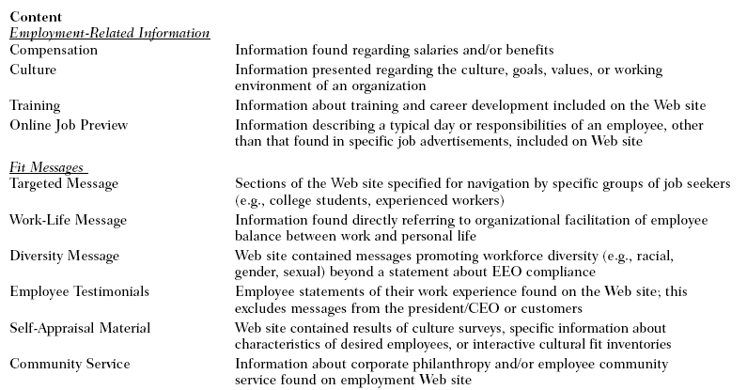
Figure 1: Content analysis
Secondly, a part of the coding scheme will permit to access the form of the websites. As it will be seen in the Theoretical Chapter, page 38, the form refers to the way the content is made available for web visitors; it includes the use of colours, pictures, animations and videos of the website (as seen in Figure 2), which can be used to make a website a more “vivid” experience for job seekers. Further, the form of the three selected websites will be evaluated and interpreted by the participants of the focus group interview. This means that the interviewees will carry out the content analysis independently.
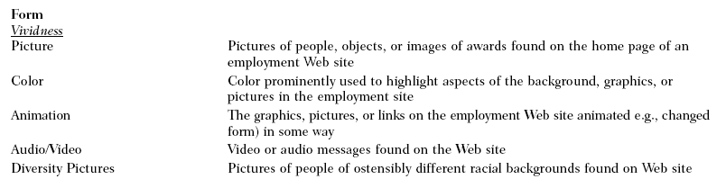
Figure 2: Form analysis
The third and last part of the coding form will permit to assess the function of the three selected websites, as seen in Figure 3. The focus will be on functions such as online applications and information in regards the application process. In addition, the navigational structure and tools of the websites that could make them more interactive are considered.
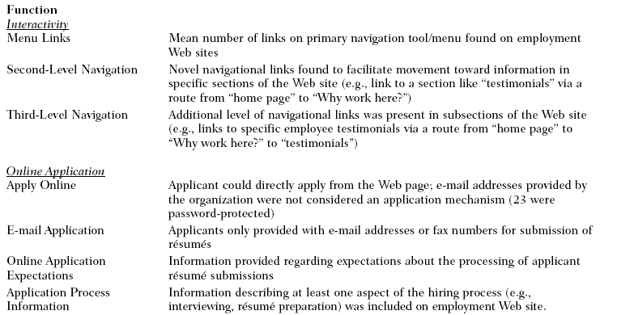
Figure 3: Function analysis
To sum up, this study employs a quantitative and qualitative content analysis methodology in order to explore how global companies make use of their career websites as a recruitment tool. In order to answer this question, the sampling unit consists of three career websites: Google, IBM and L’Oreal.
A form already drafted by some researchers is used in order to be objective, further this approach permits that no important career website elements are forgotten. However, the main disadvantage of using this form is that it was already drafted by someone else four years ago (2004), and most probably career websites have been improved and new tools are perhaps used by companies nowadays. As it can be seen in Appendix J, K, L, a long time was spend on each websites in order to fill in the form as precise as possible. Also, the number of web-pages dealing with each subject was noted. Furthermore, the interpretation of the findings will be facilitated by the results of the focus group interview.

The focus group interview method
In order to investigate what factors influence the effectiveness of a company career website as a recruitment tool and how perceptions of the form, the content and the function of career websites influence companies’ attraction, a focus group interview is conducted.
Firstly, in this chapter, a definition of focus group interview is given. Secondly, the process of conducting focus group interviews is described. Thirdly, some limitations in regards to using the focus group interview method are specified. Fourthly, the focus group interview process is explained elaborately.

Definition of a focus group interview
In order to know what factors influence the effectiveness of a company career website as a recruitment tool, a qualitative research is done. Qualitative research emphasises words rather than quantification when collecting and analysing data. Thanks to qualitative research, rich data are obtainable in a limited time. However, the major disadvantages are the lack of establishing reliability and validity. Interviews provide the opportunity for the researcher to investigate further, to solve problems and to gather data, which could not have been obtained in other ways. Kreuger (1988) defined a focus group as a "carefully planned discussion designed to obtain perceptions in a defined area of interest in a permissive, non-threatening environment". The focus group interview permits researchers to understand why people feel the way they do. In comparison with individual interviews, focus groups permit to see how people interact within the group. Also, during focus group interviews respondents listen to the answers from the others, as a consequence participants may modify or confirm their own point of view. New ideas and thoughts about the own behaviour can arise, inspired by the opportunity of hearing the views of other participants. Merton et al. (1990) suggested that a focus interview "...will yield a more diversified array of responses and afford a more extended basis both for designing systematic research on the situation in hand...“.
The main goal of using a focus group interview is to learn and understand as much as possible about what a group of people have to say regarding the topic of interest, in this case about career websites as a recruitment tool. In this context, a focus group interview is chosen because interviewees are more spontaneous than in an individual interview situation. Also, interaction among group members during the discussion of topics can stimulate many new ideas.
When conducting a focus group interview a number of considerations have to be taken into account, which will be outlined in the following discussion.
First of all, it is important to know how many groups are needed. Categorically, just one focus group will not be enough because it is possible that answers are particular for one group. Also, time and resources are a factor important to take into account when conducting a focus group interview; in his book, Bryman (2004) suggested that too many groups are a waste of time. For instance, Livingstone and Lunt (1994) reported that in their study of audience discussion programmes “the number of focus groups was determined by continuing until comments and patterns began to repeat and little new material was generated”. Some studies require that several (3-4) groups are convened. According to Morgan, "one important determinant of the number of groups is the number of different subgroups required...if there are several distinct population segments...you may want or need to run separate groups in each". Morgan (1988) believed that one group is never enough as you may be observing the dynamics of that group and little else.
To summarise, the best rule seems to set a minimum of two sessions and continue until no more new thoughts, ideas or feelings are given by different groups of respondents. However, focus group interviews need long time to organise and to transcribe as suggested by Bryman in his book. Those are the reasons why only one focus group interview is conducted in this study, mainly because of a lack of experience in organising and conducting a focus group interview.
Secondly, another consideration to take into account is how large groups should be. Morgan (1988) suggested that the typical group size is six to ten members. Most focus groups consist of 6 to 12 people. Merton et al. (1990) said that "the size of the group should manifestly be governed by two considerations...it should not be so large as to be unwieldy or to preclude adequate participation by most members nor should it be so small that it fails to provide substantially greater coverage than that of an interview with one individual". However, the number of participants will depend on the objectives of the research. For example, smaller groups (4 to 6 people) are preferable when participants have a great deal to share about the topic or have lengthy experiences with the discussed topic. However, too many participants, as for example 15, can easily change the group dynamics factor because they limit each person’s opportunity to speak.
To sum up, most experts as Merton et al. agreed that the optimal size of a focus group interview would be around 6 to 12 people, because this size ensures substantially coverage of the topic. Based on these findings, a focus group of eight people would be the best in order to conduct this research. However, a relatively small group of four persons is chosen, because of a lack of experience in doing a focus group interview and also, not a lot of time was available in order to find more adequate participants.

The interviewees
According to Bryman, anyone for whom the topic is relevant can be an appropriate participant. For instance, for their research about heart attacks, Morgan and Spanish (1985) decided to recruit people aged between 35 and 50, since they “would be likely to have more experience with informal discussion of our chosen topic”.
The success of any focus group study depends upon the researcher’s abilities to identify, select, and recruit appropriate people as participants. Different kinds of methods exist to select participants; researchers can choose them randomly or through some kind of snowball sampling methods. Also, there are several issues regarding the recruitment of focus group participants, is it possible for example to use friends or students from the same course? Some researchers prefer to exclude people that know each other. Some, like Kitzinger used groups made up of people who knew them. One of her argument was that it permits a natural discussion. According to Morgan, it is better to over recruit by 20% as some people may not wish to participate or not turn up on the day.
In order to conduct this research, the selection of the focus group participants was done in Strasbourg University, where the research takes place. It seems that it is the best place to find graduate students in Strasbourg. In collaboration with the university, an advertisement was posted the 13th of February 2009. The main problem was that the interviewees need to have communication skills in English, because the focus group interview was mainly run in this language. Participants were selected through some kind of snowball sampling methods. Three contacts (Julia, Touffik and Markus) were established, thanks to the advertisement. And then, one other person (Nathalie) was found thanks to the first contacts. As seen in Appendix E, the four participants are: Julia, Nathalie, Touffik and Markus, the average age of the sample is 25. Two different countries and cultures are represented: France and Germany. Two males and two females represent the sample. All participants are students in their final year or graduated, speak English and have different educational backgrounds and nationalities, which bring a global perspective to this study. However, this study does not aim to examine cultural differences. This diversity could bring sufficient variation among participants to allow diverse opinions and permit active discussions during the interview.
First of all, the four persons were invited to the focus group interview by sending an invitation mail that includes all the information about the focus group meeting. In this mail, different information was included: who I am, why I contact them and when and where the focus group will take place. The purpose of this mail was to comfort the person’s commitment to participate in the focus group.
As Morgan (1988) suggested, it was chosen to over-recruit the participants. In case that one of the interviewee cannot show up for the focus group interview, another participant was selected in order to replace ‘no-shows’.
The focus group interview took place in the flat of the researcher, located in Kehl, Germany. However, it would have been possible to do the interview at Strasbourg University, but it would have been a too formal environment, as the university can be easily associated with an “experiment”. Furthermore, the chosen place provides a more “cosy” environment, where people fell comfortable to speak about their experience.

The focus group session
The focus group interview took place the Tuesday 3rd of March 2009; it was aimed to keep the interview short, not longer that two hours. The day and the time were chosen in accordance to the participants’ timetable.
According to Bryman, “the focus group session will work best if it is recorded and subsequently transcribed”; because it is difficult to write down exactly what people say; also it is important to know who says what and who express their opinion. Bryman said that in qualitative researches, it is interested to know what people say, but also how they say it. For instance it is relevant to be aware of which particular language the participants employ. There is a high probability that the nuances of language will be lost if the researcher do not record it.
In order to collect data the focus group discussion was recorded and afterwards transcribed. The microphones and recorder were visible to participants. According to Bryman, transcribing a focus group interview is more difficult than transcribing a traditional interview, because of the need to take into account who is speaking and what is said. In addition, the voices are sometimes difficult to recognise and people talk over each other.
The information collected in the focus group discussion is raw data. The first step was to transcribe the entire interview. It provides a complete record of the discussion and facilitates the analysis of the data. The next step was to analyse the content of the discussion. In order to make the focus group interview analysis more amenable, the meaning condensation method was used. The meanings expressed by the interviewees were abridged into shorter formulation. To do so, long statements were compressed into briefer and more succinct formulations and statements in which the main sense of what is said is rephrased into few words. Moreover, the content of the focus group interview will be read literally.
In this section, it was shown that focus groups have advantages and are useful for an interactive and spontaneous discussion regarding a particular topic.

Limitations of focus group interviews
Focus groups also have disadvantages. First of all, in comparison to individual interviews it is difficult in a focus group interviews to have the control of the discussion. Also, it is a difficult question to know how involved moderators should be and how far a list of questions should influence the conduction of the focus group interview.
Also, one main problem regarding focus group interviews is that people agree to participate, but do not show up for the interview. Wilkinson said that “it is almost impossible to control for ‘no-shows’ other than consciously over-recruiting”.
Another limitation is that the number of participants of a focus group is not large enough to be a representative sample of the population. The sample of this research is not representative; only four persons were interviewed and it is not possible to generalise the findings and the results. Therefore, the data obtained from the focus groups is not necessarily representative of the whole population. As a consequence it is not possible to generalise the results.
In addition, as pointed out in the section above page 24, the data of a focus group interview are difficult to analyse because there are often inaudible elements and variation of the voice, which affect the transcription. However, in their studies, Morgan and Spanish (1985) demonstrated that the examination of group interaction can be used to show how issues of thematic occur during the discussion.
There are possible problems of group effects. This includes the evident problem of dealing with hesitant speakers and with those who monopolize the stage. Krueger (1988) recommended that the moderator should make clear to the participants that other people views are definitely required; for example, he suggested saying something like “that’s one point of view, does anyone have another point of view?”. If some interviewees do not speak very much, Krueger (1988) gives the advice to encourage them to say something.
To finish, the last limitation is that in group contexts, participants may be more subject to expressing culturally expected views than in individual interviews. Morgan cited the case of a study, in which group interviews with boys discussing relationships with girls were compared with individual interviews with the same topic. In the latter they expressed a degree of sensitivity that was not present in the group context, where more macho views tended to be forthcoming. This suggests that in this group interviews the boys were seeking to impress others and were being influenced by the norms of their peer group.

The focus group interview process
Since a qualitative research method of a focus group is chosen, the use of a qualitative interviewing method is utilised. An interview guide of 55 questions is created and follows the semi-structured interview method, as seen in Appendix C. This method suggests that “the researcher has a list of questions or fairly specific topics to be covered, often referred to as an interview guide, but the interviewee has a great deal of leeway in how to reply”. This means that the interviewer has the freedom to use the interview guide according to the interviewee’s answers, and do not have to follow the chronological order of the questions in the interview guide. In addition, the interviewer can come up with new questions, which spontaneously emerge during the interview, as well as referring back to previous comments made by the interviewees. However, some disadvantages can occur when using this method; such as focusing on new issues, while neglecting other scheduled topics that were intended to be raised in the original interview guide.
The interview guide is grouped into three stages. The structure of the focus group interview was selected according to the main research questions and the three selected companies; this approach enables to answer the research questions. First of all the interview guide includes general questions about the utilisation of the Internet to search a job and about career websites in particular. Secondly, specific questions about each websites were asked. The questions were elaborated according to the coding framework developed by Cober et al. (2004), which can be seen in Appendix I. The interviewees were asked to access the form of the websites. As seen page 16, the form includes the use of colour, pictures, animation and video that are present on the website. For example, questions like “do you like the colour of the website and why?”, “what do you think about the video present on the website” were asked. Also, the interviewees were asked to assess the function of the three selected websites, as the navigational structure and the interactivity of the websites. Questions such as “Is it easy to utilise?”, “what do you think about the structure of the website?” were asked. To finish the interview, a discussion about the effectiveness of career websites and more specifically about the three career websites was carried out.
As a next step the interview process will be more elaborately discussed. First of all, before to start the interview, the interviewees were asked to fill in a form with five questions. Demographic and factual questions such as name, gender, age, nationality, and educational background were asked.
After the participants filled in the form, it was then time to start the interview questions, beginning with some general introducing and opening questions about their opinion and attitude in regard to career websites. The aim was to get the respondents warmed up for the main interview questions and to create a natural flow between the welcome form and the beginning of the interview. The second part of the interview was concerned with the three selected career websites of Google, IBM, and L’Oreal. Participants were instructed to assume the role of a job seeker, when examine the three different websites. Further, participants were told that they have 15 minutes time to examine each website. After this time participants were asked to complete a questionnaire containing questions regarding their perceptions and impressions of each websites. Further, the perception of each selected company as a potential employer was discussed. As seen in Appendix C, in this questionnaire, the majority of the questions were about the form and the function of the websites. Indeed, the interviewees were asked about aspects such as pictures, design, colour, structure and videos. Unfortunately, caused by the lack of time, it was not possible to look into the content and the actual text of the websites; the participants had had only 15 minutes to look at each website in order to assess them. All questions were anchored along a 5-point scale ranging from “very good” to “very poor”. Also, the participants were asked to explain and justify their choice. Finally, participants ranked their preference for the three companies as a place to work and justified their choice. As a next step, these characteristics were discussed together in the group, with the aim to gain a better understanding of job seekers reactions regarding the form and function of career websites.

Theoretical Framework

Internet: a new medium to recruit

The use of Internet to search a job and to recruit
As described in the Introduction Chapter (Page 6), the popularization of the Internet has changed the way companies recruit employees and the way people seek employment. Job seekers in countries such as France, United Kingdom or USA, do the majority of their job searches online; which includes preparing resumes, searching for jobs and submitting applications. According to a recent survey, 52 million of Americans use the Internet to search for jobs. Also, Cober et al. (2003) said in their paper that nowadays, “millions of job seekers turn to these web sites to acquire pre-contact organizational information”. That is the reason why companies have already adjusted their recruitment practices to react to this tendency by using the Internet medium to recruit potential candidates and moving beyond the traditional newspaper advertisements. This is confirmed by surveys that report that up to 90% of large U.S. companies communicate employment information via their corporate websites.

Definition of e-recruitment
The use of the Internet as a mean of connecting job seekers and employers is described in the literature (Barber, 1998; Galanaki, 2002; Fister, 1999; etc.) by a number of different terms, including online recruitment, e-recruitment and web-based recruiting. These different terms will be used interchangeably in this paper.
E-recruitment refers to the use of the Internet to facilitate the recruitment process by advertising jobs online. This can be accomplished by using a company’s own corporate website or job boards like Monster.com. According to Schreyer & McCarter (1998) e-recruitment refers to “the recruitment process, including placing job advertisements, receiving resumes, and building human resource database with candidates and incumbents”. According to Gentner (1984) and Casper (1985), the Internet first emerged as a new recruitment tool at the disposal of employers in the mid-1980s. It was hailed in the popular management press as the driver behind a “recruiting revolution” for the reason of the benefits it could bring to recruiters. The terms online recruitment or e-recruitment imply the formal sourcing of job information online, it appears in the Human Resource journals in the mid-1990s, when IT companies and universities began to use the Internet extensively. Since then the online recruitment industry has been developing.
In most relevant literature about online recruitment (Frankland, 2000; Ganalaki, 2002; Bussler & Davis, 2002, etc.) some advantages and disadvantages of utilising e-recruitment and especially career websites have been identified. In the next sections the advantages and disadvantages of e-recruitment will be discussed.

Advantages of e-recruitment
One of the potential benefits of e-recruitment in general and especially through the use of a career website is the ability to reduce recruiting costs. In fact, Internet allows companies to advertise their vacancies inexpensively to a potential audience. Indeed, by using their own career website; companies can post unlimited vacancies and generate a pool of applicants for minimal costs. According to Frankland (2000) the cost of setting up a good career website is approximately equivalent to the associated advertising costs of a single high profile job in a national newspaper. Moreover, huge savings can be achieved by dispensing to print glossy recruitment brochures and other documents. Using the Internet to advertise a job and attract potential candidates has been shown to be less expensive than other more traditional recruiting methods, such as the use of major newspapers or head-hunters. According to Ganalaki (2002) online recruitment speeds significantly the hiring process, because companies can advertise their vacancies almost directly on their corporate website, which is inexpensive.
Secondly, the literature suggests that e-recruitment could permit companies to reduce the recruiting process time. Bussler & Davis (2002) stated that the online recruitment method can reduce the hiring time by two-thirds. For example, online posted jobs go live in minutes and candidates can respond immediately to job offers. Moreover, e-recruitment is considered as a very good tool to reach a global audience. Advertising online gives access to a much wider candidate pool than advertising in newspapers. This provides companies a better probability to find appropriate candidates, as online advertising can reach people from all over the world, by contrast, newspaper advertisement reach typically local or national groups.
Further, in comparison with job boards, like Monster which is run by third party service providers, career websites provide companies the freedom to present information and recruiting strategies in their own way.
To finish, and perhaps the most relevant to this paper, according to some authors like Cober et al. (2004) career websites may influence candidates to apply. Also, according to a study conducted by Wetfeet (2003), more than 50% of job seekers have become interested in working for a company after having visited its career website and nearly 25% have rejected a company because of a poor experience with its career website. These statistics show that career websites can have an influence on attracting candidates. That is the reason why career websites are becoming an important part of companies’ communication.

Disadvantages of e-recruitment
There are some disadvantages of using e-recruitment. Online recruitment is mainly perceived as suitable for IT jobs and young graduates which reduces its effectiveness in the quest for other profiles. In addition, e-recruitment is according to Greengard (1999) more effective for already known companies. Moreover, it is claimed that online recruitment may have an unequal impact on certain groups, like for instance ethnic minorities. Indeed, people may lack access to computers or do not have the skills necessary to use the Internet. A further issue related to e-recruitment is that Internet makes it easier for applicants to summit their resumes. Ganalaki (2002) argued that this circumstance could create a huge amount of unqualified candidates. Similarly, Pearce & Tuten (2001) claimed that e-recruitment yield a high volume of applicants but a low quality fit.

Definition of the term corporate website
A corporate website can be defined as a website produced by a company to provide general information about itself, including product or service information, company history, mission and values, organizational structure, key corporate messages, public relations information, etc. Usually, a link to the career website, typically called "career" or "jobs" can be found on the company‘s corporate websites.

Definition of the term career website
Thanks to their career websites or also called by Cober et al. (2004) “corporate employment web sites” companies can not only post vacancies, but also create strategic content to attract potential employees. Information such as company description, employee benefits, workplace culture, along with other information may increase the likelihood that job seekers will adopt a positive image of the company and submit their application. A career website is a section in a company corporate website. These websites are strategic, influential and meaningful for companies wishing to recruit new employees. Beyond simply providing job descriptions on their career websites, companies attempt to make a persuasive first impression. This argumentation is also confirmed by Cook (2001), a successful recruiting consultant, who claimed: “A corporate site is the first opportunity to make an impression on a prospective candidate. The new breed of Web-savvy, generation X job seekers will scour your site to get an indication not only of your business and direction, but also your vibe and gather some cultural cues”. This statement indicates that the use of a career website is a relevant tool that needs to be taken into account by companies wishing to attract new employees. This is one of the reasons why it was decided to investigate career websites in this study.

Career websites and companies attraction

Career websites content

Firstly, Barber (1998) found out that in the early stage of the recruitment process, company attraction depends on the company recruitment materials available to job seekers. Maurer et al. (1992) noted that the amount and type of content contained in recruitment materials are important factors of attraction, since a positive relationship has been established between the amount of content in recruitment materials and attraction of an employer. Also, Barker & King (1993) pointed out that job seekers perceive missing information as a cue that a company is disinterested or not careful in term of its recruitment. These researches show that the amount of information in recruitment materials, as for example in career websites, is significant. By comparison with the use of newspapers, that allows only few lines of advertisement; the use of career websites permits companies to provide a great quantity of information regarding the work environment, training opportunities, type of people a potential applicant would work with, etc.
Secondly, after having seen that the quantity of content is important; the type of content present on career websites is also essential. Highhouse & Hoffman (2001) stated that the type of content on a website plays a large role in determining the job seekers interests’ in employment pursuit. Schwab (1982) observed that recruitment advertising content affects company attraction. The type of information that influences job seekers attraction to a company has been examined by different authors (Barber & Roehling, 1993; Rafaeli, 1998; Cable & Graham, 2000). The results show that information related to compensation, culture and career development opportunities are strong predictors of company attraction.
For example, Barber & Roehling (1993) found that job seekers spent a considerable amount of their time considering the salary and benefits offered by a company. Also, Rafaeli (1998) examined that many job seekers look for job opportunities that offer professional development and job challenge. In addition, Cable & Graham (2000) observed that job seekers spend a large proportion of their time reviewing information related to developmental opportunities.
Also, Cober et al. (2004) found that career websites enable companies to clearly target recruitment messages to different applicant groups like for examples women, minorities, junior, graduate, senior, etc. In addition, thanks to the Internet medium, companies can communicate by using some employee testimonials that also provide job seekers with insight about the types of people they may encounter and work with.
To sum up, the present literature shows that company compensation, culture and developmental opportunities play an important role in company attraction. That is the reason why it was decided to look into these themes when analysing the three selected websites, as seen in the Methodology Chapter page 17.

Career website form
According to Rynes et al. (1991) applicants consider applying to a company when recruitment advertising engages his or her interest. Redman & Mathews (1992) suggested that aesthetic attributes attract job seekers attention and generate interest in job opportunities. Also, Yuce & Highhouse (1998) pointed out that aesthetic characteristics increase attraction of an employer. These statements show that the form of a recruitment advertisement is an important factor to take into account when aiming to attract applicants.
The Internet provides a dynamic medium for companies to attract applicants, because of the form (style or design) websites can have. According to Cober et al. (2004) the most perceptible way for companies to distinguish themselves is to control the “vividness” (aesthetic quality) of their career websites. For example Coyle & Thorson (2001) described the use of aesthetics on a website as its vividness, according to them it includes “the colour, images, sound, and animation used to make the Internet a more realistic sensory experience”.
Recent literature provides suggestions in how to improve the appearance of career websites. Some characteristics have been identified that may distinguish attractive websites from less attractive ones. These characteristics are related to technical format, textual format, layout and colouring. For instance Metz & Junion-Metz (1996) suggested that some websites’ characteristics can permit to improve recruitment images such as design, text, reading patterns and pictures. First of all, according to them the best design is simple, which means basically that visitors can navigate easily through the website. The second important aspect in regards to website development is the text. Metz & Junion-Metz (1996) advised that it may be a good idea to place the important text at the top of the website, because people often neglect to read websites in their entirety. Websites should contain sentences written concisely and the important words should be presented in bold or italic letters. Moreover, bulleted text is generally preferred to paragraphs of text. The third important aspect for website development is the reading pattern. For example people read in certain patterns, such as left to right and top to bottom. Therefore the most important information to be conveyed should be strategically located. Further, according to them, colours, graphics and fonts can improve the attractiveness of a website. For instance, website perceived as attractive makes use of bold colours, creative fonts and pictures; this helps to associate an image with the text. Metz & Junion-Metz (1996) argued that the use of contrasting colours creates visual excitement that encourages the visitor to explore the site further. According to Metz & Junion-Metz (1996) the fourth and last aspect important to website development is the use of pictures. Pictures should be included only when they are relevant to the message that is conveyed. In addition they should be colourful, large and well-organized so that they transmit a significant message.
To sum up, these findings suggest that the ability to find desired information may have a significant effect on a user’s experience with a career website. Therefore, it can be hypothesised that the perception of the form of a website has an influence on the company attraction. The focus group interview will permit to confirm or reject this hypothesis.

Career websites function
Cober et al. (2004) found that the function of a career website plays a significant role in determining the website’s success as a recruitment tool. The career website function is described by Cober et al. (2004) as the ability to interact and navigate a website.
Cober et al. (2003) established the effectiveness of career websites in attracting applicants. For instance, they found that career websites increase company attraction when they are easy to navigate. Similarly, Hannon (1998) described an attractive website as highly interactive which permits to maintain the interest of the visitors. Moreover, according to Cober et al. (2004) attractive websites generally provide a clear structure of the website’s content on the first visible screen. Additionally, they stated that an easy navigation of the website and a direct access to the information desired by the viewers is important. In opposition, a website difficult to navigate with poor usability may reflect negatively on a company. For instance, 62% of consumers reported that they stopped a product search because of problems to locate information. Likewise, navigational difficulty has been found to result in users becoming bored, frustrated and detached from websites; which had have the consequence that users terminated information searches and moved on to other websites.
Also, according to Cober et al. (2004) interactivity can make websites more entertaining and navigable. Indeed, probably the most widely utilized interactive tool is the navigational menu. Navigational menus guide job seekers to specific areas of information. According to Cober et al. (2004) career websites can make the application process easier for candidates and may reduce the cycle time of the hiring process.

To conclude, these findings indicate that career websites should be designed with attractive formatting and straightforward functionality, which could enhance a website’s appeal. As seen in this section, website content is not the only important component of a company’s recruitment strategy; also the form (design and aesthetics) and the functionality matter. That is the reason why it was decided to look into these three elements (content, form and function) when analysing the selected websites.
The content analysis of Google, IBM and L’Oreal career websites will permit to reveal how these three companies make use of the content, form and functionality aspects outlined in this section.

Employer Branding
The term employer branding is quite new, indeed it was used for the first time 1996 in a European marketing journal. Nowadays, it is frequently employed in the business press. The Conference Board proposed that “the employer brand establishes the identity of the company as an employer. It encompasses the company’s values, system, policies and behaviours toward the objectives of attracting, motivating, and retaining the company’s current and potential employees”. This definition indicates that employer branding involves promoting, both within and outside the company, a clear view of what makes a company different and desirable as an employer. Ambler & Barrow (1996) defined the employer brand in terms of benefits, calling it “the package of functional, economic and psychological benefits provided by employment, and identified with the employing company”. This definition is consistent with categorizations of brand concepts in the brand management literature. Employer branding has emerged from applying marketing principles to the field of personnel recruitment. Research on employer branding is still relatively limited. According to Collins & Stevens (2002) diverse recruitment practices can be used to externally market the employer brand. Moreover, Collins & Han (2004) found that employer branding has beneficial effects on the company performance and may increase quantity and quality of applicants.
The analysis of the three selected career websites will permit to reveal how Google, IBM and L’Oreal brand themselves as an employer on their career websites.

Objective, subjective, critical factors
In this section it will be discussed from a theoretical perspective what types of factors determine which people may answer to a recruitment advertisement. Behling et al. (1968) reported in their article “Recruiting: A theoretic base” three theories that job seekers use to decide in which company they would like to work, which are: objective, critical contact and subjective factors.

The Objective Factor Theory
According to the Objective Factor Theory, individuals choose the company they want to work at according to different objective and measurable characteristics such as salary, career development prospects, benefits, educational opportunities, the nature of the work to be performed, etc.

The Subjective Factor Theory
The Subjective Factor Theory emphasizes the similarity between personality patterns and the image of the company as the main determinant of company choice. According to this theory the choice of an employer is an emotional and personal choice based on links between the company's corporate image and the individual's personality.

The Critical Contact Theory
The Critical Contact Theory suggests that individuals are unable to make significant differentiations between diverse job offers. According to Behling et al. (1968) the length of contact with the company is too limited and most advertisements are too unclear to make any meaningful choice. However this article was written in 1968, in this time vacancies were mainly posted in newspaper and the Internet did not existed yet. Also, in their study, Behling et al. (1968) suggested that college graduates are too inexperienced to evaluate advertisements. However, candidates have to make a choice, as a consequence they are compulsory to rely on the differences they can perceive throughout their contact with companies. Therefore, the individual's decision will be based on different factors like the short time spent at an interview, the appearance and questioning of the interviewer, the physical surroundings of the company, the efficiency in responding to applications and other paperwork.
These theories developed by Behling et al. (1968) will support this study in investigating what types of factors the selected participants use when deciding in which company they would like to work. Therefore questions like for instance “Which factors influence your choice to apply for a company?” were asked during the focus group interview. The answers will permit to support or to reject the theories developed by Behling et al. (1968). However, it is important to take into account that this theory is quite old (1968) and nowadays the use of the Internet medium is well developed, with the possibility to make an unlimited amount of information to a large audience available.

Signalling theory
Signalling theory (Spence, 1973 and 1974) provides a theoretical background to understand why a company’s career website may affect a viewer’s perception of the company, when considering whether or not a company’s career website can change viewers’ impressions of it. If viewers change their perceptions of companies after being exposed to their career websites, it is important to ascertain what aspects of these websites may be responsible for these changes.
Signalling theory was developed originally in economics research and has been adopted to explain the interaction between potential applicants and recruiting companies. This theory implies that at early stages of the recruitment process, when the information about the company is limited, a potential applicant will give deduction about the company based on secondary signs. Potential applicants will interpret this limited information as “signals” about what it would be like to be employed by the company. That is the reason why factors without direct relevance to a particular job or company have been found to be influential determinants of company attraction. More specifically, applicants may interpret recruitment activities as signals concerning working conditions in the company.
For instance, unimpressive recruitment materials may signal that the company does not invest much in developing people, resulting in low attraction of the company. Further, Turban (2001) found that college job seekers’ perceptions of recruitment related activities like sponsorship affected their perceptions of a company image. In addition Rynes & Miller (1983) examined this issue by asking participants to evaluate companies after being exposed to videotapes of recruiters. Results indicate that individuals created a favourable impression of companies which was represented by recruiters with positive attitude. For example, if a company’s recruiter was perceived as friendly and competent, applicants may suppose that these qualities are also important for the company. This can occur because applicants view recruiters as being representative of their respective companies.
These results show that variables that do not seem to have a strong direct connection to a job or company can become “signals” for what it would be like to work at that company and may also influence individuals’ attraction to companies.
Signalling theory can be extended to the Internet domain in order to explain how potential applicants perceive the company after having been exposed to its career website. Applying signalling theory to the Internet domain would suggest that in the absence of other information about a company, applicants will be influenced by minor cues gained from the career website. For example, if a company has a career website difficult to navigate, job seekers may use this information to form a general negative impression of the company; because they could presume that it is suggestive of how other practices and policies at the company are implemented. In opposition, if a company’s website is well structured and organized applicants may deduce that the company has and values such qualities. In the absence of more significant information signalling theory suggests that a company career website should provide clues to the viewer about the nature of the company.
In this context signalling theory suggests that the effect of a company’s website will be higher for individuals less familiar with the company than for persons with previous knowledge or experience with it.
Signalling theory provides a theoretical support for why a company’s career website may affect a viewer’s perception of the company, especially when considering whether or not a company’s career website can change the perception of a company. If a change of perception after the exposure to a career websites occurs, it is relevant to this study to ascertain what aspects of these websites may be responsible for these changes. Despite many possibilities and aspects of a career website could exist, this study particularly focuses on the content, form and function of a career website, as already discussed early in this chapter.

Analysis part

Background information

Google presentation
Google is an American public corporation which generates revenue thanks to advertisement related to its Internet search engine, e-mail, online mapping, social networking, video sharing services, etc. The headquarters is located in California. In 2008, the company has 20,222 full-time employees. In 2007 Google was being rewarded by the Fortune Magazine as the best company to work for worldwide.

IBM presentation
IBM (International Business Machines Corporation) is a multinational computer technology and consulting corporation based in the United States. IBM has been known through most of its recent history as the world's largest computer company. IBM offers clients an end–to–end portfolio of consulting, technology and services combined with business insight. With over 388,000 employees worldwide IBM is the largest and most profitable information technology employer in the world.

L’Oreal presentation
With more than 130 products sold per second all over the world L’Oreal is the world’s largest cosmetics company and has its headquarter in Paris. In 2007 L’Oreal employed 63,358 employees in over 58 countries. Some of the most recognised brand worldwide concerning beauty, cosmetics and fragrance are part of L’Oreal’s brand portfolio including 25 global brands such as Lancôme, L’Oreal Paris, Garnier, Body Shop, Maybelline, Kerastase, Biotherm, etc.

The use of the Internet to find a job
As indicated in the Introduction and the Theoretical Chapter, the popularization of the Internet has changed the way people search and apply for jobs. This statement is confirmed by the participants of the focus group interview, indeed they are all using the Internet to look for job offers. For instance, Nathalie is using the Internet to acquire pre-contact information about companies. More precisely, when going on the Internet, the interviewees are using job boards or specific websites like Monster, Cadremploi, Jobrapido, etc. in order to find job offers. In addition, apart from Julia; the interviewees are visiting corporate websites when looking essentially for a “particular job” in a “specific region”. Regarding the use of social networks, the four interviewees are not using them; however they are aware of them. For instance, Markus has a page on LinkedIn, but he does not use it to find a job. Regarding more traditional methods to look for job offers, nobody is using the newspapers to find a job. Markus confirmed that he “don’t find some offers that fit with my profile on newspapers”.
In the following analysis, it will be seen how the three selected companies have adjusted their recruitment practices to deal with this tendency: using the Internet medium to recruit potential candidates and moving beyond the traditional newspaper advertisements.

Analysis of the three career websites
First of all, the content of the three selected career websites will be analysed by applying the content analysis method, described in the Methodology Chapter, page 15. This analysis will permit to investigate how the three selected global companies make use of their career websites as a recruitment tool. Secondly, the form of the three websites will be examined; it will contribute to determine the attractiveness of the three career websites. To finish, the function of the three websites will be explored. In order to investigate these three aspects (content, form and function) a coding form elaborated by Cober et al. (2004), exhibit in Appendix I, is used.

Websites content analysis
First of all the content of the three websites will be investigated by using the coding form of Cober et al. (2004). According to Cober et al. four types of information have been found to be important, as stated in the Methodology chapter, page 16:
- Information about salary and benefits
- Information about company culture
- Information about training and advancement opportunities
- Information about online job preview
Questions regarding these four aspects were asked to the participants of the focus group interview. This will permit to investigate if job seekers are paying attention to these types of information when applying, and in addition if the content of these types of information could influence their choice to apply to a company. In this context the Objective, Subjective and Critical Factors Theories and the Signalling Theory will be applied, which can be found in the Theoretical Chapter.

Information about salary and benefits
As stated in the Methodology Chapter page 16, first of all, Cober et al. observed that information regarding salary and/or benefits (compensation) is an important aspect companies should included in their career websites. In this perspective these questions are relevant: Do the three selected companies provide some information about compensation on their websites? And do the participants of the focus group interview found this aspect essential when deciding to apply?
In two sections of its career website Google gives information about the different compensations it offers: “Top 10 Reasons to Work at Google” and “Benefits of working at Google”, in total more than sixty lines are dedicated to this matter. For instance, the numerous benefits are explained into details which encompass “Health and wellness”, “ Retirement and savings”, “ Time away”, “ Benefits … beyond the basics“, “Benefits … way beyond the basics”.
During the focus group interview the participants were asked about their opinion about information regarding compensation. The participants pointed out that Google offers a lot of “unusual” benefits. According to Touffik Google offers all these benefits that employees “fell good, well and stay as long as possible during the day and during their life in the company”. Further, Markus pointed out that “the benefits on the website are sound with the image of the company, for example for me Google is a company which is always one step ahead then the benefits they proposed are as well extraordinary, in order to attract people which can support Google in being innovative”.
IBM dedicates fifty lines to this topic in the section “what we offer”, which is split into three themes: “your life”, “your health” and “your money”. IBM puts emphasis on its “reward package”, which is according to IBM designed to attract “top candidates”. Also, details about flexible working hours, vacation, health (including critical illness cover, personal accident cover, dental insurance, health assessments and private medical insurance), salary (“salary of between £27,000 and £32,000”), bonus and discount scheme are covered. All these advantages are characterised as “attractive benefits” by IBM. Concerning IBM benefits, Markus said that they are “straightforward, split into three basic topics, nothing special”. The other participants agreed with his interpretation.
L’Oreal gives also information about compensation in the section “your career” and more precisely in the sub-section “benefits”, ten lines are devoted to this subject. In comparison with the two other companies L’Oreal does not draw attention to salary or health benefits. In fact, in the “benefit” sub-section L’Oreal puts emphasis on the global career development opportunities, by using words such as: “new development opportunities”, “with continuous year-on-year growth and rapid development”, “L’Oreal offers wide-ranging opportunities for career development throughout the world”. Also, L’Oreal highlights the fact that the company “support” employees, most of these statements used language like: “personalised integration and support programme adaptable”, “provide ongoing support”, “you will be constantly supported by our teams” and “invaluable support from your manager”. Only some social extra activities are exposed: “numerous social activities are organized within L’Oreal: visits, trips, team sports, kids' days… so that you can enjoy, share and meet people from different horizons around work”.
To sum up, in the three websites information about compensation like benefits employees get when working in the companies including salary, opportunities for advancement, health insurance, and other more untypical benefits (especially concerning Google) were found. However, this information was expressed differently. In fact, Google puts the emphasis on the multitude and uncommon benefits it proposes like for instance “massage”, “free food all the days”, etc. IBM differentiates the benefits into three parts: “life”, “health” and “money”. In opposition, L’Oreal does not give any information about salary or healthcare benefits. In the section “benefits”, L’Oreal emphasises the “international opportunities”, the “customised training and development” and the “social life”.
It is relevant to know if information in regards to compensation is an important aspect for job seekers. For example, in general the participants of the focus group interview like to have information about the salary. As can be seen in the focus group transcription Appendix D, the interviewees said that the salary is an important aspect they take into account and could influence their choice to apply. This statement confirms The Objective Factor Theory elaborated by Behling et al. (1968) that claimed that individuals choose the company they want to work at according to different objective and measurable characteristics such as salary. Moreover, it confirms the finding of Cober et al. who put this theme into emphasises in their research. Also, as seen in the transcription (Appendix D) Markus pointed out that information about benefits and compensation are important and should be found in a career website, because according to him, “this basic information says a lot about the company and the job itself“. Also, he said that “the salary says a lot about what the company expects from you and what kind of accountabilities you will have in the job”. As well, he pointed out that information regarding compensation could influence his choice to apply in company. However, he informed us that in Germany it is not common to give information concerning salary on the company website and job descriptions, which makes it more difficult for him to search for an appropriate vacancy and company.
In addition to the text companies utilise visual elements like pictures and videos to illustrate the different compensation aspects; as it will be seen in the analysis of the form of the three websites.

Information about the Culture of the company
According to Cober et al. another aspect that should be in a career website is information regarding the culture, working environment, goals and values of the company. In this section the emphasis will be on how the three selected companies describe themselves on their career websites, as a unique company and therefore as a unique employer. According to Cober et al. this aspect includes information regarding the company: its history and mission statement. Further, information about the actual working environment should be present.
The three selected companies tend to focus on their characteristics and attributes such as their size and their success, when describing and promoting themselves as potential employers on their career websites. First of all, by using words such as “global” and “large”, the three selected companies put emphasis on their size. For example, Google uses words such as “we think, act, and work globally” “worldwide” and “offices around the globe”. IBM uses the word “largest” and a synonym to describe its operations and size: “the world’s largest IT and consulting services company”, “we are a huge, global company”. Also, L’Oreal presents itself as an international and global company by using formulations like: “global”, “international working environment” and “63,000 employees worldwide”.
Also, the three selected companies describe themselves as successful on their respective career websites. For instance, Google uses words such as “success”, “most successful organizations” and “we continue to grow”. L’Oreal describes itself as a competitive and successful company: “highly successful economically”, “with continuous year-on-year growth and rapid business development worldwide” and “highly competitive”.
The three companies are using testimonials to give information about the work itself and more precisely about the work place environment.
In order to give job seekers descriptions of the company experience from current employees’ point of view, the three selected companies use some employees’ testimonials as a communication and recruitment tool. For instance, under the section “meet some Googlers”, job seekers have the possibility to discover the working life of four Google employees. In this section, job seekers can see pictures of the employees and can learn more about their education and their accountabilities in Google. The emphasise is put on why the four employees decided to work at Google, why they like to work at Google, what “cool” projects they are working on and which are their “favourite perk/benefit about working at Google”.
In the section “profiles” six testimonials are available on the IBM website. The emphasis is put on the key responsibilities employees have, on what employees enjoy at work, why they joined IBM and on the life at IBM.
Similarly, in the section “passion for the job” of the L’Oreal website, job seekers have the opportunity to discover twenty-three stories of different employees from all over the world; including details such as: the background of the employees, what they studied, what they are actually doing and their tasks on the daily basis. The stress is put on the developed skills and the main responsibilities employees at L’Oreal have.
In these testimonials the work in the companies is described as being challenging. In all three cases the word “challenge” is implied positively in order to demonstrate the advantages of a challenging work and workplace. For instance, the three companies are using words such as: “challenging projects” (Google), “hundreds of challenges” (Google), “to work for a company where you’re challenged and stretched” (IBM) and “for the challenges of your next career step” (L’Oreal).
In addition, the three selected companies give information about the workplace environment by using the testimonials in combination with visual elements, as it will be seen in the analysis concerning the form of the websites.
The content analysis of the three websites shows that companies are trying not only to sell a job, but also the workplace. This importance is also confirmed by the structure of the career websites, which will be analysed later in this chapter. It gives the impression that the three selected companies view the workplace environment as an important factor to attract applicants. Indeed, the three career websites offer visitors a large amount of textual and visual information, that permit to have a glimpse of what working in the company is like.
In its career website Google puts the most emphasis on the workplace culture and climate. The working environment in Google is portrayed as pleasure: “in an environment designed to foster collaboration”, “creativity, health, and happiness”, “positive environment”, “small, focused teams and high-energy environments” and “work and play”.
L’Oreal describes the working place as “great” and promotes an open and respectful atmosphere. For instance L’Oreal is using words such as: “L’Oreal: Great Place to Work”, “safe and healthy working environment”, “stimulating environment”, “we encourage an atmosphere of openness, courage, generosity and respect, so that all our employees feel free to come forward with their questions, ideas and concerns” and “an exciting, demanding environment”.
Moreover, the three companies describe their working environment as international and multicultural, by using words such as: “international working environment” (L’Oreal), “working with people from all continents and cultures” (Google), “multicultural teams are what adapt our global brands to local demands” (Google), “globally diverse workforce” (Google), “interacting with diverse people” (IBM) and “people from diverse backgrounds” (IBM).
According to Cober et al. another important element that should be found in a career website is information about people, more precisely about the employees of the company. Once more, this information is communicated by using employees’ testimonials. On the three websites, the ethnicity and gender of the portrayed people varied. For example, more than 50% of the employees represented on the websites were from ethnic groups, such as Indian, African, Chinese, etc. In addition, an equal proportion of female and male was found on the three selected websites.
In their career websites the three selected companies put emphasis on their employees. For instance, Google and IBM use the words “Googlers” and “IBMers” to name their employees. These nicknames may indicate the importance of their employees.
Google emphasises the importance of its employees: “the good results of Google result from the global diverse and smart workforce”. The “Googlers” are described as talented and vital for Google; using words such as: “smart people”, “every employee has something important to say”, “every employee is integral to our success”, “and are as passionate about their lives as they are about their work” and “your creative ideas matter”.
IBM characterises its employees as curious, brilliant and motivated: “IBMers are inquisitive people motivated by high achievement”, “talented individuals”, “ambitious” and “you’ve got a passion for business”.
Likewise, L’Oreal portrays it employees as “enthusiastic about going to work”, “creative” and “passionate about the job”. L’Oreal believes that its employees are essential for the company: “we know that our employees are our greatest assets”.
Moreover, the three company career websites include information about the commitment to diversity in the workplace. The term diversity is presented as a major header in the three websites. Indeed, Google dedicates one section with more than fifty lines to this theme. IBM also has one section concerning diversity with around twenty lines. As well, L’Oreal has a section in regards to diversity with around fifteen lines. L’Oreal also highlights the value of “ethics” in one section with approximately twenty lines.
Most of the content on diversity refers to equal opportunities. The three companies emphasise that they are welcoming and open-minded. This theme is supported by pictures and videos which represent people from different races and cultures, as it will be seen later in this chapter. For instance, Google is using words such as: “welcome everybody whatever his/her nationality”, “Google celebrates diversity”, “diversity is our business”, “globally and culturally diverse”, “from a broad range of cultures and backgrounds”, “we need a broad diversity of perspectives and voices” and “diversity and inclusion are fundamental to Google's way of doing”.
Also, IBM is valuing diversity by employing words such as: “INCLUDE everyone. EXCLUDE no one”, “we’ve championed equality”, “we value differences”, “diversity is an ongoing commitment at IBM” and “IBM values difference”. According to IBM, this diversity provides “a powerful competitive advantage”. IBM recognises individual differences as a competitive advantage.
Concerning L’Oreal, the sections “diversity”, “corporate citizen” and “ethics” are present on the career website, and are all dealing with the discussed topic. The formulations “diversity is at the heart of our business!”, “respect”, “excellence”, “integrity” , “acts as a global citizen” and “Diversity is right at the heart of our industry” are utilised.
To sum up, the three selected companies describe on their career websites the work and their employees in an idealized way. Indeed, the employees are described as "talented", "respectful", "passionate", "smart" and "dedicated". In the career websites employees are characterised as "associates" and "team members".
Questions regarding information about the company culture were asked to the participants of the focus group. Markus indicated that he would like to have this kind of information on a career website and that information about this matter could influence him; however, it is important that this information is “true” and that is “not just advertising”. Moreover, as seen in Appendix D, Nathalie pointed out that it is beneficial to hear from current employees something about their experience, but she would like also to hear some negative things. According to her, if a company would indicate weaknesses as well it would make a company much more “friendly”. Further, on a career website Nathalie aimed to find information about size, activity, sector and values of the company. When applying for a job Julia would like to know something about the company culture, which is very important for her. However, she argued that the company culture cannot be communicated via a career website. In addition, she claimed that it is difficult to evaluate if the given information concerning the company culture is true. This statement confirms the Critical Contact Theory, discussed in the Theoretical chapter page 42. According to this Theory, individuals are unable to make significant differentiations between diverse job offers and companies. As a consequence candidates are compulsory to rely on the differences they can perceive throughout their contact with companies. It is confirmed by Julia who said that she can feel the company culture “when meeting them at the interview”. These statements show that information regarding company culture is important in career websites. Job seekers are interested in this kind of information. But they would like to find “real” and “true” information.

Training and Advancement Opportunities
Relatively little precise information was found on the three career websites concerning training and advancement opportunities. For example IBM uses words such as: “vast array of global career opportunities”, “global career opportunities”, “opportunities for growth”, “you seek new opportunities, and embrace change, and “we are a huge, global company and as such we have a broad range of opportunities that are open to you”. Google employs the expression “the opportunity to develop innovative new products”. L’Oreal uses formulations like: “L’Oreal offers wide-ranging opportunities for career development throughout the world”.
The interviewees found this theme important when deciding to apply; however, it is not their priority. Markus perceived the given information as “poor advertising slogans” and would have liked to have some clearer information concerning “human resource development practices” in these companies, like for instance information about the average training time per year.

Information found about vacancies and application information
According to Cober et al. information about how to apply and job opportunities is a further important theme that should be in a career website.
As discussed in the Theoretical Chapter page 35, as a recruiting tool career websites aim to collect as much as possible applications from potential candidates in order for the company to have the possibility to select the suitable applicants. Two types of information are found in regards to this theme: firstly, information about the application process, and secondly, information about open vacancies that comprises most of the time a list of available current jobs and internships.
In order to apply in Google, the section “Joining Google” helps applicants to know more about what Google expects from job seekers and gives information about the hiring process. Moreover, tips are given in order to prepare CV and future interviews. However, there is no listing of job vacancies available, but it is possible to apply online on the website. The focus group participants also commented that it was not easy to find appropriate job offers and to apply, as there is no search engine or list of available jobs on the Google website.
Concerning IBM, in the section “Applying” job seekers find information about the IBM selection process. According to IBM this section permits job seekers to familiarize themselves with the application process. To do so, five steps are proposed: “creating the CV template“, “submit the application“, “online test“, “the first round selection day” and “the assessment centre“. Also, tips are given in order to complete appropriately the CV template. The search engine “Jobs at IBM” permits to have a listing of all worldwide available jobs in the company. In March 2009 1263 jobs were available; they were categorised according to the profession (job area) and the location (region and countries). The focus group participants all agreed that it is easy to find job offers on the IBM career website. They argued that different options like the location and the job area permit to find easily appropriate vacancies, as the job engine is “clear” and “simple”.
Regarding L’Oreal, the section “Meet us” offers the possibility to apply. Based on a shame the three main phases of the recruitment process are exposed: “registration“, “pre-selection” and “in-depth analysis of the application“. Moreover, job seekers get information in relation to the application guidance. Also, a listing of available jobs was found, in March 2009, 188 vacancies were available all over the world. Candidates have the possibility to select three different categories: location, job type and employment field. The participants of the focus group confirmed that the search engine was “well done”, “simple” and “clear”, as it permits to find quickly a job according to the three different categories.
Moreover, as stated by Cober et al. companies should target their career websites to specific groups. For instance, L’Oreal uses a typical targeting: students, graduates (inexperienced job seekers) and senior (experienced job seekers).
According to the focus group interview, information regarding applications and vacancies is the most essential and important for job seekers. When going on a career website, Nathalie aims to find available vacancies and to have the possibility to apply online. Also, as it can be seen in Appendix D, Touffik said that it is essential that he gets to the vacancies “quickly” and “easily”, which could be facilitate by a “clear” search engine with different selecting options such as the choice of the country, the city, the function and the role.

Websites form analysis
A brief description of the form of each selected website will be given in this section. Moreover, the results of the focus group interview will permit to evaluate and interpret the form of the three websites. To achieve that, aesthetic features like pictures, background, colours, animations and videos will be analysed by using the coding form, elaborated by Cober et al.

Google
The background of the Google career website is white and straightforward. On the left, four different options are proposed: “life at Google”, “office locations”, “joining Google” and “students job”. The interviewees found the design and the background of the website too simple and not enough modern, further they recognised a strong similarity with the Google search engine. Nathalie for instance was not attracted at all by the career website.
Concerning the structure of the website, the interviewees found it clear and simple. Indeed, Touffik said that: “everything is categorised and listed”, “well organised” and “with useful links”. Moreover, the participants found the website easy to navigate and to utilise. Regarding the colour, the white colour of the website did not appeal to the participants. In fact, Markus found the website “too white”, “simple” and “without enough colours”, which makes it “a bit boring”. Concerning the pictures the comments differed. According to Markus and Nathalie the pictures indicate something about the company culture, showing values and characteristics such as “having a good time together”, “relax atmosphere”, “happiness”, “young team”, “dynamic”, “respect” and “mix of culture”. Also, Markus said that the pictures give a good “impression of the company”. According to Nathalie these pictures could motivate candidates to apply. Also, Nathalie liked the picture with the Google employees’ who have the Google letters in the middle of them. This picture suggests that the employees are attached to the company; it shows according to Nathalie a kind of “cohesiveness” and “team spirit in the company”. As well, Julia mentioned that the employees on the pictures are mainly “young” and “in casual clothes”, which imply for her that Google is a “dynamic” and “cool” company. However, Julia was in doubt if these pictures reflect the reality or if they are just “bad advertisement”. In the same manner, Touffik found the pictures “absurd”, “old fashion” and “caricatured”; as well Markus characterised them as a bit “stereotype”.
These pictures are in ad equation with the content described in the section above. Indeed, these pictures illustrate the text about diversity, benefits and working environment. The participants of the focus group recognised the message Google wants to communicate with these visual elements, as according to the focus group participants working at Google seems “fun”, where employees are “cool”, “friendly” and work in a “nice atmosphere”. However they are in doubt if this communicated message reflect the reality and they would like that Google is more realistic when communicating its company culture via visual elements.
As a recruitment tool Google uses videos on its career website. Google tries to communicate the company culture by utilising this tool aiming to attract candidates. The participants of the focus group interview remarked that Google intends to communicate the same message as with the pictures and the text. Indeed, videos feature employees who speak about their life at Google. In addition, a multi-cultural thriving working environment with people from different cultural background is promoted. The benefits are communicated by showing a sumptuous gratis buffet and the company health club. The participants articulated the same critic, as already outlined in the previous paragraph.

IBM
When going on the IBM career website a video is the first thing which appears. Further, office buildings are used as a background of the page. The website has four main sections: “about IBM”, “experienced hired”, “graduates” and “students”. Moreover, when clicking on “find out more”, four other sections are accessible: “spot light on”, “diversity”, “careers newsletter” and “the next five in five”. In addition, web visitors have a direct link to the IBM job search engine. Also, IBM offers the possibility for job seekers to subscribe for a “Global Careers newsletter”. This monthly newsletter is used as a marketing and recruitment tool and may permit to attract potential employees.
The opinion of the participants regarding the IBM website differed. For instance, according to Julia the website has “not enough colours” and is “too dark”, which makes it unattractive. By opposition, Nathalie and Touffik found the website “attractive”, “dynamic” and “modern”. Indeed, Touffik pointed out that the website is “well done” and “well structured”.
The interviewees had the impression that IBM wants to accentuate that it is a technology company. Indeed, the participants indicated that the buildings and skyscraper in the background of the career website are aiming to achieve that goal. Further, Touffik pointed out that the website is “modern”, “interactive” and “dynamic”. Moreover, he stated that these pictures give him a “sensation of freedom”. Also, Markus pointed out that they are using some “technical features” which “surprised” him. However, the interviewees agreed that the visual elements on the website of the IBM career website do not put emphasis on the human being. Indeed, on the fast majority of the pictures no people are shown. Further, all participants confirmed that the structure of the website is clear and easy to navigate.
As already stated above, IBM chose to highlight videos on its career website. But Markus pointed out that they do not fit with the rest of the website, because it is in opposition with the well structured website. However, these videos had had an impact on the perception of the company, because Markus said that the presence of the videos make IBM “a little bit more sympatic”. This statement confirms the Signalling Theory discussed on page 44. Indeed, the people shown on the videos were in casual clothes and one of them had had long hairs, therefore, Markus may changed his perception of the company.

L’Oreal
The structure of the L’Oreal website is composed of four main sections: “L’Oreal at a glance”, “a passion for a job”, “a career at L’Oreal” and “meet us”. Also, on the left of the web page a testimonial can be read. As well, on this welcoming page is a picture of a young black smiling girl with glasses and short hairs. The major colours of the career website are write, blue and violet. There is a unique video called “recruitment movie” available. L’Oreal offers also the possibility to subscribe to a newsletter, but this newsletter has beside recruitment related subjects other topics like for instance news about the brand, group, finances, suppliers, etc., when comparing it to the IBM newsletter page 61.
Spontaneously, after being exposed to the L’Oreal career website the interviewees were surprised. In fact, they did not expect a design like this from L’Oreal. Nathalie said for instance that she was “a bit disappointed” of the design and the pictures. Also, Julia did not like the website which was according to her too “sober” and “dark”. Moreover, Julia pointed out that the website did not fit with the “glamorous” image she had have from the company. Also, Touffik found the website not so “sexy”. In addition, he claimed that L’Oreal communicates too much on its website on the theme diversity. Indeed, according to Nathalie, L’Oreal shows “too much minority”. To sum up, the form of the website did not appeal to the interviewees; however they all said that it was easy to utilise and to navigate.
As well as the two other selected companies, L’Oreal utilises the video tool to communicate via its career website. The interviewees all agreed that the video was “too long”. However, Nathalie found the video interesting as it provides a lot of information regarding the different products and brands of L’Oreal.
To sum up, when speaking about the form of a career website, in general it can be said that pictures and videos are important to interviewees and make a career website more “vivid” and “attractive”. Therefore visual elements are essential tools that should be utilised on a career website. Indeed, as for instance stated by Markus: “one picture says more than 1000 words”. And probably the most important, according to the participants, it seems that the communicated message by visuals elements have to be “true” and “realistic”.

Website function analysis
According to Cober et al. the function analysis focuses on features that increase interactivity, navigability and instrumentality of a career website. As outlined in the form analysis, the three websites provide navigational menus which are according to the interviewees “simple” and “clear” to use. Indeed, the three career websites utilise navigational tools that permit to surf easily through the websites.
Also, the three websites have the function to create a user account, where job seekers can create their own profile which can be updated. Companies may try to create a sticky website where candidates are inclined to return in order to update résumé information or search for new vacancies. However, Markus mentioned that he does not like these kinds of recruitment practices where you have “to give all your information”, because according to him it is “time consuming”. He preferred to apply directly to an appropriate job offer by simply sending his CV and motivation letter by mail.

Discussion
In this section the above analysis of the content, form and function of the three selected career websites will be discussed. As seen in the analysis, the three selected companies utilise their career websites to provide a vast amount of information regarding themselves and their open vacancies. This information is communicated through different formats such as texts, videos, pictures, etc. These different tools on a career website allow candidates to explore self-directed their potential prospective employer, by investigating if the promoted company culture and vacancies appeal to them. As already noted in the Theoretical Chapter, page 32, the use of career websites allow companies to promote their employer brand by creating attractive websites which are in accordance with the company brand. By examining how companies describe and promote themselves as employers on their career websites, their particular employer brand is revealed. As seen in the Theoretical Chapter, page 42, when building an employer brand, it is important to develop a theme that sends a clear brand message to potential candidates. That theme must clearly communicate what working at the company is about. Through the content, form and function analysis of the three selected websites main themes were identified; even if some common themes were found, each company tries to describe and promote itself as a unique employer by drawing attention to specific and distinctive aspects of the company.
For example, the major theme Google aims to communicate is that it is a global and unique company that provides diverse and multiple benefits to employees, beyond common expectations. Furthermore, the Google career website focuses on its employees and the working environment by using many pictures and videos which represent a multicultural and fun environment. These communicated themes may indicate that Google wants to attract creative and young people.
In a different way, IBM does not emphasis on the working environment, but focuses instead on the characteristics of the company with a clear spotlight on technology, innovation and modernity. To do so IBM uses words, visual elements (pictures of buildings) and animated menus. Through its career website, it seems that IBM wants to attract individuals with a technocratic and straightforward attitude.
L’Oreal pays attention to communicate through its website values such as diversity and ethics. These values are communicated by using picture of employees from diverse origins and a large proportion of text in accordance to this theme. As L’Oreal is highlighting these values, it seems that L’Oreal is looking for employees with different personalities and cultural backgrounds.
After having indentified the main themes communicated by Google, IBM and L’Oreal it will be discussed how they make use of their career website as a recruitment tool.
Firstly, the three selected companies utilise their career websites as a recruitment tool in order to describe and promote themselves as an employer of choice. In fact, the three selected companies communicate a positive and optimistic image of large, successful, growing and international companies.
Secondly, in order to promote themselves as an employer of choice the three companies make use of their career website as a recruitment tool by giving information about the work and the work place environment. To do so, Google, IBM and L’Oreal utilise testimonials or employees’ profiles illustrated by videos and photos, which make these testimonials more attractive. These features make the websites more personal to visitors and provide an inside look through the voices and the eyes of real employees. For instance, in their testimonials the three companies include positive descriptions of the company's work culture and environment. According to the focus group interviewees information about the work and the work place environment is essential when considering applying for a company, because it allows them to make a more informed evaluation of their fit with the company. According to the participants testimonials are “interesting tools” that help when considering whether or not to apply.
When describing and promoting the work itself the three selected companies idealised it by providing information about what companies can offer and how employees can benefit from employment. Indeed, in all cases the work is presented as nearly perfect. The interviewees mentioned that they do not believe in this recruitment messages which cannot be representative of the real life in the company.
When describing and promoting the work place environment in their career website the three companies described not just a place where people are employed; also they draw a picture of a community where people gather to care for each other and do purposeful things together. In addition, the analysis of the three websites reveals that companies attract applicants thanks to economic values like for instance salary, bonus and career opportunities.
Moreover, the three selected companies use their career websites to provide information about the application process and open vacancies. To do so, they have job search engines where job seekers can effectuate quick or advanced search. According to the focus group interview, this type of information is essential.
To finish, Google, IBM and L’Oreal make use of their career website as a recruitment tool by utilising visual elements such as pictures and videos, which make them more attractive and interactive. Indeed, according to the participants of the focus group interview a nice looking background and an easy navigation have the consequence that they stay longer on the website. Also, by utilising their career websites, companies offer possibilities to job seekers to download brochures and to subscribe to newsletters which are also tools that permit to attract new employees.

Practical guidance to companies
The findings of this study might provide some practical guidance to companies wishing to create or enhance their career websites and seeking to measure the effectiveness of their online recruitment efforts.
The creation and the maintaining of a career website require a significant investment of time and resources, therefore a career website should be as effective as possible. To do so, before to launch a website companies might test it on job seekers in order to receive objective and honest feedback about the website and improve it based on this feedback. Moreover, in order to improve the website once launched, it is important to encourage applicants to give feedback concerning the e-recruitment process and take appropriate actions according to these comments.
It is further suggested that companies should try to target their career websites according to the age, experience and nationality of job seekers. For instance, the expectation of a 20 year’s old inexperienced student and a 50 year’s old experienced individual could differ. A student may be more interested in information regarding internships and the more experienced person may pay closer attention to job opportunities information. To do so, companies could adopt form and content in accordance to these specific target audiences. In addition global companies could adopt their career websites to specific cultures. For instance, European may not be interested in information regarding the health insurance, whereas American may be influenced by this type of information.
As discussed in the Theoretical Chapter, page 38, career websites are often the first contact job seekers have with companies, therefore the impression of career websites should be positive. To do so, based on the findings companies should create engaging and appealing websites by using visual elements such as pictures and videos. Also, the website should be vivid and attractive; this could be achieved by using a combination of appealing colours, fonts and design.
Moreover, the results suggest that companies should ensure that prospective job applicants can always access vacancies and company information; therefore no technical problems should occur when going on the website. Recruiters have to ensure that their websites are easily accessible. Furthermore, it is recommended to keep the content of the career website fresh and avoid displaying out of date vacancies.
In addition, it is suggested that collaboration between the Human Resources Department and the Marketing Department should be established in order to create effective recruitment advertising and particularly career websites. Indeed, marketing methods employed in effective consumer or commercial advertising could be adapted to the recruitment domain. Further, methods to brand a product or service could be used in the context of employer branding, as already outlined in the Theoretical Chapter.
Furthermore, regarding the content of the websites, the findings show that companies might present a more balanced and realistic view of themselves, the work and their employees. The recruitment messages in career websites should be representative of the real life in the company and more realistic. To achieve this goal websites could give to potential applicants the possibility to establish a direct and personal contact with current employees. In fact, job seekers who do not feel that they fit to the company will be discouraged in an early phase of the recruitment lifecycle, and as a result save the company's recruitment resources time and effort. This approach would permit to make the recruitment process more interactive and may ensure that companies get more likely the people they need.
Also the input of current employees could be used to adjust the content, form and function of a career websites. It would permit to ensure that the communicated information correspond with the impression employees have of the company.
Moreover, as already outlined in this paper the Internet medium permits to use a broad range of tools, it could be beneficial to use audio features like background music on career websites. For instance, music used for external communication such as for TV advertisement could be utilised on the career website as well. This feature could make the website more attractive and may further have the consequence that job seekers stay longer on the website.
Even, in order to give a more realistic impression of the company a webcam could be used to show the day to day life of the company, this could give candidates an impression of the general atmosphere of the working place. It can be questioned if current employees would be inclined to support such an approach and if it is legal.
To finish, special events could be organised occasionally on career websites such as games, online discussions where job seekers could speak with the Human Resource director or employees. This approach could trigger that job seekers come back on the career website or may attract new prospective candidates.

Limitations and directions for future research
Some limitations have to be taken into account in regards to this study. The first limitation is related to the sample of the focus group. Indeed, the data were collected from a relatively young (inexperienced) sample that may differ from older (experienced) individuals; as a consequence the reaction and comments of the sample may not be representative of the general population. A future research could investigate if the findings can be replicated in samples of older job seekers. However, outlined in the Introduction, according to Galanaki (2002), companies use the Internet specifically to recruit young graduates and passive job seekers; as represented by the sample of this study.
A second limitation is that participants were exposed to websites not particularly associated with their career interests. Instead, they were supposed to comment three career websites which were chosen by the author of this paper. This may have increased the risk that participants do not take their task seriously.
A third limitation is that the sample was composed of people who are currently not actively looking for a job. It could have been beneficial to interview actual job seekers who could be more motivated and attentive to their job searches, in comparison to participants taking part in an experiment.
Furthermore, it could have been beneficial to examine more company career websites in order to gain a better understanding of this recruitment tool.
Finally, this study focused only on global and large companies; however future studies could be expanded to small and medium size companies. It could be investigated how these companies could make use of their career website in order to attract suitable applicants.

Conclusion
As seen in this paper, the popularization of the Internet has changed the way people seek employment and the way companies recruit employees. Firstly, to answer how Google, IBM and L’Oreal make use of their career website as a recruitment tool the content, form and function of the three career websites were investigated. The coding form of Cober et al. (2004) was utilised to facilitate the analysis of the three career websites. Secondly, to investigate which factors may influence the effectiveness of a career website as recruitment tool a focus group interview with four participants was conducted.
The content analysis of the three selected websites showed that Google, IBM and L’Oreal not only post available vacancies and give contact information on their career website, but also communicate strategic content to attract potential employees. Indeed, the three companies use their career websites to provide information: firstly, regarding salaries and benefits, secondly, regarding the culture, values and working environment of the company, thirdly, regarding training and career development and lastly information describing a typical day at work or responsibilities of employees. This information is for instance communicated by utilising testimonials, where employees speak about how it is to work in the company. This tool was perceived positively by the participants of the focus group interview; however the communicated information and message was perceived as being unrealistic. Indeed, all this information increases the likelihood that individuals adopt a positive image of the company and may submit an application.
Regarding the form, the three analysed websites were aesthetically diverse. It is difficult to judge and evaluate the quality of a website’s form objectively; therefore the participants of the focus group interview were asked to assess the colours, design, pictures and videos of the three career websites. The participants were affected by the aesthetic of the career websites, further it was found that pictures, vivid colours and features such as animation have a positive impact on the perception of career websites. These findings confirmed the work of Cober et al., discussed in the Theoretical Chapter page 34, which stated that the role of aesthetics in recruitment advertising is important.
In regards to the function, the results of this study suggest that employers should utilize interactive tools on their career websites. In particular, the findings support the view that companies should build websites that are easy to navigate in order to ensure that potential applicants can access the desired information with a minimal effort. This is important, as participants of the focus group said that the navigation of the website could affect their motivation to apply.
Moreover, similar to Zusman and Landis (2002), a strong positive association between participants’ perceptions of the attractiveness of the three selected websites and how favourably they viewed these companies were found. These findings support the Signalling Theory, suggesting that peripheral cues of a career website can influences the perception of a company.
To finish, practical guidelines of how companies could create, design and improve their career websites where given. Based on the results, it seems that the most effective website will make the best use of highly interactive tools delivering targeted messages to job seekers that project a positive, but honest, perspective about company culture and work life.

Bibliography

Aaker, J. L. (1997): Dimensions of brand personality. Journal of Marketing Research, Vol.34, pp. 347-356.

Aaker, D. A. / Myers, J. G. (1982): Advertising management (2nd Ed.). Englewood Cliffs, NJ: Prentice-Hall.

Aikat, D. (2000): A new medium for organizational communication: Analyzing web content characteristics of Fortune 500 companies. The Electronic Journal of Communication, Vol.10 (1/2).

Ambler, T. / Barrow, S. (1996): The employer brand. Journal of Brand Management, Vol. 4, pp. 185-206.

Bach, S. (2005): Managing Human Resources: Personnel Management in Transition. Oxford: Blackwell; fourth Edition.

Backhaus, K. B. (2004): An exploration of corporate recruitment descriptions on Monster.com. The Journal of Business Communication, Vol. 41, No. 2, pp. 115-127.

Barber, A. E. (1998): Recruiting employees: Individual and organizational perspectives. Thousand Oaks, CA: Sage Publications.

Barber, A.E. / Roehling, M. V. (1993): Job postings and the decision to interview: A verbal protocol analysis. Journal of Applied Psychology, Vol. 78, pp. 845-856.

Beardwell, I. / Holden, L. / Claydon, T. (2003): Human Resource Management: A contemporary approach. London: FT Prentice Hall; fourth Edition.

Behling, O. / Labovitz, G. / Gainer, M. (1968): Recruiting: A Theoretical Base. Personnel Journal, Vol. 47, pp. 13-19.

Belt, J. A. / Paolillo, J. G. P. (1982): The influence of corporate image and specificity of candidate qualifications on response to recruitment advertisements. Journal of Management, Vol. 8, pp.105- 112.

Bergstrom, K. / Anderson, M. (2000): Delivering on promises to the marketplace: Using employment branding to build employee satisfaction. Journal of Integrated Communications.

Bowen, D. E. / Ledford, G. E. / Nathan, B. R. (1991): Hiring for the organization, not the job. Academy of Management Executive, Vol. 5, pp. 35-51.

Braddy, P.W. / Meade, A.W. / Kroustalis, C.M. (2008): Online recruiting: The effects of organizational familiarity, website usability, and website attractiveness on viewers' impressions of organizations. Computers in Human Behavior, Vol. 24, pp. 2992–3001.

Braddy, P.W. / Meade, A.W. / Kroustalis, C.M. (2006): Organizational recruitment website effects on viewers' perceptions of organizational culture. Journal of Business and Psychology, Vol. 20, No. 4, pp. 525-543.

Braddy, P.W. / Thompson,L. F. / Wuensch, K. L. / Grossnickle, W. F. (2003): Internet Recruiting: The Effects of Web Page Design Features. Social Science Computer Review, Vol. 21, pp. 374-390.

Breaugh, J. A. (1992): Recruitment: Science and practice. Boston: PWS-KENT.

Breaugh, J. A. / Starke, M. (2000): Research on employee recruitment: So many studies, so many remaining questions. Journal of Management, Vol. 26, pp. 405-434.

Byrne, D. / Neuman, J. (1992): The implications of attraction research for organizational issues. New York: Elsevier Science Publishers.

Bryman, A. (2004): Social Research Methods. University Press, Oxford.

Cable, D. M. / Judge, T. A. (1997): Interviewers’ perceptions of person-organization fit and organizational selection decisions. Journal of Applied Psychology, Vol. 82, pp. 546-561.

Cable, D. M. / D. B. Turban (2001): Establishing the dimensions, sources and value of job seekers’ employer knowledge during recruitment. In G. R. Ferris (ed.), Research in Personnel and Human Resources Management, pp. 115-163. New York: Elsevier Science.

Cappelli, P. (2001): Making the most of on-line recruiting. Harvard Business Review, Vol.79, No.3, pp.139-146.

Chapman, D. S. / Webster, J. (2003): The use of technologies in the recruiting, screening, and selection processes for job candidates. International Journal of Selection and Assessment, Vol. 11, pp. 113-120.

Chatman, J. A. (1989): Improving interactional organizational research: A model of person organization fit. Academy of Management Review, Vol. 14, pp. 333-349.

CIPD (2008): Annual survey report Recruitment, retention and turnover.

Download: 23.01.2009
http://www.cipd.co.uk/NR/rdonlyres/BE3C57BF-91FF-4AD0-9656 FAC27E5398AA/0/recruitmentretentionturnover2008.pdf

Cober, R. T. / Brown, D. J. / Cober, A. B. / Keeping, L. M. (2003): Organizational Web Sites: Web Site Content and Style as Determinants of Organizational Attraction. International Journal of Selection and Assessment, Vol. 11, pp. 158-169.

Cober, R. T. / Brown, D. J. / Levy, P. E. (2004): Form, content, and function: An evaluative methodology for corporate employment web sites. Human Resource Management, Vol. 43, pp. 201-218.

Cook, S. (2001): Search and ye shall find online. Australian CPA, Vol.71, pp.54-55.

Collins, C. J. / Stevens, C. K. (1999): Recruitment and job choice: The effects of early recruitment practices on the decision to apply. Academy of Management, Best Paper Proceedings.

Collins, C. J. / Han, J. (2004): Exploring applicant pool quantity and quality: The effects of early recruitment practice strategies, corporate advertising, and firm reputation. Retrieved [insert date] from Cornell University, School of Industrial and Labor Relations site: http://digitalcommons.ilr.cornell.edu/articles/44.

Collins, C. J. / Stevens, C. K. (2002): The relationship between early recruitment activities and the application of new labor market entrants: a brand equity approach to recruitment. Journal of Applied Psychology, Vol. 87, pp. 1121-1133.

Conference Board (2001): Engaging employees through your brand. NewYork: The Conference Board.

Cowe, R. (1998): Management: Beginner’s guide to employer branding: A new approach claims to allow companies to create the sort of identity that will attract the most talented people. The Guardian. Retrieved May 16, 2003, from InfoTrac OneFile.

Dowling, G. R. (1986): Managing your corporate images. Industrial Marketing Management, Vol. 15, pp. 109–115.

Dowling, G. R. (1994): Corporate reputations: Strategies for developing the corporate brand. London: Kogan Page Limited.

Fiske, J. (1990): Introduction to Communication Studies. Routledge, London and New York.

Fombrun, C. / Shanley, M. (1990): What's in a name? Reputation building and corporate strategy. Academy of Management Journal, Vol. 33, No. 2, pp. 233-258.

Gardner, B. B./ S. J. Levy (1955): The product and the brand. Harvard Business Review, March-April, pp. 33-39.

Gatewood, R. D. / Gowan, M. A. / Lautenschlager, G. J. (1993): Corporate image, recruitment image, and initial job choice decisions. Academy of Management Journal, Vol. 36, pp. 414-427.

Google career website: http://www.google.com/intl/en/jobs/, as found on April 22, 2009.

Hannon, N. J. (1998): The business of the internet. Cambridge: Course Technology.

Herriot, P. / Rothwell, C. (1981): Organizational choice and decision theory: Effects of employers’ literature and selection interview. Journal of Occupational Psychology, Vol. 54, pp. 17-31.

Highhouse, S. / Zickar, M. J. / Thorsteinson, T. J. / Stierwalt, S. L. /Slaughter, J. E. (1999): Assessing company employment image: An example in the fast food industry. Personnel Psychology, Vol. 52, No. 2, pp. 151–172.

Hodes, B. S. (1982): The principles and practice of recruitment advertising: a guide for personnel professionals. New York: Frederick Fell Publishers, Inc.

Hogler, R.L. / Henle, C. / Bemus, C. (1998): Internet recruiting and employment discrimination: a legal perspective. Human Resource Management Review, Vol.8, No.2, pp.149-164.

Huizingh, E.K.R.E. (2000): The content and design of web sites: An empirical study. Information & Management, Vol.37, pp.123–134.

IBM Career website: http://www-05.ibm.com/employment/uk/, as found on March 22, 2009.

iLogos Research (2003): Global 500 website recruiting.

Download: 25.01.2009
www.taleo.com/research/pdf/TaleoResearch_Global500_03_Report.pdf

Judge, T. A. / Bretz, R. D. (1992): Effects of work values on job choice decisions. Journal of Applied Psychology, Vol. 77, pp. 261-271.

Judy, R. W. (1999): Labor forecast: Gray skies, worker drought continues. HR Magazine, Vol. 44, No.11, pp. 18–26.

Kassarjian, H. H. (1977): Content Analysis in Consumer Research. The Journal of Consumer Research, Vol. 4, No. 1, pp. 8-18.

Lemmink, J. / Schuijf, A. / Streukens, S. (2003): The role of corporate image and company employment image in explaining application intentions. Journal of Economic Psychology, Vol. 24, No. 1, pp. 1-15.

Leonard, B. (1999): HR squeezed by tight labor market. HR Magazine, Vol. 44, No.6, p. 37.

Lievens, F. / Highhouse, S. (2003): The relation of instrumental and symbolic attributes to a company’s attractiveness as an employer. Personnel Psychology, Vol. 56, pp. 75-102.

Lievens, F. / Van Hoye, G. / Anseel, F. (2007): Organizational identity and employer image: towards a unifying framework. British Journal of Management, Vol. 18, pp.45-49.

L’Oreal Career website:
http://www.loreal.com/_en/_ww/html/careers/welcome.aspx?&profile=junior&profileExcl=student, as found on April 26, 2009.

Martinez, M. N. (2000): Winning Ways To Recruit. HR Magazine.

Metz, R. E. / Junion-Metz, G. (1996): Using the World Wide Web and creating home pages: A how-to do-it manual. New York: Neal-Schuman.

Paisley, W. J. (1969): Studying Style as Deviation from Encoding Norms. The Analysis of Communications Content: Developments in Scientific Theories and Computer Techniques, eds. G. Gerbner, et al., New York: Wiley, pp. 133-46.

Parry, E. / Tyson, S. (2008): An analysis of the use and success of online recruitment methods in the UK. Human Resource Management Journal, Vol. 18, No. 3, pp. 257-274.

Rynes, S. L. (1991): Recruitment, job choice and post-hire consequences. Handbook of industrial and organizational psychology (2nd Ed.). Palo Alto, CA: Consulting Psychologists Press.

Rynes, S. L. / Miller, H. E. (1983): Recruiter and job influences on candidates for employment. Journal of Applied Psychology, Vol.68, pp. 147-154.

Schneider, B. (1987): The people make the place. Personnel Psychology, Vol. 40, pp. 437-453.
Slaughter, J. E., M. J. Zickar, S. Highhouse and D. C. Mohr (2004): Personality trait inferences about organisations: development of a measure and assessment of construct validity. Journal of Applied Psychology, Vol.89, pp. 85-103.

Spence, M. (1973): Job market signaling. Quarterly Journal of Economics, Vol. 87, pp. 355–374.

Spence, M. (1974): Market-signaling. Cambridge. MA: Harvard University Press.

Taleo Research (2006): Social Networks and Talent Acquisition.

Download: 10.01.2009
http://www.knosos.be/multimedia/Social_Networks_Taleo_Research.pdf

Taleo Research (2006): Careers Site Recruiting in the FTSE 100 Companies: A Missed opportunity.

Download: 10.01.2009
http://www.taleoconnection.com/pdf/FTSE100CareersSites_Taleo_Research_0906.pdf

Thompson, L. F. / Braddy, P. W. / Wuensch, K. L. (2008): E-recruitment and the benefits of organizational web appeal. Computers in Human Behavior, vol. 24, pp. 2384-2398.

Tom, V.R. (1971): The role of personality and organizational images in the recruiting process. Organizational Behavior and Human Performance, Vol. 6, pp. 573-92.

Turban, D. B. / Greening, D. W. (1997): Corporate social performance and organizational attractiveness to prospective employees. Academy of Management Journal, Vol. 40, pp. 658-672.

Turban, D. B. (2001): Organizational Attractiveness as an Employer on College Campuses: An Examination of the Applicant Population. Journal of Vocational Behavior, Vol. 58, pp. 293–312

Turban, D. B. / Keon, T. L. (1993): Organizational attractiveness: An interactionist perspective. Journal of Applied Psychology, Vol. 78, pp. 184-193.

Tyson, T. (2006): Essentials of Human Resource Management. Butterworth-Heinemann; Fifth Edition.

Weare, C. / Lin, W. Y. (2000): Content Analysis of the World Wide Web: Opportunities and Challenges. Social Science Computer Review, Vol. 18, No. 3, pp. 272-292.

Wetfeet. (2003): Corporate recruiting Websites 2003: Key elements and best practices.

Williamson, I. / Lepak, D. / King, J. (2003): The effect of company recruitment Web site orientation on individuals' perceptions of organizational attractiveness. Journal of Vocational Behavior, Vol. 63, No.2, pp. 242-263.

Young, J. / Foot, K. (2005): Corporate e-cruiting: The construction of work in Fortune 500 recruiting Web sites. Journal of Computer-Mediated Communication, Vol. 11, article 3.

Zona Research (1998): Online shopping report: Is web-based buying reaching critical mass?
Available: http://www.zonaresearch.com/promotion/holiday

Zusman, R. R. / Landis, R. S. (2002): Applicant preferences for web-based versus traditional job postings. Computers in Human Behavior, Vol. 18, pp. 285-296.

Appendix

Appendix A: Advertisement for the Focus Group Interview

Hello
I am Julie, a French student. I am at this moment studying in Aalborg University in Denmark. I am writing a Mater thesis about career websites. If you are interested in this topic and want to share and discuss your point of view in English you are welcome to contact me by mail or by phone if you are interested in this unique experience!
My phone: 00 33 6 72 93 07 51
My mail: Julie.roland@hotmail.fr
Thanks a lot
Looking forward to hearing from you
Best Regards,
Julie

Appendix B: Invitation mail

Hello everybody,
I would like to officially invite you for the discussion about career websites!
Date: Tuesday 3rd of March 2009
Time: 7pm
Place: Schulstrasse 34, 77694 KEHL, Germany
I am going to start to ask you some questions about your job search method and your relation with career websites in general. Then, I will show you three different career websites and ask you your opinion about it and ask you to fill in a questionnaire. I expect the discussion to last 1h30.
You are more than welcome to bring a friend, but please let me know if you do.
If for any reason the time does not suit for you, do let me know if another time that day fits you better. Also, do let me know if you cannot participate to the discussion. Otherwise, please confirm that you are coming.
Looking forward to see you
See you soon
Julie

Appendix C: Focus Group Interview Guide
General questions (20min)
First of all, I would like to know…
- When looking for a job where you (would) look? Why? Which medium you use?
- Do you use the internet medium to find a job? Where on internet? (Corporate websites, job boards, social networking sites…)
- Did you already go on a corporate website? For which reasons? On which one?
- Which kind of information did you find?
- Do you remember something you liked/disliked on this web page?
- About the visual elements, could it have an impact on your choice to apply?
- What you want to know from a company in order to apply for a job? Which information is important to you?
- Which factors influence your choice to apply for a company?
- Rank these different factors in terms of importance when choosing an employer: the salary, benefits program, opportunities for advancement, location, training program, nature of the work, the products/service of the company and the name, the image of the company?
- Is an image of a company affecting your choice to apply or work in a company?

Now, I would like to speak about three companies. There are Google, IBM (IBM is the world leader in IT services and consultancy) and L’Oreal (L’Oreal is the global leader in cosmetics.).
The three companies (before to see the 3 career websites)
- Are you familiar with these three organizations? How you perceived these companies?
- Have you ever been on their corporate website?
- Which image you have of these organisation in general? , which image you have of them as an employer?
- How is it in your opinion to work for Google, IBM…?

There are two computers and I would like that you look on this career website, I let you navigate on the site during 2min, if you can have a look on the visual elements and also the text.
There is also a video, as you probably saw, we will se it together.

Questions about the three career websites (after viewing the 3 websites)
Showing Google career website 8min
- Could you tell me what come spontaneously to your mind when you look at this site?
- What you think about their corporate website? Which elements you like/dislike?
- Does it appeal to you? Do you find this website attractive? Why?
- Is it easy to utilise?
- What do you think of the visual elements? The pictures?
- How the company is described? How the work is described?
- The text? The content?
- The use of testimonials?
- Is it easy to find appropriate job offers? Easy to apply?
- Can you associate yourself with the website? Does this website fit with your personality?
- After looking this website, would you be interested to work for this company? Why?
- The video

Showing IBM career website: 8min
Same questions as Google

Showing L’Oreal career website: 8min
Same questions as Google

Comparison, discussion, conclusion (8min)
- Which impressions you have from these three recruitment websites? Which you prefer, why?
- Can you evaluate these companies after viewing their corporate websites? Which impression you have of these companies after viewing the career websites? Did your opinion change after seeing the career website? Which aspects of the website are responsible for this change?
- Could these career sites influence your choice to apply for these companies?
- What could be improved to catch more your intention to apply or to work for these companies?
- Why you fell attracted by this company? Is it because it fit to your personality?

Appendix D: Transcription of the Focus Group

- Interviewer: When looking for a job where you look? And why? Which medium you use?
Julia: euh, I use the internet, I use Monster, I use French and German sites called: connection emploi.com, I use the ANPE and “Bundesagentur für Arbeit”, euhhhh that all euhhh and cadremploi, I forgot
Touffik: ok, I use quite the same, I depends if I have a target for a job, for example if I look for a particular job, I go on the corporate websites so euhh if not I go to sites like monster, APEC, ANPE, cadremploi, like Julia said
Nathalie: for me, it depends what kind of job. If this is for the summer season I mainly use my social network for example my father’s colleagues, for me this is the best way to find quickly a summer job. And regarding a “real” job, I use internet. Yes, on internet I have all the information I need. As my plan is to work in the hospitality field, I go directly to the corporate website. Companies all have a link for career opportunities. And euhh, I also register my CV to other websites specialized in hospitality recruitment like: emploi-tourisme or catererglobal.com

- Interviewer: Ok and you Markus?
Markus: euh, for me it depends, so I also look for the corporate webpage especially if I search in a specific region for a job then I look which kind of companies are there. Which kind of companies could fit for me and I look for their particular corporate website…then I look which kind of job they offer. And of course I look also on some WebPages like Connection emploi like Julia said, because it correspond to my background because I speak some French and they search people who speak German and French and yes, not more actually, ah there is one web page I used also it is jobrapido

- Interviewer: Is it a German web page?
Markus: yes, it is a German webpage and I find it quite easy to use
Julia: yes I also have another German one it is called senp…

- Interviewer: then, nobody use newspapers?
Nathalie: no never
Julia: never
Touffik: no no
Markus: ah if you said in fact sometime I look through the local newspaper but there is not so much offers that fit to my profile. It is probably not for graduates, more for person like electrician, more the workforce people (smiling)
Julia: yes

- Interviewer: it is good that everybody spoke about the internet, because we will focus on this medium today. You spoke that you use some job boards like monster, that you already were on some corporate websites but you did not speak about social networks, do you use also social networks? Do you know it?
Julia: ah, no, I know but I do not use, I think we all know Viadeo or Xing and there is another one, euhhh, I do not remember
Touffik: Personally I do not look there when I search for a job but I have my page on Viadeo but
Julia: me nether
Nathalie: me, I was never on a network, I am not register there
Markus: There is actually this LinkedIn, I have my page there but I do not use it to find a job. I have an account there with my CV and some contacts but I do not use it that much. I just did it because everybody else has one but.

- Interviewer: ok then for example Touffik, Nathalie and Markus you said that you were on some particular corporate websites, which ones for example?
Touffik: euh, yes euhh, it depends euhh, it was particular for my previous job when I was a geo-physician, I was looking for some patrolling companies. I was there to search a job.

- Interviewer: Which kind of information did you find?
Touffik: I was there to find a job, I had have my target, you know, I started first to look on the sector then I look for precise jobs I wanted to work and then…

- Interviewer: and you Markus, Nathalie?
Markus: I depend on which kind you go but there are some websites from the bigger companies with a lot of job offers and you have to specify your choice at the beginning and for some smaller companies it is easier to find a job, it is for me more convenient to look for the job
Nathalie: for me, if I go to a corporate website, my aim is to find information regarding the company. When I apply for a job, I like to know different information regarding the company

- Interviewer: which kind of information you like to know for instance?
Nathalie: euhh, elements like the size, the activity of the company, the sector and also the corporate values, yes the values of the company. Most of the websites I checked are cruises companies like Silversea, Msc, Norwegian, Regent, Oceania

- Interviewer: And you Julia you already were on a corporate website?
Julia: no

- Interviewer: and do you remember something you liked/disliked on these corporate websites? You find quickly the information? The open vacancies?
Nathalie: in general, I liked all websites I visited. They have all pretty much the same organisation, the same design with nice pictures to attract clients, and at the top some links where you can easily find what you want. And, euhh, when I go on a corporate website, it is first to find if they have any position available which could suite me and if yes, then I apply online
Touffik: well, it depends, if it is concerning big companies, they have their own career website, usually it is well done, you have different subjects for junior, senior, and graduates, then you can click on the job you want to choose. But, for the smaller companies you do not have so much detail and ranking and everything so, yes
Markus: what I do not like in some kind of webpage is when you have to tap in some information because it is time consuming because I like more when you can send your CV and they look it through for you, and you do not have to tap in, in fact it is all the time the same questions, in fact you just have to copy past what you wrote on your CV, I do not like it
Touffik: for me, it is essential that I access to the vacancies quickly and easily thanks to a simple and clear search engine where I can choose the country, position or department of the company where I would like to work for.

- Interviewer: And in regards to the visual elements on career websites, could these elements have an affect or an impact on the perception of a career website?
Nathalie: I think yes, it could, if the website looks attractive with pictures, videos, animations, nice colour also
Markus: yes, for me also visual elements are important on a website, they make a website more attractive and could permit me to stay longer on the site, for example if I watch some videos, time to look the pictures
Julia: me I like when a website as colourful pictures, it makes it attractive

- Interviewer: when you want to apply for a company, what you want to know from a company in order to apply for a job?
Nathalie: for me, first of all, I want to know the size of the company with the number of employees, and what do they do exactly, I mean the activity of the company. Then, euuuh, when checking a career website, I want to find easily the address or the e-mail address of the human resource department. And a link to apply online with job descriptions, yes…
Touffik: ok, for me, it is the same like Nathalie but also the characteristics of the job, if I fit the job then yes, it is the most important for me. Then I would also say the salary but it is not the most important criteria and it could be the location also

- Interviewer: Is the culture of the company important for you when you apply, for example information regarding the culture, goals, and values or working environment of a company.
Markus: Yes this information can influence me, it is important that this information is true and not just advertising. If I have the feeling that the given information is not just advertising than I would definitely like to have information like this on the webpage
Nathalie: me I think it is beneficial to hear from current employees something about their experience. But I would also like to hear some negative things. This would make a company very sympatric, if they would say where they have some weaknesses.
- Interviewer: you spoke about the job and is the company important for you?
Touffik: well, It depends if it is a fast growing company, I would go. If the job is interested I guess the company is interested

- Interviewer: And you Julia which information are important for you when you want to apply for a job?
Julia: I would say the job characteristics like he said, and euhhh, what kind of candidate they search, what they study, the language skills if they search someone who speaks German, and I think it is difficult to know if the company is interested or not if you do not know the company culture, when you just read the text

- Interviewer: it is very important for you this company culture?
Julia: yes, it is very important it is something I feel when I meet them on the interview

- Interviewer: you think you cannot feel this company culture when you go on a website?
Julia: no I do not think so, yes, probably a little bit but you can have an idea but it is difficult to know if it is true
Markus: This with the culture of the company it is important for me, but I think you can guess what kind of culture they have… but of course when I want to apply I need a job that fit to my skills then if it fit, it is the first things. And of course also the salary, it is also important but for us in Germany we do not write the salary I know for example in UK or France it is written you will earn 35 thousand euro but not in Germany. But you have an idea about it and sometimes they ask that you write how much you want to earn so it is also important for the company to know the expectation you have but and what else I look for…euh

- Interviewer: The location is it important for you as well?
Julia: Yes, Very important
Markus: ah yes also
Nathalie: not so much, I am flexible, and as I want to work on a cruise, I do not care about the location of the job

- Interviewer: is the opportunity to grow in the company is important for you?
Touffik: you are talking about the progression in the company, yes it is important
Julia: yes but we do not know when you read if we can progress in the company you have anyway to make a good job to progress in the company
Touffik: yes, you can sometimes it is written for instance if you are ambitious you can have the opportunity to grow quickly
Julia: yes, but they all write that
Nathalie: for me it is not so important when I want to apply

- Interviewer: You spoke about the salary but are you also looking on other benefits, the insurance for instance?
Julia: no
Touffik: yes, you have to take into account two parts; if you are in an English speaking countries for example you do not have the same system like in France for example where everything is free. In France I do not mind, or in Europe but if I would work in these kind of countries yes I would mind
Markus: for example I saw that some companies propose to bring the children at work, but it is not urgent for me because I do not have some children yet (smiling), but it could influence me, I do not look at them but it is definitely definitely a plus. But I also do not want a job with too much paid bonus. Poor advertisement slogans are given, no concrete information about human resource development practices euuh, like information about the average training time per year

- Interviewer: and we did not talk about the name of the company if the image of a company is important for you?
Touffik: it depends because, when you work for a big company you do not have the freedom to express yourself within you job, so you just have to push a button and it is like this, it depends but it is usually like this. In smaller companies you can have more opportunities to improve and learn different things because you do not have some many departments so…

- Interviewer: For you the image or the name of a company is not so important?
Touffik: It could be because with big companies you know that you have a nice margin, and you can progress….but in small ok maybe you can have the same opportunities but maybe you are block
Julia: for me it is not important the name, not so important, no
Markus: I think if you are working for a company with a brand name then you are quit sure about your job but ahh it is difficult this question…euhh…wait

- Interviewer: then an image of a company could not affect your choice to apply or work in a company?
Touffik: yes of course it depends if you speak about a bad or positive image, if it is environmental image or something like this then in this case it is important and it could affect my choice
Julia: I think if I would have the choice between a well known company and a company no one know of course I will choose the bigger company

- Interviewer: why?
Julia: it is important for the CV, because if you change your job, the recruiters will see that it is a company he knows, for example venteprivee.com then he will see that then it is easier when you apply for a job that the recruiters known the company you worked in…
Markus: especially if you look for a placement, I think it is important to have the nice name on your CV, I know for example that good companies in Germany do not pay that much graduates for their fist job because you get the name on your CV…

- Interviewer: now we will speak about three specific companies: first Google, second IBM and then L’Oreal. Are you familiar with these three organizations?
Julia: IBM no
Nathalie: I am familiar with these companies when it comes to the name essentially for Google and IBM, and being a girl, I know a little bit more about L’Oreal. For me, these three big companies are well known worldwide with thousands of employees and growing growing…

- Interviewer: let’s speak about Google, how is it to work in Google
Julia: I think people that work in Google are very young and dynamic
Touffik: Very powerful engine
Nathalie: computer, internet
Markus: for me more computer expert
Julia: geeks
Touffik: yes, the same, young team, people ambitious
Nathalie: mostly masculine employees

- Interviewer: ok, then IBM, do you know?
Julia: yes, I saw their advert on the TV
Markus: IBM is more technology, I think it is different from Google it is more formalize, technocratic I would say, I think you have to be an expert when working there, I do not have a clear view about the people they are looking for, I know they make some software also the computers
Nathalie: as Google, for me IBM is a computer company with serious workers

- Interviewer: Then L’Oreal
Nathalie: me, I see L’Oreal as more a feminine world with business woman at the top of the hierarchy
Markus: a lot of nice women
Julia: smiling
Touffik: euhhh, L’Oreal, it is very famous concerning cosmetics, they make a lot of benefits, I think I should use some of them products for my capillary problems! Smiling
Julia: smiling

- Interviewer: And what you think it is to work at L’Oreal?
Touffik: girls
Markus: I think some good marketing jobs, they could have some advertisement, in this kind of area but of course also in production, they have to produce all their products. I think it can be nice to work there, also the image of the company is quiet good, it is also in Germany known as…euhhI do not know what they are doing, just the shampoos?
Julia: also make up, cream…

- Interviewer: Julia something to say about L’Oreal?
Julia: it is a company I would not like to work for, because I think it is just beautiful girls working there. I think that they recruit on the face, the physic

- Interviewer: really?
Julia: yes I am quiet sure

- Interviewer: Then would you like to work for one of these companies?
Julia: I would say Google
Nathalie: L’Oreal, yes why not
Touffik: I do not know, none of them
Markus: probably L’Oreal or Google

- Interviewer: There are two computers and I would like that you look on this career website, I let you navigate on the site during 15min, if you can have a look on the visual elements and also the text and if you can in the same time answer the little questionnaire. Thanks

Google:
- Interviewer: Could you tell me what come spontaneously to your mind when you look at this site?
Julia: cooool, (smiling)
Julia: relax
Nathalie: Well Organised
Markus: a fun place to work for
Markus: they take you like you are, it seems
Touffik: young
Markus: I like the pictures, because It gives a quiet good impression about the company….they are speaking together, I was actually more thinking that there are just geeks working in front of their computer but now I have a quiet different impression, more communication, more…
Touffik: I think the opposite, the pictures remember me some geeks, like they put rats in a laboratory and then you give them a ball
Nathalie: I like the picture which shows a good atmosphere, somewhere where It is good to work
Julia: I am mot so sure the pictures reflect the reality
Markus: yes this, I was also thinking
Julia: I have this impression
Touffik: I find them old fashion

- Interviewer: old fashion, why?
Touffik: The way they are taken

- Interviewer: Which elements of the website you like/dislike?
Nathalie: I find the presentation too simple, it does not attract me.
Markus: probably the pictures are a little bit stereotypes
Touffik: yes, very caricatural
Julia: yes, I agree
Julia: I dislike the way that it is all write, it is really, euuh, sorry, I read my notes, I think it is too similar to the Google search engine
Nathalie: yes, I agree with Julia, I find the colour very poor, they want to respect the image of the company

- Interviewer: Does it appeal to you this website?
Touffik: sorry?

- Interviewer: does it appeal to you?
Julia: euhhh yes (smiling) but, it is too write, not enough colours I think
Markus: what I was surprised from Google is that they are searching people with a quiet different background, because I did not know that Google search such as MBA, some kind of jobs, I think in Google there are also some administrative work to do, I do not know if they do it also there or if they outsource, I miss a little actually some figures, some company facts on this website in order to get a clue about, what kind of business they are in, so more some company facts but
Nathalie: Well, it depends of the tastes, but it does not really appeal to me in a way

- Interviewer: Is it easy to utilise?
Touffik: yes very simple, clear with useful links
Nathalie: yes, the most important is listed and in each category there are some different sub-category

Julia: yes because on the left you are these 5 links, it is easy to use

- Interviewer: Can you associate yourself with this website? Does this website fit with your personality?
Julia: yes
Nathalie: As I said before, this website does not really match with me. First because I absolutely do not plan to work for such a company and the design of the website does not invite me to go further and browse through the different links, then no, I do not like
Touffik: yes and no because it is too caricatured, for example when you look on the video, you have a black men speaking and a Chinese girl speaking. It shows that they are putting the stress on diversity, it can be disturbing because you know that it is…It is very American to use and infancies with the words, you will have great potential and the best opportunities…

- Interviewer: you think it is very typical from the American this way of doing?
Touffik: yes…very American

- Interviewer: Markus you have something to say? Do you associate yourself with this website?
Markus: I think it is done that everybody are associate because everybody is shown there, It gives the impression that you can be yourself in Google, then of course if you can be yourself everybody fit with Google

- Interviewer: After looking this website, would you be interested to work for Google?
Nathalie: Yes I would be interested to work for them, the text seems to be a good argument to push any visitor to apply for Google and the website focuses on the good relationship between employees, I like it
Touffik: no….I just put the things that it is not in my scope but they offer and propose good benefits, I think it is a nice environment to work, a nice ambience but then yes

- Interviewer: And the slogan, let’s work together, what you think?
Julia: very easy
Markus: it is simple not very particular, it fits to Google but It is boring, in every companies you have to work together
Nathalie: this slogan invites the visitor to team work I guess

- Interviewer: Is it easy to find appropriate job offers? Easy to apply?
Markus: I did not find a search engine or something like that unfortunately
Nathalie: euhh, yes, I also did not see any list of available jobs, it was not possible to select anything

- Interviewer: We finish with the video? Did you like? What did you learn?
Nathalie: Yes I like the video. They tried to involve employees in their communication too. It is pretty much in ad equation with the website. It’s just a confirmation of what the text says.
Julia: I liked it but it is an advert of course but they explain that it is so amazing and interested to work in Google, if you have thousand ideas you can applicate your ideas, yes I like it
Touffik: no I did not like, well, for my part I think it is a “attrappe nigo”, marketing in fact
Markus: but it seems that they need the best people for their kind of business. They need on one hand, smart people but also creative people

- Interviewer: do you think this website can attract talents?
Julia: not the website but the name yes
Markus: yes with the name

- Interviewer: All these benefits, you find it attractive?
Touffik: I think they do all these kind of benefits that you feel good and that you stay as long as possible, I mean during the day and the life also, so that is a nice way to do it
Markus: but I do not think so that people at Google live after 8 hours work I think they live there!
Julia: it is for that there are the messages, the gym…
Markus: I think they really need people that live for that
Nathalie: yes
Markus: for me, the benefits on the website are sound with the image of the company, for example for me Google is a company which is always one step ahead then the benefits they proposed are as well extraordinary, in order to attract people which can support Google in being innovative

- Interviewer: Do you think it is important that a company give information about salaries and others kind of benefits on its career website?
Markus: Yes I think, because this is basic information which says a lot of about the company and the job itself. Some companies just give benefits for instance if you increase sales. Other companies, if you have good ideas. You can guess that I would like to work for the last one. The salary also says a lot about what they expect from you and what kind of accountabilities you will have in the job.

- Interviewer: It could influence your choice to apply for the company?

Markus: Yes, especially the salary. I made the experience that it is in Germany not common to give information concerning the salary on the company website, which makes it more difficult for me to search for an appropriate vacancy and company.

- Interviewer: Ok something else about Google? Then let’s look IBM website

IBM
- Interviewer: Could you tell me what come spontaneously to your mind when you look at this site?
Julia: so I did not like the website, first I think there is not colour it is very dark, you see just skyscraper everywhere and no employees, no human being and I think it reflex the mentality they have in this company, Maybe I am not sure but it is the first impression I get euuh I got, so
Nathalie: I find it dynamic and modern, with the pictures of big cities, euhh and also technology
Markus: for me it is quiet similar, they focus on the technology itself with the buildings, it represents that they do not put the human into focus. I think you need to be very technocratic to work in this company
Touffik: First of all, I was very enthusiastic about this website because, it is dynamic; it is well done, well structured, if you want to know something I think you can get easily the information by clicking. But but but, what makes me join my friends point of view is that they put to much stress on the technology, that disturbed me too much because They do not make intention on human being, you could be a peace of, like Lego you know like to make the enterprise grow but …people, I think they do not care so much about their employees. It is not like Google they try to make a good environmental for working but here I think they put all on the technology
Markus: and they ask more for your technical skills not some personal skills like for example your creativity. I never so the word creativity

- Interviewer: Does it appeal to you?
Julia: No
Touffik: yes and no, for the structure and for the modernity yes but I do not know I could work for such company
Markus: I am also not sure; I would need more time to look for the jobs description, but the first impression more no
Nathalie: yes for me it appeals

- Interviewer: Is it easy to find appropriate job offers? Easy to apply?
Nathalie: yes very easy for me, it is clear and you can select different options...no well done
Touffik: yes good simple
Julia: yes, I liked because it is easy to utilise and clear. Also you have these different options which make it easy

- Interviewer: what do you think about the benefits IBM offers?
Markus: euh, they are straightforward, split into three basic topics, nothing special for me
Touffik: yes, nothing special
Julia: yes clear, simple

- Interviewer: Let’s finish with the video, what did you see, did you like it?
Julia: (smiling) one guy had had a very bad haircut, he was horrible
Nathalie: yes, I confirm!
Touffik: anyway it is the same kind of video like Google
Julia: they look very older than in Google
Markus: yes definitely
Markus: also I was very surprise about the people in saw there, they were not in suit compared to the website, more in casual clothes by opposition with the well structure website, and the people in the video, even the men with the long hair, and even a guy like this can work in IBM. And it makes the company a little bit more sympatric, especially the guy with the long hairs.

- Interviewer: then would you like to work for this company? Does it fit to your personality?
Markus: probably, I depend in which department you are working for, but I could look more on the job description but for me who study technology management it could be a place to work
Julia: no definitely not
Touffik: as I told you I do not know because for me the human part is very important so I would try but I do not know if I could stay there

L’Oreal
- Interviewer: Could you tell me what come spontaneously to your mind when you look at this site?
Julia: I was surprised
Nathalie: me too, unexpected website, I am a bit disappointed

- Interviewer: Surprised, disappointed?
Julia: yes, because the website does not fit with the image I have from the company. It is very sober; yes, it is very dark, not so many colours and the people you see on the website, I was imagining some models but (smiling)…it is normal people (smiling)
Nathalie: yes, disappointed because I don’t like the design, I fell like it is just a copy of a basic PowerPoint background! (smiling). And the picture of the woman does not fit with the image which is for me much more glamour of L’Oreal
Markus: I am also surprised, it does not say so much about the company, it could be each other company having this kind of website because there is not so much information about L’Oreal; what kind of people there are searching, it is more, I do not know, it does take me this webpage
Touffik: exactly the same as the others; I was surprised of the image of the website, there is a gap between the image I have in my mind and the website but I think they want to put a stress on diversity since they had have some issues concerning this so…

- Interviewer: Does it appeal to you this website?
Julia: No
Touffik: Not particularly
Markus: no

- Interviewer: Is it easy to utilise, to navigate?
Julia: Yes, clear
Markus: yes
Nathalie: yes, clear layout
Touffik: yes, fair enough

- Interviewer: what do you think about the testimonials present on the website?
Nathalie: I think we learn a lot about the company thanks to them, they are good, not too long but enough to provide information about the company and the work in L’Oreal
Julia: yes, me I like the possibility to select the sector we are interested in.
Markus: Yes, this kind of feature could help me to apply in a company; they are a good way to inform us about the work and the working environment
Touffik: I think that testimonials are interested tools

- Interviewer: did you find easily the open vacancies?
Markus: yes, it is easy to find jobs as there is a search engine with different categories like on IBM according to the location, the job type and the employment field.
Nathalie: well done …yes easy to find
Touffik: yes
Julia: yes euuuh a little like IBM, it is clear and simple, you do not lose time to search everywhere

- Interviewer: and what you think about the pictures?
Julia: nothing, too many black people (smiling)
Markus: no one of them could be a model I think (smiling)
Touffik: They put too much minority
Nathalie: I think they focus on ethnicity and want to involve every single category of the population

- Interviewer: Does this website fit with your personality?
Julia: ah no no
Touffik: no
Nathalie: In terms of design the website does not fit with my personality but in terms of arguments in the text I would say yes.

- Interviewer: After looking this website, would you be interested to work for this company?
Julia: No
Markus: based on the webpage, no
Nathalie: I think L’Oreal is a good place to work with a lot of possibilities and career development

- Interviewer: The video, what did you think about it?
Touffik: Too long, too much technology, the results is not good
Markus: too long, it was just; I learn nothing that was the problem
Nathalie: I do not find the video really in ad equation with the website. They should have built the website according to the whole concept of this video which is for me showing dynamism, being young and get responsibilities. But I also agree that it is too long at the end we really get board! But we learn a lot about the different products and all the brands and the success of course of the company. And again and again focus on ethnicity and diversity

- Interviewer: then to conclude which website you prefer, and why?
Julia: Google

- Interviewer: Google, Why?
Julia: because I think, it is one that reflect the more the reality of the company, I would say, it is the impression I have
Nathalie: me the one I prefer is IBM, because of the design and the modernity
Touffik: I would say also Google, because concerning the website it is easy to use, and quit simple, not too many technology or something like this to show that they are good or something and the human part is important there so I like it
Markus: I also think that Google is the best because you get an idea about how is it to work there, I think it is quiet important to have this impression, because it is actually where you will spend a lot of time there and you want to know how is it and you do not need some big words you know, we are the best, we are innovative, focus on technology and.. I think it is more than pictures said more than 1000 words.

- Interviewer: did you opinion change after seeing this website? Did your opinion change positively or negatively?
Touffik: yes, concerning L’Oreal negatively
Julia: yes
Markus: for me as well, yes, concerning L’Oreal yes
Nathalie: not really
Julia: and IBM, I already had have a bad image then it did not change because I did not like the website
Markus: IBM was for me indifferent image before and also now, so it does change that much. For Google, I did not know so much how it is to work there, what the job they offer, I think it gives a good idea and yes L’Oreal, euhh, I was actually before quit positive but after seeing the webpage it does not appeal that much to me anymore

- Interviewer: and what could be improved to catch more your intention to apply or to work for these companies?
Nathalie: I would say, for Google and L’Oreal the design. I did not like it as I said; yes the design was not good. But I think the videos are a good way to catch the attention
Julia: It is difficult because I do not think that just a website can change your mind about a company. I think you have an image before to see the website because there are well known companies

- Interviewer: yes but you said that your image change after seeing the website of L’Oreal
Julia: no, euhh yes, but I already hade have a negative image of L’Oreal and the website made it a bit worse but euuuh
Touffik: for me the common point of the three websites is that they put to many strong pictures or words, and this is disturbing me because you do not know about the sincerity, I would prefer clear and simple things, which you fill that it is honest more than marketing and communication about diversity and everything especially when after you go in the company and see just one black working there so that is my point of view
Julia: I do not think you can judge on a website, I would never judge on a website

- Interviewer: where you can judge a company then?
Julia: you can judge when you meet the people in the company, and tanks to the mouth to mouth, when you go on the interview in fact, I would never judge on a website

- Interviewer: you think during the interview you can get more information about the company?
Julia: yes
Touffik: yes, by visiting the companies…talking with the employees, visiting the company

- Interviewer: but you get some testimonials on the websites?
Julia: yes but it is so fake (smiling)
Touffik: yes but they are done in the way that you go on the same sense, you know
Markus: I would like something more honest websites
- Interviewer: you think they are not honest these websites?
Julia: it cannot be 100% true, because it is marketing

Appendix E: Questionnaires

Touffik answers

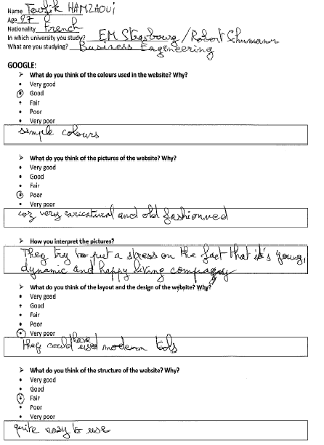
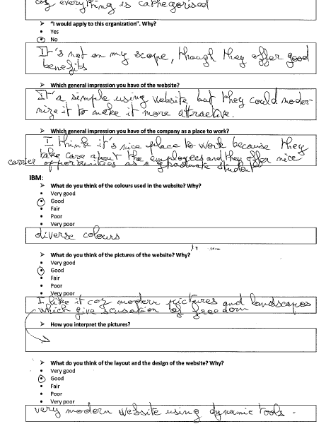
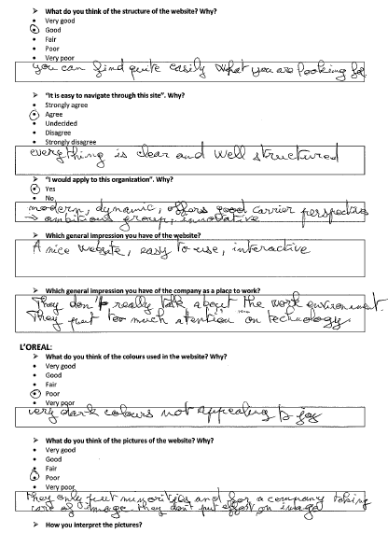
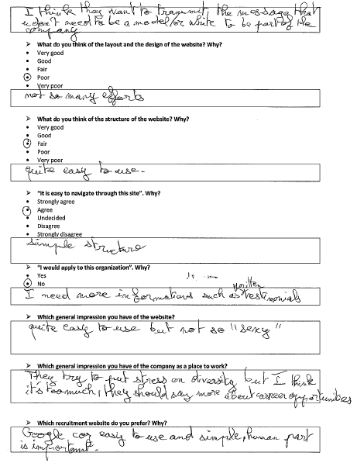

Nathalie answers
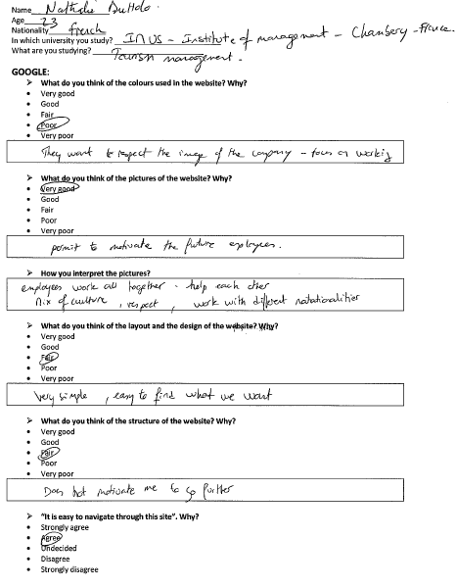
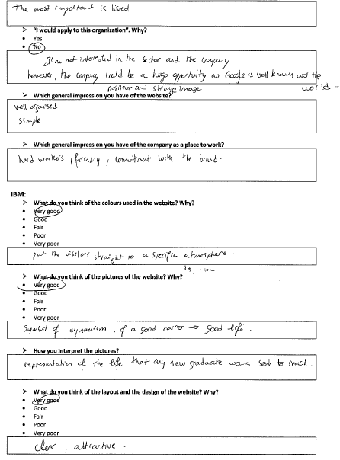
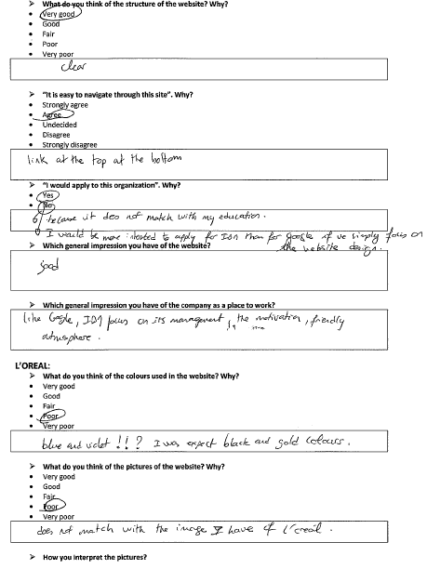
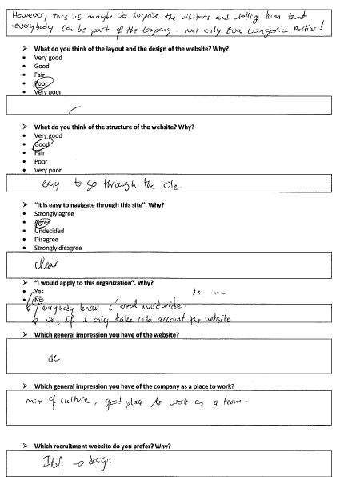

Markus answers
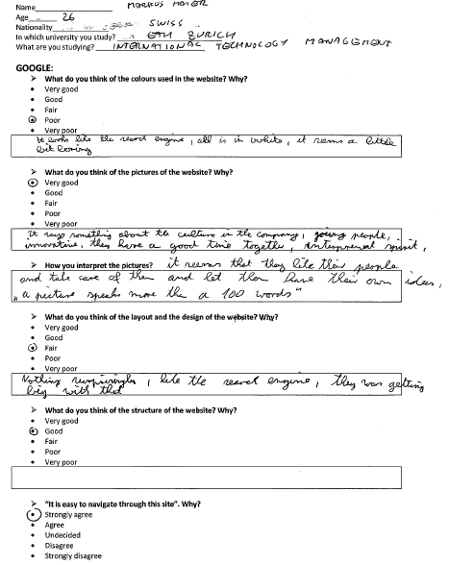
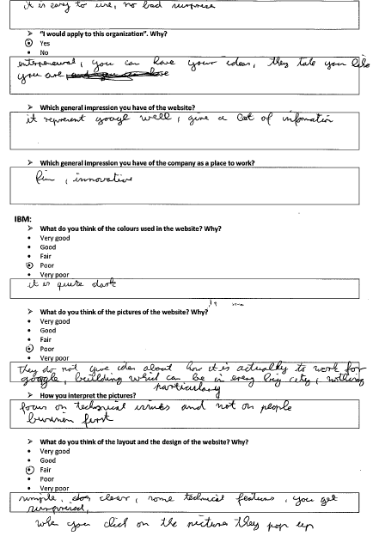
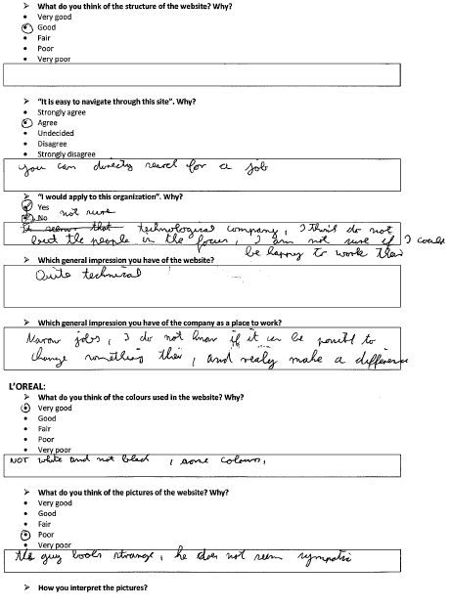
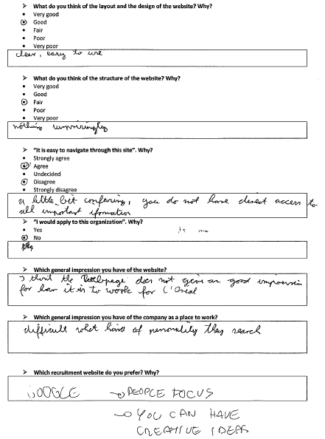

Julia answers
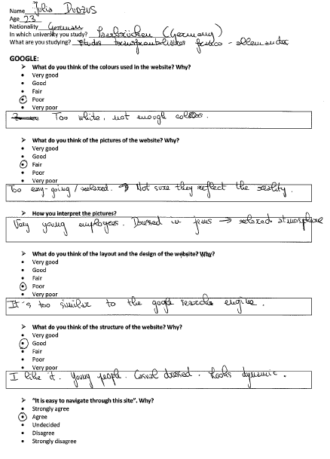
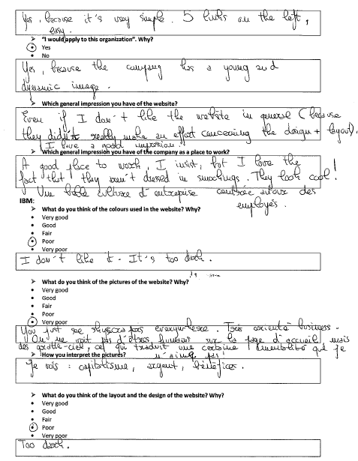
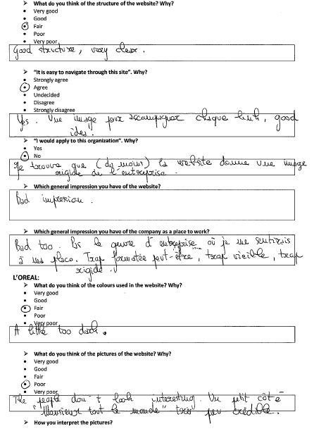
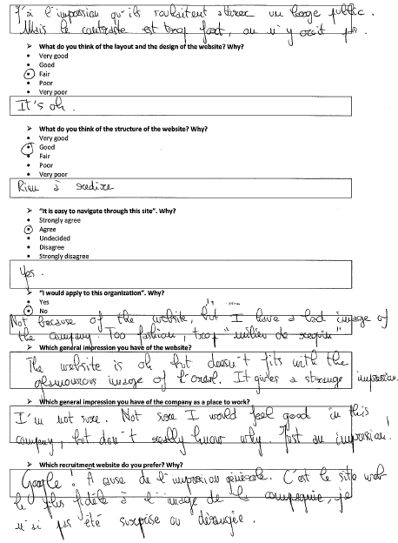

Appendix F: Google career website
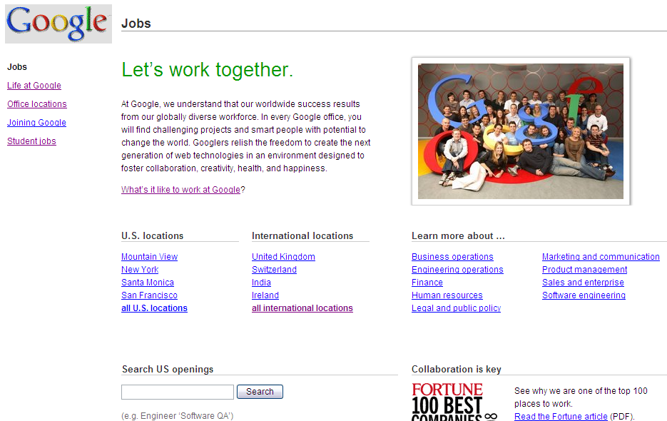

Appendix G: IBM career website

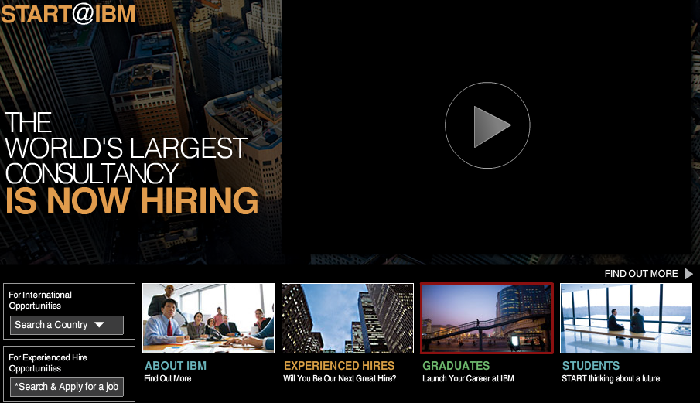

Appendix H: L’Oreal career website

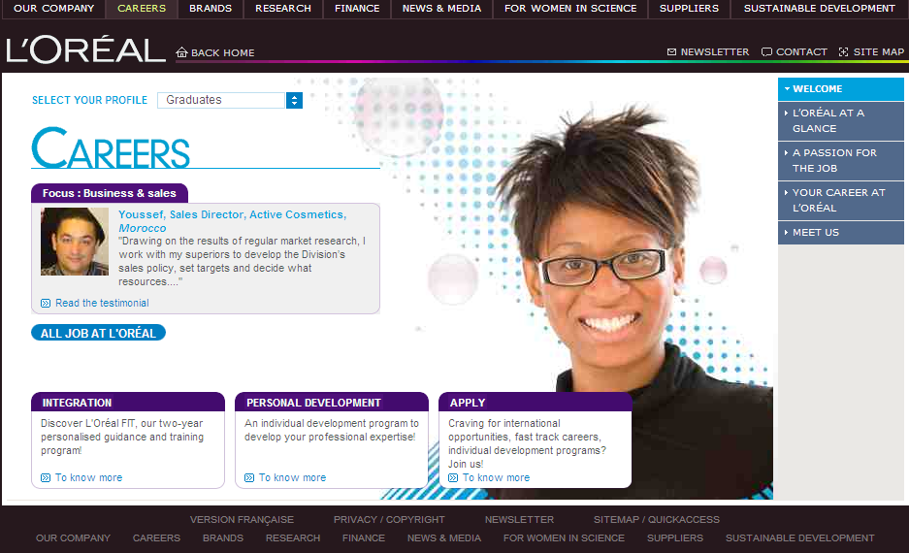

Appendix I: Websites content analysis: Coding form draft by Cober et al. (2004)

Appendix J: Google analysis

Appendix K: IBM analysis

Appendix L: L’Oreal analysis

Bach, S. (2005): Managing Human Resources: Personnel Management in Transition: p.115
Ibid: p.115
Rynes, S. L. (1991): Recruitment, job choice and post-hire consequences
Judy, R. W. (1999): Labor forecast: Gray skies, worker drought continues
Beardwell, I. et al. (2003): Human Resource Management: A contemporary approach: p.190
Taleo Research (2006): Social Networks and Talent Acquisition: p.1
Ibid: p. 2
Ibid: p. 2
Tyson, T. (2006): Essentials of Human Resource Management: p.143
Leonard, B. (1999): HR squeezed by tight labor market
Braddy, P.W. et al. (2003): Internet Recruiting: The Effects of Web Page Design Features: p.375
CIPD (2008): Annual survey report Recruitment, retention and turnover
Braddy, P.W. et al. (2003): Internet Recruiting: The Effects of Web Page Design Features: p.375
Parry, E. / Tyson, S. (2008): An analysis of the use and success of online recruitment methods in the UK: p.258
Braddy, P.W. et al. (2006): Organizational recruitment website effects on viewers' perceptions of organizational culture
Zusman, R. R. / Landis, R. S. (2002): Applicant preferences for web-based versus traditional job postings
Taleo Research (2006): Careers Site Recruiting in the FTSE 100 Companies: A Missed opportunity:p.2
Cober, R. T. et al. (2003): Organizational Web Sites: Web Site Content and Style as Determinants of Organizational Attraction: p.158
CIPD (2008): Annual survey report Recruitment, retention and turnover: p.15
CIPD (2008): Annual survey report Recruitment, retention and turnover: p.15
Ibid: p.15
Weare, C. / Lin, W. Y. (2000): Content Analysis of the World Wide Web: Opportunities and Challenges: p.274
Backhaus, K. B. (2004): An exploration of corporate recruitment descriptions on Monster.com
http://money.cnn.com/magazines/fortune/bestcompanies/2008/index.html, as found on March 20, 2009
http://business.timesonline.co.uk/tol/business/career_and_jobs/graduate_management/article3714275.ece, as found on March 10, 2009
http://www.top100graduateemployers.com/employers/profile.php?id=55, as found on March 13, 2009
Galanaki, E. (2002): The decision to recruit online: A descriptive study
Cober, R. T. et al. (2004): Form, content, and function: An evaluative methodology for corporate employment web sites
Ibid: p.201
Backhaus, K. B. (2004): An exploration of corporate recruitment descriptions on Monster.com
Ibid
Behling, O. et al. (1968): Recruiting: A Theoretical Base: p.13
Paisley, W. J. (1969): Studying Style as Deviation from Encoding Norms: p.133
Bryman, A. (2004): Social Research Methods: p.181
Ibid: p.195
Ibid: p.195
Ibid: p.195
Ibid: p.195
Ibid: p.195
Ibid: p.197
Ibid: p.197
Kassarjian, H. H. (1977): Content Analysis in Consumer Research: p.9
Cober, R. T. et al. (2004): Form, content, and function: An evaluative methodology for corporate employment web sites
Ibid: p.205
Ibid: p.205
Huizingh, E.K.R.E. (2000): The content and design of web sites: An empirical study: p.127
Cober, R. T. et al. (2004): Form, content, and function: An evaluative methodology for corporate employment web sites: p.206
Cober, R. T. et al. (2004): Form, content, and function: An evaluative methodology for corporate employment web sites: p.206
Ibid: p.206
Bryman (2004): Social Research Methods: p.266
Cunningham (1993): Action research and organisational development: p.93
Krueger (1988): Focus Groups: A Practical Guide for Applied Research: p. 18
Bryman (2004): Social Research Methods: p. 347
Bryman (2004): Social Research Methods: p.348
Merton et al. (1990): The focused interview: A manual of problems and procedures: p. 135
Livingstone et al. (1994): Talk on Television: Audience participation and public debate: p.181
Morgan (1988): Focus groups as qualitative research: p.42
Bryman (2004): Social Research Methods: p. 348
Merton et al. (1990): The focused interview: A manual of problems and procedures: p. 137
Stewart et al (1990): Focus groups: Theory and practice
Bryman (2004): Social Research Methods: p. 353
Morgan (1985): Social Interaction and the Cognitive Organization of Health-Relevant Behaviour: pp.401-22
Bryman (2004): Social Research Methods: p. 354
Ibid: p. 354
Bryman (2004): Social Research Methods: p. 354
Appendix A
Appendix B
Bryman (2004): Social Research Methods: p.354
Bryman (2004): Social Research Methods: p. 348
Ibid: p. 348
Ibid: p. 349
Bryman (2004): Social Research Methods: p. 359
Ibid: p. 359
Bryman (2004): Social Research Methods: p. 359
Krueger (1988): Focus Groups: A Practical Guide for Applied Research: p. 59
Morgan (2002): Focus Group Interviewing
Bryman (2004): Social Research Methods: p.321
Aikat, D. (2000). A new medium for organizational communication: Analyzing web content characteristics of Fortune 500 companies
Pew Internet and American Life Project (2002)
Cober, R. T. et al. (2003): Organizational Web Sites: Web Site Content and Style as Determinants of Organizational Attraction: p.158
Cappelli, P. (2001). Making the most of on-line recruiting
Schreyer, R. / McCarter, J.(1998): Future face of recruiting: p.74
Parry, E. / Tyson, S. (2008): An analysis of the use and success of online recruitment methods in the UK: p.257
Galanaki, E. (2002): The decision to recruit online: A descriptive study: p.244
Torrington, D. et al. (2008): Human Resource Management
Ibid
Galanaki, E. (2002): The decision to recruit online: A descriptive study: p.244
Ibid: p.244
Bussler, L. / Davis, E. (2002): Information systems: the quiet revolution in Human Resource management
Ibid
Young, J. / Foot, K. (2005): Corporate e-cruiting: The construction of work in Fortune 500 recruiting Web sites
Wetfeet. (2003): Corporate recruiting Websites 2003: Key elements and best practices
Cober, R. T. et al. (2003): Organizational Web Sites: Web Site Content and Style as Determinants of Organizational Attraction
Galanaki, E. (2002): The decision to recruit online: A descriptive study: p.245
Greengard, S. (1998): Putting online recruitment to work p.73
Hogler, R.L. et al. (1998): Internet recruiting and employment discrimination: a legal perspective: p.153
Galanaki, E. (2002): The decision to recruit online: A descriptive study: p.245
Pearce, C.G. / Tuten, T.L. (2001): Internet recruiting in the banking industry: p.13
Aikat, D. (2000). A new medium for organizational communication: Analyzing web content characteristics of Fortune 500 companies
Young, J. / Foot, K. (2005): Corporate e-cruiting: The construction of work in Fortune 500 recruiting Web sites
Cober, R. T. et al. (2004): Form, content, and function: An evaluative methodology for corporate employment web sites: p.201
Cober, R. T. et al. (2003): Organizational Web Sites: Web Site Content and Style as Determinants of Organizational Attraction: p.158
Cook, S. (2001):Search and ye shall find online: p.55
Cober, R. T. et al. (2003): Organizational Web Sites: Web Site Content and Style as Determinants of Organizational Attraction: p.159
Cober, R. T. et al. (2004): Form, content, and function: An evaluative methodology for corporate employment web sites: p.203
Ibid: p.203
Ibid: p.203
Ibid: p.203
Cober, R. T. et al. (2003): Organizational Web Sites: Web Site Content and Style as Determinants of Organizational Attraction: p.159
Ibid: p.159
Ibid: p.159
Ibid: p.159
Ibid: p.203
Ibid: p.203
Ibid: p.159
Cober, R. T. et al. (2004): Form, content, and function: An evaluative methodology for corporate employment web sites: p.202
Cober, R. T. et al. (2003): Organizational Web Sites: Web Site Content and Style as Determinants of Organizational Attraction: p.159
Cober, R. T. et al. (2004): Form, content, and function: An evaluative methodology for corporate employment web sites: p.202
Ibid: p.202
Braddy, P.W. et al. (2003): Internet Recruiting: The Effects of Web Page Design Features: p.376
Metz, R. E. / Junion-Metz, G. (1996): Using the World Wide Web and creating home pages: A how-to do-it manual
Cober, R. T. et al. (2004): Form, content, and function: An evaluative methodology for corporate employment web sites: p.203
Cober, R. T. et al. (2003): Organizational Web Sites: Web Site Content and Style as Determinants of Organizational Attraction: p.159
Hannon, N. J. (1998): The business of the internet
Ibid
Cober, R. T. et al. (2003): Organizational Web Sites: Web Site Content and Style as Determinants of Organizational Attraction: p.159
Zona Research (1998): Online shopping report: Is web-based buying reaching critical mass?
Cober, R. T. et al. (2004): Form, content, and function: An evaluative methodology for corporate employment web sites: p.204
Ibid: p.204
Ibid: p.209
Ambler, T. / Barrow, S. (1996): The employer brand
Cowe, R. (1998): Management: Beginner’s guide to employer branding: A new approach claims to allow companies to create the sort of identity that will attract the most talented people
Conference Board (2001): Engaging employees through your brand: p. 3
Backhaus, K. B. (2004): An exploration of corporate recruitment descriptions on Monster.com
Ambler, T. / Barrow, S. (1996): The employer brand
Gardner, B. B./ S. J. Levy (1955): The product and the brand
Cable, D. M. et al. (2001): Establishing the dimensions, sources and value of job seekers’ employer knowledge during recruitment
Collins, C. J. et al. (1999): Recruitment and job choice: The effects of early recruitment practices on the decision to apply
Collins, C. J. / Han, J. (2004): Exploring applicant pool quantity and quality: The effects of early recruitment practice strategies, corporate advertising, and firm reputation
Behling, O. et al. (1968): Recruiting: A Theoretical Base: p.13
Ibid: p.13
Ibid: p.13
Behling, O. et al. (1968): Recruiting: A Theoretical Base: p.13
Spence, M. (1973): Job market signaling
Braddy, P.W. et al. (2008): Online recruiting: The effects of organizational familiarity, website usability, and website attractiveness on viewers' impressions of organizations
Spence, M. (1974): Market-signaling
Cober, R. T. et al. (2003): Organizational Web Sites: Web Site Content and Style as Determinants of Organizational Attraction: p.160
Rynes, S. L. (1991): Recruitment, job choice and post-hire consequences
Cober, R. T. et al. (2003): Organizational Web Sites: Web Site Content and Style as Determinants of Organizational Attraction: p.160
Thompson, L. F. et al. (2008): E-recruitment and the benefits of organizational web appeal
Rynes, S. L. / Miller, H. E. (1983): Recruiter and job influences on candidates for employment
Braddy, P.W. et al. (2008): Online recruiting: The effects of organizational familiarity, website usability, and website attractiveness on viewers' impressions of organizations
Ibid
Braddy, P.W. et al. (2006): Organizational recruitment website effects on viewers' perceptions of organizational culture
Braddy, P.W. et al. (2008): Online recruiting: The effects of organizational familiarity, website usability, and website attractiveness on viewers' impressions of organizations
http://www.google.com/intl/en/press/pressrel/revenues_q408.html, as found on March 02, 2009
http://money.cnn.com/magazines/fortune/bestcompanies/2007/full_list/, as found on March 02, 2009
http://www.top100graduateemployers.com/employers/profile.php?id=51, as found on March 02, 2009
http://www.ibm.com/annualreport/2008/md_7erw.shtml, as found on March 02, 2009
http://www.top100graduateemployers.com/employers/profile.php?id=55, as found on March 02, 2009
http://www-05.ibm.com/employment/uk/graduates/lifeatibm/what-we-offer.html, as found on March 22, 2009
Behling, O. et al. (1968): Recruiting: A Theoretical Base: p.13
http://www.google.com/corporate/diversity/, as found on March 22, 2009
http://www-05.ibm.com/employment/uk/about/csr/diversity.html, as found on March 22, 2009
http://www.loreal.com/_en/_ww/html/careers/L-Oreal-at-a-glance/Diversity-is-a, priority.aspx?&profile=junior&profileExcl=student, as found on March 22, 2009
http://www.google.com/intl/en/jobs/, as found on April 22, 2009
http://www-05.ibm.com/employment/uk/, as found on April 28, 2009
http://www.loreal.com/_en/_ww/html/careers/welcome.aspx?&profile=junior&profileExcl=student, as found on April 25, 2009
Cober, R. T. / Brown, D. J. / Levy, P. E. (2004): Form, content, and function: An evaluative methodology for corporate employment web sites: pp.217-218

