Konsekvenser af systemmæssige krav

Proffessionsbachelorprojekt
Aalborg Universitet
2009
Pinar Kamil Meded

Socialrådgiveruddannelsen v. Institut for Sociologi, Socialt Arbejde og Organisation
Kroghstræde 7, 9220 Aalborg Øst, Tlf. 99 40 81 30, http://www.soc.aau.dk

Titel: Konsekvenser af systemmæssige krav

Projekttype: Proffessionsbachelor

Forfatter: Pinar Kamil Meded

Vejleder: Jens Lind

Oplæg: 4

Antal sider: 55 (efter godkendelse af vejleder)

Bilag som kan rekvireres ved sekretær Lisbeth Suhr på ovenstående adresse:
1. Interviewguide
2. Transkribering af interview 1
3. Transkribering af interview 2
4. Formål med Arbejdsevnemetoden

Afleveringsdato: d. 8. januar 2009

_______________________________
Pinar Kamil Meded

Denne opgave er udarbejdet af studerende på socialrådgiveruddannelsen ved Aalborg Universitet, som led i et uddannelsesforløb. Den foreligger urettet og ukommenteret fra socialrådgiveruddannelsens side og er således et udtryk for forfatternes egne synspunkter.
Abstract
This project deals with a problem, which can be seen from two perspectives. On one hand there is the actor or individual, the social worker and her professional competency, and on the other hand there is the structure or the system, and the demands that result from the system. The social worker acts in the crossing of these two points, with a wish of doing high quality social work, which agrees with her professional competency. But at the same time the social worker must uphold the demands of the system.
How does the social worker modify her behavior in proportion to the system demands?
The purpose is to examine whether the system demands, which in this project is “arbejdsevnemetoden” (AEM), limits the professional competency and authority of the social worker - so saying how the social worker modifies her behavior in proportion to the demands, that social work in Denmark contain. This is examined by interviews with two practicing social workers from “X-kommune”. These two social workers are asked questions, mostly about their thoughts, concerning the method AEM. The results of the interviews are therefore not to be applied to all social workers in Denmark, but are more precisely to be regarded as tendencies in social work. The most experienced one of the social workers (S1), works in a sickness benefit department, and the other, and less experienced social worker (S2), works in a supplementary benefit department. The results of the interviews are compared with the theory about the professional competency of the social worker. There are a number of disagreements between the two social workers as to AEM. S1 likes and regards the method as a help in the work, whereas S2 finds it very difficult to integrate AEM as a part of the daily routines. S2 feels that AEM is yet another unattainable assignment. These disagreements are caused partly by the basis of experience, but also by the great differences in the social workers target groups, because AEM is not suitable for all citizens. The solution to the problems with the use and management of AEM is more knowledge, education and dialogue.
The organizational structure of X-kommune is also examined to determine what kind of practice the two social workers are a part of, because that makes it easier to understand the way they work and think. This is compared to the new institutional organization theory and Weber’s ideal type model of bureaucracy. X-kommune fulfills a lot of the criteria for a bureaucratically organization, and is therefore to be regarded as one. The social worker is supposed to respect the demands of the system, but also the demands of the organization. The purpose to do high quality social work is complicated by introduction of standardized methods and tools as AEM. System demands as AEM have an influence, not only on the social work in general, but also on the behavior and role of the social worker.
Læsevejledning mht. notehenvisninger
Notehenvisninger sidst i et afsnit efter det sidste punktum, henviser til, at hele afsnittet bygger på denne note. Et afsnit er i denne forbindelse en tekstmængde startende fra eksempelvis en indrykning (Inden for børne- og ungeområdet…) og indtil næste indrykning (En metode som kan…).
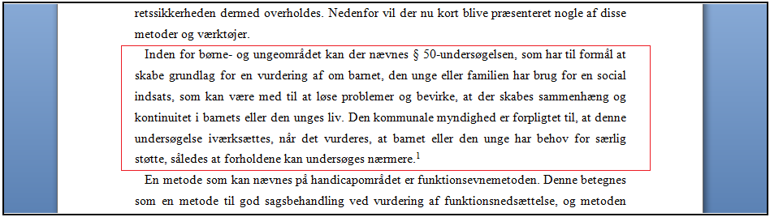
Ovenstående er et eksempel fra projektet. Tekstmængden, som er indrammet i rød, er i forhold til ovenstående forklaring et afsnit. Note 1 efter det sidste punktum i afsnittet henviser til, at hele det indrammede afsnit er baseret på denne note.
Hvis en note forekommer midt i et afsnit efter et punktum, henvises der til linjen inden noten. Hvis det derimod forekommer efter et ord, henviser noten til dette specifikke ord.
En note, som er placeret efter en overskrift, betyder, at hele afsnittet efter overskriften er baseret på denne notehenvisning.

