Semester: 10th Semester, Master Thesis
Title: Software Based Affective Smile Estimation
Project Period: 020212-250512
Semester Theme: Master Thesis
Abstract
The following Master Thesis was finished at Aalborg University Campus Ballerup during the 10th semester at Medialogy.
This thesis investigated if a computer could be programmed to interpret and reason the human smile with the same accuracy and understanding as that of humans. Research revealed that attempts at extracting meaning from facial features in Computer Vision had not been attempted from the point of view of the computer. Two testing phases were devised that provided an average smile rating based on answers given by test subjects. For test phase one the computer had a 50% success ratio of correctly rating the smile conveyed in pictures. In test phase two the computer rated the smile at the same level as the test subjects. The computer was able to understand and rate smiles that were conveyed with visual distinct features, whereas ubiquitous smiles could not be rated.
This thesis covered the following terms, Affective Computing, The Facial Action Coding System, Action Units and Emotional Intelligence. Understanding and rating a smile could only be conducted from visually distinct smiles, whereas when gaze was the predominant visual factor, the computer could not rate accordingly.
Aalborg University Copenhagen
Lautrupvang 15, 2750 Ballerup, Denmark
Semester Coordinator: Stefania Serafin
Secretary: Judi Stærk Poulsen

Supervisor: Lars Reng
Project group no.: Not Available
Members:

Tomas Fuchs Bøttern

Copies: 3
Pages: 108
Finished: 240512

Copyright © 2012. This report and/or appended material may not be partly or completely published or copied without prior written approval from the author. Neither may the contents be used for commercial purposes without this written approval.

Preface
This Master Thesis was written by Tomas Fuchs Bøttern attending Aalborg University Copenhagen Denmark, as a result of the 10th semester at Medialogy.
This report uses ISO 690 when citing works, as this is the standard in bibliographic referencing. The parenthesis following a citation or written text i.e. (Author’s Last Name, Year) refers to a source used for that particular chapter.
The Bibliography chart also follows the design and rules laid forth in the ISO 690 standard, namely the layout referencing of published material both in its print and non-print form. The following is an example of the layout of an article reference.
Reference in the Thesis:
(Russel, et al., 1997)
In Bibliography:
Russel, James A and Fernández-Dols, José Miguel. 1997. The psychology of facial expression. Cambridge: The Press Syndicate of The University of Cambridge, 1997. 0 521 49667 5
Following this thesis is a DVD located at the back of the report containing the digital equivalent of the references and this thesis. The software used for establishing the smile rating is included.
On the attached DVD locate [DVD-DRIVE]:\TOC.txt. The Table of Contents (TOC.txt) contains the guide on how to use the software created for this thesis. Furthermore the TOC.txt lists all directories on the DVD as well as describing their content.
Lastly, this thesis wishes to thank the following persons / institutions for their assistance in the creation of this thesis:
Sønderborg Fjernvarme A.m.b.a. for their participation in Test Phase One.

Table of Contents
1. Preface 0
3. Introduction 4
3.1. Final Problem Statement 4
4. Analysis 6
4.1. Emotional display and understanding in humans – Introduction 7
4.1.1. Emotions and meaning across cultures 7
4.1.2. Culturally Independent Interpretation of Emotions 8
4.1.3. The Facial Expression Program 9
4.1.4. Understand and Forming Facial Expressions 10
4.1.5. The Facial Feedback Hypothesis 11
4.1.1. Analysis Chapter Part 1 Conclusion – Emotions 12
4.2. Emotional Intelligence introduction 13
4.2.1. Emotional Intelligence 13
4.2.2. Emotional Intelligence – A Dual Process Framework 14
4.2.3. Emotional Intelligence – The Four Branch Model 15
4.2.4. Emotional Intelligence – Measurements 16
4.2.5. Emotional Intelligence – Construction Emotions 17
4.2.1. Analysis Chapter Part 2 Conclusion – Emotional Intelligence 18
4.3. Computer Vision Algorithms introduction 19
4.3.1. Automatic Analysis of Facial Expressions 20
4.3.2. Recognising Action Units 21
4.3.3. Smile Detection 22
4.3.4. The Facial Action Coding System 23
4.3.5. Analysis Chapter Part 3 Conclusion – Computer Vision 24
4.4. Affctive Computing introduction 25
4.4.1. Affective Computing in HCI 26
4.4.2. Emotion Expression and Synthesis 27
4.4.3. Affective Computing – Conclusion 28
4.5. Analysis Conclusion 29
4.5.1. Emotions 29
4.5.2. Emotional Intelligence 29
4.5.3. Computer Vision 29
4.5.4. Affective Computing 30
5. Test method 31
5.1. Test Strategy 31
5.1.1. Test Phases 31
5.2. Test Scenario and test location 32
5.2.1. Test Phase One 33
5.2.2. Test Phase Two 33
5.2.3. Demographics 33
5.2.4. Expectations 35
5.2.5. Test Phase One 35
5.2.6. Test Phase Two 35
6. Design & Design Requirements 36
6.1. Design of the website 36
6.2. Computer Software – Smile Assesment 37
7. Requirement Specification 38
7.1. Test Website Requirements 38
7.2. Programming Requirements 38
8. Implementation 39
8.1. Website Implementation 40
8.2. Smile assessment Implementation 42
9. Test Results 47
9.1. Test phase one 47
9.1.1. Test Results – Test Subjects 47
9.1.2. Test Results – Computer 49
9.2. Implementing Test Results in the Smile Assessment Algorithm 51
9.3. Test phase two 53
9.3.1. Test Results – Test Subjects 55
9.3.2. Test Results – Computer 56
10. Discussion 58
10.1. Test Method 58
10.2. Open Source Software 58
10.3. Implementation of the Smile Estimation in Phase Two 58
10.4. Errors in the smile estimation 58
11. Conclusion 59
12. Future Perspectives 60
13. Bibliography 62
14. Table of Figures 64
15. Table of Charts 65
16. Appendix 66
16.1. Test Results – Test Phase One – Test Subjects 67
16.2. Test Results – Test Phase One – Computer Results 67
16.3. Test Results – Test Phase Two – Test Subjects 68
16.4. Test Results – Test Phase Two – Computer Results 68
16.5. Source Code – Smile Assessment Implementation 69
16.6. Source Code – Face Detection [DISCARDED] 76
16.7. Source Code - Test Website 85

Introduction
The art of computer vision is a constant evolving field, encompassing automatic number plate registration aiding the police to the consumer friendly Microsoft Kinect, enabling full body computer interaction among others. As with any other research area that has existed for an extended period of time, the current state of computer vision has allowed research to open in other fields directly related but with a different area of focus. One of these research areas is Rosalind W. Piccard’s Affective Computing. Since the computer can already see fairly well, it is time to make it understand what it is seeing. Affective Computing deals specifically with teaching the computer to interpret and understand human emotions. Those emotions can be of a visual nature but also verbal or even physical.
Examples exist of voice analysis in weeding out insurance hoaxes as a caller contacts the call centre handling insurance claims. The software would analyse the pitch in the voice of the caller and if exceeding a certain specified threshold it would be flagged for later investigation. This is an example of the computer understanding an emotional state; in the described scenario the emotion is that of anxiety.
According to researchers in the field of Computer Vision, as of this day the most utilized and effective algorithm for computer vision is the combined work of Viola-Jones. As a testament to its success and applicability it is used in the automatic face detection implemented in Facebook. What researchers have neglected to the knowledge of this thesis is the analysis of the information displayed in the detected faces.
The human face holds the key to the personality and emotional state also recognised by ancient Greek philosophers that studied the art of physiognomy. To this day the argumentation both for and against physiognomy is still being debated, but what researches agree to is that the eyes and mouth are the two most telling visual indicators of an emotional state. Looking at the face the most physically changing factor is the mouth -although the eyes can signal emotional changes, the difference physically is difficult to measure from a visual standpoint; the mouth can change its shape quite rapidly and with large differences in size and complexity, whereas changes in the emotional state displayed by the eyes are subtle and small therefore difficult to register by a computer. Due to this, when analysing a facial feature displaying an emotion, the mouth is visibly the best candidate to analyse.
Therefore, the following problem statement has been articulated based on the current progress in affective computing and more specifically what research lacks to the knowledge of this thesis. The interest of this thesis lies in the extraction of meaning of the detected facial features by a computer. Since algorithms in computer vision for facial feature extraction have become increasingly accurate the focus of this thesis will be on enabling the computer to understand what the facial features convey and not as much on the intricate details of the inner workings of the algorithms that allow facial feature extraction. Therefore the following problem statement has been articulated with an emphasis on providing meaning to the facial expressions detected by a computer.

Final Problem Statement
Focusing on the human smile, to what degree can a computer be programmed to interpret and reason that smile, with the same accuracy and understanding as a human?
Before commencing the analysis the core terminology of the final problem statement will be clarified, as without it the final problem statement in its own right is quite bold. The human smile is understood as how happy or sad a person in a picture is perceived by a test audience. As the following analysis chapter will show, the display of happiness or sadness is the most understood visual emotion according to tests conducted across cultures; furthermore photographs of people have a higher tendency to be of smiling faces as opposed to sad or discontented. With regards to the accuracy of the computer program, the accuracy would be measured by smile ratings provided by test subjects.
This thesis believes that 100% accuracy by a computer to understand a smile is not yet feasible, as research has shown that the interpretation of such differs from individual to individual. Furthermore research has shown that Emotional Intelligence influences the perception and conveying of emotional states in humans, the understanding of emotions can therefore differ greatly from individual to individual, meaning that even in humans a 100% understanding of an emotion is also not possible. Only a general understanding and definition of the smile and rating should therefore be achievable.

Analysis
In order to specify the research area of the thesis the questions proposed in the problem statement and their relevant research topics have to be separated from one another. First and foremost the problem this thesis wishes to investigate is of a highly subjective nature as the understanding and resonance of emotions are differently felt and experienced from individual to individual. As the smile can be seen as both a conveyor and interpreter of a specific emotion, an understanding of how emotions are formed and experienced in humans will have to be investigated. The early work by Ekman (Ekman, 1971) will be analysed, as Ekman was the first in conducting cross-culture studies of how emotions are experienced. Since the smile is part of the human facial expression spectrum, the forming and understanding of facial expressions will be analysed. By understanding how emotional expressions are formed and how individuals interpret them, a general understanding of emotions can be established and assist the computer in interpreting them.
Following the research on how emotions are experienced and formed, Emotional Intelligence will be analysed, as research has shown that the higher the level of emotional intelligence an individual has, the easier it is for said individual to interpret, form and understand the emotional display of others. Test methods on how emotional intelligence is measured in individuals will be analysed as they can assist in determining how emotions are understood. By understanding how emotional intelligence influences the interpretation of emotions, and how the level of emotional intelligence differs from individual to individual can assist in creating the specifications for how the computer can be taught to interpret the display of emotions.
Understanding how emotions are formed and interpreted, current research in analysing emotional displays from a computer vision standpoint will be conducted. The computer vision analysis chapter will focus on the picture training sets used for the algorithms used in the selected articles. It will furthermore attempt to shed light on the lack of analysis of the extracted facial data and the lack of analysing the meaning of said data.
Lastly Affective Computing will be analysed. Affective Computing coined by Rosalind W. Piccard concerns attempts at making the computer aware of the different emotional states of its human operators. Affective Computing is predominately used in human computer interaction.
The conclusion of the analysis will therefore contain requirements for both the testing phase of the project as well as requirements for the software that is to attempt to solve the problem statement.

Emotional display and understanding in humans – Introduction
The human emotional repository is vast and intricate, from the visual cues in the form of body language and facial expressions to the lack thereof when conveying and perceiving an affective state (Sebe, et al., 2007). Not only does the current affective state of the observer affect the reasoning when interpreting an emotion in another human being, inhibiting the display of emotion in the observer can also greatly reduce the perceived emotion. Therefore, a need to confine the area of interest for emotions in this thesis is required, as stated in the problem statement; the area of interest of emotion is the human smile and what it conveys. If one had sought to cover the entire human spectrum of facial emotions, the project given its time frame would not be possible to complete. Furthermore, current research shows much debate regarding facial expressions and their meaning, both from a cultural standpoint but also from individual to individual. Research has shown congruence between the seven semantic primitives. The semantic primitives are the seven basic emotions (happiness, surprise, fear, anger, contempt, disgust and sadness). Disregarding cultural differences, these basic emotions are perceived and to some extent understood the same way.
In order to teach a computer to understand the human smile, criteria for how humans perceive and interpret a smile have to be established.
A brief foray into the history of understanding human emotions will reveal that after Darwin’s theory of evolution an attempt to classify human facial features and expressions was attempted. Darwin proposed that facial emotions and expressions are universally understood and inherited. This led researchers to attribute different psychological behaviours to certain facial features in better understanding abnormal human behaviour.
Therefore the following chapter will consist of an analysis of current and previous research in the meaning and reasoning behind different facial expressions with a focus on the human smile were applicable. The reasoning behind including other emotions is due to the conducted research in the area of facial expressions and emotions. Furthermore, by looking at the collected spectrum of emotions a more varied understanding of emotions can be established, that will assist in understanding what the smile conveys.

Emotions and meaning across cultures
One of the first studies in facial expressions and their meaning across cultures was Paul Ekman’s Universals and Cultural differences in Facial Expressions of Emotion (Ekman, 1971). Ekman sought to establish how cultures understood and perceived different emotions in facial expressions, if emotions in facial expressions where understood equally or differently, if literacy had an impact on the understanding and displaying of emotions, while also investigating if the perceived intensity of an emotion differed across cultures.
For this purpose, Ekman and his colleagues recruited 25 students from an American University and 25 students from a Japanese University. They were shown a 25min video containing both neutral but also stress inducing material. During the screening Ekman recorded their facial expressions. From these videos a 2 min snippet was cut containing both the neutral facial expression and a stressful facial expression from all 50 test subjects. Ekman ended with 25 expressions of neutral and stress from both the Americans and the Japanese.
These recorded expressions were shown to four groups in Japan and four groups in the United States, each culture rated the expressions of their own but also the expression of the other culture. The results from the test show a universal understanding of display of emotions across cultures as both groups were equally as precise in rating their own versus rating the other culture.
Before conducting the tests, Ekman created the facial affect program. Ekman describes the facial affect program as the triggering of a specific set of muscles in the face. Meaning an emotion elicited by some event will activate certain muscles in the face. I.e. in a situation where fear or anger is triggered a set of specific muscle movements in the face will occur, either displaying fear or anger depending on the situation among others. The muscles activated are what Ekman describes as the facial affect program. Ekman describes that the facial affect program is not dependent on culture or ethnicity since the same set of facial muscles are triggered for i.e. fear in every culture and race.
Ekman’s tests also showed - substantiating his facial affect program - that the display of certain facial emotions, such as the smile was based on instinct. Ekman and his colleagues tasked participants from different cultures to either rate or give an impression of what happiness looked like. Every participant formed a smile. Furthermore it should be noted that although the same muscles are used across cultures to display emotions, the interpretation of the displayed emotions differ. Their study found that the Japanese attributed more emotional weight to pictures of anger than their American counterparts attributed. The Americans on the other hand attributed more emotional weight to a picture of a smile.
Ekman’s study found that the facial affect program could be used in conjunction with the seven semantic primitives. Although the test also showed that the interpretation of the emotions are very dependent on the cultural background of the individuals and their upbringing. Furthermore the affective mood of the test subjects that were tasked to rate the displayed emotions in the screening can be influenced by their own current affective state.

Emotion and Meaning across cultures - Summary
Ekman (Ekman, 1971) established that the facial affect program was indeed applicable across cultures. His research showed that certain emotional expressions such as the display of happiness or fear were perceived the same in both culture groups. Ekman also found that when displaying a smile among others, the same muscle groups are used independent from culture or upbringing. Though the interpretation or the intensity of these emotions in the eyes of the observer varied, i.e. the Japanese attributed more intensity to fear than their American counterparts. As this thesis seeks a general definition and understanding of the human smile, Ekman’s findings that emotions such as the display of happiness or fear are universally perceived the same across cultures validates the proposition so that the smile can be generalised. For this thesis, a general understanding of the smile is necessary, if a computer is to interpret and understand the smile.

Culturally Independent Interpretation of Emotions
Paul Ekman and Dacher Keltner revisited Ekman’s original work while including all existing and present facial expression research in their Facial Expression of Emotion contained in the Handbook of Emotions 2nd Edition (Keltner, et al., 2000). In this study Ekman elaborates further on emotions and delimits the culturally independent view on emotions. Ekman found that the emotions only apply to emotions displayed in the face. It does not cover body language or the interpretations of those. Ekman and Keltner found that exact opposite displays of emotion are easier to distinguish from another, while emotions that resemble each other in their display are more difficult to differentiate for those perceiving them.
Ekman further elaborates on his facial affect program that research has shown that up to 80% of cross cultural test participant’s rate and view a facial display of an emotion the same way. In other words, the accuracy of assessing and recognizing an emotion, i.e. smile or fear is up to 80% in their test groups.
Ekman and Daniel further investigated the correlation between American and Japanese understanding of facial emotions. Taking a different approach they wanted to find out if a display of emotion differentiated between the two cultures. Tests showed that the Japanese, when an authoritarian figure was present during the tests, tried to mask their negative emotions when subjected to an unpleasant scene in the film, more than their American counterparts did in the same scenario.

Culturally Independent Interpretation of Emotions - Summary
Ekman and Keltner (Keltner, et al., 2000) specified that the facial affect program was only applicable to emotions displayed by the face and did not cover other emotional displays such as body language. They also found that emotions that are a visual mixture are difficult to interpret. Furthermore the surroundings and the people present in those can inhibit the display and sensing of emotions in the individual. Ekman and Keltner findings in regards to how the surroundings influence the perception of emotions will assist in determining the test scenario for this thesis. Since test subjects will be tasked with identifying an emotion, the surrounding in which they are present could influence their rating.

The Facial Expression Program
James A. Russel and José Miguel Fernández-Dols wrote The Psychology of facial expression (Russel, et al., 1997) building upon the research conducted by Ekman (Ekman, 1971) and others. Russel refined the facial expression program that labelled the semantic primitives as basic emotions. The basic emotions as mentioned earlier are the emotions that create the basis of all emotions, meaning a combination of surprise and fear could be the display of anxiety in a face.
Russel found that the understanding and display of the basic emotions are inherited human traits independent from culture; Russel found that infants when in company with their mothers mimicked or elicited the same emotions as their mothers i.e. if the mother was sensing fear or feeling tense the child would try to mimic the same emotions.
Russel utilized a high-speed camera in capturing facial displays of emotions; he was interested in seeing how the semantic primitives were formed. The high-speed camera revealed that in the first ~10ms the displayed emotions across cultures used the same muscles in forming. An example was the smile; culture and background had no influence in how the smile was formed in test subjects until after the first 10ms. He postulates that after the first 10ms the person displaying the emotion can use his or her upbringing and cultural background to shape the smile according to what they have been taught. The same is also applicable in the observer, after acknowledging the displayed emotion (10ms) the observers forms his or her response based on their culture or upbringing, meaning that the norms one has been taught influence the perception of the emotion. Furthermore Russel found in his test of literate and illiterate test subjects that the display of happiness was attributed to the smile and that it was the most recognised display of emotion. Russel study investigated how the five semantic primitives were perceived in his test groups. The results showed congruence in all three ethnic groups regarding acknowledging happiness in being portrayed by the smile. This is of significance to this thesis as Russell’s test showed that the most recognized facial emotion was that of the smile in the test groups.

The Facial Expression Program - Summary
Russel and Fernández-Dols (Russel, et al., 1997) found that in the first 10ms when an emotion is displayed, that emotion is interpreted and perceived the same way independent from upbringing and culture. This counts for both the individual displaying said emotion as well as the observer. After the 10ms have transpired the upbringing and the cultural background of the perceiver and the individual displaying the emotion influence the interpretation of the emotion. To further substantiate the belief that the semantic primitives are inherited, they found that infants exhibit basic emotions mimicked from their mother. These findings regarding the inheritance of understanding of the semantic primitives tie in with Ekman’s studies across cultures. If emotions are universally understood and perceived, they can therefore be measured and generalised for computer software to analyse, as is what this thesis wishes to accomplish.

Understand and Forming Facial Expressions
In 1985 Caroline F. Keating in her Gender and the Physiognomy of Dominance and Attractiveness research (Keating, 1985), tasked test subjects with rating the attractiveness and dominance of different human faces. Keating wanted to find the correlation between attractiveness and dominance. What facial features elicited the most positive responses in terms of how beautiful or dominant the face was perceived by a test group. Both female and male faces were included in the test picture database. Keating gradually altered the size and distance between the eyes and the shape of the mouth in test pictures. Test subjects were then progressively tasked with rating the pictures with emphasis on how attractive or dominant the test subjects found the face they saw in the pictures. Keating’s results show that the placement and size of the eyes and eyebrows weigh heavily when determining how attractive or dominant a person is, i.e. a large distance between the eyes was seen negatively upon. Furthermore, the mouth and the lips and their shape weigh equally as much when judging how dominant or attractive a face is.
Keating found that by mimicking adult like features in the brows, eyes, lips and jaws boosted the dominance rating, whereas mimicking childlike features minimized dominance ratings, i.e. thin lips and small eyes conveyed dominance. This accounted for a higher frequency of attractiveness ratings in male pictures. The same traits for dominance and attractiveness did not account for the female pictures; Keating suggests that the physiognomic trait for dominance lie elsewhere. In female pictures emphasizing childlike facial features increased the attractiveness rating.

Understand and Forming Facial Expressions - Summary
Keating (Keating, 1985) found that certain physical compositions in the face greatly attributed the attractiveness and dominance rating acknowledged by test subjects. Her findings tie in with how humans perceive one another; certain traits are universally understood and can apply either positively or negatively in an assessment. This study substantiates the views by Ekman (Ekman, 1971), (Keltner, et al., 2000) and Russell (Russel, et al., 1997) that certain traits and the understanding of appearance are culturally and universally perceived. Therefore it can be deduced that the attractiveness and dominance traits share equal properties among cultures. The findings by Keating et al. can therefore assist in the test phase of this thesis in regards to the selection of the pictures test subjects will be given to rate. The ideal test scenario would provide ratings in opposite ends of the spectre in terms of smile rating. Since dominance and attractiveness of an individual influence the perception, the pictures should encompass a broad selection of these traits to ensure that test subjects can relate to the individuals in the pictures.

The Facial Feedback Hypothesis
Fritz Strack, Leonard L. Martin and Sabine Stepper set out to investigate the facial feedback hypothesis in their Inhibiting and Facilitating Conditions of the Human Smile: A Nonintrusive test of the Facial Feedback Hypothesis (Strack, et al., 1988). In brief, the facial feedback hypothesis describes that when an individual is reacting to a visual emotion, by inhibiting their ability to display a reaction to said emotion, the cognitive feel of that emotion in the observer is inhibited. Strack et al. screened cartoons to test subjects, subjects were asked to place a pencil in their mouth while watching a cartoon. By placing a pencil in the mouth of the test subjects, Strack et al. effectively prohibited the test subjects in forming a smile, since the muscles in the mouth could not be formed correctly. Their results show that inhibiting the test subject’s ability to smile lowered their joy and affect towards the cartoons they were being showed. Their ability to smile was obstructed by the pencil effectively reducing their affective state. Before commencing the study, they found that by asking test subjects to display or interpret a specific emotion was inadvisable since test subjects would bias their answers in favour of the emotion they were told to display. Lairds experiment (Laird, 1984) found the same results, as soon as test participants were made aware of a certain emotion to observe or display, a bias in the test subject’s assessment or display thereof occurred, rendering the results void. Although implicit knowledge, Strack et al. found that the cartoons did not have the same appeal and affect on everyone in the test groups, smile and happiness varied as not everyone found the screened cartoons funny.
Lastly, their test also showed that people had a tendency to easier recognize and rate opposites and visual strong indicators such as a being happy or sad as opposed to assessing i.e. frowning.

The Facial Feedback Hypothesis - Summary
Strack, Martin and Stepper (Strack, et al., 1988) found that by inhibiting test subjects to effectively display a reaction to the display of an emotion, in their case a cartoon, lowered the affective state of test subjects. Leading to their main test scenario they found that tasking test subjects with displaying a specific emotion or informing test subjects of the cause of the test, compelled test subjects to answer or display an emotion in favour of the test. Test subjects rated more favourably if they were told what the agenda of the test was, resulting in unusable test results. The findings by Strack et al. that test subjects were inclined to answer favourably if they were made aware of the goal of the test are of importance to the test phase of this thesis. Since emotions are subjective and can vary in their interpretation as they are easily influenced, the test phase of this thesis should therefore not disclose the agenda of the test as it might influence the ratings being given by the test subjects. Furthermore should the ratings given by the test subjects be difficult to differentiate, the pictures used for the test would have to be changed to diametrical opposites in their display of smiles. By using easily distinguishable pictures a clearer picture of what is perceived as a smile should be possible to achieve instead of ambiguous results.

Analysis Chapter Part 1 Conclusion – Emotions
With the goals set forth in the introduction to the emotional chapter section of the analysis, the following problem was to be addressed, namely, what specifics regarding the understanding and forming of facial emotion occurs in humans. Visually, emotions can differ in the portrayal and interpretation from one culture to another, though Ekman found that emotions from the basic primitives were understood and displayed equally across two distinct cultures. Ekman also established that strong emotions such as happiness or fear were perceived the same in both culture groups used in his study, though i.e. the Japanese attributed more emotional weight to the display of fear than their American counterparts. In a later study by Ekman and Keltner, building on Ekman’s pilot study –The Facial Affect Program- the scope was narrowed to only include emotions elicited by the face and was delimited to not cover other visual expressions of emotions, such as body language. Substantiating the facial affect program another direction was taken by Keating who found that certain physical compositions in the human face greatly increased the attractiveness and dominance of an individual. She found that the facial features that increased the attractiveness were perceived with the same value across different cultures in her test groups. This tie in with Ekman’s original work of universal and cultural understanding, certain traits and appearance are universally understood.
Russel and Fernández-Dols research showed that when an emotion is displayed, that emotion is interpreted and perceived exactly the same across different cultures and upbringing for the first 10ms. This effect is valid for both the observer of the emotion as well as the elicitor. Though after the 10ms have transpired, the understanding and display of the emotion changes as the culture and upbringing of the individual influences the perceived or displayed emotional state. Substantiating the belief by Russel and Fernández-Dols that the display of the semantic primitives are inherited, they found that infants exhibit the same basic emotions by mimicking the emotional display of their mother.
Strack, Martin and Stepper found that by inhibiting test subjects ability to effectively display a desired emotion lowered their affective state. If the test subject attempted to display a smile, but was physically hindered, the perceived emotional state of the test subject was lowered than when un-obstructed. Furthermore informing test subjects of either the goal of the test or the specifics of a desired emotion swayed the results negatively as test subjects strode to meet the goal of the test, thereby creating unusable results.
Therefore this thesis believes that, if not all, semantic primitives and their display and interpretation are culturally understood, substantiated by Ekman’s continuous work and Keating’s findings in attractiveness. Extreme cases, such as the Japanese test group supressing their emotional state due to the presence of an authoritative figure, are discounted, as the goal of this thesis and test method should avoid such a situation. Furthermore the findings by Strack et al. will help shape the wording and direction of the test phase in the thesis as to avoid biasing test subjects in favour of the goal of the test. Lastly as this thesis will only focus on one semantic primitive, the smile, as studies have shown a greater unified understanding of the smile as opposed to the other semantic primitives.

Emotional Intelligence introduction
Emotional Intelligence concerns the understanding and interpretation of human emotions and is one of the human intellects on the same level as i.e. mathematical intelligence. Emotional Intelligence concerns the understanding of one’s own emotions as well as others, mainly how an individual relates, reacts, interprets and displays emotions but also concerning the interpretation and the understanding of emotions of others (Mayer, et al., 2000). As with any intelligence the degree of Emotional Intelligence differs from individual to individual, some possess a high level of Emotional Intelligence in being able to assess and interpret wide ranges of emotions in others and themselves, whereas others to a certain degree do not. Therefore the following chapters of Emotional Intelligence will take a look at the current and previous research in order to understand how humans form emotional responses to emotional stimuli. The point of view will be on human to human interaction. Emotional Intelligence in relation to what this thesis wishes to accomplish, namely teaching a computer to interpret and understand the human smile, is to understand how emotions in general are perceived by humans and what processes lie behind the understanding and reaction to emotions. This understanding will assist in creating the code following this thesis that should enable the computer to interpret and understand the human smile.

Emotional Intelligence
John D. Mayer, David R. Caruso and Peter Salovey in their Emotional Intelligence Meets Traditional Standards for an Intelligence (Mayer, et al., 2000) conducted a study attempting to classify Emotional Intelligence as being part of traditional views of intelligence. For an ability to be considered part of human intelligence certain criteria have to be met such as the ability of the intelligence to develop with age and experience. Mayer and Salovey created the four-branch model of the skills used in Emotional Intelligence (Mayer, et al., 1997) which all relate to the process of how humans assess emotional displays of their own and others. In their view emotional intelligence consists of: Reflectively Regulating Emotions, Understanding Emotions, Assimilating Emotion in Thought and Perceiving and Expressing Emotion. This can be viewed as the thought process an individual will take when reacting or trying to understand an emotion – too note is that when considering emotions as a whole, in this case the emotion can both be from that of the observer but also from the observed. An example could be in a conversation between two individuals, individual one smiles, individual two perceives the smile, understands the emotion in context with the conversation, forms a thought in regards to the smile and context of the talk and responds with an emotion deemed appropriate to the smile and context, this emotion can be regulated if needed by individual two –this process would repeat for individual one based on the reaction to individual two’s response. Their findings show that the criteria for Emotional Intelligence can be viewed as part of traditional intelligence, as their testing proved favourable towards the criteria for the classic definitions of intelligence. Furthermore their tests revealed that females were better at assessing their own emotional state compared to their male counterparts –they attribute this to the fact that women in society have less power and are therefore required to be more subtle and aware of the emotional setting. The framework of thought they created in assessing the processes beneath Emotional Intelligence has served as guidelines for future research.

Emotional Intelligence – Summary
John D. Mayer, David R. Caruso and Peter Salovey examined if emotional intelligence (EI) could be perceived as part of traditional intelligence. Their study found that EI could be viewed as part of traditional intelligence as it evolves with age and experience –a requirement for any intelligence definition. Furthermore they found correlation between EI and how individuals interact with one another, the context of social interactions influence the perception and reaction to and how emotions are elicited. People partaking in conversations expect certain reactions from their counterpart according to the context of a conversation and form a response based on their expectation as well as how the conveyor conveys their message.

Emotional Intelligence – A Dual Process Framework
In Marina Fiori’s A New Look at Emotional Intelligence: A Dual-Process Framework (Fiori, 2008) Fiori treats Emotional Intelligence as an ability that is part of the human intelligence, meaning that interpreting and sensing emotions is on par with other intellectual abilities i.e. visual intelligence, analytical intelligence among others, which further substantiates Mayer and Caruso’s original work.
Fiori found that the mood of an individual influences the way the individual processes information and make decisions. If in a good mood, individuals are more inclined to judge the target more positively than when in a bad mood (Fiori, 2008). This mood influence is attributed to memory as the current mood is considered as a source of emotion to the individual, which the individual then bases an action upon.
Fiori further examines the work by Meyer and Caruso that lead to the MSCEIT test, which consists of different tasks given to the person in question that is having their Emotional Intelligence analysed. The tasks range from identifying emotional stimuli to the analysis of emotional situations. The MSCEIT bases its tasks on the four-branch model categorizations (a, b, c, d): A regards the ability of the individual to recognize emotions in self and in others –predominately through non-verbal cues such as facial expressions and body language. B describes the ability to foresee how a certain emotion or action will feel in a certain situation –using an emotion to facilitate thought (Fiori, 2008) p.24. C is assessed as a higher ability in those with a high level of EI, namely the ability of empathy and what impact the individual’s emotional responses/reactions will have on others. Finally D, describes the ability to control the emotions of oneself and manipulate the emotions of others –furthermore individuals with a high score in D are more likely to succeed in changing a bad mood to a positive mood than others test results showed.

Emotional Intelligence – A Dual Process Framework - Summary
Fiori found that the current affective state of an individual highly influences their emotional reactions and responses –if in a positive mood individuals tended to judge another individual more positively than when in a negative mood. The MSCEIT test, which attempts to classify the level of EI in an individual, describes in chronological order the emotional process a person undergoes when assessing and evaluating emotional responses in others. Higher or lower levels in the individual contributing factors of MSCEIT can reveal a high or a low ability in EI. Fiori furthermore found that individuals with a high score in D of the MSCEIT had a higher success rate in changing a grim outlook to a positive outlook.

Emotional Intelligence – The Four Branch Model
Peter Salovey and Daisy Grewal (Salovey, et al., 2005) sought to elaborate on the four-branch model of Emotional Intelligence originally created by (Mayer, et al., 1997). They wanted to investigate how emotional intelligence assisted in social interaction and work relationships. The four-branch model of emotional intelligence consists of, in chronological order of thought and assessment as: perceiving, using, understanding and managing emotions.
Perceiving emotions: Concerns the ability to perceive emotions in faces of others, voices of others and in pictures among others. Perceiving emotions are the first step in Emotional Intelligence without it the other steps in the four-branch model are not possible.
Using emotions: Concerns different emotional states, Salovey et al. provide examples of were being in a positive mood assists in solving creative problems whereas a negative mood can assist in solving critical tasks. Furthermore, the affective mood of an individual can influence the perception of mood in others. Should an individual feel sad, the emotions of others will be viewed more negatively as opposed to said individual being in a more positive state.
Understanding Emotions: Concerns the attention to changes from one emotion to another. A higher understanding of emotions can assist an individual in understanding complex emotional scenarios or acknowledge changes in the emotional state, i.e. feeling happy to sad.
Managing Emotions: Concerns the control of emotions but also the loss of control. Using an emotional state to one’s own goals or manipulating the emotions of others. An example would be to use a certain emotional display in an attempt to sway others in a certain direction i.e. invoking the sense of pity in others and thereby ensuring support for one’s own agenda.
Salovey et al. conclude that more research in Emotional Intelligence has to be conducted, as the understanding and implications of Emotional Intelligence in social life as well as work relations is not quite clear. They postulate that an individual that is in control of their Emotional Intelligence and aware of its possibilities can assist them greatly in problem solving due to being more aware of emotional factors.

Emotional Intelligence – The Four Branch Model - Summary
Peter Salovey et al. expanded on the four-branch model of emotional intelligence. The four different steps in the four-branch model outline the mental process individuals partake when forming emotional responses or when eliciting them. For this thesis, the importance of understanding the mental thought process of how humans form an emotional response or perception of an emotion is applicable to both the test phase and the creation of the computer software following this project. During the design of the computer software the process in which it assesses the smile should be analogous to the mental thought process of humans, i.e. perceiving emotions would be the calculation of the smile by the computer and the use of emotions would be comparable to the implementation of the test subjects smile ratings in to the computer software. Lastly the formulation of the introduction describing the test to the test subjects should leverage that the given rating is the absolute truth in regards to their perception. Furthermore since emotional assessments vary from individual depending on situation and the emotional state, the average of ratings can be used as an indication of the level of smile in the picture being rated during testing.

Emotional Intelligence – Measurements
Marc A. Brackett and John D. Mayer in their Convergent, Discriminant, and Incremental Validity of Competing Measures of Emotional Intelligence (Brackertt, et al., 2003) set forth to investigate measurements of emotional intelligence. The MSCEIT mentioned earlier, the SREIT and the EQ-i was the test methods evaluated.
The MSCEIT tasks test subjects with rating how much a certain emotion is being displayed in pictures of faces. The pictures of faces either consisted of one of the semantic primitives or a blend of those. Furthermore it tasked test subjects with hypothetical situations that required regulations of their own emotions while also abiding to the emotions of others.
The EQ-i was created as another test method to assess Emotional Intelligence in test subjects. It was created as a tool to help in understanding how one’s own ability in Emotional Intelligence rated. It is described as a way to measure the common sense in the test subjects, as the author of the EQ-i saw Emotional Intelligence as common sense in social settings.
The SREIT is a self-report measure of Emotional Intelligence that tasks test subjects with answering 62 questions regarding their stance on different situations that require a certain level of Emotional Intelligence. It is primarily based on the four-branch model of emotional intelligence originally created by Mayer.
Their results show, as with the work of Salovey, females were generally rated higher in their understanding and use of Emotional Intelligence. The approach of the MSCEIT, in reporting on pictures of faces, was the most accurate and concise. They conclude that Emotional Intelligence specifically contribute to a person’s behaviour, self-assessment can greatly assist such as openness, optimism and so forth.

Emotional Intelligence – Measurements – Summary
Marc A. Brackett and John D. Mayer evaluated measurements of emotional intelligence, both from the point of view from an observer as to self-report tests given to individuals. They found that the most accurate, in terms of EI evaluation and understanding by test partakers, was the MSCEIT. The MSCEIT, which is based on pictures constructed from the semantic primitives, was the most accurate and concise, as it required test participants to directly rate the visual display of an emotion from the pictures presented. They found, as with the work of Salovey, that those of the female persuasion, generally rated higher in their understanding and use of EI.

Emotional Intelligence – Construction Emotions
Kirsten Boehner, Rogério DePuala, Paul Dourish and Phoebe Sengers investigated how emotions are made and how they can be measured in their How Emotion is made and measured study (Boehner, et al., 2007). They find that research into human emotion has been hampered by the view of traditional science as something that is rational, well-defined and culturally universal, whereas emotions tend to be personal, varies from culture, and not objectively measurable. Piccard’s (Piccard, 1997) book on Affective Computing that considers emotions as tangible, objectively measurable in terms of human to computer interaction changed the traditional view on emotion. With the advent of the tests such as MSCEIT, emotions could be classified and measured individually and objectively. Boehner et. al found that through other researchers in different areas ranging from psychologists to neuroscientists they find emotions as mediated through physiological signals, but also substantially constructed through social interaction and cultural interpretation. In other words, displaying and interpreting emotions can differ from culture to culture and the social setting in which an individual partakes can dictate emotional interpretation and emotional stimuli.
They list the problems with understanding expressions of emotion as either a culturally created factor or as a culturally dependent factor, all depending on how abstract the observer is looking.
They postulate that there is a difficulty when determining what a correct answer is regarding emotions, if there is a definitive truth to the definition of a specific emotion, whether it is based on an assumption made by a computer or by a person observing the emotion. An interesting aspect is the neglect, considering the study is based on Affective Computing and Human Computer Interaction, of the value of a correct assessment by the computer that is trying to understand the emotion.

Emotional Intelligence – Construction Emotions – Summary
As with Ekman’s original and following studies, Kirsten Boehner, Rogério DePuala, Paul Dourish and Phoebe Sengers found that culture and upbringing can influence the emotional reactions and interactions individuals’ exhibit in their daily interaction with others. They find that a great difficulty exists when assessing a display of emotion, as the affective state of the observer can influence the results. Furthermore defining a definite emotion is almost too complex a task due to the nature of emotions being experienced very differently from individual to individual. At most, a generalisation of emotions is feasible as opposed to a definite label.

Analysis Chapter Part 2 Conclusion – Emotional Intelligence
Mayer et.al established that Emotional Intelligence could be seen as part of traditional intelligence due to developing with age and experience. Their study also found that females, on average, had a higher level of EI than their male counterparts. Furthermore they found that EI greatly influences social interactions as it assists in the expectations and reactions to the social contexts. Individuals elicited certain expectations to conversations were EI assisted in the forming of responses and expected outcome. A later study by Marc A. Brackett and John D. Mayer exploring different test methods attempting to classify the level of EI in test subjects also found that females generally had a higher understanding and use of EI as opposed to their male counterparts. They found that the MSCEIT, based on emotional assessment in pictures, was the most accurate in terms of rating the display of emotions and understanding by the test participants by pictures.
Fiori et al. examined results from participants that had taken the MSCEIT and found that participants that had a higher score in D had a higher success rate in changing a grim outlook on a situation to a positive one as opposed to those with lower scores. Fiori et al. also discovered that the present affective state an individual experiences influences the emotional responses and views of the individual. In thread with understanding how EI influences thought process and actions, Salovey et al. expanded on the four-branch model, using the four steps of the model to outline the mental process of an individual when creating responses and reactions to emotional input.
Lastly Boehner et al. determined that an exact definition of a specific emotion could not be specified, as emotions differ both from experiencing said emotion to displaying it from individual to individual, generalisation of emotions are instead viewed as possible.
Therefore it is the belief of this thesis that EI and the process of EI assists individuals when forming thought and reactions to visual emotional stimuli. Furthermore the accompanying test of this thesis will include a separation of male and female answers as the studies have shown a difference between male and female in their level of EI. Lastly the test should, in a best scenario, take place in a preferred location chosen by the test participants as to avoid a specific setting that would influence the answers of the test participants. Of note is Boehner et.al recommendation of generalisation of emotions, as this thesis believes - based on both Ekman’s work and the works from the Analysis part 2 – that the smile being part of the semantic primitives can be generalised as an emotion for a test scenario.

Computer Vision Algorithms introduction
The following chapter will investigate the advances that have been made in computer vision in regard to facial expression analysis. The specific algorithms and how they function will not be evaluated but their accuracy and which picture training sets were used will be examined. As how the algorithms work both from a programming and a mathematical standpoint will not be included in the analysis, since the interest of this thesis is not accuracy or speed in the detection rate of an algorithm, but the recommendations and guidelines proposed in the included articles. Of special interest is the use of the extracted facial data and how the data is used, is the data compared to results obtained from i.e. test subjects and so forth. Furthermore as this thesis wishes to investigate smile recognition from the standpoint of a computer recognising and understanding the human smile, articles that solely focus on the effectiveness of a certain algorithm will be excluded and only their means of obtaining the results will be included.
This is done to gain an understanding of where computer vision is evolving in regards to both facial expression recognition as well as in affective computing. Research has shown that HCI is playing an ever-increasing role in affective computing by means obtained in computer vision. This is also the delimitation in this chapter, as computer vision covers a broad field of research, the core focus will be in facial expression analysis.

Automatic Analysis of Facial Expressions
Maja Pantic and Leon J.M. Rothzkratz state of the art in “Automatic Analysis of Facial Expressions: The State of the Art” (Pantic, et al., 2000) was created to assist future researchers and algorithm developers in facial expression analysis. The research was conducted to examine, at the present, the current state and effectiveness of automatic facial expression algorithms. Pantic et al. found that on average, algorithms were reaching a 90% correct detection rate but found that the results were based on pictures taken from computer vision training sets. The training sets consisted of pictures with optimum lighting conditions as well as the subject being centred in the frame and lacking amenities such as glasses or facial hair. In facial recognition factors such as facial hair and glasses can, depending on the algorithm, result in no detections or erroneous detections. Pantic et al. concluded that results obtained from such training sets were not applicable to real world scenarios, where pictures often do not meet perfect composition settings as those contained in the training sets. The detection features of the algorithms themselves focused primarily on detecting the semantic primitives and did not include the many facets of facial expressions that are constructed by a mixture of the semantic primitives, Pantic et al. found that the exclusion of a more diverse detection feature made real world usage, especially in regards to HCI, not applicable.
Pantic et al. classify the process in which facial expression analysis should occur; face detection, facial expression information extraction, and facial expression classification. The process is based on how humans extrapolate the same data in everyday situations. Furthermore the algorithms investigated focused primarily on facial expression classification excluding facial expression information extraction.
Due to a lack of available algorithms that focused on a wider gamut of facial expressions and real world training sets, Pantic et al. recommended future research to include non-optimal training sets as well as including more varied facial expressions.

Automatic Analysis of Facial Expressions – Summary
Pantic et al. found that training and only using pictures from the, at present, established databases were not comparable to real world usage. Although the detection accuracy at the time was quite high (nearing a 90% detection rate) when these same algorithms were subjected to less optimal pictures, their accuracy dropped. Therefore Pantic et al. recommended a more diverse picture training set which in turn would create results that were applicable to real world usage. Furthermore, the algorithms, at present, did not extrapolate the meaning of the detected facial expressions.

Recognising Action Units
Marian Stewart Bartlett et al. created an algorithm that automatically recognized 17 Action Units (AU) from the facial action coding system (FACS) in their Recognizing Facial Expressions (Bartlett, et al., 2005). Bartlett et al. compared, at present, algorithms for facial feature detection and their efficiency in automatically recognizing facial features. The efficiency of the algorithms was compared to an algorithm they created. The algorithm focused on recognizing expressions labelled in the form of AUs. A 93% succession rate across 17 different AUs was achieved. The algorithm was trained on a custom data set containing moving images of students displaying instructed AUs.
Their study focused on recognising spontaneous facial expressions in moving images and detected changes in the facial posture at a level of detail to the forming of wrinkles. This detail was necessary as the mixture of the semantic primitives can be difficult to distinguish, even for humans. This was shown in the study using the MSCEIT, as test participants found it difficult to separate a mixture of the semantic primitives that were closely related.
The database Bartlett et al. utilised for the final detection evaluation was the Cohn-Kanade FACS database. This database was constructed from an interview setting with subjects, who were requested to display a neutral pose. During the interview the neutral pose was formed into peak expressions. The emotions elicited by the test subjects were labelled according to FACS as well as the intended emotional display. The video of each test subject from neutral to peak expression was in black and white in optimal lighting conditions.
Applying their algorithm to the Cohn-Kanade database, Bartlett et al. achieved the highest detection rate from all the algorithms that had previously utilised the database. Furthermore they conclude that the posture of the face during facial expression analysis has an effect on the meaning of the expression. If the head is slightly bent downwards it could indicate a subordinate expression.

Recognising Action Units - Summary
In their own right they were accurate in their detection of the facial expressions but the setup they created and used for the sample pictures is believed to be inaccurate by this thesis. As mentioned earlier, if tasking test subjects with displaying specific emotions they have a tendency to over exaggerate those. In the case with Bartlett et al. the pictures of facial expression used in their test were gathered by asking test subjects to first display a neutral face followed by a test supervisor asking test subjects to change their expressions. If the expression was not perfect in regard to what the supervisor was asking, the test subjects were asked to modify the expression to look in a certain way. Therefore this thesis believes that the pictures used in their testing do not resemble a real world scenario as the displayed emotions were of an artificial nature and not spontaneous as they would be in the real world.

Smile Detection
In 2009 Jacob Whitehill analysed current smile detection algorithms and compared their detection rate with established picture databases for computer vision against randomly selected pictures (Whitehill, et al., 2009).
Their agenda was to create an algorithm for smile detection, which would be implemented as a feature in digital cameras. Their algorithm reached a 97% detection rate of smiles from the established databases but when subjected to a selection of random pictures, the detection rate dropped to 72%. They proceeded to subject other smile detection algorithms to the randomly selected pictures in which they also noticed a significant drop in overall smile detection.
The established databases were originally picture databases by MIT and Stanford created to assist researchers in Computer Vision with an emphasis on computer vision. The pictures from these databases were of optimal lighting conditions and with the subjects facing the camera. The creation of these databases allowed researchers to compare results and the effectiveness of individual algorithms, as the pictures used as training sets were the same.
Whitehill et al., attribute the drop in detection and accuracy to the use of pictures with optimal conditions. They attribute this drop in accuracy as pictures from real world usage are often incorrectly lighted or the posture of the subjects in the picture is of an angle. This created a discrepancy in accuracy since smile detection algorithms that were previously viewed as near perfect – 90-95% detection ratio – could no longer perform as well when using pictures with random alignments of motives and lightning.
Therefore, they created a database (GENKI) containing over 6000 pictures consisting of a selection of random pictures taken from online services – these ranged from pictures of family holidays to general portrait shots. The only criteria for these pictures were that the faces and people in the pictures were facing the camera and without an angle too skewed.
Their goal was to create an automatic smile detection implementation for cameras. They found that although tests showed that their algorithm was the most accurate compared to those available as of 2009 it still fell below the ability of humans to detect the smile..

Smile Detection – Summary
Whitehill et.al found that using the established databases for smile detection algorithms led to results that were only applicable to static tests and not real world scenarios. A database was created consisting of randomly selected pictures from online services. They recommend that the database be used in conjunction with computer vision algorithm test as means of establishing real world test results. They found that their algorithm was the most accurate (2009) in terms of smile detection. What differentiates Whitehill et al. from this thesis is whereas they sought to improve presently available smile detection algorithms this thesis seeks to both understand and to enable computer software to rate the smile. Whitehill et al. did not extract the meaning of the smile, or how much the individual was smiling but instead focused on the accuracy of detecting a smile. Although the accuracy of detecting the smile is important to this thesis (smile rating and classification would not be possible without detection), the primary focus lies in enabling the computer software to understand and interpret the smile.

The Facial Action Coding System
The Facial Action Coding System was created by Paul Ekman and Wallace Friesen (Ekman, et al., 1978) and is an index over facial postures. FACS consists of 44 Action Units that label the facial regions involved when a human being displays a certain emotion elicited by muscular movement in the face. The action units were created to index and assist researchers that conduct experiments in recognising and labelling facial expressions. The FACS system is vast and includes a level of detail in describing and determining specific emotional displays.
Ying-li Tian, Takeo Kanade and Jeffery F. Cohn created the Automatic Face Analysis (AFA) system designed to detect the subtle changes in a face when displaying an emotion (Tian, et al., 2001). They created this system since previous systems only covered the semantic primitives in automated detection systems and furthermore to enhance and expand on the applicability of multimodal user interfaces among others. They discovered when their system detected facial features consisting of AUs in similar nature or position to one another, it resulted in false detections in the software, as the subtle details could confuse the program and the level of detail and minuscule differences between some AUs were prone to provide false positives. Some of the errors were attributed to motion of the AUs, which their system was not configured to exclude. The Automatic Face Analysis system was configured to detect AUs in the eye and mouth region.
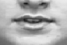
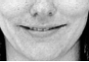
Each emotional display, depending on the emotion, has a certain combination of AUs i.e. the combination of AU12+25 is a smile, whereas AU12 on its own describes prudent lips and AU25 indexes relaxed and parted lips (Tian, et al., 2001). Below is an example of a combination of AUs that are used to display and label the smile.
Figure 1 - AU25, Titan et al.
Figure 2 - AU12+25, Titan et al.
Figure 3 - AU12, Titan et al.

The pictures used for their testing were from the Cohn-Kanade database and the Ekman-Hager database. Pictures from both databases came from test subjects that were tasked by an instructor to display a certain combination or a singular action unit, thereby creating a database consisting of all postures contained in the FACS system. Tian et al. managed an 80% correct detection rate of AUs with AFA.

The Facial Action Coding System – Summary
The Facial Action Coding system created by Ekman labelled regions of the human face that are used when shaping emotional expressions. The FACS is widely used in facial expression research and recognition in Tian et.al found that similar AUs were difficult to recognise and separate from one another. This result is in close relation to the difficulty by test participants in discriminating differences in visual expressions of emotions, when certain aspects of the semantic primitives are mixed.

Analysis Chapter Part 3 Conclusion – Computer Vision
Pantic et al. in their research on the effectiveness of facial detection and facial feature detection algorithms discovered that the training of the algorithms on established picture databases did not provide results that were transferrable to real world pictures. They attribute this inability to the fact that pictures from the established databases were constructed in optimal conditions, subjects were centred in the frame, lighting conditions were optimal and amenities such as glasses or beards were not present. Pictures that the algorithms were to be used on, such as photos taken from normal use, did often not have perfect lighting conditions and/or subjects facing the camera. Therefore the algorithms had a lower detection rate on pictures from normal use as they contained less than optimal conditions versus the established databases.
Tian et al. created a database consisting of pictures depicting the showcase of specific AUs. Their algorithm was successful in detecting the emotional display by the AUs, but the means by which the pictures were gathered, is of belief to this thesis to suffer from the same problem outlined above. Instead of using pictures taken from everyday normal use, a database with artificially constructed emotions was created. The emotional displays where created by instructing students to display a specific emotion. Research has later shown, as was the case with vocal analysis of insurance claimers that training a system on emotions that were gathered from an artificial setting were not applicable to a real world scenario.
Lastly the Facial Action Coding System created by Ekman was examined. Pantic et al. found that 55% of a message a human conveys is delivered purely by facial expressions. The FACS categorises facial expressions according to different AUs. The action units are points that reference different areas of the human face involved in displaying a certain facial expression. The combination of AUs represents a certain facial posture, Tian et al. used, among other, AU12 and AU25, which classified the human smile. Though the combination of certain AUs where found to be difficult to distinguish, both by the computer but also by the human participants.
Therefore this thesis believes that a custom picture database has to be created in order for a smile recognition and interpretation algorithm to be valid. This database would be rated by human test participants and compared to results by the algorithm and fine-tuned according to the answers by the test participants. By focusing on only two AUs, AU12 and AU25, test participants should be able to easily identify the emotional display. Furthermore the pictures in the database would have to be selected from readily available online picture resources such as Google Images (Google, et al., 1998), Flickr (Ludicorp, 2004) among others.

Affctive Computing introduction
Affective Computing (AC) covers the area of programming a computer to understand and interpret human emotions. The motivation behind AC is on one hand to enhance the level of possible human computer interaction (HCI) methods and on the other to let the computer assist in interpreting human emotions. These are only two examples of many possible areas of applicability that AC encompasses.
Rosalind W. Piccard (Piccard, 1997) created the term Affective Computing in 1997. Piccard et al. found that the next step in both HCI and Artificial Intelligence would be to include the interpretation of emotions by computers.
Piccard et al. creation of Affective Computing changed the way the computer had been previously viewed as a neutral participant in human computer interaction to that of an active participant, allowing the computer a greater understanding of human emotions. As Affective Computing covers a vast area such as emotional intelligence, human computer interaction among others, the following chapter will examine how the research in AC has progressed since RWP coined the terminology. This will be done from both the point of view of possible advances in HCI but also to investigate what progress has been made in understanding human emotions for the computer to interpret.

Affective Computing in HCI
Maja Pantic and Leon J.M. Rothkrantz (Pantic, et al., 2003) investigated how affective computing can assist in increasing the level of HCI possibilities. They sought to find a solution to make a computer able, with the same ease as humans, to understand and interpret the emotional state of its human user. This would benefit HCI, as the computer would be able to greater assist in i.e. automation of tasks, since the computer would adapt accordingly to the user’s needs.
Pantic et al. discovered at present that the approach in affective computing is limited to focusing on the individual being analysed and does not take into account the surroundings of the individual ,which she believes has a great influence on emotional perception. As humans take, beyond only visual factors of emotions, into account the surroundings and back story as well. Furthermore Pantic et al. did not find clear attempts to a whole solution to increasing the level of HCI, as researchers focused only on improving one modality that the computer could utilise.
Pantic et al. argues that the view on emotional intelligence will have to be translated to a computer in order to overcome the obstacles presented in the research. In conclusion the aspect of including emotional intelligence and affective computing in HCI is encumbered by the software solutions presently available, as they are not as precise in determining the human emotional state, whether that be by expressions of emotions by the human face or by tonal communication.

Affective Computing in HCI – Summary
Pantic et al. recommends that the surrounding in which an individual perceives an emotion be taken into account when assessing emotions. The surroundings can influence the emotional state of the individual and directly influence the emotional understanding by the individual. The findings by Pantic et al. tie in with the original research by Ekman and Keltner who also suggested that the environment influences the emotional state of the individual. These findings regarding the surroundings are important to take into account when designing the test phase of this thesis. Since test subjects will be tasked with providing a rating of a smile in a picture, which is an individual and emotional task, the surroundings could influence their answers. Therefore the test phase of this thesis will have to take the surroundings of the test subjects into account when designing the test.

Emotion Expression and Synthesis
Jimmy Or’s book on “Affective computing focus on emotion expressions, synthesis and recognition“ (Or, 2008) was a state of the art summary of current and at the time present research in areas such as affective computing. Specifically of interest to this thesis is the article contained in Or et al.: “The Devil is in the Details – the Meanings of Faces and How They Influence the Meanings of Facial Expressions” by Ursula Hess, Reginald B. Adams, Jr. and Robert E. Kleck (Hess, et al., 2008).
Hess et al. investigated the meaning of facial expressions in different facial compositions focusing on facial information other than the specific displayed facial expressions. They found successful detection implementations of the facial features that can make a face appear as sad, angry, fearful, and happy by a computer, though, when compared to how a human interprets the same visual displays, they found that as a human observer extracts the meaning of a facial expression from another person, the individual gathers data from all the visible indicators the face can convey. These indicators consist of eye gaze among others. These sources attribute to the interpretation of the facial expression by the perceiver and assists when determining the emotional label the perceiver will attribute to the conveyor. Furthermore Hess et al. found that the facial expression and gaze influenced the interpretation of dominance and if the person would withdraw or be approachable. These assessments are important as Hess et al. explains that for a social species such as humans, the ability to judge dominance from facial expressions hold, among others, information about the emotionality of the person.

Emotion Expression and Synthesis – Summary
As with attractiveness in gender, the face conveys important information about a person’s intent and emotionality. Hess et al. found that the specific areas of the human face that contribute to the display of anger or happiness among others (eye gaze, mouth) are only a small part of how humans extract information from facial expressions. The gaze and angle of look influences the assessment if a person can be approached and also reveals information of how dominant a character is. Interpreting facial expressions from a human standpoint is ambiguous since facial expressions and their meaning can be a combination of many visual cues. Ideally a computer should analyse all contributing factors to how emotions are conveyed by the human face in order to provide a valid interpretation of the displayed emotions. To include all factors such as eye gaze is beyond the scope of this project, therefore to compensate for the exclusion of eye gaze in the smile assessment, the test phase following this thesis will contain a comparison of ratings given by test subjects to pictures that only display the mouth. The same full frame picture will be given ratings by test subjects and compared to the same picture with only the mouth displayed. The results from this could provide an indication, if any, of how the test subjects rate the smile when only the mouth is present.

Affective Computing – Conclusion
Boehnera et al. found that the traditional view on Affective Computing from a computer standpoint was to only interpret and detect a certain display of human emotion. They therefore recommended that research into Affective Computing should include the ability by the computer to actively assist in human interaction. One of their points was to enable the computer to assist in interpreting emotions on behalf of a human user. This would help the human user form an opinion, if i.e. the particular human was not strong on emotional intelligence, the computer would help assessing the areas were the human user lacked expertise. This could increase the individual’s level of social interactivity among its peers.
Pantic et al. found that the surroundings, in which an individual is present, greatly influence his or her emotional perceptions. In Ekman’s study among the differences between students from Japan and the United States, he found that the Japanese would suppress their emotional responses, if an authoritative figure were present. Therefore as with Maja Pantic et al. the surroundings in which an individual is located can greatly attribute to their emotional assessment and understanding of emotions by their peers.
Hess et al. found that the gaze and facial expression by a human being can disclose much about their personality in terms of openness and dominance. This relates to Keating et al. research into attractiveness and dominance from facial features. Keating et al. also found that certain facial features attributed to the dominance and attractiveness rating an individual would be perceived to have.
Therefore this thesis believes the findings by Maja Pantic, Hess and Keating et al. can assist in shaping an optimal testing condition resulting in minimizing the factors that could influence the expressions of emotions felt by a test participant. Furthermore Boehnera et al. recommendations in what field Affective Computing should expand upon would be taken into account when designing and creating the goal of the accompanying software to this thesis. The software would assists humans in assessing and interpreting the level of smile/happiness in a picture, thus allowing the computer to help the human operator in determining levels of emotions elicited by the subjects in the pictures.

Analysis Conclusion
The following will briefly outline the specific knowledge gained from the different topics from the analysis chapter. This will lead to a requirement specification for the overall completion of this project based on the recommendations and conclusions from the selected analysed articles. The following is divided into four separate categories, each representing topics that will guide the test phase, design phase and implementation phase of this project:

Emotions
Emotions are of a highly subjective nature, both from the interpreter and the perceiver’s point of view. Ekman found that emotions within the semantic primitives were generally universally understood; different cultures viewed and understood emotions the same way. Ekman and Keltner found that only emotions elicited by the human face abode to the rule, emotions conveyed orally or via body language did not. Keating investigated which facial features improved the attractiveness of an individual and found that common denominators existed across cultures. Certain facial features enhanced the attractiveness whereas others diminished it.
Therefore this thesis believes that emotions to a certain extent are universally understood in regards to the basic primitives. Therefore by only focusing on the human smile, which studies found signalled happiness, an average understanding of what the smile constitutes can be found with the assistance of a test group. It will be the task of the test group to determine how much a person is smiling.

Emotional Intelligence
The level of emotional intelligence in an individual greatly influences their perception and interaction with peers. In the studies by Kirsten Boehner she generalised emotions, specifically the smile as being universally understood as a sign of happiness. In the research of Emotional Intelligence studies has shown, that the level of EI in females where, on average, higher than their male counterparts. Therefore as a precaution the test phase of this thesis will contain a separation of gender to be able to investigate, if the eventual should occur, differences between male and female ratings. Lastly if the ratings between genders do differentiate, it will show in a higher rating of smile in the test results in the group with the suspected higher level of emotional intelligence. To note is that an individual with a high level of emotional intelligence is faster and more accurate in determining the emotional state of the individual he or she is observing. Furthermore the location in which the test will be conducted is important due to the fact, that the environment can have an effect on the emotional perception.
Therefore this thesis believes that the level of emotional intelligence in the individuals conducting the test can influence the test results. Test subjects will be divided into two groups, male and female, should the test results reveal a significant difference in their ratings. Lastly the test will take place in a location selected by the test participants; therefore a website containing the test will be created to suit this requirement. Furthermore test of Emotional Intelligence showed that the display of emotional states via pictures assisted the test subjects the most in determining the emotional state of the individual, test subjects responded most fondly to emotional display via pictures.

Computer Vision
The recommendations in the computer vision chapter focused on the picture databases used for both testing the algorithm as well as the test subjects. To avoid pictures with imposed emotional displays and so forth, a picture set will be found only containing randomly selected pictures. The requirement for the pictures will only be that the person in the picture will display either happiness or sadness or a gradient between the two categorisations.

Affective Computing
Kirsten Boehner and Maja Pantic recommended that the location in which the test will take place be carefully considered. The location can have both a positive and negative effect on the emotional state of the individual taking the test. This further substantiates the decision to create a website for the test thus allowing the test subjects to choose their own test location, hopefully eliminating an environment that would influence their test answers.

Test method
The following chapter will describe and outline the process the accompanying test to this thesis underwent. The chapter will include the recommendations from the analysis chapter on how to obtain the most concise results and how to conduct the specifics of the test. It will furthermore describe the choices made in deciding how the test was delivered to the test subjects and which concerns were alleviated by the chosen test method.

Test Strategy
The overall test strategy was derived from the questions proposed in the final problem statement, namely how a human understands a smile. Before a computer can be tasked with rating the level of smile a person is conveying, human trials will have to be conducted. The human test subjects will be tasked to rate the level of smile in pictures presented to them. The results obtained from the human trials will be used to guide the computer in an attempt to reach the same accuracy and understanding as the test subjects.

Test Phases
- Test Phase One
- Establishing a rating scale for the smile using ratings by test subjects.
- Testing the bare algorithm on the same set of pictures and comparing the results to 1.1.
- Test Phase Two
- A new set of pictures rated by test subjects.
- Testing the refined algorithm on the picture database from 2.1 and comparing ratings by the algorithm to that of the test subjects to determine the accuracy by the computer in assessing the smile.

Test Scenario and test location
This section of the test method will discuss the decision to conduct the test by the help of a website. One of the issues with conducting a test of any sort is the difficulty in finding suitable test subjects. Traditionally tests subjects were recruited among campus students at Medialogy Copenhagen (Pellengahr, et al., 2010), could in some cases provided non-usable results. As the test subjects shared the same background in studies, they had an affinity in guessing what the purpose of the test was, biasing their answers in favour of the goal of the test. The same can be said of the study that created automated voice pitch analysis software (Batliner, et al., 2003) for use in the insurance industry. The software was tested on an actor mimicking a voice that changed in pitch, although the algorithm worked flawlessly in the test scenario, when it was subjected to real insurance claimers, the software did not work. Therefore a test website was created which would eliminate the bias by using random test subjects with different backgrounds. Creating a website for use as the test base provides a different approach compared to using university students but also imposes certain limitations. First and foremost is the lack of supervision of the test subjects. As each test subject can complete the test at their own pace and in their own setting (at home or at work) distractions during the individual testing cannot be controlled, i.e. is the TV on in the background or are they completing the test over the course of the day. Time stamping each start of the test and when it was completed was added to the output of the test, but unfortunately does not provide information on what was happening around the test subjects at the time of their test participation. Lastly, although a test of the test was conducted to ensure that test subjects would understand the goal of the test, situations could arise that would require assistance.
The strength of using a web based test scenario is that it allowed the would-be test participants to conduct the test from the comfort of their home instead of a university environment –earlier tests in previous semesters have shown that the environment, in which the test takes place, can influence the test participants (Pellengahr, et al., 2010). As mentioned above, allowing the test participants to choose the place, in which they take the test, can also result in distractive environments which could influence the test results. Furthermore it is the belief of this thesis, that by allowing test participants to choose the environment in which they complete the test, would negate the issues regarding the emotional influence the environment can have on the test participant’s as mentioned in the analysis. This thesis is aware, thatthe environment chosen by the test subjects can influence the test participants in both a positive or negative way. Lastly by utilising a website for the test a greater number of test participants can be included as the time spent with test participants is not applicable, thereby freeing time from testing to other parts of the project.

Test Phase One
Test phase one will consist of 26 pictures (20 full face pictures and 6 pictures displaying only the mouth) with a rating scale for test subjects to answer. The computer will use the same picture database where it is to provide a rating on the same questions as given to the test group.

Test Subjects
Test subjects will be tasked with rating the level of smile the person in the picture is conveying. As research has shown in the analysis, the display of happiness is commonly attributed to the smile. Furthermore as the display of happiness is part of the semantic primitives it is widely and easily recognized by humans.

Computer
The computer will be tasked with rating the smile portrayed in pictures. It is expected that the values chosen for how happy the person in the picture is, will vary as the algorithm is in its basic form. This test is done to establish a baseline for comparison when the algorithm has been refined based on the ratings given in test phase one by test subjects. The results gained in this test will be compared to test phase two to establish if the computer has become more accurate in determining the level of smile in a different picture set.

Test Phase Two
Test phase two will task a new test group with rating a different set of pictures. The computer will be tasked with the same agenda.

Test Subjects
A new test group will be tasked with rating a different set of pictures with the same goal and answer possibilities as test phase one.

Computer
The computer will be tasked with rating the level of smile portrayed in the picture database from test phase two. It is expected that the results given by the computer will lie close to and not deviate from the results given by the test participants. If this is achieved, the question proposed in the final problem statement can be answered.

Demographics
For a perfect test setting an equal number between male and female test participants is desirable. This is wanted due to the differences in the level of Emotional Intelligence in genders; if a certain picture deviates in its average rating the answers, by males and females can be examined and discrepancies if any be analysed. The age range of test participants is restricted to computer use, meaning anyone being able to interact with a computer can participate. The ideal test subjects are therefore anyone capable of human computer interaction. Test subjects will be found by emailing friends and relatives from the social network of the author of this thesis. It is emphasised in the email that the relatives and close friends are not to participate but instead asked forward the mail to their social network for their friends and relatives to participate.

Expectations
It is expected that the answers given by the test group will not deviate significantly between genders. The research in the analysis on Emotional Intelligence revealed that females tend to have higher scores, but in a test like this, the ratings given by genders are expected not to deviate strongly.

Test Phase One
The following will describe the procedure in which test phase one was conducted and how the results will help assist the computer software in its smile estimation.

Test Subjects
24 pictures will be given to test subjects with the task of rating the level of smile portrayed by the individual in the picture. The pictures used in the test are semi-random in the sense that the setting in which they take place are different, the lighting conditions are not perfect, but the person in the picture is required to show an emotional display ranging from happy to sad. The rating scale implemented allows answers from 1 to 10 were 1 is the least level of smile expressed in the picture whereas 10 is highest level of smile. Furthermore six pictures only show the mouth. The complete picture, with eye and mouth matching, are also in the picture database, the results from mouth only pictures will be compared to the full picture in order to determine if showing only the mouth influences the perceived level of smile.

Computer
The same picture set as given to the test subjects will be analysed by the computer. The computer will calculate a rating for each picture. The results from this test will be compared to that of the test subjects. The algorithm which the computer uses to rate the level of happiness will be changed accordingly to the ratings given by the test subjects.

Test Phase Two
The following will describe the procedure in which test phase two was conducted and to confirm if the implemented ratings from the test subjects increased the accuracy of the smile ratings given by the computer software.

Test Subjects
10 selected pictures will be given to test subjects with the task of rating the level of smile portrayed by the individual in the picture. The pictures for the test are semi-random in the sense that the setting in which they take place are different, the lighting conditions are not perfect, but the person in the picture is required to show an emotional display ranging from happy to sad. The rating scale implemented allows answers from 1 to 10 were 1 is the least level of smile expressed in the picture whereas 10 is the highest level of smile. This is the same approach as test phase one.

Computer
The same picture set as given to the test subjects will be analysed by the computer with the updated algorithm. The computer will calculate a rating for each picture. The results from this test will be compared to that of the test subjects from test phase two. It is anticipated that the computer should be able to more accurately rate the pictures within a closer range to results given by the test subjects from test phase two.

Design & Design Requirements
The following chapter will outline and describe the design requirements and the design decisions that will assist in finding a solution to the problem statement. The chapter is divided into two parts, first the test website will be analysed as its goal is to provide a general understanding of how test subjects rate the smile, secondly the implemented software solution and the requirements for it will be analysed.

Design of the website
The website created for this thesis will be the means that enable the computer to understand different smiles and how they are rated. The results from the test will be used to guide the computer in trying to let it understand and interpret a smile.
The design of the test website was based on feedback by a small test group. A fully working test website containing the pictures selected from the batch of 50 was created. The preliminary design of the website was based on knowledge gained in the classes from human-computer-interaction and the recommendations from HCI studies in affective computing. Before test phase one could commence, the design and overall usability of the test website had to be evaluated. A small test group was given the URL to the website and after completing the test were interviewed over the telephone.
The goal of the test was to establish if test subjects understood the goal of the test, if they could relate to the selected pictures (i.e. provide a rating), if the flow from inputting their age and gender to the display of the first picture seemed natural and to ensure that the test could be conducted without a test supervisor. Lastly it was conducted to ensure that the test participants understood the numerical rating system. Furthermore, as the test was to be conducted online, more than one test person conducted the test simultaneously, to ensure that correct values were written to xml and not overlapping other test result values. Lastly, this pre-test was also done to ensure that the code for the website functioned properly and loading times were at a minimum to not discourage test subjects from completing the test.
Six test participants were tasked with completing the test as normally and were afterwards interviewed. The following are the comments and suggestions by the combined group:
One test subject did not understand the rating scale, as the introduction was not thoroughly read due to the amount of text. Another test subject understood the rating scale but found the introductory text to be too tedious and too long. All test subjects found the rating scale 1-10 to perfectly suit their rating options but expressed concern over the lack of any visual indication of the rating. The test subjects found the chosen pictures to be fitting to the task, though they found the selection to be more favourable of a high rating (smile) than a low rating (no smile). One test subject noted that the situation in which the people in the pictures were present influenced his rating decision, i.e. one elderly male was given a lower smile rank than the smiling baby since the test subject tried to interpret the old mans intentions. Lastly all test subjects found the time it took to complete the test to be within an acceptable timeframe, it did not take too long and the number of pictures did not discourage them from providing an honest rating (no test subject blindly clicked through the pictures without considering a proper rating). The entire test was completed in 5-6minutes. Time stamping of when a test participant started the test and ended the test was used to determine the length of each test session.
The feedback from the small test group resulted in the following changes to the final testing of test phase one and test phase two. The introductory wording of the test was re-written to be easier understandable and the time it would take to read should thereby be lowered. This should alleviate the problem with test subjects skipping the introduction due to the amount of text to be read. Secondly a visual rating scale beneath the 1-10 rating scale would be created to provide test participants with a visual indication of their rating. The visual indication would not be a substitute to the numerical rating system, i.e. happy/sad emoticons below the 1-10 scale, but should indicate were in the rating system test participants were (if the mouse is hovered over rating 6 the white icon at the bottom would turn partly black, indicating a selection option).
As mentioned in the analysis the test setting is important in respect to the studies that found that the environment in which an individual is currently present can influence their emotional perception. Therefore this thesis hopes that by allowing the test subjects to choose the location in which they complete the test, would favour a setting that is natural to them. Furthermore the pictures that will be used in both test phase one and test phase two should have motives that are relatable to the test subjects. The six test participants that assisted in the selection of pictures for test phase one all expressed that they choose the pictures on how easy they could relate to the persons in the pictures. Therefore pictures of Christopher Lloyd, Cameron Diaz and Harrison Ford that came from the CMU database were included should the selected pictures be difficult to relate to by the test subjects.

Computer Software – Smile Assesment
In order to solve the problem statement of enabling a computer to be able to understand and interpret the human smile, requirements for the computer software were created. In the analysis, the combination AUs 12 and 25 were found to be the visual indicators of the smile. The implemented software should therefore use the location and combination of AU12 and AU25 to determine the area of the face that is responsible for the smile. The analysis revealed a great discrepancy in the accuracy and validity of algorithms in facial feature detection when not using optimised picture databases. For this thesis to able to answer the problem statement the implemented software solution should be able to perform facial feature detection on pictures that are not from clinical settings. Since the test subjects will be providing answers on a rating scale from 1-10, the output of the smile assessment by the computer should be of a numerical nature. This will enable a direct comparison of smile ratings from the test subjects to the computer. If i.e. test subjects on average rate picture 7 as 6.7, the computer should output accordingly, if not i.e. the computer rated picture 7 as 4.3, the smile assessment should be modified. Furthermore as the specific output of the computer software is not yet determined, the results should be plotted on graphs from both test subjects and the computer. By comparing how the graphs fluctuate, if the valleys and peaks follow the same pattern, a graphical representation of how accurate the computer solution is can be visualised. If the valleys and peaks do follow the same pattern, the implemented software solution can be said as working correctly in estimating the smile rating.
As accuracy issues are to be expected in the facial feature detection software, each rating calculation will be computed three times and the average will serve as the final smile assessment result. The average of three computations will provided a more accurate smile assessment as the accuracy of the algorithm can fluctuate.

Requirement Specification
The requirement specification is in two parts, firstly is the requirements for the test website and secondly the requirements for the smile detection and evaluation algorithm. The requirements for the test website are of the visual nature, especially easy to use for the test participants and the focus on delivering a clear message to the test subjects ensuring that the primary goal of the test cannot be misunderstood. The requirements for the smile detection implementation on the other hand are strictly limited to solving the final problem statement from a programming point of view. As the operator will only use the smile detection implementation, no decisions in terms of graphical user interface or ease of use have been considered. The implemented software solution will output its values to the console for further analysis.

Test Website Requirements
Based on feedback by testing the test, the following changes from the original inception of the test website where implemented:
- Visual indicators when the mouse is positioned over an answer.
- Numerical rating scale is constant, 1-10.
- Submit button label changed to continue label
- Shortened the amount of text on the welcome screen
- Added a test complete image

Programming Requirements
Early on in the creation of this thesis an attempt was made to create a face and facial feature detection program. The implementation of face detection in action script (AS3) was achieved quite rapidly, but the addition of facial feature detection proved cumbersome. The face detection program gave too many false positives or no detections at all with pictures in near optimum lighting conditions. An open source implementation was found (Tastenkunst, UG (haftungsbeschränkt), 2012) that fulfilled the requirements, namely face and facial feature such as eyes and mouth detection. In its present implementation the software would only detect the face and facial features but did not extract the meaning of what it saw. Therefore the software had to be altered to suit the following needs:
The software would have to output a numerical value that corresponds to the smile rating. The numerical rating can then be referenced against the answers given by test subjects to understand what differentiates the two. As this is an early attempt of smile understanding and interpretation by a computer, the speed or efficiency of the algorithm is of lesser concern, as the program is to be operated by the author of this thesis only.

Implementation
The implementation follows the structure of the requirement specification with the addition of the analysis on the pictures selected for test phase one.
Pictures used in Phase One based on the picture test:
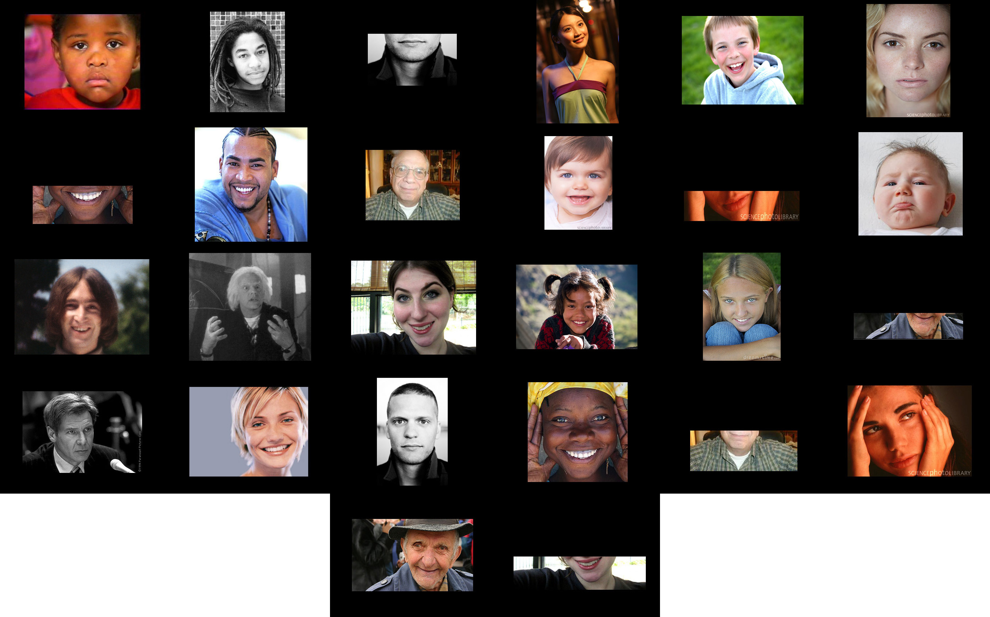
Figure 4 - Test Phase One – Pictures, in order of appearance, top left (Picture 1) to bottom right (Picture 26)
The selected pictures from Figure 1 were taken from Google image, Flickr and other photo sharing sites. Each picture was selected from a batch of +50 pictures. The requirement for each picture selected was that the expression portrayed by the subjects in the pictures had to be in the range of either completely happy or completely sad. By having diametric opposites of expressions, the expressions could then be converted to a numerical scale of 1-10. Since the author of this thesis selected the pictures in the initial batch (50 pictures), they had to be given to a test group to establish that the emotions portrayed in the pictures were real and indicative to the happy to sad range. Therefore each picture was given a dry test: each picture was printed in colour and given to a preliminary test group. Each test subject was asked to rate the level of happiness in the picture; this was to establish that bias from the author, if any, would be removed, and to insure that the test group could relate emotionally to the pictures, else a rating would not be possible. Of the 50 pictures, 20 pictures of the batch where chosen by the test group (depicted in Figure 1). The pictures in figure 1 appear in order of appearance in the test, top left is the first picture presented to the test group, bottom right last picture presented to the test group.

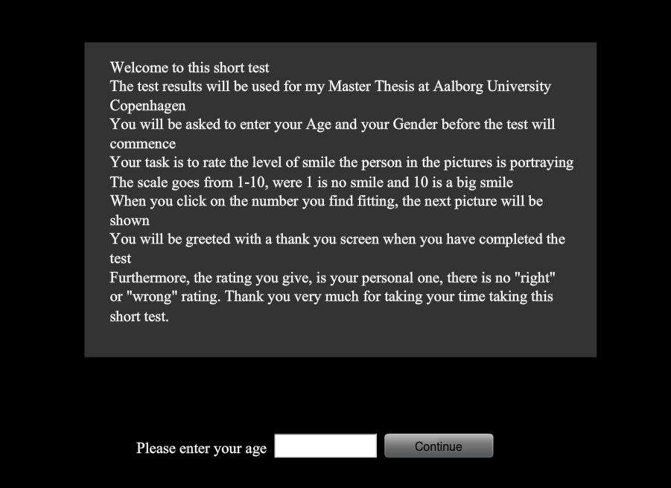
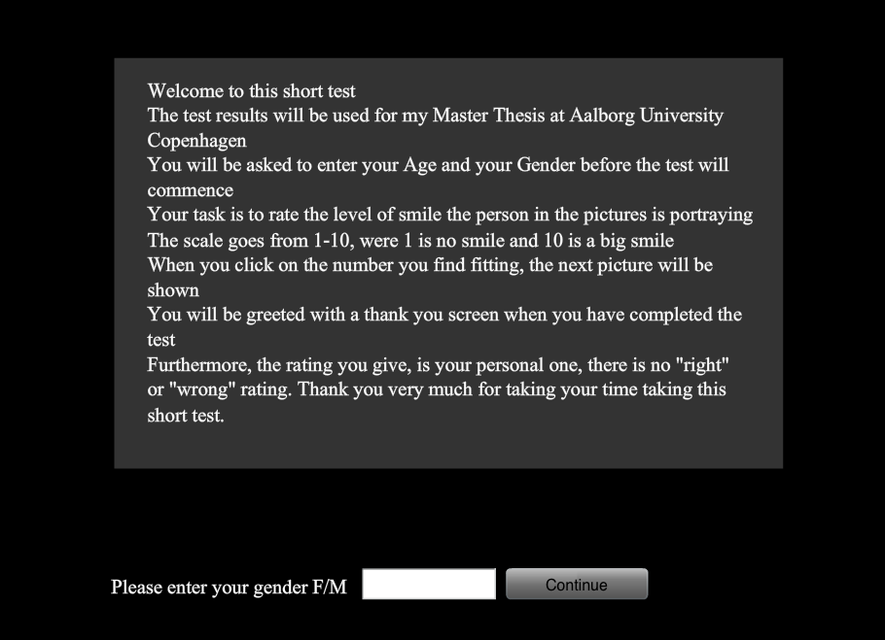
Website Implementation
Figure 5 - Welcome screen, Gender - Test Website
Figure 6 - Welcome screen, Gender - Test Website
The website created for the test was written in Action Script 3 (AS3), for complete source code see Appendix 16.7. Action script 3 was chosen due to the author’s affinity with Action Script and AS3’s fairly easy implementation in regards to PHP and xml. Test participants, upon entering the URL of the website, were greeted with a welcome screen shortly explaining the task at hand. Test participants were required to enter their gender followed by submitting their age. Each input was written to an xml file residing on the webserver, the following code snippet is an answer given by a test participant taken directly from the xml file: “m 41 6 4 5 7 10 3 10 10 8 10 2 1 7 2 6 9 8 7 3 9 4 10 5 3 8 4”. The “m” denotes male and the first number the age. Each subsequent number i.e. 6 – 4 – 5 – 7, is the rating given by the test subject to the first, second, third and fourth picture ending with a rating of 4 for the last picture. In the introduction it was stressed that no right or wrong rating exists, since the goal of the test is subjective and each rating given is the absolute truth for the particular test participant.
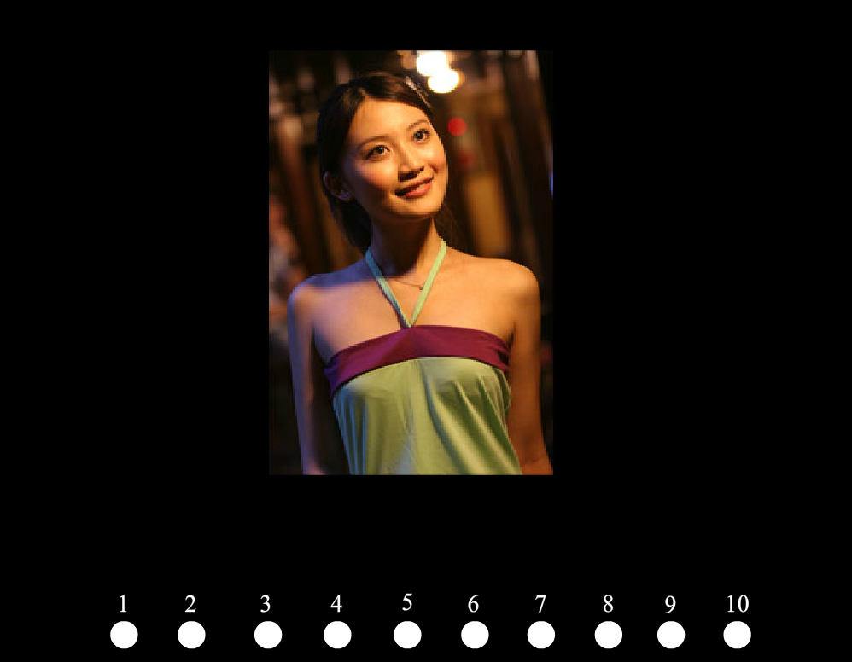
After entering their gender and age, the test participants are shown the first picture. Figure 7 shows a picture used in the test (Picture number 4 out of 26) with the numerical rating scale of 1-10 at the bottom of the frame. By placing the mouse over the white circles a black circle fills the area indicating an answer possibility. When a rating has been chosen, clicking on what the test participant finds appropriate saves the rating and immediately changes the picture to the next in line. The test participant has no option of going back thus eliminating second-guessing the given rating on the previous picture. Each picture has a preloader ensuring that the picture is first displayed when the user has finished loading the picture on their computer. After the test has been completed a final picture appears thanking the user for participating. The website can handle multiple users at the same time without mixing the results in the xml file. The source code for the test website is attached in Appendix 16.7, the website used in test phase one can be found at www.keepitsimpleidiot.com/test.
Figure 7 - Rating of Picture 4 - Test Website
Figure 8 - Thank You Screen - Test Website

Smile assessment Implementation
The software language used for the smile assessment implementation is, as with the website implementation, Action Script (AS3). Adobe Flash (CS5.5) was used as the coding front-end; see Appendix 16.5 for the full source code. As mentioned in the requirement specification, the face detection and facial feature detection source code was taken from a non-commercial open source program (Tastenkunst, UG (haftungsbeschränkt), 2012). The software is licensed as open-source if it is not used in conjunction with a commercial product.
The software allows the user to specify the eye region of the face by moving two markers were applicable. With the markers in place, the software determines the facial area from eyebrows to the chin of the face, see Figure 9. The software was developed with the purpose of applying different enhancements to the face being analysed. In the example used, the purpose of the software was to place sunglasses on the face by correctly determining the location of the eyes. This feature had to be modified if it was to be used in conjunction with this thesis; therefore the following changes were implemented. The application of sunglasses on the eye region was removed. The size of the bullet points and numbering were increased, these were the only cosmetically changes applied to the software.
Figure 9 shows the bullet points and numbering increased. The increase in size was done to provide a clearer view of which numbers corresponded to the nose and mouth regions of the face.
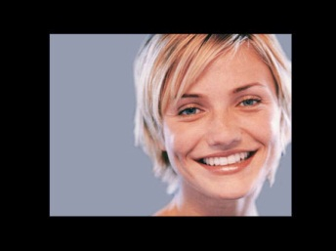
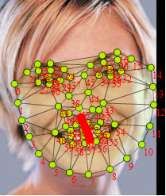
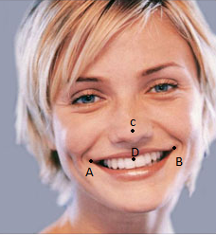
In figure drawing and forensic science, the rule of facial proportions is that the nose, mouth and eyebrows make up two thirds of the human face, by this is understood that the position of eyes, nose and mouth follow the same scale (i.e. the nose and mouth make up two thirds of the human face). By using this information, this thesis postulates that the distance between the centre of the nose and the calculated centre of the mouth can be translated to the level of smile in a human face. Therefore the software created for solving the final problem statement will evaluate the level of smile based on the distance between the calculated centre of the mouth and the centre of the nose.
Figure 9 – Before and After Facial Feature Detection
Figure 10 – Smile Estimation Points
The centre of the mouth is calculated by finding the distance between the corners of the mouth and dividing by two, Figure 10 shows the location of the points denoted by A and B, D is the calculated centre of mouth. Therefore it is the belief of this thesis that, if the distance between the calculated centre of the nose and mouth is large, the level of smile is low. Whereas when the distance between the centre of the nose and mouth is low, the level of smile is higher. Meaning, when a low smile: the distance between nose and mouth is large, the most left and most right points of the mouth are positioned downwards and further from the nose, resulting in a greater distance. When a high smile, the distance between nose and mouth is low, the most left and most right points of the mouth are positioned higher and closer to the nose. The centre of the mouth is calculated from the x and y coordinates of the left most point and the right most point (point 56 and 59 see Figure 9 & 10).

Figure 9 depicts a smiling female; this picture was used in test phase one. Figure 9 shows the same female after face feature detection has occurred, to note is the red line connecting the mouth and nose. The red line is the calculated distance between the centre of the nose and the centre of the mouth.
The distance between D and C (see figure 10) is the level of smile. D(x,y) was calculated by ((ax-bx)/2+ax) for the x-value and ((ay-by)/2+ay). The calculations where done by using this formula: ((x1-x2) / 2 +x1) to find the x-value of the centre of the mouth. The y-value of the centre of the mouth is found by ((y1-y2)/2 +y1).
As the detection algorithm finds the centre of the nose (C), the distance between the centre of the mouth and centre of the nose was calculated by subtracting the y-value of the mouth by the y-value of the nose, distance between D and C (dy-cy).
The code responsible for this calculation can be seen in the code snippet below (Comments by the author in the code as seen in Appendix 16.6 have been removed for the following code snippets).
if (i == 59)
{
mhx = point.x;
mhy = point.y;
calculateface();
}

The above code adds the x value of the right most point of the mouth, point B in Figure 10, to mhx. The same is computed for the y value and is saved in “mhy”. “mhx” meaning “mund, højre, x (mouth, right, x)”. “mhy” meaning “mund,højre, y(mouth, right, y)”. Since “point.x” and “point.y” changes according to which point from the facial feature detection is selected, it is saved in “mhx” and “mhy” accordingly. The function “calculateface" is called when the values have been saved, as “calculateface” is the function that will calculate the x and y values of the centre of the mouth.

if (i == 56)
{
mvx = point.x;
mvy = point.y;
calculateface();
}

The same procedure is repeated as above, except for the left most point in the mouth, point A in Figure 10.

if (i == 42)
{
nasx = point.x;
nasy = point.y;
calculateface();
}

The same procedure is repeated as above, except the centre point of the nose, point C in figure 10.

The following code snippet concerns the function “calculateface”.

private function calculateface() : void
{
if (mvx == undefined || mvy == undefined || mhx == undefined || mhy == undefined || nasx == undefined || nasy == undefined)
{
trace ("no detection")
}

If no detection occurs, i.e. points 59, 56 or 42 contain no value, the above if sentence prohibits the software from performing the following calculations. Without the above condition, the software would crash due to either trying to divide with zero or non-numerical characters.

else
{
x1 = (((mhx - mvx) / 2) + mvx);
y1 = (((mhy - mvy) / 2) + mvy);

}
drawlineface();
}

The above code snippet uses the distance between two points formula explained above. “x1” represents the x-value of the calculated centre of the mouth and “y1” represents the y-value. After calculation of the x and y values “drawlineface” is called. “drawlineface” is responsible for determining the level of smile as an expression of the distance between the nose and the calculated centre of the mouth.

private function drawlineface() : void
{
if (x1 == undefined || y1 == undefined)
{
trace ("no detection");
}

Should the calculations from “calculateface” contain no values the program will output “no detection” to the console. The reason for the if sentence are the same as in “calculateface”.

else
{
var my_shape:Shape = new Shape();
addChild(my_shape);
my_shape.graphics.lineStyle(10, 0xFF0000, 1);
my_shape.graphics.moveTo(nasx,nasy);
my_shape.graphics.lineTo(x1,y1);

A shape is created that will draw the line from the centre of the nose to the calculated centre of the mouth. This was done to provide a visual indication of the smile rating.

var nievau = (y1 - nasy);
trace (nievau);

The variable “niveau” is the level of smile calculated by subtracting the y-value of the mouth and the y-value of the nose.

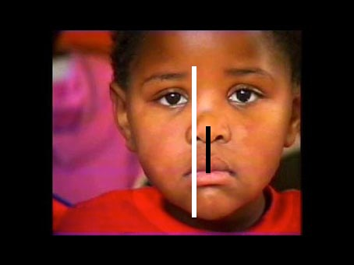
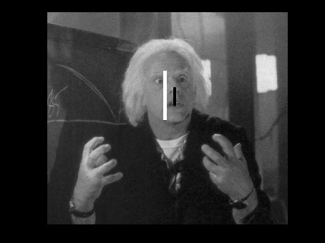
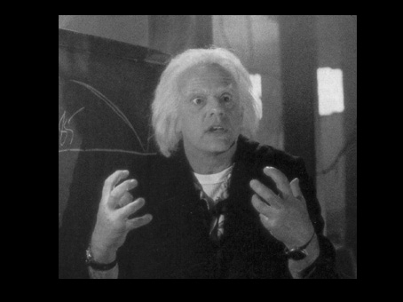
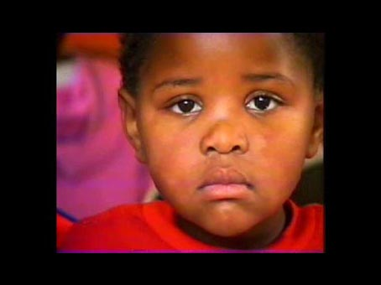
A problem with the calculations for the smile estimation was the change of dimensions in the pictures being analysed. Figure 11&12 below show two pictures used in test phase one, the left picture (Figure 11) is of a little boy and the picture to the right (Figure 12) is of Doc Brown, their expressions are at present not important, but the dimensions of their faces are. The algorithm works by determining were the eyes are located and from there estimate the location of the chin and mouth. This can cause a discrepancy in the results since the visible dimensions of the faces differ from image to image. In the example from Figure 11 the face of the little boy fills most of the frame whereas Doc Brown (Figure 12) only takes up to one third. When estimating the level of smile in each picture, the little boys rating would be considerably higher than that of Doc Brown due to the different dimensions. The different dimensions in the pictures are caused by distance to the camera as well as the angle. Therefore, before a final smile rating can be computed, each area of estimation has to be normalised. Figure 13 shows the little boy to the left (Figure 13) and Doc Brown (Figure 14) to the right. The white line represents the region of interest by the algorithm (see Figure 9 for algorithm representation) and the black line is the calculated distance between mouth and nose (see Figure 9 for algorithm representation). To normalise the results the distance between nose and mouth will have to be divided by the region of interest (i.e. the length of the black line is divided by the length of the white line). By dividing the distance between mouth and nose with the region of interest each result can be compared to the other, thus ensuring the dimensions of the picture does not influence the smile rating given by the software.
Figure 11 - Picture 1 from Test Phase One
Figure 12 - Picture 14 from Test Phase One
Figure 13 - Picture 1 From Test Phase One with scale lines, white = roi, black = smile estimation
Figure 14 - Picture 14 From Test Phase One with scale lines, white = roi, black = smile estimation
if (i == 22)
{
topy = point.y;
calculateface();
}

The above code snippet saves the top most y-value for use the calculation of the region of interest. The top most y-value is the area around the left eye brow.

if (i == 7)
{
boty = point.y;
calculateface();
}

The above code snippet saves the bottom most y-value for use the calculation of the region of interest. The bottom most y-value is taken from the lowest point of the chin.

var roi = (boty - topy);
trace ("roi");
trace (roi);

The above code snippet subtracts the chin y-value with the brow y-value and outputs the result to the console. This value is the region of interest that is used to calculate the dimension scale for each picture.

trace ("smile estimation")
var smileest = ((nievau / roi)*10);
trace (smileest);
The above code snippet calculates the dimensions of the face in the current picture. The variable “nievau” is the distance between the calculated centre of the mouth based on AU12 and AU25, the variable “roi” is the calculated distance between the brow and the chin. The variable “smileest” is the dimension calculation; “smileest” is multiplied by 10 to create easier readable results. The smile estimation is then written to the console for later analysis and input to a spread sheet to enable comparison to the results from test subjects.

Test Results
The following test results were gathered with the assumption to solve the problem statement. Two test phases were created as mentioned earlier. Test phase one would gather ratings from test subjects that would assist the computer software. Test phase one consists of two testing parts, human test subjects and computer test. After completing test phase one, the results by the human test subjects and the results from the computer software will be compared to determine the differences in ratings of the smile. The results by the test subjects would be implemented in the computer software to enhance the computer’s ability to correctly rate the smile. Followed by test phase one is test phase two and the results from test phase two will provide an indication if the problem statement was solved.

Test phase one
The following test, conducted among randomly selected test participants with a wide age span but divided in male and female groups, was conducted to establish a “basis” for how humans would rate the smile in 26 pictures. The task for the test subjects where to enter their age and gender before rating the pictures.
The procedure on which this test was conducted was to create a test website located at keepitsimpleidiot.com/test which prompted visitors to enter their age and gender as the only personal information test subjects had to disclose. This information was collected in case there should be a large discrepancy on the ratings. If such a discrepancy would exist the groups would be divided between male and females. This would disclose if males and or females rated the portrayed facial expressions differently. Therefore the age of the test participants was also asked, to be able to divide the age groups accordingly if age had an influence on smile ratings. A mail was sent to relatives and friends with a short instruction set on what was required of the test participant. It was kept short and to the point, in order to avoid people deterring from the test due to time. The test participants were tasked with rating the level of smile on a scale of 1 to 10, 1 being no smile and 10 being a big smile. There was no time restraint on the pictures, but once a rating on a specific picture had been given, the next picture would show without the ability to go back and change the rating. This was done to avoid people second-guessing their evaluation based on the forth-coming picture.

Test Results – Test Subjects
Test Subjects: General: Average age: 39. Highest age: 63. Youngest age: 11. Male test subjects: Number of males: 22, average age: 36. Female test subjects: Number of females: 19, average age: 42. Figure 15 shows each picture used in the test with the average smile rating by the combined male and female test groups (The spread sheet from test phase one, test subjects, can be found in Appendix 16.1)
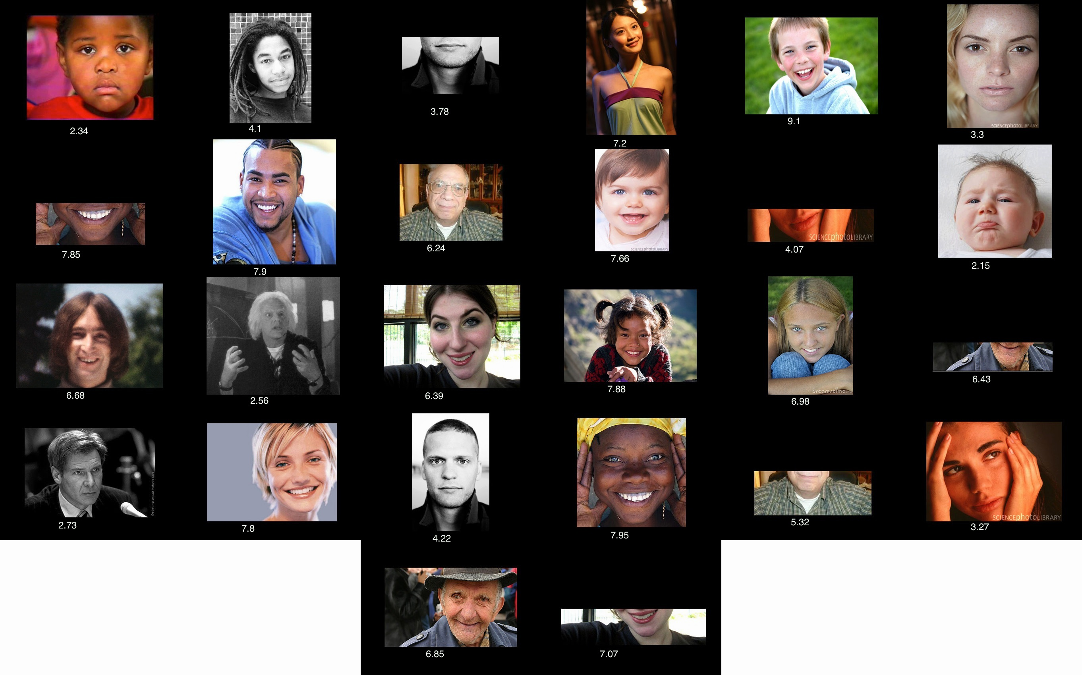
Each rating given by the test subjects will in chapter 9.2 assist the computer in determining the correct smile rating for the pictures.
Figure 15 - Test Pictures from Test Phase One in order of appearance with the smile rating for each picture denoted below the pictures

Test Results – Computer
Figure 16 shows the calculated smile ratings given by the computer. The last column – Weighting Scale – shows the ratings after the dimension scale has been calculated. The weighting scale is the smile assessment of each picture by the computer bottom (The spread sheet from test phase one, computer results, can be found in Appendix 16.2)
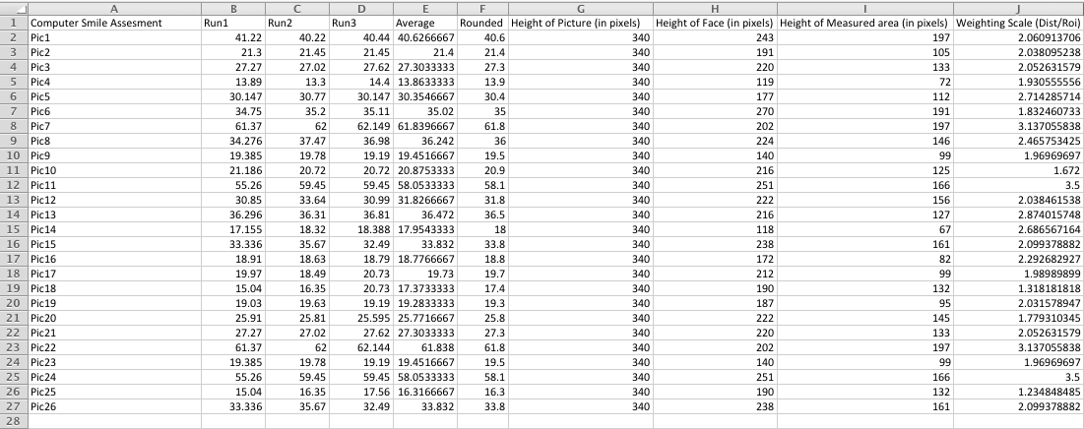
Before calculating the smile rating by the computer, the approach in obtaining the results from the computer will be analysed. The distance between the centre of the nose and the mouth was calculated three times, the resulting average is then used as the level of smile in each picture. The approach of using the average was to leverage the uncertainty in how the program calculates the region of interest. As the calculation is dependent on the user marking the location of the eyes of the test subjects, the location of the markers can vary from each calculation – as can be seen in the differences from Run1, Run2 and Run3. Therefore the average was calculated and used as the rating of the smile. Furthermore as picture 3, 7, 11, 18, 23 and 26 only contain the mouth they will not be included in the analysis by the computer, as the computer cannot estimate the level of smile due to the missing upper half of the face.
Figure 16 - Test Phase One - Computer Results
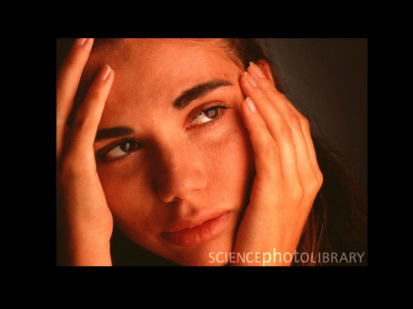
Lastly, the pictures that were chosen for test phase one were selected before the programming of the algorithm had begun. The pictures were selected as they were found to cover a wide range of smiles, both positive and negative displays of such. The only requirements for the pictures where a clear shot of the face, the angle or lighting conditions did not matter. Unfortunately the algorithm utilised was found to have detection problems when certain areas of the face were obstructed. Figure 16 is of a picture used in test phase one; the picture displays a female with her hands around her cheeks. Due to the hands the algorithm could not determine the correct region of interest, i.e. the algorithm could not correctly specify the location of the mouth, the eyes, nose and facial boarders. As can be seen in Table 1&2, the graph shows the comparison between the results calculated by the computer and the ratings given by the test subjects in test phase one. On both graphs, on the x-axis, picture 19 is of said female covering her face; the computer rated the smile as high whereas the test subjects rated the smile as low. The fault in the algorithm was found by comparing the results from the computer and the test subjects. Therefore pictures originally used in test phase one will have to be omitted from analysis by the computer, as a rating is not possible. This knowledge will be carried onto test phase two, as the requirement for pictures that are to be used, is that they can all be analysed by the computer.
Figure 17 - Picture 24 from Test Phase One

Implementing Test Results in the Smile Assessment Algorithm
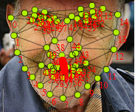
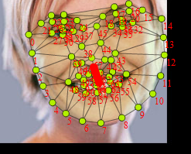
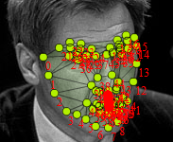
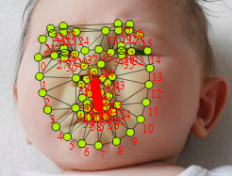
The following graphs show the comparison between the smile estimation by the computer and the smile ratings given by the test groups in test phase one. The value of the x-axis corresponds to picture 1, 2 and so forth. The value of the y-axis represents the rating scale (1-10). The computer estimation is based on the distance between the centre of point A and B to point D. The distance is an expression of the level of smile in each picture calculated by the computer. In direct comparison from the graphs, the computer estimates of the smile are correct for Picture 1,3, 4, 5, 6, 10, 12, 13, 14 and 18. But for Pictures 2, 7, 8, 9, 11, 15, 16, 17, 19, 20 they are incorrect. In the pictures from test phase one, the algorithm calculated a 50% correct estimation. The peaks and valleys from each graph were compared to one another without regard to the intensity (i.e. Picture 4 has a value of 9.2 from test subjects whereas the computer gave it a rating of 1.97). Of interest was if the valleys and peaks corresponded to the same valleys and peaks in each graph. The pictures that were given erroneous ratings by the computer will be analysed in the following to establish in what way the algorithm failed to rate correctly. Each picture was re-estimated by the algorithm from this re-estimation, the following pictures (Figure 18, 19, 20 & 21) were removed due to erroneous detections of the facial region and facial features.
Table 2 - Test Phase One - Test Subjects, average rating - Graph
Table 1 - Test Phase One - Computer Results - Graph
Figure 21 - Detection area too small, chin - Picture 20
Figure 20 - Detection area too large, right side - Picture 16
Figure 19 - Detection error, chin - Picture 15
Figure 18 - Detection area too small – Picture 9
The pictures shown in, Figure 18, 19, 20 & 21 were given an erroneous smile rating by the computer due to the display of the specific smile. The smile in picture 2 is neutral (rating by test participants: 4.1) the computer does not register either a big/small smile and therefore provides a low rating. The smile in picture 7 indicates a big smile to the computer due to the placement of the corners of the mouth, but test participants rate the smile as only 6.24, slightly over neutral. Picture 8 displays a happy child (rating by test participants: 7.66) but the computer sees it as a neutral smile due to the corners of the mouth not being higher up. Test participants rated picture 11 as a 2.56 but due to the open mouth the computer finds the smile to be of higher value than test participants. Picture 17 was rated 4.22 but the computer saw a low smile due to the placement of the corners of the mouth.
Due to these findings the following test phase two will have to be altered in order to answer the questions proposed in the problem statement at the beginning of the thesis. The findings from test phase one revealed that the implemented smile estimation algorithm could not differentiate between ambiguous smiles such as the one seen in Picture 19 among others. Therefore test phase two will comprise of pictures that clearly state a definitive smile or no smile. The extremes have to be found in order to prove if the algorithm can differentiate between smiles that are clear. This will unfortunately void the problem statement in the sense that the computer cannot be able to rate and interpret the level of smile with the present implemented algorithm on the same level and understanding as humans.

Test phase two
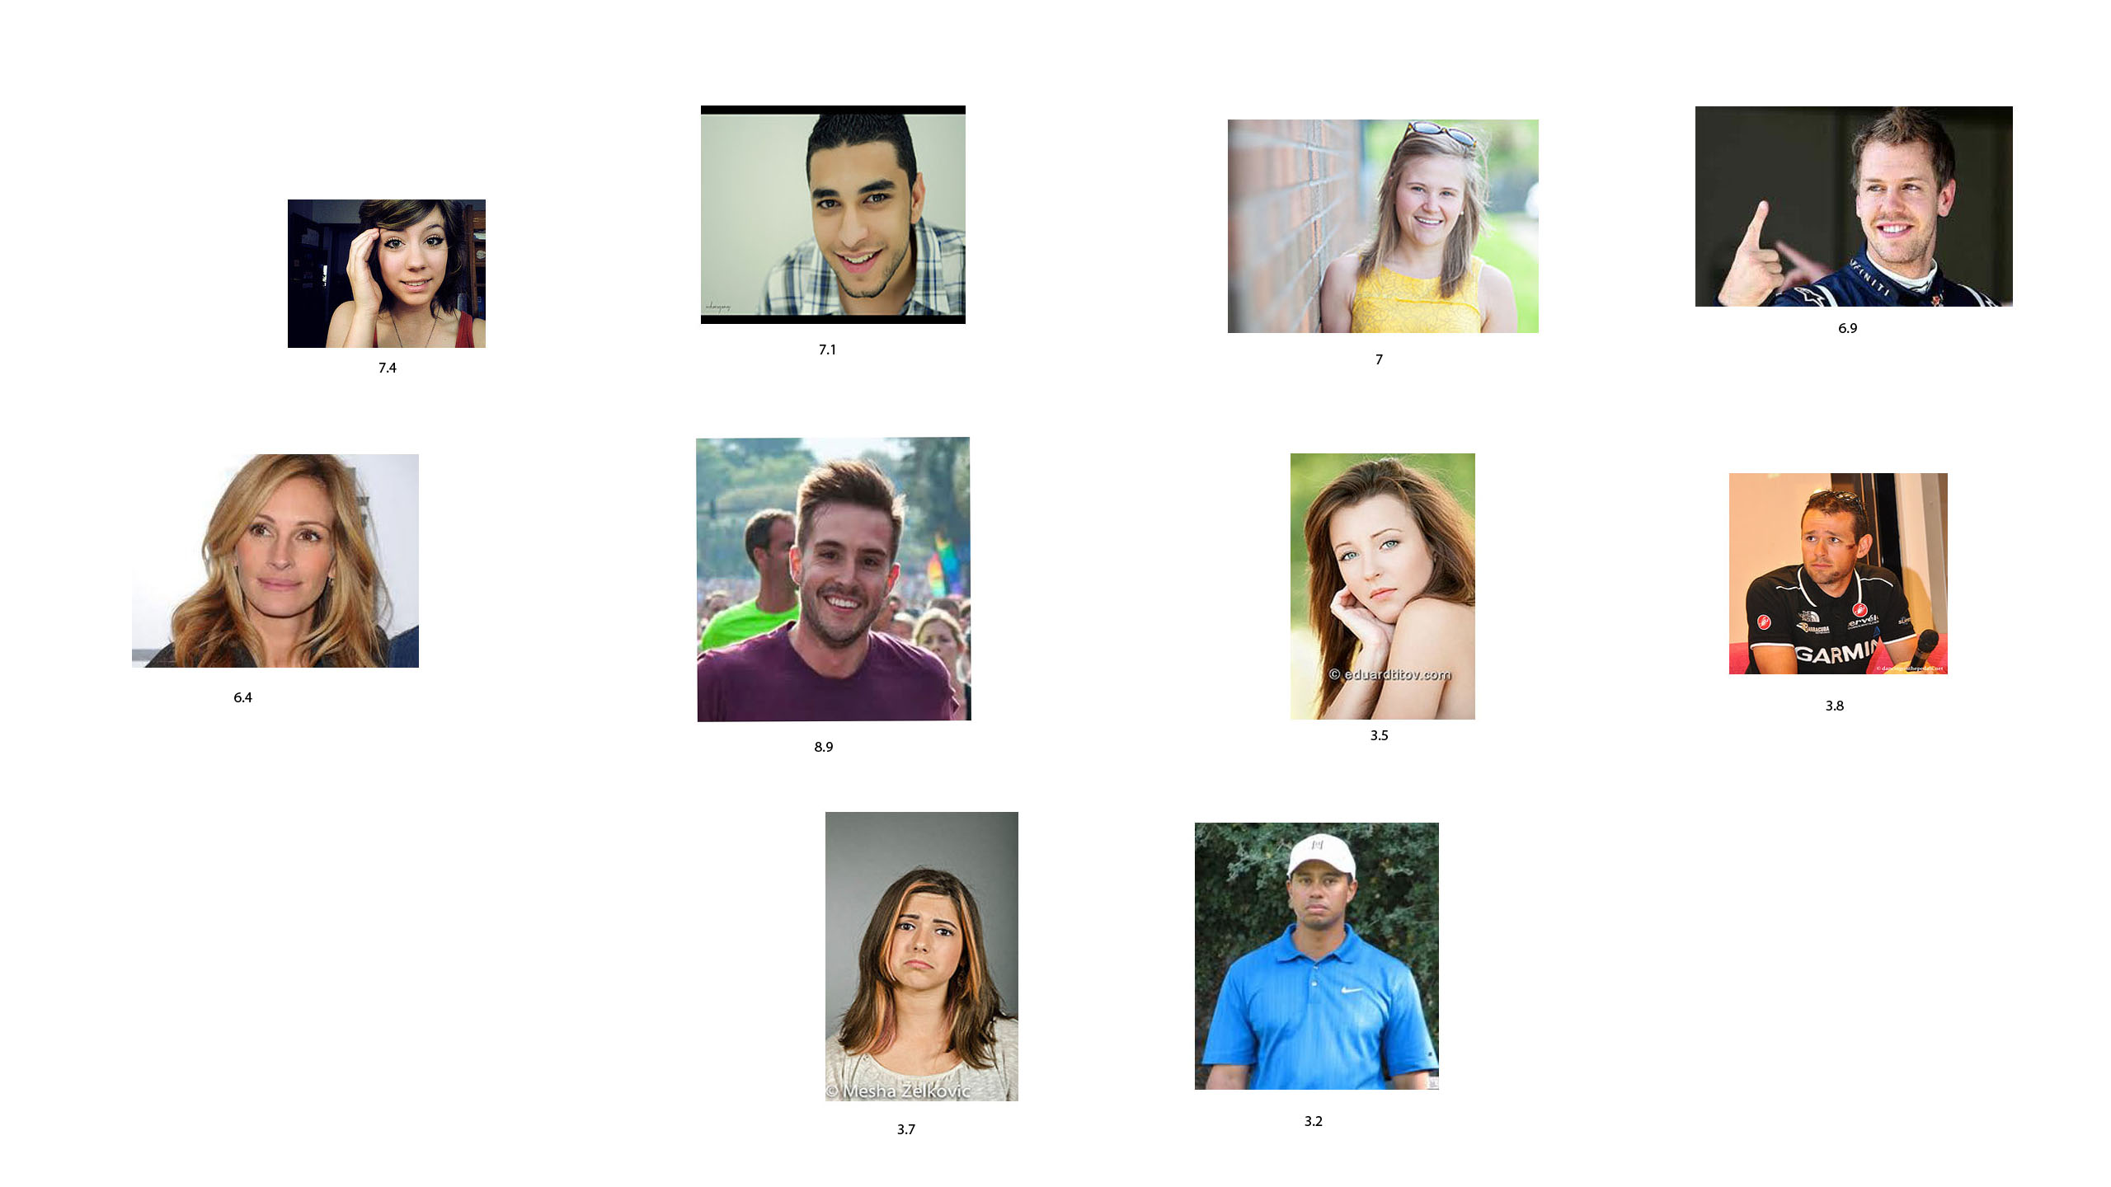
Originally test phase two was intended to be a blind trial of the algorithm on 10 further randomly selected pictures. But due to the algorithms inability to determine the level of smile in ambiguous pictures, the following test phase two has been altered to only include pictures that are clearly distinguishable from one another. This will unfortunately result, that a definitive answer to the problem statement will not be possible. Figure 22 shows the pictures in order of appearance that were used in test phase two, the average rating for each picture given by the test subjects are denoted below each picture. Each picture was specifically selected by the shape of the mouth; the mouth had to represent a clear distinction if the face was in a happy or unhappy pose. The shape of the mouth on the first six pictures clearly bends upwards. The last four pictures the mouth clearly bends downwards. Since the algorithm works by calculating the centre of the two most outward points in the mouth, by having a clear distinction between a happy smile (bending upwards) and a sad smile (bending downwards), the results will be more indicative of the level of smile.
Figure 22 - Test Pictures from Test Phase Two in order of appearance with the smile rating for each picture denoted below the pictures

Test Results – Test Subjects
10 test subjects were tasked with rating the level of smile in each picture. The procedure was the same as in test phase one, except only 10 pictures were rated. Furthermore neither age nor gender where asked by the test participants due to the change in agenda from test phase one. Table 3 shows ratings given by the test subjects for each picture with the average calculated at the bottom (The spread sheet from test phase two, test subjects, can be found in Appendix 16.3)
Table 3 - Test Phase Two - Test Subjects
Test Subjects | Pic1 | Pic2 | Pic3 | Pic4 | Pic5 | Pic6 | Pic7 | Pic8 | Pic9 | Pic10
1 | 7 | 6 | 7 | 7 | 4 | 10 | 3 | 3 | 4 | 4
2 | 7 | 7 | 8 | 7 | 7 | 9 | 4 | 3 | 3 | 3
3 | 6 | 8 | 8 | 6 | 6 | 10 | 3 | 4 | 3 | 4
4 | 8 | 7 | 7 | 7 | 7 | 9 | 5 | 5 | 5 | 2
5 | 7 | 6 | 7 | 6 | 8 | 9 | 2 | 4 | 2 | 3
6 | 6 | 6 | 6 | 8 | 6 | 7 | 4 | 5 | 4 | 1
7 | 7 | 9 | 8 | 7 | 5 | 8 | 3 | 3 | 5 | 4
8 | 7 | 7 | 6 | 8 | 9 | 9 | 2 | 4 | 3 | 5
9 | 10 | 7 | 6 | 7 | 4 | 8 | 4 | 3 | 4 | 3
10 | 9 | 8 | 7 | 6 | 8 | 10 | 5 | 4 | 4 | 3
Average | 7.4 | 7.1 | 7 | 6.9 | 6.4 | 8.9 | 3.5 | 3.8 | 3.7 | 3.2

Test Results – Computer
The same set of pictures as the test group where given to the computer for analysis. Table 4 shows the results and average for each picture. Each picture was again analysed three times and from that the average was calculated. As with test phase one, the average rating for each picture was divided by the region of interest (the area the algorithm uses for facial feature detection). The resulting calculation is the smile estimation (The spread sheet from test phase two, computer results, can be found in Appendix 16.4)
Table 4 - Test Phase Two - Computer Results
Computer Run
Pic | Run1 | Run2 | Run3 | Average | Roi | Smile Estimation
1 | 16.66544687 | 16.37728623 | 16.56030518 | 16.53434609 | 94 | 1.758972988
2 | 23.02456359 | 22.9198501 | 22.68040995 | 22.87494121 | 135 | 1.69444009
3 | 12.42981214 | 11.91738591 | 11.70685245 | 12.01801683 | 75 | 1.602402245
4 | 16.28649313 | 16.15576093 | 15.72480991 | 16.05568799 | 105 | 1.529113142
5 | 17.36557765 | 17.96318862 | 16.42881525 | 17.25252717 | 121 | 1.425828692
6 | 21.31739475 | 20.745321 | 21.51129831 | 21.19133802 | 119 | 1.780784707
7 | 15.57627663 | 16.29680304 | 16.29680304 | 16.05662757 | 102 | 1.574179174
8 | 10.78660505 | 10.75972793 | 10.9531507 | 10.83316123 | 64 | 1.692681442
9 | 14.94659186 | 14.74800215 | 14.99589758 | 14.89683053 | 87 | 1.712279371
10 | 10.62019061 | 10.65479093 | 10.56063579 | 10.61187244 | 64 | 1.658105069

The following graphs show the plotted data from test phase two – test subjects and test phase two – computer. The value of the x-axis corresponds to the picture number and the value of the y-axis corresponds to the rating. As can be seen on the graphs, by selecting pictures that perfectly match the abilities of the algorithm, the results by the computer and test subjects are almost equal. The algorithm therefore functions accordingly to being able to precisely estimate the level of smile in each picture. Although the estimations by the computer have not been normalised, the valleys and peaks from both graphs (discounting the intensity) follow the same path.
Table 5 - Test Phase Two - Test Subjects, average rating - Graph
Therefore compared to the results from test phase one, the results in test phase two show that the program was able to correctly estimate the level of smile in each picture as the graphs fluctuate the same.
Table 6 - Test Phase Two - Computer Results - Graph

Discussion
The discussion chapter will delve into the chosen test method and the choice of using open source software for the smile estimation implementation and the complications it brought with it.

Test Method
The chosen test method of creating a website where the test would take place proved successful. Useable results were gathered and the response from the test participants where positive. All test participants could relate to the pictures selected for the test thus providing useable results. In two cases, though, the results had to be removed due to two test participants not completing the test. After an interview with both test participants they retook the test and their results were included. From the point of view of gathering smile ratings the test method was successful.
Unfortunately the estimation of the smile by the computer was erroneous. The pictures initially selected for the test proved difficult for the computer to analyse. The algorithm had trouble with complete face detection when faces were covered or were at an angle. Therefore test phase two was redesigned to accommodate the knowledge gained from test phase one.

Open Source Software
Early on in the thesis a decision was made to use an open source solution for the face and facial feature detection. As mentioned in the introduction to the thesis, the goal was not to develop a new algorithm or approach for smile detection but instead focus on teaching the computer the meaning behind the smile. Unfortunately shortcomings in the open source software used were discovered during test phase one. This resulted in finding almost tailor made pictures for test phase two in order to be able to compare the results from the human test participants to that of the computer.

Implementation of the Smile Estimation in Phase Two
The function of rating the smile by the computer proved successful in regards to stereotypical smiles. Smiles that were exaggerated in either way (positive smiles or negative smiles) had to be used for the computer to able to rate the smiles. In the analysis a great effort was spent in learning and ultimately avoiding using picture databases with fabricated emotional displays or pictures in perfect conditions for a computer to analyse. Though as test phase one revealed, the open source software was not able to provide reliable facial feature detection in a selection of the pictures.

Errors in the smile estimation
Test phase two showed that the calculation of the smile rating was feasible, but only on smiles that were exaggerated. Test phase one revealed, that beyond the errors in facial feature detection, the interpretation of the human smile relies on more than just the display of a smile. Differences in ratings between full-face pictures versus only showing the mouth were dominant. Furthermore each smile is unique, some people smile without using their mouth or display sadness by means of their eyes only. Therefore the distance from nose to mouth was only applicable in pictures containing exaggerated scenarios and cannot be used as a general tool for smile estimation.

Conclusion
The following questions were asked at the beginning of this thesis:
Focusing on the human smile, to what degree can a computer be programmed to interpret and reason that smile, with the same accuracy and understanding as a human?
This thesis sought to find a solution and if possible an answer to the above problem, namely whether or not a computer could be programmed to interpret and reason a smile with the same accuracy and understanding as a human.
The implemented software solution was able to rate the smile in the pictures used for test phase one with a 50% correct estimation measured by peaks and valleys of the two graphs. As mentioned in the discussion and introduction to test phase two, errors in the facial detection algorithm prevented the software from rating every picture, thus resulting in only a 50% correct estimation. Furthermore ambiguous smiles, where the physical change in the shape of the mouth was not present also attributed to the low success rate. In test phase two the criteria for the selected pictures were that the computer software could properly identify the smile in the pictures. Furthermore, as test phase one revealed, the mouth is not the only factor that influences the level of perceived smile. Therefore the pictures used in test phase two were required to display exaggerated facial expressions in order to ensure the computer software would be able to rate the pictures. The results from test phase two revealed, that the computer could assess the same level of smile as the test participants, though of note is that only 10 test subjects were subjected to test phase two. In terms of accuracy and understanding the implemented solution worked when analysing exaggerated facial expressions. When factors such as the eye gaze are considered, the algorithm was not able to correctly assess the level of smile. The accuracy of the algorithm was not determined besides establishing, that the ratings from humans and the computer were similar in their graphical representation.
The understanding of the smile is twofold. As the articles from the analysis publicized, a clear definition of what constitutes a smile is vague at best. A general understanding of the smile and what it constitutes from a human perception standpoint is feasible, but determining an emotion is highly individual and ambiguous. Since this thesis tried to categorise the smile on a numerical scale, only a general understanding of the level of smile was achieved. Furthermore as only 42 test subjects undertook test phase one, the number of test subjects is not sufficient to determine if i.e. the rating of picture 4 would be applicable to the rating of an entire population.
The test also revealed that a clear definition of a smile is not possible as even humans have troubles defining what exactly constitutes a smile. With that in mind, the computer software can be viewed as a general rating system that is capable of rating the smile with the same inaccuracy as the human test subjects.
Therefore this thesis suggests that a new computer software should be developed and a new test devised, that should include an analysis of the mouth and eyes in order to try to determine which of these influence the perception of the smile. The following future perspectives chapter will outline the next steps in order to achieve a solution that could possibly bring the detection rate and smile rating accuracy closer to that of humans.

Future Perspectives
As with any project, development options and changes from the original plan and implementation ideas are bound to arise during the projects inception and this thesis is none the different. The original idea of creating a piece of software that could interpret and understand the human smile with the same accuracy as humans proved difficult to implement. If looked at as an isolated case, the implemented smile assessment solution succeed in rating the level of smile with the same understanding as the test subjects, but was only applicable on faces that contained a clear position of the corners of the mouth. If the individual in the pictures used for the test was smiling, but without a clear position of the corners of the mouth, the implemented solution could not rate the smile. Therefore with this information in mind the following suggestions have been created should there have been more time. The emphasis of these suggestions lies in increasing the accuracy of the smile assessment implementation.
For test phase one six pictures only displayed the mouth. The ratings of the following six pictures show a difference in the smile ratings given by test subjects (All pictures can be seen in Figure 15). The ratings of picture 24 were lower when the full face was shown (3.27) as opposed to only the mouth (4.07) (Picture 11). With picture 26 the ratings were higher (7.07) than when only the mouth (6.39) was shown (Picture 15). The same is applicable to picture 21, the ratings were higher for the display of the entire face (4.22) but lower when only shown the mouth (3.78) (Picture 3). The same was results were applicable to Pictures 22, 25 and 9. This could indicate that not only the mouth influence the perceived level of smile. The articles from the analysis showed that eye gaze had an influence on the emotional perception of the individual. When taking this into account combined with the differences in ratings from mouth only pictures to full face pictures, it can be postulated that humans assess the entire emotional response the face can convey when judging the facial expression of another individual. Therefore a new test would have to be devised that would investigate which facial feature weigh the most when humans assess the emotional display in faces. How much emotional weight does the shape of the mouth or the eye gaze have, are questions that need to be answered if a clear definition of how the smile is perceived is to be found.
Furthermore the number of test participants would have to be increased greatly as to provide a wider rating of the smile. If more test subjects were included, the differences in ratings between mouth only / full face should diminish. The articles from the analysis found that understanding and perception of human emotions differ greatly from individual to individual, therefore by gaining a larger test sample these differences could diminish.
Lastly the open source solution that was used in this thesis would have to be changed. Unfortunately, as test phase one revealed, certain pictures could not be analysed by the algorithm. When the individual in the picture was not facing the camera, the face was too small or too large in the frame, if the face was obstructed by i.e. hands, the software could not perform adequate facial feature detection. Since the implemented facial feature detection algorithm was not disclosed by its original programmers, it could not be improved or changed upon. Therefore a new program would have to be developed that can perform a more accurate facial feature detection than what was used in this thesis. The program would have to provide an accurate facial feature detection since the smile assessment implementation this thesis uses depends on accurate measurements of distances between mouth and nose and the detected facial area.
The goal of this thesis was to enable the computer to interpret and reason the smile with the same accuracy and understanding as humans. As test phase two can be considered a proof of concept as it only included pictures that displayed clear differences in the physical compositions of the mouth, the implemented software solution achieved the same level of smile rating as the test participants.

Bibliography
Bartlett, Marian Stewart, et al. 2005. Recognizing Facial Expression: Machine Learning and Application to Spontaneous Behavior. Rutgers University. New Brunswick : s.n., 2005.
Batliner, Fischer A, Huber, Spilker R and J, Noth E. 2003. How to find trouble in Communication. Speech Communication. 40, 2003, pp. 117-143. Referenced in How emotion is made and measured, Boehner et al. 2007.
Boehner, Kirsten, et al. 2007. How emotion is made and measured. 2007, pp. 275-291.
Brackertt, Mark A and Mayer, John D. 2003. Convergent, Discriminant, and Incremental Validity of Competing Measures of Emotional Intelligence. Personality and Social Psychology Bulletin. 9, 2003, Vol. 29.
Convergent, Discriminant, and Incremental Validity of Competing Measures of Emotional Intelligence. Mayer, Marc A. Brackett and John D. 2003. 2003, Personality and Social Psychology Bulletin, p. 1147.
Ekman, Paul and Friesen, Wallace. 1978. The Facial Action Coding System: A Technique For The Measurement of Facial Movement. Consulting Psychologists Press, Inc., San Francisco. 1978. Referenced in Recognizing Action Units for Facial Expression.
Ekman, Paul. 1971. Universals and Cultural Differences in Facial Expressions of Emotion. Nebraska Symposium on Motivation. 1971, pp. 1-72.
Fiori, Marina. 2008. A New Look at Emotional Intelligence: A Dual-Process Framework. Personality and Social Psychology Review. 13, 2008, pp. 21-44.
Google, Page, Larry and Brin, Sergey. 1998. Google Image. Google. [Online] March, April, May 1998. https://www.google.dk/imghp?hl=en&tab=wi.
Hess, Ursula, Adams Jr, Reginald B and Kleck, Robert E. 2008. The Devil is in the Details – the Meanings of Faces and How They Influence the Meanings of Facial Expressions. [book auth.] Jimmy Or. Affective Computing Focus on Emotion Expressions, Synthesis and Recognition. s.l. : I-TECH Education and Publishing, 2008, pp. 45-56.
Keating, Caroline F. 1985. Gender and the Physiognomy of Dominance and Attractiveness. Social Psychology Quaterly. 1, 1985, Vol. 48, pp. 61-70.
Keltner, Dacher and Ekman, Paul. 2000. Handbook of Emotions 2nd Edition. New York : Guilford Publications Inc, 2000. pp. 236-249.
Laird, J D. 1984. Self-Attribution of emotion: The effects of expressive behavior on the quality of emotional experience. Journal of Personality and Social Psychology. 29, 1984, pp. 475-486. Referenced in Strack, Martin, Stepper (Strack, et al., 1988).
Ludicorp. 2004. Flickr. Flickr. [Online] 2004. www.flickr.com/.
Mayer, John D and Salovey, Peter. 1997. What is Emotional Intelligence. New York : Basic Books, 1997. pp. 3-31. Referenced from Mayer, Caruso, Salovey 2000.
Mayer, John D, Caruso, David R and Salovey, Peter. 2000. Emotional Intelligence Meets Traditional Standards for an Intelligence. Durham : Elsevier Science Inc., 2000. 0160-2896.
Or, Jimmy. 2008. Affective Computing Focus on Emotion Expression, Synthesis and Recognition. Vienna : I-Tech Education and Publishing, 2008. 978-3-902613-23-3.
Pantic, Maja and Rothkrantz, Leon J. M. 2003. Toward an Affect-Sensitive Multimodal Human-Computer Interaction. s.l. : Proceedings of the IEEE vol.91 NO.9, 2003.
Pantic, Maja and Rothkrantz, Leon J.M. 2000. Automatic Analysis of Facial Expressions The State of the Art. Transactions on Pattern Analysis and Machine Intelligence. 2000, Vol. 22, 12, pp. 1424-1445.
Pellengahr, Claudia Elisabeth, et al. 2010. Zero Detection. 2010.
Piccard, Rosalind W. 1997. Affective Computing. Cambridge : MIT Press, 1997.
Russel, James A and Fernández-Dols, José Miguel. 1997. The psychology of facial expression. Cambridge : The Press Syndicate of The University of Cambridge, 1997. 0 521 49667 5.
Salovey, Peter and Grewal, Daisy. 2005. The Science of Emotional Intelligence. Current Directions in Psychological Science. 14, 2005, pp. 281-285.
Sebe, N, et al. 2007. Authentic facial expression analysis. Image and Vision Computing. 25, 2007, pp. 1856-1863.
Strack, Fritz, Martin, Leonard L and Stepper, Sabine. 1988. Inhibiting and Facilitating Conditions of the Human Smile: A nonobtrusive Test of the Facial Feedback Hypothesis. Journal of Personality and Psychology. 5, 1988, Vol. 54, pp. 768-777.
Tastenkunst, UG (haftungsbeschränkt). 2012. Beyond Reality Face. [Flash SDK] s.l. : Tastenkunst, 2012.
Tian, Ying-Li, Kanade, Takeo and Cohn, Jeffrey F. 2001. Recognizing Action Units for Facial Expression Analysis. Robotic Institue & Department of Psychology, Carnegie Mellon University & University of Pittsburgh. 2001. pp. 1-34.
Whitehill, Jacob, et al. 2009. Toward Practical Smile Detection. IEEE TRANSACTIONS ON PATTERN ANALYSIS AND MACHINE INTELLIGENCE. November 2009, Vol. 31, 11.

Table of Figures
Figure 1 - AU25, Titan et al. 24
Figure 2 - AU12+25, Titan et al. 24
Figure 3 - AU12, Titan et al. 24
Figure 4 - Test Phase One – Pictures, in order of appearance, top left (Picture 1) to bottom right (Picture 26) 40
Figure 5 - Welcome screen, Gender - Test Website 41
Figure 6 - Welcome screen, Gender - Test Website 41
Figure 7 - Rating of Picture 4 - Test Website 42
Figure 8 - Thank You Screen - Test Website 42
Figure 9 – Before and After Facial Feature Detection 43
Figure 10 – Smile Estimation Points 43
Figure 11 - Picture 1 from Test Phase One 46
Figure 12 - Picture 14 from Test Phase One 46
Figure 13 - Picture 1 From Test Phase One with scale lines, white = roi, black = smile estimation 46
Figure 14 - Picture 14 From Test Phase One with scale lines, white = roi, black = smile estimation 46
Figure 15 - Test Pictures from Test Phase One in order of appearance with the smile rating for each picture denoted below the pictures 49
Figure 16 - Test Phase One - Computer Results 50
Figure 17 - Picture 24 from Test Phase One 51
Figure 21 - Detection area too small, chin - Picture 20 52
Figure 20 - Detection area too large, right side - Picture 16 52
Figure 19 - Detection error, chin - Picture 15 52
Figure 18 - Detection area too small – Picture 9 52
Figure 22 - Test Pictures from Test Phase Two in order of appearance with the smile rating for each picture denoted below the pictures 54

Table of Charts
Table 2 - Test Phase One - Test Subjects, average rating - Graph 52
Table 1 - Test Phase One - Computer Results - Graph 52
Table 3 - Test Phase Two - Test Subjects 56
Table 4 - Test Phase Two - Computer Results 57
Table 5 - Test Phase Two - Test Subjects, average rating - Graph 58
Table 6 - Test Phase Two - Computer Results - Graph 58

Appendix

Test Results – Test Phase One – Test Subjects
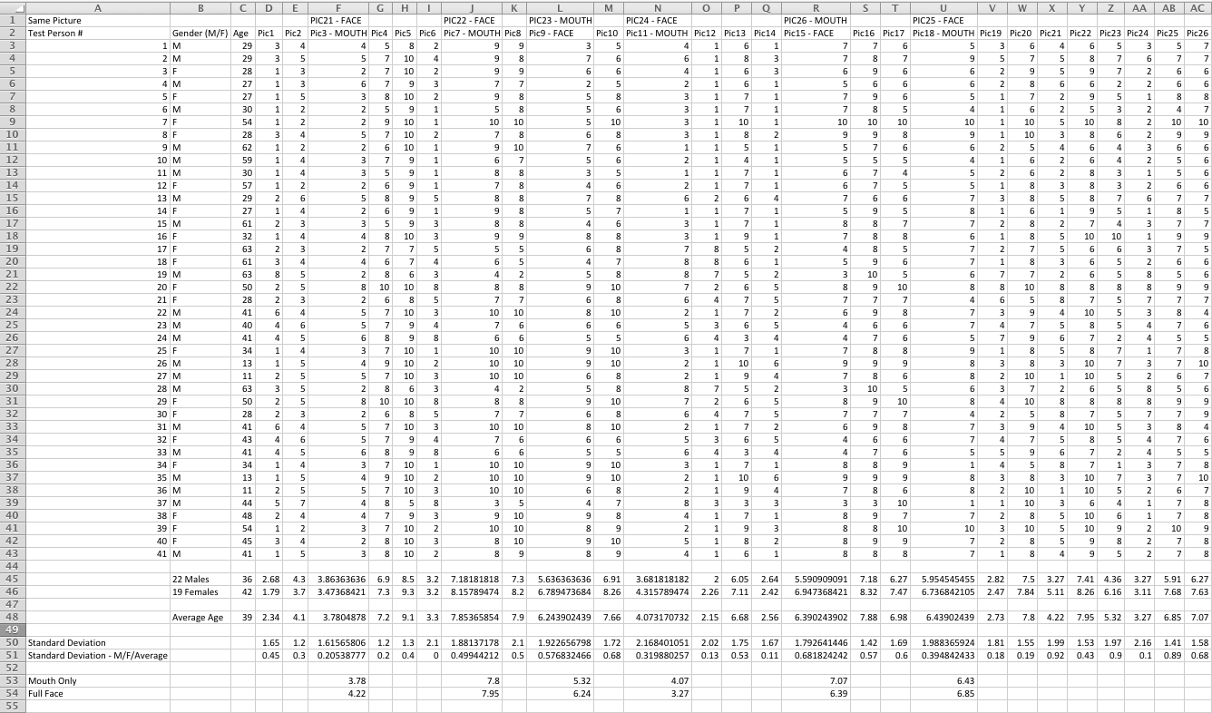
Test Results are also included on the DVD

Test Results – Test Phase One – Computer Results
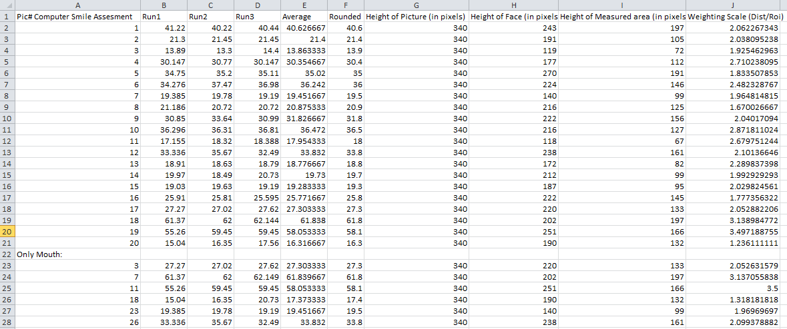
Test Results are also included on the DVD

Test Results – Test Phase Two – Test Subjects
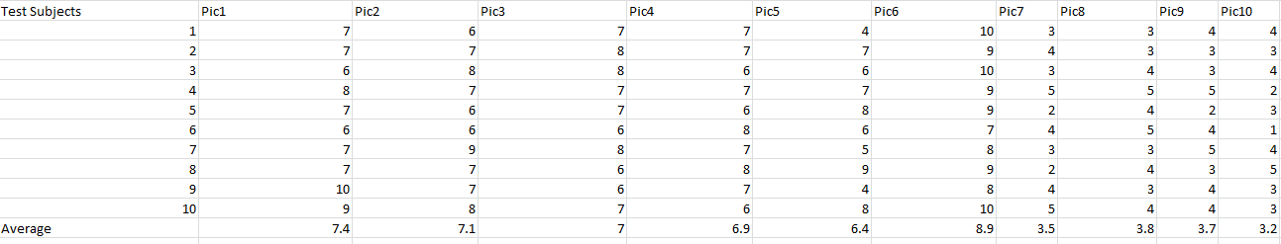
Test Results are also included on the DVD

Test Results – Test Phase Two – Computer Results
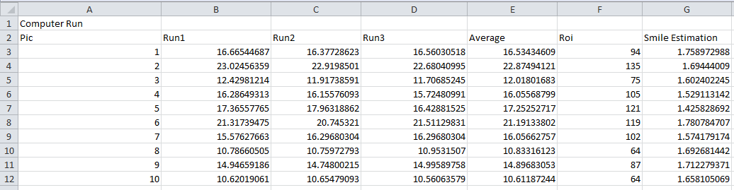
Test Results are also included on the DVD

Source Code – Smile Assessment Implementation
package com.tastenkunst.as3.brf.examples {
import com.tastenkunst.as3.brf.BRFStatus;
import com.tastenkunst.as3.brf.BRFUtils;
import com.tastenkunst.as3.brf.BeyondRealityFaceManager;
import com.tastenkunst.as3.brf.assets.BRFButtonGo;
import com.tastenkunst.as3.brf.container.BRFContainer;

import flash.display.Shape;
import flash.display.Bitmap;
import flash.display.Graphics;
import flash.display.Sprite;
import flash.display.StageAlign;
import flash.display.StageQuality;
import flash.display.StageScaleMode;
import flash.events.Event;
import flash.events.MouseEvent;
import flash.geom.Point;
import flash.geom.Rectangle;
import flash.text.TextField;
/**
* This is the basic webcam example class.
* Extends this class to use the functionality you need.
*
* @author Marcel Klammer, 2011
*/
public class BRFBasisImage extends Sprite {
private var _showPoints : Boolean = true;
private var _tfContainer : Sprite;
private var _pointsToShow : Vector.<Point>;
[Embed(source="user_image.jpg")]
public var USER_IMAGE : Class;
/** The library class, see the documentation of the interface. */
public var _brfManager : BeyondRealityFaceManager;
/** Set to true, when BRF is ready. */
public var _brfReady : Boolean = false;

public var _videoHolder : Sprite;
public var _drawingContainer : Sprite;
public var _draw : Graphics;
public var mund : Graphics;
public var mhx;
public var mhy;
public var mvx;
public var mvy;
public var nasx;
public var nasy;
public var boty;
public var topy;
public var x1;
public var y1;
//some helpers
public var _faceShapeVertices : Vector.<Number>;
public var _faceShapeTriangles : Vector.<int>;
public var _leftEyePoint : Point;
public var _rightEyePoint : Point;

// GUI
public var _container : BRFContainer;
public var _userImage : Bitmap;
public var _leftEyeMarker : BRFMarkerEye;
public var _rightEyeMarker : BRFMarkerEye;
public var _btGo : BRFButtonGo;

public function BRFBasisImage() {
if(stage == null) {
addEventListener(Event.ADDED_TO_STAGE, onAddedToStage);
} else {
stage.align = StageAlign.TOP_LEFT;
stage.scaleMode = StageScaleMode.NO_SCALE;
stage.quality = StageQuality.HIGH;
stage.frameRate = 36;
onAddedToStage();
}
}

public function onAddedToStage(event : Event = null) : void {
removeEventListener(Event.ADDED_TO_STAGE, onAddedToStage);
initVideoManager();
initGUI();
initContainer3D();
initBRF();
}

public function initVideoManager() : void {
_userImage = new USER_IMAGE();
}

public function initGUI() : void {
_videoHolder = new Sprite();
_drawingContainer = new Sprite();
_draw = _drawingContainer.graphics;

_videoHolder.addChild(_userImage);
addChild(_videoHolder);
addChild(_drawingContainer);

_leftEyeMarker = new BRFMarkerEye();
_leftEyeMarker.x = 525;
_leftEyeMarker.y = 25;
addChild(_leftEyeMarker);

_rightEyeMarker = new BRFMarkerEye();
_rightEyeMarker.x = 575;
_rightEyeMarker.y = 25;
addChild(_rightEyeMarker);

_btGo = new BRFButtonGo();
_btGo.x = 525;
_btGo.y = 400;
_btGo.addEventListener(MouseEvent.CLICK, onClickGo);
addChild(_btGo);
}

public function onClickGo(event : MouseEvent) : void {
if(_brfReady) {
_leftEyePoint.x = _leftEyeMarker.x;
_leftEyePoint.y = _leftEyeMarker.y;
_rightEyePoint.x = _rightEyeMarker.x;
_rightEyePoint.y = _rightEyeMarker.y;

_leftEyeMarker.x = 525;
_leftEyeMarker.y = 25;
_rightEyeMarker.x = 575;
_rightEyeMarker.y = 25;

_brfManager.updateByEyes(_leftEyePoint, _rightEyePoint, 5);

showResult();
}
}

/** override this function in order to use another IBRFContainer3D implementation. */
public function initContainer3D() : void {
_container = new BRFContainer(new Sprite());
}

/** Instantiates the Library and sets a listener to wait for the lib to be ready. */
public function initBRF() : void {
_brfManager = new BeyondRealityFaceManager(stage);
_brfManager.addEventListener(Event.INIT, onInitBRF);
_leftEyePoint = new Point();
_rightEyePoint = new Point();
}

/** Initialzes the lib. Must again be waiting for the lib to be ready. */
public function onInitBRF(event : Event = null) : void {
_brfManager.removeEventListener(Event.INIT, onInitBRF);
_brfManager.addEventListener(BeyondRealityFaceManager.READY, onReadyBRF);
_brfManager.init(_userImage.bitmapData, _container, 1);
}

/** The tracking is now available. */
public function onReadyBRF(event : Event = null) : void {
_faceShapeVertices = BRFUtils.getFaceShapeVertices(_brfManager.faceShape);
_faceShapeTriangles = BRFUtils.getFaceShapeTriangles();
_brfReady = true;
}

public function showResult() : void {
_draw.clear();

if(_brfManager.task == BRFStatus.FACE_DETECTION) {
drawLastDetectedFace(0x66ff00, 0.7, 0.5);
} else if(_brfManager.task == BRFStatus.FACE_ESTIMATION) {
BRFUtils.getFaceShapeVertices(_brfManager.faceShape);
drawShape(0x66ff00, 0.1, 0x000000, 0.7, 0.5);
}
}

/** Draws the resulting shape. */
public function drawShape(color : Number, alpha : Number = 1,
lineColor : Number = 0xff0000, lineThickness : Number = 0.5,
lineAlpha : Number = 0.5) : void {
_draw.lineStyle(lineThickness, lineColor, lineAlpha);
_draw.beginFill(color, alpha);
_draw.drawTriangles(_faceShapeVertices, _faceShapeTriangles); //laver overlay p堡nsigtet, fjern hvis umuligt at l泥 tallene
_draw.endFill();
//trace ("per");
createPointTextFields();

}

/** draw the last detected face. */
public function drawLastDetectedFace(lineColor : Number = 0xff0000,
lineThickness : Number = 0.5, lineAlpha : Number = 0.5) : void {
var rect : Rectangle = _brfManager.lastDetectedFace;

if(rect != null) {
_draw.lineStyle(lineThickness, lineColor, lineAlpha);
_draw.drawRect(rect.x, rect.y, rect.width, rect.height);

var roi : Rectangle = _brfManager.leftEyeDetectionROI;
_draw.drawRect(roi.x, roi.y, roi.width, roi.height);
roi = _brfManager.rightEyeDetectionROI;
_draw.drawRect(roi.x, roi.y, roi.width, roi.height);

_draw.lineStyle();

BRFUtils.estimateEyes(rect, _leftEyePoint, _rightEyePoint);

if(BRFUtils.areEyesValid(_leftEyePoint, _rightEyePoint)) {
_draw.beginFill(0x12c326, 0.5);
} else {
_draw.beginFill(0xc32612, 0.5);
}

_draw.drawCircle(_leftEyePoint.x, _leftEyePoint.y, 5);
_draw.drawCircle(_rightEyePoint.x, _rightEyePoint.y, 5);
_draw.endFill();

}
}
public function createPointTextFields() : void {
//choose the point group you want to see
// _pointsToShow = _brfManager.faceShape.pointsRightBrow;
// _pointsToShow = _brfManager.faceShape.pointsRightEye;
// _pointsToShow = _brfManager.faceShape.pointsLeftBrow;
// _pointsToShow = _brfManager.faceShape.pointsLeftEye;
// _pointsToShow = _brfManager.faceShape.pointsLowerLip;
// _pointsToShow = _brfManager.faceShape.pointsUpperLip;
_pointsToShow = _brfManager.faceShape.shapePoints;

_tfContainer = new Sprite();
addChild(_tfContainer);

var tf : TextField;
var i : int = 0;
var l : int = _pointsToShow.length;

while(i < l) {
tf = new TextField();
tf.textColor = 0xFF0000;
tf.text = i.toString();
tf.width = tf.textWidth + 6;

_tfContainer.addChild(tf);

i++;
showPoints();
}
}
public function showPoints() : void {
var points : Vector.<Point> = _pointsToShow;
var point : Point;
var tf : TextField;
var i : int = 0;
var l : int = _tfContainer.numChildren;

_draw.beginFill(0xb3f000);
while(i < l)
{

point = points[i];
_draw.drawCircle(point.x, point.y, 4.1); //strrelse af points i ansigtet
tf = _tfContainer.getChildAt(i) as TextField;
tf.x = point.x; //placering af tal p堰oints
tf.y = point.y; //placering af tal p堰oints
i++;
}
var xArray:Array = new Array();
var yArray:Array = new Array();

if (i == 54) //Mund,hjre, x+y //38+44 er center af n泥, s夡n cirkus
{
//trace (points[67]);
mhx = point.x;
mhy = point.y;
//trace (mhx);
//trace (mhy);
//xArray[0] = mhx;
calculateface();
}

if (i == 59) //Mund,venstre, x+y
{
mvx = point.x;
mvy = point.y;
calculateface();
}
if (i == 42) //N泥, center, x+y 41=venstre punkt, 42 n泥 bund
{
nasx = point.x;
nasy = point.y;
calculateface();
}
if (i == 22)
{
topy = point.y;
calculateface();
}
if (i == 7)
{
boty = point.y;
calculateface();
}
_draw.endFill();

}
private function calculateface() : void
{
/*trace ("x+y for mund venstre");
trace (mvx);
trace (mvy);
trace ("x+y for n泥");
trace (nasx);
trace (nasy);
*/
if (mvx == undefined || mvy == undefined || mhx == undefined || mhy == undefined || nasx == undefined || nasy == undefined)
{
trace ("jeg gr hvad der passer mig")
}
else
{
// x1=mvx x2=mhx y1=mvy y2=mvy
x1 = (((mhx - mvx) / 2) + mvx);
y1 = (((mhy - mvy) / 2) + mvy);

}
drawlineface();
}
private function drawlineface() : void
{

if (x1 == undefined || y1 == undefined)
{
trace ("youre fucked");
}
else
{
var my_shape:Shape = new Shape();
addChild(my_shape);
//trace (x1, y1);
//trace ("hej hej");
//trace (topy, boty);
//trace (nasx, nasy);
my_shape.graphics.lineStyle(10, 0xFF0000, 1);
my_shape.graphics.moveTo(nasx,nasy);
my_shape.graphics.lineTo(x1,y1);
//trace ("jeg kan li at tegne");
//trace ("niveau af smil");
var nievau = (y1 - nasy );
var roi = (boty - topy);
trace (nievau);
trace ("roi");
trace (roi);
trace ("smile estimation")
var smileest = ((nievau / roi)*10);
trace (smileest);
}
}
}
}

Source Code – Face Detection [DISCARDED]
//[Embed(source="font/c64.ttf", embedAsCFF="false", fontFamily="Commodore 64")]
package {

import flash.display.Sprite;
import flash.events.Event;
import flash.events.MouseEvent;
import flash.text.TextField;
import flash.text.TextFieldType;
import flash.text.TextFieldAutoSize;
import flash.text.TextFormat;
import flash.text.AntiAliasType;
import flash.text.Font;
import flash.display.StageAlign;
import flash.display.StageScaleMode;
import flash.net.FileReference;
import flash.net.FileFilter;
import flash.geom.Rectangle;
import flash.display.Loader;
import flash.display.Bitmap;
import flash.display.Graphics;
import flash.display.BitmapData;
import flash.display.MovieClip;
import flash.text.TextFormat;
import flash.filters.DropShadowFilter;
import flash.utils.getTimer;
import com.greensock.TweenLite;
Font.registerFont(Font1)
import jp.maaash.ObjectDetection.ObjectDetector;
import jp.maaash.ObjectDetection.ObjectDetectorOptions;
import jp.maaash.ObjectDetection.ObjectDetectorEvent;

public class detection extends Sprite {

//- PRIVATE & PROTECTED VARIABLES -------------------------------------------------------------------------

private var statusTxt:TextField;
private var fileRef:FileReference;
private var fileFilter:FileFilter;
private var loader:Loader;
private var bitmap:Bitmap;
private var image:MovieClip;
private var darkBox:Sprite;
private var debug :Boolean = true;
private var detector :ObjectDetector;
private var options :ObjectDetectorOptions;
private var faceImage :Loader;
private var bmpTarget :Bitmap;
private var view :Sprite;
private var faceRectContainer :Sprite;
private var tf :TextField;
private var lastTimer:int = 0;

public static const MIN_WIDTH:Number = 50;
public static const MIN_HEIGHT:Number = 50;
public static const MAX_WIDTH:Number = 1000;
public static const MAX_HEIGHT:Number = 1000;
public static const FILE_TYPES:String = "*.jpg; *.jpeg; *.png";
public static const XML_MOUTH_URL:String = 'xml/haarcascade_mcs_mouth.xml';
trace ( "mouth classifier loaded");

public function detection() {

statusTxt = new TextField();
fileRef = new FileReference();
fileFilter = new FileFilter( "Image (" + FILE_TYPES + ")", FILE_TYPES );
loader = new Loader();
//detector = new detectioner();
darkBox = new Sprite();
view = new Sprite;
faceRectContainer = new Sprite;

view.addChild( faceRectContainer );
addChild(view);

tf = new TextField;
init();

}
private function initDetector():void{

detector = new ObjectDetector;
detector.options = getDetectorOptions();
detector.addEventListener(ObjectDetectorEvent.DETECTION_COMPLETE,function( e :ObjectDetectorEvent ):void{
logger("[ObjectDetectorEvent.COMPLETE]");
tf.appendText( "\ntime: "+(new Date)+" "+e.type );
detector.removeEventListener( ObjectDetectorEvent.DETECTION_COMPLETE, arguments.callee );
if( e.rects ){
var g :Graphics = faceRectContainer.graphics;
g.clear();
g.lineStyle(4, 0xFFFFFF, 0.7 ); // black 2pix
e.rects.forEach( function( r :Rectangle, idx :int, arr :Array ) :void {
g.drawRect( r.x, r.y, r.width, r.height );
trace (r.x, r.y, r.width, r.height);

});
}
});

detector.addEventListener( ObjectDetectorEvent.DETECTION_START, function(e :ObjectDetectorEvent) :void {
tf.appendText( "\ntime: "+(new Date)+" "+e.type );
//trace ("\ntime: "+(new Date)+" "+e.type );
});

}
private function init():void {

stage.align = StageAlign.TOP_LEFT;
stage.scaleMode = StageScaleMode.NO_SCALE;
stage.addEventListener( Event.RESIZE, onStageResize );
addpicture_mc.addEventListener( MouseEvent.CLICK, browse );
domath_mc.addEventListener ( MouseEvent.CLICK, domath);
fileRef.addEventListener( Event.SELECT, onFileSelected );
fileRef.addEventListener( Event.COMPLETE, onFileComplete );
loader.contentLoaderInfo.addEventListener( Event.COMPLETE, detectFaces );
statusTxt.type = TextFieldType.DYNAMIC;
statusTxt.selectable = false;
statusTxt.autoSize = TextFieldAutoSize.CENTER;
statusTxt.antiAliasType = AntiAliasType.NORMAL;

var format1:TextFormat = new TextFormat();

format1.font="Commodore 64";
format1.size = 14;
format1.color = "0xFFFFFF";

statusTxt.defaultTextFormat = format1;
statusTxt.embedFonts = true;
statusTxt.text = "SELECT PICTURE FOR AWESOMEJUICE";
statusTxt.filters = [ new DropShadowFilter( 5, 45, 0, 1, 5, 5, 1, 3 ) ];

darkBox.graphics.beginFill( 0, .5 );
darkBox.graphics.drawRect( 0, 0, stage.stageWidth, stage.stageHeight );
darkBox.visible = false;
addChild( statusTxt );
addChild( darkBox );
positionContents();
}

private static function inRange( width:Number, height:Number ):Boolean {

if ( width < MIN_WIDTH || width > MAX_HEIGHT ) {

return false;
}
else if ( height < MIN_HEIGHT || height > MAX_HEIGHT ) {

return false;
}
else {

return true;
}
}

private function positionContents():void {

addpicture_mc.x = stage.stageWidth - addpicture_mc.width - 6;
browseBtn.x = stage.stageWidth - browseBtn.width - 10;
domath_mc.x = stage.stageWidth - domath_mc.width -30;
domathbtn.x = stage.stageWidth - domathbtn.width - 10;
statusTxt.x = ( stage.stageWidth - statusTxt.width ) / 2;
statusTxt.y = stage.stageHeight - statusTxt.height - 10;
tf.x = ( stage.stageWidth - statusTxt.width );
tf.y = stage.stageHeight - statusTxt.height - 10;
darkBox.width = stage.stageWidth;
darkBox.height = stage.stageHeight;

if ( image ) {

image.x = ( stage.stageWidth - image.width ) / 2;
image.y = ( stage.stageHeight - image.height ) / 2;
faceRectContainer.x = ( stage.stageWidth - image.width ) / 2;
faceRectContainer.y = ( stage.stageHeight - image.height ) / 2;
}
}

private function onStageResize( e:Event ):void {

positionContents();
}

private function browse( e:MouseEvent ):void {

fileRef.browse( [ fileFilter ] );

}

private function onFileSelected( e:Event ):void {

addpicture_mc.enabled = false;
statusTxt.text = "loading";
fileRef.load();
}

private function onFileComplete( e:Event ):void {

loader.loadBytes( fileRef.data );
initDetector();
}

private function detectFaces( e:Event ):void {

bitmap = Bitmap( loader.content );

if ( !inRange( bitmap.width, bitmap.height ) ) {

if ( !image ) image = new MovieClip();
image.addChild( bitmap );
addChildAt( image, 0 );
image.alpha = 1;
//TweenLite.to( image, 1, { alpha:1 } );
addpicture_mc.enabled = true;
statusTxt.text = "image to large for face detection";
return;
}

if ( !image ) image = new MovieClip()
else return;
image.addChild( bitmap );
addChildAt( image, 0 );

positionContents();
image.alpha = 1;
//TweenLite.to( image, 1, { alpha:1 } );
statusTxt.text = "CLICKY BUTTON NAMED DO MATH";
positionContents();

}
private function domath ( e:Event) :void {

// FACE DETECT HERE
statusTxt.text = "DETECTING FACE";
logger("[startDetection]");

bmpTarget = new Bitmap( new BitmapData( image.width, image.height, false ) )
bmpTarget.bitmapData.draw( image );
detector.detect( bmpTarget.bitmapData );
trace (image.width);
trace (image.height);

}
private function getDetectorOptions() :ObjectDetectorOptions {
options = new ObjectDetectorOptions();
options.min_size = 50;
return options;
}

private function onFacesDetected( e:Event ):void {
if ( !image ) image = new MovieClip()
else return;
image.addChild( bitmap );
addChildAt( image, 0 );
positionContents();
image.alpha = 0;
TweenLite.to( image, 1, { alpha:1 } );
statusTxt.text = "faces detected";
positionContents(); // To center the image
}
private function logger(... args):void{
if(!debug){ return; }
trace( args, getTimer(), getTimer() - lastTimer);
lastTimer = getTimer();
}
}
}

Source Code - Test Website

import fl.controls.ProgressBar;
import flash.text.TextDisplayMode;
import flash.text.TextField;
import fl.motion.DynamicMatrix;
import fl.controls.TextInput;
import flash.events.MouseEvent;
overlay1_mc.visible = false;
point1_mc.visible = false;
overlay2_mc.visible = false;
point2_mc.visible = false;
overlay3_mc.visible = false;
point3_mc.visible = false;
overlay4_mc.visible = false;
point4_mc.visible = false;
overlay5_mc.visible = false;
point5_mc.visible = false;
overlay6_mc.visible = false;
point6_mc.visible = false;
overlay7_mc.visible = false;
point7_mc.visible = false;
overlay8_mc.visible = false;
point8_mc.visible = false;
overlay9_mc.visible = false;
point9_mc.visible = false;
overlay10_mc.visible = false;
point10_mc.visible = false;
overlay11_mc.visible = false;
point11_mc.visible = false;
a1_mc.alpha = 0;
a2_mc.alpha = 0;
a3_mc.alpha = 0;
a4_mc.alpha = 0;
a5_mc.alpha = 0;
a6_mc.alpha = 0;
a7_mc.alpha = 0;
a8_mc.alpha = 0;
a9_mc.alpha = 0;
a10_mc.alpha = 0;
a11_mc.alpha = 0;
trace ("I feel loaded");
//Begin Greeting screen
/*
Welcome to this short test
The test results will be used for my Master Thesis at Aalborg University Copenhagen
You will be asked to enter your Age and your Gender before the test will commence
Your task is to rate the level of smile the person in the pictures is portraying
The scale goes from 1-11, were 1 is no smile, 6 is a neutral smile and 11 is a big smile
When you click on the number you find fitting, the next picture will be shown
You will be greeted with a thank you screen when you have completed the test
Furthermore, the rating you give, is your personal one, there is no "right"
or "wrong" rating. Thank you very much for taking your time taking this short test.
Please Enter your Age:

Next screen

Please Enter your Gender with either M for male or F for female:

*/

overlay1_mc.alpha = 0;

overlay1_mc.addEventListener(MouseEvent.ROLL_OVER, over1on);
overlay1_mc.addEventListener(MouseEvent.ROLL_OUT, over1out)
function over1on (e:MouseEvent):void
{
overlay1_mc.alpha = 1;

//trace ("over mig");
}
function over1out (e:MouseEvent):void
{
overlay1_mc.alpha = 0;

//trace ("v櫠igen");
}
overlay2_mc.alpha = 0;

overlay2_mc.addEventListener(MouseEvent.ROLL_OVER, over2on);
overlay2_mc.addEventListener(MouseEvent.ROLL_OUT, over2out)
function over2on (e:MouseEvent):void
{
overlay2_mc.alpha = 1;

//trace ("over mig");
}
function over2out (e:MouseEvent):void
{
overlay2_mc.alpha = 0;

//trace ("v櫠igen");
}
overlay3_mc.alpha = 0;

overlay3_mc.addEventListener(MouseEvent.ROLL_OVER, over3on);
overlay3_mc.addEventListener(MouseEvent.ROLL_OUT, over3out)
function over3on (e:MouseEvent):void
{
overlay3_mc.alpha = 1;

//trace ("over mig");
}
function over3out (e:MouseEvent):void
{
overlay3_mc.alpha = 0;

//trace ("v櫠igen");
}
overlay4_mc.alpha = 0;

overlay4_mc.addEventListener(MouseEvent.ROLL_OVER, over4on);
overlay4_mc.addEventListener(MouseEvent.ROLL_OUT, over4out)
function over4on (e:MouseEvent):void
{
overlay4_mc.alpha = 1;

//trace ("over mig");
}
function over4out (e:MouseEvent):void
{
overlay4_mc.alpha = 0;

//trace ("v櫠igen");
}
overlay5_mc.alpha = 0;

overlay5_mc.addEventListener(MouseEvent.ROLL_OVER, over5on);
overlay5_mc.addEventListener(MouseEvent.ROLL_OUT, over5out)
function over5on (e:MouseEvent):void
{
overlay5_mc.alpha = 1;
//trace ("over mig");
}
function over5out (e:MouseEvent):void
{
overlay5_mc.alpha = 0;
//trace ("v櫠igen");
}
overlay6_mc.alpha = 0;

overlay6_mc.addEventListener(MouseEvent.ROLL_OVER, over6on);
overlay6_mc.addEventListener(MouseEvent.ROLL_OUT, over6out)
function over6on (e:MouseEvent):void
{
overlay6_mc.alpha = 1;
//trace ("over mig");
}
function over6out (e:MouseEvent):void
{
overlay6_mc.alpha = 0;
//trace ("v櫠igen");
}
overlay7_mc.alpha = 0;

overlay7_mc.addEventListener(MouseEvent.ROLL_OVER, over7on);
overlay7_mc.addEventListener(MouseEvent.ROLL_OUT, over7out)
function over7on (e:MouseEvent):void
{
overlay7_mc.alpha = 1;
//trace ("over mig");
}
function over7out (e:MouseEvent):void
{
overlay7_mc.alpha = 0;
//trace ("v櫠igen");
}
overlay8_mc.alpha = 0;

overlay8_mc.addEventListener(MouseEvent.ROLL_OVER, over8on);
overlay8_mc.addEventListener(MouseEvent.ROLL_OUT, over8out)
function over8on (e:MouseEvent):void
{
overlay8_mc.alpha = 1;
//trace ("over mig");
}
function over8out (e:MouseEvent):void
{
overlay8_mc.alpha = 0;
//trace ("v櫠igen");
}
overlay9_mc.alpha = 0;

overlay9_mc.addEventListener(MouseEvent.ROLL_OVER, over9on);
overlay9_mc.addEventListener(MouseEvent.ROLL_OUT, over9out)
function over9on (e:MouseEvent):void
{
overlay9_mc.alpha = 1;
//trace ("over mig");
}
function over9out (e:MouseEvent):void
{
overlay9_mc.alpha = 0;
//trace ("v櫠igen");
}
overlay10_mc.alpha = 0;

overlay10_mc.addEventListener(MouseEvent.ROLL_OVER, over10on);
overlay10_mc.addEventListener(MouseEvent.ROLL_OUT, over10out)
function over10on (e:MouseEvent):void
{
overlay10_mc.alpha = 1;
//trace ("over mig");
}
function over10out (e:MouseEvent):void
{
overlay10_mc.alpha = 0;
//trace ("v櫠igen");
}
overlay11_mc.alpha = 0;

overlay11_mc.addEventListener(MouseEvent.ROLL_OVER, over11on);
overlay11_mc.addEventListener(MouseEvent.ROLL_OUT, over11out)
function over11on (e:MouseEvent):void
{
overlay11_mc.alpha = 1;
//trace ("over mig");
}
function over11out (e:MouseEvent):void
{
overlay11_mc.alpha = 0;
//trace ("v櫠igen");
}

greeting_mc.x = (stage.stageWidth / 6);
greeting_mc.y = (stage.stageHeight / 6);
var tot:Number = 0;
age_mc.visible = false;
submit_btn.addEventListener(MouseEvent.CLICK, sendMessage);
function sendMessage(e:MouseEvent):void
{
var my_vars:URLVariables = new URLVariables();
my_vars.senderName = name_txt.text;
var SERVER_PATH:String = "";
var foldername:String = "myXML";
var filename:String = "test.xml";
var dataPass:URLVariables = new URLVariables();
var urlLoader:URLLoader = new URLLoader();
var previewRequest:URLRequest = new URLRequest(SERVER_PATH + "saving-xml.php");
previewRequest.method = URLRequestMethod.POST;
var xmlcontents:String = my_vars.senderName;
dataPass.filename = filename;
dataPass.xmlcontents = xmlcontents;
dataPass.foldername = foldername;
previewRequest.data = dataPass;
urlLoader.load(previewRequest);
var kext = tot++;
trace (kext);
my_total = kext;
callThumbs();
trace (my_vars.senderName);
name_txt.text = " ";
gender_mc.visible = false;
age_mc.visible = true;
if (kext == 1){
gender_mc.visible = false;
age_mc.visible = false;
submit_btn.visible = false;
name_txt.visible = false;
greeting_mc.alpha = 0;
overlay1_mc.visible = true;
point1_mc.visible = true;
overlay2_mc.visible = true;
point2_mc.visible = true;
overlay3_mc.visible = true;
point3_mc.visible = true;
overlay4_mc.visible = true;
point4_mc.visible = true;
overlay5_mc.visible = true;
point5_mc.visible = true;
overlay6_mc.visible = true;
point6_mc.visible = true;
overlay7_mc.visible = true;
point7_mc.visible = true;
overlay8_mc.visible = true;
point8_mc.visible = true;
overlay9_mc.visible = true;
point9_mc.visible = true;
overlay10_mc.visible = true;
point10_mc.visible = true;
overlay11_mc.visible = true;
point11_mc.visible = true;
a1_mc.alpha = 1
a2_mc.alpha = 1;
a3_mc.alpha = 1;
a4_mc.alpha = 1;
a5_mc.alpha = 1;
a6_mc.alpha = 1;
a7_mc.alpha = 1;
a8_mc.alpha = 1;
a9_mc.alpha = 1;
a10_mc.alpha = 1;
a11_mc.alpha = 1;

//greeting_mc.greettext_mc.visible=false;
}
}
//Begin Test Code

var columns:Number;
var my_x:Number;
var my_y:Number;
var my_thumb_width:Number;
var my_thumb_height:Number;
var my_images:XMLList;
var my_total:Number;
var container_mc:MovieClip;
var preloaders_mc:MovieClip;
var x_counter:Number = 0;
var y_counter:Number = 0;
var full_mc:MovieClip;
var SERVER_PATH:String = "";
var foldername:String = "myXML";
var filename:String = "test.xml";
var dataPass:URLVariables = new URLVariables();
var urlLoader:URLLoader = new URLLoader();
var previewRequest:URLRequest = new URLRequest(SERVER_PATH + "saving-xml.php");

previewRequest.method = URLRequestMethod.POST;
dataPass.filename = filename;
var myXMLLoader:URLLoader = new URLLoader();
myXMLLoader.load(new URLRequest("gallery.xml"));
myXMLLoader.addEventListener(Event.COMPLETE, processXML);
function processXML(e:Event):void {
var myXML:XML = new XML(e.target.data);
columns = myXML.@COLUMNS;
my_x = myXML.@XPOSITION;
my_y = myXML.@YPOSITION;
my_thumb_width = myXML.@WIDTH;
my_thumb_height = myXML.@HEIGHT;
my_images = myXML.IMAGE;

//my_images.length();

createContainer();
callThumbs();

overlay1_mc.addEventListener(MouseEvent.CLICK, nextImage);
overlay1_mc.buttonMode = true;
//test_mc.buttonMode = true;

function nextImage():void
{
var kext = tot++;
trace (kext);
my_total = kext;
//trace (my_total);
//removeThumb;
//removeThumb();
callThumbs();
var xmlcontents:String = " 1"
dataPass.xmlcontents = xmlcontents;
dataPass.foldername = foldername;
previewRequest.data = dataPass;
urlLoader.load(previewRequest);
}
overlay2_mc.addEventListener(MouseEvent.CLICK, nextImage2);
overlay2_mc.buttonMode = true;
function nextImage2():void
{

var kext = tot++;
trace (kext);
my_total = kext;
//trace (my_total);
//removeThumb;
//removeThumb();
callThumbs();
var xmlcontents:String = " 2"
dataPass.xmlcontents = xmlcontents;
dataPass.foldername = foldername;
previewRequest.data = dataPass;
urlLoader.load(previewRequest);
}
overlay3_mc.addEventListener(MouseEvent.CLICK, nextImage3);
overlay3_mc.buttonMode = true;
//test_mc.buttonMode = true;
//var tot = 0;
function nextImage3():void
{

var kext = tot++;
trace (kext);
my_total = kext;
//trace (my_total);
//removeThumb;
//removeThumb();
callThumbs();
var xmlcontents:String = " 3"
dataPass.xmlcontents = xmlcontents;
dataPass.foldername = foldername;
previewRequest.data = dataPass;
urlLoader.load(previewRequest);
}
overlay4_mc.addEventListener(MouseEvent.CLICK, nextImage4);
overlay4_mc.buttonMode = true;
//test_mc.buttonMode = true;
//var tot = 0;
function nextImage4():void
{

var kext = tot++;
trace (kext);
my_total = kext;
//trace (my_total);
//removeThumb;
//removeThumb();
callThumbs();
var xmlcontents:String = " 4"
dataPass.xmlcontents = xmlcontents;
dataPass.foldername = foldername;
previewRequest.data = dataPass;
urlLoader.load(previewRequest);
}
overlay5_mc.addEventListener(MouseEvent.CLICK, nextImage5);
overlay5_mc.buttonMode = true;

//test_mc.buttonMode = true;
//var tot = 0;
function nextImage5():void
{

var kext = tot++;
trace (kext);
my_total = kext;
//trace (my_total);
//removeThumb;
//removeThumb();
callThumbs();
var xmlcontents:String = " 5"
dataPass.xmlcontents = xmlcontents;
dataPass.foldername = foldername;
previewRequest.data = dataPass;
urlLoader.load(previewRequest);
}
overlay6_mc.addEventListener(MouseEvent.CLICK, nextImage6);
overlay6_mc.buttonMode = true;
//test_mc.buttonMode = true;
//var tot = 0;
function nextImage6():void
{

var kext = tot++;
trace (kext);
my_total = kext;
//trace (my_total);
//removeThumb;
//removeThumb();
callThumbs();
var xmlcontents:String = " 6"
dataPass.xmlcontents = xmlcontents;
dataPass.foldername = foldername;
previewRequest.data = dataPass;
urlLoader.load(previewRequest);
}
overlay7_mc.addEventListener(MouseEvent.CLICK, nextImage7);
overlay7_mc.buttonMode = true;
//test_mc.buttonMode = true;
//var tot = 0;
function nextImage7():void
{

var kext = tot++;
trace (kext);
my_total = kext;
//trace (my_total);
//removeThumb;
//removeThumb();
callThumbs();
var xmlcontents:String = " 7"
dataPass.xmlcontents = xmlcontents;
dataPass.foldername = foldername;
previewRequest.data = dataPass;
urlLoader.load(previewRequest);
}
overlay8_mc.addEventListener(MouseEvent.CLICK, nextImage8);
overlay8_mc.buttonMode = true;
//test_mc.buttonMode = true;
//var tot = 0;
function nextImage8():void
{

var kext = tot++;
trace (kext);
my_total = kext;
//trace (my_total);
//removeThumb;
//removeThumb();
callThumbs();
var xmlcontents:String = " 8"
dataPass.xmlcontents = xmlcontents;
dataPass.foldername = foldername;
previewRequest.data = dataPass;
urlLoader.load(previewRequest);
}
overlay9_mc.addEventListener(MouseEvent.CLICK, nextImage9);
overlay9_mc.buttonMode = true;
//test_mc.buttonMode = true;
//var tot = 0;
function nextImage9():void
{

var kext = tot++;
trace (kext);
my_total = kext;
//trace (my_total);
//removeThumb;
//removeThumb();
callThumbs();
var xmlcontents:String = " 9"
dataPass.xmlcontents = xmlcontents;
dataPass.foldername = foldername;
previewRequest.data = dataPass;
urlLoader.load(previewRequest);
}
overlay10_mc.addEventListener(MouseEvent.CLICK, nextImage10);
overlay10_mc.buttonMode = true;
//test_mc.buttonMode = true;
//var tot = 0;
function nextImage10():void
{

var kext = tot++;
trace (kext);
my_total = kext;
//trace (my_total);
//removeThumb;
//removeThumb();
callThumbs();
var xmlcontents:String = " 10"
dataPass.xmlcontents = xmlcontents;
dataPass.foldername = foldername;
previewRequest.data = dataPass;
urlLoader.load(previewRequest);
}
overlay11_mc.addEventListener(MouseEvent.CLICK, nextImage11);
overlay11_mc.buttonMode = true;
//test_mc.buttonMode = true;
//var tot = 0;
function nextImage11():void
{

var kext = tot++;
trace (kext);
my_total = kext;
//trace (my_total);
//removeThumb;
//removeThumb();
callThumbs();
var xmlcontents:String = " 11"
dataPass.xmlcontents = xmlcontents;
dataPass.foldername = foldername;
previewRequest.data = dataPass;
urlLoader.load(previewRequest);
}

}

function createContainer():void{
container_mc = new MovieClip();
container_mc.x = (stage.stageWidth / 6);
container_mc.y = (stage.stageHeight / 6);
addChild(container_mc);

preloaders_mc = new MovieClip();
preloaders_mc.x = container_mc.x;
preloaders_mc.y = container_mc.y;
addChild(preloaders_mc);

function callFull(e:MouseEvent):void{
var full_loader:Loader = new Loader();
var full_url = my_images[e.target.name].@FULL;

full_loader.load(new URLRequest(full_url));
full_loader.contentLoaderInfo.addEventListener(Event.INIT, fullLoaded);
var full_pb:ProgressBar = new ProgressBar();
full_pb.source = full_loader.contentLoaderInfo;
full_pb.x = (stage.stageWidth - full_pb.width)/2;
full_pb.y = (stage.stageHeight - full_pb.height)/2;

preloaders_mc.addChild(full_pb);

full_pb.addEventListener(Event.COMPLETE, donePb);
function donePb (e:Event):void{
var my_pb:ProgressBar = ProgressBar(e.target);
preloaders_mc.removeChild(my_pb);
//my_pb.alpha = 0.5;
//my_pb.setStyle("barPadding", 3);

}
container_mc.removeEventListener(MouseEvent.CLICK, callFull);
container_mc.buttonMode = false;

}
function fullLoaded(e:Event):void{
full_mc = new MovieClip();
full_mc.buttonMode = true;
addChild (full_mc);
var my_loader:Loader = Loader(e.target.loader);
addChild(my_loader);
my_loader.x = (stage.stageWidth - my_loader.width)/2;
my_loader.y = (stage.stageHeight - my_loader.height)/2;
my_loader.addEventListener(MouseEvent.CLICK,removeFull);

function removeFull(e:MouseEvent):void{
var my_loader:Loader = Loader (e.currentTarget);
my_loader.unload();
removeChild(my_loader);
//textinput_mc.visible=false;
container_mc.addEventListener(MouseEvent.CLICK, callFull);
container_mc.buttonMode = true;

}
}
}
function callThumbs():void{
for (var i:Number = 0; i < my_total; i++)
{
var thumb_url = my_images[my_total].@THUMB;;
if (my_total == 27)
{
var thumb_url = my_images[27].@THUMB;; //end greeting screen
point1_mc.visible = false;
point2_mc.visible = false;
point3_mc.visible = false;
point4_mc.visible = false;
point5_mc.visible = false;
point6_mc.visible = false;
point7_mc.visible = false;
point8_mc.visible = false;
point9_mc.visible = false;
point10_mc.visible = false;
point11_mc.visible = false;
}
var thumb_loader = new Loader();
thumb_loader.load(new URLRequest(thumb_url));
thumb_loader.contentLoaderInfo.addEventListener(Event.COMPLETE, thumbLoaded);
thumb_loader.name = my_total;
thumb_loader.x = x_counter;
thumb_loader.y = y_counter;
var preloader_pb:ProgressBar = new ProgressBar();
preloader_pb.source = thumb_loader.contentLoaderInfo;
preloader_pb.x = thumb_loader.x;
preloader_pb.y = thumb_loader.y;
preloader_pb.width = my_thumb_width;
preloader_pb.height = my_thumb_height;
preloaders_mc.addChild(preloader_pb);
preloader_pb.addEventListener(Event.COMPLETE, donePb);
function donePb (e:Event):void{
var my_pb:ProgressBar = ProgressBar(e.target);
preloaders_mc.removeChild(my_pb);

}
}
}
function thumbLoaded(e:Event):void{
var my_thumb:Loader = Loader(e.target.loader);
container_mc.addChild(my_thumb);
point1_mc.addEventListener(MouseEvent.CLICK, remove);
function remove():void
{
//if(contains(my_thumb) container_mc.removeChild(my_thumb));
if(contains(my_thumb))
{
container_mc.removeChild(my_thumb);
}
//container_mc.removeChild(my_thumb);
}

}

The Japanese culture is very different from the western, especially regarding the display of gestures and emotion. In western culture meeting new people the extension of the hand is the formal way of being polite in a greeting, in the Japanese culture you bow, and the outstretched hand i.e. physical contact is not well seen. Therefore due to the differences, comparisons between these two cultures are often used in research.
At the time there were only five primitives as the last two were still being debated.
For the software to be able to learn from the ratings given by test subjects, ratings that differ greatly from picture to picture would provide a better basis for the computer to learn as opposed to ratings that are similar and less differentiable.
Pantic et al. Chapter 4.3.1
Two test participants contacted the author of this thesis during their testing due to misunderstandings in the rating system, the test results corroborated this. Only two test subjects did not complete the test as per the results, though they retook the test after verbal instruction resulting in useable results.
As the test subjects will be contacted via email providing an URL to the test website.
Close relatives and friends were aware of the agenda of this thesis and therefore excluded from participating in the test.
The implemented, non-used face detection source code is attached in Appendix 16.6
Open-Source for non-Commercial use
A preloader is a visual indication displaying that a part of the website is being loaded to the user, for the test website it indicates the loading of the next picture.
Available online till medio July 2012. Complete test website is also located on the DVD on the back of this report.
In flash, the coordinate system has its origin in the top left corner
Picture 7 - Half: 7.85 Picture 22 - Full: 7.95. Picture 18 - Half - 6.43, Picture 25 - Full - 6.85. Picture 23 - Half - 5.32, Picture 9 - Full - 6.24.

