Abstract
In the wake of the shootings in the offices of Charlie Hebdo on January 7th 2015, there has been a large and vivid debate about freedom of speech, self-censorship, and democratic principles. In relation to this debate, there have been many commentaries about Charlie Hebdo as a publication, where several people have pointed towards the publication as being overtly racist. The now murdered cartoonists have always maintained that they held a secular, anti-racist, and anti-authoritarian agenda, so in this thesis I set out to examine what it is that makes some people call the publication racist.
I investigate this matter through the use of a critical discourse analysis, with semiotic influences in my analyses of specific controversial Charlie Hebdo cartoons. I also incorporate various theories on satire and humor in order to gain a better perspective on the political motifs of political cartoons.
I look at three different types of texts; a speech, a blog, and a newspaper editorial, who have the same theme in common, that they are highly critical towards Charlie Hebdo and see it as a racist institution.
My findings include common themes and rhetorical tools used to portray Charlie Hebdo in a negative light, and a discussion about the implications of a widespread discourse which states that Charlie Hebdo are engaging in racist propagation.
Contents
Introduction 4
Problem Formulation 6
Theory 7
Satire 7
The Semantic Script Theory of Humor 7
Incongruity as a source of Humor 9
The Economy of Hyper-irony and Manic-satire 10
Post-Structuralism 11
The Death of the Author 12
The End of the Age of Irony 14
Satire and Ideology 16
Methodology 18
Data 18
Philosophy of Science 21
Ontology 22
Epistemology 23
Discourse Analysis 24
Critical Discourse Analysis 24
Discourse and Power 26
Van Dijk’s Ideological Square 26
Semiotic Analysis 28
Ferdinand de Saussure 28
Roland Barthes 29
Analysis 31
Garry Trudeau: The Abuse of Satire 32
Discursive Practice 32
The Textual Analysis 36
Jacob Canfield: In the Wake of Charlie Hebdo 46
JeSuisCharlie 46
Discursive Practice 47
The Textual Analysis 49
The NY Times Editorial 53
The Charlie Hebdo Cartoons 55
Boko Haram Sex Slaves 55
The Quran is Shit 57
A Star is Born! 59
Muhammad Overwhelmed by the Fundamentalists 60
Fairclough’s Third Dimension 61
Conclusion 64
Bibliography 65
Internet Resources 65
Authors: 65
Appendices 70
Appendix A 70
Appendix B 73
Appendix C 81

Introduction
In the wake of the attack on the offices of the French satirical newspaper Charlie Hebdo (CH) on January 7th 2015, millions of people joined together to express their opposition to the terrorist act and sympathy for the victims of the attack under the collective banner “Je Suis Charlie” – I am Charlie. The shooting which led to the tragic death of 12 people had left France and the rest of the western world in shock.
On social media platforms, the hashtag #JeSuisCharlie began to trend, and several media outlets across the political spectrum showed their transnational sympathy by republishing the offending CH caricatures and in creating original drawings on the subject. From the responses to the attack, it was obvious that people saw the shooting as a manifest attack on freedom of speech, and resultantly, #JeSuisCharlie was being used not only as an expression of sympathy for the victims, but also as a joint slogan for defiance and freedom of speech.
Indeed, Charlie Hebdo, the self-described secular, atheist, far-left-wing, and anti-racist publication (Love, 2012) had in the aftermath of the tragedy become the spotlight of a large and vivid debate about liberal principles, democratic values, self-censorship, and above all, free speech. But not everyone showed their sympathy through the banner of “Je Suis Charlie”. Many pundits, journalists, and bloggers were obviously sympathetic for the victims of the attack, but refused to show their sympathy for CH as a publication because they saw it as overtly racist and xenophobic. For example under the hashtag #JeNeSuisPasCharlie, they showed their disagreement with the unconditional support of CH.
Despite CH’s self-proclaimed anti-racist agenda, there were many persons who saw the caricatures as being offensive and racist in nature. Even the highly respected NY Times refused to republish the purportedly offensive cartoons on the basis that “… there is a line between gratuitous insult and satire. Most of these are gratuitous insult” (Appendix C, p. 82).
What is it about the CH cartoons that people find racist and offensive, and is it all a big misunderstanding, or is there actually merit to the accusations? Is the satirical message too difficult to decode? Is it possible that CH, whose cartoons are based on a long-held French tradition of particularly crude satire, was being lost in translation, especially by American commentators?
My thesis project will surround the controversy of CH as a publication, and whether it is fair to portray the publication as being racist. I will be analyzing oft-cited and controversial CH cartoons with a focus on visual semiotics and theoretical perspectives on satire as a form of political communication. In doing so, I aim to gain a better understanding of CH’s political motivations and satirical form of expression, which in turn will allow me to assess the justification made by several prominent newspaper editors not to republish the offending cartoons. Similarly, I will contrast my analysis on CH with two texts: One widespread blog article written by Jacob Canfield and one speech made by American cartoonist, Gary Trudeau. Ultimately, I wish to examine the ramifications of a widespread political discourse which states that the caricatures of CH are excessively islamophobic and insensitive towards religious sensitivities.
My research will be based on the conviction that media in all its forms have the power and potential to affect an audience’s perception about any topic. In a globalized world where news travels almost instantly throughout the world, as seen with the CH shooting, the reach of the media is enormous and easily accessible for large parts of the world’s population. Events like the CH shooting are being reported on in countries all around the world, and especially in the Western part of the world, we discuss the impact of terrorist attacks as fundamental attacks on our freedom. We turn towards media when we wish to, not only be informed, but also when we wish to reflect and debate on major topics, such as the CH shooting. As Douglas Kellner puts it: “Media culture is now the dominant form of culture which socializes us and provides materials for identity in terms of both social reproduction and change” (Kellner, 1995, p. 357).
Since the NY Times, among most other large American publications, found particular CH cartoons unprintable due to their supposed insensitivity towards Muslims, it is crucial to apply critical thinking to the situation, and explore the consequences of not printing and supporting CH’s most provocative and controversial cartoons. In other words, how can the discourse concerning CH as a publication directly affect people’s perceptions of, not just CH, but larger issues such as racism, self-censorship, and free speech? These issues are of utmost importance in today’s society, since more and more European nationalist parties are getting more and more popular, largely because of their tough stance on immigration policies. Meanwhile, more and more Muslims in Europe are feeling more and more alienated from the dominant culture in which they do not sense a belonging (Strickler, 2015). Discerning the discourses surrounding this debate can help us understand and prevent this radicalization.
American voices on the topic are taken seriously since the U.S. is generally more successful than Europe in its immigration. For example, the Danish politician, Birthe Rønn Hornbech, writes in a column:
“USA, who we can thank for our freedom from the Germans and Russians, has a whole other culture regarding the rules of expression… the Americans do not suffer from this uncontrollable urge to manifest their freedom of speech in cartoons which hurts a lot of people within the nation’s religious minority.” (Hornbech, 2015)
The larger debate surrounding CH concerns topics like self-censorship and state vs. religion. These topics are the product of increasing globalization and immigration; strongly held religious beliefs clashes with democratic principles of the Western world. This is an important debate to have in both the U.S. and in Europe, but at the same time it is imperative that the many cultural, social, and political differences between Europe and the U.S. do not create confusion and misunderstandings on topics like CH, which is a culturally unique institution in France.
I notice two major competing discourses on this topic: the discourse of satire used extensively by CH, and the discourse of solemnity and religious sensitivity often used by American commentators and newspapers.

Problem Formulation
This thesis will lay its foundation on the following three complementary research questions:
- How is Charlie Hebdo portrayed, especially with regard to issues of racism, in Gary Trudeau’s speech, Jacob Canfield’s blog article, and the NY Times’ editorial column?
- Which political motifs can be extracted from Charlie Hebdo’s satirical cartoons, and are these congruent with the aforementioned negative portrayals?
- What are the implications of the debate surrounding Charlie Hebdo as being a racist publication, considering the media’s power to impact public perception on sociopolitical issues?

Theory

Satire
A theoretical perspective on satire is fundamental for my thesis. First of all, it is a necessary tool for understanding the Charlie Hebdo cartoons in its appropriate historical, political and societal context. My approach to the thesis is that language and discourse in all forms are able to affect an audience’s opinion on important societal matters. Thus, CH as a publication holds the power to influence the public debate even though it can be seen as merely a silly weekly cartoon publication. In fact, as I will argue for in this section, good satire can be much more than just laughs and giggles – it can be an important counter-narrative to the established discourse of even the most serious topics.
Second of all, a theoretical perspective on satire will help me in my textual analysis of the CH cartoons. There is a whole study devoted to understanding what elements of the text constitute a joke. Through an understanding of the underpinnings of a joke, I will have an easier time decoding the CH cartoons to gain a more theoretically grounded analysis of their political motifs. Satire is a highly interdiscursive practice, and as such it is essential that I understand how to decode mockery from sincerity.

The Semantic Script Theory of Humor
To talk about satire in a theoretical perspective is a difficult task. There is something inherently wrong in analyzing what makes a joke funny or a picture amusing. When a person does not understand a joke you just made and you try to explain to the person why it is funny, the joke will often lose impact and become dull in the process. As such, a joke is only good so long as you understand it without the need for explanation. Nevertheless, in 1985 Victor Raskin set out to establish a linguistic overarching model for the language of humor in his book ‘Semantic Mechanisms of Humor” (Raskin, 1985) which has since become a mainstay in Raskin’s self-coined study of humorology.
Raskin’s study is significant in the sense that he outlines a blueprint for what makes a joke funny or unfunny – why some jokes causes laughs and why others fail. In his effort, he determines a set of parameters which needs to be fulfilled in order for a text to be funny. These conditions are not set in stone, and will differ from person to person. In Raskin’s terminology, whether a joke is considered funny or not depends on a person’s perceptual-cognitive manifestation. In basic terms, this means that a person must have a certain pre-requisite knowledge about the subject matter, as well as the mental ability to distinguish between irony and seriousness; reality and fantasy; rationality and irrationality etc.
However, the main focus in Raskin’s study of humorology is not centered on pure psychology but in a linguistic theory with psycho-linguistic elements which he refers to as the semantic script theory of humor (SSTH). SSTH states that for a text or picture to be a joke, it must satisfy two conditions: The text has to be compatible with two or more scripts, and that these two scripts are in one way or another opposing. The concept of scripts is borrowed from Schank and Abelson’s Script Theory which introduced scripts, themes, and plans to handle story-level understanding (Schank & Abelson, 1977). Schank and Abelson define a script as “a predetermined, stereotyped sequence of actions that defines a well-known situation” (Ibid. p. 41). Thus, a script is a knowledge structure that a subject uses to process and understand familiar concepts. When the subject is introduced to a setup, such as a restaurant, he or she is already well aware of “roles” such as cooks, waiters, guests and so on, and “props” such as a table, a menu and food. A subject’s pre-existing knowledge might lead the person to think of different conceptualizations such as the waiter being snobbish and the food as high-quality. Raskin calls this well-known setup a schema, which serves as a prescription for canonical behavior in a culturally defined situation, but never constitutes the narrative as a whole. Before a story is worth telling, the canonical scripts within the schema must at some point be breached, violated, or deviated from. In Raskin’s model relating to humor, the scripts must be contrasted with an opposing set of scripts which challenges the subject’s pre-existing conceptualizations so as to create a comedic effect.
There is a recurring joke in “Semantic Mechanisms of Humor” which does a good job of illustrating the concept of SSTH. It goes like this:
“Is the doctor at home?” the patient asked in his bronchial whisper.
“No,” the doctor’s young and pretty wife whispered in reply. “Come right in.”
(Raskim, 1985, p.100)
In this joke there are two opposing set of scripts, which in unity creates a comedic effect. The two scripts can be labeled as Doctor and Lover. Raskin attaches sub-domains to every lexical entry in the text, so as to exemplify how the two scripts oppose. For example, the third lexical item in the text ‘doctor’ connotes scripts such as ‘academic’, ‘medical’, and ‘professional’. The item ‘patient’ corroborates the ‘medical’ script, as does the modified item ‘bronchial whisper’. A new opposing script is introduced by the ‘wife’ item which is modified by the items ‘young’ and ‘pretty’. These items connote a Lover script. The fact that ‘wife’ is modified by ‘young’ and ‘pretty’ helps create a script where adultery is more likely. The combined items ‘bronchial whisper’ is compatible with both the Doctor script and the Lover script. When you first hear ‘bronchial whisper’ in conjunction with ‘doctor’ you assume that the patient is ill. However, once the Lover and adultery script is summoned, you create an image in your head of the ‘patient’ making sweet-talk to the doctor’s wife. It is only at the end of the joke that you fully realize that the ‘patient’ and ‘wife’ are committing adultery, and the comedic effect is created because the items in the text are compatible with both the Doctor and Lover script up until the punch line. In the end you laugh because you misinterpreted the situation completely, because your pre-existing scripts proved to be erroneous for the given situation. Of course, since this is a joke, the whole point of the text is to mislead the listener into one set of scripts, and when the punch line hits, shock them by revealing an opposing set of scripts.

Incongruity as a source of Humor
In extension of Raskin’s concept of script opposition, or semantic script theory of humor, Salvatore Attardo (Simpson, 2003) speaks of three temporally ordered phases in a joke: The setup, incongruity, and the resolution. Whereas the concept of script opposition helps enlighten what is inherently “funny” in a joke, Attardo’s model helps to understand the chronology and buildup of a joke. The setup and resolution are largely self-explanatory: the setup presents the situation and the characters, and the resolution ends the story with a comedic twist. Attardo emphasizes what he calls incongruity as the most interesting part of the joke, at least from a theoretical basis. The setup will, as a general rule, invoke a false script in the subject’s head which is most often congruent with the pre-existing expectations of the subject. The setup functions to create expectations for where the text is going, but at one point these expectations will be challenged as a new set of scripts are presented. The infringement of expectations creates incongruity, and thus the subject will begin to question what is real and what is not. Incongruity encompasses the uncertainty of which script is the appropriate. According to Attardo, a joke is most successful if two scripts are both functioning at the same time during the temporal phase of incongruity. This way, the surprise effect at the resolution will be bigger and more unexpected. It is essential that the joke will first be understood at the resolution phase, so that the “correct” script is revealed as late as possible (Ibid. pp. 47-69).
Paul Simpson argues that satire is not a genre of discourse, but rather a discursive practice that does things to and with genres of discourse. Satire is a discursive practice in the sense that it requires a genus, “which is a derivation in a particular culture, in a system of institutions and in the frameworks of belief and knowledge which envelop and embrace these institutions” (Ibid. p. 8). Satire, at its core, emanates from a perceived disapprobation of parts or the whole of some genus. As a discursive practice, Simpsons lists three discursive subject positions:
- The satirist (the producer of the text)
- The satiree (the addressee, whether a viewer, listener, or reader)
- The satirized (the target critiqued in the satirical discourse)
The satirist will often rely on interdiscursivity. Interdiscursivity in this sense is different than the most often understood meaning of the word in a Faircloughian sense. Fairclough speaks of Interdiscursivity denoting relations between types of discourses such as genres where they can be linked to each other through topics on other discourses (Jørgensen & Phillips, 2002, pp.82-83). Satire is highly interdiscursive even in the Faircloughian sense, but more so than other “serious” discourses, satire takes the concept of interdiscursivity to a whole new level. Satirical works will often echo, subsume, or distort other genres, registers, and styles of discourse in order to mock the satirized. Especially in recent years, this extreme mixing of discourses has been highly prevalent in satire – a phenomenon that Muradi and Hughey calls the economy of hyper-irony and manic-satire.

The Economy of Hyper-irony and Manic-satire
The theories on satire and humorology are easy to apply to a simple joke such as the doctor joke example. However, especially in recent times, humor and satire has become increasingly complex, progressively more absurd, and often multi-layered. Satirists will mock their subjects by creating a caricature of them; they will exaggerate noticeable characteristics; they will adopt their ideology and discourse; they will even portray and describe the world in the same vein as them – all in such a hyperbolic fashion that their faults and misjudgments (ideally) becomes apparent. Muradi and Hughey call the dispersion of this form of satire a product of the post-9/11 political climate, a form of satire they call the ‘economy of hyper-irony and manic-satire’ (Hughey & Muradi, 2009 pp. 206-237).
Muradi and Hughey argue that satire holds an important position in the political climate as a destabilizing factor to the mass media narrative of important topics. Satire has the power to contest popular perceptions in the media of for example wars and political debates. Particularly in the wake of 9/11, televisual representations of people of Arab, Middle-Eastern, and South Asian descent was loaded with negative and racist tones, they argue. But rather than looking at how racism is popularly portrayed in mass media, they examine how racism is countered and destabilized in modern satire, such as animated cartoons like South Park and Family Guy (Ibid. pp. 206-210).
This approach to satire is relevant to my thesis based on the fact that Charlie Hebdo also utilizes an economy of hyper-irony and manic-satire in their cartoons, as I will argue for later in my project (see page 9). Moreover, Charlie Hebdo has an editorial aim of anti-racism and anti-authoritarianism, which makes the publication a counter viewpoint to mass media.
Muradi and Hughey’s main argument is that satirical works such as South Park and Family Guy functions both to reproduce and combat racist ideologies. Satirical works incorporating the economy of hyper-irony and manic-satire promote dominant and conservative viewpoints while simultaneously ridiculing them. For this reason the satire tend to get away with dialectic themes of dominance vs. subordination, xenophobic patriotism vs. challenging state power, and criticism of racial stereotypes vs. reification of racial stereotypes. Muradi and Hughey point towards the movie Team America as an example of how a satirical work can both criticize and reproduce a negative stereotype of Middle-Eastern culture. In the movie, every single Middle-Eastern person is represented as living in clay-huts, being fanatically religious, speaking gibberish, and generally acting barbaric. This does not mean that the producers of the movie wish to portray the Middle-East in such a degrading and negative light, but rather that this representation is mocking the post-9/11 mass media discourse. However, according to Muradi and Hughey, the movie never attempts to present a reasonable portrayal of Middle-Eastern countries. Thus, it is difficult for the viewer to actually learn anything new from the movie, and resultantly gains nothing except a “world-weary, cleverer-than-thou” (Ibid. p. 226) sense of humanity.
“In the current moment of hyper-irony and manic-satire dominance, acts of irreverent parody are goals in and of itself. It matters little as to the target of caricature – whether it is censorship, religion, the media, or the mainstream populace – in so long as the process of spoof, ridicule, and lampoon is engaged” (Ibid. p.226)
Conclusively, Muradi and Hughey’s study, which focuses on South Park and Family Guy, states that the shows are simultaneously anti-racist as well as racist. The shows criticize racial stereotypes, but at the same time reinforce them. According to the authors, it is important to ask oneself whether the economy of hyper-irony and manic-satire serves as either antidote or opiate for a cynical culture. Do the satirical portrayals of Middle-Eastern culture ridicule for the sake of ridiculing, or is there a greater critique to be found other than the critique of mass media narrative? According to the authors, the satire must do more than just mock the traditional narrative in order to combat racism; it must also present an alternative, more sophisticated narrative, so as to not stigmatize the subject of satire (Ibid. pp. 203-237).

Post-Structuralism
In the studies of discourse, particularly in relation with politics and society, it can make sense to incorporate the post-structuralist linguistic philosophy, which states that our access to reality is always based on language. Accordingly, the concept of society is not necessarily seen as the individual’s construct of something vague and indescribable, but rather as a network of structures which influences the individual. In post-structuralist philosophy, concepts of society and reality do not exist only in the mind of the individual, but is constantly under construction by the population of a culture through the use of language and discourse. Adopting this notion allows the researcher to investigate reality and society through a discourse analysis (Jørgensen & Phillips, 2002, pp. 1-24).

The Death of the Author
The Death of the Author is a linguistic theory written by Roland Barthes. It questions who the real author of a text is, whether it is a book, photography, a painting, or anything that can be read by another person. It seems obvious to think of an author as a person who is responsible for a particular piece of work. A writer, for example, would probably claim that he or she wrote a book, and is therefore the author. A photographer would similarly claim to be the author of a picture because he or she stood there and pressed the button to take the picture. This relates to literally anything that has been created by a conscious mind and therefore can be judged or interpreted by another person.
Barthes theorizes that the whole notion of authorship needs to be rethought. He argues that when a text is created, it is a multi-faceted manifestation of different cultures, ideas, languages, beliefs, theologies, philosophies, etc. When an author puts their pen on paper and writes a book, they believe their ideas are their own, and when the book is finished they claim that they are the authors of the creation. However, according to Barthes, the self-proclaimed author has borrowed every single word, every single idea, and every concept from previously existing texts. It only looks like something new and original because the pre-existing words, notes, colors, etc. have been interwoven into something apparently new and unseen.
In accordance with The Death of the Author, the author’s intended meaning is secondary to the interpretation of the reader. The idea of an author with an apparent identity and discernible intent is a fictional construct. A literary text does not have a single purpose, a single meaning, or one single existence. Instead, every reader interprets every chapter, every sentence, every word from a unique perspective, giving the text a unique meaning. Meaning is interpreted and constructed by an individual from textual items. The focus on the reader’s interpretation of a text rather than the intended meaning by the author clashes with my intention of
Whereas structuralism often focuses on linguistic rules and codes, post-structuralism emphasizes the role of power-relations in discourse. Looking through a post-structural perspective, language has the ability to influence and counter established power-structures, for example through the use of deconstruction. The method of deconstruction, famously coined by Jacques Derrida, aims to disclose underlying structures and dualisms in a text in order to reveal the multiple levels of meaning contained within the language. This ambition is based on the principle that “from the moment that there is meaning there are nothing but signs. We think only in signs” (Derrida, 1997, p. 50). The dualism that Derrida writes about, relates to how any given concept must be understood in relation to its opposition. For example, if a text says something about how nice it is on the country-side, and how lovely it is to be able to hear the birds singing and the trees swaying in the wind, the text simultaneously implicitly says something about the city. Other classic examples of dualism are men vs. women, mind vs. body, and interior vs. exterior. The concept of dualism is important because when a text includes one, it usually means that one of the two terms governs the other, or in other words, one of the two terms are given a higher value than the other. Derrida’s approach aimed to reveal the multiple levels of interpretation and meaning in a text, which is never neutral but pervaded by relations of power (Delanty & Strydom, 2003, 323)
It is important to note that deconstruction is not to be seen as a method with a complete set of rules and a straightforward approach to analysis. Instead, in a deconstruction analysis, it is the researcher’s job to identify dualism in the text, and to expose the axiological emphasis within. However, it is not the researcher’s objective to surpass all oppositions, or attempt to suspend any axiological bias. There will always be a hierarchy of dual oppositions, and it is futile to resist. Derrida even argues that they are structurally necessary to produce sense. This points towards an interminable analysis, where the researcher’s main goal is to identify the dual oppositions and expose the hierarchy of a given text, if nothing else at least to make the discourse and rhetoric more transparent.
In post-structural research, one must be able to use a variety of different perspectives in order to create a multifaceted interpretation of a text, even if these interpretations conflict with each other. It is particularly important to demonstrate how the meaning of a text can be interpreted differently in relation to the identity of the reader, and the culture of which he or she derides from (Derrida, 1997, pp. 46-66).
In my analysis, I will both be analyzing Charlie Hebdo cartoons, as well as reactions to the cartoons. I will reach an understanding of the cartoons and their political motifs based on my knowledge on theoretical satire as well as looking at the historical context of the cartoons. I predict that my analysis of CH and the cartoons based on this approach will be different from Trudeau and Canfield’s interpretations. Since there are no official guidelines on how to understand each and every CH cartoon ever made, it is impossible to say for certain what the political message of the cartoons are, so in order to justify my analysis and understanding of the CH cartoons as well as the two texts, I adopt the post-structuralist approach to argue that there is a fundamental difference in interpretation between a post-9/11 American perspective and a historically rooted French satirical perspective. Moreover, in accordance with post-structuralist thought, the intended meaning of the CH cartoons are secondary to how the audience perceives them.

The End of the Age of Irony

“The end of irony would be a disaster for the world - bad things will always occur, and those at fault will always attempt to cover them up with emotional and overblown language. If their opponents have to emote back at them, you're basically looking at a battle of wills, and the winner will be the person who can beat their breast the hardest without getting embarrassed.” (Williams, Z., 2003)

The view of satire that Muradi and Hughey holds, and its role in contemporary modern society is reminiscent to the proclamations of solemnity that followed in the wake of the 9/11 terrorist attack, which shook the Western world so much that Vanity Fair editor Graydon Carter famously declared it the end of the age of irony. We would become more religious and charitable and stop watching stupid tv; sex and violence in media would be toned down and our way of expressing ourselves with irony and cynicism would be altered. In short, 9/11 marked the end of a frivolous and banal culture (Winokur, 2013, pp. 210-226). Carter was just one of many cultural commentators to call this a shift in paradigm, a sentiment shared with American tv-comedy producer and director George Schlatter, who argued that “This may be an event which historians look back to as the beginning of a new era of sensitivity, introspection, and growth” (Schlatter, G. in Winokur, 2013, p. 213). Historian Taylor Branch told the Los Angeles Times that the attacks were a “… turning point against a generation of cynicism for all of us” (Branch, T. in Winokur, 2013 p. 213).
These proclamations all happened in a time of heightened American national unity, but it did not take long until other cultural commentators would counter these bold statements. The satirical newspaper The Onion, who had suspended publication for two weeks after the attack, returned with an article under the headline: “Report: Gen X Irony, Cynicism May Be Permanently Obsolete”, in which they ironically (!) proclaim that “… the recent attack on America may have rendered cynicism and irony permanently obsolete” (www.theonion.com). Another cartoon published in the New Yorker featured a woman stating that: “It’s hard, but slowly I’m getting back to hating everyone” (Stewart, 2001). The NY Times featured an article where they exemplify how humor and irony slowly made a comeback in the 2 months after 9/11. In this article, Bob Mankoff, cartoon editor for the New Yorker, stated that “People said irony was dead. Actually, the situation now is incredibly rich with irony” (Ibid.).
It would seem that irony was alive and well after all, as Graydon Carter would even retract his previous statement with another rhetorically ironic statement that: “Only a fool would declare the end of irony. I said it was the end of ironing.” (Carter, G. in Winokur, 2013, p. 215). In 2006, at the five-year anniversary of 9/11, Brian Unger concluded in his NPR show that “Ironically, predictions of the end to the “age of irony” never materialized. Irony, it seems, is made of tougher stuff” (www.npr.org). Jon Winokur writes in his book “The Big Book of Irony” (2013), “but the post-ironic Age never dawned, the New Earnestness failed to take hold, and dissenting voices soon chimed in” (Ibid. p. 212). Pullitzer price-winning critic for the NY Times, Michiko Kakutani, disclaimed the death of irony in a lengthy review of the art scene on the ten-year anniversary of 9/11 by saying, “They were wrong of course. We know now that the new normal was very much like the old normal, at least in terms of the country’s arts and entertainmnent” (Kakutani, 2011).
It appears that there is a general consensus among many cultural commentators that while 9/11 did mark an initial sense of unity and solemnity, it was an overreaction to announce the death of the age of irony. However, one can argue that while 9/11 did not mark the death of the age of irony, the discourse surrounding irony and the producers of irony has changed consequently.
Zoe Williams writes in her 2003 essay, ‘The Final Irony’ (2003), that 9/11 for a short time turned the world into an easily understood place between the forces of good and evil. In a world where this worldview persists uncontested, the act of seeking truth through irony is pointless, because the truth is staring you in the face. Similarly, “the postmodern ironic distance that eschews concepts like “good” and “evil” has been trounced” (Ibid.). Of course, Williams points out, irony would soon flourish again since it quickly became clear that the dichotomy between good and evil was not so clear-cut after all, and that there were plentiful instances of cosmic irony left in the world. Williams states that if irony were to come to an end it would be a disaster for the world. Bad things will inevitably occur, and when they do so, leaders will try to cover them up using emotional and overblown language. If there is no irony to counter the emotionally laden rhetoric, the debate will eventually turn into a battle of who can beat their breast the hardest without getting embarrassed. In that case, irony is a perfect tool against the emotional language that often ensues in political debates. It allows the satirist to challenge someone without being dragged into the orbit of self-significance and self-regarding sentiments that stems from dichotomous representations of the world. “Irony can deflate a windbag in the way that very little else can” (Ibid.).
Williams’ view of irony and satire is fundamentally different to Muradi and Hughey’s. Williams states that irony’s primary purpose, in relation to politics and society, is to deflate the emotionally overblown language of influential leaders. Muradi and Hughey echo that sentiment with an important addendum – the satirist must not only mock the satirized; he or she must also present an alternate, more realistic and opportunistic worldview and discourse, so as to not stigmatize the topic. Thus, the two views on satire are fundamentally different on the topic of responsibility. Muradi and Hughey argue that satire is only responsible so long as it contrasts the wicked worldview with another more moral one. Williams argues that satire’s biggest responsibility is to deflate the self-righteous and emotionally overblown language with ridicule and lampooning.
This fundamentally different perspective on the responsibility of satire was exemplified nowhere better than on CNN’s Crossfire 10 years ago, when The Daily Show host, Jon Stewart visited the show. Stewart criticized the show heavily, and accused it of promoting partisan worldviews, rather than sophisticated and multi-layered analyses. Crossfire co-host, Tucker Carlson, rebutted his critique by giving examples of Stewart’s interview technique on The Daily Show. As it was obvious from the examples given, The Daily Show did not engage in the type of discourse and rhetoric that Stewart demanded from CNN Crossfire. Thus, Carlson asked, “You had John Kerry on your show and you sniff his throne and you're accusing us of partisan hackery?” (www.cnn.com) In reply, Stewart mentions that the show leading into his is puppets making crank phone calls, implying that the show should not be held responsible to the same standards of a debate show on CNN (Ibid.). I find this incident a quintessential example of the debate regarding responsible use of irony and satire; the satirist launches a critique emanating from a disapprobation of the discourse used by the satirized. In response, the satirized asks, “but how about yourself”? Thus, the satirist’s critique is considered meaningless so long as he or she does not uphold the same standards that they themselves appeal for.
In my analysis, I will examine the extent of CH’s satire, and whether they engage in a satirical, ironic discourse which serves to deflate emotionally overblown language, and perhaps more importantly, whether they make an effort to present an alternate vision of politics, discourse, and society. Do CH’s portrayal of Muslims and other minorities serve to stigmatize a generally negative image, or do they invoke a different, more progressive discourse from the traditional narrative? Finally, to which extent do the negative portrayals of CH criticize them for irresponsible use of irony and satire?

Satire and Ideology
The extreme form of cynicism and deadpan delivery that is evident in hyper-ironic manic-satire has been associated with miscues and errors among message recipients. That is, when the message receiver misinterprets the satirists remarks to be sincere, when in reality they are not. Because high levels of cognitive efforts are required to determine the satirist’s intention and true meaning, it makes understanding certain forms of satire a complicated process. Heather L. Lamarre, Kristen D. Landreville, and Michael A. Beam (Lamarre henceforth), have argued that political ideology can lead to a biased processing of ambiguous political messages in relation to satire (Lamarre et al. 2009 pp. 212-228). In fact, they even argue that “… individuals process information in ways that benefit them and that people tend to see what they want to see when the information is ambiguous” (Ibid. p.213).
Lamarre presents the example of Stephen Colbert, a hardcore conservative late-night news anchor, who is in fact just a character being played by himself. Everything he says while being filmed is in character and as such is not his own opinion, but a caricature of the most uncompromising, naïve, god-fearing, and patriotic conservative American. Lamarre analyzes participants’ reactions to an interview on CNN about global warming where Colbert, in his usual deadpan style, asks ridiculous questions such as “What can a person like me do to help that will in no way inconvenience me?“ and “What’s wrong with the ice melting… maybe now Greenland will actually turn green.” (Ibid. p. 218) The ladder argument is echoing a similar argument made by Rush Limbaugh, an actual conservative pundit.
These questions by Colbert can be considered ambiguous and open to multiple interpretations. Since Colbert presents the questions in a deadpan manner, without even a hint of a smile, it leaves open the question of who he is targeting and what he really means. “Is Colbert parodying the global warming opponent or is he using satire to ridicule the global warming activist? We argue that when faced with this type of ambiguity, viewers will see what they want to see in the situation” (Ibid. p. 218) Lamarre writes. The Colbert example serves to demonstrate how caricature can be processed with a bias towards one’s own political beliefs. Using Raskin’s understanding of Schank & Abelson’s script theory terminology, Colbert adopts a conservative script in order to mock their ideology. However, since people have different political ideologies and resultantly different pre-existing knowledge and perceptions of the words and sentences he uses, they interpret Colbert’s intentions differently.
To observe a distinction between the spoken word, the intended message, and the extracted meaning is closely related to epistemology (see page 23). As previously stated, I adopt a post-structuralist approach to my thesis, which means I will inevitably notice a difference between the author’s intended meaning and different people’s interpretation of the text. Lamarre creates their argument that “... viewers will see what they want to see in the situation” (Ibid. p. 218) based on a focus group of Midwestern U.S. university students where as many as 95 % of the participants in the study was familiar with Colbert and attested that they at least sometimes watch the show (p. 222). Thus, even though the participants of the study were familiar with Colbert and his show ‘The Colbert Report’, they still interpreted the intended meaning differently. Conservative-minded students were prone to interpret Colbert’s remarks as genuine, whereas students who considered themselves Democrats were more likely to interpret them as mockery. The fact that the participants in large part was already familiar with Colbert and still interpreted his remarks differently makes it seem like it is not lack of context that causes people to interpret satire differently, but something inherently ideological (Ibid. pp. 226-229).
The university students who participated in the Colbert study probably did not have any major epistemological considerations when they took the test. However, when I perform a similar study of the CH cartoons and divisive commentaries about CH as a publication, it is important that I do not think of them as having one indisputable meaning, but rather that the author’s intended meaning is secondary to the meaning that the reader perceives. As such, CH’s self-proclaimed anti-racist agenda is only valid so long as the reader can decode the intended meaning. Of course, since CH is based in France, and is established on a long and proud tradition of crude French satire, whereas Trudeau, Canfield, and the NY Times are based in the U.S., the concept of cultural relativism will become relevant and apparent.
CH never intended for their cartoons to cater to an American audience. Because of this, I will have to discuss the rightfulness of a post-structuralist approach to my problem statements, considering the differences in ideas and conceptions between France and the U.S. Therefore I adopt a relativist approach to epistemology, which I will elaborate on in the following section on methodology.

Methodology
Choosing an appropriate research design and method to answer my problem formulation is essential for the outcome of my research. For every different approach to a problem statement there is a different outcome, and as such the methodological approach must be chosen carefully in order to reach a desirable product (Silverman, 2006, p. 15). In this section I will begin by explaining my data gathering process, and clarify on how I rationalize my choice of empirical data. I will then elaborate on how I will approach this data philosophically and methodologically in order to purposefully answer my problem formulation.

Data
In this day and age the academic researcher has an overabundance of potential sources to collect data from. The internet allows the researcher to dig through most newspapers’ online library of articles and with relative ease find articles linked to the subject of interest. The easiest pathway to a newspapers’ online library is through the search engine Google, as shown in the following picture:
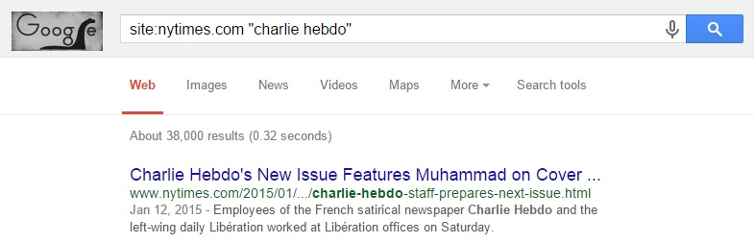
Using ‘site:nytimes.com’ filters the search to only show results from the NY Times website. Additionally, the researcher can add time intervals, so as to only include results from the relevant time period. For my thesis project I am particularly interested in the editorial choice of the NY Times to not republish offending Charlie Hebdo covers, so additionally adding ‘publish’ to my search quickly gives me the most relevant articles, blogs, or editorial columns on this topic related to Charlie Hebdo. Google is useful as a search engine, not only as a researcher, but also as a consumer. A US news consumer research behavior study by Olmstead, Mitchell, & Rosenstiel (2011) shows that in 2011 Google was the primary entry point for nationally recognized news site brands, including the NY Times. Google accounted for 26 % of incoming traffic to the NY Times website compared to Facebook which accounted for only 6 % of its traffic (Ibid.). This fact emphasizes the relevance of Google searches and its ability to easily guide the public towards information. It is important to notice that this study was done in 2011, and on the topic of search engines and social media on the internet a lot can happen over 4 years. However, this is the most comprehensible study on the topic in recent years.
Author Tim Rapley (2007) suggests generating a research archive, where the researcher can divide the data between ‘researcher-generated data’ and ‘already existing data’, or simply focus on one type of data over the other (Ibid. p. 9). It is given that when a researcher engages in researcher-generated data, he or she is taking a more active role in the generation of an archive. However, that is not to say that the researcher adopts a passive role in collecting already existing data. Quite the contrary, the researcher has an active role in discovering the data, physically collecting it, and deciding on whether to keep or ignore certain data. For my thesis I will focus on generating an archive of already existing data collected through the internet and the public domain. Accordingly, the data already lies accessible on the internet and the public domain, but my effort lies in the active role of collecting a requisite archive to answer my problem statement (Ibid. p. 10.). This choice reflects my interest in analyzing a discourse which is already prevalent in blogs and articles circulating the internet and news media, and as such I do not have to generate any data myself.
The NY Times is an internationally recognized newspaper that is generally perceived to be highly professional and respectable. Because of this, it is particularly interesting to examine why they chose not to republish the offending Charlie Hebdo covers. Performing a Google search (on April 23rd) on ‘Site: nytimes.com “Charlie Hebdo” publish’ presents me with 16,500 results, the first of which is especially interesting called ‘A Close Call on Publication of Charlie Hebdo Cartoons’, published on January 8th. In this column, the NY Times’ public editor, Margaret Sullivan writes in her personal column about the NY Times’ decision not to publish Charlie Hebdo covers featuring the prophet Muhammad on the day after the shooting. The column is listed under ‘The Opinion Pages’ and includes a conversation with the NY Times’ executive editor, Dean Bacquet, who ultimately holds the power and responsibility to publish the cartoons or not. I will be using this column in my analysis of the discourse surrounding Charlie Hebdo as a publication, since Bacquet ultimately chose not to publish the Muhammad cartoons on the basis that “that there is a line between gratuitous insult and satire. Most of these are gratuitous insult.” (Appendix 1, p. 82).
In relation to finding blog entries or articles concerning #JeSuisCharlie, one can look towards different parameters before deciding which texts are particularly interesting to analyze. Since we live in a time where social media is notably influential in spreading ideas and in causing phenomena to go viral, it makes sense to look at blog entries and articles that have been widespread on social media. In the days and months after the attack on Charlie Hebdo, thousands of blogs and articles have been posted on the internet on the topic, but a select few have been extremely popular, in large part due to the mass dissemination on social media. Jacob Canfield’s In the Wake of Charlie Hebdo is an example of a text that has gone viral and since then has also been cited in articles in large established newspapers such as the NY Times (Schuessler, 2015) and the Atlantic (Frum, 2015). It only makes sense to look at particular articles that have experienced an immense distribution and preponderance on social media, and that have also been seen and discussed by a large group of people. Since they have been read and shared by a large crowd, it must also be assumed that the message resonates in one way or another with the crowd.
‘The Abuse of Satire’ (appendix C) by cartoonist Garry Trudeau, was published in The Atlantic. As of May 30th the article, which was originally a speech, has 2049 comments, and has also been discussed in other media. Another example of a widespread blog is cartoonist Jacob Canfield’s ‘In the Wake of Charlie Hebdo, Free Speech Does Not Mean Freedom from Criticism’. This blog is a great example of how something small can go viral. The relatively unknown online publication ‘The Hooded Utilitarian’ writes about comics and culture, and has a meager 1273 likes on facebook as of april 23rd. Nevertheless, Canfield’s blog post skyrocketed with views as can be seen from the following picture that Noah Berlatsky, the editor for The Hooded Utilitarian, posted on January 10th.
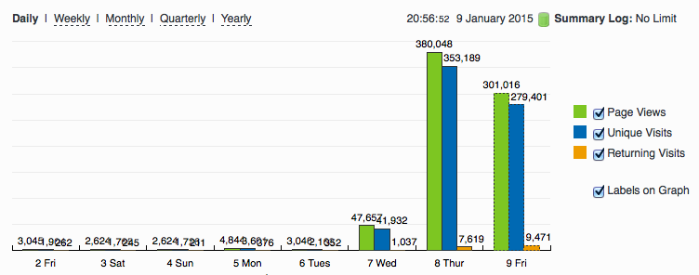
Figur 1 (Berlatsky, 2015)
Where The Hooded Utilitarian usually hovered around 2000-4000 daily page views, the site reached 380,048 site views on January 8th, the day after Canfield’s blog was published, and 301,016 on the following day. Berlatsky attributes the success to Canfield’s post: “Since the post went up on Wednesday, we’ve gotten close to as much traffic as we received in the entirety of last year” he writes.
Both Canfield and Trudeau’s posts are highly critical towards CH as a publication, and similar to Banquet of the NY Times, they argue that there is a point where freedom of speech is unnecessarily inflammatory.
Conclusively, my primary data for analysis are the NY Times public editorial page on their decision not to publish offending Charlie Hebdo cartoons and two blogs/articles criticizing Charlie Hebdo as a publication.

Philosophy of Science
When approaching the aforementioned data I will need an appropriate analytical method to direct the path of the thesis while still following the problem formulation. In analyzing a given subject, the researcher must consider the variable options regarding ontology, which is the view of reality, and epistemology, the view on knowledge. The researcher’s approach to ontology will inevitably have consequences for his or her epistemological method. Egon G. Guba (1990, p. 18) as well as Alan Bryman (2008, p. 13) argues that ontology, epistemology and the methodological premises are so closely related that it makes sense to speak of a unique paradigm that encompasses all these relations.
Guba and Lincoln (1994) points out four major paradigms within the social sciences: positivism, postpositivism, critical theory, and constructivism – and a fifth addition - the participatory paradigm in 2003 (Guba & Lincoln, 2004). Even though these are five major streams within the social sciences, that is not to say that these are the only five viable approaches, as different authors will even add or subtract different paradigms.
Nevertheless, I conduct my analysis in this project based on Guba’s constructivist paradigm. This is done, first of all, due to the simplicity of adopting an already existing paradigm, and secondly, because the paradigm fits my approach perfectly. The basis of the constructivist paradigm can be outlined through these four central points:
- The theoryladenness of facts: Reality only exists in the context of a mental framework. The researcher can never point towards universal facts or how things really are in their analysis, because the empirical data is never independent of construct, since the researcher is active in the gathering and processing of data.
- The underdetermination of theory: No theory can ever be fully tested because of the problem of induction. There is theoretically an endless amount of approaches to analyze a phenomenon, meaning it is impossible to conclude something unambiguously. Observing one million white swans in your lifetime does not exclude the possibility of a black swan event. “There can be many constructions, and there is no foundational way to choose among them” (Guba, 1990, p. 25). Reality is constructed from your theoretical perspective.
- The valueladenness of facts: Similar to how reality can be seen only through a window of theory, likewise the academic inquiry will be influenced by their values.
- The results of research are shaped by the interaction between the inquirer and the inquired into. All knowledge is seen as the outcome of human activity, meaning everything we know is a human construction, never certifiable as ultimate truth but problematic and changing (Guba, 1990, pp. 25-27).
Accepting this constructivist paradigm means that everything I read and analyze must be seen as a human construction, and accordingly, that everything I conclude must be seen as my own construction based on the theoretical and methodological approach. In elaborating on the constructivist paradigm, I will now elucidate my world view with regards to ontology and epistemology.

Ontology
When adopting a constructivist paradigm, the concept of relativism is of particular significance. The opposite of relativism is absolutism, and as I just explained, constructivists do not deal in absolutes the same way that natural sciences does. In the relativist philosophy, realities are seen as multiple, and existing in every person’s minds. People’s perspectives are constantly being drawn as they construct their perceptions of reality through series of life experiences and social engagements. There are elements of reality which can be shared between individuals of the same culture or even across different cultures. Following the constructivist paradigm, it is imperative that no reality is more correct or truthful than the other, although you can argue for a more informed and sophisticated reality. Over time, people’s constructions of reality hold the possibility of being altered or even replaced altogether (Guba, 1990).

Epistemology
Epistemologically, I adopt a subjectivist position, meaning that knowledge is ultimately subjective and is constructed in the interaction between the researcher and the object of research. It would be awkward for me to announce conclusively whether Charlie Hebdo is a racist publication or not, or whether Trudeau and Canfield are telling the truth or if they are slandering. Instead, I am interested in looking at the CH cartoons from both a theoretically satirical perspective as well as from the critical and negative portrayals of the texts that I have chosen. By looking at the cartoons from more than one perspective, I can analyze the different portrayals, and display their different argumentations and see why they reach the conclusions that they do (Ibid.).

Discourse Analysis
In the following, I will shortly present my methodological approach to analyzing discourse. For my analysis of the two texts I will adopt a “standard” Critical Discourse Analysis (CDA) approach, whereas for my initial analysis of selected Charlie Hebdo cartoons, I will focus on the semiotic sub-strand of CDA, which pays particular attention towards visual or non-verbal dimensions in discourse. Nevertheless, my general approach to discourse analysis is bound to the conviction that CDA allows me to study the way “…social power abuse , dominance, and inequality are enacted, reproduced, and restricted by text and talk in the social and political context” (Van Dijk, 2007, p. 108). There are an extraordinary amount of approaches to discourse and CDA, so in this section I will specify my approach, and clarify on its utility for my thesis.

Critical Discourse Analysis
Discourse, on a fundamental level, has two different meanings. Firstly, as a mass noun referring to the linguistic elements of social life, or as Fairclough puts it “language use in speech and writing” (1997, p. 258). The second meaning, discourse as a count noun, refers to a specific use of language and a particular representation of aspects of social life, e.g. varying discourses on welfare. Discourses in that sense can be temporally specified as well as culturally identified. For example, you can talk about American red-scare or McCarthyism discourse to specify the predominant discourse used by politically influential Americans in the 1950’s about communism. Discourses thus constitute ideas as well as perspectives about ways of talking and writing which similarly influences and are influenced by these ideas. Linguistically, discourses constitute specific sets of choices in regard to talking or writing so as to achieve a specific communicative purpose (Ibid. pp. 257-275).
Fairclough describes discourse as the whole process of social interaction of which a text is just a part. In addition to the text itself, the process includes the discursive practice, i.e. the manner and way in which the text is expressed, as well as the interpretation of the reader or listener. According to this view, discourse is seen as a social practice, which brings with it three important implications:
First of all, language and society are involved in a sort of symbiotic relationship where the language used is highly defined by social circumstances while at the same time affecting the social sphere of society. Whenever people speak, listen, talk, or write they are subject to social convention – the way people communicate both determines and is determined by the social sphere, meaning social processes and practices are not merely reflected in the language used, but are actually a part of these processes. The relationship between language and the social sphere is thus internal and dialectical (Jørgensen & Phillips, 2002, pp. 60-96).
Secondly, and closely related to the first, is the fact that language is a socially conditioned process, meaning that people engage in social practices on the basis of their entire social legacy. People produce and interpret texts of every kind based on their social legacy and origins. Fairclough refers to this as pre-knowledge encompassing people’s background knowledge and bias and how it affects their engagement in social practices (Paul Simpson refers to pre-requisite knowledge to describe a similar concept, see page 8).
Thirdly, because of this relationship, one cannot simply look towards the textual elements of data to understand discourse. Due to the unique relationship between language and the social sphere, a comprehensive discourse analysis will inevitably be three-dimensional: a text analysis, an analysis of the discursive practices, and finally an analysis of the socio-cultural practices of which the textual and discursive practices of the texts are part (Fairclough, 2001, pp. 19-21).
Seeing language and discourse as a social practice is tightly related to the post-structuralist linguist theory, as I described on page 10. Both concepts share the same starting point, that our access to reality is always through language, and use of language affects how we define and perceive reality. However, according to Jørgensen and Phillips (2002), Fairclough diverges significantly from post-structuralist thought in his insistence on creating the three-dimensional model. The systematic approach of following a model, albeit a comprehensive one, is conflicting with post-structuralist thought, which traditionally states that the researcher must be able to use a variety of perspectives to create a multi-faceted interpretation of a text, even if the interpretations turns out dissimilar. Nevertheless, I will argue that the three-dimensional model is in fact so encompassing, and so open to interpretation that it can still function with a post-structuralist approach. Fairclough’s three-dimensional model includes both a textual, a discursive, and a socio-cultural analysis, and as such you can indeed approach the analysis in a multi-faceted way. Moreover, Fairclough embodies a highly post-structural position “in claiming that discursive practice not only reproduces an already existing discursive structure but also challenges the structure by using words to denote what may lie outside the structure.” (Ibid. p. 70)
As mentioned above, a Faircloughian CDA will inevitably be three-dimensional. This means that in my analysis of the two texts I will clarify on the discursive practices of the two. How are they presented and produced, and how are they consumed and interpreted? This is referred to as the discursive level of the analysis. Naturally, I will also research heavily into the textual level of the analysis, where I focus on the language and discourse used to describe CH as a publication. Lastly, I will be able to perform an analysis of the socio-cultural practices of which the two texts are part. These concepts are both discursive and non-discursive, and the overall purpose is to apply important theoretical concepts to the discourse found in the texts.

Discourse and Power
For my thesis it is very important to look at how discourse and power is connected. Fairclough has written a lot about how language and discourse can affect power structures, and in his body of work he refers to three concepts closely related to power: discourse, ideology and hegemony.
Fairclough understands ideology as constructions of meaning that contribute to the production, reproduction, and transformation of relations of domination (Jørgensen & Phillips, 2002 p. 60). When an ideology is created, it is created in an environment and culture where the relations of dominance are based on social structures such as class, race, and gender. Fairclough argues that the discourses which serve to preserve or transform the relations of power are generally more ideological than others.
The production of meaning through language is important in maintaining social order. However, texts can be interpreted in near limitless ways, and thus get several different meanings which are different from each other (see also post-structuralism page 10). This is because of the subject’s different pre-knowledge and their dissimilar ideological positions. Since people interpret meaning differently, there is a constant battle about hegemony of meaning in society. Fairclough refers to “the hegemonic struggle” (Fairclough, 1992. P.93) to describe how the discursive practice can be seen as part of a larger social practice involving power relations. Through the use of for example interdiscursivity and intertextuality, the discursive practice can contribute to the reproduction or transformation of existing power relations. (Jørgensen & Phillips, 2002, pp. 60-66).
Dominant groups will always try to assert and maintain their ideological views on society. However, society is never controlled by one dominant discourse; there are always competing groups with different discursive practices.
Competing groups, who wish to transform society, will often use a high level of interdiscursivity. Through new articulations of discourses, and the mixing of discourses, the debate will change gears, and the possibility of socio-cultural change occurs. On the other hand, discursive practices where the mixing of discourses is done in a conventional way will often be used by groups who already hold power and wish to preserve stability (Ibid. pp. 58-70) (Fairclough, 1992).

Van Dijk’s Ideological Square
In 1998, Van Dijk wrote about the concept of an ideological square, which encapsulates the common strategies to describe ingroup members and institutions in a positive light, and outgroup members and institutions in a negative light. This binary opposition often manifests itself in lexical choices, but also combines into propositions expressed by clauses and sentences. For example, the oft-used example of the word terrorist can also be seen as a freedom fighter from another perspective. Depending on which lexical item you use will help paint an ideological bias in the text.
The word terrorist can further have a predicate such as desperate or cold-blooded. Choosing desperate over cold-blooded implies another, less negative, opinion about the terrorist, implying that the terrorist is acting in a last resort. Dysphemisms can be used in order to make them look worse, and euphemisms can be used to make us look better. These implications can also be inferred to by the way of modalities such as “they were obliged to”. Implications such as these are made in an effort to make us look better than them, illustrating the abstract evaluative structure of the ideological square:
- Emphasize our good priorities/actions
- Emphasize their bad priorities/actions
- Mitigate our bad properties/actions
- Mitigate their good properties/actions
Following this thought, Van Dijk points out the importance of examining which parts are given agency in a text. The syntactic structure of a text can be “manipulated” in such a way that our people only appear as actors when the acts are good, and vice versa, their people only appear as actors when the acts are bad (Van Dijk, 998, pp. 263-313).
Fairclough also highlights the importance of discerning agency in a text. Fairclough refers to transitivity as the focus on how events and processes are connoted (or not connoted) with subjects and objects (Jørgensen and Phillips, p. 79). In using a passive form rather than an active form in the following example, Fairclough omits any agent from the equation: “50 nurses were sacked yesterday” (Ibid.) By emphasizing the effect rather than the trigger, the hypothetical administrator of the hospital is not responsible for the lost jobs. Another linguistic tool is nominalization, where the author can use a noun instead of a verb to reduce agency and emphasize effect, like in this example: “There were many dismissals at the hospital” (Ibid.)
In this millennium there is one archetypal example of us and them representation which happened less than ten days after 9/11. George W. Bush, who was the American President at the time, famously declared “either you are with us, or you are with the terrorists” (whitehouse.gov). This dichotomous representation of the global political sphere is highly congruent with the part of my project entitled The Death of the Age of Irony (see page 13). In that section I cite Zoe Williams who argues that the greatest tool against such a dichotomous rhetoric of us, the good guys and them, the terrorists is irony (at least that was the case after the initial few days of solemnity and sorrow that followed 9/11 were over).

Semiotic Analysis
In order to convincingly discuss the problems stated in my introduction, I will also need to perform an analysis of some specific CH cartoons in order to evaluate their political motifs and overall message. In order to do so, I extend my CDA to include analyses of visual and non-textual elements through a semiotic approach.
A political cartoon is an ideal place where the three related fields of communication, CDA, and semiotics can meet. Political cartoons in general, and indeed in the case of CH, are often involving satire and distortion of truth, hyperbole, and ad hominem attacks. They integrate various expression forms such as language, picture, and color. Thus, a traditional linguistic CDA does not suffice to explore the non-verbal expressions of a political cartoon.

Ferdinand de Saussure
The French linguist, Ferdinand de Saussure, is together with Charles Sanders Pierce considered the two major fathers of semiotics/semiology. At the time where Saussure wrote about semiotics in the early twentieth century, there was not an established science that covered the sign language that Saussure was interested in. He predicted that:
“…it is possible to conceive of a science which studies the role of signs as part of social life. It would form part of social psychology, and hence of general psychology. We shall call it semiology. It would investigate the nature of signs and the laws governing them.” (Saussure, 1983, pp. 15-16)
Saussure defined the sign as a compound between the signifier and the signified. The signifier is the form which makes up the actual word, photo, sound etc. The signified, on the other hand, is the concept that is triggered when you see, hear, or read the sign. Thus, the signifier is an object or a “thing” in our world, whereas the signified is a mental representation of the signified. These two elements are united and mutual, and each recalls the other. The representation that the interpreter manufactures is wholly dependent on the individual’s knowledge and experience. Because of this, Saussure argues that the nature of the sign is arbitrary, because the bound between the signified and signifier is itself arbitrary - a signifier does not have meaning in and of itself without a mental representation which activates a concept, and thereby giving meaning to it (Ibid. pp. 15-22).

Roland Barthes
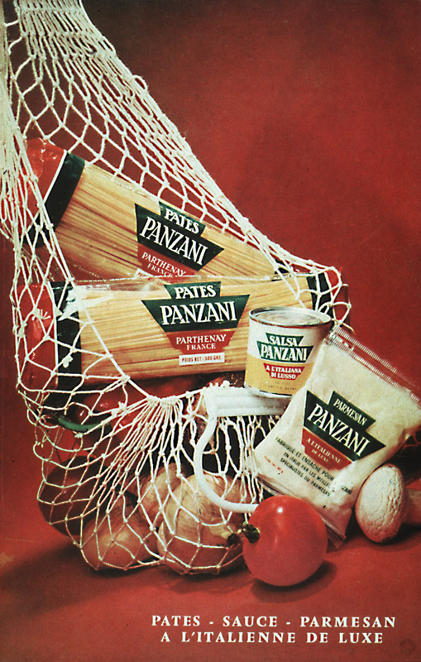
In one of his most famous essays, The Rhetoric of the Image, (Barthes, 1980) Roland Barthes explores how images acquire meaning and how it is attached to them. Barthes has written and researched in various scientific fields including semiotics. In his work on semiotics, Barthes is drawing on Saussure’s definitions of the signifier and the signified in order to identify three classes of a message within an advertisement: the linguistic message, the symbolic message, and the literal message. Even though Barthes is analyzing an advertisement in his essay, it does not mean that the theory is only applicable to advertisements. In fact, the theory and the terminology can perfectly be applied to any other types of picture and even video for that matter. The three messages in an image are:
The linguistic message, which refers to the text on the picture. In Barthes’ analysis of a pasta advertisement, he observes two kinds of messages: the denoted message, which refers to the caption and the label on the pasta as well as the text down the right corner. The other is the connoted message, which refers to where the label says Panzini, which, according to Barthes, implies ‘Italianicity’.
The symbolic message, or the connoted image, comprises the non‐linguistic symbolic message of the picture. For example, the tomatoes and peppers once again symbolize Italianicity, and the half open bag signifies a return from the market and the values that a traditional market represents.
The literal message, or the denoted image, describes the non‐coded parts of the image. The tomato represents a tomato and the pasta represents pasta. Here the signifiers and the signified is equivalent to each other.
Barthes points out anchorage and relay as the two basic functions in relation to the linguistic message. Since a picture can be interpreted in a multitude of ways, the author of a picture can guide the viewer towards a particular interpretation or meaning by including a linguistic message. Barthes refers to this as anchorage. The other function is relay, which is somewhat similar to anchorage. The difference is, though, that with relay, the text and the picture works together to form a meaning. The words are part of the meaning in the same sense that the picture is part of the meaning, but it is only when you can see them in conjunction that you understand the full meaning of the picture.
When analyzing a picture or other media, Barthes sees the image as a collection of connoted and denoted elements. Some parts of a picture are placed deliberately to connote a message, while others are simply denoted elements within the picture. The visual elements that symbolize a message are called ‘connotators’, and it is these particular elements that jointly create the rhetoric of the image (pp. 269‐285).
Since I adopt a post-structural approach, it might seem counter-intuitive to include semiotics as part of my methodology. For example, the concept of anchorage, where the author guides the reader towards a certain interpretation of the image goes against the idea of Barthes’ The Death of the Author where the author’s intended meaning is secondary to the interpretation of the reader. However, I will argue that even the linguistic message, cf. The Rhetoric of the Image, can be interpreted differently by different people. Think only of Renè Magritte’s famous The Treachery of the Image, where the picture quite clearly resembles a pipe, yet the linguistic message explicitly states that it is not a pipe. The question becomes, which do you trust more: the linguistic message or the literal message. There are of course several ways to interpret this image. For example, Magritte could refer to the fact that the picture is not an actual pipe, but just a picture of a pipe. However, the point still stands, that there is a struggle between the denoted message of the author, and the connoted message that the viewer interprets. Thus, the author can try as hard as he or she might, but there is still a chance that the viewer or reader will interpret it differently than the anchorage intended for.

Analysis
Having defined the problem statement of the thesis and outlined the theoretical framework, I will now focus on the analysis of my empirical data. In accordance with Fairclough’s three-dimensional model, I will divide the analysis into three separate stages:
In the first stage I will focus on textual elements of the data. By researching the linguistic characteristics of the texts, it enables me to examine how discourses are activated “…textually and arrive at, and provide backing for, a particular interpretation” (Jørgensen & Phillips, p.79). The textual analysis will give insight into how each text represents events and discussions concerning Charlie Hebdo, and how they construct “particular versions of reality, social identities and social relations” (Ibid.).
The second stage encompasses the analysis of discursive practices within my empirical data. The main purpose of the discursive practice analysis is to analyze the context of production and the context of consumption of the texts, i.e. how and where a text is produced and presented, as well as how and where it is consumed.
The final stage is the part of the analysis where I incorporate socio-cultural practices related to the texts. These socio-cultural practices are both discursive and non-discursive, and the overall purpose of this stage is to apply key theoretical themes to the texts, e.g. cultural relativism, the death of the age of irony, and the responsibility of satire.
I will begin by performing a two-staged analysis of Garry Trudeau’s The Abuse of Satire, after which I will analyze Jacob Canfield’s In the Wake of Charlie Hebdo, Free Speech Does Not Mean Freedom From Criticism. I will then shortly compare and contrast the views within these two texts with the NY Times’ January 8th editorial on Charlie Hebdo with particular focus on their reasoning not to publish controversial cartoons. I will ultimately analyze a few selected CH cartoons where I will also incorporate the field of semiotics in my analysis to support the visual and non-textual elements therein. I will only incorporate Fairclough’s third dimension, the socio-cultural dimension, at the very end so that I can make an apt analysis where I compare and contrast each text with a specific focus on the topic of responsibility and satire.

Garry Trudeau: The Abuse of Satire
On April 10th 2015, Garry Trudeau received the George Polk Career Award in Journalism at Long Island University in Brooklyn, New York for his longstanding work as a cartoonist. The award is given annually to honor excellence in print and broadcast journalism. It is predominantly focused on American journalism, although foreign journalists can also become recipients so long as they publish their work to an American publication. Trudeau, who is also a Pulitzer-prize winner, is most famous for his Doonesbury comic strip which he has been working on for over 45 years (Cavna, 2015).
The Abuse of Satire was originally the speech that Trudeau gave after he received the George Polk Award, but on the following day it was also published online in the Washington D.C. located magazine, The Atlantic. As of May 30th it has garnered over 2000 comments on the article on The Atlantic website, and it has been both praised and criticized heavily in other media (notably, neo-conservative commentator David Frum wrote a heavy critique which was also published in The Atlantic (Frum, 2015), fellow cartoonist, Michael Cavna gave a nuanced double-sided argument on the speech in the Washington Post (Cavna, 2015), and American author, Jim Sleeper, sided with Trudeau in a long opinion-piece in the online news website Salon (Sleeper, 2015)).

Discursive Practice
Production and consumption of the text
As I mentioned just above, The Abuse of Satire was originally a speech, and as such it is considered a monologue. This means that Trudeau can present his arguments in a cohesive and uninterrupted manner, but at the same time that there are no second or third parties who can make inquiries when there are points they are unsure about. Since I base my analysis on the text published in The Atlantic, I am unable to analyze on Trudeau’s use of voice. The rhythmic flow of words and sounds can emphasize greater meaning to certain passages in the text, and can help insinuate use of irony and humor. Furthermore, a measured use of cadence can give the speech a more flowing and poetic expression. Unfortunately, there are no available videos on the internet, so the transcription of the speech as presented in the Atlantic will have to suffice.
Since The Abuse of Satire is a speech, Trudeau is not limited by the same convictions of, for example, a news article. This point is reflected in the fact that the speech is loaded with Trudeau’s own general truths about the world. Throughout the text, Trudeau throws around aphorisms about the roles of satire and society in order to present his ideal view of these concepts. These aphorisms are highly debatable, and are not grounded in any universally agreed upon consensus, but rather Trudeau’s own conviction. As a result, agreement or disagreement with Trudeau’s arguments depends wholly on the listener’s/reader’s interpretation of these statements, and whether they subscribe to his maxims. If it was a news article, Trudeau would have to be much more careful when expressing general truths about the world, since objectivity and neutrality is expected from a serious news report. I will dwell further into Trudeau’s rhetorical use in the text analysis (see page 36).
Contrary to for example everyday dialogue, a speech is generally well prepared and thought through. This means that Trudeau has had a lot of time to prepare his speech, and to make sure that the presentation of the speech matches with the tone of the situation and its audience. The speech was held at an award show for journalists, by journalists, honoring their own field of work. Thus, it must be presumed that the audience was highly informed, and more opinionated on the topic than the average American citizen. Trudeau inevitably knew this before he stood up and spoke on the scene.
The assumed knowledge about events and discussions surrounding Charlie Hebdo is evident in how Trudeau presents them in an including manner. “As you know…”(Appendix A, p. 71), says Trudeau, before expanding on the Danish Muhammad crisis which happened nearly ten years ago. Clearly, Trudeau assumes that his audience is well-informed on the matter, and that he does not have to explain his case from the ground up. Similarly, he references “Great French satirists like Molière and Daumier…” (Appendix A, p. 71) by last name only and without further introduction. These are by no means household names, but because Trudeau is speaking to an audience that share the same pre-knowledge (in Fairclough’s terms - see page 24) he assumes the audience is familiar with them.
Recontextualization
The speech as a genre is very open to the use of recontextualizations, which can be either intratextual, intertextual, or interdiscursive. Unless the speech is held in front of a very conservative and formal crowd, the speaker can include several different types of discourses in order to make the presentation interesting and varied. The Abuse of Satire begins in a narrative manner, where Trudeau recalls back 45 years to when he was first hired to create comic strips.
“My years in college had given me the completely false impression that there were no constraints, that it was safe for an artist to comment on volatile cultural and political issues in public” (Appendix A, p. 70)
In Trudeau’s narration, he depicts his fresh-out-of-college approach to satire as naïve and clueless. He spends the most of the first half of his speech on telling his story about how he got to where he is today, and how his view on satire has been molded and matured throughout his career. At one point in the speech there is, however, a significant change in tone. “And now we are adrift in an even wider sea of pain”, Trudeau says, as he changes the topic from himself to the topic of Charlie Hebdo. The end of the history narration is marked by the use of the temporal location adverb, now. But this paragraph does not just mark a change in topic and temporality, it also marks a distinct change in discourse and style. Trudeau stops speaking in a narrative monologue style, and switches over to a more active monologue style.
From a personal narration about his own life and career and the choices that he made, he changes gears and uses the rest of the speech to talk about Charlie Hebdo and why he believes that their satire is dangerous and irresponsible. Obviously, the major theme of Trudeau’s speech is the responsibility of satire, which is also evident in the title, The Abuse of Satire. In the following I will look at how Trudeau recontextualizes discourses in order to depict the perimeter between irresponsible satire and responsible satire.
- Religious discourse: The Charlie Hebdo shooting is closely related to religion in the sense that the attackers committed their actions on the basis of religious beliefs. However, in Trudeau’s speech, the religious discourse is not attached to the attackers, but to CH and other “free speech absolutists” (Appendix 1, p. 71).
- Class stratification discourse: Trudeau goes into great detail about satire punching upwards or punching downwards. In Trudeau’s optic, CH was punching downwards “… by attacking a powerless, disenfranchised minority with crude, vulgar drawings closer to graffiti than cartoons”. In the speech, Trudeau creates a clear distinction between the powerful and the powerless. This divide is entirely based on social status and political power, which in France is generally unfavorable towards Muslims. Trudeau is seemingly ignoring the fact that the CH cartoonists had been living under constant mortal threat by Muslim extremists in his assessment of privilege. Furthermore, on a global scale, Islam is a very powerful religion. As such, Trudeau’s distinction between the powerful and the powerless is very strict, and does not take into account the many nuances of such an assessment.
- Juridical discourse: At one point in the speech, Trudeau strongly alludes to CH as perpetrators of hate-speech. Although he does not adopt a traditional formal juridical discourse, he does make the effort to shortly define French hate-speech laws, and exemplify why he thinks that CH was wandering dangerously close to hate-speech.
- Satirical discourse: Even though The Abuse of Satire is far from loaded with jokes and humor, there is one good example of Trudeau’s sharp wit. Trudeau speaks of “red lines” (Appendix A, p. 71) in relation to how offensive satire can be before it becomes irresponsible. He tells the story of how he himself recently apparently crossed the line in making fun of transvaginal probes, which lost him 70 papers for the week. He then contrasts this with the Danish Muhammad crisis, which cost the life of one cartoonist and instigated deadly uproars in the Middle East. The term Red lines is being used to create the transition from the relatively innocent probe story to the large-scale Muhammad crisis and CH shooting. The two examples are similar in the sense that they both question to which degree it is okay to lampoon something serious, but they are also similar in the sense that they both connote pictures of blood. In this light, red lines can both refer to the phrase used to indicate a figurative point of no return and a more literal interpretation where red lines refer to either the blood of a vagina or the blood of a cartoonist. This is a morbid image, but Trudeau only hints at it. The absurd comparison works to great effect as a transition in style, and it creates a huge contrast between the type of satire that Trudeau works with and the type of satire that CH works with.

These are all examples of interdiscursivity, where Trudeau imports elements from existing discourses to present his argument about Charlie Hebdo and the abuse of satire. There are also numerous examples of intertextuality and intratextuality in the text. In the coming section, the text analysis, I will point out these examples, and I will expand on how Trudeau linguistically works with different discourses. Above all, I will examine Trudeau’s rhetoric and “cast light on how discourses are activated textually and arrive at, and provide backing for, a particular interpretation.” (Jørgensen & Phillips, p. 81)

The Textual Analysis
As I explained in the above section, The Abuse of Satire is split up in a personal narration in the first half, and a critique of Charlie Hebdo in the second half. This setup of the text works by letting Trudeau establish confidence, or ethos, between him and the audience before he embarks on a hard-hitting critique of the murdered cartoonists. As I will argue extensively for in this section as well, it also functions to create a contrast between what Trudeau considers responsible satire and abuse of satire. The narration part serves to give Trudeau trustworthiness as well as humility. In recalling how he landed his first job as a cartoonist, he shows modesty by saying that his initial view of satire was false, and that his approach has since been molded and matured.
“He [Trudeau’s editor] saw the sloppy draftsmanship as a kind of cartoon vérité, dispatches from the front, raw and subversive. Why were they so subversive? Well, mostly because I didn't know any better. My years in college had given me the completely false impression that there were no constraints, that it was safe for an artist to comment on volatile cultural and political issues in public. In college, there's no down side. In the real world, there is, but in the euphoria of being recognized for anything, you don't notice it at first. Indeed, one of the nicer things about youthful cluelessness is that it's so frequently confused with courage.” (Appendix A, p. 70)
In this section, the naïve and clueless fresh-out-of-college Trudeau from 45 years ago is contrasted with the current Trudeau who is wiser and more experienced. Trudeau’s editor saw his work as “a kind of cartoon vèritè”. This simile refers to cinema vèritè, the genre of documentary filmmaking, which aims to unveil truth or highlight topics hidden behind crude reality through the use of handheld camera. Cartoon vèritè is described as “dispatches from the front,” a descriptive phrase followed by the two adjective postmodifiers “raw and subversive”.
This description of Trudeau’s early work makes it seem unpolished, but very true to a real depiction of how he saw the world at the time. Trudeau focuses on the adjective “subversive” as he presents the hypophora: “Why were they so subversive?” Subversive means to have intentions about overthrowing, undermining, or destroying an established or existing system, such as a government or a set of beliefs. By taking distance to the idea of subversion, Trudeau draws on the familiar discourse of a rebellious college student, weary of the world and wanting to change it completely. What usually happens to this person, though, is that they grow older and more mature, and becomes less rebellious when facing the “real world”.
Trudeau answers the rhetorical question by arguing that, at the time, he was under the false impression that there were no constraints as an artist, and that he was safe to comment on whichever volatile cultural and political issues he wanted to. “One of the nicer things about youthful cluelessness is that it’s so frequently confused with courage”, Trudeau argues, and in turn depicts a dualism between “youthful cluelessness” and “the real world”. Trudeau’s axiological emphasis is clearly favored towards “the real world”, which can be illustrated by the negative connotations of for example “false impression” “euphoria”, and “cluelessness” all related to his college-student approach to satire.
Even though Trudeau has not even mentioned Charlie Hebdo yet, he is building the foundation for the second part of his speech, where he will be criticizing the publication heavily. Instead of just starting right off the bat by criticizing and condemning the recently murdered cartoonists, Trudeau smartly builds up the theme of responsibility in relation to satire, while simultaneously arguing for why he is both competent and experienced enough to speak on this matter. This makes the critique appear less hostile and more thought out.
Trudeau continues to speak of his career until he creates the transition about red lines which I mentioned on page 34 of the analysis.
I, and most of my colleagues, have spent a lot of time discussing red lines since the tragedy in Paris. As you know, the Muhammad cartoon controversy began eight years ago in Denmark, as a protest against “self-censorship,” one editor’s call to arms against what she felt was a suffocating political correctness. The idea behind the original drawings was not to entertain or to enlighten or to challenge authority—her charge to the cartoonists was specifically to provoke, and in that they were exceedingly successful. (Appendix A, p. 71)
It must be mentioned that there are three factual errors in this quote. First of all, the editor that Trudeau presumably refers to is Flemming Rose, the male cultural editor of Jyllands-Posten at the time, who initiated the idea to publish different cartoonist’s depictions of Muhammad. Second of all, the cartoons were published on September 30th 2005, nine and a half years from Trudeau’s speech. Finally, Rose’s charge to the cartoonists was not to specifically provoke, but to “depict Muhammad as they see him” (Rose, 2005).
Trudeau brings up the Muhammad crisis because it has a lot of similarities to the CH shooting. The similarity is explicated by the quick shift between mentioning how he, and most of his colleagues, have spent a lot of time discussing red lines since the tragedy in Paris, to the seemingly effortless transition over to talking about the Muhammad cartoon controversy. Trudeau describes this controversy as a protest against self-censorship, where the word self-censorship is put in quotation marks. Putting quotation marks around the word “self-censorship” works to perplex the meaning of the word, suggesting that the concept of self-censorship is an abstract idea open to interpretation. Trudeau describes Rose’s effort as a call against a “suffocating political correctness” even though Rose does not actually use this phrase in the original article with the 12 infamous drawings (Rose, 2005).
The idea behind the original drawings was not to entertain or to enlighten or to challenge authority—her charge to the cartoonists was specifically to provoke, and in that they were exceedingly successful”, Trudeau writes. In the section about theories on satire (see page 7), I describe satire, at its core, to stem from a perceived disapprobation of parts or the whole of some genus, and its greatest tool is to deflate a windbag in a way that very little else can. Trudeau’s depiction of Jyllands-Posten’s Muhammad drawings is completely converse to this. If the only purpose of the drawings was to provoke, then it is a stretch to label it as satire. Muradi & Hughey (see page 10) argues that a cartoon must do more than just ridicule for the sake of ridiculing. If a cartoon is just meant to provoke, it only serves to stigmatize the topic, and as such Muradi & Hughey calls this a reproduction of racist discourse.
But according to Trudeau, the cartoons were the catalyst of much more than just racism:
Not only was one cartoonist gunned down, but riots erupted around the world, resulting in the deaths of scores. No one could say toward what positive social end, yet free speech absolutists were unchastened. Using judgment and common sense in expressing oneself were denounced as antithetical to freedom of speech. (Appendix A, p. 71)
In relation to this quote, it is interesting to look at the concept of what Van Dijk calls the ideological square and what Fairclough refers to as transitivity (see page 28). According to these concepts, one can analyze the bias of a text by looking at how the author posits agency in various situations. The basic concept of the ideological square is to paint a positive image of ingroup members and institutions, and a negative image of outward members and institutions.
There are actually three groups related to this citation: offended Muslims who react violently, Jyllands-Posten and free speech absolutists, and the wise and sensible satirists who do not indulge in unnecessary provocations.
When Trudeau writes “Not only was one cartoonist gunned down, but riots erupted around the world, resulting in the deaths of scores”, he writes it in a passive tone, where the agents who committed the atrocities are omitted. Thus, the negative outcome can be traced back to the cartoons which worked as a catalyst for the effect. The offended Muslims are given no agency in this matter, and their actions are depicted as natural occurrences happening only as a result of the Muhammad cartoons.
Jyllands-Posten and the 12 cartoonists, on the other hand, are given an enormous amount of agency in this matter. Not only are they responsible for their own actions as can be seen from this sentence: “her charge to the cartoonists was specifically to provoke, and in that they were exceedingly successful.” Trudeau emphasizes Jyllands-Posten’s bad priorities / actions, and mitigates their good priorities / actions. This can be seen in how Trudeau describes the newspaper’s motif as a protest against so-called self-censorship and political correctness. In Rose’s article “Muhammeds Ansigt” (Rose, 2015), he argues thoroughly that artists, writers, cartoonists and translators all ignore the most important cultural clash of our time, the one between Islam and the secular Western societies. Trudeau severely diminishes his motifs by describing Rose’s goal with the cartoons as “not to entertain or to enlighten or to challenge authority—her charge to the cartoonists was specifically to provoke”. There are, of course, many ways to interpret “Muhammeds Ansigt”, but Trudeau’s interpretation is particularly simplified. Did the Muhammad drawings not challenge authority when they published drawings of Muhammad, which has been strictly forbidden by the authorities of Islam? It appears that Trudeau does not consider religious authority considerable enough to be considered an actual authority in the Western world.
“No one could say toward what positive social end, yet free speech absolutists were unchastened. Using judgment and common sense in expressing oneself were denounced as antithetical to freedom of speech.” (Appendix A, p. 71)
The above citation is a great example of interdiscursivity, where a religious discourse is being used to describe secular free speech promoters. Trudeau does not actually use the word “secularism” to describe the “free speech absolutists”, but secularism is inherently rooted to the concept of free speech absolutism in this context, since they fight against religious influence on politics. The collective noun “absolutists” implies that the free speech promoters believe that there are absolute standards against which moral questions can be judged; that there are certain actions that are either good or evil, regardless of context. This is reminiscent to religious doctrines, where a body of principles, such as the Ten Commandments in Catholicism, is presented as absolute moral truth. The adjective “unchastened” can also give connotations towards religion. To chasten, in this context, means to rid of excess; refine or purify. Thus, the free speech absolutists remained absolutists, and did not moderate their views in any way, even after the big impact of the Muhammad cartoon controversy. In the archaic context of the bible, chasten means God’s punishment on humans.
In the ladder part of the above citation, the use of “judgment and common sense” is being “denounced” as “antithetical” to freedom of speech. You would think that secular free speech promoters would welcome the use of judgment and common sense, since that is inherently rooted in secularism and progressivism. Secularists will often pride themselves on using rationality in lieu of faith, but in this context they are actually denouncing it. The past tense verb “denounced” brings strong religious connotations with it. To denounce something means to publicly condemn something as wrong or morally reprehensible. This idea of publicly condemning use of judgment and common sense is reminiscent to the caricature of the Medieval Dark Ages where ignorance and superstition ruled over personal experience and rational activity.
Lastly, the denominal adjective “antithetical” bolsters the religious connotations of free speech absolutists even further. If “judgment and common sense” is antithetical to free speech absolutism, then it gives that free speech absolutists endorse ignorance and irrationality.
Using Derrida’s concept of dualism (see page 13), Trudeau creates and presents two opposing concepts which I refer to as: dogmatism vs. rationality.

- The concept of dogmatism encompasses the belief in absolute standards of moral truth based on a pre-existing doctrine. The belief in this doctrine is more likely to be based on faith than evidence. The dogmatic view of the world is incontrovertibly true, and it cannot be changed or discarded without affecting the very nature of the paradigm.

- The concept of dogmatism is contrasted with the concept of rationality. Unlike the dogmatic view of the world, the rational view does not adhere to a pre-existing doctrine of moral goods and evils. The rationalist view bases its perception and opinion on facts and evidence rather than blind faith. There are no irrefutable truths and certainties as every dilemma is approached with good sense and sound judgment.

Fairclough argues (see page 28) that high levels of interdiscursivity are a sign that the author wishes to challenge the hegemony or the consensus way of speaking about this topic. By using interdiscursivity in this context, Trudeau challenges the established hegemony by turning the roles of secularists and Muslim extremists upside down; In The Abuse of Satire, secularists are the ones holding a dogmatic world view, whereas the Muslim extremists are basically overlooked. Their actions are ignored, since they are seen as the naturally occurring effect initiated by the free speech absolutists. What Trudeau does here is challenge the hegemonic view in the Western world that secularism, free speech, and fundamental democratic values must be upheld at all costs. By painting the unlimited belief in democracy and the state as just another form of religion, Trudeau asks who the real fanatics are: the free speech absolutists or the Muslim extremists.
“And now we are adrift in an even wider sea of pain. Ironically, Charlie Hebdo,which always maintained it was attacking Islamic fanatics, not the general population, has succeeded in provoking many Muslims throughout France to make common cause with its most violent outliers. This is a bitter harvest.” (Appendix A, p. 71)
In this quote, Trudeau makes the transition from the Muhammad crisis to Charlie Hebdo. Trudeau compares the current situation to being adrift in a metaphorical “sea of pain”. To be adrift means to float around without being moored or steered. Thus, the situation is out of control to the point where we can no longer decide ourselves which way we are going. Charlie Hebdo’s drawings have caused so much damage that even moderate Muslims are turning fanatical. According to Trudeau, this was something that CH aimed towards and “succeeded” in doing. Through their cartoons, they have succeeded in sharpening the dichotomous representation of us and them, as in the non-Muslims vs. the Muslims.
The tragic consequence was that the CH cartoonists were to be murdered in their own offices in Paris on January 7th. Trudeau calls this a “bitter harvest”. For there to be a harvest, you have to first sow the seeds, thus Trudeau implies that CH’s cartoons had been provoking and infuriating Muslims for so long that the inevitable happened. “You reap what you sow”, the old idiom goes, meaning everything that happens to you is a result of your own actions. This idiom can be traced back to the bible where it says:
“Be not deceived; God is not mocked: for whatsoever a man soweth, that shall he also reap.” (Galatians 6:7, King James Bible)
Whether this is an intentional use of intertextuality by Trudeau is difficult to assume, but given that the entire paragraph is filled with religious connotations and discourse, it makes sense to at least mention the possibility of intertextuality.
Invoking the metaphor of a “harvest” to represent the execution of the CH cartoonists is a strange choice. Traditionally, a harvest is something desirable, and something you have worked towards for a long time so you can eventually reap the benefits of your hard work. However, in the case of the CH cartoonists, it was a “bitter harvest”, meaning to earn something undesirable as a result of all your hard work. The strained use of “harvest” in this sense is an example of catachresis, where the choice of words at first glance seems misplaced; however its intention is entirely for rhetorical purposes. First of all, to invoke the metaphor “bitter harvest” makes the CH cartoonists’ deaths seem even more tragic, because their “sacrifice” only caused even more dichotomization between Muslims and non-Muslims. Second of all, the catachresis works to, once again, allude towards a religious discourse in relation to the secular discourse.
“Traditionally, satire has comforted the afflicted while afflicting the comfortable. Satire punches up, against authority of all kinds, the little guy against the powerful. Great French satirists like Molière and Daumier always punched up, holding up the self-satisfied and hypocritical to ridicule. Ridiculing the non-privileged is almost never funny—it’s just mean.” (Appendix A, p. 71)
Following the critique of Charlie Hebdo and the effects of their offending cartoons, Trudeau goes on to argue for the virtues of satire and the abuse of satire. He begins by listing two aphorisms. The first is presented as an antimetabole, where the words “comforted” and “afflicted” in the first clause are closely replicated in reverse grammatical order in the following phrase, using the words “afflicting” and “comfortable”. The aphorism follows the chiastic structure of A-B-B-A, giving it a beautiful symmetrical structure. The rhetorical efficacy of this style is to create a contrast between the powerful and the powerless. The “comfortable” represents the powerful, i.e. authorities, or the hegemony in Fairclough’s terminology, whereas the “afflicted” represents the disenfranchised and powerless, who has very little socio-political power. The role of satire is, thus, to afflict the powerful while comforting the powerless.
The second aphorism states that satire punches up against authority of all kinds. Punching up, in this context, has the same meaning as “afflicting the powerful” in the former aphorism. It is repeated in the next sentence where Trudeau references two historical French satirists. Referencing two great historical figures to bolster his statement, works to establish credibility to his argument. The paragraph ends with the sentence: “Ridiculing the non-privileged is almost never funny—it’s just mean”. This sentence stands in stark contrast to the rest of the paragraph, and functions as the pathway to the next section where Trudeau will elaborate on CH and how they are punching downwards rather than upwards.
“By punching downward, by attacking a powerless, disenfranchised minority with crude, vulgar drawings closer to graffiti than cartoons, Charlie wandered into the realm of hate speech, which in France is only illegal if it directly incites violence. Well, voila—the 7 million copies that were published following the killings did exactly that, triggering violent protests across the Muslim world, including one in Niger, in which ten people died.” (Appendix A, p. 71)
Trudeau implies that Charlie Hebdo is strongly verging on the brink of committing hate-speech crimes by creating what appears to be a Modus Ponens argument. He argues that if hate-speech directly incites violence it is illegal. “Well, voila—the 7 million copies that were published following the killings did exactly that, triggering violent protests across the Muslim world, including one in Niger, in which ten people died.” Thus, the publication of the Je Suis Charlie cover cartoon depicting a crying Muhammad following the CH shooting can be considered illegal since it resulted in violent protests and the deaths of ten people in Niger. Just like in the aforementioned example with Jyllands-Posten, Trudeau is completely omitting any agency from the Muslim extremists who commit the violence and murders. “Triggering violent protests across the Muslim world, including one in Niger, in which ten people died” is written in a passive tone where “violent protests” and “ten people died” does not have any agent connected. The only agent connected to this evil is Charlie Hebdo. In fact, Trudeau uses the word “triggering”, thereby strongly implying that they knew what was going to happen. The actual violators in the Muslim world are not given any blame, and it appears as if their actions are natural and to be expected, as if they do not know any better.
“What free speech absolutists have failed to acknowledge is that because one has the right to offend a group does not mean that one must. Or that that group gives up the right to be outraged. They’re allowed to feel pain. Freedom should always be discussed within the context of responsibility. At some point free expression absolutism becomes childish and unserious. It becomes its own kind of fanaticism.” (Appendix A, p. 72)
The above quotation elaborates on the responsibility of satire. There is an example of intratextuality in the first sentence. “Because one has the right to offend a group does not mean that one must” can be linked back to when Trudeau spoke of Jyllands-Posten and their incentives for engaging in a debate about the depiction of Muhammad and free speech, which Trudeau explained as: “one editor’s call to arms against what she felt was a suffocating political correctness.” The editor felt obliged to offend because of a feeling of suffocating political correctness. However, Trudeau argues, just because they have the right to does not mean that they must. Thus, Trudeau’s argument gains higher significance and impact since the reader or listener can relate to it.
Trudeau argues that Muslims are allowed to feel pain and be outraged over the CH cartoons; a privilege that free speech absolutists does not grant them. This makes the free speech absolutists appear extremely contemptuous and cynical. The question is, of course, who actually argues that Muslims are not allowed to feel pain and be outraged. Trudeau does not give any direct reference, and as such the argument seems more like a straw man argument. Unlike in the first sentence, Trudeau has not given any examples prior in the text of any free speech absolutists who denied Muslims the right to feel pain. Free speech absolutists, traditionally, argues that Muslims are not allowed to engage in violent riots and kill in the name of their religion – not that they are not allowed to feel hurt or angered. By the end of the paragraph, Trudeau elucidates on the dogmatism concept attached to secularists in a very explicit manner: “It becomes its own kind of fanaticism.” Trudeau ends his speech with the following paragraph:
“Writing satire is a privilege I’ve never taken lightly. And I’m still trying to get it right. Doonesbury remains a work in progress, an imperfect chronicle of human imperfection. It is work, though, that only exists because of the remarkable license that commentators enjoy in this country. That license has been stretched beyond recognition in the digital age. It’s not easy figuring out where the red line is for satire anymore. But it’s always worth asking this question: Is anyone, anyone at all, laughing? If not, maybe you crossed it.” (Appendix A, p. 72)
The end paragraph functions as a peroration, the closing part of an argument which purpose is to remind the audience of the main points of the speech and to leave a final appeal to pathos. The peroration follows the same style and tone of the entire speech up until this point – a narrative description of Trudeau’s own career in writing satire followed by a critique on the abuse of satire. Trudeau describes Doonesbury as “An imperfect chronicle of human imperfection”. The stylistic scheme in this phrase resembles a polyptoton, where the word “imperfect” is reused and slightly altered in the context of “human imperfection”. Since human nature is characteristically imperfect, it makes perfect sense that Doonesbury is likewise an imperfect chronicle of said imperfection. The poetic style that Trudeau utilizes here can be considered an appeal to pathos, since he is not actually arguing through either logos or ethos. Rather, the poetic diction and imagery appeals to pathos by creating a bond between Trudeau and the audience. Similarly, the reference to human imperfection and uncertainty of “red lines” in the digital age speaks about the extreme difficulties associated with the creation of meaning through art in this day and age.
In that same vein, Trudeau ends his speech with a rhetorical question relating to Charlie Hebdo and the responsibility of satire:
It’s not easy figuring out where the red line is for satire anymore. But it’s always worth asking this question: Is anyone, anyone at all, laughing? If not, maybe you crossed it.”
This end hypophora aims for refutation through exposing discrepancies in CH’s body of work. The present progressive verb “laughing” in this context is interesting to look at. Laughing is a core ingredient in satire, so if no one is laughing about CH’s cartoons, then what is the point? However, when the word laughing is used in this context, it should not be understood literally, but rather in contrast with the tragic CH shooting and the violent aftermaths in many Muslim countries. This contrast is invoked in the audience through the intratextual reference of “red lines”, which Trudeau spoke of earlier in the text in reference to the Muhammad controversy and the CH shooting. Surely, no one is laughing at this, and so Trudeau asks the audience the question whether satire has maybe overstepped its boundaries. This question works to great effect as a closing section since it sums up Trudeau’s fundamental approach to responsibility and satire; that if the satirical cartoons only work to provoke and incite violence it is irresponsible and abuses the principles of democracy and free speech since it targets and affects a repressed minority.

Jacob Canfield: In the Wake of Charlie Hebdo
As explained earlier, I will also look at the relatively unknown cartoonist Jacob Canfield and his blog article “In the Wake of Charlie Hebdo, Free Speech Does Not Mean Freedom from Criticism” (In the Wake of Charlie Hebdo henceforth) which went viral on the day after the CH shooting. Many of the same themes that I explained in the above section on The Abuse of Satire are repeated in this blog article, and as such I will not describe them as in-depth so I do not repeat myself.
“In the Wake of Charlie Hebdo” is a blog post written on the day of the Charlie Hebdo shooting. Like The Abuse of Satire, the text is a monologue. However, there are many important differences between the production and consumption of the two texts. First of all, the blog post was posted at 12:49 Eastern standard time, roughly eight hours after the tragedy in Paris occurred. This is a fairly quick reaction to the tragedy, especially taken into account that the blog concerns itself with an assessment of Charlie Hebdo’s history and body of work. Before the shooting on January 7th, most people had not even heard of the small French publication. Nevertheless, Canfield has a clear opinion about CH, and gives plenty examples throughout the text of why he thinks the publication is so racist, xenophobic, and racist, and thus it appears that Canfield was already well aware of CH’s work before the day of the shooting.
Before I begin my analysis I will give a short introduction to the blog as a medium and the origins of the #JeSuisCharlie movement that occurred on Twitter.

JeSuisCharlie
The fast reaction time and publication of Canfield’s blog post is distinctive to the current internet culture where it is possible to hastily write an article and see it published on the web few seconds after finishing it. On social media platforms in particular, every person with access to the internet have a platform where they can share their thoughts and opinions on current events. A good example of this is Twitter, where the immense surge of #JeSuisCharlie posts began to pop up after the incident. According to several news reports (Goldman, 2015) (Beech, 2015) French journalists and bloggers began the trend by posting a simple image with the text ‘Je Suis Charlie’ on a black background, insisting that assailants could not take away their freedom. Thus, in its inception, #JeSuisCharlie was not only a global solidarity movement, but a slogan for defiance against terrorist attacks and as a rallying cry for freedom of expression.
In social media tweets, updates, blogs, etc. the hashtag would often be accompanied with a cartoon in solidarity with CH. People would defend their freedom of speech by propagating the irreverent, satirical message of CH, even to the extent of changing their social media avatar to a depiction of Muhammad the prophet, which is seen by many Muslims as sacrilegious.
On January 10th, there had been made over 5 million tweets with #JeSuisCharlie, making it one of the most popular hashtags in the history of Twitter (Goldman, 2015). JeSuisCharlie could also be seen in vigils and demonstrations around the world and featured prominently on several newspaper covers on the day after the shootings (Ibid.).
The extent of #JeSuisCharlie is difficult to grasp. As millions of people have used the hashtag for varying purposes, it is impossible to define clearly what the hashtag comprises since there is no official definition. However, it can be concluded that #JeSuisCharlie is generally used to sympathize with the victims of the shootings, and that the hashtag is often used in defiance of terrorism and in defense of freedom of speech. This perception is echoed by Head of social content at The Mirror, Richard Beech, who writes: “Je Suis Charlie – meaning “I am Charlie” – is being used by tweeters who wish to show refusal to be silenced by the massacre” (Beech, 2015) and “…solidarity with France and those who lost their lives in the shooting” (Ibid. 2nd paragraph).
Generally speaking, #JeSuisCharlie is not used in direct support of CH’s body of work and their entire political agenda. Paul Waldman, who is a contributor at Washington Post, writes:
“But does saying “Je Suis Charlie” necessarily mean that you celebrate the work they did before this week? I don’t think it does in the minds of many who are saying it, nor should it. The people holding up those signs are announcing their commitment to an idea of free speech that has nothing to do with that speech’s content” (Waldman, 2015).
Thus, #JeSuisCharlie, above all, is used to indicate sympathy for the victims of the atrocity and defense of freedom of speech. Jacob Canfield has a distinct perception of what #JeSuisCharlie means, which I will elaborate on in the textual analysis part of the text.

Discursive Practice
Production and consumption of the text
Blogging as a medium for political action and a facilitator for a global political movement, is a new phenomenon that has arisen concurrently with the global increase in internet-users and –accessibility. For example, Twitter is a so-called microblog, where users can write small messages to a limit of 140 characters per message or ‘tweet’. At first sight, Twitter can easily be mistaken for a simple online diary where people share their everyday thoughts and feelings. However, according to internet politics scholar Stephen Coleman, blogging is much more than just that. In fact, blogging changes the rules of journalism in politics:
“The most transformative impact of blogging is upon journalism. Journalists are increasingly setting up their own blogs in order (sic) tell the stories that are filed but not used, collect information from their readers and audiences, and promote activism around issues that concern them. Not only professional journalists, but a new breed of citizen-reporters, utilizing mobile-phone cameras and discrete networks of intelligence, are breaking down the old dichotomy between message-sender and message-receiver.” (Coleman, S, (2005) p. 274)
Thus, Coleman argues, journalists and ordinary citizens can engage in a political debate on their own terms outside of editorial gatekeepers. Through alternative journalism, individuals can play an active role in the process of gathering, processing, and disseminating news and information – A process which was almost exclusive to the established media before the internet became widespread (Coleman, S. (2005) pp. 272-280).
Of course, since this form of alternative journalism is largely an amateur vocation, many of the traditional journalistic integrities will not be upheld, and as such the blogger will not always be qualified to verify information and will often lack the tools and experience for in-depth research. There are in fact people who have argued that blogging should not be considered journalism primarily on the basis that journalism is a profession. Melissa Wall, professor in journalism at California State University, argues that blogging heavily diverges from traditional journalism in its subjective representation of truth. “With the exception of columnists, the traditional voice for a journalist is detached, neutral, and tells ‘both’ sides of the story” (Wall, M, (2005 p. 161). Wall argues that traditional journalists are expected to remain uninvolved in the story, whereas bloggers on the other hand are personalized, opinionated, and often one-sided. Wall nevertheless still argues that blogging can be seen as a form of journalism, even if it deviates from traditional practices. Wall characterizes blogs as a shift away from traditional journalism’s modern approach toward a new form of journalism infused with postmodern sensibilities. Thus, blogging can be seen as an example of evolved journalism (Ibid. pp. 153-172).
The interpretation of blogging as a form of participatory journalism is important to my perspective on the #JeSuisCharlie movement and the blog article In the Wake of Charlie Hebdo, as it transcends tweets and blogs from being simple public diary-updates to a serious journalistic addition to the public debate. The blogs does not just form one person’s opinion, they form a unique perspective which people can upvote or like, share to their friends if they agree with, and comment on if they so desire. In that sense, the blog fulfills many of the virtues of traditional journalism by allowing for a public debate, in which people can become enlightened, be amazed or outraged, and agree or disagree with.
In the Wake of Charlie Hebdo was a widely shared article which went viral (see page 21), and following the trail of thought where blogs is considered an evolved type of journalism it makes sense to seriously analyze a blog on the topic of Charlie Hebdo.
Recontextualization
Many of the same interdiscursive practices seen The Abuse of Satire are evident in In the Wake of Charlie Hebdo. The class stratification is even more evident in Canfield’s text than in Trudeau’s, and just like Trudeau, Canfield also uses a religious discourse to describe CH. However, there is an easily visible change in tone and presentation from Trudeau to Canfield. Trudeau would often speak in a poetic manner whereas Canfield appears much more hostile and infuriated in his presentation. Canfield does not use humor or a satirical discourse in his text, but rather an outraged and agitated discourse. At one point in the text he explicitly states that white cartoonists tend to reinforce the status quo, and criticizes heavily the dichotomous representation of good valiant Westerners vs. evil savage Muslims. This is a direct challenge to contest the hegemony of the traditional narrative, and as such can be seen as a viewpoint to counter the dichotomous discourse representation of us vs. them.

The Textual Analysis
Canfield begins his blog in a style reminiscent of news reporting:
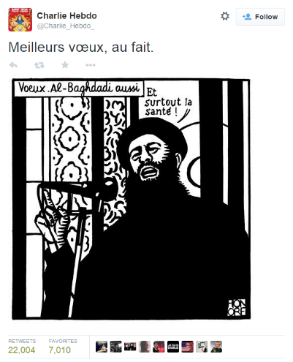
“On Wednesday morning, the French satirical paper Charlie Hebdo was attacked by three masked gunmen, armed with kalashnikovs, who stormed the building and killed ten of its staff and two police officers. The gunmen are currently understood to be Muslim extremists. This attack came minutes after the paper tweeted this drawing of ISIS leader Abu Bakr Al-Baghdadi.” (Appendix B, p. 73)
The first thing to notice, after having methodically analyzed The Abuse of Satire, is that the three assailants are given agency over the matter. The three masked gunmen “stormed the building and killed ten of its staff and two police officers”, Canfield writes, thereby identifying the agents and pointing them out as the perpetrators. In this equation there is no trigger which caused them to commit the massacre, but instead the text is simply stating the facts. Since the blog was written relatively shortly after the shooting, Canfield is hesitant to identify the perpetrators identity and motif, since it was not yet known at the time of publication. When Canfield writes that the attack happened minutes after a tweet with a drawing attached of ISIS leader Abu Bakr Al-Baghdadi, he makes no effort to suggest that the tweet was the reason for the attack. Rather, he just states the facts and shows the picture to the reader with the English translation written underneath.
Canfield goes on to describe how some people might find it wrong to criticize Charlie Hebdo so soon after the tragedy, and that it is better to make sure that their work is being propagated rather than silenced. However, Canfield disagrees:
“In this case, it is the wrong response.
Here’s what’s difficult to parse in the face of tragedy: yes, Charlie Hebdo is a French satirical newspaper. Its staff is white. (Update:Charlie Hebdo’s staff it not all white. See note below.) Its cartoons often represent a certain, virulently racist brand of French xenophobia. While they generously claim to ‘attack everyone equally,’ the cartoons they publish are intentionally anti-Islam, and frequently sexist and homophobic.” (Appendix B, p. 74)
Interestingly, Canfield is much blunter in his critique of Charlie Hebdo than Trudeau. Trudeau in The Abuse of Satire would often hints at CH using racism, for example by referencing hate speech laws, or by describing them as “punching downwards” against a “disenfranchised minority”, but never actually uses the word racism. Just in the one paragraph that I quoted here, Canfield uses several words and phrases with explicit racist connotations or references. “Its staff is white”, “virulently racist”, “French xenophobia”, “anti-islam”, “sexist”, and “homophobic” are all presented in just two sentences.
It feels a bit superfluous to say this, but Canfield is creating a distance between himself and Charlie Hebdo, where he tends to emphasize their bad priorities / actions and mitigating their good priorities / actions. In fact, applying Van Dijk and Fairclough’s terminologies in relation to bias in the text is unnecessary. The text is so clearly intended as a critique of Charlie Hebdo and their satirical modus operandi. The reason that I think the terminologies and methods of discerning bias in the example of The Abuse of Satire worked so well is because Trudeau is a lot more suggestive than Canfield in his speech. Canfield is tremendously unhindered and unabashed in his critique of CH. Therefore, to apply methodological tools to discern “hidden” bias in a text where the bias is so outspoken seems silly and misplaced.
After the above cited paragraph, Canfield gives several examples of what he considers to be offending cartoons published by CH. Interestingly, this time around he does not offer a translation of the cartoons, nor does he provide any context about the cartoons and when and why they were published. The only direct commentary on the cartoons is this:

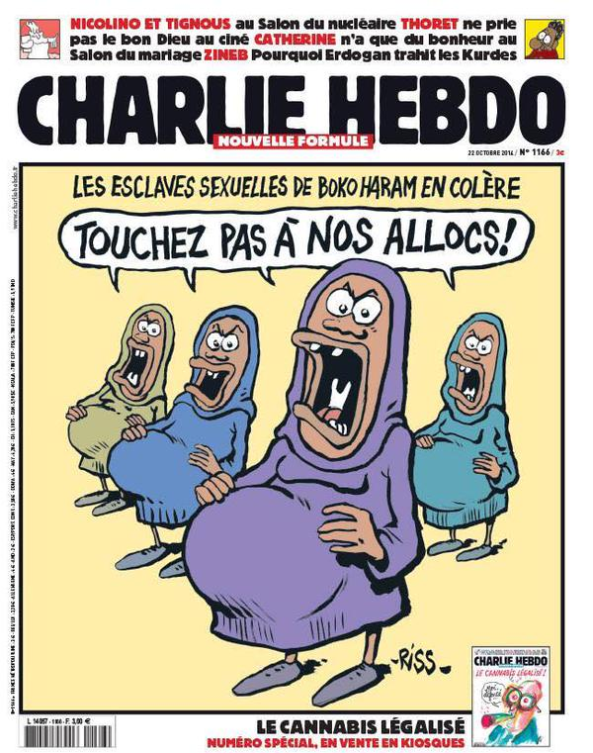
“(Yes, that last one depicts Boko Haram sex slaves as welfare queens.) [Referring to the cartoon on the right]
These are, by even the most generous assessment, incredibly racist cartoons. Hebdo’s goal is to provoke, and these cartoons make it very clear who the white editorial staff was interested in provoking: France’s incredibly marginalized, often attacked, Muslim immigrant community.” (Appendix B, p. 76)
In his analysis of the cartoons, Canfield operates with an us vs. them discourse where “us” represents “the good, valiant Westerners” and “them” represents the “evil, savage Muslims” (see page 76). Although Canfield operates within this dualism, he strongly resents the narrative, and he is disputing the legitimacy it. “Hebdo’s goal is to provoke”, Canfield writes, and is thus echoing Trudeau in the sentiment that CH’s satire’s main purpose is to provoke (in contrast to enlighten, elucidate, or challenge authority). Canfield believes that CH’s main goal was to provoke the marginalized, often attacked, Muslim immigrant community. Trudeau argues something similar when he says that CH has managed to provoke many Muslims throughout France to make common cause with its most violent outliers. Trudeau does not explicitly call it their main goal, but he does also hold that the general Muslim population is being attacked.
As I mentioned earlier, Canfield does not offer a translation or a historical context of the cartoons, although he does mention that the one cartoon is depicting Boko Haram sex slaves as welfare queens. For reference, I will look further into this cartoon on page 55. Because of the cartoons and the way Canfield interprets them, he calls Charb, the murdered editor, a racist asshole.
“Now, I understand that calling someone a ‘racist asshole’ after their murder is a callous thing to do, and I don’t do it lightly. This isn’t ambiguous, though: the editorial staff of Hebdo consistently aimed to provoke Muslims.
It can be argued that even using the word “racist” is an ad hominem attack used to derail an opponent’s argument. Canfield seeks to dismiss CH’s arguments and motifs based on the color of their skin. Instead of arguing why their cartoons are racist, and why their depiction of for example Boko Haram sex slaves is wrong, he launches a personal attack based on personal qualities. When Canfield calls Charb, not just a racist, but a “racist asshole” the ad hominem attack becomes clear. Canfield also makes fun of CH’s supposed “edgy-white-guy mentality” where nothing is sacred and everyone should just lighten up. “White men punching down is not a recipe for good satire, and needs to be called out”, he writes in a much angrier tone than Trudeau does. “The murder of the satirists in question does not prove that the satire was good. Their satire was bad, and remains bad. Their satire was racist, and remains racist” (Appendix B, p. 76). Once again, Canfield is not actually giving any examples or arguments as to why this is. The closest he is coming to presenting an actual argument is that punching down is not good satire. Canfield is dismissing CH’s cartoons on the basis of his own outrage over CH’s privilege.
When Canfield creates his arguments from outrage, there are two implicit premises which needs to be fulfilled in order for the audience to be persuaded by the argumentation: first of all, Canfield’s emotional sensibilities are roughly the same as the audience’s. Therefore, secondly, they must agree that when something makes Canfield angry or outraged, it must not be tolerated. If these two premises are achieved, the reader can follow Canfield’s argumentation. In the text, Canfield’s main source of outrage stems from CH’s privilege and their “punching down”. Thus, the reader must be equally enraged by CH’s cartoons, and agree that CH is indeed punching down on powerless minorities before they can agree with the text.
“Changing your twitter avatar to a drawing of the Prophet Muhammad is a racist thing to do, even in the face of a terrorist attack. The attitude that Muslims need to be ‘punished’ is xenophobic and distressing. The statement, “JE SUIS CHARLIE” works to erase and ignore the magazine’s history of xenophobia, racism, and homophobia.” (Appendix B, p. 78)
In the above quotation, Canfield goes beyond just criticizing CH. His discourse here can be seen as a sort of class stratification discourse, where everything a person does can be analyzed through a scope of class structure. An action such as changing your twitter avatar to a drawing of the Prophet Muhammad is not seen as a demonstration of freedom of speech, but rather as a racist tool to attack a minority class. The defense of one’s own value set is similarly seen as an overt attack on the entirety of another group or class of people. This description is indicative of a state of war between the two classes. By proclaiming #JeSuisCharlie, you are actively contributing to erase and ignore the magazine’s xenophobic, racist, and homophobic agenda. If you proclaim that you are Charlie, in the us vs. them paradigm you similarly proclaim that you are in opposition to the Muslims.

The NY Times Editorial
In the Wake of Charlie Hebdo and The Abuse of Satire are both commentaries on Charlie Hebdo as publications. The authors, Canfield and Trudeau, hold no actual power over juridical or political affairs. Their power lies in the ability to influence the debate and in swaying the discourse. Through their texts they can challenge the discursive hegemony, and thereby change the way people perceive world politics. The NY Times editorial is different than the previous two texts in the sense that Dean Baquet, the executive editor of the NY Times, holds the power to decide whether the NY Times should publish the offending cartoons of Muhammad in one of the most influential newspapers in the world. This decision will have major consequences because the publication of Muhammad has become a highly politicized activity. For a newspaper like the NY Times which has correspondents, reporters, and journalists all over the world, the decision can affect their work and how they are generally perceived. Margaret Sullivan, the public editor for the NY Times, approached Baquet on his decision not to publish the offending cartoons, and describes that: “They told him they would not feel endangered if The Times reproduced the images, he told me, but he remained concerned about staff safety.” (Appendix C, p. 82) Even though the reporters and editors of the international bureaus said they would not feel threatened if the NY Times were to publish the cartoons, Baquet still remained concerned about staff safety. However, it was not a question of safety which ultimately led to Baquet’s decision not to republish; it was religious sensitivity.
“Ultimately, he decided against it, he said, because he had to consider foremost the sensibilities of Times readers, especially its Muslim readers. To many of them, he said, depictions of the prophet Muhammad are sacrilegious; those that are meant to mock even more so. “We have a standard that is long held and that serves us well: that there is a line between gratuitous insult and satire. Most of these are gratuitous insult.” (Appendix C, p. 82)
Baquet argues that the NY Times has a long held standard not to publicize gratuitously insulting cartoons. Many commentators on the internet has questioned whether this was actually the case, and has dug up examples of the past where the NY Times has published images designed to offend. The New York based blog, Gawker, for example, found seven examples where they believe the NY Times published gratuitously racist cartoons (Trotter, 2015). Whether the NY Times is hypocritical on this matter or not is relevant to my thesis because it is important to distinguish between understanding of religious sensitivity and adherence to religious doctrine against the depiction of Muhammad. However, the scope of my thesis is already really wide, and so it would only serve to confuse the overall impression of my thesis. Moreover, a comprehensive analysis about a newspaper’s hypocrisy could well be a whole thesis report in itself. For my thesis, I suffice by saying that there are people on the internet who disagrees with Baquet’s assertion.
Baquet argues that if the NY Times were to publish any CH cartoon, they would have to show the very most controversial, so that people would know exactly what all the fuss is about. To post a mildly offensive cartoon would be misleading, he says: “Something like that is probably so compromised as to become meaningless.” The NY Times would have had to publish the most “incendiary” cartoon, so that people would know exactly why the Muslim world reacts so strongly towards them. In the editorial, very little effort is actually put into describing the CH cartoons, and why they are so offensive.
There are only three instances where Banquet speaks directly about the cartoons: when he contends that “depictions of the prophet Muhammad are sacrilegious; those that are meant to mock even more so.”, and when he argues that “there is a line between gratuitous insult and satire. Most of these are gratuitous insult” and finally by saying “You would have to show the most incendiary images”. In other words, you will have to take Baquet’s word that the cartoons are sacrilegious and too insulting and incendiary to be published.
It is difficult to discuss how and why a cartoon is racist if you cannot show it, and as such it makes sense that Baquet is unable to describe CH’s supposed racism. In the following section I will take a closer look at some of the most talked about and controversial CH cartoons, with a particular focus on satirical approach and the depiction of Muslims.

The Charlie Hebdo Cartoons
It is a difficult task to choose which cartoons to analyze due to the fact that the negative portrayals of Charlie Hebdo tend to speak in very general terms and not mention specific cartoons that are racist and offensive. Nevertheless, there are some cartoons which has been referenced several times around the internet as being particularly offensive and controversial. In the following, I will be analyzing a selected few with special emphasis on dissecting the satirical message and political motif therein. Following the post-structural perspective, it is crucial to point out that my interpretation is not necessarily the “correct” one, nor will everyone see it the way I see it, but I base my interpretation on the theoretical perspectives that I have presented in my thesis so far. Thus, my interpretation is a construct of the carefully selected theories and methodologies I have chosen to incorporate for my project.

Boko Haram Sex Slaves
One of the most often used example of offensive and controversial satire made by Charlie Hebdo, is this cartoon cover depicting Boko Haram sex slaves as welfare queens.
The image is featured in Canfield’s In the Wake of Charlie Hebdo as well as many other critical articles of CH’s satire. The headline of the cover says: “BOKO HARAM’S SEX SLAVES ARE ANGRY” and the women in the picture are saying “DON’T TOUCH OUR BENEFITS”.
In order to understand this cartoon, one must know the historical context of the cartoon. There are two stories intertwined into the cartoon, namely the kidnapping of school girls in Nigeria by the militant and self-professed Islamist movement Boko Haram, who it was reported was likely going to end up as sex slaves. Secondly, the ongoing debate about child benefits in France is also invoked (Troup, 2015) (McPartland, 2015).
The girls on the picture are, in lack of better words, hideous and repulsive. They are drawn in such an unappealing manner that when you look at them you cannot help but to resent them. Their noses are drawn to look unnaturally long and flat, their eyes are wide open, and their eyebrows are quirked in an angry fashion; their mouths are open to such a degree that you can imagine them shouting and they are missing several of their teeth. Even their pregnant stomachs are drawn to look unpleasant. The only thing that differentiates the girls is the color of their hijab. They even share the same text bubble!
Needless to say, this is a very unflattering representation of the kidnapped Nigerian girls. The fact that it is the color of their hijab that is the only individual characteristic of the girls, gives the impression that the girls’ only form of identity lies in the hijab. As a signifier, the hijab signifies a primitive culture where women are repressed and not allowed to show their body and hair. When you put the cartoon in relation to the proposed change in how child benefits are distributed throughout France, it invokes an ugly image: the sex slaves are complaining about changing the welfare system in France, so that if, or when, they get accepted as refugees in France, they will abuse their state benefits. In France, like many other countries, you get increased child-support by the state with every baby you give birth to. This is the reason why the concept of welfare queens persists in many countries, where mothers will give birth to several children for the sole purpose of receiving more benefits. Thus, the speech bubble anchors towards an interpretation of the cartoon where the girls are coming to France to squeeze out babies and reap state benefits. This is also why Canfield writes “Yes, that last one depicts Boko Haram sex slaves as welfare queens.” (Appendix B, p. 75).
However, I will argue that the cover cartoon is an example of what Muradi and Hughey calls the economy of hyper-irony and manic-satire (see page 10). I do not believe that Charlie Hebdo genuinely wishes to depict the Nigerian sex slaves in such a negative light. The absurdity of the claim that the kidnapped girls are only thinking about ways to reap state benefits is so ridiculous and bizarre that one must assume that CH are mocking another narrative. Muradi and Hughey gives the example of the movie Team America, where the Middle-Eastern population is depicted in a very similar fashion as the Nigerian sex slaves. Muradi and Hughey argue that this unflattering depiction should be seen as a commentary on the mass media narrative. As such, the CH cartoon can be seen as mocking the French far-right nationalist party, Front National who are often highly critical towards the Muslim population of France and other countries.
The unflattering and racist depiction of the girls similarly makes more sense when seen in this light. CH is not trying to say that this is an actual representation of how the Nigerian sex slaves look, but rather that the narrative that Front National is using is painting Muslims in such a distasteful way that this is probably how they think of them. The fact that their only individual characteristic is the hijab becomes a commentary on how Front National only sees Muslim women as different types of walking cloaks, and not individual persons. Thus, CH is not criticizing any parts of the Muslim population – in or outside France - but the far-right politicians of France. Of course, this does not mean that the cartoon is exempt of a discussion about racism. As Muradi and Hughey argue, the extreme form of mockery that is characteristic of the economy of hyper-irony and manic-satire can work to imitate and reproduce the racism that they are protesting against in the first place. CH certainly makes no effort to counter the narrative with a more sophisticated view on this cover cartoon.

The Quran is Shit
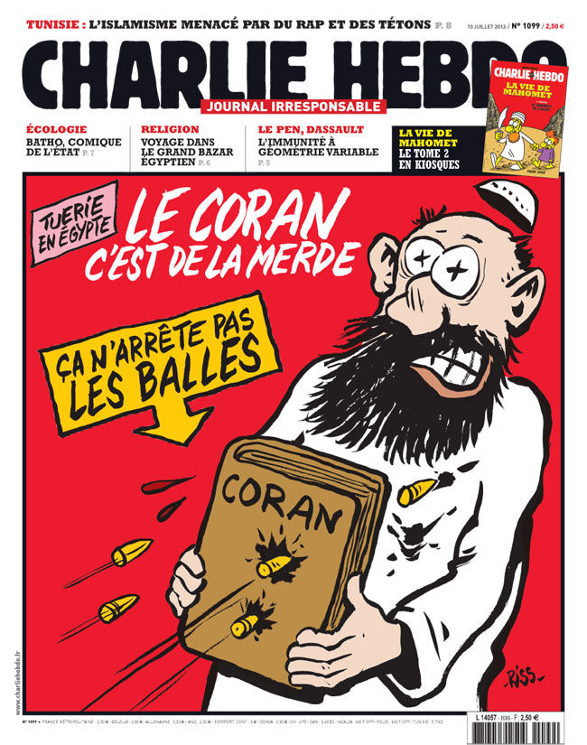
Another example that is often invoked in the discussion about CH’s supposed racism is this one featuring a Muslim Brotherhood militant holding the Quran as a shield.
The pink label says: “KILLINGS IN EGYPT”. The white text says: “THE QURAN IS SHIT” and the yellow label says “IT DOESN’T STOP BULLETS”.
The cartoon refers to the crackdown of the Muslim Brotherhood after President Morsi’s removal from power in 2013. Muslim Brotherhood supporters would occupy various squares and set up camps around the country in protest. As a reaction, the military organized raids to dismount the protests, and violence occurred, resulting in hundreds of deaths and the majority of the Muslim Brotherhood leaders in custody (Hubbard, 2013).
Holding up the Quran in this context symbolizes the concept of covering behind your religion. In the most literal meaning, as depicted on this cartoon, it holds true that a book does not stop bullets. In a metaphorical sense however, the Muslim Brotherhood were no longer successful in holding up the Quran as justification for their authority in Egypt. The Egyptian coup d’état of July 2013 removed the Muslim Brotherhood from power following four days of widespread national protests when a coalition with the backup from the military managed to remove president Morsi from power.
As such, the bullets penetrating the Quran can also be seen as the Egyptian population fighting against a government quasi-theocracy. The linguisitic message: “THE QURAN IS SHIT” in the basic sense means that the Quran sucks because it does not deflect bullets. However, knowing CH and their standpoint on religion, they will argue that the Quran also sucks as the basis for a religion.
The cartoon owes much of its impact to shock value. The depiction of a Muslim Brotherhood supporter getting shot is extremely morbid and unexpected as a cover cartoon. However, looking at the cartoon without incorporating the text is to ignore the full meaning of the cartoon, or as Barthes call it, the relay. Without knowing what the text means and being unfamiliar with the historical context of the cartoon, the morbid image of a Muslim Brotherhood supporter getting shot is extremely shocking. However, knowing the historical context also lets the viewer observe the metaphor of the secondary meaning of using the Quran as a shield.
For this cartoon, and most other CH cartoons for that matter, it is difficult to apply Raskin’s semantic script-theory of humor. The reason for this is that the SSTH is meant to be applied to simple spoken jokes. CH’s cartoons have no clear temporal phases, such as a setup, incongruity, or resolution, which therefore makes it problematic to speak of how and where incongruity is evident. However, there is a clear opposition in many of CH’s cartoons about the literal message and the connoted message. In The Quran is Shit, the literal message of a Muslim Brotherhood supporter getting shot is shocking and morbid. However, when you take into account the anchorage of the pink banner: “KILLINGS IN EGYPT” and understand the historical context of the cartoon, you are presented with enough information to create your own meaning outside of the literal message.
You can interpret the Quran in the cartoon as the signifier for various signified interpretations. Shielding yourself behind the Quran can have a literal message and a connoted message. The literal message is that the Quran is a book and therefore it gets penetrated by bullets. The connoted message depends on the conceptualization of the audience. One possible conceptualization, from a secular viewpoint, is that the Quran represents holiness and divinity. Therefore, when the Muslim Brotherhood supporter is shielding himself by hiding behind his holiness and divinity and still dies, it can be seen as a commentary on the fallaciousness of religious glorification – Their asserted position as holier than everyone else gets penetrated and exposed after the realization that the Quran, in the end, is just a book.
Using Raskin’s SSTH, the Quran has two opposing scripts in this sense: the literal interpretation and the metaphorical understanding. In the literal interpretation, the Quran is used as a shield, and in the metaphorical understanding the Quran is a symbol of religious superiority. The incongruity between these two scripts can be seen both through lexical items in the literal message, as well as through semantic signifiers.
Bullets can be understood literally as the bullets used by the Egyptian military to shoot at Muslim Brotherhood occupiers. However, the bullets can also be understood as metaphors for the tangible, physical world penetrating the fabricated divinity of the Quran. The cartoon is difficult to decode in relation to the temporal phases of the joke. However, one can argue that the first thing that a person will notice when seeing the cartoon for the first time is the Muslim being shot. This is the setup, where CH is invoking a false script in the audience’s eyes. Incongruity occurs when the audience sees the context of the shooting. If the audience understands the historical context and shares the same secular ideology as CH, then they can create the resolution in their mind.

A Star is Born!
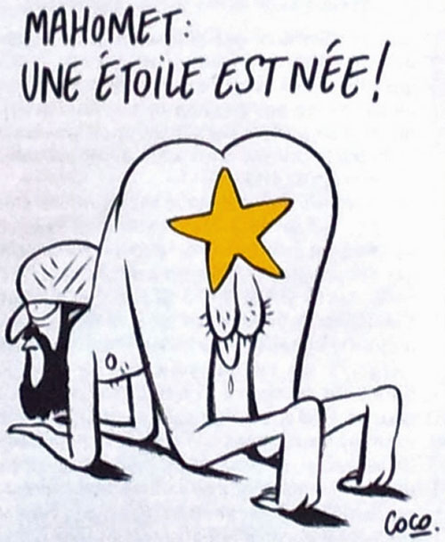
This cartoon serves as a good example of how Charlie Hebdo uses satire to strip religion from its sanctity. The headline reads: “MUHAMMAD: A STAR IS BORN!” Trudeau and Canfield argues in their texts that CH in their critique of Islam is only interested in provoking. This is probably one of the most provocative cartoons of CH’s library, yet I will still argue that the cartoon is more than just ridicule for the sake of ridicule, cf. Muradi and Hughey.
Islam shares the creation myth of Judaism and Christianity, where God is gradually creating everything on earth over the course of a week. This cartoon mocks the idea of creationism, by presenting the idea that Muhammad is forming the stars butt naked. Muhammad is depicted in a very non-authoritative position as he appears to be creating the stars through his butthole. The fact that the stars are coming out of his butthole connotes the idea that the stars in space are in fact Muhammad’s defecation. This demystification of the creation myth serves to expose the absurdity of the myth in a very derogative manner. Muhammad’s sitting position is the one you take when you are on the receiving end of a doggy-style sex position, which is often passive and submissive, while the other partner is active and dominant, hence, Muhammad appears weak and pathetic.
Zoe Williams posits that one of the greatest tool against self-significance and self-regarding statements is irony. “Irony can deflate a windbag in the way that very little else can”, she argues. Islam as a religion makes many claims about absolute truths and unconditional certainties. These claims are often based primarily on faith, and as such are difficult to argue against through logic. The absurdity of Muhammad creating stars as depicted in this cartoon allows CH to criticize the creation myth without being dragged into a debate characterized by faith and self-significance.
I believe that this cartoon can easily be considered very offensive by Muslims of great faith, since their prophet is shown in such a negative and pathetic light. However, the commentary, as seen through a satirical perspective, is not punching down on disenfranchised and powerless Muslims in France or anywhere else in the world. The commentary is countering the narrative held by many Muslims, that they know the absolute truth of the universe and that their religion is the greatest.

Muhammad Overwhelmed by the Fundamentalists
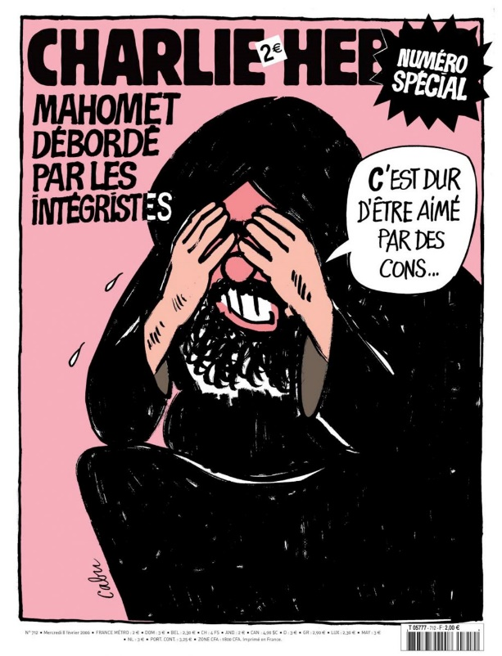
One argument that is often applied towards CH, is that they are attacking the Muslim minority population in France. At first glance, this cartoon could seem like an example of this, since Muhammad is seen covering his head, saying: “IT’S TOUGH BEING LOVED BY IDIOTS”. However, the text to the left says: “MUHAMMAD OVERWHELMED BY THE FUNDAMENTALISTS”, thereby relaying the information that Muhammad is not speaking of all Muslims as a group, but the fundamentalists who commits violence and other evils in his name.
The cartoon also plays around with the idea of whether it is okay to depict Muhammad if he is holding his hands over his head so that one cannot see his eyes and facial characteristics. The only reason that the viewer knows that this person is Muhammad is because the literal message anchors towards the interpretation that it is him. On page 30, I debated whether The Treachery of the Images actually depicted a pipe or not. In a similar vein, you can debate whether this image actually shows Muhammad or not. The literal message explains that it is Muhammad, but we cannot see his eyes or his facial structure. So how do we know it is actually him? What if there was no literal message, or if the text instead said “This is not Muhammad”?
Roland Barthes argues in The Death of the Author that an author with a discernable intention is a fictional construct. The text or work of art has no single purpose or single meaning. It is the reader who interprets the text and thereby gives ultimate meaning to the text. If this is so, then how can CH be responsible for the cartoons?
The answer is that all these questions and hypotheticals are uncovering the ambiguity of the strict restriction not to depict the prophet Muhammad that some Muslims adhere to. But the questions also reveal the important theme about meaning and how it is created, and who is responsible for this meaning if it is a controversial one. In the following I will discuss this theme in relation to my problem formulation and the analysis I have made for the three texts and the CH cartoons.

Fairclough’s Third Dimension
Although I call this section Fairclough’s third dimension, this is the part of the analysis where I will summarize my findings and discuss them in a socio-cultural context. I will compare and contrast how Trudeau, Canfield, and The NY Times describes the role of responsible satire in this day and age. I will also compare their views on Charlie Hebdo as a racist publication. After this I will examine how congruent the negative portrayals of CH are with my analysis of CH. This comparison will incorporate parts of my theoretical data which I presented earlier in my thesis, such as: the death of the author, the end of the age of irony, satire and ideology, and relativism.
Charlie Hebdo and Racism
Trudeau never uses the word racism to describe CH, although he strongly insinuates that they are engaging in a racist discourse. Trudeau uses the expression “punching downward” several times throughout the text, which can be understood as a euphemism for racism. However, Trudeau’s speech is generally very articulate and poetic in nature, so his criticism sounds less hostile than Canfield’s for example. That is not to say that Trudeau is holding back in his critique, but rather that he is less aggressive in his tone. There are places in the speech where it can look like Trudeau is suggesting that CH had it coming for them because of their long held activity of punching downwards against a disenfranchised minority.
Canfield is much more aggressive and hostile than Trudeau is. His text shares many of the same themes of Trudeau’s, but he presents them in such an angry tone that he sounds outraged at the whole ordeal. Like Trudeau, Canfield interprets CH’s cartoons as targeting the general French Muslim community. Canfield is making a big deal out of portraying CH as the elitist white male-dominated publication creating racist imageries against the Muslims. Thus, he portrays a class war between the privileged white people and the underprivileged Muslims.
Baquet, the executive editor at the NY Times, calls the most controversial CH cartoons incendiary, insulting, and sacrilegious. Baquet does not imply anything about which part of the population CH’s cartoons are targeting, but suffices to say that part of the Muslim community will get offended by some of the cartoons.
In my analysis of some of the most controversial cartoons, I did not find any examples of CH targeting the French Muslim community in particular. Unless you consider drawing Muslims in a classic caricature fashion as racist, I did not find any examples of CH cartoons explicitly targeting the French Muslim community. Sure, CH made fun of, and lampooned to a great extent, the Prophet Muhammad and other parts of Islam, but the satirical commentary and the target of the cartoons never seemed to be directed at the average Muslim. Instead, they focus on Islam extremists, and on silly Islam doctrines such as the creation myth.
Following the post-structural thought, it goes that the author’s intended meaning is a fictional construct, and that it is ultimately the reader who creates the final, actual meaning of a text. This concept becomes blurred when put in relation to the Islamic doctrine of prohibition from depicting the Prophet Muhammad. If the real author of a text is the reader, then who is to blame for depicting Muhammad? Surely, it cannot be Charlie Hebdo, since they just drew the signifiers. The real meaning is created inside the head of the reader, when they interpret the signifiers to mean something based on their social legacy, cultural environamen, and pre-existing knowledge.
In the same sense, when Trudeau, Canfield, and Baquet criticizes CH for punching down on a repressed minority, this is only their interpretation of the cartoons. Their interpretation is neither correct nor wrong, but just examples of unique interpretations of the cartoons, based on their world views. As I have showed in my analysis, there is often an incongruence in how Trudeau, Canfield, and Baquet portray CH, and how I perceive them, seen through a theoretical, satirical world view.
This inconsistency in interpretation demonstrates why the debate about publishing the controversial CH cartoons is necessary. Trudeau, Canfield, and Baquet all mention, either implicitly or explicitly, that the depiction of Muhammad is sacrilegious according to some interpretations of Islam faith, however, their focus is to a large degree placed on the religious sensitivity of Muslims, and on how CH is obtusely provoking their sensibilities. The critique of CH as a racist publication is extensive, but in the three examples I have analyzed here, the negative portrayals are not giving concrete examples on how and why they are racist – the reader is simply supposed to believe the person when he says so. The closest example of a text trying to understand the CH cartoons is found in Canfield’s text where he explains the Boko Haram cartoon in one sentence.
The texts are criticizing CH based solely on the literal message of the image. Canfield only provides the translation to one of the CH cartoons that he is presenting in his text, and he makes no effort to put the cartoons into an historical context. Trudeau speaks in inexplicit terms, and does not provide any examples of any racist CH cartoons. Finally, Baquet argues that the worst cartoons are incendiary, insulting, and sacrilegious, but ultimately chooses that it would be inappropriate for the reader to actually see the cartoons in question. Post-structural theory posits that there is no correct or exact meaning related to the interpretation of a text, but is it not possible that there are some interpretations that are more informed and historically acquainted than others, and should therefore be held to a higher regard? The three texts in question bases their “punching down” arguments solely on personal convictions, and as such depends on the audience’s ignorance to follow their argumentation.
Roland Barthes’ The Death of the Author argues that the post-structural rejection of the author’s identity and intention has resulted in the metaphorical death of the author. This theme takes on added meaning when the radical interpretation of Charlie Hebdo’s cartoons provokes a few Muslim extremists to cause the morbidly literal death of the authors.
Perhaps the three texts are the product of a time and place where the topic of challenging Islam has exceeded the use of irony. Irony’s greatest purpose, with regard to politics and society, is to deflate emotionally laden rhetoric. And since there are few greater claims to authority and divinity than those of religion, it should mean that irony is the perfect counter response. However, due to the nature of religion and the sensitivity of its followers, there is also no greater catalyst for conflict.
The three texts are well aware that there are dangers of conflict involved with the depiction and publication of Muhammad, and as such they are reluctant to involve themselves with this practice. However, as a researcher, I wish the three texts were clearer in their distinction between the critique of Charlie Hebdo as a racist publication and the critique of Charlie Hebdo as a publication that dares to draw and publish cartoons with Muhammad on them. The immense focus on class war that is evident in Trudeau and Canfield’s texts only serves to deflect the concrete issue related to the Islamic doctrine of prohibition from drawing Muhammad.

Conclusion
Garry Trudeau’s The Abuse of Satire, Jacob Canfield’s In the Wake of Charlie Hebdo, and Dean Banquet’s comments in Margaret Sullivan’s Close Call on the Publication of Charlie Hebdo Cartoons share many themes and rhetorical tools. They all focus on the incendiary aspect of the cartoons, and how it can be considered irresponsible to publish the cartoons, considering the fact that there is a real danger that Muslim extremists will retaliate through violence. Trudeau and Canfield’s texts in particular focuses heavily on the violent effect of the cartoons, and how the authors of the cartoons should also be held responsible for the effects that their cartoons provoke. A common theme throughout Canfield and Trudeau’s texts is the concept of privileged white men punching down on underprivileged and disenfranchised Muslims in France. Baquet’s justification for not publishing the cartoons is entirely based on his own convictio, and he does not provide as many elaborations on CH’s supposed racism in his description.
In my analysis of the Charlie Hebdo cartoons, I found that the publication often engages in extreme forms of caricature of, for example, the French far-right nationalist party, Front National. Whether the cartoons are actually racist or not is difficult to assess, since it is largely a subjective question. However, in my analysis, I found that when looking at the cartoons from a theoretical satirical world view, the cartoons related to Islam appear to be targeting predominantly Muslim extremists and lampooning ridiculous ideas about religion in general. If you do not know and understand the historical and cultural context, as well as the French language, it can be very difficult to decode the cartoons. As such, without the proper knowledge, the cartoons can easily appear racist. One can argue that even when you know the language, context, etc. the cartoons are still racist. The fact that Charlie Hebdo draws their characters in such a degrading and humiliating fashion can serve to stigmatize racist pictures in the minds of the audience.
Ultimately, I argue that a major implication of describing Charlie Hebdo as a racist publication is that it can serve to deflect the debate away from the concrete issues towards more superficial issues. The now deceased Charlie Hebdo cartoonists maintained their right to draw whatever they wanted to; they refused to be censored on the basis of threats of violence. I argue that it is important that if commentators wish to criticize Charlie Hebdo for being a racist institution, they should give concrete examples of how and why they were racist. By being transparent in their critique it would be easier for the audience to know what they were referring to, and consequently, the audience can have an easier time to make their own assessments. In the end, the problem lies in the fact that the depictions of Muhammad are offensive to many Muslims in and of itself, and therefore, it becomes difficult to have a transparent debate on the subject. In the end, I believe commentators should value the transparency of their discourse over the religious sensitivity of Muslims in their critique – only then will the debate actually matter.

Bibliography

Internet Resources

www.whitehouse.gov
http://georgewbush-whitehouse.archives.gov/news/releases/2001/09/20010920-8.html - Entered on May 30th

www.cnn.com
http://edition.cnn.com/TRANSCRIPTS/0410/15/cf.01.html - Entered on May 30th

www.npr.org
http://www.npr.org/templates/story/story.php?storyId=6053478 - Entered on May 30th

www.theonion.com
http://www.theonion.com/articles/report-gen-x-irony-cynicism-may-be-permanently-obs,3299/ - Entered on May 30th

Authors:

Barthes, R. (1980)
Barthes, R. (1980). ‘The Rhetoric of The Image’ In A. Trachtenberg (Ed.), Classic Essays on Photography (pp. 269–285). Stony Creek: Leete’s Island Books.

Beech, D. (2015)
Beech, D. (2015) ‘Je Suis Charlie Trends as People Refuse to be Silenced’ www.mirror.co.uk Retrieved May 30th from http://www.mirror.co.uk/news/world-news/je-suis-charlie-trends-people-4935086

Berlatsky, N. (2015)
Berlatsky, N. (2015) ’Utilitarian Review 1/10/15’ www.hoodedutilitarian.com Retrieved May 30th from http://www.hoodedutilitarian.com/2015/01/utilitarian-review-11015/

Bruner, J, (1991)
Bruner, J. (1991), ‘The Narrative Construction of Reality’, The University of Chicago Press

Bryman, A. (2008)
Bryman, A. (2008). ‘Social research methods’, Oxford: Oxford University Press, 3rd edition

Cavna, M. (2015)
Cavna, M. (2015). ‘Of Trudeau and Hebdo: How 15 top cartoonists really feel about satirical ‘red lines’, www.washingtonpost.com Retrieved May 30th from http://www.washingtonpost.com/news/comic-riffs/wp/2015/04/14/of-trudeau-and-hebdo-how-15-top-cartoonists-really-feel-about-satirical-red-lines/

Coleman, S. (2005)
Coleman, S. (2005) ‘Blogs and the new political listening’, The Political Quarterly,
vol. 76, no. 2, pp. 272–280.

Delanty & Strydom, 2003, 323
Delanty, G. & Strydom, P. (2003). ‘Philosophies of social science: The classic and contemporary readings. Philadelphia’, PA: Open University Press.

Derrida, J. (1997)
Derrida, Jacques (1997), ‘Of Grammatology’, Baltimore: The Johns Hopkins University Press

Fairclough, N. (1992)
Fairclough, N. (1992) ‘Discourse and Social Change’ Cambridge: Polity (p. 259). Cambridge: Polity Press
Fairclough, N. (2001)
Fairclough, N. (2001), ‘Language and power’ 2nd edition. Harlow: Pearson Education Limited

Frum, D. (2015)
Frum, D. (2015). ‘Why Garry Trudeau is Wrong About Charlie Hebdo’ www. Theatlantic.com retrieved May 30th from http://www.theatlantic.com/politics/archive/2015/04/why-garry-trudeau-is-wrong-about-charlie-hebdo/390336/

Goldman, D. (2015)
Goldman, D. (2015) ’#JeSuisCharlie Becomes One of the Most Popular Hashtags in Twitter’s History’ www.cnn.com Retrieved May 30th from http://money.cnn.com/2015/01/09/technology/social/jesuischarlie-hashtag-twitter/index.html

Guba, E.G. (1990)
Guba, E.G. (1990). ‘The alternative paradigm dialog’, Newbury Park, CA: Sage, 17-27

Guba, E.G. & Lincoln, Y.S. (2004)
Guba, E.G. and Lincoln, Y.S. (2004). ‘Competing paradigms in qualitative research: Theories and issues’. In Hesse-Biber, S. & Leavy, P. (Eds.) Approaches to qualitative research. A reader on theory and practice. New York: Oxford University Press, 17-39

Hornbech, B. R. (2015)
Hornbech, B.R. (2015 ‘Hvorfor Står Vi Så Fast På Retten Til at Håne og Spotte Profeten?” www.politiken.dk Retrieved May 30th from http://politiken.dk/debat/debatindlaeg/ECE2549354/hvorfor-staar-vi-saa-fast-paa-retten-til-at-haane-og-spotte-profeten/

Hubbard, B. (2013)
Hubbard, B. (2013) ‘Mayhem in Cairo as Morsi Backers Fight for Return’ www.nytimes.com Retrieved May 30th from http://www.nytimes.com/2013/07/06/world/middleeast/egypt.html

Hughey, M.W. & Muradi, S. (2009)
Hughey, M.W. & Muradi, S. (2009) ‘Laughing Matters: Economies of Hyper-Irony and Manic-Satire in South Park and Family Guy’, Humanity and Society vol. 33, no.3, pp. 206-237.

Jørgensen, M. & Phillips, L.J. (2002)
Jørgensen, M. & Phillips, L.J. (2002), ’Discourse analysis as theory and method’, London: SAGE Publications

Kakutani, M. (2011)
Kakutani, M. (2011) ’Outdone by Reality’ www.nytimes.com Retrieved May 30th from

Kellner, D. (1995)
Kellner, D. (1995), ’Media Culture: Cultural Studies, Identity and Politics Between the Modern
and the Postmodern’, London and New York: Routledge.

Lamarre, H.L. et al. (2009)
Lamarre, H.L., Landreville, K.D., Beam, M.A. (2009) ’The Irony of Satire’, International Journal of Press/Politics, vol. 14, no. 2, pp. 212-228.

Love, B. (2012)
Love, B. (2012) ’No Regrets for French Cartoonists in Muhammad Storm’ www.reuters.com Retrieved May 30th from http://www.reuters.com/article/2012/09/19/film-protests-charlie-idUSL5E8KJE6320120919

McPartland, B. (2015)
McPartland, B. (2015) ‘France to Cut Child Benefit for Most Well-Off’ www.thelocal.fr Retrieved May 30th from http://www.thelocal.fr/20141017/france-to-cut-family-allowances-for-most-well-off

Olmstead, K. et al.(2011)
Olmstead, K., Mitchell, A., & Rosenstiel, T. (2011). ‘Navigating News Online: Where People Go, How They Get There And What Lures Them Away’. Pew Research Center Project, pp. 1-30

Rapley, T. (2007)
Rapley, T. (2007). Doing Conversation, Discourse and Document Analysis. London: Sage Publications Ltd.

Raskin, V. (1985)
Raskin, V. (1985) ‘Semantic Mechanisms of Humor’ Doordrecht: D. Reidel Publishing Company

Rose, F. (2005)
Rose, F. (2005) ‘Muhammeds Ansigt’, www.jp.dk Retrieved may 30th from http://multimedia.jp.dk/archive/00080/Avisside_Muhammed-te_80003a.pdf

Saussure, F. (1983)
Saussure, Ferdinand de (1983): ‘Course in General Linguistics’, London: Duckworth

Schank, R. & Abelson, R.P. (1977)
Schank, R. & Abelson, R.P. (1977) ’Scripts, Plans, Goals, and Understanding’ New York: Simon and Schuster

Schuessler, J. (2015)
Schuessler, J. (2015) ‘Charlie Hebdo Attack Chills Satirists and Prompts Debate’ www.nytimes.com Retrieved May 30th from http://www.nytimes.com/2015/01/10/arts/an-attack-chills-satirists-and-prompts-debate.html?_r=0

Silverman, D. (2006)
Silverman, D. (2006) ‘Interpreting Qualitative Data’ (Third ed.). London: Sage Publication Ltd.

Sleeper, J. (2015)
Sleeper, J. (2015), ‘Right-Wing Media’s Big Con’ www.salon.com Retrieved May 30th from http://www.salon.com/2015/05/05/right_wing_medias_big_con_why_privileged_powerful_conservatives_pretend_they%E2%80%99re_underdog_insurgents/

Stewart, B. (2001)
Stewart, B. (2001) ‘Cartoonists Find Issues for Humor’ www.nytimes.com Retrieved May 30th from http://www.nytimes.com/2001/11/05/business/media-cartoonists-find-issues-for-humor.html

Strickler, L. (2015)
Strickler, L. (2015) ‘Homegrown Terror Threat Higher in Europe than U.S., Academics Say’ www.cbsnews.com Retrieved May 30th from http://www.cbsnews.com/news/homegrown-terror-threat-higher-in-europe-than-united-states-academics-say/

Trotter, J.K. (2015)
Trotter, J.K. (2015) ‘7 Offensive Images The New York Times Wasn’t Afraid to Publish’ www.gawker.com Retrieved May 30th from http://gawker.com/7-offensive-images-the-new-york-times-wasn-t-afraid-to-1678338658?utm_campaign=socialflow_gawker_twitter&utm_source=gawker_twitter&utm_medium=socialflow

Troup, S. (2015)
Troup, S. (2015) ’21 Girls in Nigeria Still Missing’ www. Foxnews.com Retrieved May 30th from http://www.foxnews.com/world/2014/06/23/nigeria-says-21-girls-in-boko-haram-kidnapping-still-missing/

Van Dijk, T.A. (1998)
Van dijk, T.A. (1998), ‘Ideologies: A Multidisciplinary Approach’, California: SAGE publications

Van Dijk, T.A. (2007)
Van Dijk, T.A. (2007) ‘Critical Discourse Analysis’, in Discourse and Power: Contributions to Critical Discourse Studies, pp. 108–25. Houndmills: Palgrave/Macmillan.

Wall, M. (2005)
Wall, M. (2005) ‘Blogs of war: weblogs as news’, Journalism: Theory, Practice & Criti-
cism, vol. 6, no. 2, pp. 153–172.

Williams, Z. (2003)
Williams, Z., 2003, ‘The Final Irony’, www.theguardian.co.uk Retrieved may 14th from http://www.theguardian.com/theguardian/2003/jun/28/weekend7.weekend2

Winokur, J. (2013)
Winokur, J. (2013). ’The Big Book of Irony’. St. Martin’s Press

Appendices

Appendix A
The Abuse of Satire
Garry Trudeau on Charlie Hebdo, free-speech fanaticism, and the problem
- APR 11, 2015
My career—I guess I can officially call it that now—was not my idea. When my editor, Jim Andrews, recruited me out during my junior year in college and gave me the job I still hold, it wasn’t clear to me what he was up to. Inexplicably, he didn’t seem concerned that I was short on the technical skills normally associated with creating a comic strip—it was my perspective he was interested in, my generational identity. He saw the sloppy draftsmanship as a kind of cartoon vérité, dispatches from the front, raw and subversive.
Why were they so subversive? Well, mostly because I didn't know any better. My years in college had given me the completely false impression that there were no constraints, that it was safe for an artist to comment on volatile cultural and political issues in public. In college, there's no down side. In the real world, there is, but in the euphoria of being recognized for anything, you don't notice it at first. Indeed, one of the nicer things about youthful cluelessness is that it's so frequently confused with courage.
In fact, it’s just flawed risk assessment. I have a friend who was the Army’s top psychiatrist, and she once told me that they had a technical term in the Army for the prefrontal cortex, where judgment and social control are located. She said, “We call them sergeants.”
In the print world, we call them editors. And I had one, and he was gifted, but the early going was rocky. The strip was forever being banned. And more often than not, word would come back that it was not the editor but the stuffy, out of touch owner/publisher who was hostile to the feature.
For a while, I thought we had an insurmountable generational problem, but one night after losing three papers, my boss, John McMeel, took me out for a steak and explained his strategy. The 34-year-old syndicate head looked at his 22-year-old discovery over the rim of his martini glass, smiled, and said, “Don’t worry. Sooner or later, these guys die.”
Well, damned if he wasn’t right. A year later, the beloved patriarch of those three papers passed on, leaving them to his intemperate son, whose first official act, naturally, was to restore Doonesbury. And in the years that followed, a happy pattern emerged: All across the country, publishers who had vowed that Doonesbury would appear in their papers over their dead bodies were getting their wish.
So McMeel was clearly on to something—a brilliant actuarial marketing strategy, but it didn’t completely solve the problem. I’ve been shuttled in and out of papers my whole career, most recently when I wrote about Texas’s mandatory transvaginal probes, apparently not a comics page staple. I lost 70 papers for the week, so obviously my judgment about red lines hasn’t gotten any more astute.
I, and most of my colleagues, have spent a lot of time discussing red lines since the tragedy in Paris. As you know, the Muhammad cartoon controversy began eight years ago in Denmark, as a protest against “self-censorship,” one editor’s call to arms against what she felt was a suffocating political correctness. The idea behind the original drawings was not to entertain or to enlighten or to challenge authority—her charge to the cartoonists was specifically to provoke, and in that they were exceedingly successful. Not only was one cartoonist gunned down, but riots erupted around the world, resulting in the deaths of scores. No one could say toward what positive social end, yet free speech absolutists were unchastened. Using judgment and common sense in expressing oneself were denounced as antithetical to freedom of speech.
And now we are adrift in an even wider sea of pain. Ironically, Charlie Hebdo,which always maintained it was attacking Islamic fanatics, not the general population, has succeeded in provoking many Muslims throughout France to make common cause with its most violent outliers. This is a bitter harvest.
Traditionally, satire has comforted the afflicted while afflicting the comfortable. Satire punches up, against authority of all kinds, the little guy against the powerful. Great French satirists like Molière and Daumier always punched up, holding up the self-satisfied and hypocritical to ridicule. Ridiculing the non-privileged is almost never funny—it’s just mean.
By punching downward, by attacking a powerless, disenfranchised minority with crude, vulgar drawings closer to graffiti than cartoons, Charlie wandered into the realm of hate speech, which in France is only illegal if it directly incites violence. Well, voila—the 7 million copies that were published following the killings did exactly that, triggering violent protests across the Muslim world, including one in Niger, in which ten people died. Meanwhile, the French government kept busy rounding up and arresting over 100 Muslims who had foolishly used their freedom of speech to express their support of the attacks.
The White House took a lot of hits for not sending a high-level representative to the pro-Charlie solidarity march, but that oversight is now starting to look smart. The French tradition of free expression is too full of contradictions to fully embrace. Even Charlie Hebdo once fired a writer for not retracting an anti-Semitic column. Apparently he crossed some red line that was in place for one minority but not another.
What free speech absolutists have failed to acknowledge is that because one has the right to offend a group does not mean that one must. Or that that group gives up the right to be outraged. They’re allowed to feel pain. Freedom should always be discussed within the context of responsibility. At some point free expression absolutism becomes childish and unserious. It becomes its own kind of fanaticism.
I’m aware that I make these observations from a special position, one of safety. In America, no one goes into cartooning for the adrenaline. As Jon Stewart said in the aftermath of the killings, comedy in a free society shouldn’t take courage.
Writing satire is a privilege I’ve never taken lightly. And I’m still trying to get it right. Doonesbury remains a work in progress, an imperfect chronicle of human imperfection. It is work, though, that only exists because of the remarkable license that commentators enjoy in this country. That license has been stretched beyond recognition in the digital age. It’s not easy figuring out where the red line is for satire anymore. But it’s always worth asking this question: Is anyone, anyone at all, laughing? If not, maybe you crossed it.

Appendix B
In the Wake of Charlie Hebdo, Free Speech Does Not Mean Freedom From Criticism
by Jacob Canfield
On Wednesday morning, the French satirical paper Charlie Hebdo was attacked by three masked gunmen, armed with kalashnikovs, who stormed the building and killed ten of its staff and two police officers. The gunmen are currently understood to be Muslim extremists. This attack came minutes after the paper tweeted this drawing of ISIS leader Abu Bakr Al-Baghdadi.
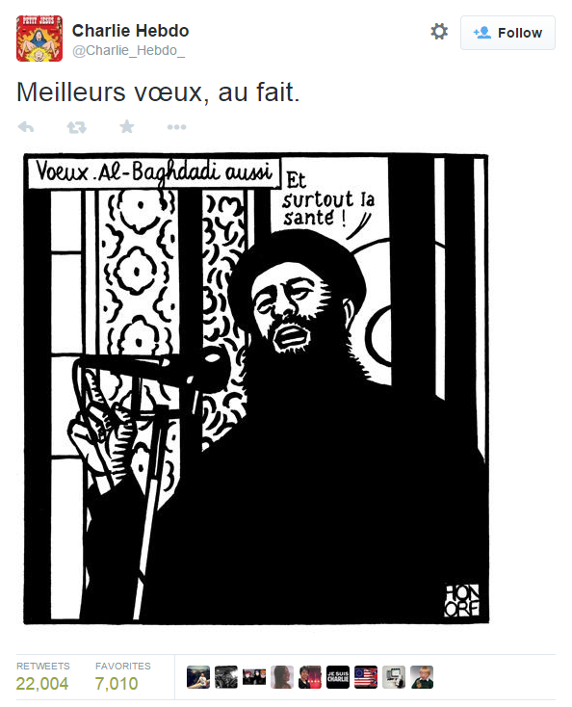
(“Best wishes, by the way.” Baghdadi: “And especially good health!”)
An armed attack on a newspaper is shocking, but it is not even the first time Hebdo has been the subject of terrorist attacks. Gawker has a good summary of past controversies and attacks involving Hebdo. Most famously, the magazine’s offices were firebombed in 2011, after they printed an issue depicting the Prophet Muhammad on the cover.
In the face of such an obvious attack on free speech, voicing anything except grief-stricken support is seen by many as disrespectful. Tom Spurgeon at The Comics Reporter, one of the first American comics sources to thoroughly cover the attack, quickly tweeted this:
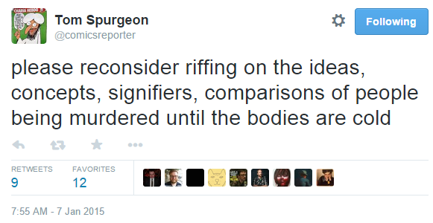
When faced with a terrorist attack against a satirical newspaper, the appropriate response seems obvious. Don’t let the victims be silenced. Spread their work as far as it can possibly go. Laugh in the face of those savage murderers who don’t understand satire.
In this case, it is the wrong response.
Here’s what’s difficult to parse in the face of tragedy: yes, Charlie Hebdo is a French satirical newspaper. Its staff is white. (Update:Charlie Hebdo’s staff it not all white. See note below.) Its cartoons often represent a certain, virulently racist brand of French xenophobia. While they generously claim to ‘attack everyone equally,’ the cartoons they publish are intentionally anti-Islam, and frequently sexist and homophobic.
Here, for context, are some of the cartoons they recently published.
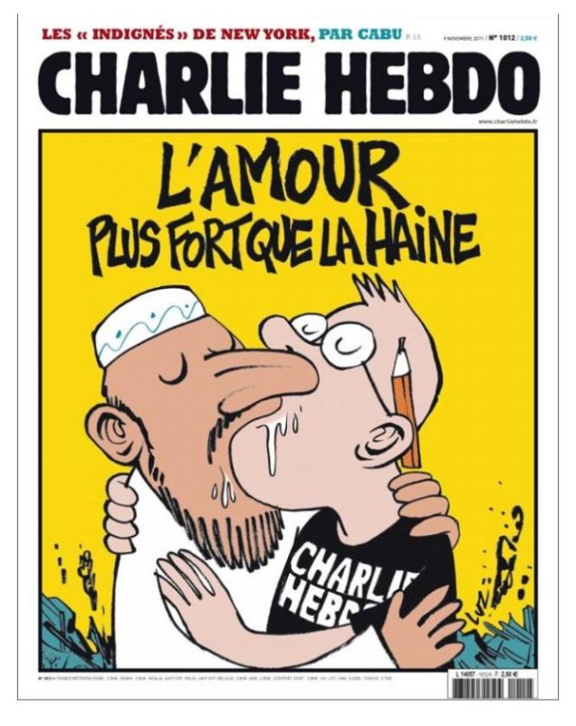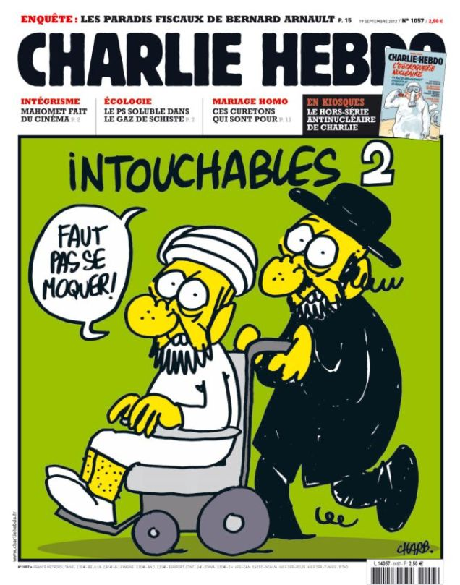

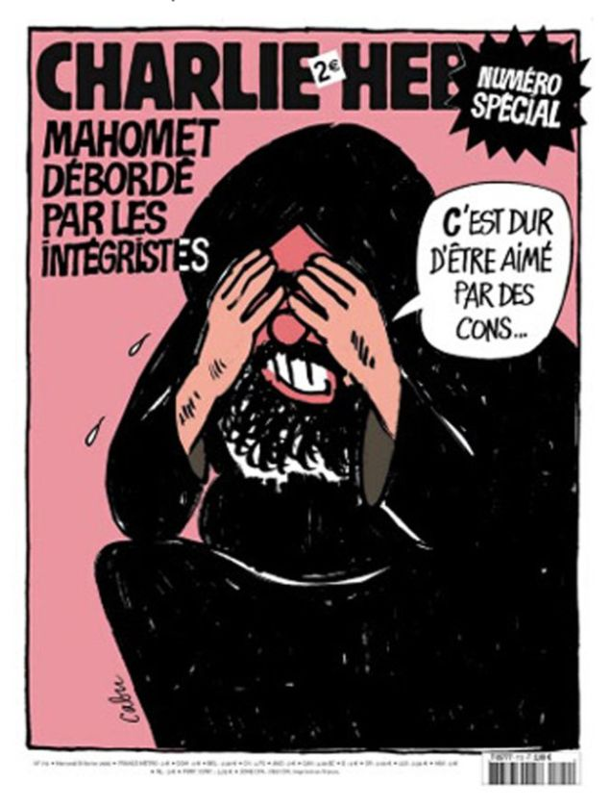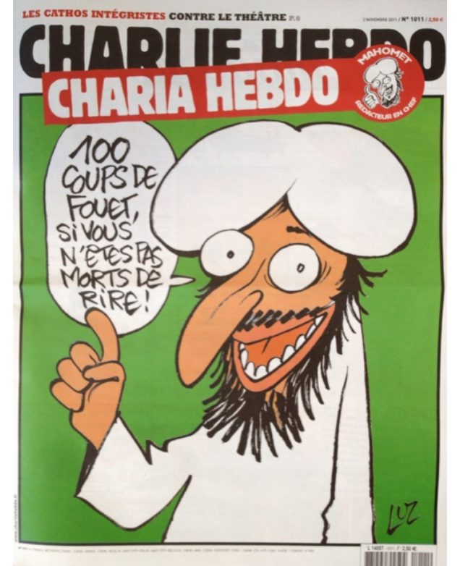

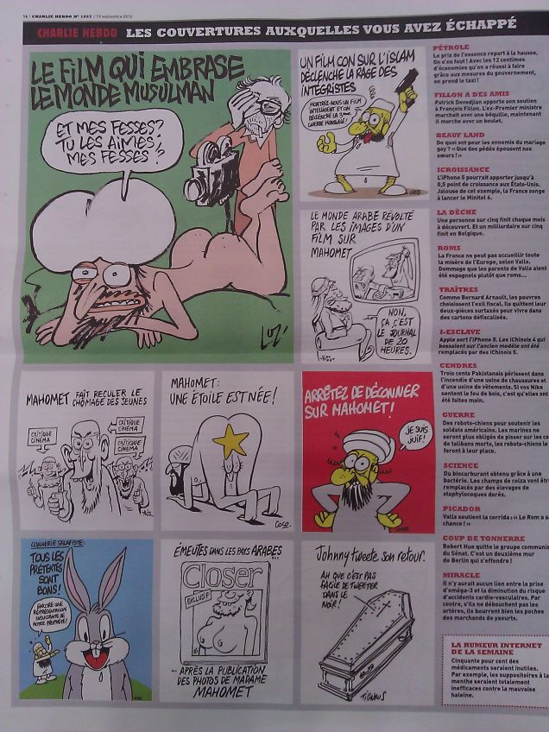
(Yes, that last one depicts Boko Haram sex slaves as welfare queens.)
These are, by even the most generous assessment, incredibly racist cartoons. Hebdo’s goal is to provoke, and these cartoons make it very clear who the white editorial staff was interested in provoking: France’s incredibly marginalized, often attacked, Muslim immigrant community.
Even in a fresh-off-the-press, glowing BBC profile of Charb, Hebdo’s murdered editor, he comes across as a racist asshole.
Charb had strongly defended Charlie Hebdo’s cartoons featuring the Prophet Muhammad.
“Muhammad isn’t sacred to me,” he told the Associated Press in 2012, after the magazine’s offices had been fire-bombed.
“I don’t blame Muslims for not laughing at our drawings. I live under French law. I don’t live under Koranic law.”
Now, I understand that calling someone a ‘racist asshole’ after their murder is a callous thing to do, and I don’t do it lightly. This isn’t ambiguous, though: the editorial staff of Hebdo consistently aimed to provoke Muslims. They ascribe to the same edgy-white-guy mentality that many American cartoonists do: nothing is sacred, sacred targets are funnier, lighten up, criticism is censorship. And just like American cartoonists, they and their supporters are wrong. White men punching down is not a recipe for good satire, and needs to be called out. People getting upset does not prove that the satire was good. And, this is the hardest part, the murder of the satirists in question does not prove that their satire was good. Their satire was bad, and remains bad. Their satire was racist, and remains racist.
The response to the attacks by hack cartoonists the world over has been swift. While many are able to keep pretty benign:
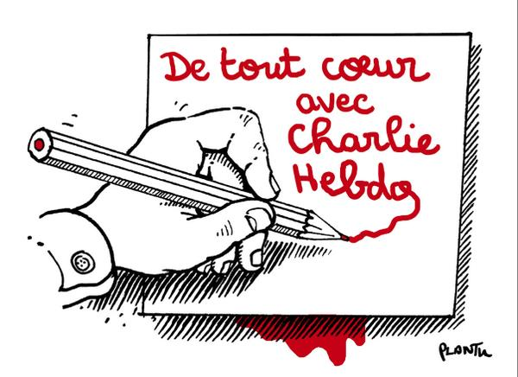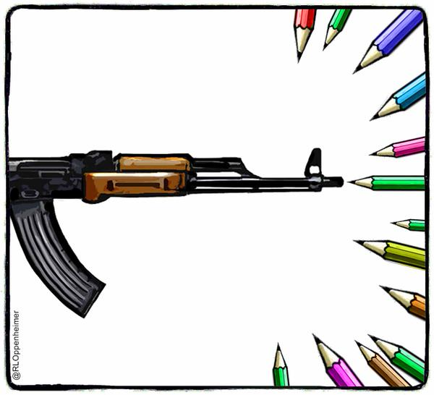

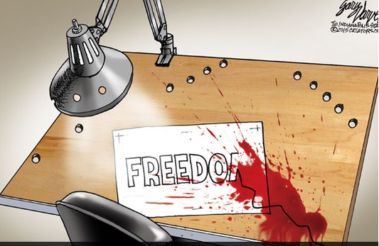
Several of the cartoons sweeping Twitter stooped to drawing hook-nosed Muslim caricatures, reminiscent of Hebdo’s house style.
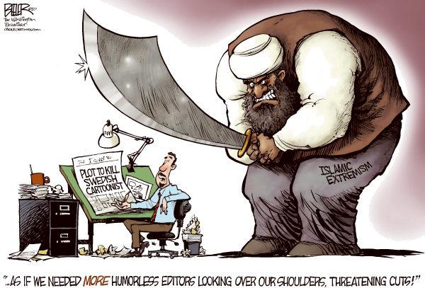
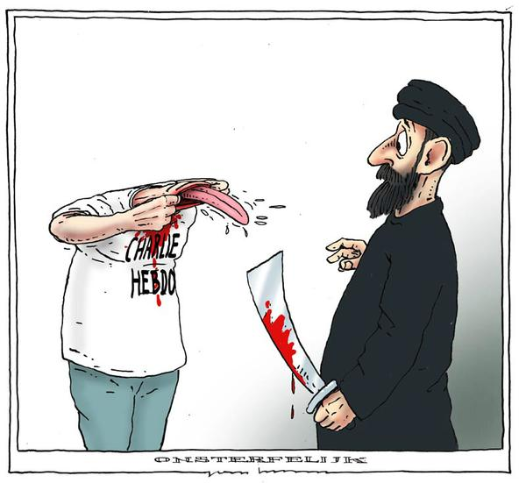
Perhaps most offensively, this Shaw cartoon (incorrectly attributed to Robert Mankoff) from a few years back swept Twitter, paired with the hashtag #CharlieHebdo:
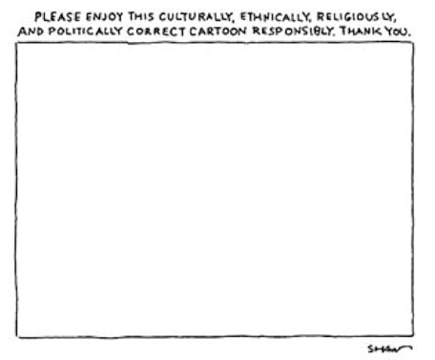
Political correctness did not kill twelve people at the Charlie Hebdo offices. To talk about the attack as an attack by “political correctness” is the most disgusting, self-serving martyr bullshit I can imagine. To invoke this (bad) Shaw cartoon in relation to the Hebdo murders is to assert that cartoons should never be criticized. To invoke this garbage cartoon is to assert that white, male cartoonists should never have to hear any complaints when they gleefully attack marginalized groups.
Changing your twitter avatar to a drawing of the Prophet Muhammad is a racist thing to do, even in the face of a terrorist attack. The attitude that Muslims need to be ‘punished’ is xenophobic and distressing. The statement, “JE SUIS CHARLIE” works to erase and ignore the magazine’s history of xenophobia, racism, and homophobia. For us to truly honor the victims of a terrorist attack on free speech, we must not spread hateful racism blithely, and we should not take pride in extreme attacks on oppressed and marginalized peoples.
A call “TO ARMS”
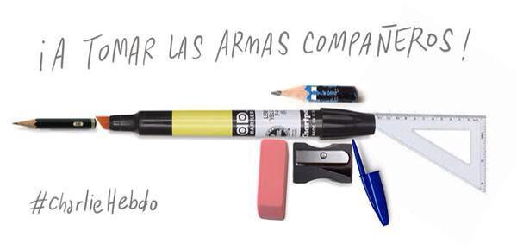
is gross and inappropriate. To simplify the attack on the Charlie Hebdo offices as “Good, Valiant Westerners vs. Evil, Savage Muslims” is not only racist, it’s dangerously overstated. Cartoonists (especially political cartoonists) generally reinforce the status quo, and they tend to be white men. Calling fellow cartoonists TO ARMS is calling other white men to arms against already marginalized people. The inevitable backlash against Muslims has begun in earnest.
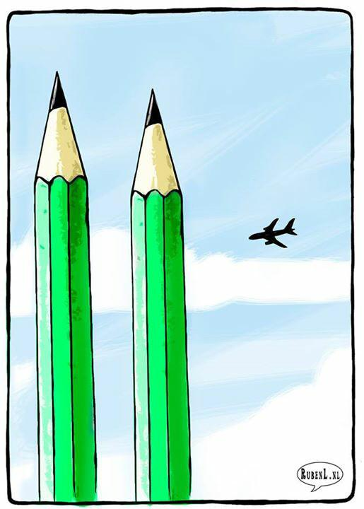
This is the worst.
The fact that twelve people are dead over cartoons is hateful, and I can only pray that their attackers are brought to justice. Free speech is an important part of our society, but, it should always go without saying, free speech does not mean freedom from criticism. Criticism IS speech – to honor “free speech martyrs” by shouting down any criticism of their work is both ironic and depressing.
In summary:
Nobody should have been killed over those cartoons.
Fuck those cartoons.
________
Update by Noah: Jacob initially stated that Charlie Hebdo’s “staff is white”. In fact, CH did have non-white staffers, including copy editor Mustapha Orrad, who was murdered by the terrorists, and journalist Zineb El Rhazoui. Jacob said that his point was that Charlie Hebdo’s chief editor was white, and that “The controversial cartoonists being mourned as free-speech martyrs are all white men.”

Appendix C
A Close Call on Publication of Charlie Hebdo Cartoons
By MARGARET SULLIVAN
JANUARY 8, 2015 2:18 PM January 8, 2015 2:18 pm 709 Comments
Was The Times cowardly and lacking in journalistic solidarity when it decided not to publish the images from the French satirical newspaper Charlie Hebdo that precipitated the execution of French journalists?
Some readers I’ve heard from certainly think so. Evan Levine of New York City wrote: “I just wanted to register my extreme disappointment at what can only be described as a dereliction of leadership and responsibility by the New York Times in deciding not to publish the Charlie Hebdo cartoons after today’s massacre.”
Todd Stuart of Key West, Fla., expressed the same view: “I hope the public editor looks into the incredibly cowardly decision of the NYT not to publish the Charlie Hebdo cartoons. I can’t think of anything more important than major papers like the NYT standing up for the most basic principles of freedom.”
And many outside commenters and press critics agreed. Jeff Jarvis of City University of New York wrote: “If you’re the paper of record, if you’re the highest exemplar of American journalism, if you expect others to stand by your journalists when they are threatened, if you respect your audience to make up its own mind, then dammit stand by Charlie Hebdo and inform your public. Run the cartoons.”
I talked to the executive editor, Dean Baquet, on Thursday morning about his decision not to show the images of the prophet Muhammad – a position that was taken by The Washington Post (on its news pages), The Associated Press, CNN and many other American news organizations. BuzzFeed and the Huffington Postwere among those that did publish the cartoons.
The Washington Post’s editorial page published a single image of a Charlie Hebdo cover on its printed Op-Ed page with Charles Lane’s column; that decision was made by the editorial page editor, not the executive editor of the paper, who presides over the news content. The executive editor, Martin Baron, told the Post’s media reporter Paul Farhi that the paper doesn’t publish material “that is pointedly, deliberately, or needlessly offensive to members of religious groups.”
A number of European newspapers did publish the images, often on their front pages or prominently on their websites.
I found it interesting that at least one outspoken champion of free expression, Glenn Greenwald, questioned the solidarity angle,tweeting: “When did it become true that to defend someone’s free speech rights, one has to publish & even embrace their ideas? That apply in all cases?”
And even many people who were horrified by the attack have become troubled by the embrace of a paper they believe crossed the line into bigotry.
Mr. Baquet told me that he started out the day Wednesday convinced that The Times should publish the images, both because of their newsworthiness and out of a sense of solidarity with the slain journalists and the right of free expression.
He said he had spent “about half of my day” on the question, seeking out the views of senior editors and reaching out to reporters and editors in some of The Times’s international bureaus. They told him they would not feel endangered if The Times reproduced the images, he told me, but he remained concerned about staff safety.
“I sought out a lot of views, and I changed my mind twice,” he said. “It had to be my decision alone.”
Ultimately, he decided against it, he said, because he had to consider foremost the sensibilities of Times readers, especially its Muslim readers. To many of them, he said, depictions of the prophet Muhammad are sacrilegious; those that are meant to mock even more so. “We have a standard that is long held and that serves us well: that there is a line between gratuitous insult and satire. Most of these are gratuitous insult.”
“At what point does news value override our standards?” Mr. Baquet asked. “You would have to show the most incendiary images” from the newspaper; and that was something he deemed unacceptable.
I asked Mr. Baquet about a different approach — something much more moderate, along the lines of what the Post’s Op-Ed page did in print.
“Something like that is probably so compromised as to become meaningless,” he responded, though he was speaking generally, not of The Post’s decision.
The Times undoubtedly made a careful and conscientious decision in keeping with its standards. However, given these events — and an overarching story that is far from over — a review and reconsideration of those standards may be in order in the days ahead.

