CRS and excursion operators’ role

Bali, Indonesia

This thesis discusses the issues of implementing CSR in excursion operators in the SIDS of Bali located in Indonesia. The excursion operators’ role in implementing CSR is currently almost non-existing as they will most likely need and also want assistance from the Indonesian government. However, the excursion operators have a chance to do it themselves by creating a board of director for CSR. It will produce a more sustainable and ethical tourism outcome for the excursion operators as they contribute to improvement and sustainability of their destination environmentally, culturally and economically for future generations.

**Keywords:** responsible tourism, CSR, tourism policies, Bali, Indonesia, mass-tourism, excursions operators.

2015

Anne Jespersen

Aalborg University - Sydhavnen

02-01-2015

Tabel of Content

1 Introduction 4

2 Problem statement 7

2.1 Research question 7

3 Literature review 8

3.1 Responsible tourism versus CSR 8

3.2 CSR and authenticity 10

3.3 CSR in tourism policies 12

3.4 CSR issues on small islands and developing nations 17

4 Methodology 20

4.1 Science of Philosophy 20

4.2 Data collection 21

4.2.1 Qualitative interviews 22

4.2.2 Ethnographical observations 26

4.3 Limitations 29

4.4 Delimitations 29

5 Findings 31

5.1 Excursion operators and CSR 31

5.1.1 Travelling Indonesia 31

5.1.2 Pacto Bali 33

5.1.3 Indoplan Holidays 34

5.1.4 Bali Crystal Divers 35

5.1.5 Nick Tours 36

5.1.6 Sum up 37

5.2 Excursion operators’ influences on culture and environment 38

5.2.1 Excursion areas 38

5.2.2 Mass-tourism areas 39

5.2.3 Sum up 42

6 Analysis 43

6.1 Excursion operators and CSR 43

6.2 Excursion operators’ influences on culture and environment 46

6.3 Sum up 49

7 Discussion 50

8 Critique / Deviation 60

9 Conclusion 61

10 Reference list 64

11 Appendixes 71

11.1 Ethnographic research 71

11.1.1 Balinese tours 71

11.1.2 General observations 80

11.1.3 Photo evidence 81

11.2 Interview with excursion operators 89

11.2.1 Interview 1 - Travelling Indonesia 90

11.2.2 Interview 2 - Pacto Bali 93

11.2.3 Interview 3 - Pacto Bali 95

11.2.4 Interview 4 - Indoplan Holidays 98

11.2.5 Interview 5 - Bali Crystal Divers 100

11.2.6 Interview 6 - Nick Tours 103

11.3 Content analysis 107

11.3.1 Travelling Indonesia (Wonderful Indonesia) 107

11.3.2 Pacto Bali 108

11.3.3 Indoplan Holidays 116

11.3.4 Bali Crystal Divers 117

11.3.5 Nick Tours 119

11.4 Human Index report 120

# 1 Introduction

In tourism, sustainable CSR (Corporate Social Responsibility) and responsible tourism are contemporary subjects that many organizations try to focus on. The reason for this is that organizations have found that there is a competitive advantage in becoming a ‘good corporate citizen’ (Petrovic‐Lazarevic, 2008). Furthermore, CSR helps organizations contribute to a destination, both socially, economically and environmentally (Cochran, 2007; Frey & George, 2009; Tepelus, 2005). ‘Good corporate governance’ supports socially responsible business, and is in the sphere of CSR; the advantages of being a ‘good corporate citizen’ is that it will help an organization improve it’s image, sustainability, relationships with suppliers, OHS (Occupational Health & Safety), working environment and commitment, to the local communities’ protection and engagement. Moreover Petrovic‐Lazarevic (2008) states that it is the moral obligation of an organization be ‘good citizens’ and ‘to do the right thing’, and that organizations should apply a corporate governance structure in order to fully develop their CSR and develop the trait of being ‘good citizens’ (Petrovic‐Lazarevic, 2008).

CSR is diverse from sustainable and responsible tourism, because the theory offers organizations a strategic way to do well and have a healthy ‘bottom line’. As a result, destinations as a collective of businesses and services will prosper (Falck & Heblich, 2007). When an organization is a ‘good corporate citizen’, it will assist in gaining an advantage in the marketplace, improve consumer loyalty, and have a positive influence on the brand. Therefore, an organization’s investment in CSR is essentially a strategic investment in the organization’s brand (Petrovic‐Lazarevic, 2008). One of the issues with CSR is creating a tourism policy environment that will help and facilitate organizations implementing CSR into their processes as these policies can become very complex. Moreover the policies can involve actors, governments, and institutions, thereby making the process even more complex. However, the policies will make it easier for organizations to understand and implement the processes involved with the policies (Farsari, Butler & Szivas, 2011).

Efforts to support tourism in developing countries are often concentrated on hard infrastructures, such as the provision of infrastructure, and on facilitating tourism activities through promotion and visitor information services (Thapa, 2012). However, these efforts focused on the development of soft infrastructure, such as human resource development, and that creates a skilled and knowledgeable workforce that is less of a priority, although such skills will influence the level of innovation in a country (Thapa, 2012).

Some of the issues that developing countries face regarding tourism are climate changes, pollution, water consumption, economy, loss of culture, and the mass influx of travelers (Responsible Travel Report, n.d.; UNEP, n.d.). With the increase in globalization many small island states face similar obstacles. They, however, are also more vulnerable to external influences, such as economics, politics, loss of culture and environmental influences (Responsible Travel Report, n.d.; Read, 2004).

An example of these small island states is Indonesia, who is number 108 on the Human Index report (11.4 Human Index report), and one of the top destinations is Bali, which is an island that suffers greatly from outside influences and is slowly being destroyed by trash (bottles, plastic bags, etc.), both on and off land. This is due to mass tourism, the government and the locals, and a lack of knowledge to properly dispose of the trash, which in the future can create issues regarding the development and the growth of local tourism (MacRae, 2012; Thiermann, 2013; Milne & Milne, 2014; Valera, 2014; Role Foundation, n.d.; Surfer, 2014). Additionally, Indonesia is number 108 out of 187 on the of carbon dioxide emissions per capita (Human development report, 2015). The destination’s economy also relies 80% on tourism, and the loss of this would be devastating to the island, in regards of regaining consumer loyalty, OHS, image, sustainability, working environment, the local communities, suppliers and working environment (Thiermann, 2013; Petrovic‐Lazarevic, 2008).

The focus of this thesis is to explore the role of the excursion operators in implementing CSR for a more ethical and sustainable tourism industry by concentrating on the issues of garbage, and the visual and environmental pollution it creates when not appropriately dealt with, and the impact tourism has on culture. The aim of choosing a destination as Bali is that there is an issue with the handling of garbage on the island, and CSR might be a solution to solving some of the issues by convincing local excursion operators to take responsibility and help to improve the destination by doing good, being ‘good corporate citizens’ and creating a word-of-mouth with their good doings (MacRae, 2012; Thiermann, 2013; Petrovic‐Lazarevic, 2008; Milne & Milne, 2014; Valera, 2014; Role Foundation, n.d.; Surfer, 2014). The first objective is to understand the level of knowledge and attitude of the excursion operators regarding CSR, and an investigation into the tourism policies needed to provide a foundation for CSR. Furthermore, it is to understand the excursion operators’ impact on the environment and society, and how CSR can assist the excursion operators in managing the waste disposal and engage in the local communities. The second objective is to understand and investigate the excursion operators’ influence on the local culture and environment by an ethnological observation of the destination’s issues with pollution and the authenticity of the destination, by looking at CSR, responsible tourism, tourism policies, and authenticity, and if the excursion operators are using CSR in real life, with or without knowledge. Finally, to find a solution for the issues using CSR in the excursion operators.

# 2 Problem statement

During the research for this thesis, it was found that there is a waste issue on Bali in Indonesia. As a small island in a developing nation, it presents issues and challenges for the destination (Briguglio, 1995). Furthermore, Bali is also a subject to mass tourism, which has been increasing in developing nations (Thapa, 2012). The interest of the thesis is to investigate what role the excursion operators play in the issues, and how they can help improve these issues by implementing CSR, and what their role is in the development of CSR. Moreover, how CSR can improve a destination by contributing to a more sustainable and ethical outcome, regarding tourism.

The objectives were created for the purpose of answering the main research question. The objectives used for investigating the issues are if the excursion operators are in fact aware of CSR and how the excursion influence the destination’s culture and environment by transporting tourists to these areas. The literary areas of interest used for the thesis are CSR, responsible tourism, authenticity, tourism policies and issues on small islands in developing nations.

## 2.1 Research question

**What role does excursions operators have in implementing CSR, and can CSR contribute to a more ethical and sustainable tourism outcome?**

* **Are the excursion operators aware of CSR?**
* **How do excursions influence a destination’s culture and environment?**

# 3 Literature review

## 3.1 Responsible tourism versus CSR

Tourism movement has a great effect on the environment at a destination, as the activities involved consumes more at certain times and almost none at all at other times (Angelkova, Koteski, Jakovlev & Mitrevska, 2012). As a consequence, travel agents, local authorities, the population, tourist and tour operators are often looking for new ways to lower the impact in regards to the natural environment, poverty, heritage, culture and competitiveness (Carey, Gountas & Gilbert, 1997). This is often achieved by looking at either sustainable and/or responsible tourism (Miller, Rathouse, Scarles, Holmes & Tribe, 2010; Frey & George, 2009). However CSR offers companies a way to be a ‘good corporate citizen’, while still gaining a profit and addressing the same issues as responsible tourism (Petrovic‐Lazarevic, 2008; Falck & Heblich, 2007). For this reason, and as explained here, CSR and responsible tourism are conceptualized as being closely related.

Responsible tourism involves environmental, socio-cultural and economic issues that are produced by tourist visitation, and offers a sustainable development of a destination, for instance by creating responsible behavior in travelers (Manente, Minghetti & Mingotto, 2014, p. 3-6). However, it does not provide a corporate solution for companies to engage in responsible tourism (Manente, Minghetti & Mingotto, 2014, p. 3-6). Likewise Spenceley (2002 cited in Frey & George, 2009) agrees that responsible tourism is about increasing tourists’ experiences and business opportunities by enhancing natural resource management and better-quality socio-economic benefits.

“*A good corporate citizen image includes good corporate governance. The good corporate citizen is also central to the concept of CSR*” (Ghazali, 2007 cited in Petrovic‐Lazarevic, 2008, p. 93).

This means that CSR is about ‘doing well, by doing good’, and will assist in providing an organization with a better image and perhaps a healthier profit. Furthermore, if an organization does not contribute to the environment and the local community, it might face the consequences of boycott of services from visitors or local residents, or pressure from the government (Petrovic‐Lazarevic, 2008; Pederson, 2007). Additionally Becker-Olsen, Cudmore and Hill (2006) indicates that CSR can lead to an improvement in consumer attitudes, beliefs and intentions, if the initiatives have a high level of fit with the marketplace and are proactive.

However CSR also implies that companies are responsible for the social, economic and environmental effects that companies produce, and deals with the integration of social and environmental concerns into the activities of the company (Manente, Minghetti & Mingotto, 2014, p. 15-17). Both responsible tourism and CSR focuses on the social, environmental and economic issues that is produced by the tourist movement, yet CSR offers the companies an awareness of the necessity for responsible activities of a company in order to maintain the product that the company sells. Additionally Frey and George (2009) states that responsible tourism management can be characterized under CSR, meaning that responsible tourism and CSR are closely linked. CSR has grown within the past decade due to the global society’s demand for organizations to take social and environmental initiatives into their management strategies and not solely focus on profits (Frey & George, 2009). This implies that the global society wants organizations to take responsibility for their actions and impacts on the environment, society and economy without solely thinking of their own profit.

One can say that responsible tourism offers a way to create responsible and positive influences that address the negative impacts of tourism on an entire destination. Alternatively CSR provides the same for organizations, companies and businesses, and emphasizes the fact that they are also responsible for the negative impacts, and can gain from being involved in sustaining the destination’s environment, society and economy for the future (Petrovic‐Lazarevic, 2008; Falck & Heblich, 2007; Angelkova, Koteski, Jakovlev & Mitrevska, 2012; Carey, Gountas & Gilbert, 1997; Miller, Rathouse, Scarles, Holmes & Tribe, 2010; Frey & George, 2009; Manente, Minghetti & Mingotto, 2014).

Finally, Burke and Logsdon (1996) argue that if an organization uses CSR, it will contribute to value creation as a strategic outcome by providing the organizations with guidelines to exploit the opportunities of CSR. Burke and Logsdon (1996) present five strategic dimensions that will create value for an organization, which are centrality, specificity, proactivity, voluntarism and visibility, whereas Prahalad and Ramaswamy (2004) state that value creation is a co-creation between an organization and the consumers by, for instance, creating unique experiences. The two theories imply that using CSR can create value creation by providing guidelines for an organization by using five strategic dimensions, and additionally by a co-creation between an organization and the consumer by using mutual interactions.

## 3.2 CSR and authenticity

CSR entails being a ‘good corporate citizen’ by focusing on, and taking responsibility for, the social, environmental, and economic issues that are partly produced by an organization in the conduct of their business (Petrovic‐Lazarevic, 2008; Manente, Minghetti & Mingotto, 2014). In this way, CSR is responsible for the social aspect of how organizations’ operations relate and contribute to the local communities in which their organization operates. This can partially be identified as authenticity of a destination, as authenticity means the ingenious way they live in the host society (Bendix, 1989). CSR addresses the issues of heritage and culture under social responsibility (Petrovic‐Lazarevic, 2008; Falck & Heblich, 2007), which are both connected to authenticity (Chhabra, Healy & Sills, 2003; Taylor, 2001).

According to Bendix (1989) authenticity will always be staged by the mere fact that the tourist is present. However a landscape cannot be staged as culture can and if the natural beauty is intense enough it cannot spoil the authenticity (Bendix, 1989). This means that a performance might be staged, but a beautiful view cannot. Whereas Weiss (2011) state that merely because something is typical for an area it does not automatically make it authentic, and it is not an adequate description of a culture.

*“In ‘sincere’ cultural experiences, where tourists and ‘actors’ are encouraged to ‘meet half way’, authenticity may be more positively redefined in terms of local values. Rather than seeing value as the emanation of an ‘authentic object’, the moment of interaction may become the site in which value is generated.”* (Taylor, 2001, p. 9).

Taylor (2001) has a more positive look at authenticity as local values, implying that even though something is inauthentic, it does not make it less valuable. Likewise Chhabra, Healy and Sills (2003) agree that it does not need to be an accurate re-creation of the past, but it needs to be perceived as authentic to be valuable. Taylor (2001) and Chhabra, Healy and Sills (2003) agree that present-day authenticity is derived from the original concept through sites, images and people, which is the result of epochs, ways of life and past events that has lead the culture to where it is today. However Ek, Larsen, Hornskov and Mansfeldt (2008) argue that tourists are not only looking for authentic places, they also look for sociability between each other as a form of authenticity. This means that authenticity can occur at any place during travelling and is not limited to sites, images and locals. Authenticity can provide value to an experience, if organizations use authenticity in their CSR initiatives. An authentic CSR initiative could provide a more valuable experience for the tourists by engaging in what really matter in the destination and observing authentic experiences.

Wang (1999) define three types of authenticity based upon previous theories of authenticity: objective authenticity, constructive or symbolic authenticity, and existential authenticity. Objective authenticity refers to the authenticity of the originals (Wang, 1999), constructive authenticity refers to the authenticity projected in toured objects in terms of expectations, preferences, imagery, beliefs and powers, and finally existential authenticity refers to a possible existential state of ‘being’ that is activated by tourist activities (Wang, 1999).

From these theories, it can be argued that authenticity deals with the entire experience of a tourist at a certain destination, and CSR assists in preserving the authenticity of a destination by companies engaging in the local communities by being a ‘good citizen’ and ‘doing the right thing’. For instance, excursion operators can have a certain influence on the impact on a certain area that they work within (Petrovic‐Lazarevic, 2008). Companies can subsequently engage in relationships with suppliers, unions and employees, commitment to local communities’ protection, accountability and transparency, improved image and reputation, and meeting the needs of the present without compromising the ability of future generations (Petrovic‐Lazarevic, 2008, p. 94).

## 3.3 CSR in tourism policies

Some of the issues in CSR are corruption and irresponsibility created by managers and executives, for instance out of either greed or negligence (Putrevu, McGuire, Siegel & Smith, 2012). Sharing leadership and informal relationships will lower the tendency beyond legal sanctions and public pressures, and the possible future decline in unethical practices might exemplify the silver-lining of the global economic crisis (Putrevu, McGuire, Siegel & Smith, 2012). This implies that good communication between different key stakeholders is imperative for the survival of tourism policies and CSR initiatives. In order to overcome these issues, tourism policies and planning offers a way to plan and implement goals, as argued by Cullingsworth (1997, p. 5 cited in Hall, 2008, p. 9):

“*Planning is the purposive process in which goals are set and policies elaborated to implement them”.*

The previous quote issupported by Dredge and Jenkins (2007, p. 170):

“*The process through which policy ideas and plans are translated into practice”.*

*W*hereas Dodds (2007 cited in Krutwaysho & Bramwell, 2010) indicate that the investigation of implementation of policies in tourism is poor and weak. This means that creating tourism policies will help the survival of CSR in a destination by providing plans and goals for organizations to follow. However, the implementation of the tourism policies is the difficult part and requires time, and trial and error.

*“Policy makers should focus their attention to social and political structures accelerating productive economic activity by encouraging socially responsible behavior. The impact of CSR government activities on long-run growth is limited for now (variable policy has low impact on growth). This is the reflection of the poor CSR policy structure being too regulative and less simulative for CSR firms. A more flexible and targeted government policy supporting firms resolute to engage socially would result in higher growth rate differences.”* (Skare & Golja, 2014, p. 564).

This suggests policies should be less regulatory and provide more stimulus for companies, and should make the companies want to engage in CSR by making it more attractive and easy for them, and making them want to be socially responsible and a ‘good coporate citizen’ (Petrovic‐Lazarevic, 2008). Additionally Hjalager (2001) claims that policies in tourism aimed at innovation should not solely concentrate on the tourism industry, but also look at the driving forces of other industries and the public sectors. Therefore, the policies should not just be attractive to the companies within one industry, but should be attractive to all industries and they should all be able to implement the policies.

Maas and Reniers (2014, p. 107) illustrate a conceptual management system framework called ‘Sus5’. ‘Sus5’ serves as a practical tool for companies to accept a self-assessment and detect plausible gaps in their CSR policies, and to motivate them to a wider responsiveness area, and moreover to show that CSR policies contains of a set of ‘interdependent building blocks bonded by casual relationships’ (Maas & Reniers, 2014). There are five areas of the ‘Sus5’ (Maas & Reniers, 2014).:

1. Management knowledge and commitment linked with …
2. Stakeholder knowledge and commitment
3. Strategic planning,
4. Knowledge and commitment on the work floor
5. Operational planning, implementation and monitoring.

‘Sus5’ shows how communication, commitment, and the sharing of knowledge between key stakeholders is important. Moreover, it shows that planning and monitoring is imperative for the future success of the CSR policies. Whereas Halkier (2006) argue that there are three levels of analysis that can be combined to uncover key elements of the policy process. These are: organizational dimensions that are internal to each of the interacting organizations, relationship dimensions that are the interaction between the different organizations, and multi-organizational dimensions exemplifying the inscription of the relationship dimensions into a bigger social context (Halkier, 2006). Halkier (2006) emphasizes that neither of them are essential without the other two, as no organization subsists in a vacuum and stresses that the interaction is imperative.

Additionally, Mass and Reniers (2014) also put emphasis on the communication and relationship between the stakeholders. This implies that in order for CSR policies to succeed, communication, collaboration and commitment are significant elements.

Alternatively Fayos-Solá (1996 cited in Henriksen & Halkier, 2009) state that tourism policies contain three different generations that show how policies evolve over time. First-generation policies focused on increasing the number of activities in order to capitalize on the income (boosterism), second-generation policies attempts to expand tourism through subsidies, regulations (environmental, spatial planning) and promotion, and third-generation policies to increase the competitiveness by heightening quality and efficiency in service delivery (Fayos-Solá, 1996 cited in Henriksen & Halkier, 2009). Although Mass and Reniers (2014) and Fayos-Solá (1996 cited in Henriksen & Halkier, 2009) both display the progress of policies through time, and the steps that needs to be taken for the policies to succeed, the theories do not present concrete to what a CSR policy should consist off.

**Figure 1:** Halkier, 2006, p. 93.

Halkier (2006) defines a more detailed and rational way of looking at Hall’s (2008, p. 15) model of Easton’s model, making it easier to put into practice. ‘Figure 1’ demonstrations how the left side is the public controlled side and the right side is the public uncontrolled side (Halkier, 2006). The four square boxes represents the policy actors that influences the input to the design, implementers and target with resources, competences, contexts and roles (Halkier, 2006). Moreover, the ‘policy target’, ‘implementing organization’, ‘political environment’, ‘problem definition’ and ‘policy outcome’ represent the policy process, which is not always linear, but includes formulation, design, implementation and evaluation (Halkier, 2006). Finally, the ‘problem definition’ presents the need for a goal and strategies for reaching it controlled by the public (Halkier, 2006). One of the main issues in CSR is corruption (Putrevu, McGuire, Siegel & Smith, 2012), and in order for a CSR policy to be successful key stakeholders have to cooperate. This means that there is a possibility for the policies to fail, if all the stakeholders are not committed. Moreover, a developing country’s economic capability is quite vulnerable, which will make it more difficult for a CSR policy to succeed (Briguglio, 1995).

Whereas Kernel (2005) debates that tourism operates in a mass of competing interests, and crosses turfs with expertise and administrative limitations as well as the entirety of the local communities, because economic, social and political forces influence policies and management directions, and thereby creating interdependence within a wide variety stakeholders. Kernel (2006) also argues that tourism organizations are small organized units that have diverse resources and capabilities from their different positions, and in that way the organizations have different attributes to impact the policy planning processes. Lastly, Kernel (2006) states that the organizations that should influence the policy making process should consist of a diverse set of stakeholders to reach the vision, and there is a need to include and exclude certain organizations and individuals. Therefore the policy makers should not just consist of any organizations with a link to the tourism industry, but should consist of relevant and diverse stakeholders in order to reach all elements of CSR in economy, the society and the environment. A ‘good corporate citizen’ (Putrevu, McGuire, Siegel & Smith, 2012) is not limited to the tourism industry alone.

As mentioned earlier on, Skare and Golja (2014) states that CSR policies should be easier for companies to support, and have created ‘Ideal types of CSR policies’ as shown in ‘Figure 2’ and presents more concrete examples for establishing policies with the different stakeholder in mind. Unlike Halkier’s (2006) and Kernel’s (2006) more objective looks at policies in general, with no specific reference to CSR.

‘Figure 2’ shows how the public sector should handle CSR policies through stimulated, regulated and implicit CSR and how the companies should handle them as well through explicit CSR, using exogenous and endogenous push- and pull factors; which can have a positive impact on the corporate social behavior through public policy intervention (Skare & Golja, 2014, p. 568). Moreover, for a developing nation it is important to develop and maintain the tourism industry with sustainable strategies for expansions and competiveness to support the economy in urban and rural areas, because of increasing tourism arrivals in developing countries (Thapa, 2012). With this in mind CSR provides a stimulated, regulated and implicated way to sustain a developing nation with strategies for expansions and competiveness.

**Figure 2:** Skare & Golja, 2014, p. 568

Additionally, according to Simpson (2007) key stakeholders (government, private sector, communities and non-governmental organizations) working together for sustainable and responsible tourism will ensure a continuous healthy development of tourism through CBTIs (Community Benefit Tourism Initiatives). CBTIs consists of environmental, economic, socio-cultural and building of skills and influence (Simpson, 2007). Simpsons (2007) adds that it does not matter if the tourism initiative is in a developed or in a developing country, but as long as there is a significant level of community participation at all stages, it will provide the stakeholders with a stronger chance of having an influence in forming development in the community to achieve the highest benefits, and that community involvement is imperative to a sustainable development of tourism (Simpson, 2007). This means that using CBTIs in CSR will create a healthier development of tourism in developing countries as it involves the participation of the communities, and thereby increasing the level of knowledge of CSR. Moreover Easterly and Kraay (2000) state that small states are no different from large states, therefore the small states should receive the same policy advice as the large states.

## 3.4 CSR issues on small islands and developing nations

The tourism industry is one of the fastest growing industries in the last two decades and arrivals have risen from 31% in 1990 to 47% in 2010, especially amongst countries with emerging and developing economies (Thapa, 2012). Therefore, it is imperative to enhance and maintain the tourism industry in these countries with sustained strategies for further expansions and competitiveness to reinforce the economic sectors in urban and rural areas (Thapa, 2012). Pelling and Uitto (2001) adds that globalization is not new to many small islands, due to the long history of small island societies and environments being fundamentally reshaped by international political relations, spread of technological innovations and economics.

Some of the special disadvantages of being a SIDS are the small size of population, area and GNP with regards to (1) limited natural resource endowments and high import content, (2) limitations on import-substitution possibilities, (3) small domestic market and dependence on export markets, (4) dependence on a narrow range of products, (5) limited ability to influence domestic prices, (6) limited ability to exploit economies of scale, (7) limitations on domestic competition and (8) problems of public administration (Briguglio, 1995). Moreover, insularity and remoteness with regards to (1) high per-unit transport, (2) uncertainties of supply and (3) large stocks (Briguglio, 1995). Additionally, proneness to natural disasters; also environmental factors with regards to (1) pressures arising from economic development and (2) environmental characteristics of SIDS (Briguglio, 1995). Finally other characteristics of SIDS with regards to (1) dependence on foreign sources of finance and (2) demographic factors (Briguglio, 1995). Furthermore, corruption is a major issue in many of the developing nations in the world and is a serious problem (Nwabuzor, 2005). Corruption is a violation of the established rules and conducts to obtain personal gain or profit, which can include bribe or misuse of public funds (Sen, 1999 cited in Nwabuzor, 2005).

Many of issues and disadvantages accompanied with being a small island developing state (SIDS) are the small size, remoteness, insularity and proneness to natural disasters. These issues and disadvantages render the economy of the SIDS quite vulnerable to outside influences and at times threaten the economic capability (Briguglio, 1995). Solomon and Forbes (1999) agree with the proneness for natural disasters on small island states from coastal hazards. They suggest public education and awareness for planning for coastal disasters (Solomon & Forbes, 1999). Furthermore, CSR cannot assist in the proneness to natural disasters, small size or remoteness. However, CSR can assist in insularity as it will increase the level of knowledge in the local communities by presenting, for instance, CBTIs, which involves local community participation, and will thereby increase the level of knowledge within environment, socio-culture, and economy (Simpson, 2007; Manente, Minghetti & Mingotto, 2014).

One of the main issues with CSR is corruption and irresponsibility, and a developing country is more vulnerable to this (Putrevu, McGuire, Siegel & Smith, 2012; Nwabuzor, 2005). This means that corruption will be more difficult to eliminate in small islands and developing nations.

However, Read (2004) provides a list of the key factors for growth in SIDS, which consists of (1) openness and comparative advantage by international trade, (2) sectoral specialization and growth by sectoral activities, (3) islandness and growth by topography, (4) vulnerability and growth from external economies, (5) locational determinants of growth, (6) political sovereignty and growth, (7) economic sovereignty and growth, (8) human capital and growth and (9) social cohesion and growth. Nwabuzor (2005) state that can a honest government can provide a more sustainable income and promote growth through the elimination of corruption by empowering the public, capability of function to lift the public out of poverty and to protect the public from the disproportionately of corruption on the poor. This is also stated by Simpson (2007) CBTIs that community involvement is imperative. Therefore the using CBTIs in CSR could help eliminate corruption. This means that the main issue with CSR in small islands and developing nations is corruption.

Another issue that threatens small islands is climate change, yet there is a somewhat scientific uncertainty involved with regards to sea levels (Barnett, 2001). Walsh, McInnes and McBride (2012) agree that small islands are more prone to the effects of the climate change and the rising sea levels. It is difficult to adapt to these changes, because it requires system wide analysis and intervention (Barnett, 2001). However, Barnett (2001) states that adaptation means modification and/or fitting to suit. Adger and Barnett (2005) agree that for people to live their lives in their place of origin instead of migration, adaption policies are needed. CSR offers various options and fields for organizations to focus their attention on in order to try to solve the issue by focusing on the environment. As Easterly and Kraay (2000) state: that small states should receive the same policy advice as the large states, also regarding CSR policies. This means that in order for small islands to overcome climate change, they will have to adapt to the changes and modify accordingly, using for instance CSR policies for organizations to assist in developing and adapting the island. As Kernel (2006) state: that organizations should influence the CSR policy with a diverse set of stakeholder. Therefore, the policy makers should not only consist of organization within on specific industry, but many different organizations with different resources and competences (Kernel, 2006).

# 4 Methodology

## 4.1 Science of Philosophy

According to Pearce (2012) using both quantitative and qualitative methods complement each other and would fill in each other’s weaknesses and strengths, and the approach is called pragmatic. Moreover, according to Morgan (2007, cited in Pearce, 2012) using a pragmatic approach (also called abduction) will increase the value of data results. However, when dealing with the problem statement of this thesis, it is argued that a qualitative method would provide the best data collection as the problem statement (2.1 Research question) give the a reason for a more nuanced insight into the destination by answering the ‘whys’ and ‘hows’ by using ethnographics and interviews (Frels & Onwuegbuzie, 2013).

According to Bhopal (1999), Thomas Kuhn’s opinion of sciences is that it typically works with a single paradigm driven by exemplars of successful work, and that suggest a paradigm change is often resisted. Sciences that evolve, mature and change over time does not have a dominate paradigm (Bhopal, 1999). Thomas Kuhn suggests a paradigm shift in this philosophy of science theory, which can be needed or impending, as his depiction of the ‘rabbit/duck’ icon and uses this as his example of a paradigm shift (Bhopal, 1999). Social constructivism is somewhat about taking Kuhn’s philosophy of science further, social constructivism highlights the importance of context and culture in understanding of what arises in society and constructing knowledge based on this understanding (Derry, 1999 and McMahon, 1997 cited in Hollins-Alexander, 2013), thereby creating paradigm shifts. According to Hollins-Alexander (2013) social constructivists believe that reality is constructed through human activities, knowledge is also a human product, and can be culturally and socially constructed. Social constructivists also view learning as a social process, meaning it does not take place only within an individual or is a passive development of behaviors that are shaped by external forces (Hollins-Alexander, 2013). Moreover, a social constructivism approach to ethical decision making places the ethical decision out in the open (Cottone, 2011)

The forms of data collection used for this thesis were qualitative methods, which according to Pearce (2012) means that the thesis is based on a social constructivism approach. Furthermore, the approach is created during the interaction between the interviewer and the interviewee (Hannam & Knox, 2010, p. 196).

## 4.2 Data collection

The theoretical approach used for this thesis is based on a qualitative method, which was chosen because a qualitative approach provided answers to ‘why’ and how’ (Frels & Onwuegbuzie, 2013), instead of giving a broad quantitative picture of the destination and brought the data down to the underlying reasons behind.

*“… Moreover, although quantitative research is particularly useful for answering questions of who, where, how many, how much, and what is the relationship between the specific variables, it is not optimal for answering why and how questions”* (Cited in Frels & Onwuegbuzie, 2013).

According to Morgan (2007, cited in Pearce, 2012) that using only qualitative research will create inductive results; meaning that the researcher will create theories from data, instead of being deductive and create data from theories. However, it is in the opinion of the researcher of this thesis that it would create a more nuanced answer to the problem statement. Therefore, the primary form of data collection used is a qualitative method gathered from interviews of excursion operators and ethnographical research of the destination (11 Appendixes).

Additionally, the methods used will provide more trustworthy and valid results as the researcher and the interviewees were relevant to the problem statement and research question in relations to the issue at hand (Pearce, 2012).

When doing data collection, there are always primary and secondary data, which includes primary and secondary data as well as quantitative and qualitative data. The figure below classified the data collection method.

|  |  |  |
| --- | --- | --- |
|  | **PRIMARY** | **SECONDARY** |
| **QUALITATIVE** | 1. Ethnographical research 2. Interviews with excursion operator 3. Content analysis | 1. Books 2. Articles |
| **QUANTITATIVE** |  | 1. Internet 2. Teaching material |

### 4.2.1 Qualitative interviews

In order to understand the excursion operators, it was of course necessary to conduct interviews with some of the organizations conducting excursions on Bali, as it would not have been sufficient just to observe the excursion operators, but also have insight into the organizations rather than just a superficial point-of-view (11.2 Interview with excursion operators). The qualitative interview was used to fulfill the first objective, which was to understand if the excursion operators were aware of CSR (2.1 Research question).

The interviews were conducted on Bali in Indonesia, when the researcher of this thesis was visiting. This meant that the contacted interviewees on Bali were valid to the research as they were not just people sitting behind a desk, but were people who had influence and hands on when it came to CSR in the organizations and the researcher of this thesis had somewhat control over who was interviewed. The questions used for the interviews were standardized and structured, as they were framed in advance (Harboe, 2010). In addition, the researcher used a passive questioning technique, thereby not influencing the answers given by the interviewee (Harboe, 2010).

The questions for the interview were framed from the research question and the objectives, as the questions used should support the research question and objectives in order to assist in answering those (Bitsch Olsen & Pedersen, 2008). All the questions had a hypothesis and were operationalized accordingly and adapted, thereby making it easier for the interviewee to understand the question without having in sight knowledge into the subject of the research and the meaning (Bitsch Olsen & Pedersen, 2008). In order to not influence the interviewee and making it possible for the interviewee to formulate their perception of the question and using their own words instead of putting words in their mouths, the questioning technique used was open-ended (Harboe, 2010). Finally, the interviews went under a content analysis during the ‘findings’ and ‘analysis’, and under ‘afterthought’ (11.2 Interview with excursion operators). A content analysis does not only focus on what is being said, but also the correlation, situation, the unsaid and context of the interview (Harboe, 2010).

There were 18 main questions that were asked, which were as follows (11.2 Interview with excursion operators):

|  |  |  |
| --- | --- | --- |
| **Question** | **Hypothesis** | **Aim** |
| **1** | That the question would be different for each excursion operator. | To understand, if there was a general trend of there the excursion operators took the tourists. |
| **2** | That they would experience issues with mass-tourism and garbage. | To understand, how the excursion operators understood issues with excursion areas. |
| **3** | That they would not have any formal way of handling garbage. | To see, how they would react and understand if they had any procedures for handling garbage. |
| **4** | That they would mention the waste amount of tourists coming to Bali. | To understand, their point-of-view with the issues on Bali. |
| **5** | That they would understand supporting the local communities as just bringing tourists to the area. | To see, if they were supporting any local communities on Bali and if so, how. |
| **6** | That they would bring tourists to small markets rather than big markets. | To see, if they were supporting local communities by bring the tourists to spend money on local products and shops. |
| **7** | That many of the activities on Bali are mostly for tourists, and thereby not as authentic. | To understand, how the excursion operators sees the activities on Bali, and if they feel they are only for tourists’ eyes. |
| **8** | That the main income for most people on Bali would be regards to tourism. | To understand the level of influence tourism has on Bali. |
| **9** | That the main form of income besides tourism would be farming. | To understand what other areas of income the local communities have. |
| **10** | That nothing real and effective is being done. | To understand, how they are currently supporting the environment. |
| **11** | That they would know what CSR is. | To understand the level of knowledge of CSR. |
| **12** | That the excursion operators would be interested in implementing CSR. | To understand the level of interest. |
| **13** | That they would be interested to improve the destination. | To understand the reason behind wanting or not wanting to implement CSR. |
| **14** | That they are not trying to implement CSR. | To see the current level of implementation of CSR. |
| **15** | That they would need governmental and local support. | To understand their needs for implementing CSR in their organization. |
| **16** | That they would need governmental, local and tourism support. | To understand their needs for implementing CSR in their organization. |
| **17** | That the excursion operators would need tourism policies and guidelines. | To understand their needs for implementing CSR in their organization. |
| **18** | That the excursion operators would need tourism policies and guidelines. | To understand their needs for implementing CSR in their organization. |

Additionally, there were 5 questions for interviewees, who were more talkative than the others, which would provide more detailed look at the excursion operators’ activities, they were as follows (11.2 Interview with excursion operators):

|  |  |  |
| --- | --- | --- |
| **Question** | **Hypothesis** | **Aim** |
| **1** | That the excursion operators would see it as a good starting-point for improving the destination. | To understand, if they see sustainability starting with them as a first mover. |
| **2** | That there would not be a collective tourism institute working on CSR on Bali. | To see, if there were any organizations working on implementing CSR in organizations on Bali. |
| **3** | That the excursion operators would not know any other organization working on implementing CSR. | To understand, their level on knowledge of other organizations on Bali. |
| **4** | That the excursion operators would want governmental help for implementing CSR. | To understand, their needs for governmental help. |
| **5** | That the excursion operators would like help for garbage handling and guidelines, but would not have any concrete preferences. | To understand, their needs for tourism policies and what they would like them to consist off. |

Furthermore, there was one Danish excursion operator on Bali, which was Nick Tours; and the organization was asked one additional question (11.2 Interview with excursion operators):

|  |  |  |
| --- | --- | --- |
| **Question** | **Hypothesis** | **Aim** |
| **1** | That the Danish excursion operator would have brought their ethics of garbage and CSR to Bali. | To see, if they Danish excursion operator actually did bring their ethics with them from home. |

#### 4.2.1.1 Sampling

The sampling for the interviews was to find relevant excursion operators to interview, while the researcher was visiting Bali for the ethnographical observations. The excursion operators chosen were some of the organizations that the researcher of this thesis had used for the ethnographical research conducted on the island, which were Indoplan Holidays and Pacto Bali. Nick Tours, Bali Crystal Divers and Travelling Indonesia were interviewed separately from the excursions, while on the island. The interviews were conducted on different dates and time according to the excursions and the time the excursion operators had for doing the interview.

In average, the interviews took 40 minutes and were conducted on Bali in Indonesia.

#### 4.2.1.2 Content analysis

All of the different excursion operators that were interviewed had their own homepage, which allowed for a more in depth research of their actual level of CSR and if it were present on their respective homepages.

In order to support the interviews conducted with the excursion operators and their level of CSR, a content analyses of each of their five homepages were completed. Content analysis refers to research dealing with texts’ message, context, quality and contemporary significance (Bitsch Olsen & Pedersen, 2008). By using the type of research, it was possible to support the findings from the interviews and if the interviewees actually had extensive knowledge of CSR in their respective companies. The intent was to find, if there were any underlying linguistic and graphic depictions on the homepage that would lead messages, discourses, symbols, logos, hints and images to describe the companies’ level of CSR and placed there to attract the attention of tourists to support them for using CSR.

A side effect of doing a content analysis could possibly be that there are international and cultural differences involved when communicating the content of the homepage. An objectionable response is possible when the distributor of the message is from another cultural context than the receiver.

Larsen (2007) states that ‘picturing’ and ‘writing’ are influential impacts in relations to promoting a destination, which he acknowledged as ‘material environments’. These can become powerful tools to reshape and shape realities about a destination, because places are filled with myths, fantasies and desires that are mobilized and materialized through postcards, homepages, books, photos and brochures (Larsen, 2007). This means that doing a content analysis will allow for a more thorough investigation of the environment used by the interviewed companies.

### 4.2.2 Ethnographical observations

With the aim of understanding the how the excursions are influencing the Bali’s culture and environment, it was essential to do an ethnographical observation of the destination. Bitsch Olsen and Pedersen (2008) states that an ethnographical method in general means direct observation by being invisible, participant or through others who have real experiences of the field. The ethnographical observations were used to fulfill the second objective, which was to understand how the excursions influence a destination’s culture and environment (2.1 Research question).

Ethnographic research is about examining a group of people at a given situation and place by observing a selected group, make interviews with the members of the group, assimilate into the group and/or live with them for a while (Bruner, 2005), for this research the objective was to observe the place and situation of different excursion sights selected by the excursion operators and make interviews with them afterwards to understand the impact of the excursion on the environment and the culture.

The field study was conducted on the island of Bali in Indonesia through an ethnographical observation, where the researcher goes into an unknown field of the everyday life (Riis, 2005). The field of study was within the limitations of the excursions operators, their excursion sight and the average conducted excursion (Riis, 2005).

The researcher was a participant, however did not try to influence the outcome of the different excursions and let the excursion guide suggest the most popular places to go and let them decide the excursion sight to some degree (Bitsch Olsen & Pedersen, 2008). Therefore, there some of the investigation of the observation are also influenced on the excursion guide and are to some degree also based on an excursion guide’s real experiences of the field through stories that were told on the excursions on Bali (Bitsch Olsen & Pedersen, 2008).

The structure of the observations was flexible, which means that it included did not include specific chosen excursion sights beforehand, but was chosen when on Bali to get the excursion operators own take on the most important sights (Riis, 2005).

The subjects of interest to the field observation were average excursion areas and mass-tourism areas that were suggested by the excursion operators (11.1 Ethnographic research). Some of the different excursion sights were conduct on the same day, but were located at different areas (11.1 Ethnographic research). The photographic evidence collected presents the impacts of the excursions in the areas to support the claims of the ethnographical research (11.1.3 Photo evidence).

#### 4.2.2.1 Excursion areas

This refers to the excursion areas that did not see many tourists or none at all. Photographic evidence consists of photo 14 and 15 (11.1.3 Photo evidence).

|  |  |  |
| --- | --- | --- |
| **Area** | **Relevant use and aim** | **Level of tourists present** |
| Balinese home | To see the authentic side of Bali from a Balinese point-of-view. | None. |
| Tree fields | To see the impact of outside influences and impacts. | Few. |
| Rice field |  | Few. |
| Full moon celebration | To experience the real Bali and the culture. | None. |

#### 4.2.2.2 Mass-tourism areas

This refers to areas that had a large number of tourists present. Photographic evidence consists of photo 1- 13 and 16-17 (11.1.3 Photo evidence).

|  |  |  |
| --- | --- | --- |
| **Area** | **Relevant use and aim** | **Level of tourists present** |
| Barong Dance | To see an authentic Balinese performance of their culture. | 100 at one time, twice a day. |
| Celuk | To see the handcrafted jewelry of the Balinese people. | 20 or more. |
| Butterfly Park | To see a museum on Bali and level of waste present there for comparison. | 40 or more. |
| Mount Batur | To see the amount of tourists present at one area and the impact left behind. | 100 or more. |
| Sanur Beach | To see the amount of tourists present at one area and the impact left behind. | 500 or more. |
| Ubud | To see the amount of tourists present at one area and the impact left behind. | 1000 or more |
| Local temple | To see the impacts of tourism on a local temple. | 80 or more. |
| Elephant tour | To see the level of authenticity of the area and excursion. | 100 or more. |
| White river rafting | To see the impact of excursions on natural environments. | 200 or more. |
| Temple on the ocean | To see the amount of tourists present at one area and the impact left behind. | 1000 or more. |
| Temple on the lake | To see the amount of tourists present at one area and the impact left behind. | 1000 or more. |

## 4.3 Limitations

The researcher of this thesis focused doing qualitative interviews with excursion operators in order to give a more nuanced understanding of Bali. However, it could have provide a more in depth understanding of the destination, if a quantitative survey had been done in order to have a more broad in sight of the destination; nevertheless due to time limitation, it was not possible.

## 4.4 Delimitations

The researcher could also have focused on hotels and other tourism institutes, however due to time and resource limitations, it was not possible and also that the researcher had to limit herself to the maximum pages of the thesis. However, it would have provided a much more nuanced and documented understanding of CSR on Bali.

The researcher of this thesis wanted to conduct interviews with governmental bodies on Bali, however it was not possible as none of the contacted answered emails for interviews before arriving on Bali and were not found while looking on Bali. Furthermore, they did not answer when again contacted via email at home with request for an interview via mail or via skype. Moreover, the informational contacts webpage for the local governments on Bali were unavailable (http://www.baliprov.go.id/index.php?page=2&action=detail&id=95), when it was visited several times from September to November.

Furthermore, the researcher also wanted to interview several other excursion companies on Bali, however due to language barriers it was not possible as they were not fluent in English and therefore did not understand the questions.

# 5 Findings

## 5.1 Excursion operators and CSR

In order to find the role the excursion operators have in implementing CSR, it is necessary to understand their level of knowledge of the subject and if they are aware of CSR as indicated by the first objective: “*Are the excursion operators aware of CSR?*” (2.1 Research question). The findings for the first objective of the thesis will be presented individually and then summed up in order to see the bigger picture. The data used with the purpose of answering the question are ’11.2 Interview with excursion operators’ and ’11.3 Content analysis’.

### 5.1.1 Travelling Indonesia

Travelling Indonesia (will be referred to as TI from now on) usually sells one-day-tours with a duration of 8-10 hours, deals with all of Indonesia including Bali and is a medium-sized organization with employees on each island, furthermore TI has connections to the Ministry of Tourism under the Republic of Indonesia; on TI’s homepage, there is no indication of CSR anywhere on the site (11.2.1 Interview 1 – Travelling Indonesia; 11.3.1 Travelling Indonesia (Wonderful Indonesia).

One of their main issues were a lack of toilets at sights for tourists and the infrastructure of the areas; however when asked about the trash left by tourists, TI answered that they only try to explain the local cultures, though it could mean that they try to create sympathy by letting the tourists understand that people live there (11.2.1 Interview 1 – Travelling Indonesia). Although TI mentioned that environmental issues created by tourists are waste, but that they try to stick to the standards of ‘Green Globe’, which is an international recognized organization that assists companies worldwide in going green (http://greenglobe.com/standard/). Moreover, TI stated that they support local communities by contribution fees, local product by bringing tourists to art shops and traditional markets, and direct sellers, however there are issues when dealing with some communities, if they are managed by the government (11.2.1 Interview 1 – Travelling Indonesia).

When asked, if some activities on Bali are only for tourists, TI answered most of the activities are for tourists, and that locals are only coming as servicer and for holy trip/ceremonies. Moreover, that most locals make a living out of tourist objects and their only other form of income is farming (11.2.1 Interview 1 – Travelling Indonesia).

The general knowledge on Bali does not seem to be high according to TI, as TI explained “*It must start from knowledge and awareness”* (11.2.1 Interview 1 – Travelling Indonesia). However, there are actions, but no maximal efforts (11.2.1 Interview 1 – Travelling Indonesia, question 10).

In the subject of CSR, TI explained that they are aware of CSR, but they do not know where to start or what to do, and have not yet implemented any CSR initiatives (11.2.1 Interview 1 – Travelling Indonesia). Furthermore, TI believes that there is a need for special management involving knowledge, awareness and a fund (11.2.1 Interview 1 – Travelling Indonesia). TI explained that they would need support in the form of learning, system setup, knowledge, goal, awareness and involvement from the government as not just a regulator, but from concrete rules, implementation or even punishment (11.2.1 Interview 1 – Travelling Indonesia). The issues that TI would like to have resolved from CSR are awareness, fund availability to start and a system management (11.2.1 Interview 1 – Travelling Indonesia).

TI has faith in CSR and believes it could solve issues and problems on Bali, additionally they are not aware of any other company working with CSR, but believes some established and/or big private foreign companies are. However, TI is aware of some activities related to a collective tourism institute working with responsible tourism and CSR in the form of beach cleaning and greening, though they did not know the name (11.2.1 Interview 1 – Travelling Indonesia).

Finally according to IT, the Indonesian government has created some policies for implementing CSR, however it was for smaller companies and IT heard very little about the policies. Moreover, IT believes that big companies with their capability should assist the smaller companies in implementing CSR programs through policies (11.2.1 Interview 1 – Travelling Indonesia).

The general impression of the interview was an annoyance with the Indonesian government and their lack of assistance to the smaller excursion operators with policies, awareness and knowledge.

### 5.1.2 Pacto Bali

Pacto Bali (will be referred to as PB from now on) is a medium-sized organization with departments on some of the other Indonesian islands, however their main focus is Bali and PB is a part of the larger organization Pacto (11.3.2 Pacto Bali). PB presents a list of awards and news that they have received over the years, moreover they also have six single CSR initiatives: ‘happiness to the community’, BIWA annual charity bazaar, ‘sustainable tourism in Indonesia’, ‘corporate social responsibility’, ‘greening act’ and Cataract charity event (11.3.2 Pacto Bali).

The main issues that PB faces are lack of toilets, vandalism, too many people at excursion areas and poor waste management. PB wants to provide trash bins for the waste at every place and wants the sanitary service to handle the trash more efficiently, however PB are not doing anything at this time to improve it; the main environmental issues created by tourists are mass-tourism and littering as there are not trash bins available (11.2.2/3 Interview 2/3 – Pacto Bali).

PB supports the local communities by increasing their income with tourism activities as it can have a positive effect at their area and increase their sales in local shops and local craft (11.2.2/3 Interview 2/3 – Pacto Bali). Furthermore, the two interviews with PB indicate that there is a miscommunication as one answered that some activities are only for tourists and the other answered that everyone needs leisure time (11.2.2/3 Interview 2/3 – Pacto Bali).

The subject changed to involve CSR, and one did not know anything about CSR and did not feel comfortable answering anymore questions regarding CSR (11.2.2/3 Interview 2/3 – Pacto Bali). However, the other one did know about CSR. PB is aware of CSR and is interested in implementing CSR into their company by supporting communities/areas, develop and conserve the environment with donations of cleaning tools and tree plantation, however contrary to their homepage PB answered that they do not yet have any CSR initiatives implemented (11.2.2/3 Interview 2/3 – Pacto Bali; 11.3.2 Pacto Bali).

PB wants governmental help in the form of regulations that will make communities, companies and anyone on Bali join a CSR program, and they government should donate some of the companies’ revenues to support CSR (tax reliefs), however they do not think that CSR will ensure sustainability on Bali (11.2.2/3 Interview 2/3 – Pacto Bali).

### 5.1.3 Indoplan Holidays

Indoplan Holidays (will be referred to IH from now on) offers full-day excursions, is a small-sized organization located on Bali and on their homepage it is indicated that IH also offers trips to other Indonesian islands, however they cannot be accessed on their homepage (11.2.4 Interview 4 – Indoplan Holidays; 11.3.3 Indoplan Holidays). There is no evidence of CSR or responsible tourism on the homepage (11.2.4 Interview 4 – Indoplan Holidays; 11.3.3 Indoplan Holidays).

The main problems IH faces are infrastructure, toilets and waste management; however regarding waste management IH states that the Indonesian government is doing the maximal to deal with it, though IH thinks it is depended on the local people (11.2.4 Interview 4 – Indoplan Holidays). Furthermore, IH supports the local communities by donations at visits (by the tourists) and by bringing tourists to local shops with local produce (11.2.4 Interview 4 – Indoplan Holidays). Most of the activities on Bali are, according to IH, mostly for tourists and most local people make a living out of jobs in the tourism industry, the other form of income is mainly farming (11.2.4 Interview 4 – Indoplan Holidays).

IH is aware of CSR and would implement if possible for the nature, although they believe that the size of the company is vital for the survival of CSR and it would need an distribution fund to do so, and according to IH, some companies do clean-up days, which is coordinated by the government (11.2.4 Interview 4 – Indoplan Holidays). IH believe they would need help in the form of system, fund and education, however they also believe that CSR is only for big organizations (11.2.4 Interview 4 – Indoplan Holidays).

IH does believe CSR is enough to ensure the environment, but states that only foreign management implements CSR and some hotels (11.2.4 Interview 4 – Indoplan Holidays). Furthermore, IH states that the Indonesian government has set up policies for CSR, however that only big organizations will be able to manage it and finally IH states that the governmental policies should embrace smaller companies as well with a fund to build ideas and have implementation as the goal (11.2.4 Interview 4 – Indoplan Holidays).

### 5.1.4 Bali Crystal Divers

Bali Crystal Divers (will be referred to as BCD from now on) is a small sized organization that operates on Bali and their excursion sight is the ocean; furthermore on their front page of their homepage there is no evidence of CSR, yet when looking on ‘about us’ and ‘crystal diver facts’, it is indicated that they are committed to the environment and focuses on eco-tourism (11.2.5 Interview 5 – Bali Crystal Divers; 11.3.4 Bali Crystal Divers). Moreover, they are also strong supporters of project AWARE, which is a diver organization that wants to protect the world’s oceans (11.2.5 Interview 5 – Bali Crystal Divers; 11.3.4 Bali Crystal Divers).

BCD has a lot of problems with trash and overfishing, however they do cleanups of the ocean every 6-8 weeks and other issues created by tourists are trash demand for better roads and more hotels, moreover they do support the local communities, but not with local products and they stated that: “*No we don’t, most of the time they are selling stuff that should not be taken from the sea.*” (11.2.5 Interview 5 – Bali Crystal Divers). BCD mentioned that all for the activities, where they operate, are for tourist and that besides working within the tourism industry, there is not a lot of other jobs for the locals; moreover BCD mentioned that “*there is a lot of talk and no action*” in regards to ensuring the sustainability of the area (11.2.5 Interview 5 – Bali Crystal Divers).

BCD are aware of CSR and are interested in implementing it in order to make Bali a cleaner place, and as seen on their homepage, they are already trying to implement and have implemented CSR initiatives (11.2.5 Interview 5 – Bali Crystal Divers; 11.3.4 Bali Crystal Divers). However, BCD would like more interest from local organizations to support them in implementing CSR and governmental, tourist and community help in order to assist in waste management and stop overfishing (11.2.5 Interview 5 – Bali Crystal Divers; 11.3.4 Bali Crystal Divers).

BCD does not think CSR is the answer to ensure the area, and is not aware of any collective tourism institute for responsible tourism, and would like governmental policies to help with CSR initiatives to help with waste management and overfishing, furthermore BCD are not aware of anyone working on CSR (11.2.5 Interview 5 – Bali Crystal Divers).

### 5.1.5 Nick Tours

Nick Tours (will be referred to as NT from now on) is a small-sized organization that operates from Bali and does any kind of excursion that is asked of the tourist, moreover there was found no evidence of CSR anywhere on the homepage (11.2.6 Interview 6 – Nick Tours; 11.3.5 Nick Tours).

NT does not feel that they have any issues or problems at the excursion areas, and did not seem overly concerned about trash issues and blamed it on the locals; furthermore with the environmental issues created by tourists, NT answered “*well of course the CO2 out with all the flights/tours around the islands in cars etc.*” (11.2.6 Interview 6 – Nick Tours). NT does not actively contribute to local communities, but rather just bring the tourists to the local shops to shop and NT also believes that most of the activities are for both domestic and foreign tourists (11.2.6 Interview 6 – Nick Tours). Additionally, NT states that around 80% of the population is connected to the tourism industry and the other form of income is farming (11.2.6 Interview 6 – Nick Tours).

NT is aware of CSR and knows about many ‘aware’ projects going on Bali to ensure sustainability, however NT thinks that CSR are for bigger organizations and has not concentrated on CSR at all (11.2.6 Interview 6 – Nick Tours). NT also believes there is a collective tourism institute for responsible tourism and CSR, but does not know the name and that some adventure agents have CSR initiatives; however NT does think that governmental policies and educations of children in going ‘green’ would be a good idea for CSR initiatives (11.2.6 Interview 6 – Nick Tours). NT has a Danish CEO, and he was asked if he had brought his environmental ethics with him from Denmark, “*well I try to teach people around me, so I hope they will teach other people that will teach other people*” (11.2.6 Interview 6 – Nick Tours; 11.3.5 Nick Tours).

### 5.1.6 Sum up

From the finding from the interviews and the content analysis, the main issues are lack of toilets, waste, bad infrastructure and locals needs more awareness of the issues in regards to education.

Only one of the five excursion operators has CSR initiatives, even though PB has CSR present on their homepage, none of the two interviewees were aware of this and one does not even know what CSR is. According to the interviews none of them helps locals directly, only through tourists’ donations by shopping or donations at temples. Some of the companies know of some collective tourism institute that deals with responsible tourism and CSR, but none of them knows the names of any. As BCD mentioned that “*there is a lot of talk and no action*”. Besides locals working in the tourism industry, which is around 80%, most work in farming.

The company size is for all 5 companies important for the survival of CSR and some think that mostly foreign companies do implement CSR, there is no indication that the five companies think that CSR is important or relevant for them, except BCD. However, all of the companies came up with some ideas that would help them in implementing CSR into their business; system setup, fund, regulations, interest from local organizations, community and governmental help, community involvement, education, awareness, policies, big organization helping smaller ones.

To sum up, none of them seemed to find it very important to implement CSR and did not seem very enthusiastic, however they were all aware of CSR except one, yet it seems that they do not know where to begin. Moreover, all the answers given were short and not very elaborated (often yes or no), the lack of a thorough elaboration of the questions suggests that either they know very little about CSR, they are not interested (even if they said they are to make them look better) or they are do not find it relevant at all. A final thought is that the companies might have been apprehensive and intimidated, because of a tourism-student coming asking questions about how they conduct things in their business in their own country, and did not want to make a bad impression.

## 5.2 Excursion operators’ influences on culture and environment

In order to find out how the excursion operators are influencing Bali’s culture and environment, it is necessary to look into the excursions themselves and see the excursion areas from a first person perspective, which leads to the second objective: “*How do excursions influence a destination’s culture and environment?*” (2.1 Research question). The findings for the second objective of the thesis will be presented by mass-tourism areas and excursion sight that are smaller and then finally summed up to see the bigger picture. The data used with the purpose of answering the question are ’11.1 Ethnographic research’.

### 5.2.1 Excursion areas

The small excursion sights that were researched included a Balinese home, teak tree fields, rice fields and a full moon celebration (11.1 Ethnographic research).

The influences that has affected the culture and environment experienced at the excursion areas included the influences of the Dutch colonization in their language and city structure that each city has their own specialty, and the adaptation of Chinese culture and architecture (11.1 Ethnographic research). Furthermore, that the women in the ‘small village’ have their own small shop on the street corners for locals and tourists travelling by (11.1 Ethnographic research).

Secondly, the tree fields of teak and mahogany consisted of small trees due to overcutting in the past (11.1 Ethnographic research). Here the guide explained how they teach the children on how to handle trash, to either bury it locally or burn it, and the sense was that this was the solution to everything and that the trash would decompose in the ground (11.1 Ethnographic research).

Thirdly, the big rice field was clean with lots of seller; however at the small local rice field there was a hotel in the middle of nowhere (11.1 Ethnographic research). It seemed from the guide that the hotel was placed there because of tourist demand for hotel in secluded areas of Bali due to excursions bringing tourists to the areas (11.1 Ethnographic research). Furthermore, the rice fields are slowly reducing as consequence of this, because of governmental corruption and Bali’s economic dependence on tourism (11.1 Ethnographic research). At one of the secluded rice fields, there was a water spring, where they produced Balinese water bottles for distribution and only the five gallon bottles are recycled, not the ½-2 liter bottles (11.1 Ethnographic research).

Finally, the full moon celebration was a perfect example of the authentic Bali, where there were no other tourists and the locals acted as they would normally and interacted casually (11.1 Ethnographic research). There were no vails or alterations, but a true Hindu celebration (11.1 Ethnographic research).

### 5.2.2 Mass-tourism areas

The mass-tourism excursion sights that were researched included a Barong Dance, Celuk, Butterfly Park, Mount Batur, Sanur beach, Ubud, a local temple, an elephant tour, white river rafting, Temple on the Ocean and Temple on the Lake (11.1 Ethnographic research).

Firstly, the traditional Barong Dance did not seem authentic, but rather staged for tourists with a show each morning and each night, even though it was implied that locals go see the dance as well, it did not seem likely (11.1 Ethnographic research). The dance seemed more like a theater play with several modern costumes as well as older costumes, and there were no local presented besides the excursion guides and the performers (11.1 Ethnographic research). The dance took place at a temple, where there was lots of trash present, presumably due to tourists (see picture 1) (11.1 Ethnographic research).

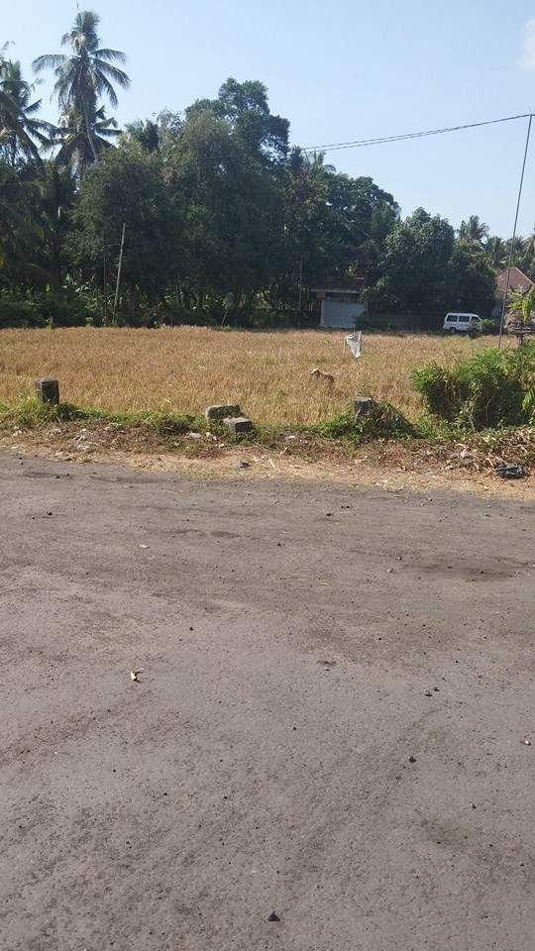

**Picture 1:** 11.1.3 Photo evidence

Secondly, the city of Celuk is a place where the locals are famous from their silver hand craft, however the silver is imported from Java and Sumatra (11.1 Ethnographic research). The area was filled with trash outside and the jewelry did not seem authentic to Bali, even though it was presented as local produce, this is probably due to the demand of tourists visiting the shop from all over the world (11.1 Ethnographic research).

The shop seemed depended on economic benefit of the excursions and besides the employees, there was nothing but tourists present (11.1 Ethnographic research). The whole tour of the production line and the shop seemed staged and a clerk followed each tourist around (11.1 Ethnographic research). The same was also experienced at a local market, where the shop seemed economically depended on tourists being brought there on excursions (11.1 Ethnographic research).

Thirdly, even in the Butterfly Park, there was trash present (11.1.3 Photo evidence, photo 9).

Fourthly, on a mountain with a view of Mount Batur was overrun with tourists, which lead to the presence of many street sellers and piles of trash everywhere along the road, the excursion to the area had caused locals to see an opportunity to sell souvenirs to tourists there, which in turn ruined the area due to over population and no trash handling (11.1 Ethnographic research).

Fifthly, several places at Sanur beach, there was trash buried underneath the sand (11.1 Ethnographic research).

Sixthly, Ubud was a small town not so many years ago, however due to increasing tourists coming on excursions, the city gradually grew and shops and hotels popped up everywhere (11.1 Ethnographic research). The traffic is awful and it is dangerous to move about, locals were also wearing masks to cover their mouth and nose from the air pollution (11.1.3 Photo evidence, photo 16).

Seventhly, in a local temple, there was often looting from Balinese, trying to make money out of selling extremely old statues and relics from the temple (11.1 Ethnographic research).

Eighthly, on the elephant tour, the elephants were well taken care off and there was people continuously cleaning the area. The tour only took 30 minutes to ensure the elephants did not get stressed from all the tourists, however elephants are not indigenous to Bali, but are from Sumatra and no wild elephant ever lived on Bali (11.1 Ethnographic research). The slogan of the tour was ‘a true Balinese experience’ (11.1 Ethnographic research). Moreover, there were wild monkeys present in the area that came down from the mountains to find food as they were hungry, which made them very aggressive (11.1 Ethnographic research).

Ninthly, on the white river rafting excursion, there were tons of different rafting companies organizing excursions down the river. The overcrowding of different companies lead to a lack of space on the river, which was also filled with waste in the form of old life vests, beer bottles, plastic bags, etc.. The company did not have any clean-up policies and did not have a joint clean-up policy with any of the other rafting companies. Moreover, the guide did not seem quite convinced himself that salmon and eel actually lived in the river, but it seemed it was rather something that he had been told (11.1 Ethnographic research).

Tenthly, on the Temple on the Ocean, there were actual maintenance employees working to clean the park around the temple and trashcans, however the trashcans did not seemed to be used as there was litter most places. As seen in ‘picture 2’, the beach was filled with waste and it was only visible from the cliff bridge out towards the temple. The excursion guide explained that the employees and also locals will gather the waste and burn it locally in small fires. The excursion guide did not see this as dangerous or unhealthy, but seemed to think that it was a sustainable solution to the waste issue (11.1 Ethnographic research).

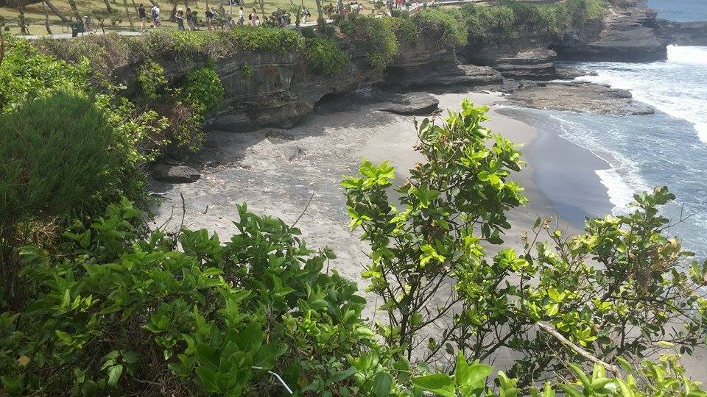

**Picture 2:** 11.1.3 Photo evidence

Finally, on the Temple on the Lake was a well preserved park around an old temple that was well taken care off with no waste. The whole area felt very official and had police officers present to protect the park (11.1 Ethnographic research).

### 5.2.3 Sum up

The important elements from the small excursion areas were that women in the ‘small villages’ have their own small shops on the street corner, the local handling of trash, little recycling, hotels ruining the natural areas on Bali and an authentic full moon celebration.

The important elements from the mass-tourism excursion areas were the inauthenticity and pollution of the Barong Dance, local shops dependence on excursions, trash on most excursion sights with mass-tourism, locals becoming souvenir sellers, small village grown into tourist Mekka, elephants are not indigenous to Bali, ruined and polluted river created by mass tourism, beach shoreline destroyed by waste and waste being burnt locally.

Generally, there were lots of local wearing masks, while driving or out, due to the air pollution in the areas, a general mistrust of the Indonesian government and tons of local selling excursions as middlemen for the real excursion operators.

# 6 Analysis

## 6.1 Excursion operators and CSR

As found in the findings, five of the six interviewees are aware of CSR. However, only two has actual CSR initiatives with in their organizational structure. BCD has a genuine continuous CSR policy of cleaning the ocean at their excursion sights, while PB has sporadically initiatives concerning the local communities and environment. All of the interviewed companies seem to fail to understand the concept of CSR in being ‘a good corporate citizen’ and that CSR can improve their image and gain from involvement (Petrovic‐Lazarevic, 2008). None of the companies engage directly in the local communities, only through tourists’ donations and shopping behaviors.

Responsible tourism focuses on the importance of the environment, socio-culture and economy, which is created by tourist movement, for instance by changing the behavior of tourists and thereby increasing their experience (Manente, Minghetti & Mingotto, 2014; Spenceley, 2002 cited in Frey & George, 2009). However, this does not provide companies with a viable way to do business, but rather a general term for improving the issues created by tourism. It does not offer the five companies a feasible and profitable solution for the issues created by tourism.

Whereas CSR implies that companies are accountable for the social, environmental and economic impacts, which is generated by the companies and they should improve the impact by responsible activities (Manente, Minghetti & Mingotto, 2014). Therefore, CSR implies that the companies are themselves responsible for the issues they face and have created some of the negative impacts. For instance, lack of toilets, waste, bad infrastructure and the need for education of local, may possibly be the companies own responsibility as they have the influence.

Furthermore, none of the companies could name a collective tourism institute for responsible tourism, none of them could come with a concrete option for a policy involving CSR, almost none seemed very enthusiastic and almost all of them think that CSR is for big foreign organizations. This might suggest that the companies do not have a real concept of CSR and lack knowledge and/or interest in the subject.

The five companies can achieve CSR initiative by using five strategic dimensions that will create value through a strategic outcome and guidelines (Burke & Logsdon, 1996). The CSR initiatives within the individual company should be central, specific, proactive, voluntary and visible, and a co-creation between the company and the consumer (Burke & Logsdon, 1996). For instance, BCD could engage their consumers in cleaning the oceans through voluntarism, co-creation, central and specific to their company, proactive and visible for locals. Through this activity, BCD could engage their consumers in an activity to preserve the authenticity of Bali by commitment to local communities’ protection and thereby improving their image and reputation (Petrovic‐Lazarevic, 2008).

However, in CSR, corruption and irresponsibility are complications that surfaces from managers and executives (Putrevu, McGuire, Siegel & Smith, 2012). This can perhaps be resolved by creating public policies from governmental bodies. Even though the general perception from the interviews would suggest that the companies does not have faith in the Indonesian government and perceive them as corrupt.

The tourism industry has risen in emerging and developing economies such as Indonesia, and around 80% of Bali’s economy is reliant on tourism (Thapa, 2012). Therefore, it is even more important for the excursion operators on Bali to involve in CSR to maintain their income and their industry. Issues involved with being a small island developing state (SIDS) are the small size, outside influences, economic capability, remoteness, insularity and proneness to natural disasters (Briguglio, 1995).

Besides the internal aspects of the five strategic dimensions offers, tourism policies offer guidelines from the public sector. The issues that the five companies would like to have addressed in possible policies are system setup, fund, regulations, and interest from local organizations, community and governmental help, community involvement, education, awareness, policies and big organization helping smaller ones. Besides policies Kernel (2006) argues that tourism organizations are small organized entities that have diverse resources and capabilities, and therefore should have influence over the policy making process. This would perhaps overcome the companies’ lack of faith in the government or otherwise involve local governmental bodies on Bali.

When dealing the tourism policies, governmental bodies will most likely be involved (Halkier, 2006; Skare & Golja, 2014). However, using local governmental bodies can create better opportunities for the excursion operators on Bali, as the local governmental bodies will have more insight into the issues present on the island. Yet it can become difficult for the excursion operators, if the Indonesian government does not want to participate.

Besides the governmental issues, the excursion operators face another problem of being a developing small island state. However, Simpsons (2007) states that the success of CSR and CBTIs is not influence by the fact that it is a developing or none-developing country, as long as there is a significant level of community participation at all stages.

The most likely of events for the excursion operators on Bali to preserve their destination is to take matter into their own hands and deal with the issues outside of the Indonesian government, if they cannot get their attention. Moreover, as BCD mentions that “*there is a lot of talk and no action*”.

## 6.2 Excursion operators’ influences on culture and environment

In order to understand the findings for the second objective, it is imperative to understand that responsible tourism involves environmental, socio-cultural and economic issues that are produced by tourism movement (Manente, Minghetti & Mingotto, 2014). Therefore, in order to overcome the issues found in the second objective, the excursion operators have to understand their part in the issues created. Moreover, as found in the analysis of the first objective, the excursion operators are lacking knowledge of the issues and CSR, and the influences they have on the culture and environment of Bali. In order to manage the issues, one can for instance use responsible tourism management, which can be considered as a part of CSR (George, 2009).

One of the main issues that can be addressed by responsible tourism management and CSR is the waste problem found on Bali, which ruin the natural beauty of the island. Environmentally, the excursion operators’ activities have brought waste to otherwise untouched areas, expansions to rural areas and oceans. Socio-culturally, the excursion operators have created big cities from small villages, expansions to rural areas, waste being burnt locally and small street shops. Economically, the excursion operators have indirectly brought economic dependence in certain small shops by bringing tourists there on excursions and made locals become street sellers by selling products at the mass-tourism areas. CSR implies that the excursion operators are responsible for these effects (Manente, Minghetti & Mingotto, 2014). In order to overcome these issues to some degree is by implementing CSR into the excursion operators organizational structure and contribute to the environment and the local communities (Petrovic‐Lazarevic, 2008).

One of the ways in which the excursion operators could assist in the cultural and social impact that they have created is by using authenticity. CSR addresses both culture and heritage, which is connected to authenticity (Chhabra, Healy & Sills, 2003; Taylor, 2001). However, Bendix (1989) argues that authenticity will always be staged by the simple fact that the tourist is present, yet a landscape cannot be stated. This means that the excursion operators can use authenticity to manage the waste issue that disturbs the natural beauty of Bali to create authenticity for the tourists. The excursion operators could solve the issues of the elephant tour’s slogan, waste issues by involving initiatives and tourists.

As Bendix (1989) states, the excursion operators cannot change the authenticity of the Barong Dance, the city of Ubud and the full moon celebration. This is because of the measly fact that there are tourists present, therefore it cannot be authentic. However, this does not make the attractions less valuable to the tourists as authenticity can be more positively defined as local values (Taylor, 2001). This means that the attractions can be somewhat authentic. Nonetheless a tourist can never experience the true authentic experience before actually becoming a part of the culture. However this does not make is less valuable for the tourists, as it only needs to be perceived as authentic (Chhabra, Healy & Sills, 2003).

However, the companies cannot solve the rural areas being destroyed by hotels and expansions as they are most likely a result of the Indonesian government’s activities and the impact of mass tourism demands. Moreover, in mass tourism areas, the search for authenticity does not have to be lost as authenticity can occur at any place and time, and is not limited to sites, images and locals (Ek, Larsen, Hornskov & Mansfeldt, 2008).

In order to overcome some of the environmental issues, the excursion operators could assist by demanding tourism policies to have guidelines to contribute to the environment. However, the mistrust in the Indonesian government could lead to a difficult situation in the relationship. The negative effects that the movement of tourists has on the environment are partly excursion operators’ movement of tourists to small rural- and mass tourism areas. As it creates a demand from tourists to stay at these areas, but also enables the demand for expansions to rural areas. The excursion operators’ role in influencing Bali’s culture and environment are by bringing the tourism movement to rural areas instead of containing it within the mass tourism areas. The Indonesian government should take the opportunity to create CSR policies and tourism policies for organizations to follow. Otherwise the Indonesian government will slowly be ruining Bali, one of their most visited destinations.

Halkier (2006) stated that policy-making is collaboration between the public controlled side and the public uncontrolled side. However, if the relationship consists of mistrust and uncertainty, the success of the policies is threatened. In order to achieve a competitive advantage over other destination in a globalizing world, it is imperative for tourism stakeholders (for instance government and excursion operators) to have an understanding of the direction of change and its effects for destination and business management (Dwyer, Edwards, Mistilis, Roman & Scott, 2008). This means that collaboration is imperative for a destination to succeed. Moreover, communication is important for solving economic, social and environmental issues (Saxena, 2003).

However, from the findings it would suggest that the most unwilling to change the destination for the better is the Indonesian government that more sees Bali as a case machine. This could possibly also be understood from the numerous failed attempts to contact the Indonesian tourism ministry in the research of this thesis.

The solution might be that it is necessary for the excursion operators to take matters into their own hands and define their own policies. This means that the excursion operators will have to resolve their influences on the culture and environment of Bali themselves by becoming a ‘good corporate citizen’ (Petrovic‐Lazarevic, 2008). According to Simpson (2007) key stakeholders working together will ensure a healthy development of tourism through CBTIs. However, this will likely have to be developed without the Indonesian government, which is of course a key stakeholder. Simpson (2007) also emphases that it does not matter if the initiatives are in a developed or in a developing country as long as there is community participation at all stages. This means that the most important stakeholder is the community and the excursion operators will have to get the local communities involved, if they are to succeed.

It is imperative for the Indonesian government to understand the importance of the tourism industry on Bali and the need for a sustainable development of the destination and for future competitiveness. SIDSs are especially vulnerable due to the small size, remoteness, insularity and proneness to natural disasters (Briguglio, 1995). This means that the disadvantages make the economy very vulnerable to outside influences, for instance tourism movement.

The excursions have a bigger influence on SIDSs, because of the small size of the area. This means that the excursions can also show so much without influences every areas of the destination. Moreover, the insolation and insularity of the population influences the level of knowledge of the effects of excursions.

Read (2004) provided a list of key factors for growth in SIDSs, which indicated key points in the destination that needs to be improved in order to achieve growth. Read’s (2004) list consists of things similar to CSR initiatives, which could provide a good indication for policy-making for Bali. For instance economic sovereignty, human capital, social cohesion and islandness, this could all lead to growth. Therefore it would be beneficial for CSR policies to include these key points.

## 6.3 Sum up

The important issues that were found in the analysis of the first and second objectives were the lack of knowledge of CSR within the excursion operators, even if they actually did have CSR implemented. Issues that arise with both mass tourism and excursion to small rural areas, the subject that perhaps mass tourism is more responsible tourism than excursions to small rural areas. The issue with the corrupt Indonesian government and the effect it can have on the development of CSR policies. Another issue is the difficulty of being a SIDS with a corrupt government, which perhaps only sees the destination as a cash machine and the role of the excursion operators in all of the issues and the implementation. The final points that will be discussed are the advantages and disadvantages of CSR.

# 7 Discussion

The ‘good corporate citizen’ image is a central part of CSR (Ghazali, 2007 cited in Petrovic‐Lazarevic, 2008). Being a ‘good corporate citizen’ entails involvement in environment, socio-cultural and economic issues created by tourist movement. However, as a small island in a developing nation, Bali is faced with more challenges than most destinations with regards to inauthenticity, lack of tourism policies, lack of knowledge of CSR, vulnerability to outside influences and possibly a corrupt government (Briguglio, 1995). In order for Bali’s excursion operators to implement CSR, there are several issues that need to be addressed. These issues will be presented from the findings and the analyses to be further discussed here.

The current role of the excursion operators in CSR on Bali is almost non-existing, even the Danish excursion operator did not have a single CSR initiative. BCD was the only one of the operators who had stated, both in their interview and on their website, that they deal with CSR in regards of cleaning up the ocean. PB had several indications of CSR on their website, but none of the two interviewed from the operator had any idea of the initiatives. This could possibly mean that PB’s employees know nothing about the CSR that goes on, or that the information on the homepage is incorrect. As there were two employees who had no knowledge of the CSR initiatives, it is most likely that the information on the website is incorrect, and the initiatives were put there to make PB seem more attractive for ‘green tourists’. There seem to be a general understanding that bringing the tourists to local markets and shops is supporting the local communities, and in some ways that is correct. However, the operators are also causing the local communities to depend on the income they receive from tourists, which can be seen from hundreds of street sellers around visited areas. Five of six of the tour operators wanted tourism policies from the Indonesian government, but to no avail. As BCD mentioned: “*There is a lot of talk and no action”.* One employee from PB knew nothing of CSR, even though according to their webpage PB actually has CSR initiatives. Moreover, it is not only the excursion operators that lack knowledge of CSR or responsible tourism. It seems that the locals also lack knowledge. The considerable amount of waste found all over Bali would indicate that it cannot only be the fault of tourists and excursion operators.

Nevertheless, the excursion operators have a role and a responsibility within CSR by being a ‘good corporate citizen’, and they can improve their image by developing initiatives and policies to ensure the continuous arrival of tourists to the island (Petrovic‐Lazarevic, 2008). As already established, the current role of the excursion operators in CSR is almost non-existing and there is a lack of knowledge, which could be due to the possible corruption in the Indonesian government as mentioned by several guides within the excursion operators (11.1.2 General observations). One of the driving forces of planning and implementing CSR is tourism policies, which is usually cooperation between a government and key stakeholder (Putrevu, McGuire, Siegel & Smith, 2012; Halkier, 2006). This means that there is a need to heighten the level of knowledge.

Five of the excursion operators are aware of CSR, however they all lack knowledge. This could be derived from the lack of knowledge of actual concrete initiatives that the excursion operators would like to have assistance with from the Indonesian government, and how implementing CSR could result in having a positive effect on both the excursion operators as companies and Bali as a destination. There is a need to increase the level of knowledge in both the excursion operators and the Indonesian government. The issue is how this can be done. However, it is not a simple issue to resolve as it would require commitment and communication from all key stakeholders to succeed in CSR policies (Mass & Reniers, 2014). The relationship between the excursion operators and the government would need to be mended.

The excursion operators and the Indonesian government would have to understand how tourism and excursions affect Bali’s culture and environment, as analyzed in the analysis. Furthermore, they would have to understand their role in improving and developing the destination’s urban and rural areas for future generations (Thapa, 2012). In the case of Bali, it would seem that the excursion operators have an important role in implementing CSR due to the supposedly corrupt government which does not seem to be willing to assist in the matter.

Before the role of the excursion operators’ role in implementing CSR can be fully understood, it is necessary to understand the issues they participate in creating. Both in small and mass tourism areas waste was a huge issue. There was also trash present along the roads and in the local communities. Waste was present in nature, rivers, cities, roads, ocean, beaches, etc.. The waste is a front stage presentation to the tourists and a back stage for the locals that presents the creation of a tourism policy that could benefit both the tourists and the locals (Crossman, 2015). In the case of the river, it is difficult to imagine locals fishing in the lake or using anything from it, as there were so many boats and companies present. The once small village of Ubud has grown into a tourism Mekka. Moreover, the expansion of hotels in rural areas that are untouched by tourism can create more cases as Ubud and in the end it will be irreversible (11.1.2 General observations). All these issues indicate that Bali will need to develop CSR initiatives and focus more on responsible tourism to overcome these issues, and this can be done while also profiting (Petrovic‐Lazarevic, 2008; Falck & Heblich, 2007). One of the possible ways to do this in order not to destroy any more rural areas is to focus on the mass tourism areas instead of doing excursions to rural areas, and possibly destroying them permanently in the future.

According to Bendix (1989) authenticity will always be staged except for a landscape. However if the natural environment of Bali is continuously mistreated, the natural beautiful landscapes of Bali will also be destroyed. The question is: *“Are excursions to small rural areas as sustainable in the long run as mass tourism, which contains tourism to particular and selected areas?”.* This means that like people will act differently around tourists like some people would in front of a camera, but a landscape cannot change due to the presence of tourists. The search for authenticity does not have to be lost in mass tourism areas, as authenticity can occur at any place and time, and is not limited to sites, images and locals (Ek, Larsen, Hornskov & Mansfeldt, 2008). If the development continues, as indicated by the excursion guides, the natural environment will become inauthentic and ruined by waste and hotels (11.1.2 General observations). This is something that the excursion operators can contribute to by using CSR policies, for instance by cooperating with each other select specific areas that will then become mass tourism areas. Additionally, the excursion operators would leave the small rural areas untouched. This is assumed to be a more sustainable development, in addition to creating responsible behavior in tourists (Manente, Minghetti & Mingotto, 2014). If all the excursion operators participate in this initiative, they will all gain a profit and provide them with the image of a ‘good corporate citizen’ (Petrovic‐Lazarevic, 2008; Falck & Heblich, 2007). Furthermore, it can improve consumer attitudes, intentions and beliefs by creating relevant CSR initiatives and making the consumer understand the importance of the change and providing the tourists with constructed authenticity (Becker-Olsen, Cudmore & Hill, 2006; Wang, 1999).

Looking at the issue of mass versus small scale area excursion, and the benefits of limiting tourism to mass scale areas has not previously been explored as assumed by the lack of articles found. Responsible tourism and CSR are about preserving a destination for the future. Therefore instead of affecting vast areas of the destination, down to the small untouched areas, it could be assumed that limiting the excursion to mass tourism areas instead. It provides an interest subject for future research. In the case of Bali, to could be assumed that this sort of research would be beneficial for the island to preserve the destination for future generations. However there is the issue of tourism demand and tourists’ needs for unique experiences. Although these needs could be meet in another manner, by only driving through the small excursion areas without a stop. For instance backpackers’ lifestyle travelling could interfere with the subject (Cohen, 2011). Moreover according to Williams and Soutar (2009) customer value is an imperative element in in consumer consumption and decision making behavior, which is linked to the customer satisfaction. This means that it can be difficult for the excursion operators to implement this due to consumer demand and their expectations and needs and values.

The excursion operators will have to create responsible activities, such as suggested previously with limiting excursions to mass tourism areas, in order to achieve CSR. According to Burke and Logsdon (1996), these CSR initiatives will have to be central, specific, proactive, voluntary and visible in order to create value. Additionally the CSR initiatives will also have to be a co-creation between the excursion operator and the consumer (Prahalad & Ramaswamy, 2004). Looking at the issues, the CSR initiatives will have to increase the authenticity, try to resolve the waste issue and try to stop the expansion of tourism to rural areas. The previously mentioned CSR initiative of limiting excursion to mass tourism areas can create constructed authenticity and thereby increase the authenticity of the landscapes by removing and limiting waste in the mass tourism areas and the rural areas (Wang, 1999; Bndix, 1989). Moreover the initiative covers all of the five dimensions and will also be co-creation between the excursion operators and the consumers, as the demand of the tourists will have to change in order to it to succeed (Prahalad & Ramaswamy, 2004). This will result in a CSR initiative that can assist in resolving to of the issues, authenticity, expansions and waste. However it can also resolve the issue of the continuous expansion of tourism to rural areas, as it will protect the areas from tourism influences in the form of economic dependence and protection of the environment. As it will no longer have a much interest, as the tourists will not be able to visit these areas with the assistance of excursion operator, and hopefully travel agents as well. This CSR initiative could contribute to a more ethical and sustainable tourism outcome for Bali and the excursion operators.

Another CSR initiative that the excursion operators could focus on is to do a clean-up day like BCD. This could create an opportunity for BCD to engage with the other key stakeholders on Bali to cooperate in engaging themselves and local communities in cleaning up. Furthermore, it would also present a perfect way for ‘green’ tourists to give something back to the destination by engaging in a clean-up day, thereby also improving the image of the excursion operators (Petrovic‐Lazarevic, 2008).

According to Halkier (2006) tourism policies are a co-creation between the publicly controlled side and the public uncontrolled side. This means that it is cooperation between the government, public- and private actors. However as mentioned earlier the Indonesian government is most likely corrupt, which will create an issue for the success of the tourism policies. Additionally Bali is a small island in a developing nation and the island is more prone to corruption (Nwabuzor, 2005). Moreover one of the main issues in CSR is corruption and irresponsibility from managements and executives (Putrevu, McGuire, Siegel & Smith, 2012). Therefore the role of the excursion operators in implementing CSR will be much larger than, if the government was not corrupted and will most likely not assist in the implementation or development of CSR. The excursion operators will have to take the initiative of developing and implementing CSR into their own hands due to the corrupt government. However Simpsons (2007) argue that community involvement is imperative for a sustainable development, therefor if the excursion operators involve the whole community of Bali as a single entity it can succeed. This means that there will have to be a higher level of communication and commitment at all levels of the island and will thereby also increase the level of knowledge of CSR.

The tourism policy model created by Halkier (2006) will therefore have to be redefined in the case of Bali. Thereby eliminating the Indonesian government from the model, however the local governments on Bali might assist. However the local Balinese governments’ level corruption is not known or stated, as they did not respond to any of the contacts taken during the course of this thesis (4.4 Delimitations). The solution could be to create a board of directors of CSR initiatives and policies on Bali, including members from different key stakeholders and possibly local regional Balinese governments. Additionally it could also be a valid point to keep governmental bodies out if the board to decrease the likelihood of corruption (Putrevu, McGuire, Siegel and Smith, 2012; Nwabuzor, 2005). The policy maker in the board of directors should consist of relevant and diverse stakeholder in order to reach all elements of CSR in the economy, society and environment to get all perspectives, and create a system setup for the organization to use, regulations and education in CSR (Kernel, 2006). This means that the board of directors does not only have to consist of organizations within tourism, as a ‘good corporate citizen’ is not limited to the tourism industry alone and could therefore also contain big organizations to help small organizations (Putrevu, McGuire, Siegel and Smith, 2012). A good start for the tourism and CSR policies to consist off would be the previously mentioned CSR initiatives of authenticity, waste and limitation of excursions, and clean-up days. Like BCD state *“there is a lot of talk and no action”,* this makes for a golden opportunity for them to take the initiative and start communicating with the other excursion operators and starting off with clean-up days. Thus, increasing the communication and could lead to the creation of a board of directors for CSR on Bali.

Another issue in regards to the tourism policies is that Bali is a small island in a developing nation and is therefore more prone to outside influences that could threaten the economic capability of the destination (Briguglio, 1995). Thereby making it less attractive for the excursion operators and the stakeholders to plan and implement CSR. However this can only be resolve by the Indonesian government or local regional Balinese governments by creating a fund to assist the organizations in implementing CSR. Otherwise the board of directors for CSR could assist each other in implementing the policies through a member fee, however this could increase corruption.

The board of directors for CSR should define the CSR policies according to problem, however the policy making process is not always linear, but should include formulation, design, implementation and eventually evaluation of the policies for further improvement (Halkier, 2006). The board of directors of CSR would contribute to the policies with resources, target, contexts, roles and competences to each of the policies, and will probably lead to more CSR policies than stated in this thesis (Halkier, 2006).

There are many issues and disadvantages of being a SIDS, for instance the small size of Bali, the remoteness, the assumed insularity of waste disposal and proneness to natural disasters (Briguglio, 1995). The small size and remoteness cannot be solved or improved and should not be, as it is a part of what makes the destination unique. However the proneness to natural disasters can be improved by preparing and planning by adapting, modifying and fitting by focusing on the environment for instance by using CSR policies or policies in general (Barnett, 2001). The previously mentioned board of directors of CSR can assist in developing and adapting the island to be more prepared for a natural disaster and make emergency plans for evacuation and safety measures.

One of the main issues of SIDS and CSR is corruption, both SIDSs and CSR are prone to corruption, thereby making it difficult to resolve. However Nwabuzor (2005) argue that an honest government can eliminate corruption by empowering the public and protecting the poor. However the Indonesian government does not seem to be a completely honest government and it may well be corrupted. The challenge is that the organizations on Bali will have to take the initiative to develop the destination themselves by for instance the board of directors of CSR and try to eliminate local corruption on the island. Using CBTIs in CSR could help eliminate corruption by community involvement, which would also include the poor (Simpson, 2007). The excursion operators and other organizations will have to stand together to build skills and influence on the island in environmental, social and economic issues and challenges (Simpson, 2007). If the excursion operators have the skills of CSR and the influence in the local communities, it could be possible also to improve the knowledge level and skills in the locals of waste management and make them less economically depended on tourism.

The previously mentioned board of directors for CSR could use the five areas of ‘sus5’ as a practical tool for self-assessment and to detect gaps in the CSR policies of authenticity, waste and limitation of excursions (Maas & Renier, 2014). Moreover, it would motivate them to a wider responsiveness area (Maas & Renier, 2014). The management and the stakeholder should therefore acquire knowledge of CSR and be committed to CSR policies, thereby also communicate with each other. The board of directors of CSR should create a strategic plan for the CSR policies in practice, and make use that knowledge and commitment are also present on the work floor. In this case the work floor could be the local communities. Lastly the board of directors should do operational planning, implementation guidelines and finally monitoring the CSR policies for future modification (Maas & Renier, 2014). In order for the CSR policies to work, it is imperative for there to be communication and commitment, and for planning and monitoring for the success of the CSR policies.

As established in the discussion, the excursion operators’ current role in implementing is non-existing as only BCD actually has CSR initiatives and is aware of them. According to the homepage PB also has CSR, but none of the two employees knew of it. If the excursion operators want the areas improved, they will have to take the initiative and create internal CSR policies or work together with other organizations to create a board of directors for CSR due to the corrupt government. This means that the future role of the excursion operators of implementing CSR and policies is a massive task. They will have to acquire the knowledge and the skills in order to do so as they will probably have no governmental help. Furthermore, the difficulties of being a SIDS provide more disadvantages for the destination by challenges that cannot be changed, for instance remoteness and small size. The advantages of the excursion operators taking matters into their own hands are that they will create a unique relationship with other stakeholders and the local communities that can improve the CSR policies for future improvements and modifications. The relationships will assist in the knowledge base of the issues and knowledge of how to improve them. However, the Indonesian government’s corruption could spread to these entities from bribes and/or it could eventually be a wakeup call for the government to improve and better their ways of corruption.

The disadvantages of CSR policies are that it is difficult to implement and monitor as it can take a long while to see the effects. Moreover, many of the policy theories that exist focus strongly on the government and public sector sides, and even fewer give concrete examples of how a tourism policy and a CSR policy should consist off. For instance, Halkier (2006) focus strongly on public actors, authorities and political sponsors. Skare and Golja (2014) focus on the public sector’s tasks in facilitating, networking, mandates of CSR and endorsement, and how the organizations should formulate, adopt and promote the CSR policies mandated by the public sector. Also Simpson (2007) focuses on key stakeholder communication including the government.

Moreover, as mentioned corruption and irresponsibility is a main issue in CSR (Putrevu, McGuire, Siegel & Smith, 2012). However, sharing leadership and informal relationships will lower this tendency (Putrevu, McGuire, Siegel & Smith, 2012). Putrevu, McGuire, Siegel and Smith (2012) state that good communication between the key stakeholders are important for the survival of tourism and CSR policies, and in the end it could contribute to future decline in unethical practices and be the silver-lining of the global economic crisis. This means that CSR can contribute to a more ethical tourism outcome in the end, even with a corrupt government.

The advantages of CSR are of course the enhanced communication in multiple networks and between stakeholders. Moreover, that CSR focuses on building skills and knowledge of important issues for any destination in the environment, economy and socio-culture. Furthermore, CSR distinguishes itself from responsible tourism by engaging and motivating organizations to get involved with their destination and local communities’ welfare. Thus, CSR is creating ‘good corporate citizens’ (Petrovic‐Lazarevic, 2008). The excursion operators has a noticeable effect on the environment, economy and socio-culture of a destination from their activities and tourist movement, therefore it is also important for them to focus on these issues and preserve their destination and environment for the future by more ethical practices (Angelkova, Koteski, Jakovlev & Mitrevska, 2012; Carey, Gountas & Gilbert, 1997).

To conclude the discussion, mass tourism excursions could be a more sustainable option than excursions to small rural areas for excursion operators. Moreover, the excursion operators and other organizations should create a board of directors for CSR in order to cooperate, and enhance communication and commitment to CSR and the destination.

# 8 Critique / Deviation

The critique of this report is that it would have been more valid, if there was an interview with the Indonesian government and/or governmental bodies on Bali. However, it was not possible as they did not respond to any inquires that was made, as mentioned in ‘4.4 Delimitations’.

Moreover, it would have been more effective, if more excursion operators were interviewed. However, this was also not possible as many of them did not speak English well enough to conduct a proper interview, as mention in ‘4.4 Delimitations’.

# 9 Conclusion

The purpose of this thesis was to research and investigate: **‘What role does excursions operators have in implementing CSR, and can CSR contribute to a more ethical and sustainable tourism outcome?’** by using the theoretical subjects of CSR, responsible tourism, authenticity, tourism policies and the issues of being a SIDS. There were two objectives created in order to answer the research question, which were if the excursion operators are aware of CSR and how the excursions influence a destination’s culture and environment.

The important findings from the first objective were that none of the excursion operators seemed to find CSR important. However, they were all aware of CSR except one from PB. None of the excursion operators gave elaborate explanations suggesting that they knew little of CSR or were not interested in the subject or that they were intimidated and apprehensive speaking to a tourism-student. The findings from the second objective were environmental issues of waste, air-pollution and hotel ruining the natural areas on Bali. Moreover, the mistrust in the Indonesian government and the view of them as corrupt.

In the analysis, it was found that the excursion operators do lack knowledge of CSR, even though some of them actually had CSR implemented into their organization. Furthermore, it was found that excursion to mass tourism areas instead of small rural areas might be more sustainable by containing it to certain areas instead of spreading tourism to the entire island. An issue found in the analysis was that the corrupt Indonesian government might have an effect on the development of CSR policies as government bodies are involved in the development of policies. Moreover, another issue found was the difficulties of implementing CSR that arise with being SIDS with a corrupt government.

The issues discussed in the discussion were mass tourism excursions versus small rural excursions, the corrupt Indonesian government, SIDS issues and developing policies without the assistance of the Indonesian government. It was found that the current role of the excursion operators’ role in implementing CSR on Bali was almost non-existing, even the Danish excursion operator did not have CSR implemented. Five of the six excursion operators wanted tourism policies from the Indonesian government, however nothing is happening, as BDC mentioned: “*there is a lot of talk and no action”.* There is a considerable lack of knowledge of CSR and responsible tourism both in the organization and the local communities, which is indicated from the interview, yet also from the considerable amount of waste all over Bali. However the excursion operators have an important role to play by expanding tourism and needs to become a ‘good corporate citizen’.

Discussing the impacts of tourism on small rural areas, it was suggested that the excursion operators create a policy to avoid small rural areas on their excursions. Thereby focusing their excursions on mass tourism areas, this does not lower the authenticity as it can occur at any place and time, and is not limited to sites, images or locals. The CSR initiative would create a constructed authenticity for the tourists, however as mentioned this is not less valuable. However, there is a strong possibility for this initiative to interfere with the consumers’ demand, expectations, needs and values.

Creating a CSR policy to limit excursions to mass tourism areas would possibly assist in solving the waste issue, the continuous expansions and the inauthenticity. Thereby the CSR policy would result in a more ethical and sustainable tourism outcome for Bali and the excursion operators.

Tourism policies are a co-creation between the publicly controlled side and the public uncontrolled side, meaning that it is collaboration between the government and key stakeholders. However, Bali is a SIDS with a corrupt government and the main issue with CSR is corruption and irresponsibility. Therefore, it was suggest that organizations in different industries should stand together to create a board of directors for CSR on Bali with the help of local communities in order to create initiative and policies themselves and thereby avoid the corrupt governmental interference. Moreover, SIDS are also more prone to natural disasters, here the board of directors for CSR can assist in preparing and planning by CSR policies or policies in general. For these policies the excursion operators and the board of directors can use ‘sus5’ for self-assessment.

The disadvantages found with CSR are that it is difficult to implement and monitor, and corruption, many of the existing theories of CSR all include government assistance. The advantages of CSR are the enhanced focus on communication between multiple networks and key stakeholders. Moreover, that CSR increases skills and knowledge of important issues. Additionally that CSR engage and motivate organizations to involve themselves with the local environment and communities. This means that in the end it will create more a sustainable and ethical tourism outcome.

In the discussion the two objectives were more thoroughly answered. The first objective of the excursion operators’ level of awareness of CSR was found to be present, yet lacking knowledge of implementation and issues to be handle. Furthermore, one particular interviewee from PB knew nothing of CSR, even though PB actually has CSR according to their homepage. The excursion operators’ lack of knowledge of that they wanted to change indicates that the level of knowledge is not high, but they are aware of the term of CSR. The second objective was the excursion operators’ influence in the environment and culture. The tourist movement has created small shops along roads, created pollution of waste in nature and rivers, local markets economic dependence on tourism, inauthenticity of old dramas and has made a small village grow into a tourist Mekka. This means that the excursion operators have contributed to the economic dependence, pollution, expansion of tourism to former rural areas and inauthenticity.

In conclusion, the excursion operators’ role in implementing CSR is presently almost non-existing as they will most likely need and want assistance from the Indonesian government. However, the excursion operators have an opportunity to do it themselves by creating a board of director for CSR, and thereby making their future role in implementation of CSR massive. Yet in the end it will create a more sustainable and ethical tourism outcome for the excursion operators as they assist in improving and sustaining their destination environmentally, culturally and economically for the future.

# 10 Reference list

Adger, N. & Barnett, J. (2005). *Compensation for climate change must meet needs.* Nature 435, p. 328.

Angelkova, T., Koteski, C., Jakovlev, Z. & Mitrevska, E. (2012). *Sustainability and competitiveness of*

*tourism.* Social and behavioral science, Elsevier, p. 221-227.

Barnett, J. (2001). *Adapting to climate change in pacific island countries: the problem of uncertainty.*

World development, Elsevier, 29(6), p. 977-993.

Becker-Olsen, K. L., Cudmore, A. & Hill, R. P. (2006). *The impact of perceived corporate social*

*responsibility on consumer behavior.* Journal of business research, Elsevier, 59(0), p. 46-53.

Bendix, R. (1989). *Tourism and cultural displays: Inventing tradition for whom?.* The journal of

American folklore, 102(404), p. 131-146.

Bhopal, R. (1999). *Paradigms in epidemiology textbooks: in the footsteps of Thomas Kuhn.* American

journal of public health, 89(8), p. 1162-1165.

Bitsch Olsen, P., & Pedersen, K. (2008). *Problem-oriented project work – A workbook.*

Frederiksberg, Denmark: Roskilde University Press.

Briguglio, L. (1995). *Small island developing states and their economic vulnerabilities.* World

development, Elsevier, 23(9), p. 1615-1632.

Bruner, E. (2005) Introduction. Travel Stories told and Retold. In Culture on Tour. Ethnographies of

Travel. Chicago: University of Chicago Press, p. 3-29.

Burke, L. & Logsdon, J. M. (1996). *How corporate social responsibility pays off.* Long range planning,

Elsevier, 29(4), p. 495-503.

Carey, S., Gountas, Y. & Gilbert, D. (1997). *Tour operators and destination sustainability.* Tourism

management, Elsevier, 18(7), p. 425-432.

Chhabra, D., Healy, R. & Sills, E. (2003). *Staged authenticity and heritage tourism.* Annals of tourism

research, Elsevier, 30(3), p. 702-719.

Cochran, P. L. (2007). *The evolution of corporate social responsibility.* Science Direct, Elsevier, 50(0),

p. 449-454.

Cohen, S. A. (2011). *Lifestyle travelers – Backpacking as a way of life.* Annals of tourism research,

Elsevier, 38(4), p. 1535-1555.

Cottone, R. R. (2011). *A social constructivism model of ethical decision making in counseling.* Journal

of counseling and development, 79(1), p. 39-45.

Crossman, A. (2015, January 2). *Backstage and frontstage.* About education:

http://sociology.about.com/od/B_Index/g/Frontstage.htm

Dredge, D. & Jenkins, J. (2011). *Stories of practice: Tourism policy and planning.* Surrey, England:

Ashgate Publishing Limited.

Dwyer, L., Edwards, D., Mistilis, N., Roman, C. & Scott, N. (2008). *Destination and enterprise*

*management for a tourism future.* Tourism management, Elsevier, 30(0), p. 63-74.

Easterly, W. & Kraay, A. (2000). *Small states, small problems? Income, growth, and volatility in small*

*states.* World development, Elsevier, 28(11), p. 2013-2027.

Ek, R., Larsen, J., Hornskov, S. B. & Mansfeldt, O. K. (2008). *A dynamic framework of tourist*

*experiences: Space-time and performances in the experience economy.* Scandinavian journal of hospitality and tourism, Routledge, 8(2), p. 122-140.

Falck, O. & Heblich, S. (2007). *Corporate social responsibility: Doing well by doing good.* Science Direct,

Elsevier, 50(0), p. 247-254.

Farsari, I., Butler, R. W. & Szivas, E. (2011). *Complexity in tourism policies: A cognitive mapping*

*approach.* Annals of Tourism Research, Elsevier, 38(3), p. 1110-1134.

Frels, R. K. & Onwuegbuzie,A. J. (2013*). Administering Quantitative Instruments With*

*Qualitative Interviews: A Mixed Research Approach.*

Frey, N. & Georg, R. (2009). *Responsible tourism management: The missing link between business*

*owners’ attitues and behavior in the Cape Town tourism industry.* Tourism management, Elsevier, 31(0), p. 621-628.

Farsari, I., Butler, R. W. & Szivas, E. (2011). *Complexity in tourism policies: A cognitive mapping*

*approach.* Annals of Tourism Research, Elsevier, 38(3), p. 1110-1134.

Halkier, H. (2006). *Institutions, Discourse and Regional Development: The Scottish Development*

*Agency and the Politics of Regional Policy*. Bruxelles, Belgium: Peter Lang.

Hall, C. M. (2008).  *Tourism planning – Policies, processes and relationships.* Essex, England: Pearson

Education Limited

Hannam, K & Knox, D. (2010) *Understanding Tourism: A Critical introduction*. London, United

Kingdom: Sage Publications Ltd.

Harboe, T. (2010). *Method and project writing – an introduction*. Frederiksberg, Denmark:

Samfunds litteratur.

Henriksen, P. F. & Halkier, H. (2009). *From local promotion towards regional tourism policies:*

*knowledge processes and actor networks in North Jutland, Denmark.* European planning studies, Routledge, 17(10), p. 1445-1462.

Hjalager, A. (2001). *Repairing innovation defectiveness in tourism.* Tourism management, Elsevier,

23(0), p. 465-474.

Hollins-Alexander, S. (2013). *Online Professional Development Through Virtual Learning Communities.*

Corwin: Insight Education Group, Inc.

Human development report. (2015, January 2). *Carbon dioxide emissions per capita (tonnes).* UNDP:

http://hdr.undp.org/en/content/carbon-dioxide-emissions-capita-tonnes

Kernel, P. (2006). *Creating and implementing a model for sustainable development in tourism*

*enterprises.* Journal of cleaner production, Elsevier, 13(0), p. 151-164.

Krutwaysho, O. & Bramwell, B. (2010). *Tourism policy implementation and society.* Annals of tourism

research, Elsevier, 37(3), p. 670-691.

Larsen, J. (2007). *Picturing Bornholm: Producing and Consuming a Tourist Place through*

*Picturing Practices*. Scandinavian Journal of Hospitality and Tourism, 6(2), p. 75-94.

MacRae, G. (2012). *Solid waste management in tropical Asia: what can we learn from Bali?.* Waste

management and research, SAGE, 30(1), p. 72-79.

Manente, M., Minghetti, V. & Mingotto, E. (2014). *Responsible tourism and CSR – Assessment systems*

*for sustainable development of SMEs in tourism.* Switzerland: Springer International Publishing.

Mass, S. & Reniers, G. (2014). *Development of a CSR model for practice: connecting five inherent areas*

*of sustainable business.* Journal of cleaner production, Elsevier, 64, p. 104-114.

Miller, G., Rathouse, K., Scarles, C., Holmes, K. & Tribe, J. (2010). *Public understanding of sustainable*

*tourism.* Annals of tourism research, Elsevier, 37(3), p. 627-645.

Milne, L. & Milne, M. (2014, October 3). *Why You Should Take Bali Off Your Bucket List*. The

Huffington Post. http://www.huffingtonpost.com/larissa-and-michael-milne/why-you-should-take-bali-_b_4925542.html

Nwabuzor, A. (2005). *Corruption and development: New initiatives in economic openness and*

*strengthened rule of law.* Journal of business ethics, Springer, 59(0), p. 121-138.

Pearce, L. D. (2012). *Mixed Methods Inquiry in Sociology.*

Pederson, E.R. (2007). *Perceptions of performance: how European organizations experience EMAS*

*registration*. Corporate Social Responsibility and Environmental Management, 14(0), p. 61–73.

Pelling, M. & Uitto, J. I. (2001). *Small islands developing states: natural disaster vulnerability and*

*global change.* Environmental hazards, Elsevier, 3(0), p. 49-62.

Prahalad, C. K. & Ramaswamy, V. (2004). *Co-creation experiences: the next practice in value creation.*

Journal of interactive marketing, 18(3), p. 5-14.

Putrevu, S., McGuire, J., Siegel, D. S. & Smith, D. M. (2012). *Corporate social responsibility,*

*irresponsibility, and corruption: Introduction to the special section.* Journal of business research, Elsevier, 65(0), p. 1618-1621.

Read, R. (2004). *The Implications of Increasing Globalization and Regionalism for the Economic*

*Growth of Small Island States.* World Development, Elsevier, 32(2), p. 365-378.

Responsible Travel Report. (n.d.). *The Effects Mass Tourism Has Had on Developing Countries.*

Retreived 25th of September 2014, from

http://www.responsibletravelreport.com/component/content/article/2642-mass-tourism-effects

Riis, O. (2005).  *Samfundsvidenskab I praksis. Introduction til anvendt methode.* Copenhagen K,

Denmark: Hand Reitzels forlag.

Role foundation. (n.d.). *Bali’s Waste Crisis.* ROLE Foundation.

http://www.rolefoundation.org/wastecrisis/

Saxena, G. (2003). *Relationships, networks and the learning regions: case evidence from the Peak*

*District National Park.* Tourism management, Elsevier, 26(0), p. 277-289.

Simpson, M. C. (2007). *Community benefit tourism initiatives – a conceptual oxymoron?.* Tourism

management, Elsevier, 29(0), p. 1-18.

Skare, M. & Golja, T. (2014). *The impact of government CSR supporting policies on economic growth.*

Journal of policy modeling, Elsevier, 36(0), p. 562-577.

Solomon, S. M. & Forbes, D. L. (1999). *Coastal hazards and associated managementt issues on South*

*Pacific islands.* Ocean & coastal management, Elsevier, 42(0), p. 523-554.

Surfer. (2014, January 30). *The plastic problem.* Surfer. http://www.surfermag.com/features/bali-

garbage/

Taylor, J. P. (2001). *Authenticity and sincerity in tourism.* Annals of tourism research, Elsevier, 28(1), p.

7-26.

Tepelus, C. M. (2005). *Aiming for sustainability in the tour operating business.* Journal of cleaner

production, Elsevier, 13(0), p. 99-107.

Thiermann, K. (2013, October 16). *Bali: Paradise Lost?.* The Huffington Post.

http://www.huffingtonpost.com/kyle-thiermann/bali-paradise-lost_b_4109637.html

Thapa, B. (2012). *Soft-infrastructure in Tourism development in developing Countries.* Annals of

Tourism Reserch, Elsevier, 39(3), p. 1705-1710.

UNEP. (n.d.). *Negative Economic Impacts of Tourism.* Retreived from 25th of September 2014, from

http://www.unep.org/resourceefficiency/Business/SectoralActivities/Tourism/FactsandFiguresaboutTourism/ImpactsofTourism/EconomicImpactsofTourism/NegativeEconomicImpactsofTourism/tabid/78784/Default.aspx

Valera, S. (2014, November 17). *Trash Season Arrives on Bali Beach (PHOTOS).* The Weather Channel.

http://www.weather.com/travel/news/trash-season-arrives-bali-beach-photos-20140123.

Walsh, K. J. E., McInnes, K. L. & McBride, J. L. (2012). *Climate change impacts on tropical cyclones and*

*extreme sea levels in the South Pacific – A regional assessment.* Global and planetary change, Elsevier, 80/81(0), p. 149-164.

Wang, N. (1999). *Rethinking authenticity in tourism experiences.* Annals of tourism research, Elsevier,

26(2), p. 349-370.

Weiss, A. S. (2011). *Authenticity.* Gastronomica: the journal of food and culture, 11(4), p. 74-77.

Williams, P. & Soutar, G. N. (2009).  *Value, satisfaction and behavioral intentions in an adventure*

*tourism context.* Annals of tourism research, Elsevier, 36(3), p. 413-438.

# 11 Appendixes

## 11.1 Ethnographic research

### 11.1.1 Balinese tours

30th of September 2014

Today I had a meeting with Mr. Made from Indo Plan Holidays; he was very informative about the culture, society and environment of Bali. He explained how when Bali was a Dutch colony that each city on Bali had to have its own specialty that was theirs, for instance one city is only known for the silver jewelry that they product and one city for its wood carvings.

Furthermore we made plans for a number of different excursions, for instance white river rafting, elephant riding, trip to the northern island, and trip to the floating temple.

When I asked into the issues of CSR and the environment, he was more reluctant to address the issue and he referred back to the unique culture and heritage of the Balinese people.

Mount Batur

1st of October 2014

*Barong Dance*

The first thing on the excursion that I visited was Batubulan, where each day and night, a traditional dance called the Barong dance is performed. Before entering the “temple” there was trash piles most places that seemed to have been randomly thrown into the side at the location. The dance took about an hour and was beautifully costumed and design, with traditional music played on a sort of tin cans. The tour guide was however not present during the dance, as he told me that he had seen the dance ten thousand times before, and the look he gave was kind of an annoyance with the whole thing, but as a tour guide he was obligated to show me it. He furthermore gave me a description of the dance that was written in Danish, so that I could understand the dance. The dance in itself did, however, not seem very traditional. It was more like a theater play created for tourists and the authenticity of it can be argued, as it does not seem like a dance or play that would be performed for locals or at a local gathering. Moreover the some of the costumes seemed very authentic, while others looked very newly made and modern. After the dance he told about the statues present at the venue, however he did not at all talk about the dance or explain where it came from or even when asked, which lead me to believe that the dance was only for tourists.

*Balinese home*

The second stop on the excursion was the home of our tour guide as I had told him about my research and he wanted me to experience the authentic Bali and the homes and families. He explained about the offerings for the good and the bad spirits that the offerings for the bad spirit was on the ground and the offerings for the good spirit was high up, and of the importance of the balance between the good and the evil. The offerings can be seen all over Bali, even in Sanur, so there is no question of the authenticity of this. He went on to explain about how a whole family would live together in a little village within a bigger village, and off the family temples each little village had. He also explained how many of the elements in Balinese culture are adopted from other cultures such as the Dutch (as Bali is a former Dutch colony) and the Chinese. The Chinese were mostly architectural elements and the Dutch it is words. He furthermore explained that in the little village one woman stayed at home to take care of the children and that most of these women would have a small shop on the road, which explained why there were many small shops just on the road that he lived.

*Celuk*

The third stop on the excursion was the city of Celuk, where silver jewelry is produced, however the silver is imported from elsewhere in Indonesia, like Java or Sumatra. Here I was faced with a very modern and beautiful store with most of the jewelry looking the same as most places in the world, however there were a few that seemed to be special to Bali. When I asked the clerk to show me the authentic Balinese jewelry styles, she could not show me any. The whole experience seemed very staged, I was greeted at the entrance and showed how they made the silvery jewelry and then showed into the giant stores as more tourists showed up that were on excursions. Also here at the entrance there were piles of trash right in the view of the tourists and not hidden away from their eyes. The tour guide explained that during the Dutch colonization, each Balinese city had to choose their own special skill, some city had to be good at wood work and Celuk had to be good at making silver jewelry.

*Batur*

On the way to the next stop, we stopped at a local coffee field and I tried the local coffee that is very tasty, however when leaving the coffee field, there were sellers everywhere and almost attacking you to try to sell you something and I had to be helped in to the car. The final place that I visited was the volcano, Batur, here I came to a beautiful view of the volcano, where I was dropped off at a restaurant with a magnificent view of the sight, which was extremely impressive. However it was evident that you paid more for the view as the food was cold and unappealing. From there you could see the black lava from the eruption from seven years ago, and how the houses were slowly being built against the front of the lava. When I had finished my lunch, I took a walk down the viewing street, where there were loaded with sellers of any form of souvenirs that you could imagine and they were all over me, my guide joked about them being tourist mosquitoes. During my walk down there were again several piles of trash just lying on the road. From here I was driven home to the hotel.

Ubud

3rd of October 2014

*Sanur Beach*

First the guide showed me the local beach in Sanur and explained about the difference between the lower part of Bali and the Northern part of Bali. He explained that the lower part of Bali was a mixing pot of all sorts of traditions and people looking to make money, and was a very fake presentation of the Balinese culture. He told me that there were many criminals and people looking to take advantage of the tourists, moreover he seemed to be quite ashamed to explain it as it was fare from his traditional Balinese upbringing. Furthermore at the beach, I noticed that several places there were trash buried underneath the sand to find or in a manner try to decompose it.

*Ubud*

The second place that I came to was Ubud, a town that not so many year ago was a small undisturbed village, where few tourists came. The tour guide explained that the city gradually grew with the increasing amount of visitors coming and small shops popped up everywhere, leaving the streets too small and narrow for parking and almost driving, thankfully the preferred transport is scooters that were everywhere; however the traffic in Ubud made it very dangerous to walk about. The impression that the guide gave was that he did not particularly like it, but he brought me there because he thought that I would like to shop; however this was not the case. Here there were again tons tourist mosquitoes (as he kindly called it) and it seemed extremely crowded. I saw several people wearing masks around their faces, covering their mouth, I asked the guide about it; he explained that most people thought that it was because of sickness; however they were wearing it due to the pollution level in Ubud and did not want to get ill from it.

*Tree fields*

Next we stopped at a tree growing field, where there were fields of teak and mahogany. The trees were all small and not ready. The guide told me that because in the past there was so much tree cutting due to demand in furniture that the Balinese people just cut them without thought of the future. He explained that now they had to wait at least forty years before the trees were big enough to cut. Here there was also trash present at the area. I asked the guide about the level of trash, and he told me that now they teach their young children how to handle the trash; however he told me that they bury it locally at the houses and not gather it at one place to keep it away from the locals. He did not seem to see a problem in that it was not a very sustainable idea not to do it locally and seemed to think this was the solution to all the issues related to the trash. While he explained he seemed to give the impression that he believed that the trash could actually be decompressed, if were to be buried and therefore it would not leave its mark. Mr. Made’s statement was all in all that teaching the children at a young age is that everything starts in small steps.

*Temple*

The fourth stop was an ancient local temple that can be dated back to the 10th century, here a lady put me in a traditional robe to cover my legs. He explained beautifully about the carvings and their meaning, and about the Hindu religion of Bali. Moreover he started to explain that there was a special building that had a TV in it that was for locals that were staying overnight at the temple. I asked him about it, and he explained that each night ten locals had to sleep at the temple because to looting from other Balinese people that had learned the value of the extremely old statues and relics at the temple. When leaving the temple, I made a donation to the temple as it was a custom.

Next I visited a beautiful rice field in steps, to enter; I had to pay an entrance fee. Here there was a beautiful view of the fields, and there was no trash evident and I saw my first trashcan in Bali. However again there were sellers and scooters everywhere. The final spot that I visited was small local rice field; here I noticed a hotel in the middle of everything and I asked the guide about it. He told me that due to governmental corruption, hotels popped up everywhere even in the small village, because most of Bali’s economics depended on it. Moreover it also took more and more land away from the local farmers and the rice fields were slowly reducing; he explained that it was time for the Indonesian government to step in and stop it, otherwise the hotels would in the end take over Bali and nothing would be left, if it continued in the same tempo as now.

Elephant tour

4th of October 2014

The elephant tour was a nice experience with lots of fun moments with the wild monkeys at the elephant center. I was told that the monkeys came down from the mountains from their home in the forest to eat, because they were hungry; meaning that they could become quite aggressive and bite people. The tour took about 30 minutes to ensure that the elephants were not stressed from having tourists on them all day long, and after they would have a rest. At the elephant center there were not trash present and there were at least three people collecting leaves and other things that had fallen from trees and what not. The slogan of the elephant center was “a true Balinese experience”, however there was nothing really authentic about it; as everything was staged and the elephants are not originally from Bali, but from another Indonesian island, Sumatra; there has never been wild elephants on Bali.

At the entrance, I paid for both the elephant tour and the next day’s white river rafting as they were located at the same area and were under the same organization. I signed papers regarding that it was my own responsibility to not get hurt on the elephant and in the boat. The organization administered those two tours, however it was only at the elephant reserve that they had a general clean-up policy and there was none present on the river as there were other companies working on the river as well, and the different river rafting organizations did not have a joined clean-up policy.

White water rafting

5th of October 2014

The rafting experience was very entertaining and the sights beautiful; with nature and ancient carvings along the river’s rocky sides. It was possible to see the rich and long history from the beautiful carvings, but to my disappointment the guide I had knew nothing about the carvings. A long the river there were loads of other companies doing river rafting, at one point we were at least 10 different boats at one stop along the nine kilometer route. At one particular stop along the route, we stopped to see waterfalls and jump off a cliff, here I asked the guide about the river as I had not seen one fish in the water; he told me that in the river lives eel and salmon; however it seemed that he was a bit unsure of the actual content of the river, and was just repeating what he had been told by others. It was also at this stop that the guide and another participant threw a beer bottle at the river side and left it there. As we went further down the river the sides became less rocky and the water a bit clearer; it was here that I gradually noticed the increasing amount of trash in the water and on the river side. I saw everything from old lifejackets in the water to bottles along the river side. It was a beautiful trip, but the sight of trash in the amazing nature ruined it. When I arrived at the end of the trip and was guided to a restaurant to have lunch, and later to my ride. In advance my driver apologized from the roads ahead as they were very bumpy; he explained that the Indonesian government does not repair the roads on Bali, but only takes their money.

Along the ride on the river, we encountered several other companies that were doing river rafting as well, we were told by the guide that if we meet the other companies that we should splash them with water. There seemed to be friendships between the guides from the different companies as they were joking and laughing, and talking with each other.

The temple on the ocean

8th of October 2014

This trip took me to the temple at the ocean, but first we stopped at a local market to see souvenirs, on the walk from the car there, I saw a sign that I had seen before on my visit to Bali; the guide explained that the sign said “do not litter”. He explained that domestic tourists from Java or other Indonesian islands came to Bali in their car and just threw garbage out of their window; moreover he explained the corruption in the Indonesian government, but that things were better now with the new president, but still bad. The old president had spent 32 years on the seat, before the new one came. Second we stopped at a rice field to see the beautiful green colors, on the other side of the road was a water spring, where they collected and produced the Balinese water bottles; the guide explained that the big water bottles of five gallons were recycles and I asked about the smaller ones that I had seen everywhere, however they are not recycled. The guide seemed as if he found the question to be stupid, that the small bottles should be recycled and the purpose of it. From here we went on a long journey to the temple on the ocean; the instant that I came there I was flooded with sellers. However the sight of the temple was extremely beautiful and they had created a park along the coast of flowers and trees; the temple was old and beautiful. When I first enter I saw a trashcan and employees running around gathering trash to put away. The cleaners were hired to clean up the area, however only the visible areas. There was only little pieces of trash a few places along the grass and bushes; however when I walk onto the massive rock taking me over to the temple, I looked out onto the shoreline and saw that the entire beach of black lava sand was filled with trash. After I had wandered around on the sight, I met up with my guide and asked him what they did with all the trash that they collected here every day; he described how they would collect the trash and burn it on sight, and that it was a common thing to do on Bali (on other days I had seen small fires along the roadsides as well). He did not seem to understand the danger and fumes of plastic being burned.

The temple on the lake

9th of October 2014

The first stop on the road was Butterfly Park, which was a beautiful park that helped preserve and keep all the different butterflies on Bali. There were incubating cages, where the larvae were kept until their came out and had dried off. Right next door to the park, there was a ceremony happening, where people were dancing in the street and wearing traditional clothing, this was as an authentic experience as it could get. The guides informed me that the ceremony was in order to please the good spirit and drive away the bad; on Bali they make offerings every day from the good and the bad spirit to keep the balance between good and evil. In this city, I again saw the masks on people and asked a new guide about them, and he informed me the same thing as last, that it was due to pollution.

The final stop was the temple on the lake, which was located in the mountains, therefore it was very cold. It was a beautiful and amazing old temple with lots of flowers and green, located right next to a lake in between mountains. There were loads of people present everywhere at the temple and there was a cage with a sort of miniature deer like animal for no apparent reason than to please the visitors. In the park of the temple, plastic animals of tigers and zebras were around for the children, I presume; however it ruined the authenticity of the ancient temple and took away some of the charm related to it. I asked the guide about the animals and he informed me that my suspicions were right that it was indeed for children; he also went on the say that the tiger was there, because in old times tigers were on Bali. Yet he did not mention the zebra, which of course is from Africa, it made no sense to have it there and not to choose a Balinese animal instead like a monkey.

Full moon celebration

11th of October 2014

I was kindly invited by my tour guide operator from Indoplan Holiday, Mr. Made, to join his local community at the full moon celebration in his village. I was picked up at the hotel early in the morning and was driven to his house about half an hour outside of Sanur, where his daughter, Putu, gave my some traditional Balinese cloths to wear for the ceremony. After this we walked about the 150 meters to their local temple by a holy spring, where the water comes up from the ground as it is holy in the Hindu religion. There were loads of locals sitting and waiting to enter the temple to pray to their God (as in Hindu there is actually only one God; however there are many manifestations of that one God). At the temple, there were lots of offerings, a singer and a band; the local priest was guiding the prayers and the dances as they took place at the small area at the temple. After the people have prayed, they would dance in a circle with the priest leading and finally dance towards to other locals outside the temple, finishing with the burning of the offerings. I was very much an outsider as my friend and I was the only foreigners present and was the main attractions for the locals with looks and questions. The experience seemed the most authentic thing I had experienced since coming to Bali, there was nothing changed for us and we were the only tourists present. Mr. Made had arranged this for me as he knew about the subject of my master’s thesis and wanted me to see the true Bali, and not at the facades.

### 11.1.2 General observations

When I had to find the interesting tour operators on Bali, it was became a more complicated and difficult task than initially thought as on every street corner in Sanur, there were tons of locals selling tours for others, and they did not do the tours themselves. Therefore they could not be a valid interview for the thesis as they were only a middle man that would take a percentage of the cost.

General mistrust of the Indonesian government, all of the guides that took us on excursion expressed mistrust in the Indonesian government and directly called them corrupt. The guides said that the government just takes the money from the Balinese people to keep for themselves, as they mentioned that you could see on the roads, as they were falling apart and needed repair. Furthermore the government allows private companies to build hotels where they like by taking bribes and without consideration to the Balinese nature.

### 11.1.3 Photo evidence

|  |  |
| --- | --- |
|  | Photo 1: Barong dance |
|  | Photo 2: Barong dance |
|  | Photo 3: Barong dance |
|  | Photo 4: Barong dance |
|  | Photo 5: Temple on the ocean |
|  | Photo 6: Temple on the ocean |
|  | Photo 7: Temple on the ocean |
|  | Photo 8: Temple on the ocean |
|  | Photo 9: Butterfly park |
|  | Photo 10: Temple on the lake |
|  | Photo 11: Temple on the lake |
|  | Photo 12: Celuk |
|  | Photo 13: Celuk |
|  | Photo 14: Teak tree plantation |
|  | Photo 15: Rice field with hotel in background |
|  | Photo 16: Mask in Ubud |
|  | Photo 17: Trash cans in Butterfly park |

## 11.2 Interview with excursion operators

The interview form was as follows:

**DETAILS:**

* + Date:
  + Time:
  + Excursion Company:
  + Sight:
  + Person of interest:

**QUESTIONS:**

1. What is your average excursion sight?
2. Do you experience any issues or problems with the excursion areas?
3. How do you handle the trash, the tourists may leave?
4. Are there any other environmental issues created by the tourists?
5. Do you support the local community that the excursions visit?
6. Do you support local product and shops on your excursions?
7. Are some of the activities here, only for the tourists?
8. Do they make a living out of the tourists visiting, if yes how so?
9. What are their other income sources?
10. What is being done in order to insure the sustainability of the area?
11. Are you aware of CSR?
12. Are you interested in implementing CSR?
13. If yes or no, why?
14. Are you already trying to implement any CSR initiatives?
15. What sort of support would you need, if you wanted to use CSR in your business?
16. Do they need support from government or tourists, locals in order to implement CSR?
17. Is yes, how so?
18. Is they do not have CSR; what problems would you like to have improved at the area in order to ensure the continuous use of the area as an excursion?

**ADDITIONAL:**

1. Do you think CSR enough to insure the sustainability of the area?
2. Are there a collective tourism institute working on responsible tourism and CSR?
3. Do you know if any of the other stakeholders/excursion operators have CSR initiatives?
4. Should the Indonesian government implement some policies in order to help companies implement CSR?
5. What should the policies consist off, do you think?

**DANISH:**

1. Have you brought your environmental ethics with you from Denmark and the impact of garbage?

### 11.2.1 Interview 1 - Travelling Indonesia

**DETAILS:**

* + **Date:** 11th of October 2014
  + **Time:** 12:00
  + **Excursion Company:** Travelling Indonesia
  + **Place:** Denpasar, Bali
  + **Person of interest:** Veric S.

**QUESTIONS:**

1. **What is your average excursion sight?**

Mostly one day trip program within 8-10 hour duration.

1. **Do you experience any issues or problems with the excursion areas?**

Yes, if is about the infrastructure. No standard toilets available in each sight. People are not aware of this.

1. **How do you handle the trash, the tourists may leave?**

We try to explain the local cultures.

1. **Are there any other environmental issues created by the tourists?**

Yes, it is about waste. However now all related holder try to maintain I manage according to standards required by ie. Green Globe.

1. **Do you support the local community that the excursions visit?**

Yes, through contribution fees, however there are some issues about feedback to local communities, if it is managed by the government.

1. **Do you support local product and shops on your excursions?**

Yes, through direct sellers, art shops and traditional markets, by bringing the tourists there.

1. **Are some of the activities here, only for the tourists?**

Yes, mostly for tourists. Local people coming only to be servicers and some holy trips/ceremonies.

1. **Do they make a living out of the tourists visiting, if yes how so?**

Yes, there are rule (local) for tourists objects ie. temples must be steril/prohibited from any building/home stay.

1. **What are their other income sources?**

Farming.

1. **What is being done in order to insure the sustainability of the area?**

There are some actions, but no maximal efforts. It must start from knowledge and awareness.

1. **Are you aware of CSR?**

Yes, we are.

1. **Are you interested in implementing CSR?**

Yes, but we do not know what to do.

1. **If yes or no, why?**

It is need for special management involving knowledge building, awareness and fund.

1. **Are you already trying to implement any CSR initiatives?**

Not at all.

1. **What sort of support would you need, if you wanted to use CSR in your business?**

Learning, system setup, knowledge and awareness goal.

1. **Do they need support from government or tourists, locals in order to implement CSR?**

Yes, exactly needed, involvement from the government, not just to be a regulator.

1. **Is yes, how so?**

Concrete rules, implementation or even punishment.

1. **Is they do not have CSR; what problems would you like to have improved at the area in order to ensure the continuous use of the area as an excursion?**

Awareness, fund and system management.

**ADDITIONAL:**

1. **Do you think CSR enough to insure the sustainability of the area?**

Yes, it is related.

1. **Are there a collective tourism institute working on responsible tourism and CSR?**

Yes, there are activities related done like beach cleaning and greening.

1. **Do you know if any of the other stakeholders/excursion operators have CSR initiatives?**

I think that none do at all, there are only private foreigner companies trying to implement CSR, some established and/or big companies.

1. **Should the Indonesian government implement some policies in order to help companies implement CSR?**

Yes, it has been done; however in the small companies. We have almost never heard about any policies.

1. **What should the policies consist off, do you think?**

Big companies with their capability must be handling up small companies in to synergize CSR programs.

**AFTERTHOUGHTS:**

There seem to be some annoyance with the government and their unwillingness to help the Balinese companies and some indifference; there seems to be a big need for governmental help with policies and knowledge of trash handling. Furthermore most activities seem to be tourists related only and not at all for the locals. The interviewee only mentioned greening and beach cleaning, however did not give an example of where this took place, as I have seen trash buried under the sand at beaches.

### 11.2.2 Interview 2 - Pacto Bali

**DETAILS:**

* + **Date:** 10th of October 2014
  + **Time:** 14:00
  + **Excursion Company:** Pacto Bali
  + **Person of interest:** Agusdharma

**QUESTIONS:**

1. **What is your average excursion sight?**

Unable to answer as there are many.

1. **Do you experience any issues or problems with the excursion areas?**

Toilets and vandalism.

1. **How do you handle the trash, the tourists may leave?**

(Did not answer).

1. **Are there any other environmental issues created by the tourists?**

The carrying capacity, more tourists coming and more crowded areas.

1. **Do you support the local community that the excursions visit?**

Yes (did not answer how).

1. **Do you support local product and shops on your excursions?**

Yes (did not answer how).

1. **Are some of the activities here, only for the tourists?**

Yes (did not answer which).

1. **Do they make a living out of the tourists visiting, if yes how so?**

(Did not answer).

1. **What are their other income sources?**

(Did not answer).

1. **What is being done in order to insure the sustainability of the area?**

(Did not answer).

1. **Are you aware of CSR?**

Yes.

1. **Are you interested in implementing CSR?**

Yes.

1. **If yes or no, why?**

Companies can give support to communities/areas near them to improve, develop or conserve the environment, like donations of cleaning tools or tree plantation.

1. **Are you already trying to implement any CSR initiatives?**

Not yet.

1. **What sort of support would you need, if you wanted to use CSR in your business?**

Tree plantation, trash cans, cleaning tools and equipment.

1. **Do they need support from government or tourists, locals in order to implement CSR?**

Yes.

1. **Is yes, how so?**

The government to make regulations and can make the communities, companies and anyone in their territory join a CSR program.

1. **Is they do not have CSR; what problems would you like to have improved at the area in order to ensure the continuous use of the area as an excursion?**

Vandalism, toilet conditions and availability, and cleanness.

**ADDITIONAL:**

1. **Do you think CSR enough to insure the sustainability of the area?**

No.

1. **Are there a collective tourism institute working on responsible tourism and CSR?**

Yes (did not answer which).

1. **Do you know if any of the other stakeholders/excursion operators have CSR initiatives?**

Yes (did not answer which).

1. **Should the Indonesian government implement some policies in order to help companies implement CSR?**

Yes.

1. **What should the policies consist off, do you think?**

The government should donate some of the companies’ revenues to support CSR.

**AFTERTHOUGHTS:**

The interviewee did not answer what exactly they did in order to ensure the local environments, but rather what he wanted to have done.

### 11.2.3 Interview 3 - Pacto Bali

**DETAILS:**

* + **Date:** 11th of October 2014
  + **Time:** 13:00
  + **Excursion Company:** Pacto Bali
  + **Person of interest:** Agry Sughyamasi

**QUESTIONS:**

1. **What is your average excursion sight?**

We do a minimum of 2 tours a week.

1. **Do you experience any issues or problems with the excursion areas?**

Too many people around excursion areas and is does not make it comfortable enough, and poor waste management.

1. **How do you handle the trash, the tourists may leave?**

We do not, but we would like to provide trash bins at every place; moreover that the sanitary service to improve their team work for handling the trash.

1. **Are there any other environmental issues created by the tourists?**

Yes, the tourists always litter at the excursion areas due to no trash bins available around the area.

1. **Do you support the local community that the excursions visit?**

Yes I do, since the excursions sight could give a positive effect for local communities, such as increasing their income with tourism activities at their area.

1. **Do you support local product and shops on your excursions?**

Yes I do, since local products and local shops that local people have will help their life and it will be better, and tourists could know about their local craft.

1. **Are some of the activities here, only for the tourists?**

Not at all, the activities here can be enjoyed by local people due to every person have the opportunity to be a tourist and they need leisure time.

1. **Do they make a living out of the tourists visiting, if yes how so?**

Sometimes.

1. **What are their other income sources?**

The local communities have their income from their main jobs and not focused on tourism; only the areas where tourism activities become their main occupation.

1. **What is being done in order to insure the sustainability of the area?**

The number of tourists have been reduced and the environment is being kept.

1. **Are you aware of CSR?**

I do not know what CSR is.

1. **Are you interested in implementing CSR?**

?

1. **If yes or no, why?**

?

1. **Are you already trying to implement any CSR initiatives?**

?

1. **What sort of support would you need, if you wanted to use CSR in your business?**

?

1. **Do they need support from government or tourists, locals in order to implement CSR?**

?

1. **Is yes, how so?**

?

1. **Is they do not have CSR; what problems would you like to have improved at the area in order to ensure the continuous use of the area as an excursion?**

?

**ADDITIONAL:**

1. **Do you think CSR enough to insure the sustainability of the area?**

?

1. **Are there a collective tourism institute working on responsible tourism and CSR?**

?

1. **Do you know if any of the other stakeholders/excursion operators have CSR initiatives?**

?

1. **Should the Indonesian government implement some policies in order to help companies implement CSR?**

?

1. **What should the policies consist off, do you think?**

?

**AFTERTHOUGHTS:**

The interviewee did not want to answer the questions about CSR as he did not know what it was and did not want to answer even when explained. He wanted time to think about the answer before answering.

### 11.2.4 Interview 4 - Indoplan Holidays

**DETAILS:**

* + **Date:** 8th of October 2014
  + **Time:** 14:21
  + **Excursion Company:** Indoplan Holidays
  + **Sight:** All of Bali
  + **Person of interest:** EKA

**QUESTIONS:**

1. **What is your average excursion sight?**

Full day excursion, 8-10 hours.

1. **Do you experience any issues or problems with the excursion areas?**

Yes indeed, about the infrastructure, public toilets for tourists and another thing is garbage.

1. **How do you handle the trash, the tourists may leave?**

Our government is doing the maximal in relation; however it is depended on the minded and local people.

1. **Are there any other environmental issues created by the tourists?**

Yes, it is about waste management.

1. **Do you support the local community that the excursions visit?**

Yes, by contribution some fund from every visit, ie. donation.

1. **Do you support local product and shops on your excursions?**

Yes, wood carving products and handcrafted products.

1. **Are some of the activities here, only for the tourists?**

Yes, they are mostly for tourists.

1. **Do they make a living out of the tourists visiting, if yes how so?**

Yes, mostly local people coming to tourist objects as to be services as restaurant staff, hotel staff and sell something to get some income.

1. **What are their other income sources?**

Farming mostly.

1. **What is being done in order to insure the sustainability of the area?**

Some companies do a cleaning day as coordinated by the government.

1. **Are you aware of CSR?**

Yes we are; however it is depended on the size of the company, since it will need a allocation fund to do so.

1. **Are you interested in implementing CSR?**

Yes we are.

1. **If yes or no, why?**

It is for the sustainable nature.

1. **Are you already trying to implement any CSR initiatives?**

Not yet.

1. **What sort of support would you need, if you wanted to use CSR in your business?**

System, fund and education.

1. **Do they need support from government or tourists, locals in order to implement CSR?**

It is only for the big companies that can manage it, bur for small companies they would not even be thinking about CSR.

1. **Is yes, how so?**

(Did not answer).

1. **Is they do not have CSR; what problems would you like to have improved at the area in order to ensure the continuous use of the area as an excursion?**

I have no idea.

**ADDITIONAL:**

1. **Do you think CSR enough to insure the sustainability of the area?**

Yes.

1. **Are there a collective tourism institute working on responsible tourism and CSR?**

Yes (did not answer which).

1. **Do you know if any of the other stakeholders/excursion operators have CSR initiatives?**

Only foreign management implements CSR; local companies will coming from hotels.

1. **Should the Indonesian government implement some policies in order to help companies implement CSR?**

Rule of CSR has been set up again, but only big sized companies will be able to manage it.

1. **What should the policies consist off, do you think?**

CSR will not only be managed by big companies. They should embrace small companies in the system. A fund to build ideas for every staff and implementation as the goal.

**AFTERTHOUGHTS:**

The interviewee seemed to think that CSR is only for big sized companies and not for small, and the ideas from the big companies cannot be implemented in small companies.

### 11.2.5 Interview 5 - Bali Crystal Divers

**DETAILS:**

* + **Date:** 9th of October 2014
  + **Time:** 08.00
  + **Excursion Company:** Bali Crystal Divers
  + **Sight:** Diving around Bali
  + **Person of interest:** Else Poulsen

**QUESTIONS:**

1. **What is your average excursion sight?**

The Ocean.

1. **Do you experience any issues or problems with the excursion areas?**

There is a lot of problems with trash, over fishing and so on.

1. **How do you handle the trash, the tourists may leave?**

We do under water and beach cleanup every 6-8 week.

1. **Are there any other environmental issues created by the tourists?**

Trash, demand for better roads, more hotels.

1. **Do you support the local community that the excursions visit?**

Yes we do.

1. **Do you support local product and shops on your excursions?**

No we don’t, most of the time they are selling stuff that should NOT be taken from the sea.

1. **Are some of the activities here, only for the tourists?**

All of them.

1. **Do they make a living out of the tourists visiting, if yes how so?**

Yes as boat captains, dive guides, porters and so on.

1. **What are their other income sources?**

Not much.

1. **What is being done in order to insure the sustainability of the area?**

A lot of talk and no action.

1. **Are you aware of CSR?**

Yes very much.

1. **Are you interested in implementing CSR?**

Yes very much.

1. **If yes or no, why?**

To make Bali a cleaner place.

1. **Are you already trying to implement any CSR initiatives?**

Yes.

1. **What sort of support would you need, if you wanted to use CSR in your business?**

More interest from local originations.

1. **Do they need support from government or tourists, locals in order to implement CSR?**

Yes.

1. **Is yes, how so?**

Do create the interest in doing it.

1. **Is they do not have CSR; what problems would you like to have improved at the area in order to ensure the continuous use of the area as an excursion?**

Trash collection and stop overfishing.

**ADDITIONAL:**

1. **Do you think CSR enough to insure the sustainability of the area?**

No but it would be a start.

1. **Are there a collective tourism institute working on responsible tourism and CSR?**

No.

1. **Do you know if any of the other stakeholders/excursion operators have CSR initiatives?**

I don’t think so.

1. **Should the Indonesian government implement some policies in order to help companies implement CSR?**

Yes.

1. **What should the policies consist off, do you think?**

Rules for Trash and overfishing.

**AFTERTHOUGHTS:**

The first tour operator that did actual handling off trash and did something active in order to achieve a cleaner Bali. As for many of the other tour operators, they need help and need governmental help in order to do a more active impact in sustaining the ocean and beaches around Bali. There seemed to be come helplessness, as it was indicated that there is a lot of talk about actions for a cleaner area, however there has not been taken any actual steps except for themselves cleaning.

### 11.2.6 Interview 6 - Nick Tours

**DETAILS:**

* + **Date:** 13th of October 2014
  + **Time:** 20:00
  + **Excursion Company:** NICK TOURS & TRAVEL / BALI
  + **Sight:** Tours around Indonesia
  + **Person of interest:** Nikolaj Jensen / Director

**QUESTIONS:**

1. **What is your average excursion sight?**

We are doing 10 different islands in Indonesia and all are very different in sights. In Bali we mostly do adventure tours / River Rafting / Mountain biking / Volcano Hike / Cannyoning, but also sailing tours to islands around for snorkeling and diving.

1. **Do you experience any issues or problems with the excursion areas?**

Not really. Ofcourse if we have volcanic eruptions / earthquake etc, we have to often try to find other solution.

1. **How do you handle the trash, the tourists may leave?**

Well we are in the office all the time. But for sure there are trash problems (if you mean garbage). But mostly tourist are aware, its more the locals that needs education

1. **Are there any other environmental issues created by the tourists?**

Well of course the CO2 out with all the flights / tours around the islands in car etc.

1. **Do you support the local community that the excursions visit?**

Yes in some of the tours. (Asked how: Tours that goes to local communities, but not active)

1. **Do you support local product and shops on your excursions?**

Yes in some of the tours. (Asked which: on tours that takes the tourists to local areas)

1. **Are some of the activities here, only for the tourists?**

Hmmmm…..i guess most activities that are here are for tourists, both foreign and domestic tourist.

1. **Do they make a living out of the tourists visiting, if yes how so?**

Well around 80% of population is in some way connected to get some income from tourists.

1. **What are their other income sources?**

Well their crops for selling and exporting, handicraft for export etc. (For instance, they make many Christmas decorations that are sold in Europe and America)

1. **What is being done in order to insure the sustainability of the area?**

Lots of “aware” project ongoing.

1. **Are you aware of CSR?**

Costumer Survey Review? Yes. (Corrected, Corporate Social Responsibility).

1. **Are you interested in implementing CSR?**

Well we are a small company so its more for bigger agents that are implementing this.

1. **If yes or no, why?**

(Did not answer).

1. **Are you already trying to implement any CSR initiatives?**

**No.**

1. **What sort of support would you need, if you wanted to use CSR in your business?**

Have not been thinking in this area.

1. **Do they need support from government or tourists, locals in order to implement CSR?**

Have not been thinking in this area.

1. **Is yes, how so?**

(Did not answer).

1. **Is they do not have CSR; what problems would you like to have improved at the area in order to ensure the continuous use of the area as an excursion?**

I have not been concentrating on any CSR.

**ADDITIONAL:**

1. **Do you think CSR enough to insure the sustainability of the area?**

**No.**

1. **Are there a collective tourism institute working on responsible tourism and CSR?**

I think there is – not used my energy there.

1. **Do you know if any of the other stakeholders/excursion operators have CSR initiatives?**

Well I know that some of the adventure agents have a CSR.

1. **Should the Indonesian government implement some policies in order to help companies implement CSR?**

That would for sure be a good idea.

1. **What should the policies consist off, do you think?**

Start the education of children to thing “green”.

**DANISH:**

1. **Have you brought your environmental ethics with you from Denmark and the impact of garbage?**

Well I try to teach people around me, so I hope they will tell other people that will tell other people.

**AFTERTHOUGHTS:**

They do not engage actively in the communities, but just bring the tourists there to see and buy. Again it seemed that there was a lot of talk about doing something for the environment, but nothing active. Even as a Dane, he did not put much energy into the thought of implementing CSR into his company, and did not give them sense that it would be any different in the future; however he did seem to try to create some word-of-mouth to the public on Bali.

## 11.3 Content analysis

### 11.3.1 Travelling Indonesia (Wonderful Indonesia)

*Information gathered from: http://www.indonesia.travel/*

*14th of November 2014*

**Homepage:**

http://www.indonesia.travel/

**Organizational structure:**

The organization deals with all of Indonesia, not just Bali. It is the official tourism promotion site of Indonesia. Medium sized organization with employees on each of the islands in Indonesia.

TheOrganization is linked closely to the Ministry Of Tourism under the Republic Of Indonesia. The organization also have representatives all over the world, including China, Australia, France, Germany, etc. (http://www.indonesia.travel/en/frequently-asked-questions).

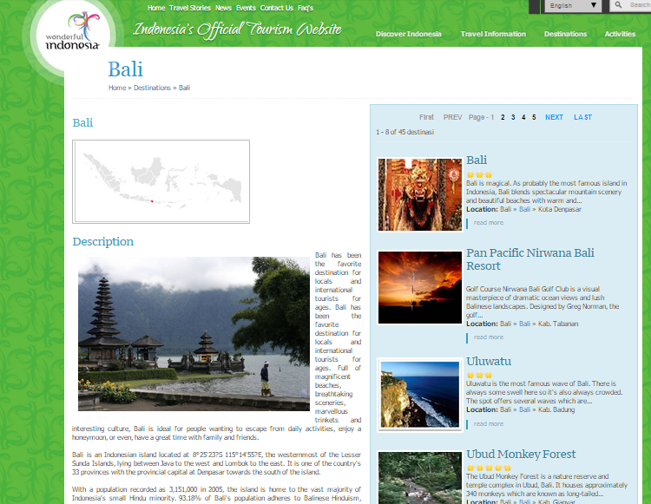**Website content:**

There is no evidence present of CSR or being a ‘good citizen’, for neither the organization nor the tourists.

The Bali page of the website only contains an overview of general facts about Bali and furthermore presents a link to each of the different destinations, none of which mentions anything about CSR, sustainable- or responsible tourism.

However lots of the destinations presented for Bali contains nature areas, and the photos are clearly indicating that they are focusing on Bali’s nature.

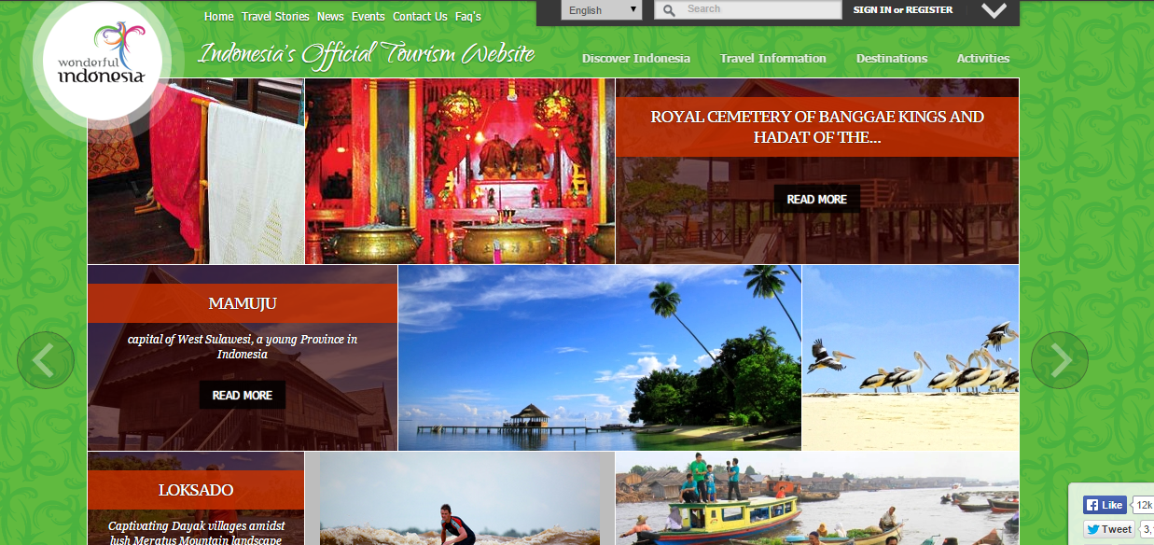

Even when looking at the front page for all of Indonesia, there is a focus on the beaches and the nature, however nowhere is there indicated anything about responsible tourism or initiatives that they might be taking to ensure the survival of the destinations.

There is loads of information available for culture, information, activities and all the destinations.

### 11.3.2 Pacto Bali

*Information gathered from: http://www.pactoltd.com/*

*14th of November 2014*

**Homepage:**

http://www.pactoltd.com/

**Organizational structure:**

The organization deals with all of Indonesia as well as Bali, and has departments some of the islands including Bali. The organization also has representatives in Germany, India, Hungary and Italy. It is a medium sized organization with approximately 50 employees, including guides, offices and representatives. Pacto Bali is a part of the larger organization of Pacto.

**Website content:**

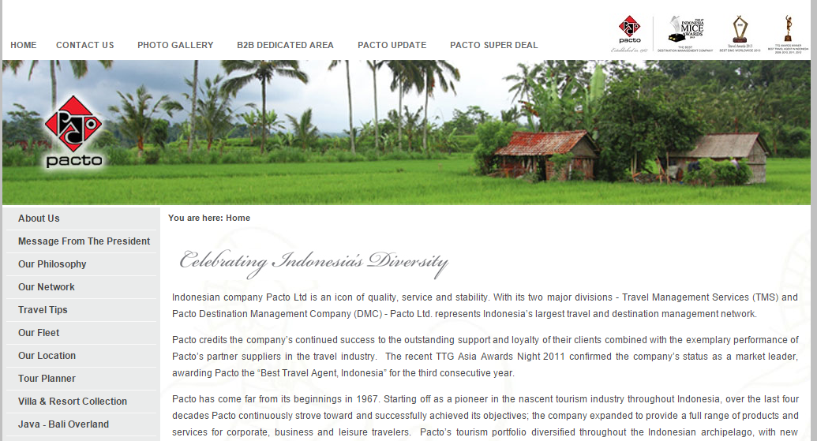

On the front page of the website, there is no evidence of CSR of anything leading to it; however when moving under ‘pacto update’, there is a lot of evidence as presented below. Moreover it is clear that they are marketing Bali with the green nature and culture. Even under ‘Our Philosophy’, there is no mention of any CSR initiatives.

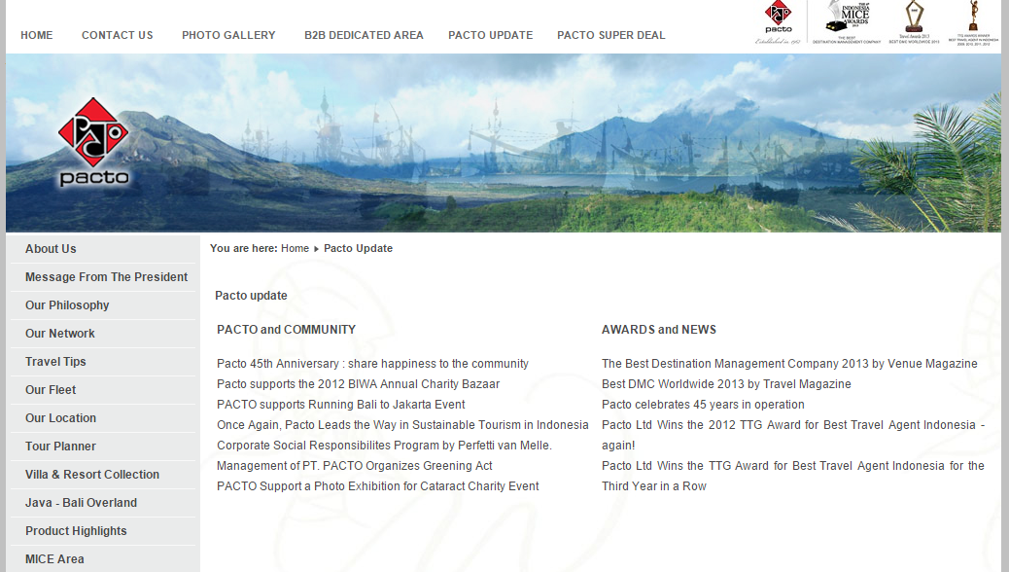

This organization presents a list of awards and news that they have received over the years, moreover they also present evidence of CSR in the form of ‘happiness to the community’, BIWA annual charity bazaar, ‘sustainable tourism in Indonesia’, ‘corporate social responsibility’, ‘greening act’ and Cataract charity event. These are also links that brings the reading to news articles that presents the organization doing good for the communities and nature.

**The articles are as follows:**

*Under ‘*[*Pacto 45th Anniversary : share happiness to the community*](http://www.pactoltd.com/pacto-update/89-pacto-update/181)*’:*

In celebration of Pacto 45th Anniversary, we have successfully conducted our most extensive CSR activity in the company’s history on Sunday, 18 November 2012.

To take advantage of our status as the largest Travel Network in Indonesia, we encourage all branches to directly bring all the team to clean and repaint a local school. This successful program took Team Building out of the office, forging links of solidarity with local communities, students, educators as well as among our dedicated staff.

We wish to celebrate a lot more years to come.

*Under ‘*[*Pacto supports the 2012 BIWA Annual Charity Bazaar*](http://www.pactoltd.com/pacto-update/89-pacto-update/179)*’*:

Pacto proudly support the Bali International Women’s Association (BIWA) Annual Charity Bazaar held on 08 July 2012 in Denpasar.

The event managed to raise IDR 50.127.000 (USD 5,304) to fund their Social Welfare programs which aim to educate, provide health services and implements project to help village women build up self-supporting business by their own labours. The funds raised by the Charity Bazaar will also fund visits to villages by the BIWA Dental Bus.

The organization was established for helping Balinese women gain pride in themselves and their own efforts to provide extra income for themselves and their families.

At Pacto, we look forward for the next BIWA Annual Charity Bazaar and given our commitment to Corporate Social Responsibility Program.

*Under ‘*[*PACTO supports Running Bali to Jakarta Event*](http://www.pactoltd.com/pacto-update/89-pacto-update/178)*’:*

Pacto proudly support the ‘keep running’ campaign organized by Mr. Scott Thompson in order to raise money for social, education and health for Indonesian children.

The ‘keep running’ marathon started in Bali on March 8th 2012 and cover 30 cities in 5 provinces for total distance 1,250 kilometers before arriving to finish line in Jakarta on April 1st 2012.

Pacto has supporting the campaign by providing the accommodation throughout the itinerary. The charity event has been a great success and has raised a total 3.2 billion rupiah (USD 355,556) which will be distributed by Yayasan Cinta Anak Bangsa (YCAB) a national organization which provides children with educational assistance and Mary’s Cancer Kiddies (MCK) which provides cancer treatment for children.

At Pacto, we look forward the next ‘keep running’ campaign and given our commitment to Corporate Social Responsibility program.

*Under ‘*[*Once Again, Pacto Leads the Way in Sustainable Tourism in Indonesia*](http://www.pactoltd.com/pacto-update/89-pacto-update/188)*’:*

How often have you visited a monument or temple, and found yourself overwhelmed by the noise of guides screaming their way to their clients’ ears, thus rendering the experience a much less enjoyable one? At Pacto, we have decided to address the issue of acoustic pollution in places of interest for tourists.

At Pacto, we realize the challenges in guiding large groups while respecting the environment, allowing guests to receive the needed explanation perfectly, with the guide maintaining the control over the group at all times.

Pacto is the first and only travel agent in Indonesia to adopt the Vox Tours Radio Guide as an additional service to their GIT clients as on May 2013. A one – way communication tool from guide to their clients during the visits, this multi channel radio is ideal to guarantee a noise free environment during visits and thanks to its 96 channels allows multilingual tours.

A simple idea that has completely changed the way organized group tours are managed: the guide communicates with clients using a wireless microphone and visitors listen to the explanation through earpiece, even at a distance, while moving around at leisure. The use of only one earpiece only assure that the clients can move around safely, remaining aware of the surrounding environment. The service is currently available in Bali and soon to be expanded to the whole of Indonesia.

A much comfortable trips for clients, a noise – less journey and just another way to respect the environment. Because at Pacto we care.

*Under ‘Corporate Social Responsibilites Program by Perfetti van Melle’:*

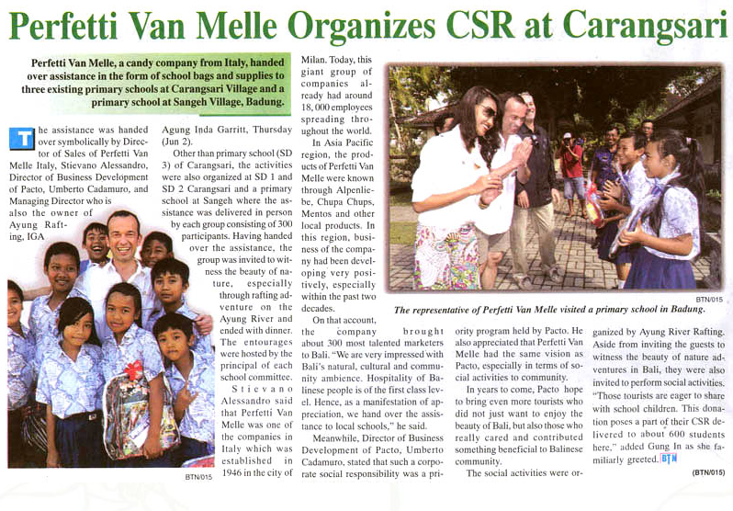

*Under ‘*[*Management of PT. PACTO Organizes Greening Act*](http://www.pactoltd.com/pacto-update/89-pacto-update/160)*’:*

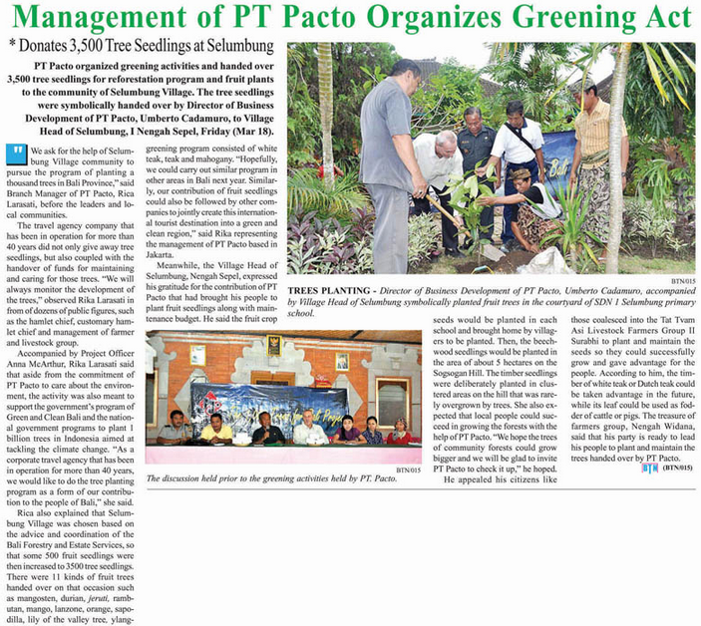

*Under ‘*[*PACTO Support a Photo Exhibition for Cataract Charity Event*](http://www.pactoltd.com/pacto-update/89-pacto-update/159)*’:*

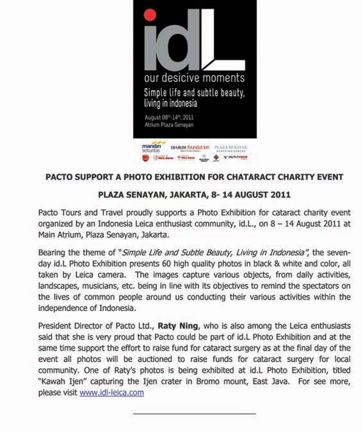

### 11.3.3 Indoplan Holidays

*Information gathered from: http://www.bali-indoplanholidays.com/*

*14th of November 2014*

**Homepage:**

http://www.bali-indoplanholidays.com/

**Organizational structure:**

The organization is a small sized organization located in the island of Bali, even though it is indicated that they also sell to other Indonesian islands like Java, it is not possible to find it anywhere on the website.

**Website content:**

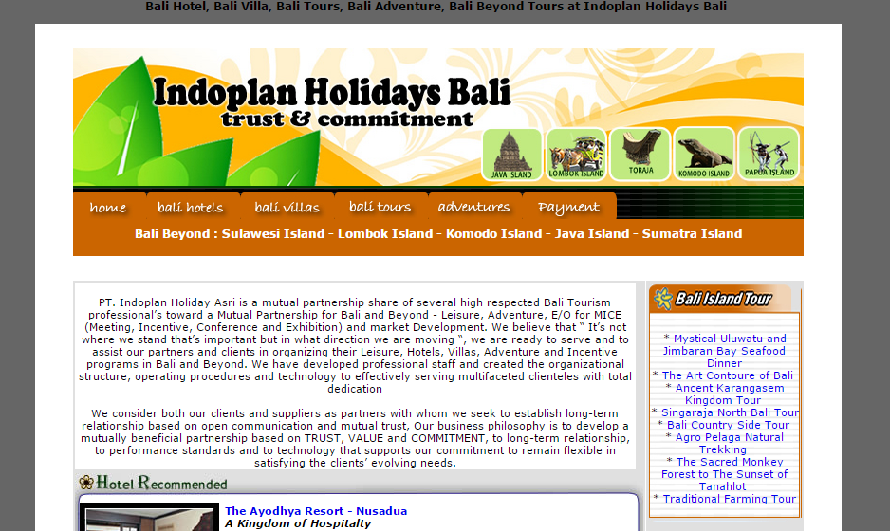

There is no evidence of CSR, responsible- or sustainable tourism on the front page of the website. There is also none to find elsewhere on the website, therefore there seem to be no indication that they are doing anything for the environment or communities. It is not possible to click on any of the links for Java or Sumatra, even though they are indicated as links, and it is also nowhere to be found in the contains of the website.

### 11.3.4 Bali Crystal Divers

*Information gathered from: http://www.crystal-divers.com/*

*14th of November 2014*

**Homepage:**

http://www.crystal-divers.com/

**Organizational structure:**

The organization is a small sized organization with 12 employees. The organization operates on Bali.

**Website content:**

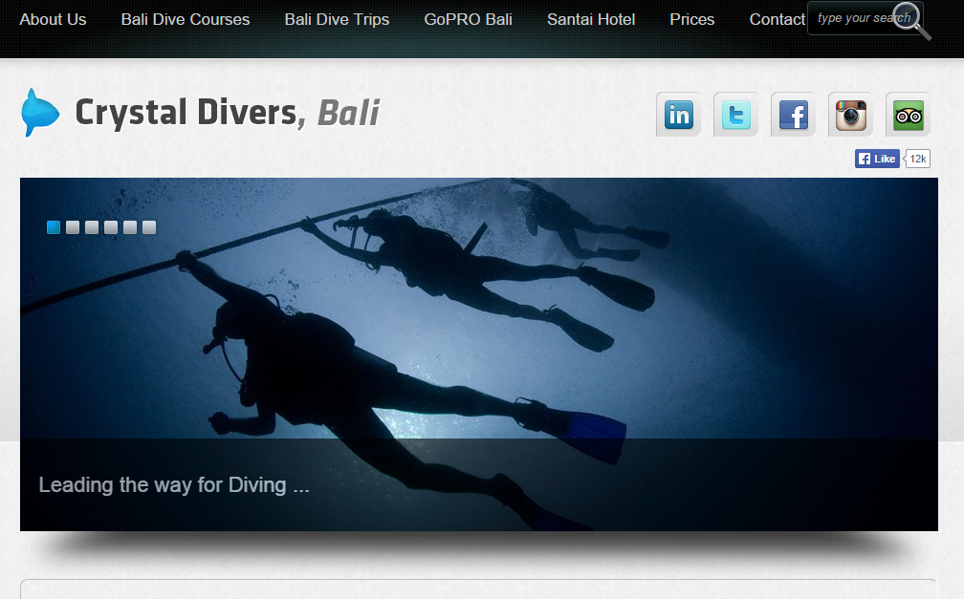

There is no evidence of CSR, responsible- or sustainable tourism on the front page of the website, however there are beautiful photos of the ocean.

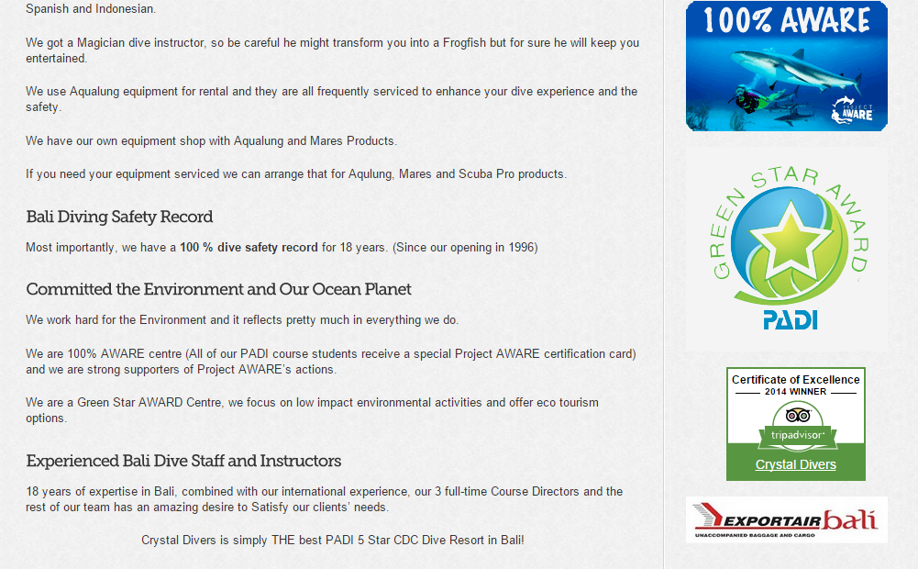

However, when you click on ‘About us’ and ‘crystal diver facts’, it is indicated that they are committed to the environment and that they focus on eco-tourism. Furthermore it is indicated that Bali Crystal Divers are strong supporters of project AWARE, which is an organization of divers that serve to protect the oceans of the world in more than 180 countries.

Project AWARE’s homepage: http://www.projectaware.org/?gclid=CJrCx8zWucICFULecgodM0UAdQ

### 11.3.5 Nick Tours

*Information gathered from: http://www.nicktours.com/*

*14th of November 2014*

**Homepage:**

http://www.nicktours.com/

**Organizational structure:**

The organization is small sized and operators from Sanur, Bali. However they also offer tours to other Indonesian islands, but mainly focus on Bali. It was founded and is run by Danish Nikolaj Jensen.

**Website content:**

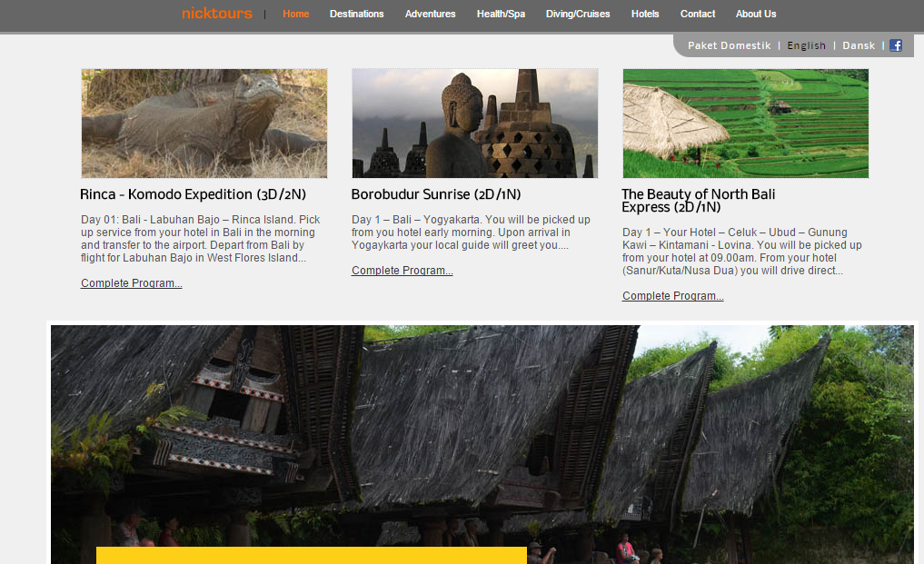

There is no evidence of CSR, responsible- or sustainable tourism on the front page of the website. The pictures focus on the nature, culture and heritage of the destination. There is no evidence of CSR on any of the pages of the website that could be found.

## 11.4 Human Index report

Taken from http://hdr.undp.org/en/data (2015, January 2) under ‘download all 2014 data by indicator, year and country.

|  |  |  |  |  |  |  |  |  |  |  |  |  |  |  |  |
| --- | --- | --- | --- | --- | --- | --- | --- | --- | --- | --- | --- | --- | --- | --- | --- |
| **Key to HDI countries and ranks, 2013** | | | | | | | |  | |  | |  | |  | |
|  |  | | | |  |  | |  | |  | |  | |  | |
|  |  | | | |  |  | |  | |  | |  | |  | |
|  |  | | | |  |  | |  | |  | |  | |  | |
|  |  | | | |  |  | |  | |  | |  | |  | |
|  |  | | | |  |  | |  | |  | |  | |  | |
| Afghanistan | 169 | | | |  | Georgia | | 79 | |  | | Norway | | 1 | |
| Albania | 95 | | | |  | Germany | | 6 | |  | | Oman | | 56 | |
| Algeria | 93 | | | |  | Ghana | | 138 | |  | | Pakistan | | 146 | |
| Andorra | 37 | | | |  | Greece | | 29 | |  | | Palau | | 60 | |
| Angola | 149 | | | |  | Grenada | | 79 | |  | | Palestine, State of | | 107 | |
| Antigua and Barbuda | 61 | | | |  | Guatemala | | 125 | |  | | Panama | | 65 | |
| Argentina | 49 | | | |  | Guinea | | 179 | |  | | Papua New Guinea | | 157 | |
| Armenia | 87 | | | |  | Guinea-Bissau | | 177 | |  | | Paraguay | | 111 | |
| Australia | 2 | | | |  | Guyana | | 121 | |  | | Peru | | 82 | |
| Austria | 21 | | | |  | Haiti | | 168 | |  | | Philippines | | 117 | |
| Azerbaijan | 76 | | | |  | Honduras | | 129 | |  | | Poland | | 35 | |
| Bahamas | 51 | | | |  | Hong Kong, China (SAR) | | 15 | |  | | Portugal | | 41 | |
| Bahrain | 44 | | | |  | Hungary | | 43 | |  | | Qatar | | 31 | |
| Bangladesh | 142 | | | |  | Iceland | | 13 | |  | | Romania | | 54 | |
| Barbados | 59 | | | |  | India | | 135 | |  | | Russian Federation | | 57 | |
| Belarus | 53 | | | |  | Indonesia | | 108 | |  | | Rwanda | | 151 | |
| Belgium | 21 | | | |  | Iran (Islamic Republic of) | | 75 | |  | | Saint Kitts and Nevis | | 73 | |
| Belize | 84 | | | |  | Iraq | | 120 | |  | | Saint Lucia | | 97 | |
| Benin | 165 | | | |  | Ireland | | 11 | |  | | Saint Vincent and the Grenadines | | 91 | |
| Bhutan | 136 | | | |  | Israel | | 19 | |  | | Samoa | | 106 | |
| Bolivia (Plurinational State of) | 113 | | | |  | Italy | | 26 | |  | | Sao Tome and Principe | | 142 | |
| Bosnia and Herzegovina | 86 | | | |  | Jamaica | | 96 | |  | | Saudi Arabia | | 34 | |
| Botswana | 109 | | | |  | Japan | | 17 | |  | | Senegal | | 163 | |
| Brazil | 79 | | | |  | Jordan | | 77 | |  | | Serbia | | 77 | |
| Brunei Darussalam | 30 | | | |  | Kazakhstan | | 70 | |  | | Seychelles | | 71 | |
| Bulgaria | 58 | | | |  | Kenya | | 147 | |  | | Sierra Leone | | 183 | |
| Burkina Faso | 181 | | | |  | Kiribati | | 133 | |  | | Singapore | | 9 | |
| Burundi | 180 | | | |  | Korea (Republic of) | | 15 | |  | | Slovakia | | 37 | |
| Cambodia | 136 | | | |  | Kuwait | | 46 | |  | | Slovenia | | 25 | |
| Cameroon | 152 | | | |  | Kyrgyzstan | | 125 | |  | | Solomon Islands | | 157 | |
| Canada | 8 | | | |  | Lao People's Democratic Republic | | 139 | |  | | South Africa | | 118 | |
| Cape Verde | 123 | | | |  | Latvia | | 48 | |  | | Spain | | 27 | |
| Central African Republic | 185 | | | |  | Lebanon | | 65 | |  | | Sri Lanka | | 73 | |
| Chad | 184 | | | |  | Lesotho | | 162 | |  | | Sudan | | 166 | |
| Chile | 41 | | | |  | Liberia | | 175 | |  | | Suriname | | 100 | |
| China | 91 | | | |  | Libya | | 55 | |  | | Swaziland | | 148 | |
| Colombia | 98 | | | |  | Liechtenstein | | 18 | |  | | Sweden | | 12 | |
| Comoros | 159 | | | |  | Lithuania | | 35 | |  | | Switzerland | | 3 | |
| Congo | 140 | | | |  | Luxembourg | | 21 | |  | | Syrian Arab Republic | | 118 | |
| Congo (Democratic Republic of the) | 186 | | | |  | Madagascar | | 155 | |  | | Tajikistan | | 133 | |
| Costa Rica | 68 | | | |  | Malawi | | 174 | |  | | Tanzania (United Republic of) | | 159 | |
| Côte d'Ivoire | 171 | | | |  | Malaysia | | 62 | |  | | Thailand | | 89 | |
| Croatia | 47 | | | |  | Maldives | | 103 | |  | | The former Yugoslav Republic of Macedonia | | 84 | |
| Cuba | 44 | | | |  | Mali | | 176 | |  | | Timor-Leste | | 128 | |
| Cyprus | 32 | | | |  | Malta | | 39 | |  | | Togo | | 166 | |
| Czech Republic | 28 | | | |  | Mauritania | | 161 | |  | | Tonga | | 100 | |
| Denmark | 10 | | | |  | Mauritius | | 63 | |  | | Trinidad and Tobago | | 64 | |
| Djibouti | 170 | | | |  | Mexico | | 71 | |  | | Tunisia | | 90 | |
| Dominica | 93 | | | |  | Micronesia (Federated States of) | | 124 | |  | | Turkey | | 69 | |
| Dominican Republic | 102 | | | |  | Moldova (Republic of) | | 114 | |  | | Turkmenistan | | 103 | |
| Ecuador | 98 | | | |  | Mongolia | | 103 | |  | | Uganda | | 164 | |
| Egypt | 110 | | | |  | Montenegro | | 51 | |  | | Ukraine | | 83 | |
| El Salvador | 115 | | | |  | Morocco | | 129 | |  | | United Arab Emirates | | 40 | |
| Equatorial Guinea | 144 | | | |  | Mozambique | | 178 | |  | | United Kingdom | | 14 | |
| Eritrea | 182 | | | |  | Myanmar | | 150 | |  | | United States | | 5 | |
| Estonia | 33 | | | |  | Namibia | | 127 | |  | | Uruguay | | 50 | |
| Ethiopia | 173 | | | |  | Nepal | | 145 | |  | | Uzbekistan | | 116 | |
| Fiji | 88 | | | |  | Netherlands | | 4 | |  | | Vanuatu | | 131 | |
| Finland | 24 | | | |  | New Zealand | | 7 | |  | | Venezuela (Bolivarian Republic of) | | 67 | |
| France | 20 | | | |  | Nicaragua | | 132 | |  | | Viet Nam | | 121 | |
| Gabon | 112 | | | |  | Niger | | 187 | |  | | Yemen | | 154 | |
| Gambia | 172 | | | |  | Nigeria | | 152 | |  | | Zambia | | 141 | |
|  |  | | | |  |  | |  | |  | | Zimbabwe | | 156 | |
| **Key to HDI countries and ranks, 2013** | | | | | | |  | |  | |  | |  | |
|  | |  |  |  | | |  | |  | |  | |  | |
|  | |  |  |  | | |  | |  | |  | |  | |
|  | |  |  |  | | |  | |  | |  | |  | |
|  | |  |  |  | | |  | |  | |  | |  | |
|  | |  |  |  | | |  | |  | |  | |  | |
| Afghanistan | | 169 |  | Georgia | | | 79 | |  | | Norway | | 1 | |
| Albania | | 95 |  | Germany | | | 6 | |  | | Oman | | 56 | |
| Algeria | | 93 |  | Ghana | | | 138 | |  | | Pakistan | | 146 | |
| Andorra | | 37 |  | Greece | | | 29 | |  | | Palau | | 60 | |
| Angola | | 149 |  | Grenada | | | 79 | |  | | Palestine, State of | | 107 | |
| Antigua and Barbuda | | 61 |  | Guatemala | | | 125 | |  | | Panama | | 65 | |
| Argentina | | 49 |  | Guinea | | | 179 | |  | | Papua New Guinea | | 157 | |
| Armenia | | 87 |  | Guinea-Bissau | | | 177 | |  | | Paraguay | | 111 | |
| Australia | | 2 |  | Guyana | | | 121 | |  | | Peru | | 82 | |
| Austria | | 21 |  | Haiti | | | 168 | |  | | Philippines | | 117 | |
| Azerbaijan | | 76 |  | Honduras | | | 129 | |  | | Poland | | 35 | |
| Bahamas | | 51 |  | Hong Kong, China (SAR) | | | 15 | |  | | Portugal | | 41 | |
| Bahrain | | 44 |  | Hungary | | | 43 | |  | | Qatar | | 31 | |
| Bangladesh | | 142 |  | Iceland | | | 13 | |  | | Romania | | 54 | |
| Barbados | | 59 |  | India | | | 135 | |  | | Russian Federation | | 57 | |
| Belarus | | 53 |  | Indonesia | | | 108 | |  | | Rwanda | | 151 | |
| Belgium | | 21 |  | Iran (Islamic Republic of) | | | 75 | |  | | Saint Kitts and Nevis | | 73 | |
| Belize | | 84 |  | Iraq | | | 120 | |  | | Saint Lucia | | 97 | |
| Benin | | 165 |  | Ireland | | | 11 | |  | | Saint Vincent and the Grenadines | | 91 | |
| Bhutan | | 136 |  | Israel | | | 19 | |  | | Samoa | | 106 | |
| Bolivia (Plurinational State of) | | 113 |  | Italy | | | 26 | |  | | Sao Tome and Principe | | 142 | |
| Bosnia and Herzegovina | | 86 |  | Jamaica | | | 96 | |  | | Saudi Arabia | | 34 | |
| Botswana | | 109 |  | Japan | | | 17 | |  | | Senegal | | 163 | |
| Brazil | | 79 |  | Jordan | | | 77 | |  | | Serbia | | 77 | |
| Brunei Darussalam | | 30 |  | Kazakhstan | | | 70 | |  | | Seychelles | | 71 | |
| Bulgaria | | 58 |  | Kenya | | | 147 | |  | | Sierra Leone | | 183 | |
| Burkina Faso | | 181 |  | Kiribati | | | 133 | |  | | Singapore | | 9 | |
| Burundi | | 180 |  | Korea (Republic of) | | | 15 | |  | | Slovakia | | 37 | |
| Cambodia | | 136 |  | Kuwait | | | 46 | |  | | Slovenia | | 25 | |
| Cameroon | | 152 |  | Kyrgyzstan | | | 125 | |  | | Solomon Islands | | 157 | |
| Canada | | 8 |  | Lao People's Democratic Republic | | | 139 | |  | | South Africa | | 118 | |
| Cape Verde | | 123 |  | Latvia | | | 48 | |  | | Spain | | 27 | |
| Central African Republic | | 185 |  | Lebanon | | | 65 | |  | | Sri Lanka | | 73 | |
| Chad | | 184 |  | Lesotho | | | 162 | |  | | Sudan | | 166 | |
| Chile | | 41 |  | Liberia | | | 175 | |  | | Suriname | | 100 | |
| China | | 91 |  | Libya | | | 55 | |  | | Swaziland | | 148 | |
| Colombia | | 98 |  | Liechtenstein | | | 18 | |  | | Sweden | | 12 | |
| Comoros | | 159 |  | Lithuania | | | 35 | |  | | Switzerland | | 3 | |
| Congo | | 140 |  | Luxembourg | | | 21 | |  | | Syrian Arab Republic | | 118 | |
| Congo (Democratic Republic of the) | | 186 |  | Madagascar | | | 155 | |  | | Tajikistan | | 133 | |
| Costa Rica | | 68 |  | Malawi | | | 174 | |  | | Tanzania (United Republic of) | | 159 | |
| Côte d'Ivoire | | 171 |  | Malaysia | | | 62 | |  | | Thailand | | 89 | |
| Croatia | | 47 |  | Maldives | | | 103 | |  | | The former Yugoslav Republic of Macedonia | | 84 | |
| Cuba | | 44 |  | Mali | | | 176 | |  | | Timor-Leste | | 128 | |
| Cyprus | | 32 |  | Malta | | | 39 | |  | | Togo | | 166 | |
| Czech Republic | | 28 |  | Mauritania | | | 161 | |  | | Tonga | | 100 | |
| Denmark | | 10 |  | Mauritius | | | 63 | |  | | Trinidad and Tobago | | 64 | |
| Djibouti | | 170 |  | Mexico | | | 71 | |  | | Tunisia | | 90 | |
| Dominica | | 93 |  | Micronesia (Federated States of) | | | 124 | |  | | Turkey | | 69 | |
| Dominican Republic | | 102 |  | Moldova (Republic of) | | | 114 | |  | | Turkmenistan | | 103 | |
| Ecuador | | 98 |  | Mongolia | | | 103 | |  | | Uganda | | 164 | |
| Egypt | | 110 |  | Montenegro | | | 51 | |  | | Ukraine | | 83 | |
| El Salvador | | 115 |  | Morocco | | | 129 | |  | | United Arab Emirates | | 40 | |
| Equatorial Guinea | | 144 |  | Mozambique | | | 178 | |  | | United Kingdom | | 14 | |
| Eritrea | | 182 |  | Myanmar | | | 150 | |  | | United States | | 5 | |
| Estonia | | 33 |  | Namibia | | | 127 | |  | | Uruguay | | 50 | |
| Ethiopia | | 173 |  | Nepal | | | 145 | |  | | Uzbekistan | | 116 | |
| Fiji | | 88 |  | Netherlands | | | 4 | |  | | Vanuatu | | 131 | |
| Finland | | 24 |  | New Zealand | | | 7 | |  | | Venezuela (Bolivarian Republic of) | | 67 | |
| France | | 20 |  | Nicaragua | | | 132 | |  | | Viet Nam | | 121 | |
| Gabon | | 112 |  | Niger | | | 187 | |  | | Yemen | | 154 | |
| Gambia | | 172 |  | Nigeria | | | 152 | |  | | Zambia | | 141 | |
|  | |  |  |  | | |  | |  | | Zimbabwe | | 156 | |